Multi-GPCR Candidates

CCR2-CCR5

Homologues and motifs

We present CCR2-CCR5 as a potential multi-GPCR isoform of two previously known GPCR sequences. One specific multi-GPCR is found in Bos mutus (wild Yak) with the UniProt identifier A0A6B0S3N8, in which the first domain has 85% identity to a Primate (Macaca mulatta) CCR2; the second domain has ~100% identity to Cow (Bos taurus) CCR5. High sequence identities also give confidence in identifying the native agonist of these potential multi-GPCR isoforms. Moreover, all of the motifs for GPCR functionality are present in both of the GPCR domains in the multi-GPCR isoform. This is expected, since the hypothesized isoform is assumed to be an alternative splicing event that joins the two GPCR sequences together.

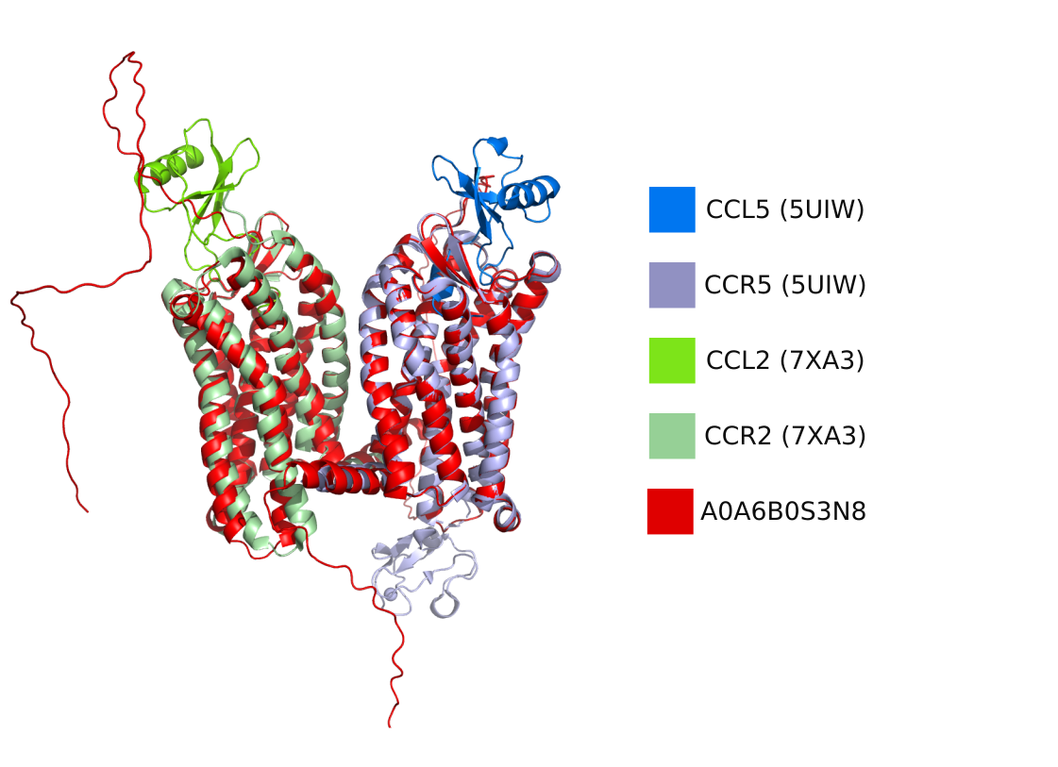

Syntenic Orthology

In other animals, the two genes are located in the same order and orientation within ~10kbp distance consistently throughout vertebrates, which have similar immune system foundations. Outgroups in this view are less trustworthy further away from Humans –because of lack of reviewed curation–, but some noteworthy taxonomic outgroups that have this genomic conditions are Cats (outgroup for mammals), Chicken (birds), Lizards (amphibians). This is discussed further below.

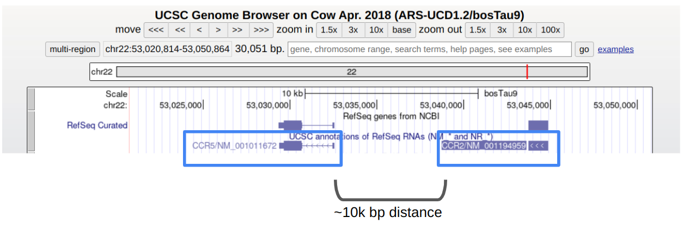
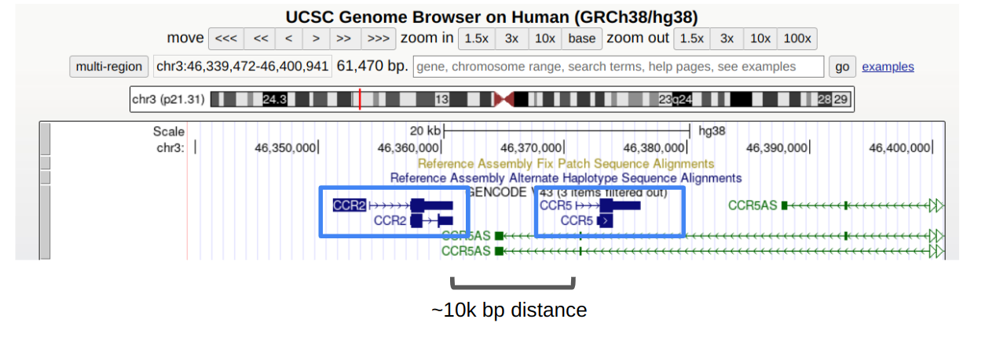

Tissue Expression

When regarding CCR2-CCR5 as a potential multi-GPCR isoform of two previously identified genes, supporting evidence that they are expressed in the same cells is important for retaining this idea. The following figure was adapted from the work of Hughes and Nibbs (2018). The authors looked at transcript data from different immune-related cell types to infer the expression levels of chemokine receptors in corresponding cell types. Remarked again with a pair of red rectangles, the figure below shows that CCR2-CCR5 is commonly expressed together. We hypothesize that in some of these cell types, there might exist an alternative splicing isoform that is a multi-GPCR, containing at least CCR2 and CCR5 in the same chain.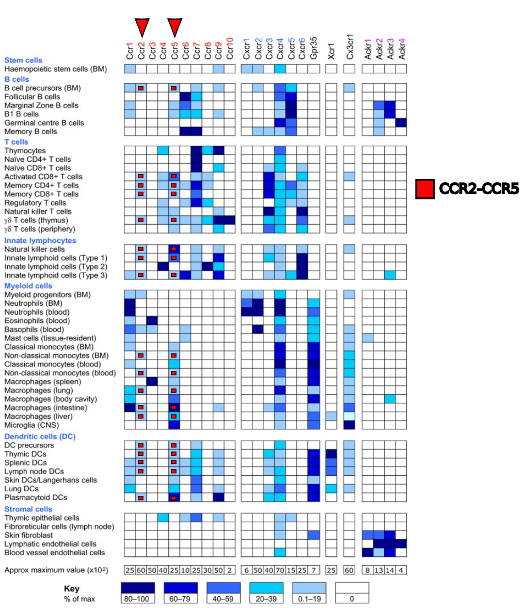

UCSC Genome derived CCR2-CCR5 loci alignment
With the UCSC Genome Browser links provided below, all of the DNA sequences were aligned that fit the genetic topology of CCR2 and CCR5. In primates, there is considerable alignment in the linker region between them. Most notably, in all genomic loci from the species below, almost all seem to suggest the relative orientation (both on template or coding strand) of two genes remained the same. Additionally, the inter-genic linker region seems to be constrained in a narrow range of base pairs (7200<N<11400, with the exception of Horse locus (29000)).

Viewed in Ugene, here are the alignments of the loci, with the x-axis standing for the index in the msa, and the y-axis standing for the conservation of the given x position.

Here is an annotated view of the CCR2-CCR5 loci aligned for primates:

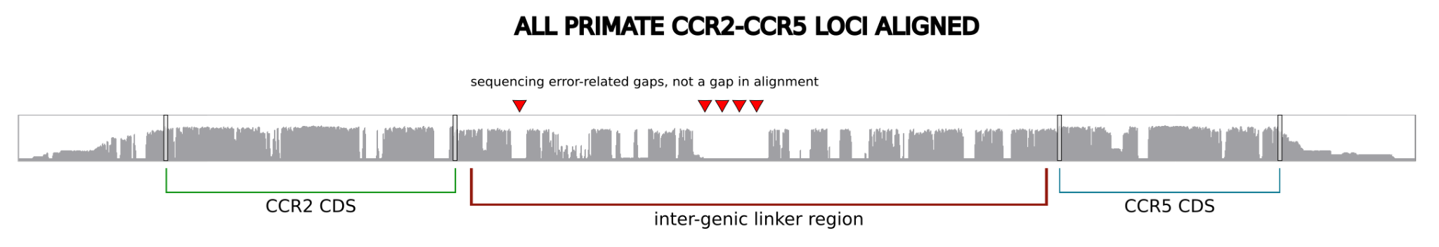

Notably, the major gap between the primate loci is from technical gaps (no nucleotide annotation from the collected sequence). Rest of the inter-genic sequence seems to be conserved in primates.

Here is an annotated view of the CCR2-CCR5 loci aligned for all the species below:

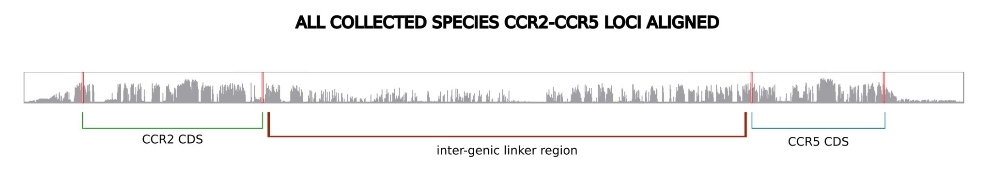

In the alignment with all of the species, horse CCR2-CCR5 locus seems to be the main reason behind the length of the alignment, and the gaps in between. This is also noted below in parentheses, where only the Horse locus is 30,000 base pairs.

UCSC Genome Browser Links
Inter-genic lengths were taken using the UCSC genome browser, after the end of CCR2, until the beginning of CCR5.

Primates

Human:
Inter-genic length: ~9,000 bp https://genome-euro.ucsc.edu/cgi-bin/hgTracks?db=hg38&lastVirtModeType=default&lastVirtModeExtraState=&virtModeType=default&virtMode=0&nonVirtPosition=&position=chr3%3A46336070%2D46397539&hgsid=297589444_n7pmBjOOtoGTKWzUQARzf1BIgUV3

Chimp:
Inter-genic length: ~9,500 bp
https://genome-euro.ucsc.edu/cgi-bin/hgTracks?db=panTro6&lastVirtModeType=default&lastVirtModeExtraState=&virtModeType=default&virtMode=0&nonVirtPosition=&position=chr3%3A46582145%2D46610008&hgsid=297596892_5OIZAlQLmVEG3NB0owCTQ8N137se

Bonobo:
Inter-genic length: ~9,200 bp
https://genome-euro.ucsc.edu/cgi-bin/hgTracks?db=panPan3&lastVirtModeType=default&lastVirtModeExtraState=&virtModeType=default&virtMode=0&nonVirtPosition=&position=chr3%3A46224716%2D46308307&hgsid=297596920_1v7kRkQzSJjG2pBZgF5CABmEWfSv

Gorilla:
Inter-genic length: ~9,000 bp
https://genome-euro.ucsc.edu/cgi-bin/hgTracks?db=gorGor6&lastVirtModeType=default&lastVirtModeExtraState=&virtModeType=default&virtMode=0&nonVirtPosition=&position=chr3%3A46377882%2D46405745&hgsid=297596942_ih7HNTQyN3XZFuUAtSs7jB1f5uT5

Orangutan:
Inter-genic length: ~9,300 bp
https://genome-euro.ucsc.edu/cgi-bin/hgTracks?db=ponAbe3&lastVirtModeType=default&lastVirtModeExtraState=&virtModeType=default&virtMode=0&nonVirtPosition=&position=chr3%3A95527682%2D95558641&hgsid=297596964_23anroGOhBJe9TfPT6QrRnvrJnhh

Gibbon:
–does not exist in an assembled genome–

Green monkey (different chromosome after here-on out):
Inter-genic length: ~9,100 bp
https://genome-euro.ucsc.edu/cgi-bin/hgTracks?db=chlSab2&lastVirtModeType=default&lastVirtModeExtraState=&virtModeType=default&virtMode=0&nonVirtPosition=&position=chr22%3A7791731%2D7819594&hgsid=297597062_kPquLdXIRIsD2AGvz9M7DZXuJ2AT

Crab-eating Macaque:
Inter-genic length: ~10,800 bp
https://genome-euro.ucsc.edu/cgi-bin/hgTracks?db=macFas5&lastVirtModeType=default&lastVirtModeExtraState=&virtModeType=default&virtMode=0&nonVirtPosition=&position=chr2%3A101374842%2D101402705&hgsid=297597101_A8vY1DnK0x7lHyDrTs73sqb1Zo0w

Rhesus:
Inter-genic length: ~9,000 bp
https://genome-euro.ucsc.edu/cgi-bin/hgTracks?db=rheMac10&lastVirtModeType=default&lastVirtModeExtraState=&virtModeType=default&virtMode=0&nonVirtPosition=&position=chr2%3A102366420%2D102395660&hgsid=297597001_dTK1ojzvSjlvsMYR96WuDaFOnKVY

Baboon (anubis):
Inter-genic length: ~8,300 bp
https://genome-euro.ucsc.edu/cgi-bin/hgTracks?db=papAnu4&lastVirtModeType=default&lastVirtModeExtraState=&virtModeType=default&virtMode=0&nonVirtPosition=&position=chr2%3A89378613%2D89406476&hgsid=297600792_omV2tP9EtHjgAuzRMARTSlWe9SuF

Baboon (hamadryas):

Proboscis monkey:
Inter-genic length: ~8,500 bp
https://genome-euro.ucsc.edu/cgi-bin/hgTracks?db=nasLar1&lastVirtModeType=default&lastVirtModeExtraState=&virtModeType=default&virtMode=0&nonVirtPosition=&position=chr2%3A85879563%2D85907426&hgsid=297601190_CbWiczv8V9m0ERspn9ue2Wihgk70

Golden snub-nosed monkey:
Inter-genic length: ~8,500 bp
https://genome-euro.ucsc.edu/cgi-bin/hgTracks?db=rhiRox1&lastVirtModeType=default&lastVirtModeExtraState=&virtModeType=default&virtMode=0&nonVirtPosition=&position=KN297259v1%3A1946943%2D1977902&hgsid=297601197_KeVkkWGCkj4Pcg2NvAK2P0XRxfu3

Marmoset:
Inter-genic length: ~9,500 bp
https://genome-euro.ucsc.edu/cgi-bin/hgTracks?db=calJac4&lastVirtModeType=default&lastVirtModeExtraState=&virtModeType=default&virtMode=0&nonVirtPosition=&position=chr15%3A23518597%2D23549556&hgsid=297601201_RnTVgQxZyqwy8tHDFzirz845C0KQ

Squirrel monkey:
Inter-genic length: ~9,100 bp
https://genome-euro.ucsc.edu/cgi-bin/hgTracks?db=saiBol1&lastVirtModeType=default&lastVirtModeExtraState=&virtModeType=default&virtMode=0&nonVirtPosition=&position=JH378122%3A8945487%2D9038366&hgsid=297601210_KZJff03LiRh5pIbH7512dEmrUaco

Tarsier:
Inter-genic length: ~11,400 bp
https://genome-euro.ucsc.edu/cgi-bin/hgTracks?db=tarSyr2&lastVirtModeType=default&lastVirtModeExtraState=&virtModeType=default&virtMode=0&nonVirtPosition=&position=KE948712v1%3A102737%2D144415&hgsid=297601216_LxLJaer7ll8K89WDxvuAuuNbMMWx

Mouse lemur:
Inter-genic length: ~8,700 bp
https://genome-euro.ucsc.edu/cgi-bin/hgTracks?db=micMur2&lastVirtModeType=default&lastVirtModeExtraState=&virtModeType=default&virtMode=0&nonVirtPosition=&position=KQ053959v1%3A3529129%2D3560088&hgsid=297601226_OLazIx8Kf1hwYntCGLAQQ2oWg0kX

Bushbaby:
Inter-genic length: ~10,100 bp
https://genome-euro.ucsc.edu/cgi-bin/hgTracks?db=otoGar3&lastVirtModeType=default&lastVirtModeExtraState=&virtModeType=default&virtMode=0&nonVirtPosition=&position=GL873601%3A7521485%2D7547836&hgsid=297601232_uL9kAk3X0YQnSBk6k0YoxWpBx4IL

Other Mammals
*note: here on out, I only took the animals from UCSC browser which have assembled genomes (looking at if chromosome numbering was present)

Mouse:
Inter-genic length: ~8,000-11,200 bp (two different end-points for CCR2)
https://genome-euro.ucsc.edu/cgi-bin/hgTracks?db=mm10&lastVirtModeType=default&lastVirtModeExtraState=&virtModeType=default&virtMode=0&nonVirtPosition=&position=chr9%3A124100033%2D124133932&hgsid=297749114_4fyygO4IdxTi2oU29SFIPEqwVsel

Rat: (maybe it doesn’t exist here)
Inter-genic length: ?
https://genome-euro.ucsc.edu/cgi-bin/hgTracks?db=rn6&lastVirtModeType=default&lastVirtModeExtraState=&virtModeType=default&virtMode=0&nonVirtPosition=&position=chr8%3A133192672%2D133217125&hgsid=297752687_uxRSAYA30txEVPCMWGeYHjThS3Qo

Rabbit:
Inter-genic length: ~11,200 bp
https://genome-euro.ucsc.edu/cgi-bin/hgTracks?db=oryCun2&lastVirtModeType=default&lastVirtModeExtraState=&virtModeType=default&virtMode=0&nonVirtPosition=&position=chr9%3A14540535%2D14564777&hgsid=297752865_FmsnwMNwrC71TzyFx15zrtyPYdDi

Pig:
Inter-genic length: ~8,700 bp
https://genome-euro.ucsc.edu/cgi-bin/hgTracks?db=susScr11&lastVirtModeType=default&lastVirtModeExtraState=&virtModeType=default&virtMode=0&nonVirtPosition=&position=chr13%3A29367944%2D29388715&hgsid=297752865_FmsnwMNwrC71TzyFx15zrtyPYdDi

Cow:
Inter-genic length: ~8,700 bp
https://genome-euro.ucsc.edu/cgi-bin/hgTracks?db=bosTau9&lastVirtModeType=default&lastVirtModeExtraState=&virtModeType=default&virtMode=0&nonVirtPosition=&position=chr22%3A53027046%2D53049742&hgsid=297752865_FmsnwMNwrC71TzyFx15zrtyPYdDi

Sheep:
Inter-genic length: ~8,900 bp
https://genome-euro.ucsc.edu/cgi-bin/hgTracks?db=oviAri4&lastVirtModeType=default&lastVirtModeExtraState=&virtModeType=default&virtMode=0&nonVirtPosition=&position=chr19%3A52956067%2D52978917&hgsid=297753065_70XGccFsiprDPAiKaobVGPGboI96

Horse: (inter-genic distance increases here)
Inter-genic length: ~29,000 bp
https://genome-euro.ucsc.edu/cgi-bin/hgTracks?db=equCab3&lastVirtModeType=default&lastVirtModeExtraState=&virtModeType=default&virtMode=0&nonVirtPosition=&position=chr16%3A41953236%2D41996344&hgsid=297752865_FmsnwMNwrC71TzyFx15zrtyPYdDi

Dog:
Inter-genic length: ~7,700 bp
https://genome-euro.ucsc.edu/cgi-bin/hgTracks?db=canFam4&lastVirtModeType=default&lastVirtModeExtraState=&virtModeType=default&virtMode=0&nonVirtPosition=&position=chr20%3A42698795%2D42719394&hgsid=297753182_xClrta7KH8qzYcwfP0XakBzuxwey

Cat:
Inter-genic length: ~7,200 bp
https://genome-euro.ucsc.edu/cgi-bin/hgTracks?db=felCat9&lastVirtModeType=default&lastVirtModeExtraState=&virtModeType=default&virtMode=0&nonVirtPosition=&position=chrA2%3A15918326%2D15939375&hgsid=297753246_KuDrHbsiDsYpDSvAkQeVo4h9Bz8A

Platypus: (outgroup for mammals, the ref-seq annotation seems foggy here)
Inter-genic length: ~10,500 bp
https://genome-euro.ucsc.edu/cgi-bin/hgTracks?db=ornAna2&lastVirtModeType=default&lastVirtModeExtraState=&virtModeType=default&virtMode=0&nonVirtPosition=&position=chrUn_DS180993v1%3A3925639%2D3939642&hgsid=297753334_xMaXKVSC7VVCLnKa0ljJX3da9njG

Birds, Reptiles, and Amphibians

Chicken:
Inter-genic length: ~11,000 bp
https://genome-euro.ucsc.edu/cgi-bin/hgTracks?db=galGal6&lastVirtModeType=default&lastVirtModeExtraState=&virtModeType=default&virtMode=0&nonVirtPosition=&position=chr2%3A42617044%2D42635745&hgsid=297753334_xMaXKVSC7VVCLnKa0ljJX3da9njG

Turkey: (relatively unclear, and also annotated on 2 different chromosomes (6, and 7). Here is the one from where the gene topology is like the ones above (chr6))
Inter-genic length: ~14,900 bp (?)
https://genome-euro.ucsc.edu/cgi-bin/hgTracks?db=melGal5&lastVirtModeType=default&lastVirtModeExtraState=&virtModeType=default&virtMode=0&nonVirtPosition=&position=chr6%3A43052857%2D43072641&hgsid=297753507_a25R4bJA5czv5oJnsOSI6ah5zgAa

Zebra finch:
Inter-genic length: ~11,800 bp
https://genome-euro.ucsc.edu/cgi-bin/hgTracks?db=taeGut2&lastVirtModeType=default&lastVirtModeExtraState=&virtModeType=default&virtMode=0&nonVirtPosition=&position=chr2%3A63209779%2D63226637&hgsid=297753602_HXskMwfLjPpaO4pDCnZerls6EJeq

Lizard: (might be the same picture as above organisms, but the annotation is very mixed up. Some inferences join the two genes together, and some split them apart. The chemokine type annotation is all over the place here as well.)
Inter-genic length: ~8,900 bp
https://genome-euro.ucsc.edu/cgi-bin/hgTracks?db=anoCar2&lastVirtModeType=default&lastVirtModeExtraState=&virtModeType=default&virtMode=0&nonVirtPosition=&position=chr1%3A88970930%2D88983604&hgsid=297753751_xy4CBbmfA7413BqOMhZ4yb1aQsvO

*The signal/conservation seems to stop somewhere here around amphibians, we don’t see this in Frogs (X. tropicalis and African Clawed Frog). Additionally, these proteins are not found/annotated yet in the most studied aquatic vertebrate Zebrafish.

