# CSE333 - Operating Systems Project 1 Report

Install file 150114048_150115048_Pro1.zip and extract into a directory. In screenshots, you will see that the files extracted to Desktop/ directory. Then use commands consecutively;

:~$ cd Desktop/150114048_150115048_Pro1/menu // to open directory that myProgram.sh exists

:~$ chmod + myProgram.sh //change permissions to run myProgram.sh

:~$ ./myProgram.sh //run myProgram.sh

The commands written are also in first comment lines of myProgram.sh file.

After you will have the screen with 6 options, 5 code and 1 exit option, same as in Figure 1.

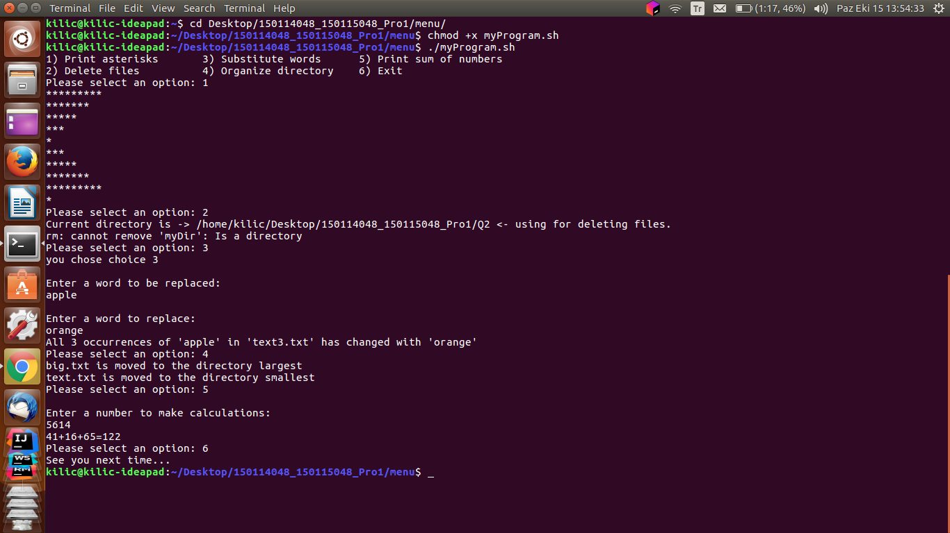

Figure 1

You can check all the options as shown in Figure 1.

If you want to see the changes while these shell script is running, you can check Figure 2,3,4,5,6 and 7 also you can check directory which have subdirectories menu,Q1,Q2,Q3,Q4 and Q5. In all of these directories, the given numbers related to question number. Check files with nano text editor or any other editor that support .sh file extension.

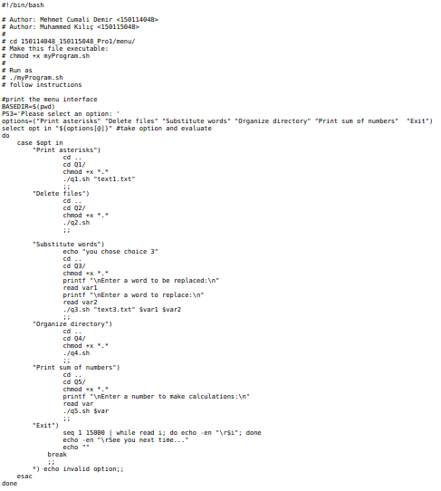

Figure 2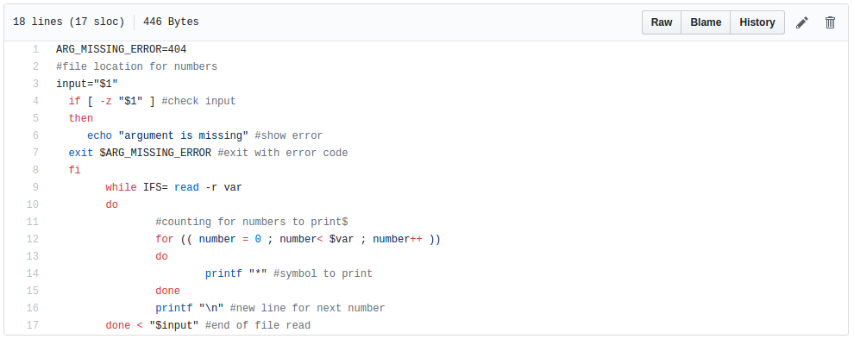

Figure 3

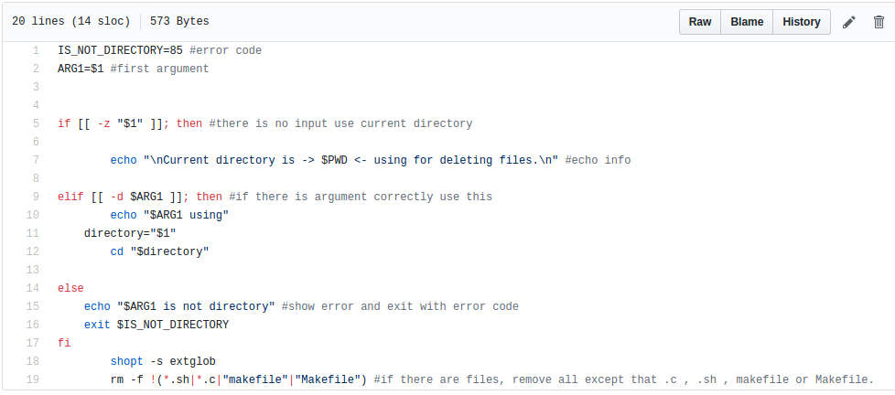

Figure 4

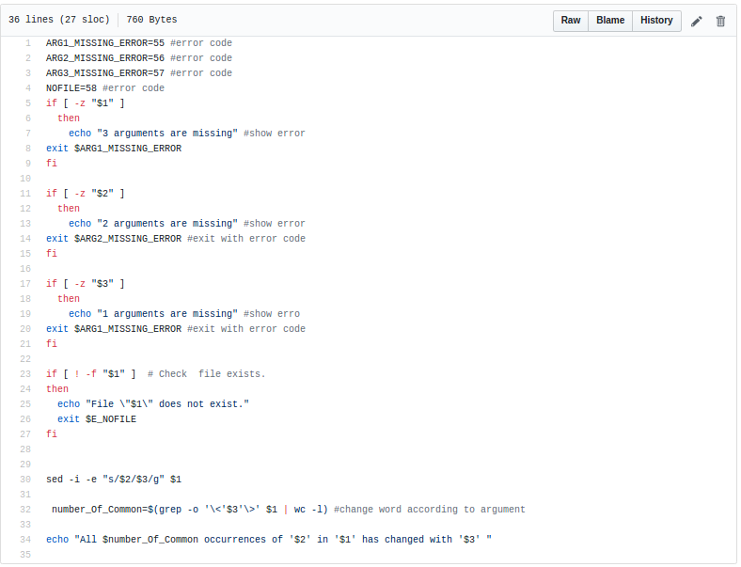

Figure 5

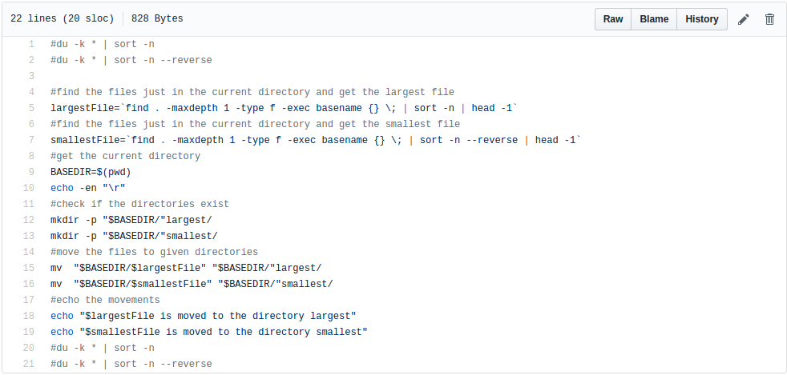

Figure 6

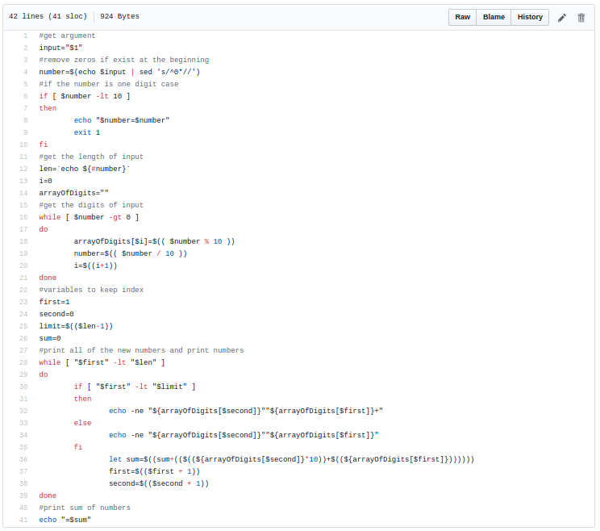

Figure 7

The Questions numbered 2,3,4 are related to files and directories so in Figures 8 to 14 will show how these options works.

Question 2-)

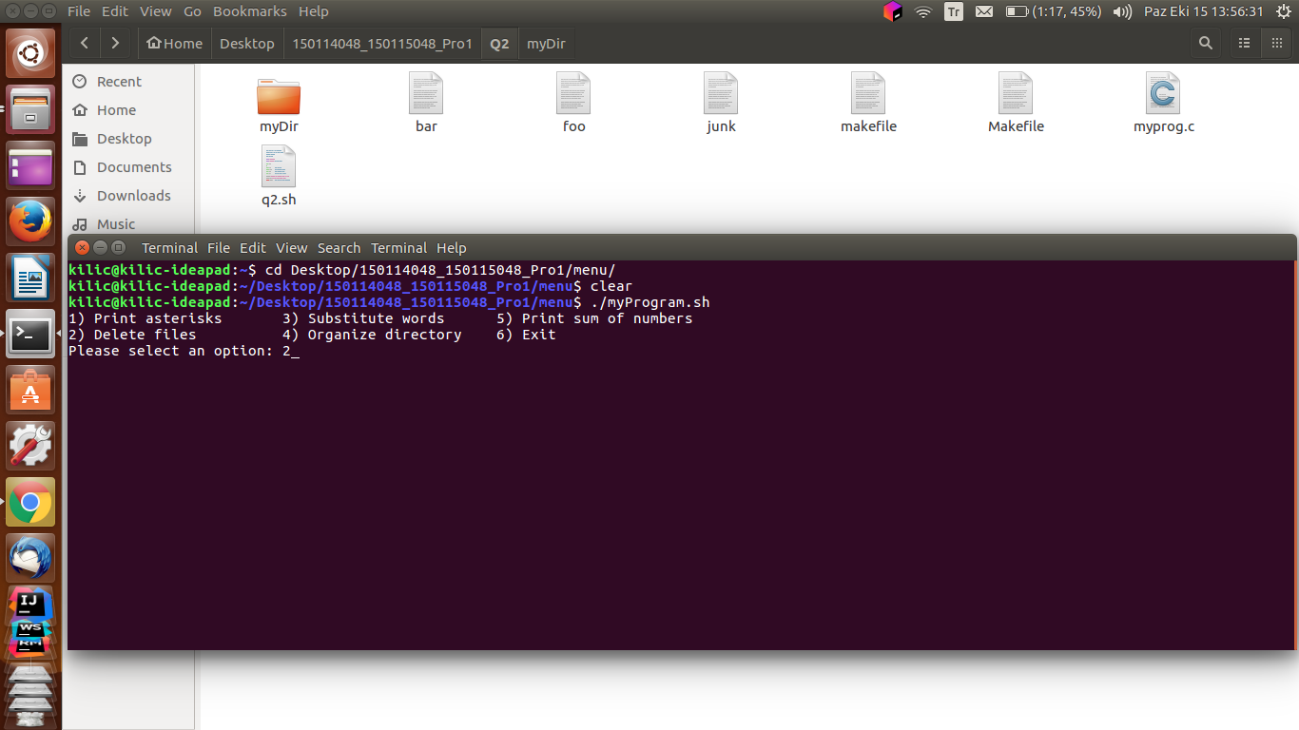

Figure 8

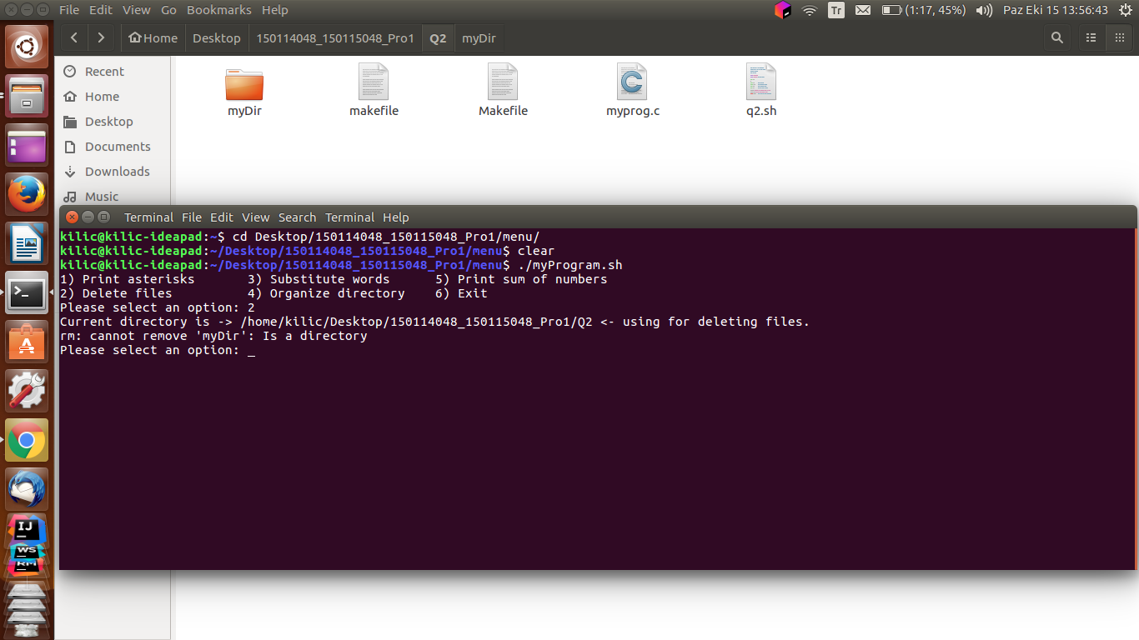

Figure 9

Question 3-)

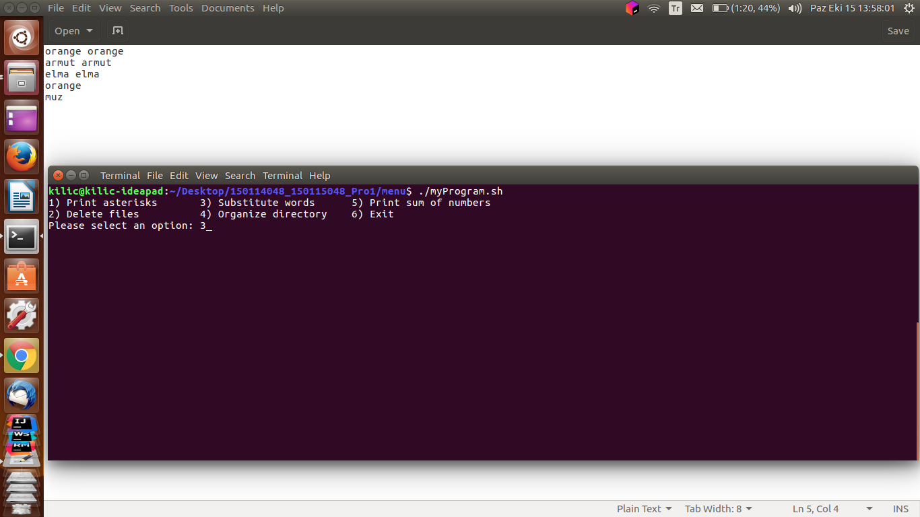

Figure 10

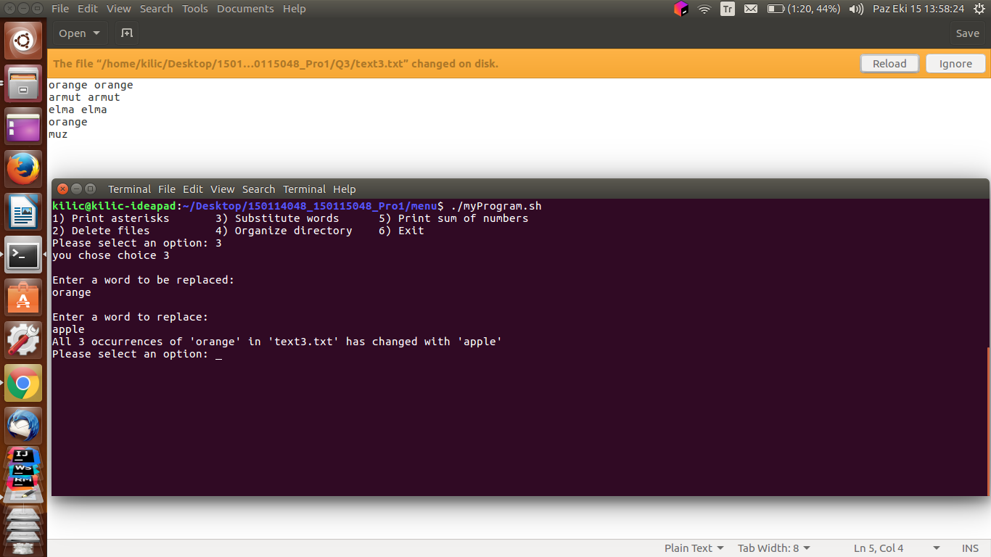

Figure 11

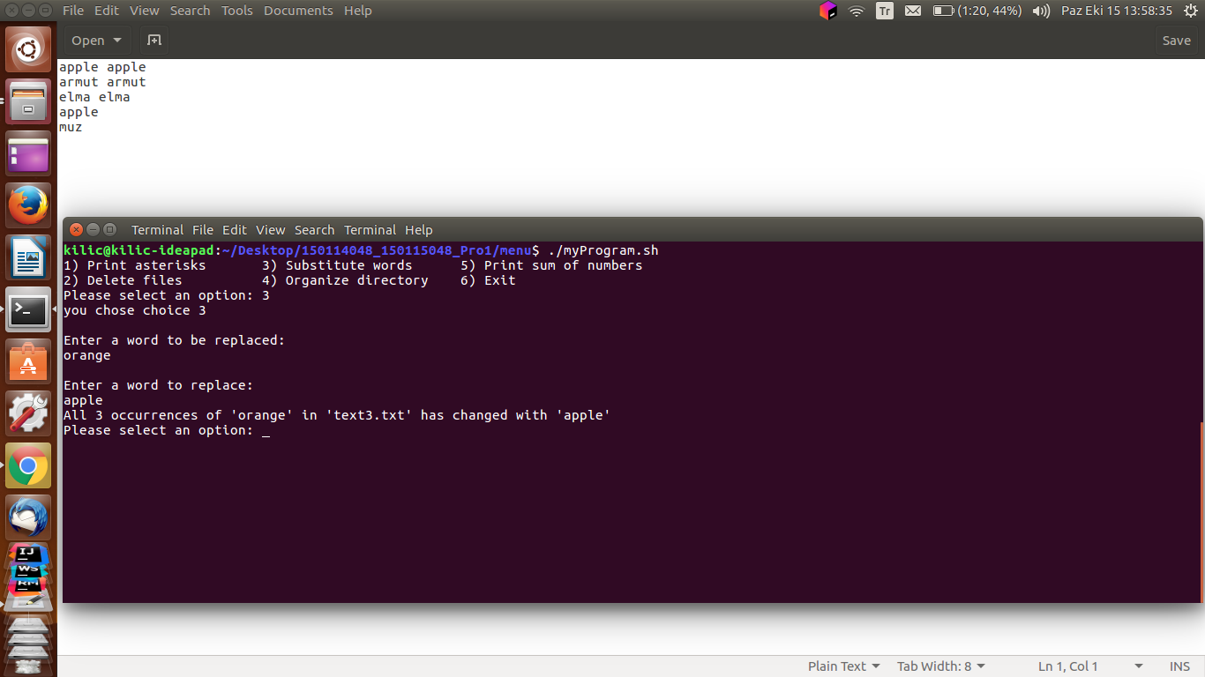

Figure 12

Question 4-)

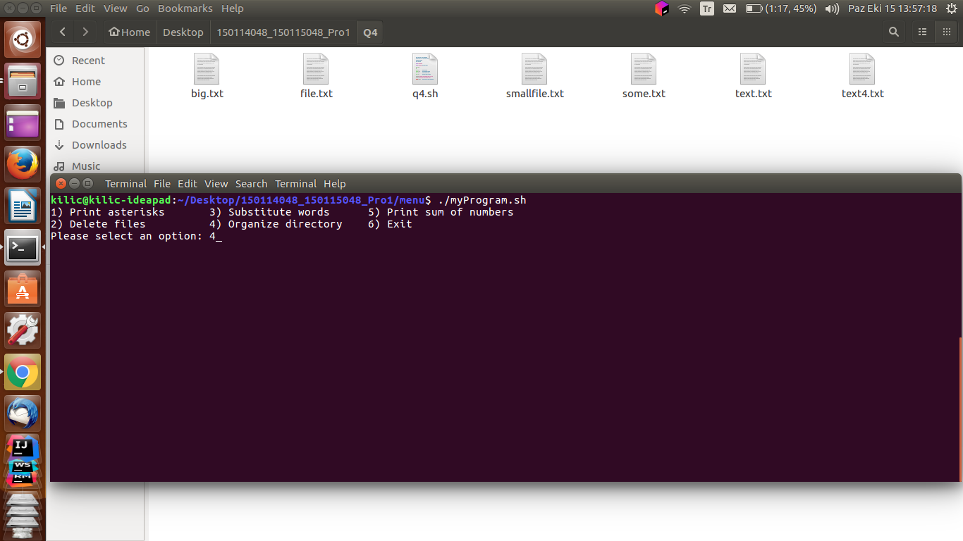

Figure 13

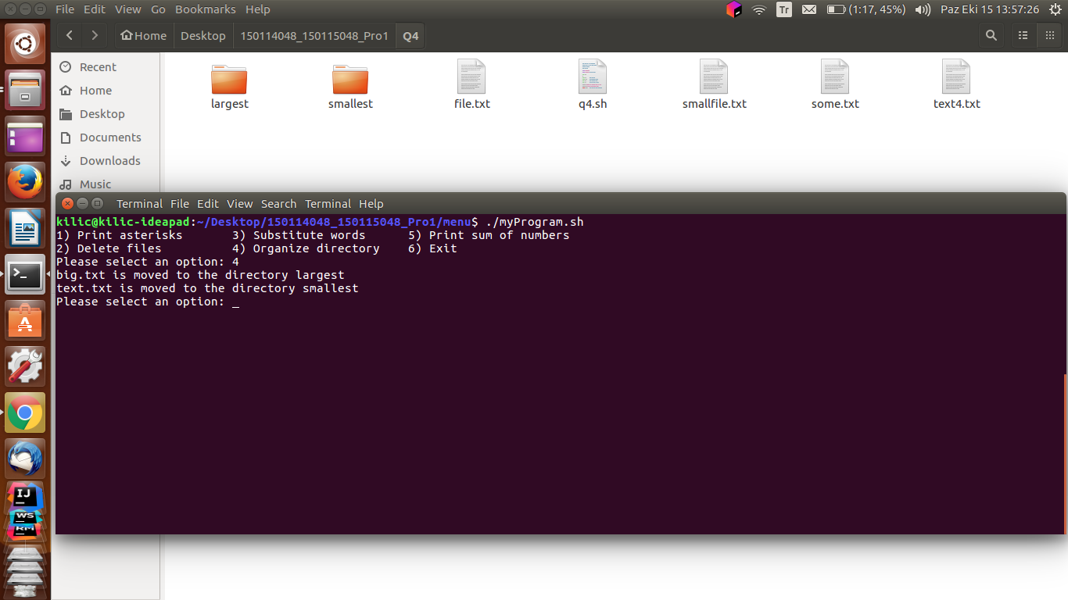

Figure 14

# Technical Details

Q1-) Check that there is command line argument or not. If not exist prompt the error and exit with ARG_MISSING value. If argument exist, read text by line by and store the number value. Then execute for loop and print “*” value of each line.

Q2-) Check that there is command line argument or not in first if statement. If there is no argument, use current directory. Else if there is an argument check that is argument or not and then use rm command via –f (If file exist remove else do nothing.).

Q3-) Check that 3 command line argument has entered. If one is these are missing show suitable error and exit program with error code value. If every argument is available for command, then check if file exist check that there is file. The use grep function and send parameter input arg2 and arg3.

Q4-) Get the largest and smallest file names by commands and assign them to variables then check the directories to create directories if they are not exist. Move them to the given directories.

Q5-) Get a number as an argument, then separate this number to its digits. After assigning digits to and array, get the new numbers to calculate and show the sum.

Menu-) Switch case used in while to get options until user wants to exit the program. Firstly set chmod executable for all files in directory. Then execute relevant file. Then go previous directory via “cd..” . Then prompt menu if not pressed 6 and take an input from user. Then change directory into relevant input.