Marmara University
Faculty of Engineering
Computer Science & Engineering Department
CSE333-Operating Systems
Project #3 Report

Assignment Topic: Multithread Text Manupilation with Posix Threads
Lecturer: Assist. Prof. Ali Haydar Özer
Assistans: Sanem Arslan Yılmaz / Zuhal Altuntaş
Students:
150114048- Mehmet Cumali Demir
150115048-Muhammed Kılıç
Submission Date: 27/12/2017

In this assignment we were expected to built a program which is commanded to parse the text files in the given directory by the given numbers of worker thread which will be organized by main thread from main function. Word parser will add vocabularies to the array by checking if they were added before, if not it will be in another index of vocabulary array. Main method starts with the argument control and checking files in given directory and also if assigned file pointer works. Later thread array and file arrays are created according to the given data. There is a while loop runs until condition is satisfied which means all files are parsed. Inside that loop to create each thread there is another while loop. Where the file name and function assigned to the thread. After that while loop all threads are controlled by join and after all done it closes file pointer in main method and finish the program.

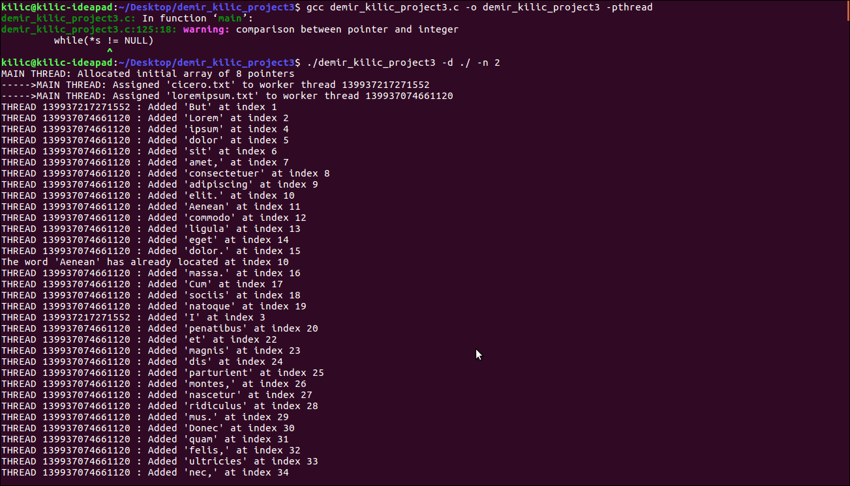
Here how it is compiled and first two file assignments.
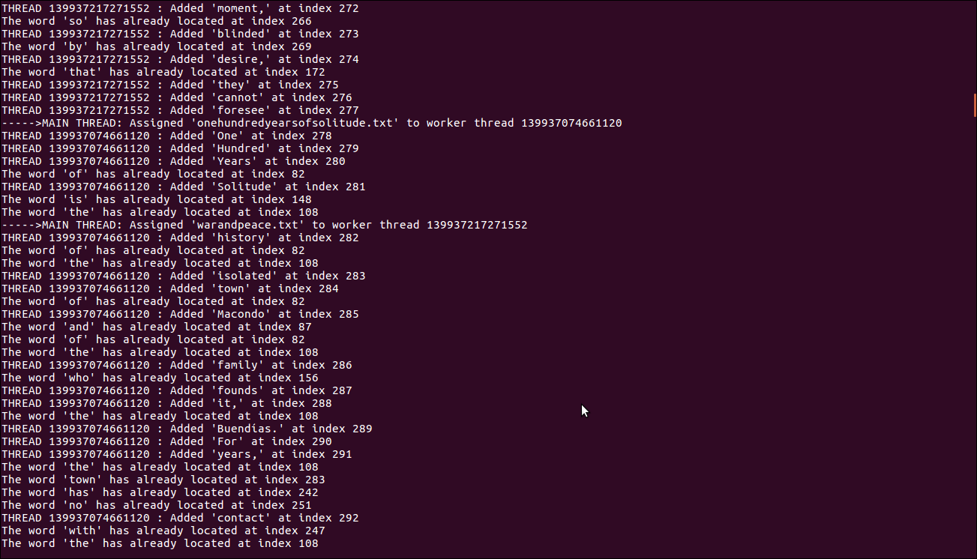
It can be seen how threads work synchronously and new file assignment by main thread.
We used a struct to keep file name, text in file, index and write to control the worker thread to send as arguments to the pthread creation method. Seen as following:

struct thread_data
{
char path[100];
char text[100];
int index;
int write;
};

Note: ./compile.sh can be used for 2 threads and current directory

