AP CYBERSECURITY • TOOL LAB COMPANION
Reading the Screen
Interface Guide | Wireshark, Nmap, Autopsy | Use alongside the Tool Lab packet
This guide shows you what each tool’s window looks like and names its parts, so you know where to look during the Tool Lab. Each diagram uses the real evidence files from that lab.
NOTE These are labeled diagrams built to match each tool’s real layout, not live screenshots. Your own window may use a different theme or arrange panels slightly differently — the parts and their names stay the same.

Station 1 Wireshark packet capture viewer
Wireshark opens a .pcap file and shows every packet as one row. This example has the filter http applied and packet 8 (the login POST) selected, so you can see all three panes working together.
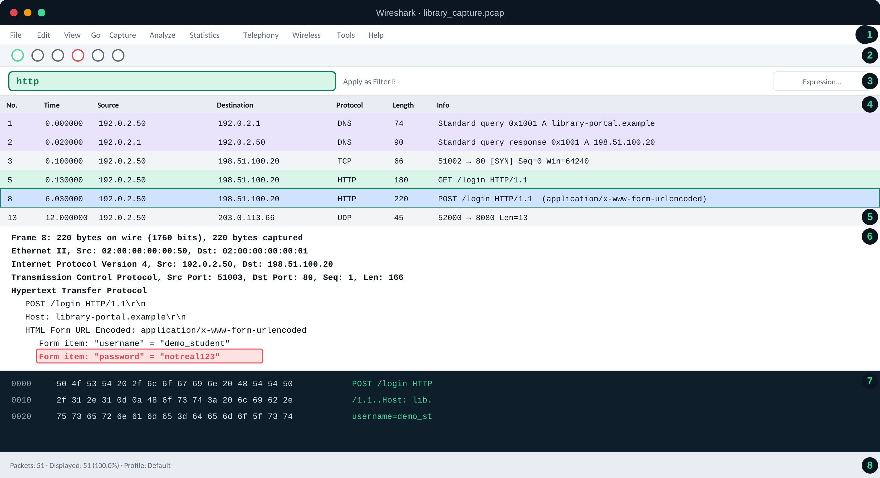
# | Part of the window | What it does
1 | Menu bar | File, Edit, View, Capture, Analyze, Statistics and the rest of Wireshark’s menus.
2 | Toolbar | Buttons to start/stop a live capture, reload, and other quick actions. You will not start a capture in this lab — you are only opening a saved file.
3 | Filter bar | Type a display filter here (like dns or http) and press Enter to show only matching packets. Green means the filter is valid.
4 | Packet list | Every packet, one per row: number, time, source, destination, protocol, length, and a one-line summary. Click a row to select it.
5 | Selected packet | The highlighted row is the one shown in the two panes below it. This is packet 8, the login POST.
6 | Packet details | The selected packet’s layers, from Ethernet up to the protocol on top (here, HTTP). Readable fields — like the submitted password — show up here in plain text.
7 | Bytes pane | The packet’s raw bytes in hex, with the matching text alongside. What the details pane interprets, this pane shows as the original data.
8 | Status bar | How many packets are in the file and how many match your current filter.
In your own Wireshark: open `library_capture.pcap`, type `dns` in the filter bar, and find panes 4–7 for a DNS packet instead.

Station 2 Nmap scan report, read in a terminal
Nmap has no window of its own — you read its report in a terminal, the same place you have been running cat and grep. This example reads the sample report for Station 2.
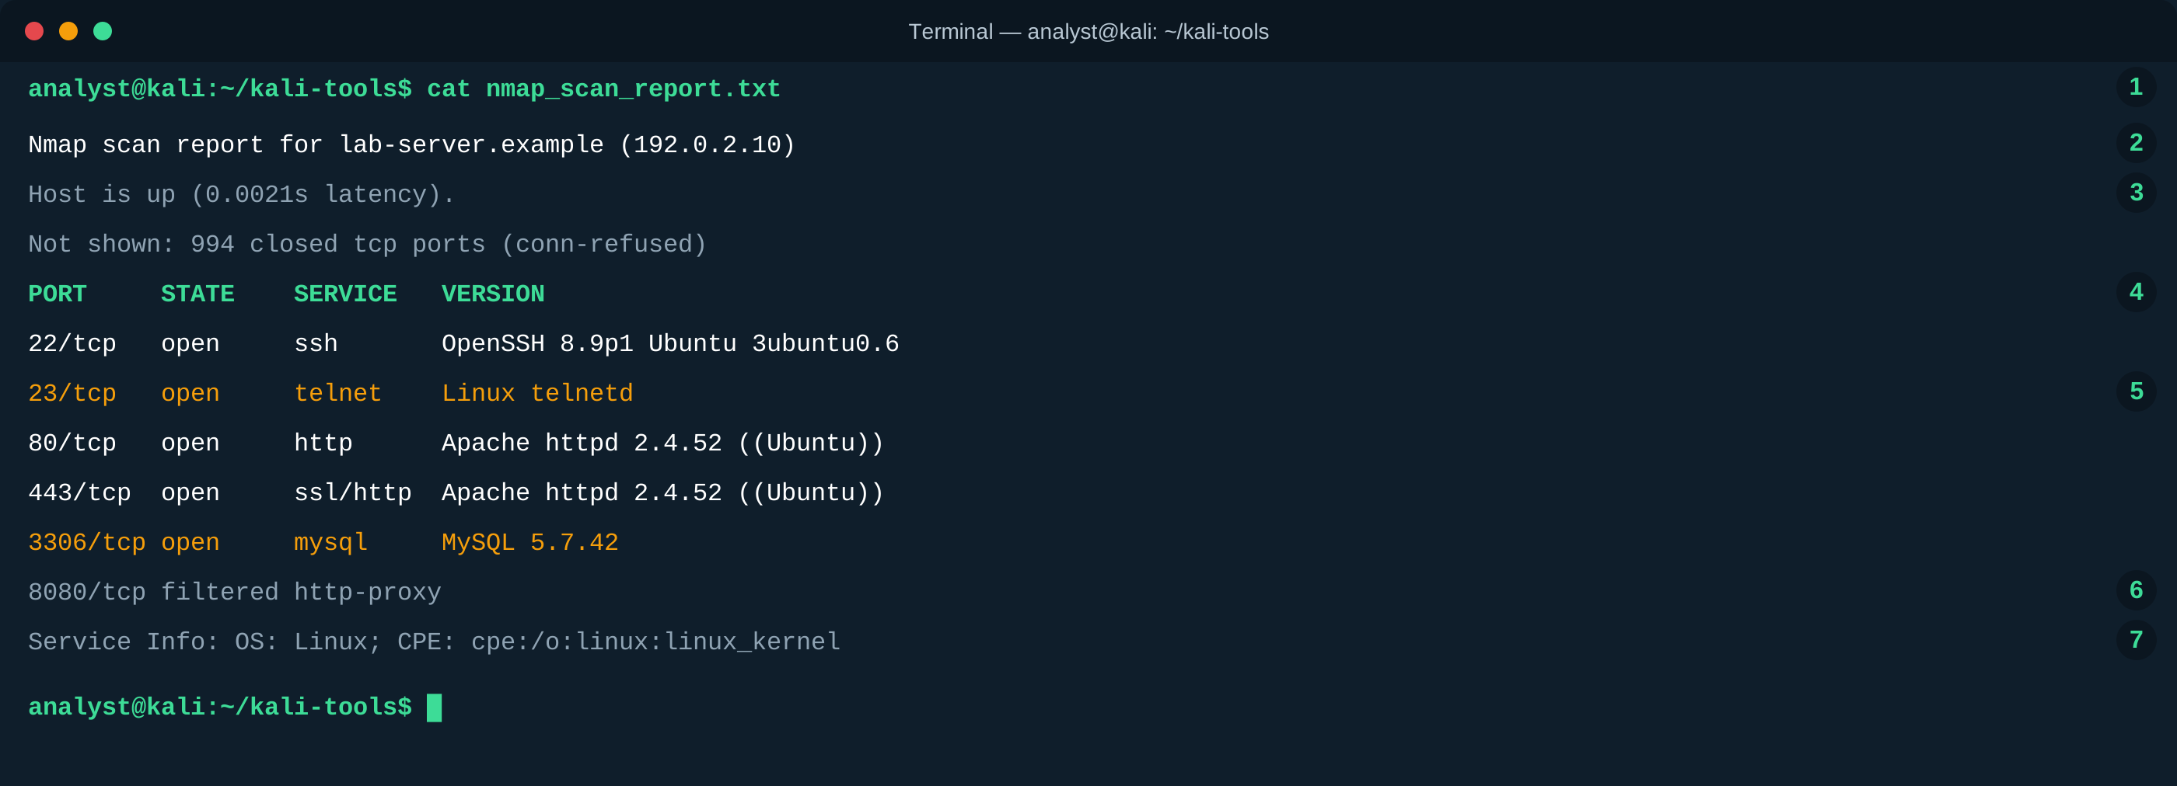
# | Part of the window | What it does
1 | The command | What was typed to display the file. You are reading a saved report, not scanning anything.
2 | Target | The device that was scanned: a name (if known) and its IP address.
3 | Host status | Whether the device answered, and how quickly (latency).
4 | Column headers | Label the table below: PORT, STATE, SERVICE, VERSION.
5 | An open port | A service answered on this port. Plain-text services like telnet (highlighted) are worth a second look.
6 | A filtered port | Something blocked the check, so Nmap cannot tell if the port is open or closed.
7 | Service info | Nmap’s best guess at the operating system, based on how the device responded.
In your own terminal: run `cat nmap_scan_report.txt`, then `grep open nmap_scan_report.txt` to see only rows like 5.

Station 3 Autopsy disk image examiner
Autopsy opens a disk image as a case and lets you browse it like a file manager — including files that were deleted. This example has the case open on usb_drive.img, with the Deleted Files view selected.
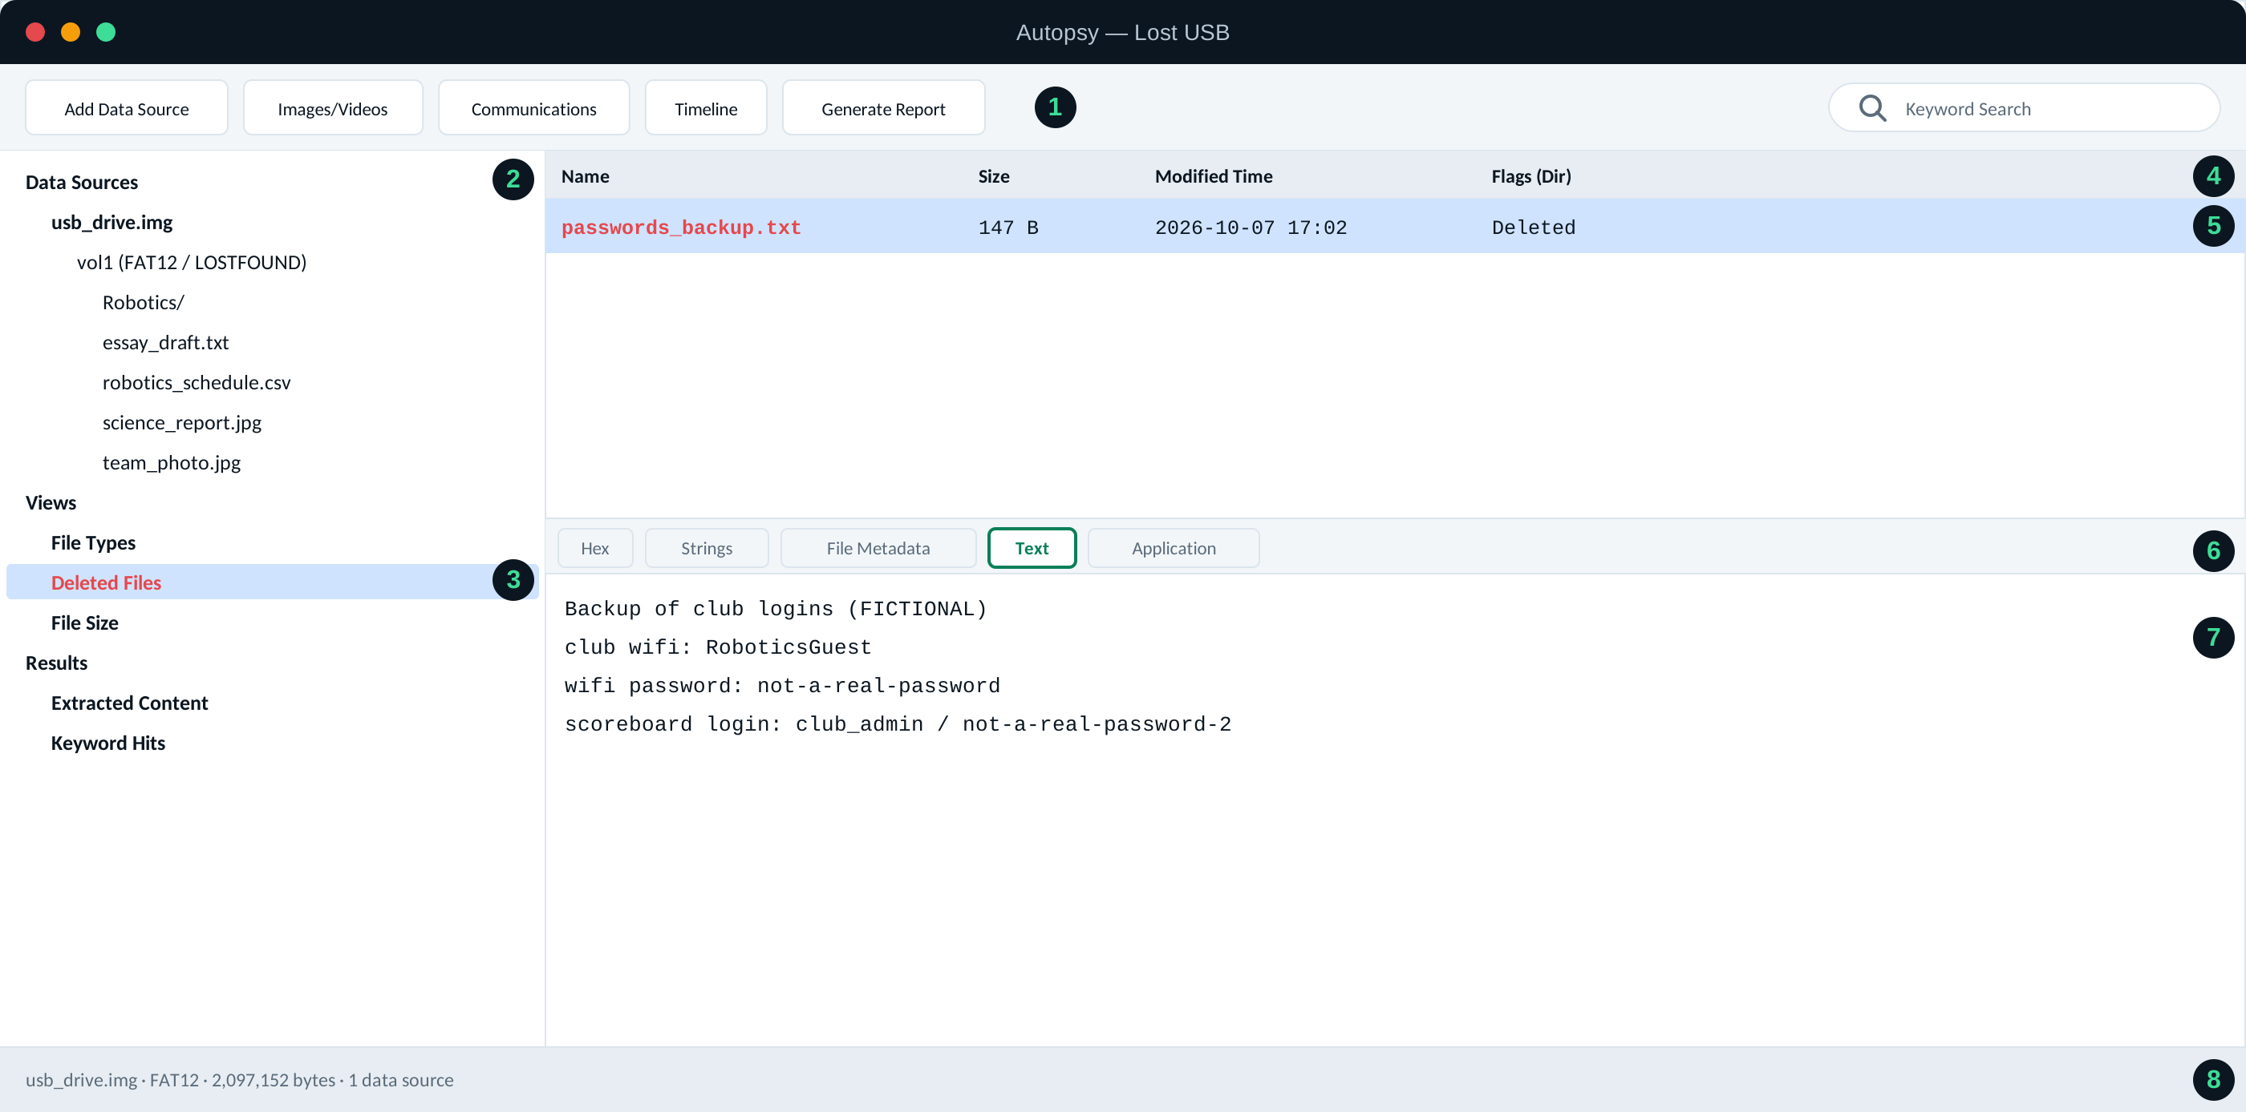
# | Part of the window | What it does
1 | Toolbar | Add a data source, jump to specific content types, build a timeline, or generate a report.
2 | Data source tree | The image you added, with its volume and the ordinary (not deleted) files and folders inside it.
3 | Views → Deleted Files | A built-in view that lists only files marked as deleted — the directory entry is gone, but the content may still be recoverable.
4 | Listing columns | Name, size, when it was last modified, and flags like Deleted for the selected view.
5 | A deleted file | Selecting this row loads its content in the pane below, exactly like any other file.
6 | Content viewer tabs | Different ways to view the selected file: raw Hex, extracted Strings, File Metadata (timestamps), or plain Text.
7 | Recovered content | The Text tab showing what was actually in the deleted file.
8 | Status bar | The image file, its format, and its size.
In your own Autopsy: open `usb_drive.img` as a new case, then click Views → Deleted Files to find panes 4–7 for yourself.

