Home Page
Welcome to Your Employee Knowledge Portal
Welcome to Daythree!
Whether you are a new joiner or an existing employee, this portal is designed to help you quickly and easily access the information you need.
Our goal is to make your transition smooth by providing easy access to HR information, employee benefits, and workplace resources—all in one place.
"Knowledge is only valuable when it's easy to access."

Leave Entitlement
Leave Benefits
Daythree provides various types of leave to support employees' work-life balance and well-being.
Your leave entitlement depends on:
- Employment type
- Years of service
- Employment contract

Types of Leave
Attach image/table
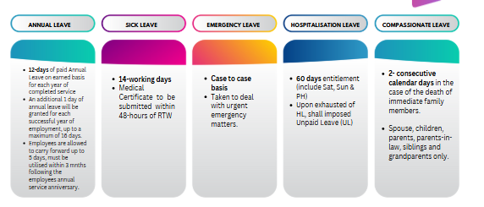
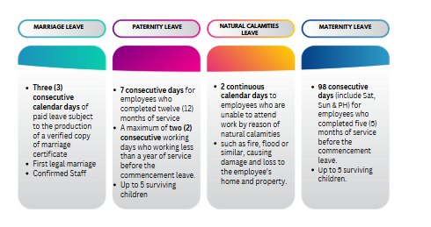
Dress Code
Professional Appearance
Employees are expected to maintain a professional appearance and dress appropriately for the working environment.
Depending on the business or client assignment, additional dress code requirements may be communicated by your Manager or Supervisor.
General Guidelines
✅ Dress neatly and professionally
✅ Maintain good personal grooming
✅ Follow client-specific dress requirements
Attach image/table
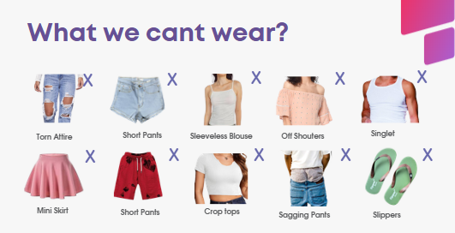

Overtime Policy
Overtime & public holiday
Employees may be required to work overtime based on operational requirements and with prior approval from their supervisor.
Overtime eligibility and payment are subject to:
- Employment Act requirements
- Company policy
- Client requirements

All work done before/beyond normal hours of work shall be compensated at the following rates.
(Add OT calculation table/Image here.)

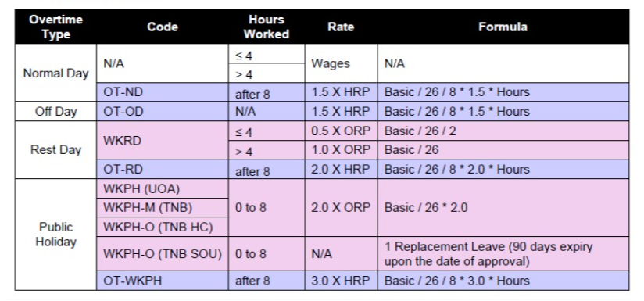

Public Holiday
- You will follow the public holidays assigned to you based on your job role and campaign you are serving.
- If you are absent from work on the working day immediately before or after a public holiday without a relevant reason, you shall not be entitled for the salary for public holiday.

  - Labour Day
  - Agong's Birthday
  - National Day
  - Malaysia Day
  - Sultan Selangor Birthday
  - New Year's Day
  - Australia Day
  - Good Friday
  - Easter
  - Anzac Day
  - King’s Birthday
  - Labour Day
  - Christmas Day
  - Boxing Day

Grievance Procedure
Need to Raise a Concern?
We encourage employees to speak up whenever they experience concerns relating to:
- Work environment
- Working relationships
- Unfair treatment
- Workplace issues
- Employment matters
Our grievance process ensures concerns are handled fairly, confidentially, and professionally.
Contact
👤 Your HR Business Partner
📧 askhr@daythree.co

Whistleblowing
Speak Up With Confidence
Daythree encourages employees to report genuine concerns regarding unethical or unlawful conduct.
Employees who report concerns in good faith will be protected from retaliation.
Email
📧 whistleblowing@daythree.co

🚭 Workplace Safety
Smoking or Vaping in Prohibited Areas
Smoking and vaping are strictly prohibited in all designated non-smoking areas within the workplace and building premises.
Employees must comply with both Company policy and building management regulations at all times.
⚠️ Consequences of Violation
If an employee is found smoking or vaping in prohibited areas:
- A fine of RM100 will be imposed by the building management
- The fine must be paid directly to the building management
- Disciplinary action will be taken by the Company in accordance with HR policy
🚫 Failure to Pay Fine
If the RM100 fine is not settled:
- The building management may restrict or block lobby/access privileges for the employee
- This may impact the employee’s ability to enter or access the premises

FAQ
💰 Payroll
📄 When and how can I request my payslip?
Your payslip will be available within four (4) working days after your salary has been credited.
If you have not received your payslip after this period, please email:
📧 askhr@daythree.co

🕌 How can I set up Zakat deductions from my salary?
Employees may register directly through the official Zakat website for their respective state.
For example:
- Zakat Selangor
- Zakat Pulau Pinang
- Zakat Wilayah Persekutuan
- (According to your state)
During registration:
- Use askhr@daythree.co as your employer's email address.
- The Zakat office will notify Daythree directly.
- Once confirmation is received, the monthly deduction will be processed through payroll.

🌍 EPF & SOCSO refunds for foreigners leaving Malaysia
EPF
Foreign employees may withdraw their EPF contributions upon permanently leaving Malaysia, subject to EPF regulations.
SOCSO
SOCSO contributions are not refundable.

💵 How does income tax work for foreign employees?
Foreign employees are required to pay Malaysian income tax.
Tax treatment depends on your tax residency status.
Residency Status | Tax Rate
Resident (Stayed more than 182 days) | Progressive tax rates (0%–30%)
Non-Resident | Flat rate of 30%

🏥 Medical Benefits
Can unused medical claims be carried forward?
No.
Medical claims operate on a Pay & Claim basis.
Unused monthly claim entitlement cannot be carried forward or accumulated.

🎓 Leave & Working Arrangements
Can I request a special working arrangement if I am a part-time student?
Employees are required to follow the work schedules assigned by the Operations team.
Special work arrangements cannot be guaranteed.
If you need to attend examinations:
- Apply for Annual Leave.
- Submit your examination timetable.
- Obtain approval from your Operations Manager.
- Apply through the Faith system following the normal leave application process.

How do I apply for Time Off (TO)?
Time Off (TO) requests require approval from your Operations Manager (OM).
Before submitting your request:
- Inform your Team Leader (TL).
- Obtain OM approval.
- Submit your request through the required process.
Maximum Time Off allocation: 2 hours.

💼 Performance & Salary
Will there be bonuses or salary increments?
Performance bonuses are not provided, as employee performance is assessed on a monthly basis through Key Performance Indicators (KPIs).
Salary increments are reviewed based on your overall annual performance, business needs, and company policies.

🤝 Employee Relations
I have a complaint about someone. What should I do?
If you experience workplace issues or wish to raise a grievance, please report the matter as soon as possible.
You may:
- Speak with your assigned HR Business Partner (HRBP).
- Submit your concern via email.
📧 askhr@daythree.co
All concerns will be handled professionally, fairly, and confidentially in accordance with the Company's Grievance Procedure.

📢 HR Communication
How can I stay updated with HR announcements?
To stay informed about company updates, please regularly check:
- 📢 Company Memos- Faith portal
These channels provide updates on HR policies, employee benefits, events, and important company announcements.
🌴 Leave
1. How do I check my leave balance?
You can view your leave balance by logging into the Faith HR System. The system displays your available leave entitlement, leave history, and upcoming approved leave.
If you believe your leave balance is incorrect, please reach out to your immediate superior, or email to askhr@daythree.co.

2. When will my leave be approved?
Leave approval depends on operational requirements and your manager's approval.
Employees are encouraged to submit leave requests as early as possible to allow sufficient time for review.
Please do not make personal commitments or travel arrangements until your leave has been officially approved in the Faith system.

3. Can I cancel or amend my approved leave?
Yes. If you wish to cancel or amend an approved leave request, please inform your immediate supervisor as soon as possible.
The cancellation or amendment must also be updated in the Faith system and is subject to your manager's approval.

4. What happens if I fall sick while on Annual Leave?
If you become ill during your Annual Leave and obtain a valid Medical Certificate (MC) from a registered medical practitioner, you should notify your immediate supervisor promptly and submit your MC through the company's prescribed process.
The Company will review the request in accordance with the Company's leave policy.

💰 Payroll
5. When is salary paid?
Salary is normally credited on the last working day of each month, unless otherwise communicated by the Company.
Employees will be informed in advance if there are any changes due to public holidays or operational requirements.

6. How do I update my bank account details?
To update your salary bank account details, submit your request to HR together with supporting documents (such as a copy of your bank statement or account details).
The update must be completed before the payroll cut-off date to take effect for the current payroll cycle.
For assistance, email askhr@daythree.co.

7. How do I update my EPF nomination?
EPF nominations must be updated directly with the Employees Provident Fund (EPF/KWSP).
Employees can update their nomination by:
- Visiting any EPF branch, or
- Using EPF's online services (where applicable).

8. How can I request an Employment Confirmation Letter or Salary Letter?
Employees may request employment-related letters by emailing askhr@daythree.co.
Please specify:
- Type of letter required
- Purpose of the request
- Any specific information that should be included
Please allow several working days for processing.

🏥 Medical Benefits
How do I submit a medical claim?
Medical claims should be submitted via faith system according to the Company's medical claim procedure.
Please ensure you provide:
- Original receipt of medical
- Medical certificate (if applicable)
Claims should be submitted within the stipulated timeline for reimbursement.

Incomplete submissions may delay reimbursement.
Medical reimbursement will be processed after the claim has been verified and approved in the system.
- If the claim is approved by the 24th of the month, it will be reimbursed in the same payroll cycle.
- If the claim is approved after the payroll cut-off date (24th), it will be reimbursed in the following month’s payroll cycle.
Employees are encouraged to submit claims early and ensure all required documents are complete to avoid delays.
What is EV Portal?
"EV Portal" refers to the Employee Verification Portal, a platform where all new candidates must verify their personal details through the provided link to ensure a smooth payroll process.

What is the company’s bank panel for salary?
RHB Bank

👥 HR Support
Who is my HR Business Partner (HRBP)?
Each business unit is assigned an HR Business Partner (HRBP) who supports employees on HR-related matters.
If you are unsure who your HRBP is, please email askhr@daythree.co, and your enquiry will be directed to the appropriate HR representative.

How do I update my personal information?
If there are any changes to your:
- Home address
- Mobile number
- Emergency contact
- Marital status
- Personal email
- educational
Please notify HR promptly and submit your updated details via email to askhr@daythree.co
Supporting documents may be required for certain updates.

14. How do I submit my resignation?
Employees who wish to resign should:
- Inform their immediate and Submit their resignation supervisor.
- Serve the required notice period as stated in their Employment Contract.
HR will guide employees through the clearance and exit process.

🚀 Career Development

Where can I view internal job vacancies?
Internal vacancies are announced through official company communication channels in Faith system
Who should I contact if I have questions about a policy?
If you require clarification on any company policy, please contact your HR Business Partner or email askhr@daythree.co.
We are happy to assist and ensure you have the correct information.

🔒 Information Security
What should I do if I receive a suspicious email?
Do not click on any links or download attachments from suspicious emails.
Report the email immediately to the IT Helpdesk and delete it only after receiving guidance from IT.

Can I use my personal email to send company information?
No. Company information should only be shared using approved company systems and email accounts.
Sharing confidential information through personal email or unauthorized platforms is strictly prohibited and may result in disciplinary action.

🌟 Employee Benefits
How can I enjoy corporate discounts offered by Daythree?
Daythree employees may enjoy exclusive corporate discounts with selected partners, including Grab, foodpanda, Proton, INTI International College, and Celebrity Fitness. (attach table or image)

These website will give your portal a comprehensive, user-friendly knowledge base that reduces repetitive HR enquiries while providing employees with clear guidance and self-service resources.

