Министерство науки и высшего образования Российской Федерации

Федеральное государственное бюджетное образовательное учреждение

высшего образования

«Вятский государственный университет»

Колледж ВятГУ

**ОТЧЕТ**

**ПО ДОМАШНЕЙ КОНТРОЛЬНОЙ РАБОТЕ №9**

**«ОСНОВЫ-СОБЫТИЙНО-ОРИЕНТИРОВАННОГО ПРОГРАММИРОВАНИЯ**

**«МДК 05.02 РАЗРАБОТКА КОДА ИНФОРМАЦИОННЫХ СИСТЕМ»**

Выполнил: студент учебной группы

ИСПк-203-52-00

Вертелецкий И.П.

Преподаватель:

Сергеева Е.Д.

Киров

2023

Цель работы – получить представление об организации хранения и использования информации посредством типизированных файлов, закрепить навыки создания пользовательского интерфейса.

Задание:

1. Сформировать структуру записи, с которой будет осуществляться работа, и согласовать ее с преподавателем
2. Разработать приложение, позволяющее извлекать набор записей из типизированного файла, визуализировать данный набор, а также позволяющее изменять данных и выполнять сохранение проделанных изменений

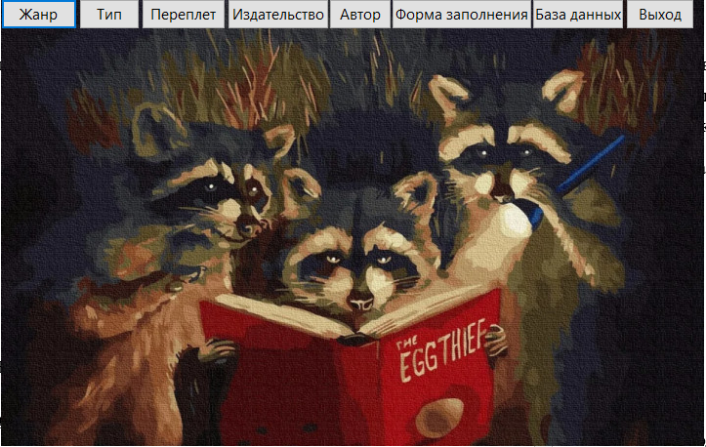

Рисунок 1 – главный интерфейс

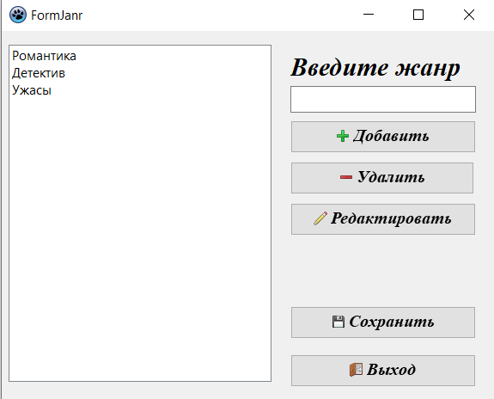

Рисунок 2 – добавление жанра

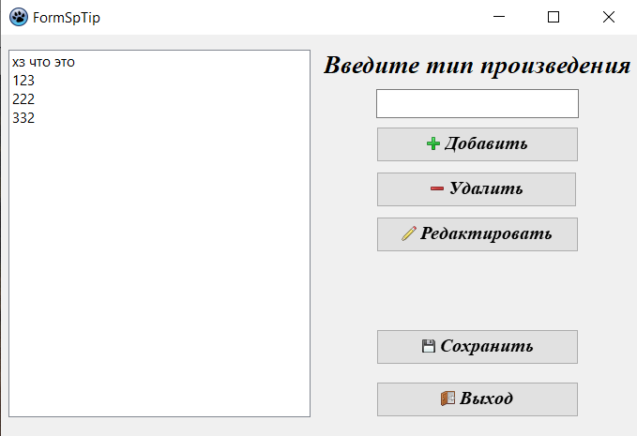

Рисунок 3 – добавление типа

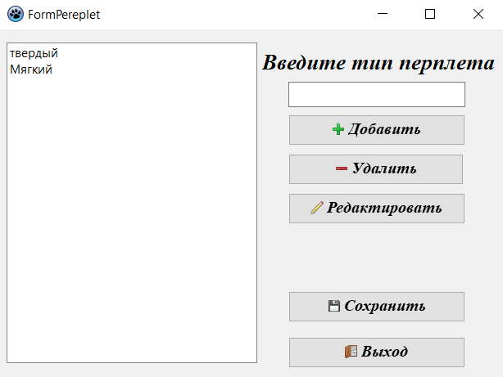

Рисунок 4 – добавление переплета

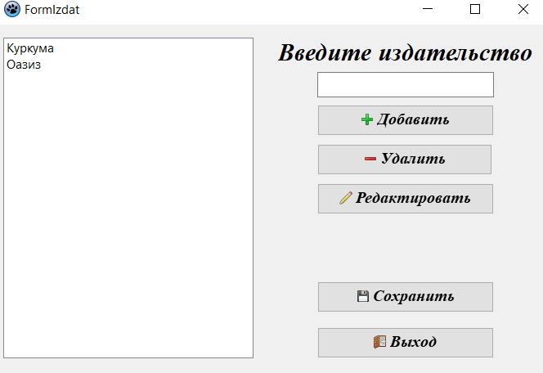

Рисунок 5 – добавление издательства

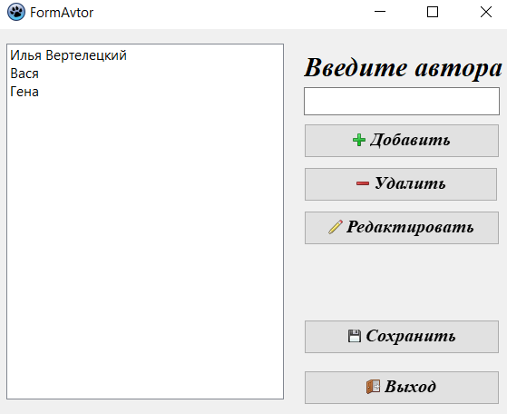

Рисунок 6 – добавление автора

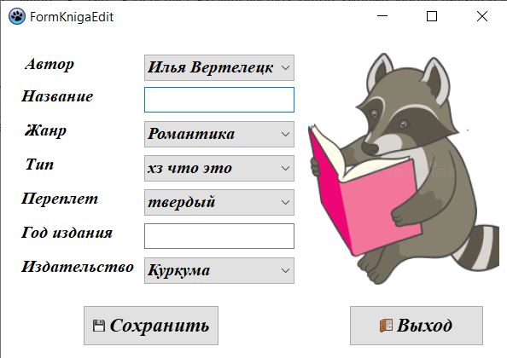

Рисунок 7 – форма заполнения

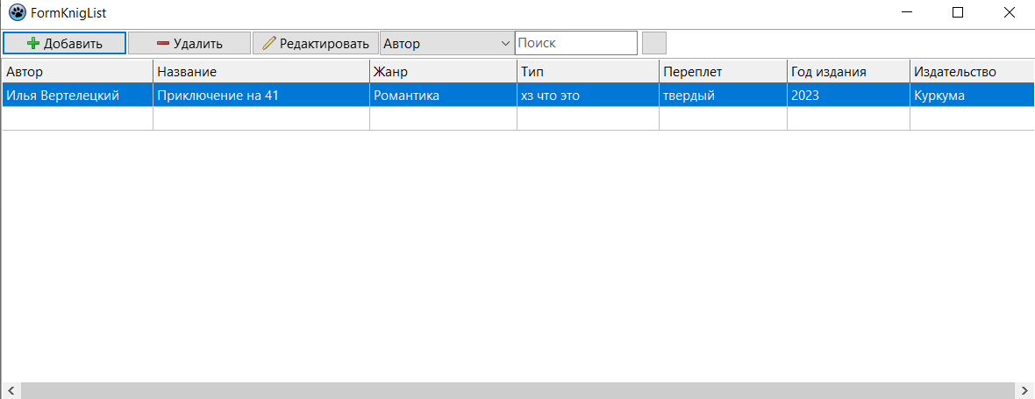Рисунок 8 – база данных

Код программы:

procedure TFormMain.Button3Click(Sender: TObject);

begin

Formpereplet.show;

end;

procedure TFormMain.Button4Click(Sender: TObject);

begin

FormGodIzd.Show;

end;

procedure TFormMain.Button5Click(Sender: TObject);

begin

FormAvtor.Show;

end;

procedure TFormMain.Button6Click(Sender: TObject);

begin

FormKnigaEdit.show;

end;

procedure TFormMain.Button7Click(Sender: TObject);

begin

FormKnigList.show;

end;

procedure TFormMain.Button8Click(Sender: TObject);

begin

close;

end;

end.

program project1;

{$mode objfpc}{$H+}

uses

{$IFDEF UNIX}

cthreads,

{$ENDIF}

{$IFDEF HASAMIGA}

athreads,

{$ENDIF}

Interfaces, // this includes the LCL widgetset

Forms, Unit1, unitKnigList, unitknigaedit, unitJanr, unitsptip, unitpereplet,

unitizd, unitavtor

{ you can add units after this };

{$R *.res}

begin

RequireDerivedFormResource:=True;

Application.Scaled:=True;

Application.Initialize;

Application.CreateForm(TFormMain, FormMain);

Application.CreateForm(TFormKnigList, FormKnigList);

Application.CreateForm(TFormKnigaEdit, FormKnigaEdit);

Application.CreateForm(TFormJanr, FormJanr);

Application.CreateForm(TFormSpTip, FormSpTip);

Application.CreateForm(TFormPereplet, FormPereplet);

Application.CreateForm(TFormGodIzd, FormGodIzd);

Application.CreateForm(TFormAvtor, FormAvtor);

Application.Run;

end.

unit unitknigaedit;

{$mode ObjFPC}{$H+}

interface

uses

Classes, SysUtils, Forms, Controls, Graphics, Dialogs, StdCtrls, Buttons,

ExtCtrls, unitkniglist;

{

type

Kniga = record

Avtor : String [50];

Nazvanie : String [50];

Janr : String [20];

Tip : String [20];

Pereplet : String [50];

GodIzdan : String [4];

Izdatelstvo : String [50];

end;

}

type

{ TFormKnigaEdit }

TFormKnigaEdit = class(TForm)

BitBtn1: TBitBtn;

BitBtn2: TBitBtn;

ComboBox1: TComboBox;

ComboBox2: TComboBox;

ComboBox3: TComboBox;

ComboBox4: TComboBox;

ComboBox5: TComboBox;

Edit2: TEdit;

Edit6: TEdit;

Image1: TImage;

Label1: TLabel;

Label2: TLabel;

Label3: TLabel;

Label4: TLabel;

Label5: TLabel;

Label6: TLabel;

Label7: TLabel;

procedure BitBtn1Click(Sender: TObject);

procedure BitBtn2Click(Sender: TObject);

procedure FormShow(Sender: TObject);

private

public

end;

var

FormKnigaEdit: TFormKnigaEdit;

kng : Kniga;

x:integer;

implementation

{$R *.lfm}

{ TFormKnigaEdit }

procedure TFormKnigaEdit.BitBtn2Click(Sender: TObject);

begin

Close;

end;

procedure TFormKnigaEdit.FormShow(Sender: TObject);

begin

ComboBox1.Items.LoadFromFile('bd\avtor.bd');

ComboBox1.ItemIndex:= 0;

ComboBox2.Items.LoadFromFile('bd\janr.bd');

ComboBox2.ItemIndex:= 0;

ComboBox3.Items.LoadFromFile('bd\tip.bd');

ComboBox3.ItemIndex:= 0;

ComboBox4.Items.LoadFromFile('bd\pereplet.bd');

ComboBox4.ItemIndex:= 0;

ComboBox5.Items.LoadFromFile('bd\izd.bd');

ComboBox5.ItemIndex:= 0;

if (FormKnigList.reg = 2) then

begin

x := FormKnigList.StringGrid1.Row;

ComboBox1.Text := FormKnigList.StringGrid1.Cells[0, x];

Edit2.Text := FormKnigList.StringGrid1.Cells[1, x];

ComboBox2.Text := FormKnigList.StringGrid1.Cells[2, x];

ComboBox3.Text := FormKnigList.StringGrid1.Cells[3, x];

ComboBox4.Text := FormKnigList.StringGrid1.Cells[4, x];

Edit6.Text := FormKnigList.StringGrid1.Cells[5, x];

ComboBox5.Text := FormKnigList.StringGrid1.Cells[6, x];

end;

end;

procedure TFormKnigaEdit.BitBtn1Click(Sender: TObject);

var

f : Text;

begin

kng.Avtor := ComboBox1.Text;

kng.Nazvanie := Edit2.Text;

kng.Janr := ComboBox2.Text;

kng.Tip := ComboBox3.Text;

kng.Pereplet := ComboBox4.Text;

kng.GodIzdan := Edit6.Text;

kng.Izdatelstvo := ComboBox5.Text;

if (FormKnigList.reg = 1) then begin

FormKnigList.arrCount:=FormKnigList.arrCount+1;

FormKnigList.arrKnig[FormKnigList.arrCount]:=kng;

FormKnigList.UpdateGrid(Sender);

End;

if (FormKnigList.reg = 2) then begin

FormKnigList.arrKnig[x] := kng;

FormKnigList.UpdateGrid(Sender);

end;

{

AssignFile (f, 'bd\listknig.bd');

Append(f);

WriteLn(f, kng.Avtor);

WriteLn(f, kng.Nazvanie);

WriteLn(f, kng.Janr);

WriteLn(f, kng.Tip);

WriteLn(f, kng.Pereplet);

WriteLn(f, kng.GodIzdan);

WriteLn(f, kng.Izdatelstvo);

WriteLn(f, '');

CloseFile(f);

CLose;

end;

}

end;

end.

unit unitKnigList;

{$mode ObjFPC}{$H+}

interface

uses

Classes, SysUtils, Forms, Controls, Graphics, Dialogs, ComCtrls, Grids,

Buttons, EditBtn, StdCtrls;

type

Kniga = record

Avtor : String [50];

Nazvanie : String [50];

Janr : String [20];

Tip : String [20];

Pereplet : String [50];

GodIzdan : String [4];

Izdatelstvo : String [50];

end;

type

{ TFormKnigList }

TFormKnigList = class(TForm)

BitBtn1: TBitBtn;

BtnDel: TBitBtn;

BtnAdd: TBitBtn;

ComboBox1: TComboBox;

EditButton1: TEditButton;

StringGrid1: TStringGrid;

ToolBar1: TToolBar;

procedure BitBtn1Click(Sender: TObject);

procedure BtnDelClick(Sender: TObject);

procedure BtnAddClick(Sender: TObject);

procedure BtnEditClick(Sender: TObject);

procedure EditButton1Change(Sender: TObject);

procedure FormCreate(Sender: TObject);

procedure FormShow(Sender: TObject);

procedure UpdateGrid(Sender: TObject);

private

public

arrKnig : array [1..100] of Kniga;

arrCount : Integer;

reg:Integer;

end;

var

FormKnigList: TFormKnigList;

implementation

uses unitknigaedit;

{$R *.lfm}

{ TFormKnigList }

procedure TFormKnigList.FormCreate(Sender: TObject);

begin

end;

procedure TFormKnigList.UpdateGrid(Sender: TObject);

var

i : Integer;

begin

stringgrid1.RowCount:=arrCount+1;

for i := 1 to arrCount do begin

StringGrid1.Cells[0, i] := arrKnig[i].Avtor;

StringGrid1.Cells[1, i] := arrKnig[i].Nazvanie;

StringGrid1.Cells[2, i] := arrKnig[i].Janr;

StringGrid1.Cells[3, i] := arrKnig[i].Tip;

StringGrid1.Cells[4, i] := arrKnig[i].Pereplet;

StringGrid1.Cells[5, i] := arrKnig[i].GodIzdan;

StringGrid1.Cells[6, i] := arrKnig[i].Izdatelstvo;

end;

end;

procedure TFormKnigList.BtnAddClick(Sender: TObject);

begin

reg :=1;

FormKnigaEdit.ShowModal;

end;

procedure TFormKnigList.BtnDelClick(Sender: TObject);

var

i:integer;

x : integer;

begin

x := StringGrid1.row;

for i:=x to arrCount-1 do begin

arrKnig[x] := arrKnig[x+1];

end;

arrCount:=arrCount-1;

for i:=1 to StringGrid1.RowCount-1 do

StringGrid1.Rows[i].Clear;

UpdateGrid(Sender);

end;

procedure TFormKnigList.BitBtn1Click(Sender: TObject);

begin

reg :=2;

FormKnigaEdit.ShowModal

end;

procedure TFormKnigList.BtnEditClick(Sender: TObject);

begin

reg :=2;

FormKnigaEdit.ShowModal

end;

procedure TFormKnigList.EditButton1Change(Sender: TObject);

var

i, k: integer;

begin

for i:=1 to StringGrid1.RowCount-1 do

StringGrid1.Rows[i].Clear;

k:=1;

if ComboBox1.ItemIndex = 0 then

for i:=1 to arrCount do

if (arrKnig[i].Avtor = EditButton1.Text) then begin

StringGrid1.Cells[0, k] := arrKnig[i].Avtor;

StringGrid1.Cells[1, k] := arrKnig[i].Nazvanie;

StringGrid1.Cells[2, k] := arrKnig[i].Janr;

StringGrid1.Cells[3, k] := arrKnig[i].Tip;

StringGrid1.Cells[4, k] := arrKnig[i].Pereplet;

StringGrid1.Cells[5, k] := arrKnig[i].GodIzdan;

StringGrid1.Cells[6, k] := arrKnig[i].Izdatelstvo;

k := k+1;

StringGrid1.RowCount:=k + 1;

end;

if ComboBox1.ItemIndex = 1 then

for i:=1 to arrCount do

if (arrKnig[i].Nazvanie = EditButton1.Text) then begin

StringGrid1.Cells[0, k] := arrKnig[i].Avtor;

StringGrid1.Cells[1, k] := arrKnig[i].Nazvanie;

StringGrid1.Cells[2, k] := arrKnig[i].Janr;

StringGrid1.Cells[3, k] := arrKnig[i].Tip;

StringGrid1.Cells[4, k] := arrKnig[i].Pereplet;

StringGrid1.Cells[5, k] := arrKnig[i].GodIzdan;

StringGrid1.Cells[6, k] := arrKnig[i].Izdatelstvo;

k := k+1;

StringGrid1.RowCount:=k + 1;

end;

if ComboBox1.ItemIndex = 2 then

for i:=1 to arrCount do

if (arrKnig[i].Janr = EditButton1.Text) then begin

StringGrid1.Cells[0, k] := arrKnig[i].Avtor;

StringGrid1.Cells[1, k] := arrKnig[i].Nazvanie;

StringGrid1.Cells[2, k] := arrKnig[i].Janr;

StringGrid1.Cells[3, k] := arrKnig[i].Tip;

StringGrid1.Cells[4, k] := arrKnig[i].Pereplet;

StringGrid1.Cells[5, k] := arrKnig[i].GodIzdan;

StringGrid1.Cells[6, k] := arrKnig[i].Izdatelstvo;

k := k+1;

StringGrid1.RowCount:=k + 1;

end;

if ComboBox1.ItemIndex = 3 then

for i:=1 to arrCount do

if (arrKnig[i].Tip = EditButton1.Text) then begin

StringGrid1.Cells[0, k] := arrKnig[i].Avtor;

StringGrid1.Cells[1, k] := arrKnig[i].Nazvanie;

StringGrid1.Cells[2, k] := arrKnig[i].Janr;

StringGrid1.Cells[3, k] := arrKnig[i].Tip;

StringGrid1.Cells[4, k] := arrKnig[i].Pereplet;

StringGrid1.Cells[5, k] := arrKnig[i].GodIzdan;

StringGrid1.Cells[6, k] := arrKnig[i].Izdatelstvo;

k := k+1;

StringGrid1.RowCount:=k + 1;

end;

if ComboBox1.ItemIndex = 4 then

for i:=1 to arrCount do

if (arrKnig[i].Pereplet = EditButton1.Text) then begin

StringGrid1.Cells[0, k] := arrKnig[i].Avtor;

StringGrid1.Cells[1, k] := arrKnig[i].Nazvanie;

StringGrid1.Cells[2, k] := arrKnig[i].Janr;

StringGrid1.Cells[3, k] := arrKnig[i].Tip;

StringGrid1.Cells[4, k] := arrKnig[i].Pereplet;

StringGrid1.Cells[5, k] := arrKnig[i].GodIzdan;

StringGrid1.Cells[6, k] := arrKnig[i].Izdatelstvo;

k := k+1;

StringGrid1.RowCount:=k + 1;

end;

if ComboBox1.ItemIndex = 5 then

for i:=1 to arrCount do

if (arrKnig[i].GodIzdan = EditButton1.Text) then begin

StringGrid1.Cells[0, k] := arrKnig[i].Avtor;

StringGrid1.Cells[1, k] := arrKnig[i].Nazvanie;

StringGrid1.Cells[2, k] := arrKnig[i].Janr;

StringGrid1.Cells[3, k] := arrKnig[i].Tip;

StringGrid1.Cells[4, k] := arrKnig[i].Pereplet;

StringGrid1.Cells[5, k] := arrKnig[i].GodIzdan;

StringGrid1.Cells[6, k] := arrKnig[i].Izdatelstvo;

k := k+1;

StringGrid1.RowCount:=k + 1;

end;

if ComboBox1.ItemIndex = 6 then

for i:=1 to arrCount do

if (arrKnig[i].Izdatelstvo = EditButton1.Text) then begin

StringGrid1.Cells[0, k] := arrKnig[i].Avtor;

StringGrid1.Cells[1, k] := arrKnig[i].Nazvanie;

StringGrid1.Cells[2, k] := arrKnig[i].Janr;

StringGrid1.Cells[3, k] := arrKnig[i].Tip;

StringGrid1.Cells[4, k] := arrKnig[i].Pereplet;

StringGrid1.Cells[5, k] := arrKnig[i].GodIzdan;

StringGrid1.Cells[6, k] := arrKnig[i].Izdatelstvo;

k := k+1;

StringGrid1.RowCount:=k + 1;

end;

if (EditButton1.Text = '') then UpdateGrid(Sender);

end;

procedure TFormKnigList.FormShow(Sender: TObject);

var

f: Text;

i: Integer;

begin

i := 1;

AssignFile(f, 'bd\listknig.bd');

Reset(f);

while not (EOF(f)) do begin

ReadLn(f, arrKnig[i].Avtor);

ReadLn(f, arrKnig[i].Nazvanie);

ReadLn(f, arrKnig[i].Janr);

ReadLn(f, arrKnig[i].Tip);

ReadLn(f, arrKnig[i].Pereplet);

ReadLn(f, arrKnig[i].GodIzdan);

ReadLn(f, arrKnig[i].Izdatelstvo);

ReadLn(f);

i := i + 1;

end;

arrCount := i;

UpdateGrid(Sender);

end;

end.

unit unitavtor;

{$mode ObjFPC}{$H+}

interface

uses

Classes, SysUtils, Forms, Controls, Graphics, Dialogs, StdCtrls, Buttons;

type

{ TFormAvtor }

TFormAvtor = class(TForm)

BtnAdd: TBitBtn;

BtnDel: TBitBtn;

BtnEdit: TBitBtn;

BtnExit: TBitBtn;

BtnSave: TBitBtn;

Edit1: TEdit;

Label1: TLabel;

ListBox1: TListBox;

procedure BtnAddClick(Sender: TObject);

procedure BtnDelClick(Sender: TObject);

procedure BtnEditClick(Sender: TObject);

procedure BtnExitClick(Sender: TObject);

procedure BtnSaveClick(Sender: TObject);

procedure FormShow(Sender: TObject);

procedure ListBox1Click(Sender: TObject);

private

public

end;

var

FormAvtor: TFormAvtor;

implementation

{$R *.lfm}

{ TFormAvtor }

procedure TFormAvtor.BtnAddClick(Sender: TObject);

begin

ListBox1.Items.AddText(Edit1.Text);

Edit1.Clear;

end;

procedure TFormAvtor.BtnDelClick(Sender: TObject);

begin

ListBox1.Items.Delete(ListBox1.ItemIndex);

Edit1.Clear;

end;

procedure TFormAvtor.BtnEditClick(Sender: TObject);

begin

if (ListBox1.ItemIndex >= 0) then

ListBox1.Items[ListBox1.ItemIndex] := Edit1.Text;

Edit1.Clear;

end;

procedure TFormAvtor.BtnExitClick(Sender: TObject);

begin

Close;

end;

procedure TFormAvtor.BtnSaveClick(Sender: TObject);

begin

ListBox1.Items.SaveToFile('bd\avtor.bd');

Edit1.Clear;

end;

procedure TFormAvtor.FormShow(Sender: TObject);

begin

ListBox1.Items.LoadFromFile('bd\avtor.bd');

end;

procedure TFormAvtor.ListBox1Click(Sender: TObject);

begin

if (ListBox1.ItemIndex >= 0) then

Edit1.Text:=ListBox1.Items[ListBox1.ItemIndex];

end;

end.

unit unitizd;

{$mode ObjFPC}{$H+}

interface

uses

Classes, SysUtils, Forms, Controls, Graphics, Dialogs, StdCtrls, Buttons;

type

{ TFormGodIzd }

TFormGodIzd = class(TForm)

BtnAdd: TBitBtn;

BtnDel: TBitBtn;

BtnEdit: TBitBtn;

BtnExit: TBitBtn;

BtnSave: TBitBtn;

Edit1: TEdit;

Label1: TLabel;

ListBox1: TListBox;

procedure BtnAddClick(Sender: TObject);

procedure BtnDelClick(Sender: TObject);

procedure BtnEditClick(Sender: TObject);

procedure BtnExitClick(Sender: TObject);

procedure BtnSaveClick(Sender: TObject);

procedure FormShow(Sender: TObject);

procedure ListBox1Click(Sender: TObject);

private

public

end;

var

FormGodIzd: TFormGodIzd;

implementation

{$R *.lfm}

{ TFormGodIzd }

procedure TFormGodIzd.BtnAddClick(Sender: TObject);

begin

ListBox1.Items.AddText(Edit1.Text);

Edit1.Clear;

end;

procedure TFormGodIzd.BtnDelClick(Sender: TObject);

begin

ListBox1.Items.Delete(ListBox1.ItemIndex);

Edit1.Clear;

end;

procedure TFormGodIzd.BtnEditClick(Sender: TObject);

begin

if (ListBox1.ItemIndex >= 0) then

ListBox1.Items[ListBox1.ItemIndex] := Edit1.Text;

Edit1.Clear;

end;

procedure TFormGodIzd.BtnExitClick(Sender: TObject);

begin

Close;

end;

procedure TFormGodIzd.BtnSaveClick(Sender: TObject);

begin

ListBox1.Items.SaveToFile('bd\izd.bd');

Edit1.Clear;

end;

procedure TFormGodIzd.FormShow(Sender: TObject);

begin

ListBox1.Items.LoadFromFile('bd\izd.bd');

end;

procedure TFormGodIzd.ListBox1Click(Sender: TObject);

begin

if (ListBox1.ItemIndex >= 0) then

Edit1.Text:=ListBox1.Items[ListBox1.ItemIndex];

end;

end.

unit unitsptip;

{$mode ObjFPC}{$H+}

interface

uses

Classes, SysUtils, Forms, Controls, Graphics, Dialogs, StdCtrls, Buttons;

type

{ TFormSpTip }

TFormSpTip = class(TForm)

BtnAdd: TBitBtn;

BtnDel: TBitBtn;

BtnEdit: TBitBtn;

BtnExit: TBitBtn;

BtnSave: TBitBtn;

Edit1: TEdit;

Label1: TLabel;

ListBox1: TListBox;

procedure BtnAddClick(Sender: TObject);

procedure BtnDelClick(Sender: TObject);

procedure BtnEditClick(Sender: TObject);

procedure BtnExitClick(Sender: TObject);

procedure BtnSaveClick(Sender: TObject);

procedure FormShow(Sender: TObject);

procedure ListBox1Click(Sender: TObject);

private

public

end;

var

FormSpTip: TFormSpTip;

implementation

{$R *.lfm}

{ TFormSpTip }

procedure TFormSpTip.BtnAddClick(Sender: TObject);

begin

ListBox1.Items.AddText(Edit1.Text);

Edit1.Clear;

end;

procedure TFormSpTip.BtnDelClick(Sender: TObject);

begin

ListBox1.Items.Delete(ListBox1.ItemIndex);

Edit1.Clear;

end;

procedure TFormSpTip.BtnEditClick(Sender: TObject);

begin

if (ListBox1.ItemIndex >= 0) then

ListBox1.Items[ListBox1.ItemIndex] := Edit1.Text;

Edit1.Clear;

end;

procedure TFormSpTip.BtnExitClick(Sender: TObject);

begin

Close;

end;

procedure TFormSpTip.BtnSaveClick(Sender: TObject);

begin

ListBox1.Items.SaveToFile('bd\tip.bd');

Edit1.Clear;

end;

procedure TFormSpTip.FormShow(Sender: TObject);

begin

ListBox1.Items.LoadFromFile('bd\tip.bd');

end;

procedure TFormSpTip.ListBox1Click(Sender: TObject);

begin

if (ListBox1.ItemIndex >= 0) then

Edit1.Text:=ListBox1.Items[ListBox1.ItemIndex];

end;

end.

unit unitJanr;

{$mode ObjFPC}{$H+}

interface

uses

Classes, SysUtils, Forms, Controls, Graphics, Dialogs, StdCtrls, Buttons;

type

{ TFormJanr }

TFormJanr = class(TForm)

BtnDel: TBitBtn;

BtnAdd: TBitBtn;

BtnEdit: TBitBtn;

BtnSave: TBitBtn;

BtnExit: TBitBtn;

Edit1: TEdit;

Label1: TLabel;

ListBox1: TListBox;

procedure BtnAddClick(Sender: TObject);

procedure BtnDelClick(Sender: TObject);

procedure BtnEditClick(Sender: TObject);

procedure BtnExitClick(Sender: TObject);

procedure BtnSaveClick(Sender: TObject);

procedure FormShow(Sender: TObject);

procedure ListBox1Click(Sender: TObject);

private

public

end;

var

FormJanr: TFormJanr;

implementation

{$R *.lfm}

{ TFormJanr }

procedure TFormJanr.BtnExitClick(Sender: TObject);

begin

Close;

end;

procedure TFormJanr.BtnAddClick(Sender: TObject);

begin

ListBox1.Items.AddText(Edit1.Text);

Edit1.Clear;

end;

procedure TFormJanr.BtnDelClick(Sender: TObject);

begin

ListBox1.Items.Delete(ListBox1.ItemIndex);

Edit1.Clear;

end;

procedure TFormJanr.BtnEditClick(Sender: TObject);

begin

if (ListBox1.ItemIndex >= 0) then

ListBox1.Items[ListBox1.ItemIndex] := Edit1.Text;

Edit1.Clear;

end;

procedure TFormJanr.BtnSaveClick(Sender: TObject);

begin

ListBox1.Items.SaveToFile('bd\janr.bd');

Edit1.Clear;

end;

procedure TFormJanr.FormShow(Sender: TObject);

begin

ListBox1.Items.LoadFromFile('bd\janr.bd');

end;

procedure TFormJanr.ListBox1Click(Sender: TObject);

begin

if (ListBox1.ItemIndex >= 0) then

Edit1.Text:=ListBox1.Items[ListBox1.ItemIndex];

end;

end.

unit unitpereplet;

{$mode ObjFPC}{$H+}

interface

uses

Classes, SysUtils, Forms, Controls, Graphics, Dialogs, StdCtrls, Buttons;

type

{ TFormPereplet }

TFormPereplet = class(TForm)

BtnAdd: TBitBtn;

BtnDel: TBitBtn;

BtnEdit: TBitBtn;

BtnExit: TBitBtn;

BtnSave: TBitBtn;

Edit1: TEdit;

Label1: TLabel;

ListBox1: TListBox;

procedure BtnAddClick(Sender: TObject);

procedure BtnDelClick(Sender: TObject);

procedure BtnEditClick(Sender: TObject);

procedure BtnExitClick(Sender: TObject);

procedure BtnSaveClick(Sender: TObject);

procedure FormShow(Sender: TObject);

procedure ListBox1Click(Sender: TObject);

private

public

end;

var

FormPereplet: TFormPereplet;

implementation

{$R *.lfm}

{ TFormPereplet }

procedure TFormPereplet.BtnAddClick(Sender: TObject);

begin

ListBox1.Items.AddText(Edit1.Text);

Edit1.Clear;

end;

procedure TFormPereplet.BtnDelClick(Sender: TObject);

begin

ListBox1.Items.Delete(ListBox1.ItemIndex);

Edit1.Clear;

end;

procedure TFormPereplet.BtnEditClick(Sender: TObject);

begin

if (ListBox1.ItemIndex >= 0) then

ListBox1.Items[ListBox1.ItemIndex] := Edit1.Text;

Edit1.Clear;

end;

procedure TFormPereplet.BtnExitClick(Sender: TObject);

begin

Close;

end;

procedure TFormPereplet.BtnSaveClick(Sender: TObject);

begin

ListBox1.Items.SaveToFile('bd\pereplet.bd');

Edit1.Clear;

end;

procedure TFormPereplet.FormShow(Sender: TObject);

begin

ListBox1.Items.LoadFromFile('bd\pereplet.bd');

end;

procedure TFormPereplet.ListBox1Click(Sender: TObject);

begin

if (ListBox1.ItemIndex >= 0) then

Edit1.Text:=ListBox1.Items[ListBox1.ItemIndex];

end;

end.