The things that Ii’m forward to look at:

Rhino:

NODEJS

JavaScript方法：

Css：

1.下拉框样式问题：去掉剪头 。

border: solid 1px #000;

appearance:none;
-moz-appearance:none; /* Firefox */
-webkit-appearance:none; /* Safari and Chrome */

padding-right: 14px;

-moz-appearance: none;

.testSelect{
-moz-appearance: none;
-webkit-appearance:none;
background: transparent url("../images/dropdown_arrow.png") no-repeat scroll right -8px;
}

cursor
<html>

<body>
<p>请把鼠标移动到单词上，可以看到鼠标指针发生变化：</p>
<span style="cursor:auto">
Auto</span><br />
<span style="cursor:crosshair">
Crosshair</span><br />
<span style="cursor:default">
Default</span><br />
<span style="cursor:pointer">
Pointer</span><br />
<span style="cursor:move">
Move</span><br />
<span style="cursor:e-resize">
e-resize</span><br />
<span style="cursor:ne-resize">
ne-resize</span><br />
<span style="cursor:nw-resize">
nw-resize</span><br />
<span style="cursor:n-resize">
n-resize</span><br />
<span style="cursor:se-resize">
se-resize</span><br />
<span style="cursor:sw-resize">
sw-resize</span><br />
<span style="cursor:s-resize">
s-resize</span><br />
<span style="cursor:w-resize">
w-resize</span><br />
<span style="cursor:text">
text</span><br />
<span style="cursor:wait">
wait</span><br />
<span style="cursor:help">
help</span>
</body>

</html>

设置复选框的边框颜色
outline: 1px solid rgb(91, 20, 98);

background: rgb(91, 20, 98) none repeat scroll 0 0 !important;

border: 1px solid rgb(91, 20, 98) !important;

I resolve these issues.
- the pop center issue
- The checkbox style in Polls and Surveys page
- Add alert in the add polls page.
- Add title up the upload button in the attendee page

border:1px solid #e0e0e0;
width:2px;
height:32px;

var totalHeight = $(window).innerHeight();
var startpos = getOffset(document.getElementById('layout')).top;
var eventsHeight = totalHeight - startpos;
eventsHeight = eventsHeight -50;
$('#event').mCustomScrollbar({
setHeight:eventsHeight,
autoDraggerLength:true,
horizontalScroll:true,
theme:"dark-3"
});

466 22 36

840
234
83
402
719
120
720
50
370
450

console.log("arg1 "+arg1);
var emails="";
var fileName =arg1.split(".");
if(fileName.length==1){
alert("Accepts only .csv files");
return false;
}
console.log("fileName.length "+fileName.length);
var fileType=fileName[fileName.length-1];
if(fileType!="csv"&&fileType!="CSV"){
alert("uploaded File format is not proper");
return false;
}else{
$scope.Attendee_filepath=arg1;
}

$(".xcConfirm p").css({"line-height":"20px","height":"70px","margin-top":"16px"});

.xcConfirm .popBox .txtBox .bigIcon

Accepted formats are only .gif,.png,.jpeg,.svg!

var txt= "Are you sure to delete this record!";
window.wxc.xcConfirm(txt, window.wxc.xcConfirm.typeEnum.confirm,{
onOk:function(v){
$scope.deletetheRecord(events);
}
});

6798 701 Social Business Enablement Replays

folderId file_link 表

DACH DEEP DIVE CALL: Social - Social Media Enablement - Your perfect profiles for social media

DACH Deep Dive Call: Social Media Enablement - Your perfect profiles for social media

EventSession eventSession = new EventSession();
eventSession.setOrder(i);
switch (j) {
case 0:
str = getStringCellValue(row.getCell((short) j)).trim();
// 判断输入的年份是否正确
if (!yearTime.equals(str)) {
throw new Exception("The year in row " + i
+ " is wrong!");
} else {
yearTime = str;
monthlySchedule.setRequestYear(str);
}
break;
case 1:
str = getStringCellValue(row.getCell((short) j)).trim();
// 判断输入的月份是否正确
if (!monthTime.equals(str)) {
throw new Exception("The month in row " + i
+ " is wrong!");
} else {
monthTime = str;
monthlySchedule.setRequestMonth(str);
}
break;
case 2:
dayTime = getStringCellValue(row.getCell((short) j))
.trim();
// 判断输入的日期是否正确 isValidDate
str = yearTime + "/" + monthTime + "/" + dayTime
+ " 00:00";
if (isValidDate(str)) {
// 获取daylySchedule 数据
DaylySchedule daylySchedule = new DaylySchedule();
// month 数字转英文
String monthTimeEng = MonthUtil
.getMonthString(Integer.parseInt(monthTime));
daylySchedule.setDayTitle(monthTimeEng + " "
+ dayTime);
daylySchedule.setMonth(monthTimeEng);
daylySchedule.setDay(str);
daylySchedule.setOrder(i);
monthlySchedule.addDaySessions(daylySchedule);
} else {
throw new Exception("The day in row " + i
+ " is wrong!");
}
break;
case 3:
str = getStringCellValue(row.getCell((short) j)).trim();
eventCategory = str;
break;
case 4:
str = getStringCellValue(row.getCell((short) j)).trim();
if (str != null && !"".equals(str)) {
eventSession.setSessionTitle(str);
} else {
throw new Exception("The session_title in row " + i
+ " is null!");
}
break;
case 5:
str = getStringCellValue(row.getCell((short) j)).trim();
if (str != null && !"".equals(str)) {
eventSession.setSessionTime(str);
} else {
throw new Exception("The session_time in row " + i
+ " is null!");
}
break;
case 6:
str = getStringCellValue(row.getCell((short) j)).trim();
if (str != null && !"".equals(str)) {
eventSession.setDetail_title(str);
} else {
throw new Exception("The detail_title in row " + i
+ " is null!");
}
break;
case 7:
str = getStringCellValue(row.getCell((short) j)).trim();
if (str != null && !"".equals(str)) {
eventSession.setProfiledFor(str);
} else {
throw new Exception("The profiled_for in row " + i
+ " is null!");
}
break;
case 8:
str = getStringCellValue(row.getCell((short) j)).trim();
if (str != null && !"".equals(str)) {
eventSession.setDescription(str);
} else {
throw new Exception("The description in row " + i
+ " is null!");
}
break;
case 9:
str = getStringCellValue(row.getCell((short) j)).trim();
if (str != null && !"".equals(str)) {
eventSession.setSpeakers(str);
} else {
throw new Exception("The speakers in row " + i
+ " is null!");
}
break;
case 10:
str = getStringCellValue(row.getCell((short) j)).trim();
if (str != null && !"".equals(str)) {
eventSession.setCallDetails(str);
} else {
throw new Exception("The call_details in row " + i
+ " is null!");
}
break;
case 11:
str = getStringCellValue(row.getCell((short) j)).trim();
if (str != null && !"".equals(str)) {
eventSession.setTollFree(str);
} else {
throw new Exception("The toll_free in row " + i
+ " is null!");
}
break;
case 12:
str = getStringCellValue(row.getCell((short) j)).trim();
if (str != null && !"".equals(str)) {
eventSession.setPasscode(str);
} else {
throw new Exception("The passcode in row " + i
+ " is null!");
}
break;
case 13:
str = getStringCellValue(row.getCell((short) j)).trim();
if (str != null && !"".equals(str)) {
eventSession.setSmartCloud(str);
} else {
throw new Exception("The smartcloud in row " + i
+ " is null!");
}
break;
case 14:
str = getStringCellValue(row.getCell((short) j)).trim();
if (str != null && !"".equals(str)) {
eventSession.setSmartCloudPass(str);
} else {
throw new Exception("The cloud_passcode in row "
+ i + " is null!");
}
break;
case 15:
str = getStringCellValue(row.getCell((short) j)).trim();
if (str != null && !"".equals(str)) {
eventSession.setCallHost(str);
} else {
throw new Exception("The call_host in row " + i
+ " is null!");
}
break;
case 16:
str = getStringCellValue(row.getCell((short) j)).trim();
if (str != null && !"".equals(str)) {
eventSession.setVideoLiveStream(str);
} else {
throw new Exception("The live_stream in row " + i
+ " is null!");
}
break;
}
j++;

Exception in thread "main" javax.mail.SendFailedException: Sending failed;
nested exception is:
class javax.mail.MessagingException: Could not connect to SMTP host: origin-smtp-usw.mail.na.collabserv.com, port: 25;
nested exception is:
java.net.ConnectException: Connection refused: connect
at javax.mail.Transport.send0(Transport.java:218)
at javax.mail.Transport.send(Transport.java:80)
at com.ibm.gs.portfolio.SendEmail1.main(SendEmail1.java:76)

var txt2= "Please Add Sessions, speakers, attendees and Layout";
window.wxc.xcConfirm(txt2, window.wxc.xcConfirm.typeEnum.info);

$(".xcConfirm p").css({"line-height":"20px","height":"70px","margin-top":"16px"});

var txt= "Are you sure to delete this record!";
window.wxc.xcConfirm(txt, window.wxc.xcConfirm.typeEnum.confirm,{
onOk:function(v){
$scope.deletetheRecord(events);
}
});

int fileInfoSize=fileInfo.length;
for(){

}

Yes.But the session drop down is different from the attendee type drop down. The attendee type is written by just html.The session drop down is writen by angularjs. And its display value is composed of eventname ,’-’ and eventId.So it can’t be changed into Please Select an event.If you still want to change it into Please Select an event,we must change the structure of the drop down display value.But it will

Angularjs confirm 提示确认框 执行 删除操作，不及时刷新

js权威指南
- forEach()
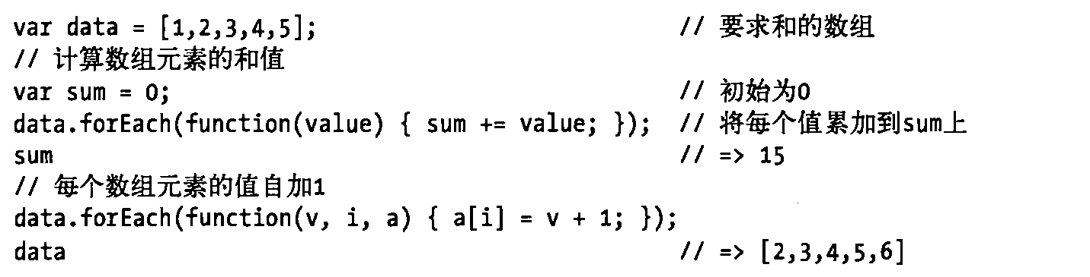

2.
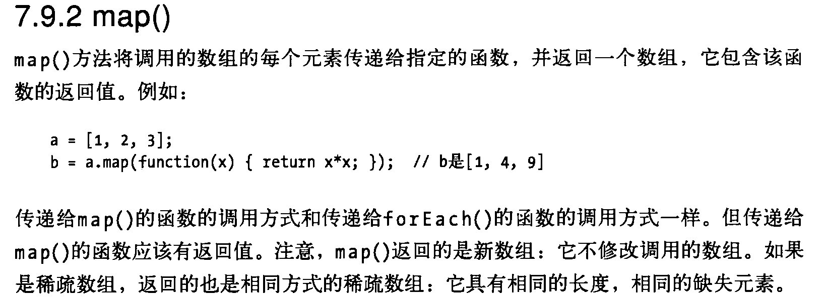
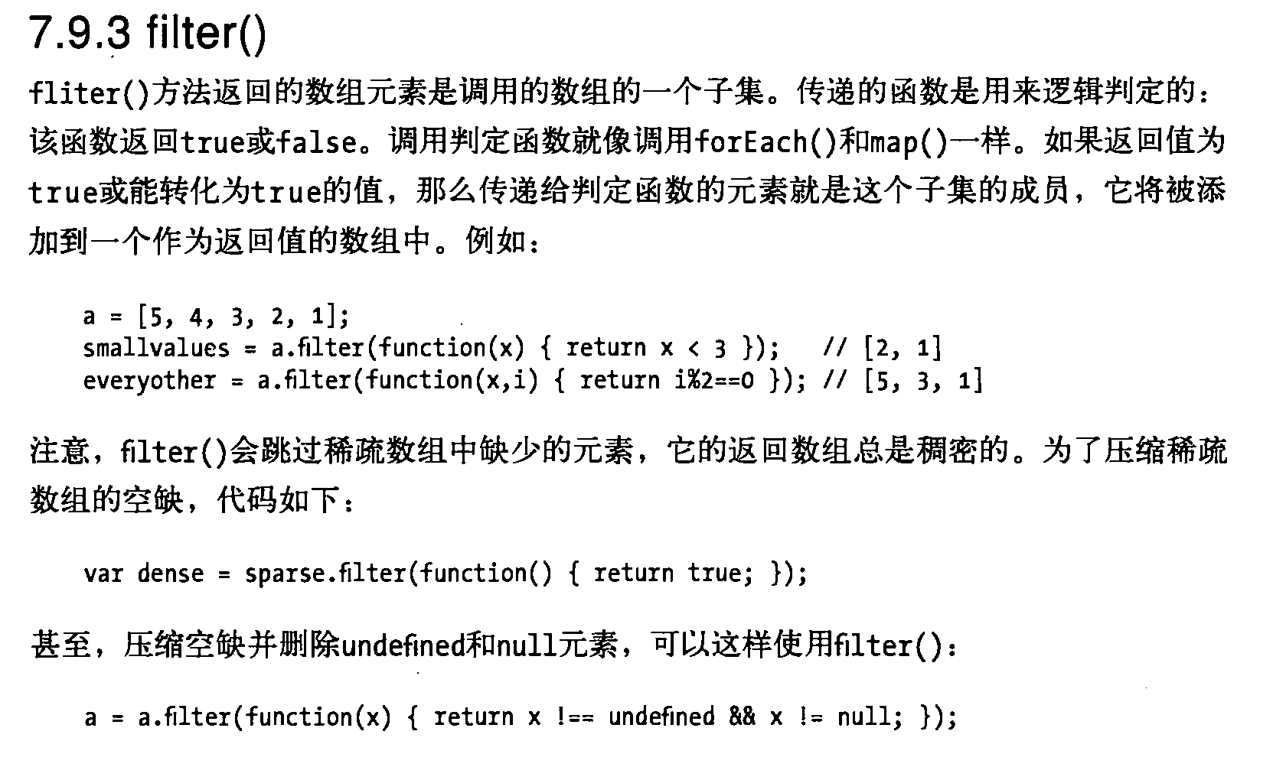

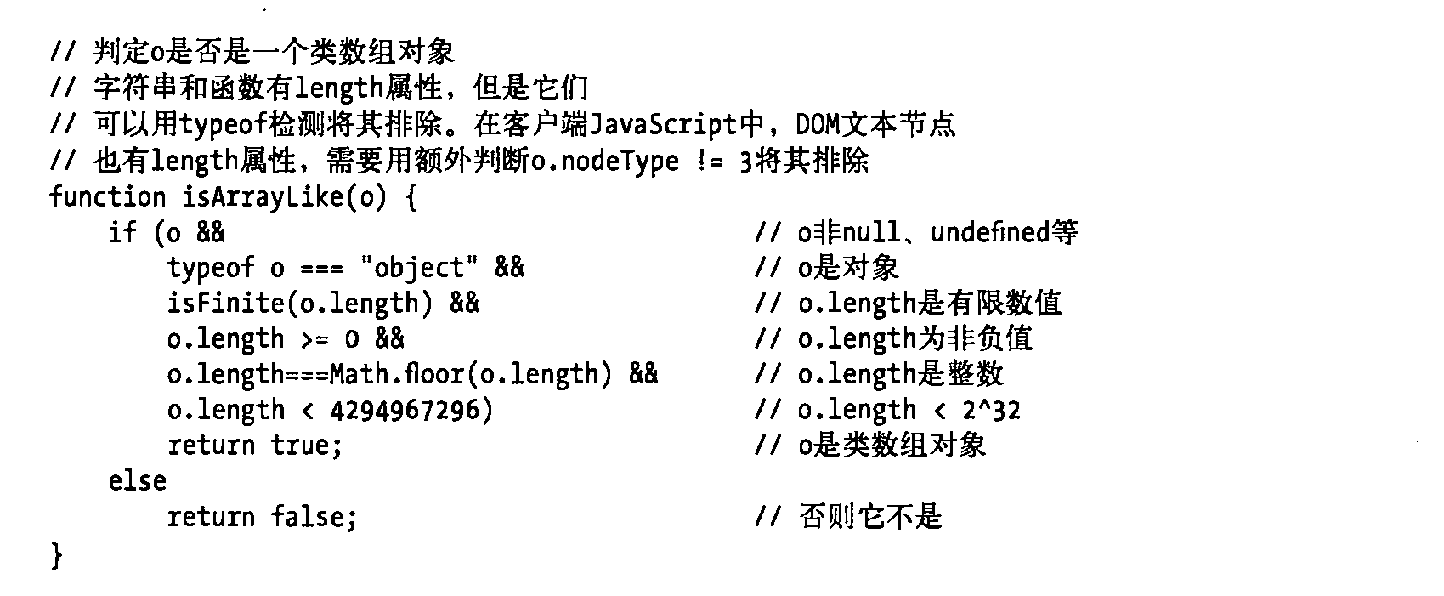

对象的不可枚举
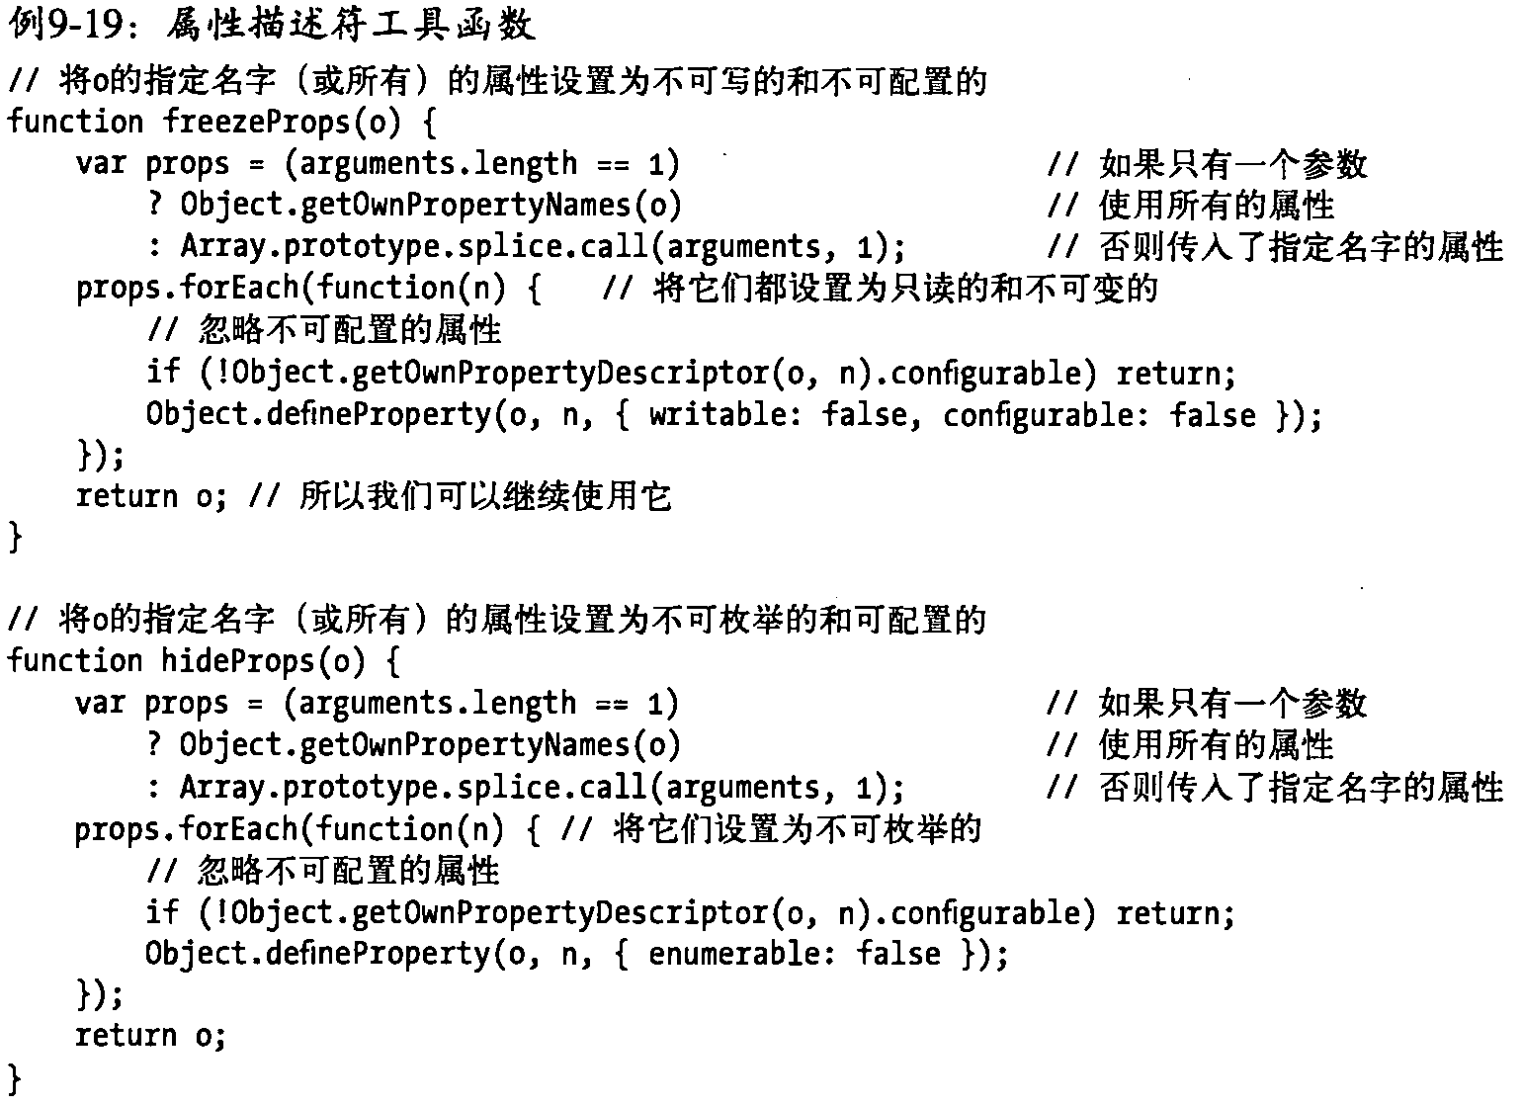

3.正则表达式
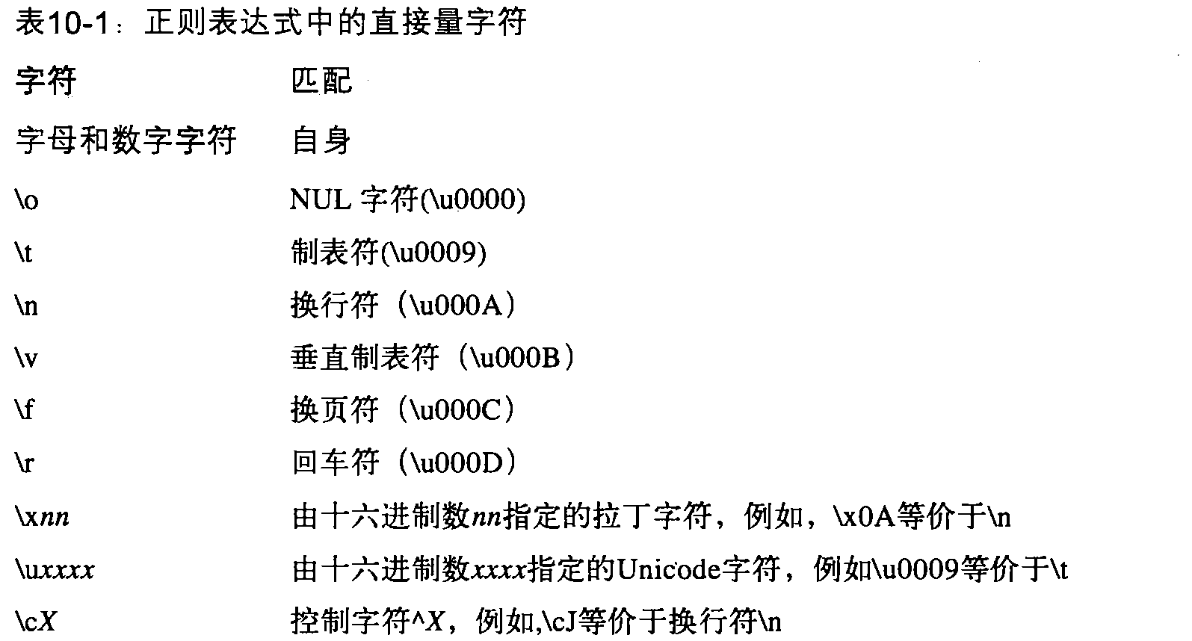
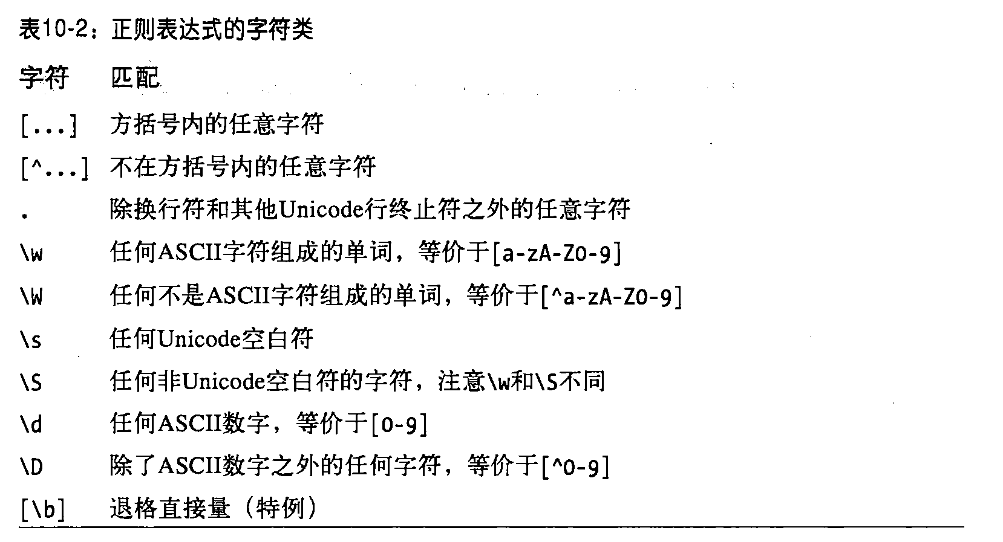
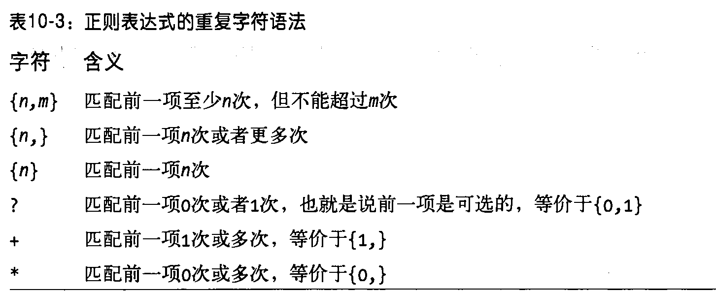
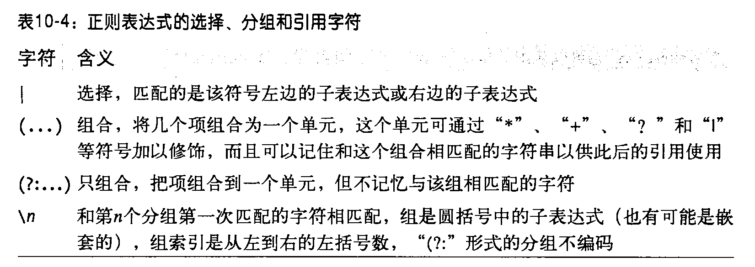
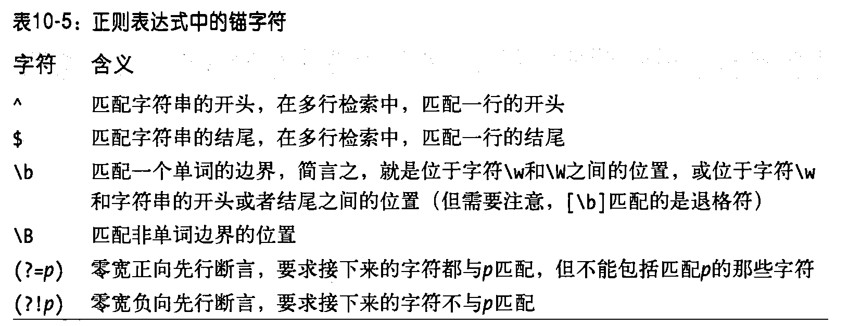
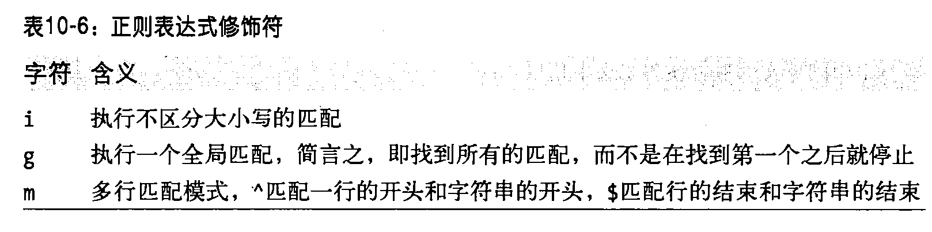

解构赋值
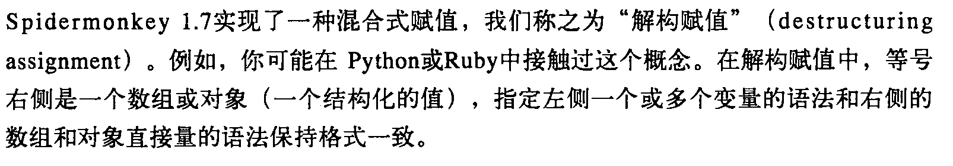

Hi,Antonina. The reason that the parser application is that the DB account is expired .And we need the help of the DB member .So when we resolve it ,we will tell you.I’m sorry for the inconvenience.

5.对话框
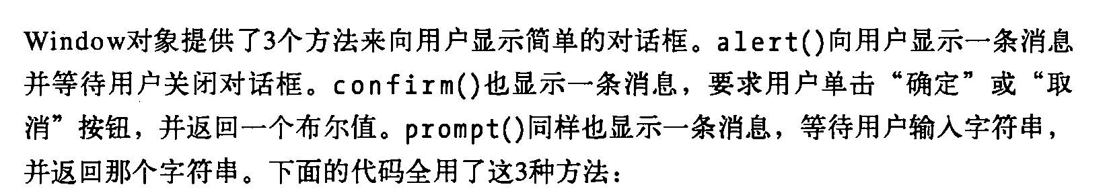

查询滚动条的位置
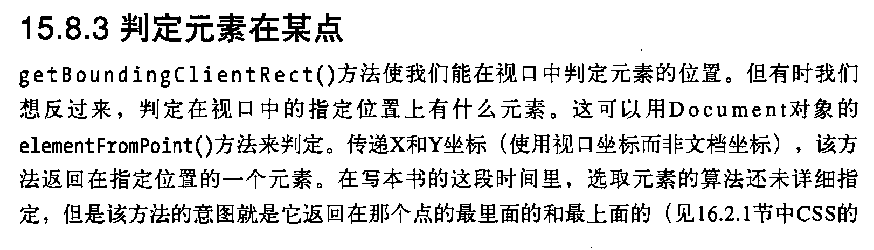

轮盘抽奖案例

自动切换图片和手动切换图片案例

双击网页 自动翻页功能

如果您已经把我们的 JavaScript 教程学习完毕，并且需要更深入地学习这门语言，那么 w3school 提供的 《JavaScript 高级教程》绝对是您最好的选择。
本教程从 JavaScript 的历史开始讲起，直到当前它对 XML 和 Web 服务的支持。
您将学习到如何扩展该语言，以使它适应特殊的需求。
您还将学到如何使用 JavaScript 创建无缝的客户机 - 服务器通信。
本教程深入浅出，在您认真学习之后，一定会获益良多。

cf push convertSpeechOrText1 -m 512m

cf push ConvertDemo -p demo1.war

bluemix login -u dllmyliu@cn.ibm.com -o dllmyliu@cn.ibm.com -s JavaTomcat

convertdemo.mybluemix.net

C:\Users\IBM_ADMIN\Documents\SametimeFileTransfers\AndroidSDK\AndroidSDK\platform-tools

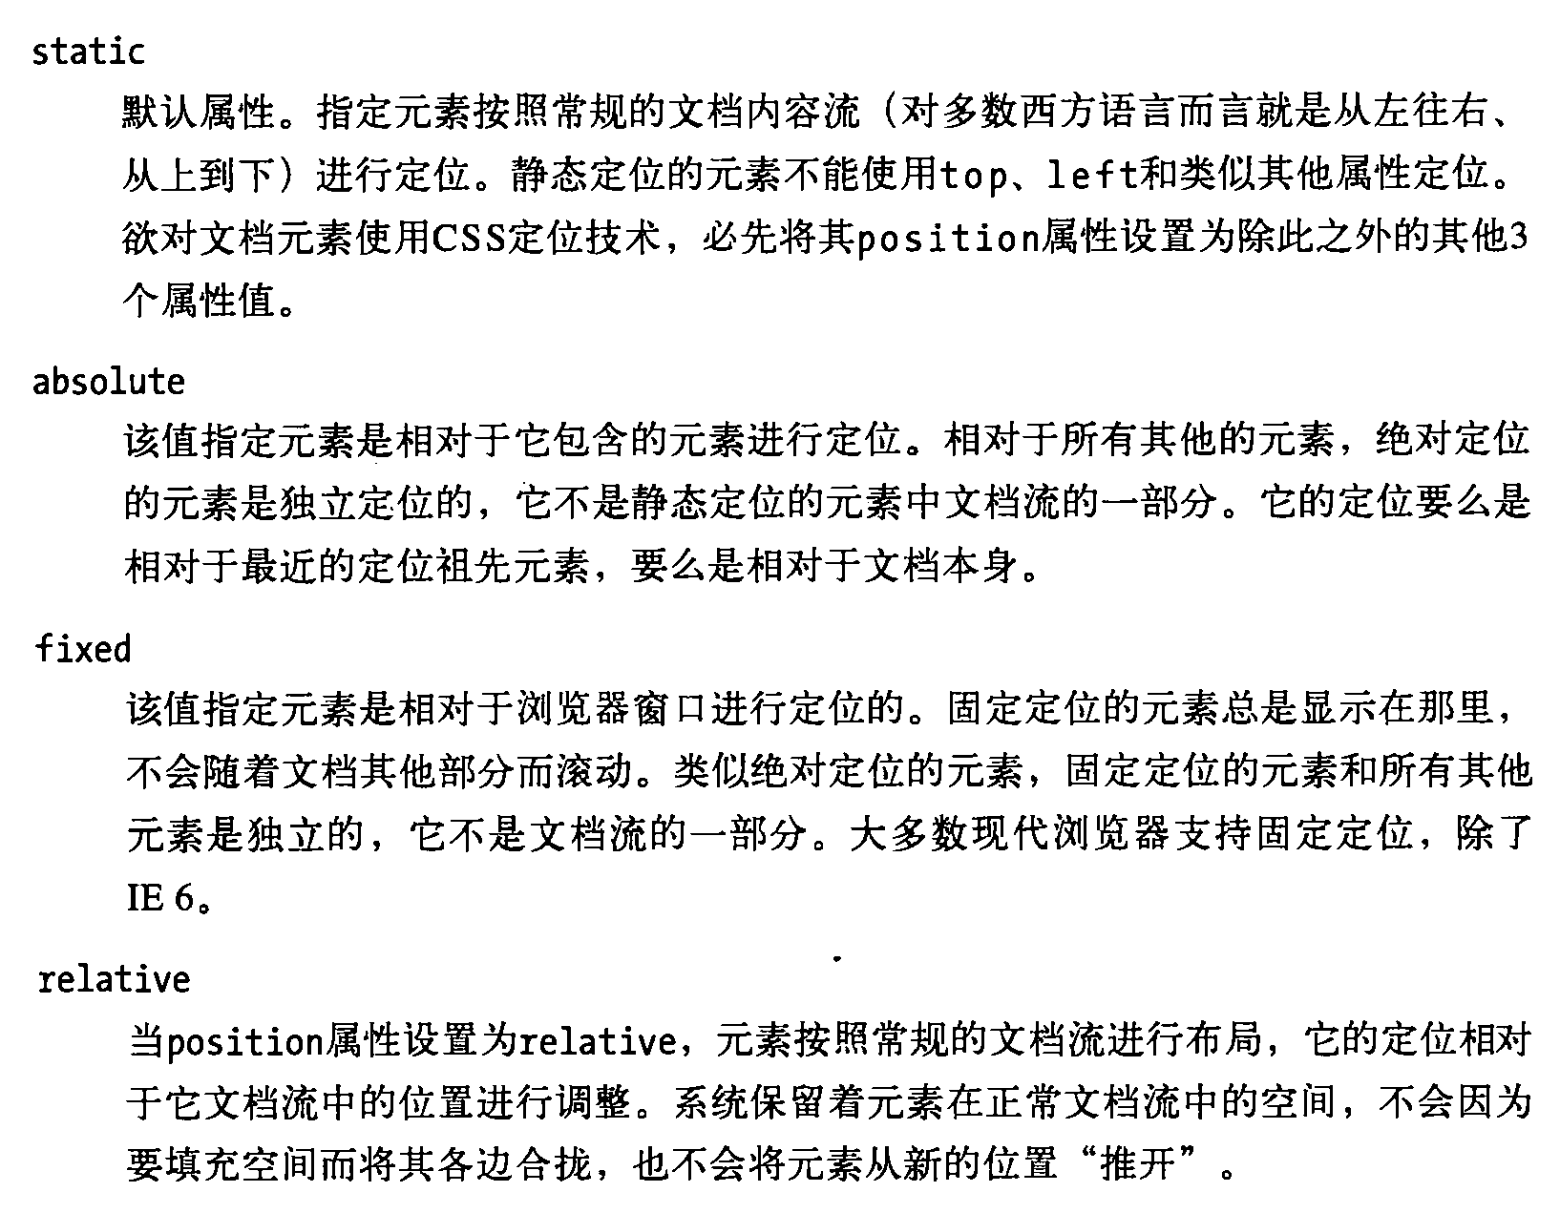

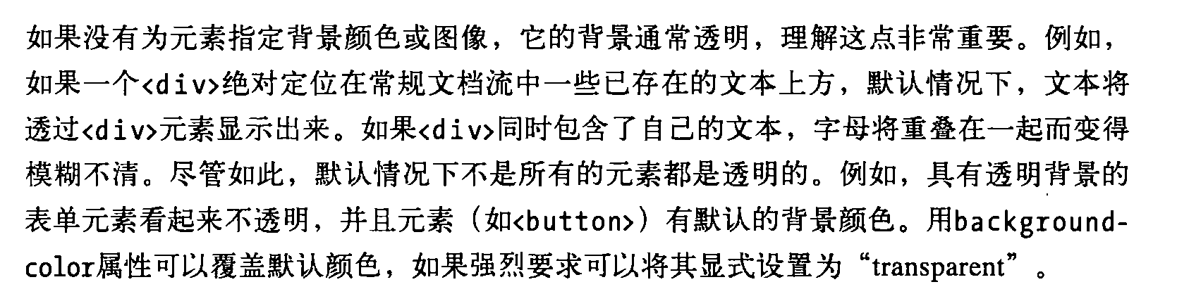

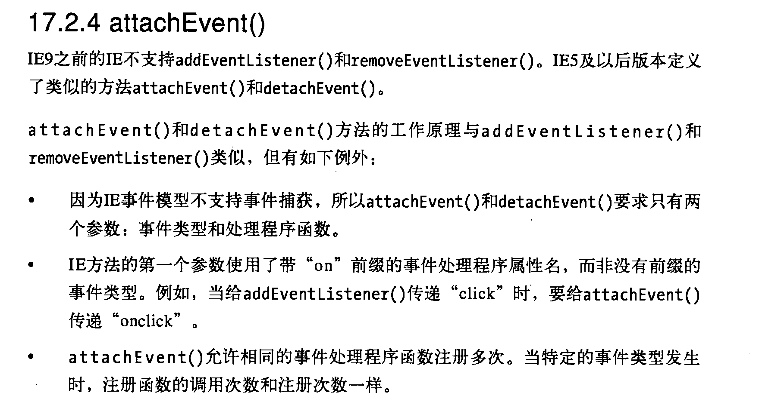

·ÃÎÊµØÖ·£ºhttp://xxxxx:¶Ë¿Ú/ÏîÄ¿Ãû

ÓÃ»§Ãû£ºadmin

ÃÜÂë £º1

Çë²»ÒªÖ±½ÓÔÚÊý¾Ý¿âÐÞ¸Ä ÃÜÂë£¬ÃÜÂë¶¼ÊÇ¼ÓÃÜ¹ýµÄ

linuxÏÂÊý¾Ý¿â±íÃûÉèÖÃÏÂºöÂÔ´óÐ¡Ð´

tomcat¾ø¶ÔÃ»ÎÊÌâµÄ°æ±¾

apache-tomcat-8.0.15
apache-tomcat-7.0.62
apache-tomcat-7.0.32
apache-tomcat-6.0.43

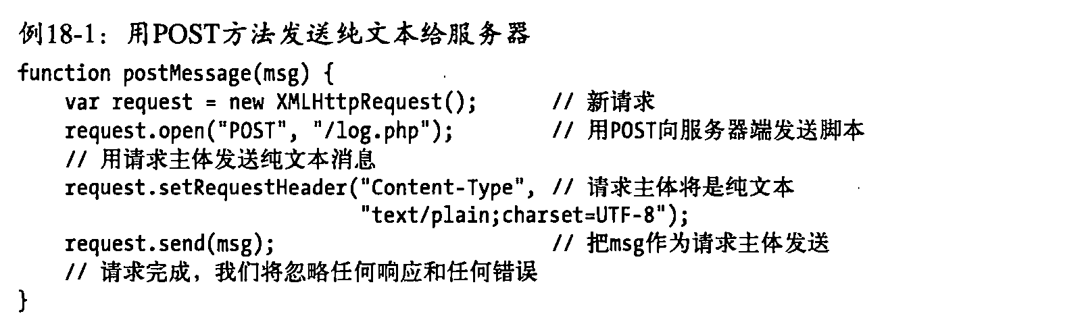

将英文语音转换为汉字
做成一个app

上传文件进度条

Cordova 调用iphone

cordova.exec(successCallback, errorCallback, "CallPhonePlugin",
"callPhone", [ num ]);

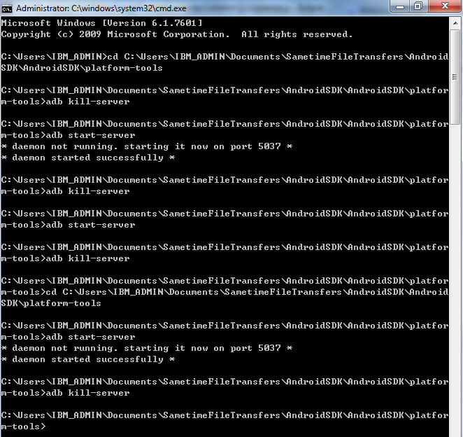

C:\Users\IBM_ADMIN\Documents\SametimeFileTransfers\AndroidSDK\AndroidSDK\platform-tools

Android
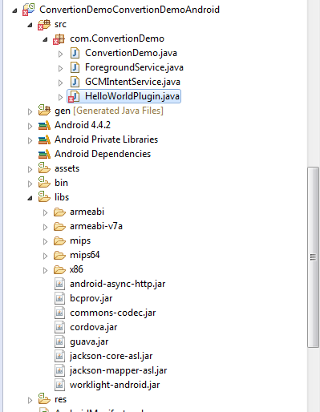

Angularjs ng-options option value 没法设置

Input file 控件 给文本框赋值不起作用
<input type="file" id="speechFile" name="speechFile" class="form-control" file-model="speechFileModel"
style="display: none"/>
<div class="input-append">
<input id="speechFileInput" class="input-large" type="text" placeholder="please choose a file"> <a
class="btn" onclick="$('input[id=speechFile]').click();">Browse</a>
</div>
<script type="text/javascript">
$('input[id=speechFile]').change(function() {
$('#speechFileInput').val("Englishddd.wav");
alert("this "+$(this).val());
alert($('#speechFileInput').val());
});
</script>

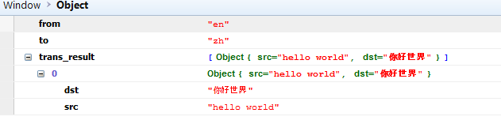

表不好用了 这么办：

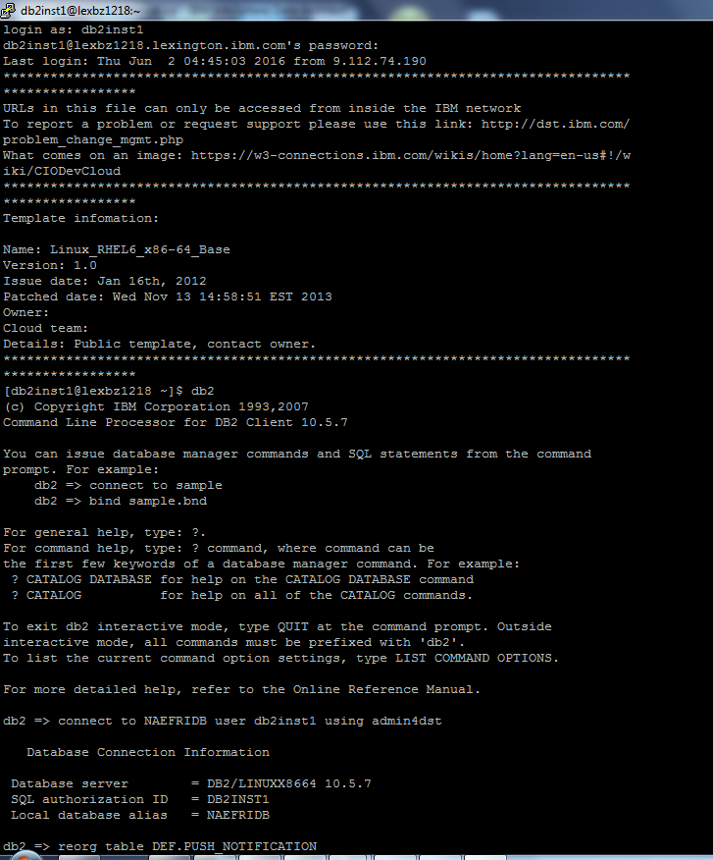

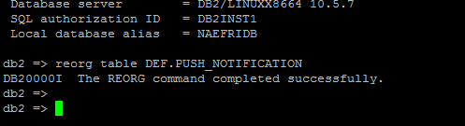

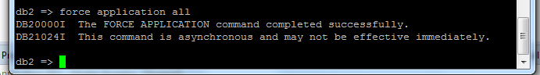

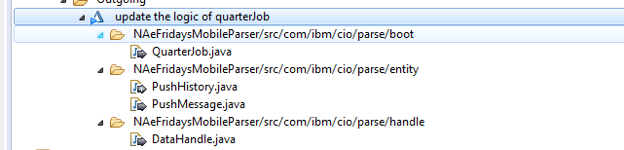

2016-07-12 :单词

Situation

问题
当吧一个servlet 备份在同一目录下，servlet的context路径会出现两个同样的，所以会出现在servlet中打断点不生效问题。

Hi,Ligia.I’m modifying the database tables ,add adapter for the admin page.No blocker.

问题1

$scope.apply(); -→什么时候使用

C:\Users\IBM_ADMIN\workspace\NAeFridaysMobileApp\apps\efridaysapp\common\commonapp\home_phone\subscription.js

Jquery toggle animate



金银花 桑葚 枸杞 灵芝 西洋参

