**Class:** Final Year (Computer Science and Engineering)

**Year:** 2022-23 **Semester:** 1

**Course:** High Performance Computing Lab

**Practical No. 11**

**Exam Seat No:** 2019BTECS00070

**Name:** Killedar Prathmesh

Q1. Execute the all-to-all broadcast operation (Program C) with varying message sizes.

Plot the performance of the operation with varying message sizes from 1K to 10K (with

constant number of processes, 8). Explain the performance observed.

**Code:**

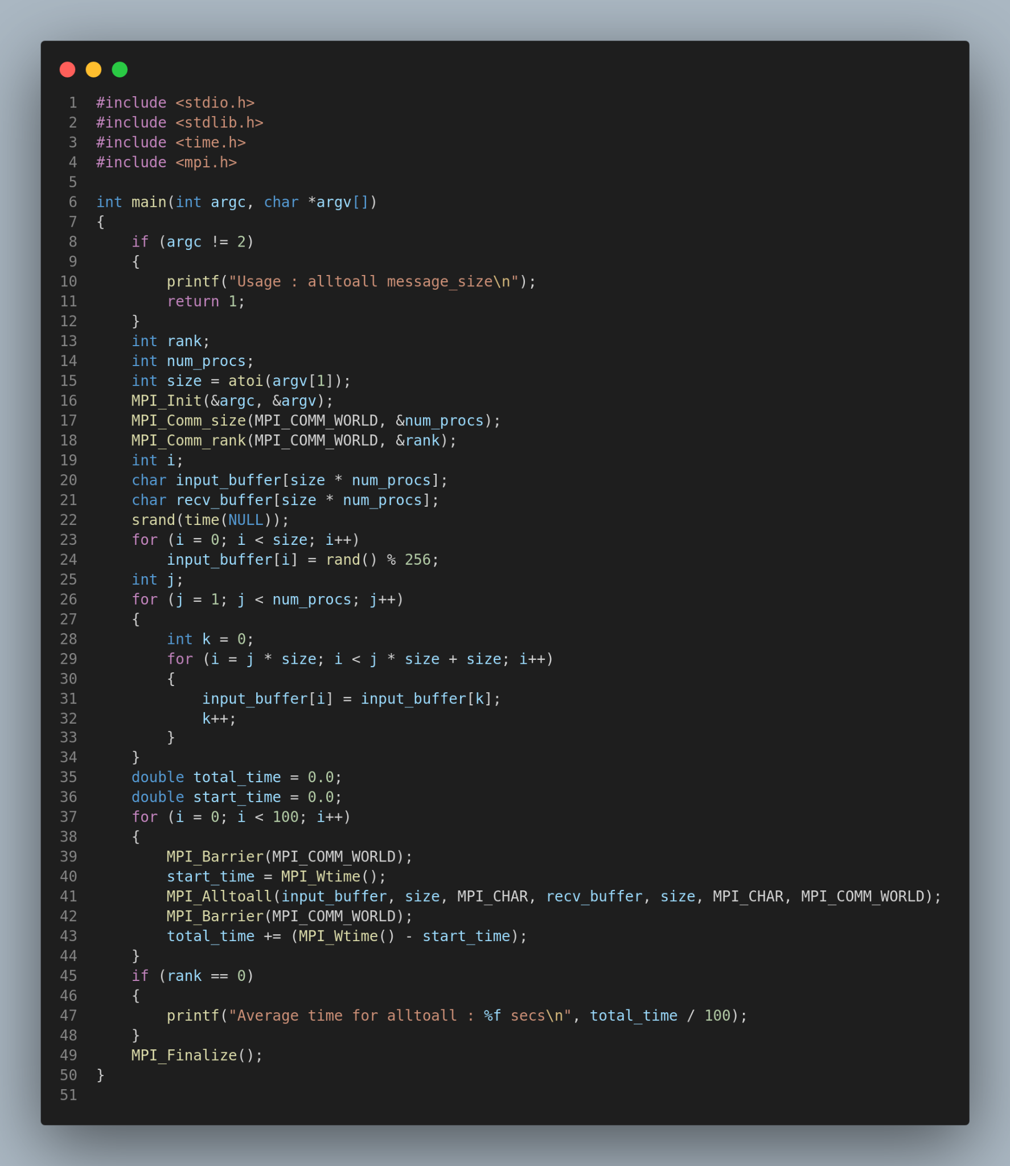

**Output:**

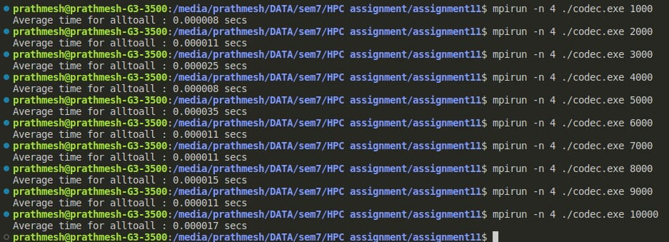

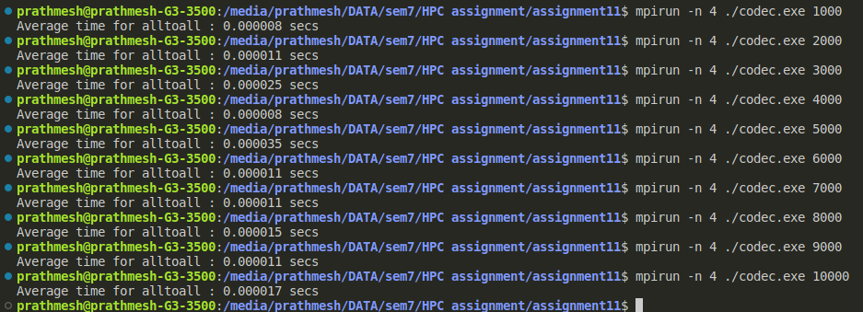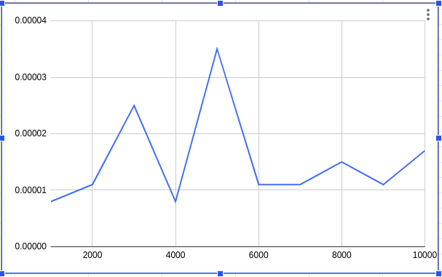

Q2. Execute the all-reduce operation (Program D) with varying number of processes (1

to 16) and fixed message size of 10K words. Plot the performance of the operation with

varying number of processes (with constant message size). Explain the performance

observed.

**Code:**

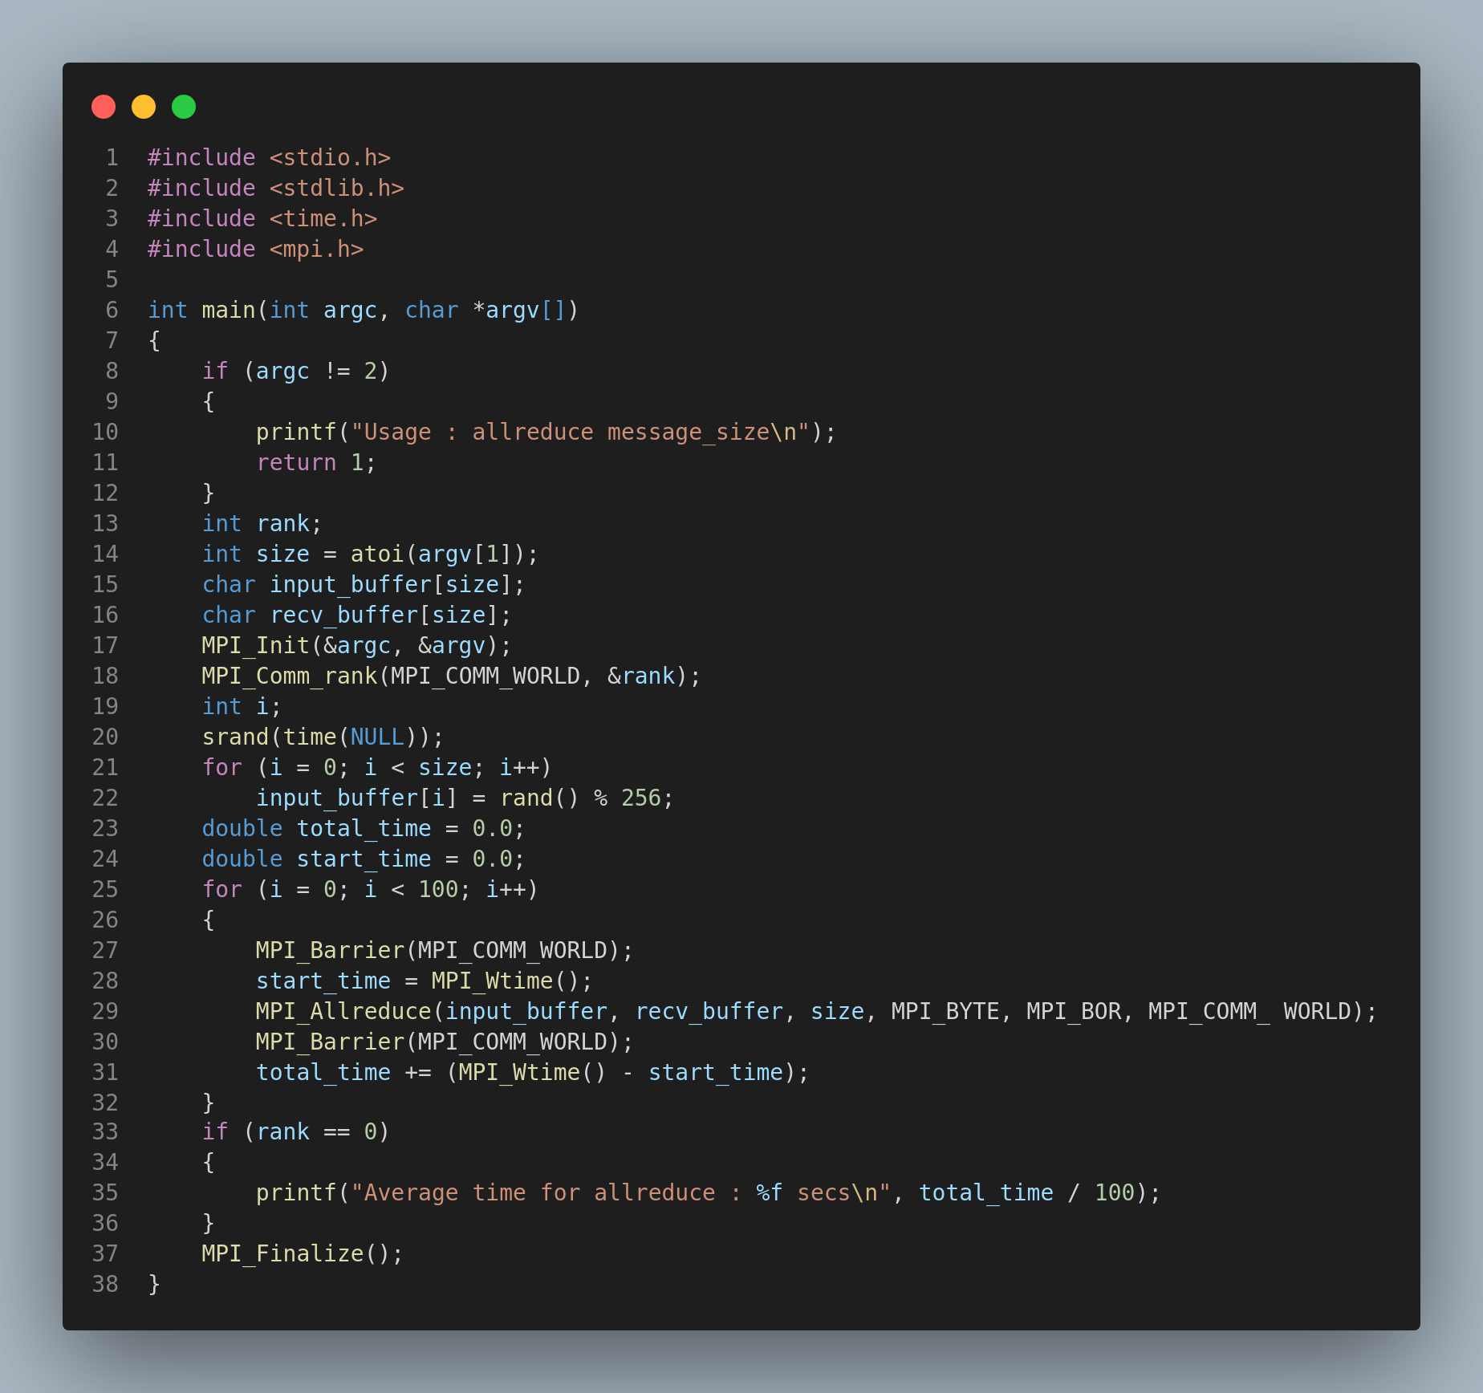

**Output:**

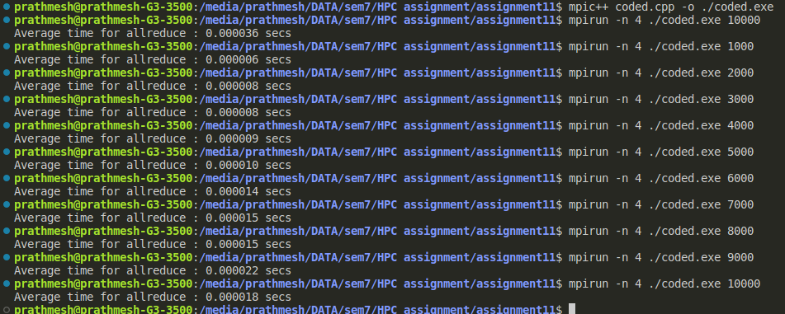

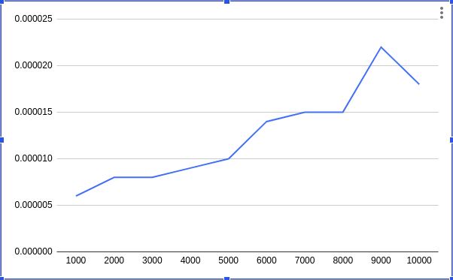

**Github Link:** [**https://github.com/abhi-05-04/High-Performance-Computing/tree/master/Assignment11**](https://github.com/abhi-05-04/High-Performance-Computing/tree/master/Assignment11)