**Class:** Final Year (Computer Science and Engineering)

**Year:** 2022-23 **Semester:** 1

**Course:** High Performance Computing Lab

**Practical No. 7**

**Exam Seat No:** 2019BTECS00070

**Name:** Killedar Prathmesh

1. Implement Matrix-Vector Multiplication using MPI. Use different number of processes and analyze the performance.

**Code:-**

#include <mpi.h>

#include <stdio.h>

#include <stdlib.h>

// size of matrix

#define N 1000

*int* main(*int* *argc*, *char* \**argv*[])

{

*int* np, rank, numworkers, rows, i, j, k;

// a*b = c

*double* a[N][N], b[N], c[N];

MPI_Status status;

MPI_Init(&argc, &argv);

MPI_Comm_rank(MPI_COMM_WORLD, &rank);

MPI_Comm_size(MPI_COMM_WORLD, &np);

numworkers = np - 1; // total process - 1 ie process with rank 0

// rank with 0 is a master process

*int* dest, source;

*int* tag;

*int* rows_per_process, extra, offset;

// master process, process with rank = 0

if (rank == 0)

{

printf("Running with %d tasks.\n", np);

// matrix a and b initialization

for (i = 0; i < N; i++)

for (j = 0; j < N; j++)

a[i][j] = 1;

for (i = 0; i < N; i++)

b[i] = 1;

// start time

*double* start = MPI_Wtime();

// Send matrix data to other worker processes

rows_per_process = N / numworkers;

extra = N % numworkers;

offset = 0;

tag = 1;

// send data to other nodes

for (dest = 1; dest <= numworkers; dest++)

{

rows = (dest <= extra) ? rows_per_process + 1 : rows_per_process;

MPI_Send(&offset, 1, MPI_INT, dest, tag, MPI_COMM_WORLD);

MPI_Send(&rows, 1, MPI_INT, dest, tag, MPI_COMM_WORLD);

MPI_Send(&a[offset][0], rows * N, MPI_DOUBLE, dest, tag, MPI_COMM_WORLD);

MPI_Send(&b, N, MPI_DOUBLE, dest, tag, MPI_COMM_WORLD);

offset = offset + rows;

}

// receive data from other nodes and add it to the ans matrix c

tag = 2;

for (i = 1; i <= numworkers; i++)

{

source = i;

MPI_Recv(&offset, 1, MPI_INT, source, tag, MPI_COMM_WORLD, &status);

MPI_Recv(&rows, 1, MPI_INT, source, tag, MPI_COMM_WORLD, &status);

MPI_Recv(&c[offset], N, MPI_DOUBLE, source, tag, MPI_COMM_WORLD, &status);

}

// print multiplication result

// printf("Result Matrix:\n");

// for (i = 0; i < N; i++)

// {

// printf("%6.2f ", c[i]);

// }

// printf("\n");

*double* finish = MPI_Wtime();

printf("Done in %f seconds.\n", finish - start); // total time spent

}

// all other process than process with rank = 0

if (rank > 0)

{

tag = 1;

// receive data from process with rank 0

MPI_Recv(&offset, 1, MPI_INT, 0, tag, MPI_COMM_WORLD, &status);

MPI_Recv(&rows, 1, MPI_INT, 0, tag, MPI_COMM_WORLD, &status);

MPI_Recv(&a, rows * N, MPI_DOUBLE, 0, tag, MPI_COMM_WORLD, &status);

MPI_Recv(&b, N, MPI_DOUBLE, 0, tag, MPI_COMM_WORLD, &status);

// calculate multiplication of given rows

for (i = 0; i < rows; i++)

{

c[i] = 0.0;

for (j = 0; j < N; j++)

c[i] = c[i] + a[i][j] * b[j];

}

// send result back to process with rank 0

tag = 2;

MPI_Send(&offset, 1, MPI_INT, 0, tag, MPI_COMM_WORLD);

MPI_Send(&rows, 1, MPI_INT, 0, tag, MPI_COMM_WORLD);

MPI_Send(&c, N, MPI_DOUBLE, 0, tag, MPI_COMM_WORLD);

}

MPI_Finalize();

}

**Output:-**

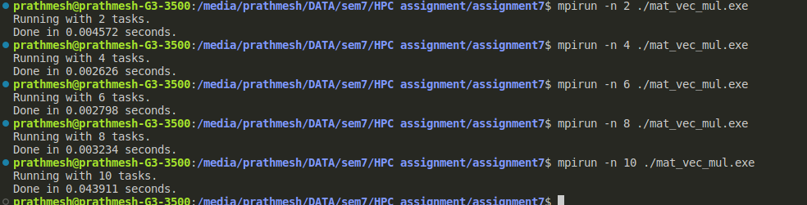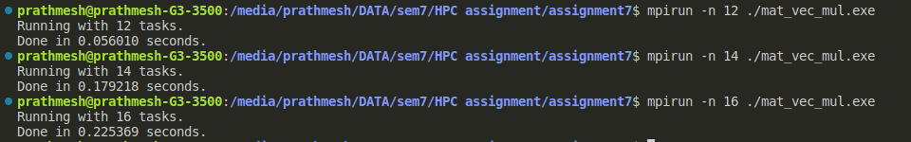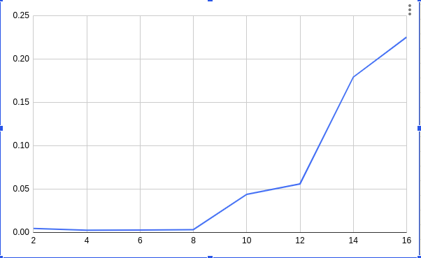

2. Implement Matrix-Matrix Multiplication using MPI. Use different number of processes and analyze the performance.

**Code:**

#include "mpi.h"

#include <stdio.h>

#include <stdlib.h>

#define MATSIZE 500

#define NRA MATSIZE /* number of rows in matrix A */

#define NCA MATSIZE /* number of columns in matrix A */

#define NCB MATSIZE /* number of columns in matrix B */

#define MASTER 0 /* taskid of first task */

#define FROM_MASTER 1 /* setting a message type */

#define FROM_WORKER 2 /* setting a message type */

*int* main(*int* *argc*, *char* \**argv*[])

{

*int* numtasks, /* number of tasks in partition */

taskid, /* a task identifier */

numworkers, /* number of worker tasks */

source, /* task id of message source */

dest, /* task id of message destination */

mtype, /* message type */

rows, /* rows of matrix A sent to each worker */

averow, extra, offset, /* used to determine rows sent to each worker */

i, j, k, rc; /* misc */

*double* a[NRA][NCA], /* matrix A to be multiplied */

b[NCA][NCB], /* matrix B to be multiplied */

c[NRA][NCB]; /* result matrix C */

MPI_Status status;

MPI_Init(&argc, &argv);

MPI_Comm_rank(MPI_COMM_WORLD, &taskid);

MPI_Comm_size(MPI_COMM_WORLD, &numtasks);

if (numtasks < 2)

{

printf("Need at least two MPI tasks. Quitting...\n");

MPI_Abort(MPI_COMM_WORLD, rc);

exit(1);

}

numworkers = numtasks - 1;

/********** master task ************/

if (taskid == MASTER)

{

printf("mpi_mm has started with %d tasks.\n", numtasks);

// printf("Initializing arrays...\n");

for (i = 0; i < NRA; i++)

for (j = 0; j < NCA; j++)

a[i][j] = i + j;

for (i = 0; i < NCA; i++)

for (j = 0; j < NCB; j++)

b[i][j] = i * j;

/* Measure start time */

*double* start = MPI_Wtime();

/* Send matrix data to the worker tasks */

averow = NRA / numworkers;

extra = NRA % numworkers;

offset = 0;

mtype = FROM_MASTER;

for (dest = 1; dest <= numworkers; dest++)

{

rows = (dest <= extra) ? averow + 1 : averow;

// printf("Sending %d rows to task %d offset=%d\n",rows,dest,offset);

MPI_Send(&offset, 1, MPI_INT, dest, mtype, MPI_COMM_WORLD);

MPI_Send(&rows, 1, MPI_INT, dest, mtype, MPI_COMM_WORLD);

MPI_Send(&a[offset][0], rows * NCA, MPI_DOUBLE, dest, mtype,

MPI_COMM_WORLD);

MPI_Send(&b, NCA * NCB, MPI_DOUBLE, dest, mtype, MPI_COMM_WORLD);

offset = offset + rows;

}

/* Receive results from worker tasks */

mtype = FROM_WORKER;

for (i = 1; i <= numworkers; i++)

{

source = i;

MPI_Recv(&offset, 1, MPI_INT, source, mtype, MPI_COMM_WORLD, &status);

MPI_Recv(&rows, 1, MPI_INT, source, mtype, MPI_COMM_WORLD, &status);

MPI_Recv(&c[offset][0], rows * NCB, MPI_DOUBLE, source, mtype,

MPI_COMM_WORLD, &status);

// printf("Received results from task %d\n",source);

}

/* Print results */

/*

printf("******************\n");

printf("Result Matrix:\n");

for (i=0; i<NRA; i++)

{

printf("\n");

for (j=0; j<NCB; j++)

printf("%6.2f ", c[i][j]);

}

printf("\n********************\n");

*/

/* Measure finish time */

*double* finish = MPI_Wtime();

printf("Done in %f seconds.\n", finish - start);

}

/********** worker task ************/

if (taskid > MASTER)

{

mtype = FROM_MASTER;

MPI_Recv(&offset, 1, MPI_INT, MASTER, mtype, MPI_COMM_WORLD, &status);

MPI_Recv(&rows, 1, MPI_INT, MASTER, mtype, MPI_COMM_WORLD, &status);

MPI_Recv(&a, rows * NCA, MPI_DOUBLE, MASTER, mtype, MPI_COMM_WORLD, &status);

MPI_Recv(&b, NCA * NCB, MPI_DOUBLE, MASTER, mtype, MPI_COMM_WORLD, &status);

for (k = 0; k < NCB; k++)

for (i = 0; i < rows; i++)

{

c[i][k] = 0.0;

for (j = 0; j < NCA; j++)

c[i][k] = c[i][k] + a[i][j] * b[j][k];

}

mtype = FROM_WORKER;

MPI_Send(&offset, 1, MPI_INT, MASTER, mtype, MPI_COMM_WORLD);

MPI_Send(&rows, 1, MPI_INT, MASTER, mtype, MPI_COMM_WORLD);

MPI_Send(&c, rows * NCB, MPI_DOUBLE, MASTER, mtype, MPI_COMM_WORLD);

}

MPI_Finalize();

}

**Output:**

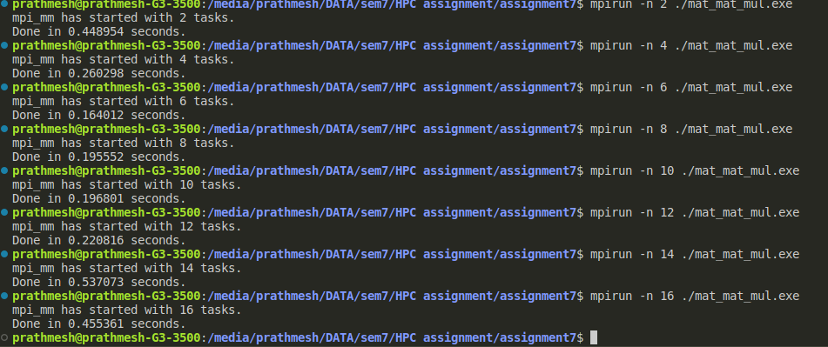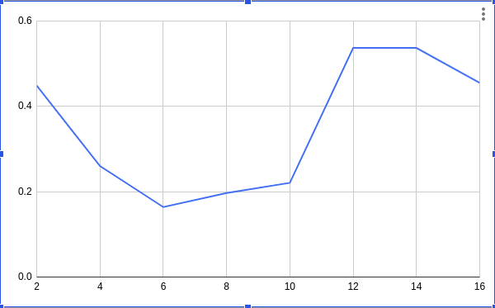

**Github Link:**

**https://github.com/killedar27/HPC-assignments/tree/main/assignment7**