**Class:** Final Year (Computer Science and Engineering)

**Year:** 2022-23 **Semester:** 1

**Course:** High Performance Computing Lab

**Practical No. 8**

**Exam Seat No:** 2019BTECS00070

**Name:** Killedar Prathmesh

1. Study and implement 2D Convolution using MPI. Use different number of processes and analyze the performance.

**Code:**

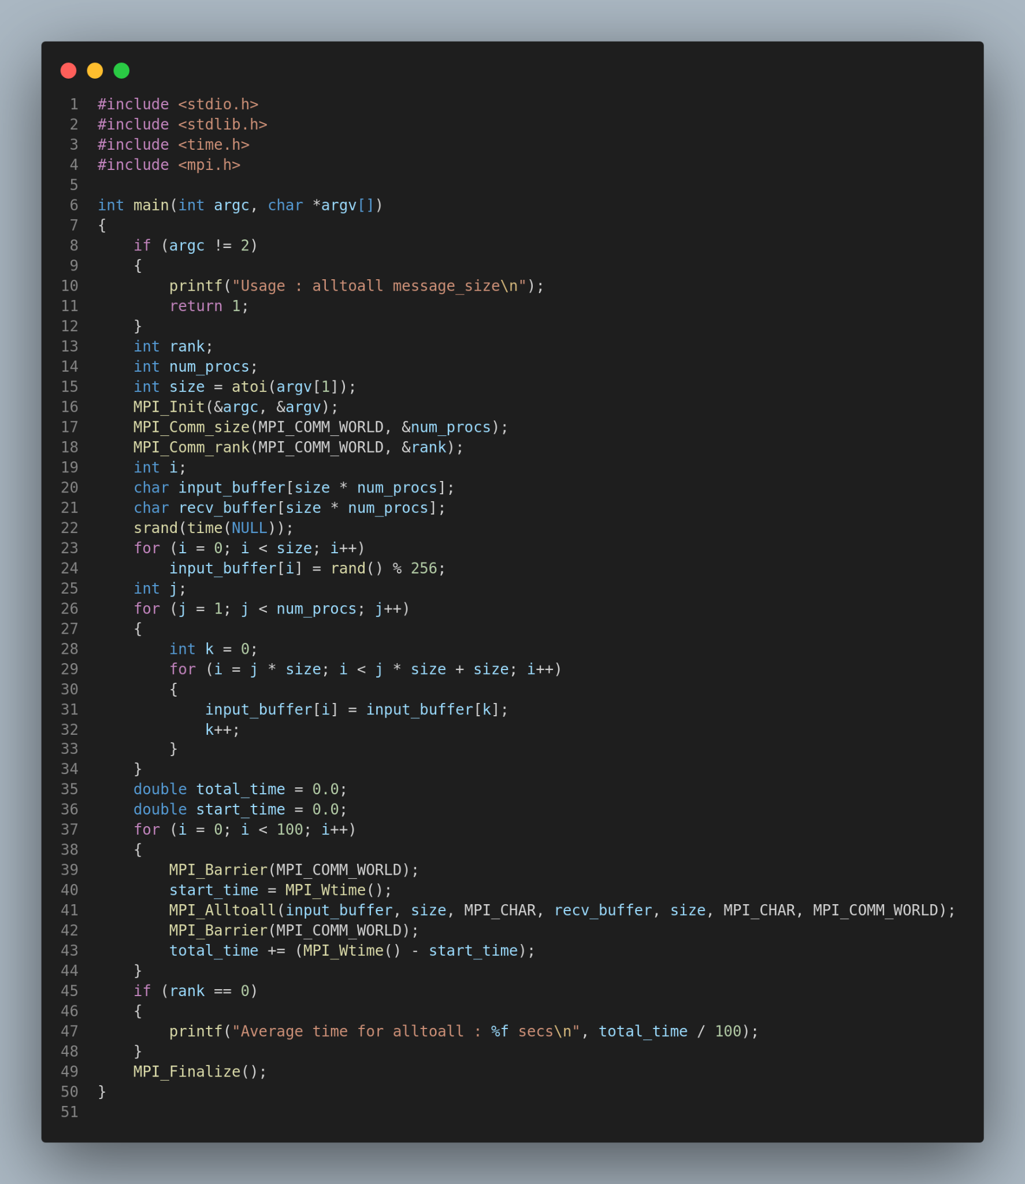

**Output:**

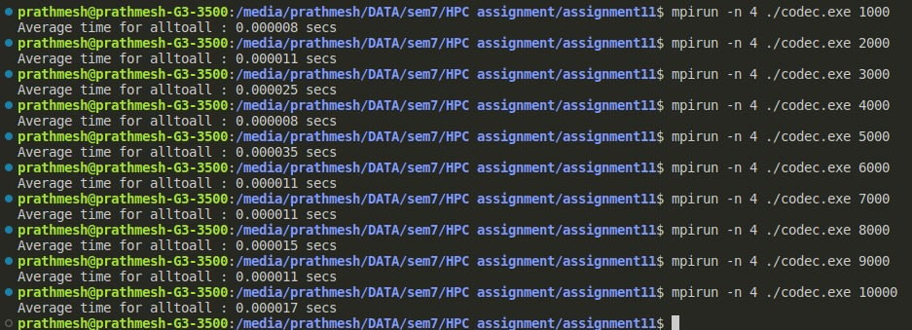

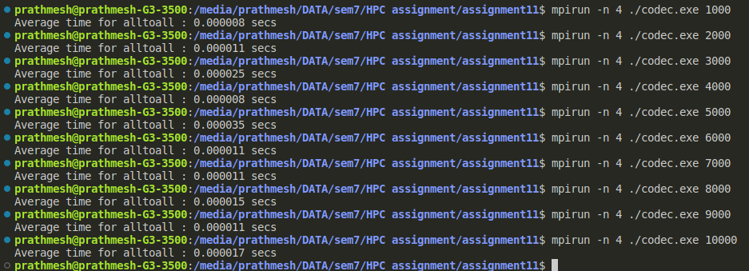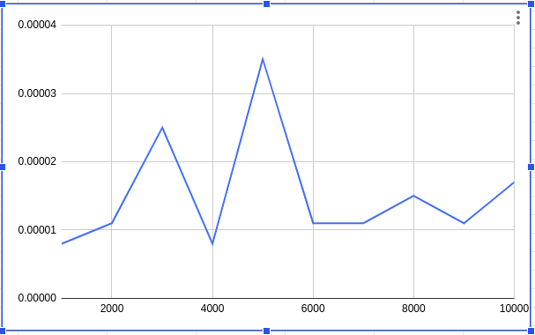

2. Implement dot product using MPI. Use different number of processes and analyze the performance.

**Code:**

#include <stdio.h>

#include <mpi.h>

#include <unistd.h>

#include <math.h>

#include <time.h>

#include <stdlib.h>

#define NELMS 100000

#define MASTER 0

#define MAXPROCS 16

*int* dot_product(*int* *s*,*int* *e*, *int* *x*[], *int* *y*[], *int* *n*){

*int* i,prod=0;

for (i = *s*; i < *e*; i++)

prod = prod + *x*[i] * *y*[i];

return prod;

}

*void* init_lst(*int* \**l*,*int* *n*){

*int* i;

for (i=0; i<*n*; i++) \**l*++ = i;

}

*void* print_lst(*int* *l*[],*int* *n*){

*int* i;

for (i=0; i<*n*; i++) {

printf("%d ", *l*[i]);

}

printf("\n");

}

*int* main() {

*int* i,n,vector_x[NELMS],vector_y[NELMS];

*int* prod,sidx,eidx,size;

*int* pid,nprocs, rank;

*double* stime,etime;

MPI_Status status;

MPI_Comm world;

n = 100000;

if (n > NELMS) { printf("n=%d > N=%d\n",n,NELMS); exit(1); }

MPI_Init(NULL, NULL);

world = MPI_COMM_WORLD;

MPI_Comm_size(MPI_COMM_WORLD, &nprocs);

MPI_Comm_rank(MPI_COMM_WORLD, &pid);

*int* portion = n / nprocs;

sidx = pid * portion;

eidx = sidx + portion;

init_lst(vector_x, n);

init_lst(vector_y, n);

*int* tmp_prod[nprocs];

for (i = 0; i < nprocs; i++)

tmp_prod[i] = 0;

stime = MPI_Wtime();

if (pid == MASTER) {

prod = dot_product(sidx, eidx, vector_x, vector_y, n);

for (i = 1; i < nprocs; i++)

MPI_Recv(&tmp_prod[i-1], 1, MPI_INT, i, 123, MPI_COMM_WORLD, &status);

}

else {

prod = dot_product(sidx, eidx, vector_x, vector_y, n);

MPI_Send(&prod, 1, MPI_INT, MASTER, 123, MPI_COMM_WORLD);

}

if (pid == MASTER) {

for (i = 0; i < nprocs; i++)

prod += tmp_prod[i];

}

etime = MPI_Wtime();

if (pid == MASTER) {

//print_lst(vector_x,n);

//print_lst(vector_y,n);

printf("pid=%d: final prod=%d\n",pid,prod);

printf("pid=%d: elapsed=%f\n",pid,etime-stime);

}

MPI_Finalize();

}

**Output:**

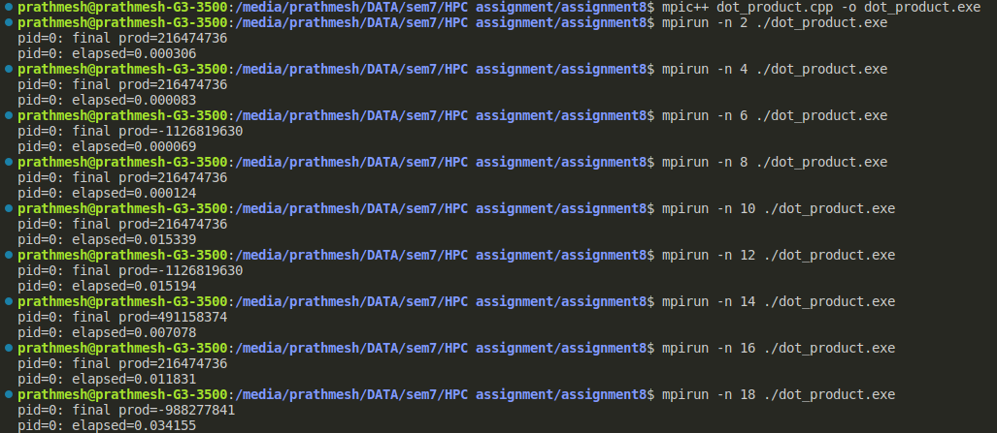

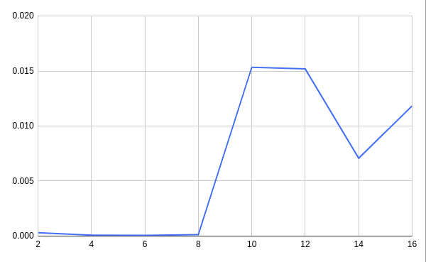

3. Implement Prefix sum using MPI. Use different number of processes and analyze the performance.

Code:-

#include <stdio.h>

#include<stdlib.h>

#include <math.h>

#include "mpi.h"

*int* main(*int* *argc*, *char*\* *argv*[]){

*int* my_rank; /* rank of process */

*int* p; /* number of processes */

MPI_Status status ; /* return status for receive */

*int* value;

/* start up MPI */

MPI_Init(&*argc*, &*argv*);

/* find out process rank */

MPI_Comm_rank(MPI_COMM_WORLD, &my_rank);

/* find out number of processes */

MPI_Comm_size(MPI_COMM_WORLD, &p);

*int* prefix_arr[p];

/* getting input and scatter values */

if(my_rank == 0){

*int* i;

for(i = 0; i < p; ++i){

prefix_arr[i] = i + 1;

}

}

*double* start = MPI_Wtime();

//all call scatter

MPI_Scatter(prefix_arr, 1, MPI_INT, &value, 1, MPI_INT, 0, MPI_COMM_WORLD);

/*

prefix sum:

repeat log n times

each time, if we are the chosen one, we receve a value from someone and add to ours

otherwise, we send to the chosen one

*/

*int* i;

*int* logn = log2(p);

for(i = 0; i <= logn; i++){

*int* lower_bound = pow(2,i);

*int* upper_bound = p - lower_bound;

if(upper_bound < lower_bound){

upper_bound = lower_bound;

}

if(my_rank < lower_bound){

*int* send = (*int*) (my_rank + pow(2,i));

if(send >= p)

continue;

printf("%d sending to %d\n", my_rank, (*int*) (my_rank+pow(2,i)));

MPI_Send(&value, 1, MPI_INT, (*int*) (my_rank+pow(2,i)), 0, MPI_COMM_WORLD);

}

else if(my_rank >= upper_bound){

*int* recv = (*int*) (my_rank - pow(2,i));

if(recv >= p)

continue;

*int* recv_value;

printf("%d receving..\n", my_rank);

MPI_Recv(&recv_value, 1, MPI_INT, (my_rank - pow(2,i)), 0, MPI_COMM_WORLD, &status);

value += recv_value;

}

else{

*int* send = (*int*) (my_rank + pow(2,i));

*int* recv = (*int*) (my_rank - pow(2,i));

if(send >= p || recv >= p)

continue;

printf("%d sending to %d\n", my_rank, (*int*) (my_rank+pow(2,i)));

MPI_Send(&value, 1, MPI_INT, (*int*) (my_rank+pow(2,i)), 0, MPI_COMM_WORLD);

printf("%d receving..\n", my_rank);

*int* recv_value;

MPI_Status status;

MPI_Recv(&recv_value, 1, MPI_INT, (my_rank - pow(2,i)), 0, MPI_COMM_WORLD, &status);

value += recv_value;

}

}

//after algorithm, each processor hols its own prefix sum

//we gather at rank

*int* gather[p];

MPI_Gather(&value, 1, MPI_INT, gather, 1, MPI_INT, 0, MPI_COMM_WORLD);

if(my_rank == 0){

*double* end = MPI_Wtime();

printf("Execution Time: %f\n", end - start);

}

/* shut down MPI */

MPI_Finalize();

return 0;

}

Output:-

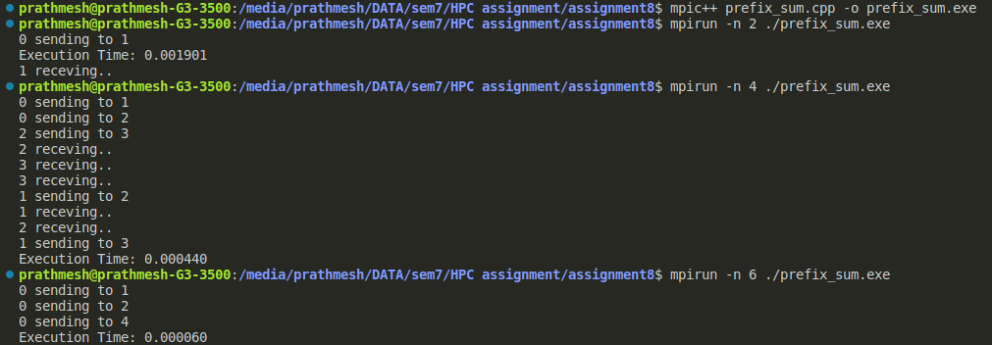

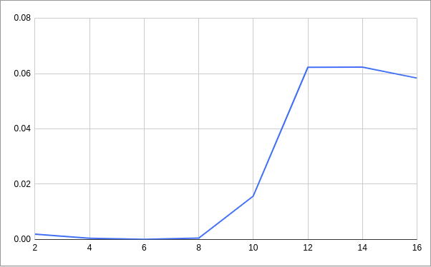**Github Link:**

[**https://github.com/killedar27/HPC-assignments/tree/main/assignment8**](https://github.com/killedar27/HPC-assignments/tree/main/assignment8)