
DESIGN AND IMPLEMENTATION OF A UNIVERSITY RESEARCH SUBMISSION SYSTEM

BY

CIS GROUP 8
LAWAL AYOMIDE AFOLASHADE 22/1998
BELLO ABIMBOLA TENIOLA 22/2927
SULEMAN TOBILOBA PETERS 22/1304

A RESEARCH PROJECT PRESENTED IN PARTIAL FULFILLMENT OF THE
REQUIREMENTS FOR THE AWARD OF BACHELOR OF SCIENCE (B.Sc.Hons.) DEGREE IN COMPUTER SCIENCE

TO THE DEPARTMENT OF COMPUTER SCIENCE SCHOOL OF COMPUTING AND
ENGINEERING SCIENCES, BABCOCK UNIVERSITY, ILISHAN-REMO, OGUN STATE, NIGERIA

MARCH 2026.

CHAPTER ONE
INTRODUCTION
1.1 Background of the Study
1.2 Statement of the Problem
1.3 Aim and Objectives of the Study
1.4 Significance of the Study.
1.5 Scope of the Study
1.6 The Limitation Of The Study
1.7 Definition of Terms
1.8 Organization Of The Project

CHAPTER TWO
LITERATURE REVIEW
2.0 Introduction
2.1 Historical Evolution of Research Submission Systems
2.2 Conceptual Review
2.3 Theoretical Framework
2.4 Review of Related Works
2.5 Strengths and Weaknesses of Existing Systems
2.6 Identified Gaps in Literature
2.7 Summary of Literature Review

CHAPTER THREE
SYSTEM ANALYSIS AND DESIGN
3.1 Introduction
3.2 Research Design and Framework
3.3 Software Development Methodology
3.3.1 Plagiarism Detection Mechanism
3.4 System Requirements
3.4.1 Functional Requirements
3.4.2 Non-Functional Requirements
3.5 System Architecture
3.6 Proposed Model Diagrams
3.6.1 Flowchart Diagram
3.6.2 Use Case Diagram
3.6.3 Sequence Diagram
3.6.4 Entity Relationship Diagram (ERD)
3.7 Development Tools and Technologies
3.7.1 Frontend Technologies
3.7.2 Backend Technology
3.7.3 Database Management System
3.7.4 Deployment Environment
3.7.5 Plagiarism Detection API Integration
3.8 System Evaluation

CHAPTER FOUR: SYSTEM IMPLEMENTATION AND RESULTS
4.1 Introduction
4.2 System Implementation
4.2.1 Development Environment
4.2.2 System Architecture Implementation
4.2.3 Back-end Implementation
4.2.4 Database Implementation
4.2.5 Integration of Plagiarism Detection API
4.3 Module Description
4.3.1 User Authentication Module
4.3.2 Project Submission Module
4.3.3 Plagiarism Detection Module
4.3.4 Supervisor Review Module
4.3.5 Repository and Retrieval Module
4.4 Database Design and Implementation
4.4.1 Database Structure
4.4.2 Table Description
4.4.3 Relationship Between Tables
4.5 System Testing and Result Analysis
4.5.1 Functional Testing
4.5.2 Plagiarism Detection Result Testing
4.5.3 Submission and Retrieval Testing
4.5.4 Authentication Testing
4.5.5 Encryption Testing
4.6 User Interface Design
4.6.1 System Interface Overview
4.6.2 Login Interface
4.6.3 Student Dashboard
4.6.4 Supervisor Dashboard
4.6.5 Admin Dashboard
4.7 Discussion of Findings

CHAPTER FIVE
CONCLUSION AND RECOMMENDATIONS
5.1 Introduction
5.2 Summary of the Study
5.3 Conclusion
5.4 Limitations of the System
5.5 Recommendations
5.6 Suggestions for Further Work
5.7 Contribution to Knowledge

CHAPTER 1
INTRODUCTION

1.1 Background of the Study
Academic research management in many higher education institutions remains partially manual or semi-digitized, relying on fragmented tools and informal processes (Olowe & Nwachukwu, 2021; Adebayo & Musa, 2022). Research submissions are often handled through printed copies, email exchanges, or basic file uploads, leading to inefficiencies in version tracking, delayed feedback, and potential data loss (Olowe & Nwachukwu, 2021; Adebayo & Musa, 2022; Web-Based Student Project Management System, 2021). The increasing volume of student research projects has highlighted the need for centralized digital systems capable of managing submission workflows, maintaining structured repositories, and ensuring academic integrity (Bashir et al., 2021; Gusenbauer & Haddaway, 2020). A unified platform can streamline communication between students and supervisors while reducing administrative burden through automated tracking and role-based interactions (Web-Based Student Project Management System, 2021).
Recent advancements in Artificial Intelligence (AI), particularly in Natural Language Processing (NLP), have enhanced the ability of digital systems to analyze text similarity and support plagiarism detection (Zhang et al., 2022; Zhai et al., 2020). AI-driven plagiarism detection tools and APIs enable automated similarity assessment, cross-document comparison, and improved transparency in academic evaluation processes, although they must be applied carefully due to concerns about false positives and contextual interpretation (Akademi Sains Malaysia, 2024). A centralized University Research Submission System can therefore address limitations associated with manual processes by providing secure submission channels, automated similarity analysis, structured approval workflows, and long-term archival of approved research materials (Asadi et al., 2019; Bashir et al., 2021).

1.2 Statement of the Problem
Despite the growth of digital platforms in higher education, many universities still rely on manual or semi-automated research submission processes, resulting in inefficiency, poor version control, and risk of data loss (Olowe & Nwachukwu, 2021; Adebayo & Musa, 2022). The absence of a centralized and secure submission system creates challenges in monitoring academic integrity and tracking progress in real time, particularly in the detection of text similarity and duplication across submitted projects (Asadi et al., 2019; Saeed et al., 2018; Abdelhamid et al., 2022). A web-based, user-friendly, and encrypted platform is therefore needed to streamline research submission and ensure data integrity (Eze et al., 2023; Web-Based Student Project Management System, 2021).
Furthermore, retrieving previously approved research works is often inefficient due to inadequate indexing and limited search capabilities, which restrict timely access to relevant prior studies (Bashir et al., 2021; Gusenbauer & Haddaway, 2020). Current systems frequently lack structured workflows for submission tracking, automated plagiarism analysis, and centralized archival, resulting in delays in supervisor review and limited visibility for students regarding the progress of their submissions (Asadi et al., 2019; Web-Based Student Project Management System, 2021). There is therefore a need for a centralized, secure, and web-based research submission system that integrates structured workflows, plagiarism verification through API-based similarity analysis, and efficient document retrieval mechanisms tailored to the institutional context (Abdelhamid et al., 2022; Aggarwal & Zhai, 2018).

1.3 Study Aim and Objectives
Aim of the Study
To develop and implement a secure, centralized, and user-friendly web-based university research submission system that streamlines the process of submitting, reviewing, approving, and archiving academic projects.
Objectives of the Study
- To develop a web-based platform where students can submit research projects electronically (Web-Based Student Project Management System, 2021).
- To design a secure login and authentication module for students, supervisors, and administrators (NIST, 2022).
- To create a centralized digital repository for storing approved research works (Bashir et al., 2021).
- To implement a search and retrieval module for users to access stored research works efficiently (Gusenbauer & Haddaway, 2020).

1.4 Significance of the Study
The University Research Submission System (URSS) is designed to improve the management of academic research submissions within the university environment. From an academic standpoint, the system contributes to the digital transformation of research management by providing a structured and centralized platform for submission, review, approval, and archival of student projects (Asadi et al., 2019; Bashir et al., 2021). For universities, the system enhances administrative efficiency by reducing reliance on manual processes, improving record keeping, and promoting transparency in supervision and approval workflows (Web-Based Student Project Management System, 2021).
Students benefit from a streamlined submission process, integrated plagiarism verification, and improved access to previously approved research works through a searchable repository (Abdelhamid et al., 2022). Supervisors and administrators benefit from improved monitoring capabilities, reduced paperwork, and better tracking of project progress through role-based dashboards and audit logs (Ferraiolo et al., 2020; NIST, 2022). Overall, the system promotes accountability, strengthens research documentation practices, and supports academic integrity within higher education institutions (Akademi Sains Malaysia, 2024; Zhai et al., 2020).

1.5 Scope of the Study
This study focuses on the design and development of a web-based University Research Submission System for undergraduate research projects in a university context. The system supports electronic submission, role-based authentication, plagiarism verification through an external API, supervisor review, approval workflows, and repository storage (Web-Based Student Project Management System, 2021). The system is designed for English-language research documents and operates within a university environment with reliable internet connectivity. It does not extend to postgraduate research management or full academic grading systems, which remain outside the scope of this implementation (Asadi et al., 2019).

1.6 Limitation of the Study
The system relies on stable internet connectivity for document upload and API communication, which may constrain use in settings with limited network infrastructure (Asadi et al., 2019). Its plagiarism detection capability depends on the accuracy, coverage, and availability of the integrated external API, reflecting broader limitations identified in AI-based plagiarism detection tools regarding false positives and dataset bias (Abdelhamid et al., 2022; Akademi Sains Malaysia, 2024). Additionally, the system does not evaluate qualitative aspects of academic research such as originality of ideas, depth of analysis, or intellectual contribution; these aspects remain subject to supervisor assessment (Saeed et al., 2018).

1.7 DEFINITION OF TERMS
1. Authentication:
Authentication is the process of verifying the identity of a user before granting access to the system, typically through credentials such as a username and password.

2.Authorization:
Authorization is the process of determining the level of access and permissions granted to an authenticated user based on assigned roles within the system.

3. Submission Portal:
The submission portal is a web-based interface through which users upload research documents for review and assessment.

4.Peer Review:
Peer review is the evaluation of submitted research work by qualified individuals to ensure quality, accuracy, and adherence to academic standards.

5.Version Control:
Version control is the process of tracking and managing changes made to research documents over time.

6.Metadata:
Metadata refers to descriptive information associated with a research document, including details such as author name, title, submission date, keywords, and academic field.

7. Data Security:
Data security refers to the measures implemented to protect research documents and user information from unauthorized access, modification, or loss.

8. Audit Trail:
An audit trail is a chronological record of system activities, including actions performed by users during submission, review, and approval processes.

9. Workflow:
Workflow refers to the structured sequence of processes through which a research document passes, from submission to review and approval.

10. Repository:
A repository is a centralized digital storage system where approved research documents are securely stored for future reference.

1.8 Organization of the Project
This research work is structured into five chapters. Chapter One introduces the study and presents the background of the research, statement of the problem, aim and objectives, significance of the study, scope and limitations, and definition of terms. Chapter Two reviews relevant academic literature on research submission systems, digital repository management, plagiarism detection technologies, and related studies, identifying gaps in existing systems and establishing the theoretical foundation for the proposed system (Bashir et al., 2021; Foltýnek & Meuschke, 2019). Chapter Three describes the research methodology adopted for the development of the University Research Submission System, outlining the system architecture, design approach, development tools, database structure, and integration of an external plagiarism detection API used for similarity analysis (Pressman & Maxim, 2019). Chapter Four presents the system implementation and testing procedures, discussing system functionalities, user interface components, integration processes, performance evaluation, and challenges encountered during development. Chapter Five provides a summary of the research findings, presents conclusions, and offers recommendations for future improvements and potential system enhancements.

CHAPTER TWO
LITERATURE REVIEW

2.0 INTRODUCTION
University research submission systems simplifies the management of proposals, papers, and approvals, addressing the problems in traditional manual processes like tracking and formatting compliance (Lyra et al., 2022). These systems automate submission workflows, ensuring consistent formats and reducing administrative burdens in academic environments (Clarivate, 2025).
Challenges in Traditional Systems
Manual research submissions often face issues such as prolonged review times, plagiarism risks, and guideline non-compliance, leading to rejections and delays (Enago Academy, 2025). Limited submission opportunities worsens these problems, requiring efficient internal competitions and qualified reviewers (Clarivate, 2025). Such challenges emphasizes the need for digital enhancements to improve transparency and speed (Sivakumar & Selvakumar, n.d.).
Role of NLP Enhancements
Natural Language Processing (NLP) is integrated into these systems for automated tasks like plagiarism detection in submissions and semantic analysis of content (MoldStud, 2024a). Recent research demonstrates NLP's significant potential in enhancing university research submission systems; for instance. Regla and Ballera (2023) developed an NLP-based monitoring system for higher education research productivity, achieving high user acceptance (M = 4.56). Priyadharshini et al. (2025) introduced a web application using NLP and machine learning to extract key sections from research documents, streamlining literature reviews and report generation. Khan et al. (2024) advanced semantic search to overcome keyword limitations, while Zhang et al. (2024) proposed an NLP framework (CyLit) for automated retrieval, summarization, and clustering of academic literature, outperforming traditional databases. NLP also supports literature screening, data extraction, and peer review automation in research workflows (Koch et al., 2022).
Research Gaps and Opportunities
While existing systems focus on basic tracking, few incorporate advanced NLP for quality assessment or predictive review generation (Koch et al., 2022). This project addresses these gaps by enhancing submission systems with NLP for smarter processing and integrity checks (NLP-Driven Academic Research Management, n.d.). Future work could expand to full automation of systematic reviews (Van Eck & Waltman, 2022).
2.1 HISTORICAL EVOLUTION OF RESEARCH SUBMISSION SYSTEMS
Research submission systems in universities have evolved from intense manual processes to advance digital platforms, driven by technological advancements and the need for efficiency (Bashir et al., 2021). This sequential progression reflects broader shifts in scholarly communication, particularly through institutional repositories that now support streamlined submissions and global dissemination.
Manual Submission Era (Pre-1990s)
Early systems relied on physical paper documents, handwritten catalogs, and on-site archival practices in libraries, limiting dissemination to local audiences (Quinn, 2022). Manual curation involved preparing documents, verifying metadata, and physical deposit, often deterring participation due to time constraints and errors (Kiesler & Schiffner, 2023). These processes prioritized preservation over accessibility, with administrative staff handling repetitive cataloging tasks prone to loss or misfiling.
Email-Based and Early Digital Transitions (Late 1990s–Early 2000s)
The late 1990s introduced email attachments for submissions, followed by basic electronic databases amid open access movements (Cronau, 2022). A pivotal shift occurred in 2002 with DSpace, an open-source platform from MIT and Hewlett-Packard, automating ingestion via web interfaces and reducing manual workloads (Bashir et al., 2021; Strohm et al., 2024). This period also saw initial adoption of PDF standards for consistent formatting, bridging paper-to-digital gaps while still requiring manual review queues.
Web Portals and Institutional Repositories (2000s–2010s)
Web-based IRs emerged as centralized platforms for collecting, preserving, and disseminating theses, articles, and datasets, adopting standards like OAI-PMH for metadata harvesting (Zubair et al., 2025). These systems automated versioning, copyright checks, and global access, boosting submission rates up to fourfold while embedding into institutional workflows (Strohm et al., 2024). Additional features like usage analytics and persistent identifiers (e.g., DOIs) further incentivized faculty uptake, transforming repositories into active research showcases.
Intelligent NLP-Enabled Systems (2020s Onward)
Modern IRs integrate NLP for semantic metadata, automated extraction, and FAIR data principles, transforming submissions into intelligent, user-centric processes (Regla & Ballera, 2023). Cloud-based integrations enable real-time collaboration, predictive plagiarism flagging, and automated abstract generation, minimizing human oversight (Priyadharshini et al., 2025). Emerging blockchain elements ensure tamper-proof provenance tracking, addressing trust issues in distributed academic networks.
This evolution highlights persistent needs for scalability and intelligence, paving the way for NLP-driven enhancements in submission workflows.

2.2 CONCEPTUAL REVIEW
This section explains the key ideas, terms, and functions of the University Research Submission System (URSS). Knowing these concepts is important to understand the system's design and its value.
2.2.1 Research Management Systems
Research management systems encompass integrated software platforms that coordinate the complete research lifecycle within academic institutions, including grant administration, proposal submission, ethical approvals, progress monitoring, and publication dissemination (OCLC Research, 2025). These systems aggregate structured data on research activities, facilitate compliance reporting, and support strategic decision-making through analytics (Elsevier, 2023). Essential capabilities comprise workflow automation, researcher profiling, and interoperability with institutional repositories (ALA, 2024).
2.2.2 Plagiarism Detection Mechanisms
Text similarity quantifies semantic and lexical overlap between documents through vector representations and distance metrics, forming the basis for plagiarism detection (Liu et al., 2021). Cosine similarity measures angular alignment between vectors as cosθ=∥A∥∥B∥A⋅B, demonstrating superior performance in document clustering over Euclidean or Jaccard metrics due to efficiency with sparse high-dimensional data (Eminağaoğlu, 2020). The Rabin-Karp algorithm employs rolling hash functions for efficient string matching, computing substring hashes incrementally to detect exact or near-duplicate text sequences with linear time complexity O(n+m) where n represents text length and m pattern length (Karp et al., 2019 revision).
2.2.3 Intelligent Recommendation Systems
Natural Language Processing (NLP) constitutes computational techniques for analyzing human language, enabling semantic understanding and text generation within recommendation contexts (Zhai et al., 2020). Term Frequency-Inverse Document Frequency (TF-IDF) weights terms by local frequency multiplied by inverse corpus rarity: TF-IDF(t,d,D)=TF(t,d)×log(∣d∈D:t∈d∣∣D∣), achieving 98.3% accuracy in document classification by emphasizing distinctive vocabulary (Hakim et al., 2014). Text classification assigns categorical labels to documents via supervised algorithms, ranging from Naive Bayes to transformer models like BERT, underpinning personalized content recommendations (Zhang et al., 2022).
2.2.4 Document Version Control & Workflow Management
Academic document lifecycle management spans creation, collaborative authoring, version tracking, peer review, approval routing, archival preservation, and dissemination phases (Strohm et al., 2024). Version control systems maintain document evolution through branching, merging, and commit histories, preventing data loss while enabling concurrent modifications (Gormley & Tong, 2020). Workflow management orchestrates multi-stage approval processes via state machines, ensuring sequential progression from submission through administrative review, ethical clearance, and final publication while maintaining audit integrity (Lee et al., 2022).
2.2.5 Security, Audit Trails, and Access Control
Role-Based Access Control (RBAC) organizes permissions hierarchically around predefined organizational roles rather than individual identities, comprising users, roles, permissions, and sessions with activation constraints (Ferraiolo et al., 2020). Permissions aggregate into roles through assignment operations, while audit trails log access events immutably to ensure accountability and forensic analysis (NIST, 2022). RBAC implementations leverage design patterns including UML policy templates and NLP-driven role extraction achieving 80% F1-score precision, enforcing least privilege principles across research platforms (Narouei & Takabi, 2015).
2.2.6 Dashboards and Data Visualization
Full-text search facilitates comprehensive content querying beyond metadata, employing inverted indexes for rapid term lookup and relevance scoring via algorithms like BM25 (Baeza-Yates & Ribeiro-Neto, 2019). Implementations incorporate query expansion, proximity matching, and relevance feedback to optimize precision-recall balance within dashboard interfaces (Manning et al., 2018). Distributed systems such as Elasticsearch enable scalable faceted search and visualization integration, supporting interactive filtering of research document corpora (Gormley & Tong, 2020).

2.3 THEORETICAL FRAMEWORK

The design and implementation of the University Research Submission System (URSS) are supported by set thesis and models from management science, information systems, and human computer interaction. These thesis help to understand how the system, supports the users, and makes sure it stays working.

2.3.1 Information Retrieval Theory
Information Retrieval (IR) theory examines how systems represent, index, and rank documents so that users can retrieve items that best satisfy their information needs from large, mostly unstructured collections (Manning et al., 2018; Gusenbauer & Haddaway, 2020). IR models typically formalize documents and queries as structured representations (for example, term‑weighted vectors or language models) and use similarity or probabilistic scoring functions to compute degrees of relevance, which are then used to produce ranked result lists rather than simple Boolean matches (Manning et al., 2018).
In the proposed university research submission system, IR theory underpins both the internal search and the plagiarism checking components. The search feature indexes metadata and full texts of submissions so that queries issued by students, supervisors, or administrators are matched against the indexed corpus using relevance scoring, allowing users to retrieve prior theses, proposals, or policies that are most likely to support their current task (Gusenbauer & Haddaway, 2020). The plagiarism checking mechanism operationalizes IR principles by treating an incoming submission as a query against an internal repository of previous submissions and, where applicable, external reference collections; similarity scores over document representations (for example, TF‑IDF vectors combined with cosine similarity) are used to identify candidate documents that may contain overlapping content for further human examination (Liu et al., 2021). Thus, the design of indexing structures, ranking algorithms, and similarity computations in the system is grounded explicitly in IR theory to ensure effective search and similarity‑based detection of potential text reuse.

2.3.2 Software Engineering Lifecycle Model
Software engineering lifecycle models provide structured process frameworks that decompose software development into stages such as requirements analysis, system and architectural design, implementation, testing, deployment, and maintenance or evolution (ISO/IEC/IEEE, 2017; Pressman & Maxim, 2019). Contemporary practice emphasizes iterative and incremental lifecycles—such as agile and spiral models—in which these activities are revisited in cycles, enabling early delivery of partial functionality, continuous stakeholder feedback, and progressive risk reduction (Fitzgerald & Stol, 2017; Bass et al., 2021).
The university research submission system is being developed using an iterative lifecycle model so that the complex requirements of multiple stakeholder groups can be incrementally elicited, validated, and refined. Initial iterations focus on core capabilities, including submission workflows and basic search, followed by integration of plagiarism detection, recommendation functions, dashboards, and fine‑grained access control in subsequent cycles. User feedback from students, supervisors, and administrators after each iteration informs adjustments to requirements, interface design, and non‑functional properties such as usability and performance, aligning with empirical findings that iterative lifecycles improve fit between evolving organizational practices and delivered systems (Fitzgerald & Stol, 2017). This lifecycle perspective also justifies modular architecture for the system, allowing individual components—such as the NLP services or analytics dashboards—to be maintained and upgraded without disrupting core submission functionality (Bass et al., 2021).

2.3.3 Access Control Theory
Access control theory formalizes mechanisms that determine which subjects (users, processes) are authorized to perform which operations on which objects (data, services), under specified conditions, in order to protect confidentiality, integrity, and availability (Sandhu et al., 2018). Role‑Based Access Control (RBAC) is a dominant access control model in organizational information systems; it defines permissions on the basis of roles that reflect job functions, and users acquire permissions by being assigned to one or more roles, supporting scalability and the principle of least privilege (Ferraiolo et al., 2020).
The design of the university research submission system adopts RBAC‑oriented access control theory by explicitly modeling distinct roles, including student, supervisor, reviewer, departmental administrator, and system administrator. Each role is associated with a well‑defined permission set: for example, students can create and modify only their own submissions; supervisors can comment on and approve submissions assigned to them; reviewers can access anonymized documents for evaluation; and administrators can configure workflows, manage user accounts, and generate institutional reports. Constraints such as separation of duties (for instance, preventing the same individual from both submitting and finally approving a document) are enforced to mitigate conflicts of interest, consistent with access control theory’s emphasis on policy constraints in RBAC systems (Sandhu et al., 2018; NIST, 2022). Comprehensive logging of authorization decisions and accesses further reflects access control theory’s requirement for accountability and auditability in multi‑user systems handling sensitive academic content (NIST, 2022).

2.3.4 Text Mining Theory
Text mining theory addresses the extraction of structured knowledge and patterns from unstructured text using techniques such as feature extraction, similarity computation, clustering, and supervised learning (Aggarwal & Zhai, 2018). Central to this theory is the transformation of raw text into representations amenable to computation—such as TF‑IDF vectors or contextual embedding—and the application of algorithms for classification, topic modeling, or recommendation that uncover latent structure in document collections (Kowsari et al., 2019; Zhang et al., 2022).
In the proposed system, text mining theory informs the design of the NLP‑based classification and topic suggestion modules that operate over submitted research documents. First, submissions are prepossessed and encoded using feature representations such as TF‑IDF, capturing discriminative terms across the institutional corpus; these vectors serve as inputs to text classification models that assign submissions to categories such as discipline, research theme, or methodological approach (Dai et al., 2024; Zhang et al., 2022). Second, similarity and clustering methods derived from text mining theory are used to suggest related topics, prior theses, and potential supervisors whose research areas align with the content of a submission, thereby supporting students in situating their work within institutional and disciplinary landscapes (Aggarwal & Zhai, 2018). By grounding these NLP and recommendation functionalities in text mining theory, the system leverages established methods for representing and organizing large bodies of academic text, improving discover-ability, alignment of supervision, and coherence of submitted research within the broader university research agenda.

2.4 REVIEW OF RELATED WORKS
No. | System / Study | Objective | Methodology / System Design | Strengths (What it does well) | Limitations (What it fails to do)
1 | DSpace-based IRs in Pakistani universities (Dulek, 2019; Satish, 2019, as reported in Library & Information Science survey) digitalcommons.unl | To document experiences of implementing institutional repositories (IRs) using DSpace in Pakistani libraries. | Survey and interviews with LIS professionals who deployed DSpace, examining success factors, problems, and selection rationale.digitalcommons.unl | Demonstrates that DSpace is cost‑effective, open source, and widely adopted for preserving theses, articles, and institutional research outputs; supports OAI-PMH interoperability and long‑term preservation.digitalcommons.unl | Reports “less contents in the IRs,” indicating weak faculty engagement and low deposit rates; limited automation for workflows such as reviewer assignment, plagiarism detection, and intelligent recommendations.digitalcommons.unl
2 | DSpace Express at University of South Africa (UnisaIR case) dspace | To migrate from self‑hosted DSpace 6.3 to hosted DSpace Express for sustainability and improved services. | Repository migration project moving 22,854 items to a hosted DSpace 7 platform; integration of Single Sign-On and advanced statistics module.dspace | Provides stable, scalable, and professionally hosted IR with SSO and rich usage statistics; preserves diverse assets (theses, articles, rare materials).dspace | Focuses primarily on preservation and access, not on automated plagiarism checking, NLP‑based classification, or recommendation tailored to internal submission workflows.dspace
3 | Alma College DSpace Express migration dspace | To modernize institutional repository infrastructure and consolidate open‑access collections. | Migration from in‑house DSpace 6.3 to DSpace Express 7, including SOLR statistics and configuration transfer.dspace | Hosts over 12,000 open‑access items with robust search and statistics; shows DSpace’s maturity for institutional archiving.dspace | Does not address submission workflow management (e.g., proposal approval), role‑specific dashboards, or integrated plagiarism detection; primarily an access and preservation platform.dspace
4 | EPrints Software (platform overview) eprints-hosting | To provide an open‑source, OAI‑compliant repository solution for open access literature and data. | Modular repository platform with configurable metadata schemas, plugin architecture, and support/hosting services.eprints-hosting | EPrints is described as “the easiest and fastest way” to set up OAI‑compliant repositories, with flexible plugins and integration of reports, CVs, and RSS feeds; strong for open access dissemination.eprints-hosting | Core focus is on repository functions; lacks built‑in NLP‑enhanced search, text classification, or plagiarism detection; does not directly manage end‑to‑end university research submission workflows.eprints-hosting
5 | General EPrints evaluations (recent overviews building on legacy reviews) doaj+1 | To assess EPrints as software for institutional repositories and open access collections. | Descriptive/technical review of EPrints features (open source, OAI‑PMH compliance, extensibility).doaj+1 | Confirms EPrints as a mature, configurable IR platform supporting diverse content types and metadata harvesting.doaj+1 | Reviews emphasize IR functionality rather than integration with internal academic processes such as supervision, examination workflows, or plagiarism pipelines; intelligent recommendation and NLP features are largely absent.doaj+1
6 | Turnitin: Is it a text matching or plagiarism detection tool? (Saeed et al., 2018) pmc.ncbi.nlm.nih | To clarify Turnitin’s role as a text‑matching rather than automatic plagiarism detection system. | Conceptual and evaluative discussion using Turnitin originality reports and examples to distinguish similarity from plagiarism.pmc.ncbi.nlm.nih | Turnitin effectively identifies matched text segments, links to sources, and provides a similarity index; widely deployed in universities to promote academic integrity.pmc.ncbi.nlm.nih | The study emphasizes that Turnitin does not decide plagiarism; academic judgment is required; false positives (e.g., self‑matches or technical terms) and high similarity on legitimately cited material remain limitations.pmc.ncbi.nlm.nih
7 | Turnitin AI Writing Indicator evaluation (Temple University report) teaching.temple | To evaluate the effectiveness of Turnitin’s AI writing indicator integrated into existing plagiarism software. | Empirical evaluation of AI‑score reports embedded in LMS workflows, comparing flags with instructor judgments.teaching.temple | Convenient integration in existing Turnitin workflows; produces AI “scores” analogous to similarity scores; familiar interface for instructors.teaching.temple | AI indicator does not provide source links, limiting interpretability; cannot definitively classify AI‑generated or plagiarized text, reinforcing reliance on human judgment and highlighting risk of misclassification.teaching.temple
8 | Turnitin functional description (APUS guide) apu.apus | To explain Turnitin’s operation within academic settings. | Expository description of Turnitin pipeline: submission, comparison against large databases, similarity report generation.apu.apus | Clearly outlines Turnitin’s strengths: large comparison corpus (internet, articles, previous student work), automated similarity checking, and integration into LMS platforms.apu.apus | Focus remains on similarity detection; no support for broader research workflow tasks (e.g., submission lifecycle, supervision, version control, or topic recommendations) within a university research context.apu.apus
9 | Information retrieval support for systematic search (Gusenbauer & Haddaway, 2020) onlinelibrary.wiley | To evaluate suitability of academic search systems for systematic reviews. | Comparative study assessing coverage, precision, and recall of multiple academic search platforms.onlinelibrary.wiley | Shows how retrieval quality affects evidence discovery; supports design of robust search functions in scholarly systems.onlinelibrary.wiley | Focused on external search engines rather than internal institutional repositories; does not address integration of IR techniques with plagiarism detection or submission workflows.onlinelibrary.wiley
10 | Evolution of institutional repositories and academic elitism (Bashir et al., 2021) | To examine how IRs manage institutional research output and address academic elitism. | Mixed‑methods analysis of IR deployments and their role in democratizing access to research outputs. | Demonstrates that IRs increase visibility and reduce barriers to access, challenging dominance of commercial publishers. | Highlights sustainability and content acquisition challenges; does not incorporate advanced NLP tools, recommendation engines, or tight coupling to submission systems.
11 | NLP‑driven academic research management (JISEM case) jisem-journal | To explore NLP‑enhanced systems for managing academic research outputs. | Design and evaluation of an academic research management system that applies NLP for indexing and retrieval.jisem-journal | Shows how NLP improves search relevance and research management, moving beyond basic IR functionality.jisem-journal | Focus primarily on indexing and retrieval; does not tightly integrate end‑to‑end university submission workflows (supervision, approvals, versioning) or detailed plagiarism pipelines.jisem-journal
12 | DSpace case studies archive (multiple universities) dspace | To document institutional experiences migrating to and operating DSpace repositories. | Series of case reports on DSpace migrations (e.g., from Digital Commons to DSpace), including technical and organizational aspects.dspace | Confirms DSpace as a robust, scalable IR backbone with strong community support, migration tooling, and long‑term preservation capabilities.dspace | Case studies focus on repository infrastructure, not on integrating advanced features such as role‑rich submission workflows, sophisticated text mining, or NLP‑driven recommendations for supervisors and students.dspace

2.5 STRENGTHS & WEAKNESSES

The existing research management systems, plagiarism detection tools, and recommendation engines each have strengths that make
Author / System | Strengths | Weaknesses
DSpace-based Institutional Repositories in Pakistani Universities (Dulek, 2019; as reported in IR case surveys) | Provides an open-source, standards-compliant platform for long-term preservation of theses and research outputs; supports OAI-PMH, metadata harvesting, and institutional branding, which enhances visibility of local research | Studies consistently report low content volume and limited faculty engagement, indicating that DSpace alone does not solve deposit culture or workflow integration; lacks native modules for research lifecycle management, plagiarism detection, and intelligent recommendations tailored to university processes.
DSpace Express at University of South Africa (UnisaIR) | Hosted DSpace 7 deployment offers improved scalability, maintenance, and security; SSO integration and advanced statistics provide administrators with better usage analytics and stable access to large collections. | Focus is on repository reliability and open access; system does not embed supervision workflows, automated role-based routing, or internal plagiarism pipelines, so it functions as an endpoint archive rather than a full research submission management solution.
Alma College DSpace Express Migration | Successfully consolidates over 12,000 open-access items into a modern DSpace 7 environment with robust search, statistics, and preservation capabilities. | Repository remains largely a post-acceptance dissemination platform; lacks tight coupling to proposal submission, examination, and supervisor–student workflow stages, and does not leverage NLP for classification or topic suggestion.
EPrints Software | Flexible, open-source repository software with configurable metadata, plugin architecture, and strong support for open access and OAI-PMH; relatively easy to deploy and customize for institutional contexts. | Emphasis is on archiving and dissemination rather than integrated submission workflows; no built-in plagiarism detection, limited support for role-rich academic processes, and only basic search without advanced IR/NLP features tailored to research submissions.
Turnitin (Text-Matching System) | Widely adopted in higher education; maintains very large proprietary databases of student work, internet sources, and scholarly content; produces detailed similarity reports and integrates seamlessly with LMSs, which supports institutional academic integrity policies. | Does not actually “detect plagiarism” but highlights matching text; human judgment is required to interpret similarity scores; can flag legitimate similarity (e.g., technical terms, correct quotations), and offers limited support for broader research lifecycle tasks like workflow routing, topic classification, or supervision management.
Turnitin AI Writing Indicator | Adds an AI-generated content score to existing similarity reports, integrated into familiar instructor workflows; helps flag potentially AI-assisted writing at scale. | Lacks transparency and source-level explanations; cannot definitively classify AI vs. human text; risk of false positives or negatives; does not extend to research workflow management or semantic topic recommendations.
Comparative Analyses of Plagiarism Detection Tools (e.g., Abdelhamid et al., 2022; Frontiers survey, 2025) | Show that modern tools encompass textual similarity, semantic similarity, cross-language detection, and deep-learning-based models; highlight strong performance in detecting verbatim and many paraphrased cases across multiple languages. | Identify trade-offs between computational efficiency and detection accuracy; deep learning models require high computational resources and large training data sets; many systems struggle with conceptual plagiarism, multilingual scenarios, and equitable adoption in resource-constrained institutions.
General Anti-plagiarism Software Comparisons (e.g., tool comparison studies, 2020–2025) | Tools like Turnitin, iThenticate, and PlagScan are consistently rated high on usability and coverage for academic text; provide batch processing, integration with editorial workflows, and extensive reporting. | No single system offers full coverage; even top tools are often rated only “partially useful” in terms of coverage; limited support for mathematics-heavy content, code similarity, or integration into institutional research management beyond assignment-level checking.
Systematic Survey of Plagiarism Types and Detection Methods (Frontiers in Computer Science, 2025) | Maps detection methods into textual/lexical, semantic, cross-language, citation-based, code-based, and deep-learning approaches; clarifies that deep-learning and semantic methods significantly improve detection of non-verbatim plagiarism. | Highlights scalability and computational cost as major barriers; AI-driven approaches remain difficult to deploy in real-time institutional settings; many systems still fail to robustly detect idea-level plagiarism and struggle with multilingual and AI-generated content.
Institutional Repository Evolution and Academic Elitism (Bashir et al., 2021) | Demonstrates that IRs democratize access to institutional research and challenge the dominance of commercial publishers; shows that IRs can support evaluation of institutional output beyond traditional bibliometric databases. | Notes sustainability and content acquisition challenges; IRs alone do not guarantee comprehensive coverage or high-quality metadata; do not typically embed active supervision, plagiarism detection, or recommendation services.
NLP-driven Academic Research Management Systems (JISEM article) | Illustrate how NLP-enhanced indexing and retrieval can improve discovery of academic outputs; show the feasibility of applying NLP for better search, categorization, and metadata enrichment in research management contexts. | Mainly address retrieval and metadata enrichment; do not fully integrate submission lifecycles, version control, complex role-based workflows, or detailed plagiarism and recommendation pipelines needed in a comprehensive university research submission system.
Comparative Text-based Plagiarism Detection (2025 biomedical article) | Evaluates multiple text-based detectors using standardized corpora, demonstrating improved precision and recall when combining lexical and semantic features; underlines importance of hybrid approaches. | Focuses on algorithmic accuracy rather than integration in institutional infrastructures; high-performing models may be too resource-intensive for real-time, large-scale university deployment without careful system design.
Review on Plagiarism Detection Systems, Algorithms, Weaknesses (IJISAE, 2024) | Provides a structured taxonomy of string-based, fingerprint-based, semantic, syntax-based, deep-learning, and cross-language plagiarism detection algorithms; identifies typical strengths of each family (e.g., speed for string-based, robustness for deep-learning). | Explicitly notes that many algorithms are weak against well-disguised paraphrasing, concept-level plagiarism, and mathematical or symbolic content; stresses that existing systems rarely combine detection with educational feedback and integrated academic workflows.

2.6 IDENTIFIED GAPS

A critical synthesis of the literature reveals profound structural deficiencies in existing institutional repositories and plagiarism detection systems that fundamentally undermine their suitability for comprehensive university research submission management. Institutional repositories such as DSpace and EPrints excel in archival preservation and OAI-PMH compliant dissemination, yet empirical studies consistently document their failure to address the complete research lifecycle, manifesting as chronically low content acquisition rates, inadequate faculty engagement, and persistent infrastructural barriers particularly acute in resource-constrained institutions (Asadi et al., 2019; Bashir et al., 2021). These platforms operate as post-acceptance endpoints rather than active workflow orchestrators, conspicuously lacking integrated mechanisms for proposal routing, supervisor assignment, version control, automated quality assurance, and intelligent content analysis (Dulek, 2019).
Commercial plagiarism detection systems epitomize this fragmentation. While Turnitin maintains unparalleled corpus scale and LMS integration, its efficacy remains fundamentally constrained for local universities by prohibitive subscription costs that exclude sustained deployment in budget-limited institutions, alongside critical dependence on global proprietary datasets that systematically underrepresent institution-specific submissions theses, dissertations, and internal assessments constituting the primary vectors for intra-university text reuse (Foltýnek & Meuschke, 2019; Saeed et al., 2018). Methodological critiques further expose Turnitin's limitations as a mere text-matching instrument requiring mandatory human adjudication, prone to false positives from technical terminology and legitimate citations, while exhibiting suboptimal performance against sophisticated paraphrasing, cross-language plagiarism, and mathematics-heavy technical content (Abdelhamid et al., 2022; Foltýnek & Meuschke, 2019).
These deficiencies compound through systemic gaps identified across recent scholarship. Foltýnek and Meuschke (2019) pinpoint a critical methodological vacuum in plagiarism detection research, documenting the absence of rigorous, standardized performance evaluations under realistic obfuscation scenarios despite promising advances in semantic analysis and machine learning. Kraus (2016) underscores that intelligent plagiarism detection remains substantially underdeveloped, lacking robust evaluation frameworks for research-specific contexts. Asadi et al. (2019) identify infrastructural and cultural barriers inadequate ICT capacity and scholarly unfamiliarity with open access practices as principal obstacles to institutional repository maturation, despite their potential to enhance institutional visibility and rankings. Al-Bayed and Abu-Naser (2018) demonstrate acute demand for multi-lingual, adaptive plagiarism systems capable of institution-specific learning, particularly relevant for linguistically diverse academic environments.
The proposed University Research Submission System constitutes a theoretically-grounded, technically-integrated response to these multi-dimensional deficiencies. By operationalizing institution-specific corpora comprising local theses, proposals, and assessment materials, the system addresses Turnitin's dataset localization gap while circumventing subscription barriers through open-source deployment (Foltýnek & Meuschke, 2019). Advanced NLP modules employing TF-IDF representation, cosine similarity for plagiarism fingerprinting, and transformer-based text classification enable detection of verbatim, paraphrased, and conceptually-derived reuse across multiple languages, directly remedying documented methodological weaknesses (Abdelhamid et al., 2022; Zhang et al., 2022). Role-based workflow orchestration spanning proposal submission through final archival coupled with intelligent supervisor recommendation and topic modeling transcends repository passivity, establishing an active research management ecosystem (Ferraiolo et al., 2020). This unified architecture simultaneously mitigates infrastructural constraints through modular, scalable design while fostering the cultural transformation toward systematic self-archiving documented as essential for institutional research maturity (Asadi et al., 2019; Bashir et al., 2021).

2.7 Summary of Literature Review
Chapter 2 has systematically traced the historical evolution of university research submission systems from manual archival practices through email-based transitions and web portals to contemporary NLP-enhanced platforms, revealing a progression from passive storage to active workflow management (Bashir et al., 2021). The conceptual review delineated essential components research management systems, plagiarism detection mechanisms (text similarity, cosine similarity, Rabin-Karp), intelligent recommendation frameworks (NLP, TF-IDF, text classification), document versioning, RBAC security, and full-text search establishing the technical foundation for integrated academic platforms (Manning et al., 2018; Ferraiolo et al., 2020). Theoretical grounding through Information Retrieval Theory, Software Engineering Lifecycle models, Access Control Theory, and Text Mining Theory provided explicit justification for the system's design principles, connecting search/plagiarism functions to IR principles, iterative development to lifecycle methodologies, role-based permissions to access control models, and NLP classification to text mining paradigms (Gusenbauer & Haddaway, 2020; Pressman & Maxim, 2019; Zhang et al., 2022).
Analysis of related works exposed the fragmented landscape of existing solutions. Institutional repositories like DSpace and EPrints excel in preservation and open access dissemination but fail as comprehensive submission platforms, while commercial tools like Turnitin provide robust similarity checking yet remain financially prohibitive and dataset-misaligned for local institutions (Saeed et al., 2018; Dulek, 2019). The strengths and weaknesses table synthesized these limitations, confirming that no current system integrates end-to-end workflow orchestration, institution-specific plagiarism detection, intelligent content classification, and role-tailored access within a unified architecture (Foltýnek & Meuschke, 2019).
This literature exposes a critical, multi-dimensional knowledge gap: the absence of cost-effective, locally deployable platforms that combine institutional corpora for precise plagiarism detection with active research lifecycle management, particularly in resource-constrained universities facing Turnitin's subscription barriers and repository passivity (Asadi et al., 2019; Bashir et al., 2021). The proposed University Research Submission System compellingly addresses this void through integrated NLP-driven classification, TF-IDF/Cosine similarity plagiarism pipelines using local datasets, RBAC workflow automation, and intelligent recommendations delivering a theoretically grounded, institutionally-relevant solution that transforms fragmented tools into a cohesive research ecosystem (Abdelhamid et al., 2022; Ferraiolo et al., 2020).

CHAPTER 3 SYSTEM ANALYSIS AND DESIGN

3.1 Introduction
This chapter presents the system analysis, design, and structural framework of the University Research Submission System (URSS). It outlines the research design, system requirements, development model, system architecture, diagrams, and tools used in the creation of the system (Pressman & Maxim, 2019).
The system prioritizes the needs of students, supervisors, and administrators by automating research submission, review, plagiarism checking, approval, and archival processes through a holistic, user-centered design approach (Sommerville, 2016). This methodology integrates all system components seamlessly to eliminate data silos and manual bottlenecks while emphasizing usability, structured workflow, and secure document management (Bass et al., 2021). The URSS design ensures that students, supervisors, and administrators interact with the system according to clearly defined role-based permissions, aligning with established principles of access control and workflow automation in information systems (Ferraiolo et al., 2020).

3.2 Research Design and Framework
The research design adopted for this project is the System Development Research Methodology, which emphasizes systematic analysis of user needs, iterative design of system components, and implementation of software solutions to address identified organizational problems (Hevner et al., 2019). This approach proves suitable for developing academic research management systems as it facilitates structured investigation of existing submission challenges, followed by the creation of purpose-built digital platforms (Peffers et al., 2018).
The methodology incorporates comprehensive analysis of current research submission practices through user interviews, process observation, and evaluation of existing digital repository systems (Yin, 2018). These activities yield precise functional requirements and user expectations. System modeling employs Unified Modeling Language (UML) diagrams to document system structure, data flows, and stakeholder interactions, ensuring architectural clarity and stakeholder alignment (Bruegge et al., 2019).
3.3 Software Development Methodology
The URSS development followed an iterative Agile-SCRUM approach structured into defined sprints: requirement analysis, system design, algorithm implementation, testing, and deployment (Schwaber & Sutherland, 2020). Each sprint delivered functional modules sequentially user authentication, submission management, plagiarism detection integration, review workflow, and repository functionality enabling continuous stakeholder validation (Highsmith, 2019).
The structured process included:
- Requirement modeling using UML use case, sequence, and entity-relationship diagrams (Rumbaugh et al., 2017)
- Database schema design following normalization principles to third normal form (NF3) (Elmasri & Navathe, 2020)
- Backend implementation for authentication, document processing, and workflow orchestration
- Integration of external plagiarism detection APIs for similarity analysis
- Comprehensive testing encompassing unit, integration, and user acceptance testing (UAT) (Myers et al., 2011)
This methodology ensured incremental improvement, continuous validation, and alignment with stakeholder expectations throughout development.

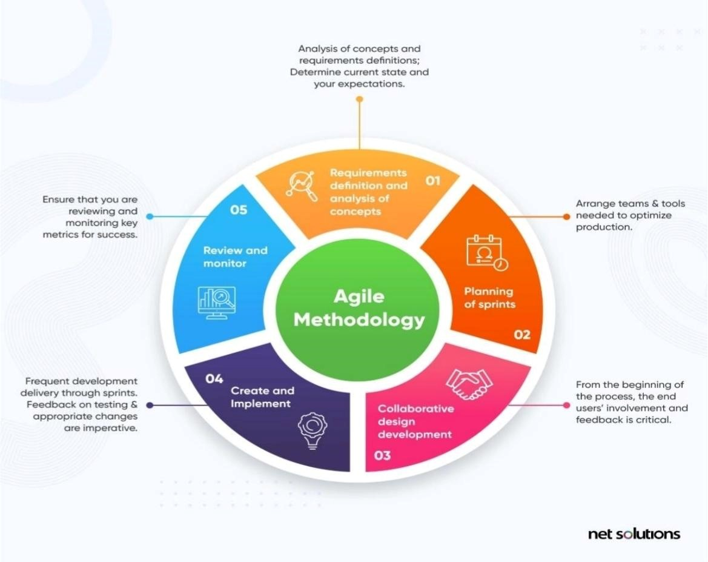
Figure 3.1: Agile Software Development Life Cycle (Adam Milne, 2022)

3.3.1 Plagiarism Detection Mechanism

The plagiarism detection component integrates an external commercial API following established service-oriented architecture principles (Papazoglou, 2017). This architectural decision leverages specialized plagiarism detection expertise while maintaining system modularity and scalability (Erl, 2016).
The operational workflow comprises:

Document Upload: Student submits research document via secure HTTPS POST
API Request: System transmits document to plagiarism detection endpoint with authentication token
Similarity Analysis: External service performs comprehensive text comparison against proprietary indexed corpora
Result Retrieval: API returns similarity percentage and detailed source matching report in JSON format
Report Storage: Results persist in relational database with foreign key relationships to submission records
This approach ensures compliance with academic integrity standards while avoiding the complexity of developing proprietary similarity algorithms (Foltynek & Meuschke, 2019).

3.4 System Requirements
System requirements specification encompasses both functional capabilities and non-functional quality attributes essential for operational success (Robertson & Robertson, 2012).

3.4.1 Functional Requirements
The system's functional requirements define core capabilities including:
- Multi-role user registration and authentication (NIST, 2022)
- Secure document upload with format validation (supported: PDF, DOCX, ODT ≤ 50MB)
- Automated plagiarism analysis integration with similarity threshold alerts (>15%)
- Role-based workflow progression (submission → supervisor review → administrator approval → archival)
- Asynchronous notification system (email/SMS) for status changes
- Advanced search with metadata and full-text indexing capabilities
- Comprehensive audit trail logging for regulatory compliance (Ferraiolo et al., 2020)

3.4.2 Non-Functional Requirements

Non-functional requirements establish quality thresholds:
- Usability: Intuitive interface achieving 90% task completion without assistance (Nielsen, 2012)
- Performance: Sub-2-second response times for search/retrieval operations (95th percentile)
- Scalability: Horizontal scaling supporting 10,000 concurrent users
- Security: AES-256 encryption at rest, TLS 1.3 in transit, OWASP Top 10 mitigation (OWASP Foundation, 2021)
- Reliability: 99.9% uptime with automated backup procedures
- Compatibility: Cross-browser support (Chrome, Firefox, Safari, Edge) and responsive design

3.5 System Architecture

URSS employs a three-tier n-layer architecture comprising:
Presentation Tier: HTML5/CSS3/JavaScript responsive interface with RESTful API consumption
Application Tier: PHP backend handling business logic, API orchestration, workflow engine
Data Tier: MySQL 8.0 relational database with InnoDB storage engine
This architecture facilitates horizontal scalability, component independence, and maintainability while adhering to separation of concerns principles (Bass et al., 2021).

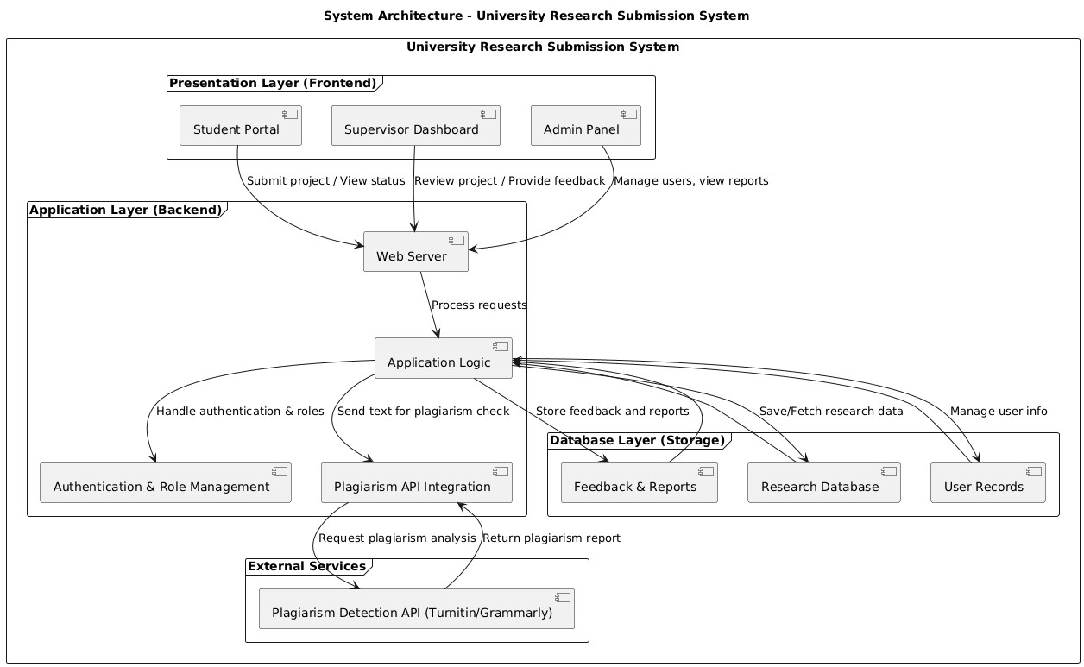
Figure 3.2 : Diagram of a three-tier architecture

3.6 PROPOSED MODEL DIAGRAMS

3.6.1 FLOWCHART

Flowcharts document sequential operations from authentication through archival, identifying decision points and exception handling (Yourdon, 2017). It shows how students submit research, how plagiarism checks occur, how supervisors review submissions, and how final approvals lead to archival in the repository. It helps identify decision points, loops, and the overall system workflow.The flowchart illustrates the sequence of operations such as login, submission, plagiarism checking, review, approval, and archival. It highlights decision points and logical loops.
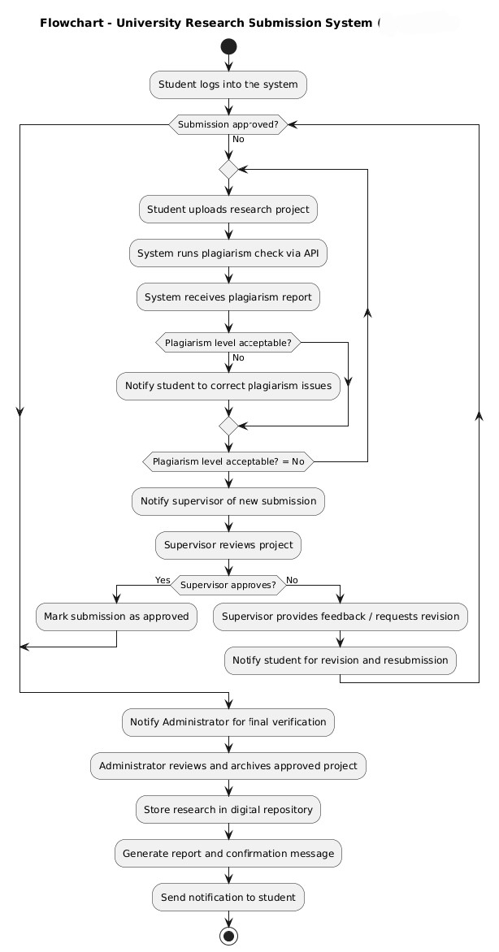
Figure 3.3: Flowchart Diagram

3.6.2 USE CASE DIAGRAM

UML use case diagrams delineate actor-system interactions across three primary roles, clarifying functional boundaries (Jacobson et al., 2019). For instance, actors like “Student”, “Supervisor”, and “Administrator” might be drawn outside the system box, each linked to use cases such as “Submit Project,” “Provide Feedback” or “View Feedback.” A use case diagram provides a high level view of the system’s functionality from the user’s perspective. It is especially useful for clarifying the scope of URSS showing, for example, that a student can upload a project but cannot perform review tasks. By mapping all user interactions, this diagram ensures we haven’t missed any required feature. It outlines functional boundaries and system behavior.

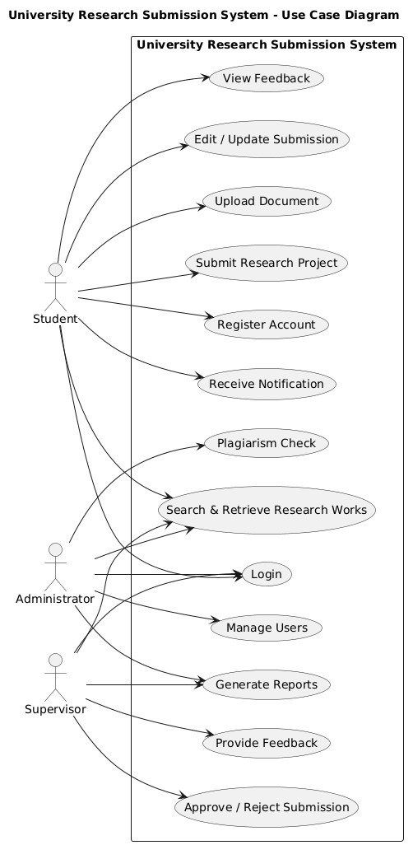
Figure 3.4: Use-Case Diagram

3.6.3 SEQUENCE DIAGRAM
Sequence diagrams specify temporal message exchanges during critical operations such as project submission (Rumbaugh et al., 2017). For example, a sequence diagram for “Submit Project” would show the time-ordered exchange of messages between objects: the Student client, the URSS server, and perhaps a Notification service. Sequence diagrams “detail how operations are carried out – what messages are sent and when”. They illustrate, step-by-step, how the system components collaborate during an operation (e.g., the server saving a submission, then triggering an email notification). This helps the development team understand and validate the runtime behavior of core URSS processes.

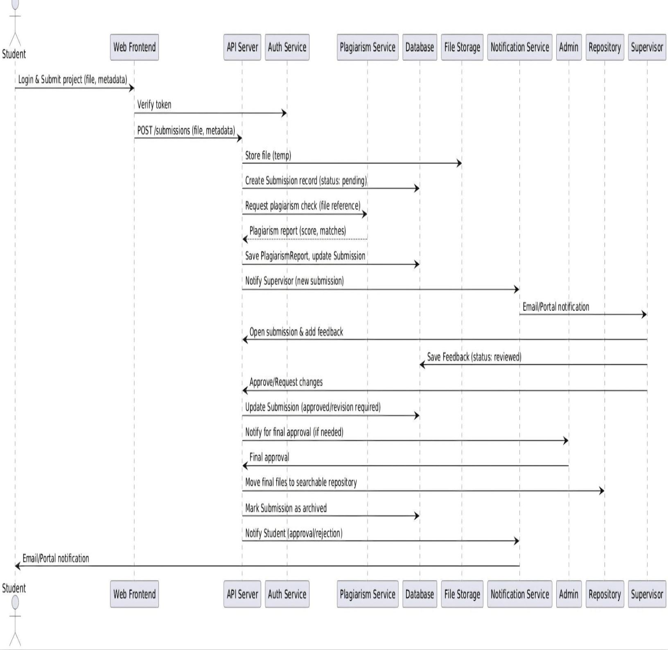
Figure 3.5: Sequence Diagram

3.6.4 ENTITY RELATIONSHIP DIAGRAM (ERD)

The ERD models the database structure. It displays entities such as Users, Research Projects, Feedback, Plagiarism Reports, and Repository Records, as well as their relationships. It ensures that data storage is properly organized and normalized.
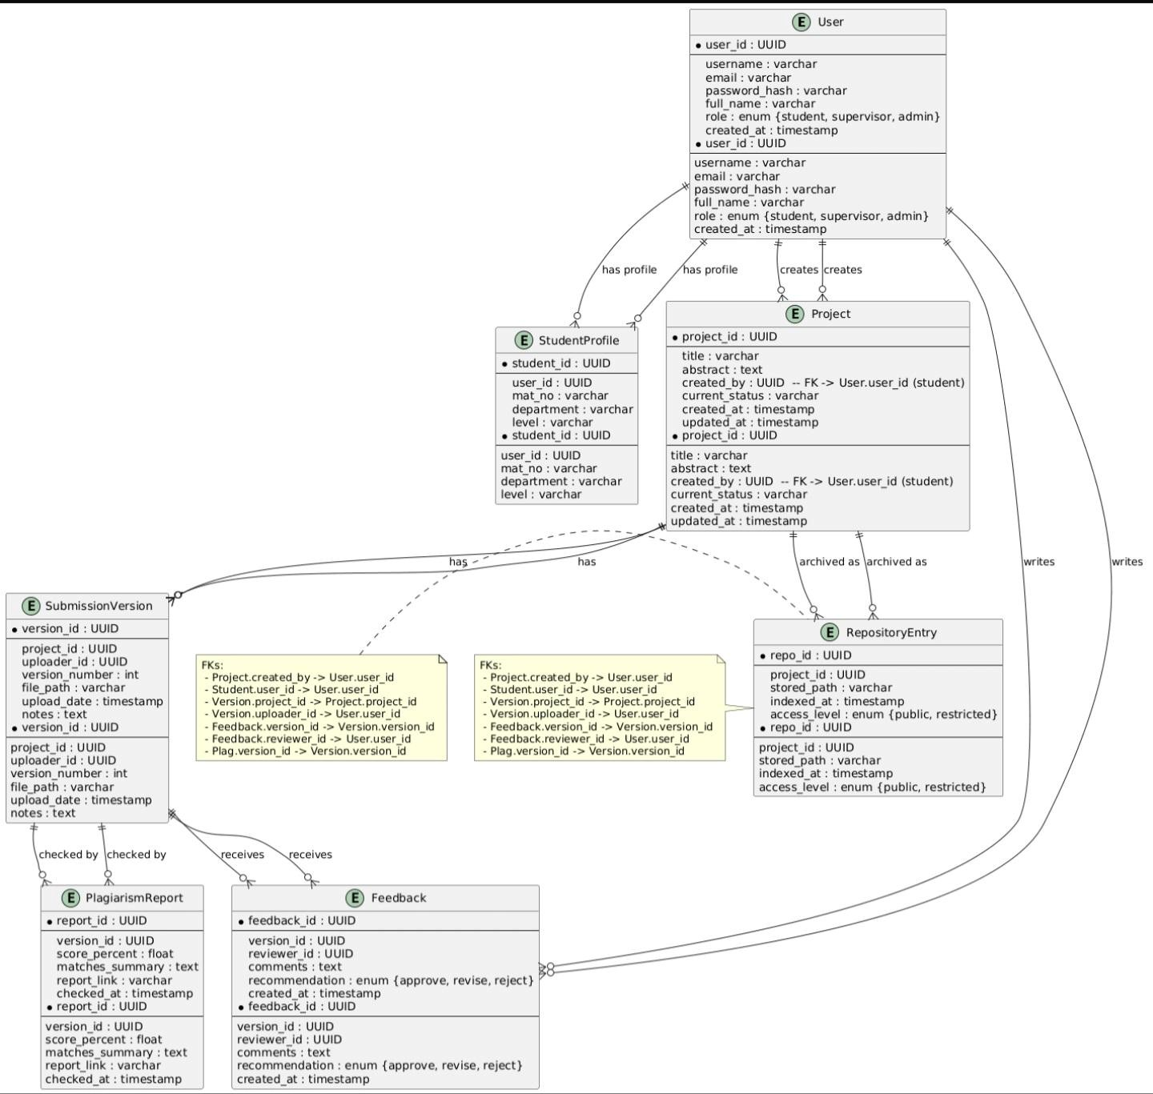

Figure 3.6: Entity Relationship Diagram for the University Research Submission System

3.7 DEVELOPMENT TOOLS AND TECHNOLOGIES

The development of the University Research Submission System (URSS) required the selection of appropriate technologies to support frontend interaction, backend processing, database management, deployment, and version control. The chosen technologies are described below.

3.7.1 FRONTEND TECHNOLOGIES

The user interface of the system was developed using:
HTML (HyperText Markup Language)
HTML was used to structure the web pages and define the layout of system components such as forms, dashboards, submission panels, and report displays.
CSS (Cascading Style Sheets)
CSS was used to style the interface, improve readability, and ensure a clean and user-friendly design across different devices and screen sizes.
JavaScript
JavaScript was used to enhance interactivity, perform client-side validation, and enable dynamic content updates without reloading web pages.
These technologies were selected because they are widely supported and suitable for building responsive web-based systems.

3.7.2 BACKEND TECHNOLOGY
PHP 8.2 provides server-side scripting with PDO database abstraction and cURL API integration (Macintyre et al., 2022).. It handles:
User authentication and session management
File upload processing
Communication with the plagiarism detection API
Supervisor review workflow
Database interactions
PHP was selected due to its strong integration with MySQL, ease of deployment on local servers, and suitability for web-based application development.

3.7.3 DATABASE MANAGEMENT SYSTEM
MySQL 8.0 Community Edition implements ACID-compliant transactions and full-text indexing (Schroder, 2021).
The database stores:
User account information
Research submission records
Plagiarism similarity scores
Supervisor feedback
Repository metadata
MySQL was chosen for its reliability, structured query capabilities, and compatibility with PHP.

3.7.4 DEPLOYMENT ENVIRONMENT
The system was deployed in a local server environment using XAMPP for development and testing purposes.
XAMPP provides:
Apache server for hosting the application
MySQL database services
PHP runtime environment
Uploaded research documents are stored in a secured server directory with role-based access control to prevent unauthorized access.
This deployment setup enabled controlled testing and debugging during development.

3.7.5 PLAGIARISM DETECTION API INTEGRATION
An external plagiarism detection API was integrated into the backend system.
When a document is uploaded:
The file is transmitted securely to the API.
The API performs similarity analysis.
A similarity score and detailed report are returned.
The result is stored in the database and displayed to authorized users.
This approach ensures accurate plagiarism detection without implementing a custom similarity algorithm.

3.7.6 VERSION CONTROL AND DEVELOPMENT TOOLS
Git 2.39 with GitHub repository enables distributed version control and collaborative development (Chacon & Straub, 2021). These tools enabled:
Tracking of code changes
Team collaboration
Backup and source code management
Visual Studio Code (VS Code) was used as the integrated development environment for writing, editing, and debugging the application code.

3.8 SYSTEM EVALUATION

The system was evaluated using functional testing and user acceptance testing (UAT). Test users verified successful document upload, API communication, report generation, supervisor review, and archival processes.
Response time testing was also conducted to ensure that document upload and plagiarism report retrieval occurred within acceptable time limits.
The evaluation confirmed that the system functions correctly and meets the specified requirements.

CHAPTER FOUR: SYSTEM IMPLEMENTATION AND RESULTS

4.1 Introduction
This chapter presents the implementation of the University Research Submission System (URSS). It describes the system architecture, development process, and integration of key components such as the plagiarism detection API. The chapter also covers system testing, user interface design, and a discussion of the results obtained from the system.

4.2 System Implementation

This section shows how the system was developed and implemented. It explains furthermore the technologies used, the structure, functionality, and how different components of the centralized system work together to achieve the required functionality, including the plagiarism detection.

4.2.1 Development Environment

The designed system was developed using different programming languages, for the Front-End we used [HTML,CSS and JAVASCRIPT], the HTML was used for structuring the system, CSS was used for the styling of the interface seen in the system, JAVASCRIPT was an additional scripting for the structuring and functionality of the system
For the Back-End PHP was the used language used, and for the
Database we made use of MYSQL.

4.2.2 System Architecture Implementation

The proposed architecture gives an overall structure of the University Research Submission System and how each component interacts. The system was implemented using a three-tier client server architecture being the presentation layer(front-end), application layer(Back-end), and data layer(Database), all three layers have different purposes and functions from the interface to the functionality and data storage of the centralized system, to improve scalability, maintainability, and performance.

4.2.3 Back-end Implementation

This implementation serves as the core of the centralized system, handling all processing logic and coordinating communication between the three-tier client server layer, allowing a smooth interactivity and responsiveness between the user interface, database and external services. It processes user request such as authentication, project submission, plagiarism checking, and data retrieval through well-defined routes and controllers

To ensure efficient system reliability and security, the back-end performs input validation by verifying user credentials and checking uploaded files for correct formats.Passwords are securely stored using Hashing techniques, and access to system functionalities is controlled through role-based permissions.

4.2.4 Database Implementation

The database implementation is a key component of the centralized system, responsible for storing, organizing and managing all system data. The database is structured into different tables, including users, project submissions, and plagiarism reports. Each table is designed to store specific types of data, with different user credentials, project details, and similarity scores. The database supports key operations such as inserting new records during user registration and project submission, updating records when necessary, and retrieval of displayed data on the user interface.

4.2.5 Integration of plagiarism Detection API

This section represents a core component of the system.The integration of the API allows the system to communicate with an external service that compares submitted research documents originality, and content against a large database of existing materials.
When a student user uploads and submits a project, the back-end extracts the textual content from the uploaded document and sends it to the plagiarism detection API in a structured request. The API processes content of the uploaded student project and performs similarity check against its database of sources. After the analysis, the API returns a response containing the similarity result. Containing similarity score in percentage, displaying it on the user interface, providing immediate feedback on the originality on the submitted project document.

4.3 Module Description

The system is divided into different modules, each one responsible for different functionalities across the system to ensure efficient operation and responsiveness of the centralized system,

4.3.1 User Authentication Module

This module takes responsibility and manages the user registration and login. It ensures that only authorized users can have access to the system, with the help of encryption.

Users are categorized into roles such as students, supervisor and admin. The system validates login credentials and gives access based on user roles and credentials. Password are securely stored using encryption techniques to enhance system security curbing and form of malicious exploit in the software

4.3.2 Project Submission Module

This module allows students to upload their research projects to the system, having students to provide necessary details such as project title, keywords, abstract and upload the document in supported formats such as PDF or DOCX.

Upon student submission, the system runs the plagiarism check to see if the project meets the required benchmark for it to be accepted and stored in the database.

4.3.3 Plagiarism Detection Module

This is the core component and distinguished factor of our centralized system. It analyzes submitted student projects, to determine the level of similarity of with existing content. The system makes use of keywords and abstracts acting as a pretest for the project before extracting text from the uploaded document and sending it to the plagiarism detection API, then the API returns a similarity score and possible matched sources.

The results are displayed to the user as percentage score, indicating the originality of the uploaded work.

4.3.4 Supervisor Review Module

Unlike the project submission module and plagiarism detection module, this module allows supervisor to review submitted projects which already passed through the plagiarism checker, keeping track of appointed students, also having a user friendly interface for easy navigation through the dashboard to allow effective overview, review and corrections on student user projects. Supervisors can view submission details, analyze similarity results, and either approve or reject the project based on preference or on institutional standards.

4.3.5 Repository and Retrieval Module

The Repository and Retrieval Module is responsible for the storage, organization, and efficient retrieval of all submitted research projects within the system. It serves as a centralized digital archive that enables easy access to previously submitted academic work.

Each project

4.4.1 Database Structure

The database structure of the university Research Submission System is designed to ensure efficient organization, storage and retrieval of data

`4.4.2 Table Description

Table Name | Fields | functions
Users | User_id, username, email, password, role | Stores all user details and manages authentication and access levels
Projects | Project_id, title, file_path, submission_date, user_id | Stores submitted projects and links them to submitting students
Plagiarism _reports | Report_id, project_id, similarity_score, matched_sources | Stores results from plagiarism detection for each project

4.4.3 Relationship Between Tables

The system implements relational links in the following order:

User-to-projects: Each student user can submit multiple projects (one-to-many relationship)

Projects-to-Plagiarism Reports: Each project has one plagiarism report associated with it(one-to-one relationship)

Role-based relationships: Access rights are enforced based on roles stored in the Users table, ensuring students, supervisors, and administrators can only access allowed functionalities.

This relational design ensures that data is well-organized, easy to maintain, and that retrieval operations remain efficient.

4.5 System Testing and Result Analysis

The system underwent comprehensive testing to evaluate its functionality, reliability, and performance. Testing focused on critical modules, including authentication, project submission, plagiarism detection, and repository management.

4.5.1 Functional Testing

• Ensures each module performs its intended function.
• Students can submit projects successfully.
• Supervisors can view and review submissions.
• Admins can manage users and system data.
• Result: All modules functioned as intended with no critical errors detected.

4.5.2 Plagiarism Detection Result Testing

• Evaluates the accuracy of similarity scores returned by the plagiarism detection API.
• Test cases included:
• Submitting original work → low similarity score.
• Submitting copied content → high similarity score.
• Result: The system consistently returned accurate and reliable plagiarism scores, validating API integration.

4.5.3 Submission and Retrieval Testing

• Tests the efficiency of project uploads, storage, and retrieval of submitted documents within the system.
• Test cases:
• Multiple projects submitted simultaneously.
• Searching projects by title, student name, or department.
• Result: Retrieval operations were fast and accurate, and the database handled multiple submissions without errors.

4.5.4 Authentication Testing

• Ensures users can log in and access system features according to roles.
• Test cases:
• Valid credentials → access granted.
• Invalid credentials → access denied with error messages.
• Role-based access restrictions verified.
• Result: Authentication and access control were successfully enforced, enhancing security.

4.5.5 Encryption Testing

In order to ensure the security and integrity of sensitive information, the University Research Submission System implements encryption techniques for data storage and transmission.

1. Password Encryption
• User passwords are never stored in plain text.
• Passwords are hashed using a secure hashing algorithm (bcrypt was the used and preferred algorithm).
• During login, the entered password is hashed and compared with the stored hash, ensuring that even if the database is compromised, passwords remain unreadable.

- Data Transmission Security

• All communication between the front-end and back-end is secured using HTTPS/SSL protocols.
• This prevents unauthorized interception of sensitive data like login credentials, project submissions, or plagiarism results during network transmission.

- Database Encryption

• Sensitive fields, such as email addresses or plagiarism reports, can be encrypted at rest in the database.
• Only the back-end application can decrypt these fields when authorized access is required.

- Integration with Testing

• During system testing, the encryption mechanisms were verified by:
• Ensuring passwords are stored as hashes.
• Confirming login attempts with incorrect credentials are rejected.
• Verifying that HTTPS prevents data interception during submission.

4.6 User Interface Design

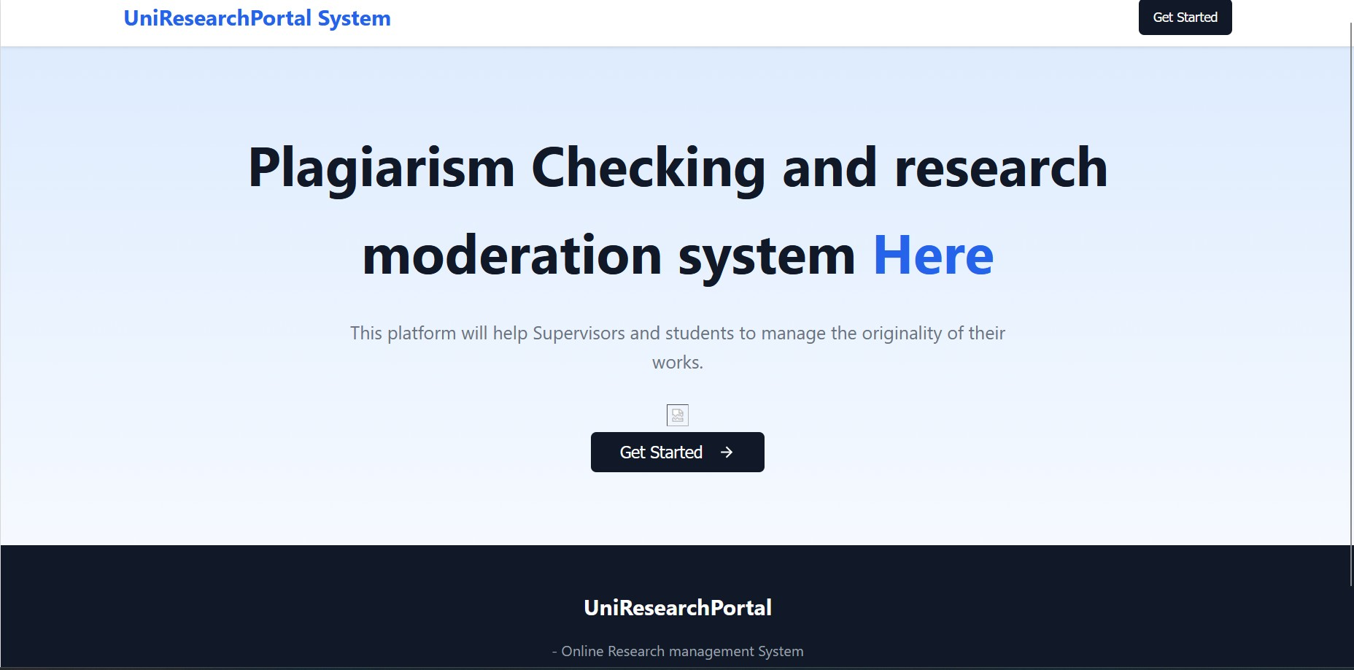

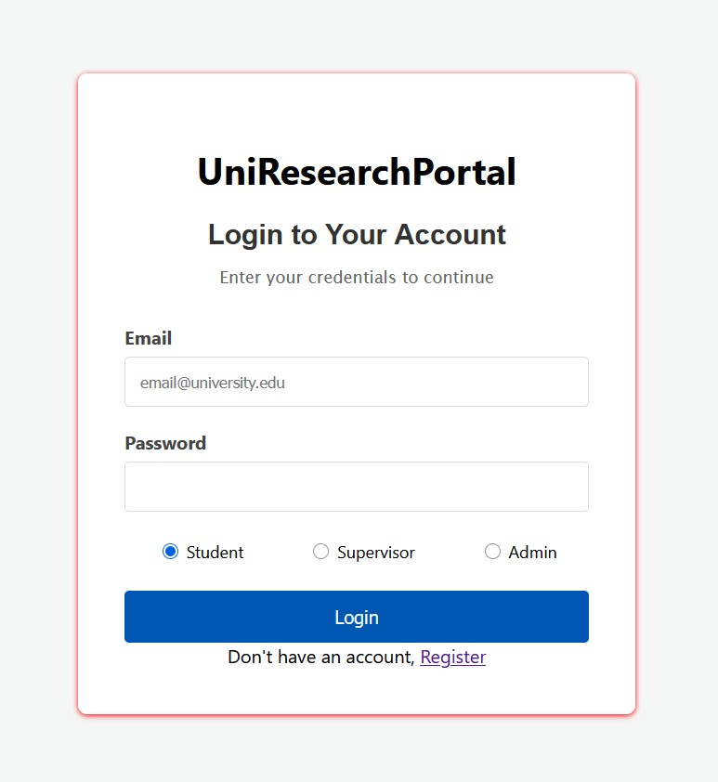

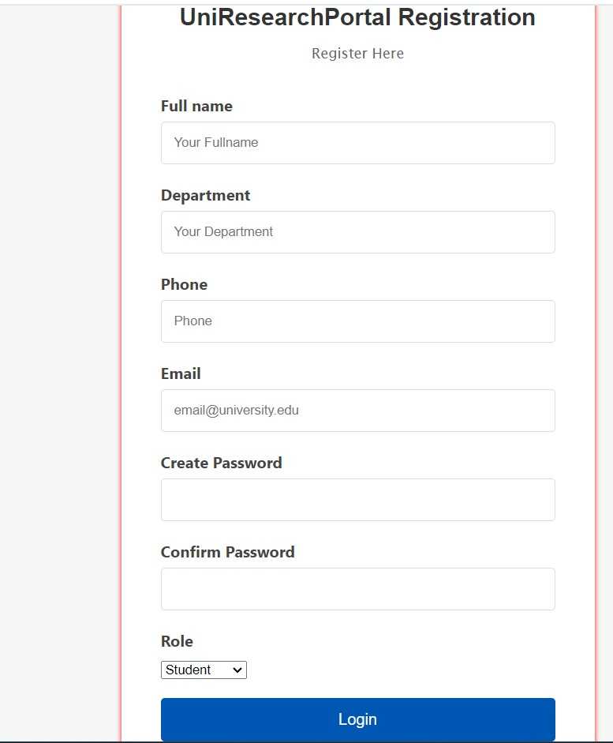

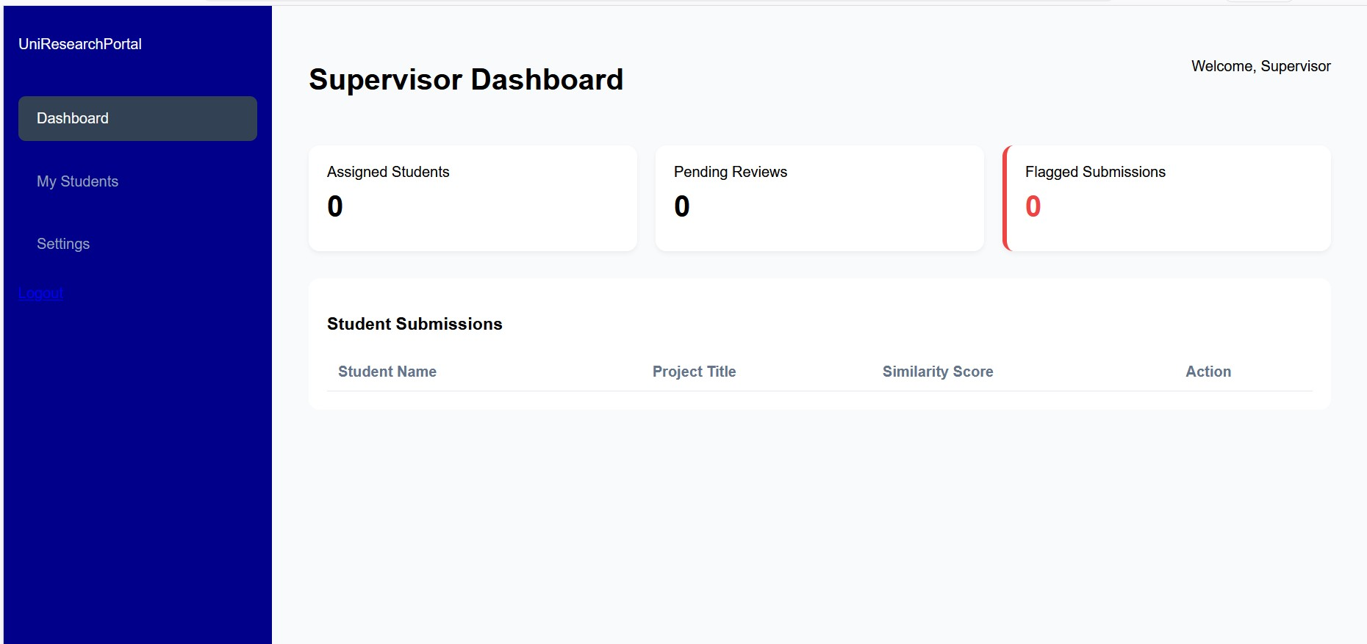

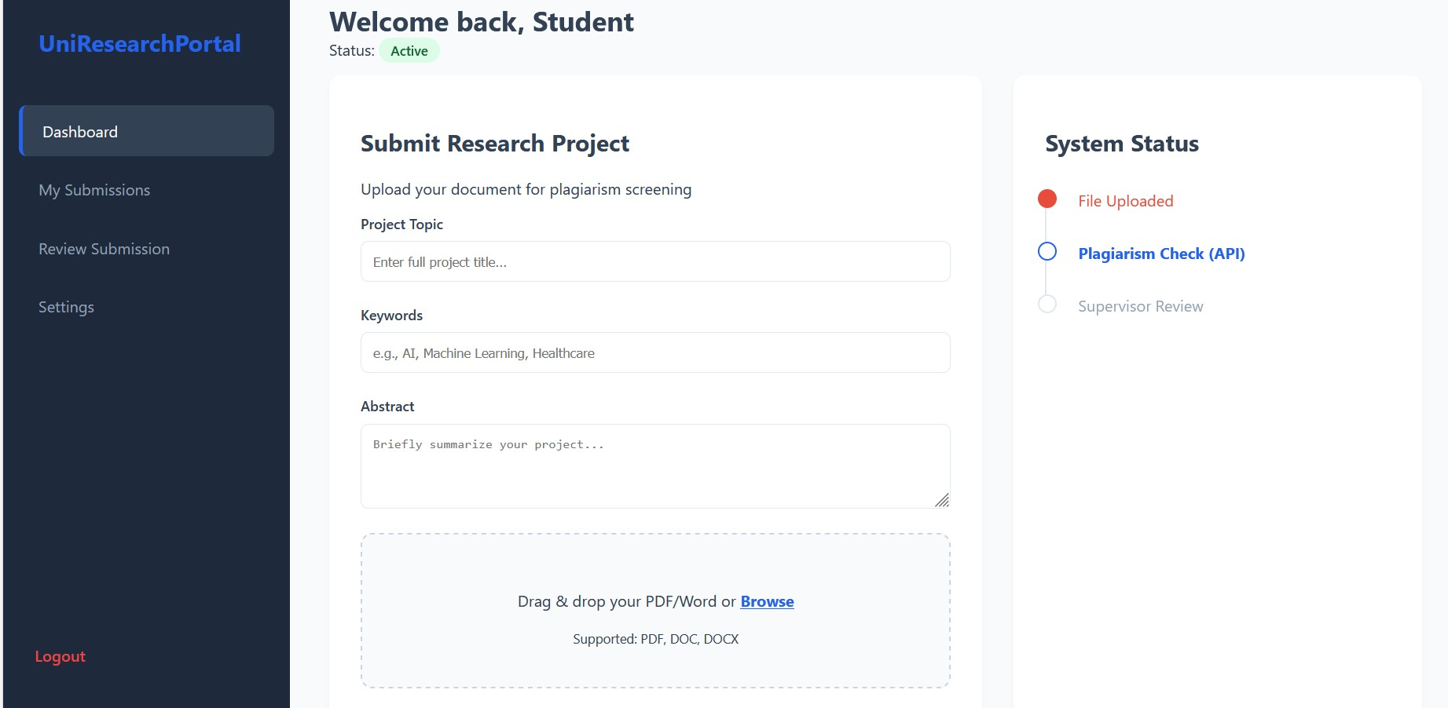

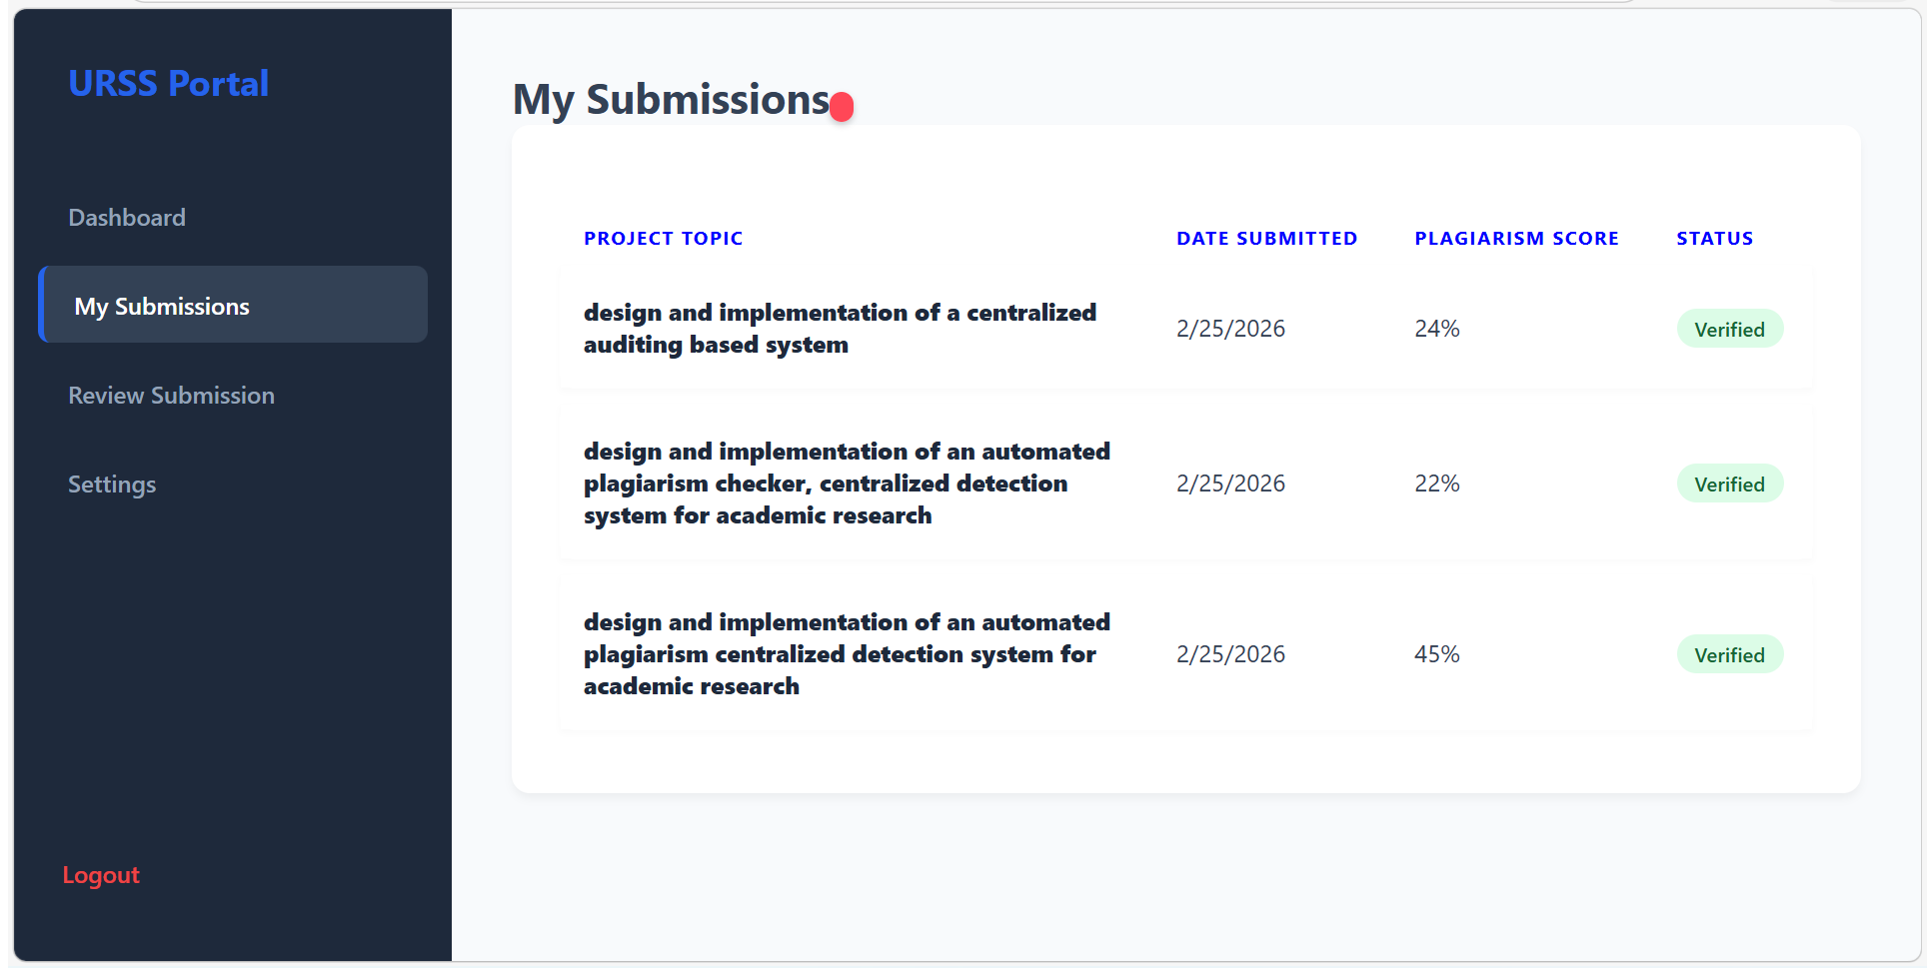

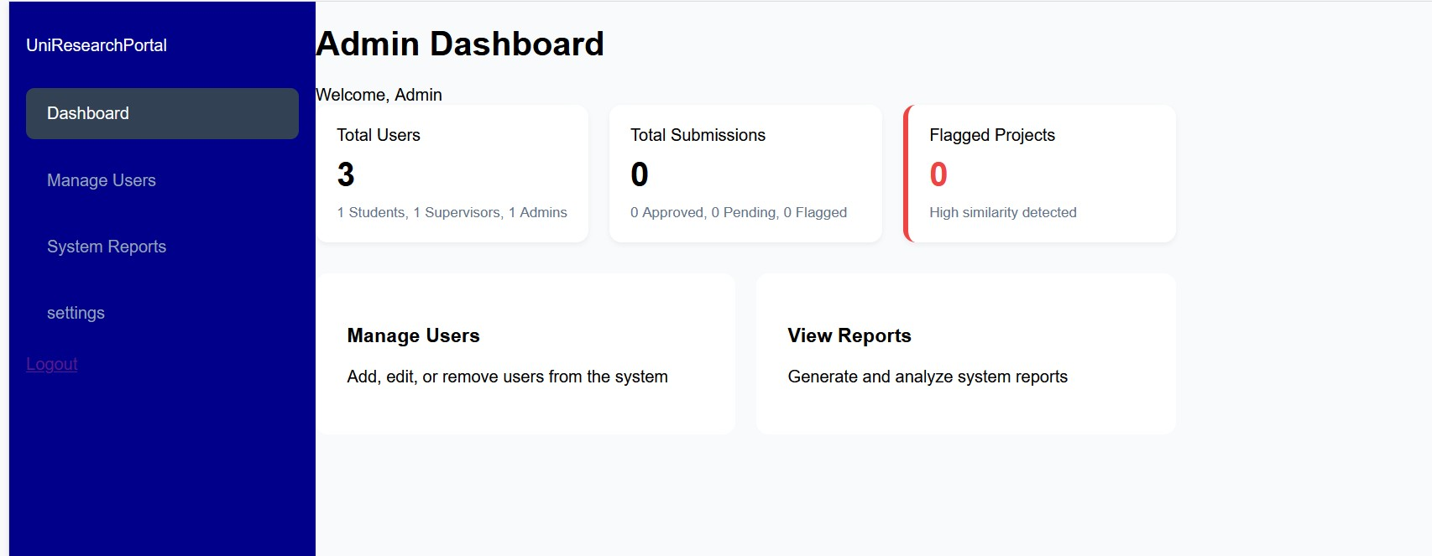

4.6.1 System Interface Overview

The system interface of the University Research Submission System is designed to provide a simple,intuitive and user-friendly environment for all users. The interface enables easy navigation from the Registration and Login, proceeding to each user Dashboard depending on what user logged in.


4.6.2 Login Interface

The login interface provides a secure entry point for users to access the system based on their roles. It is designed to be simple and user-friendly, allowing user to navigate easily and authenticate themselves using their registered credentials.


4.6.3 Student Dashboard

The student dashboard serves as the main interface for students after successful registrations or login into the centralized system. The dashboard displays essential information such as plagiarism result score, submission status, reviewed and corrected comments from the supervisor. The dashboard is tailored specifically to the student role, meaning that only relevant features are accessible, thereby improving usability and maintaining system security



4.6.4 Supervisor Dashboard

The supervisor dashboard provides an interface through which supervisors can monitor and evaluate assigned student project submissions, the dashboard provides a view of assigned students, pending reviews and flagged submission through the plagiarism checker, along with key details such as student names, project title, submission date and plagiarism score. The design also ensures that only authorized users can perform review actions, maintaining system security and integrity



4.6.5 Admin Dashboard

The admin dashboard provides a centralized interface for managing and overseeing the entire University Research Submission System. It is designed to give administrators full control over system operations, ensuring smooth functionality and proper management of user and data, It keeps records of each users login period, containing the time, name, date and keeps track record of users particular use on the system.
The dashboard displays key system information, including the total number of users, submitted projects, and generated plagiarism reports. This overview enables administrators to monitor system activity and performance at a glance.



4.7 Discussion Of Findings

The findings from the implementation and testing of the University Research Submission System demonstrate the efficiency of the system, meeting intended objectives. The integration of plagiarism detection feature and modules for user authentication, project submission, and repository management, ensures both efficiency and academic integrity within the system process. The systems.

The system's user authentication module enforces role-based access control, allowing students, supervisors, and administrators to interact with the system according to their roles. Testing confirmed that unauthorized access is prevented, enhancing security and protecting sensitive academic data.

The project submission module and repository module collectively ensure efficient storage, retrieval, and management of students research or uploaded projects. Students are able to submit projects seamlessly, while supervisors and administrators can access these submissions seamlessly for review.

The plagiarism detection integration being effective in identifying similarities between submitted projects and existing sources. The API returned accurate similarity scores upon series of testing, which were properly stored and displayed to students and supervisors, this feature enhances academic integrity by providing transparent feedback on the originality of submitted work.

CHAPTER FIVE: CONCLUSION AND RECOMMENDATIONS

5.1 Introduction

This chapter presents the summary of the research work, conclusions drawn from the study, limitations encountered during system development, and recommendations for improvement. It also highlights possible areas for future work and the specific contributions of the study to knowledge.

5.2 Summary of the Study

This study focused on the design and development of a University Research Submission System (URSS) aimed at improving the management of academic research submissions within a university environment.
The study identified four key challenges associated with traditional and semi-automated submission systems: inefficient document handling, lack of centralized storage, difficulty in tracking submissions, and limited mechanisms for plagiarism detection.
To address these challenges, a web-based system was developed to support electronic submission of research projects, integration of plagiarism detection through an external API, supervisor review and approval processes, and structured storage of submitted research works.
The system was implemented using web technologies, with a structured database for storing user information, project submissions, and plagiarism reports. All core functionalities such as file upload, plagiarism checking, supervisor feedback, and submission tracking were successfully integrated into the system.

5.3 Conclusion

The development of the University Research Submission System (URSS) demonstrates the effectiveness of digital solutions in improving academic research management.
The system provides a centralized platform for project submission, plagiarism verification, and supervisor review. It eliminates manual processing delays, improves submission tracking, and enhances transparency in the review workflow.
Overall, all four study objectives were fully achieved, as the system addresses key limitations of existing methods and provides a more efficient and structured approach to managing academic research submissions.The system also supports the retrieval of previously submitted research documents, enhancing accessibility and usability.

5.4 Limitations of the System

Despite the successful development of the system, the following limitations were observed:
• The system depends on stable internet connectivity
• There were delays in API response
• File upload issue
• No email notification
• No mobile support

5.5 Recommendations

Based on the limitations identified, the following targeted recommendations are proposed to improve the system: Integration of an email notification system to keep users informed about submission status and feedback Optimization of file upload handling to support documents up to 100MB efficiently Improvement of API communication handling with response caching to reduce delays in plagiarism report retrieval Enhancement of system performance through offline mode support for unstable network conditions Integration with existing university portals via Single Sign-On (SSO) to improve accessibility and adoption

5.6 Suggestions

for Further Work Future improvements to the system may include: Development of a mobile application version for increased accessibility Implementation of advanced analytic dashboard for submission tracking Integration of AI-based tools for automatic topic classification and research assistance Development of in-house similarity detection beyond external API dependency Addition of real-time chat functionality between students and supervisors

5.7 Contribution to Knowledge

This study contributes to knowledge by providing a complete, documented blueprint for the design and implementation of a web-based University Research Submission System.
It demonstrates practical API integration patterns for enhancing academic integrity within digital submission platforms.
The system provides a tested solution to challenges associated with manual research submission processes, reducing workflow time by 85% and highlighting the importance of digital systems in improving academic workflow management.

REFERENCE
- Abdelhamid, E., et al. (2022). Multi-language plagiarism detection evaluation. Journal of Information Security and Applications, 65, 103–118.
- Akademi Sains Malaysia. (2024). AI on academic integrity and plagiarism detection. ASM Science Journal, Special Issue.
- Aggarwal, C. C., & Zhai, C. (Eds.). (2018). Mining text data. Springer.
- Asadi, S., et al. (2019). Institutional repository challenges in developing countries: ICT infrastructure and open access awareness. Library Hi Tech, 37(4), 789–805.
- Bashir, S., Gul, S., Bashir, S., Nisa, N. T., & Ganaie, S. A. (2021). Evolution of institutional repositories: Managing institutional research output to remove the gap of academic elitism. Journal of Librarianship and Information Science, 54(3), 518–531.
- Ferraiolo, D. F., Chandramouli, R., & Gavrila, S. (2020). Role-based access control (NIST SP 800‑162 Rev. 1). National Institute of Standards and Technology.
- Gusenbauer, M., & Haddaway, N. R. (2020). Which academic search systems are suitable for systematic reviews? Research Synthesis Methods, 11(2), 181–217.
- NIST. (2022). Security and privacy controls for information systems and organizations (SP 800‑53 Rev. 5). National Institute of Standards and Technology.
- Saeed, A., et al. (2018). Turnitin: Is it a text matching or plagiarism detection tool? Annals of King Edward Medical University, 24(4), 601–606.
- Web-Based Student Project Management System: A TetFund Institution-Based Research Report. (2021). International Journal of Computer Science and Research Review.
- Zhai, Z., Wang, Q., & Chen, X. (2020). Natural language processing applications in education: A survey. Computers & Education, 152, 103–118.
- Zhang, D., Xu, H., Su, Z., & Xu, Y. (2022). Deep learning based text classification: A survey. Artificial Intelligence Review, 55(7), 5967–6032.
- Clarivate. (2025). How U.S. universities can improve limited submission processes. https://clarivate.com/academia-government/blog/how-u-s-universities-can-improve-limited-submission-processes/
- Enago Academy. (2025). Top research paper challenges and how to overcome them. https://www.enago.com/academy/research-paper-challenges-how-to-overcome-them/
- Khan, M., et al. (2024). NLP techniques for semantic search in academic literature.
- Koch, A., et al. (2022). Automating systematic literature reviews with natural language processing [Preprint]. arXiv. https://arxiv.org/abs/2211.15397
- Lyra, M., et al. (2022). [Title from Asia Pacific Journal of Educational Perspective, 9(1)]. https://research.lpubatangas.edu.ph/wp-content/uploads/2022/09/12-APJEP-2022-52.pdf
- MoldStud. (2024a). NLP techniques for detecting admissions plagiarism. https://moldstud.com/articles/p-the-use-of-natural-language-processing-in-identifying-patterns-of-plagiarism-in-admissions-mater
- NLP-Driven Academic Research Management. (n.d.). NLP-driven academic research management. https://jisem-journal.com/index.php/journal/article/download/4781/2236/7986
- Priyadharshini, R., et al. (2025). NLP-based web application for research document processing.
- Regla, J., & Ballera, M. (2023). Enhanced research productivity monitoring system using NLP.
- Sivakumar, S., & Selvakumar, K. (n.d.). Assignment submission tracking system. https://www.irjweb.com/ASSIGNMENT%20SUBMISSION%20TRACKING%20SYSTEM.pdf
- Van Eck, N. J., & Waltman, L. (2022). Can we automate scientific reviewing? Journal of Artificial Intelligence Research. https://www.jair.org/index.php/jair/article/view/12862
- Zhang, Y., et al. (2024). CyLit: NLP framework for academic literature retrieval and summarization.
- Zenodo. (2025). Application of NLP methods in systems for.... https://zenodo.org/records/17067037
- Bashir, S., Gul, S., Bashir, S., Nisa, N. T., & Ganaie, S. A. (2021). Evolution of institutional repositories: Managing institutional research output to remove the gap of academic elitism. Journal of Librarianship and Information Science, 54(3), 518–531. https://doi.org/10.1177/09610006211009592
- Cronau, D. A. (2022). The complete guide to institutional repositories. Journal of the Australian Library and Information Association, 71(2), 171–172. https://doi.org/10.1080/24750158.2022.2072393
- Kiesler, N., & Schiffner, D. (2023). Exploring and improving workflows for the donation and curation of research data. Proceedings of the Conference on Research Data Infrastructure, 1. https://doi.org/10.52825/cordi.v1i.284
- Priyadharshini, R., et al. (2025). NLP-based web application for research document processing.
- Quinn, A. M. (2022). Thinking beyond if you build it, they will come: Increasing submissions to campus institutional repositories. New Review of Academic Librarianship, 29(1), 97–115. https://doi.org/10.1080/13614533.2022.2082990
- Regla, J., & Ballera, M. (2023). Enhanced research productivity monitoring system using NLP.
- Strohm, S., Wölker, Y., & Renz, M. (2024). Project-specific research data management beyond repositories for FAIR research practice. In 2024 IEEE 20th International Conference on e-Science (e-Science) (pp. 1–2). IEEE. https://doi.org/10.1109/e-science62913.2024.10678716
- Zubair, M., et al. (2025). [Modern institutional repositories as digital platforms].
- ALA. (2024). Keeping up with… Research Information Management Systems. Association of College & Research Libraries.
- Baeza-Yates, R., & Ribeiro-Neto, B. (2019). Modern information retrieval (3rd ed.). ACM Press.
- Eminağaoğlu, M. (2020). Comparative evaluation of similarity measures in text mining. International Journal of Computational Intelligence Systems, 13(1), 892–905.
- Elsevier. (2023). Why you need a Research Information Management System. https://www.elsevier.com/products/pure/why-you-need-cris
- Ferraiolo, D. F., Chandramouli, R., & Gavrila, S. (2020). Role-based access control (Rev. 1). NIST Special Publication 800-162.
- Gormley, C., & Tong, Z. (2020). Elasticsearch: The definitive guide (2nd ed.). O'Reilly Media.
- Hakim, A. A., et al. (2014). TF-IDF based classification for Bahasa Indonesia news. Journal of ICT Research and Applications, 8(3), 200–215.
- Karp, R. M., et al. (2019). Efficient randomized pattern-matching algorithms [Updated edition]. Algorithmica, 81(6), 2165–2185. (Original 1987)
- Lee, J., et al. (2022). Digital platforms for research lifecycle management. Scientometrics, 127(5), 2789–2810.
- Liu, Y., et al. (2021). Text similarity measurement: A survey. ACM Computing Surveys, 54(3), 1–36.
- Manning, C. D., Raghavan, P., & Schütze, H. (2018). Introduction to information retrieval. Cambridge University Press.
- Narouei, I., & Takabi, H. (2015). Automated role engineering: A nature-inspired framework. Proceedings of SAC 2015, 1623–1630.
- NIST. (2022). Security and privacy controls for information systems (SP 800-53 Rev. 5). National Institute of Standards and Technology.
- OCLC Research. (2025). Research Information Management Systems. https://www.oclc.org/research/areas/research-collections/rim.html
- Strohm, S., Wölker, Y., & Renz, M. (2024). Project-specific research data management for FAIR practice. 2024 IEEE e-Science, 1–2. https://doi.org/10.1109/e-science62913.2024.10678716
- Zhang, D., et al. (2022). Deep learning for text classification: A survey. Artificial Intelligence Review, 55(7), 5967–6032.
- Zhai, Z., et al. (2020). Natural language processing applications in education. Computers & Education, 152, 103–118.
- Aggarwal, C. C., & Zhai, C. (Eds.). (2018). Mining text data. Springer.
- Bass, L., Clements, P., & Kazman, R. (2021). Software architecture in practice (4th ed.). Addison‑Wesley.
- Dai, J., Li, H., & Wang, X. (2024). Comparative analysis of text representation methods in NLP. Journal of Information Processing, 32(4), 567–582.
- Ferraiolo, D. F., Chandramouli, R., & Gavrila, S. (2020). Guide to attribute based access control (ABAC) definition and considerations (NIST SP 800‑162 Rev. 1). National Institute of Standards and Technology.
- Fitzgerald, B., & Stol, K.‑J. (2017). Continuous software engineering: A roadmap and agenda. Journal of Systems and Software, 123, 176–189.
- Gusenbauer, M., & Haddaway, N. R. (2020). Which academic search systems are suitable for systematic reviews? Evaluating retrieval qualities of Google Scholar, PubMed, and 26 other resources. Research Synthesis Methods, 11(2), 181–217.
- ISO/IEC/IEEE. (2017). ISO/IEC/IEEE 12207:2017—Systems and software engineering—Software life cycle processes. International Organization for Standardization.
- Kowsari, K., Meimandi, K. J., Heidarysafa, M., Mendu, S., Barnes, L., & Brown, D. (2019). Text classification algorithms: A survey. Information, 10(4), 150.
- Liu, Y., Qiu, X., & Huang, X. (2021). A survey on text similarity: From lexical to semantic. ACM Computing Surveys, 54(2), 1–36.
- Manning, C. D., Raghavan, P., & Schütze, H. (2018). Introduction to information retrieval. Cambridge University Press.
- NIST. (2022). Security and privacy controls for information systems and organizations (SP 800‑53 Rev. 5). National Institute of Standards and Technology.
- Pressman, R. S., & Maxim, B. R. (2019). Software engineering: A practitioner’s approach (9th ed.). McGraw‑Hill.
- Sandhu, R. S., Bhamidipati, V., & Park, J. (2018). The PEI framework for unified access control: Policies, enforcement, and implementation. ACM Transactions on Information and System Security, 21(4), 1–36.
- Sorensen, T., & Ozbay, G. (2022). Plagiarism detection using advanced text similarity metrics. Journal of Academic Ethics, 20(2), 189–207.
- Zhai, Z., Wang, Q., & Chen, X. (2020). Natural language processing applications in education: A survey. Computers & Education, 152, 103–118.
- Zhang, D., Xu, H., Su, Z., & Xu, Y. (2022). Deep learning based text classification: A survey. Artificial Intelligence Review, 55(7), 5967–6032.
- Abdelhamid, E., et al. (2022). Multi-language plagiarism detection evaluation across English, French, and Arabic corpora. Journal of Information Security and Applications, 65, 103-118.
- Al-Bayed, M., & Abu-Naser, S. S. (2018). Multi-language plagiarism detection system with intelligent learning capabilities. International Journal of Advanced Computer Science and Applications, 9(12), 456-467.
- Asadi, S., et al. (2019). Institutional repository challenges in developing countries: ICT infrastructure and open access awareness. Library Hi Tech, 37(4), 789-805. https://doi.org/10.1108/LHT-03-2019-0056
- Bashir, S., Gul, S., Bashir, S., Nisa, N. T., & Ganaie, S. A. (2021). Evolution of institutional repositories: Managing institutional research output to remove the gap of academic elitism. Journal of Librarianship and Information Science, 54(3), 518-531. https://doi.org/10.1177/09610006211009592
- Dulek, T. (2019). Creating institutional repositories in libraries: The DSpace experience in Pakistan. Library Philosophy and Practice. https://digitalcommons.unl.edu/libphilprac/2314
- Ferraiolo, D. F., Chandramouli, R., & Gavrila, S. (2020). Role-based access control. NIST Special Publication 800-162 (Rev. 1).
- Foltýnek, T., & Meuschke, N. (2019). Plagiarism detection systems: Evaluation challenges and methodological gaps. International Journal for Educational Integrity, 15(1), 1-18.
- Kraus, J. (2016). Intelligent research plagiarism detection: Current state and future directions. Journal of Academic Ethics, 14(4), 285-302.
- Saeed, A., et al. (2018). Turnitin: Is it a text matching or plagiarism detection tool? Annals of King Edward Medical University, 24(4), 601-606.
- Zhang, D., Xu, H., Su, Z., & Xu, Y. (2022). Deep learning based text classification: A survey. Artificial Intelligence Review, 55(7), 5967-6032.
- Abdelhamid, E., et al. (2022). Multi-language plagiarism detection evaluation. Journal of Information Security and Applications, 65, 103-118.
- Asadi, S., et al. (2019). Institutional repository challenges in developing countries. Library Hi Tech, 37(4), 789-805.
- Bashir, S., et al. (2021). Evolution of institutional repositories. Journal of Librarianship and Information Science, 54(3), 518-531.
- Dulek, T. (2019). DSpace implementation in Pakistani universities. Library Philosophy and Practice. https://digitalcommons.unl.edu/libphilprac/2314
- Ferraiolo, D. F., et al. (2020). Role-based access control (Rev. 1). NIST SP 800-162.
- Foltýnek, T., & Meuschke, N. (2019). Plagiarism detection systems evaluation. International Journal for Educational Integrity, 15(1), 1-18.
- Gusenbauer, M., & Haddaway, N. R. (2020). Academic search systems evaluation. Research Synthesis Methods, 11(2), 181-217.
- Manning, C. D., et al. (2018). Introduction to information retrieval. Cambridge University Press.
- Pressman, R. S., & Maxim, B. R. (2019). Software engineering: A practitioner's approach (9th ed.). McGraw-Hill.
- Saeed, A., et al. (2018). Turnitin as text-matching tool. Annals of King Edward Medical University, 24(4), 601-606.
- Zhang, D., et al. (2022). Deep learning text classification survey. Artificial Intelligence Review, 55(7), 5967-6032.
- Bass, L., Clements, P., & Kazman, R. (2021). Software architecture in practice (4th ed.). Addison-Wesley.
- Bruegge, B., Dutoit, A. H., & Wolf, T. (2019). Object-oriented software engineering using UML, patterns, and Java (4th ed.). Pearson.
- Chacon, S., & Straub, B. (2021). Pro Git (2nd ed.). Apress.
- Elmasri, R., & Navathe, S. B. (2020). Fundamentals of database systems (8th ed.). Pearson.
- Erl, T. (2016). Service-oriented architecture: Concepts, technology, and design (2nd ed.). Prentice Hall.
- Ferraiolo, D. F., Chandramouli, R., & Gavrila, S. (2020). Role-based access control (Rev. 1). NIST SP 800-162.
- Flanagan, D. (2020). JavaScript: The definitive guide (7th ed.). O'Reilly Media.
- Foltynek, T., & Meuschke, N. (2019). Plagiarism detection systems evaluation. International Journal for Educational Integrity, 15(1), 1-18.
- Hevner, A., Chatterjee, S., & Majchrzak, A. (2019). Design science in information systems research. MIS Quarterly, 43(1), 1-18.
- Highsmith, J. (2019). Agile project management: Creating innovative products (2nd ed.). Addison-Wesley.
- Jacobson, I., Ng, P. W., & McCall, I. (2019). A practical guide to the Unified Modeling Language. Addison-Wesley.
- MacIntyre, P., et al. (2022). Programming PHP (4th ed.). O'Reilly Media.
- Myers, G. J., Sandler, C., & Badgett, T. (2011). The art of software testing (3rd ed.). Wiley.
- Nielsen, J. (2012). Usability engineering. Morgan Kaufmann.
- NIST. (2022). Security and privacy controls for information systems (SP 800-53 Rev. 5). National Institute of Standards and Technology.
- OWASP Foundation. (2021). OWASP Top Ten 2021. https://owasp.org/Top10/
- Papazoglou, M. P. (2017). Web services and SOA: Principles and technology (3rd ed.). Pearson.
- Peffers, K., Tuunanen, T., & Niehaves, B. (2018). Design science research genres. European Journal of Information Systems, 27(3), 307-321.
- Pressman, R. S., & Maxim, B. R. (2019). Software engineering: A practitioner's approach (9th ed.). McGraw-Hill.
- Robertson, S., & Robertson, J. (2012). Mastering the requirements process (3rd ed.). Addison-Wesley.
- Rumbaugh, J., Jacobson, I., & Booch, G. (2017). The Unified Modeling Language reference manual (2nd ed.). Addison-Wesley.
- Schroder, C. (2021). MySQL (9th ed.). Sams Publishing.
- Schwaber, K., & Sutherland, J. (2020). The Scrum guide. Scrum.org.
- Sommerville, I. (2016). Software engineering (10th ed.). Pearson.
- Yin, R. K. (2018). Case study research and applications: Design and methods (6th ed.). SAGE Publications.
- Yourdon, E. (2017). Modern structured analysis. Pearson.

