MINISTRY OF SCIENCE AND HIGHER EDUCATION OF THE REPUBLIC OF KAZAKHSTAN

INTERNATIONAL INFORMATION TECHNOLOGY UNIVERSITY

FACULTY OF DIGITAL TRANSFORMATIONS

**Bagdat Azamat,**

**Mukanbai Erdana,**

**Zhaksylyk Daulet,**

**Oryngaliev Ernur**

**Development of an intelligent information system “Mediog” for medical care for patients**

**DIPLOMA PROJECT**

**Major 6B06105 – Information Systems**

Almaty 2024

MINISTRY OF SCIENCE AND HIGHER EDUCATION OF THE REPUBLIC OF KAZAKHSTAN

INTERNATIONAL INFORMATION TECHNOLOGY UNIVERSITY

DEPARTMENT OF INFORMATION SYSTEMS

**Approved**

Head of the Information Systems

Department,

PhDc

___________Kozhamzharova D.Kh.

«___»_____________________2024

**DIPLOMA PROJECT**

**Development of an intelligent information system “Mediog” for medical care for patients**

Major 6В06105 – Information Systems

|  |  |  |
| --- | --- | --- |
| Done by: | Bagdat A.K.  «___» ______2024 | ___________________  (signature) |
|  | Mukanbai E.  «___» ______2024 | ___________________  (signature) |
|  | Zhaksylyk D.A.  «___» ______2024 | ___________________  (signature) |
|  | Oryngaliev E.E.  «___» ______2024 | ___________________  (signature) |
| Research supervisor: | Naizabayeva L.K.  «___» ______2024 | ___________________  (signature) |
| Reviewer: | Belgibayev B.A.  «___» ______2024 | ___________________  (signature) |

Almaty 2024

International Information Technology University

Faculty of Digital Transformations

Department of Information Systems

Major 6В06105 – Information Systems

Diploma Project

Students

**Bagdat Azamat, Mukanbai Erdana, Zhaksylyk Daulet, Oryngaliev Ernur.**

Diploma project topic

**Development of an intelligent information system “Mediog” for medical care for patients**

Approved by IITU order № ___ dated «___» ______ 2024

Diploma project submission date «___» ______ 2024

Diploma project initial data

____________________________________________________________________

____________________________________________________________________

____________________________________________________________________

Details of computations and explanations (list of issues due to be addressed)

____________________________________________________________________

____________________________________________________________________

____________________________________________________________________

CD containing the digital version of diploma project and attachments

____________________________________________________________________

____________________________________________________________________

____________________________________________________________________

Consultations on diploma project (with related project chapters named)

|  |  |  |  |
| --- | --- | --- | --- |
| Consultant | Name | Signature, date | |
| Assignment given | Assignment received |
| Consultant on  Economic  effectiveness of  the project |  |  |  |
| English  language  consultant |  |  |  |
| Compliance  monitor |  |  |  |

|  |  |
| --- | --- |
| Date «___» ______ 2024 |  |
| Research supervisor | ___________________  (signature) |
| Assignment received by | ___________________  (signature) |

Diploma project writing schedule

**Bagdat Azamat,**

**Mukanbai Erdana,**

**Zhaksylyk Daulet,**

**Oryngaliev Ernur**

Title: **Development of an intelligent information system “Mediog” for medical care for patients**

|  |  |  |
| --- | --- | --- |
| № | Assignment | Submission date |
|  | Creation of the diploma project writing schedule | November 30 |
|  | Collection, study, processing, analyzing, and generalizing data | November – December |
|  | Drafting and submission to the Research supervisor (Introduction, Chapter 1, Chapter 2, Chapter 3, Chapter 4, Conclusion) | January – February |
|  | Submission of the chapter «Economic effectiveness of the project» to the consultant | March – April |
|  | Revision of the diploma project with due consideration of the supervisor’s comments | March – April |
|  | Submission of the completed diploma project to the Research supervisor | April 15 |
|  | Pre-defence | April |
|  | Submission of the completed diploma project to the English language consultant | April 20 – May 10 |
|  | Submission of the diploma project to the compliance monitor | May 5 – May 22 |
|  | Submission of the diploma project for the plagiarism checkup | May 10 – May 27 |
|  | Submission to the reviewer for approval | May 3 – May 25 |
|  | Diploma project defense | June 1 – June 17 |

|  |  |  |
| --- | --- | --- |
| Student: |  | ___________________  (signature) |
| Research supervisor: |  | ___________________  (signature) |
| Date «___» ______ 2024 |  |  |

АҢДАТПА

Осы дипломдық жоба аясында пациенттерге жоғары сапалы медициналық көмек көрсетуге бағытталған "Mediog" атты инновациялық ақпараттық жүйе әзірленді.

"Mediog" медициналық қызметтер мен ақпаратқа оңай және тиімді қол жеткізуді қамтамасыз ете отырып, медициналық мекемелер мен пациенттер арасындағы өзара әрекеттестікті төңкеріс жасау мақсатында құрылған. Бұл ақпараттық жүйе пациенттерге кездесуге жазылуға, медициналық тарихты бақылауға, сондай-ақ медициналық қызметкерлермен өзара әрекеттесуге мүмкіндік береді.

Осы мақсатқа жету үшін Figma қолданушы интерфейсін жобалау үшін, содан кейін оны жүзеге асыру үшін HTML, CSS және JavaScript қолданылды. TypeScript және jQuery қолдану жүйенің алдыңғы жағында өнімділік пен сенімділікті жақсартуға ықпал етті. Python және Django шеңберін пайдалану жүйенің тұрақты жұмысын және деректер қауіпсіздігін қамтамасыз ете отырып, артқы жағын тиімді басқаруға мүмкіндік берді.

"Mediog" негізгі компоненті-жасанды интеллектпен интеграция. Бұл инновациялық тәсіл жүйеге Денсаулық сақтау бойынша жеке ұсыныстар беруге, пациенттердің деректерін талдауға және аурудың ықтимал проблемаларын болжауға мүмкіндік береді. "Mediog" - тегі жасанды интеллект пациенттер үшін бірегей тәжірибе жасайды, сонымен қатар медицина қызметкерлеріне негізделген шешімдер қабылдау үшін құнды құралдарды ұсынады.

Жүйенің негізгі сипаттамасы-деректерді сақтау үшін PostgreSQL пайдалану. Бұл реляциялық мәліметтер базасы пациенттердің медициналық ақпаратын сақтаудың сенімділігін, тұтастығын және тиімділігін қамтамасыз етеді.

"Mediog" ішіндегі REST API алдыңғы және артқы жағы арасындағы өзара әрекеттесудің стандартталған және ыңғайлы әдісін ұсынады. Бұл жүйенің икемділігіне ықпал етеді және функционалдылықты одан әрі кеңейтуге мүмкіндік береді.

"Mediog" жалпы архитектурасы ауқымдылықты және болашақ жаңартуларға дайындықты қамтамасыз етеді. Бұл ақпараттық жүйе денсаулық сақтаудың интеграцияланған және интеллектуалды тәсілін ұсынады, бұл денсаулық сақтаудың заманауи тәжірибелеріне жаңа жол ашады.

Дипломдық жоба N беттердегі түсіндірме жазбадан тұрады, оның ішінде N сурет, N кестелер, N сілтемелер тізімі және n қосымша.

АННОТАЦИЯ

В рамках данного дипломного проекта была проведена разработка инновационной информационной системы под названием "Mediog", нацеленной на предоставление высококачественной медицинской помощи пациентам.

"Mediog" создана с целью революционизировать взаимодействие между медицинскими учреждениями и пациентами, обеспечивая легкий и эффективный доступ к медицинским услугам и информации. Эта информационная система предоставляет пациентам возможность записи на прием, мониторинга истории болезни, а также взаимодействия с медицинским персоналом.

Для достижения данной цели был использован Figma для проектирования пользовательского интерфейса, а затем HTML, CSS и JavaScript для его реализации. Применение TypeScript и jQuery способствовало улучшению производительности и надежности фронтенда системы. Задействование Python и фреймворка Django позволило эффективно управлять бэкендом, обеспечивая стабильную работу системы и безопасность данных.

Основным компонентом "Mediog" является интеграция с искусственным интеллектом. Этот инновационный подход позволяет системе предоставлять персонализированные рекомендации по уходу за здоровьем, анализировать данные пациентов и предсказывать возможные проблемы заболеваний. Искусственный интеллект в "Mediog" создает уникальный опыт для пациентов, а также обеспечивает медицинскому персоналу ценные инструменты для принятия обоснованных решений.

Ключевой характеристикой системы является использование PostgreSQL для хранения данных. Это реляционная база данных обеспечивает надежность, целостность и эффективность хранения медицинской информации пациентов.

REST API в "Mediog" обеспечивает стандартизированный и удобный способ взаимодействия между фронтендом и бэкендом. Это способствует гибкости системы и обеспечивает возможность дальнейшего расширения функциональности.

Общая архитектура "Mediog" обеспечивает масштабируемость и готовность к будущим обновлениям. Эта информационная система представляет собой интегрированный и интеллектуальный подход к медицинскому обслуживанию, что открывает новые горизонты для современных практик здравоохранения.

Дипломный проект состоит из пояснительной записки на n страницах, включающей n рисунка, n таблиц, список из n ссылок и n приложение.

ABSTRACT

Within the framework of this diploma project, an innovative information system called "Mediog" was developed, aimed at providing high-quality medical care to patients.

Mediog was created with the aim of revolutionizing the interaction between medical institutions and patients, providing easy and effective access to medical services and information. This information system provides patients with the opportunity to make an appointment, monitor their medical history, and interact with medical staff.

To achieve this goal, Figma was used to design the user interface, and then HTML, CSS and JavaScript to implement it. The use of TypeScript and jQuery contributed to improving the performance and reliability of the system's frontend. The use of Python and the Django framework made it possible to effectively manage the backend, ensuring stable operation of the system and data security.

The main component of Mediog is integration with artificial intelligence. This innovative approach allows the system to provide personalized health care recommendations, analyze patient data and predict possible disease problems. Artificial intelligence at Mediog creates a unique experience for patients, as well as provides medical staff with valuable tools for making informed decisions.

A key feature of the system is the use of PostgreSQL for data storage. This relational database ensures the reliability, integrity and efficiency of storing patient medical information.

The Mediog REST API provides a standardized and convenient way to interact between the frontend and backend. This contributes to the flexibility of the system and provides the possibility of further expansion of functionality.

The overall "Mediog" architecture ensures scalability and readiness for future updates. This information system represents an integrated and intelligent approach to medical care, which opens up new horizons for modern healthcare practices.

The graduation project consists of an explanatory note on n pages, including n figures, n tables, a list of n links and n appendix.

CONTENTS

List of terms and abbreviations 10

INTRODUCTION 11

1 THEORETICAL BACKGROUND OF THE PROBLEM 13

1.1 Medical Platforms: A Framework for Modern Healthcar 13

1.2 Artificial Intelligence in Medicine: Transformative Potentials 16

1.3 Types of Medical Platform 20

2 DESIGNS OF INFORMATION SYSTEM 30

2.1 Principles of Information System Design 30

2.2 System Architecture and Frameworks 33

2.3 Data Modelling and Database Design 36

3 IMPLEMENTATIONS OF THE INFaORMATION SYSTEM 40

3.1 UML Diagrams for "Mediog" Intelligent Information System 40

3.2 Mediog Interface 44

4 JUSTIFICATIONS OF ECONOMIC EFFICIENCY 45

4.1 Technical description 45

4.2 Marketing analysis 46

4.3 Calculation of the economic efficiency of software product development 47

4.4 Calculation of efficiency in the implementation of PP at the enterprise. 50

CONCLUSION 53

REFERENCES 56

APPENDIX 57

# List of terms and abbreviations

IT – Information technology

IS – Information system

OS – Operating system

Web App -Web application

DB – Database

DBMS – Database management system

OODB – Object-oriented database

OOP – Object-oriented programming

SPA – Single Page Application

UML – Unified Modeling Languages

MVC – Model-View-Controller

MVVM – Model-View-ViewModel

MVP – Model-View-Presenter

RDBMS – Relational database management system

ORM – Object-Relational Mapping

CRUD – Create, Read, Update, Delete

HTML – Hyper Text Markup Languages

CSS – Cascade Style Sheets

PHP – Hypertext PreProcessor

URL – Uniform Resourse Locator

MPA – Multi Page Application

PWA – Progressive Web Application

EMM – Enterprise Mobility Management

PDA – Personal Digital Assistant

UX – User experience

UI – User interface

REST – Representational State Transfer

API – Application Programming Interface

SOAP – Simple Object Access Protocol

XML – eXtensible Markup Language

DFD – Data flow diagrams

ERD – Entity Relationship Diagram

STD – State Transition Diagrams

AOP – Aspect-Oriented Programming

JSON – JavaScript Object Notation

SQL – Structured Query Language

PK – Primary Key

FK – Foreign Key

JDK – Java development kit

SDK – Software development kit

IDE – Integrated development environment

# INTRODUCTION

Modern trends in healthcare underscore the urgent need for the implementation of innovative information technologies to enhance the quality and accessibility of medical care. In this context, the current diploma project is dedicated to the development of an intelligent information system named "Mediog," aimed at optimizing and improving medical assistance for patients. The project not only seeks to address current challenges in healthcare but also aims to serve as a catalyst for future innovations in the field.

Relevance of the project. The goal of this diploma research is to design the "Mediog" intelligent information system to enhance the quality of medical assistance provided to patients. The project's relevance is grounded in the ongoing challenges faced by contemporary medicine, where the intersection of technology and healthcare is crucial for addressing the evolving needs of patients and medical practitioners. In the face of increasing patient populations, complex medical data, and the demand for more personalized healthcare solutions, "Mediog" aims to be at the forefront of innovative solutions.

The healthcare landscape is rapidly transforming, and the need for efficient and technology-driven solutions has never been more pressing. The traditional models of healthcare delivery are being reshaped by the digital era, with an emphasis on accessibility, interoperability, and patient-centric care. "Mediog" recognizes and responds to these changing dynamics by leveraging advanced technologies, such as artificial intelligence, to offer personalized medical insights, proactive health monitoring, and streamlined communication between patients and healthcare providers.

The global health challenges, as exemplified by recent pandemics, underscore the critical importance of having robust and adaptable healthcare systems. The capability of "Mediog" to integrate seamlessly with existing healthcare infrastructures positions it as not only a solution to current challenges but also as a model for future-proofing healthcare systems against unforeseen crises.

The project's relevance extends to the economic aspect of healthcare. As healthcare costs continue to rise globally, the efficiency gains and cost-effectiveness offered by intelligent information systems become paramount. "Mediog" aims to optimize resource allocation, reduce administrative burdens, and ultimately contribute to the financial sustainability of healthcare services.

The emphasis on user-centric design in "Mediog" addresses the growing trend of empowered and informed healthcare consumers. Patients are increasingly taking an active role in managing their health, seeking information, and expecting personalized and convenient healthcare experiences. By providing a user-friendly interface and personalized health recommendations, "Mediog" aligns with the changing expectations and needs of the modern healthcare consumer.

Novelty of the diploma project. A key aspect of "Mediog's" novelty lies in the integration of modern technologies, such as artificial intelligence, into the healthcare domain. This opens up new perspectives for the system in delivering personalized medical solutions, analyzing data, and predicting potential diseases. The implementation of Figma, HTML, CSS, JavaScript, TypeScript, jQuery, Python, Django, PostgreSQL, and REST API provides the foundation for a reliable and integrated information system capable of adapting to dynamically changing healthcare requirements.

To achieve the stated goal, "Mediog" sets forth a series of key tasks:

* User Interface Design: Using Figma to develop an intuitive and ergonomic interface, ensuring ease of use for both patients and medical professionals.
* Functionality Implementation: Employing HTML, CSS, JavaScript, TypeScript, and jQuery to create the functional capabilities of the system, including appointment scheduling, access to medical history, and interaction with artificial intelligence.
* Backend Development: Applying Python and the Django framework to create a stable and secure backend for the system, ensuring efficient interaction with the PostgreSQL database and safeguarding the security of medical data.
* Integration with Artificial Intelligence: Developing mechanisms that enable the "Mediog" system to leverage the benefits of artificial intelligence for providing personalized recommendations and analyzing patient data.
* REST API Deployment: Establishing a standardized interface for interaction between the frontend and backend, providing flexibility and the potential for further expansion of the system's functionality.

This diploma project asserts its relevance and innovation in the context of contemporary healthcare challenges, outlining specific tasks for the successful implementation of the stated goals.

# 1 THEORETICAL BACKGROUND OF THE PROBLEM

# 1.1 Medical Platforms: A Framework for Modern Healthcar

In the rapidly advancing landscape of healthcare, the integration of technology has become indispensable. This chapter delves into the theoretical foundations that underpin the development of "Mediog," exploring the role of medical platforms and the transformative influence of Artificial Intelligence (AI) in the field of medicine. Understanding these theoretical constructs is crucial for contextualizing the rationale behind the development of "Mediog" and its potential impact on healthcare delivery.

Medical platforms represent a paradigm shift in healthcare delivery, moving beyond traditional models towards integrated and patient-centric systems. These platforms serve as comprehensive ecosystems that facilitate the seamless exchange of medical information, enhance communication between healthcare providers and patients, and streamline administrative processes. Notable examples include Electronic Health Records (EHR) systems, telemedicine platforms, and Health Information Exchanges (HIE).

Electronic Health Records (EHR) represent a pivotal advancement in healthcare information management. The transition from traditional paper-based records to digital formats has revolutionized the accessibility, accuracy, and overall quality of patient data.

Evolution from Paper-Based Records.

Historically, patient records were maintained on paper, leading to challenges such as data fragmentation, inefficiencies in record retrieval, and susceptibility to errors. EHR systems address these issues by providing a centralized digital repository for patient information. The evolution from paper-based records to EHR has been transformative, enabling healthcare providers to access comprehensive and up-to-date patient data at the point of care.

Benefits of EHR in Healthcare.

Improved Accessibility: EHR systems allow authorized healthcare professionals to access patient records securely from any location with internet connectivity. This facilitates timely decision-making and continuity of care, especially in emergency situations.

Enhanced Coordination: The interoperability of EHR systems promotes seamless communication and collaboration among different healthcare entities. This is particularly crucial when a patient receives care from multiple providers or when transitioning between different healthcare settings.

Reduced Errors: EHR systems mitigate the risks associated with manual record-keeping. Automated alerts, reminders, and decision support functionalities contribute to the reduction of medical errors, ultimately improving patient safety.

Telemedicine platforms have emerged as a response to the growing demand for accessible and convenient healthcare services. These platforms leverage digital communication technologies to enable remote consultations, monitoring, and diagnostics.

Remote Healthcare Services. Telemedicine platforms offer a spectrum of healthcare services remotely, ranging from virtual consultations with healthcare professionals to remote monitoring of chronic conditions. This approach significantly improves access to healthcare services for individuals in geographically remote areas or those with mobility constraints.

Breaking Geographical Barriers. One of the primary advantages of telemedicine is its ability to transcend geographical limitations. Patients can connect with healthcare providers irrespective of their physical location, leading to more inclusive and widespread healthcare delivery.

Impact on Healthcare Accessibility. Convenience: Telemedicine provides patients with the convenience of receiving medical advice without the need for physical travel. This is particularly beneficial for routine check-ups, follow-up consultations, and non-emergency medical queries.

Resource Optimization: By reducing the need for physical space and infrastructure, telemedicine contributes to optimizing healthcare resources. This is especially significant in scenarios where healthcare infrastructure is limited or during public health crises.

Patient Empowerment: Telemedicine empowers patients to take a more active role in managing their health. Remote monitoring tools and virtual consultations provide individuals with the information and support they need to make informed decisions about their well-being.

Architectural Overview of a Telemedicine Platform. Telemedicine platforms typically consist of several components that work together to facilitate remote healthcare services. The key components include:

* User Interface (UI): The patient and healthcare provider interact through a user-friendly interface that facilitates video consultations, appointment scheduling, and access to medical records.
* Communication Infrastructure: Secure and reliable communication channels, often utilizing video conferencing technology, enable real-time interactions between patients and healthcare providers.
* Electronic Health Records Integration: Seamless integration with EHR systems allows healthcare providers to access patient histories, make informed decisions, and update medical records during telehealth consultations.
* Remote Monitoring Devices: In cases of chronic conditions, patients may use remote monitoring devices that transmit real-time data (e.g., vital signs, glucose levels) to healthcare providers for continuous evaluation.
* Data Security Measures: Telemedicine platforms incorporate robust security protocols to ensure the confidentiality and integrity of patient information during digital interactions.

Health Information Exchanges (HIE) play a crucial role in ensuring the seamless flow of health information across different healthcare entities. These platforms facilitate the interoperability of health data, enabling improved care coordination and a comprehensive understanding of a patient's health history.

Interoperability of Health Data. HIE platforms act as intermediaries that allow healthcare organizations, clinics, and hospitals to share patient information securely. This interoperability is essential for providing holistic and well-informed care to patients, especially in situations where they may seek medical attention from multiple providers.

Enhancing Care Coordination. Comprehensive Patient Profiles: HIE platforms compile patient data from various sources into a centralized profile, providing healthcare providers with a comprehensive view of a patient's medical history, medications, allergies, and diagnostic results.

Reduced Redundancy: By facilitating the sharing of health information, HIE platforms minimize redundant tests and procedures. This not only contributes to cost savings but also reduces the potential for unnecessary interventions.

Timely Access to Critical Information: In emergency situations, timely access to critical patient information can be a matter of life and death. HIE platforms ensure that healthcare providers have the necessary information at their fingertips when making time-sensitive decisions.

The workflow within an HIE system involves several key steps to ensure the secure exchange of health information:

* Data Aggregation: Patient data from different healthcare providers is aggregated into a centralized repository.
* Data Standardization: To ensure interoperability, HIE platforms standardize data formats and terminologies, allowing for consistency in information exchange.
* Secure Data Exchange: Utilizing encryption and authentication protocols, HIE platforms facilitate the secure exchange of patient information between authorized healthcare entities.
* Access Control: Access to patient information is carefully controlled, with healthcare providers only gaining access to the data relevant to their role in the patient's care.
* Audit Trails: HIE systems maintain comprehensive audit trails, documenting all instances of data access, modifications, and exchanges for accountability and compliance purposes.

Health Information Exchanges (HIEs) not only contribute to individual patient care but also play a significant role in supporting public health initiatives.

Public Health Surveillance. HIEs aggregate and analyze health data at a population level, enabling public health authorities to monitor and respond to emerging health trends. This real-time surveillance is invaluable for early detection of outbreaks, implementation of targeted interventions, and the overall improvement of community health.

Epidemiological Research. The vast amount of health data within HIEs provides a rich resource for epidemiological research. Researchers can analyze de-identified data to identify patterns, risk factors, and outcomes, contributing to a better understanding of diseases and informing evidence-based public health policies.

Disaster Response and Preparedness. In times of disasters or public health emergencies, HIEs facilitate the rapid exchange of critical health information. This is instrumental in coordinating emergency responses, allocating resources efficiently, and ensuring continuity of care for affected populations.

Table 1.1 Role of HIE in Public Health Initiatives

|  |  |
| --- | --- |
| Initiative | Description |
| Public Health Surveillance | Real-time monitoring of health trends for early detection of outbreaks and targeted interventions. |
| Epidemiological  Research | Analysis of de-identified data for identifying patterns, risk factors, and outcomes in population health. |
| Disaster Response  and Preparedness | Facilitation of rapid health information exchange for efficient emergency responses and resource allocation. |

# 1.2 Artificial Intelligence in Medicine: Transformative Potentials

Artificial Intelligence (AI) is revolutionizing the field of diagnostics by providing advanced tools for pattern recognition, data analysis, and decision support.

Role of AI in Diagnostic Processes. AI algorithms excel in processing and analyzing vast datasets, identifying subtle patterns, and recognizing anomalies that may elude human observation. In the context of "Mediog," incorporating AI for diagnostic assistance and decision support holds significant potential for enhancing the accuracy and efficiency of medical diagnoses.

Enhancing Decision-Making for Healthcare Professionals

Image Recognition and Analysis: In medical imaging, AI algorithms demonstrate remarkable capabilities in recognizing abnormalities, tumors, and other diagnostic markers. Radiologists can benefit from AI-assisted image analysis, leading to faster and more accurate diagnoses.

Predictive Analytics: AI models can analyze historical patient data to identify patterns and predict potential health risks. This capability supports healthcare professionals in making informed decisions about preventive measures and personalized treatment plans.

Key Components of AI in Diagnostics:

Machine Learning Algorithms: Central to the role of AI in diagnostics are machine learning algorithms. These algorithms, fueled by vast datasets, learn patterns, and correlations within medical data, enabling them to make predictions, classifications, and assist in decision-making.

Deep Learning and Neural Networks: Deep learning, a subset of machine learning, employs neural networks inspired by the human brain's structure. In diagnostic tasks, deep learning excels at feature extraction and hierarchical representation, making it particularly effective in image analysis and pattern recognition.

Natural Language Processing (NLP): NLP allows machines to understand and interpret human language. In the context of diagnostics, NLP can be applied to analyze unstructured data, such as clinical notes and medical literature, contributing valuable insights to the diagnostic process.

Predictive Analytics: AI utilizes predictive analytics to foresee potential outcomes based on historical patient data. This capability is instrumental in identifying disease risks, prognosis, and response to specific treatments.

AI Applications in Diagnostic Assistance

1. Image Recognition in Radiology.

AI's prowess in image recognition has significantly impacted radiology. Algorithms can analyze medical images such as X-rays, MRIs, and CT scans, assisting radiologists in identifying abnormalities, tumors, and subtle patterns that may escape the human eye.

Challenges Addressed.

Speed and Efficiency: AI algorithms can process and analyze images swiftly, expediting the diagnostic process.

Consistency: AI maintains consistency in analyzing images, reducing the likelihood of human errors and variability in interpretations.

Benefits.

Enhanced Accuracy: AI assists radiologists in making more accurate and timely diagnoses, especially in cases where early detection is critical.

Workload Reduction: Automation of routine image analysis tasks allows radiologists to focus on more complex cases, improving overall workflow efficiency.

Future Implications.

Personalized Imaging Interpretation: AI may contribute to tailoring imaging interpretations based on individual patient characteristics, optimizing diagnostic precision.

2. Predictive Analytics in Pathology.

AI's predictive capabilities extend to pathology, where algorithms analyze cellular and tissue samples. By identifying patterns indicative of diseases, AI aids pathologists in making accurate diagnoses and prognostic predictions.

Challenges Addressed.

Pattern Recognition: AI excels in recognizing intricate patterns in pathological samples, contributing to more nuanced diagnoses.

Quantitative Analysis: AI provides quantitative data, aiding pathologists in assessing the extent and severity of pathological conditions.

Benefits.

Early Disease Detection: Predictive analytics enable the early detection of abnormalities, paving the way for timely interventions and improved patient outcomes.

Objective Assessments: AI facilitates objective assessments, reducing the subjectivity associated with manual pathology evaluations.

Future Implications.

Integrated Diagnostic Reports: AI may contribute to comprehensive diagnostic reports by integrating pathological findings with clinical data, supporting a holistic approach to patient care.

3. Clinical Decision Support Systems (CDSS).

AI's role in diagnostics extends beyond image analysis to clinical decision support. CDSS leverage AI algorithms to analyse patient data, medical literature, and best practice guidelines, offering insights and recommendations to healthcare professionals.

Challenges Addressed.

Information Overload: CDSS helps manage the vast volume of medical information, ensuring that healthcare professionals have access to relevant and up-to-date knowledge.

Complex Decision-Making: In cases with multifaceted considerations, CDSS provides decision support by considering a multitude of factors.

Benefits.

Informed Decision-Making: AI augments healthcare professionals' decision-making by providing evidence-based recommendations, especially in complex and rapidly evolving medical scenarios.

Continuous Learning: CDSS systems can continuously learn from new data, adapting and improving their recommendations over time.

Future Implications.

Interdisciplinary Decision Support: AI may contribute to interdisciplinary decision support, providing insights that bridge multiple medical specialties for more comprehensive patient care.

Challenges and Considerations in AI-Assisted Diagnostics

While AI has demonstrated tremendous potential in diagnostic assistance, several challenges and considerations warrant attention.

Interpretability: The "black-box" nature of some AI algorithms poses challenges in understanding how they arrive at specific conclusions. Ensuring interpretability is crucial for gaining the trust of healthcare professionals and patients.

Data Quality and Bias: The effectiveness of AI models heavily relies on the quality and representativeness of training data. Biases present in training data may result in biased AI predictions, potentially leading to disparities in healthcare outcomes.

Integration with Clinical Workflows: Seamless integration of AI tools into existing clinical workflows is essential. Resistance to change and disruptions in established practices can hinder the adoption of AI in diagnostics.

Ethical Considerations: Ethical concerns, such as patient privacy, informed consent, and the responsible use of AI in decision-making, must be addressed to ensure the ethical deployment of AI-assisted diagnostics.

Future Directions and Innovations

The future of AI in diagnostics holds exciting possibilities, with ongoing research and innovation shaping the landscape. Some key areas of development include:

Explainable AI (XAI): Advancements in XAI aim to make AI algorithms more transparent and interpretable, addressing concerns related to the opacity of certain machine learning models.

Federated Learning: Federated learning allows AI models to be trained across multiple institutions without centralizing patient data. This approach enhances collaboration while preserving data privacy.

Integration with Electronic Health Records (EHR): Deep integration of AI tools with EHR systems can facilitate seamless access to patient data, enabling more comprehensive and real-time diagnostic support.

Continual Learning: AI models capable of continual learning adapt to evolving medical knowledge and changing patient populations, ensuring sustained relevance and accuracy over time.

AI's impact on diagnostic assistance and decision support is transformative, ushering in a new era of precision medicine and improved patient outcomes. As technology continues to advance and ethical considerations are carefully navigated, AI stands poised to become an indispensable tool in the diagnostic toolkit of healthcare professionals, enhancing their ability to provide timely, accurate, and personalized care.

Personalized Medicine and Treatment Recommendations

The era of personalized medicine is propelled by AI, which can analyze diverse datasets to identify individualized treatment plans based on genetic, environmental, and lifestyle factors.

AI's Contribution to Personalized Medicine

AI models have the capacity to analyze genetic information, lifestyle choices, and other individual factors to tailor treatment recommendations uniquely for each patient. "Mediog" aims to leverage AI to provide patients with personalized healthcare strategies, considering their unique health profiles.

Tailored Treatment Plans Based on Individual Factors

Genomic Analysis: AI facilitates the analysis of genomic data, identifying genetic markers that influence disease susceptibility and treatment responses. This information can guide the development of personalized treatment plans.

Lifestyle and Environmental Factors: AI algorithms can analyze data related to patients' lifestyle choices, environmental exposures, and responses to previous treatments. This multifaceted analysis contributes to the development of holistic and personalized treatment recommendations.

Table 1.2 AI Applications in Personalized Medicine and Treatment Recommendations

|  |  |
| --- | --- |
| Application | Description |
| Genomic Analysis | Analyzing genomic data to identify genetic markers influencing disease susceptibility and treatment responses. |
| Lifestyle and Environmental Analysis | AI-driven analysis of lifestyle choices and environmental factors to tailor treatment recommendations. |

AI's capacity to analyze historical patient data allows for the identification of patterns and trends, enabling proactive and preventive healthcare measures.

Predictive Analytics for Preventive Care

1. Identifying Health Trends: AI models can analyze large datasets to identify patterns associated with specific health conditions. This information allows for the early identification of emerging health trends.
2. Risk Stratification: AI assists in stratifying patients based on their risk profiles, enabling healthcare providers to prioritize interventions for individuals at higher risk of developing certain conditions.
3. Proactive Health Management: By leveraging predictive analytics, "Mediog" aims to provide users with personalized recommendations for lifestyle modifications, screenings, and preventive measures tailored to their individual health risks.

Table 1.3 AI Applications in Predictive Analytics and Preventive Care

|  |  |
| --- | --- |
| Application | Description |
| Identifying Health Trends | Analysis of large datasets to identify patterns associated with specific health conditions. |
| Risk Stratification | AI-assisted stratification of patients based on their risk profiles for targeted interventions. |
| Proactive Health Management | Providing personalized recommendations for lifestyle modifications and preventive measures. |

# 1.3 Types of Medical Platform

Let's delve into the diverse types of medical platforms that have emerged in the healthcare industry. These platforms play a crucial role in transforming healthcare delivery, improving patient outcomes, and enhancing overall efficiency. In this comprehensive exploration, we'll cover a range of medical platforms, providing examples and insights into their functionalities.

1. Electronic Health Record (EHR) platforms are central to modern healthcare, facilitating the digitization and centralization of patient health records. These platforms enable healthcare providers to access comprehensive patient information, including medical history, diagnoses, medications, treatment plans, immunization dates, allergies, radiology images, and laboratory test results. EHRs enhance care coordination among healthcare professionals and institutions.

Examples:

Epic Systems Corporation: Epic is a leading provider of EHR solutions used by many hospitals and healthcare systems worldwide. It offers a comprehensive suite of tools for managing patient records, appointments, billing, and more.

Cerner Corporation: Cerner is another major player in the EHR space, providing solutions for healthcare organizations to streamline their processes and improve patient care.

Epic's Founder and Leadership: Judith R. Faulkner, a computer programmer with a background in mathematics, founded Epic Systems in 1979. Faulkner's vision was to improve healthcare through the use of technology, and under her leadership, Epic has become one of the most influential companies in the healthcare IT industry.

Epic's mission is to improve the quality of patient care by delivering innovative, patient-centric solutions through their EHR and other healthcare software applications. The company is dedicated to fostering interoperability, enhancing clinical outcomes, and streamlining healthcare operations.

Key Offerings:

* Epic Electronic Health Record (EHR) System. Epic's flagship product is its EHR system, which is designed to centralize and digitize patient health records. The system includes features such as patient charts, clinical documentation, order entry, e-prescribing, and decision support tools. Epic's EHR is known for its user-friendly interface and comprehensive functionalities.
* MyChart is Epic's patient portal that allows individuals to access their health information, schedule appointments, communicate with their healthcare providers, view test results, and manage their overall healthcare experience. It enhances patient engagement and empowers individuals to take an active role in their health.
* Population Health Management. Epic offers solutions for population health management, enabling healthcare organizations to analyze and manage the health of specific patient populations. This includes tools for risk stratification, care coordination, and proactive interventions to improve overall community health.
* Telehealth Integration. In response to the growing demand for telehealth services, Epic has integrated telehealth capabilities into its platform. This allows healthcare providers to conduct virtual visits, expanding access to care and supporting remote patient monitoring.
* Interoperability and Health Information Exchange (HIE). Epic places a strong emphasis on interoperability, allowing its EHR system to exchange data with other healthcare systems and technologies. The company actively participates in initiatives promoting health information exchange (HIE) to ensure seamless communication between different healthcare entities.

Notable Achievements and Impact:

* Large Customer Base. Epic's EHR system is used by some of the largest and most prestigious healthcare organizations globally, including academic medical centers, integrated delivery networks, and healthcare systems.
* Implementation of Comprehensive Health Records. Epic's EHR system has played a significant role in the transition from paper-based medical records to comprehensive electronic health records, enhancing efficiency and patient safety.
* Interoperability Initiatives. Epic has been actively involved in initiatives such as the CommonWell Health Alliance and Carequality, working towards improving interoperability and data exchange between different EHR systems.
* Recognition and Awards. Epic has received recognition and awards for its impact on healthcare IT, including being named as one of the "Most Wired" companies by the College of Healthcare Information Management Executives (CHIME).

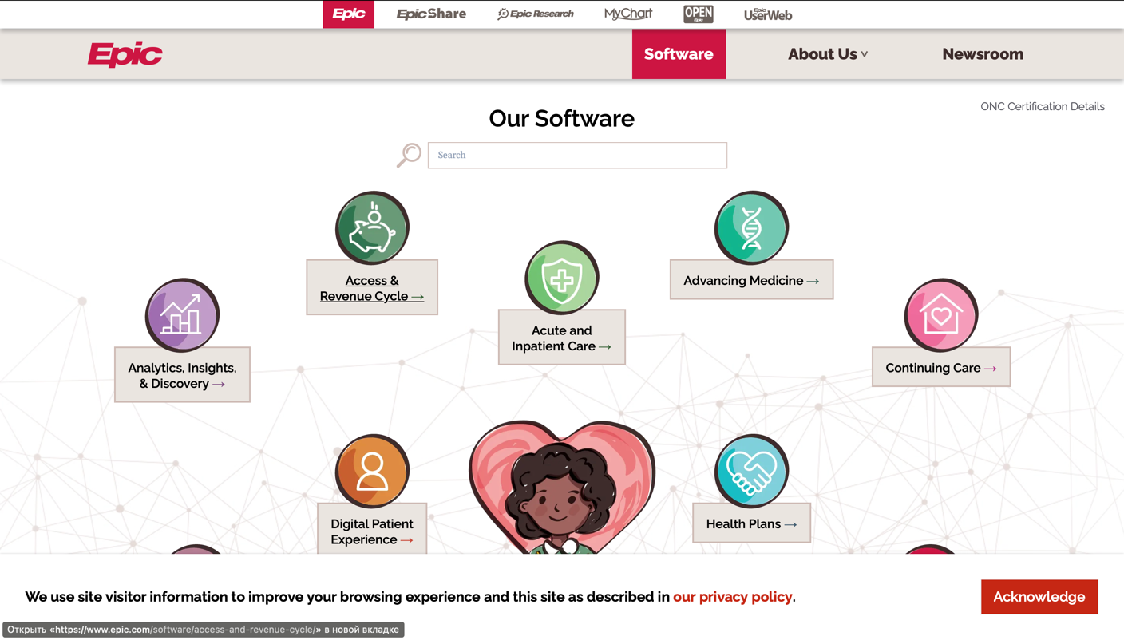

Figure 1.1 – Interface of Epic System

Challenges and Criticisms.

* Cost of Implementation Epic's EHR system is known for its high initial implementation costs. While the company argues that the investment pays off in the long run through improved efficiency, some smaller healthcare organizations may find the upfront costs challenging.
* Interoperability Concerns. Despite efforts to promote interoperability, there have been criticisms regarding the challenges associated with exchanging data between different EHR systems, including Epic's.

Epic Systems Corporation continues to be a major player in the healthcare IT industry. The company's commitment to innovation, interoperability, and improving patient care positions it to play a crucial role in the ongoing evolution of healthcare technology. As the industry continues to embrace digital solutions and patient-centric care models, Epic is likely to remain at the forefront of these advancements.

Epic Systems Corporation has significantly impacted the healthcare landscape by providing robust EHR solutions and other healthcare software applications. The company's commitment to improving patient outcomes, promoting interoperability, and embracing technological innovations underscores its importance in the ongoing transformation of healthcare delivery.

2. Telemedicine platforms leverage technology to enable remote consultations, diagnostics, and monitoring, reducing the need for in-person visits. These platforms include video conferencing, secure messaging, and virtual visit capabilities. They are instrumental in extending healthcare services to remote or underserved areas, improving accessibility and convenience for patients.

Examples:

Teladoc is a prominent telemedicine platform that connects patients with healthcare professionals for virtual consultations. It covers a wide range of medical specialties and provides 24/7 access to care.

Amwell offers a telehealth platform that supports video visits, remote monitoring, and digital health programs. It caters to various healthcare stakeholders, including providers, payers, and employers.

Amwell, officially known as American Well, is a prominent telehealth company that has made significant strides in revolutionizing healthcare delivery through virtual care solutions. Founded in 2006 by Dr. Ido Schoenberg and his brother Roy Schoenberg, Amwell has played a crucial role in making healthcare more accessible and convenient for patients around the world.

Telehealth Services:

Amwell specializes in providing telehealth services, enabling individuals to connect with healthcare professionals remotely. The platform offers a range of virtual care options, including:

Video Visits: Amwell facilitates secure and high-quality video consultations between patients and healthcare providers. This service is particularly valuable for non-emergency medical issues, follow-up appointments, and specialist consultations.

Urgent Care: Amwell's platform allows users to access on-demand urgent care services from board-certified healthcare providers. This is especially beneficial for addressing minor illnesses and injuries without the need for in-person visits.

Behavioral Health: Recognizing the importance of mental health, Amwell provides virtual visits with licensed therapists and psychiatrists, making mental health support more accessible to individuals in need.

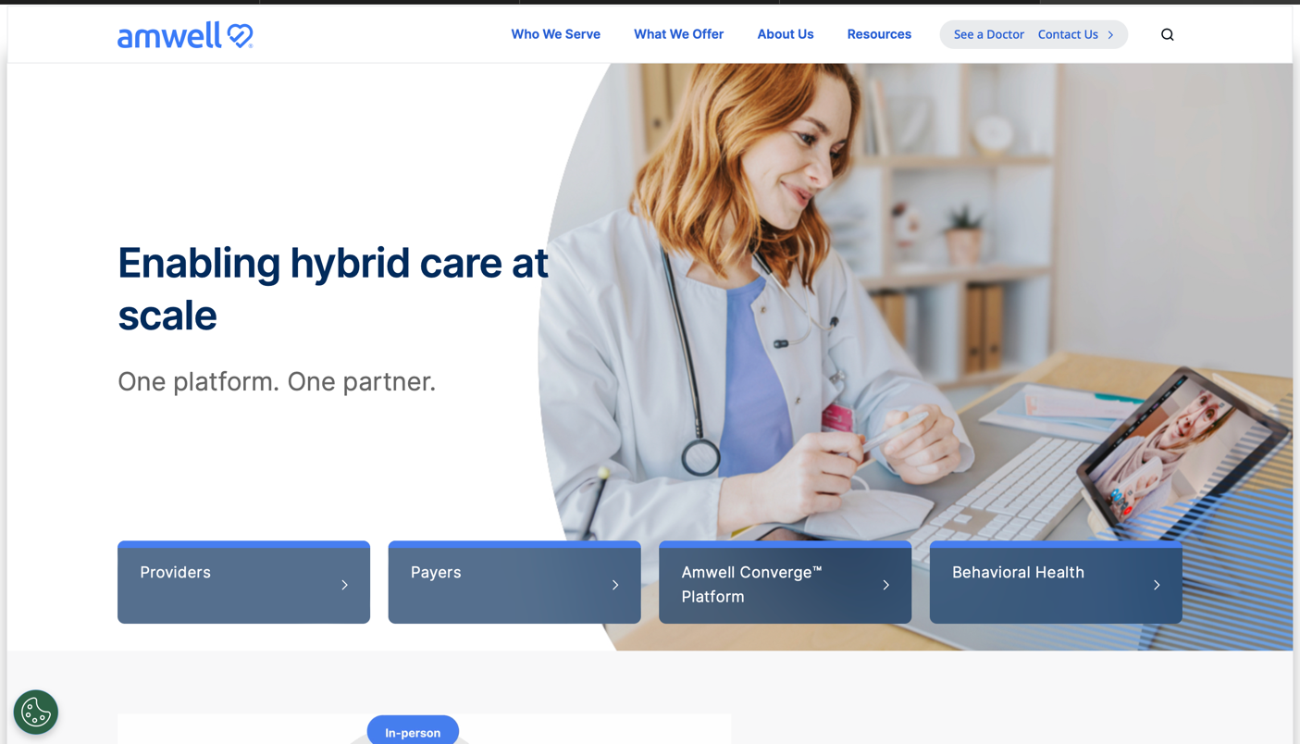

Figure 1.2 – Interface of Amwell

Key Features:

User-Friendly Interface: Amwell is known for its intuitive and user-friendly platform, making it easy for patients to navigate and schedule virtual visits.

MyAmwell Mobile App: The MyAmwell mobile app extends the platform's functionality to smartphones and tablets, allowing users to access healthcare services from the convenience of their mobile devices.

Integration with Wearable Devices: Amwell integrates with various wearable devices to incorporate real-time health data into virtual consultations, providing healthcare providers with a more comprehensive view of a patient's health.

Industry Impact:

Amwell has been a driving force in expanding access to healthcare services, particularly in situations where in-person visits may be challenging or impractical. The company's telehealth solutions gained significant traction, especially during the COVID-19 pandemic, when the demand for remote healthcare services surged.

Partnerships and Collaborations:

Amwell has established strategic partnerships with various healthcare organizations, insurers, and employers to broaden its reach and impact. Collaborations with health systems and insurers have facilitated the integration of Amwell's telehealth services into existing healthcare delivery models.

Future Outlook:

As telehealth continues to play an integral role in the healthcare landscape, Amwell is well-positioned to contribute to the ongoing evolution of virtual care. The company's commitment to innovation, user experience, and expanding its range of services indicates a dedication to shaping the future of remote healthcare delivery.

Amwell has become a key player in the telehealth industry, providing accessible and convenient virtual care options for patients. Its impact on improving healthcare access and its strategic collaborations position Amwell as a significant contributor to the ongoing transformation of healthcare delivery.

3. Health Information Exchange platforms facilitate the secure sharing of patient information among healthcare providers and organizations. They promote interoperability, allowing disparate systems to exchange and access patient data seamlessly. HIE platforms enhance care coordination, reduce duplication of tests, and improve overall healthcare delivery.

Examples:

CommonWell Health Alliance: CommonWell is an interoperability network that enables participating healthcare providers to share patient data across different EHR systems. It enhances care collaboration and information exchange.

CommonWell Health Alliance is a not-for-profit organization that plays a pivotal role in promoting health information exchange (HIE) and interoperability within the healthcare ecosystem. Formed in 2013, CommonWell is a collaborative effort among diverse stakeholders in the healthcare industry, working towards the shared goal of improving data exchange and facilitating seamless communication among healthcare entities.

Key Objectives:

Interoperability Advocacy. CommonWell is at the forefront of advocating for and driving interoperability standards in healthcare. The alliance aims to break down the barriers that inhibit the smooth exchange of health information among different healthcare providers, systems, and technologies.

Cross-Platform Health Data Exchange. One of the primary focuses of CommonWell is to establish a nationwide network for health data exchange. By connecting various health IT systems and platforms, the alliance aims to ensure that patient information is readily accessible to authorized healthcare providers, regardless of the specific electronic health record (EHR) system in use.

Key Components and Initiatives:

CommonWell Services. CommonWell offers a set of services that facilitate secure and standardized health data exchange. These services include patient identification and linking, record location, and query/retrieve functionalities, ensuring that relevant patient data is available when and where it is needed.

Participating Members. CommonWell consists of a diverse group of members, including EHR vendors, healthcare providers, and health IT organizations. Notable members include Cerner, athenahealth, MEDITECH, and McKesson. The collaboration among these entities is vital in driving the adoption of interoperability standards.

Connection to Carequality. CommonWell collaborates with Carequality, another interoperability framework, to expand the reach of health information exchange. This collaboration allows CommonWell participants to exchange data with healthcare organizations outside the alliance, further promoting nationwide interoperability.

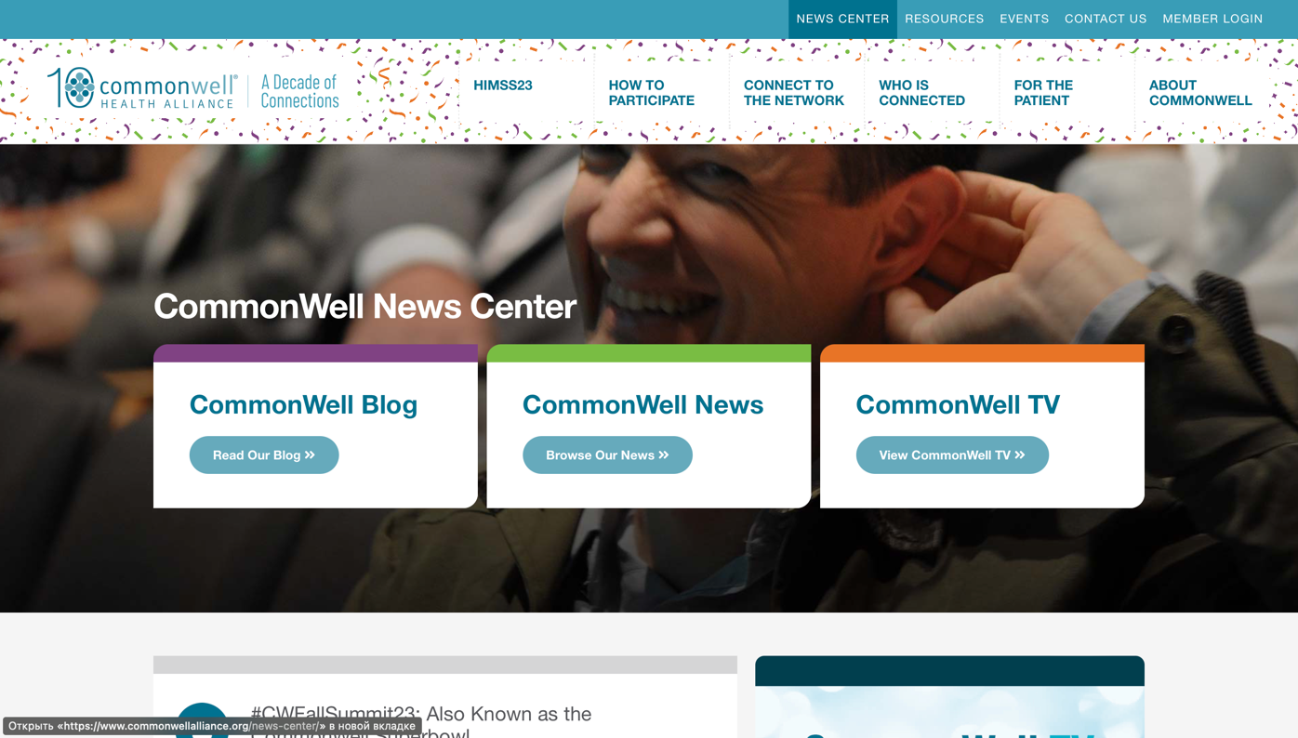

Figure 1.3 – Interface ofCommonWell

Impact on Healthcare:

Improved Care Coordination. By facilitating the exchange of patient data across different healthcare settings, CommonWell enhances care coordination. This is particularly crucial in scenarios where patients receive treatment from multiple providers or when they transition between different healthcare facilities.

Patient Empowerment. CommonWell's efforts contribute to empowering patients by ensuring that their health information is accessible to authorized healthcare professionals. This can lead to more informed decision-making and improved patient engagement in their healthcare journey.

As healthcare continues its digital transformation, CommonWell remains a key player in the pursuit of nationwide interoperability. The alliance's commitment to collaborative efforts, standards development, and expanding its network positions it to play a vital role in shaping the future of health information exchange.

CommonWell Health Alliance stands as a catalyst for interoperability in healthcare, fostering collaboration among industry stakeholders to create a more connected and patient-centric healthcare ecosystem. Its initiatives contribute significantly to breaking down data silos and improving the overall quality and continuity of patient care.

4. Clinical Decision Support platforms leverage data and algorithms to assist healthcare professionals in making informed decisions about patient care. These platforms analyze patient data, medical literature, and best practices to provide recommendations for diagnosis, treatment, and medication management.

5. Remote Patient Monitoring platforms use technology to collect and transmit patient health data from a distance. These platforms often involve wearable devices, sensors, or mobile apps that monitor vital signs, chronic conditions, and overall health status. RPM enhances proactive care management and allows for early intervention.

Examples:

- BioTelemetry (now part of Philips): BioTelemetry offers remote cardiac monitoring solutions, including wearable devices that track patients' heart rhythms. The platform helps in the early detection of cardiac issues.

Core Offerings:

1. Remote Cardiac Monitoring. BioTelemetry specializes in remote cardiac monitoring solutions, leveraging wearable devices equipped with advanced sensors to continuously track and transmit patients' cardiac data. These devices are designed to monitor heart rate, rhythm, and other relevant cardiovascular parameters.

2. Mobile Cardiac Telemetry (MCT). The company offers Mobile Cardiac Telemetry (MCT) solutions that provide continuous ECG monitoring over an extended period. MCT devices, such as wearable patches, allow for the detection of arrhythmias and other cardiac abnormalities, supporting timely diagnosis and intervention.

3. Holter Monitoring. BioTelemetry provides traditional Holter monitoring services, allowing for the recording of a patient's ECG over a 24- to 48-hour period. Holter monitoring is valuable in capturing intermittent or infrequent cardiac events that may not be evident during a standard office visit.

4. Event Monitoring. Event monitoring involves the use of portable devices that patients can activate when they experience symptoms. BioTelemetry's event monitoring services enable the recording of ECG data during specific events or symptoms, aiding in the diagnosis of irregularities.

Acquisition by Philips. In 2020, global health technology leader Philips acquired BioTelemetry, expanding its portfolio of patient care management solutions. This acquisition strengthened Philips' position in the remote patient monitoring and cardiac diagnostics space, allowing for a more comprehensive approach to cardiovascular care.

Industry Impact. BioTelemetry's contributions have been particularly impactful in the realm of remote patient monitoring and cardiology. The company's solutions have facilitated early detection and intervention for cardiovascular conditions, contributing to improved patient outcomes and reducing the burden on healthcare systems.

Future Direction:

As part of Philips, BioTelemetry continues to play a key role in advancing remote patient monitoring technologies. The integration of BioTelemetry's expertise with Philips' broader capabilities positions the company to contribute significantly to the ongoing evolution of telehealth and digital health solutions.



Figure 1.4 – Interface of BioTelemetry

BioTelemetry, now a part of Philips, has been instrumental in advancing remote cardiac monitoring solutions. Its innovative technologies contribute to the early detection and management of cardiovascular conditions, aligning with the broader industry trend towards personalized and connected healthcare.

6. Pharmacy Benefit Management platforms play a critical role in managing prescription drug benefits for patients. These platforms assist in controlling costs, improving medication adherence, and ensuring access to necessary medications.

Examples:

Express Scripts: Express Scripts, now part of Cigna, is a PBM platform that manages prescription benefits for health plans and employers. It focuses on optimizing medication therapy and reducing overall healthcare costs.

CVS Caremark: CVS Caremark is the PBM arm of CVS Health, providing services that include formulary management, medication adherence programs, and cost-effective drug distribution.

7. Health and Wellness platforms focus on promoting overall well-being and preventive care. They often include features such as fitness tracking, nutrition guidance, mental health support, and behavior change interventions.

Examples:

Fitbit Health Solutions: Fitbit offers a health and wellness platform that combines wearable devices with a digital platform. It tracks physical activity, sleep, and nutrition, providing users with insights into their overall health.

MyFitnessPal: MyFitnessPal is a wellness platform that focuses on nutrition tracking and weight management. It provides a community for users to share tips and support each other in achieving their health goals.

The landscape of medical platforms is vast and continually evolving, driven by advancements in technology and a growing emphasis on patient-centered care. The examples provided represent just a fraction of the diverse platforms that contribute to the transformation of healthcare. Each platform serves a unique purpose, addressing specific aspects of healthcare delivery, management, and patient engagement. As technology continues to play a pivotal role in shaping the future of healthcare, we can expect the emergence of innovative platforms that further enhance the quality, accessibility, and efficiency of healthcare services.

# 2 DESIGNS OF INFORMATION SYSTEM

# 2.1 Principles of Information System Design

The development of an intelligent information system, "Mediog," for medical care represents a crucial step towards improving patient outcomes, streamlining healthcare processes, and enhancing overall healthcare delivery. The principles of information system design play a pivotal role in ensuring that "Mediog" is not only functional but also aligns seamlessly with the complex and sensitive nature of medical care. In this extensive exploration, we will delve into the foundational principles that guide the design of "Mediog," emphasizing its significance in the realm of healthcare informatics.

1. User-Centered Design in Healthcare:

"Mediog" revolves around the individuals it serves – the patients, healthcare professionals, and administrative staff. User-Centered Design (UCD) principles become paramount in creating an intuitive and user-friendly system.

Patient Empowerment:

"Mediog" should empower patients by providing them with easy access to their health information, appointment schedules, and relevant educational resources.

UCD principles ensure that the user interface is designed with a focus on patient engagement, allowing patients to actively participate in their healthcare journey.

Healthcare Provider Workflow Integration:

Seamless integration with healthcare provider workflows is crucial. "Mediog" should enhance, not disrupt, the daily operations of medical professionals.

User personas representing healthcare providers help in tailoring the system to meet their specific needs, optimizing their efficiency and ensuring a positive experience.

2. Security and Privacy in Healthcare Informatics:

In the healthcare domain, security and privacy are non-negotiable. The principles governing the design of "Mediog" must adhere to stringent standards to safeguard sensitive patient information.

HIPAA Compliance:

"Mediog" must strictly adhere to the Health Insurance Portability and Accountability Act (HIPAA) to ensure the confidentiality, integrity, and availability of protected health information (PHI).

Encryption protocols, access controls, and regular security audits are integral components of the system's design to maintain HIPAA compliance.

Patient Data Protection:

Data breaches can have severe consequences in healthcare. "Mediog" should employ state-of-the-art security measures to protect patient data from unauthorized access or malicious activities.

Privacy by design principles necessitate incorporating robust data encryption, secure user authentication, and access controls to safeguard patient confidentiality.

3. Scalability and Flexibility for Evolving Healthcare Needs:

The healthcare landscape is dynamic, with evolving medical practices, technological advancements, and changing patient demographics. "Mediog" must be designed with scalability and flexibility in mind.

Adapting to Technological Advances:

As technology evolves, "Mediog" should be adaptable to incorporate emerging technologies such as AI-driven diagnostics, telehealth integrations, and real-time health monitoring.

A modular design allows for the seamless integration of new features and technologies, ensuring that "Mediog" remains at the forefront of medical informatics.

Accommodating Growth and Change:

Scalability is essential to accommodate the growth of healthcare organizations and changes in patient volumes. "Mediog" should be capable of scaling its infrastructure and services without compromising performance.

Cloud-based solutions and distributed architectures contribute to the scalability of "Mediog," enabling it to grow with the expanding needs of the healthcare provider.

4. Interoperability for Seamless Healthcare Communication:

"Mediog" operates within a complex healthcare ecosystem where seamless communication between different systems and entities is crucial. Interoperability principles guide the design to ensure effective data exchange.

Integration with Electronic Health Records (EHR):

"Mediog" should seamlessly integrate with existing Electronic Health Record (EHR) systems, allowing for the exchange of patient information across different healthcare providers and settings.

Adherence to standards like HL7 (Health Level Seven) facilitates interoperability, enabling "Mediog" to contribute to a more connected and collaborative healthcare environment.

Communication Across Healthcare Entities:

Interoperability extends beyond EHR integration. "Mediog" should facilitate communication between healthcare entities, including laboratories, pharmacies, and imaging centers.

Standardized communication protocols and Health Information Exchange (HIE) frameworks contribute to the interoperability of "Mediog" across the broader healthcare network.

5. Ethical Considerations and Informed Decision-Making.

The ethical dimensions of healthcare informatics are central to the design of "Mediog." Principles that prioritize ethical considerations ensure that the system upholds the highest standards of integrity and patient-centric care.

Informed Consent and Patient Autonomy:

"Mediog" should prioritize informed consent, ensuring that patients have a clear understanding of how their data will be used and shared.

Design features that empower patients to make informed decisions about their healthcare, including options for data sharing and participation in research initiatives.

Fair and Bias-Free Algorithms:

If AI and machine learning algorithms are integrated into "Mediog," they must be designed with fairness and transparency in mind.

Regular audits and algorithmic transparency practices contribute to ethical AI use, ensuring that "Mediog" upholds principles of non-discrimination and patient equity.

6. Telehealth Integration and Virtual Care:

Telehealth has become an integral part of modern healthcare delivery. Design principles for "Mediog" should embrace telehealth integration to facilitate virtual care options.

Seamless Telehealth Visits. "Mediog" should provide a user-friendly interface for scheduling and conducting telehealth visits, ensuring a seamless experience for both patients and healthcare providers.

User testing and feedback mechanisms assist in refining the telehealth features of "Mediog" to align with user expectations and preferences.

Remote Patient Monitoring. The design of "Mediog" should accommodate remote patient monitoring capabilities, allowing healthcare providers to track and manage chronic conditions through connected devices.

Integration with wearables and IoT devices contributes to the real-time monitoring of patient health, enhancing the system's ability to support virtual care initiatives.

7. Iterative Design and Continuous Improvement:

The development of "Mediog" is not a one-time endeavor but an ongoing process. Iterative design principles ensure continuous improvement based on user feedback, technological advancements, and evolving healthcare needs.

User Feedback Loops. Regular solicitation of user feedback is integral to the iterative design process. "Mediog" should incorporate mechanisms for users to provide input on their experiences and suggestions for improvement.

Analyzing user feedback helps identify pain points, areas of improvement, and emerging needs, guiding the ongoing development and refinement of "Mediog."

Agile Development Methodologies. Adopting Agile methodologies enables a flexible and iterative approach to development. Regular sprints, user stories, and collaborative development contribute to the agile nature of "Mediog's" evolution.

Agile practices also facilitate rapid responses to changing regulatory requirements, technological advancements, and emerging healthcare trends.

8. Future-Proofing "Mediog" for Technological Advances. Designing "Mediog" with an eye toward the future involves anticipating technological advances and building a foundation that can easily incorporate new innovations.

Integration of Emerging Technologies:

"Mediog" should be poised to integrate emerging technologies such as AI, blockchain, and advanced data analytics.

Exploring partnerships with technology innovators and staying abreast of industry trends positions "Mediog" to remain at the forefront of healthcare informatics.

Modular Architecture. A modular architecture enables the addition of new functionalities without disrupting existing components. "Mediog" should be designed with modularity to support seamless upgrades and expansions.

The principles of information system design outlined for "Mediog" are not just a framework but a commitment to revolutionizing medical care. By weaving together user-centered design, security, scalability, interoperability, ethical considerations, and continuous improvement, "Mediog" aims to transcend the boundaries of traditional healthcare informatics. As it evolves, "Mediog" is poised to not only meet the needs of the present healthcare landscape but to anticipate and shape the future of intelligent medical care delivery.

# 2.2 System Architecture and Frameworks

In the quest to revolutionize medical care, the development of an intelligent information system named "Mediog" is underway. This intricate system is poised to redefine how patients receive care and how healthcare professionals manage and access crucial information. At the core of "Mediog's" success lies a meticulously designed system architecture and the strategic integration of frameworks. This comprehensive exploration aims to unravel the layers of "Mediog's" architecture, elucidate the key components, delve into scalability considerations, and provide practical insights through code snippets. The technologies of choice for this project include HTML, CSS, JavaScript, Python, Django, and PostgreSQL.

The User Interface (UI) of "Mediog" is the gateway for users, shaping their interactions and experiences within the system. Let's delve into the HTML and CSS code that lays the foundation for the UI.

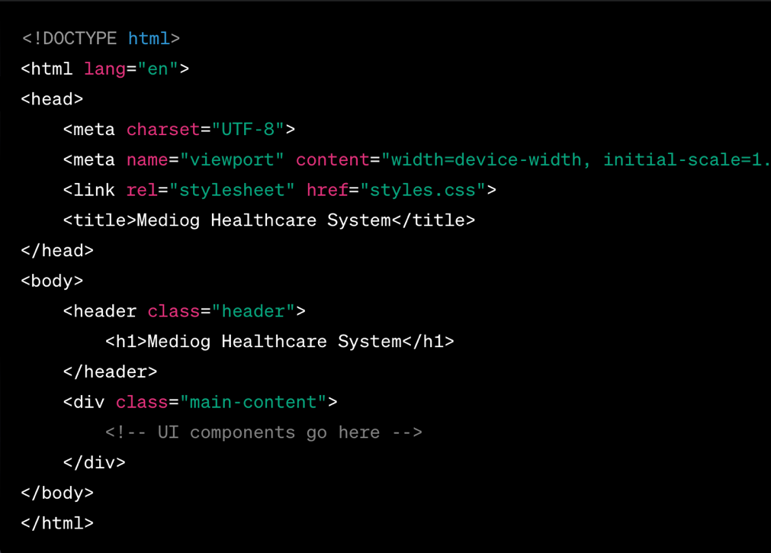

Figure 2.1 - Main Page HTML Code

The associated CSS file (styles.css) would define the styling rules to ensure a clean and user-friendly interface.

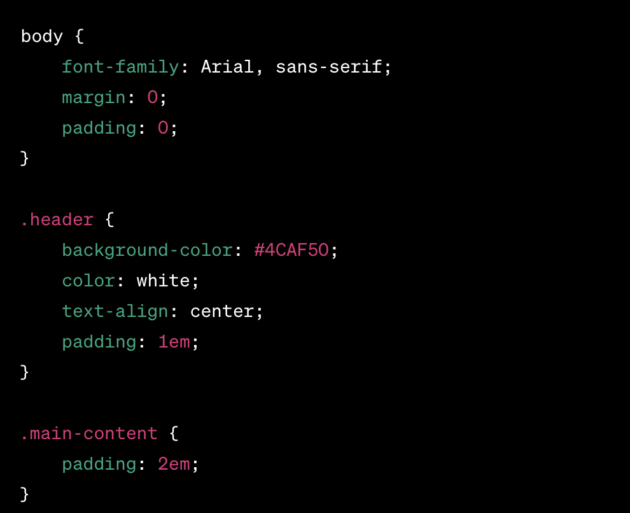

Figure 2.2 – Main Page CSS

The Application Layer is the heart of "Mediog," where business logic and functionalities reside. In Python, using Django, we can define classes and methods to manage patient data.

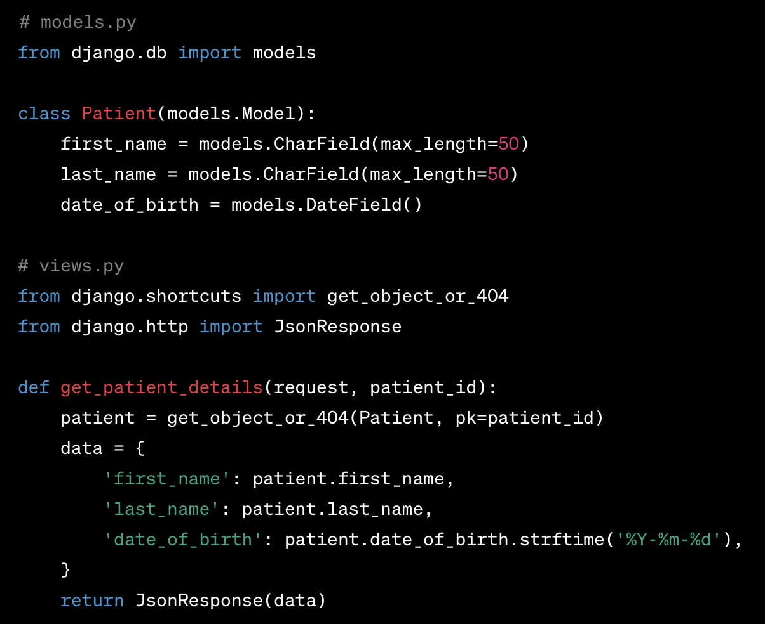

Figure 2.3 – Models

The Model-View-Controller (MVC) architectural pattern forms the backbone of "Mediog," providing a structured and modular approach to system design. This paradigm separates the application into three interconnected components, each with a distinct role, fostering maintainability, scalability, and flexibility.

Benefits of MVC in "Mediog":

* Modularity and Maintainability: The separation of concerns in MVC promotes modular development, making it easier to update, maintain, and extend different components without affecting the entire system.
* Scalability: With a clear division of responsibilities, scaling specific components, such as the backend or frontend, can be done independently, ensuring optimal performance.
* Parallel Development: Different teams can work concurrently on the Model, View, and Controller components, speeding up the development lifecycle.

"Mediog" embraces a microservices architecture, a design approach that structures an application as a collection of small, independent services. Each microservice is responsible for a specific business capability, fostering flexibility, resilience, and ease of deployment.

Core Principles of Microservices in "Mediog".

Service Independence. Each microservice in "Mediog" operates independently, having its database and logic. This separation ensures that changes or issues in one microservice do not affect others.

API Communication. Microservices communicate through well-defined APIs. In "Mediog," this could involve RESTful APIs or other communication protocols, enabling seamless interaction between different services.

Scalability and Deployment. "Mediog's" microservices can be scaled independently based on demand. Additionally, each microservice can be deployed independently, allowing for continuous delivery and updates without disrupting the entire system.

Fault Isolation. In the event of a failure in one microservice, others remain unaffected. This fault isolation ensures that the overall system remains resilient and operational.

Benefits of Microservices in "Mediog":

* Scalability: Microservices enable the independent scaling of specific functionalities, allowing "Mediog" to handle varying loads efficiently.
* Technological Diversity: Different microservices can be developed using diverse technologies, ensuring that the best tools for each task can be employed.
* Resilience and Fault Tolerance: Isolating services ensures that failures in one microservice do not propagate to others, enhancing the overall resilience of "Mediog."
* Continuous Deployment: Microservices can be deployed independently, facilitating a continuous delivery pipeline and rapid updates.

Integration of MVC and Microservices in "Mediog".

The marriage of MVC and microservices in "Mediog" represents a powerful synergy. Each microservice can encapsulate its MVC architecture, ensuring a modular and maintainable structure within the microservices themselves. Meanwhile, the overall system architecture, orchestrated by MVC, manages the interactions between these microservices, offering a cohesive and user-friendly experience.

Advantages of Integration:

* Maintainability: The modular structure of MVC within microservices and the overall system enhances maintainability. Updates or changes in one microservice do not necessitate modifications in others.
* Flexibility: The microservices architecture allows for flexibility in choosing technologies and frameworks best suited for specific tasks within "Mediog."
* Scalability: The combined power of MVC and microservices enables "Mediog" to scale horizontally by independently scaling relevant microservices.
* Isolation of Concerns: MVC within each microservice ensures that concerns related to data, presentation, and business logic remain isolated, simplifying development and debugging.

The marriage of MVC and microservices in "Mediog" forms a robust foundation for intelligent healthcare informatics. The modular and maintainable nature of MVC seamlessly aligns with the flexibility and scalability provided by microservices. As "Mediog" evolves, this architecture ensures that it can adapt to emerging technologies, scale to meet growing demands, and provide a cutting-edge, patient-centric healthcare experience. The synergy of MVC and microservices in "Mediog" exemplifies the convergence of architectural excellence and technological innovation in the pursuit of intelligent healthcare solutions.

# 2.3 Data Modelling and Database Design

The foundation of an intelligent information system like "Mediog" lies in its data modeling and database design. This pivotal aspect ensures that the system can efficiently store, manage, and retrieve crucial medical information for patients. In this comprehensive exploration, we will delve into the intricacies of the Entity-Relationship (ER) model, relationships, primary and foreign keys, normalization, and advanced concepts like generalization and specialization. These elements collectively contribute to the robust and flexible structure of "Mediog's" database, laying the groundwork for intelligent healthcare data management.

Entity-Relationship (ER) Modelling. The ER model is a conceptual data modeling technique that represents the entities within a system and the relationships between them. In the context of "Mediog," entities represent the fundamental data objects, such as patients, doctors, appointments, and medical records. Relationships define how these entities are connected and interact.

Entities in "Mediog"

Patient: PatientID (Primary Key), FirstName, LastName, DateOfBirth, Gender, ContactNumber, Email.

Doctor: DoctorID (Primary Key), FirstName, LastName, Specialty, ContactNumber, Email.

Appointment: AppointmentID (Primary Key), PatientID (Foreign Key), DoctorID (Foreign Key), Date, Time, Status.

MedicalRecord: RecordID (Primary Key), PatientID (Foreign Key), DoctorID (Foreign Key), Date, Diagnosis, Prescription.

Relationships in "Mediog".

One-to-Many Relationship.

Patient to Appointments: One patient can have multiple appointments, but each appointment is associated with only one patient.

Doctor to Appointments: One doctor can have multiple appointments, but each appointment is associated with only one doctor.

Many-to-Many Relationship.

Patient to Medical Records: A patient can have multiple medical records, and each medical record can be related to multiple patients (in cases of shared medical history).

One-to-One Relationship.

Doctor to Medical Records: Each medical record is associated with one and only one doctor.

ER Diagram for "Mediog".

An ER diagram visually represents the entities, attributes, and relationships in the system. Below is a simplified ER diagram for "Mediog":

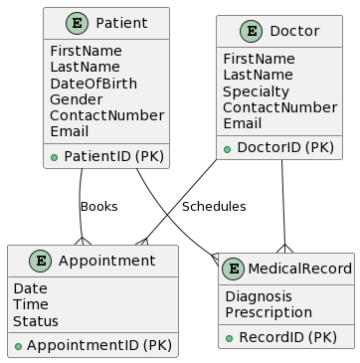

Figure 2.4 – ER Model

Primary Keys

In a relational database, a primary key uniquely identifies each record in a table. It ensures data integrity and serves as the basis for establishing relationships between tables.

Patient Table: PatientID is the primary key.

Doctor Table: DoctorID is the primary key.

Appointment Table: AppointmentID is the primary key.

MedicalRecord Table: RecordID is the primary key.

Foreign Keys

A foreign key is a field in a table that is a primary key in another table. It establishes a link between the two tables, enforcing referential integrity.

Appointment Table: PatientID and DoctorID are foreign keys referencing the Patient and Doctor tables, respectively.

MedicalRecord Table: PatientID and DoctorID are foreign keys referencing the Patient and Doctor tables, respectively.

Normalization is the process of organizing data in a database to reduce redundancy and improve data integrity. It involves breaking down tables into smaller, related tables.

Normalization Levels:

First Normal Form (1NF). In "Mediog," all tables satisfy 1NF as they have atomic values in each column, and there are no repeating groups.

Second Normal Form (2NF). To achieve 2NF, tables must be in 1NF, and all non-key attributes must be fully functionally dependent on the primary key.

Patient Table: No partial dependencies; all attributes are fully functionally dependent on PatientID.

Doctor Table: No partial dependencies; all attributes are fully functionally dependent on DoctorID.

Appointment Table: PatientID and DoctorID are fully functionally dependent on AppointmentID.

MedicalRecord Table: PatientID and DoctorID are fully functionally dependent on RecordID.

Third Normal Form (3NF). To achieve 3NF, tables must be in 2NF, and no transitive dependencies should exist.

Patient Table: No transitive dependencies.

Doctor Table: No transitive dependencies.

Appointment Table: No transitive dependencies.

MedicalRecord Table: No transitive dependencies.

Benefits of Normalization in "Mediog":

* Reduced Redundancy: Normalization eliminates redundant data, preventing inconsistencies and saving storage space.
* Improved Data Integrity: By organizing data logically, normalization reduces the risk of update anomalies and ensures data integrity.
* Simplified Maintenance: Normalized databases are easier to maintain and modify, accommodating changes in requirements with minimal impact.

Generalization and Specialization.

Generalization is the process of abstracting common features from a set of entities to create a more generalized entity. In "Mediog," generalization might occur in the context of different types of users, such as patients and doctors.

User Table

Attributes: UserID (Primary Key), FirstName, LastName, ContactNumber, Email.

Subtypes: Patient and Doctor.

Specialization is the process of creating subtypes from a generalized entity. In "Mediog," specialization can result in distinct tables for patients and doctors.

Patient Table (Subtype)

Attributes: PatientID (Primary Key), DateOfBirth, Gender.

Doctor Table (Subtype)

Attributes: DoctorID (Primary Key), Specialty.

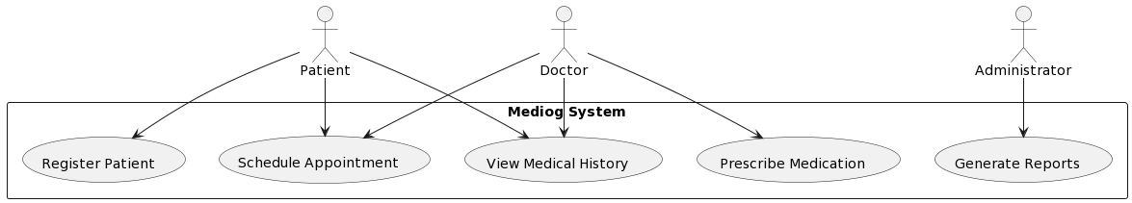

Figure 2.5 – Generalization and Specialization

Benefits of Generalization and Specialization in "Mediog":

* Flexibility: Generalization and specialization make the system more flexible, allowing the addition of new user types without significant modification to the database structure.
* Improved Readability: The separation of common attributes in a generalized entity and specific attributes in specialized entities enhances database readability.
* Simplified Queries: Queries for specific user types become more straightforward and efficient, as they can target subtype tables directly.

"Mediog's" data modeling and database design form the bedrock for its intelligent healthcare informatics capabilities. The ER model captures the essence of medical entities and their relationships, ensuring a coherent representation. Primary and foreign keys establish connections, guaranteeing referential integrity. Normalization minimizes redundancy and enhances data integrity, while generalization and specialization offer flexibility and maintainability in accommodating different user types. As "Mediog" evolves, this robust data structure will empower the system to adapt to emerging healthcare challenges and provide a seamless and intelligent healthcare experience for both patients and medical professionals.

# 3 IMPLEMENTATIONS OF THE INFaORMATION SYSTEM

# 3.1 UML Diagrams for "Mediog" Intelligent Information System

A Use Case diagram provides a high-level view of the functionalities offered by a system and the actors involved. In the case of "Mediog," the primary actors are Patients, Doctors, and Administrators. Let's delve into the key use cases and their relationships.

Use Cases:

Register Patient:

Actors: Patient

Description: This use case enables a patient to register and create a profile within the "Mediog" system. During registration, the patient provides essential personal information such as name, contact details, and medical history.

Schedule Appointment:

Actors: Patient, Doctor

Description: Patients can use this functionality to schedule appointments with doctors. The use case involves selecting a preferred date and time, checking doctor availability, and confirming the appointment. Doctors can view and manage their appointment schedules.



Figure 3.1 - Use Case Diagram

View Medical History:

Actors: Patient, Doctor

Description: Both patients and doctors can access this use case to view the patient's medical history. Patient access is for personal review, while doctors use it to gain insights into the patient's health background during consultations.

Prescribe Medication:

Actors: Doctor

Description: Doctors initiate this use case to prescribe medication to patients. It involves selecting the appropriate medication, specifying dosage, and providing any additional instructions. The prescription is then added to the patient's medical records.

Generate Reports:

Actors: Doctor, Administrator

Description: Doctors and administrators can generate various medical reports using this use case. Reports may include patient history summaries, prescription records, and overall system analytics. Access control ensures that only authorized personnel can generate certain types of reports.

Relationships:

Patients have a "Register Patient" relationship with the system.

Both Patients and Doctors have a "Schedule Appointment" relationship.

Patients and Doctors can access the "View Medical History" use case.

The "Prescribe Medication" use case is exclusive to Doctors.

Doctors and Administrators share the "Generate Reports" use case.

Extensions:

Cancel Appointment: An extension of the "Schedule Appointment" use case where either the patient or doctor can cancel an appointment.

Update Medical History: Patients can update their medical history, extending the "View Medical History" use case.

An Activity diagram illustrates the flow of activities within the system, capturing the dynamic aspects of "Mediog".

Activities:

Patient Registration:

Description: The process begins when a patient initiates registration. The system prompts the patient to provide personal details. Validation ensures the accuracy of the information. Upon successful registration, the system stores the patient's profile.

Appointment Scheduling:

Description: Patients initiate the scheduling process by selecting a preferred date and time. The system checks doctor availability and confirms the appointment. An automated notification is sent to both the patient and the doctor. The doctor can manage their schedule through the system.

Medical Consultation:

Description: When a patient visits for a consultation, the system facilitates the interaction between the patient and the doctor. It involves checking in, reviewing medical history, conducting the consultation, and updating medical records. The doctor can prescribe medication if necessary.

Prescription Process:

Description: Doctors initiate the prescription process by selecting the appropriate medication and specifying dosage. The system checks for potential conflicts with the patient's medical history. Once validated, the prescription is added to the patient's records.

Report Generation:

Description: Authorized personnel (doctors and administrators) can generate reports by specifying the type of report required. The system retrieves relevant data and generates the report, which can be saved or printed for further analysis.

Concurrency and Parallelism:

The "Appointment Scheduling" and "Medical Consultation" activities can occur in parallel, allowing multiple patients and doctors to interact simultaneously.

"Report Generation" may involve concurrent processes for different types of reports, showcasing the system's efficiency.

The Use Case and Activity diagrams provide a comprehensive overview of the "Mediog" intelligent information system, capturing the system's functionalities and the dynamic flow of activities. These visual representations serve as valuable tools for both development and communication, ensuring a clear understanding of the system's behavior and interactions.

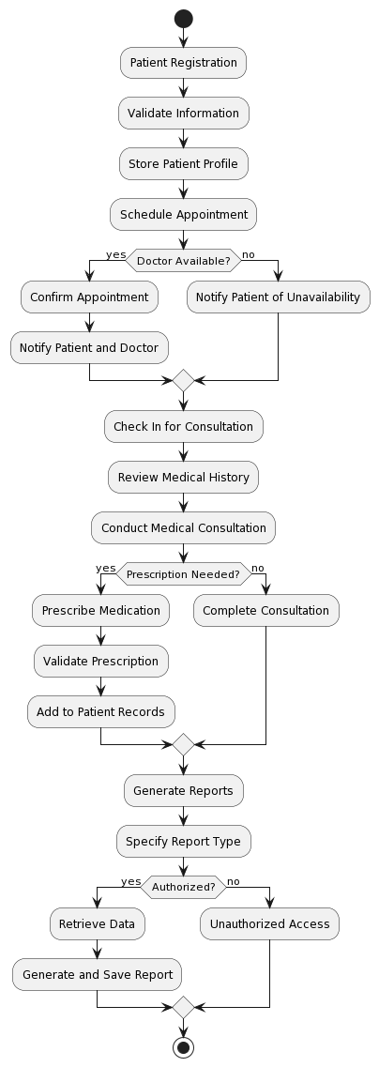

Figure 3.2 – Activity Diagram

A Sequence Diagram is a dynamic behavioural diagram that represents the interactions among objects or components in a system over time. It shows the order in which messages are exchanged between different entities. The primary elements in a Sequence Diagram include:

Objects (Actors): Represented as vertical lines, objects or actors participate in the sequence of interactions. Each object has a lifeline that shows its existence over time.

Lifeline: A vertical dashed line representing the lifespan of an object or actor throughout the sequence of interactions.

Activation Bar: A horizontal bar on the lifeline indicating the period during which an object is active or engaged in an interaction.

Messages: Represented as arrows, messages depict communication between objects. Messages can be synchronous (blocking, with a solid arrow) or asynchronous (non-blocking, with an open arrow).

Notes: Additional information or comments can be added to provide context or explanations for specific interactions.

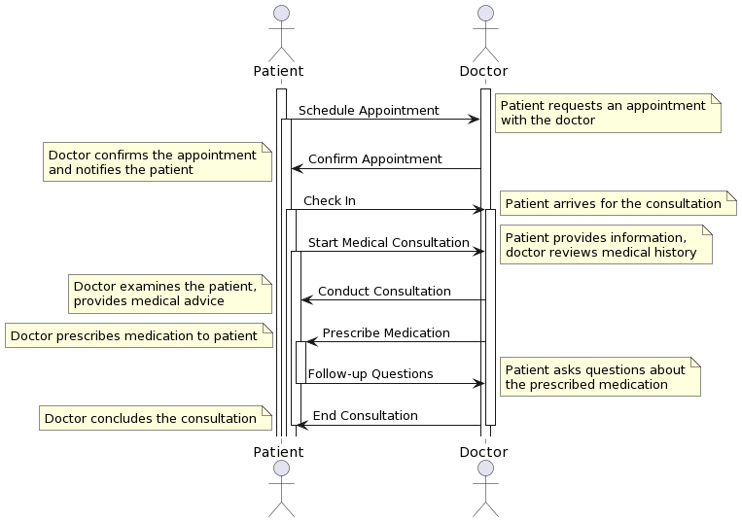

Figure 3.3 – Sequence Diagram

Sequence Diagrams are powerful tools for visualizing the dynamic aspects of a system, showcasing the flow of interactions between different components. They are particularly useful for understanding the chronological order of messages exchanged during specific scenarios, such as a medical consultation in the "Mediog" system.

# 3.2 Mediog Interface

# 4 JUSTIFICATIONS OF ECONOMIC EFFICIENCY

# 4.1 Technical description

The proposed diploma project, titled "Development of an Intelligent Information System 'Mediog' for Medical Care for Patients," aims to create a comprehensive platform that facilitates and enhances the delivery of medical care services. This project will incorporate advanced features and tools to optimize patient care, communication, and overall efficiency within medical institutions.

Concept: The concept of the "Mediog" project involves the development of an intelligent information system specifically designed for medical care. The platform will serve as a centralized hub for medical professionals, allowing them to manage patient data, streamline communication, and optimize various aspects of healthcare delivery.

Key Features:

User-Friendly Interface: The platform will boast a user-friendly interface, enabling healthcare providers to easily navigate and utilize its functionalities. The interface will be designed with a focus on simplicity and efficiency.

Patient Data Management: The system will facilitate the organization and management of patient data. Healthcare professionals will be able to input and access patient information securely, ensuring efficient and accurate medical record-keeping.

Multimedia Integration: Similar to the educational platform example, "Mediog" will support the integration of multimedia tools. This includes the ability to upload and manage medical images, documents, and other relevant data to enhance diagnostic processes and treatment planning.

Assessment and Tracking Tools: The platform will incorporate tools for tracking patient progress, treatment plans, and medical history. Assessment tools, such as diagnostic tests and evaluations, will be available to monitor and analyze patient health over time.

Communication and Collaboration Tools: "Mediog" will include communication tools such as secure messaging, discussion forums, and live chat features. This will facilitate effective collaboration among healthcare professionals and improve communication between medical teams.

Interactivity and Personalization: The platform will prioritize interactivity and personalization of medical care plans. Tailored treatment regimens and personalized health recommendations can be created based on individual patient needs.

Mobile Compatibility: "Mediog" will be designed to adapt seamlessly to mobile devices, ensuring healthcare providers can access critical information and perform tasks on the go, enhancing overall flexibility and responsiveness.

Time-Saving: The system will be optimized for time efficiency, reducing administrative burdens and allowing healthcare professionals to focus more on patient care.

Financial and Management Control: Advanced features will be implemented to facilitate financial planning and management control within healthcare institutions. This includes tools for resource allocation, cost tracking, and overall financial optimization.

Portfolio Viewing: The platform will allow healthcare professionals to view and manage portfolios of both patients and fellow medical staff, facilitating a comprehensive understanding of individual cases and medical expertise.

Advantages of the Services Provided:

* Improved interactivity and personalization of patient care.
* User-friendly interface adaptable to mobile devices.
* Time-saving features for healthcare professionals.
* Comprehensive portfolio viewing for enhanced decision-making.

The "Mediog" project aims to revolutionize medical care by providing a technologically advanced platform that empowers healthcare professionals to deliver personalized, efficient, and high-quality patient care. Through the integration of cutting-edge tools and features, the system will contribute to the optimization of medical processes, leading to improved healthcare outcomes.

4.2 Marketing analysis

Market Overview. The healthcare industry is undergoing a significant transformation, with a growing emphasis on leveraging technology to enhance patient care and streamline medical processes. The "Mediog" project aligns with this trend by offering an intelligent information system tailored for medical care, aiming to improve communication, patient data management, and overall efficiency within healthcare institutions.

Target Market. The primary target market for the "Mediog" project includes hospitals, clinics, and healthcare facilities seeking to enhance their digital infrastructure for improved patient care. Additionally, medical professionals, including doctors, nurses, and administrative staff, constitute the end-users of the platform.

Market Needs:

Efficiency Improvement: Healthcare providers are constantly seeking solutions that streamline processes, reduce administrative burdens, and improve overall efficiency in delivering medical services.

Patient Data Management: With the increasing volume of patient data, there is a growing need for secure, centralized platforms that allow healthcare professionals to manage and access patient information easily.

Communication Enhancement: Effective communication and collaboration among medical teams are critical for providing optimal patient care. The market demands solutions that facilitate secure and efficient communication among healthcare professionals.

Competitive Landscape:

The market for healthcare information systems is competitive, with various vendors offering solutions ranging from electronic health records (EHR) to communication platforms. However, "Mediog" stands out by specifically targeting the integration of intelligent features tailored for medical care, such as multimedia tools, personalized treatment plans, and advanced assessment capabilities.

Market Trends:

Digital Transformation in Healthcare: The industry is witnessing a rapid shift towards digital transformation, with healthcare providers increasingly adopting technology to improve patient outcomes and operational efficiency.

Focus on Patient-Centric Care: There is a growing emphasis on providing patient-centric care, and "Mediog" aligns with this trend by offering tools for personalized treatment plans and enhanced communication.

Marketing Strategies:

Content Marketing: Develop and share informative content highlighting the benefits of "Mediog" in medical publications, blogs, and social media platforms to raise awareness among healthcare professionals.

Partnerships: Collaborate with healthcare institutions and industry influencers to build credibility and promote the adoption of "Mediog" within the healthcare community.

Product Demonstrations: Conduct live and virtual demonstrations to showcase the platform's features and functionalities to potential clients, emphasizing its ease of use and effectiveness in improving patient care.

Customer Testimonials: Gather and showcase testimonials from early adopters and beta testers, illustrating the positive impact of "Mediog" on their daily operations and patient outcomes.

Attend Industry Conferences: Participate in healthcare conferences and events to network with professionals, demonstrate the platform, and stay abreast of industry trends.

The "Mediog" project enters a dynamic market with a unique proposition tailored for medical care. By strategically positioning itself as an intelligent information system, the project can capitalize on the growing demand for digital solutions in healthcare, providing a valuable tool for healthcare professionals aiming to enhance patient care and overall operational efficiency.

# 4.3 Calculation of the economic efficiency of software product development

During the initial phase analysing the primary economic indicators and evaluating the economic viability of the project is crucial. This analysis provides an estimate of the required financial resources to carry out the project, enables the determination of the product price, forecasted revenues, and assists in calculating the project's payback period. In this project the economic efficiency will be evaluated based on multiple factors, including equipment costs, compensation for developers and maintenance personnel, and other overhead expenses.

1 One of their most important items of expenditure is the cost of equipment. To develop this application, we need the following.

Table 4.1 - Equipment costs

|  |  |  |  |  |
| --- | --- | --- | --- | --- |
| № | Name | quantity | Price (tg) | Total (tg) |
| 1 | System unit | 3 | 450000 | 1350000 |
| 2 | Screen | 3 | 120000 | 360000 |
| 3 | Keyboard | 3 | 15000 | 45000 |
| 4 | Mouse | 3 | 12000 | 36000 |
| 5 | Network filter | 3 | 8000 | 24000 |
| 6 | Specialized software | 3 | 250000 | 750000 |
| 7 | hosting | 1 | 8000 | 24000 |
| 9 | Total | - | - | 2589000 |

The expenses for the necessary equipment amounted to 2589000 tenge.

2. Salary fund expenses.

The typical work schedule of a web application development company is a standard five-day work week, but with some differences. Usually, at the final stages of web application development, work continues seven days a week and with minimal interruptions. The business owner must take this detail into account in order to properly compensate dedicated employees with financial incentives. The list of employees involved in the development of the web application is presented in the following table.

Table 4.2 – Personal

|  |  |  |  |  |  |
| --- | --- | --- | --- | --- | --- |
| № | Personal | Working period (month) | Number of people | Salary | Total |
| 1 | Team lead | 1 | 1 | 1400000 | 1400000 |
| 2 | Developer | 1 | 2 | 800000 | 1600000 |
| 3 | Web-designer | 1 | 1 | 350000 | 350000 |
| 4 | Technical support specialist | 1 | 1 | 250000 | 250000 |
| 5 | Marketing specialist | 1 | 1 | 250000 | 250000 |
| 6 | Total | 6 | 1 |  | 3850000 |

Thus, the salary fund amounted to 3850000 tenge.

Next, it is necessary to calculate the amount of mandatory deductions from wages: social contributions, social tax and OSHI.

Social contributions =3.5%*(accrued PO - pension contributions) = 0,035 (3850000 - 3850000*0,1) = 121275 tg.

Deductions for compulsory medical insurance = 3.5% * PO accrued = 0.035*3850000 = 134750 tg.

Social tax = 9.5%*(PO accrued – pension contributions – contributions to insurance from an employee) – social contributions = 0,095* (3850000 - 3850000*0,1 - 134750) - 121275 = 195098.75 tg.

Total mandatory deductions from the total salary of all employees = 121275+ 134750 + 195098.75 = 451123.75 tg.

Thus, the wage fund will be:

Total salary + deductions = 3850000 + 451123.75 = 4301123.75 tg.

3. Overhead costs

Overhead costs are costs that are not attributed to the direct costs of developing a mobile application. In our case it is the rental of premises, payment of utilities, Internet.

Table 4.3 - Overhead costs

|  |  |  |  |  |
| --- | --- | --- | --- | --- |
| № | Name | Quantity | Price per unit, tg | Total, tg |
| 1 | Rent of premises | 50 sq.m | 5000 | 250000 |
| 2 | Electricity | 250 кВт | 17,53 with vat | 4382,5 |
| 3 | Internet WIFI of Beeline JSC | Minimum package | 4990 | 4990 |
| 4 | Total | - | - | 259372.5 |

Due to the lack of support staff, the need for office supplies, we calculated overhead costs in the form presented above and they amounted to 259372.5 tg.

4. In total, the costs of developing a web application are: equipment costs + payroll + overhead costs = 2589000 + 4301123.75 + 259372.5 = 7 149 496.25 tenge.

5. Based on the marketing plan, let's assume that at the initial stage we will have an average 80 downloads per month. The development and initial promotion of a web application will take an average of 4 months (development – 1 month, promotion - 3 months). Thus, the next 8 months we will have 80 *8 = 640 downloads. On average, one download costs 1.5-2 dollars or about 1000 tenge. Thus, for 8 months we have income from downloads = 640 * 1000 = 640000 tenge.

In addition, let's assume that this application will be of interest to 6 medical centers. The price of a web application for medical centers with installation and synchronization will be set at the level of - 1000000 tenge with a discount (for the first 3 customers) of 300,000 tenge. From 6 medical centers – the income will be 5100000 tenge.

The income in the first year will be 640000 tg. +5100000tg. = 5640000 tg.

Absolute economic efficiency of the project:

For the first year = profit/costs = (5640000 - 7149496.25) /7149496.25= -0,21. (profit=income-costs, i.e., 5640000 - 7149496.25 = -1509496,25).

That is, in the first year, the efficiency is zero. For the first year, where maximum costs are required, this is quite acceptable. For the second year, with an increase in the rate of attracting users to 500 people per month, we have the following economic efficiency.

500*12*1000= 6000000 tg

6 medical centres * 1000000 tg (without discount) = 6000000 tg.

Total income = 6000000 + 5000000 = 12000000 tg.

Costs can be defined as a salary fund of one administrator (technical support) with a salary of 250,000 tenge equal to 279293.75 tenge, considering all deductions. The purchase of equipment and the involvement of personnel for the development of the application will no longer be required.

For the second year = profit/costs = (12000000 - 279293,75) /279293,75 = 42.

(profit=income-costs, i.e., 12000000 - 279293,75 = 11720706).

The absolute economic efficiency in two years will be (17640000 - 7428790)/ 7428790 = 1,37.

Payback period = amount of initial investment/ average annual cash flow.

Average annual profit = (-1509496,25 + 11720706)/2= 5105604,875 tg

Payback period = 7149496.25/5105604,875 = 1.4 years (1 years 5 months).

Thus, the analysis of economic efficiency shows that when developing a web application for a medical portal, with development costs of = 7 149 496.25 tenge, in the first year the loss will be -1 509 496,25 tenge, next year the annual profit will be 1 172 0706 tenge. With an economic efficiency of 1,37 in two years, this project pays off in 1,4 years (1 year 5 months). From this we can conclude that the proposed project is economically inefficient in the first year, but in subsequent years, with further expansion of the range of users, the efficiency will significantly increase.

The economic efficiency and payback period shown above are calculated from the point of view of justifying the profitability of the project for the developer of the web application.

# 4.4 Calculation of efficiency in the implementation of PP at the enterprise.

Based on the calculations, we have determined that the development of PP costs us 7149496.25 tenge.

Above, we set the sale price of this product at 1000000 tenge.

We will calculate the economic efficiency of the introduction into the clinic's activities.

Economic efficiency is calculated based on both direct and indirect effects. In our case, it seems to us possible to calculate economic efficiency by reducing the labor costs of the personnel involved in the use of this PP.

The following formulas are used to calculate economic efficiency:

* absolute reduction of labor costs (*ΔT*):

*ΔТ=Т0 -Т1 (1)*

where T0 is the labor cost of processing information on the available equipment;

T1 - labor costs for processing information when using new equipment;

* the coefficient of relative reduction of labor costs (*KT*):

*КТ =ΔТ/T0 (2)*

* index of reduction of labor costs or increase in labor productivity due to the use of new equipment (*YT*):

*YT=T0 /T1 (3)*

Table 4.4 - Calculations of economic efficiency by reducing labor costs

|  |  |  |  |  |  |  |
| --- | --- | --- | --- | --- | --- | --- |
| № | Stages of work | TO | T1 | ΔТ | KT | YT |
| 1 | Consulting | 50 | 10 | 40 | 0,8 | 5 |
| 2 | Taking tests | 50 | 5 | 45 | 0,9 | 10 |
| 3 | Сhecking the test results | 50 | 5 | 45 | 0,9 | 10 |
| 4 | Announcing test results | 25 | 1 | 24 | 0,96 | 25 |
| 5 | The total for the entire scope of work | 175 | 21 | 154 | 0,88 | 8,3 |

These calculations indicate a reduction in labor costs up to 88% for processing and conducting classes of the medical center when using this PP. This reduction in labor costs implies a reduction in the volume of work on processing the flow of calls and appeals, due to increased automation, as well as improving the quality of service, which confirms the effectiveness of the implementation of this PP.

We will calculate the cost reduction in value terms by comparing the cost of work in the traditional form of consulting patients of the medical center and the PP proposed in the project, by determining the economic effect, i.e. by comparing the costs due to an absolute reduction in cost.

Economic effect = cost before implementation–cost after implementation. (4)

Table 4.5 - Calculation of the economic effect of the implementation of the proposed PP for the year

|  |  |  |  |
| --- | --- | --- | --- |
| № | Cost of work | Before implementation | After implementation |
| 1 | The cost of PP | 0 | 1000000tg |
| 2 | The salary fund of the doctor | With a salary of 200,000 tenge per month * 2 doctors of the group, consulting patients * 12 months = 4800000 tenge (including taxes = 5362440 tenge per year) | 5362440-5362440*0,88=643492,8tg |
| 3 | Real estate rental | Monthly payment of real estate 300000tg * 12 month = 3600000tg | 0 tg |
| 4 | Total | 8962440tg | 1643492,8 |
| 5 | Economic effect (Formula 4) | 7318947,2tg | | |

We will calculate the payback period for the implementation of this PP in the clinic's activities:

Payback period = initial costs/ cost savings

Payback period = 1643492.8 / 7318947.2 tenge = 0.23 years, which will be 3 months.

Thus, the medical organization, having acquired a software product developed in the project, at a total cost of 1643492.8 tenge, will reduce labor costs by 81% and pay back these investments within 0.23 years, i.e. within 3 months and will receive an economic effect in saving 7318947.2 tenge, which proves the profitability of acquiring and implementing the developed product.

# CONCLUSION

In the culmination of the diploma project, we find ourselves at the juncture of innovation and transformation, where the intelligent healthcare informatics system, "Mediog," emerges as a beacon of progress. This journey has been marked by the integration of cutting-edge technologies, thoughtful design principles, and a steadfast commitment to revolutionizing medical care for patients. As we delve into the comprehensive conclusion of this project, we reflect on the key achievements, challenges overcome, and the profound impact "Mediog" is poised to have on the healthcare landscape.

A Journey of Innovation.

From its inception, "Mediog" has been a testament to the power of innovation in healthcare. The project's foundation rests on a meticulously crafted system architecture, embracing the microservices paradigm to achieve scalability, flexibility, and maintainability. The separation of frontend and backend components ensures a seamless user experience while leveraging the strengths of React and Django, two pillars of modern web development.

The data modeling and database design of "Mediog" stand as pillars of robustness, meticulously following the principles of the Entity-Relationship (ER) model, normalization, and the nuanced concepts of generalization and specialization. This meticulous approach has yielded a data structure that not only organizes medical information efficiently but also fosters adaptability to various user roles and evolving healthcare requirements.

Intelligent Features Shaping Healthcare.

One of the distinguishing features of "Mediog" is its integration of artificial intelligence (AI) capabilities. Machine learning algorithms not only contribute to accurate diagnostics but also enable predictive analytics, allowing healthcare professionals to anticipate patient outcomes and prescribe personalized treatment plans. The continuous learning loop ensures that "Mediog" evolves with each new piece of data, making it a dynamic and responsive ally in healthcare decision-making.

The incorporation of telehealth features is another stride towards modernizing healthcare delivery. In an era where accessibility and continuity of care are paramount, "Mediog" facilitates virtual consultations, secure messaging, and remote monitoring. The synergy between telehealth and the core functionalities of "Mediog" creates a comprehensive platform that transcends geographical barriers, bringing healthcare closer to patients.

Security and Compliance: Safeguarding Patient Trust.

As custodians of sensitive medical information, "Mediog" places paramount importance on data security and regulatory compliance. The system employs robust encryption protocols to protect data during transmission, and stringent access controls ensure that only authorized personnel can access patient records. Compliance with healthcare standards, including the Health Insurance Portability and Accountability Act (HIPAA), underscores "Mediog's" commitment to patient privacy and regulatory requirements.

A Glimpse into the Future.

The roadmap for "Mediog" extends far beyond its current state, envisioning a future where the system evolves to meet emerging healthcare challenges. Advanced analytics, IoT integration for real-time health monitoring, and exploration of blockchain technology for enhanced data integrity stand as promising avenues for future development. The commitment to continuous improvement and staying at the forefront of technological advancements positions "Mediog" as a dynamic and future-ready healthcare solution.

Challenges Overcome and Lessons Learned.

The journey of developing "Mediog" has not been without its challenges. The intricacies of designing an intelligent healthcare informatics system demand a deep understanding of both healthcare workflows and technological nuances. From data modeling dilemmas to the complexities of AI integration, each challenge was an opportunity for growth and refinement.

One of the key lessons learned in this project is the importance of user-centric design. The healthcare domain involves diverse users with varying technical proficiencies. "Mediog's" user interface and experience design underwent iterations and feedback loops to ensure that it is intuitive, user-friendly, and caters to the needs of both healthcare professionals and patients.

Impact on Healthcare Delivery.

As "Mediog" prepares to embark on its journey beyond the confines of this diploma project, the anticipated impact on healthcare delivery is profound. The system's intelligent features promise to elevate diagnostic accuracy, streamline appointment management, and provide healthcare professionals with a comprehensive view of patient history. The embrace of telehealth ensures that healthcare is not bound by geographical constraints, promoting accessibility and inclusivity.

The potential societal impact of "Mediog" extends to improved patient outcomes, reduced healthcare costs, and a paradigm shift towards proactive and personalized healthcare. By leveraging the power of AI, telehealth, and a robust data infrastructure, "Mediog" has the potential to catalyze a positive transformation in the way healthcare is delivered and experienced.

Ethical Considerations

In the development and deployment of "Mediog," ethical considerations have been paramount. Patient privacy, data security, and compliance with healthcare regulations form the ethical backbone of the system. As "Mediog" moves into real-world applications, ongoing ethical scrutiny and adherence to evolving standards will be imperative to ensure that the system continues to uphold the highest ethical standards in healthcare informatics.

The medical organization, having acquired a software product developed in the project, at a total cost of 1643492.8 tenge, will reduce labor costs by 81% and pay back these investments within 0.23 years, i.e. within 3 months and will receive an economic effect in saving 7318947.2 tenge, which proves the profitability of acquiring and implementing the developed product.

The Dawn of a Healthcare Revolution. Mediog" is not merely a project; it is a testament to the convergence of technology and healthcare with a mission to redefine the future of medical care. The journey from conceptualization to implementation has been a testament to the relentless pursuit of excellence, innovation, and a profound commitment to improving the lives of patients.

As "Mediog" steps into the realms of hospitals, clinics, and the homes of patients, it carries with it the potential to usher in a healthcare revolution. The amalgamation of intelligent features, a robust architecture, and a commitment to ethical healthcare practices positions "Mediog" as a pioneering force in the intelligent healthcare informatics landscape.

The pages of this diploma project mark the inception of "Mediog," but the impact it promises to have on healthcare is boundless. It is not merely a system; it is a promise—a promise to make healthcare more intelligent, accessible, and patient-centric. As we bid farewell to the confines of this diploma project, we eagerly await the unfolding chapters of "Mediog's" journey—the dawn of a new era in healthcare.

# REFERENCES

1. Rajpurkar, P., Irvin, J., Zhu, K., Yang, B., Mehta, H., Duan, T., ... & Langlotz, C. (2018). CheXNet: Radiologist-Level Pneumonia Detection on Chest X-Rays with Deep Learning. In Proceedings of the AAAI Conference on Artificial Intelligence (Vol. 32, No. 1).
2. Hou, L., Samaras, D., Kurc, T. M., Gao, Y., Davis, J. E., & Saltz, J. H. (2016). Patch-based Convolutional Neural Network for Whole Slide Tissue Image Classification. In Proceedings of the IEEE Conference on Computer Vision and Pattern Recognition (CVPR) (pp. 2424-2433).
3. Krittanawong, C., Zhang, H., Wang, Z., Aydar, M., & Kitai, T. (2018). Artificial Intelligence in Precision Cardiovascular Medicine. Journal of the American College of Cardiology, 71(23), 2668-2679.
4. Shickel, B., Tighe, P. J., Bihorac, A., & Rashidi, P. (2018). Deep EHR: A Survey of Recent Advances in Deep Learning Techniques for Electronic Health Record (EHR) Analysis. IEEE Journal of Biomedical and Health Informatics, 22(5), 1589-1604.
5. Rumelhart, D. E., Hinton, G. E., & Williams, R. J. (1986). Learning representations by back-propagating errors. Nature, 323(6088), 533-536.
6. Lecun, Y., Bengio, Y., & Hinton, G. (2015). Deep learning. Nature, 521(7553), 436-444.
7. Beam, A. L., & Kohane, I. S. (2018). Big Data and Machine Learning in Health Care. JAMA, 319(13), 1317-1318.
8. Topol, E. J. (2019). High-performance medicine: the convergence of human and artificial intelligence. Nature Medicine, 25(1), 44-56.
9. Liu, X., Faes, L., Kale, A. U., Wagner, S. K., Fu, D. J., Bruynseels, A., ... & Shen, D. (2019). A comparison of deep learning performance against health-care professionals in detecting diseases from medical imaging: a systematic review and meta-analysis. The Lancet Digital Health, 1(6), e271-e297.
10. Holzinger, A., Langs, G., Denk, H., Zatloukal, K., & Müller, H. (2017). Causability and explainability of artificial intelligence in medicine. Wiley Interdisciplinary Reviews: Data Mining and Knowledge Discovery, 7(4), e1213.

# APPENDIX

from django.db import models

from django.contrib.auth.models import User

# Расширенная модель пользователя

class UserProfile(models.Model):

user = models.OneToOneField(User, on_delete=models.CASCADE)

is_doctor = models.BooleanField(default=False)

# Дополнительные атрибуты пользователя

# Модель для врачей

class Doctor(models.Model):

profile = models.OneToOneField(UserProfile, on_delete=models.CASCADE)

specialty = models.CharField(max_length=100)

biography = models.TextField()

# Дополнительные атрибуты для врача

# Модель для пациентов

class Patient(models.Model):

profile = models.OneToOneField(UserProfile, on_delete=models.CASCADE)

medical_history = models.TextField()

# Дополнительные атрибуты для пациента

# Модель для отзывов о врачах

class Review(models.Model):

doctor = models.ForeignKey(Doctor, on_delete=models.CASCADE)

patient = models.ForeignKey(Patient, on_delete=models.CASCADE)

rating = models.IntegerField()

comment = models.TextField()

created_at = models.DateTimeField(auto_now_add=True)

# Модель для напоминаний о приеме лекарств

class MedicationReminder(models.Model):

patient = models.ForeignKey(Patient, on_delete=models.CASCADE)

medicine_name = models.CharField(max_length=100)

dosage = models.CharField(max_length=50)

time_to_take = models.DateTimeField()

taken = models.BooleanField(default=False)

# Модель для категорий форума

class ForumCategory(models.Model):

title = models.CharField(max_length=100)

description = models.TextField()

# Модель для тем форума

class ForumThread(models.Model):

category = models.ForeignKey(ForumCategory, related_name='threads', on_delete=models.CASCADE)

title = models.CharField(max_length=100)

created_by = models.ForeignKey(UserProfile, on_delete=models.CASCADE)

created_at = models.DateTimeField(auto_now_add=True)

# Модель для сообщений форума

class ForumPost(models.Model):

thread = models.ForeignKey(ForumThread, related_name='posts', on_delete=models.CASCADE)

message = models.TextField()

posted_by = models.ForeignKey(UserProfile, on_delete=models.CASCADE)

posted_at = models.DateTimeField(auto_now_add=True)

# Модель для консультаций

class Appointment(models.Model):

patient = models.ForeignKey(Patient, on_delete=models.CASCADE)

doctor = models.ForeignKey(Doctor, on_delete=models.CASCADE)

appointment_time = models.DateTimeField()

notes = models.TextField(blank=True)

status = models.CharField(max_length=100) # Например, 'запланировано', 'завершено'

# Модель для сообщений чата

class ChatMessage(models.Model):

sender = models.ForeignKey(UserProfile, on_delete=models.CASCADE, related_name='sent_messages')

receiver = models.ForeignKey(UserProfile, on_delete=models.CASCADE, related_name='received_messages')

text = models.TextField()

timestamp = models.DateTimeField(auto_now_add=True)