Experiment No.: 04 Date: / /

Flip-Flops
AIM: Study and realize the functional table of D flip-flop, SR flip-flop, T flip flop and JK flip-flop
EQUIPMENTS & COMPONENTS:
- Digital Trainer Board
- IC 7474, 74LS279, 74LS73
THEORY:
A flip flop is an electronic circuit with two stable states that can be used to store binary data. The stored data can be changed by applying varying inputs. Flip-flops and latches are fundamental building blocks of digital electronics systems used in computers, communications, and many other types of systems.
- R-S flip flop
- D flip flop
- J-K flip flop
- T flip flop

- SR Flip Flop:
The basic NAND gate RS flip flop circuit is used to store the data and thus provides feedback from both of its outputs again back to its inputs. The RS flip flop actually has three inputs, SET, RESET and clock pulse.
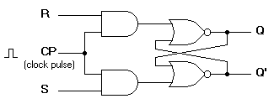 | OR | 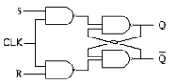
Figure-1: R-S flip flop circuit diagram
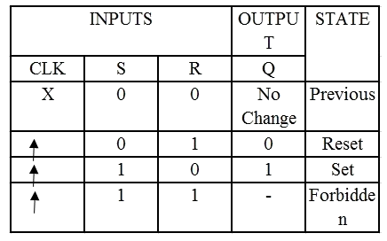
Figure-2: Characteristics table of R-S flip flop

74LS279 [Quad SR-Latch]

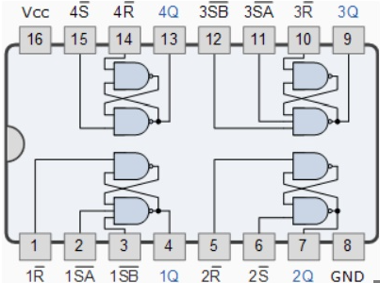
- D flip flop
A D flip flop has a single data input. This type of flip flop is obtained from the SR flip flop by connecting the R input through an inverter, and the S input is connected directly to data input. The modified clocked SR flip-flop is known as D-flip-flop and is shown below. From the truth table of SR flip-flop we see that the output of the SR flip-flop is in unpredictable state when the inputs are same and high. In many practical applications, these input conditions are not required. These input conditions can be avoided by making them complement of each other.
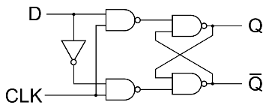
Figure-3: Circuit diagram of D flip flop
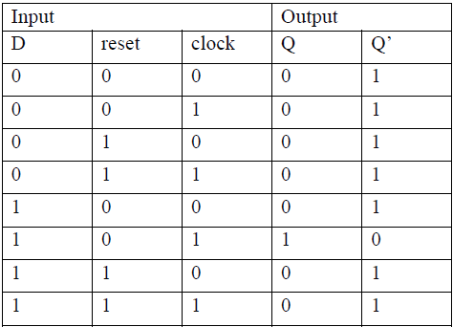
Figure-4: Characteristics table of D flip flop

IC 74LS74 [Dual D-type Flip Flops with Preset and Clear]
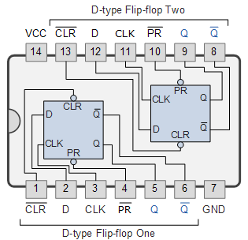
- JK Flip Flop:
JK flip-flop is a refinement of RS flip-flop where the indeterminate state of RS type is defined. Input J and K are respectively the set and reset inputs of the flip-flop. When both the inputs are high then the output of the flip-flop switches to its complemented state. A clocked JK flip-flop is shown below.
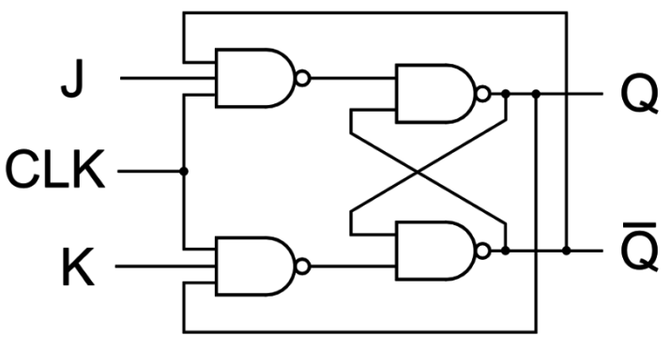
Figure-5: Circuit diagram of J-K flip flop
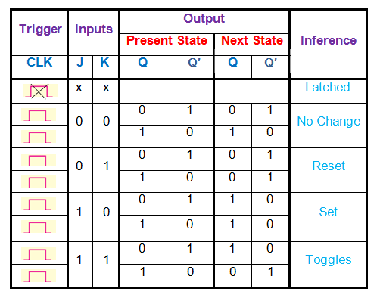
Figure-6: Characteristics table of J-K flip flop
74LS73 [Dual JK-type Flip Flops with Clear]
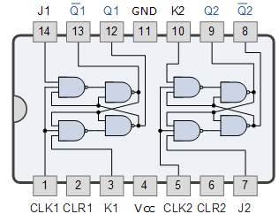
- T Flip Flop
T flip-flop is known as toggle flip-flop. The T flip-flop is modification of the J-K flip-flop. Both the JK inputs of the JK flip – flop are held at logic 1 and the clock signal continuous to change as shown in table below.
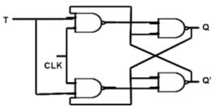 | OR | 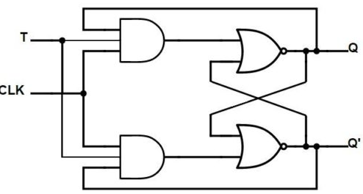
Figure-7: Circuit diagram of T flip flop
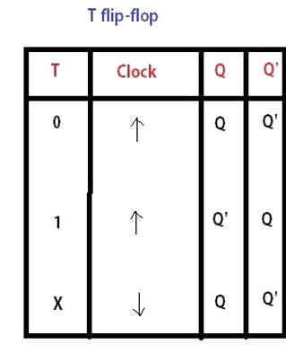
Figure-8: Characteristics table of T flip flop
PROCEDURE:
- Place the IC on the Bread Board.
- Connect VCC and ground to respective pins of IC Trainer Kit.
- Connect the inputs to the input switches provided in the IC Trainer Kit.
- Connect the outputs to the switches of O/P LEDs,
- Apply various combinations of inputs according to the truth table and observe condition of LEDs.

CONCLUSIONS: Functionality of D, T, SR and JK flip-flop has been verified using respective ICs
We also noted that flip-flops, being edge-triggered, are better for synchronized tasks, whereas latches, being level-sensitive, respond continuously to input changes.

