Experiment No.: 05 Date: / /

Multiplexer
AIM: Realize Boolean expressions using Multiplexer
EQUIPMENTS & COMPONENTS:
- Digital Trainer Board
- IC 74153(Multiplexer), IC 7404(NOT gate), IC 74151
THEORY:
In electronics, a multiplexer (or MUX) is a device that selects one of several analog or digital input signals and forwards the selected input into a single line. A multiplexer of 2n inputs has n select lines, which are used to select which input line to send to the output. Multiplexers are mainly used to increase the amount of data that can be sent over the network within a certain amount of time and bandwidth. A multiplexer is also called a data selector.
The below figure shows the block diagram of a multiplexer consisting of n input lines, m selection lines and one output line. If there are m selection lines, then the number of possible input lines is 2m. Alternatively, we can say that if the number of input lines is equal to 2m, then m selection lines are required to select one of n (consider 2m = n) input lines.
This type of multiplexer is referred to as 2n × 1 multiplexer or 2n-to-1 multiplexer. For example, if the number of input lines is 4, then two select lines are required. Similarly, to select one of 8 input lines, three select lines are required.
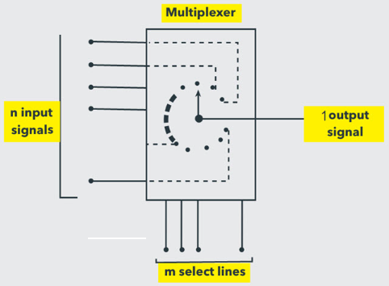
Generally, the number of data inputs to a multiplexer is a power of two such as 2, 4, 8, 16, etc. Some of the most frequently used multiplexers include 2-to-1, 4-to-1, 8-to-1 and 16-to-1 multiplexers.
These multiplexers are available in IC forms with different input and select line configurations. Some of the available multiplexer ICs include 74157 (Quad 2-to-1 MUX), 78158 (Quad 2-to-1 MUX with inverse output), 74153 (4-to-1 MUX), 74151 (8-to-1 MUX) and 74150 (16-to-1 MUX).
74153 is a dual 4 line-to-1 line multiplexer. It has the schematic representation shown in Fig 1. Selection lines A and B select the particular input to be multiplexed and applied to the output IY {1 = 1, 2}. Each of the strobe signals IG {I = 1, 2} acts as an enable signal for the corresponding multiplexer. Figure 2(a) & 2(b) shows the multiplex function of 74153 in terms of select lines. Note that each of the on-chip multiplexers act independently from the other, while sharing the same select lines A and B.
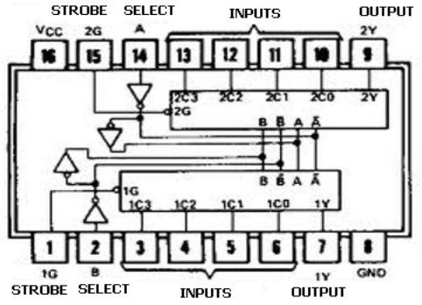
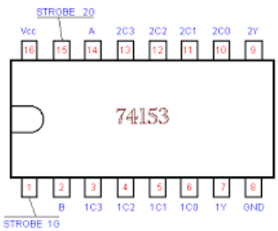
Figure 1(74153)
Strobe | Select Lines |  | Outputs
1G | A | B | 1Y
1 | x | x | 0
0 | 0 | 0 | 1C0
0 | 0 | 1 | 1C1
0 | 1 | 0 | 1C2
0 | 1 | 1 | 1C3
Strobe | Select Lines |  | Outputs
2G | A | B | 2Y
1 | x | x | 0
0 | 0 | 0 | 2C0
0 | 0 | 1 | 2C1
0 | 1 | 0 | 2C2
0 | 1 | 1 | 2C3
Figure 2(b)

Figure 2(a)
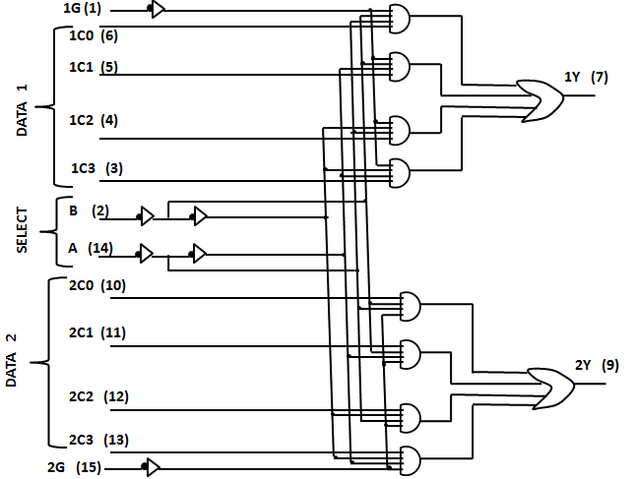
The above circuit diagram shows the detail gate level structure of 74153(Dual 4 line to 1 line Multiplexer)

IC 74151:
74151 is a 8 line-to-1 line multiplexer. It has the schematic representation shown in Fig 3. Three select lines(A,B,C) select the particular input to be multiplexed and applied to the output Y, Y is the inverted output of the original output(Y). Strobe signal or Enable signal should be low to ensure proper multiplexing operation. If Enable is made high, then the output Y will always be low irrespective of any logic levels asserted by select lines A, B, C and the eight inputs.
An 8-to-1 Multiplexer can be used to implement any 3-variable switching function.
For example, consider the function
F (A,B,C) = ∑m (0,3,5)
Then the inputs D0, D3 and D5 should be set to logic 1 while the remaining five inputs we set to logic '0'.
Thus, for A = 0, B = 0, C = 0 Y = D0 = '1'
for A = 0, B = 1, C = 1, Y = D1, = '1'
for A = 1, B = 0, C = 1, Y = D5, = '1'
For the remaining combination of A, B, C Y = '0'.
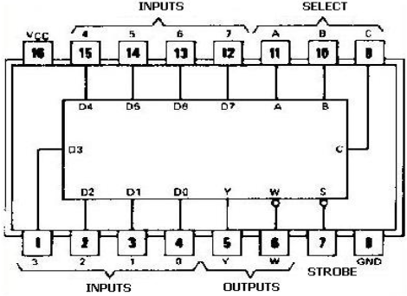
Fig 3(a) Pin Configuration of IC 74151

Strobe | Select Lines |  |  | Inputs |  |  |  |  |  |  |  | Outputs
Strobe | A | B | C | D0 | D1 | D2 | D3 | D4 | D5 | D6 | D7 | Y | W
H | X | X | X | X | X | X | X | X | X | X | X | L | H
L | L | L | L | H | X | X | X | X | X | X | X | H | L
L | L | L | L | L | X | X | X | X | X | X | X | L | H
L | L | L | H | X | H | X | X | X | X | X | X | H | L
L | L | L | H | X | L | X | X | X | X | X | X | L | H
L | L | H | L | X | X | H | X | X | X | X | X | H | L
L | L | H | L | X | X | L | X | X | X | X | X | L | H
L | L | H | H | X | X | X | H | X | X | X | X | H | L
L | L | H | H | X | X | X | L | X | X | X | X | L | H
L | H | L | L | X | X | X | X | H | X | X | X | H | L
L | H | L | L | X | X | X | X | L | X | X | X | L | H
L | H | L | H | X | X | X | X | X | H | X | X | H | L
L | H | L | H | X | X | X | X | X | L | X | X | L | H
L | H | H | L | X | X | X | X | X | X | H | X | H | L
L | H | H | L | X | X | X | X | X | X | L | X | L | H
L | H | H | H | X | X | X | X | X | X | X | H | H | L
L | H | H | H | X | X | X | X | X | X | X | L | L | H
Figure 3(b) Functional Table of IC 74151

PROCEDURE:
- Place the IC on the Bread Board/Trainer Board.
- Connect VCC and ground to respective pins of IC Trainer Kit.
- Connect the inputs to the input switches provided in the IC Trainer Kit.
- Connect the outputs to the switches of O/P LEDs,
- Apply various combinations of inputs according to the truth table and observe condition of LEDs.
- Implement given Boolean function using Multiplexer.
- Verify the functionality as per the truth table.
CONCLUSIONS: Functionality of 2:1, 4:1 and 8:1 Multiplexer ICs has been verified. Implementation and verification of given Boolean expressions using IC 74151 has been done.

Example 1:
Implement the following Boolean function using 8:1 Multiplexer
F (A, B, C) = ∑m (0, 1, 3, 4, 8, 9, 15)
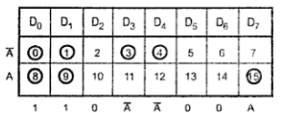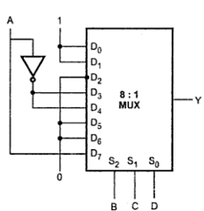

Example 2:
Implement the following Boolean function using 8:1 Multiplexer
F (A, B, C) = ∑m (0, 1, 2, 4, 6, 9, 12, 14)
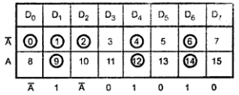
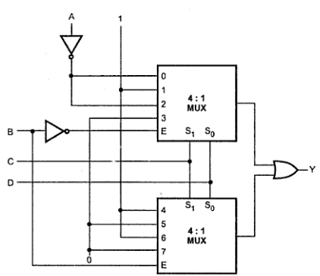
Fig. Implementation using 4:1 Multiplexer

Example 3
Implement the following Boolean function using 8:1 Multiplexer.
Solution:
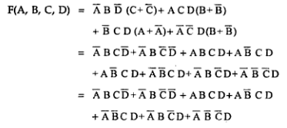
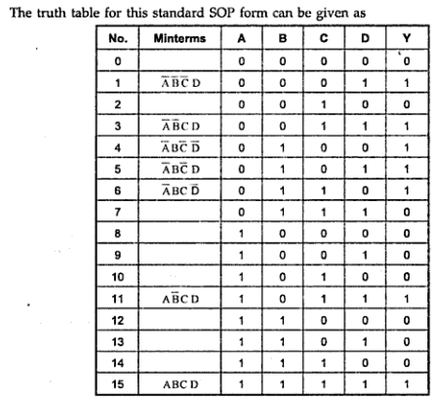
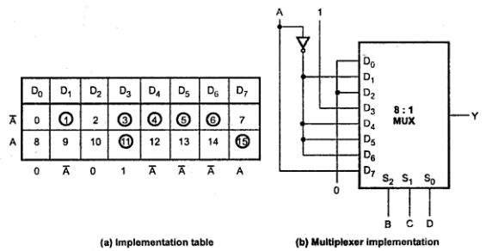
Example 4:
Implement the following Boolean function using 8:1 Multiplexer
F (A, B, C) = ∑m (0, 2, 6, 10, 11, 12, 13)+d(3, 8, 14)
