Experiment No.: 06 Date: / /

FSM
AIM: Design sequence detector for the given sequence using Mealy/Moore Machine.
EQUIPMENTS & COMPONENTS:
- Digital Trainer Board
- Flip-flops ICs and Logic gates ICs
THEORY:
Mealy machines and Moore machines are two types of FSMs. If the output of FSM depends on both the present state and the present inputs of the FSM it must be a Mealy machine. However, if the output depends on just the present state, it is a Moore machine.
A sequence detector is a sequential state machine that takes an input string of bits and generates an output 1 whenever the target sequence has been detected. In a Mealy machine, output depends on the present state and the external input (x). Hence, in the diagram, the output is written outside the states, along with inputs. Sequence detector is
of two types:
- Overlapping
- Non-Overlapping
In an overlapping sequence detector, the last bit of one sequence becomes the first bit of the next sequence. However, in a non-overlapping sequence detector, the last bit of one sequence does not become the first bit of the next sequence. In this post, we’ll discuss the design procedure for non-overlapping 101 Mealy sequence detectors.
Example:
For non-overlapping case
Input: 0110101011001
Output: 0000100010000
For overlapping case
Input: 0110101011001
Output: 0000101010000
The steps to design a non-overlapping 101 Mealy sequence detectors are: e
Step1: State Diagram is:
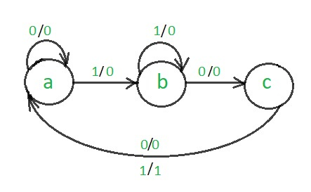

Step2: State Transition Table

Please note that the total bit number for your FSM state is ⌈log₂𝑁⌉⌈log₂​N⌉, where N represents the number of states. This is the number of Flip Flops required in the circuit implementation of the FSM.t 2: Code Assignment –
. 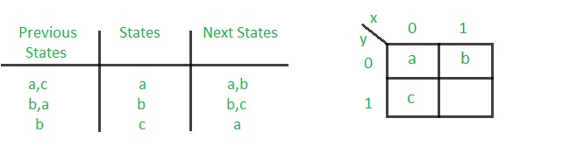
The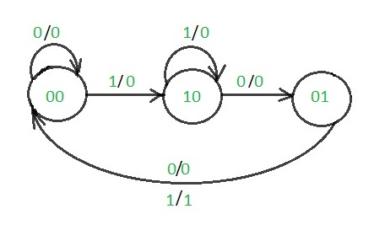
Step3: State Assignment Table
Now, for designing circuit, we need assign a number to each state. There are various methods to assign number to states such as binary, gray, and one hot code. In this lab we use binary code as we assign each state a number which starts from 0 for the first state and N-1 for the state N.
S. No. | States Name | State Assignments
1 | S0 | 00
2 | S1 | 01
3 | S2 | 10

To design the circuit, we should redraw state-transition table base on the assigned state that we did in the Step 3. This table is completed by considering the Flip Flop excitation-response behaviors as shown in the following tables for DFF, TFF, and JKFF.
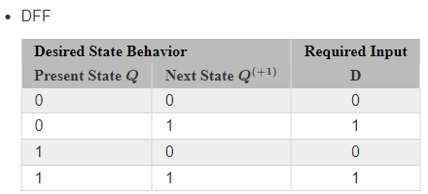
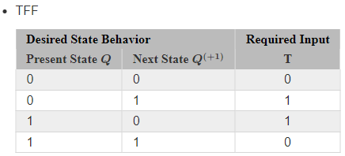
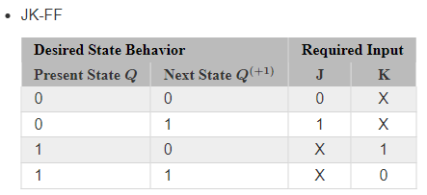
Accounting for a 2-bit internal state and a 1-bit input, there are eight cases to cover in this design. The desired next state and out depend on the desired state diagram you want to implement. The inputs of the flip-flop are then designed based the type of flip-flop used for a given bit in the state. While one could use a different flip-flop for every state bit, at least be able to consider a design using only one type of FF.
3 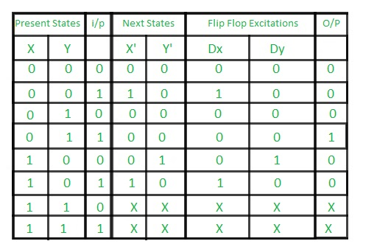
Step4: Transition Equations
Finally, to implement the circuit, we should find the switching expression for outputs, input of Flip Flops based on the value of present state and the inputs through the Karnaugh map. If the FSM is designed by DFF:
Step K-\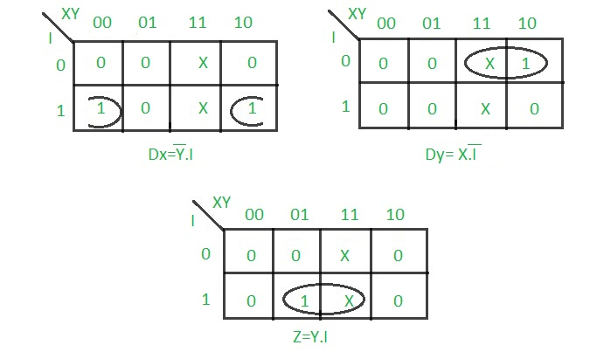
Step 5: Logical Diagram for Sequence detector
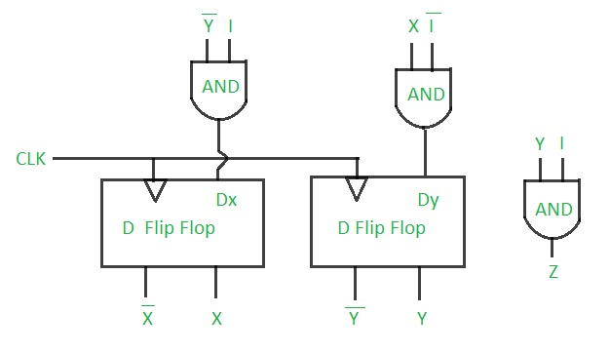1 non-overlapping
PROCEDURE:
- Place the IC on the Bread Board.
- Connect VCC and ground to respective pins of IC Trainer Kit.
- Connect the inputs to the input switches provided in the IC Trainer Kit.
- Connect the outputs to the switches of O/P LEDs,
- Apply various combinations of inputs according to the truth table and observe condition of LEDs.
CONCLUSIONS: The implementation of the sequence detector experiment using both Mealy and Moore machine models successfully demonstrated their respective functionalities and operational differences.

