LESSON 4:
SECTION 1:
- Graph:
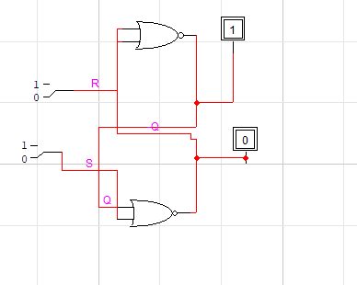
- Truth table:
R | S | Q | /Q
0 | 0 | 1 | 0
0 | 1 | 1 | 0
1 | 0 | 0 | 1
1 | 1 | 0 | 0

- The reasons of Q and -Q: These are complementary outputs, meaning they are always the inverse of each other. Providing both allows for greater design flexibility, as the user can access both the stored value and its opposite without needing additional logic gates.
Curcuit operation: The RS Flip-Flop functions using feedback between cross-coupled NOR gates to act as a basic memory unit.
- S=1, R=0 (Set): Forces Q to 1
- R=1,S=1(Reset): Forces Q to 0
- R=0,S=0(Memory):Maintains circuit’s current state
- R=1,S=1(Invalid): this is undefined state.

SECTION 2:
- Graph
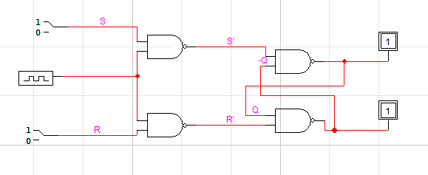
Qn | /Qn | R | S | Qn+1 | /Qn+1
0 | 1 | 0 | 0 | 0 | 1
1 | 0 | 0 | 0 | 1 | 0
0 | 1 | 0 | 1 | 1 | 0
1 | 0 | 0 | 1 | 1 | 0
0 | 1 | 1 | 0 | 0 | 1
1 | 0 | 1 | 0 | 0 | 1
0 | 1 | 1 | 1 | 0 | 0
1 | 0 | 1 | 1 | 0 | 0
- Truth table

Key Logic from the Table:
- Hold (R=0, S=0): The state Qn+1​ remains identical to Qn​.
- Set (R=0, S=1): Qn+1​ will always become 1, regardless of what Qn​ was.
- Reset (R=1, S=0): Qn+1​ will always become 0, regardless of what Qn​ was.
- Invalid (R=1, S=1): This state is unstable and forces both outputs to the same level.
- Convert into D-type flip flop:
  - Graph:
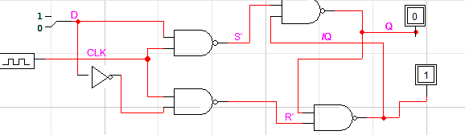
  - Truth table
Qn | /Qn | D | Qn+1 | /Qn+1
0 | 1 | 0 | 0 | 1
1 | 0 | 0 | 0 | 1
0 | 1 | 1 | 1 | 0
1 | 0 | 1 | 1 | 0

  - How does it work:The output Q only updates to match input D when a clock pulse (low-to-high-to-low transition) occurs.
Usefulness
- Memory: Acts as a basic unit for storing a single bit of data.
- Registers: Combined to create multi-bit data registers.
- Control: Ensures data moves through a system in sync with a master clock.
SECTION 3:
- Graph:

- Examine the output:
Truth table:
J | K | Qn+1 | Status
0 | 0 | Qn | Hold
0 | 1 | 0 | Reset
1 | 0 | 1 | Set
1 | 1 | /Qn | Toggle

When:
- J=0,k=0: the circuit remains its previous status
- J=0,k=1: Reset Qn to 0
- J=1,k=0: Set Qn to 1
- J=1,k=1: Toggle Qn to /Qn(if Qn=1 then Qn+1=0)
SECTION 4:
- Conclusion:
  - Understanding Memory Units: Learned how asynchronous RS flip-flops use feedback to store bits and why complementary outputs (Q and /Q) are used,.
  - Synchronous Logic: Gained experience with clock signals, understanding that state changes occur only during a clock pulse.
  - Flip-Flop Variations: Verified that D-type flip-flops simplify data storage by removing invalid states, and observed the J-K flip-flop's unique toggle ability.
  - System Building: Recognized flip-flops as the fundamental components required to implement data registers and synchronized digital system.

