PROJECT SEMINAR REPORT

ON

Signature Verification Using Artificial Neural Network

Submitted in partial fulfillment of the requirements for the award of the degree of

Bachelor of Engineering
In
Computer Engineering

By
\
Sarvajeet Kadam
Siddhesh Khavanekar
Sunil Khatate

CERTIFICATE

This is to certify that the Project Seminar Report Entitled
“Signature Verification Using Artificial Neural Networks”

Submitted by
Sarvajeet Namdev Kadam Roll No: 16
Siddhesh Sainath Khavanekar Roll No: 17
Sunil Subhash Khatate Roll No: 42

is a record of bonafide work carried out by him/her, under our guidance, in partial fulfillment of the requirement for the award of Degree of Bachelors of Engineering(Computer Engineering) at GIT, Lavel under the University of Mumbai. This work is done during July 2015- Dec 2015 of Academic year 2015-16.

Date: 23 Oct. 2015
Place: GIT, Lavel.

Prof. M.R.Balpande Prof. P.P.Patil Prof. J.G.Borade Dr .S.A.Patil
(Project Guide) (Project Coordinator) (HOD) (Principal)
Dept.CE, GIT Dept.CE, GIT Dept.CE, GIT GIT,Lavel

Internal Examiner Sign

ACKNOWLEDGEMENTS

It is matter of great pleasure for us to submit this project seminar report on “Signature verification using artificial neural network”, as a part of curriculum for award of Bachelor in Computer Engineering degree of University of Mumbai.
We are thankful to my project guide Prof.M.R.Balpande, Assistant Professor in Computer Engineering Department for his constant encouragement and valuable guidance. We are also thankful to Dr.S.A.Patil Principal of GIT, Lavel, and Prof.J.G.Borade Head of Computer Engineering Department for their valuable support and guidance.
We take this opportunity to express my deep sense of gratitude towards Prof.P.P.Patil project coordinator and those who have helped us in various ways for preparing my report. At the last but not least, we are thankful to our parent, friends who had encouraged & inspired us with their blessings.

LIST OF ABBREVIATIONS

ANN | Artificial Neural Networks

i

LIST OF FIGURE

Fig No. | Name of Figure | Page No
1 | Neural network architecture | 5
2 | Product architecture | 8
3 | Class diagram | 10
4 | Usecase diagram | 11
5 | Flowgraph | 14

LIST OF TABLE

T. NO. | NAME OF TABLE | PAGE NO.
8.1 | Result Table | 15
9.1 | Project Planner | 16
9.2 | Project Outline | 16
10.1 | Cost Table | 17

TABLE OF CONTENTS
CERTIFICATE
ACKNOWLEDGEMENT
LIST OF ABBREVIATIONS |  |  |  | i
LIST OF FIGURE |  |  |  | iii
LIST OF TABLE |  |  |  | Iv
Chapter  No |  | Title |  |  | Page No
1 |  | ABSTRACT  1.1 Project Summary/Abstract |  |  | 1
2 |  | Introduction |  |  | 2
3 |  | Literature survey |  |  | 3
4 |  | Research Methodology |  |  | 5
5. |  | Potential significance |  |  | 7
6. |  | Project design |  |  | 8
 | 6.1 |  | Purpose
 | 6.2  6.3 |  | Scope  Overall description  6.3.1 Problem statement  6.3.2 Product perspective  6.4 Specific requirement  6.4.1 Functional requirement  6.4.2 Non-Functional requirement
7. |  | IMPLEMENTATION 14
 |  | 7.1 Algorithmic steps
8. |  | RESULT 15
 |  | 8.1 Analysis of the result
9. |  | SCHEDULE OF Project WORK 16
10. |  | FINANCING BUDGET 17
11. |  | CONCLUSION AND FUTURE SCOPE 18
12. |  | REFERENCES 19

CHAPTER 1
ABSTRACT

For identification of a particular human being, signatures proves to be an important biometric. The signature of a person is an important biometric attribute of a human being which can be used to authenticate human identity. However human signatures can be handled as an image and recognized using computer vision and neural network techniques. With modern computers, there is need to develop fast algorithms for signature recognition.
There are various approaches to signature recognition with a lot of scope of research. In the proposed system, off-line signature recognition & verification using neural network is proposed, where the signature is captured and presented to the user in an image format. Signatures are verified based on parameters extracted from the signature using various image processing techniques. This report gives proposed method for verifying offline-signatures .Novel features are used for classification of signatures.
Keywords-Security, Neural networks, Image processing, Offline signature verification.

CHAPTER 2
INTRODUCTION
As signature is the primary mechanism both for authentication and authorization in legal transactions, the need for efficient auto-mated solutions for signature verification has increased .Unlike a password, PIN, PKI or key cards – identification data that can be forgotten, lost, stolen or shared – the captured values of the handwritten signature are unique to an individual and virtually impossible to duplicate. Signature verification is natural and intuitive. The technology is easy to explain and trustworthy.
The primary advantage that signature verification systems have over other type’s technologies is that signatures are already accepted as the common method of identity verification . A signature verification system and the techniques used to solve this problem can be divided into two classes Online and Off-line .On-line approach uses an electronic tablet and a stylus connected to a computer to extract information about a signature and takes dynamic information like pressure, velocity, speed of writing etc. for verification purpose.
Off-line signature verification involves less electronic control and uses signature images captured by scanner or camera. An off-line signature verification system uses features extracted from scanned signature image. The features used for offline signature verification are much simpler. In this only the pixel image needs to be evaluated. But, the off-line systems are difficult to design as many desirable characteristics such as the order of strokes, the velocity and other dynamic information are not available in the off-line case . The verification process has to wholly rely on the features that can be extracted from the trace of the static signature images only.

CHAPTER 3
LITERATURE SURVEY
In the literature survet, following papers were studied in order to achieve better understanding of the proposed system.

- Journal/Conference: IJETAE, August 2013

Authors: Shivani Sthapak, Minal Khopade , Chetana Kashid

Methodology Used: Offline signature Verification
Advantages:
1. Simple to implement.
2. Constant False rejection rate
Disadvantages:
1. After definite amount of iteration false acceptance rate get increase.
2. Verification is done offline.

- Journal/Conference: IJRTE, November 2009

Authors: Kshitij Sisodia, S.Mahesh Anand

Methodology Used: Static signature Verification
Advantages:
1. Efficiency in verification time.
2. Greater true acceptance rate (92.72%).
Disadvantages :
- True rejection rate is greater than true acceptance rate(95.83%).

- Journal/Conference: IJSER, February 2012

Authors: Ashwini Pansare, Shalini Bhatia
Methodology Used:Offline verification using training-testing of neural networks.
Advantages:
1.Correct classification rate is approximately 98%.
Disadvantages :
- For new signature samples, false acceptance rate is 12%.

- Published at : University of Vienna

Authors: Erich Schikuta

Methodology Used: Knowledge based database system.
Advantages:
1. Integrity control.
2. Concurrency management.
3. Recovery
Disadvantages :
- It is not comprehensive enough to change weights and activation value.

CHAPTER 4
RESEARCH METHODOLOGY

Artificial neural networks are models motivated by the brain that is competent of machine learning and pattern recognition. They are usually presented as organization of interconnected "neurons" that can calculate values from inputs by providing information through the network .
Neural networks are characteristically structured in layers. Layers are consisting of a number of interrelated 'nodes' which hold an 'activation function'. Patterns are available to the network by means of the ' input layer', which communicate to one or more 'hidden layers' where the concrete processing is done using a system of subjective 'connections'. The hidden layers then unite to an 'output layer' where the answer is final output of the system as shown in the figure below.

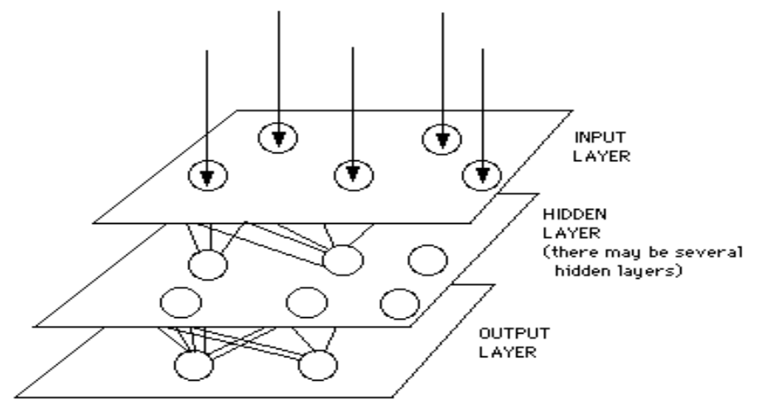

Fig.4.1. Neural Network Architecture

In machine learning and cognitive science, ANN are a family of models inspired by biological neural networks (the central nervous systems of animals, in particular the brain) and are used to estimate or approximate functions that can depend on a large number of inputs and are generally unknown. Artificial neural networks are generally presented as systems of interconnected "neurons" which exchange messages between each other. The connections have numeric weights that can be tuned based on experience, making neural nets adaptive to inputs and capable of learning. For example, a neural network for handwriting recognition is defined by a set of input neurons which may be activated by the pixels of an input image. After being weighted and transformed by a function (determined by the network's designer), the activation of these neurons are then passed on to other neurons. This process is repeated until finally, an output neuron is activated. This determines which character was read. Like other machine learning methods - systems that learn from data - neural networks have been used to solve a wide variety of tasks that are hard to solve using ordinary rule-based programming, including computer vision and speech recognition.

CHAPTER 5
POTENTIAL SIGNIFICANCE

The neural network must be trained and tested along with the support of database to make sure that proposed system has greater correct classification rate.
Proposed model can be extended in the various fields where signature verification is required. Various fields where proposed system can be extended are banking sector, government sector or any other sector where various documents are authenticated with the help of signature verification. The proposed system gives the better way of signature verification, which is currently being done manually.

CHAPTER 6
PROJECT DESIGN

6.1. Purpose:

The purpose of the proposed system is to avoid various forms of signature forgeries using signature verification by using various local and global features of signature and with the help of artificial neural network.

6.2. Scope:

The proposed system can be deployed wherever the forgery of the human signature is possible. Some of the sectors where the proposed system can be used are as follows:

- Banking sector: In various banks, the signature verification is required for verifying the transactions of the customer which involves paperwork, for example, cheque transfer, demand drafts etc.
- Government sector: In government sector, various government offices are largely dependent on paperwork. Human signature is used in such paperwork to authenticate the document. Hence this sector is largely prone for signature forgery. Thus proposed system can be used to avoid any crime in such sectors.

6.3. Overall Description

6.3.1. Problem Statement:

- In the proposed system, the signature samples will be stored in the database along with various credentials of the user.
- During verification, the input signature will be scanned against various samples of the signature which are present in the database using artificial neural network.
- In proposed system, the neural network is trained and tested in order to achieve efficiency in time required for verification.

6.3.2. Product Perspective:

Product does have database, external interface and internal processing module etc. Detailed view of application architecture as shown in fig below:
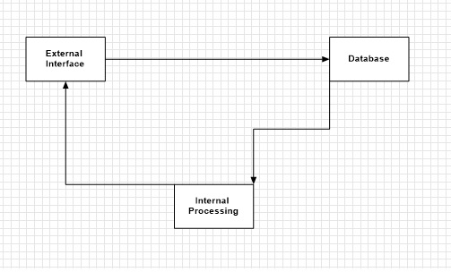

Fig.6.1. Product Architecture

6.4. Specific Requirement:
    - Functional Requirement:

Requirement ID | R 6.4.1.1
Title | Image Registration along with user credentials.
Description | System should accept source image of JPEG format along with various user credentials
Priority | 1
Risk | L

Requirement ID | R 6.4.1.2
Title | Image Enhancement.
Description | Algorithmic steps extracts various global and local features of user signature.
Priority | 2
Risk | H

Requirement ID | R 6.4.1.3
Title | Signature verification.
Description | Signature verification and recognition will be carried out using ANN.
Priority | 3
Risk | H

    - Non Functional Requirement:

- Software Requirement:
1) MATLAB
2) Windows OS
B. Hardware Requirement:
1) Intel Core2 2.16 GHz
2) 2 GB RAM

6.5. Different Diagrams
6.5.1. Class Diagram:
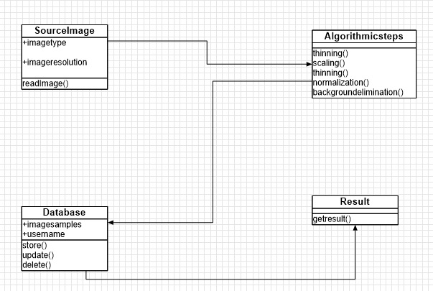

Fig.6.5.1. Class diagram

6.5.2. Use Case Diagram:
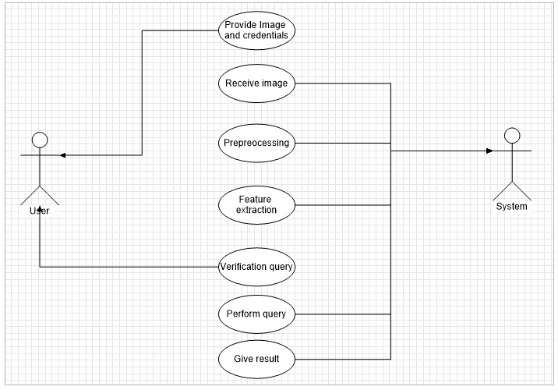
Fig.6.5.2. Use case diagram

CHAPTER 7
IMPLEMENTATION

1. Pre-processing
Generally in any image processing application preprocessing is required to remove alteration, from the original input image . Any normal scanner with sufficient resolution can be used as an image attainment device for offline operation . Signatures are scanned in gray, using following equation as
Gray color = (0.299*Red) + (0.5876*Green) +(0.114*Blue)

a).Scaling
Let H be the height of the inputted image & W be the width of the inputted image . We can fit the image uniform at 100*100 pixels by using the following equation as
Xnew = (Xold * 100)/H;
Where Xnew & Xold are calculated & original X coordinate
Ynew = (Yold* 100)/W;
Where Ynew & Yold are calculated & original Y coordinate.With these equations input image is transformed to uniformed 100*100 pixels image.

b). Noise Reduction
Images are contaminated due to stemming from decoding errors or noisy channels. An image also gets degraded because of the detrimental effects due to illumination and other objects in the environment.
Median filter is extensively used for smoothing and restoring images corrupted by noise . This is a nonlinear process useful principally in reducing impulsive noise . In a median filter, a window slides over the image, and for each location of the window, the median concentration of the pixels within it decide the intensity of the pixel positioned in the middle of the window. As weigh against to the mean filter, median filter has striking properties for suppressing impulse noise while preserving edges; due to this feature we are recommended this filter in our proposed system.

2.Normalization
a) Signature Normalization
Irregularity in image capturing and scanning process causes dimensions of signature to fluctuate . Height and width of signatures fluctuate from person to person and occasionally even the same person may exercise different sizes of signature . Therefore it is needed to get rid of the size variation and achieve a benchmark signature size for all input signatures. Throughout the normalization process, the characteristic ratio between the width and height of a signature is kept undamaged and following the process, all the signatures will have the similar dimension .

Normalization process make use of the following equations:
Xnew = [(Xold-Xmin)/ (Xmax-Xmin)]*M
Ynew = [(Yold-Ymin)/ (Ymax-Ymin)]*M
Where,
Xnew, Ynew = Pixel coordinates for the normalized
signature,
Xold, Yold = Pixel coordinates for the original signature,
M = Width/height meant for the normalized signature.

b) Thinning
The goal of thinning is to eliminate the thickness, differences of pen by making the image one pixel thick. Thinning was introduced to describe the global properties of objects and to reduce the original image intoa more compact representation.

3.Feuture Extraction
a)Background Elimination
Numerous image processing applications necessitate segregation of objects from the background. Thresholding is the most trivial and effortlessly appropriate method for this . We used Thresholding method for distinguish the signature from the background. In proposed application, we are concerned in dark objects on light background and hence a threshold value T entitled as the brightness threshold is suitably chosen and applied to image. After the Thresholding, the pixels of the signature would be 1 and the other pixels which belong to the background would be 0 .The brightness threshold can be chosen such that it satisfies the following conditions;
Suppose image pixels f(x, y) then,
If f(x, y) ≥ T
Then f(x, y) = Background
Else f(x, y) = Object

CHAPTER 8
PROPOSED EXPERIMENT/RESULT/ ANALYSIS OF WORK

8.1. Proposed Model:Algorithm for proposed system is as follows:
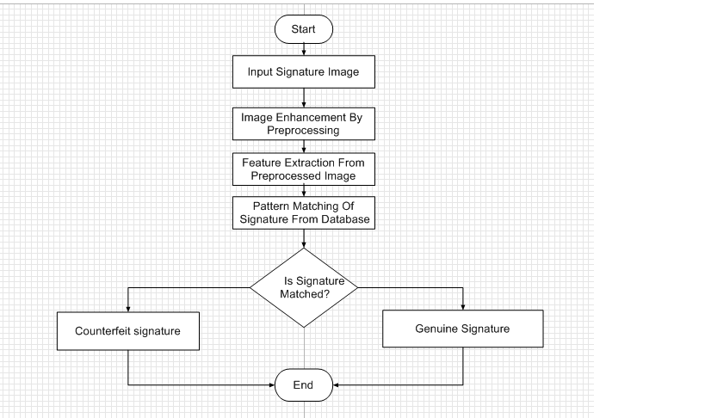
Fig.8.1 Flow diagram of proposed system

8.2. Result Table:
This section briefly describes several quantitative measure for visual as well quality evaluation of resultant fused image. The visual analysis alone cannot be only the criteria for quality evaluation.
Sr. No. | Number of iterations | False acceptance rate % | False rejection rate % | Correct classification rate%
1 | 100 | 15 | 12 | 27
2 | 102 | 12.5 | 15 | 27.5
3 | 103 | 12.5 | 10 | 22.5
4 | 104 | 14.5 | 12 | 26.5
5 | 105 | 17.5 | 15 | 22.5
Table 8.1 Result Table

CHAPTER 9
SCHEDULE OF WORK

9.1.Project Work Schedule / Planner:
Sr.No | Task Accomplished | Duration
01 | Identify project Area | 2 week
02 | Literature survey on project area | 3week
03 | Implementation of Exiting Algorithm | 3 week
04 | Formulation of Problem Statement/Proposed System model | 2 week
05 | Report Stage-I | 3 week
Table 9.1. Project Planner

9.2. Outline Of The Project Work:
Sr.No | Project work
01 | Literature survey on artificial neural network.
02 | Implementation of exiting system using Matlab tool.
03 | Analysis of Result of exiting system.
04 | Formulation of problem statement.
05 | Identified Proposed method.
\
Table 9.2. Project Outline

CHAPTER 10
FINANCING BUDGET

Sr.No | Particulars | Cost (In Rs.)
01 | Development cost | 10,000/-
02 | Operational cost | 25,000/-
02 | Software cost | -
03 | Hardware cost | -
04 | Total | 35,000/-

Table 10.1. Cost table

CHAPTER 11
CONCLUSION AND FUTURE SCOPE

The concepts of Neural Networks as well as Wavelet transforms hold a lot of promise in building systems with high accuracy.
- Banking sector: In various banks, the signature verification is required for verifying the transactions of the customer which involves paperwork, for example, cheque transfer, demand drafts etc.
- Government sector: In government sector, various government offices are largely dependent on paperwork. Human signature is used in such paperwork to authenticate the document. Hence this sector is largely prone for signature forgery.Thus proposed system can be used to avoid any crime in such sectors.

REFERENCES
[1] Artificial Neural Network Based Signature Recognition & Verification ,International journal; Shiwani Sthapak,Minal Khopade, Chetana Kashid. Volume 3, Issue 8, August 2013
[2] Ostu N., 'A Threshold Selection Method from Gray Level Histogram', IEEE Trans. on Systems, Man and Cybernetics, SMC-8, 1978, pp. 62-66.
[3] Plamondon.R., Brault J.J., 'A Complexity Measure of Handwritten curves: Modeling of Dynamic Signature Forgery', IEEE Trans. on Systems, Man and Cybernetics, Vol. 23,No.2, 1993, pp. 400-413.
[4] Qi.Y, Hunt B.R., 'Signature Verification using Global and Grid Features', Pattern . Recognition, Vol. 27, No. 12, 1994, pp. 1621-1629.
[5] Erich Schikuta University of Vienna Knowledge based database system. Rathausstrae 19/9, A-1010, Vienna, Austria

