CURA — Adaptive AI Assistant
Official Brand Color Palette & Design System Specification
Built for Care, Designed for Trust
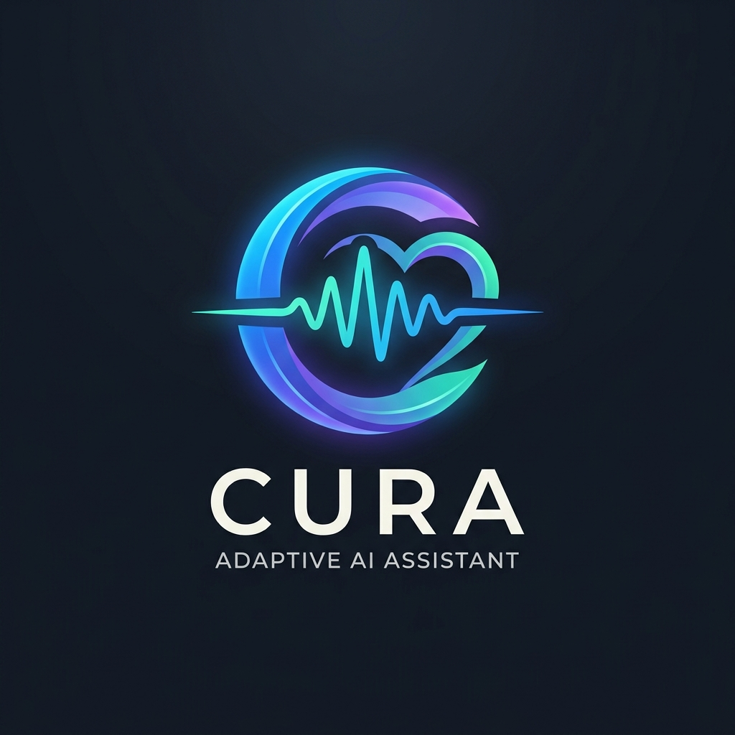
Official Master Logo • Selected for Cura Adaptive Ecosystem

1. Master Brand Color Palette
Color | Role / Name | HEX | RGB | HSL | Semantic Application
 | Azure Electric Blue  Primary Brand | #16B9FE | 22, 185, 254 | 198°, 99%, 54% | Primary CTA buttons, active state, core AI identity
 | Electric Cyan  Voice & Wave | #60EFEB | 96, 239, 235 | 178°, 82%, 66% | Audio waveform, voice listening state, glow effects
 | Orchid Violet  ADHD Focus | #AF6AFB | 175, 106, 251 | 269°, 95%, 70% | ADHD focus sessions, task timers, milestone rings
 | Turquoise Mint  Empathy & Care | #3FEDBA | 63, 237, 186 | 162°, 82%, 59% | Alzheimer’s Care Mode, medication confirmations, safety
 | Studio White  Primary Text | #FFFFFF | 255, 255, 255 | 0°, 0%, 100% | Main wordmark ("CURA"), primary headings, high contrast
 | Glacier Slate  Secondary Text | #E8EDF1 | 232, 237, 241 | 207°, 23%, 93% | Subtitle ("ADAPTIVE AI ASSISTANT"), body labels, borders
 | Midnight Obsidian  Canvas Dark | #131B26 | 19, 27, 38 | 215°, 33%, 11% | App dark theme background, OLED screen, deck background
 | Deep Navy Slate  Card / Surface | #1A2433 | 26, 36, 51 | 216°, 32%, 15% | Containers, dashboard cards, modal dialog panels

2. CSS Gradients & Code Snippets
Signature Logo Mark Flow:
background: linear-gradient(135deg, #16B9FE 0%, #AF6AFB 50%, #3FEDBA 100%);
Cognitive Focus Glow (ADHD Mode):
background: linear-gradient(135deg, #16B9FE 0%, #AF6AFB 100%);
Calming Care Glow (Alzheimer’s Mode):
background: linear-gradient(135deg, #16B9FE 0%, #3FEDBA 100%);

3. Mode-Specific Design Guidelines

Alzheimer's Mode (Low Cognitive Load)
Emphasize high contrast with Midnight Obsidian (#131B26) background and Turquoise Mint (#3FEDBA) for confirmations. Buttons should be large, clear, and reassuring with simple icons to reduce anxiety.

ADHD Mode (Focus & Flow)
Utilize Orchid Violet (#AF6AFB) for single-task focus timers and progress bars. Avoid flashing animations; use gentle ambient glow indicators to guide attention without overwhelming.
Cura Adaptive AI Assistant • Graduation Project • Document generated for submission and design archive.

