Instructions to follow-
1. Write HTML/CSS/JS code to make it responsive, without using any front end framework, write custom media queries
2. add font-family “Open Sans” (or any free google font)
3. on clicking watch video, play any youtube video in popup, the popup will have close button at top right corner to close the popup
4. “How much can i make” Section (write js code to implement the functionality)

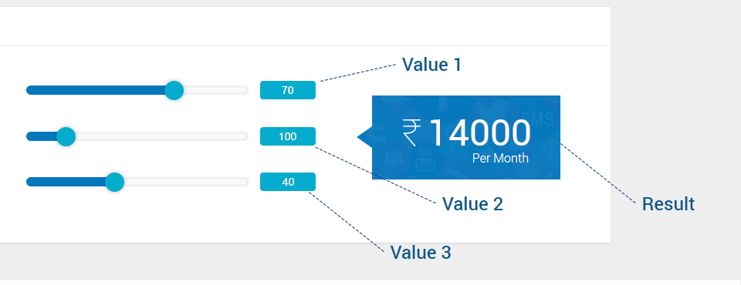
Place 3 slider, 3 text containing box, one big box for the result
Slider1- range – (1 to 100)
Slider2- range – (1 to 500)
Slider3- range – (1 to 100)
each slider will have one text containing box
on scrubbing the slider the text in the near by box and big box will change
big box value will be calculated on the formula
i.e. result = value1*(value2*5/100)*value3 = 70*(100*5/100)*40 = 14000

5. make the header sticky on desktop and mobile site
6. use fontawesome or any icon library for icons (social media icons)

*write cross browser/responsive//minimal code

