THE NATIONAL INSTITUTE OF ENGINEERING
Mananthavadi Road, Mysuru-570 008
Phone: 0821-2480475,2481220,4004947 Fax: 0821-2485802,
Email: echod@nie.ac.in


INDUSTRY INTERNSHIP REPORT
COURSE TITLE: Research/ Industry Internship
COURSE CODE:21EC8I01
DEPARTMENT: ELECTRONICS & COMMUNICATION ENGINEERING
SEMESTER: VIII
SECTION: B
NAME OF THE ORGANIZATION: PECSOL TECHNOLOGIES PVT LTD
AREA OF PROJECT/WORK: EMBEDDED SYSTEMS
NAME | USN
PRATHIK RAJ M G | 4NI21EC078

Submitted under the supervision of:
Sobia Naz, Assistant Professor
Dept of ECE, NIE, Mysore.
Acknowledgment

I would like to express my heartfelt gratitude to all those who supported and guided me throughout my internship journey at Pecsol Technologies Private Limited.
First and foremost, I am sincerely thankful to Ms. Sobia Naz, my academic internship guide, for her continuous encouragement, timely feedback, and valuable insights that helped me stay focused and motivated during the course of this internship.
I would also like to extend my deep appreciation to Mr. Ranjan, my internship mentor at Pecsol Technologies, for his unwavering support, expert guidance, and for providing me with meaningful opportunities to learn and contribute in a professional setting.
My thanks also go to the entire team at Pecsol Technologies for their collaboration and for creating a learning-friendly environment that enriched my technical and professional skills.
Last but not least, I am grateful to my family and friends for their constant support and encouragement throughout this experience

TABLE OF CONTENTS
SI.NO | CONTENTS | PAGE NO.
1 | Abstract | 4
2 | Introduction | 5
3 | Organization Overview | 6
4 | Internship Tasks & Responsibilities | 9
5 | Learning Outcomes | 12
6 | Recommendations | 14
7 | Conclusion | 15
8 | Appendices | 16
9 | References | 17

1.ABSTRACT

This report summarizes the internship experience undertaken at PECSOL Technologies Private Limited, a Mysuru-based company specializing in embedded systems, PCB design, and electronic product development. The internship focused on gaining hands-on exposure to microcontroller-based firmware development using the STM32G070RB board. Over the course of the internship, I was involved in a structured training program that covered a wide range of topics, including GPIO driver development, timer configuration, ADC interfacing, UART and SPI communication, USB firmware, and real-time task management using FreeRTOS.
The initial phase included setup and familiarization with STM32CubeIDE and STM32CubeMX, enabling peripheral configuration and project structuring. This was followed by modules that involved writing low-level drivers from scratch using embedded C and ARM assembly. I also gained experience in implementing both polling and interrupt-based communication protocols, configuring DMA for efficient data transfer, and building USB HID and virtual COM port functionalities.
One of the most valuable aspects of the internship was working with FreeRTOS, where I learned task creation, priority management, and inter-task communication in a real-time environment. The training was comprehensive, and each module reinforced practical learning through hands-on experimentation and problem-solving.
Under the mentorship of Mr. Ranjan and the academic guidance of Mrs. Sobia Naz , I was able to navigate challenges effectively and develop a deep understanding of embedded systems design and development. This internship has significantly strengthened my technical foundation and prepared me for future roles in embedded firmware engineering.
Overall, the experience was intellectually stimulating and professionally rewarding, equipping me with the essential skills, tools, and confidence to contribute to real-world embedded system projects

2. INTRODUCTION

The internship at Pecsol Technologies Private Limited was designed to provide practical exposure in the field of embedded systems, specifically focusing on microcontroller firmware development using the STM32G070RB board. This training aimed to bridge academic knowledge with industry-relevant skills, offering hands-on experience in low-level programming, peripheral interfacing, and real-time embedded firmware development.
By working with professional tools like STM32CubeIDE and STM32CubeMX, the internship helped me understand microcontroller architecture, embedded C programming, and driver development. It enabled me to apply classroom theories in a real-world setting and gain essential skills required for a career in embedded systems engineering.
This report aims to document the internship journey in a structured format, highlighting the various modules covered, tasks undertaken, challenges faced, and skills acquired.
It serves to Provide a detailed account of the technical work completed. Outline the use of tools and programming techniques for firmware development. Reflect on personal and professional growth throughout the internship.
The internship began with tool setup, including the installation and configuration of STM32CubeIDE and CubeMX, followed by a series of hands-on modules. These covered GPIO driver development, including input/output control and interrupt handling.
Further modules included bare-metal programming using C and ARM assembly, and general-purpose timers for generating delays, counting events, and producing PWM signals. The ADC module focused on single, continuous, and DMA-based data acquisition.
I also developed SPI and UART drivers in polling, interrupt, and DMA modes, along with support for multiple UARTs. USB driver development involved HID and virtual COM port implementation.
The internship concluded with FreeRTOS training, where I created tasks, managed priorities, accessed hardware across threads, and used inter-thread communication.
Overall, the internship offered valuable insights into embedded firmware development and significantly enhanced my technical and problem-solving skills in a real-world engineering environment
3.ORGANIZATION OVERVIEW

Brief History
PECSOL Technologies Private Limited is a Mysuru-based engineering company established on March 27, 2015, specializing in embedded systems, PCB design, and electronic product development. It operates as a private, non-government entity under the CIN U31908KA2015PTC079506. The company was formerly known as Lentas Accessories Private Limited and has evolved into a provider of advanced electronic design and development solutions.
The company’s registered address is Benaka Nivas, HIG-55, 1st Floor, Group-4, Double Road, KHB Colony, Hootagalli, Mysore, Karnataka – 570018.
Vision:
To grow hand in hand with our customer's success by delivering highly reliable, world-class advanced technologies and design solutions.
Mission:
To realizes success in Customer success. To be technology partners for our customers by providing intellectual solutions. To establish a safe and healthy work environment for our employees
Values:
Our values is to provide our clients with wide-ranging, secured and finest engineered solutions to achieve the standards. We aim to do this by being responsive towards our clients and strive relentlessly to improve. We at PECSOL want to be worthy of our customer’s trust and provide them with the finest solutions.

Objectives
PECSOL aims to provide end-to-end embedded solutions that are:
- Highly reliable
- Cost-effective
- Low in power consumption
- Rapid in time-to-market
- Technologically advanced
Services / Products
PECSOL offers a wide array of electronic design services, including:
- Digital Design Solutions
  - Embedded hardware design, schematic capture, RTL coding, and testing.
  - Experience with DDR2/3, PCIe, USB3.0, Ethernet, and memory interfaces.
- PCB Layout Solutions
  - Design of digital, high-speed, analog, RF, and mixed-signal boards up to 48 layers.
- Board-Level Analysis
  - Signal Integrity, Power Integrity, EMI/EMC compliance, and Thermal Analysis.
- Design and Analysis
  - Mechanical design and structural analysis services.
- FPGA / RTL Design Solutions
  - Expertise with Xilinx, Altera, and other FPGA platforms; VHDL/Verilog coding.

- Power Supply and Management
  - Custom power designs using LDOs and switching regulators for varied power requirements.
Organizational Structure
- Managing Director: Mr. Jyothi Kumar Ranjan
- Whole-Time Director: Dr. Mullur Natarajaranjan Dr Vijayakumar
The company promotes a collaborative environment, integrating electrical, mechanical, and simulation teams to deliver comprehensive product development solutions.
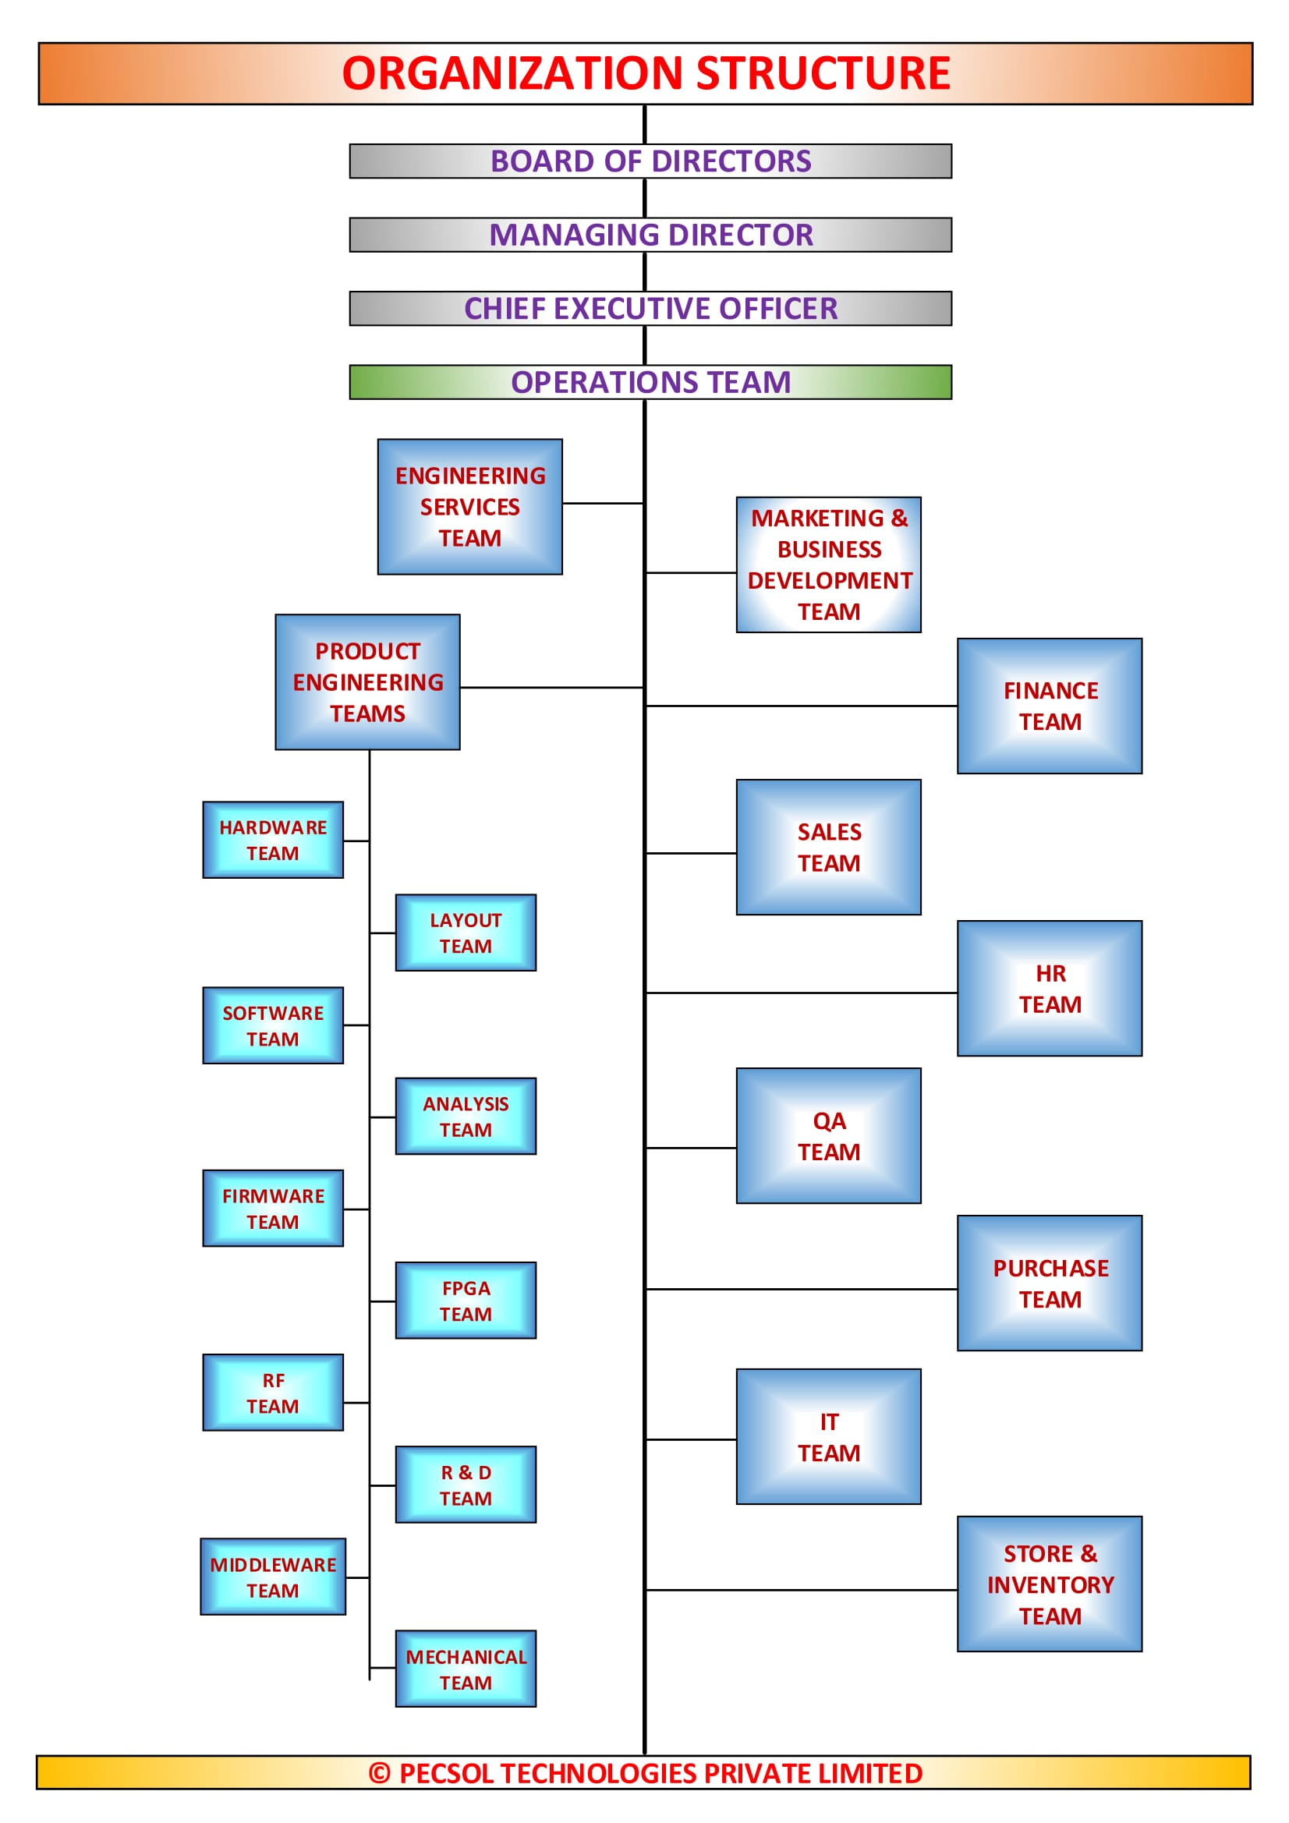
4.Internship Tasks & Responsibilities

Detailed Description of the Tasks Assigned
During my internship at PECSOL Technologies Private Limited, I was involved in a structured training and development program focused on embedded systems using the STM32G070RB microcontroller board. The internship was divided into ten core modules, each targeting a specific area of embedded firmware development.
- Tool Setup and Introduction
- Installed and configured STM32CubeIDE and STM32CubeMX.
- Explored CubeMX package installation and clock configuration tabs.
- GPIO Driver Development
- Developed input/output drivers using HAL and low-level coding techniques.
- Created interrupt-based input drivers, including support for multiple input pins.
- Bare-Metal Embedded C and Assembly Programming
- Coded GPIO drivers from scratch using STM32 datasheets.
- Implemented simple GPIO control logic using ARM assembly language in CubeIDE.
- Timer Driver Development
- Wrote firmware for hardware timers to generate precise delays.
- Developed drivers for event counting, output compare, PWM generation, and precise interrupt generation.
- ADC Driver Development
- Developed ADC drivers for single and continuous conversion modes.
- Implemented ADC conversion using interrupt, single-channel DMA, and multi-channel DMA scan modes.

- SPI Driver Development
- Coded SPI drivers for polling, interrupt, and DMA transfer modes.
- UART Driver Development
- Developed UART drivers using polling, interrupt, and DMA methods.
- Configured multiple UART modules for communication.
- USB Firmware Development
- Understood USB features on STM32 boards.
- Developed USB HID drivers (mouse and keyboard).
- Implemented virtual COM port functionality for TX-only and TX/RX modes.
- FreeRTOS and Real-Time Firmware Development
- Created and prioritized tasks in FreeRTOS.
- Developed applications using inter-thread notifications and hardware access across multiple threads.
- Closing Projects and Review
- Participated in final project demonstrations and internal evaluations.

Projects Worked On
- GPIO and timer driver implementation from scratch.
- DMA-based ADC and UART communication.
- USB HID and virtual COM device simulation.
- FreeRTOS-based real-time task management projects.

Challenges Faced and How We Resolved Them
- Understanding low-level registers and peripheral mapping: Resolved through datasheet study and debugging with CubeIDE.
- Implementing interrupt-driven modules: Gained proficiency through iterative testing and mentor support.
- Configuring DMA for multi-channel ADC and UART: Overcame through logical planning and validating memory alignment.

Skills Applied and Developed
- Embedded C and ARM assembly programming.
- Real-time debugging and driver-level programming.
- Peripheral integration using UART, SPI, ADC, and USB.
- Real-time task handling using FreeRTOS.

5.Learning Outcomes

Practical Skills Acquired
During my internship at PECSOL Technologies Private Limited, I gained extensive hands-on experience in embedded systems development. Key practical skills acquired include:
- Proficiency in using STM32CubeIDE and STM32CubeMX for microcontroller programming and configuration.
- Development of bare-metal drivers for GPIO, timers, ADC, SPI, UART, and USB interfaces.
- Implementation of DMA, interrupt-based, and polling-based communication protocols.
- Design and testing of firmware modules for signal processing, delay generation, and peripheral interaction.
- Exposure to ARM Cortex-M0+ architecture and embedded C programming at register level.
- Ability to integrate FreeRTOS for real-time application development, including task creation, priority management, and inter-task communication.

Professional Behavior and Ethics
Throughout the internship, I was introduced to professional work ethics and industry practices. I learned to:
- Communicate effectively with mentors and team members for task clarity and project updates.
- Follow structured problem-solving approaches and maintain discipline in documentation and code quality.
- Accept constructive feedback and incorporate it into improving my technical and collaborative skills.
- Meet deadlines while ensuring the accuracy and stability of the developed firmware.

Industry Knowledge and Exposure
This internship provided valuable exposure to industry-grade development workflows and embedded system practices. Key takeaways include:
- Understanding the full product development cycle from hardware interfacing to firmware development.
- Gaining familiarity with engineering standards and compliance protocols related to signal integrity, power management, and EMI/EMC.
- Insight into how embedded technologies are applied in real-world projects, particularly in areas such as IoT devices, industrial automation, and electronic product design.
- Awareness of collaborative development environments, involving cross-functional teams such as hardware designers, software engineers, and system testers.

6.Recommendations

For the Organization
- Structured Documentation: While the training was comprehensive, maintaining centralized documentation (e.g., module-wise guides, code examples, and FAQs) would benefit interns by reducing dependency and speeding up their learning curve.
- Periodic Assessments: Introducing brief evaluations or quizzes after each module could help reinforce concepts and identify areas where interns need more support.
- Advanced Projects: Including optional advanced-level projects or real-time application challenges would allow fast learners to explore beyond foundational skills.
For Future Interns
- Brush Up on Basics: Before starting the internship, it's helpful to revise C programming, digital electronics, and microcontroller concepts, especially the ARM Cortex-M series.
- Explore STM32 Resources Early: Familiarity with STM32CubeIDE, CubeMX, and the STM32 datasheets/manuals will significantly reduce the initial learning curve.
- Be Curious and Ask Questions: Don’t hesitate to ask for clarification or explore how each low-level function connects with actual hardware behavior—it’s a great way to deepen understanding.
- Practice Beyond Assigned Tasks: Trying variations of each lab task (e.g., different clock settings, peripherals, or driver optimizations) is a good way to gain confidence and mastery.
For Academic Improvement
- Incorporate Industry Tools into Curriculum: Exposure to industry-standard tools like STM32CubeIDE, CubeMX, and FreeRTOS in regular academic labs would better prepare students for internships.
- Focus on Bare-Metal Programming: Emphasizing low-level embedded programming in courses can make students more proficient in writing hardware-oriented code, rather than just application-layer logic.
- Encourage Collaborative Mini-Projects: Team-based hardware-software integration projects during academic semesters can simulate the collaborative engineering environment experienced in real-world internships.

7.Conclusion

The internship at PECSOL Technologies Private Limited was a highly enriching and transformative experience that allowed me to bridge the gap between academic learning and real-world engineering applications. Throughout the internship period, I was exposed to an intensive hands-on environment where I worked extensively with the STM32G070RB microcontroller and industry-standard tools like STM32CubeIDE, CubeMX, and FreeRTOS. This experience helped me understand the practical implementation of embedded systems and the internal workings of microcontrollers at a very fundamental level.
From developing GPIO drivers and configuring hardware timers to implementing UART, SPI, ADC, and USB interfaces in both polling and interrupt-based modes, each module contributed to building a strong foundation in low-level embedded programming. Additionally, learning how to work with FreeRTOS and handle real-time task scheduling provided valuable insights into embedded firmware development in multitasking environments.
The structured learning approach, along with the support and guidance from experienced mentors, particularly Mr Ranjan , and academic guidance from Mrs. Sobia Naz , played a vital role in my technical and professional development. It was through their mentorship that I gained confidence in debugging, problem-solving, and independently handling embedded hardware tasks.
Moreover, this internship instilled in me a deeper appreciation for disciplined engineering practices such as clean coding, documentation, and version control, which are essential in any professional development setting. It also introduced me to collaborative work environments and the importance of communication in multidisciplinary teams.
In summary, the internship has not only enhanced my technical skill set but has also shaped my mindset toward continuous learning and innovation in the field of embedded systems. I feel more prepared and confident to take on future roles in this domain and contribute effectively to real-world engineering challenges.

8.Appendices
Research/ Industry Internship Report Evaluation Marks Sheet

Sl. No. | Industry/ Research Internship Report | Max.Marks. | Marks Scored.
1. | Originality and relevance of learning experience | 05
2. | Adequacy and purpose of the write-up | 05
3. | Organization, format, drawings, sketches, style, language etc. | 05
4. | Practical applications, relationships with basic theory and concepts, usage of tools, technologies relevant to Internship | 05
5. | Completion Certificate or Declaration from relevant Authorized Authority and timely submission of the report | 05
Total |  | 25

Research/ Industry Internship Daily Diary Evaluation Marks Sheet

Sl. No. | Student Internship dairy | Max.Marks. | Marks Scored.
1. | Regularity in the maintenance of the diary | 10
2. | Adequacy and quality of information presented | 10
3. | Drawings, sketches and data recorded | 10
4. | Thought process and recording techniques used | 10
5. | Organization of the information and timely submission of  the diary | 10
Total |  | 50

Name & Signature of Mentor Name & Signature of Examiner

9.References

1.https://www.st.com/resource/en/user_manual/um2324-stm32-nucleo64 boards-mb1360-stmicroelectronics.pdf
2.Programming Embedded Systems in C and C++
Michael Barr Publisher: O'Reilly First Edition January 1999
ISBN: 1-56592-354-5, 191 pages Released by guojerry@teamfly
3. https://wiki.st.com/stm32mcu/wiki/Getting_started_with_GPIO
4. https://www.youtube.com/watch?v=mIGorhzZdyM
5. https://www.st.com/en/evaluation-tools/nucleo-g071rb.html

