Technical Parameters
Operating Voltage (V): DC5V
Quiescent Current (mA): 4MA
Modulation: AM (OOK)
Working temperature: -10 ℃ ~ +70 ℃
Receiver sensitivity (dBm):-105DB
Operating Frequency (MHz): 315,433.92 MHz (266-433MHZ frequency band optional)
Dimensions (LWH): 30 * 14 * 7mm
Remarks:
Far as the pro-distance requirements, can be accessed by 1/4 wavelength antenna, generally use 50 ohm single-core wire, the length of the antenna is about 315M of 23cm, 433M of about 17cm;
Antenna position also affected the reception of the module, install the antenna stretched as far as possible, away from the shield, high pressure, and the sources of interference; frequency used to receive, decode mode and oscillation resistance should be matched with the launch
Pin and use:
1 ANT antenna connection
2 VCC power supply positive
3,4 DATA Data Output
5 GND power supply negative
Receiver module has four external interfaces, VCC "indicates positive power supply," DATA "indicates that the output," GND "indicates negative one (marked on the product is available in English).
Uses: remote control switch, receiver module, motorcycle, car alarm products, home security products, electric doors, shutter doors, windows, remote control socket, remote control LED, remote stereo, remote control electric doors, garage door remote control, remote control retractable doors, remote control gate volume , sliding door, remote door opener, the door closing machine control system, remote control curtains, alarm host, alarm, remote control motorcycle, electric car remote control, remote control MP3, remote control lights, remote control cars, security and other remote areas of civil and industrial facilities
[Quality Features]:
1, the receiver module on the market can be fixed code, learning code same frequency remote control any supporting the use of ancillary shop for all wireless remote control.
2, super-regenerative receiver module using LC oscillator circuit, containing amplification shaping, the output data signal is TTL level, you can go directly to the decoder, extremely easy to use and inexpensive, it is widely used. Products are small, high sensitivity; frequency debugging easy, short lead times; product quality, consistency, and cost-effective, wireless remote control market is currently the largest amount of the most widely used high-frequency receiver module. Receiver module has a wide receiver bandwidth, typically ± 10MHz, factory general emphasis on the 315MHz or 433.92MHZ (if any special requirements adjustable frequency, frequency adjustment range is 266MHz ~ 433MHz.). Receiver module generally use DC5V power supply, any special requirements adjustable voltage, the voltage adjustment range is 3 ~ 8V.
Receiver module factory quiescent current typically 4mA, any special requirements can reduce the current, minimum current adjustable from 1.5mA, but the receiver sensitivity will be reduced. Receiver module factory output is noisy output, any special requirements can be changed without noise output, but the receiver sensitivity will be reduced.
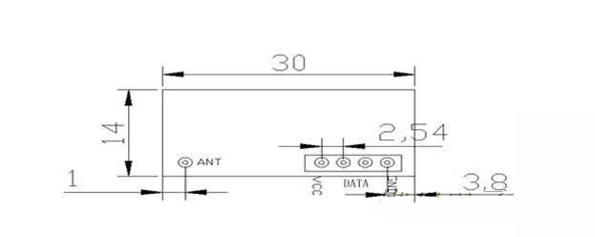
接收模块尺寸图

