System Design Document (SDD)
DPMG Term Project — Student Submission
WorkNest — Smart Workspace Booking & Membership Management Platform
Field | Details
Project Name | WorkNest Smart Workspace Booking & Membership Management Platform
Group Number & Team Members | Group 3 Lakshmi P, Sangeetha, Kajal, Sristi Sinha, Sufyaan Bin Salman
Version | v1.0
Date | 04-09-2026
Prepared By | Lakshmi P
Reviewed By | Kajal

Design ownership note: Lakshmi P owns the Design phase, including UI/UX flow, wireframes and design handoff. Sufyaan Bin Salman owns Requirements; Sangeetha owns Build; Kajal owns Test; Sristi Sinha owns Demo & Closure.
Workflow and architecture figures are intentionally represented as placeholders in this document and will be generated separately after the written SDD is approved.

1. Purpose
This System Design Document translates the WorkNest Business Requirements Document into a practical design for the web application, database and user experience. It describes what will be built, how the major components interact, how users navigate the system, how booking and cancellation rules are enforced, and how each BRD requirement maps to a design element.
WorkNest is designed as a single source of truth for workspace operations. The system replaces fragmented spreadsheet and phone/WhatsApp processes with a shared database-backed application for resources, memberships, bookings, pricing, cancellation rules and support. The BRD identifies the problem as double-bookings, inconsistent refund calculations and limited visibility into revenue and resource utilisation.
2. Build Approach
Item | Choice | Design / Rationale
AI Coding Tool | Claude (Claude Code) | One coding assistant retained throughout the project.
Platform | Responsive Web Application | Single browser application with separate Member and Admin experiences.
Frontend | Next.js 16.3.2, React, TypeScript, App Router, Tailwind CSS | Component-based screens, routing and responsive UI.
UI | shadcn/ui + Radix UI | Reusable accessible components for forms, tables, dialogs and navigation.
Backend / Database | Supabase PostgreSQL | Persistent shared data, relational integrity and database-level booking protection.
Authentication | Supabase Auth / application identity | Supports Member/Admin access separation.
Authorisation | Supabase Row-Level Security (RLS) | Member and location-level data isolation.
Analytics | Recharts | Revenue and occupancy visualisation.
Deployment | Vercel | Agreed hosting platform.
Version Control | GitHub | Source repository and collaboration baseline.
Billing | Mock/sample INR calculations | Real payment gateway and card data are out of scope.

2.1 Current Implementation Baseline
• Phase 0 setup has been completed: the application runs locally, GitHub is updated, Supabase is active, shadcn/ui is installed, and Recharts is present in dependencies.
• The next technical stage is Phase 1: the nine-table database schema, constraints, double-booking exclusion rule and RLS policies.

3. System Architecture Overview
The architecture is intentionally lean for the course scope: the Next.js application provides the Member and Admin experiences, while Supabase provides authentication, PostgreSQL persistence and row-level access control. No live payment gateway, SMS/WhatsApp integration or native mobile application is included in scope.
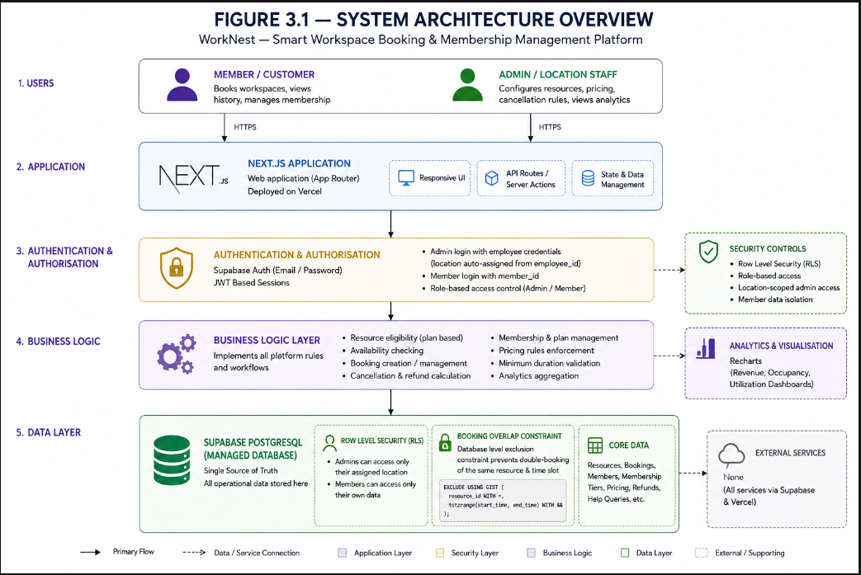Figure 3.1. System Architecture Overview.

Component | Responsibility | Key Design Rule
Member Interface | Login, membership, booking, history, cancellation, support. | Only authorised member data is visible.
Admin Interface | Resource, pricing, tier-rule configuration, live grid and analytics. | Admin scope follows authorised location.
Application Logic | Eligibility, duration, pricing, cancellation and allowance validation. | UI checks improve usability; DB rules remain authoritative.
Supabase Auth | Identity/session management. | Protected screens require valid identity.
PostgreSQL | Nine core entities and relationships. | PK/FK, checks, indexes and overlap protection.
RLS | Row-level access control. | Member = own records; Admin = authorised location.
Analytics | Read-oriented booking/resource aggregation. | Charts reconcile to source data.

4. Design Ownership & User Roles
Team Member | Phase Owned | Responsibility
Sufyaan Bin Salman | Requirements | Requirements, BRD scope and requirement-change control.
Lakshmi P | Design | System design, UI/UX flows, wireframes, navigation, design decisions and SDD.
Sangeetha | Build | Booking engine, pricing/plan logic and cancellation/refund rule engine.
Kajal | Test | Double-booking, refund and role-based access test design.
Sristi Sinha | Demo & Closure | Demo script, seed/sample data and closure documentation.
The BRD explicitly assigns Lakshmi P to Design and to UI/UX flow and wireframes for booking, pricing and membership.

4.1 User Roles
Role | Access / Need | Design Treatment
Admin / Location Employee | Configure resources, pricing and cancellation rules; monitor bookings and analytics. | Location-aware Admin Dashboard; location derived from employee identity.
Regular Member | Pay-per-use booking; no monthly allowance. | Eligible resources and charges shown from member profile.
Silver / Gold / Platinum | Monthly plan, remaining hours and tier-specific cancellation. | Dashboard shows plan state, hours and renewal/expiry.
Course Instructor | Evaluates scope/build/demo. | Approval gate before Phase 1 schema is locked.
5. Screens & Navigation
The navigation has two clear role-based branches after authentication. The Member path is optimised for self-service; the Admin path is optimised for configuration and monitoring. This supports the BRD's To-Be flow and NFR2's shallow booking journey.
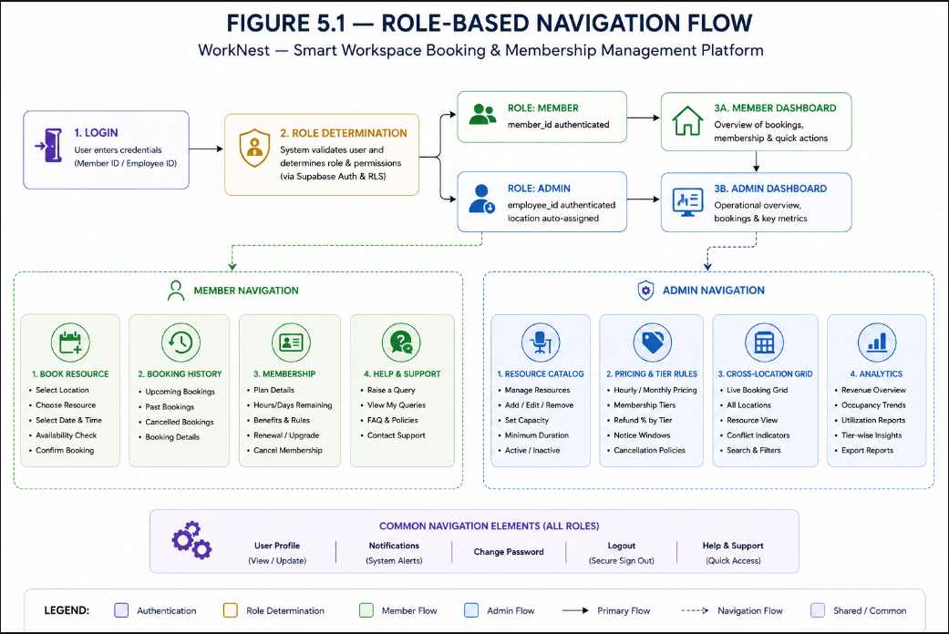

Figure 5.1. Role-Based Navigation Flow.

Screen | Purpose | Key Elements | Navigates To
Admin Login | Authenticate location staff. | Employee ID, password, generic error. | Admin Dashboard
Admin Dashboard | Location-aware landing page. | Location banner, shortcuts, operational summary. | Admin modules
Resource Catalog | Manage resources. | Type, capacity, minimum duration, active state. | Admin Dashboard
Pricing & Tier Rules | Configure prices and cancellation rules. | Hourly/monthly price, refund %, notice window, tiers. | Admin Dashboard
Cross-Location Grid | View live booking status. | Location/resource/time grid. | Admin Dashboard
Analytics | View revenue/occupancy. | Location, resource type, date filters, charts. | Admin Dashboard
Member Login | Authenticate member. | Member ID, generic error. | Member Dashboard
Member Dashboard | Show plan and booking summary. | Plan, hours, renewal/expiry, upcoming booking. | Book / History / Membership / Help
Book Resource | Create booking. | Location, eligible type, date/time, duration, Confirm. | Confirmation
Booking Confirmation | Show successful booking. | Booking ID, resource, slot, amount. | History / Dashboard
Booking History | View and cancel bookings. | Date, resource, location, status, Cancel. | Cancellation
Cancellation / Refund Preview | Explain outcome before commit. | Tier, notice window, refund %, amount. | Confirm / Keep booking
Membership | Show plan state. | Tier, remaining hours, renewal/expiry. | Book / Dashboard
Help & Support | Raise query. | Message, submit, status. | Dashboard

.

5.2 Indicative Member Wireframe
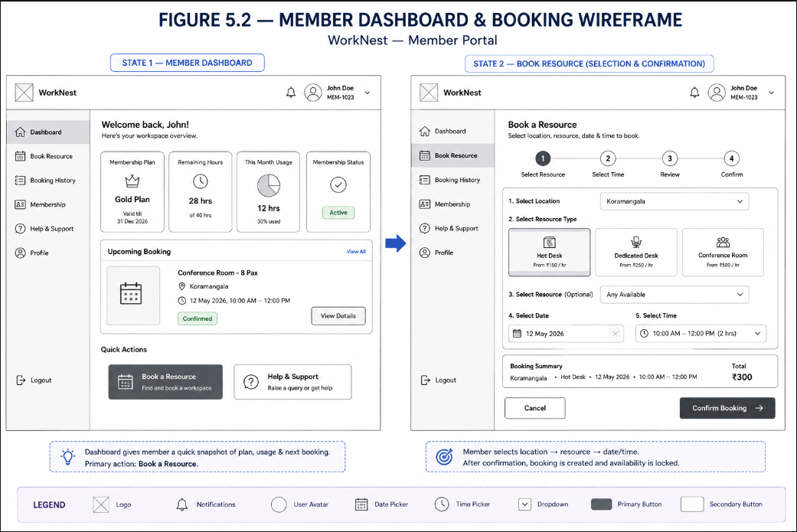Figure 5.2. Member Dashboard & Booking Wireframe.

6. Core Workflows
The BRD To-Be process is: member login → location/resource selection filtered by plan → live availability check → database-protected booking → history/membership update → optional self-service cancellation → automatic tier/notice-window refund calculation.
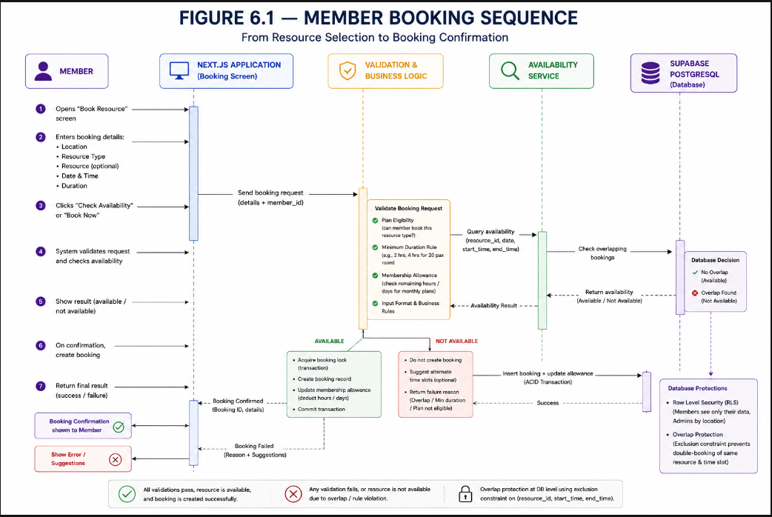

Figure 6.1. Member Booking Sequence.
6.1 Booking Workflow — Design Rules
• Only resource types included in the active plan are selectable.
• Minimum booking duration is checked before submission and shown when violated.
• Availability is read from the current database state.
• The final write is protected by a PostgreSQL overlap constraint so concurrent attempts cannot both reserve the same resource/time interval.
• Successful booking appears in booking history and applicable membership counters in the same session.
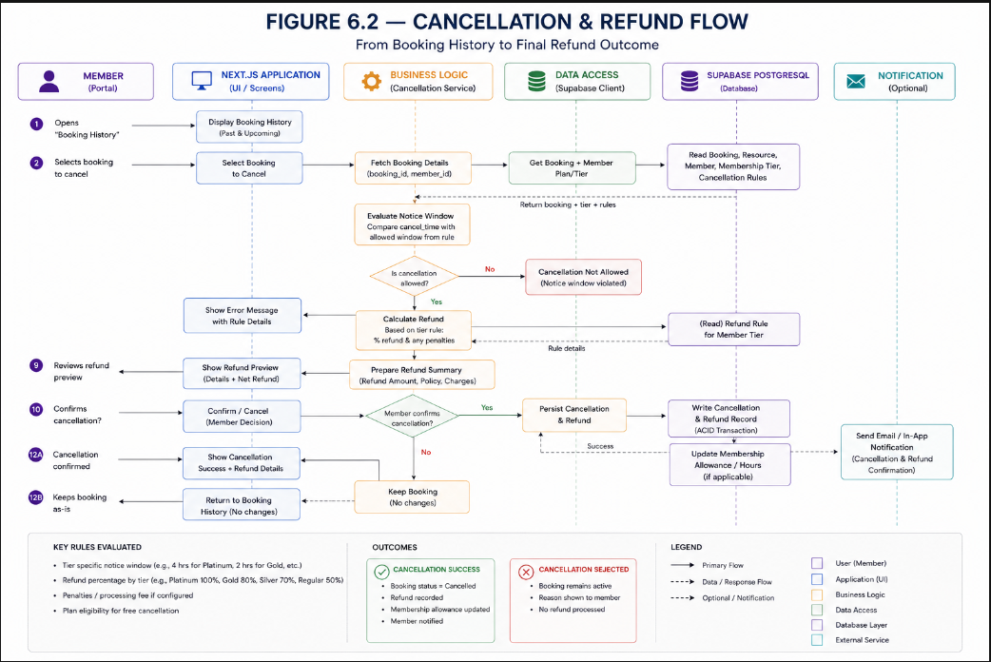

Figure 6.2. Cancellation & Refund Flow.
6.2 Cancellation & Refund Rules
• Refund percentage is configured by membership tier.
• Notice window determines whether the configured percentage applies, is reduced, or becomes zero.
• Refund is shown before cancellation is confirmed.
• Cancellation record stores the applied tier rule and refund values for auditability.
• No real payment is processed; WorkNest calculates and records the financial outcome.
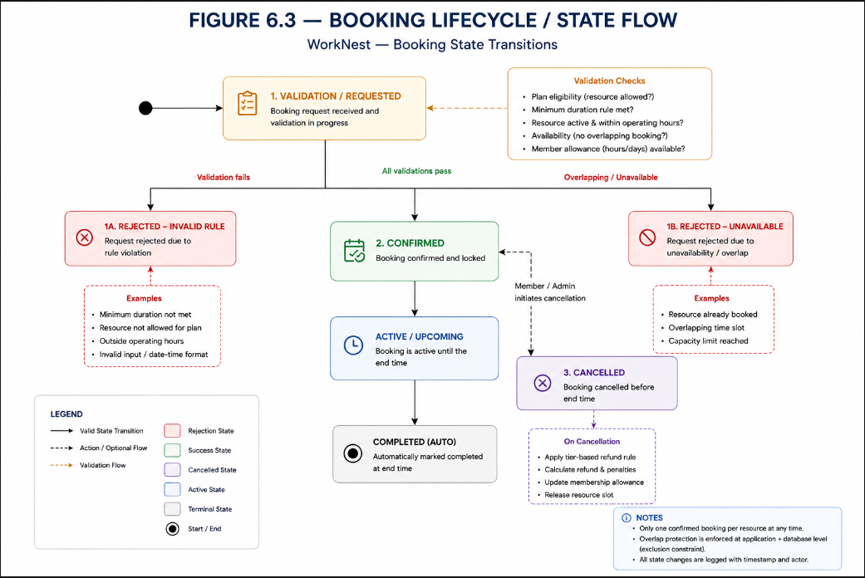

Figure 6.3. Booking Lifecycle / State Flow.

6.4 As-Is vs To-Be Summary
Current Manual Process | WorkNest To-Be Process
Member calls/messages admin for availability. | Member logs in and checks availability directly.
Admin checks spreadsheets across locations. | System queries the shared PostgreSQL source of truth.
Admin verbally confirms and updates spreadsheet. | Booking is committed with database overlap protection.
Cancellation requested by phone/WhatsApp. | Member cancels directly from Booking History.
Admin calculates refund manually. | System applies tier + notice-window rules.
Admin updates spreadsheet manually. | Booking/refund/membership state updates in the system.

7. Data Model
The database is the backbone of the single-source-of-truth design. The case study provides conceptual inspiration for Member, Plan, Booking, Resource, Location and Staff, while the WorkNest BRD determines the actual scope. WorkNest therefore uses nine core tables and does not add case-study-only Invoice, Shift or Staff_Training entities.

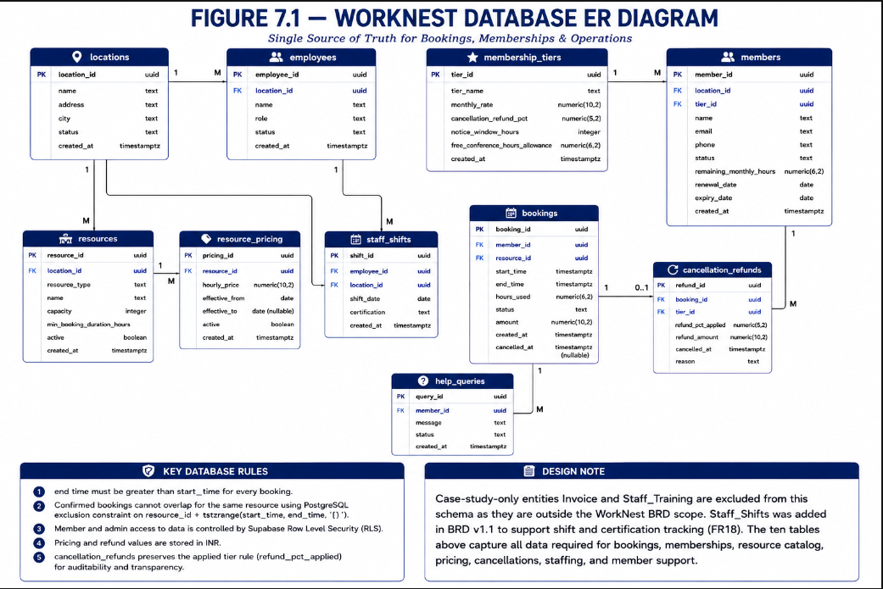Figure 7.1. WorkNest Database ER Diagram.

Entity | Key Attributes | Relationships / Notes
locations | location_id PK, name, address | 1:M employees, resources and members.
employees | employee_id PK, name, role, location_id FK | M:1 location; used for admin scope.
membership_tiers | tier_id PK, tier_name, monthly_rate, cancellation_help_queries_applied, notice_window, free_conference_hours_allowance | 1:M members; drives plan/cancellation rules.
members | member_id PK, name, tier_id FK, location_id FK, status, remaining_monthly_hours, renewal/expiry | M:1 tier/location; 1:M bookings/help queries.
resources | resource_id PK, location_id FK, resource_type, capacity_tier, min_booking_duration, active | M:1 location; 1:M bookings/pricing.
resource_pricing | pricing_id PK, resource_id FK, hourly_price, monthly_price, effective dates/status | M:1 resource; configurable pricing.
bookings | booking_id PK, member_id FK, resource_id FK, start_time, end_time, status, amount, created_at | M:1 member/resource; central reservation transaction.
cancellation_refunds | refund_id PK, booking_id FK, tier_rule_id FK, help_queries_applied_applied, refund_amount, cancelled_at | Booking 1:0..1; preserves applied rule.
help_queries | query_id PK, member_id FK, message_text, status, created_at | M:1 member; visible to authorised admin.
staff_shifts | shift_id (PK), employee_id (FK), location_id (FK), shift_date, certification, created_at | Supports FR18; one row per assigned shift

7.1 Relationship & Cardinality Rules
Relationship | Cardinality | Meaning
locations → employees | 1:M | One location has many employees; employee maps to one location.
locations → resources | 1:M | One location contains many bookable resources.
locations → members | 1:M | Members are associated with a location for operational scope.
membership_tiers → members | 1:M | One tier can be assigned to many members.
members → bookings | 1:M | One member can create many bookings.
resources → bookings | 1:M | A resource has many bookings over time, but no overlapping confirmed intervals.
resources → resource_pricing | 1:M | Pricing records support configurable/effective pricing.
members → help_queries | 1:M | A member can raise multiple support queries.
bookings → cancellation_refunds | 1:0..1 | A booking may have no cancellation or one cancellation/refund record.
membership_tiers → cancellation_refunds | 1:M | Applied tier rule is retained for auditability.
employees → staff_shifts | 1:M | one employee can be assigned many shifts

7.2 Database Integrity & Business Rules
• PK/FK relationships maintain referential integrity.
• end_time must be later than start_time.
• Confirmed bookings for the same resource cannot overlap.
• Indexes support availability and member-history queries.
• RLS restricts members to their own records and admins to authorised location data.
• Gold/Platinum free conference-hour allowance remains unresolved; the field can default to 0 until the team agrees a value.
7.3 Core Booking Constraint — PostgreSQL Design
CREATE EXTENSION IF NOT EXISTS btree_gist;
ALTER TABLE bookings
ADD CONSTRAINT bookings_valid_time
CHECK (end_time > start_time);
ALTER TABLE bookings
ADD CONSTRAINT bookings_no_overlap
EXCLUDE USING gist (
resource_id WITH =,
tstzrange(start_time, end_time, '[)') WITH &&
)
WHERE (status = 'confirmed');
This is the database-level control that supports the BRD target of zero double-bookings
8. Requirement → Design Mapping
Req ID | Design Element | Design Treatment / Verification
FR1 | Admin Login + employees | Valid credentials load dashboard; invalid credentials return generic error.
FR2 | employees.location_id | Admin location is derived from employee mapping, not selected at login.
FR3 | Resource Catalog + resources | Create/update/deactivate resources for authorised location; reflected in booking view.
FR4 | resources.min_booking_duration | Below-minimum booking rejected and required minimum displayed.
FR5 | resource_pricing | Hourly/monthly pricing is configuration data and reflected in booking screen.
FR6 | membership_tiers.cancellation_help_queries_applied | Refund percentage selected from member tier.
FR7 | membership_tiers.notice_window | Notice-window evaluation determines refund outcome shown before confirmation.
FR8 | Member Login + members | Valid member ID loads member dashboard; invalid ID returns generic error.
FR9 | Book Resource + tier eligibility | Only resource types permitted by active plan are selectable.
FR10 | bookings + exclusion constraint | Overlapping confirmed intervals rejected at database level.
FR11 | Booking History + bookings | Member sees past/upcoming bookings with date/resource/location/status.
FR12 | Cancellation + cancellation_refunds | Refund calculated and previewed; applied rule persisted.
FR13 | Member Dashboard + allowance | Remaining hours/plan dates refresh after booking/cancellation.
FR14 | Help & Support + help_queries | Query stores member, timestamp, message and status.
FR15 | Cross-Location Grid + bookings | Booking status surfaced across all three locations with live refresh.
FR16 | Analytics + bookings/resources | Six-month revenue/occupancy aggregates reconcile to booking data.
FR17 | membership_tiers + member allowance | Free conference hours reduce allowance before charging; exact allowance pending.
FR18 | staff_shifts table | Shift assignment and certification coverage tracked per location; surfaced on the Admin Dashboard
9. Non-Functional Design Choices
NFR ID | Design Element | Design Choice / Response
NFR1 Performance | Indexed availability queries | Target <2 seconds for up to 400 bookings across 3 locations.
NFR2 Usability | Shallow navigation + booking flow | Location → resource type → time slot; clear validation and confirmation.
NFR3 Scalability | Relational PostgreSQL schema | Sized for approx. 50–80 members, 60 resources and 250–400 bookings.
NFR4 Data & Privacy | No real payment fields | Mock/sample INR billing only; no real card/payment data.
NFR5 Availability | Vercel + Supabase | Business-hours target 8 AM–8 PM on agreed hosted stack.
NFR6 Security | Supabase RLS + role/location checks | Member = own records; admin = authorised location.
NFR7 Auditability | cancellation_refunds snapshot | Stores tier rule, applied refund %, amount and timestamp.
10. Security & Access Design
Control | Implementation | Purpose
Authentication | Supabase Auth / application identity | Verify user before protected screens.
Role Separation | Member/Admin routes and checks | Prevent members from entering admin workflows.
Location Scoping | employee.location_id + RLS | Keep admin operations within authorised location.
Member Isolation | member_id-based RLS | Prevent cross-member booking/query access.
Input Validation | Client + server/database checks | Reject invalid dates, durations and malformed requests.
Database Integrity | PK/FK/check/exclusion constraints | Protect critical rules at the source of truth.
Error Handling | Generic auth/conflict messages | Avoid leaking sensitive validation information.

11. Analytics & Reporting Design
Analytics is a read-oriented layer over the same booking and resource data. Admins can filter by location, resource type and date range and view revenue and occupancy. FR16 requires the last six months' totals to reconcile to the underlying booking data.
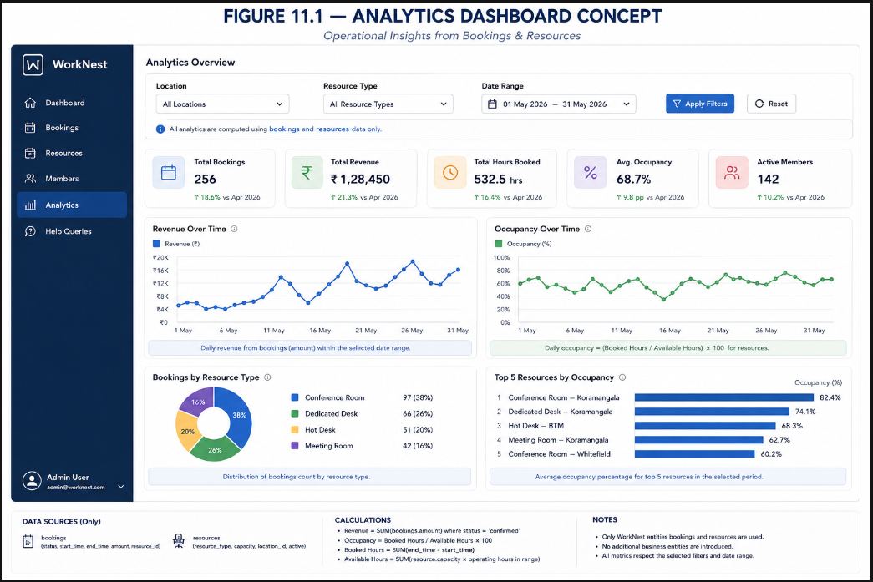 Figure 11.1. Analytics Dashboard Concept.
12. Open Design Decisions / Risks
Item | Current Position | Mitigation / Owner
I-01 — Gold/Platinum conference hours | Exact free monthly conference-room-hours allowance not finalised; FR17 is Could. | Keep configurable allowance field/default 0; Lakshmi + Sangeetha confirm before final implementation.
R-01 — Concurrent bookings | Race conditions may not appear in sequential tests. | Kajal tests near-simultaneous attempts; DB exclusion is primary control.
R-02 — Refund branching | Four tiers × notice-window bands can create configuration errors. | Kajal builds matrix; Sangeetha validates rule engine.
D-01 — Supabase availability | Free-tier project must remain accessible through demo. | Periodic activity/checks by team.
D-02 — BRD sign-off | Schema is not locked until instructor sign-off. | Sufyaan obtains formal approval; treat IDs/scope as provisional until then.

11. CARIAD Log
Reassessed from the BRD's CARIAD log. C = Constraint, A = Assumption, R = Risk, I = Issue, D = Dependency. New entries introduced during design are marked “New.”
No. | Statement | Description / Notes / Mitigation
C-01 | Still valid — project must run entirely on free-tier services (Vercel + Supabase). | Carried over from the BRD unchanged; schema design in §7 was kept lean specifically to stay inside free-tier row/compute limits.
C-02 | Still valid — total build timeline capped at roughly 5 weeks. | Schema design (this SDD) took slightly longer than planned because of the expanded membership-tier scope; team agreed to compress the polish phase to stay on track.
A-01 | Still valid — employee IDs are assumed to already exist and be valid. | No change; WorkNest still does not issue employee IDs itself.
A-02 | Still valid — all 3 locations price in INR only. | Confirmed again during schema design; no currency column was added to Resources or Membership_tiers.
A-03 | Still valid — seed data of 50–80 members / 250–400 bookings is enough to demo. | No change from the BRD.
R-01 | Still open — double-booking bugs may only surface under concurrent load. | Mitigation unchanged: Kajal to add concurrent-booking test cases. The exclusion constraint (FR10) is now implemented at the schema level, which reduces — but doesn't eliminate — this risk; app-level race conditions above the DB layer still need testing.
R-02 | Partially resolved — refund logic branching risk. | The Cancellation_refunds table now snapshots help_queries_applied at cancellation time (NFR7), which removes one source of the risk (retroactive rule changes). The tier × notice-window test matrix from the BRD is still needed and remains Kajal's responsibility.
I-01 | Resolved for schema purposes — free-conference-hours allowance for Gold/Platinum. | Team still hasn't picked a final number, but the schema now has a dedicated free_conference_hours_allowance field on Membership_tiers that safely defaults to 0, so this no longer blocks build work.
D-01 | Still valid — Supabase project and GitHub repo must stay accessible through the demo date. | No change; still needs periodic login to avoid free-tier pause.
D-02 | Resolved — BRD sign-off dependency. | BRD was submitted; this SDD proceeds on the assumption of BRD approval. If the instructor requests scope changes on review, FR/NFR IDs in §8–9 above will need re-mapping.
R-03 | New — Realtime subscriptions (FR15, Admin Live Booking Grid) add a layer of complexity not in the original MSA plan. | Mitigation: if Supabase Realtime proves unstable in testing, fall back to a 5–10 second polling refresh instead of a live subscription — acceptable for a 3-location demo.
I-02 | New — Admin view of Support_Queries (reading and responding to member queries) was not fully specified in the BRD. | Treated as a stretch goal beyond the MVP demo; FR14 covers the member-side submission only for now.

14. Design-to-Build Handoff
Handoff Area | Design Output | Next Owner / Action
Requirements | FR/NFR traceability and open decisions | Sufyaan controls scope changes against BRD.
UI/UX | Navigation, screen definitions, wireframes | Lakshmi finalises design; Sangeetha implements screens/components.
Database | Nine-table model, relationships, constraints, RLS | Sangeetha implements; Kajal validates integrity/security.
Booking Engine | Sequence and validation rules | Sangeetha implements; Kajal tests concurrency/edge cases.
Cancellation/Refund | Rule evaluation and refund snapshot | Sangeetha implements; Kajal tests tier × notice-window matrix.
Analytics | Revenue/occupancy design and data source | Sangeetha implements; Sristi prepares seed data.
Demo | End-to-end journey and data needs | Sristi prepares script and closure documentation.
14.1 Design Sign-off Checklist
• All nine database entities are approved and mapped to BRD functionality.
• Booking overlap protection is implemented at database level.
• Member/Admin navigation and primary screens are agreed.
• Cancellation/refund calculation and audit snapshot are agreed.
• RLS access boundaries are agreed.
• Open issue I-01 is resolved or explicitly carried forward with a documented default.
• Instructor BRD sign-off is obtained before the schema is treated as locked.
15. Approval / Design Sign-off
Role | Name | Signature / Date
Prepared / Design Phase Owner | Lakshmi P
Requirements Owner | Sufyaan Bin Salman
Build Owner | Sangeetha
Test Owner | Kajal
Demo & Closure Owner | Sristi Sinha
Approved by Instructor | Prof. Swaminathan N

