System Design Document (SDD)
DPMG Term Project — Student Submission
WorkNest — Smart Workspace Booking & Membership Management

Field | Details
Project Name | WorkNest — Smart Workspace Booking & Membership Management
Group Number & Team Members | Group 3 — Lakshmi P, Sangeetha, Kajal, Sristi Sinha, Sufyaan Bin Salman
Version | v1.0
Date | 03-09-2026
Prepared By | Sufyaan Bin Salman
Reviewed By | Sangeetha
Design status: Implementation-ready design baseline derived from the approved BRD and completed Phase 0 setup. Database details below are the proposed Phase 1 logical design; the BRD states that schema work follows after scope sign-off.

1. Purpose
This SDD translates the WorkNest BRD into a buildable technical design: the application structure, screens, navigation, booking and cancellation workflows, database model, security controls, technology choices, and traceability from requirements to design.
The design preserves the BRD scope: two interfaces (customer/member and admin), three resource categories (Hot Desk, Dedicated Desk and Conference Room), four membership tiers (Regular, Silver, Gold and Platinum), configurable pricing and cancellation rules, self-service booking/cancellation, live admin visibility, and analytics.
- Primary business outcome: replace spreadsheet/phone/WhatsApp-driven booking administration with a self-service, database-backed workflow.
- Design principle: business rules that affect correctness are enforced server/database-side, not only through UI validation.
- Scope boundary: real payment processing, SMS/WhatsApp notifications, native mobile apps and multi-tenant support remain out of scope.

2. Build Approach
Item | Choice
AI Coding Tool | Not specified as a locked project tool in the supplied project record; the team may use its chosen coding assistant, but the application design is tool-agnostic.
Platform | Responsive web application
Frontend | Next.js 16.3.2, React, TypeScript, App Router, Tailwind CSS
UI Component System | shadcn/ui with Radix UI components; Nova preset was selected during Phase 0
Backend / Database / Auth | Supabase — PostgreSQL database, authentication support, Row-Level Security and realtime capabilities
Analytics | Recharts
Deployment | Vercel
Version Control | GitHub
Data / Currency | INR; mock/sample billing data only; no real card data
Phase 0 is already established: the Next.js application was created successfully, Supabase is connected, shadcn/ui is installed, Recharts is installed, and the code is pushed to GitHub. The project setup uses TypeScript, Tailwind, App Router and the src/ directory. fileciteturn5file3L329-L346

3. System Architecture Overview
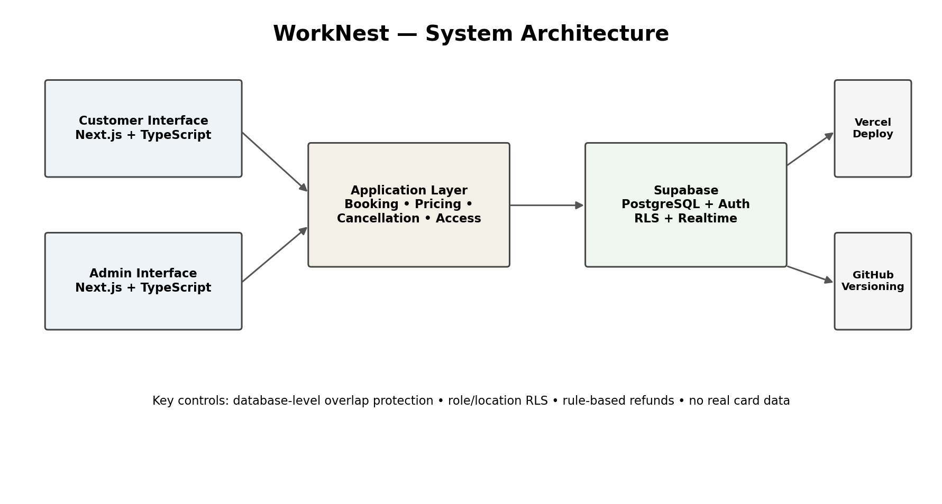
Figure 1. High-level WorkNest architecture.
- Presentation layer — responsive member and admin interfaces built in Next.js/TypeScript using shadcn/ui.
- Application logic — booking eligibility, minimum-duration validation, pricing lookup, cancellation/refund calculation and role-aware navigation.
- Data layer — Supabase PostgreSQL stores locations, employees, members, plans, resources, pricing, cancellation rules, bookings and support tickets.
- Security — Supabase authentication plus Row-Level Security. Member records are isolated from other members; admin access is constrained by the administrator's location.
- Deployment and delivery — Vercel hosts the web application; GitHub provides source control and the project already uses a working repository.

4. Screens & Navigation
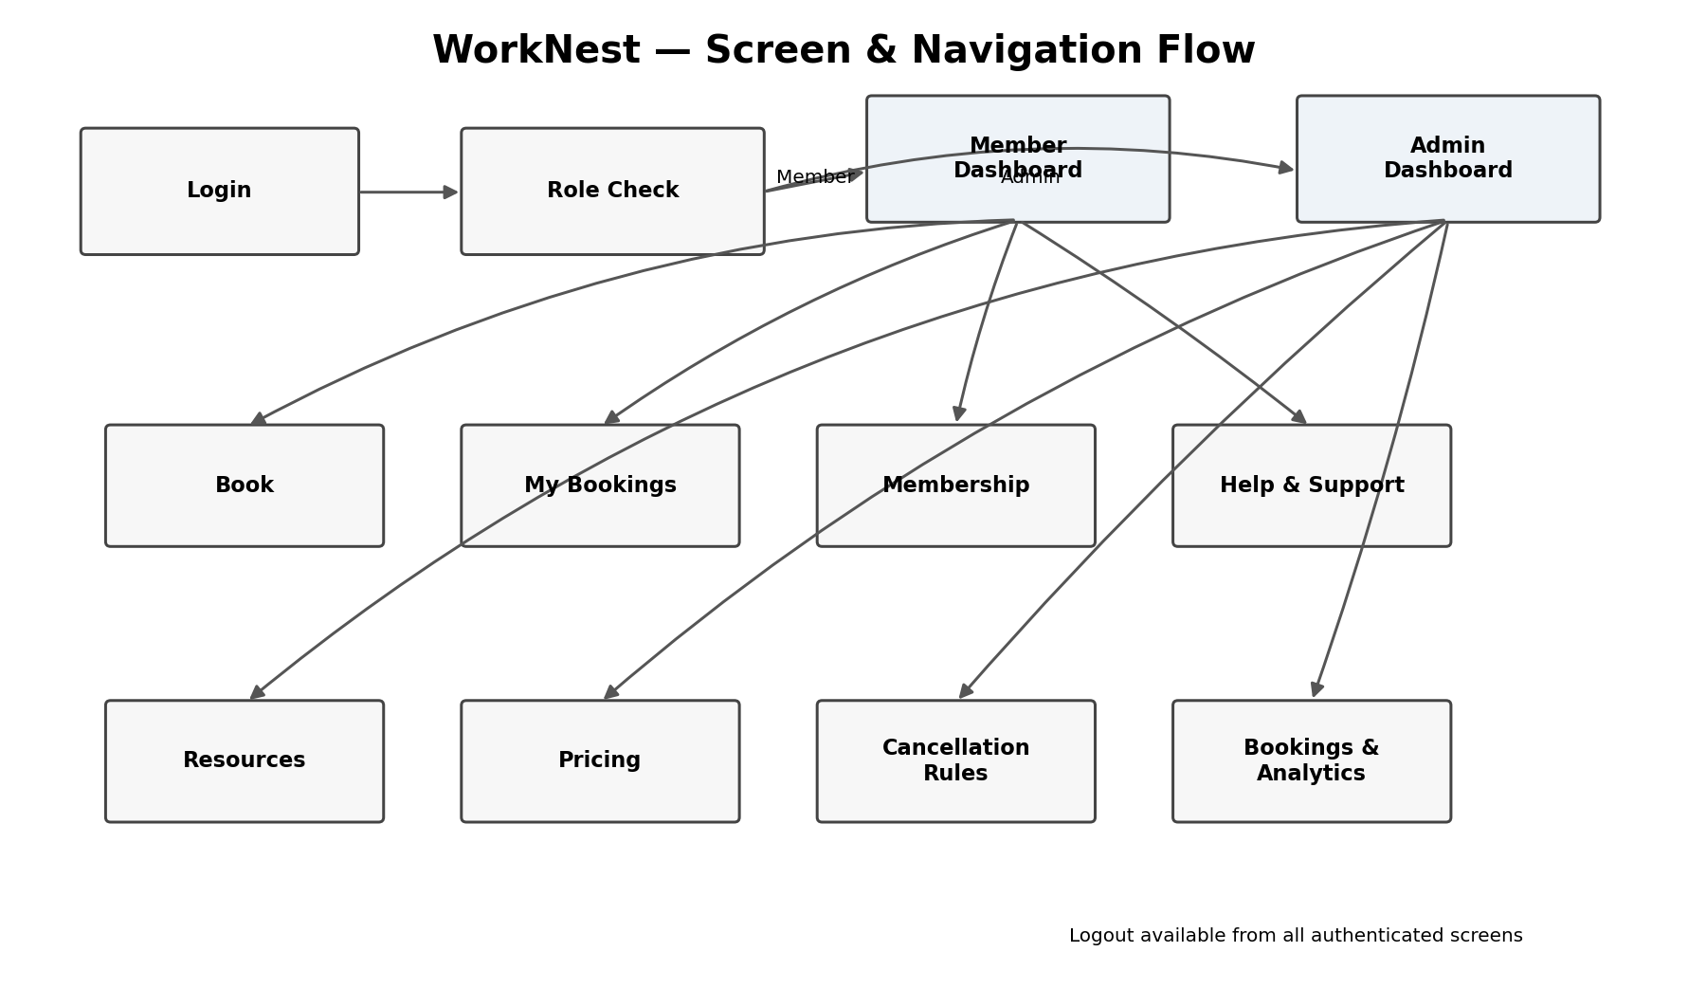
Figure 2. Role-based screen navigation.
The navigation is deliberately shallow for the member journey so the BRD usability target can be met: a first-time member should be able to complete a booking within three screens. fileciteturn4file1L314-L318
Screen | Purpose | Key Elements | Navigates To
Login | Authenticate member or admin and determine role. | Member ID / employee credentials; generic invalid-login message. | Member Dashboard or Admin Dashboard
Member Dashboard | Entry point for member self-service. | Next booking, plan summary, quick Book action, remaining hours. | Book, My Bookings, Membership, Help & Support
Book Workspace | Create a new booking. | Location, resource type, date, time, duration, availability, price, rule messages. | Confirmation / My Bookings
Booking Confirmation | Confirm successful booking. | Resource, location, slot, duration, amount, booking ID. | My Bookings / Membership
My Bookings | View past and upcoming bookings. | Date, resource, location, status, cancellation action. | Cancellation confirmation
Cancellation / Refund Preview | Show policy result before cancellation. | Notice window, applicable tier rule, refund percentage, refund amount. | My Bookings
Membership | Show current plan and allowance. | Tier, renewal/expiry, remaining monthly hours, conference allowance if enabled. | Book / Dashboard
Help & Support | Raise a query. | Message, timestamp, ticket status. | Dashboard
Admin Dashboard | Operational overview. | Location context, live bookings, occupancy/revenue summary. | Resources, Pricing, Cancellation Rules, Bookings & Analytics
Resource Management | Configure location resources. | Resource type, capacity, minimum duration, active/inactive. | Admin Dashboard / Booking Grid
Pricing Management | Configure hourly/monthly prices. | Resource pricing, effective values, save/validation. | Admin Dashboard
Cancellation Rules | Configure notice windows and refund percentages. | Membership tier, notice threshold, refund %, active rule. | Admin Dashboard
Bookings & Analytics | Monitor all locations and performance. | Cross-location grid, occupancy and revenue charts. | Resource / booking details

4.1 Indicative Booking Wireframe
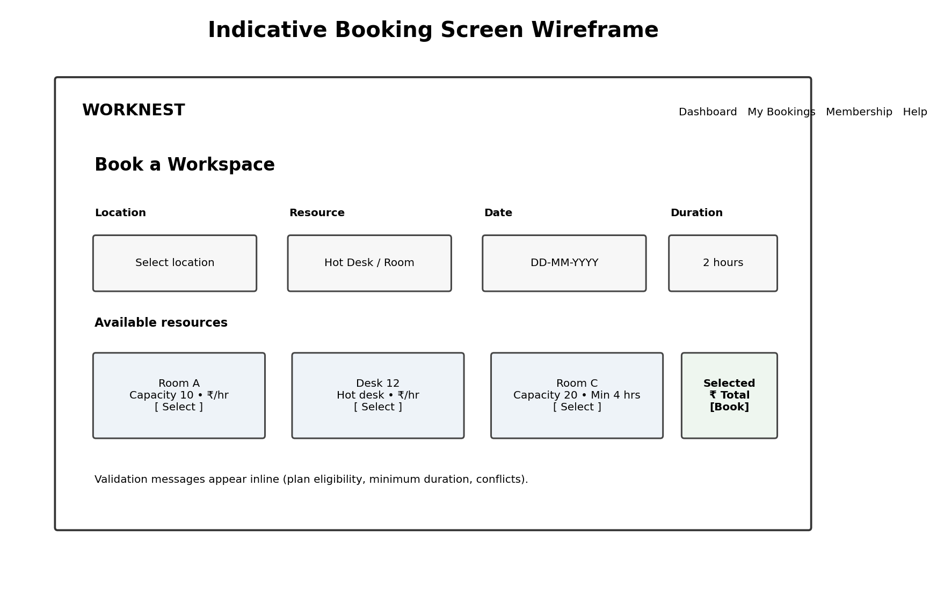
Figure 3. Low-fidelity booking screen showing the intended information hierarchy; final visual styling remains with the UI/UX implementation.

5. Data Model
The project record establishes a nine-table Phase 1 database design with constraints, a database-level double-booking exclusion rule and RLS policies. fileciteturn4file0L14-L18 The following logical schema maps that requirement to the expanded BRD scope. It is a design baseline and should be validated once Phase 1 implementation begins.
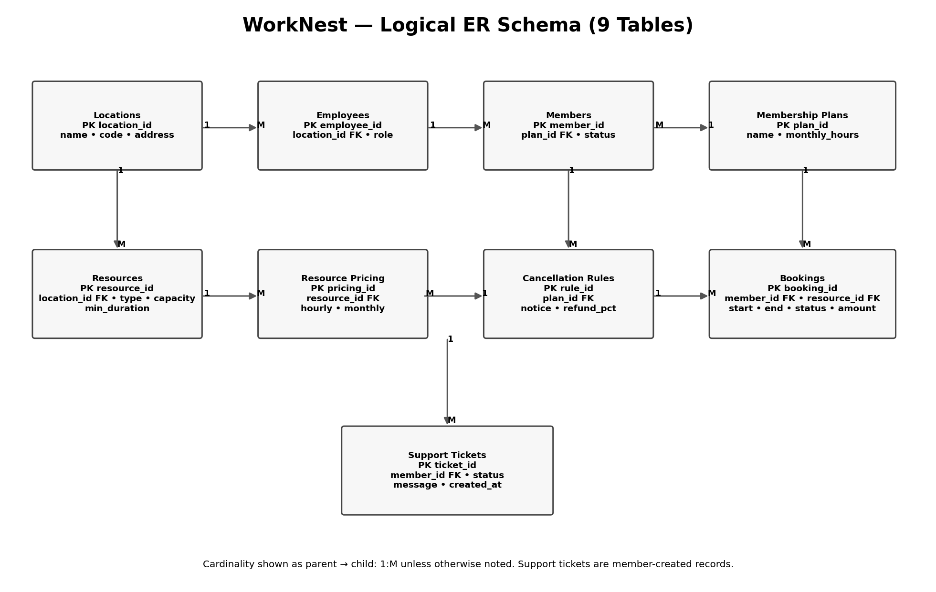
Figure 4. Logical ER-style schema with cardinality. The design uses nine tables by consolidating resource type as a controlled attribute of the resources table and keeping pricing/cancellation rules as separate configuration tables.
Entity | Key Attributes | Relationship / Design Notes
locations | location_id PK; name; code; address | One location has many employees and resources.
employees | employee_id PK; location_id FK; role | Admin employee identity is mapped to a location; location is derived after login.
members | member_id PK; plan_id FK; name; status | Each member has one current membership plan; Regular is supported as the hourly tier.
membership_plans | plan_id PK; name; monthly_hours; benefits | Stores Regular, Silver, Gold and Platinum plan definitions.
resources | resource_id PK; location_id FK; type; capacity; min_duration; active | Resource type is controlled as Hot Desk, Dedicated Desk or Conference Room; capacity supports room tiers.
resource_pricing | pricing_id PK; resource_id FK; hourly_price; monthly_price; active | Allows admin-controlled Hourly and Monthly pricing per resource.
cancellation_rules | rule_id PK; plan_id FK; notice_hours; refund_pct; active | Stores the rule used to calculate refund by membership tier and notice window.
bookings | booking_id PK; member_id FK; resource_id FK; start_at; end_at; status; amount; refund_amount | Core transaction. Overlap protection is enforced for active bookings at DB level.
support_tickets | ticket_id PK; member_id FK; message; status; created_at; resolved_at | Stores member queries and makes them visible to authorised admin users.

5.1 Key Data Rules
- Primary and foreign keys must be enforced by PostgreSQL.
- A resource belongs to exactly one location; a location can contain many resources.
- A member has one current membership plan; a plan can be assigned to many members.
- A booking belongs to one member and one resource; a member and resource can each participate in many bookings over time.
- Booking start/end timestamps must form a valid interval, with end_at later than start_at.
- The final anti-double-booking control must be database-side, using PostgreSQL range/exclusion logic or an equivalent transactional constraint. This is explicitly required by FR10 and the project Phase 1 plan.
- Cancellation must preserve the refund amount and the rule inputs used at the time of cancellation so that NFR7 auditability is met.
- The exact Gold/Platinum free conference-room allowance remains unresolved in the BRD; the schema should therefore permit an allowance value but default it to 0 until the team finalises it. fileciteturn4file1L341-L343

6. Core Workflows
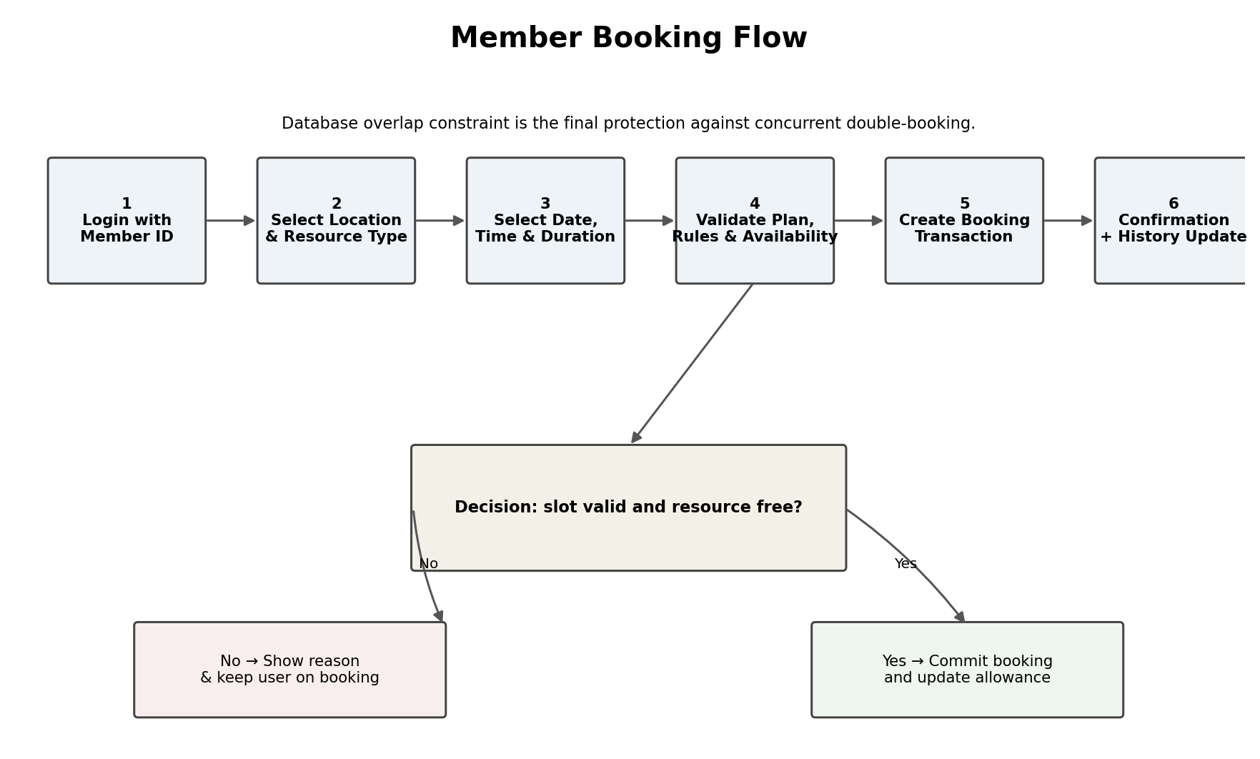
Figure 5. End-to-end member booking workflow.
Booking logic: authenticate → select location/resource → choose slot and duration → validate membership eligibility and minimum duration → query live availability → commit transaction → update booking history and membership allowance. The UI can pre-check availability, but the database transaction remains authoritative for concurrency.
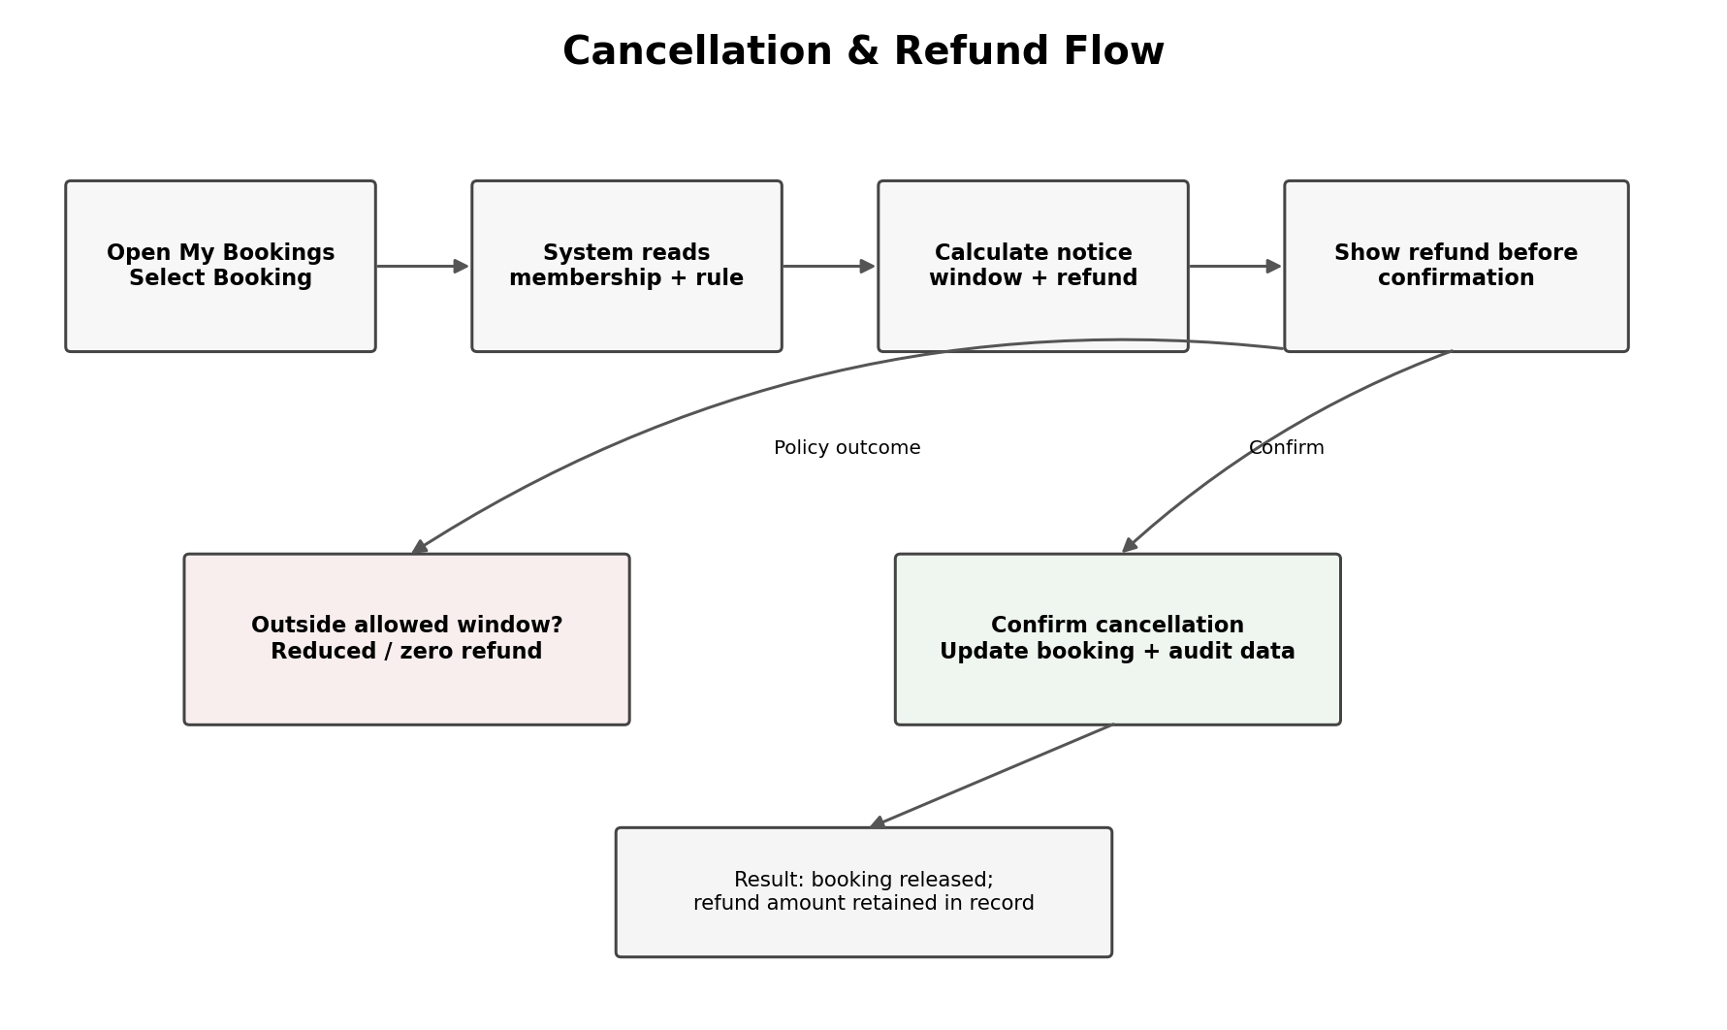
Figure 6. Cancellation and refund workflow.
Cancellation logic: retrieve the booking and current member tier → identify the applicable active cancellation rule and notice window → calculate refund → show the amount before confirmation → on confirmation, update booking status, release the slot and persist the refund calculation. The BRD requires the displayed refund to match the configured tier percentage and notice window. fileciteturn4file1L300-L306

7. Requirement → Design Mapping
Req ID | Design Element | Implementation Note
FR1 | Login + Supabase authentication | Admin credentials validated; generic error on failure.
FR2 | Employee + locations tables; login context | Employee location is loaded after authentication and not selected manually.
FR3 | Resource Management + resources table | Create/edit/deactivate resources for authorised location.
FR4 | Resource form + resources.min_duration | Duration validation is applied before booking; conference capacity can carry its own minimum.
FR5 | Pricing Management + resource_pricing | Hourly/monthly prices are read at booking time.
FR6 | Cancellation Rules + cancellation_rules | Refund percentage is configuration data, not hard-coded UI logic.
FR7 | Cancellation Rules + notice_hours | Notice window drives the refund outcome shown before confirmation.
FR8 | Member Login | Member ID identifies the member and loads dashboard.
FR9 | Book Workspace + membership_plans | Resource types are filtered/disabled according to active plan.
FR10 | bookings + PostgreSQL overlap protection | Database is final authority against concurrent overlapping bookings.
FR11 | My Bookings | Query filtered to authenticated member; includes past/upcoming status.
FR12 | Cancellation / Refund Preview | Rule engine calculates refund before commit.
FR13 | Membership | Shows plan, remaining hours and renewal/expiry information.
FR14 | Help & Support + support_tickets | Ticket stored with member, timestamp and message.
FR15 | Admin Bookings Grid + Supabase realtime/read refresh | Cross-location operational view for authorised admin.
FR16 | Analytics dashboard + Recharts | Revenue and occupancy derived from booking data for the last six months.
FR17 | Membership allowance field + booking transaction | Allowance counter can be implemented without changing the core schema; exact value remains an open decision.

8. Non-Functional Design Choices
NFR ID | Design Element | How the design addresses it
NFR1 | Indexed PostgreSQL queries + compact availability query | Availability grid queries only relevant resources/time range; target is <2 seconds for up to 400 bookings across 3 locations.
NFR2 | Shallow member navigation + prefilled booking form | Core booking path is Login → Book → Confirmation; policy messages appear inline.
NFR3 | Relational schema + Vercel/Supabase separation | No architecture change is required for the BRD target of 80 members and 60 resources across 3 locations.
NFR4 | No payment-card table / no gateway | Only mock/sample billing values are retained; real payment details are never stored.
NFR5 | Vercel + Supabase hosted services | Deployment uses the agreed free-tier services and is intended to meet the business-hours availability target.
NFR6 | Supabase Auth + Row-Level Security | Member rows are isolated by authenticated identity; admin rows are constrained by location/role.
NFR7 | Booking cancellation snapshot fields + audit record | Refund amount and rule inputs are persisted so the cancellation result can be traced to the rule active at the time.

9. Open Design Decisions / Risks
Decision / Risk | Current Design Position | Action Before Build Lock
Exact Gold/Platinum free conference-room allowance | Schema supports an allowance value; default 0 is safe for the current design. | Confirm allowance hours with the team before FR17 is implemented.
AI coding tool | No single AI coding tool is explicitly locked in the supplied SDD prompt/Phase 0 record. | Record the team's selected tool in the build log if the course requires one.
Employee authentication source | BRD assumes employee IDs already exist and are supplied by HR/ops simulation. | Seed authorised employee IDs and location mappings during Phase 1/seed-data setup.
Pricing versioning | Current scope requires configurable prices but does not specify effective-dated historical pricing. | For demo scope, keep one active pricing record per resource; if historical pricing is required, add effective_from/effective_to.
Cancellation rule versioning | NFR7 requires traceability to the rule active at cancellation time. | Store the applied refund percentage/notice inputs on the booking/cancellation record; do not rely only on the current rule table.
Realtime admin grid | BRD expects live cross-location visibility without manual reload. | Use Supabase realtime where practical; retain a normal refresh/query path as fallback.

10. CARIAD Log
C = Constraint, A = Assumption, R = Risk, I = Issue, D = Dependency. The SDD reassesses the BRD CARIAD log in the context of technical design, as requested by the template.
No. | Statement | Description / Notes / Mitigation
C01 | Free-tier delivery constraint remains active. | Architecture stays within Vercel + Supabase free-tier services; avoid paid infrastructure dependencies.
C02 | Approx. five-week build window remains the working schedule constraint. | Prioritise Must requirements first; keep demo buffer for concurrency/refund testing.
A01 | Employee IDs and location mapping are externally supplied/simulated. | Seed a clean authorised employee list; WorkNest does not issue employee IDs.
A02 | All three locations use INR. | No multi-currency tables or conversion service are included in the current design.
A03 | 50–80 members and 250–400 bookings are sufficient demo data. | Seed enough historical bookings for six-month analytics without changing architecture.
R01 | Concurrent bookings can expose race conditions. | Use database-level overlap protection and run two near-simultaneous booking tests before demo.
R02 | Refund configuration has multiple tiers and notice windows. | Use a rule matrix covering all four tiers and at least three notice-window cases; test displayed and persisted refund.
I01 | Gold/Platinum free conference-room allowance is still unresolved. | Keep FR17 optional and allowance at 0 until a number is approved.
D01 | Supabase project and GitHub repository must remain accessible through demo. | Keep project active and verify deployment before rehearsal.
D02 | Formal BRD sign-off is required before Phase 1 scope is locked. | Do not treat the schema as final until instructor/team sign-off is recorded.
D03 | Phase 1 database implementation is the immediate technical dependency. | Implement the nine-table schema, constraints, overlap protection and RLS before booking UI integration.

11. Recommended Build Sequence
- Phase 1 — Database: implement the nine logical tables, foreign keys, indexes, booking overlap protection and RLS policies.
- Phase 2 — Authentication & role routing: connect member/admin login to authorised records and enforce location/role context.
- Phase 3 — Admin configuration: resources, minimum durations, pricing and cancellation-rule screens.
- Phase 4 — Member booking: availability query, plan filtering, booking validation and database transaction.
- Phase 5 — Cancellation & membership: refund preview, cancellation commit, allowance tracking and audit fields.
- Phase 6 — History & support: My Bookings, Membership, Help & Support and admin ticket visibility.
- Phase 7 — Analytics & hardening: Recharts dashboards, seeded historical data, performance checks, RLS tests and concurrency tests.
- Phase 8 — Deployment & demo: Vercel deployment, environment variables, final regression, demo script and documentation closure.

12. Design Traceability Summary
The SDD is intentionally aligned to the supplied SDD template: Purpose, Build Approach, System Architecture Overview, Screens & Navigation, Data Model, Requirement → Design Mapping, Non-Functional Design Choices, Open Design Decisions / Risks, and CARIAD Log. fileciteturn2file5L483-L509
The BRD remains the authoritative business baseline: it defines the 17 functional requirements and 7 NFRs, including database-enforced double-booking prevention, self-service cancellation, membership visibility, live admin booking view and analytics. fileciteturn4file1L280-L324
Phase 0 technical setup is already complete and verified in the project record, including Next.js, TypeScript, Tailwind, App Router, Supabase, shadcn/ui and Recharts. fileciteturn5file3L329-L346

13. Approval / Design Sign-off
Role | Name | Signature / Date
Prepared by (Team) | Sufyaan Bin Salman
Reviewed by | Sangeetha
Approved by (Instructor) | Prof. Swaminathan N

