Business Requirements Document (BRD)
DPMG Project Team 3 — WorkNest
Project Name | WorkNest — Smart Workspace Booking & Membership Management Platform
Group Number & Team Members | Group 3 — Lakshmi P, Sangeetha, Kajal, Sristi Sinha, Sufyaan Bin Salman
Version | v1.2
Date | 29-08-2026
Prepared By | Sufyaan Bin Salman
Reviewed By | Sangeetha

1. Team Charter
Team Member | Phase Owned | Role / Responsibility
Sufyaan Bin Salman | Requirements | Wrote functional and non-functional requirements; coordinated scope discussions between admin-interface and customer-interface needs; owns this BRD.
Lakshmi P | Design | Owns UI/UX flow for the admin and customer interfaces; defines wireframes for the booking, pricing, and membership screens. Owns Database Schema
Sangeetha | Build | Leads implementation of the booking engine, pricing/plan logic, and the cancellation refund rule engine.
Kajal | Test | Owns test case design for double-booking conflicts, refund calculations across membership tiers, and role-based access rules.
Sristi Sinha | Demo & Closure | Prepares the demo script, seed/sample data, and final project closure documentation for submission.

2. Purpose & Problem Statement
Small coworking operators running 2–3 locations currently track desk and conference-room bookings, membership tiers, and cancellation refunds by hand — across spreadsheets and phone/WhatsApp messages. This causes double-bookings, inconsistent refund amounts when members cancel, and no clear view of which locations or resource types actually earn revenue. WorkNest gives location staff a single dashboard to configure resources, pricing, and cancellation rules per membership tier, while letting members book desks and rooms, track their remaining plan hours, and cancel bookings themselves under rules the admin controls.

3. Business Objectives & Success Metrics (SLA / KPIs)
These metrics define what "success" looks like for WorkNest once it goes live, and are what the team will be graded against during the demo.
Objective | KPI / Success Metric | Target (SLA)
Eliminate double-bookings | Number of overlapping/double-booked resource slots after go-live | 0 double-bookings, enforced at the database level
Cut admin cancellation workload | Average time admin spends manually processing one cancellation (today: manual, ~10 min) | Under 1 minute of admin involvement per cancellation post-launch
Give members real-time visibility | Share of members who can view their remaining plan hours without contacting admin | 100% of active members, updated within the same session as a booking
Drive self-service adoption | Share of active members completing at least one self-service booking | 80% within the first month after launch
Keep the platform available | System uptime during business hours (8 AM–8 PM), Vercel + Supabase free tier | 99% uptime during business hours
Guarantee refund accuracy | Cancellation refunds calculated per the admin-configured tier rule | 100% match between refund shown and the configured tier percentage

4. Scope

In Scope
- Admin login using employee credentials, with the admin's location auto-assigned from their employee ID
- Admin-configurable resource catalog (Hot Desk, Dedicated Desk, Conference Room) per location, with add/edit/remove
- Admin-defined minimum booking duration per resource type, including per conference-room capacity tier (e.g., 2 hrs standard, 4 hrs for a 20-person room)
- Admin-defined Hourly and Monthly pricing, and 4 membership tiers (Regular, Silver, Gold, Platinum) with tier-based cancellation refund percentages and notice windows
- Member booking flow: select location, resource type (filtered to the member's plan), and time slot, with double-booking prevented at the database level
- Member booking history, self-service cancellation (per admin-defined policy), membership status (plan, hours/days remaining), and a Help & Support screen
- Admin cross-location live booking view and revenue/occupancy analytics
- Admin shift scheduling and certification coverage tracking per location"

Out of Scope
- Real payment gateway integration — fees and refunds are calculated but not processed through a live payment processor
- SMS / WhatsApp notifications
- Native mobile app
- Multi-tenant support (multiple coworking brands on a single deployment)

5. Stakeholders & User Roles
Role | Description / Needs
Admin / Location Employee | Logs in with employee credentials (location auto-assigned by employee ID); configures resources, pricing, and cancellation rules for their location; monitors cross-location bookings and analytics.
Member – Regular (hourly) | Books desks or rooms on a pay-per-use basis with no monthly commitment; no monthly hour allowance to track.
Member – Silver / Gold / Platinum | Books resources under a monthly plan; tracks remaining monthly hours; cancels bookings under their tier's refund rule (Platinum highest refund, Silver lowest).
Course Instructor (Prof. Swaminathan N) | Evaluates the BRD, build, and final demo against the DPMG course rubric; approves scope before Phase 1 is locked.
Development Team | Five-member student team (Section 1 above) responsible for requirements, design, build, test, and closure.

6. Functional Requirements
Each requirement is written so it can be tested independently — one behaviour per row.
Req ID | Requirement | Priority | Owner | Acceptance Criteria
FR1 | Admin can log in using employee credentials | Must | Sangeetha | Valid credentials load the admin dashboard within 2 seconds; invalid credentials show an error without revealing which field was wrong.
FR2 | System auto-assigns the admin's location based on their employee ID at login | Must | Sangeetha | The admin's location is set automatically post-login and cannot be changed from the login screen.
FR3 | Admin can add, edit, or remove resources (Hot Desk, Dedicated Desk, Conference Room) for their location | Must | Sangeetha | A resource added, edited, or removed by the admin reflects on the live booking grid within the same session, no reload required.
FR4 | Admin can set a minimum booking duration per resource type, including per conference room capacity tier | Must | Sangeetha | A booking attempt below the configured minimum (e.g., 2 hrs for a standard room, 4 hrs for a 20-person room) is rejected and the minimum is shown to the member.
FR5 | Admin can configure Hourly and Monthly pricing per resource type | Must | Sangeetha | A price change made by the admin reflects on the member's booking screen for that resource within the same session.
FR6 | Admin can define the cancellation refund percentage per membership tier | Must | Sangeetha | Refund percentages set by the admin (e.g., Platinum 100%, Gold 80%, Silver 70%) are applied automatically when a member of that tier cancels.
FR7 | Admin can define the cancellation notice window (e.g., days/hours before the booking) | Must | Sangeetha | A cancellation requested outside the configured notice window shows the reduced or zero refund before the member confirms.
FR8 | Member can log in using their member ID | Must | Kajal | A valid member ID loads that member's dashboard; an invalid ID shows a generic error.
FR9 | Member can book a resource by selecting a location and resource type | Must | Sangeetha | Only resource types included in the member's active plan are selectable; other types are hidden or disabled.
FR10 | System prevents double-booking of the same resource for overlapping time slots | Must | Sangeetha | A second booking on an already-booked slot is rejected at the database level, not only in the UI.
FR11 | Member can view their booking history | Must | Kajal | All past and upcoming bookings for the logged-in member display with date, resource, location, and status.
FR12 | Member can cancel a booking under the admin-defined cancellation policy | Must | Kajal | The refund amount shown before the member confirms cancellation matches the admin-configured tier percentage and notice window.
FR13 | Member can view their current plan, remaining monthly hours, and renewal/expiry date | Must | Kajal | Remaining hours update immediately after each new booking or cancellation.
FR14 | Member can raise a query through a Help & Support screen | Should | Lakshmi P | A submitted query is stored and visible to admin with the member ID, timestamp, and message text.
FR15 | Admin can view a live, cross-location booking grid | Should | Sangeetha | The grid reflects booking status across all 3 locations in real time, without a manual page reload.
FR16 | Admin can view revenue and occupancy analytics by location and resource type | Could | Sangeetha | Chart totals for the last 6 months match the underlying bookings table for the same period.
FR17 | Gold and Platinum members can receive a configurable free monthly conference-room-hours allowance | Should | Sangeetha | Free hours used reduce the member's allowance counter and do not generate a charge until the allowance is exhausted. Locked allowance: Gold = 4 hrs/month, Platinum = 8 hrs/month, Regular/Silver = 0.
FR18 | Admin can assign staff shifts per location and track certification coverage | Should | Sangeetha | Each shift shows assigned staff, location, and date; a location with no certified staff on a shift is flagged

7. Non-Functional Requirements
NFR ID | NFR Area | Requirement
NFR1 | Performance | The booking availability grid should load in under 2 seconds for up to 400 bookings spread across 3 locations.
NFR2 | Usability | A first-time member should be able to complete a booking within 3 screens without needing training material.
NFR3 | Scalability | The system should support up to 80 members and 60 resources across 3 locations without requiring architecture changes.
NFR4 | Data & Privacy | No real payment card data is stored; only mock/sample billing data is used for the class demo.
NFR5 | Availability | The system should be reachable during business hours (8 AM–8 PM) with no more than 1% downtime, in line with the Vercel/Supabase free-tier SLA.
NFR6 | Security | Role-based access (admin vs. member) is enforced via Row-Level Security so a member cannot view another member's bookings, and an admin cannot view another location's data.
NFR7 | Auditability | Every cancellation and its refund calculation is traceable to the membership-tier rule that was active at the time of cancellation.

8. CARIAD Log.
C = Constraint, A = Assumption, R = Risk, I = Issue, D = Dependency.
No. | Statement | Description / Notes / Mitigation
C-01 | The project must run entirely on free-tier services (Vercel + Supabase). | No budget line exists for this course project; any paid add-on (e.g., extra Supabase compute) is off the table unless the team funds it personally.
C-02 | Total build timeline is capped at roughly 5 weeks to fit the DPMG submission calendar. | Phase estimates in the technical plan (setup through deploy) must stay inside this window, including buffer for the demo rehearsal.
A-01 | Employee IDs used for admin login are assumed to already exist and be valid; WorkNest does not issue them. | We're assuming HR/ops (simulated for the class project) hands us a clean list of employee IDs mapped to locations — we haven't built an ID-issuing flow.
A-02 | All 3 locations price in INR; no multi-currency support is assumed necessary. | Confirmed against the case study data (Hot-desk ₹4,000/mo etc.); revisit if the instructor's rubric expects multi-currency.
A-03 | Seed data of 50–80 members and 250–400 bookings is enough to demo booking, cancellation, and analytics convincingly. | Matches the volumes agreed in our earlier project agreement; we won't generate a larger synthetic dataset unless analytics screens look sparse.
R-01 | Double-booking bugs may only surface under concurrent booking load, which is hard to fully test with a 5-person team before demo day. | Mitigation: Kajal to add explicit concurrent-booking test cases (two near-simultaneous booking attempts on the same slot) before demo rehearsal, not just sequential tests.
R-02 | Refund logic has enough branching (4 tiers × notice-window bands) that a wrong admin configuration could silently apply the wrong refund. | Mitigation: Kajal to write a test matrix covering all 4 tiers against at least 3 notice-window bands before sign-off; Sangeetha to review the rule engine against that matrix.
I-01 | Resolved: the free-conference-hours allowance for Gold/Platinum tiers is now locked ahead of Build (see SDD v1.1). | Locked values: Gold = 4 hrs/month, Platinum = 8 hrs/month, Regular/Silver = 0. FR17 priority raised from Could to Should to reflect that this is now a committed feature, not an optional one.
D-01 | The Supabase project (Worknest_project_db) and GitHub repo must stay accessible through the demo date. | Free-tier Supabase projects can pause after a period of inactivity — someone on the team needs to log in periodically to keep it active.
D-02 | Formal BRD sign-off from Prof. Swaminathan N is needed before Phase 1 (schema design) is treated as locked scope. | Until sign-off, treat FR/NFR numbering in this document as v1.0 draft — IDs may shift if scope changes after review.

9. Process Flow: As-Is vs. To-Be
The flow below contrast today's manual, phone/spreadsheet-driven process with the WorkNest self-service flow.

As-Is (Current Manual Process)
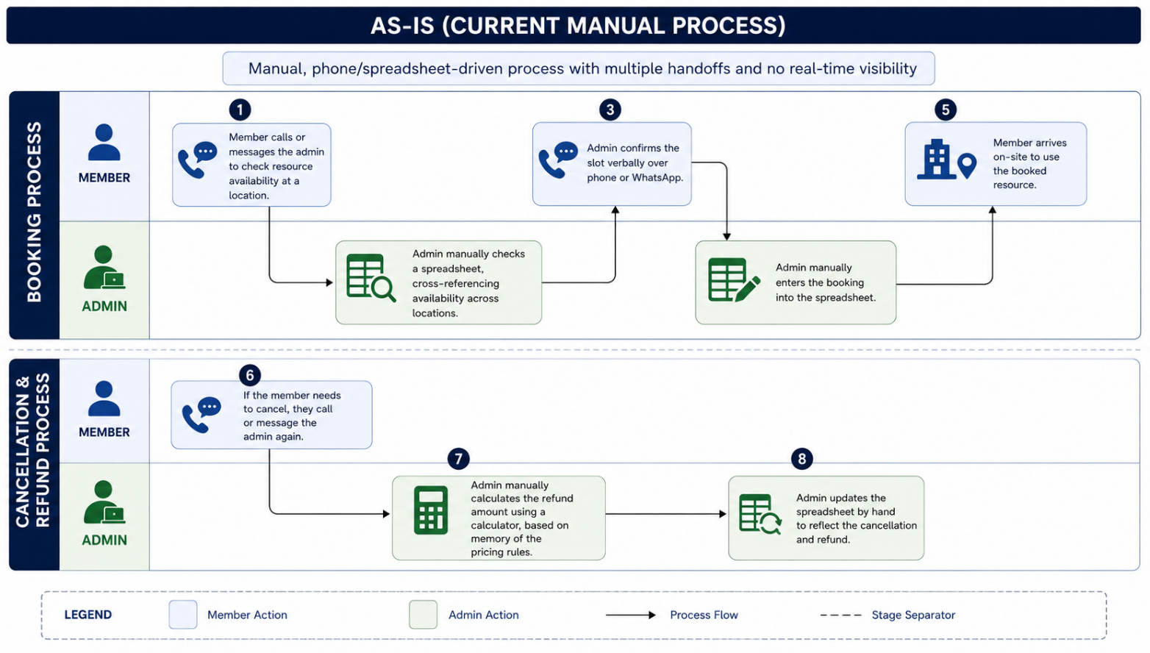

To-Be (WorkNest Self-Service Process)
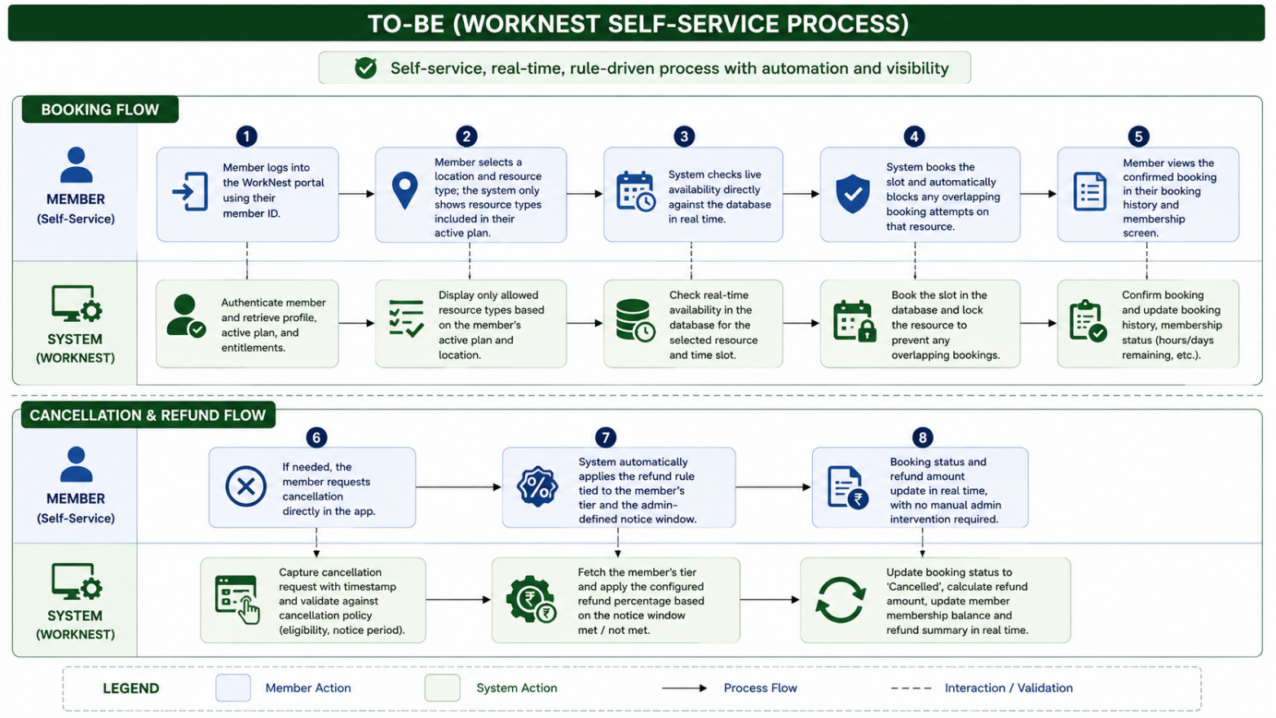

10. Approval
Role | Name | Signature / Date
Prepared by (Team) | Sufyaan Bin Salman
Approved by (Instructor) | Prof. Swaminathan N

