The Fisherman’s Bastion

The Fisherman’s Bastion is one of the best known monuments in Budapest. It is located near the Buda Castle, in the 1st district of Budapest.
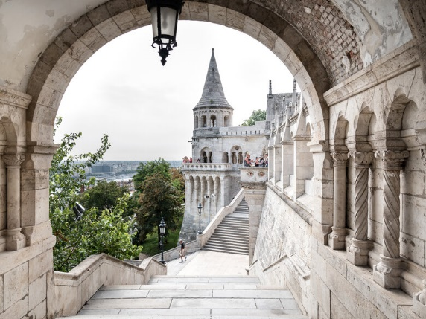
It is one of the most important toursit attraction, because of its beautiful panorama. Its seven high-pitched stone towers simbolize the seven chieftains of the Hungarians who founded Hungary.
In the Middle Ages fishermen protected the castle walls. They lived under the walls in the so-called Fishtown.
The Bastion was built in 1890-1905, by Frigyes Shulek. The style is neoroman and gothic.
The reason why people visit this place is the fascinating view. From its deck you can see Budapest and the Danube as well. The whole place has a romantic feeling, so many lovers come here and they take photos. Ont he terrace there is the statue of St. Stephan. If you want to eat, you can find a restaurant and a small café in the main tower itself.
My cousin lives in Budapest, and we visit her many times. I have nice memories about this place, we went there together and as I remember, I liked the guards very much.
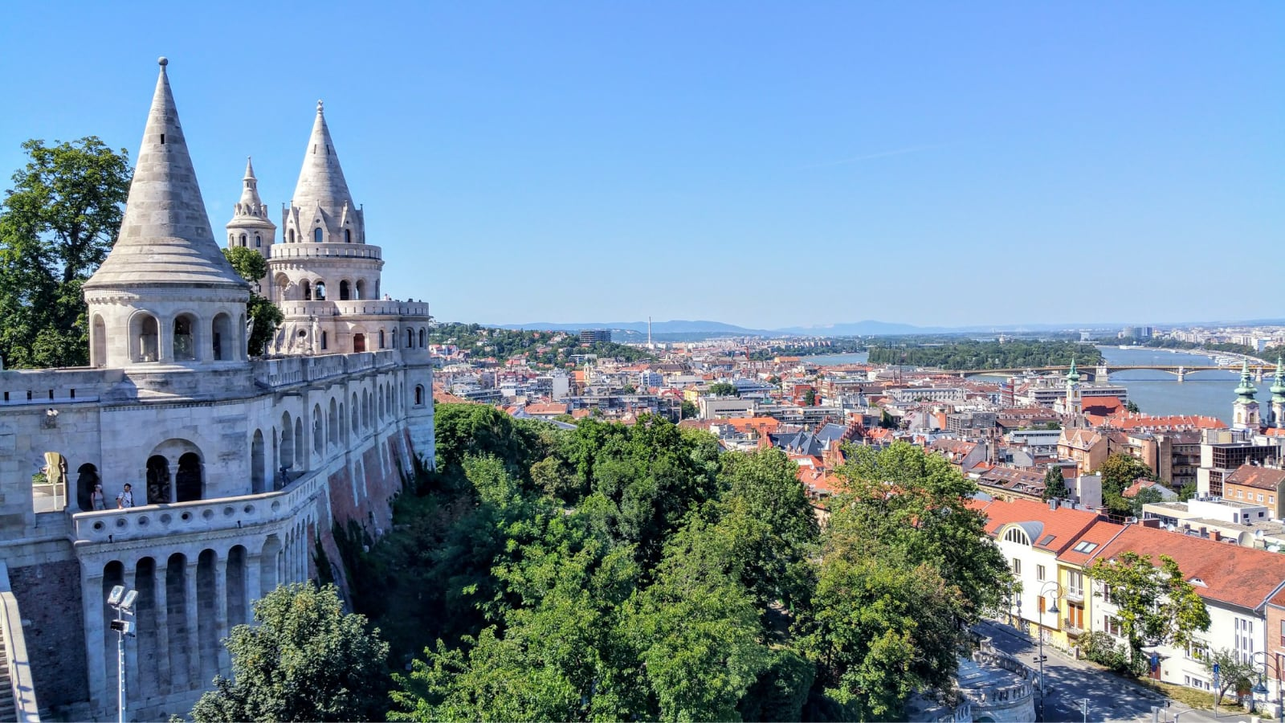
Harcsa Vince

