# Summary of Business Process

* The president is alerted about a soviet nuclear attack
* President decides whether to launch a counter nuclear attack
* If president says yes – he will open the nuclear suitcase, type in nuclear launch codes
* Launch code will be encrypted via web service and then creates an XML file. This XML file (containing the cipher text together with the country) will be sent to IM via a queue.
* IM will interact with Strategic Command via a request-reply queue, with the country as the message, requesting for order in JSON format.
* Strategic command will decide the location to target, prepare the order xml which contains order id, country, city, payload type and number. It will then send back in JSON format the above mentioned details.
* IM will query google maps API to get exact coordinates, combine with ciphertext from president’s launch code and payload details to create an XML document in a format that nuclear bases accept. This XML doc will be sent to the correct nuclear base (nuclear missile system) based on target country. There will be a properties file to map the country to the correct nuclear base.
* Operator at nuclear base will decrypt the ciphertext to obtain launch codes, system will verify the launch code with nuclear base’s database. If launch code is verified, the missile will be launched.

# Diagram of Scenario

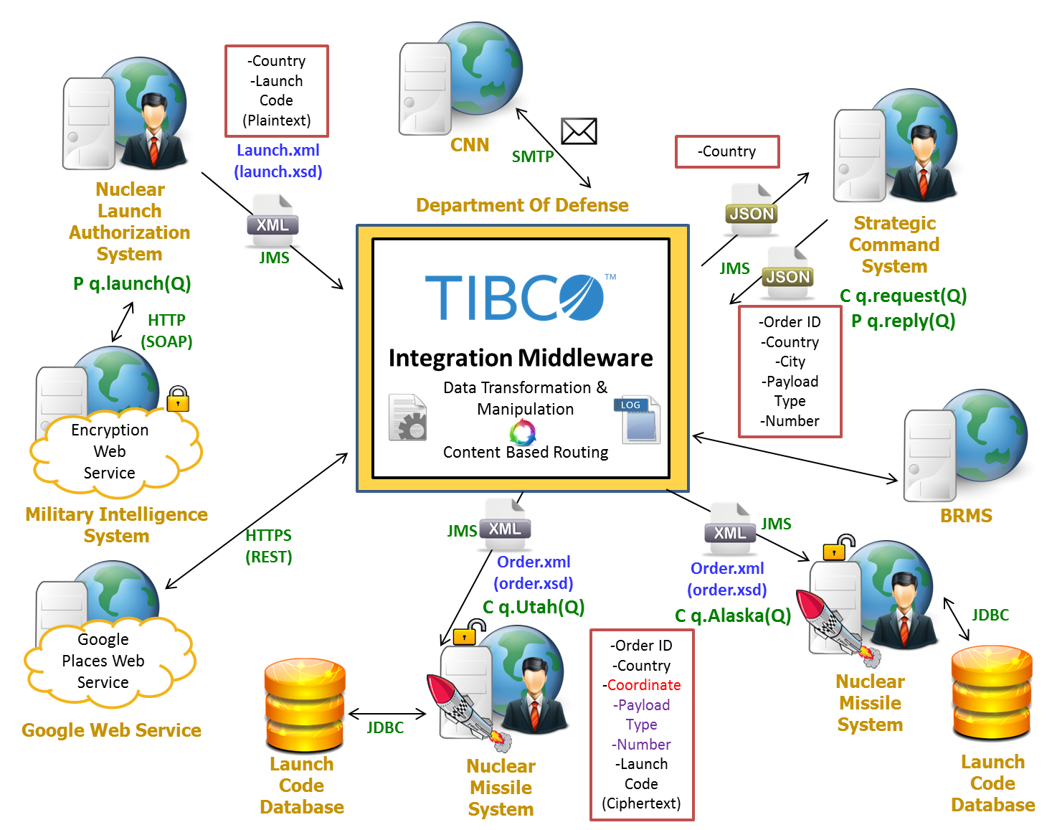

# JMS Interactions (at least 1)

1. President will send launch code and target country to IM using a queue
2. IM will send a JSON string via a RR queue to Strategic Command System, sending the country and expecting a reply about order details.
3. IM will send Order via a Queue to Nuclear Missile System

# Web Services (at least 2)

1. EncryptionService (Self coded)
2. Google Places API

# XML Documents (at least 2)

1. President’s office will produce XML documents (target country and launch code).
2. Nuclear base will process XML documents (launch order).

# Data Transformation (at least 1)

1. Strategic command will send city and country information to the nuclear base. The nuclear base requires location information in coordinate format.
2. Strategic command will send the order in JSON format. The nuclear base requires the order in XML format.

# Content Routing (at least 1)

1. Based on target city, the message will be routed to different nuclear bases.

**Additional Functions (at least 1)**

1. Google Places Web Service
2. HTTPS Connections to Google
3. Web Service connected via SSL
4. Data transformation of JSON to XML
5. Error Log
6. Usage of BRMS
7. Send press report via email