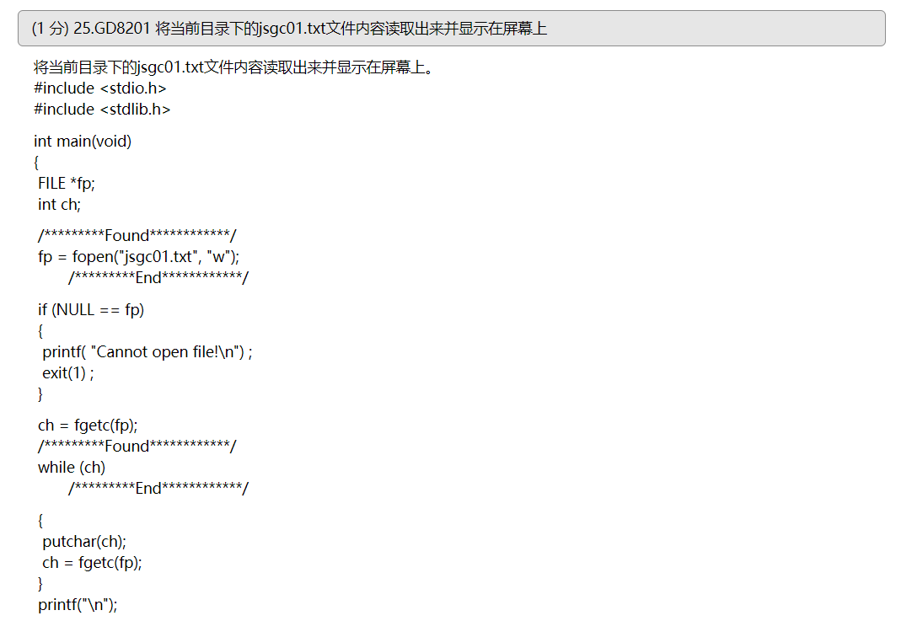

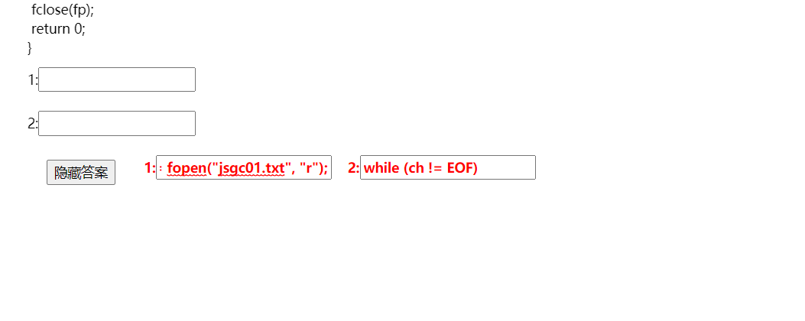

1：fp=fopen(“jsgc01.txt”,”r”);

2:while=(ch!=EOF)

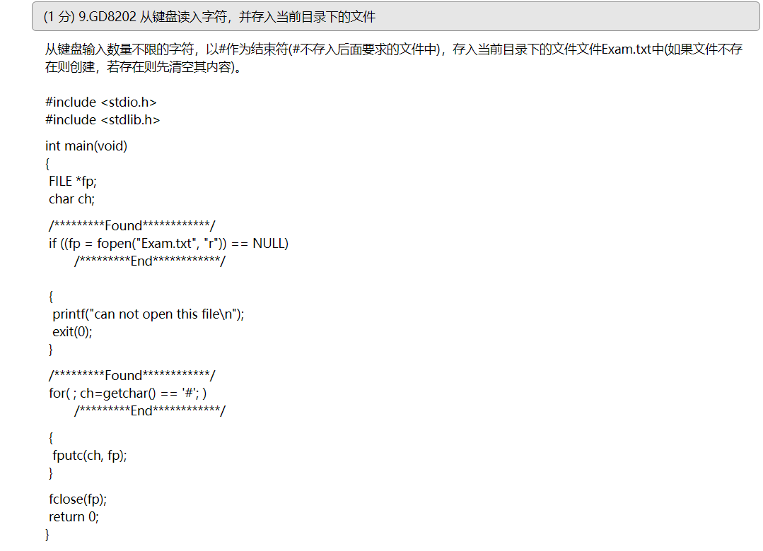



1:if((fp=fopen(“Exam.txt”,”w”))==NULL)

2:for(; (ch=getchar())==’#’;)

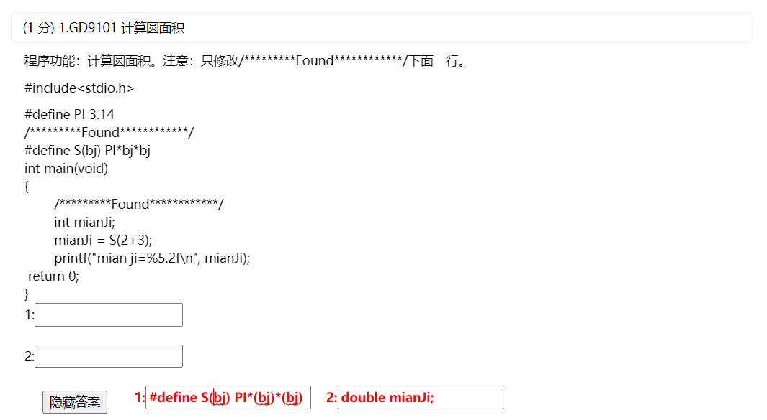

1:#define S(bj)PI\*(bj)\*(bj)

2: double mianJi;