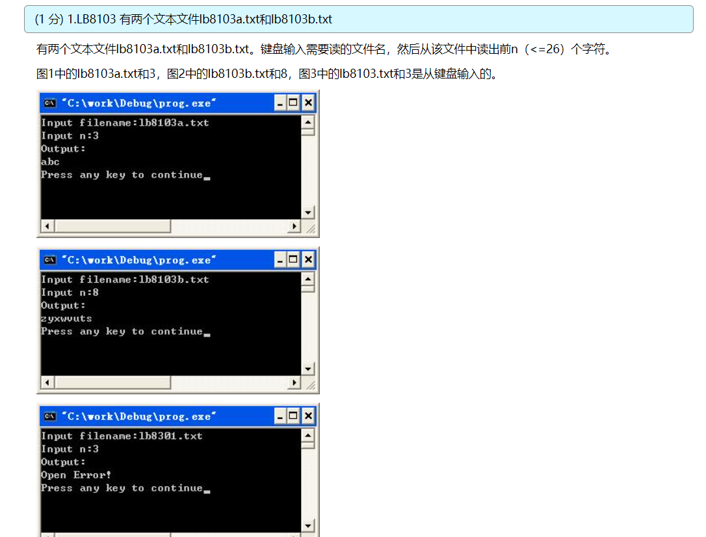

#include <stdio.h>

int main(void)

{

int n, sum = 0, i;

char ch;

char str[20];

FILE *fp;

printf("Input filename:");

scanf("%s", str);

printf("Input n:");

scanf("%d", &n);

printf("Output:\n");

fp = fopen(str, "r");

if (fp == NULL)

{

printf("Open Error!\n");

return 0;

}

for (i = 0; i < n; i++)

{

ch = fgetc(fp);

putchar(ch);

}

fclose(fp);

printf("\n");

return 0;

}

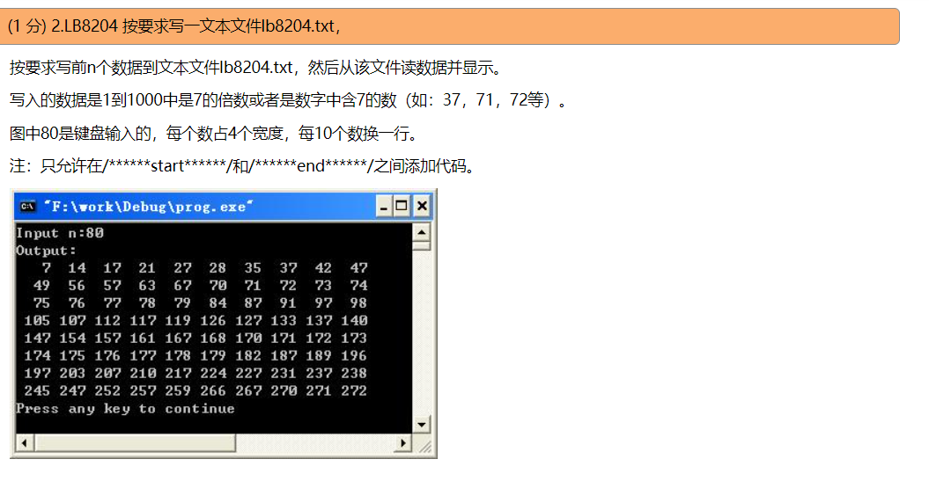

#include <stdio.h>

#include <stdlib.h>

void save(int n);

void out(void);

int main(void)

{

int n;

printf("Input n:");

scanf("%d", &n);

save(n);

out();

return 0;

}

void save(int n)

{

/******start******/

int i, cnt = 0;

FILE *fp;

fp = fopen("lb8204.txt", "w");

if (fp == NULL)

{

exit(0);

}

for (i = 1; i <= 1000; i++)

{

if (i % 7 == 0 || i % 10 == 7 || i / 100%10 == 7 || i/10%10==7)

{

fprintf(fp, "%4d", i);

cnt++;

if (cnt == n)

{

fclose(fp);

return ;

}

if (cnt % 10 == 0)

{

fprintf(fp, "\n");

}

}

}

fclose(fp);

/******end******/

}

void out(void)

{

char str[48];

char *pch = NULL;

FILE *fp;

fp = fopen("lb8204.txt", "r");

if (fp == NULL)

{

exit(0);

}

printf("Output:\n");

while (!feof(fp))

{

pch = fgets(str, 48, fp);

if (pch == NULL)

{

break;

}

printf("%s", str);

}

printf("\n");

fclose(fp);

}

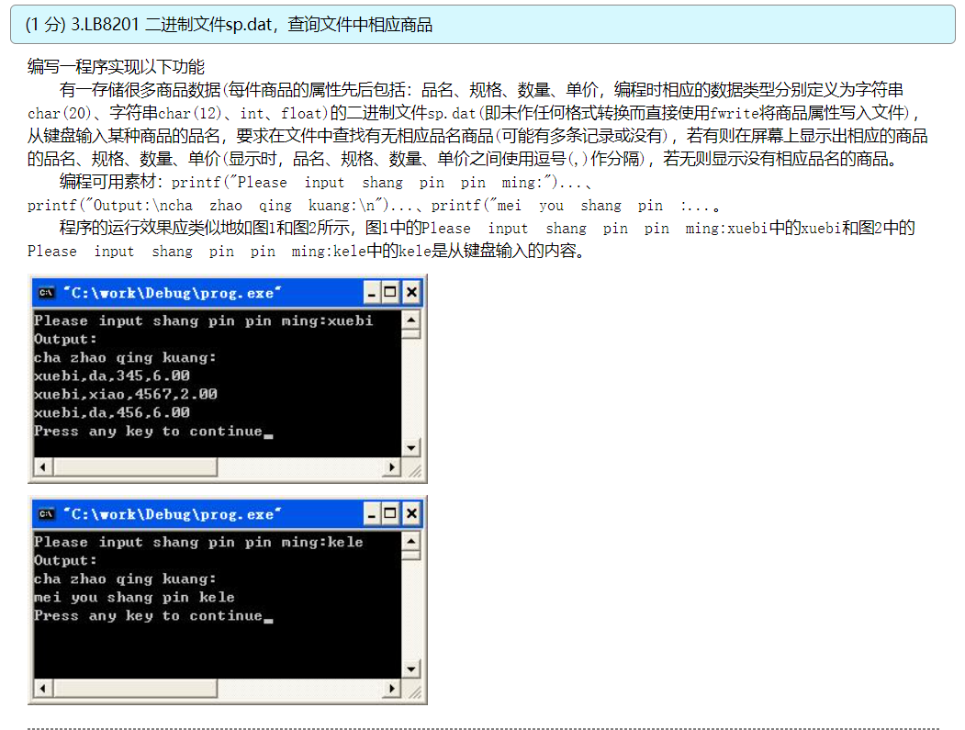

#include <stdio.h>

#include <string.h>

struct good

{

char name[20];

char type[12];

int number;

float price;

};

int main(void)

{

int i = 0, n, flag;

char str[20];

struct good goods[100];

FILE *fp;

fp = fopen("sp.dat", "rb");

while (!feof(fp))

{

fread(&goods[i], sizeof(struct good), 1, fp);

i++;

}

n = i;

flag = 0;

printf("Please input shang pin pin ming:");

scanf("%s", str);

printf("Output:\ncha zhao qing kuang:\n");

for (i = 0; i < n; i++)

{

if (strcmp(goods[i].name, str)==0)

{

printf("%s,%s,%d,%.2f\n", goods[i].name, goods[i].type,

goods[i].number, goods[i].price);

flag = 1;

}

}

if (flag == 0)

{

printf("mei you shang pin %s\n", str);

}

return 0;

}

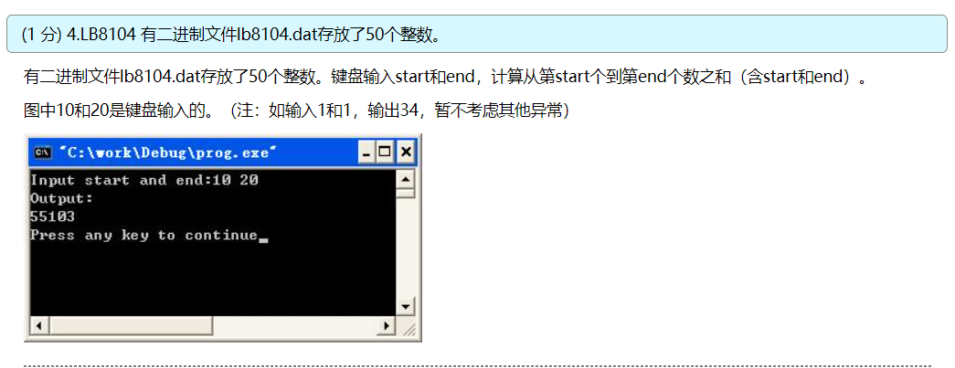

#include <stdio.h>

int main(void)

{

int i, start, end, sum = 0;

int a[50];

FILE *fp;

printf("Input start and end:");

scanf("%d%d", &start, &end);

printf("Output:\n");

fp = fopen("lb8104.dat", "rb");

if (fp == NULL)

{

printf("File Open Error!\n");

return 0;

}

fread(a, sizeof(int), 50, fp);

for (i = start - 1; i <= end - 1; i++)

{

sum += a[i];

}

printf("%d\n", sum);

return 0;

}

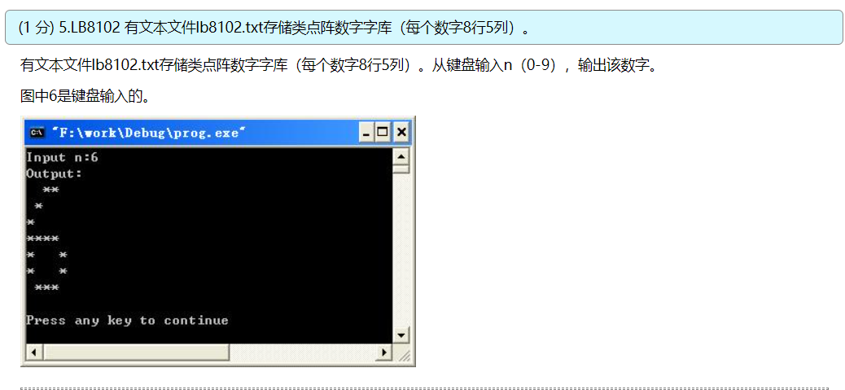

#include <stdio.h>

int main(void)

{

int i, n;

char str[12];

FILE *fp;

fp = fopen("lb8102.txt", "r");

printf("Input n:");

scanf("%d", &n);

printf("Output:\n");

for (i = 0; i < n*8;i++)

{

fgets(str, 11, fp);

}

for (i = 0; i < 8; i++)

{

fgets(str, 11, fp);

printf("%s", str);

}

return 0;

}

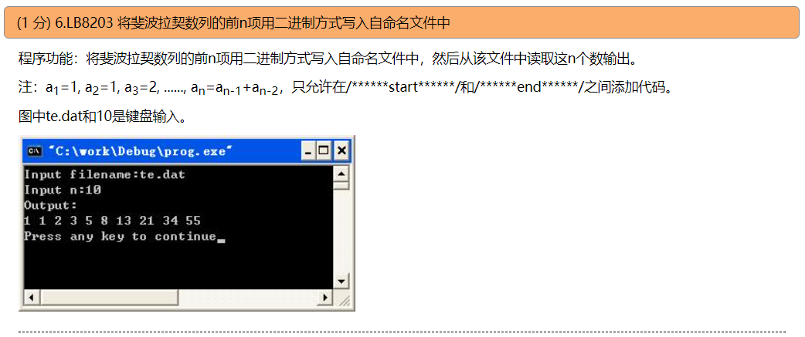

#include <stdio.h>

#include <stdlib.h>

void save(char str[20], int n);

void prnt(char str[20], int n);

int main()

{

int n;

char str[20];

printf("Input filename:");

scanf("%s", str);

printf("Input n:");

scanf("%d", &n);

save(str, n);

prnt(str, n);

return 0;

}

void save(char str[20], int n)

{

/******start******/

int i, f1 = 1, f2 = 1;

FILE *fp;

fp = fopen(str, "wb");

fwrite(&f1, sizeof(int), 1, fp);

fwrite(&f2, sizeof(int), 1, fp);

for (i = 0; i < n/2; i++)

{

f1 = f1+f2;

f2 = f1+f2;

fwrite(&f1, sizeof(int), 1, fp);

fwrite(&f2, sizeof(int), 1, fp);

}

fclose(fp);

/******end******/

}

void prnt(char str[20], int n)

{

int i, te;

FILE *fp;

fp = fopen(str, "rb");

if (fp == NULL)

{

exit(0);

}

printf("Output:\n");

for (i = 0; i < n; i++)

{

fread(&te, sizeof(int), 1, fp);

printf("%d ", te);

}

printf("\n");

fclose(fp);

}

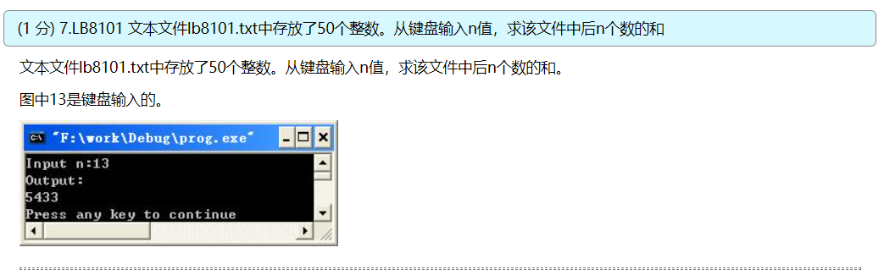

#include <stdio.h>

int main(void)

{

int i, n, sum = 0;

int arr[50];

FILE *fp;

fp = fopen("lb8101.txt", "r");

printf("Input n:");

scanf("%d", &n);

for (i = 0; i < 50; i++)

{

fscanf(fp, "%d", &arr[i]);

}

for (i = 50-n; i < 50; i++)

{

sum += arr[i];

}

printf("Output:\n%d\n", sum);

return 0;

}

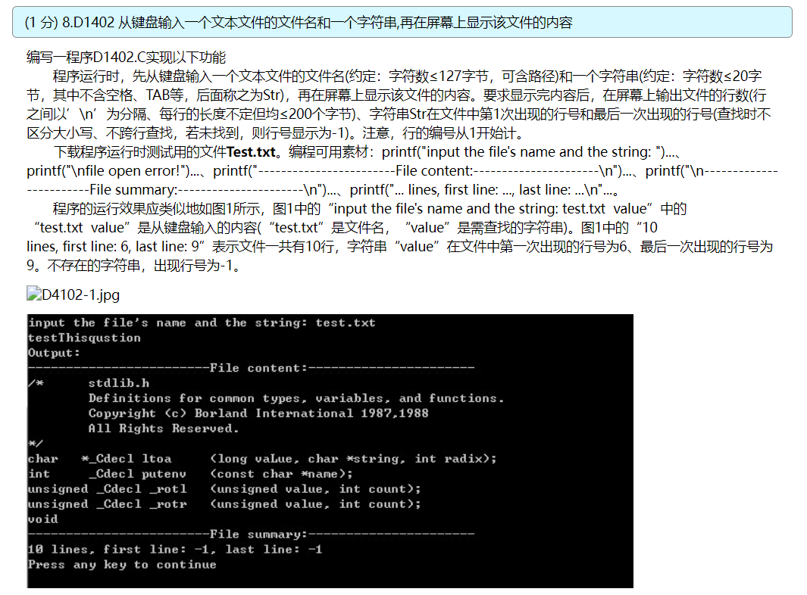

#include <stdio.h>

#include <stdlib.h>

void readfile(char filename[128], char file[100][204], int *totalline);

void findstr(char file[100][204], char str[24], int *firstline, int *lastline, int totalline);

int main(void)

{

int i;

int totalline, firstline, lastline;

char filename[128], str[24];

char file[100][204];

printf("input the file's name and the string: ");

scanf("%s%s", filename, str);

printf("Output:\n");

readfile(filename, file, &totalline);

printf("------------------------File content:----------------------\n");

for (i = 0; i < totalline; i++)

{

puts(file[i]);

}

printf("------------------------File summary:----------------------\n");

findstr(file, str, &firstline, &lastline, totalline);

printf("%d lines, first line: %d, last line: %d\n", totalline, firstline, lastline);

return 0;

}

void readfile(char filename[128], char file[100][204], int *totalline)

{

int i, j;

FILE *fp;

fp = fopen(filename, "r");

if (fp == NULL)

{

printf("\nfile open error!");

exit(0);

}

i = 0;

j = 0;

while (!feof(fp))

{

file[i][j] = fgetc(fp);

if (file[i][j] == '\n')

{

file[i][j] = '\0';

i++;

j = 0;

continue;

}

j++;

}

file[i][j - 1] = '\0';

*totalline = i + 1;

fclose(fp);

}

void findstr(char file[100][204], char str[24], int *firstline, int *lastline, int totalline)

{

int i, j, k, flag = 0;

for (i = 0; i < totalline; i++)

{

for (j = 0; file[i][j] != '\0'; j++)

{

for (k = 0; str[k] != '\0'; k++)

{

if (str[k] >= 'a' && str[k] <= 'z')

{

if (file[i][j + k] != str[k] && file[i][j + k] != str[k] - 32)

{

break;

}

}

else if (str[k] >= 'A' && str[k] <= 'Z')

{

if (file[i][j + k] != str[k] && file[i][j + k] != str[k] + 32)

{

break;

}

}

else

{

if (file[i][j + k] != str[k])

{

break;

}

}

}

if (str[k] == '\0')

{

if (flag == 0)

{

*firstline = i + 1;

flag = 1;

}

*lastline = i + 1;

}

}

}

if (flag == 0)

{

*firstline = -1;

*lastline = -1;

}

}

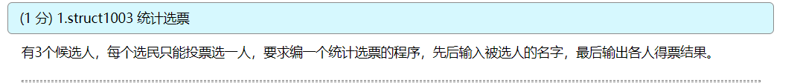

#include <string.h>

#include <stdio.h>

struct person // 声明结构体类型struct person

{char name[20]; // 候选人姓名

int count; // 候选人得票数

}leader[3]={"Li",0,"Zhang",0,"Fun",0}; // 定义结构体数组并初始化

int main()

{int i,j;

char leader_name[20]; // 定义字符数组

for (i=1;i<=10;i++)

{scanf("%s",leader_name); // 输入所选的候选人姓名

for(j=0;j<3;j++)

if(strcmp(leader_name,leader[j].name)==0) leader[j].count++;

}

printf("\nResoult:\n");

for(i=0;i<3;i++)

printf("%5s:%d\n",leader[i].name,leader[i].count);

return 0;

}

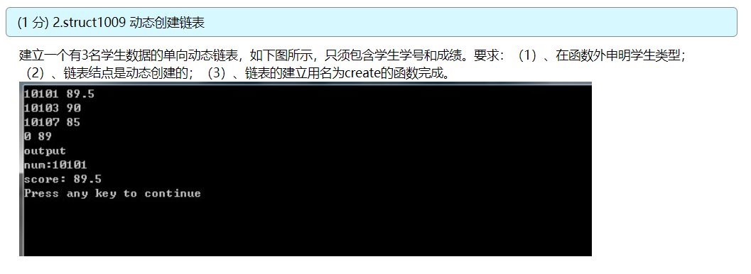

#include <stdio.h>

#include <malloc.h>

#define LEN sizeof(struct student)

struct student

{long num;

float score;

struct student *next;

};

int n;

struct student *creat(void)

{struct student *head;

struct student *p1,*p2;

n=0;

p1=p2=(struct student *)malloc(LEN);

scanf("%ld%f",&p1->num,&p1->score);

head=NULL;

while(p1->num!=0)

{n=n+1;

if(n==1)head=p1;

else p2->next=p1;

p2=p1;

p1=(struct student*)malloc(LEN);

scanf("%ld%f",&p1->num,&p1->score);

}

p2->next=NULL;

return(head);

}

int main()

{ struct student *pt;

pt=creat(); // 函数返回链表第一个结点的地址

printf("output\nnum:%ld\nscore:%5.1f\n",pt->num,pt->score); // 输出第一个结点的成员值

return 0;

}

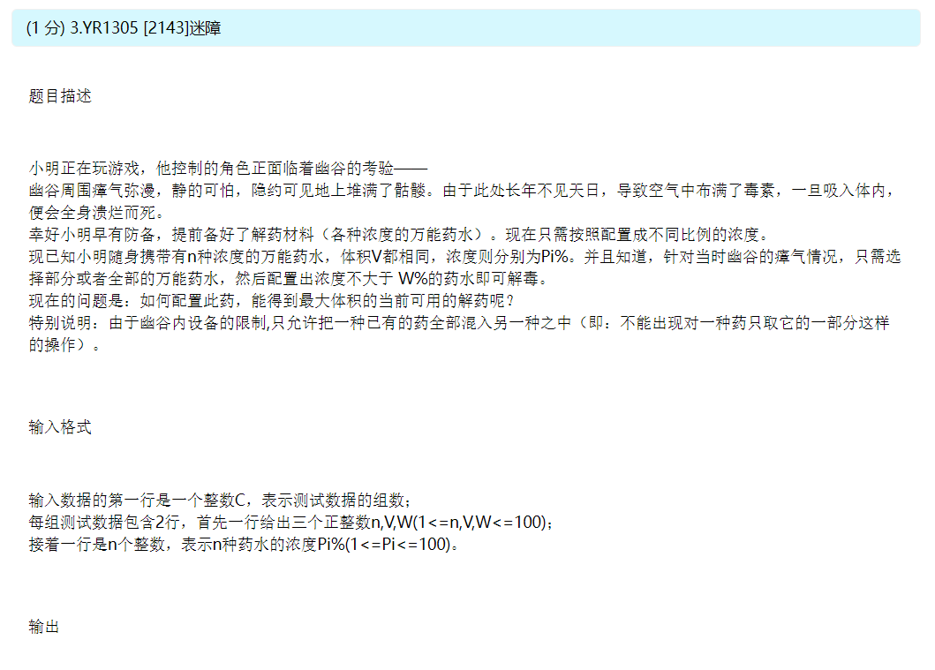

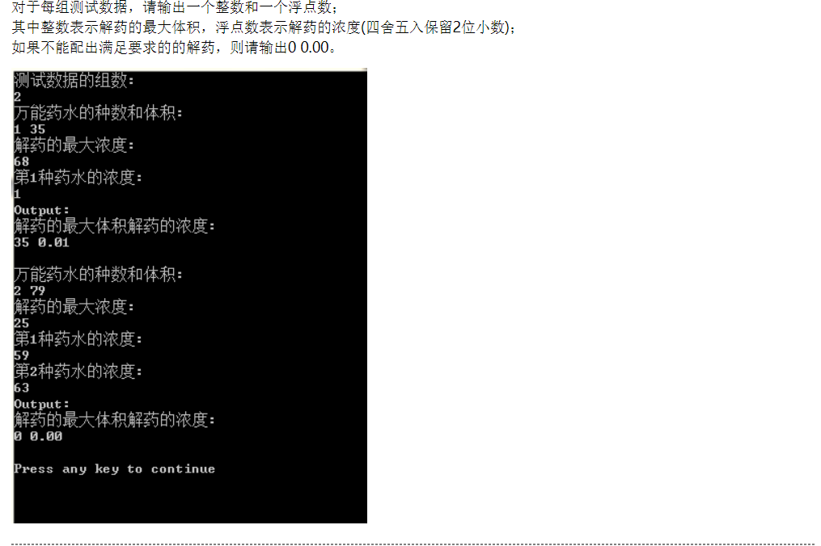

#include<stdio.h>

#include<stdlib.h>

int cmp(const void *a,const void *b)

{

return *((int*)a)-*((int*)b);

}

int main()

{

int i,n,v,w,cnt;

double now;

int as[109],cas;

printf("测试数据的组数:\n");

scanf("%d",&cas);

while( cas-- )

{

printf("万能药水的种数和体积:\n");

scanf("%d%d",&n,&v);

printf("解药的最大浓度:\n");

scanf("%d",&w);

now=0;

cnt=0;

for( i=0; i<n; i++ )

{

printf("第%d种药水的浓度:\n",i+1);

scanf("%d",as+i);

}

qsort(as,n,sizeof(as[0]),cmp);

for( i=0; i<n; i++ )

{

if( now+as[i] > (cnt+1)*w )

break;

else

now+=as[i],cnt++;

}

if( cnt )

now=now/cnt/100;

printf("Output:\n");

printf("解药的最大体积解药的浓度:\n");

printf("%d %.2lf\n",cnt*v,now);

printf("\n");

}

return 0;

}

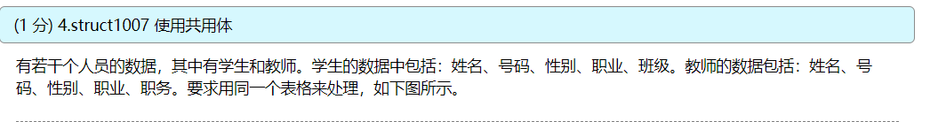

#include <stdio.h>

struct

{

int num;

char name[10];

char sex;

char job;

union

{int clas;

char position[10];

}category;

}person[2];

int main()

{

int i;

for(i=0;i<2;i++)

{printf("please enter the data of person:\n");

scanf("%d %s %c %c", &person[i].num, &person[i].name,

&person[i].sex, &person[i].job);

if(person[i].job == 's')

scanf("%d", &person[i].category.clas);

else if(person[i].job == 't')

scanf("%s", person[i].category.position);

else

printf("Input error!");

}

printf("\n");

printf("No. name sex job class/position\n");

for(i=0;i<2;i++)

{

if (person[i].job == 's')

printf("%-6d%-10s%-4c%-4c%-10d\n",person[i].num, person[i].name,

person[i].sex, person[i].job, person[i].category.clas);

else

printf("%-6d%-10s%-4c%-4c%-10s\n",person[i].num, person[i].name,

person[i].sex, person[i].job, person[i].category.position);

}

return 0;

}

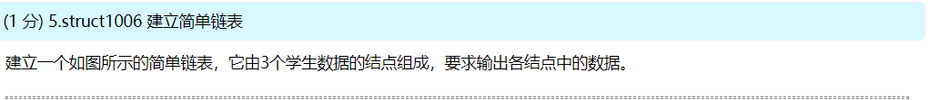

#include <stdio.h>

struct student // 声明结构体类型struct student

{int num;

float score;

struct student *next;

};

int main()

{struct student a,b,c,*head,*p; // 定义3个结构体变量作为链表的结点

a. num=10101; a.score=89.5; // 对结点a的num和score成员赋值

b. num=10103; b.score=90; // 对结点b的num和score成员赋值

c. num=10107; c.score=85; // 对结点c的num和score成员赋值

head=&a; // 将结点a的起始地址赋给头指针head

a.next=&b; // 将结点b的起始地址赋给a结点的next成员

b.next=&c; // 将结点c的起始地址赋给a结点的next成员

c.next=NULL; // c结点的next成员不存放其他结点地址

p=head; // 使p也指向a结点

do

{printf("%ld %5.1f\n",p->num,p->score); // 输出p指向的结点的数据

p=p->next; // 使p指向下一结点

}while(p!=NULL); // 输出完c结点后p的值为NULL，循环终止

return 0;

}

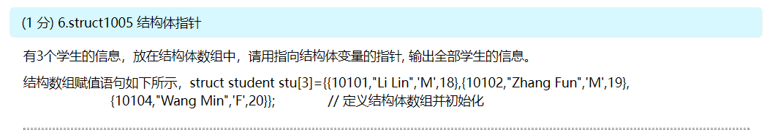#include <stdio.h>

struct student

{int num;

char name[20];

char sex;

int age;

};

struct student stu[3]={{10101,"Li Lin",'M',18},{10102,"Zhang Fun",'M',19},

{10104,"Wang Min",'F',20}}; // 定义结构体数组并初始化

int main()

{struct student *p; //定义指向struct student结构体的数组

printf(" No. Name sex age\n");

for (p=stu;p<stu+3;p++)

printf("%5d %-20s %2c %4d\n",p->num, p->name, p->sex, p->age);

return 0;

}

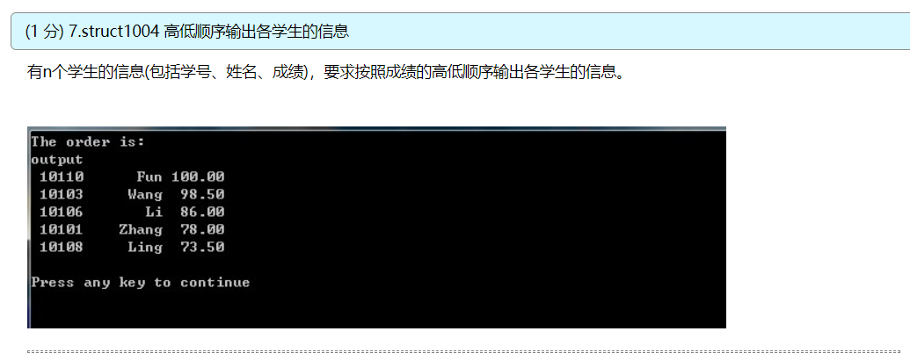#include <stdio.h>

struct student // 声明结构体类型struct student

{int num;

char name[20];

float score;

};

int main()

{struct student stu[5]={{10101,"Zhang",78},{10103,"Wang",98.5},{10106,"Li",86},

{10108,"Ling",73.5},{10110,"Fun",100}}; // 定义结倒构体数组并初始化

struct student temp; //定义结构体变量temp，用作交换时的临时变量

const int n=5;

int i,j,k;

printf("The order is:\n");

for(i=0;i<n-1;i++)

{k=i;

for(j=i+1;j<n;j++)

if(stu[j].score>stu[k].score) // 进行成绩的比较

k=j;

temp=stu[k];stu[k]=stu[i];stu[i]=temp; // stu[k]和stu[i]元素互换

}

printf("output\n");

for(i=0;i<n;i++)

printf("%6d %8s %6.2f\n",stu[i].num,stu[i].name,stu[i].score);

printf("\n");

return 0;

}

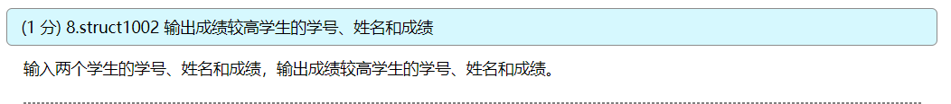

#include <stdio.h>

int main()

{struct student // 声明结构体类型struct student

{int num;

char name[20];

float score;

}student1,student2; // 定义两个结构体变量seudent1,student2

scanf("%d%s%f",&student1.num,student1.name, &student1.score); //输入学生1敌数据

scanf("%d%s%f",&student2.num,student2.name, &student2.score); //输入学生1敌数据

printf("output:The higher score is:\n");

if (student1.score>student2.score)

printf("%d %s %6.2f\n",student1.num,student1.name, student1.score);

else if (student1.score<student2.score)

printf("%d %s %6.2f\n",student2.num,student2.name, student2.score);

else

{printf("%d %s %6.2f\n",student1.num,student1.name, student1.score);

printf("%d %s %6.2f\n",student2.num,student2.name, student2.score);

}

return 0;

}

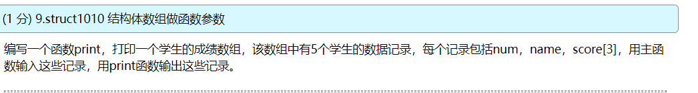

#include <stdio.h>

#define N 3

struct student

{ char num[6];

char name[8];

int score[4];

}stu[N];

int main()

{void print(struct student stu[6]);

int i,j;

for (i=0;i<N;i++)

{printf("\ninput score of student %d:\n",i+1);

printf("NO.: ");

scanf("%s",stu[i].num);

printf("name: ");

scanf("%s",stu[i].name);

for (j=0;j<3;j++)

{printf("score %d:",j+1);

scanf("%d",&stu[i].score[j]);

}

printf("\n");

}

print(stu);

return 0;

}

void print(struct student stu[6])

{int i,j;

printf("\n NO. name score1 score2 score3\n");

for (i=0;i<N;i++)

{printf("%5s%10s",stu[i].num,stu[i].name);

for (j=0;j<3;j++)

printf("%9d",stu[i].score[j]);

printf("\n");

}

}

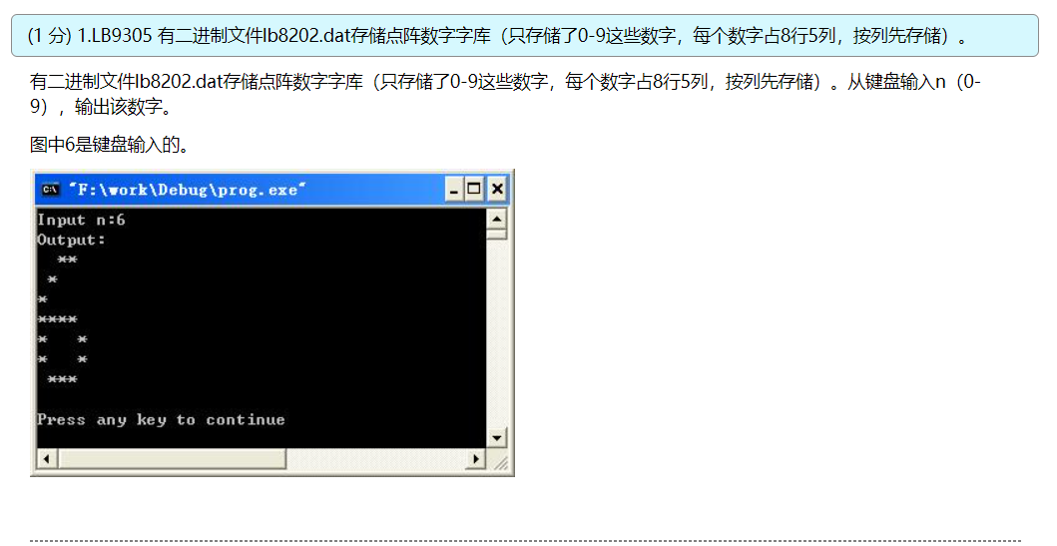

#include <stdio.h>

void rotate(int a[5][8], int b[8][5]);

int main(void)

{

int i, j;

int n;

unsigned char ch;

int a[5][8], b[8][5];

FILE *fp;

printf("Input n:");

scanf("%d", &n);

fp = fopen("lb8202.dat", "rb");

fseek(fp, n*5, 0);

for (i = 0; i < 5; i++)

{

fread(&ch, 1, 1, fp);

for (j = 0; j < 8; j++)

{

a[i][j] = (ch >> (7-j)) & 0x01;

}

}

fclose(fp);

printf("Output:\n");

rotate(a, b);

for (i = 0; i < 8; i++)

{

for (j = 0; j < 5; j++)

{

if (b[i][j] == 1)

{

printf("*");

}

else

{

printf(" ");

}

}

printf("\n");

}

return 0;

}

void rotate(int a[5][8], int b[8][5])

{

int i, j;

for (i = 0; i < 5; i++)

{

for (j = 0; j < 8; j++)

{

b[j][i] = a[i][j];

}

}

}

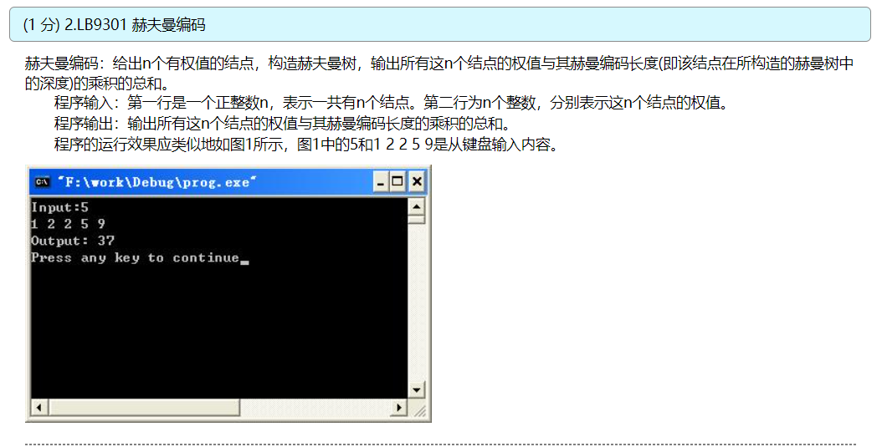

#include <stdio.h>

void sort(int arr[], int low, int high);

int main(void)

{

int i, j, n, sum = 0;

int arr[101];

printf("Input:");

scanf("%d", &n);

for (i = 0; i < n; i++)

{

scanf("%d", &arr[i]);

}

for (i = 0; i < n - 1; i++)

{

sort(arr, i, n);

/*for (j = 0; j < n; j++)

{

printf("%d ", arr[j]);

}

printf("sum=%d\n", sum);

*/

arr[i + 1] = arr[i] + arr[i + 1];

sum = sum + arr[i + 1];

}

printf("Output: %d\n", sum);

return 0;

}

void sort(int arr[], int low, int high)

{

int i, j, te;

for (i = low; i < high; i++)

{

for (j = low; j < high + low - i - 1; j++)

{

if (arr[j] > arr[j+1])

{

te = arr[j];

arr[j] = arr[j + 1];

arr[j + 1] = te;

}

}

}

}

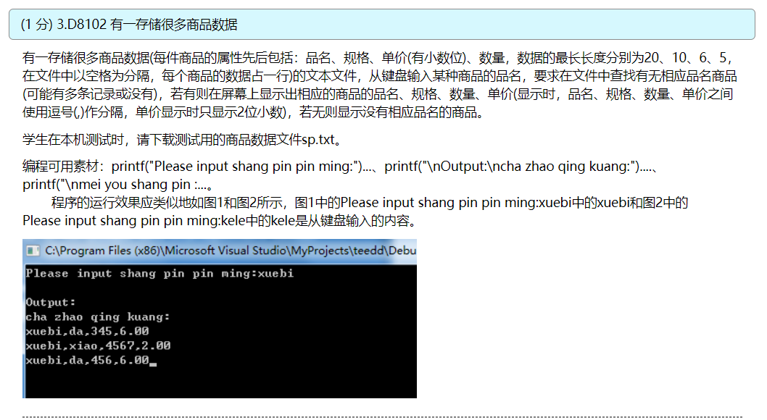

#include <stdio.h>

#include <stdlib.h>

#include <string.h>

/* User Code Begin(考生可在本行后添加代码，定义程序中使用的结构体类型，行数不限) */

struct goods

{

char pinming[24];

char guige[12];

float danjia;

long shuliang;

};

/* User Code End(考生添加代码结束) */

int main(void)

{

int n;

char sppm[21];

FILE *fp;

struct goods SP;

printf("Please input shang pin pin ming:");

gets(sppm);

fp = fopen("sp.txt", "r");

if (NULL == fp)

{

printf("file open error!");

exit(0);

}

n = 0;

printf("\nOutput:\ncha zhao qing kuang:");

/* User Code Begin(考生可在本行后添加代码，行数不限) */

while (!feof(fp))

{

if (fscanf(fp, "%s%s%6f%5ld", SP.pinming, SP.guige, &SP.danjia, &SP.shuliang) < 4)

{

break;

}

else

{

/* User Code End(考生添加代码结束) */

if (strcmp(sppm, SP.pinming) == 0)

{

n++;

printf("\n%s,%s,%ld,%.2f", SP.pinming, SP.guige, SP.shuliang, SP.danjia);

}

/* User Code Begin(考生可在本行后添加代码，行数不限) */

}

}

if (n == 0)

{

printf("\nmei you shang pin :%s\n", sppm);

}

fclose(fp);

/* User Code End(考生添加代码结束) */

return 0;

}

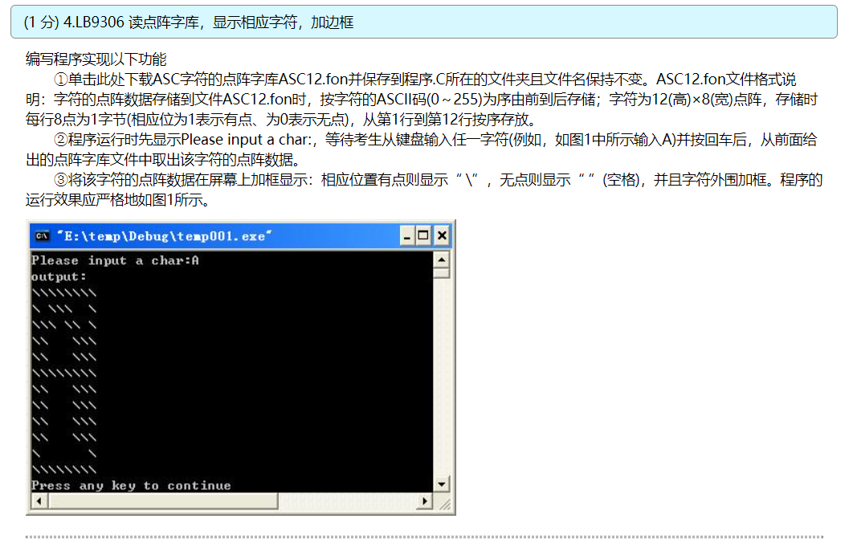

#include <stdio.h>

int main(void)

{

int i, j;

unsigned char ch;

FILE *fp;

printf("Please input a char:");

scanf("%c", &ch);

fp = fopen("ASC12.FON", "rb");

if (fp == NULL)

{

return 0;

}

fseek(fp, ch * 12, SEEK_SET);

printf("output:\n");

for (i = 1; i <= 12; i++)

{

fread(&ch, 1, 1, fp);

if (i == 1 || i == 12)

{

printf("\\\\\\\\\\\\\\\\\n");

continue;

}

for (j = 1; j <= 8; j++)

{

if (j == 1)

{

printf("\\");

continue;

}

if (j == 8)

{

printf("\\\n");

continue;

}

if (((ch >> (8 - j)) & 0x01) == 1)

{

printf("\\");

}

else

{

printf(" ");

}

}

}

fclose(fp);

return 0;

}

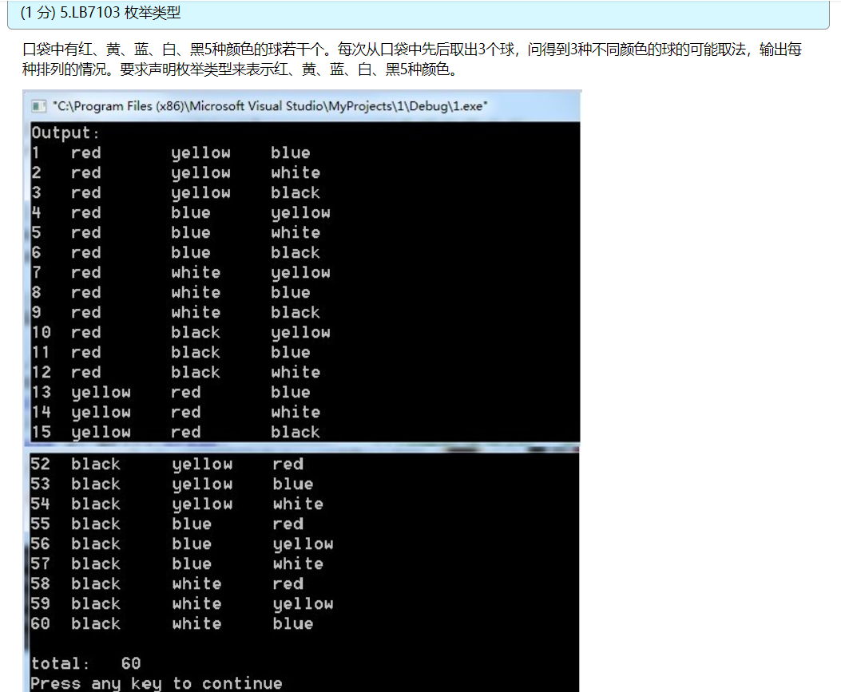

#include <stdio.h>

int main()

{enum Color {red,yellow,blue,white,black}; //声明枚举类型enum Color

enum Color i,j,k,pri; //定义枚举变量i,j,k,pri

int n,loop;

n=0;

printf("Output:\n");

for (i=red;i<=black;i++) //外循环使i的值从red变到black

for (j=red;j<=black;j++) //中循环使j的值从red变到black

if (i!=j) //如果二球不同色

{ for (k=red;k<=black;k++) //內循环使k的值从red变到black

if ((k!=i) && (k!=j)) //如果3球不同色

{n=n+1; //符合条件的次数加1

printf("%-4d",n); //输出当前是第几个符合条件的组合

for (loop=1;loop<=3;loop++) //先后对三个球分别处理

{switch (loop) //loop的值从1变到3

{case 1: pri=i;break; //loop的值为1时，把第1球的颜色赋给pri

case 2: pri=j;break; //loop的值为2时，把第2球的颜色赋给pri

case 3: pri=k;break; //loop的值为3时，把第3球的颜色赋给pri

default:break;

}

switch (pri) //根据球的颜色输出相应的文字

{case red:printf("%-10s","red"); break; //pri的值等于枚举常量red时输出“red”

case yellow: printf("%-10s","yellow"); break; //pri的值等于枚举常量yellowd时输出“yellow”

case blue: printf("%-10s","blue"); break; //pri的值等于枚举常量blue时输出“blue”

case white: printf("%-10s","white"); break; //pri的值等于枚举常量white时输出“white”

case black: printf("%-10s","black"); break; //pri的值等于枚举常量black时输出“black”

default :break;

}

}

printf("\n");

}

}

printf("\ntotal:%5d\n",n);

return 0;

}