Contents

1 Introduction 2

2 Hybrid Propulsion Systems 2

2.1 Operating modes 3

2.1.1 Power Take Off mode (PTO) 3

Bibliography 47

# 1 Introduction

In recent years, concerns about severe environmental pollution and fossil fuel consumption have become a center of attention especially in the transportation industry, particularly to the marine vessels industry. Traditional marine vessels produce excessive amounts of carbon dioxide CO2, nitrogen oxide NOx, sulphur oxide SOx and other greenhouse gases GHGs. [1] Hybrid marine power systems are introduced to tackle these issues of air pollution by integrating different clean energy sources on board vessels. Hybrid marine propulsion systems mainly consist of energy storage systems like batteries, supercapacitors and fuel cells. It also needs an energy management system which runs the propulsion system with the highest efficiency with the lowest emissions. In overall, hybrid marine power systems aim to tackle pollution and emissions in order to fulfil guidelines set by the International Maritime Organization (IMO) and at the same time following shipboard electrical restrictions outlined by different international organizations standards.

In this report, several key technologies in the marine industry along with on-going research work are presented. Section 2 describes hybrid propulsion systems.

# 2 Hybrid Propulsion Systems

Hybrid propulsion is any vehicle propulsion system that includes two or more sources of propulsion in one design, usually which can be used either together or alternately. In this case it would be a vessel propulsion system with diesel-electric propulsion. Hybrid propulsion with hybrid power supply utilizes the maximum efficiency of direct mechanical drive (1) and the flexibility of a combination of combustion power from prime mover(s) (2) and stored power from energy storage (3) for electrical supply. At low propulsive power an electric drive (4) is available to propel the ship and switch off the main engine (1). The machine providing electric drive can also be used as a generator. Fig.1 shows the layout of the HPS.

Hybrid propulsion systems offer high operating flexibility as well as more environmentally friendly solutions. With the fast-developed power electronics and mechanical transmissions, different hybrid modes can be achieved. Fig.2 shows a general design methodology of an HPS [2].

There are 3 different hybrid marine propulsions mode of configuration systems each having its own pros and cons - Series hybrid systems, Parallel hybrid systems and Series-parallel hybrid systems. Then, there are also 3 different modes of operation – Power Take Off (PTO), Power Take In (PTI) and Power Take Home (PTH).

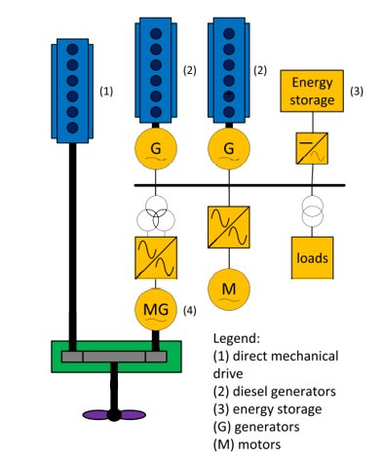

Fig.1 Layout of the Hybrid Power System

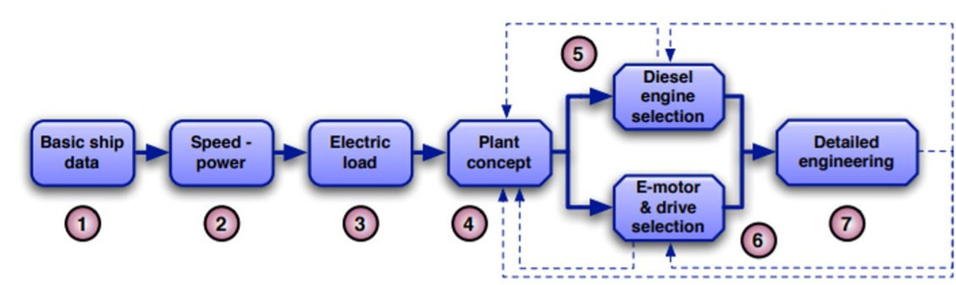

Fig.2 General Design Methodology of Hybrid Propulsion Systems

## 2.1 Operating modes

In this section, the different possible operating modes of a marine vessel are described.

### 2.1.1 Power Take Off mode (PTO)

In PTO mode, the shaft generator operates as an alternator, driven from the main propulsion engine, providing power supply for the vessel`s electrical system. [2] Part of the engine's mechanical rotating power is transferred into the electrical network via gearbox and generator. For frequency variations and voltage matching, a complete drive chain is needed for utilization of the energy. It is an efficient way to create the require electrical power, rather than running additional engine to produce it. Basically, PTO work as part of a power plant [1]. Fig 3 shows the layout of PTO with power flow direction

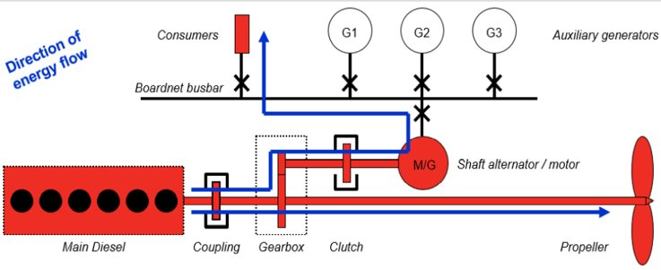

Fig.3 Layout of PTO with power flow direction [1]

2.1.2 Power Take In Mode (PTI)

In PTI mode, the shaft generator operates as a synchronous motor whereby electrical power are being supplied by the auxiliary diesel generator set. It can either provides a boost in power, working alongside the main engine to increase vessel`s speed or it allows the main engine to reduce power, thus lowering fuel consumption and wear on main engine. [2]. Basically, PTI work as part of the propulsion systems [1]. Fig.4 shows the layout of PTI mode with power flow direction.

There are 2 Options for utilization in electrical propulsion [2]:

Electrical Mode: Used usually in low power range like in low speed or idle

Hybrid Mode: Used usually either to improve propulsion engine performance by taking the power off or to boost maximum speed/thrust out of the propulsion train. When operation profile needs short duration of full power – tugboats or pushers.

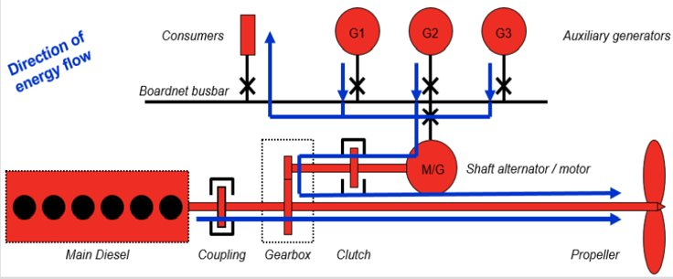

Fig.4 Layout of PTI with power flow direction [1]

2.1.3 Power Take Home Mode (PTH)

Similar to PTI, the shaft generator operates as a synchronous motor in PTH. But this time, it provides 100% of the ship`s propulsion power [1]. This scenario is usually in emergency situations whereby the main engines fail or require sudden maintenance. Unlike PTI mode, in PTH mode the shaft generator requires self-starting capability to run the motor up from zero speed. Fig. 5 shows the layout of PTH with power flow direction.

One thing to consider it that when the shaft generator is used in a PTH mode of operation, the shaft generator should be mechanically disconnected from the ship’s propeller shaft during start up. A suitable clutch mechanism is normally used for this purpose. This will reduce the level of starting torque required and subsequently, the inrush current will also be minimized.

There are mainly 5 ways to self-start the generator [1] - Pony Motor Start, Auto-Transformer Start, Excitation Controlled Start (Single Propeller), Excitation Controlled Start (Twin Propeller) and Variable Frequency Drive (VFD) Start.

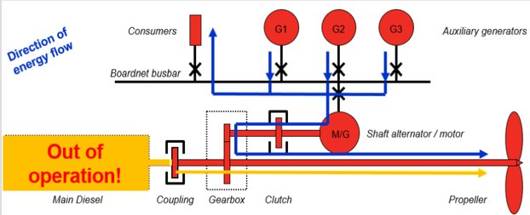

Fig.5 Layout of PTH with power flow direction [1]

2.2 Hybrid marine propulsions configurations

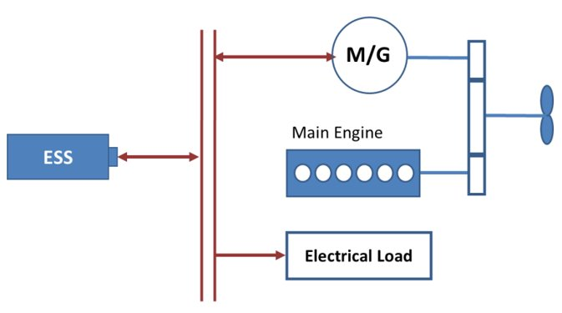Fig. 6 Parallel Hybrid Propulsion Configuration [3] Fig.7 Series Hybrid Propulsion Configuration [3]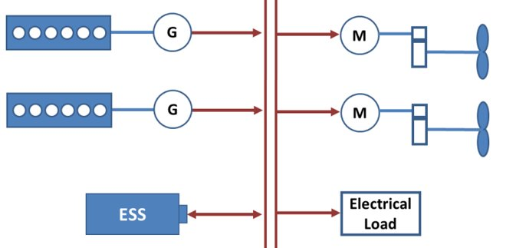

2.2.1 Parallel Hybrid Propulsion Configuration

Parallel hybrid marine propulsion is very similar to the conventional PTI/PTO configuration, except to the added battery ESS. The auxiliary gensets can be retained or removed, depending on the specific application of the user. Battery ESS can also support the requested electrical energy for auxiliary loads and propulsion loads. The Engine and electrical drives are coupled in a gearbox to propel the thruster.

In a Parallel configuration, it can take advantage of mechanical drive from the engine to the propeller directly without sacrificing energy conversions. Thus, a higher system energy efficiency can be achieved at the high load demand. Parallel configurations are commonly used in ferries as the shaft generators have been traditionally in the original design. Fig.6 shows the Parallel Hybrid Propulsion Architecture.

In this configuration, its design is generated by selecting medium speed propulsion engines (>500rpm) and shaft generator is dedicated to bow thrustor motors only by isolating the shaft generator from the electrical network and bypass it with the thrustor motors. From there, the propulsion is designed typically with Controllable Pitch Propeller (CPP) and the hybrid propulsion system will need to be interfaced with pitch control.

2.2.2 Serial Hybrid Propulsion Configuration

Series hybrid marine propulsion is formed by adding a battery ESS to the integrated diesel-electrical propulsion [3]. It works as a fully electrified system since all the power from engines will be transformed into electric energy. The rechargeable ESS acts as a buffer to store and supply energy. Through optimized powertrain system control, it can be expected to have lower fuel consumption and emissions compared to the conventional counterpart. Fig 7 shows a Serial Hybrid Propulsion Configuration.

The main advantage of the serial hybrid propulsion is that the engine can work in its most efficient area by de-coupling the mechanical connection between the engine and propeller and if the ESS is sufficiently large, it can provide all required energy and work as pure electric propulsion.

When considering Serial Hybrid Propulsion, the main difference is the physical size of the electrical motor. In serial hybrid, propulsion electrical motor (PEM) is installed in the same shaft line as main propulsion engine. PEM revolutions correspond accordingly to propeller speed, resulting in the electrical motor to slow down [4]. Things to take note for the serial hybrid configuration are:

1. Physical installation is beneficial when there is no room to put equipment in parallel, common case for single propeller vessels
2. In the event where utilized energy is so large in quantity, savings in gear losses become meaningful and serial hybrid does seems viable
3. In 2-stroke engine category, serial hybrid concept usually does not include gearboxes and its main engine is a slow speed engine.
4. If it’s a medium speed engine, existing gearbox offset (positioning of input and output shafts) may pre-determine that installation needs to be done in serial form.

2.2.3 Series-Parallel Hybrid Configuration

Series-parallel hybrid configuration is the most complicated structure because it requires advanced gear sets to transmit the power both mechanically and/or electrically. Fig.8 shows a Series-parallel hybrid configuration with its operating modes

Limitations and possibilities of applying electric continuously variable transmissions (e-CVT) in power-split marine propulsions are also studied [5], however, it is not a common feature for marine vessel applications

In this research [3], a series-parallel hybrid configuration is realized through four clutches (C1, C2, C3 and C4) and several gear reduction devices. Two electrical motor/generators (MG1 + MG2) can work as generator when charging the ESS, or as motor when using electrical energy to boost the engines.

The combination of using both series and parallel hybrid mode provides more flexible operations and can help achieve higher system efficiency. Although the complexity of system design is increased, it offers more degree of freedoms to optimize the control algorithm for a better system performance.

There are 5 modes of operation in the study of [3]:

1. Pure electric (or series) mode: Operate in low or medium power demands to reduce pollutions, where the power is supplied by the ESS and all engines are shut down (or operated in high efficiency area to charge the battery)
2. Engine start mode: Consume electrical energy from battery ESS to start main engines, so that no auxiliary Gensets are needed
3. Pure engine mode: More suitable under the high load demand situation, where the main engines can drive propellers through gear reductions directly with the lest energy conversion losses
4. Parallel model: ESS and engine work together to create higher torque/power for the propeller
5. Series-parallel mode: One of the main engines is operated to mechanically propel one propeller and electrically drive the motors for another propeller

The complexity consideration of implementing series-parallel configuration in marine vessels is very different from automotive industry. Hybrid electric vehicles have different choices to achieve series-parallel hybrid transformation, either by using planetary gear sets or a few gear reductions with clutches. A typical example would be the Hybrid Synergy Drive (HSD), which is a refinement term of Toyota Hybrid System (THS), used in the Toyota hybrid electric vehicles.

Although the study of using power-split propulsion system in ships showed promising feasibility [95], the gear reductions with clutches to change power transmission paths are more applicable regarding to the cost, reliability, complexity, etc.

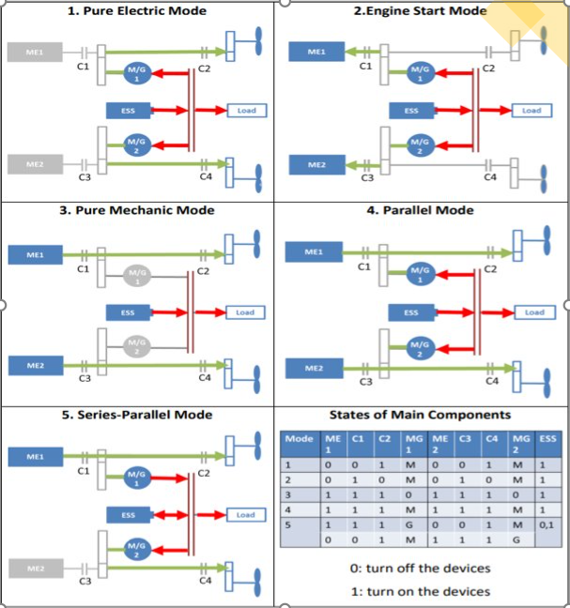

Fig.8 Series-Parallel Hybrid Operation Modes [3]

2.4 Control Strategies for hybrid propulsion with hybrid power supply

2.4.1 Heuristic Control Strategy

Research at Delft University of Technology suggest hybrid propulsion with hybrid power supply can reduce local emission partly using energy batteries recharges with shore connection. These savings can be achieved with a heuristic rule-based approach [7,8]. In this approach the control mode of the plant is determined by the operating mode of the vessel (towing, high speed transit, low speed transit or standby) and the battery state of charge.

This approach achieves positive results mainly due to the operating modes of the plant leads to very distinct loading of the system. However, the amount of fuel and emission savings that can be achieved with a heuristic control strategy strongly depends on the operating profile of the ship and on the sizing of the components.

In addition, hybrid propulsion configuration allows designs in which the main engines cannot deliver full bollard pull on their own. However, a design that for delivery of full bollard pull depends on an electric motor or batteries potentially introduces reliability and safety risks.

Thus, in current designs the main engine is sized to deliver full bollard pull without additional power from the electric motor.

2.4.2 Equivalent Consumption Minimization Strategy

In Grimmelius [9] the models required for an ECMS control strategy for hybrid propulsion with a battery as a single electrical power supply are introduced and the application on a tug as a test case is presented. The application does not include a comparison with a rule-based strategy, so the benefits of the approach have not yet been established for the case study.

Furthermore, practical applications tend to use diesel generators as well, further complicating the optimization strategy. However, the models used in Grimmelius [9] only need minor additions to include a diesel generator power source.

|  |  |
| --- | --- |
| **Parallel Hybrid Propulsion** | **Serial Hybrid Propulsion** |
| Motor dimensioning for fast RPM | Suitable for single propeller hull shape |
| Low torque and transfer torque dimensioning | No gear losses on electrical generation |
| Investment is smaller than serial hybrids | No gear losses on electrical propulsion |
| Electrical mode improves the operational efficiency at slow speed range | Electrical mode improves the operational efficiency at slow speed range |
| Hybrid mode improves the operational efficiency at higher speed range | Hybrid mode improves the operational efficiency at higher speed range |
| Gearbox 'protects' the electrical motor from axial shaft forces. Allows freedom in choosing PEM bearings | Design process is easier as there is no gearbox |

Table.1 Benefits of Parallel/Serial Hybrid Propulsion [4]

|  |  |
| --- | --- |
| **Parallel Hybrid Propulsion** | **Serial Hybrid Propulsion** |
| Gearbox weight and investment | PEM dimensioning for transfer torque through motor shaft |
| Gear losses in the generator mode | Slow speed makes PEM heavy and increase investment |
| Gear losses in motor mode | Axial forces from propeller requires dedicated thrust bearing. Motor bearing solution needs to be designed accordingly. |
| Requires width (space reservation) | Requires length (space reservation) |
| Gearbox is a single point of failure | PEM is a single point of failure |

Table.2 Drawbacks of Parallel/Serial Hybrid Propulsion [4]

3 Energy Storage Systems

The rapid growth of electric and hybrid propulsion systems has potential developments in the ESS in the marine industry. But, for now, the solutions are not sufficient in several features both technologically and commercially creating a barrier of entry for wider usage. ESS technologies differs from each other in aspects like energy density, power density, charge and discharge time, lifetime, operating temperature, green impact and maintenance. One single ESS technology which are capable to provide both high power and energy density and other specifications are not likely to be developed in the near future. So, for now 2 or more ESS technologies are hybridized to provide improvements to capabilities of the hybrid power systems. ESS consists of energy storage device with conversion of power and control electronics. Cycle efficiency of ESS is defined as defined as η = Eout/Ein where Eout and Ein is the output and input energy. Flywheel, SEMS and ultra-capacitor are highly efficient technologies. But for this report, only supercapacitors, batteries and fuel cells will be discussed.

|  |  |  |  |  |  |  |
| --- | --- | --- | --- | --- | --- | --- |
| **System** | **Power Density**  **(kW/kg)** | **Energy Density (kWh/kg)** | **$/kW** | **Efficiency**  **(%)** | **Lifetime**  **(Years)** | **Response**  **Time** |
| Lead Acid | 75-300 | 30-50 | 300-600 | 65-80 | 3-15 | ms |
| NiCd | 150-300 | 50-75 | 500-1500 | 75-85 | 5-20 | ms |
| NaS | 150-230 | 150-240 | 1000-3000 | 75-90 | 10-15 | ms |
| Li-ion | 150-315 | 75-200 | 1200-4000 | 90-97 | 5-100 | ms-s |
| Fuel Cells | 500+ | 800-10000 | 10000+ | 20-50 | 10-30 | ms-min |
| SMES | 500-2000 | 0.5-5 | 200-300 | 90-95 | 20+ | ms |
| Flywheel | 400-1500 | 10-30 | 250-350 | 90-95 | 15-20 | ms-s |
| Ultra-capacitor | 100000+ | 20+ | 100-300 | 85-98 | 4-12 | ms |

Table.3 Technical features of ESS [10,11,12,13]

3.1 Batteries

Batteries are devices that convert chemical potential energy into electrical energy. Batteries are categorized into primary and secondary. Primary batteries can be rechargeable whereas secondary are not. Increase in energy and power demand in hybrid marine power systems causes large desire for batteries that are able to provide high energy density. In this case, lithium-ion are commonly used.

3.1.1 Lead Acid

Lead acid are the world`s most commonly used batteries. They have smally daily self-discharge rate of less than 0.3%, low capital cost, fast response time and high cycle efficiency. Also, lead acid is a mature technology which are easily recyclable, cheaper and simple charging method [14]. But the disadvantage is that lead acid has low energy density and uses hazardous materials to construct (lead). It is also not suitable for discharges over 20% of its rated value because it will reduce the cycle life.

3.1.2 Nickel Cadmium (NiCd)

Nickel cadmium higher power and energy density, greater number of life cycles as compared to lead acid. Lifespan of NiCd ranges from 1500-3000 cycles depending on the type of used plate [15]. Unique feature of NiCd is that it operates in low temperatures of - 20°C to -40°C. When NiCd discharged between 20% to 50% of its rated value, that’s when peak performance is displayed [16]. The disadvantage is that there are some restrictions to the application especially in Europe due to the toxicity and high cost [17]. So NiCd are mainly used in stationary applications.

3.1.3 Sodium Sulphur (NaS)

Sodium sulphur batteries are constructed of liquid sulphur at the positive end of the electrode and liquid sodium at the negative end. Right in between of the two ends, lies a beta aluminum tube which is the electrolyte. NaS batteries have efficiency around 75% with life cycles around 4500, slightly higher than lead acid batteries. The operating temperature ranges from 300°C to 350°C. Thus, a heat source is needed to maintain this temperature range for consistent performance.

3.1.4 Lithium Ion (Li-ion)

Lithium-ion batteries have nominal voltage of 3.7V for each cell as compared to 1.2V for NiCd batteries. Li-ion batteries also have higher energy and power density as compared to lead-acid and NiCd batteries. It has efficiency of about 95%-98% and approximately 5000 life cycles. 2 main disadvantage is the cost to recharge and safety concerns. The price is more than 600$/kWh due to overcharge protection and its specific packaging. Metal oxide electrodes in Li-ion are unstable and may decompose at elevated temperature. So, to deal with this problem, the batteries are commonly equipped with monetizing unit to avoid over-discharging/charging.

|  |  |  |
| --- | --- | --- |
| **Type of Battery** | **Advantage** | **Disadvantage** |
| Lead Acid | - Inexpensive  - Lead is easily recyclable  - Low self-discharge (2-5%/month) | - Shorty cycle-life (around 1500 cycles)  - Cycle life is affected by depth of charge  - Low energy density (about 30–50 kWh/kg) |
| Nickel Cadmium | - High Energy Density (50-75kWh/kg)  - High Cycle Count (1500-3000 cycles) | - High degradation rate  - Expensive  - Toxic nature of cadmium metal |
| Sodium Sulphur | - High energy density (150-240 kWh/kg)  - No self-discharge  - No degradation for deep charge  - High efficiency (75%-90%) | - Need to maintain battery temperature constantly at 300-350°C |
| Lithium-ion | - Very high efficiency (150-240kWh/kg)  - Very low self-discharge (1-3%/month)  - Low maintenance | - Expensive  - Each discharge reduces life cycle  - Require special overcharge protection circuit |

Table.4 Comparison between different type of batteries technologies

3.2 Supercapacitors

Capacitors store energy in terms of an electric field and are known for their symmetrical charge/discharge rate. Capacitors have low equivalent series resistance which therefore allow it to supple power efficiently. Applications wise, they are usually used in scenarios where high power is required in short duration of time. Key characteristics of supercapacitors are higher power density, faster charging/discharging due to lower internal resistance, enhanced life cycle, low voltage, and higher cost per Watt-hour (up to 20 times compared to Li-ion batteries). Disadvantage of a sole supercapacitor as ESSs is high sensitivity to over-voltage and, thus, overcharging, relatively low energy density, linear discharge voltage, high self-discharge, and low cell voltage.

In order to increase the lifetime of the battery and preserve system voltage above the minimum threshold, ultra-capacitors are hybridized with batteries in hybrid vehicles. Studies have proved that by hybridizing battery and ultra-capacitor results in improving the lifetime, performance, and cycle life of the battery for hybrid vehicles.

3.3 Hybrid Energy Storage Systems

HESS is a combination of various ESS technologies which can be further categorized into higher energy and power technologies:

1.) High Energy devices: battery, Fuel Cells, pumped hydro and CAES – supply energy for longer duration BUT low power

2.) High Power devices: Flywheel, super-capacitor, SMES and higher power batteries – supply shorter duration BUT higher power

Hybridization of higher energy density devices with higher power density devices will create a better ESS. In this way higher energy density devices provide long-term power needs, whereas higher power devices will cater short duration but higher power needs.

3.3.1 Battery-supercapacitors findings

There are 4 topologies for Battery-Supercapacitor's topologies of hybrid ESS with each having its own pros and cons.

a.) Passive topology is simple and cheap to construct, but unable to control power distribution resulting in poor performance.

b.) Battery semi-active topology can control power flow and protect battery, but it`s structure fail to make use of SC fully because the SC operate in a narrow range of voltage

c.) SC semi-active topology is able to control power flow and make full use of SC. However, the topology requires a high-performance control algorithm to protect the battery.

d.) Active topology is flexible as both the battery and SC can be controlled by improving accuracy of power allocation. This topology is the best and commonly used in marine vessel.

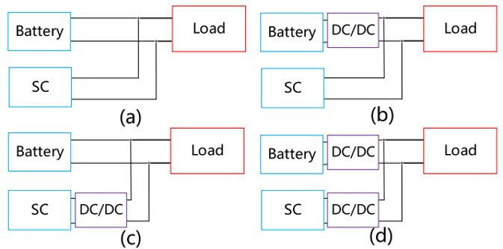

Fig.5 topologies for Battery-SC hybrid ESS

Yichao tang [18] explores the feasibility by hybridizing battery and super-capacitor energy storage for naval applications. A dual active bridge-based topology is proposed to control the bi-directional power flow through phase shifting for both charging and discharging ultra-capacitors and batteries. The topology is designed in such manner that it can meet the requirements of both 1 MW pulsed load and 100 to 500 kW propulsion system. Higher frequency switching devices were selected such that to achieve DC-DC conversion at higher power and voltage levels. The electric propulsion system in vessel experiences large torque and power fluctuations on their drive shaft because of waves and rotational motion of propeller.

The hybrid energy storage system based on ZEBRA batteries and super-capacitors modules for All-electric ships were considered in [19] to decrease the battery charge and discharge peak currents. Super-capacitor modules were considered in order to extend the expected life of the battery.

Cohen [20] presented an actively controlled Li-ion battery hybridized with super-capacitor for pulsed power applications aiming to maximize the energy density of Li-ion battery and also to maximize the energy and power density of super-capacitor. Authors designed, constructed, and validated the hybrid model using commercial off-the-shelf technologies and it is observed that the generator’s frequency and voltage deviations are massively improved.

3.3.2 Battery-Fuel Cell findings

In 2008, Alster-Touristik GmBH developed FCS Alsterwasser, vessel was entirely powered by fuel cells. FCS Alsterwasser can withstand up to 100 passengers operating at cruising speed of 8 knots, it has two 50 kW fuel cells powering 100 kW hybrid electric propulsion system in combination with lead-acid batteries [21].

In 2009, Nemo H2, a zero-emission canal boat was developed by Fuel Cell Boat B.V. operating at a cruise speed of 16 km/h. Hybrid propulsion system consists of 60–70 kW PEM-based fuel cells with 30–50 kW batteries and 24 kg of Hydrogen is stored in 6 cylinders at a pressure of 35 MPa [22].

A hybrid fuel cell/diesel generator power system is proposed in [23] for propulsion and for test equipment on a research vessel. The PEM-based fuel cell system has a battery as backup and secondary energy source simulated in power system computer aided design (PSCAD). Secondary source is a lead-acid battery with a rating of 360 V and energy 82 kWh. Simulation-based analysis depicts that the system has the capability to handle sudden load changes with minimal transients.

Alireza [24] presented an intelligent power strategy in order to improve the performance of FC without utilizing dc/dc interfacing converters. A new FC power management-based strategy by using genetic algorithm proposed guarantee the efficient performance of FC stack by preserving FC voltage within a required range in FC–battery hybrid system without the use of DC/DC interfacing converters.

A study in [25] proposed a hybrid system based on battery and PEM-based fuel cell to control power generation in a shipboard power system. A mathematical model for regulating active and reactive power is derived and integrated with PEMFCs to enhance the system dynamic response. Test results shows injunction of hydrogen fuel into the fuel cells can be regulated automatically with fluctuations in loads. Batteries are used to compensate power in order to maintain operational security of the system.

German Class 214 submarines use two Siemens-based 120 kW PEFC modules [26]. It is connected to the main grid via DC/DC converter and has the efficiency of 56% on full load.

3.4 Application of ESS

There are 6 functions of the application of ESS integrating into a SPS listed below.

1.Improving the stability of the system, which arises due to slow response of the engines to load demand.

2. Decreases operational cost due to less engine maintenance and by optimizing fuel consumption.

3. Minimize the risk of blackout by installing an ESS as a UPS, such that it provides quicker response to a blackout as compared to emergency generators. Act as a power reserve, in case of generator failure.

4. Also, ESS can reduce the number of generators that have been online to improve the redundancy of the power system.

5. Helpful in peak shaving, load levelling, power smoothing, frequency and voltage fluctuations, and power quality.

6. Decreasing thruster load ramp limits by adding inertia through ESS, which limits the power slew-rate and enables quick thrust force. Therefore, it enables quick response of vessel and boosts the capabilities of maneuvering.

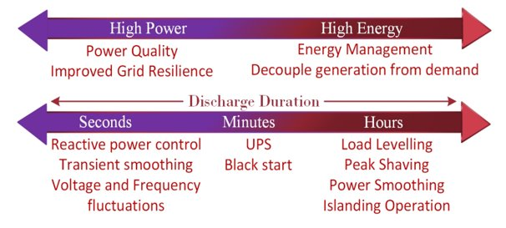

Fig.6 Application of ESS

3.4.1 Load levelling & Peak shaving

Currently, ESS particularly Li-ion battery has been adopted to cater to variable loads in all-electric ships that are on shorter routes such as MF Ampere, MF Folgefonn, and Aero Ferry. The cost-effective benefits are achieved by: peak shaving, spinning reserve, and load levelling functionalities [27].

In [28], distributed ESS contains a NaS battery that is utilized to shave the peak in order to mitigate the capacity constraints.

1 MW ESS based on Li-ion battery is installed at Nagasaki Shipyard for peak shaving operations. When a marine vessel approaches near the harbor and is required with swift response in maneuvering, deprived of starting additional generators, ESS can be helpful in this scenario [29].

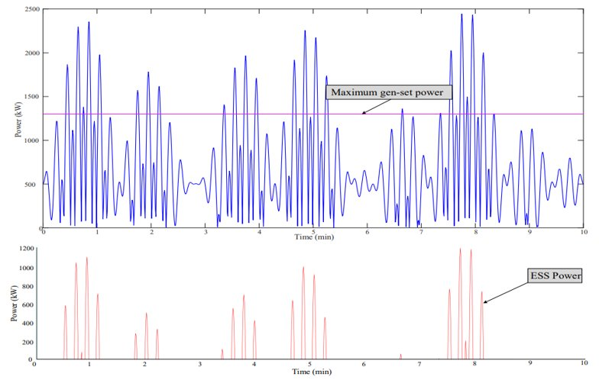

Fig.7 Peak shaving in maritime vessels

3.4.2 Power Smoothing

The battery-based power smoothing control in a shipboard microgrids based on using non-linear predictive control is proposed in [30]. In large vessels power fluctuations are quite high, which results in frequency fluctuations and can cause wear and tear of the source power plants. To cater to this issue, integrating batteries with DC/AC drive has been proposed by the same authors [30].

High fluctuations caused by the propulsion loads result in temperature increase of the batteries. Using band pass filter with an optimized cutoff frequency parameters based on model predictive control can help. ESS such as batteries can also be added next to propeller motors to smooth the power oscillations. The power is smoothed by storing the energy from peaks and controls the ramp rate (MW/min) to eliminate rapid voltage and power fluctuations from the grid.

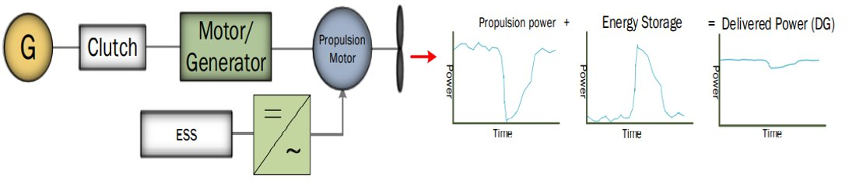

Fig.8 Power Smoothing utilizing energy storage technologies

3.4.3 Frequency and Voltage Fluctuations

Heavy loads such as pulsed loads (propulsion motors, pumps, thrusters, etc.) can draw a large power in a short duration of time. If this amount of power exceeds certain limits, it might result in voltage and frequency fluctuations.

In [31], a HESS based on improved maximum power point tracking (MPPT)-based algorithm is presented to enhance the performance of photovoltaic plant that is installed in the shipboard power system. This strategy helped to smooth and regulate the frequency oscillations

Viknash Shagar [32] utilized advance control strategies such as model predictive control (MPC) on the ESS to minimize frequency fluctuations within the permissible limit as recommended by power quality standards in a shipboard power system.

Study in [33] utilized 1000 kW battery ESS with a DC-link capacitor and an active front-end (AFE) converter in order to boost the voltage and frequency quality together to suppress the grid harmonics. To verify the approach, the authors took a transient load that causes sudden change in the frequency of grid and ultimately trips the generator and pulse load (an active and reactive power load), which causes sudden change in voltage and frequency of the power system. Transient total 8.17 MW trapezoidal load consists of 5 MW of power for 200ms, service load that consumes 1 MW with 250kVar and propulsion load that consumes 2.17MW.

Battery ESS compensation strategy shows the deviation of voltage at point of common coupling (PCC) was decreased to less than 10%, and the deviation in frequency was reduced to 2.5% as well, which satisfies the standards.

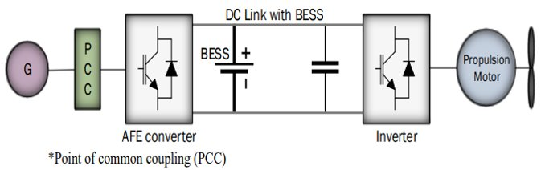

Fig.9 Integrating BESS with IPS

3.4.4 Power Quality

Power quality has become a hot topic in shipboard microgrids. Issues are voltage dips, voltage and frequency fluctuations, harmonic contamination, and flickers, etc. Harmonic distortion is one of the main issues which arise due to the presence of non-linear loads of the electric power system.

Most used solutions for power quality issues in the terrestrial grids is the application of passive and active power filters [34,35]. Since shipboard microgrids can be considered as a self-sufficient microgrid, solutions used for terrestrial grids can be extended to shipboard microgrids as well

Different marine classification bodies have proposed limitations for power quality issues of shipboard microgrids.

|  |  |  |  |  |  |
| --- | --- | --- | --- | --- | --- |
|  | **DNV** | **LRS** | **IEEE Std 45-2002** | **IEC 60092-101** | **ABS** |
| Total harmonic distortion (THD) | 8% | 8% | 5% | 5% | 5% |
| Single harmonic distortion | 8% | 1.5% | 3% | 3% | 3% |

Table.5 Harmonic voltage limitation in shipboard power system

3.5 BESS based vessels

MV Ampere is the world's first battery electric car ferry, operating between Lavik and Oppedal in Norway. It consists of two onboard motors, where one of the motors is used to drive the thrusters. These motors are operated by lithium-polymer-based batteries [15]. The sailing time of the ferry is roughly 20 minutes, and an extra 10 minutes are particularly specified for charging the batteries from the battery station located at shoreside. In order to recharge the batteries faster and not to put a burden on the village grid, battery banks are installed on each side of shore to recharge the batteries. In the MV Ampere annual operation, one million liter of diesel per year is saved, 15 tons of nitrogen oxide and 570 tons of carbon dioxide emissions are reduced.

The first fully electric cargo ship was launched by Guangzhou Shipyard International Company Ltd in 2017. It is a first cargo ship to use Li-ion batteries with such a huge power rating of 2.4 MW which takes approximately 2 h to charge these batteries [17]. When fully charged, it travels 80km at a speed of 7 knots.

Greenline 33 is a hybrid yacht with diesel/electric propulsion system and additional 6 solar panels. Li-ion-based batteries are installed to run in electric mode. The yacht is emission free and the running cost in case of electric mode is reduced by 10 times as compared to the diesel engine.

Greenline 40 and Greenline 46 are among the ongoing projects, which are based on fully electric propulsion system with Li-ion battery packs [16].

The Vision of the Fjords is a diesel-electric hybrid vessel owned and operated by the Fjords. ABB’s onboard DC system is installed on the vessel that controls and manages the flow of energy between propeller, diesel engine, and the charging station. [36] The power system comprises of 2 main engines, 2 electric motors, lithium-ion-based ESS, and an onboard 825 V DC. Batteries are connected with a manual plug to the grid, and it takes around 20 min to charge it.

Future of the Fjords, sister vessel of The Vision of the Fjords is a fully electric vessel with 2 lithium-ion-based battery packs for the propulsion motors. Total electricity consumption is around 700 kWh per trip, roughly equivalent to 80 liters of diesel. [37]

M/F Finnøy, a car ferry that was originally a diesel-electric ferry built in 1999. The vessel was upgraded in 2013 with an energy storage system, particularly a lithium polymer-based battery system is installed [38]. It consists of Siemens based drive system, four diesel-based generators, a battery storage system, and main propulsion system.

3.6 Challenges of Integrating Energy Storage System in Shipboard Microgrids

In literature, there`s several works if energy storage being utilized in terrestrial microgrids to minimize the effects of changes in loads on the crucial parameters of the system. However, in shipboard microgrids, such approaches are yet to be applied at such level. Recently, control techniques being used are adaptive control, particle swarm optimization, proportional integral (PI) control, active and reactive power (PQ) control, etc. Installing ESS as part of motor drives eliminates the requirement of additional power conversion devices resulting in the reduction in cost and weight. Then, installing ESS alongside with an AFE, the ESS can attain application flexibility, thus mitigate harmonics, peak shaving, etc. Currently, single energy storage system may not be a solution as batteries can only provide higher energy density whereas capacitor can provide higher power density. Also, Batteries have shorter life cycle as compared to higher power density-based energy sources. Hence, hybridizing two energy storage devices might be an interesting solution for future shipboard microgrids.

4 Fuel Cells

Fuel cells are clean power sources which are very attractive to the maritime industry in recent years. This is mainly because they are sustainable and able to reduce pollutant emissions from marine vessels. Fuel cells can be in a form of either hydrogen, ammonia, renewable methane & methanol. However, there are common factors to consider when integrating fuel cells into a marine propulsion systems like power capacity, energy efficiency, durability and operability & cost.

4.1 Inside a fuel cell

Fuel cells consist of an anode, cathode and electrolyte. It`s primary working principle is to convert chemical energy into electrical energy. 3 common types of fuel cells technologies used in the marine industry are Proton Exchange Membrane Fuel Cell (PEMFC), High Temperature Proton Exchange Membrane Fuel Cell (HT-PEMFC), Molten Carbonate Fuel Cell (MCFC) and Solid Oxide Fuel Cell (SOFC). However, it is quite difficult to decide which type of fuel cell technologies to employ. So, a multi-criterion decision making approach and analytic hierarchy process are suggested in [39] where PEMFC, HT-PEMFC, MCFC and SOFC are most promising fuel cells technologies for the industry [40,41]

4.1.1 Proton Exchange Membrane Fuel Cells (PEMFC)

PEMFC allows flexible & safe operation, less strict material requirements and quick start up because PEMFC operate in low temperatures of 60°C to 80°C. But, because of this low operating temperature condition, there is a drawback on lack of waste heat recovery options and complex system for water management [42]. In using PEMFC, the challenge arises in removing excess water from the cathode and humidification of the air supply. On the aspect of cost, a platinum catalyst is also a factor to consider as it can be poisoned by carbon monoxide (CO) and sulphur (S) with a medium sensitivity. So, normally a reforming unit and purification unit is required to obtain a certain level of pure hydrogen if hydrocarbons are used as fuels instead of pure hydrogen.

In the Zemships project, a PEMFC power systems was designed for FCS Alsterwasser powered by hydrogen fuel cells with maximum power of 100kW. The power system contains 12 storage tanks with 50kg of hydrogen at pressure of 350 bar, 2 48kW PEMFC modules, 7 lead-gel battery backs with capacities of 234kWh and total voltage of 560V, a 100kW propulsion electric motor with a 20kW bow thruster [43]. The hydrogen stored onboard allows 2-3 days of operation without the need to refill an it took only 12min to refill the hydrogen tank when needed/

In the Nemo H2, a PEMFC power systems was developed. The power system consists of 6 storage tanks with 24kg of hydrogen at pressure of 350 bar, 2 30kW PEMFC modules, 55 lead-acid battery packs with total capacities of 70kWh, 75kW propulsion electric motor with a 11kW bow thruster [44]. PEMFC power systems is engaged to power to the propulsion motor directly or to charge up the lead-acid battery packs. Refueling only occurs once daily in operation.

In the SF Breeze project, an only hydrogen-powered passenger ferry was developed. It`s power systems consist of a single Type C storage tank with 1200Kg of LH2, 4 30kW PEMFC stacks each, DC-AC & DC-DC converters and 2 waterjet propulsion systems driven by AC motors with power of 2000kW each [45]. Plus, 120kW of power was used for auxiliary systems and 400kW was retained as working margin. The vessel only refuels twice a day

4.1.2 High Temperature Proton Exchange Membrane Fuel Cell (HT-PEMFC)

HT-PEMFC differs from PEMFC as it is mineral acid electrolyte based instead of a water based one. Therefore, this allows operating temperature to be increase to 200°C. The benefits of a HT-PEMFC is that it is no need for a water management system and a less sensitivity to CO and S poisoning due to its high operating temperature. Also, to increase overall system efficiency, a waste heat recovery (WHR) system can be engaged by using a bottoming cycle. In recent times, HT-PEMFC is also a trending area of research interest [46].

In the E4Ships Pa-X-ell project, a 60kW HT-PEMFC power system was developed for the MS Mariella [100,101]. The power system only supplied it`s auxiliary load and the fuel consumed in this ship would be methanol. The power systems consist of 2 30kW HT-PEMFC units, reformer, afterburner, fuel cell stack, in-process heat exchanger, DC-DC converter while the control units were integrated in one module housing with fuel and cooling water pipes.

For the RiverCell project [40], a 250kW HT-PEMFC power system with methanol as fuel was developed as part of a hybrid power supply for river cruise vessels. Also, a 192kW HT-PEMFC power system RiverCell project supplied with hydrogen and combined with 1250kWh battery packs was experimented. The vessel contains 6 storage tanks with 740kg of hydrogen at pressure below 500 bar.

4.1.3 Molten Carbonate Fuel Cell (MCFC)

MCFC are highly efficient fuel cells with low-cost catalyst and electrolytes with high flexibility towards fuels and contaminants [65]. It also has high operating temperature of 600°C to 700°C with LNG, methanol and hydrocarbons (except pure hydrogen) used as fuels. Due to high temperature nature, a WHR is usually employed. If hydrogen is used, there will be no CO2 emission as CO2 only circulates in fuel cells to regenerate carbonate in the electrolyte. But if hydrocarbons are used as fuels, there will be CO2 emission with no NOx. However, NOx may exist in the WHR. Disadvantages of MCFC are vulnerability to negative cycling effects like corrosion and cracking of components, slow start up and less flexibility towards changing power demands than low temperature FC [40]. In addition, MCFC are highly costly with limited lifespan and low power density [49,50]. MCFC can be combined with batteries/super capacitors for steady operation of the fuel cell to reduce the strain of thermal cycling.

Viking Lady uses MCFC power system as an onboard APU and is a full electric propulsion vessel powered by dual fuel engines. It uses LNG as the fuel. The 320kW MCFC comprised of 500 fuel stacks and include a WHR system with internal reforming unit. 380-520V DC voltage were delivered by the MCFC and the lifespan of its module were expected to be 24,000h.

A 29MW MCFC-based propulsion system which consumed both LNG and hydrogen gas was developed for a LH2 tanker [51,52,53]. Additionally, there was a 625kW MCFC power system and a 500kW(concept design)/150kW (final design) developed based on US SSFC project and MC-WAP project, respectively [40]. Both of these are fueled by diesel and no application demonstration was executed onboard the vessels.

4.1.5 Solid Oxide Fuel Cell (SOFC)

In the case of SOFC, no CO2 is required for circulation to the cathode of SOFC as compared to MCFC. Similar to MCFC, SOFC is also costly and work at high temperature between 500°C to 1000°C. This means a WHR system is also employed in SOFC and are subjected to the same vulnerability of negative cycling effects. Combination of SOFC with batteries/super capacitors also allow steady operation of the fuel cell to reduce the strain of thermal cycling. Planar SOFC more favorable due to high energy density and ease of manufacture as compared to a tubular one [40].

In the METAPHU project, conceptual study of a 250kW SOFC APU using methanol was completed. Then the practical operation of a 20kW SOFC unit onboard the MV Undine was conducted. The 20kW SOFC unit is actually separated from the vessel`s propulsion source or electric system as the primary aim was to test the performance and emission under real-life condition onboard the MV Undine as well as assessing the methanol-based technology for the maritime industry. The SOFC system consists of the SOFC stack itself, reformer, methanol tank, catalytic combustion after burner and in-process heat exchangers [54,55].

In the E4Ships SchIBZ project, a hybrid power system combines a 50kW containerized SOFC unit with lithium-ion battery packs to supply auxiliary power load on the MS Forester [48]. The hybrid power system comprised of the SOFC stack itself, reformer, diesel tank and water tank, catalytic combustion afterburner, heat exchanger for WHR, lithium-ion batteries and some power electronics. The SOFC are supplied by low-sulphur diesel and are expected to deliver 25-50% for the vessel power demand. Additionally, the SOFC stack may be scaled up to 500kW for power output.

|  |  |  |  |  |  |  |  |  |
| --- | --- | --- | --- | --- | --- | --- | --- | --- |
| Types | Operating  Temperature °C °C | | Power  Capacity | Efficiency  Electric| Overall | Cost | Life Expectancy | Physical  Size | |
| PEMFC | 65 | | <120kW | 50-60% | - | Low | Medium | Small | |
| MCFC | 650-700 | | 120Kw-10MW | 50-55% | 85% | High | Good | Large | |
| SOFC | 500-1000 | | <10MW | 50-60% | 85% | High | Medium | Medium | |
| Types | | Waste Heat Recovery Systems | | | | | |
| PEMFC | | - | | | | | |
| MCFC | | Heat Exchanger/ Steam Turbine/ Gas Turbine | | | | | |
| SOFC | | Heat Exchanger/ Steam Turbine/ Gas Turbine | | | | | |

Table.6 Comparison of Fuel Cells

4.2 Future challenges and prospects

The future prospect of fuel cells technologies should be assessed based on multidimensional-framework considering economic costs, environmental impacts and technological indexes. For a marketable marine power system 5 main important factors for consideration are power capacity, reliability, durability, operability and cost.

4.2.1 Power Capacity

In marine power systems, the power demand in a very high range of a few kW to tens of MW. But the current issue is that fuel cells are only able to output maximum power of several MW. Thus, the limitation of power output limits the potential for marine applications. So, advantages of fuel cells are realized through use in APUs and also acting as main propulsion power plants for short sea routes. Maximum power capacity and total performance usually improved by combining with batteries, which are proven by existing operating projects [40]. In addition, creation of hybrid systems coupled with turbomachinery, high temperature fuel cells (MCFC&SOFC) display the ability to supply propulsive power for larger maritime vessels rather than just only contributing auxiliary power. This is proven in several projects with modularized fuel cells like RiverCell project [40], E4sHIPS Pa-X-ell project [47], and the E4Ships SchIBZ project [48].

4.2.2 Reliability

Reliability depends on 2 aspects, which are fuel availability and trouble-free operations. Without mechanical moving parts, fuel cells are relatively more reliable as there will not be mechanical failure. This is especially true for low temperature fuel cells in normal working conditions. But in a MCFC and SOFC power systems, high operating temperatures and cycling effects due to load changes result in the fuel cell stack to be vulnerable, along with the probability of failure to be increase when WHR units and fuel reforming units are introduced into the systems. This issue is usually dealt with using a battery bank with decent control strategies to buffer load fluctuations of fuel cells to avoid negative cycling to achieve reliability.

Fuel availability solely depends on infrastructure. Today, there is on market motivation for infrastructure as there very few ships fueled by eco-friendly fuels in operation which means less motivation for fuel-cell powered vessels as there are not much infrastructure available for fuel bunkering. So, perhaps the marine community can set legal frameworks and policies incentives to encourage infrastructure support for fuel cell vessels.

4.2.3 Durability

Durability refers to the lifespan of a fuel cell stack. 40,000h to 50,000h the expected lifespan for a PEMFC applications in stationery and transportation applications [56]. Some MCFC and SOFC plants achieved lifetime of more than 30,000h [57,58,59]. Main contributing factors which affect the lifespan of a fuel cell are the degradation of electrolyte, electrode and bipolar plate [66,67]. In the case of PEMFC, the degradation mechanisms are loss of catalysts, reduced conductivity of electrolyte, corrosion, poisoning and flooding [60,61]. For SOFC, the degradation mechanisms are loss of catalysts and electrolyte, cracking and corrosion [62]. Nonetheless, there are existing technologies and novel materials to improve durability and performance with consideration of fuel cell degradation. Durability of a fuel cell also depends on operating conditions like thermal cycling, load cycling, and unwanted impurities found in the air and fuel. With appropriate design and optimized control strategies, steady-state operation can be maintained which is a important aspect for durability of a fuel cell. But because of the sea water environment nature, marine power systems fuel cells are required to be protected from salt mist ingression in the cathode air as it may result in degradation [63].

4.2.4 Operability

Operability refers to the transient dynamic response and start-up time. For PEMFC, the startup time ranges from a few seconds to tens of minutes whereas for SOFC, it requires more time for tack and reformer preheating because of the high temperature range of operation [59]. Generally, long start-up time in not really a problem and can be tolerated in marine applications. Transient dynamic response refers to the response of fuel cell power systems when subjected to external load changes. In SOFC transient response time is about 15min or less while for PEMFC would be 10s or less [59]. For a reforming system, transient response time would generally be a few minutes. So, in the case of standalone fuel cell systems, supercapacitors/batteries are needed to offset the sudden change of external load since transient response time of supercapacitors/batteries are less than 10s [64]. Once the fuel cell stacks are well adapted to external loads working conditions, the supercapacitors/batteries no longer contribute power to the grid.

5. Power Management Systems

Power Management System controls power generation and power distribution onboard the ship in order to secure enough available power for propulsion, maneuvering and other operations. PMS reduce the risk of poor performance and blackouts.

PMS consist of 2 important styles of Energy Management Strategy (EMS)

1.) Rule-based EMS - Deterministic base or Fuzzy base

2.) Optimization-based EMS - Real-time optimization or Global optimization

Rule-based EMSs are commonly used but it`s performance mostly depends on the researcher`s knowledge and engineering experience. Also, it is difficult to achieve optimal performance of the power system. Optimization based EMSs are introduced to solve the issues in rule-base. However, Optimization base EMSs sometime fails to consider energy source`s degradation.

5.1 Deterministic Approach

In the deterministic approach, there are 2 developed methods/strategies of EMS which is the wavelet transform and frequency split strategy.

5.1.1 Frequency Split Strategy

The main idea of this strategy is that each power source can be distinguished by discharge/generating response time [68]. Then, using low-pass filters, an acceptable range of load frequency for each power source is classified and distributed to each power controller. The advantages of this strategy are: 1.) Ability to achieve load leveling/peak shaving by the frequency-based charging/discharging of the HPS 2.) Ability to provide an effective load distribution scheme in terms of charging/discharging of the DC HPS 3.) Protection of Diesel-generator from sudden load variation

5.1.2 Filter-based approach

Filter-based EMSs is one of the simplest control strategies because it is robust and with a low computation complexity. The approach is very similar to wavelet-based EMSs as they both control power allocation by frequency division. The approach is able to realize both high energy density output from the HESS and the entire HPS.

5.1.3 State Machine approach

State machine approach is a general method for achieving fault tolerance and implementing decentralized control in distributed systems. State machine control strategy is based on switching rules, whose principle is to determine the operating state of the system according to the load power demand and battery SOC, so as to determine the reference output power of every power system.

5.2 Wavelet Transform

Wavelet method decouples the power demand of ship into high and low frequency [69]. The decoupled power is then split to different power sources according to their characteristics. Advantage of the Wavelet Transform methods are: 1.) Prolongs service life of FC and improve reliability of system 2.) Solves Fuel Cell Hybrid System suffering from high-frequency transient power 3.) Split power requirement reasonably and maintain battery and UC SOC in a normal level. Disadvantage: 1.) Only applicable to small ships

5.2.1 Fuzzy Approach

In the fuzzy approach, there are 2 developed strategies/methods of EMS which are mainly the Fuzzy logic controller or Fuzzy logic controller using intelligent methods.

5.2.2 Fuzzy logic (FL) controller

FL controller method provides total storage reference power for the HESS [70]. Low pass filter (LPF) is used to separate the total storage reference power between the battery and supercapacitor. The reference powers are then sent to the controllers of the Dual Active Bridge converters to control the charging and discharging of the energy storages. Advantages of FL controller are: 1.) Optimization of dynamic characteristics of each power source 2.) Well distribution of output power from each power source, thus improving fuel efficiency Disadvantage of FL controller are: 1.) Disregarding of power source degradation thus increasing operation cost for the replacement of the power source unit

5.2.3 Fuzzy logic controller using intelligent methods

There are mainly 3 methods for development of Fuzzy logic controller using intelligent methods [71]. Power balance analysis, Optimal control strategy and fuzzy logic supervisor. The advantage of this method is that it is able to determine the split of power between the fuel cell stack and ESS while satisfying the load power requirement and maintaining the SOC of battery and the SOC of the UC within a reasonable range.

5.2.4 Conventional fuzzy approach

In this approach, a list of variables is taken in as inputs for example like real time load demand of vessel or SOC of battery.

The Input variables are fuzzified, and then the fuzzy rules and logic functions are used for calculation. Next, after anti-fuzzy conversion, the actual reference output power of the storage battery can be obtained. Finally, through the PI controller, the real-time power output of the battery can be precisely controlled.

2.2.2.2 Adaptive fuzzy approach

For this adaptive fuzzy approach, there is a management system call the Adaptive Fuzzy Energy Management Systems (AFEMS) with 3 objective criteria taken into account for EMS evaluations. 1.) Maximization of system efficiency 2.) Minimization of the battery current variation 3.) Minimization of Supercapacitor state of charge (SOC) difference

The advantages for this approach is that it provides better comprehensive control performances than other benchmark EMSs while it does not need the driving cycle information in advance.

5.3 Global-Optimization

In global-optimization, there consists of 2 developed methods, either dynamic programming or the pontryagin minimum principle.

5.3.1 Dynamic Programming (DP)

Based on bellman`s principle of optimality, DP method solves for global optimal solution over the whole driving cycle in the power management control of HEVs [72-81] which may include hybrid vessels. It formulates and improves the optimality of power management controllers by calculating every possible combination of engine and battery power to find the control input that gives the lowest cost. Advantages of DP are the potential fuel savings of 5.56% to 30.75% as compared to conventional Rule-based strategy [75,79,81].

But the drawback of DP is that it creates computational burden especially for large or complicated systems. DP is also an offline power management approach thus knowledge of full driving cycle is required before computation. This results in difficulty to implement DP in real-time applications.

In most cases, DP is set as a benchmark for evaluation of the optimality of the other developed power management approaches. DP solutions are also used to formulate or to improve the optimality of power management controllers. Examples include the improved RB strategy [79, 80] and Stochastic Dynamic Programming (SDP) [82, 83]. RB strategy is improved by extracting the rules from the optimal results from DP solution

5.3.2 Pontryagin minimum principle

Pontryagin minimum principle is an analytical technique and is not practical for real-time situation. But it still provides insights into the problem and highlight characteristics of optimal solutions like dealing with fast pulsed power loads performance. Also, it can identify configurations or operating points that may be difficult to solve or have multiple solutions [84-87].

5.3.3 Stochastic Approach

Stochastic approach assumes that it is possible to define a Probability Density Function (PDF) and a Cumulative Distribution Function (CDF) for each load installed on-board. This approach allows the designer to consider, from the early phase of design, some important aspects such as the maximum power absorbed by the users in each scenario, the probability distribution of power demand, modal value, mean value and allows to perform risk analysis and long-term load predicting.

Stochastic Approach innovates a more effective approach to load prediction in design phase and during the operational life of the ships.

5.4 Real-time optimization

Under the real-time optimization, there are 3 developed methods namely Equivalent Consumption Minimization Strategy (ECMS), Model Predictive Control (MPC) and Artificial Intelligence (AI)

5.4.1 Equivalent Consumption Minimization Strategy (ECMS)

The main idea of ECMS is an equivalent fuel consumption for the battery energy used and based on charge-sustaining where the battery is never charged by external energy [88]. Based on the assumption that the amount of battery energy used will be recharged by the engines in the future, an equivalent fuel cost for battery energy can be derived by considering the average fuel required to charge the battery along the energy path from the engine to the battery. In the case of battery charging, it means that the engine can save on that same amount of energy in the future. Hence, the total equivalent fuel consumption will be subtracting the equivalent fuel consumption for the charged battery energy from the actual fuel consumption of the engine.

The objective of the PMS is to meet the power load demand of ship with minimal fuel consumption. ECMS carefully considers the fuel consumption conversion factor in order to avoid low engine loading. ECMS also has the ability to maintain the engine`s optimal operating range while effectively managing instantaneous power-split between the engines and the batteries

The equivalence factor is a crucial factor in affecting the results of the ECMS. Literature has shown different ways to calculate the equivalence factor, which can be broadly categorized into 4 groups [89]. First group derives a constant equivalent factor. In [88, 90], the constant equivalent factor is derived using the average efficiencies from the fuel to the battery and vice-versa. The second group pre-calculates the equivalent factors to achieve the least instantaneous fuel cost for all vehicle operating points [91]. The equivalent factors have to be re-calculated if the model parameters change. The third group calculates the equivalent factor in real time. The most common method uses a tangent function, to manage the battery SOC within designed range [92-94]. Other methods include the rule-based ECMS method [95] and tuning using fuzzy logic [96]. The main disadvantage of the third group is the tuning of the equivalent factor functions. A well-tuned function for a driving cycle might not work as well in another driving cycle. Lastly, the fourth group utilizes prediction methods such as the adaptive technique (A-ECMS) to calculate equivalent factor in real-time [97-101], which attempts to solve the problem in the tuning and computation of the changing equivalent factors, but has the risk of heavier computational burden. ECMS demonstrates significant fuel savings compared to conventional Rule-Based strategies [102], and is able to achieve close to optimal solution when compared to DP approaches [94, 103, 104].

5.4.2 Model Predictive Control (MPC)

MPC works by having a controller that incorporates AFE rectifiers with dc–dc converters. MPC generate control commands to minimizes the voltage fluctuation under the load variations and other influencing factors. The controller is extended to regulate the load sharing between the DGs and the battery by adding an isochronous load sharing method and low-pass filters.

MPC predicts the required output to track the desired reference, based on the internal dynamic model of the plant that is defined in the controller. It demonstrates the ability for reference tracking and minimizing output error, as well as fuel savings in various power management studies.

The benefits of having MPC are providing fast and stable control performance/steady-state voltage regulation and enhancing the power smoothing function of the battery. MPC provides better fuel economy against ECMS or Rule-based (RB) approach.

In [105], MPC is first proposed for power split HEV, based on a linearized plant model, and demonstrated promising results in fuel economy over RB control in PSAT, a commercial HEV simulation software. In [106-108], a nonlinear MPC (NMPC) is proposed to further improve the fuel economy from linear time varying MPC (LTV-MPC), by including battery’s SOC as an additional cost. Simulation is performed over PSAT, and the proposed NMPC shows noticeable improvement in fuel economy over LTV-MPC, as well as RB control in the PSAT software.

Compared to ECMS, some cases shows that MPC is demonstrating better fuel economy [104]. However, two crucial factors that affects the performance of MPC is the accuracy of the prediction model, as well as the tuning of the penalty weightings. In some cases, large efforts are required to tune the penalty weights to achieve good results.

5.4.3 Artificial Intelligence

Rhodium Marine developed their own Energy Management System (EMS) [110]. The self-learning artificial intelligence algorithm automatically distributes the power demand over the available energy sources to ensure optimal operation based on an operational goal [109]. Under unpredictable sailing profile, 11% fuel saving and 32% generator running hours reduction were achieved while under predictable sailing profile, 35% fuel saving and 28% generator running hours reduction were achieved

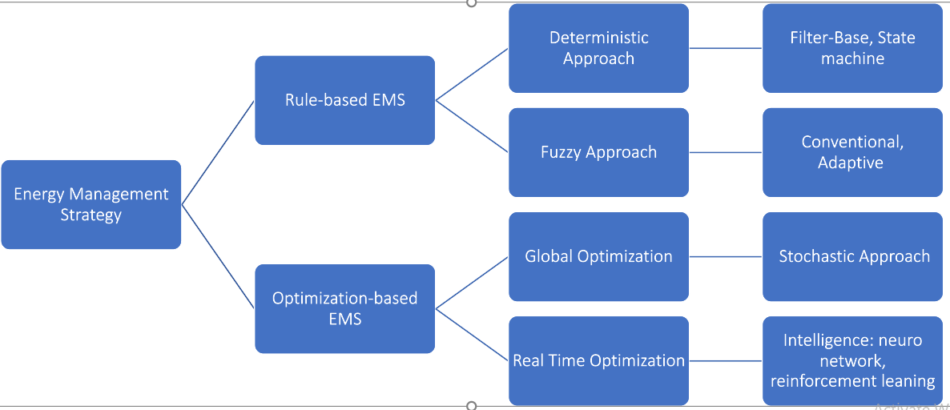

Fig.10 Category of EMSs used for Marine Hybrid Power Systems

|  |  |  |  |  |
| --- | --- | --- | --- | --- |
| **Algorithm** | **Optimal** | **Sub-Optimal** | **On-line** | **Real-Time** |
| DP | ✔ | **✘** | **✘** | **✘** |
| Fuzzy-logic | **✘** | ✔ | ✔ | ✔ |
| Rule-base | **✘** | ✔ | ✔ | ✔ |
| ECMS | **✘** | ✔ | ✔ | Conditional |
| MPC | ✔ | **✘** | ✔ | Conditional |

Table.7 Comparison of different power management algorithms

|  |  |  |
| --- | --- | --- |
| **Type** | **Developed Method** | **Advantages / Disadvantages** |
| Deterministic Approach | - Frequency Split Strategy  - Wavelet Transform | ✔ - Simple & practical and can be optimized  **✘** - Rely on human expertise & difficult to optimize |
| Fuzzy Approach | - Fuzzy Logic Controller  - Fuzzy Logic Controller using intelligent methods | ✔- Easy to design & excellent performance  **✘**- Difficulty to reach the optimal & rely on human expertise  **✘** - highly depend on load profile/may not applicable to other conditions. |
| Global Optimization | - Dynamic Programming  - Pontryagin Minimum Principle | ✔**✘ -** Super performance & can be used as other strategies benchmark / need prior power demand information & high computation complexity  ✔**✘** - Light computation complexity & Closing to the global optimization/ Sensitive to initial values |
| Real-Time Optimization | - Equivalent Consumption Minimization Strategy (ECMS)  - Model Predictive Control  - Intelligence | ✔- High real-time performance  **✘**- No consideration of devices degradation  ✔**✘ -** Need to design dynamic models  ✔- Improve fuel cell lifetime and fuel efficiency  **✘**- Need large data for training the model & low interpretability |

Table.8 Summary of various energy management strategies

6. Shipboard microgrids: System Architectures, Power Quality and Power Electronics

Ship power systems have significantly evolved over the last century with complex network architectures and power electronically interfaced multifarious high-power loads and sources. Due to presence of large dynamic loads and various operating scenarios, power management and control of ship microgrids have become more complex compared to terrestrial microgrids [111]. Large dynamic loads demand significant changes in the supply within a short time which lead to large deviations in voltage/frequency. ESS has been identified as a better alternative compared to a spinning reserve. Also, ESS can be used for shaving peak-load, energy recovery during regeneration and providing auxiliary services to main generators.

Distortions created by high power converters with passive front-end interface or low frequency are more significant than low power converters. Most power converters in vessels are of these types. Nowadays, the trend is to use active filters which are based on power electronic converters. However, modern ESS has bi-directional power electronic converter systems which can control both active and reactive power instantaneously. So, ESS can be used as an active filter and to reduce waveform distortions

6.1 Modern Power System Architecture

Zonal Electrical Distribution (ZED) has emerged as one of the most suitable power system architectures to achieve higher survivability, reliability and efficiency, [113,114] It can be either an AC ZED or DC ZED in Fig.11&12. ZED obtain high survivability by separating the distribution system into zones and maintaining independent power sources in each zone [113-115]. ZED systems require comprehensive understanding of load profiles and complex communication and coordination strategies. [112-115]

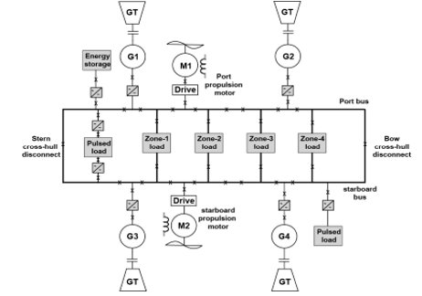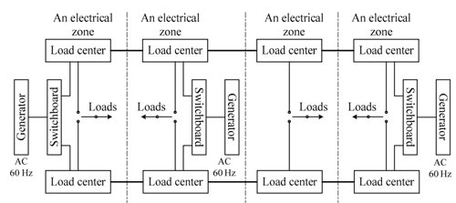

Fig.11 DC ZED SPS Fig.12 AC ZED SPS

|  |  |
| --- | --- |
| **Type of technologies developed in ZED power systems** | **List & References** |
| Communication technologies | Controller area network (CAN), Local area network (LAN) [114] |
| Protection algorithm & monitoring systems | Multi-functioning monitoring (MFM) systems |
| Complex decision-making algorithm | Graph theory-based techniques [114] |

Table.9 Technology development in ZED based ship power systems

6.1 Control Architecture of Power Electronic Systems

With accordance to IEEE Std 1676-2010 [116,117], generic structure control architecture is divided into different layers as seen in Fig.3.

1.System Control Layer – Consists of all functions required to determine system`s mission and role of each power electronics needed to carry out a mission

2.Application Control Layer – Involved in operation of power converter to satisfy the mission pre-determined by system control layer

3.Converter Control Layer – Feedback control system is included in this layer. Functions like PLL, current & voltage measurement filtering and calculation performance are required for feedback control.

4.Switching Control Layer – Modulation control and pulse generation to control switching operation of power converter

5.Hardware Control Layer – Handles everything related to power devices and executing many functions such as isolation, commutation, gating, protection, etc.

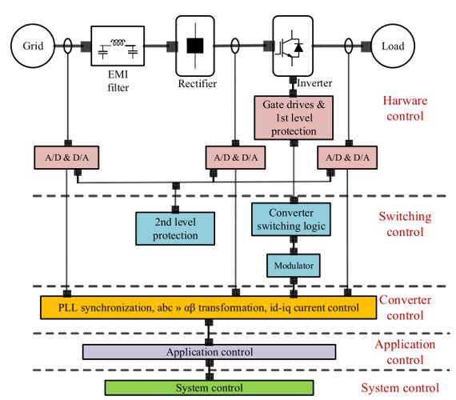

Fig.13 Control and protection architecture for power electronics

6.2 Comparison of AC and DC power systems and the impact on Power Quality

|  |  |
| --- | --- |
| AC ZED  Range:  3.3-13.8kV  [118-120] | Advantage:  - Possibility of using brushless ac machines for loads without the need of control electronics  - Ease of protection during faults due to zero voltage arc extinguishment  Disadvantage:  - Need for bulky transformer for step-up/down  - Low efficiency due to reactive power transfer  - Require strict fixed frequency which means prime mover need to run at fixed speed all the time under varying loads  - Require multiple generator synchronization which may encounter difficulties in immediate re-engagement of isolated systems |
| DC ZED  Range:  1kV-35kV  [118-121] | Advantage:  - Ease of re-engagement of isolated systems [118,122]  - Weight savings  - Elimination need of low frequency transformer [122,123]  - Absence of harmonic issues |

Table.10 Comparison of AC ZED and DC Zed SPS impact on power quality

6.3 Impact on shipboard power quality due to loads

In ZED systems, utilization of different components of the system is complicated [125] to analyze all the load profile and characteristics. Stochastic method is proposed in literature to evaluate the power system operation under a range of operating conditions and estimate corresponding load profiles. [124] This method allows analysis of power quality to guarantee high quality power in all operating scenarios. Time constants of loads characterize the rapidness of power demand. Load management in a complex ship microgrid while having components with such a wide range of time constants is a challenging task. Strategies based on time constant are becoming popular as promising load management methods for shipboard microgrids. [128]

|  |  |
| --- | --- |
| **Component** | **Time Constant** |
| Ship run-up time | 20-500s |
| Gas turbine generator | 5-10s |
| Propulsion motor | 1-5s |
| Propulsion motor stator with leakage time constant | 1-10ms |
| Propulsion motor rotor time constant | 50ms-1s |
| Motor service loads | 0.5-1s |
| DC-DC converters | 100-500ms |
| Pulse Width Modulation | 0.5-2ms |

Table.11 Time constants of different components of a marine electric power system [126,127]

6.4 Hybrid Energy Storage Systems

Hybrid ESS are proposed in recent years to deal with various needs of microgrids [129-131]. Most common proposed hybrid ESS is a combination of batteries and supercapacitor, which provides high energy and power density respectively [129,130]. Supercapacitors provide transient power response for short timing to mitigate transient power quality issues while batteries provide power quality for long durations. Hybrid ESS requires complex control architectures [132] since different energy storage technologies have different characteristics, hence should be optimally controlled to extract maximum benefit from both energy systems. Various power architecture has also been proposed for hybrid ESSs [129].

6.5 Power Converter Technologies

Adjustable Speed Drive (ASD) systems are effective energy saving solutions in electric propulsion and other variable speed drive applications in maritime systems. Common power electronic converters for marine applications are Thyristor Rectifier (SCR) for DC motor drive, Current Source Inverter (CSI), Cycloconverters and Matrix Converter, Voltage Source Inverter (VSI), Active Front End (AFE), Multilevel Inverters and Single-phase systems.

6.5.1 Thyristor Rectifier (SCR) for DC motor drive

For most high-power applications, DC drive uses a full-bridge thyristor rectifier feeds the DC motor with a controlled armature current and a field winding is excited with a regulated field current. Maximum power factor which can be achieved is approximately 0.96 at 15◦ firing angle. For a six-pulse converter, the line current contains harmonics of the order 5, 7, 11, 13 and so on, with 5th and 7th as the most dominate harmonic components in the six-pulse converter. To reduce the harmonic distortion, multi-pulse configuration such as 12, 18 and 24-pulse is used. A 12-pulse configuration eliminate approximately 90% of the 5th and 7th harmonics, enough to bring the distortion down to an acceptable limit. The disadvantage for the SCR is that require regular maintenance when the mechanical contact between the stator and rotor via brushes becomes a major source of failure. Also, practical limits for the DC motor drive are only 2-3MW. Thus, DC drives in propulsion systems have been replaced by AC drives in the 1980s [133].

6.5.2 Current Source Inverter (CSI)

CSI are normally used for synchronous AC motors. In this configuration, a three-phase thyristor-controlled rectifier with an inductor (Ldc) to smooth the DC-link is linked to a load commutated inverter. But, to perform thyristor commutation in the inverter part, a motor which generates back-EMF is required. So, it is mainly used in synchronous motor with a leading power factor. This causes an issue at lower speed (5-10% rated speed), back-EMF too low to perform natural commutation, inverter runs in pulsed mode operation, leading to higher torque ripple and shaft vibration. Main disadvantage of the CSI configuration is large time constant in the DC link inductor, which degrades the dynamic performance of the drive. Moreover, this configuration generates non-characteristic harmonics in the network, which can be an issue to comply with future power quality standards. The power rating of CSI to utilize in large synchronous motor drives is up to 60MW [134].

6.5.3 Cycloconverter and Matrix Converter

The low-speed issue of CSI is overcome using cycloconverter, which offers high torque at low speeds with low torque pulsations. Applications of the cycloconverter are limited to low-speed direct shaft drives without gears as output frequency are limited to about one-third of the input supply frequency. The output voltage waveform of the cycloconverter has a complex harmonics spectrum. It`s higher order harmonics are filtered by motor inductance; thus, motor current has less harmonics. Remaining harmonics causes harmonic losses and torque pulsations. Also, cycloconverter have been used only for synchronous motors due to their output power factor characteristics for maritime applications. No inductors/capacitors present in the DC-link, so motor side harmonics (non-characteristics) pattern can be seen in input current waveform [135]. It`s amplitudes of the non-characteristic’s harmonic are normally higher than CSI. Cycloconverter is available in a power range of 2-30MW per drive [133].

6.5.4 Voltage Source Inverter (VSI)

VSI requires constant DC voltage input to the inverter which is achieved with a LC filter in the DC-link. Modern AC drive configuration uses a VSI with Pulse Width Modulation (PWM) technique to control switching elements in inverter stage to achieve desired voltage output to the motor. Fig.8. PWM drive has excellent dynamic performance and torque is smoothly controlled over wide speed range, including zero speed (e.g., in vector-controlled algorithm). Also, PWM drives are best suited for high-speed motor drive applications, such as propulsion systems with stepdown gearbox – which offer cost and weight-effective solutions. In marine applications, passive techniques such as AC and DC chokes are still preferred solutions because of cost-effectiveness, simplicity, and reliability advantages [136].

In recent years, a reduced DC link capacitor used in a three-phase power converter named ‘‘Slim DC’’ link converter is also getting more attention as one of the harmonic mitigation techniques, but their performance is highly unpredictable at system level [137-139]. Today, the PWM-VSI type converter became a standard solution for all electric propeller marine vessels offering constant performance over wide speeds/loads range with low torque pulsations. This topology is capable to run AC motors in both directions.

But due to the diode or controlled rectifier topology, the power regeneration from the AC motor cannot be feedback to the network.

6.5.5 Active Front End (AFE)

Active Front End (AFE) is a bi-directional power flow converter which provides high quality sinusoidal line current waveform. AFE operates at higher switching frequency and results in better harmonic performance at low frequency (0-2kHz) but generates high order harmonics and noise in 2-150 kHz range. The increasing use of AFE causes concern in this new frequency range, which attracts attention of standardization organizations to develop new standard in 2-150 kHz range as well. The system has six active power switches such as IGBT or MOSFET and are controlled based on a suitable PWM technique. To control the switching frequency ripple, front side filter is needed, can be either L, LC or LCL type. LCL filters are common as they remove high frequency noise and clean the line current at the grid side. One thing to note is that the motor side performance is the same as PWM-VSI and AFEs are mainly used in low power vessels such as passenger ferry.

6.5.6 Other Converter Topologies

In order to optimize weight and volume, the trend of power systems is shifting towards medium voltage networks in marine applications. Converters used in medium voltage are usually modified version of a two-level converter. In order to accommodate increased DC-link voltage, more switches are connected in series in inverter part for three-level converter configuration. The rectifier part is normally supplied by phase-shifting transformer, which also reduces harmonic distortion in line current. A three-level converter also gives lower current distortion in motor currents at same switching frequency as a two-level converter. A matrix converter [140] provides a wide range of output voltages and frequencies and it also offers excellent steady-state performance and dynamic response [141]. But matrix converter topology is still immature and not yet fully analyzed for marine applications

6.5.7 Single Phase Systems

For low-load applications, single-phase converter topologies are still common in marine applications: Diode/Thyristor Rectifier and Power Factor Correction (PFC). The input bridge is directly connected to the AC network, and then rectified voltage is smooth with LC filter in the DC-link. Fig.11. Single phase results in distorted line current with significant low order harmonics, mainly below 2kHz. Special characteristics of single-phase rectifiers are very high 3rd order harmonic contents in the line current .This causes concerns in overheating of transformer due to a combination of harmonic contents in current, stray flux and high neutral currents [142].

In recent years, the use of Power Factor Corrector (PFC) circuit has increased in several single-phase appliances, such as computer, television and modern lighting system (e.g., LED and compact fluorescent lamps). Main advantages of this topology are to improve the line current quality and power factor of the system due to use of active circuit in the DC-link system. However, the boost converter is operated at higher switching frequency, which can generate noise in 9-150 kHz range.

6.6 Protection Systems

Electric fault results in consequences of maritime application if not dealt with by a protection system. It may lead to blackouts, fire, electric shocks, operation delays and so on. To avoid such issues, a maritime system should be equipped with a dedicated protection system. 3 main aspects of a protection systems are protection requirements, protection principle and future challenges.

6.6.1 Protection Requirements

5 Basic Requirements for protection requirements are [143-145]: 1. Sensitivity: protection system able to detect and react to the smallest unwanted fault 2. Selectivity: protection system able to isolate any faulted part of the system 3. Operational speed: protection system able to clear the electric faults as soon as possible to avoid any further damage to the equipment and system 4.Reliability: protection system should be highly reliable to ensure system protection in the event of fault 5. Simplicity and economics: simple protection system that offers the required functionalities at lower cost.

6.6.2 Protection Principle

Protection principle in maritime system is based on primary and backup protection strategy [145]. Primary protection is the first line defense which acts quickly in the event of fault and clear fault. It is provided in each section of an electrical installation.

Backup protection is the second line of defense, which isolates the faulty section of the system in case the primary protection fails to function properly. It may be provided by the same circuit breaker which would normally be opened by the primary protection or in a different circuit breaker.

To improve the reliability of the of the system, a zonal electric distribution system has been considered as preferred solution in maritime applications [146]. In zonal ship design concept, a decentralized protection system is recommended to meet the survivability conditions.

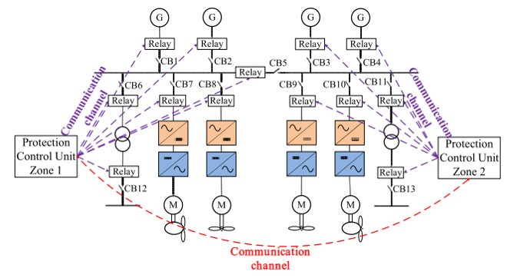

Fig.14 Decentralized protection system

6.6.3 Future challenges

With the increase of marine vessel`s complexity, new challenges for power system protection design are introduced for marine applications.

The list of challenges are as follows: Increment of generation and load power, increment of voltage levels, higher power densities to optimize weight and volume, more efficient use of generator sets, increasing penetration of power electronic based loads, developing newer upcoming system architectures such a DC onboard system and the increasing use of cold ironing process in shipping industry to improve efficiency.

To meet these challenges, new protection methods need to develop to ensure safe and reliable operation of maritime systems.

6.7 Managing Power Quality Issues

In terrestrial microgrids, generation sources are based on inverter-interfaced generation sources, and ESSs are also interfaced through power electronic converter systems. Thus, the output current could be controlled instantaneously to mitigate power quality issues in microgrids. But rapid response capability of inverter systems is limited by the characteristics of the energy storage devices.

High power density and rapid response are vital characteristics of ESSs to provide rapid energy needs dictated by the inverter. Therefore, based on nature of the power quality disturbance, appropriate ESS should be selected for the inverter system.

|  |  |
| --- | --- |
| **Power Quality Issues** | **Possible Causes** |
| Voltage Sags/Dips | Bow Thruster [147] |
| Voltage Variations/Unbalance | Radar Systems [148] |
| Voltage Swell | Radar Systems [148] |
| Frequency Drop | Switching of Large Loads [149] |
| Harmonics & Resonance | Power electronically interfaced loads and generators [150] |

Table.12 Classification of power quality issues in shipboard microgrid

|  |  |  |  |
| --- | --- | --- | --- |
| **Quantity in Operation** | **Variations** | | |
| Permanent | | Transient (Recover time) |
| Frequency | ± 5% | ± 10% (5s) | |
| Voltage | +6% to –10% | ±20% (1.5s) | |

Table.13 Acceptable range of voltage & frequency variations in AC distribution systems

6.7.1 Voltage Sags/Dips

Voltage sags are related to the low-voltage ride-through (LVRT) or fault ride-through (FRT) studies in microgrids.

Reactive power control is a common strategy for mitigating voltage sags in microgrids, allowing the microgrid to ride-through faults [152], aka Q/V droop control. Strategy is achieved either using existing power electronics-based sources or additional dynamic reactive power devices, such as static synchronous compensators (STATCOMs) [151,153].

For this strategy, error between actual and reference voltage is calculated and then processed through a droop constant (Kv_droop) to generate the reactive power reference (Qref), finally based on the voltage error, the STATCOM will inject reactive power to the microgrid to compensate the voltage sag [153].

A unified power quality conditioner proposed in [155] adopted a similar control strategy for mitigating voltage sags in microgrids. So, a similar reactive power control strategy could also be adopted for power electronic interfaced ESSs in microgrid [154]. In [156], a supercapacitor based ESS is proposed for improving FRT capability of microgrid.

A negative and positive sequence droop-based control method is proposed in [148] to mitigate asymmetrical voltage sags in microgrids. This strategy [148] is developed for a 3-phase voltage source inverter (VSI) based distributed generation (DG) system, which can also be applied to an ESS interfaced with 3-phased VSI.

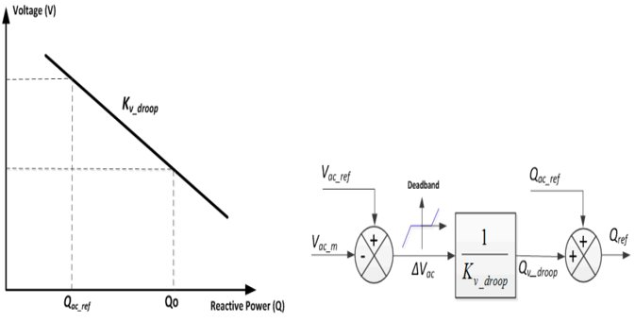

Fig.15 Q/V droop control strategy

6.7.2 Voltage Unbalance

Excess voltage unbalance causes pumps in the induction motor to overheat and eventually fail. Voltage unbalance is mainly caused by unevenly distributed single-phased loads in microgrid. Various voltage unbalance mitigation strategies are mainly implemented at the power electronic converter of the distributed generator.

In [157], voltage unbalance mitigation strategy was implemented for DGs and active power filter in a microgrid. The hierarchical control strategy is used in [162] in which primary control was used for power sharing among DGs, while at the secondary control voltage unbalance mitigation strategy was implemented

This strategy only activates when the microgrid violates the maximum voltage unbalance factor (VUF) allowed for the microgrid [162].

[158] deploys a direct voltage unbalance compensation scheme by controlling the negative sequence reactive power in the synchronous reference frame. The advantage of this strategy is that it can continuously control voltage unbalance in the microgrid.

Authors in [159] proposed to control the active and reactive power ripple in order to attenuate the voltage unbalance in the microgrid. A factor called “K” was defined by the authors in order to command active and reactive power ripple from the DG.

Since all these strategies are implemented in 3-phase VSIs, these strategies could be adopted for ESSs interfaced with 3-phase VSIs.

6.7.3 Harmonics & Resonance issues

Non-linear power electronic loads connected on board cause the power network to contain significant harmonics which may lead to detrimental resonance issues in the network. For selective harmonic current injection, injecting opposing current from the VSI cancels out the harmonic currents present in the microgrid [160-163]. In addition to the main load current reference an additional harmonic current is added to the current reference of the battery inverter as stated in [160].

Similar selective harmonic compensation scheme has been proposed in references [161] for the DGs in the microgrid.

A virtual impedance is added to the control loop in [163] to attenuate the harmonic current injections by DGs due to voltage distortions present in the network. In [163], a virtual impedance method has also been used for the damping harmonic voltages due to the adverse effect of the grid-side inductor of the LCL filter.

Also, in proposed resistive active filter method [164], harmonic voltages are extracted in synchronous reference frame and subsequently drive the current regulator to produce a voltage command to suppress harmonic voltages. Furthermore, repetitive control methods have also been proposed for voltage harmonic suppression while D-STATCOMs are used to suppress harmonics in the network.

6.7.4 Frequency Excursions

AC network frequency is considered as the main indicator for the power balance in ac microgrids, hence the ESSs can be primarily controlled based on the microgrid ac network frequency. Implementation of energy storage technologies for mitigating voltage and frequency fluctuations is well explored in the recent literature [165–167]. In most AC systems, where the grid is predominantly inductive, the ESSs are designed to exchange active power to regulate the frequency. If there is a sudden change of load, the ESS can act fast to supply the power deficit or absorb the surplus power and thus the system frequency stays within a predefined range. This approach is commonly known as P/f control.

6.8 Challenges of Incorporating Power Quality Mitigation Strategies into ESSs

The main challenge is the accurate selection and design of the ESS to counteract each power quality issue in the shipboard microgrid. E.g. A battery based ESS is selected to mitigate voltage sags due to high pulsed load, then the ESS could fail over time due to its incapability to deliver power at fast ramp rates. The prementioned P/f & Q/V control is only suitable for inductive systems [168]. But low voltage AC power systems in ships are more resistive than inductive, which means active power has a greater influence on the voltage.

Thus, ESSs are required to exchange active power for voltage regulation with reactive power exchange being controlled to regulate frequency. In summary, ESS need to act fast to keep the voltage and frequency within a tolerated range irrespective of type/characteristics of power system. Finally, ESS interfacing power converters can be used as an active filter to mitigate harmonics generated by large motor drives.

References

[1] https://www.stamford-avk.com/sites/stamfordavk/files/AGN039_C.pdf

[2]https://www.man-es.com/docs/default-source/marine/tools/5510-0003-03ppr.pdf?sfvrsn=b570e4e5_12

[3] https://www.uvic.ca/research/centres/iesvic/assets/docs/dissertations/chen_li_phd_2019.pdf pg54-59

[4] https://library.e.abb.com/public/6e3c955f85914f999774a6177734a62d/Detailed%20Description%20_%20PTOPTI.pdf

[5] C. Rossi, P. Corbelli, L. Zarri, and D. Casadei, "Power split e-CVT ship propulsion system," in 2009 IEEE Electric Ship Technologies Symposium, 2009, pp. 505-514.

[6] https://www.scirp.org/journal/paperinformation.aspx?paperid=71094

[7] Drijver J. Evaluation of transmission losses, heat flows and temperatures of propulsion drive lines. Msc. thesis, Faculty 3ME, Delft University of Technology, The Netherlands; 2013.

[8] van Koperen RM. Conceptual design of an environmentally friendly harbour tug. Msc. thesis, Faculty 3ME, Delft University of Technology, The Netherlands; 2009.

[9] Grimmelius HT, de Vos P, Krijgsman M, van Deursen E. Control of hybrid ship drive systems. In: Proceedings of the 10th conference on computer and its applications in the maritime industry. Hamburg, Germany; 2011. p. 1–14

[10] Chen, H.; Cong, T.N.; Yang, W.; Tan, C.; Li, Y.; Ding, Y. Progress in electrical energy storage system: A critical review. Prog. Nat. Sci. 2009, 19, 291–312

[11] Argyrou, M.C.; Christodoulides, P.; Kalogirou, S.A. Energy storage for electricity generation and related processes: Technologies appraisal and grid scale applications. Renew. Sustain. Energy Rev. 2018, 94, 804–821

[12] Zhao, H.; Wu, Q.; Hu, S.; Xu, H.; Rasmussen, C.N. Review of energy storage system for wind power integration support. Appl. Energy 2015, 137, 545–553.

[13] Chatzivasileiadi, A.; Ampatzi, E.; Knight, I. Characteristics of electrical energy storage technologies and their applications in buildings. Renew. Sustain. Energy Rev. 2013, 25, 814–830

[14] Ampere Ferry, World’s First All-Ectric Car Ferry. Available online: https://corvusenergy.com/marineproject/mf-ampere-ferry/

[15] Corvus Energy. Available online: https://corvusenergy.com/tag/corvus-at6500/

[16] Greenline Yachts. Available online: https://www.greenlinehybrid.si

[17] World’s First 2,000-Ton Electric Boat Launched. Available online: http://www.chinadaily.com.cn/china/ 2017-11/13/content_34470726.htm

[18] Tang, Y.; Khaligh, A. On the feasibility of hybrid battery/ultracapacitor energy storage systems for next generation shipboard power systems. In Proceedings of the Vehicle Power and Propulsion Conference (VPPC), Lille, France, 1–3 September 2010; pp. 1–6.

[19] Balsamo, F.; Capasso, C.; Miccione, G.; Veneri, O. Hybrid Storage System Control Strategy for All-Electric Powered Ships. Energy Procedia 2017, 126, 1083–1090.

[20] Cohen, I.J.; Westenhover, C.S.; Wetz, D.A.; Heinzel, J.M.; Dong, Q. Evaluation of an actively contolled battery-capacitor hybrid energy storage module (HESM) for use in driving pulsed power applications. In Proceedings of the Pulsed Power Conference (PPC), Austin, TX, USA, 31 May–4 June 2015; pp. 1–5.

[21] Anvari-Moghaddam, A.; Dragicevic, T.; Meng, L.; Sun, B.; Guerrero, J.M. Optimal planning and operation management of a ship electrical power system with energy storage system. In Proceedings of the IECON 42nd Annual Conference of the IEEE Industrial Electronics Society, Florence, Italy, 24–27 October 2016; pp. 2095–2099.

[22] Fuel Cell Boat (Nemo H2). Available online: http://www.opr-advies.nl/fuelcellboat/efcbboot.html (accessed on 27 August 2018)

[23] Luckose, L.; Urlaub, N.J.; Wiedeback, N.J.; Hess, H.L.; Johnson, B.K. Proton exchange membrane fuel cell (pemfc) modeling in pscad/emtdc. In Proceedings of the Electrical Power and Energy Conference (EPEC), Winnipeg, MB, Canada, 3–5 October 2011; pp. 11–16.

[24] Abkenar A.T.; Nazari, A.; Jayasinghe, S.D.G.; Kapoor, A.; Negnevitsky, M. Fuel cell power management using genetic expression programming in all-electric ships. IEEE Trans. Energy Convers. 2017, 32, 779–787.

[25] Su C.L.; Weng, X.T.; Chen, C.J. Power generation controls of fuel cell/energy storage hybrid ship power systems. In Proceedings of the Transportation Electrification Asia-Pacific (ITEC Asia-Pacific), Beijing, China, 31 August–3 September 2014; pp. 1–6.

[26] Sattler, G. PEFCs for naval ships and submarines: Many tasks, one solution. J. Power Sources 1998, 71, 144–149.

[27] Energy Storage System for Ships-Work in Progress. Available online: http://corvusenergy.com/work-inprogress/ (accessed on 20 September 2018).

[28]Mattern, K.; Ellis, A.; Williams, S.E.; Edwards, C.; Nourai, A.; Porter, D. Application of inverter-based systems for peak shaving and reactive power management. In Proceedings of the Transmission and Distribution Conference and Exposition, Chicago, IL, USA, 21–24 April 2008; pp. 1–4.

[29] Sonoda, N.; Matsunaga, H.; Gengo, T.; Minami, M.; Oishi, M.; Hashimoto, T. Development of Containerized Energy Storage System with Lithium-ion batteries. Mitsubishi Heavy Ind. Tech. Rev. 2013, 50, 36–41

[30] Bø, T.I.; Johansen, T.A. Battery power smoothing control in a marine electric power plant using nonlinear model predictive control. IEEE Trans. Control Syst. Technol. 2017, 25, 1449–1456.

[31] Tang, J.; Xiong, B.; Huang, Y.; Yuan, C.; Su, G. Optimal configuration of energy storage system based on frequency hierarchical control in ship power system with solar photovoltaic plant. J. Eng. 2017, 13, 1511–1514.

[32] Shagar, V.; Jayasinghe, S.G.; Enshaei, H. Frequency transient suppression in hybrid electric ship power systems: A model predictive control strategy for converter control with energy storage. Inventions 2018, 3, 13.

[33] Kim, S.Y.; Choe, S.; Ko, S.; Sul, S.K. A Naval Integrated Power System with a Battery Energy Storage System: Fuel efficiency, reliability, and quality of power. IEEE Electr. Mag. 2015, 3, 22–33.

[34] Terriche, Y.; Kerdoun, D.; Djeghloud, H. A new passive compensation technique to economically improve the power quality of two identical single-phase feeders. In Proceedings of the IEEE 15th International Conference on Environment and Electrical Engineering (EEEIC), Rome, Italy, 10–13 June 2015; pp. 54–59.

[35] Terriche, Y.; Golestan, S.; Guerrero, J.M.; Kerdoune, D.; Vasquez, J.C. Matrix pencil method-based reference current generation for shunt active power filters. IET Power Electron. 2017, 11, 772–780

[36] Vision of the Fjords. Avalaible online: https://new.abb.com/marine/references/vision-of-the-fjords

[37] Future of the Fjords. Available online: https://www.braa.no/news/future-of-the-fjords

[38] Finnøy, M.F. Available online: https://corvusenergy.com/portfolio/mf-finnoy/

[39] chinas, O.; Stefanakos, C.N. Selecting technologies towards compliance with MARPOL Annex VI: The perspective of operators. Transport. Res. Part D Transport. Environ. 2014, 28, 28–40.

[40] Tronstad, T.; Åstrand, H.H.; Haugom, G.P.; Langfeldt, L. Study on the Use of Fuel cells in Shipping; Report to European Maritime Safety Agency by DNV GL; DNV GL: Oslo, Norway, 2017.

[41] Inal, O.B.; Deniz, C. Assessment of fuel cell types for ships: Based on multi-criteria decision analysis. J. Clean. Prod. 2020, 265, 121734

[42] Dai, W.; Wang, H.; Yuan, X.Z.; Martin, J.J.; Yang, D.; Qiao, J.; Ma, J. A review on water balance in the membrane electrode assembly of proton exchange membrane fuel cells. Int. J. Hydrogen Energy 2009, 34, 9461–9478

[43] Zemships. One Hundred Passengers and Zero Emissions: The First Ever Passenger Vessel to Sail Propelled by Fuel Cells. Available online:https://ec.europa.eu/environment/life/project/Projects/index.cfm?fuseaction=home.showFile&rep=file& fil=Zemships_Brochure_EN.pdf

[44] Chakraborty, S.; Dzielendziak, A.S.; Köro ˘glu, T.; Yang, K. Evaluation of Smart Eco-Friendly Public Transport Options in Coastal Cities: Towards a Green Future for the City of Southampton; LRF Collegium 2013 Series; University of Southampton: Southampton, UK, 2013; Volume 2.

[45] Pratt, J.W.; Klebanoff, L.E. Feasibility of the SF-BREEZE: A Zero-Emission, Hydrogen Fuel Cell, High-Speed Passenger Ferry; SANDIA Report; SAND2016-9719; Sandia National Laboratories: Livermore, CA, USA, 2016.

[46] Rosli, R.E.; Sulong, A.B.; Daud, W.R.W.; Zulkifley, M.A.; Husaini, T.; Rosli, M.I.; Majlan, E.H.; Haque, M.A. A review of high-temperature proton exchange membrane fuel cell (HT-PEMFC) system. Int. J. Hydrogen Energy 2017, 42, 9293–9314.

[47] German e4ships project reports on fuel cell maritime demos. Fuel Cells Bull. 2016, 2016, 5, 11.

[48] E4ships. Fuel Cells in Marine Applications (2009–2016). December 2016. Available online: https://www.e4ships.de/english/ news/

[49] Van Biert, L.; Godjevac, M.; Visser, K.; Aravind, P.V. A review of fuel cell systems for maritime applications. J. Power Sources 2016, 327, 345–364.

[50] Kulkarni, A.; Giddey, S. Materials issues and recent developments in molten carbonate fuel cells. J. Solid State Electrochem. 2012, 16, 3123–3146

[51] Ahn, J.; Noh, Y.; Park, S.H.; Choi, B.I.; Chang, D. Fuzzy-based failure mode and effect analysis (FMEA) of a hybrid molten carbonate fuel cell (MCFC) and gas turbine system for marine propulsion. J. Power Sources 2017, 364, 226–233

[52] Ahn, J.; Park, S.H.; Lee, S.; Noh, Y.; Chang, D. Molten carbonate fuel cell (MCFC)-based hybrid propulsion systems for a liquefied hydrogen tanker. Int. J. Hydrogen Energy 2018, 43, 7525–7537.

[53] Ahn, J.; You, H.; Ryu, J.; Chang, D. Strategy for selecting an optimal propulsion system of a liquefied hydrogen tanker. Int. J. Hydrogen Energy 2017, 42, 5366–5380.

[54] Green Car Congress. Project to Start Trials on Ship-Board Methanol SOFC APU. 18 March 2008. Available online: https: //www.greencarcongress.com/2008/03/project-to-star.html

[55] Strazza, C.; Borghi, A.D.; Costamagna, P.; Traverso, A.; Santin, M. Comparative LCA of methanol-fuelled SOFCs as auxiliary power systems on-board ships. Appl. Energy 2010, 87, 1670–1678

[56] Office of Energy Efficiency & Renewable Energy. Fuel Cells. Available online: <https://www.energy.gov/eere/fuelcells/fuel-cells>

[57] Baldi, F.; Moret, S.; Tammi, K.; Maréchal, F. The role of solid oxide fuel cells in future ship energy systems. Energy 2020, 194, 116811.

[58] De-Troya, J.J.; Alvarez, C.; Fernandez-Garrido, C.; Carral, L. Analysing the possibilities of using fuel cells in ships. Int. J. Hydrogen Energy 2016, 41, 2853–2866

[59] Shabani, B.; Hafttananian, M.; Khamani, S.; Ramiar, A.; Ranjbar, A.A. Poisoning of proton exchange membrane fuel cells by contaminants and impurities: Review of mechanisms, effects, and mitigation strategies. J. Power Sources 2019, 427, 21–48.

[61] Khatib, F.N.; Wilberforce, T.; Ijaodola, O.; Ogungbemi, E.; El-Hassan, Z.; Durrant, A.; Thompson, J.; Olabi, A.G. Material degradation of components in polymer electrolyte membrane (PEM) electrolytic cell and mitigation mechanisms: A review. Renew. Sustain. Energy Rev. 2019, 111, 1–14.

[62] Yokokawa, H.; Tu, H.; Iwanschitz, B.; Mai, A. Fundamental mechanisms limiting solid oxide fuel cell durability. J. Power Sources 2008, 182, 400–412

[63] Sasank, B.V.; Rajalakshmi, N.; Dhathathreyan, K.S. Performance analysis of polymer electrolyte membrane (PEM) fuel cell stack operated under marine environmental conditions. J. Mar. Sci. Technol. 2016, 21, 471–478

[64] Maru, H.; Singhal, S.C.; Stone, C.; Wheeler, D. 1–10 kW Stationary Combined Heat and Power Systems Status and Technical Potential; Independent Review Report for U.S. Department of Energy Hydrogen and Fuel Cells Program; The National Renewable Energy Laboratory: Washington, DC, USA, 2010

[65] McPhail, S.J.; Aarva, A.; Devianto, H.; Bove, R.; Moreno, A. SOFC and MCFC: Commonalities and opportunities for integrated research. Int. J. Hydrogen Energy 2011, 36, 10337–10345

[66] De Bruijn, F.A.; Dam, V.A.T.; Janssen, G.J.M. Review: Durability and degradation issues of PEM fuel cell components. Fuel Cells 2008, 1, 3–22

[67] Hawkes, A.D.; Brett, D.J.L.; Brandon, N.P. Fuel cell micro-CHP techno-economics: Part 2-Model application to consider the economic and environmental impact of stack degradation. Int. J. Hydrogen Energy 2009, 34, 9558–9569

[68] D. B. W. Abeywardana, B. Hredzak, V. G. Agelidis, and G. D. Demetriades, ‘‘Supercapacitor sizing method for energy-controlled filter-based hybrid energy storage systems,’’ IEEE Trans. Power Electron., vol. 32, no. 2, pp. 1626–1637, Feb. 2017

[69] X. Zhang, C. C. Mi, A. Masrur, and D. Daniszewski, ‘‘Wavelet-transformbased power management of hybrid vehicles with multiple on-board energy sources including fuel cell, battery and ultracapacitor,’’ J. Power Sources, vol. 185, no. 2, pp. 1533–1543, Dec. 2008

[70] Q. Li, W. Chen, Y. Li, S. Liu, and J. Huang, ‘‘Energy management strategy for fuel cell/battery/ultracapacitor hybrid vehicle based on fuzzy logic,’’ Int. J. Electr. Power Energy Syst., vol. 43, no. 1, pp. 514–525, Dec. 2012, doi: 10.1016/j.ijepes.2012.06.026

[71] S. Al-Sakkaf, M. Kassas, M. Khalid, and M. A. Abido, ‘‘An energy management system for residential autonomous DC microgrid using optimized fuzzy logic controller considering economic dispatch,’’ Energies, vol. 12, no. 8, p. 1457, 2019

[72] A. Brahma, Y. Guezennec, and G. Rizzoni, "Optimal energy management in series hybrid electric vehicles," in Proc. American Control Conference, 2000, vol. 1, no. 6, pp. 60-64

[73] J. Knapp, A. Chapman, S. Mody, and T. Steffen, "Optimal control inputs for fuel economy and emissions of a series hybrid electric vehicle," Presented at: SAE 2015 World Congress and Exhibition: Leading Mobility Innovation, 21st-23rd April 2015, Detroit, USA

[74] L. V. Pérez, G. R. Bossio, D. Moitre, and G. O. García, "Optimization of power management in an hybrid electric vehicle using dynamic programming," Mathematics and Computers in Simulation, vol. 73, no. 1-4, pp. 244-254, 2006.

[75] R. Wang and S. M. Lukic, "Dynamic programming technique in hybrid electric vehicle optimization," in Proc. IEEE International Electric Vehicle Conference (IEVC), 2012, 2012, pp. 1-8

[76] C. Weng, Y. Wang, V. Tsourapas, C. Patil, and J. Sun, "Optimal control of hybrid electric vehicles with power split and torque split strategies: A comparative case study," in American Control Conference (ACC), 2011, pp. 2131-2136

[77] Y. Zou, H. Shi-jie, L. Dong-ge, G. Wei, and X.-s. Hu, "Optimal energy control strategy design for a hybrid electric vehicle," Discrete Dynamics in Nature and Society, vol. 2013, Article ID 132064, 8 pages, 2013. https://doi.org/10.1155/2013/132064.

[78] L. Lai and M. Ehsani, "Dynamic programming optimized constrained engine on and off control strategy for parallel HEV," in Proc. 2013 IEEE Vehicle Power and Propulsion Conference (VPPC), 2013, pp. 1-5

[79] C.-C. Lin, J.-M. Kang, J. Grizzle, and H. Peng, "Energy management strategy for a parallel hybrid electric truck," in Proc. American Control Conference, 2001, vol. 4, pp. 2878-2883

[80] C.-C. Lin, H. Peng, J. W. Grizzle, and J.-M. Kang, "Power management strategy for a parallel hybrid electric truck," IEEE transactions on control systems technology, vol. 11, no. 6, pp. 839-849, 2003.

[81] J. Liu and H. Peng, "Modeling and control of a power-split hybrid vehicle," IEEE transactions on control systems technology, vol. 16, no. 6, pp. 1242- 1251, 2008.

[82] C.-C. Lin, H. Peng, and J. Grizzle, "A stochastic control strategy for hybrid electric vehicles," in Proc. American Control Conference, 2004, vol. 5, pp. 4710-4715: IEEE.

[83] T. Leroy, J. Malaizé, and G. Corde, "Towards real-time optimal energy management of HEV powertrains using stochastic dynamic programming," in Proc. IEEE Vehicle Power and Propulsion Conference (VPPC), 2012, pp. 383-388

[84] N. Kim, S. Cha, and H. Peng, "Optimal control of hybrid electric vehicles based on Pontryagin's minimum principle," IEEE Transactions on Control Systems Technology, vol. 19, no. 5, pp. 1279-1287, 2011

[85] Y. Wu, A. Ravey, D. Chrenko, and A. Miraoui, ‘‘Demand side energy management of EV charging stations by approximate dynamic programming,’’ Energy Convers. Manage., vol. 196, pp. 878–890, Sep. 2019.

[86] S. Zhang and R. Xiong, ‘‘Adaptive energy management of a plugin hybrid electric vehicle based on driving pattern recognition and dynamic programming,’’ Appl. Energy, vol. 155, pp. 68–78, Oct. 2015, doi: 10.1016/j.apenergy.2015.06.003.

[87] R. Zaccone, E. Ottaviani, M. Figari, and M. Altosole, ‘‘Ship voyage optimization for safe and energy-efficient navigation: A dynamic programming approach,’’ Ocean Eng., vol. 153, pp. 215–224, Apr. 2018

[88] G. Paganelli, S. Delprat, T.-M. Guerra, J. Rimaux, and J.-J. Santin, "Equivalent consumption minimization strategy for parallel hybrid powertrains," in Proc. IEEE 55th Vehicular Technology Conference, VTC Spring, 2002, vol. 4, pp. 2076-2081

[89] M. Khodabakhshian, L. Feng, and J. Wikander, "Improving fuel economy and robustness of an improved ECMS method," in Proc. 10th IEEE International Conference on Control and Automation (ICCA), 2013, pp. 598- 603

[90] J. McDonald and S. Fallah, "A Novel Equivalent Consumption Minimisation Strategy for a Series Hybrid Electric Vehicle," J Robot Mech Eng Resr, vol. 1, no. 1, pp. 24-30, 2015

[91] J. Couch, L. Fiorentini, and M. Canova, "An ECMS-Based Approach for the Energy Management of a Vehicle Electrical System," IFAC Proceedings Volumes, vol. 46, no. 21, pp. 115-120, 2013

[92] L. Johannesson, S. Pettersson, and B. Egardt, "Predictive energy management of a 4QT series-parallel hybrid electric bus," Control Engineering Practice, vol. 17, no. 12, pp. 1440-1453, 2009

[93] F. Payri, C. Guardiola, B. Pla, and D. Blanco-Rodriguez, "On a stochastic approach of the ecms method for energy management in hybrid electric vehicles," IFAC Proceedings Volumes, vol. 45, no. 30, pp. 341-348, 2012

[94] L. Serrao, S. Onori, and G. Rizzoni, "A comparative analysis of energy management strategies for hybrid electric vehicles," Journal of Dynamic Systems, Measurement, and Control, vol. 133, no. 3, p. 031012, 2011

[95] T. Hofman, M. Steinbuch, R. Van Druten, and A. Serrarens, "Rule-based energy management strategies for hybrid vehicles," International Journal of Electric and Hybrid Vehicles, vol. 1, no. 1, pp. 71-94, 2007

[96] D. Zhao, R. Stobart, G. Dong, and E. Winward, "Real-time energy management for diesel heavy duty hybrid electric vehicles," IEEE Transactions on Control Systems Technology, vol. 23, no. 3, pp. 829-841, 2015

[97] J. Han, Y. Park, and Y.-s. Park, "A novel updating method of equivalent factor in ECMS for prolonging the lifetime of battery in fuel cell hybrid electric vehicle," IFAC Proceedings Volumes, vol. 45, no. 30, pp. 227-232, 2012

[98] C. Musardo, G. Rizzoni, Y. Guezennec, and B. Staccia, "A-ECMS: An adaptive algorithm for hybrid electric vehicle energy management," European Journal of Control, vol. 11, no. 4-5, pp. 509-524, 2005

[99] S. Kutter and B. Bäker, "An iterative algorithm for the global optimal predictive control of hybrid electric vehicles," in Proc. IEEE Vehicle Power and Propulsion Conference (VPPC), 2011, pp. 1-6

[100] L. Qiu, L. Qian, H. Zomorodi, and P. Pisu, "Design and optimization of equivalent consumption minimization strategy for 4WD hybrid electric vehicles incorporating vehicle connectivity," Science China Technological Sciences, vol. 61, no. 1, pp. 147-157, 2018

[101] A. Sciarretta, M. Back, and L. Guzzella, "Optimal control of parallel hybrid electric vehicles," IEEE Transactions on control systems technology, vol. 12, no. 3, pp. 352-363, 2004

[102] J. Liu and H. Peng, "Modeling and control of a power-split hybrid vehicle," IEEE transactions on control systems technology, vol. 16, no. 6, pp. 1242- 1251, 2008

[103] N. Kim, S. Cha, and H. Peng, "Optimal control of hybrid electric vehicles based on Pontryagin's minimum principle," IEEE Transactions on Control Systems Technology, vol. 19, no. 5, pp. 1279-1287, 2011

[104] I. E. Aiteur, C. Vlad, and E. Godoy, "Optimization-based energy management strategies for electric vehicles," in Proc. 41st Annual Conference of the IEEE Industrial Electronics Society (IECON), 2015, pp. 003449-003454

[105] H. A. Borhan, A. Vahidi, A. M. Phillips, M. L. Kuang, and I. V. Kolmanovsky, "Predictive energy management of a power-split hybrid electric vehicle," in Proc. American Control Conference, 2009, pp. 3970- 3976: IEEE

[106] H. Borhan, A. Vahidi, A. M. Phillips, M. L. Kuang, I. V. Kolmanovsky, and S. Di Cairano, "MPC-based energy management of a power-split hybrid electric vehicle," IEEE Transactions on Control Systems Technology, vol. 20, no. 3, pp. 593-603, 2012

[107] H. A. Borhan, C. Zhang, A. Vahidi, A. M. Phillips, M. L. Kuang, and S. Di Cairano, "Nonlinear model predictive control for power-split hybrid electric vehicles," in Proc. 49th IEEE Conference on Decision and Control (CDC), 2010, pp. 4890-4895

[108] H. Borhan, "Optimization-based power management of hybrid power systems with applications in advanced hybrid electric vehicles and wind farms with battery storage," Ph.D. Thesis, Dept. Mech. Engr. Clemson University, Clemson, South Carolina, 2011

[109] F. Pallonetto, M. De Rosa, F. Milano, and D. P. Finn, ‘‘Demand response algorithms for smart-grid ready residential buildings using machine learning models,’’ Appl. Energy, vol. 239, pp. 1265–1282, Apr. 2019

[110] <https://www.rhmarine.com/yachts/hybrid/>

[111] Chalfant, J.S.; Chryssostomidis, C. Analysis of various all-electric-ship electrical distribution system topologies. In Proceedings of the 2011 IEEE Electric Ship Technologies Symposium, Alexandria, VA, USA, 10–13 April 2011; pp. 72–77

[112] Skjong, E.; Rødskar, E.; Molinas, M.; Johansen, T.; Cunningham, J. The marine vessel’s electrical power system: From its birth to present day. Proc. IEEE 2015, 103, 2410–2424

[113] Hegner, H.; Desai, B. Integrated fight through power. In Proceedings of the 2002 IEEE Power Engineering Society Summer Meeting, Chicago, IL, USA, 21–25 July 2002; pp. 336–339

[114] Rose, M.W.; Cuzner, R.M. Fault isolation and reconfiguration in a three-zone system. In Proceedings of the 2015 IEEE Electric Ship Technologies Symposium (ESTS), Alexandria, VA, USA, 21–24 June 2015; pp. 409–414.

[115] Bose, S.; Natarajan, B.; Scoglio, C.; Das, S.; Schulz, N.N. Analysis of robustness for shipboard power system with non-radial power flow. In Proceedings of the 2011 IEEE Electric Ship Technologies Symposium, Alexandria, VA, USA, 10–13 April 2011; pp. 181–186

[116] IEEE Guide for Control Architecture for High Power Electronics (1 MW and Greater) Used in Electric Power Transmission and Distribution Systems, IEEE Standard 1676, 2010.

[117] Y. Khersonsky, ‘‘New IEEE power electronics standards for ships,’’ in Proc. Electr. Mach. Tech. Symp. (EMTS), 2012, pp. 1–10

[118] Hansen, J.F.; Wendt, F. History and State of the Art in Commercial Electric Ship Propulsion, Integrated Power Systems, and Future Trends. Proc. IEEE 2015, 103, 2229–2242

[119] Dubey, A.; Santoso, S. Availability-Based Distribution Circuit Design for Shipboard Power System. IEEE Trans. Smart Grid 2015.

[120] Schuddebeurs, J.D.; Norman, P.J.; Booth, C.D.; Burt, G.M.; McDonald, J.R. Emerging Research Issues Regarding Integrated-Full-Electric-Propulsion. In Proceedings of the 41st International Universities Power Engineering Conference, Newcastle-upon-Tyne, UK, 6–8 September 2006; pp. 669–673

[121] Bosich, D.; Vicenzutti, A.; Pelaschiar, R.; Menis, R.; Sulligoi, G. Toward the future: The MVDC large ship research program. In Proceedings of the 2015 AEIT International Annual Conference (AEIT), Naples, Italy, 14–16 October 2015; pp. 1–6

[122] Apsley, J.M.; Gonzalez-Villasenor, A.; Barnes, M.; Smith, A.C.J.; Williamson, S.; Schuddebeurs, J.D.; Norman, P.J.; Booth, C.D. Propulsion Drive Models for Full Electric Marine Propulsion Systems. IEEE Trans. Ind. Appl. 2009, 45, 676–684

[123] Chen, X.; Wang, X. A novel wound rotor BDFIG for ship shaft generator application—Control and prototype tests. In Proceedings of the 2014 17th International Conference on Electrical Machines and Systems (ICEMS), Hangzhou, China, 22–25 October 2014; pp. 1196–1200

[124] McCoy, T.J. Trends in ship electric propulsion. In Proceedings of the 2002 IEEE Power Engineering Society Summer Meeting, Chicago, IL, USA, 21–25 July 2002; Volume 1, pp. 343–346.

[125] Rules for Classification Ships, Part 4 Systems and components, Chapter 8 Electrical installations. Det Norske Veritas GL Edition: Høvik, Norway, 2011. Available online: https://rules.dnvgl.com/docs/pdf/DNV/ rulesship/2011-01/ts408.pdf

[126]QUEENMARYIITechnicalInformation.Availableonline:http://www.cunard.com/documents/press% 20kits/queen%20mary%202/queen_mary_2_technical.pdf

[127] IEEE Industry Applications Society. 1709–2010—IEEE Recommended Practice for 1 kV to 35 kV Medium-Voltage DC Power Systems on Ships; IEEE Standard: New York, NY, USA, 2010; pp. 1–54.

[128] Feng, X.; Butler-Purry, K.L.; Zourntos, T. Multi-Agent System-Based Real-Time Load Management for All-Electric Ship Power Systems in DC Zone Level. IEEE Trans. Power Syst. 2012, 27, 1719–1728

[129] Adhikari, S.; Lei, Z.; Peng, W.; Tang, Y. A battery/supercapacitor hybrid energy storage system for DC microgrids. In Proceedings of the 2016 IEEE 8th International Power Electronics and Motion Control Conference (IPEMC-ECCE Asia), Hefei, China, 22–26 May 2016; pp. 1747–1753

[130] Vechiu, I.; Etxeberria, A.; Camblong, H.; Vinassa, J.M. Three-level Neutral Point Clamped Inverter Interface for flow battery/supercapacitor Energy Storage System used for microgrids. In Proceedings of the 2011 2nd IEEE PES International Conference and Exhibition on Innovative Smart Grid Technologies (ISGT Europe), Manchester, UK, 5–7 December 2011; pp. 1–6

[131] Xiao, J.; Wang, P.; Setyawan, L. Hierarchical Control of Hybrid Energy Storage System in DC Microgrids. IEEE Trans. Ind. Electron. 2015, 62, 4915–4924

[132] Kollimalla, S.K.; Mishra, M.K. Coordinated control and energy management of hybrid energy storage system in PV system. In Proceedings of the 2014 International Conference on Computation of Power, Energy, Information and Communication (ICCPEIC), Chennai, India, 16–17 April 2014; pp. 363–368.

[133] A. J. Sørensen, ‘‘Marine control systems: Propulsion and motion control systems of ships and ocean structures,’’ Norwegian Univ. Sci. Technol., Trondheim, Norway, Lecture Notes, 2012

[134] A. K. Ådnanes, A. J. Sørensen, and T. Hackman, ‘‘Essential characteristics of electrical propulsion and thruster drives in DP vessels,’’ in Proc. Dyn. Positioning Conf., 1997, pp. 1–20.

[135] B. R. Pelly, Thyristor Phase-Controlled Converters and Cycloconverters: Operation, Control, and Performance. New York, NY, USA: Wiley, 1971

[136] D. Kumar and F. Zare, ‘‘Analysis of harmonic mitigations using hybrid passive filters,’’ in Proc. 16th Int. Power Electron. Motion Control Conf. Expo. (PEMC), Sep. 2014, pp. 945–951.

[137] H. Yoo and S.-K. Sul, ‘‘A novel approach to reduce line harmonic current for a three-phase diode rectifier-fed electrolytic capacitor-less inverter,’’ in Proc. 24th Annu. IEEE Appl. Power Electron. Conf. Expo. (APEC), Feb. 2009, pp. 1897–1903.

[138] H. M. Delpino and D. Kumar, ‘‘Line harmonics on systems using reduced DC-link capacitors,’’ in Proc. 39th Annu. Conf. IEEE IECON, Nov. 2013, pp. 961–966.

[139] H. Wang, P. Davari, H. Wang, D. Kumar, and F. Blaabjerg, ‘‘Mission profile based reliability evaluation of DC-link capacitors in adjustable speed drives,’’ IEEE Trans. Power Electron., to be published.

[140] D. Kumar, P. Wheeler, J. C. Clare, and L. Empringham, ‘‘A multi-drive system based on a two-stage matrix converter,’’ in Proc. EPE, Barcelona, Spain, Sep. 2009, pp. 207–212.

[141] R. R. Beasant, W. C. Beattie, and A. Refsum, ‘‘An approach to the realization of a high-power Venturini converter,’’ Proc. IEEE PESC, Apr. 1990, pp. 291–297.

[142] R. C. Dugan, M. F. McGranghan, S. Santoso, and H. W. Beaty, Electrical Power System Quality. New York, NY, USA: McGraw-Hill, 2003.

[143] C. I. Ciontea, C. Leth Bak, F. Blaabjerg, K. K. Madsen, and C. H. Sterregaard, ‘‘Review of network topologies and protection principles in marine and offshore applications,’’ in Proc. 25th Australas. Univ. Power Eng. Conf., Sep. 2015, pp. 1–6.

[144] J. L. Blackburn and T. J. Domin, Protective Relaying: Principles and Applications, 3rd ed. Boca Raton, FL, USA: Taylor & Francis Group, 2006

[145] P. M. Anderson, Power System Protection, 1st ed. Hoboken, NJ, USA: Wiley, 1998

[146] E. Tironi, M. Corti, and G. Ubezio, ‘‘Zonal electrical distribution systems in large ships: Topology and control,’’ in Proc. Int. Annu. Conf. (AEIT), Naples, Italy, Oct. 2015, pp. 1–6.

[147] Mindykowski, J. Case Study—Based Overview of Some Contemporary Challenges to Power Quality in Ship Systems. Inventions 2016, 1, 12.

[148] Musolino, V.; Piegari, L.; Tironi, E. Technical and economical evaluation of storage systems in naval applications. In Proceedings of the 2013 International Conference on Clean Electrical Power (ICCEP), Alghero, Italy, 11–13 June 2013; pp. 120–127

[149] Hebner, R.E.; Davey, K.; Herbst, J.; Hall, D.; Hahne, J.; Surls, D.D.; Ouroua, A. Dynamic Load and Storage Integration. Proc. IEEE 2015, 103, 2344–2354

[150] Evans, I.C.; Hoevenaars, A.H.; Eng, P. Meeting Harmonic Limits on Marine Vessels. In Proceedings of the 2007 IEEE Electric Ship Technologies Symposium, Arlington, VA, USA, 21–23 May 2007; pp. 115–121

[151] Srivatchan, N.S.; Rangarajan, P.; Rajalakshmi, S. Control Scheme for Power Quality Improvement in Islanded Microgrid Operation. Procedia Technol. 2015, 21, 212–215.

[152] Zhao, X.; Guerrero, J.M.; Savaghebi, M.; Vasquez, J.C.; Wu, X.; Sun, K. Distributed low voltage ride-through operation of power converters in grid-connected microgrids under voltage sags. In Proceedings of the IECON 2015—41st Annual Conference of the IEEE Industrial Electronics Society, Yokohama, Japan, 9–12 November 2015; pp. 1909–1914

[153] Jayawardena, A.V.; Meegahapola, L.G.; Robinson, D.A.; Perera, S. Low-voltage ride-through characteristics of microgrids with distribution static synchronous compensator (DSTATCOM). In Proceedings of the 2015 Australasian Universities Power Engineering Conference (AUPEC), Wollongong, Australia, 27–30 September 2015; pp. 1–6.

[154] Meegahapola, L.G.; Robinson, D.; Agalgaonkar, A.P.; Perera, S.; Ciufo, P. Microgrids of Commercial Buildings: Strategies to Manage Mode Transfer from Grid Connected to Islanded Mode. IEEE Trans. Sustain. Energy 2014, 5, 1337–1347.

[155] Gayatri, M.T.L.; Parimi, A.M.; Kumar, A.V.P. Utilization of Unified Power Quality Conditioner for voltage sag/swell mitigation in microgrid. In Proceedings of the 2016 Biennial International Conference on Power and Energy Systems: Towards Sustainable Energy (PESTSE), Bangalore, India, 21–23 January 2016; pp. 1–6

[156] Gkavanoudis, S.I.; Oureilidis, K.O.; Demoulias, C.S. Fault ride-through capability of a microgrid with wtgs and supercapacitor storage during balanced and unbalanced utility voltage sags. In Proceedings of the 2013 International Conference on Renewable Energy Research and Applications (ICRERA), Madrid, Spain, 20–23 October 2013; pp. 231–236.

[157] Hashempour, M.M.; Savaghebi, M.; Vasquez, J.C.; Guerrero, J.M. Voltage unbalance and harmonic compensation in microgrids by cooperation of distributed generators and active power filters. In Proceedings of the 2016 7th Power Electronics and Drive Systems Technologies Conference (PEDSTC), Tehran, Iran, 16–18 February 2016; pp. 646–651

[158] Zhao, X.; Wu, X.; Meng, L.; Guerrero, J.M.; Vasquez, J.C. A direct voltage unbalance compensation strategy for islanded microgrids. In Proceedings of the 2015 IEEE Applied Power Electronics Conference and Exposition (APEC), Charlotte, NC, USA, 15–19 March 2015; pp. 3252–3259.

[159] Kabiri, R.; Holmes, D.G.; McGrath, B.P. Control of Active and Reactive Power Ripple to Mitigate Unbalanced Grid Voltages. IEEE Trans. Ind. Appl. 2016, 52, 1660–1668

[160] Xu, L.; Miao, Z.; Fan, L.; Gurlaskie, G. Unbalance and harmonic mitigation using battery inverters. In Proceedings of the North American Power Symposium (NAPS), Charlotte, NC, USA, 4–6 October 2015; pp. 1–6.

[161] Savaghebi, M.; Vasquez, J.C.; Jalilian, A.; Guerrero, J.M.; Lee, T.L. Selective harmonic virtual impedance for voltage source inverters with LCL filter in microgrids. In Proceedings of the 2012 IEEE Energy Conversion Congress and Exposition (ECCE), Raleigh, NC, USA, 15–20 September 2012; pp. 1960–1965

[162] Micallef, A.; Apap, M.; Spiteri-Staines, C.; Guerrero, J.M. Mitigation of Harmonics in Grid-Connected and Islanded Microgrids via Virtual Admittances and Impedances. IEEE Trans. Smart Grid 2015.

[163] He, J.; Li, Y.W.; Wang, R.; Zhang, C. Analysis and Mitigation of Resonance Propagation in Grid-Connected and Islanding Microgrids. IEEE Trans. Energy Convers. 2015, 30, 70–81

[164] Lee, T.L.; Hu, S.H. Discrete Frequency-Tuning Active Filter to Suppress Harmonic Resonances of Closed-Loop Distribution Power Systems. IEEE Trans. Power Electron. 2011, 26, 137–148.

[165] Tan, Y.; Muttaqi, K.; Ciufo, P.; Meegahapola, L. Enhanced Frequency Response Strategy for PMSG Based Wind Energy Conversion System Using Ultracapacitor in Remote Area Power Supply Systems. IEEE Trans. Ind. Appl. 2016, in press.

[166] Sebastián, R. Application of a battery energy storage for frequency regulation and peak shaving in a wind diesel power system. IET Gener. Transm. Distrib. 2016, 10, 764–770

[167] Stroe, D.I.; Knap, V.; Swierczynski, M.; Stan, A.; Teodorescu, R. Operation of Grid-Connected Lithium-Ion Battery Energy Storage System for Primary Frequency Regulation: A Battery Lifetime Perspective. IEEE Trans. Ind. Appl. 2017, 53, 430–438.

[168] Rocabert, J.; Luna, A.; Blaabjerg, F.; Rodríguez, P. Control of Power Converters in AC Microgrids. IEEE Trans. Power Electron. 2012, 27, 4734–4749

# Bibliography

|  |  |
| --- | --- |
| [1] | T. 2. |
| [2] | Test. |