SUMMARY

USC ID/s: 3463514868_3899011612_4520411250_6159315758_9838191484

Datapoints
M+N | Time in MS (Basic) | Time in MS (Efficient) | Memory in KB (Basic) | Memory in KB (Efficient)
16 | 0.19 | 0.66 | 0 | 0
64 | 0.63 | 2.55 | 0 | 0
128 | 1.62 | 6.35 | 128 | 0
256 | 6.13 | 12.77 | 640 | 0
384 | 14.29 | 29.51 | 1408 | 0
512 | 25.62 | 50.01 | 2560 | 0
768 | 59.53 | 112.27 | 5888 | 0
1024 | 111.81 | 170.27 | 10368 | 128
1280 | 176.05 | 277.95 | 16128 | 128
1536 | 228.30 | 364.18 | 23296 | 128
2048 | 409.43 | 630.27 | 41216 | 128
2560 | 647.83 | 994.02 | 64384 | 256
3072 | 927.92 | 1403.15 | 92800 | 256
3584 | 1327.98 | 1838.10 | 126208 | 256
3968 | 1675.70 | 2275.87 | 154752 | 384

Insights

Graph1 – Memory vs Problem Size (M+N)

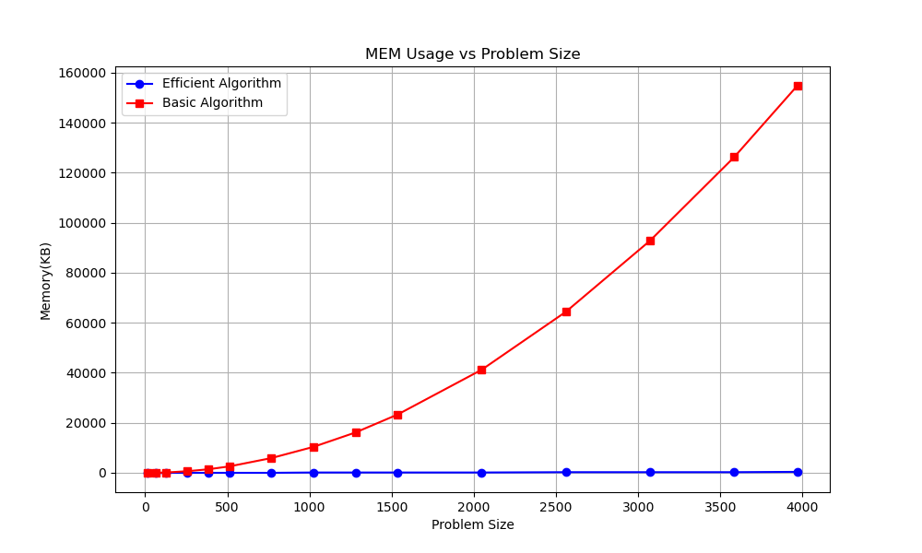

Nature of the Graph (Logarithmic/ Linear/ Polynomial/ Exponential)
Basic: Linear
Efficient: Linear

Explanation:

The basic algorithm uses $θ(mn)$ space which is a large number. The efficient algorithm only uses $θ(m)$ space which is $n$ times less than basic algorithm.

Graph2 – Time vs Problem Size (M+N)

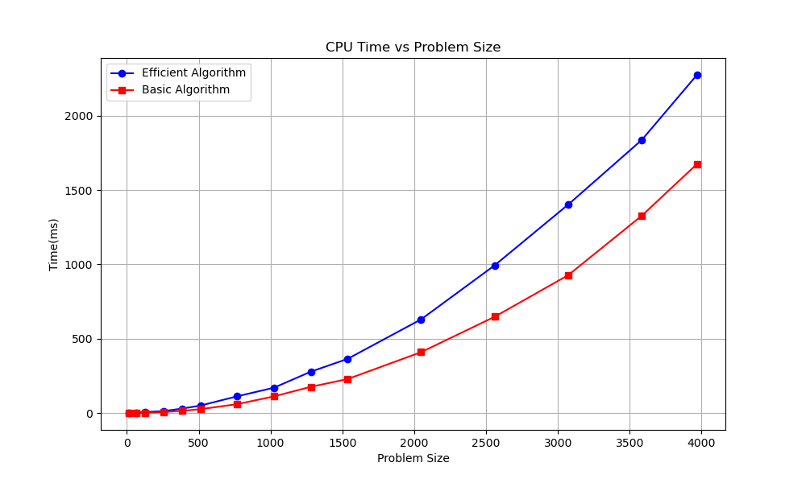

Nature of the Graph (Logarithmic/ Linear/ Polynomial/ Exponential)
Basic: Linear
Efficient: Linear

Explanation:

The basic algorithm uses $θ(mn)$ time which is an efficient solution. The efficient algorithm also uses $θ(mn)$ which is also efficient. However, due to extra divide and conquer steps, it takes a little bit more.

Contribution
(Please mention what each member did if you think everyone in the group does not have an equal contribution, otherwise, write “Equal Contribution”)
<USC ID/s>: <Equal Contribution>
3463514868: Equal Contribution
3899011612: Equal Contribution
4520411250: Equal Contribution
6159315758: Equal Contribution
9838191484: Equal Contribution

