

**APC Document Management System**

A Paper Submitted

To the Faculty of

School of Computing and Information Technologies

of Asia Pacific College

In Partial Fulfilment of the Requirements for the subject

**MCSPROJ**

by

Amiel Pocholo B. Sobisol

Maverick Jave C. Bolo

**Adviser:** Mr. Jayvee Cabardo

**January 2020**

Table of Contents

**I.** **Introduction** 3

Background of the Study 3

Background of the Study 4

Statement of the Problem 5

Objectives 6

Significance of the study 7

Scope and Limitations 8

**II.** **Review of Related Systems** 9

**III.** **Technical Background** 10

**IV.** **Methodology** 11

Swim lane diagram (Current System – Document Creation) 11

Swim lane diagram (Document Revision) 12

GAP Analysis 13

**V.** **Results and Discussions** 14

Software Design 14

Document Revision Module 15

Forms 17

Notification Bar 20

**VI. Conclusions and Recommendations** 21

**VII. Appendices** 21

Project Adviser Request Form 21

**Other Relevant Documents** 22

Vision of the Solution 22

A. Vision Statement 22

B. Major Feature 22

Assumptions and Dependencies 23

**VIII. Bibliography** 24

# **Introduction**

# Background of the Study

Electronic Document Management System (EDMS) helps the administrator of documents to manage the creation, storing, and version control digitally. Institutions with a high volume of paper documents to approve, revise, and control are one of the main beneficiaries of EDMS. Medical Institutions, Academic Institutions, and even Government Institutions contain a high volume of paper documents that need to have a document management system. According to (Mancini, 2011) operating an organization with insufficient methods to document management puts them at risk. He stated that whether you have a large or small business, one of the keys to success is the effectiveness of management. Electronic and even paper documents are one of the most important parts of an organization. Unintentional loss of data, time and cost, communication gaps, poor decisions, and losing competitive edge are the risks of not having EDMS in an organization. (Mancini,2011) These risks not only affects the organization but also the productivity of employees. The document management system is often referred to as DMS. A software that stores and tracks documentation of paper-based information. It is a software that can control and help organizations to organize their documents and paper works. According to the website (What is Document Management (DMS)? n.d.), Document management systems today range in size and scope from standalone systems to larger scale configuration. The standard document filing practices include storage location, security and access control, version control, audit trails, and document lockdown.

Background of the Study

According to Dr. Aslihan Karatas the definition of Quality Management System (QMS) is a collection of resources, organizations, people, and procedures that implement the quality policy of the organization. It clearly defines the expectations of the customer's quality level. It ensures that incoming materials consistently meet processing and quality specifications. It is the planning, monitoring, and control of the critical activities that have a significant effect on the Quality of products including service, hardware, software, and process. It is the Conformance to specifications level of efficiency of conformance to specifications. (Dr. Aslihan Karatas, 2016) This can also be a big factor for creating a document management system because without quality management, it would be hard to maintain the quality and content of all documents that are contained in the system.

Statement of the Problem

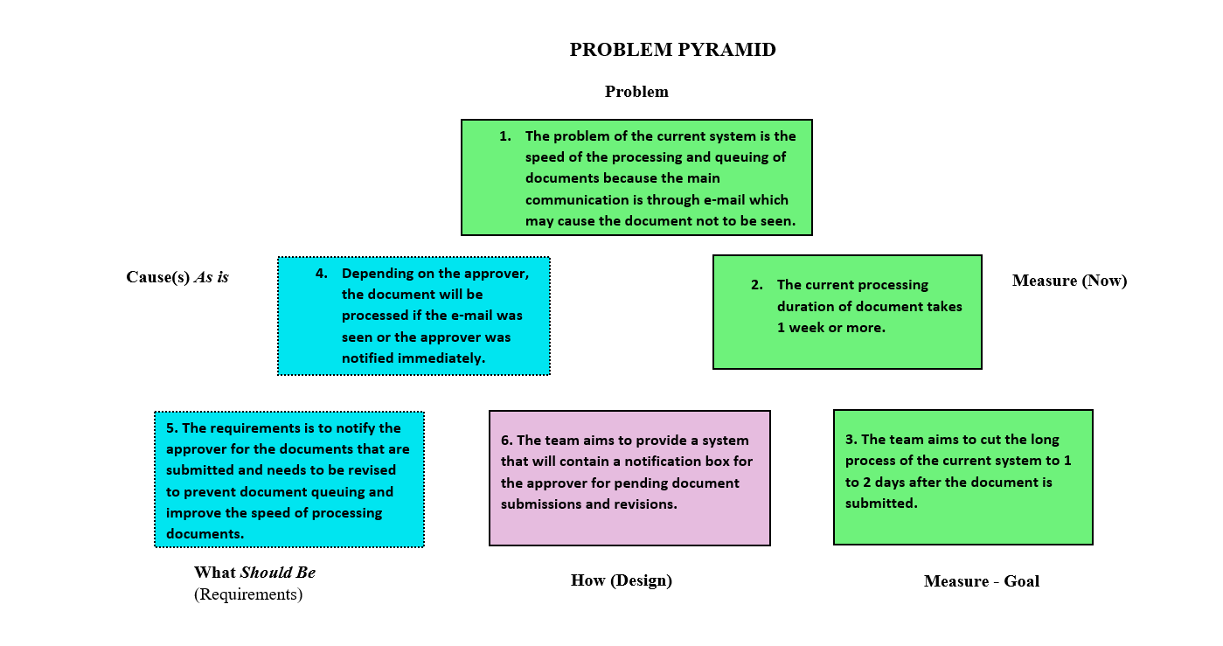 The current process of the Asia Pacific College requires manual creation, approving, and reviewing of documents. In the creation process, it is not possible to proceed from one step to another unless seen by the first person who oversees the approval of documents.

Figure 1 Problem Pyramid

The problem pyramid explains the encountered problems and challenges of the current process and provides the proposed solution of the team. The top part of the pyramid describes the problem of the current system wherein the processing and queuing of the documents are affects the duration of approval and revision because the main platform of submitting the documents are through e-mail which in return can cause delay when the document is not seen immediately by the reviewer and approver. According to the client there is no specific duration on the approval and revision of document but as an estimation, it usually takes 1 week or more for the document. On that given situation, the team aims to reduce the process of the current process to 1 to 2 days after the document is submitted on which the notification box will be implemented for the user’s quicker access for the documents.

Objectives

**General Objectives of the Project:**

To develop a document management system for process creation and revision for workflow efficiency and document security.

**Specific Objectives of the Project:**

1. To design a module for:
2. **Document Tracking Status** – for users to know that status of their submitted or revised documents.
3. **Document Notification tab** – to notify approvers of all documents submitted to the system.
4. **Version Control/File History** – for multiple document revisions and submissions.
5. **Search bar** – for efficient file searching of the user
6. To provide document security according to the standardized compliance rules of Asia Pacific College.

Significance of the study

The study is beneficial for Asia Pacific College. It will give an easy execution of approval and reviewing of documents throughout the organization. The process of managing documents will be more efficient and secured for future creation, storage, approval, and revision. Fast retrieval and collaboration of documents on the system will improve the workflow of all concerned, Notification tab that will be implemented on the system will be the solution for this concern. This study will also benefit those group of people that will develop a system like the proposed project, it will serve as a guide for developing document management systems. Version control from the proposed study will also be beneficial for the maintenance group of both soft and hard copy of documents are ensured to be secured and properly stored.

Scope and Limitations

This project is primarily focused on the documents in Asia Pacific College that aims to lessen the time of processing documents from manual to automated process of documents only with the following features:

**Scope:**

1. The system will allow all concerned employees to create, revise, store, retrieve, and secure documents based on the user permissions assigned.
2. The system can give tracking status of documents to the user.
3. The system can conduct version control of documents.
4. The system can provide a digital signature for the documents.
5. The system accepts all documents for approval and review.
6. The system will allow users to search document titles and status.

**Limitations:**

1. The documents are exclusively used and viewed inside the organization premises.
2. The system will only show documents that need approval and review.
3. The document creation and revision module can only be accessed through the intranet, but document tracking can still be accessed online.

# **Review of Related Systems**

In this section, Review of related systems are conducted to know many transformations about EDMS:

1. Maxx Vault provides electronic document management software (EDMS) solutions to small, medium, and large companies in many vertical industries. This helps the team to develop a Document management system that is flexible on any scale of users. (Maxx Vault, n.d.)
2. Open KM is a web-based document management that also uses open source technologies. It provides full document management capabilities including version control and file history, metadata, scanning, workflow, and search. This software relates to the proposed system like the version control, file history, workflow, and search. The team can also use the metadata and scanning depending on the expected user requirements of the client. (Open KM, n.d.)
3. Doc Star is a software that permits users to store all document records electronically in one spot. The framework has a great deal to offer permitting you to effectively recover any record inside the framework (especially customer documents). The recovery of record is one of the features of this system that the team can use for data retrieval. Doc Star also stores all documents in one spot, allowing users to retrieve and store documents conveniently. (Doc Star, n.d.)
4. Synergis Software develops document management and workflow solutions that enable you to effectively leverage business and design content across the enterprise to drive growth, mitigate risk and gain competitive advantage This software can help the team on an advanced system design (depends on the client) for more effective document management and workflow solutions. (Synergis Software, n.d.)

# **Technical Background**

**Programming Language:**

1. **PHP Laravel Framework** - is a server-side scripting language designed primarily for web development but also used as a general-purpose programming language.

**Resource requirements:**

1. Minimum Hardware Requirements
2. CPU Processor: Intel Pentium Core 2 Duo
3. Memory: 4 GB
4. Storage: 5 GB available space

**Software Requirements:**

1. Web Service - Nginx Server or Apache Server
2. Database Server - MySQL
3. Browser - Internet Explorer, Microsoft Edge, Mozilla Firefox, Google Chrome, or Safari
4. Operating System - Windows, Linux, or MAC OS

# **Methodology**

In this part, the current manual process of Asia Pacific College on document creation and revision is shown with the use of the swim lane diagram. According to the client, the current system process usually takes longer than usual because of the many factors that can occur when the document owner sends the document through email. The first issue is the document queueing, because of the many electronic mails that a user receives each day, the documents will not be seen immediately by the reviewing authority and will not be submitted to other concerned for the document.

Swim lane diagram (Current System – Document Creation)

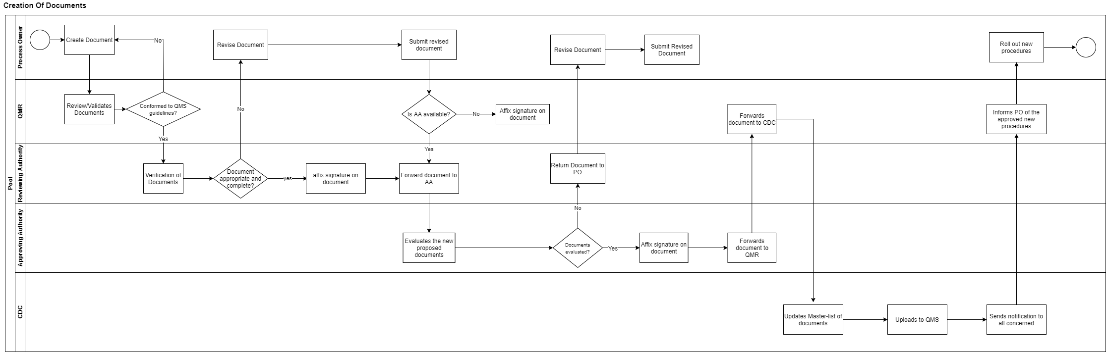

Swim lane diagram (Document Revision)

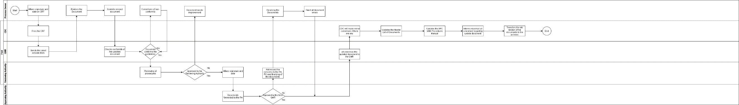

GAP Analysis

|  |  |  |
| --- | --- | --- |
| **User Requirements** | **Current Process** | **Proposed Changes** |
| 1. The system prevents loss of data from doing manual processes. | 1.1 Most of the data are still in hard copy, a lot of errors or unfortunate things. | 1.2 The system will automate all processes and storage of the data to avoid data loss. |
| 1. To make   the document creation or revision efficient. | 2.1 The document creation/revision is a bit inconvenient because the request can easily be flooded by another message especially if there are many other Processes Owner’s requesting to create or revise a document. | 2.2 A web-based system for all the people involved in creating or revising documents to ease the process of request in creations/revision, to avoid ignoring of request, and to be able to track the request by the process owner. |
| 1. To reduce the time consumed by approval of the document creation/revision and reduce the use of resources like papers, inks, etc. | 3.1 In a manual document process, errors can be such a waste of time and resources because you must revise and print a new copy of the document until you perfect it to approve it by the approving authority. | 3.2 The system aims to automate all the document processes to lessen the time consumed and users just need to upload the files for reviewing different authorities to avoid wasting resources and time. |

**System Design**

The system is designed for the employees of Asia Pacific College for them to create and revise important documents. As well as approving and reviewing these documents controlled by a person with authority. These documents will be stored in the system and can be accessed or used if the user wants to change or revise a certain document. The system is a website application which only can be accessed only to the premises of Asia Pacific College.

**System Development**

The system was developed using PHP Laravel Framework as for the creation of design of the system and the web server used is Apache server which is connected to the database server MySQL. All the data is can be seen in the PhpMyAdmin which can be accessed through XAMPP.

**System Testing**

Agile methodology was used to test the different modules of the system. Every module was checked and verified for any bugs and errors to ensure that the execution of every process was achieved.

**System Implementation**

The system will be implemented in Asia Pacific College where the employees can access through the school’s Intranet.

# **Results and Discussions**

A. Design and Description of Prototype

This section provides an overview of the system and discusses the functionalities of each module of the website. As stated on the objectives of the project, the system will serve as a new alternative for the current process of the document creation and revision of Asia Pacific College. The system will include notifications, file history, approval, review, and revision of documents. The different functionalities have been tested using the test plan and test case. The team also followed the Agile methodology for the testing of the system. Screenshots of the test case per module will be included in this section.

Software Design

1. Login Page

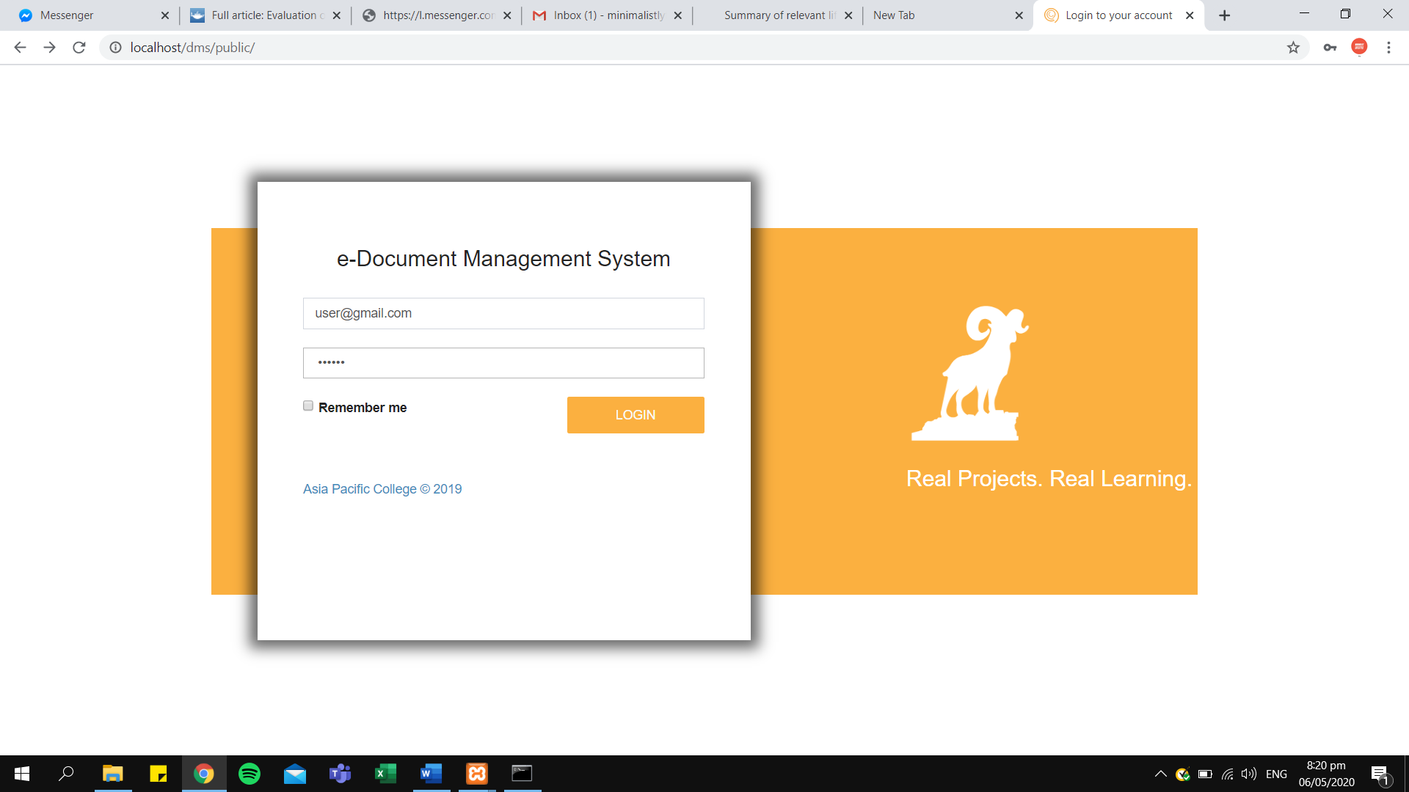

**Figure 2 Login/Home Page**

1. **Main page** – the main page is where the Process Owner/Author will choose between document creation and revision.

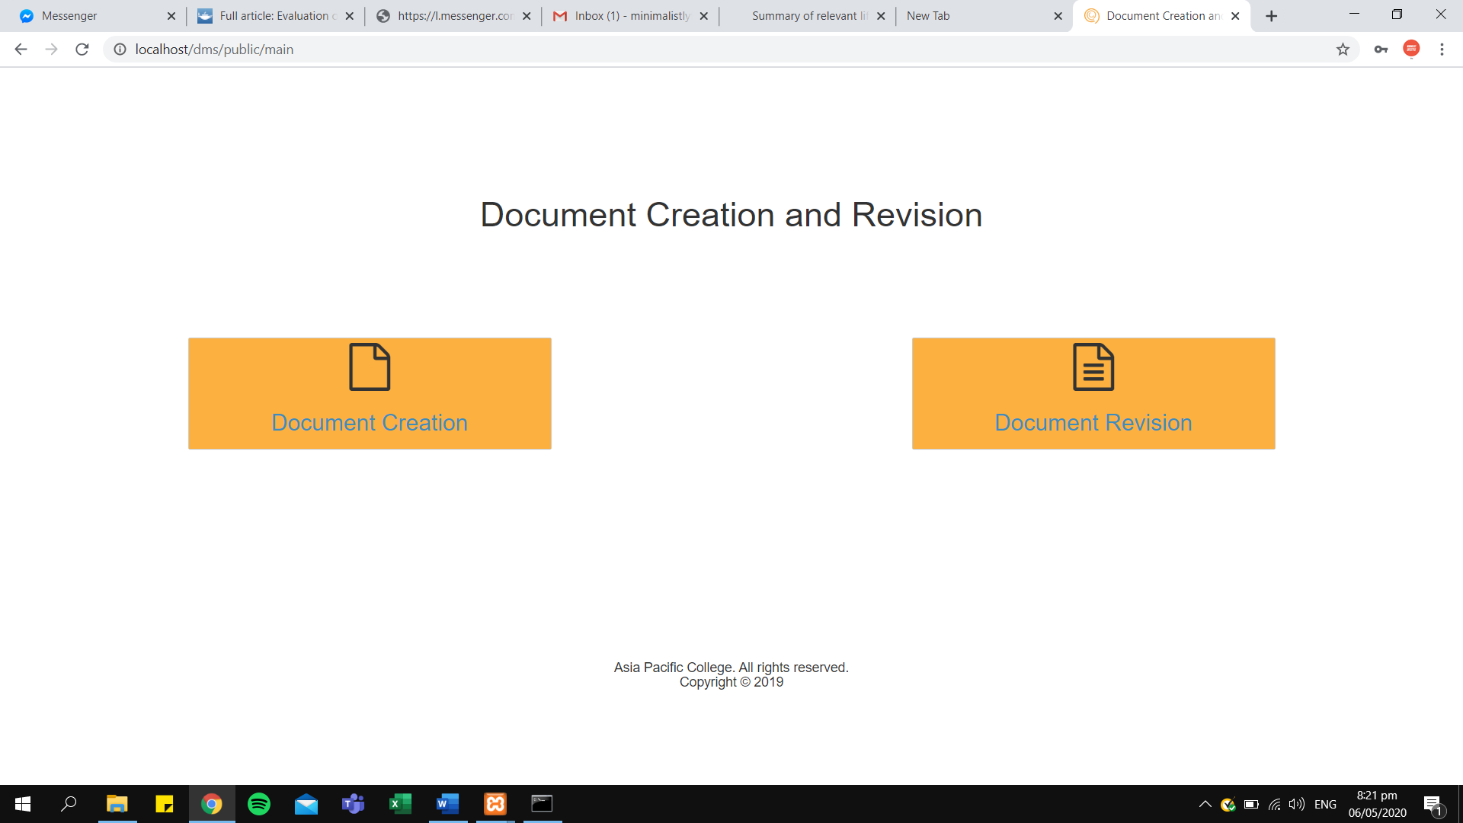

**Figure 3 Main Page (User/Admin)**

Document Revision Module

1. 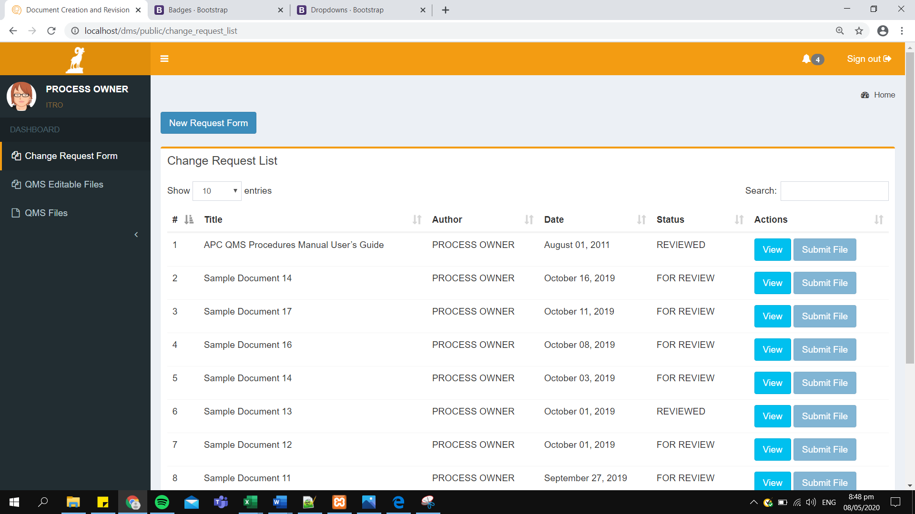**Change Request List** – The list of documents that are submitted by the users. It has a detailed information of the title, author, date and status of the document.

Figure 4 Change Request List

1. 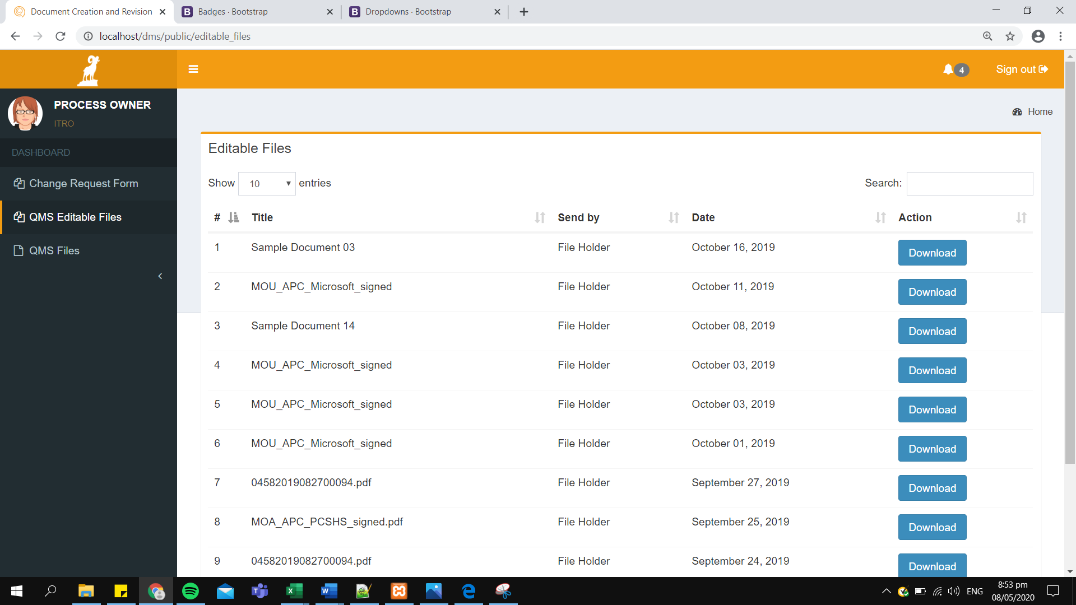**Qms Editable Files tab**  This serves as a view for all the downloadable documents for the user.

Figure 5 QMS Editable File

**QMS Files tab -** This tab serves as the view for all the feedbacks of documents. It will show users the following details:

A. Title of the document

B. Date of Submission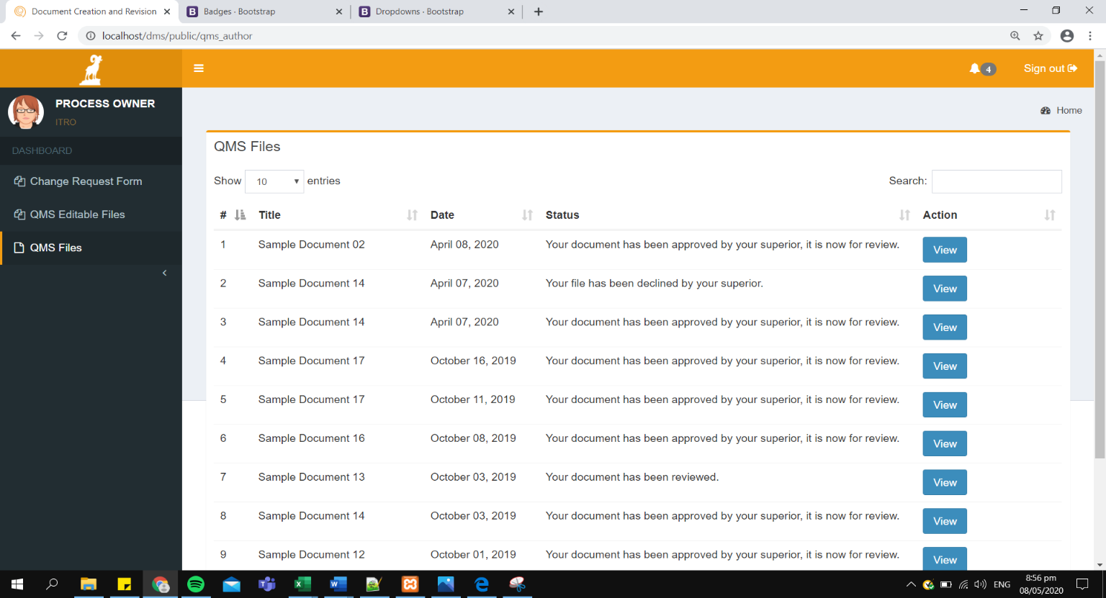 C. Document Status

Figure 6 QMS Files Tab

**Forms**

This part displays the three different forms on the system. please refer to the images provided below:

1. **A screenshot of a social media post

   Description automatically generatedChange Request Form (CRF) –** this form is for the process owner who wants to request for document revision. The form includes document title, version number, new version number, date of effectivity, classification, and nature of request.
2. **Change Request Form (Printable)**

This form replicates the format of the printed paper that the process owner fills up for every revision of documents that they will make.

1. Procedure Manual Form

This form displays all the information of the document that has been submitted by the process owner. The form also includes File history for the user.

Figure g Ram logo, Toggle bar, and Main button

Notification Bar

This part of the system displays the notification bar which is one of the main features and requirement of the client.

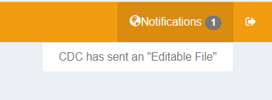

Each user will have different triggers from the notification. Below are the list of every user and the different notifications that they will receive.

1. **Process Owner** – notifications for this user will trigger when:

a. The document is for review

b. The document is approved or declined

c. The document is for revision

d. An editable file is available

2. **Reviewing Authority** – notifications for this user will trigger when:

a. A new document is for review

b. A new document is for approval

c. The document is submitted to QA

3. **Quality Assurance** – notifications for this user will trigger when:

a. A document is for approval.

b. A document is for review.

4. **File Holder** – notifications for this user will trigger when:

a. A document is for approval – which will require the file holder to send an editable file back to the process owner.

# **VI. Conclusions and Recommendations**

# **VII. Appendices**

Project Adviser Request Form

# **Other Relevant Documents**

Vision of the Solution

1. Vision Statement

The APC Document Management System intends to be one of the most useful and efficient system that will boost employee productivity and improve quality assurance workflow.

1. Major Feature

The major features of the system are as follows:

1. Document Approval and Revision Notification through the system
2. Search Bar
3. Version Control

.

Assumptions and Dependencies

1. **Scope of Initial Release**

The scope of the initial release covers the following functionalities:

1. **Notification Bar** – this notifies the user of the documents that are needed to be revised, reviewed, and approve by all concerned.
2. **Document Creation Module** – This module will cover the creation of documents of the user. Instead of filling-up the form physically, it would be electronically filled-up by the user on the system.
3. **Document Revision Module –** This module will cover the revision of documents of the user. The notification bar which is included on the initial scope release will help this module to notify the approver and reviewer of the documents for a more efficient workflow.
4. **File History –** This module will show the users the history of document status. The system will automatically backup versions of the files. When the document is approved, declined, and reviewed it will show up on the procedure manual module.

# **VIII. Bibliography**

*Doc Star*. (n.d.). Retrieved from Doc Star : (http://www.docstar.com/)

Dr. Aslihan Karatas, A. P. (2016). Application of Quality Management Systems (QMS) in Construction Industry.

Mancini, J. (2011). 8 Risks Organizations Can Avoid by Using a Document Management Solution.

*Maxx Vault*. (n.d.). Retrieved from Maxx Vault: http://www.maxxvault.com

*Open KM*. (n.d.). Retrieved from Open KM: (http://www.openkm.com/).

*Synergis Software*. (n.d.). Retrieved from Synergis Software : http://www.synergissoftware.com/

*What is Document Management (DMS)?* . (n.d.). Retrieved from aiim: http://www.aiim.org