

REPORT ON
AADHAR ENROLMENT DISPARITY ANALYSIS

Descriptive Analytics Project

PREPARED BY:-
CHRISTIAN YARED DONDO

Table of Contents

Chapter | Title | Page no.
1) Introduction | 1.1 Problem Statement  1.2 Project Vision / Approach  1.3 Methodology Overview  1.4 Tools & Technologies used  1.5 Data Description | 4-8
2) Methodology  3) Final Conclusion & Recommendations | 2.1 Introduction  2.2 Data Loading and Integration  2.3 Data Preprocessing  2.4 Feature Engineering  2.5 Outlier Detection  2.6 Exploratory Data Analysis (EDA)  2.6.1 Introduction  2.6.2 State-Wise Distribution Analysis  2.6.2.1 Plot: Enrolment Distribution Frequency  2.6.2.2 Plot: Demographic Update Distribution Frequency  2.6.2.3 Plot: Biometric Update Distribution Frequency  2.6.3 Total Entries State-Wise Record Count  2.6.3.1 Plot: Total Enrolment by State  2.6.3.2 Plot: Total Demographic Updates by State  2.6.3.3 Plot: Total Biometric Updates by State  2.6.4 Distribution Skewness  2.6.4.1 Plot: Value Counts / Distribution Graphs  2.6.5 Ranking Analysis  2.6.5.1 Top States  2.6.5.2 Top 5 Districts  2.6.5.3 Bottom 5 Districts  2.6.6 Selected State Insights: North East States  2.6.7 North-East Region – Temporal and Statistical Analysis:  2.6.7.1 Enrolment Trends  2.6.7.2 Demographic Trends  2.6.7.3 Biometric Trends  2.6.8 Regional Analysis  2.6.8.1 Enrolment by Region  2.6.8.2 Demographic Updates by Region  2.6.8.3 Biometric Updates by Region  2.6.9 Age Group Analysis  2.6.9.1 Enrolment Age Distribution  2.6.9.2 Biometric Age Distribution  2.6.9.3 Demographic Age Distribution  2.6.9.4 Age Distribution by Region  2.6.10 Temporal Analysis  2.6.10.1 Records per Date (Line Plots)  2.6.11 Relationship Analysis  2.6.11.1 Enrolment vs Demographic (Scatter)  2.6.11.2 Enrolment vs Biometric  2.6.11.3 Age0-5 vs Total Enrolment (Scatter)  2.7 Statistical Testing (Hypothesis Testing)  2.7.1 Chi-Square Test: Age Distribution Across States  2.7.2 Chi-Square Test: Demographic Updates Across Age Groups  2.7.3 T-Test: Comparison of Biometric Updates Across Age Groups  2.7.4 Comparison of Mean Enrolment Between North and South Regions  2.7.5 ANOVA Test: Effect of State on Age Group (0–5) Enrolment Proportion  2.7.6 Analytical Insights  2.7.7 EDA Conclusion  2.8 Dashboard Development (Power BI)  2.8.1 Overview  2.8.2 Data Model Design  2.8.2.1 Fact Tables  2.8.2.2 Dimension Tables  2.8.2.3 Relationships  2.8.2.4 Model Characteristics  2.8.2.5 Advantages of Data Model  2.8.3 Dashboard Implementation  2.8.3.1 Overview Dashboard  2.8.3.2 Regional Disparity Dashboard  2.8.3.3 Age & Lifecycle Dashboard  2.8.3.4 Key Features  2.8.4 Dashboard Conclusion  3.1 Final Conclusion  3.2 Recommendations  3.3 Future Scope | 9-73  74-76

Chapter 1: Introduction
1.1 Problem Statement
Despite the high nationwide penetration of Aadhaar, enrolment and update activities show noticeable variation across:
- States
- Districts
- Age groups
- Time periods
The presence of inconsistent administrative data (e.g., spelling variations, case inconsistencies, invalid entries) further complicates accurate regional comparison.
Without proper data cleaning and statistical validation:
- Regional inequalities remain hidden.
- Policy decisions lack analytical support.
- High-load operational districts cannot be identified efficiently.
- Age-wise enrolment gaps remain unquantified.
Therefore, there is a need for a structured data science framework to:
- Clean and standardize large-scale Aadhaar datasets.
- Analyze enrolment disparities.
- Validate findings statistically.

Project Goal / Objective
The primary objectives of this project are:
- To identify regional disparities in Aadhaar enrolment.
- To analyze age-wise enrolment distribution (0–5, 5–17, 18+).
- To detect high-load districts and states.
- To examine temporal enrolment patterns.
- To statistically validate regional and demographic differences.
The project aims to provide data-driven insights that can support digital governance and policy optimization.

Motivation
Although Aadhaar coverage in India is high, disparities may still exist due to:
- Regional administrative efficiency
- Urban vs rural accessibility
- Age-based enrolment differences
- Data recording inconsistencies
Understanding these patterns can help:
- Improve digital inclusion
- Identify underserved districts
- Optimize enrolment infrastructure

  - Project Vision / Approach
The project follows a systematic data science pipeline:
- Data ingestion and integration of multiple datasets.
- Data cleaning and categorical normalization.
- Outlier detection.
- Feature engineering for analytical clarity.
- Exploratory Data Analysis (EDA).
- Hypothesis testing (ANOVA, Chi-Square).
- Temporal trend analysis.
Each stage is implemented modularly using reusable functions in Python.

1.3 Methodology Overview
The methodology is divided into the following phases:
Phase 1: Data Acquisition & Integration
- Multiple CSV partitions will be imported from API-based datasets.
- Schema and column consistency across all files will be verified.
- Structured concatenation will be performed to create unified master datasets for:
  - Enrolment data (3 csv)
  - Demographic data (5 csv)
  - Biometric data (4 csv)
- Dataset shape and structural integrity will be validated after merging.
Phase 2: Data Cleaning & Standardization
- State names will be normalized to remove spelling and formatting inconsistencies.
- District names will be standardized to ensure accurate aggregation.
- Invalid and noisy entries will be identified and removed.
- Date columns will be converted into proper datetime format for temporal analysis.
- Duplicate records will be detected and removed.
- Missing values in numeric columns will be handled using median imputation.
Phase 3: Feature Engineering & Exploratory Data Analysis
- A Total Enrolment feature will be created from age-wise enrolment counts.
- Age-group ratio features (0–5, 5–17, 18+) will be generated to enable demographic proportion analysis.
- Univariate distribution analysis will be conducted to understand data spread.
- Bivariate comparisons across states and districts will be performed.
- Aggregation and ranking analysis will be executed to identify high-load regions.
Phase 4: Statistical Validation
- One-Way ANOVA will be applied to test for significant differences in enrolment across states.
- Chi-Square Test of Independence will be conducted to examine dependency between age groups and states.
- Statistical methods will be used to validate patterns identified during exploratory analysis.
Phase 5: Temporal & Outlier Analysis
- Time-series grouping will be performed to examine enrolment trends over time.
- IQR-based outlier detection will be applied to identify extreme enrolment values.
- Observed anomalies will be interpreted to derive governance and infrastructure insights.

1.4 Tools & Technologies Used
Python as the Primary programming language
- Google Colab → Execution environment
- Pandas → Data manipulation
- NumPy → Numerical operations
- Matplotlib & Seaborn → Visualization
- Plotly → Interactive visualization
- SciPy / Statistical libraries → Hypothesis testing

1.5 Data Description
The dataset represents aggregated daily enrolment counts at district level, not individual Aadhaar records.
Dataset Source
The dataset consists of Aadhaar-related API data stored in Google Drive and accessed through Google Colab. It represents operational Aadhaar enrolment data for the year 2025.

The dataset contains three major components:
- Aadhaar Enrolment Dataset
- Aadhaar Demographic Dataset
- Aadhaar Biometric Dataset

Type of Data
- Structured tabular data
- Government administrative records
- Numeric and categorical attributes
- Time-stamped enrolment entries

Dataset Size (After Merging)
Dataset | Rows | Columns
Enrolment | 1,006,029 | 7
Demographic | 2,071,700 | 6
Biometric | 1,861,108 | 6
Total records analyzed across datasets exceed 5 million entries.

Important Features
Common attributes across datasets:
- date → Enrolment date
- state → State name
- district → District name
- pincode → Area PIN code
- age_0_5 → Enrolment count for children
- age_5_17 → Enrolment count for youth
- age_18_greater → Adult enrolment
This is an unsupervised exploratory statistical analysis project. There is no target variable.

Necessity and Utility of the Dataset
This dataset is useful because:
- It reflects real government operational data.
- It covers pan-India administrative divisions.
- It allows demographic and biometric pattern analysis.
- It supports time-series and regional statistical testing.
The dataset enables evidence-based insights into national digital identity implementation.

Stakeholders and Beneficiaries of the Project
- UIDAI and Government Authorities – Policy planning
- District Administration – Resource allocation
- IT Infrastructure Teams – Load optimization
- Researchers & Analysts – Digital governance insights
- Citizens – Improved service delivery
Dataset Verification & Trustworthiness
  - Government-sourced API dataset
  - Structured tabular format
  - Large-scale real operational records
  - Contains consistent schema across dataset partitions
However, categorical inconsistencies required normalization before analysis.

Chapter 2 – Methodology
2.1 Introduction
The methodology of this project follows a structured data science pipeline designed to transform raw Aadhaar enrolment data into meaningful analytical insights. Since the dataset is large-scale, multi-source, and contains categorical inconsistencies, a rigorous preprocessing and normalization strategy was required before conducting statistical analysis.
The overall methodology consists of the following stages:
- Data Loading and Integration
- Schema Verification
- Data Cleaning and Normalization
- Outlier Detection
- Feature Engineering
- Exploratory Data Analysis (EDA)
- Temporal Analysis
- Hypothesis Testing
Each stage was implemented modularly using reusable functions within the notebook.

2.2 Data Loading and Integration
The project used three independent Aadhaar datasets:
- Aadhaar Enrolment Dataset
- Aadhaar Demographic Dataset
- Aadhaar Biometric Dataset
Each dataset was divided into multiple CSV partitions due to size constraints.
Step Performed:
- Loaded each partition using pd.read_csv()
- Verified column consistency using verify_column_consistency()
- Merged partitions using pd.concat()

Resulting Dataset Sizes:
Dataset | Rows | Columns
Enrolment | 1,006,029 | 7
Demographic | 2,071,700 | 6
Biometric | 1,861,108 | 6
Purpose:
- Ensure complete data coverage
- Prevent schema mismatch
- Maintain data integrity before cleaning
This step confirms reliable ingestion of approximately 5 million+ records, demonstrating real-world big data handling.

2.3 Data Preprocessing
Data preprocessing is the most critical stage in this project because the dataset:
- Contains over 5 million aggregated records
- Is sourced from multiple CSV partitions
- Includes high-cardinality categorical variables
- Contains spelling inconsistencies and structural irregularities
- Includes mixed formatting across administrative regions
Since this is a government administrative dataset, even minor categorical inconsistencies can:
- Inflate state/district counts artificially
- Distort statistical testing
- Mislead policy interpretation
Therefore, a rigorous and structured preprocessing framework was implemented before conducting any exploratory or statistical analysis.

2.3.1 Structural Validation
Before cleaning, structural checks were performed using modular functions:
- shape_checker()
- head_checker() and tail_checker()
- column_checker()
- index_checker()
- info_checker()
- dtypes_checker()
- describe_checker()
- isnull_checker()
- value_counts_checker()
- unique_checker()
- nunique_checker()
Observations:
- No initial missing values detected.
- Date column stored as object (string).
- State and district columns contained extremely high cardinality.
- Numeric columns suitable for aggregation.
- Schema consistency verified across partitions before merging.
Importance:
Structural validation ensured:
- No schema mismatch
- No data loss during concatenation
- Consistent feature names
- Reliable foundation for cleaning
Skipping this validation step when merging 5M+ records can introduce silent data corruption.

2.3.2 Date Conversion
Original Issue:
- Date column stored as object (string type).
- Not suitable for grouping or time-series operations.
Converted date column using:
pd.to_datetime(df[column], dayfirst=True)

Purpose:
- Enable temporal grouping
- Support time-series trend analysis
- Prepare dataset for monthly/periodic aggregation
- Improve computational efficiency

2.3.3 State Name Normalization
The state column contained severe inconsistencies:
- Case inconsistencies
- WEST BENGAL
- West bengal
- west Bengal
- Spelling variations
- Orissa vs Odisha
- Old administrative names
- Uttaranchal
- Duplicate UT representations
- Dadra & Nagar Haveli
- Dadra and Nagar Haveli and Daman and Diu
- Invalid entries
- 100000
- District names incorrectly stored as states

Cleaning Steps:
- Strip whitespace
- Normalize capitalization
- Apply correction mapping dictionary
- Merge renamed Union Terrirories names
- Remove numeric or invalid entries
Result:
- Reduced artificial inflation of state count
- Final standardized count: 28 States + 8 UTs
- Reliable state-level aggregation

2.3.4 District Normalization
District cleaning was even more complex due to:
Issues Identified
- Spelling variations (e.g., Kanchipuram vs Kancheepuram)
- Directional prefixes (Purba, Dakshin, Paschim)
- Special characters (*, encoding errors)
- Mixed-case inconsistencies
- Local address fragments
- Old district names
- Encoding anomalies (UTF character issues)
Cleaning Strategy
- Standardize capitalization.
- Remove directional-only entries.
- Apply dictionary-based mapping corrections.
- Remove garbage or numeric entries.
- Correct encoding artifacts.
- Ensure district consistency across datasets.
Impact:
- Significant reduction in duplicate districts
- Improved cross-dataset compatibility
- Enabled accurate district ranking
- Prevented artificial geographic inflation
Analytical Importance:
District-level aggregation is central to:
- High-load detection
- Outlier identification
- Resource allocation insights
Without district normalization, results would be structurally flawed.

2.3.5 Handling Invalid and Noise Values
During normalization the following was detected.:
- Numeric entries (e.g., 100000)
- Standalone words
- Broken strings
- Misplaced administrative labels
Actions Taken:
- Removed invalid rows.
- Dropped corrupted entries.
- Ensured geographic columns only contain valid labels.
This prevented:
- Data distortion
- False clustering
- Misleading statistical inference

2.3.5 Null Handling
Although initial checks showed no nulls, post-cleaning operations introduced nulls due to:
- Removal of invalid categorical entries
- Mapping mismatches
Action Taken
- Removed rows with null district labels using remove_null_values() function
Result
- Maintained dataset integrity
- Ensured no missing geographic identifiers
- Preserved aggregation reliability

2.3.6 Duplicate Handling
Duplicate values in large-scale administrative datasets can severely distort aggregation-based analytics. Since this project focuses on:
- State-wise enrolment comparison
- District ranking
- Age-group distribution analysis
- Statistical testing (ANOVA, Chi-Square)
removing duplicate rows was essential to ensure statistical validity and unbiased results.
  - Duplicate detection (Full Row)
A generic function was created:
def check_duplicates(df):
duplicates = df.duplicated().sum()
print(“Total duplicate rows:”, duplicates)
This checks for complete row duplication across all columns.
Findings
Dataset | Total Rows | Duplicate Rows | Percentage
Enrolment | 1,005,293 | 30,627 | 3.05%
Demographic | 2,069,852 | 480,310 | 23.21%
Biometric | 1,859,633 | 99,767 | 5.36%

  - Interpretation of Duplicate Presence
Enrolment Dataset (3.05%)
- Moderate duplication
- Likely due to partition merging overlap
Demographic Dataset (23.21%)
- Extremely high duplication rate
- Indicates repeated extraction or API overlap
- Would severely inflate demographic counts if untreated

Biometric Dataset (5.36%)
- Noticeable duplication
- Potential system replication during data export

  - Key-Based Duplicate Validation
To validate logical duplicates, a subset-based check was performed:
key_cols = ['date','state','district','pincode']
This ensured duplicates were identified based on geographic-temporal keys rather than only full-row equality.
This step was critical because:
- Aadhaar data is aggregated by location and date
- Repeated key combinations indicate true redundancy

  - Duplicate Distribution Per State
A state-wise duplicate analysis was conducted:
df[df.duplicated()].groupby('state').size()
Purpose:
- Identify regions contributing most to duplication
- Detect systemic data ingestion issues
This helped confirm that duplication was not random but geographically distributed.

  - Duplicate Removal
Duplicates were removed using:
df.drop_duplicates(inplace=True)
df.reset_index(drop=True, inplace=True)

Records Removed:
Dataset | Duplicates Removed
Enrolment | 30,627
Demographic | 480,310
Biometric | 99,767
This ensured:
✔ No redundant rows
✔ Clean aggregation
✔ Accurate state-wise totals
✔ Valid hypothesis testing
Additionally:
- info() check confirmed structural consistency.
- isnull() check confirmed no missing values introduced.
- Row counts reduced appropriately.

  - Impact of Duplicate Removal on Analysis
Without removing duplicates:
- State enrolment totals would be inflated.
- Age-group proportions would be distorted.
- ANOVA test would produce biased F-statistics.
- Chi-Square test would overestimate dependency.
- District rankings would be misleading.
Especially critical was the 23.21% duplication in demographic data, which would have significantly skewed disparity interpretation.

Final Conclusion:
Duplicate value handling was a critical preprocessing step in this project.
A significant percentage of duplicates were detected, particularly:
- 23.21% in demographic data
- 5.36% in biometric data
- 3.05% in enrolment data
All duplicates were successfully removed, ensuring:
- Reliable aggregation
- Valid statistical inference
- Accurate regional disparity detection
- Clean dataset for EDA
This step significantly strengthened the credibility and validity of the entire analytical pipeline.

2.4 Feature Engineering
Introduction
After completing data cleaning, normalization, and duplicate removal, the next crucial step in the Data Science lifecycle was Feature Engineering.
Since this project is exploratory and statistical (not predictive), feature engineering focused on:
- Creating meaningful analytical variables
- Enabling demographic proportion analysis
- Supporting regional comparison
- Preparing dataset for statistical testing
The objective was to transform raw age-wise counts into interpretable demographic indicators.

2.4.1 Objectives of Feature Engineering in This Project
The feature engineering phase was designed to:
- Simplify multi-column age data into interpretable metrics.
- Enable state-wise and district-wise comparison.
- Detect demographic imbalance.
- Support hypothesis testing.
- Identify operational load concentration.
- Enable temporal grouping.

2.4.2 Derived Features Created
a. Total Enrolment Feature
Why It Was Needed
The original dataset contained separate columns:
- age_0_5
- age_5_17
- age_18_greater
However, comparative analysis across districts and states requires a unified enrolment measure.
Therefore, a new feature was created:
Formula used:
$$\text{Total Enrolment}=age_0_5+age_5_17+age_18_greater$$
Purpose:
- Enables state-wise aggregation
- Enables district ranking
- Supports ANOVA testing
- Forms denominator for ratio calculations
This feature is central to all subsequent analyses.

b. Age-Group Ratio Features
Raw age counts vary significantly across districts. Therefore, proportional metrics were engineered:
$$\text{Toddler's Ratio 0–5}=\frac{age_0_5}{total_enrolment} \\ \text{School-Age Children Ratio 5–17}=\frac{age_5_17}{total_enrolment} \\ \text{Adults Ratio 18+}=\frac{age_18_greater}{total_enrolment}$$
Purpose
Absolute numbers alone do not reflect demographic structure. Ratios help:
- Compare demographic composition across states.
- Identify underrepresentation of child enrolment.
- Detect youth-heavy or adult-dominated districts.
Analytical Advantage
- Eliminates population scale bias.
- Enables Chi-Square testing for demographic dependency.
- Improves cross-state comparability.

Insight:
Ratios revealed:
- Adult (18+) enrolment dominates nationwide.
- Some districts show disproportionately low 0–5 enrolment.

Missing Value Handling After Feature Creation
Ratio calculation can produce missing values if:
- total_enrolment = 0
- Original age values contain nulls
To handle this safely, median imputation was applied.

Median Imputation Function
def fill_missing_all_median(df):
numeric_cols = df.select_dtypes(include='number').columns
df[numeric_cols] = df[numeric_cols].fillna(df[numeric_cols].median())
Why Median?
- Robust to skewed distribution
- Not affected by extreme outliers
- Suitable for enrolment count data
Columns Affected:
- Total enrolment
- Age counts
- Ratio features

2.4.3 Analytical Impact of Feature Engineering
The newly engineered features will enable:
a. State-Wise Disparity Analysis
Using total_enrolment
b. District Ranking
Using aggregated totals
c. Age-Group Proportion Comparison
Using ratio columns
d. Chi-Square Testing
Using demographic proportions
e. ANOVA Testing
Using total enrolment comparison across states

2.5 Outlier Detection
IQR (Interquartile Range) based bounds were calculated:
$$IQR=Q3-Q1 \\ Upper Bound=Q3+1.5×IQR \\ Lower Bound=Q1-1.5×IQR$$
Purpose
- Identify unusually high enrolment districts.
- Detect underperforming regions.
- Prevent skewed statistical inference.
Interpretation
High positive outliers represented:
- Metro and high-density districts.
Low-end outliers represented:
- Low-access or rural districts.
These were not data errors but structural realities.

2.5 Why Feature Engineering Was Critical
Without engineered features:
- Age groups remain fragmented.
- No simple comparison metric exists.
- Hypothesis testing becomes complex.
- Temporal analysis impossible.
- Outlier detection unreliable.
Feature engineering transformed raw administrative counts into:
✔ Analytical metrics
✔ Comparative variables
✔ Statistically testable features
✔ Governance-relevant indicators

Limitations of Current Feature Engineering
While strong, further improvements could include:
- Per capita enrolment normalization using Census data.
- Urban vs rural classification feature.
- Population density mapping.
- Year-over-year growth rate feature.
- District disparity index score.

2.6 Exploratory Data Analysis (EDA)
2.6.1 Introduction
Exploratory Data Analysis (EDA) is a critical step in the data science lifecycle used to understand data structure, detect patterns, identify anomalies, and validate assumptions before applying statistical techniques.
In this project, EDA was performed on:
- Aadhaar Enrolment Dataset
- Aadhaar Demographic Dataset
- Aadhaar Biometric Dataset
Objectives of EDA:
- Analyze distribution across states and regions
- Identify regional disparities
- Study age-group behaviour
- Examine relationships between enrolment and updates
- Understand temporal patterns

    - State-Wise Distribution Analysis
2.6.2.1 Plot: Enrolment Distribution Frequency
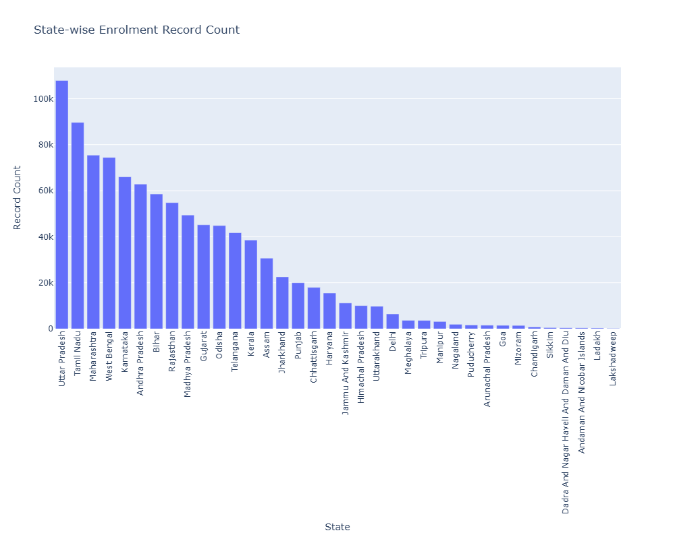
Figure 1: Enrolment Distribution Frequency
Insight:
- High concentration observed in:
  - Uttar Pradesh
  - Maharashtra
  - Tamil Nadu
  - West Bengal
Interpretation:
- Enrolment is population-driven, not efficiency-driven
- Larger states contribute more records due to scale

      - Plot: Demographic Update Distribution Frequency
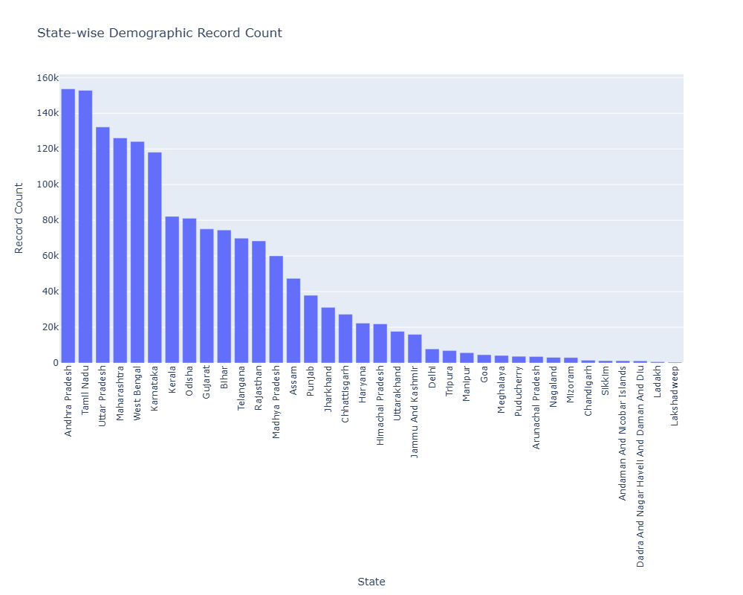
Figure 2: Demographic Update Distribution Frequency
Demographic update activity is highest in states like Andhra Pradesh, Tamil Nadu, and Maharashtra. Some states with high enrolment do not necessarily show equally high update activity. Interpretation:
This indicates that update behaviour varies across states, suggesting differences in administrative efficiency, awareness, or update frequency, rather than just population size.
Reason:
- Job Opportunities and Permanent Settlement.
Insight:
- Southern states (Andhra Pradesh, Tamil Nadu) show higher update activity
- Some large states show lower update participation
Interpretation:
- Update activity depends on:
  - Awareness
  - Urbanization
  - Service accessibility
2.6.2.3 Plot: Biometric Update Distribution Frequency
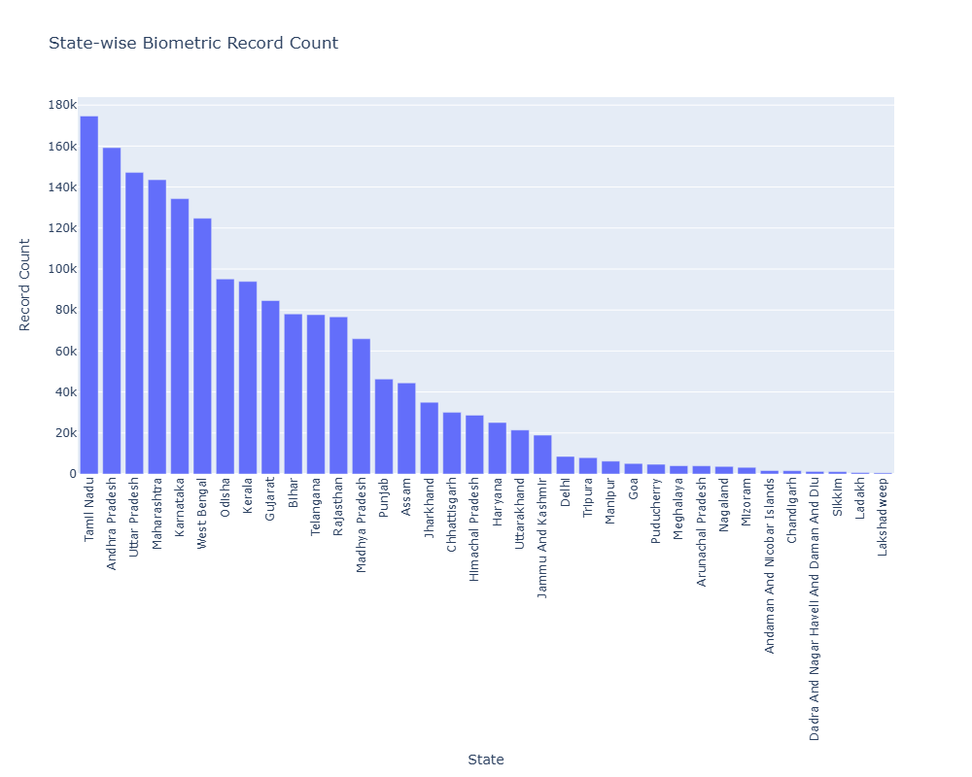
Figure 3: Biometric Update Distribution Frequency
Insight:
- Strong presence in:
  - Tamil Nadu
  - Andhra Pradesh
  - Uttar Pradesh
Interpretation:
- Biometric updates scale with enrolment but are also influenced by:
  - Age transitions
  - Regulatory requirements

Biometric update records are highest in large and digitally active states such as Andhra Pradesh, Tamil Nadu, West Bengal, and Maharashtra, reflecting periodic biometric revalidation, particularly among children transitioning into adulthood.
Lower counts in smaller states and Union Territories primarily reflect population size rather than lower update activity.
Interpretation:
This suggests that biometric updates are linked to lifecycle events (e.g., child updates, revalidation) and are more frequent in digitally mature regions.

    - Total Entries State-Wise Record Count
2.6.3.1 Plot: Total Enrolment by State
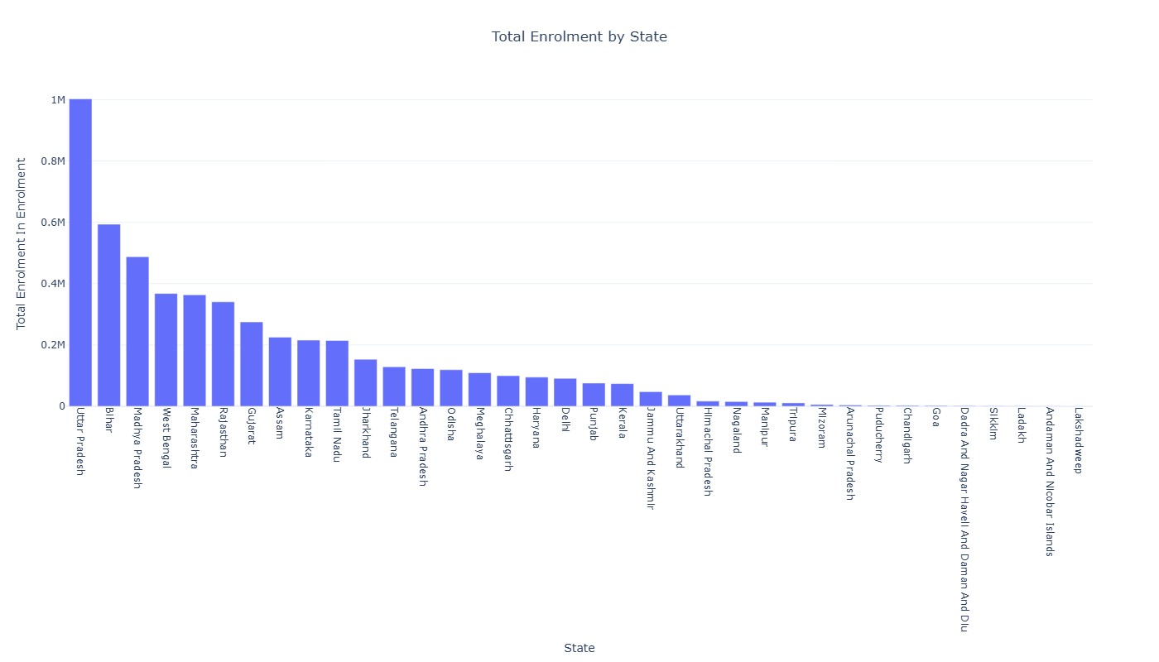
Figure 4: Total Enrolment by State
Insight:
- Highest: Uttar Pradesh, Bihar, Madhya Pradesh, West Bengal, Maharashtra
- Moderate: Rajasthan, Gujarat, Karnataka, Tamil Nadu
- Lowest: North-Eastern states and Union Territories
Interpretation
- Enrolment strongly correlates with population size
- Higher counts also reflect better administrative and digital reach
- Lower values in smaller states/UTs are due to low population, not low activity
Conclusion
The distribution is skewed, with a few large states contributing most of the enrolment, highlighting the need for scalable systems and inclusive coverage.
2.6.3.2 Plot: Total Demographic Updates by State
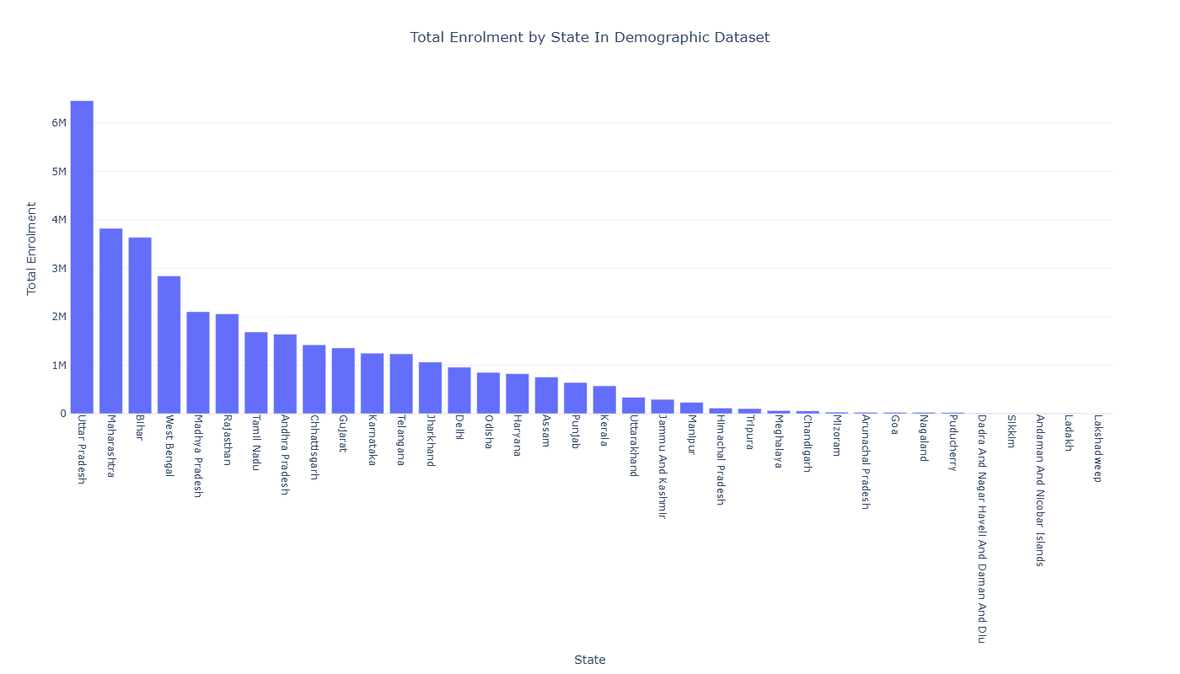
Figure 5: Total Demographic Updates by State
Insight
- Highest: Uttar Pradesh, Maharashtra, Bihar, West Bengal
- Moderate: Rajasthan, Tamil Nadu, Andhra Pradesh, Gujarat
- Lowest: North-Eastern states and Union Territories
Interpretation
- Demographic updates scale with population size and enrolment levels
- Higher updates also indicate frequent data modifications (address, name, etc.)
- Lower counts in smaller states/UTs reflect smaller population base
Conclusion
Demographic updates are concentrated in populous and administratively active states, showing a strong link between enrolment volume and update activity.

2.6.3.3 Plot: Total Biometric Updates by State
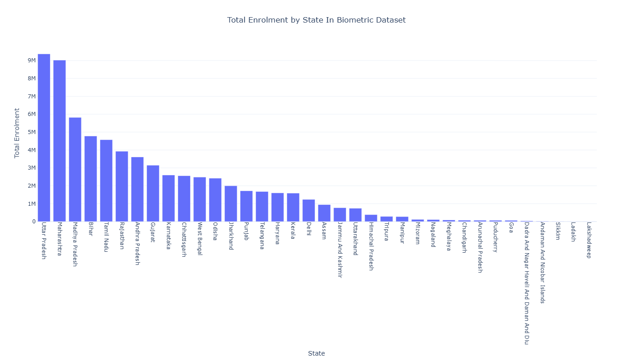
Figure 6: Total Biometric Updates by State
Insight
- Highest: Uttar Pradesh, Maharashtra, Madhya Pradesh, Bihar
- Moderate: Tamil Nadu, Rajasthan, Andhra Pradesh, Karnataka
- Lowest: North-Eastern states and Union Territories
Interpretation
- Biometric updates scale with enrolment volume and population size
- High counts indicate frequent revalidation, especially for age-based updates (e.g., children to adults)
- Lower values reflect smaller population base, not reduced activity
Conclusion
Biometric updates are concentrated in large and digitally active states, highlighting the role of population size, lifecycle updates, and administrative reach.

    - Distribution Skewness
2.6.4.1 Plot: Value Counts / Distribution Graphs
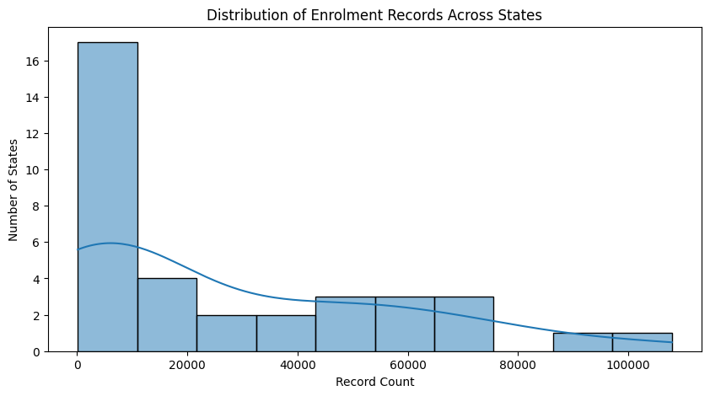
Figure 7: Value Counts / Distribution Graphs
Insight:
- Data is highly skewed
- Few states dominate majority of records
Interpretation:
- Dataset is not uniformly distributed
- Direct comparison using raw values can be misleading
This confirms regional concentration of enrolment activity, where a few large states dominate the dataset. It supports the presence of structural disparity in enrolment distribution.

    - Ranking Analysis
2.6.5.1 Top States
Enrolment
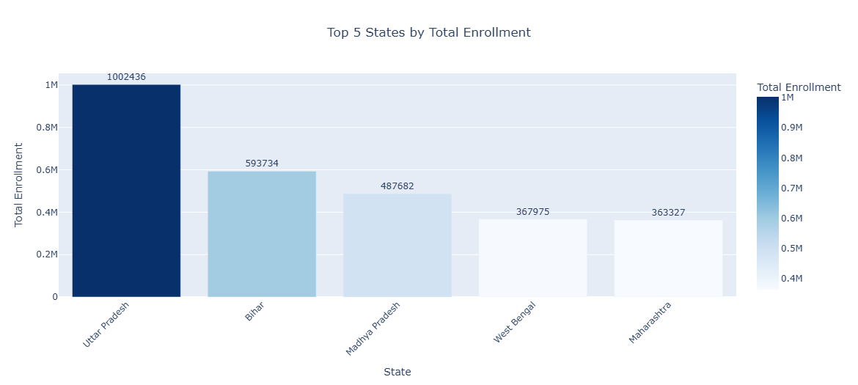
Figure 8: Top States in Enrolment
Demographic
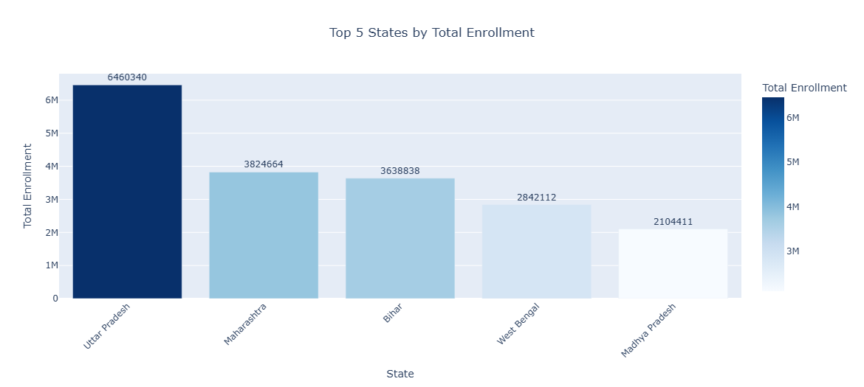
Figure 9: Top States in Demographic

Biometric
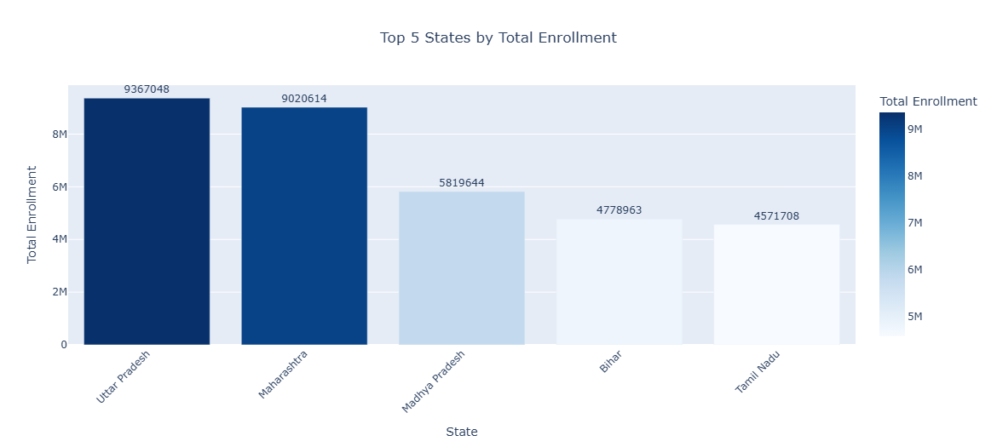
Figure 10: Top States in Biometric
A small number of states contribute the majority of total enrolment. These states are typically highly populated and urbanized. Interpretation:
This confirms regional dominance, where enrolment activity is concentrated in a few key states, supporting the hypothesis of state-wise disparity.

2.6.5.2 Top 5 Districts:
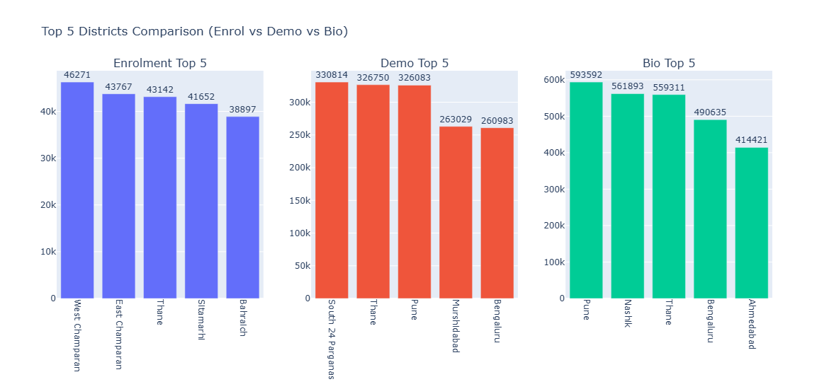
Figure 11: Top Districts
The plot compares the top 5 districts across enrolment, demographic updates, and biometric updates. It reveals that districts leading in enrolment (e.g., West and East Champaran) do not appear among the top districts for updates, indicating that enrolment and update activities are driven by different factors.
Urban districts such as Pune, Thane, and Bengaluru dominate both demographic and biometric updates, reflecting higher awareness, better infrastructure, and increased Aadhaar usage. In contrast, rural and semi-urban districts show higher enrolment activity.
This highlights a clear rural–urban divide, where rural regions are enrolment-heavy while urban regions are update-heavy. Additionally, districts like Thane and Pune emerge as high-load operational hubs, contributing significantly across multiple datasets.
Key Insight
The comparison reveals a clear divergence between enrolment-heavy and update-heavy districts, indicating that Aadhaar service utilization varies significantly across geographic and socio-economic contexts.
The Top 5 district comparison highlights a dual-pattern system where rural districts dominate enrolment while urban districts drive update activities, emphasizing the need for region-specific infrastructure and policy planning. This divergence suggests that Aadhaar usage transitions from enrolment-driven in rural areas to maintenance-driven in urban regions.

2.6.5.3 Bottom 5 Districts:
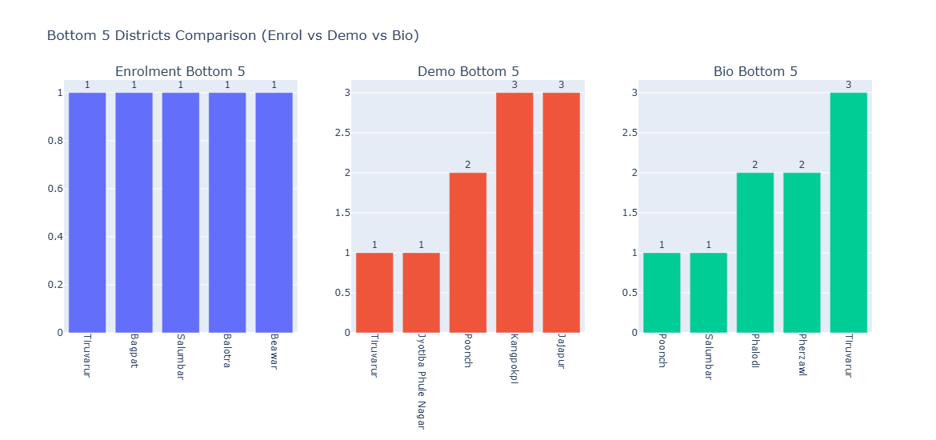
Figure 12: Bottom Districts
The plot compares the bottom 5 districts across enrolment, demographic updates, and biometric updates. It shows that several districts consistently record extremely low activity across all three datasets, with enrolment values as low as 1 and similarly minimal counts in demographic and biometric updates.
This indicates the presence of low-activity or underrepresented regions, which may be due to factors such as low population density, limited infrastructure, geographical constraints, or reduced access to Aadhaar services.
Additionally, some districts appear across multiple bottom categories, highlighting persistently low engagement in Aadhaar-related activities.
Key Insight
The existence of consistently low-performing districts highlights regional disparities and potential service accessibility gaps, emphasizing the need for targeted interventions to improve Aadhaar penetration and update activity in these areas.
2.6.6 Selected State Insights: North-East States
A focused analytical function was applied to evaluate Aadhaar activity across selected North-East states (Assam, Meghalaya, Manipur, Tripura, Mizoram, Nagaland, Arunachal Pradesh). The analysis covered:
- Total enrolment contribution
- Average activity levels
- Growth trends
- Stability and variability
- Temporal peaks
- State-wise ranking and contribution
Enrolment
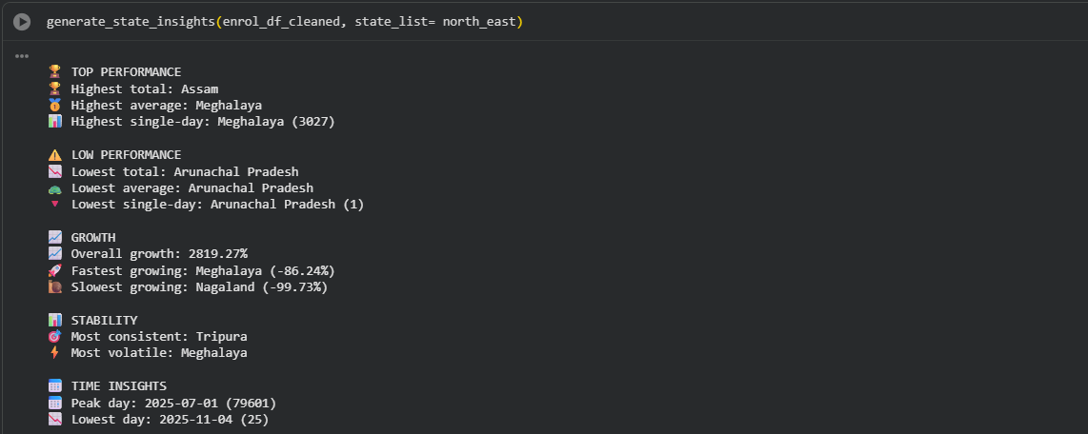
Figure 13.1: North-East States in Enrolment
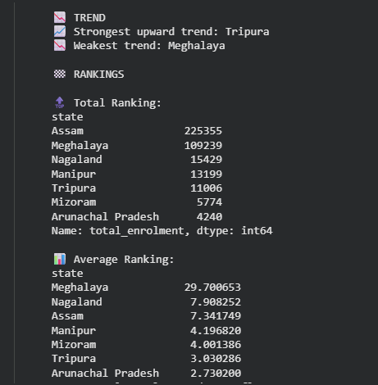
Figure 13.2: North-East States in Enrolment
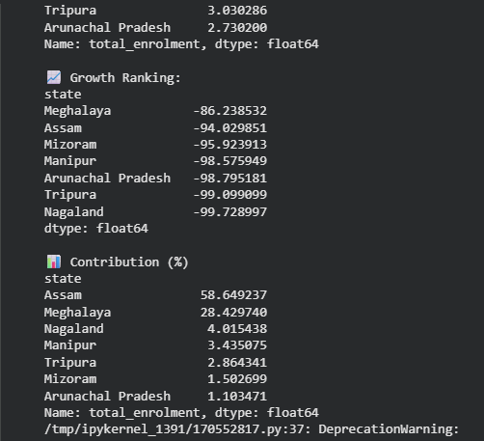
Figure 13.3: North-East States in Enrolment
Demographic
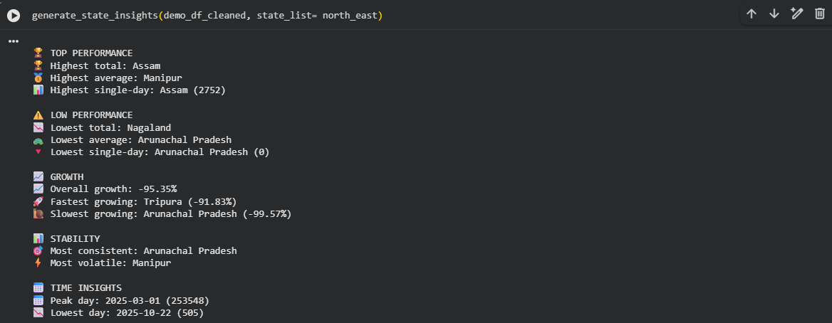
Figure 14.1: North-East States in Demographic
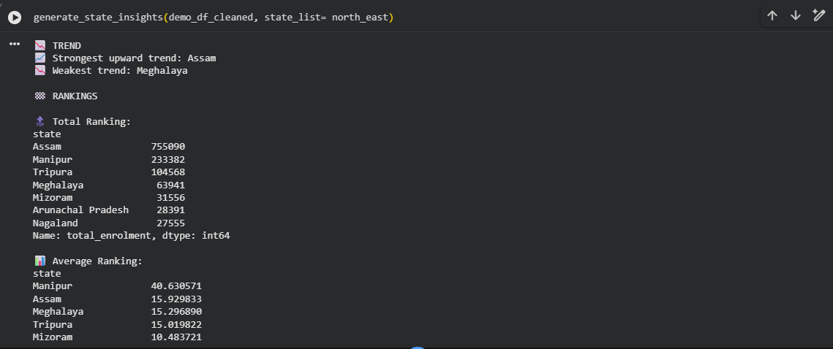
Figure 14.2: North-East States in Demographic
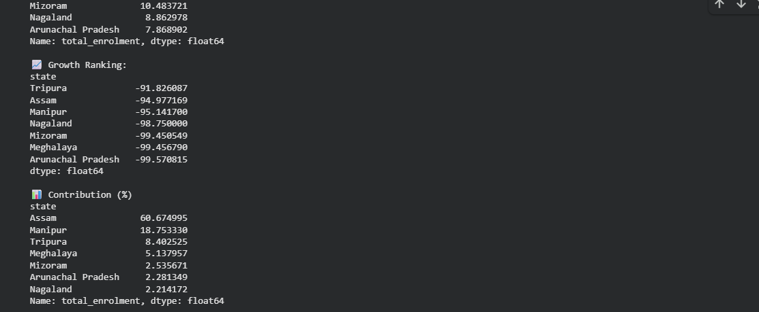
Figure 14.3: North-East States in Demographic
Biometric
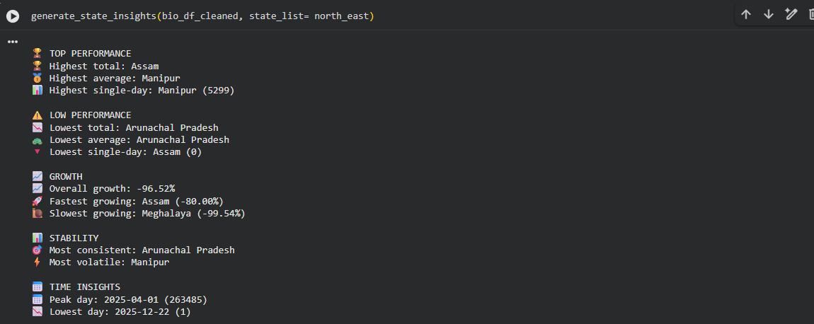
Figure 15.1: North-East States in Biometric
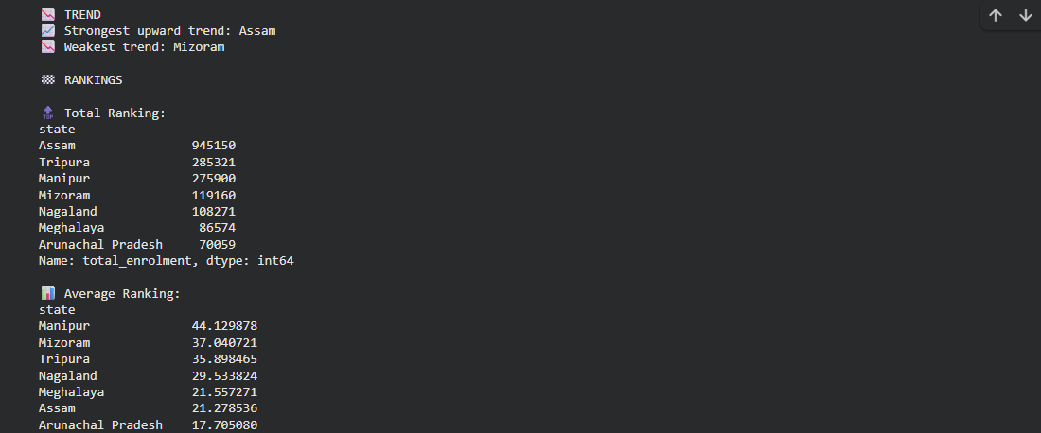
Figure 15.2: North-East States in Biometric
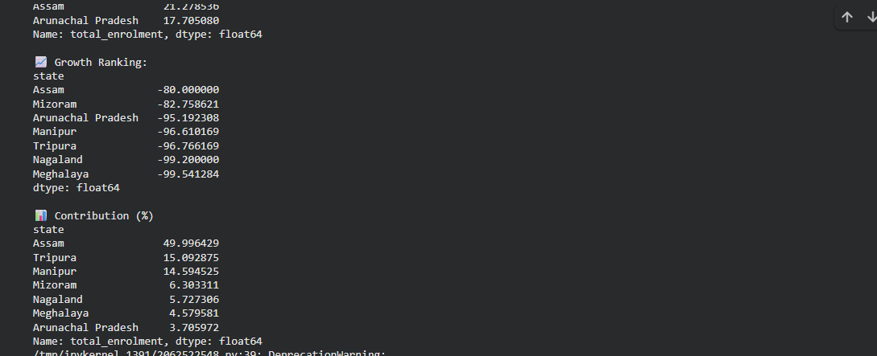
Figure 15.3: North-East States in Biometric
Key Observations: North-East Region Analysis
The detailed analysis of North-East states reveals significant variation in Aadhaar enrolment, demographic updates, and biometric activity across the region.
1. Dominance of Assam
Assam consistently records the highest total enrolment and contributes approximately 50–60% of overall activity across all datasets.
This indicates that Assam functions as the primary Aadhaar activity hub in the North-East, likely due to its relatively higher population, better infrastructure, and greater accessibility to services.
2. Secondary High-Performing States
States such as Meghalaya and Manipur exhibit higher average values and strong participation in update activities.
This suggests efficient service utilization and higher engagement levels, even though their total contribution is lower compared to Assam.
3. Low-Performing States
Arunachal Pradesh consistently records the lowest enrolment and update activity.
This highlight potential challenges such as limited infrastructure, difficult terrain, and lower service penetration in these regions.
4. Negative Growth Trends
All states show negative growth trends over time, with some states experiencing extremely sharp declines.
This may indicate a reduction in new enrolments, possibly due to Aadhaar saturation or decreased demand for fresh registrations.
5. Stability and Volatility
States like Tripura and Arunachal Pradesh demonstrate relatively stable but low activity levels, while states such as Meghalaya and Manipur show higher variability.
This reflects differences in consistency of Aadhaar operations across states.
Key Insight
Aadhaar activity in the North-East region is highly uneven, with Assam dominating overall contribution while several states exhibit significantly lower participation, indicating disparities in infrastructure and service accessibility.
Analytical Finding
Despite belonging to the same geographic region, North-East states show substantial variation in enrolment, update activity, and growth trends, demonstrating that regional grouping does not guarantee uniform service utilization.

2.6.7 North-East Region – Temporal and Statistical Analysis:
2.6.7.1 Enrolment Trends
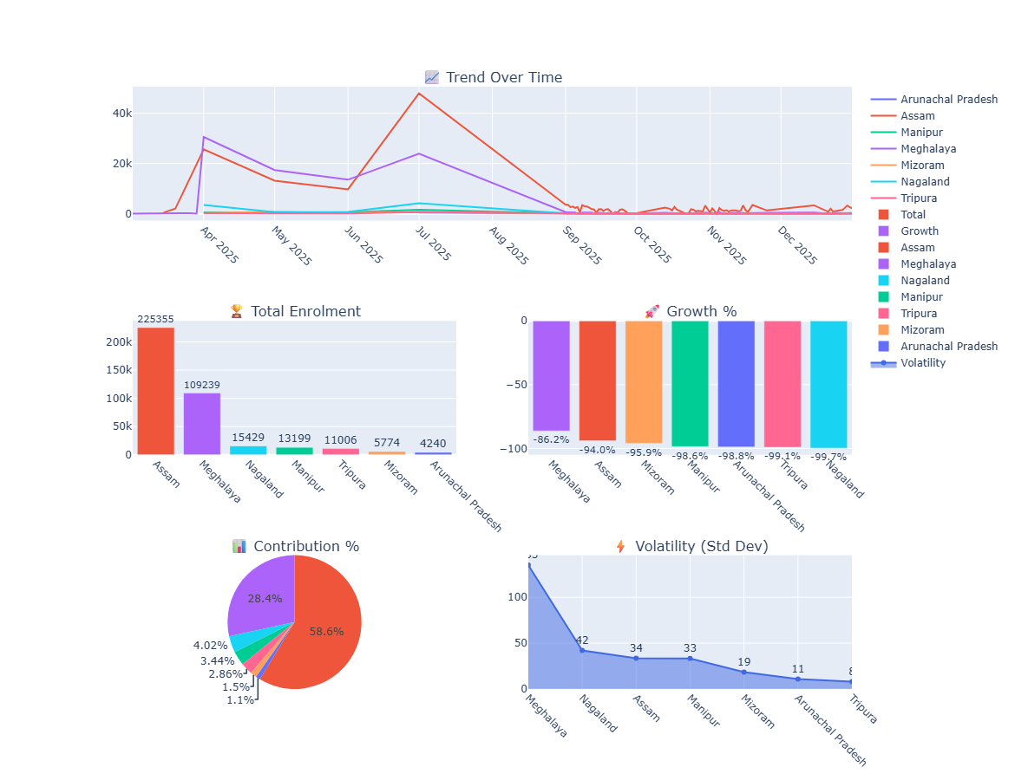
Figure 16: Enrolment Trends in Northeastern States
Key Observations
1. Trend Over Time
The time-series plot shows that enrolment activity peaked around mid-2025, followed by a sharp decline and relatively low activity thereafter. Assam and Meghalaya exhibit the highest peaks, while other states maintain comparatively lower trends.
Interpretation:
- Aadhaar activity is event-driven rather than continuous
- Mid-year spikes may correspond to enrolment drives or administrative campaigns
2. Total Enrolment Distribution
Assam dominates total enrolment (~225K), followed by Meghalaya (~109K), while other states contribute significantly less.
Interpretation:
- Strong centralization of enrolment activity
- Reflects population and infrastructure imbalance
3. Growth Percentage
All states exhibit negative growth rates, with steep declines observed across the region.
Interpretation:
- Indicates declining enrolment trend over time
- Suggests possible saturation of Aadhaar enrolment
4. Contribution Share
The pie chart shows Assam contributing nearly 58.6% of total activity, followed by Meghalaya (~28.4%), with remaining states contributing minimal shares.
Interpretation:
- High dependency on a single state
- Regional imbalance is clearly visible
5. Volatility Analysis
Meghalaya shows the highest volatility, while states like Tripura and Arunachal Pradesh exhibit low variability.
Interpretation:
- High volatility → inconsistent activity (spikes and drops)
- Low volatility → stable but low activity levels
Key Insight
Aadhaar activity in the North-East region is highly concentrated, temporally inconsistent, and declining over time, with Assam acting as the dominant contributor while other states remain underrepresented.
Analytical Finding
The combined analysis of trends, growth, contribution, and volatility confirms that Aadhaar operations in the North-East are uneven, event-driven, and increasingly saturated, highlighting the need for balanced regional development and sustained engagement strategies.

2.6.7.2 Demographic Trends
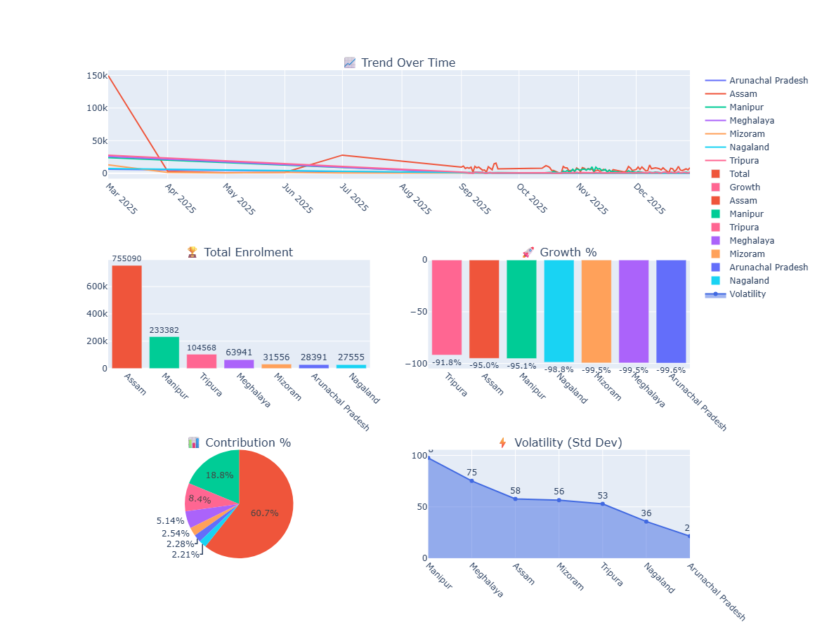
Figure 17: Demographic Trends in Northeastern States
Key Observations
1. Trend Over Time
The time-series plot shows a very high spike at the beginning of the year, followed by a sharp decline and relatively low, fluctuating activity thereafter. Assam dominates the trend initially, while other states maintain comparatively lower and stable patterns.
Interpretation:
- Demographic updates are highly event-driven
- Initial spike may indicate bulk updates or data backlog processing
2. Total Demographic Updates
Assam leads significantly (~755K), followed by Manipur (~233K) and Tripura (~104K), while other states contribute relatively smaller volumes.
Interpretation:
- Assam acts as the primary update hub
- Manipur shows strong secondary participation
3. Growth Percentage
All states show negative growth rates, indicating a consistent decline in update activity over time.
Interpretation:
- Suggests:
  - Reduced update demand
  - Possible stabilization after initial bulk updates
4. Contribution Share
Assam contributes approximately 60.7% of total demographic updates, followed by Manipur (~18.8%) and Tripura (~8.4%), with remaining states contributing minimal shares.
Interpretation:
- Strong centralization of update activity
- Significant regional imbalance persists
5. Volatility Analysis
Manipur and Meghalaya show higher volatility, while Arunachal Pradesh and Nagaland exhibit relatively lower variability.
Interpretation:
- High volatility → irregular update patterns
- Low volatility → consistently low activity
Key Insight
Demographic update activity in the North-East region is highly centralized, declining over time, and influenced by initial high-volume update events, with Assam dominating and other states showing comparatively limited participation.
Analytical Finding
The demographic dataset highlights that update activity is not uniformly distributed and tends to decrease significantly after initial peaks, indicating that Aadhaar demographic updates are episodic and driven by specific operational or administrative factors.

2.6.7.3 Biometric Trends
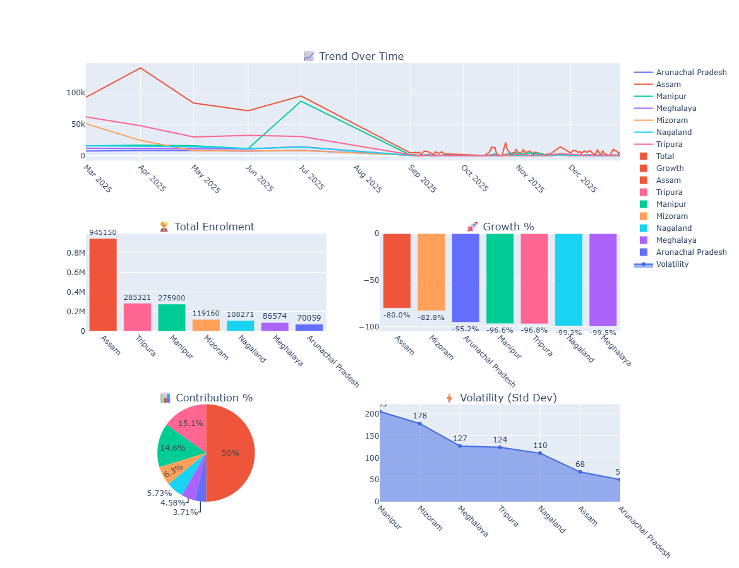
Figure 18: Biometric Trends in Northeastern States
Key Observations
1. Trend Over Time
The time-series plot shows moderate activity in the early months, followed by a noticeable spike around mid-year (especially for Assam and Manipur), and a sharp decline thereafter with minimal fluctuations.
Interpretation:
- Biometric updates are event-driven and periodic
- Mid-year spike likely corresponds to:
  - Revalidation cycles
  - Policy-driven update campaigns
2. Total Biometric Updates
Assam leads significantly (~945K), followed by Tripura (~285K) and Manipur (~275K), while other states contribute smaller shares.

Interpretation:
- Assam remains the dominant contributor
- Tripura and Manipur play strong secondary roles
3. Growth Percentage
All states show negative growth, though Assam and Mizoram show relatively less decline compared to others.
Interpretation:
- Indicates:
  - Decreasing update activity over time
  - Possible completion of major biometric update cycles
4. Contribution Share
Assam contributes around 50% of total biometric updates, followed by Tripura (~15%) and Manipur (~14.6%), with other states contributing smaller portions.
Interpretation:
- Activity is highly centralized
- Strong dependency on few states
5. Volatility Analysis
Manipur and Mizoram exhibit the highest volatility, while Arunachal Pradesh and Assam show relatively lower variability.
Interpretation:
- High volatility → irregular and burst-like updates
- Low volatility → steady but limited activity
Key Insight
Biometric update activity in the North-East region is concentrated in a few states, shows strong mid-cycle spikes, and declines over time, indicating that updates are periodic and driven by lifecycle or regulatory requirements.
Analytical Finding
The biometric dataset confirms that Aadhaar updates are not continuous but occur in bursts, with significant regional concentration and declining trends, reflecting completion of update cycles and uneven infrastructure distribution.

2.6.8 Regional Analysis
2.6.8.1 Enrolment by Region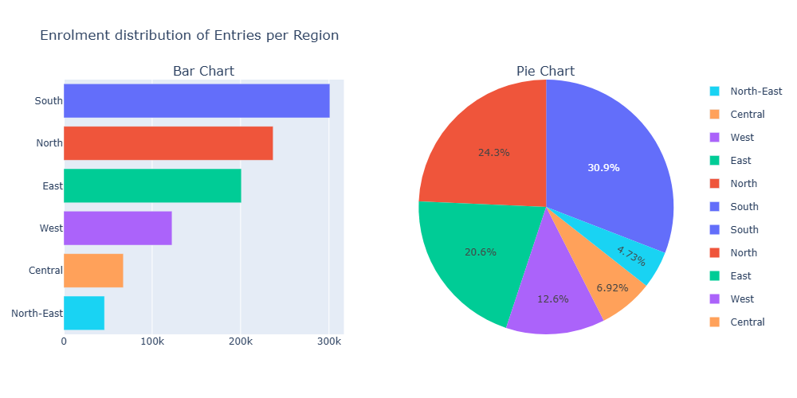
Figure 19: Enrolment by Region
The bar chart shows South region clearly dominating enrolment counts. Pie chart confirms proportional contribution: South ≈ 30.9% North ≈ 24.3% East ≈ 20.6% West ≈ 12.6% Central ≈ 6.9% North-East ≈ 4.7%
Interpretation:
Enrolment activity is heavily concentrated in South and North regions, contributing over 50% of total entries combined. The long-tail distribution highlights regional disparity, supporting the need for targeted policy intervention in underrepresented regions.

2.6.8.2 Demographic Updates by Region
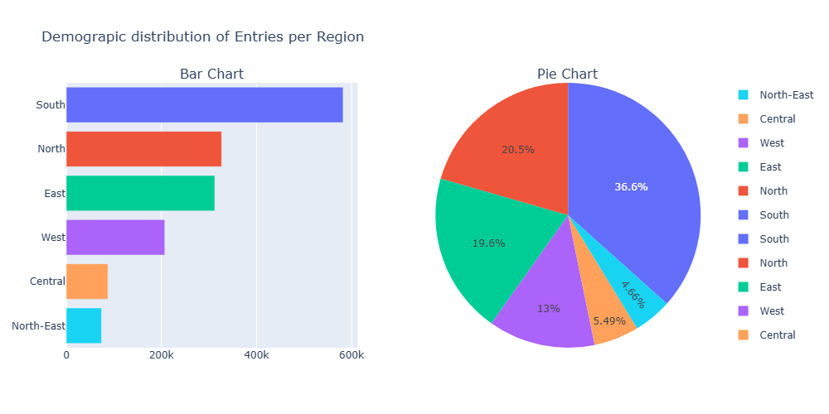
Figure 20: Demographic Updates by Region
South region again shows the highest demographic update activity. Pie chart distribution: South ≈ 36.6% (highest) North ≈ 20.5% East ≈ 19.6% West ≈ 13% Central ≈ 5.49% North-East ≈ 4.66%
Interpretation:
Demographic updates are even more concentrated in the South region compared to enrolment, indicating higher update frequency and digital engagement. This suggests that residents in the South may be more proactive in updating Aadhaar details.

2.6.8.3 Biometric Updates by Region 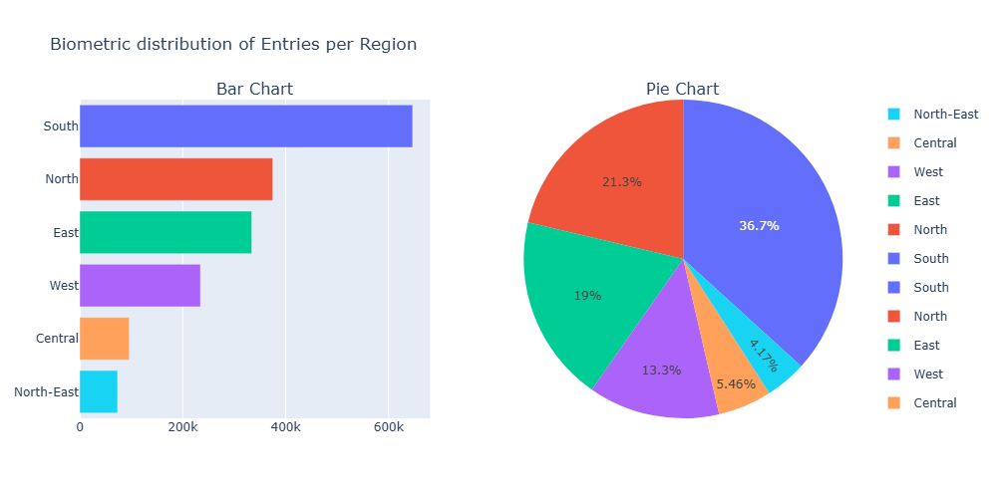
Figure 21: Biometric Updates by Region
Similar pattern observed as previous datasets. Pie chart distribution: South ≈ 36.7% North ≈ 21.3% East ≈ 19% West ≈ 13.3% Central ≈ 5.46% North-East ≈ 4.17%
Biometric updates follow the same regional trend as demographic updates, confirming that regions with high enrolment also show high update activity. This indicates strong correlation between enrolment volume and update frequency.
Insight:
- Highest contribution:
  - South
  - North
- Lowest:
  - North-East
  - Central

Interpretation:
- Clear regional imbalance
- Driven by:
  - Population
  - Infrastructure
  - Digital access

2.6.9 Age Group Analysis
2.6.9.1 Enrolment Age Distribution
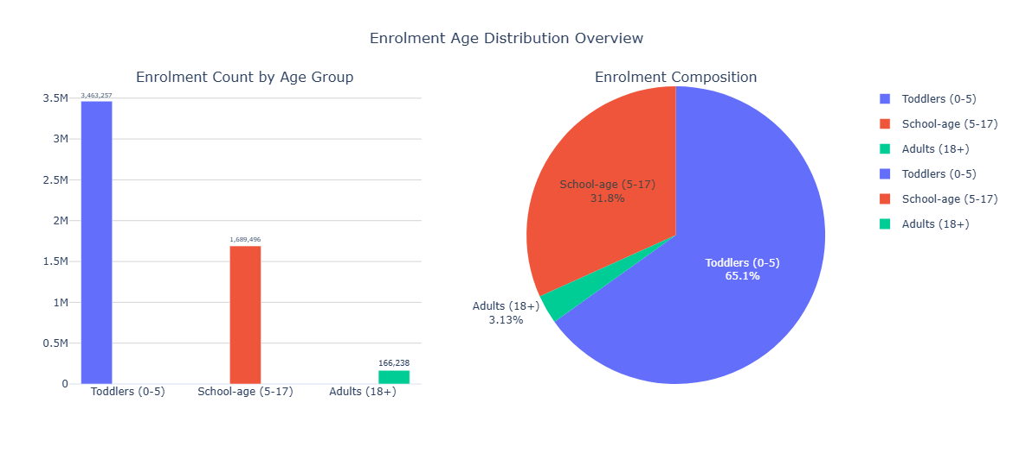
Figure 22: Enrolment Age Distribution
The plot represents the overall distribution of enrolment across age groups: Age 0–5 Age 5–17 Age 18+ The age group 5–17 has the highest enrolment count, forming the largest portion of the distribution. The 0–5 age group shows moderate enrolment, indicating early registration but still lower than school-age participation. The 18+ age group has the lowest contribution, forming a very small proportion compared to other categories.
Interpretation:
The dominance of the 5–17 age group confirms that Aadhaar enrolment is highly influenced by institutional requirements, such as: School registrations, Government child-related schemes, Identity verification for education
The moderate presence of 0–5 group suggests: Increasing awareness of early Aadhaar registration but still not as aggressively implemented as school-age enrolment
The very low 18+ proportion indicates: Most adults are already enrolled in previous years Current data reflects incremental updates rather than fresh enrolments

Insight:
The dataset shows a youth-heavy enrolment pattern, where: Aadhaar operations are currently more active among younger populations
Adult enrolment activity is relatively stagnant.

2.6.9.2 Biometric Age Distribution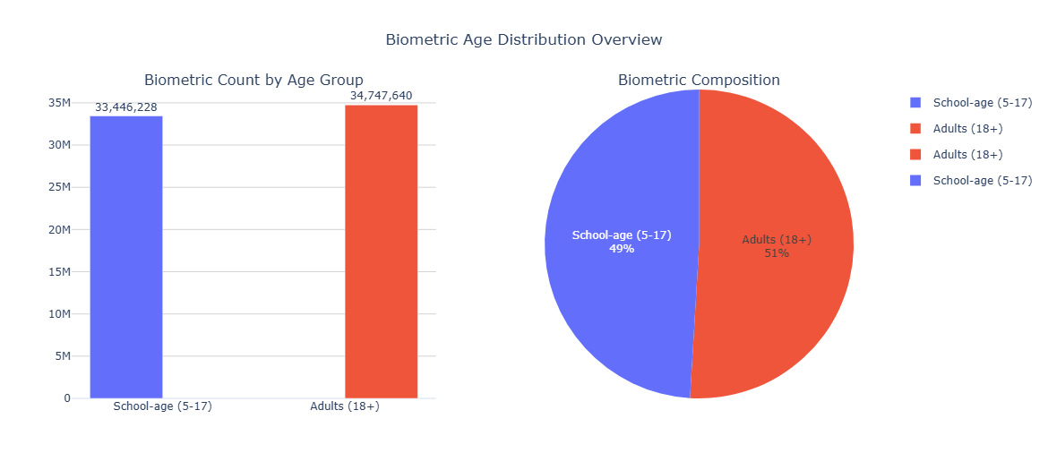
Figure 23: Biometric Age Distribution
Interpretation:
Biometric updates are primarily driven by children and adolescents, due to: Mandatory biometric updates at specific ages
Physical changes in fingerprints/iris during growth Government-mandated update cycles
The low adult participation (18+) suggests: Biometric updates are less frequent once adulthood is reached Adult biometric data remains relatively stable over time
Insight:
Biometric dataset shows a child-focused update pattern, unlike demographic updates which are adult-driven.
- Age 18+ dominates.

2.6.9.3 Demographic Age Distribution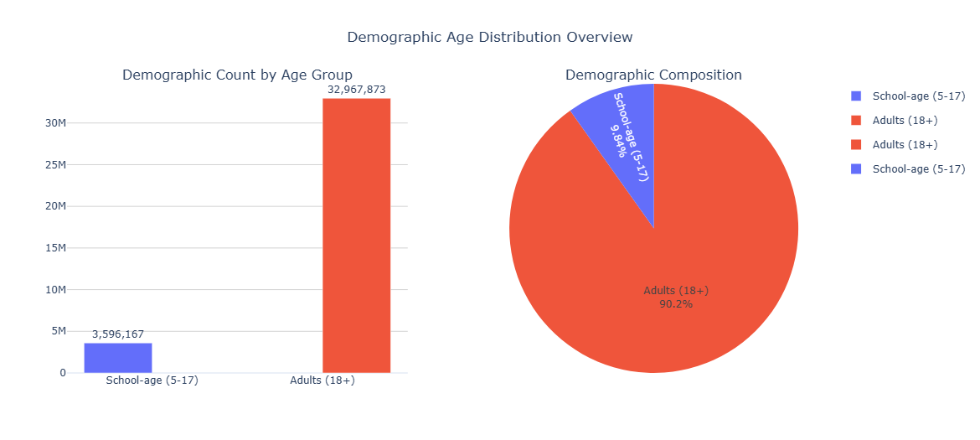
Figure 24: Demographic Age Distribution
Unlike enrolment data, the 18+ age group dominates the demographic updates. The 5–17 age group shows moderate contribution, while the 0–5 age group has the lowest share in demographic updates.
Interpretation:
The dominance of the 18+ age group indicates that demographic updates are primarily performed by adults, which includes: Address updates Mobile number updates Name or correction requests.
The lower contribution of children (0–5 and 5–17) suggests: Fewer demographic changes required Updates are usually managed by guardians and occur less frequently This contrasts with enrolment data, where younger age groups dominated.
Insight:
Aadhaar system shows a clear lifecycle pattern: Enrolment → dominated by children (5–17) Updates → dominated by adults (18+)
Key Finding:
Demographic updates are predominantly driven by the adult population (18+), indicating that Aadhaar modification activities are largely associated with individuals who actively manage and update their identity information.
While enrolment data is skewed toward younger age groups (5–17), demographic update data shows a reverse trend, with adults (18+) contributing the majority, highlighting different usage patterns across lifecycle stages of Aadhaar.

2.6.9.4 Age Distribution by Region
Enrolment
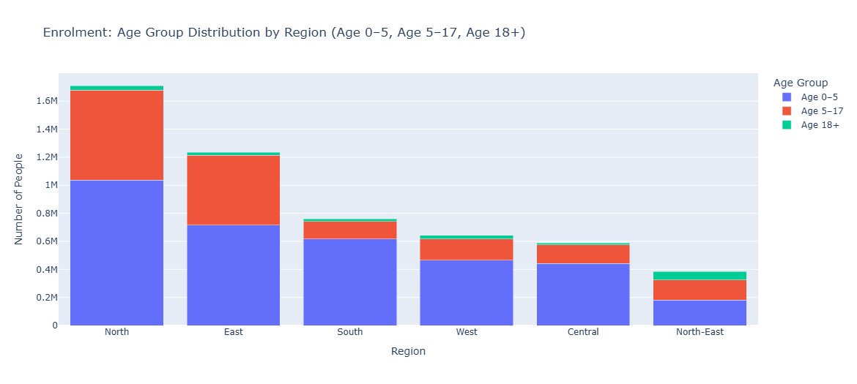
The stacked bar chart shows age-wise enrolment distribution across regions: Age 0–5 (bottom segment) Age 5–17 (middle segment) Age 18+ (top segment) North region has the highest total enrolment, followed by East and South.
Across all regions: Age 0–5 contributes the largest share Age 5–17 contributes moderately Age 18+ is minimal North-East region has the lowest enrolment across all age groups.
Interpretation:
The dominance of age 0–5 and 5–17 groups across regions indicates: Strong focus on early-age and school-age enrolment Influence of government schemes and institutional requirements.
The very low 18+ contribution across all regions suggests: Adult enrolment is mostly already completed Current data reflects new registrations rather than updates
Regional ranking (North > East > South > West > Central > North-East) reflects: Population distribution Administrative efficiency Infrastructure availability
Insight:
Enrolment is consistently youth-driven across all regions, not just specific states. This confirms that age-based patterns are uniform, but volume differs regionally.
Key Finding:
Across all regions, Aadhaar enrolment is predominantly concentrated in younger age groups (0–17), with minimal contribution from adults, indicating a uniform youth-driven enrolment pattern across India.

Demographic & Biometric
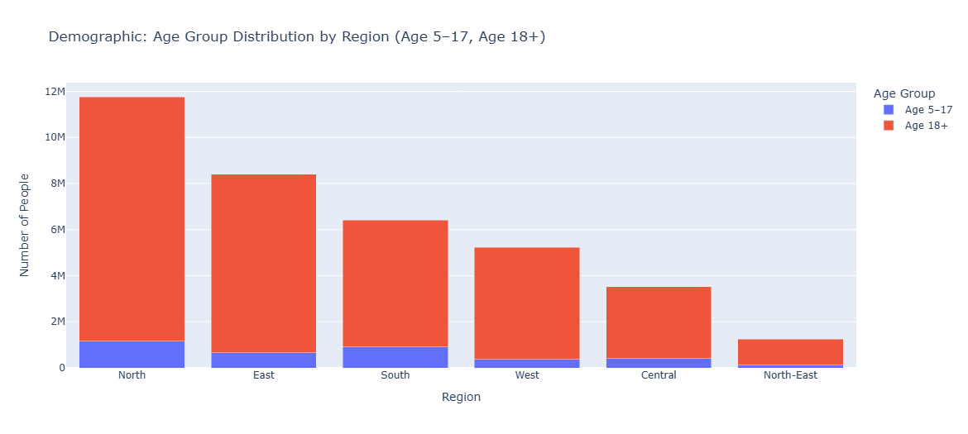
Figure 25: Age Group Distribution by Region for Demographic
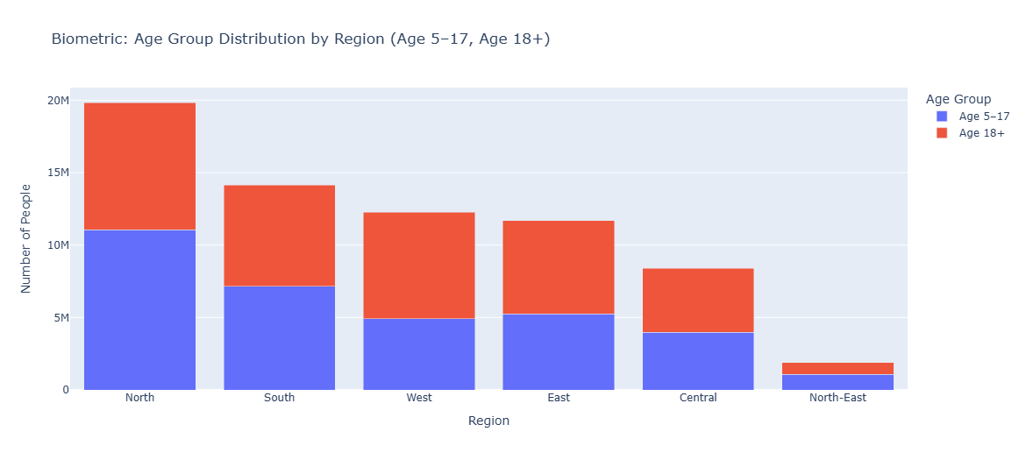
Figure 26: Age Group Distribution by Region for Biometric
Large gap exists between: Top regions (North, East) Bottom regions (Central, North-East)
Interpretation: This indicates macro-level regional disparity, likely due to: Population differences Access to enrolment centers Digital infrastructure
Insight:
Regional disparities are driven more by infrastructural and demographic factors than by age-group behaviour.

2.6.10 Temporal Analysis
2.6.10.1 Records per Date (Line Plot)
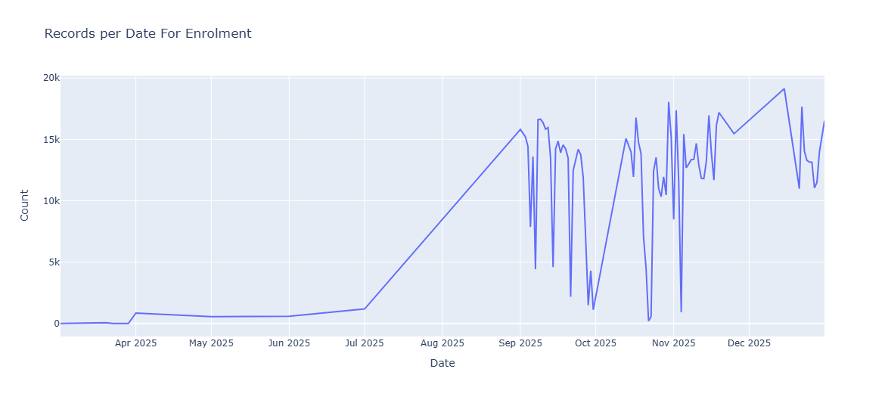
Figure 27: Records per Date for Enrolment
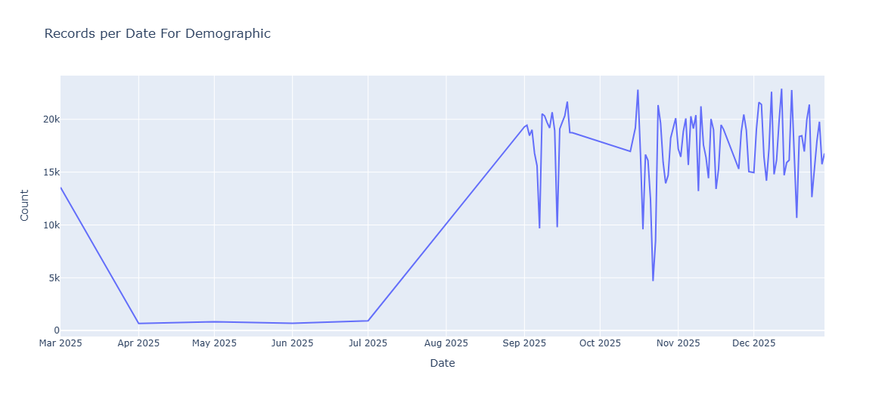
Figure 28: Records per Date for Demographic
The plot shows daily enrolment record counts over time (2025). Initial months (April–June) show very low and stable activity. From July onwards, a sharp increase in enrolment is observed. The trend peaks around September–December, with values reaching up to ~18k–19k. Significant fluctuations and sudden drops (sharp dips) are visible during later months.
Interpretation:
The gradual rise from July to September suggests: Increased enrolment drives Administrative scaling Possibly backlog processing
The high fluctuations after September indicate: Non-uniform activity (event-driven behaviour) Possible system downtime, batch processing, or irregular reporting The sharp drops (near-zero values) are not natural trends and may represent: Missing data days Reporting gaps System interruptions
Insight:
Aadhaar enrolment is not continuous, but rather: Campaign-driven Operationally dependent Irregular over time
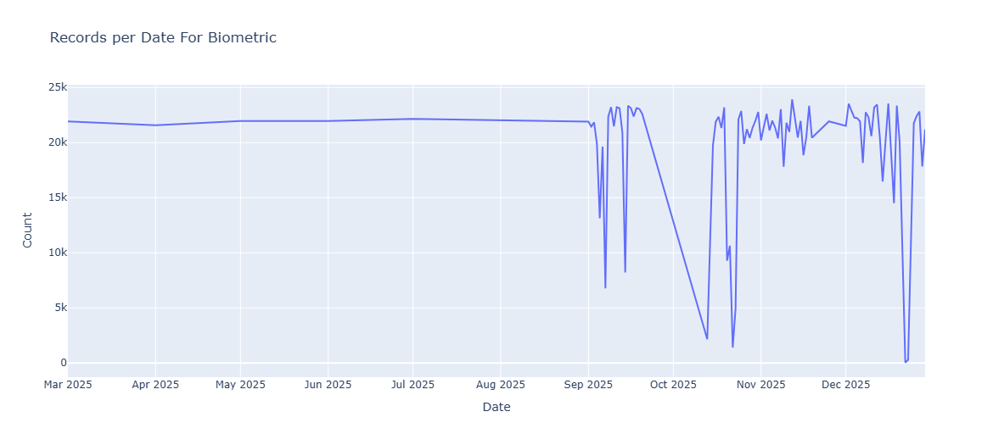
Figure 29: Records per Date for Biometric
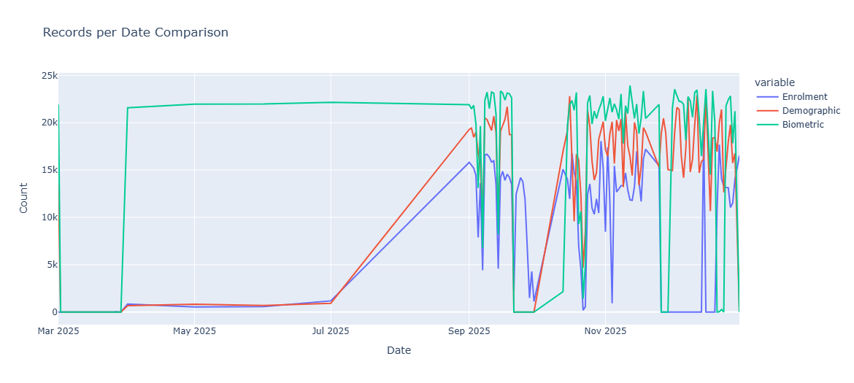
Figure 30: Records per Date Comparison
No smooth linear trend is observed. Instead, the data shows: Sudden spikes Irregular dips Volatile behaviour.
Interpretation:
This indicates absence of a stable long-term trend. Enrolment activity is influenced by: External factors (government drives) Administrative schedules Data upload patterns.
Enrolment is:
  - Event-driven
  - Non-linear
  - Operationally dependent
Insight:
The enrolment system behaves as a non-stationary time series, where patterns change over time instead of following a consistent trend.
- Sharp increase after mid-year
- High fluctuations later

    - Relationship Analysis
2.6.11.1 Enrolment vs Demographic (Scatter)
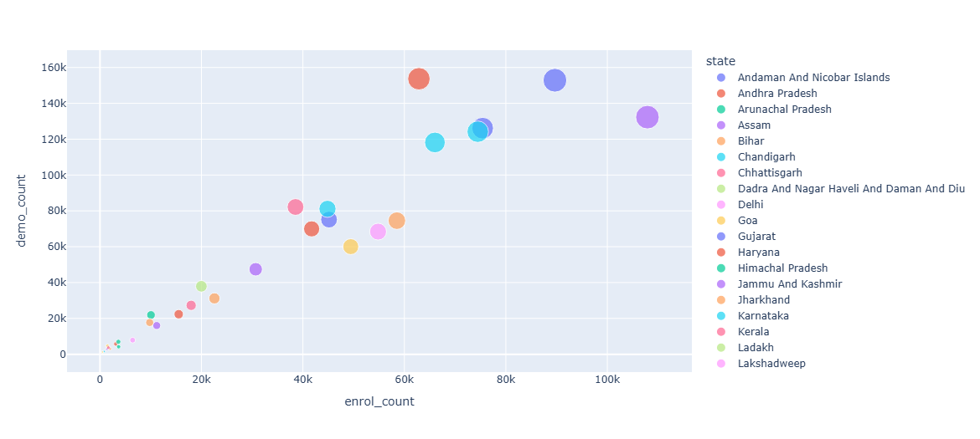
Figure 31: Enrolment vs Demographic
The scatter plot shows the relationship between: X-axis: Enrolment count (enrol_count) and Y-axis: Demographic update count (demo_count)
A clear upward trend is visible — as enrolment increases, demographic updates also increase.
Larger states (e.g., Andhra Pradesh, Karnataka, etc.) appear in the upper-right region, indicating high activity in both enrolment and updates. Smaller states and UTs cluster near the bottom-left, with low counts.
Interpretation:
This indicates a strong positive correlation between enrolment and demographic updates. States with higher enrolment naturally generate: More update requests More corrections and modifications.
However, slight variation among similar enrolment values suggests: Differences in user behaviour Differences in administrative efficiency or awareness
Insight:
Aadhaar demographic update activity scales proportionally with enrolment volume, indicating that higher population regions require continuous identity maintenance.
Key Finding:
There exists a strong positive relationship between enrolment and demographic updates, confirming that update demand increases with the size of the enrolled population.

2.6.11.2 Enrolment vs Biometric
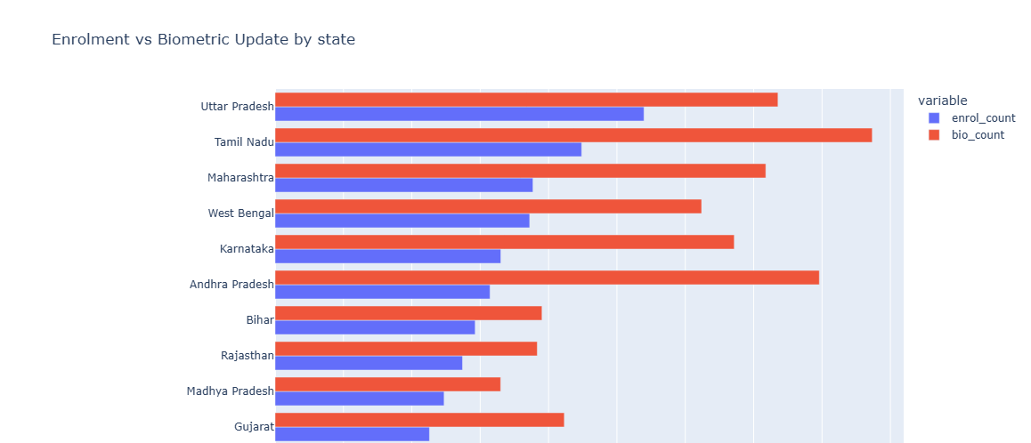
Figure 32: Enrolment vs Biometric Updates by State
States with higher Aadhaar enrolment generally also show higher biometric update activity. This suggests that biometric updates scale with enrolment size, likely driven by lifecycle needs such as children reaching adulthood and routine biometric revalidation.
Comment:
Both demographic and biometric updates increase with enrolment. However: Demographic updates are more adult-driven Biometric updates are more child-driven
Interpretation:
This highlights different behavioural patterns within the same system: Adults → Modify data Children → Update biometrics
Insight:
Aadhaar system exhibits distinct behavioural segmentation, where different age groups contribute differently to various types of updates

2.6.11.3 Age0-5 vs Total Enrolment (Scatter Plots)
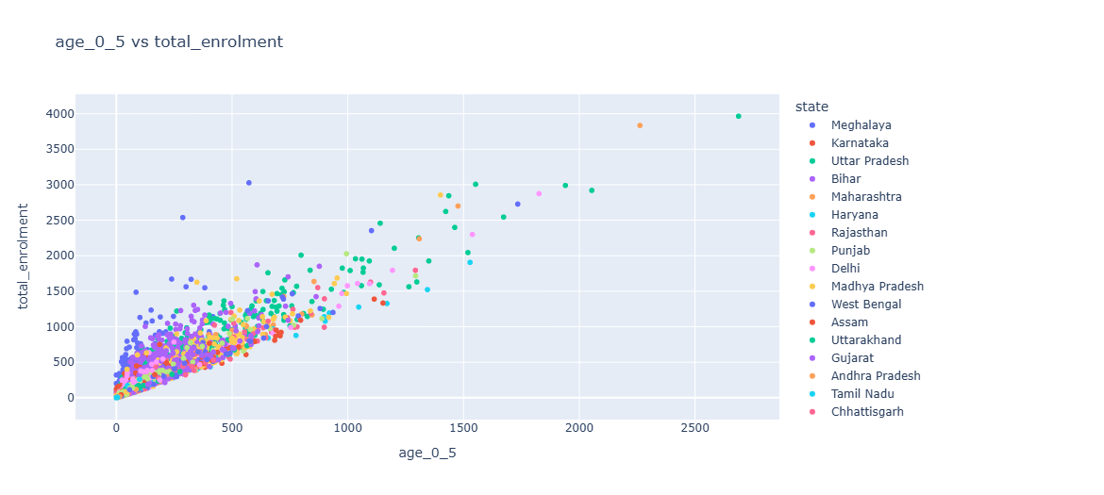
Figure 33: Age0-5 vs Total Enrolment
The scatter plot shows relationship between: X-axis: Age 0–5 enrolment Y-axis: Total enrolment A strong upward linear pattern is visible. Points are tightly clustered along a rising trend line.
Interpretation:
This indicates a strong positive correlation between: Young children enrolment (0–5) Overall enrolment States with higher toddler enrolment naturally have higher total enrolment.
Insight:
The age group 0–5 contributes significantly to total enrolment, making it a strong predictor of overall enrolment volume.
Key Finding:
A strong linear relationship exists between 0–5 age enrolment and total enrolment, indicating that early-age registration plays a crucial role in Aadhaar coverage.

2.6.11 Key Insights from EDA
Major Findings:
- Aadhaar enrolment is highly concentrated in a small number of populous states, indicating scale-driven participation rather than uniform distribution
- A strong regional imbalance exists, with significant disparities across different parts of India
- South and North regions dominate overall activity, contributing the majority of enrolment and update records
- The North-East region remains consistently underrepresented, reflecting infrastructure and accessibility constraints
- Aadhaar enrolment is predominantly youth-driven (ages 0–17), largely influenced by institutional and early registration requirements
- Demographic updates are heavily dominated by adults (18+), highlighting active identity management behaviour in this group
- Biometric updates follow a lifecycle pattern, primarily driven by children due to mandatory periodic updates and physical changes.

  - Statistical Testing (Hypothesis Testing)
2.7.1 Chi-Square Test: Age Distribution Across States
To examine whether age distribution varies significantly across states, a Chi-square test of independence was performed.
Hypotheses
- Null Hypothesis (H₀):
State and age group (0–5) are independent (no association exists)
- Alternative Hypothesis (H₁):
State and age group (0–5) are not independent (an association exists)
Methodology
- The continuous variable age_0_5 was categorized into three groups using quantile-based binning:
  - Low
  - Medium
  - High
- A contingency table was created between:
  - State
  - Age group category (Low, Medium, High)
- The Chi-square test of independence was applied using this table.
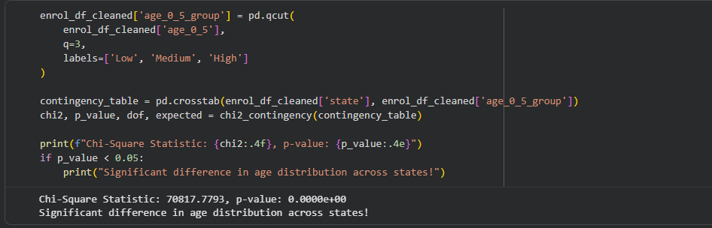
Figure 34: Chi-Square Test
Results:
- Chi-Square Statistic: 70817.78
- p-value: < 0.05 (approximately 0)
Decision Rule:
Since the p-value is significantly less than the threshold of 0.05:
- Reject the Null Hypothesis (H₀)
Conclusion:
There is a statistically significant association between state and the age group (0–5).
Interpretation:
This result indicates that:
- Age distribution is not uniform across states
- Some states have higher proportions of children (0–5), while others have lower proportions
- Regional demographic differences play a significant role in Aadhaar enrolment patterns
Project Insight:
The significant variation in age distribution across states highlights the presence of regional demographic disparities, supporting the project objective of identifying age-wise and regional enrolment differences.

    - Chi-Square Test: Demographic Updates Across Age Groups
To determine whether the proportion of demographic updates differs significantly between age groups (5–17 and 18+).
Hypotheses
- Null Hypothesis (H₀):
The proportions of demographic updates are equal across age groups
- Alternative Hypothesis (H₁):
At least one age group has a different proportion of updates
Methodology
- Total counts of demographic updates were aggregated for:
  - Age group 5–17
  - Age group 18+
- A Chi-square goodness-of-fit test was applied:
  - Observed values → Actual update counts
  - Expected values → Equal distribution assumption
- Additionally, Cramér’s V was calculated to measure effect size.
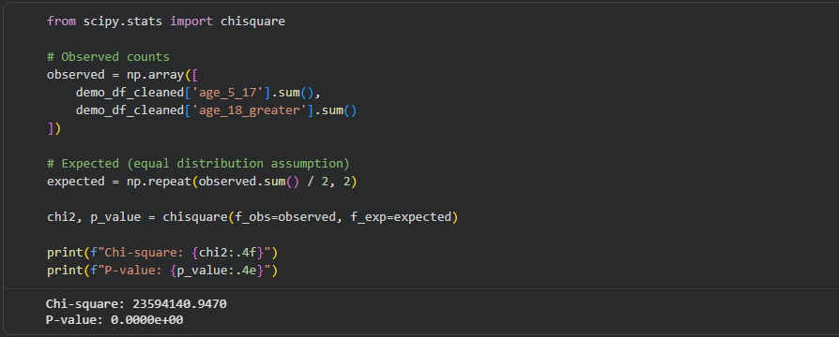
Figure 35: Chi-Square Test
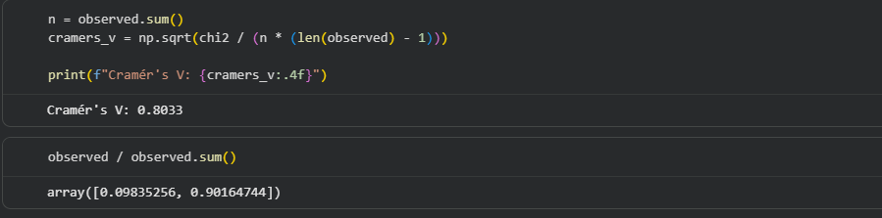
Figure 36: Cramer's Value
Results:
- Chi-Square Statistic: 23,594,140.95
- p-value: < 0.05 (≈ 0)
- Cramér’s V: 0.8033
- Observed Proportions:
  - Age 5–17 → 9.84%
  - Age 18+ → 90.16%
Decision Rule:
Since the p-value is significantly less than 0.05:
- Reject the Null Hypothesis (H₀)
Conclusion:
There is a statistically significant difference in demographic update proportions across age groups.
Interpretation:
- Adults (18+) overwhelmingly dominate demographic updates
- Younger individuals (5–17) contribute a very small share
- The difference is not random, but highly significant and substantial
- The very high Cramér’s V (0.8033) indicates a strong practical effect, confirming that age group plays a major role in update activity.
Project Insight:
Demographic updates are heavily concentrated among the adult population (18+), indicating that Aadhaar update behaviour is primarily driven by individuals requiring regular data modifications for official, financial, or identity-related purposes.
Key Analytical Finding:
The analysis reveals a strong age-based imbalance in demographic updates, with adults contributing nearly 90% of total updates, highlighting a significant skew in service utilization across age groups.

    - T-Test: Comparison of Biometric Updates Across Age Groups
To determine whether there is a significant difference in the mean number of biometric updates between:
- Age group 5–17
- Age group 18+
Hypotheses
- Null Hypothesis (H₀):
Mean biometric updates are equal across age groups
(Mean₍5–17₎ = Mean₍18+₎)
- Alternative Hypothesis (H₁):
Mean biometric updates are different
(Mean₍5–17₎ ≠ Mean₍18+₎)
Methodology
- Conducted Welch’s Independent T-Test (assumes unequal variances)
- Compared both:
  - Full dataset results
  - Sampled dataset (n = 10,000) for robustness
- Calculated:
  - Mean values
  - p-value
  - Confidence Interval (95%)
  - Effect Size (Cohen’s d)
Figure 37: Means and difference of Means
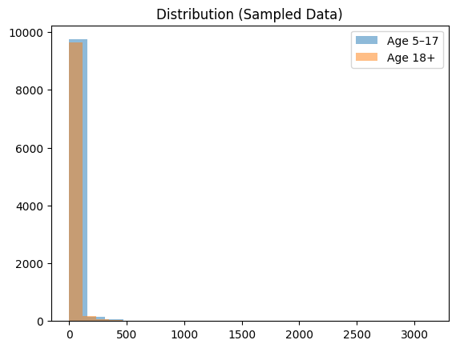
Figure 38: Sample Distribution
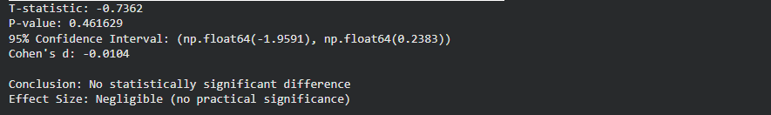
Figure 39: Result
Results (Sampled Dataset – Reliable Interpretation)
- Mean (Age 5–17): 19.73
- Mean (Age 18+): 20.59
- Mean Difference: -0.86
- T-statistic: -0.7362
- p-value: 0.4616 (> 0.05)
- 95% Confidence Interval: (-1.96, 0.24)
- Cohen’s d: -0.0104
Decision Rule:
Since p-value > 0.05:
- Fail to reject the Null Hypothesis (H₀)
Conclusion:
There is no statistically significant difference in the mean biometric updates between the two age groups.
Interpretation:
- The difference in means is very small and statistically insignificant
- The confidence interval includes zero, confirming no real difference
- The effect size (Cohen’s d ≈ 0) indicates negligible practical impact
Important Observation (Full vs Sampled Data)
Dataset | p-value | Effect Size | Interpretation
Full Dataset | ≈ 0 | ≈ 0 | Statistically significant but misleading
Sampled Dataset | 0.46 | ≈ 0 | Not significant (reliable result)
This highlights that:
- Large datasets can produce false statistical significance
- Effect size and sampling provide more realistic insights

Project Insight:
Biometric update behavior is consistent across age groups, indicating that both children (5–17) and adults (18+) contribute similarly to biometric activity despite differences observed in demographic updates.
Key Analytical Finding:
While statistical tests on large datasets may indicate significance, the negligible effect size and sampled analysis confirm that there is no meaningful difference in biometric updates between age groups, emphasizing the importance of combining statistical significance with practical interpretation.

    - Comparison of Mean Enrolment Between North and South Regions
To determine whether there is a statistically significant difference in mean Aadhaar enrolment between the North and South regions of India.
Hypotheses
- Null Hypothesis (H₀):
There is no significant difference in mean enrolment between North and South regions
(μₙₒᵣₜₕ = μₛₒᵤₜₕ)
- Alternative Hypothesis (H₁):
There is a significant difference in mean enrolment between North and South regions
(μₙₒᵣₜₕ ≠ μₛₒᵤₜₕ)
Methodology
- Extracted total enrolment values for:
  - North region
  - South region
- Applied Independent Two-Sample T-Test
- Calculated:
  - Mean and standard deviation
  - p-value
  - Effect size (Cohen’s d)
Descriptive Statistics
- North Region:
  - Sample size (n) = 236,827
  - Mean = 7.22
  - Standard Deviation = 44.27
- South Region:
  - Sample size (n) = 300,990
  - Mean = 2.52
  - Standard Deviation = 8.91
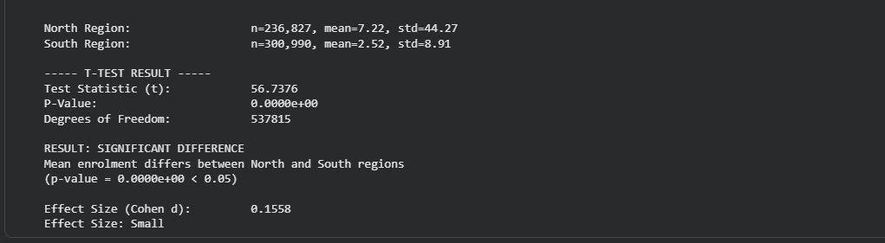
Figure 40: Result
Results:
- T-statistic: 56.7376
- p-value: < 0.05 (≈ 0)
- Degrees of Freedom: 537,815
- Effect Size (Cohen’s d): 0.1558
Decision Rule:
Since p-value < 0.05:
- Reject the Null Hypothesis (H₀)
Conclusion:
There is a statistically significant difference in mean enrolment between North and South regions.
Interpretation:
- The North region shows a higher average enrolment compared to the South
- However, the effect size is small (d = 0.1558), indicating that the actual difference is minor in practical terms
- The very large sample size contributes to detecting statistical significance even for small differences
Project Insight:
While regional differences in enrolment exist statistically, the small effect size suggests that Aadhaar enrolment levels across North and South regions are broadly comparable in practical scenarios.

Key Analytical Finding:
The analysis highlights that statistical significance does not always imply practical importance; despite a measurable difference between North and South regions, the real-world variation in enrolment remains minimal.

    - ANOVA Test: Effect of State on Age Group (0–5) Enrolment Proportion
To examine whether the state of residence has a statistically significant effect on the proportion of Aadhaar enrolments for children aged 0–5.
Hypotheses
- Null Hypothesis (H₀):
There is no significant difference in the mean proportion of age group (0–5) enrolment across states
- Alternative Hypothesis (H₁):
There is a significant difference in the mean proportion of age group (0–5) enrolment for at least one pair of states
Methodology
- Computed ratio:
$$\text{Proportion}=\frac{\text{age_0_5}}{\text{total_enrolment}}$$
- Cleaned dataset by removing:
  - Missing values
  - Infinite values
- Grouped data by state
- Applied:
  - One-Way ANOVA (F-test)
  - Manual ANOVA validation
  - Tukey HSD post-hoc test
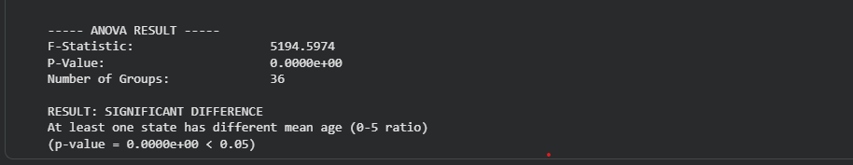
Figure 41: Result

ANOVA Results:
- F-statistic: 5194.5974
- p-value: < 0.05 (≈ 0)
- Number of groups: 36
- Degrees of Freedom:
  - Between groups: 35
  - Within groups: 974,630
Decision Rule:
Since p-value < 0.05:
- Reject the Null Hypothesis (H₀)
Conclusion (ANOVA):
There is a statistically significant difference in the proportion of children aged 0–5 across states.
Post-Hoc Analysis (Tukey HSD Test):
To identify specific differences between states, a Tukey HSD test was conducted.
Key Findings:
- A large number of state pairs show statistically significant differences (reject = True)
- Only a small number of pairs show no significant difference (reject = False)
Interpretation:
- The variation observed in ANOVA is not random
- It is driven by actual differences between states
- States such as:
  - Meghalaya
  - Nagaland
  - Arunachal Pradesh
  - Bihar
frequently show significant differences when compared to other states
Project Insight:
The proportion of Aadhaar enrolment for children aged 0–5 varies significantly across states, indicating uneven early-age enrolment patterns and disparities in demographic participation.

Strong Analytical Finding:
State-level factors such as population structure, awareness, and administrative efficiency play a crucial role in influencing child enrolment proportions, leading to substantial variation across regions.
Key Takeaway:
- State is a significant influencing factor
- Early-age enrolment is not uniformly distributed across India
- Indicates:
  - Regional inequality
  - Differences in outreach and accessibility

2.7.6 Analytical Insights
- A strong positive correlation exists between enrolment and updates:
  - Higher enrolment → higher demographic updates
  - Higher enrolment → higher biometric updates
- The dataset is highly skewed and non-uniform, with a few states contributing disproportionately to total activity
- Observed outliers represent real-world disparities, not anomalies, indicating genuine regional differences
- Aadhaar activity exhibits event-driven temporal patterns, with spikes corresponding to campaigns, administrative drives, or batch processing

2.7.7 EDA Conclusion
Exploratory Data Analysis reveals that Aadhaar operations are strongly influenced by population distribution, regional infrastructure, and age-group dynamics. The presence of high inter-variable correlation, non-uniform data distribution, and significant regional disparities indicates that Aadhaar activity is both structurally imbalanced and operationally driven, highlighting the need for targeted, region-specific policy interventions to ensure more equitable service utilization.

2.8 Dashboard Development (Power BI)
2.8.1 Overview
To effectively communicate the findings from the Aadhaar enrolment disparity analysis, an interactive dashboard was developed using Microsoft Power BI.
The dashboard integrates enrolment, demographic updates, and biometric updates into a unified analytical interface, enabling dynamic filtering and comparative analysis across regions, states, age groups, and time.
The dashboard is structured into three analytical pages, each focusing on a specific dimension of the analysis:
- Overview Analysis
- Regional Disparity Analysis
- Age & Lifecycle Analysis

2.8.2 Data Model Design
To support efficient analysis and interactive dashboarding, a structured data model was designed using Microsoft Power BI.
The model follows a star schema approach, ensuring optimal performance, scalability, and simplified filtering across datasets.
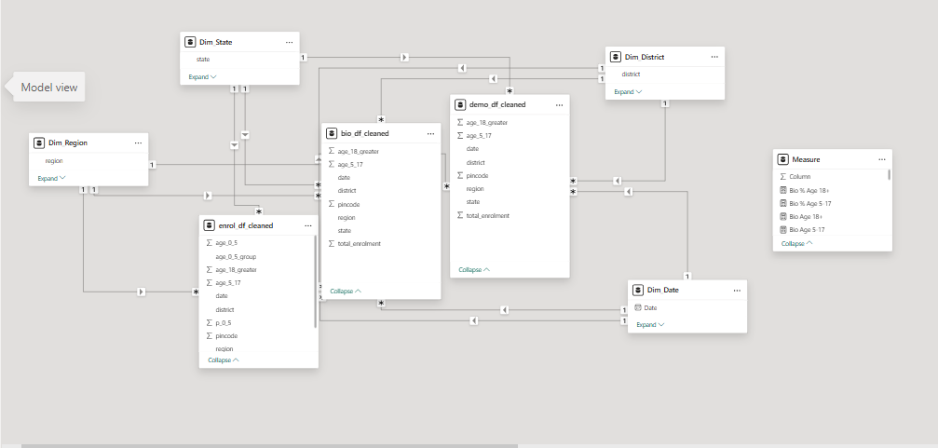
Figure 42: Data Modelling
2.8.2.1 Fact Tables
The model consists of three primary fact tables:
- Enrolment Data (enrol_df_cleaned)
  - Contains Aadhaar enrolment records
- Demographic Updates (demo_df_cleaned)
  - Tracks updates such as address and personal details
- Biometric Updates (bio_df_cleaned)
  - Includes fingerprint, iris, and photo updates
These tables store quantitative measures such as:
- Total enrolment
- Age-group counts (0–5, 5–17, 18+)
- Update counts
2.8.2.2 Dimension Tables
To enable filtering and slicing, separate dimension tables were created:
- Dim_Region
- Dim_State
- Dim_District
- Dim_Date
These tables contain categorical attributes used for analysis:
- Geographic hierarchy (Region → State → District)
- Temporal hierarchy (Year → Month → Day)
2.8.2.3. Relationships
- All dimension tables are connected to fact tables using one-to-many (1:*) relationships
- Filtering flows from dimension tables → fact tables
- Common keys used:
  - region
  - state
  - district
  - date
This ensures:
- Consistent filtering across all visuals
- Accurate aggregation of measures

2.8.2.4. Model Characteristics
- Star Schema Design
  - Improves query performance
  - Simplifies report logic
- Single-direction filtering
  - Prevents ambiguity and circular relationships
- Centralized Measures Table
  - All calculations stored separately for maintainability

2.8.2.5. Advantages of the Data Model
- Enables cross-dataset analysis
  - Enrolment vs Updates vs Biometric trends
- Supports interactive filtering
  - Region, state, age group, time
- Improves dashboard performance
- Ensures data consistency and scalability
The use of a structured data model ensures that the dashboard is not only visually interactive but also analytically robust, enabling reliable insights for policy and decision-making.

    - Dashboard Implementation
2.8.3.1 Overview Dashboard
Displays key metrics including total enrolment, demographic updates, biometric updates, and update ratio, along with state-wise and time-based trends.
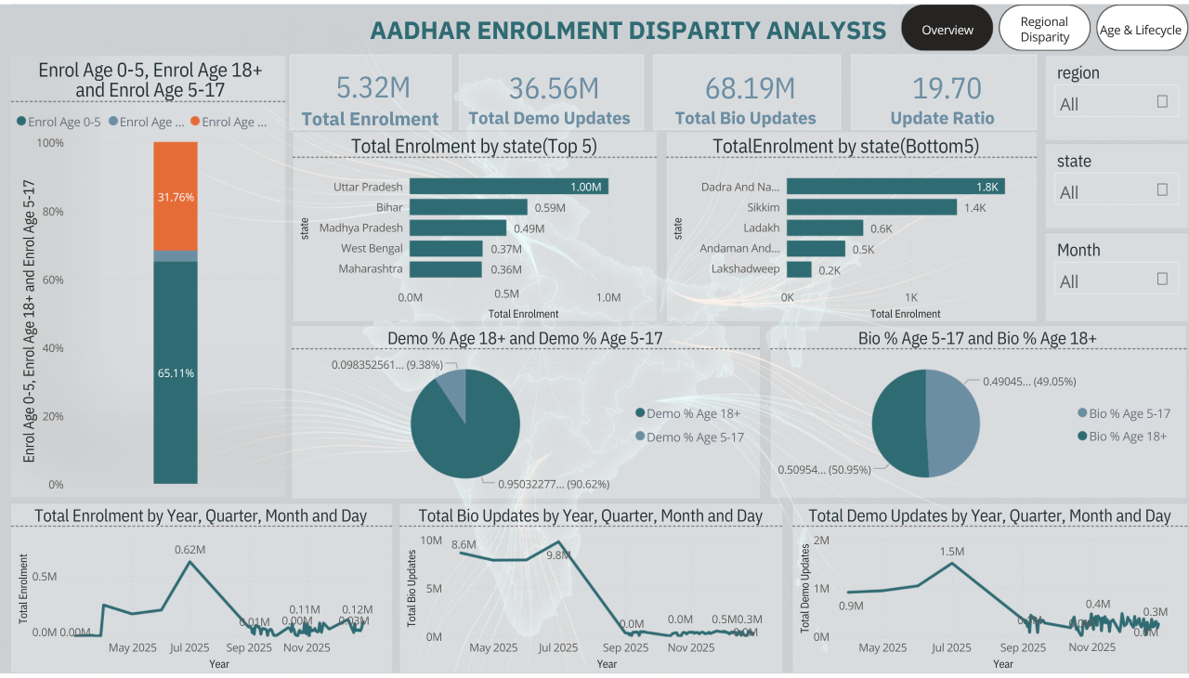
Figure 43: Dashboard Overview
Key Components
- KPI Cards:
  - Total Enrolment (5.32M)
  - Total Demographic Updates (36.56M)
  - Total Biometric Updates (68.19M)
  - Update Ratio (19.70)
- Top 5 and Bottom 5 States by Enrolment
- Age-wise enrolment distribution (0–5, 5–17, 18+)
- Time-series trends for enrolment and updates
- Interactive slicers:
  - Region
  - State
  - Month
Insights
- Aadhaar enrolment is highly concentrated in a few large states such as Uttar Pradesh and Bihar.
- The 5–17 age group dominates enrolment, indicating strong influence of school-based registration.
- Update activities significantly exceed enrolment, showing a mature system focused on maintenance.
- Time trends indicate event-driven spikes, likely due to policy or operational campaigns.

      - Regional Disparity Dashboard
Illustrates regional variations in enrolment and update activity, including geographic distribution, update intensity, and state-level contributions.
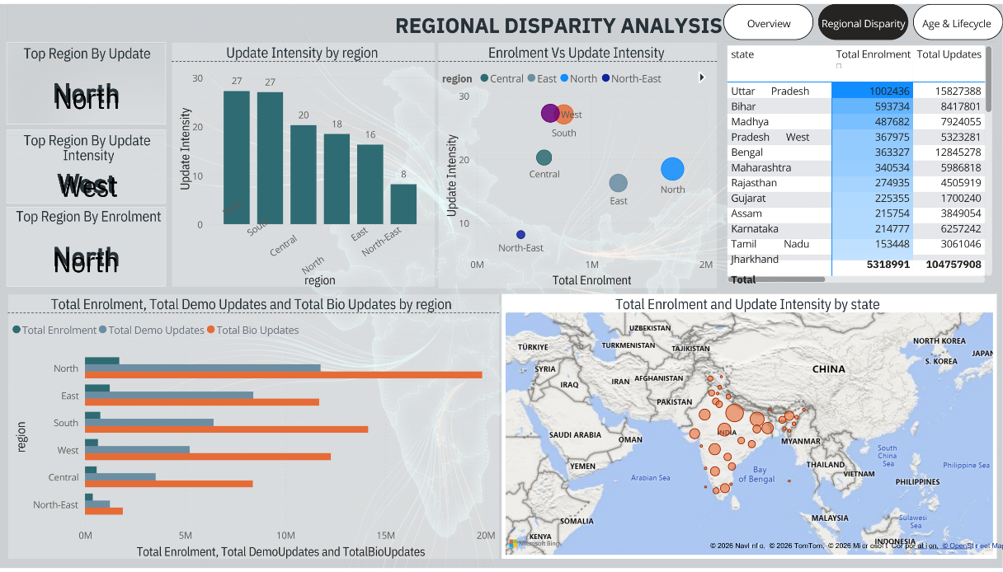
Figure 44: Regional Disparity
Key Components
- KPI Highlights:
  - Top Region by Enrolment → North
  - Top Region by Updates → North
  - Highest Update Intensity → West
- Bar Chart: Enrolment vs Updates by Region
- Scatter Plot: Enrolment vs Update Intensity
- Map Visualization: State-wise distribution
- Data Table: State-level contribution
- Region-wise Update Intensity comparison
Insights
- Northern and Eastern regions dominate enrolment, driven by population density.
- Western region shows highest update efficiency, indicating stronger digital infrastructure.
- The North-East region consistently shows low activity, highlighting accessibility gaps.
- Scatter analysis reveals that:
  - High enrolment does not always imply high update intensity
  - Regional efficiency varies significantly
      - Age & Lifecycle Analysis Dashboard
Shows age-wise distribution of enrolment and updates, highlighting lifecycle patterns and transition from enrolment-driven to update-driven activity.
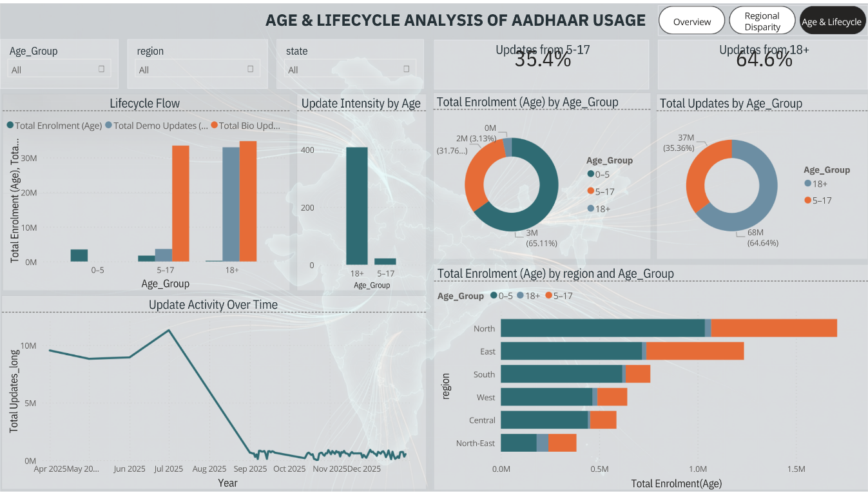
Figure 45: Age & Lifecycle
Key Components
- KPI Cards:
  - Updates from 5–17 → 35.4%
  - Updates from 18+ → 64.6%
- Lifecycle Flow Chart:
  - Enrolment vs Updates across age groups
- Donut Charts:
  - Age-wise enrolment distribution
  - Age-wise update distribution
- Update intensity by age group
- Region-wise age distribution
- Time-based update activity
Insights
- Aadhaar exhibits a clear lifecycle pattern:
  - Enrolment → dominated by children (0–17)
  - Updates → dominated by adults (18+)
- The 18+ group contributes the majority of updates, reflecting active identity management.
- Younger groups show higher enrolment but lower update activity.
- This confirms a transition from:
  - Registration-driven system → Maintenance-driven system

2.8.3.4 Key Features of the Dashboard
- Interactive filtering (Region, State, Age Group, Time)
- Multi-page structured storytelling
- Combination of:
  - KPI indicators
  - Geographic visualization
  - Trend analysis
  - Comparative analytics
- Drill-down capability for deeper insights
- Clean and consistent visual encoding of metrics

2.8.4 Dashboard Conclusion
The Power BI dashboard transforms raw Aadhaar data into an intuitive and interactive analytical tool. It highlights:
- Significant regional disparities
- Strong age-based lifecycle patterns
- Clear distinction between enrolment-driven and update-driven regions
The dashboard enables stakeholders to:
- Identify underperforming regions
- Monitor operational intensity
- Support data-driven policy decisions

Chapter 3: Conclusion & Recommendations
3.1 Final Conclusion
This study analyzed Aadhaar enrolment and update datasets to uncover patterns across regions, age groups, and time. Through systematic data cleaning, exploratory analysis, statistical validation, and dashboard development, several key findings emerged.
The analysis reveals that Aadhaar operations in India are not uniformly distributed. Enrolment activity is heavily concentrated in populous states such as Uttar Pradesh and Bihar, while regions like the North-East show consistently lower engagement. This highlights the presence of regional disparities influenced by population density, infrastructure availability, and service accessibility.
A clear age-based lifecycle pattern was identified:
- Enrolment is predominantly driven by younger populations (0–17), especially the 5–17 age group due to institutional requirements.
- Update activities are dominated by adults (18+), reflecting active identity management such as address and demographic changes.
Statistical testing further confirmed that:
- There are significant differences across regions and states
- Age groups contribute differently to enrolment and updates
- However, some statistically significant differences have low practical impact, emphasizing the importance of effect size interpretation
The interactive dashboard developed in Microsoft Power BI successfully transforms complex datasets into an intuitive analytical tool, enabling stakeholders to explore disparities and trends dynamically.
Overall, the project demonstrates how data science and visualization can be used to generate actionable insights for large-scale digital identity systems.

  - Recommendations
Based on the findings, the following recommendations are proposed:
1. Improve Accessibility in Low-Performing Regions
- Focus on North-East and low-activity districts
- Increase enrolment centers and mobile Aadhaar units
- Enhance awareness campaigns
2. Strengthen Digital Infrastructure
- Regions with high update intensity (e.g., West) show better performance
- Replicate similar infrastructure and systems in underperforming regions

3. Targeted Policy Interventions
- Use district-level insights to identify high-load vs low-access areas
- Allocate resources accordingly
4. Enhance Early Enrolment Programs
- Increase focus on 0–5 age group, which still shows lower participation
- Integrate Aadhaar enrolment with healthcare and birth registration systems
5. Optimize Update Processes
- Since updates dominate system activity:
  - Improve efficiency of update centers
  - Reduce processing time
  - Enhance online update capabilities

3.3 Future Scope
The project can be extended in several ways to enhance analytical depth and real-world applicability:
1. Integration with Population Data
- Normalize enrolment data using census population
- Enable per-capita analysis for more accurate comparisons

2. Advanced Predictive Modeling
- Use machine learning models to:
  - Predict future enrolment trends
  - Forecast update demand
  - Identify potential high-load regions

3. Real-Time Dashboard Integration
- Connect dashboard to live data sources
- Enable real-time monitoring of Aadhaar operations

4. Inclusion of Socio-Economic Factors
- Incorporate data such as:
  - Income levels
  - Literacy rates
  - Urban vs rural classification
- Understand deeper causes of disparities

5. Drill-Down to Village Level
- Extend analysis beyond districts
- Identify micro-level service gaps

6. Comparative Policy Impact Analysis
- Analyze impact of government schemes or campaigns
- Measure effectiveness of enrolment drives

This project highlights the importance of combining data cleaning, statistical analysis, and visualization to uncover meaningful insights, demonstrating how data-driven approaches can support efficient governance and equitable service delivery in large-scale systems like Aadhaar.

