100% working USB charging adaptor for creative ZEN V plus MP3 players

Here i will describe what you really need to charge your ZEN V plus with every 5VDC power supply!
1. You need the following parts:
- a Mini-USB connector with 5 soldering pins inside from a standard USB-A to Mini-USB cable (see picture 2)
- for the complete adapter a Mini-USB plug (see picture 3)
- a 470 Ohm resistor (SMD (code 471) or metall film because they are smaller as standard resistors)
- soldering implements
For myself i've made an adaptor (see picture 1, 4 and 5) to use my motorola RAZR power supply (see picture 1).
On the pictures 6 and 7 you can see that the (my) adaptor works!
To use this adaptor on every PC/Notebook you need additionally such an standard USB-A to Mini-USB cable (see picture 2).
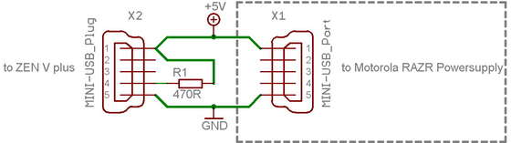

i

Second version that works: (i've not tested it, it comes from an universal adaptor for the ZEN V series)
The second version uses 2 resistors, 1 kOhm and 2kOhm!
In this wiring diagram you can see, how the both resistors are connected:
