Need to manually install

* PSX
* PSX2
* ~~PCSX Reloaded~~
* ResidualVM - [ log: /home/orangepi/Documents/Emulators/RetroPie/RetroPie-Setup/logs/rps_2023-01-31-215429.log.gz ]

lr-desmume2015 NDS emu –

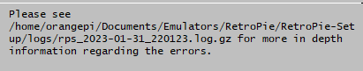

Rps –

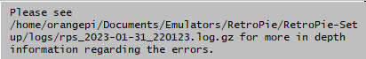

Steamlink –

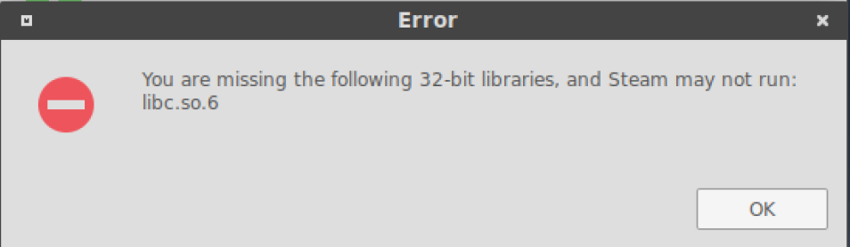

PCSXR Reloaded –

