**ICA 01-30-24**

**Task One - Create file system**

It should look something like this:

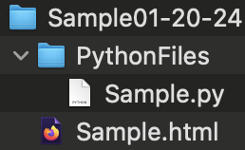

**Sample.html** and Python folder are on the same level in the directory branch.

**Task Two - Create the program**

This includes the design and planning phases of either the web page or text games.

**REQUIREMENTS:**

In addition to the basic the structural tags and links, html page must contain the following tags: **h1** through **h6, bold, and strong**.

Make a desktop environment utilizing **tkinter** with AT LEAST two buttons; each button enables a separate text game, such as "War." Note: if using the card game in the example, add the following feature: bet limit is actual bank balance.

This game must be accessible via a downloadable zip folder using a web reference.

Although you are asked to get creative, the details of the games, the style of web page, and any and all other features not mentioned, are UP TO YOU.

**Task Three - Prepare to submit**

HAND IN INSTRUCTIONS

Copy an image of the following:

- local directory holding appropriate files.

- images of BOTH html page AND appropriate code showing the web links

- images of any and all planning documents

**- image of weblink downloading**

Figure 1 – The Fastest Webpage Known To Mankind

Figure 2 – Peak Web Design For 1990

Figure 3 – The greatest games known to mankind – tennis against a brick wall and coin flipping. You know these are real games you have played in real life, but now they are digital.

Figure 4 – Part II of the code, wow, look at those lines.

Figure 5 – Tkinter running, showing that the code actually works FUN.

Figure 6 – A web page I made earlier, submitted as proof that I am capable of completing the assignment beyond the requirements, but wow that takes a lot of time – here is proof I can do it.

**Appendix A**

Html Sample from Class

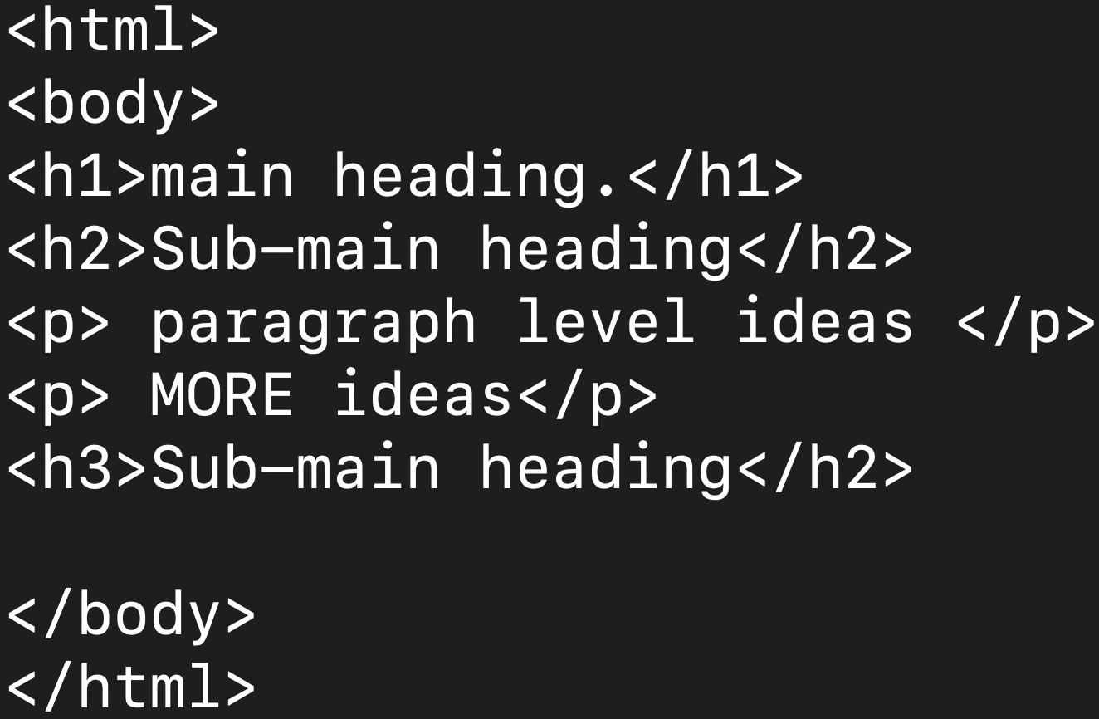

Html sample with weblink code:

Sample Python Game

Sample Python Game with Desktop

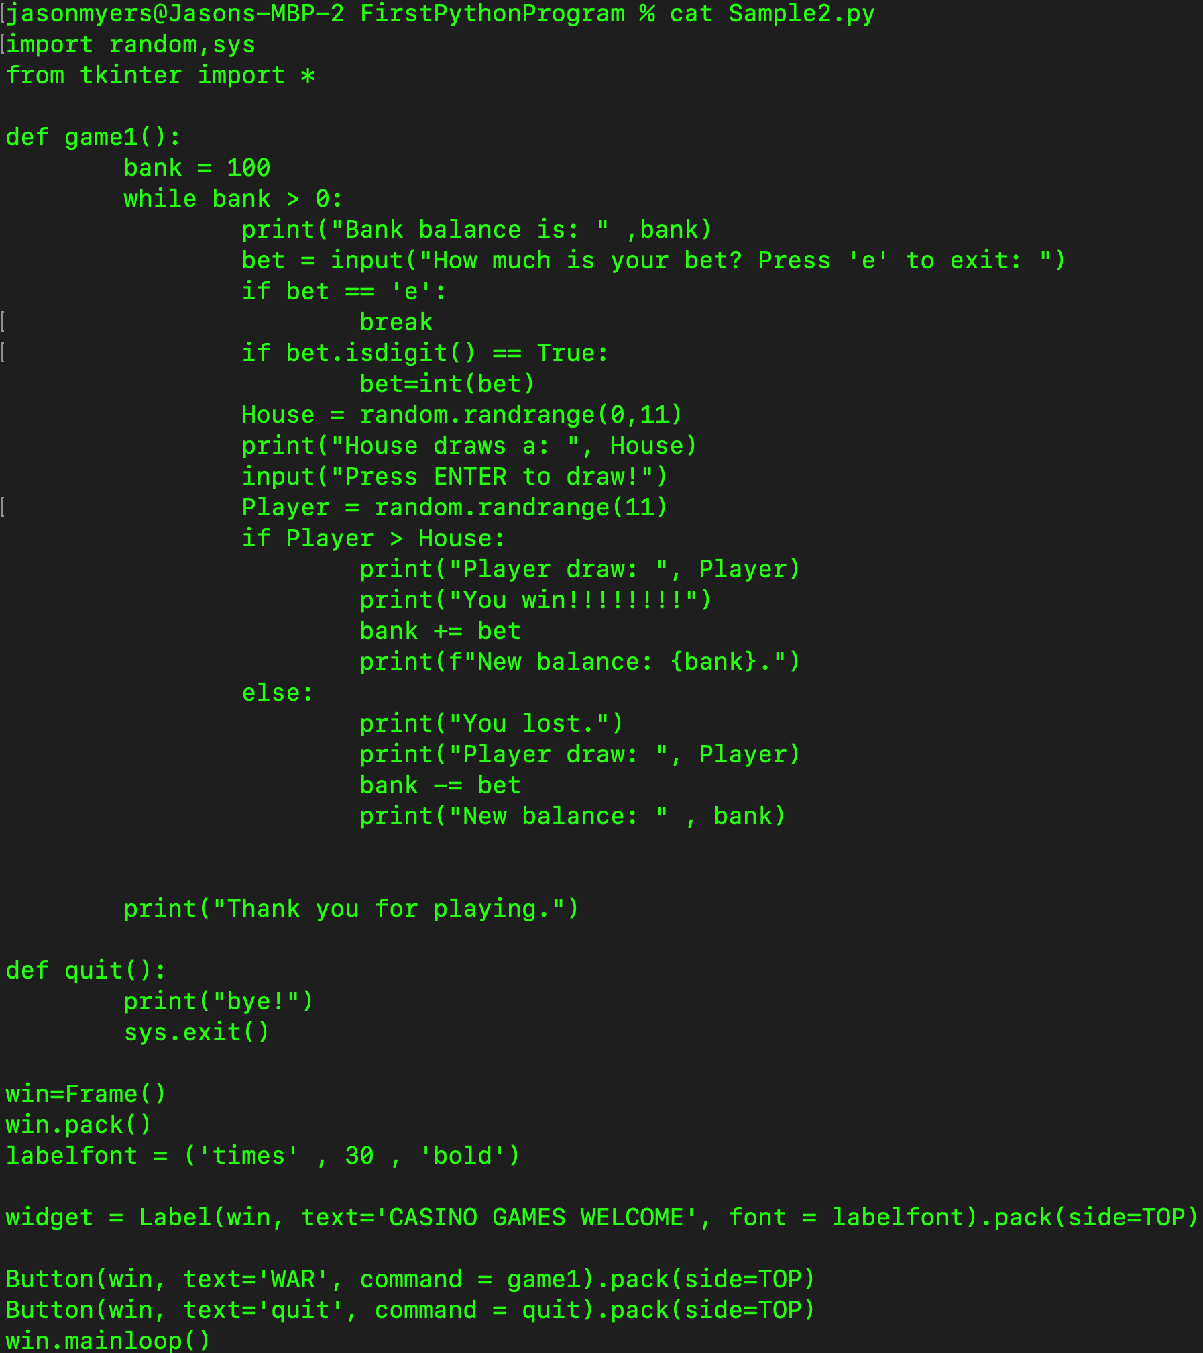

Image of web-link:

