Assignment 2

Due Date: May 27 12:00 AM

100 Points

1- a) Construct a **DFA** that accepts all strings ending with **aba** over the alphabet {a,b}.(5 Points)

b) Construct a **NFA** that accepts all strings ending with **aba** over the alphabet {a,b}.(5 Points)

2- a) Construct a DFA that accepts any string that includes the substring **abba** over the alphabet {a,b}.(5 Points)

b) Construct a DFA that accepts any string that does not include the substring abba over the alphabet {a,b}. (5 Points)

3- Given the NFA below, write the transition functions and then draw the equivalent DFA. (10 Points)

Note: The transitions between q0 and q1 are either a, or lambda.

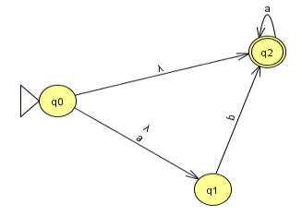

4. Minimize the number of states of the below DFA. (10 Points)

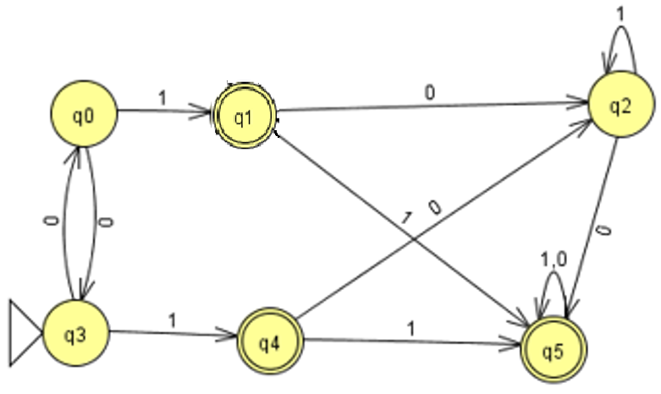

5-a) Find a dfa that accepts the following regular language: L = (aaa* + aba*bb*) (5 Points)

b) Find an NFA that accepts the regular language L (aa* (ab + b)) (5 Points)

6- Find a regular expression for the set {anbm: n ≥ 3, m is odd} (10 Points)

7- Let L1 = L(ab*aa), L2 = L(a*bba*). Find a regular expression for (L1 ∪ L2)* L2 (10 Points)

8- Construct a right- and left-linear grammar for the regular language L=(anbm : n≥3, m≥2) (10 Points)

9- Consider the Following GTG:

a) Find an equivalent GTG with only 2 states. (5 Points)

b) What is the regular language accepted by this graph. (5 Points)

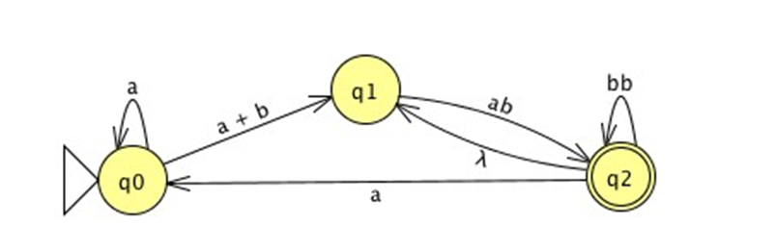

10-What regular language is accepted by the following GTG? (10 Points)