Assignment 2

Due Date: May 27 12:00 AM

100 Points

1- a) Construct a **DFA** that accepts all strings ending with **aba** over the alphabet {a,b}.(5 Points)

b) Construct a **NFA** that accepts all strings ending with **aba** over the alphabet {a,b}.(5 Points)

2- a) Construct a DFA that accepts any string that includes the substring **abba** over the alphabet {a,b}.(5 Points)  
  
b) Construct a DFA that accepts any string that does not include the substring abba over the alphabet {a,b}. (5 Points)

3- Given the NFA below, write the transition functions and then draw the equivalent DFA. (10 Points)

Note: The transitions between q0 and q1 are either a, or lambda.

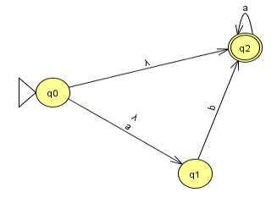

TRANSITION FUNCTIONS  
  
  
4. Minimize the number of states of the below DFA. (10 Points)

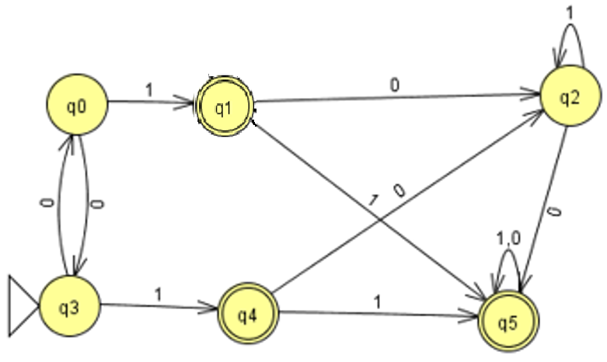  
FINAL STATES: q1,q4,q5

NON FINAL STATES: q0,q2,q3

|  |  |  |  |  |  |  |
| --- | --- | --- | --- | --- | --- | --- |
|  | Q0 | Q1 | Q2 | Q3 | Q4 | Q5 |
| Q0 |  |  |  |  |  |  |
| Q1 | X |  |  |  |  |  |
| Q2 |  | X |  |  |  |  |
| Q3 |  | X |  |  |  |  |
| Q4 | X |  | X | X |  |  |
| Q5 | X |  | X | X |  |  |

Map of all terminal-nonterminal pairings.  
CHECK ALL REMAINING PAIRINGS, DETERMINE ALL TRANSITION FUNCTIONS BETWEEN THEM. IF TRANSITION FUNCTIONS BETWEEN THEM HAVE THE SAME INPUTS, MARK THOSE PAIRS. IF PAIRINGS HAVE THE EXACT SAME INPUTS THEN THEY ARE INDISTINGUISHABLE AND CAN BE COMBINED  
q3,0 -> q0

5-a) Find a dfa that accepts the following regular language: L = (aaa* + aba*bb*) (5 Points)  
  
b) Find an NFA that accepts the regular language L (aa* (ab + b)) (5 Points)

6- Find a regular expression for the set {anbm: n ≥ 3, m is odd} (10 Points)  
L (r) = aaaa*( b(bb*b)*)

7- Let L1 = L(ab*aa), L2 = L(a*bba*). Find a regular expression for (L1 ∪ L2)* L2 (10 Points)  
(ab*aa + a*bba*) a*bba*

8- Construct a right- and left-linear grammar for the regular language L=(anbm : n≥3, m≥2) (10 Points)  
The direction of grammar merely indicates what side is replaced in each production.  
The minimum that must be achieved is aaabb  
  
STARTING SYMBOL IS ALWAYS S  
  
RIGHT LINEAR GRAMMAR:  
  
S -> aaaA

A-> aA | bB

B->bB |b

LEFT LINEAR GRAMMAR  
S -> Bbb

B -> Aaa |Bb  
A-> Aa | a

9- Consider the Following GTG:

a) Find an equivalent GTG with only 2 states. (5 Points)  
  
  
b) What is the regular language accepted by this graph. (5 Points)

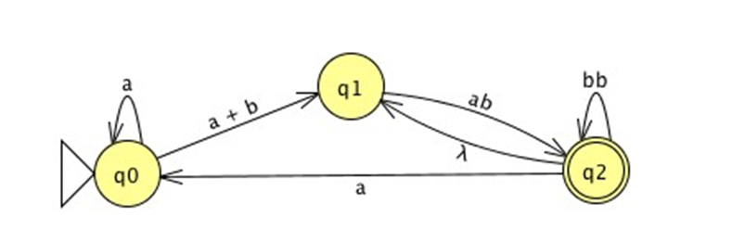  
L®((a*aab + a*bab)(bb+(a+LAMBDA)(a*aab + a*bab))*

10-What regular language is accepted by the following GTG? (10 Points)

A*(a(a+b)*(a+b)(a+b*)* ( (a*+b+c)a*(a(a+b)*(a+b)+(a+b*)*))*