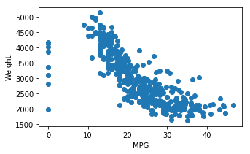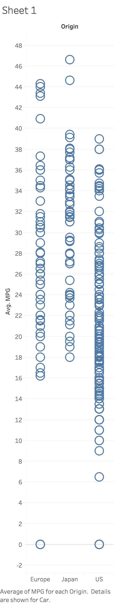

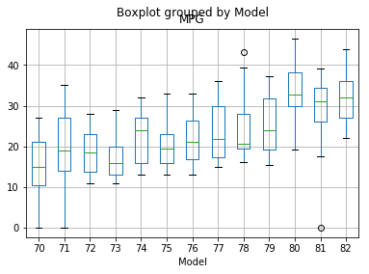The chart above tells us that cars with higher MPG results in a lighter car. Additionally, cars from US have a lower average MPG than cars from Europe or Japan. This may be a result of the 1973 oil crisis that happened in the Middle East.

From this boxplot, one can gather that as time goes on, the need for higher MPG cars is shifted upwards. The mean, median and maximum/minimum values are all increasing. The US Energy Tax Act imposed manufacturers and importers that if they don’t meet a certain “minimum” then they will be severely taxed. Evidently enough, the minimum for MPG values started to rise.

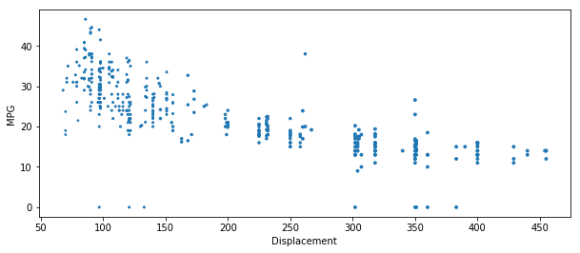

Clearly, the higher the engine displacement, the lower the MPG value would be. This would be the result of American cars having higher engine displacement which produces more power in the engines. Small, fuel-efficient cars from Japan started to become more popular as the three top auto makers, GM, Ford and Chrysler started to take a hit from the 1979 energy crisis; political events in Iran instigated the crisis and with the high inflation and high interest rates, the American companies couldn’t compete with Japanese auto makers.