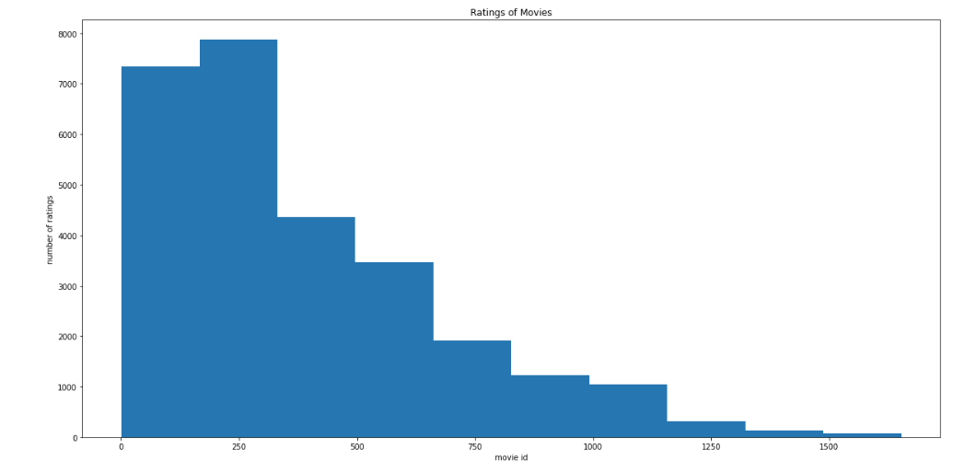

Tommy

Tan

The figure above displays the correlation of a certain movies and the amount of high ratings they have from the dataset.

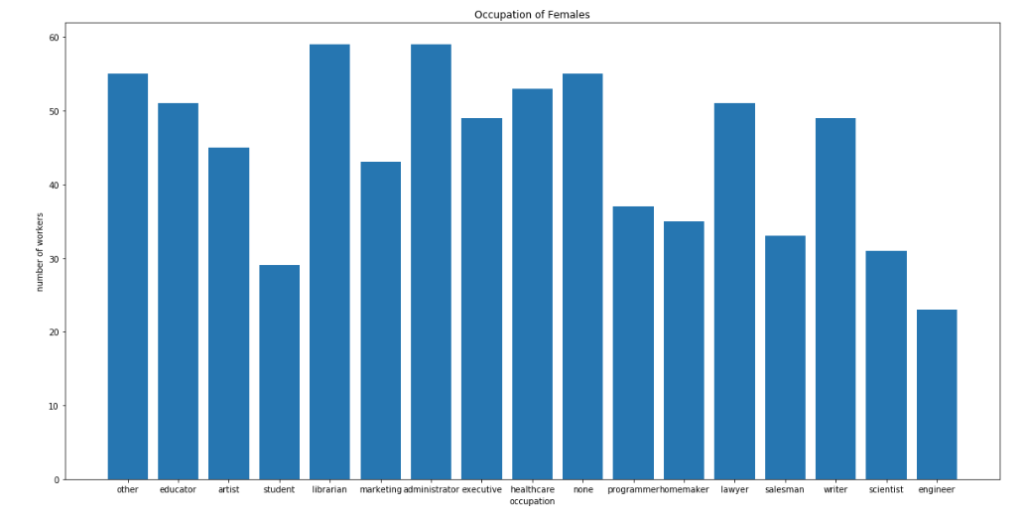

The figure above displays the relationship of the different types of occupation that females are in from the dataset.

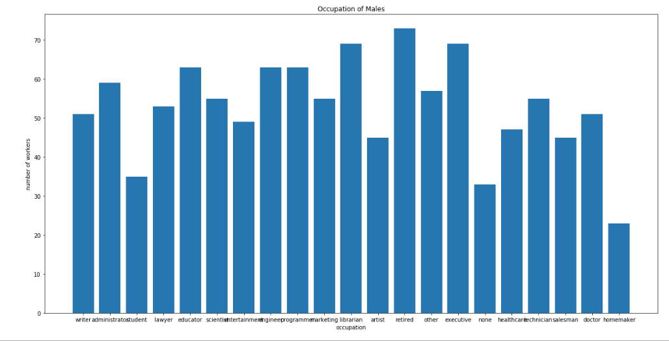

Here we see that males have more occupations in the workforce and their numbers are higher in scale when compared to females from the datasets.