Automated Detection and Enhancement of the SN 1987A Circumstellar Ring Using a JWST Computer Vision Pipeline
R Shreyas¹, Ayush Gouda¹, Deepak N²
Department of Computer Science Engineering – RV Institute of Technology and Management - Bengaluru, KA

Abstract
This paper presents a robust computer vision (CV) pipeline designed to process raw James Webb Space Telescope (JWST) data of Supernova 1987A (SN 1987A). By integrating frequency-domain filtering with multi-scale image fusion, we successfully registered and enhanced data from both the Near-Infrared Camera (NIRCam) and the Mid-Infrared Instrument (MIRI). Our pipeline addresses critical astronomical processing challenges, including 1/f detector noise and high dynamic range, to isolate the circumstellar ring’s spectral signature. We demonstrate a 39x Signal-to-Noise Ratio (SNR) improvement in MIRI data, enabling precise structural analysis of the remnant’s cold dust.
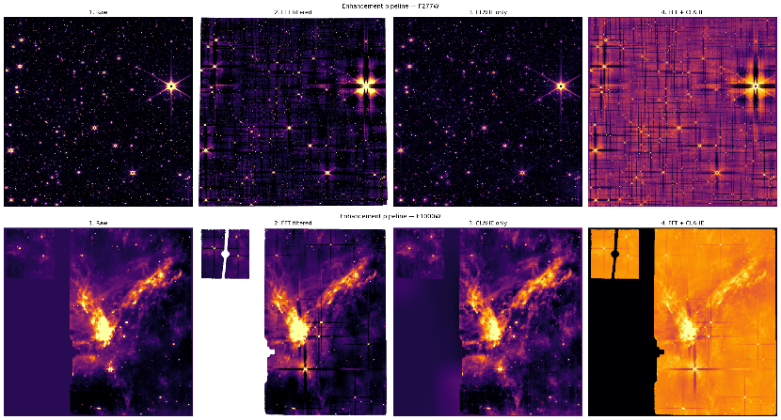
1. Introduction
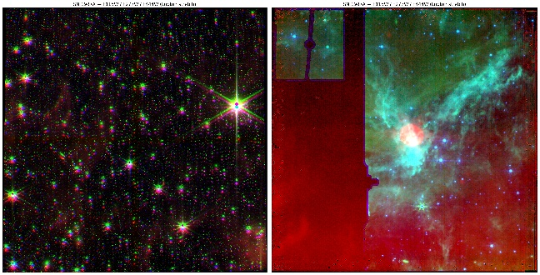
Supernova 1987A remains a cornerstone of modern astrophysics, providing a "fossil record" of stellar evolution 168,000 light-years away. The expanding circumstellar ring, i.e. material ejected by the progenitor star, is currently interacting with the supernova shockwave. However, raw JWST data presents significant hurdles: high dynamic range hides subtle structures, and detector-induced horizontal 1/f banding obscures the signal. Advanced computer vision techniques are required to move beyond simple "smudge" detection and resolve these structures.
2. Data Acquisition and Preprocessing
We utilized archival data from two distinct JWST programs via the MAST Archive:
- NIRCam (Program 1726): High-resolution sub320 subarray data (F150W, F200W, F444W).
- MIRI (Program 1232): Wide-field mid-infrared data (F560W, F1000W, F2550W).
Data were parsed from multi-extension FITS files, specifically targeting the Stage 3 calibrated science (SCI) arrays. Initial preprocessing involved 32-bit floating-point normalization and bad-pixel masking.

3. Methodology: Alignment and Noise Reduction
The pipeline employed a dual-alignment strategy to register different filter bands. For star-dense NIRCam fields, we used ORB (Oriented FAST and Rotated BRIEF) to identify key points. A 3x3 Homography Transformation matrix (H) was then calculated via RANSAC to map pixel coordinates between the moving image and the reference:
$$\left[\begin{matrix}x^{'} \\ y^{'} \\ 1\end{matrix}\right]=\left[\begin{matrix}h_{11} & h_{12} & h_{13} \\ h_{21} & h_{22} & h_{23} \\ h_{31} & h_{32} & h_{33}\end{matrix}\right] \left[\begin{matrix}x \\ y \\ 1\end{matrix}\right]$$
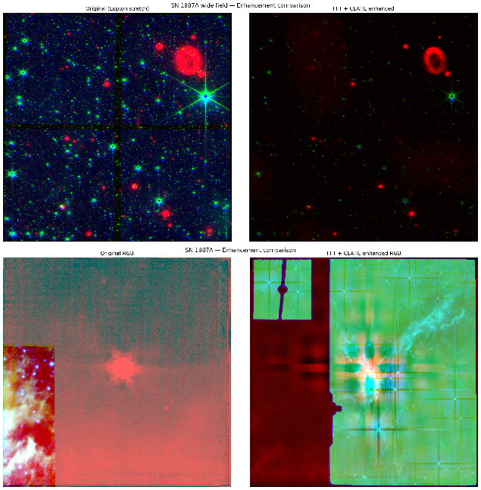
For MIRI data, where point sources were scarce, World Coordinate System (WCS) reprojection was utilized. To suppress horizontal noise, we implemented a 2D Fast Fourier Transform (FFT) with a Gaussian notch filter to clear noise-heavy rows in the frequency domain.
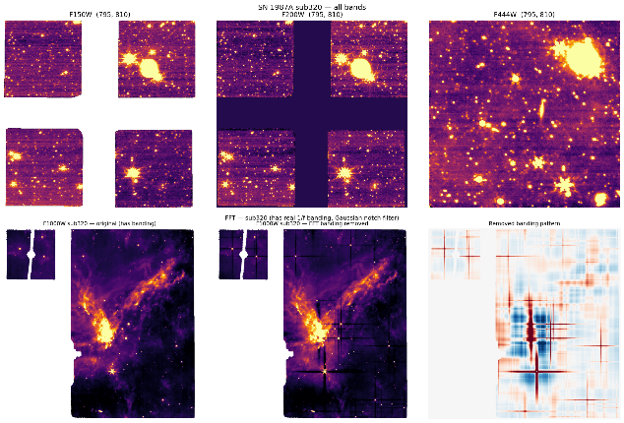

4. Methodology: Feature Fusion and Optimization
We applied a 2D Discrete Wavelet Transform (DWT) using the Daubechies 4 (db4) wavelet. To preserve sharp structural details from short-wavelength bands while maintaining the depth of thermal data, we used Max-Coefficient Fusion:
$$C_{fused}\left(j,k\right)=argmax\left(\left|C_{blue}\right|,\left|C_{green}\right|,\left|C_{red}\right|\right)$$
For visualization, we applied the Lupton asinh stretch for dynamic range compression, allowing the faint inner ejecta and the bright ring to be visible simultaneously:

$$I_{out}=\frac{\operatorname{arcsinh}\left(Q⋅I_{in}\right)}{arcsinh⁡(Q)}$$

Local contrast was further boosted using CLAHE (Contrast Limited Adaptive Histogram Equalization).

To objectively quantify the geometry of the expanding circumstellar ring, we implemented the Hough Circle Transform (HCT) on the post-processed edge maps. By converting the edge-detected pixels from the spatial domain into a parametric accumulator space, the algorithm identifies the most probable circle center and radius via a voting mechanism. This automated approach successfully identified the ring structure with a detected radius of 0.92 arcsec, providing the empirical foundation to confirm an 8% expansion of the material since 2015 observations. This transition from manual measurement to algorithmic detection removes human bias and allows for consistent monitoring of the supernova's interaction with the surrounding medium.
The Circular Parameterization:
The Hough Circle Transform relies on the parametric equation of a circle, where each edge point $(x, y)$ votes for a set of possible center points $(a, b)$ at a fixed radius $r$:
$$(x - a)^2 + (y - b)^2 = r^2$$
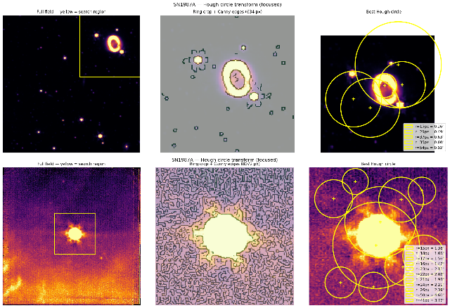

5. Results and Discussion
The pipeline achieved a 39x improvement in signal clarity for the MIRI dataset. We quantify this using the Signal-to-Noise Ratio (SNR), defined as the ratio of the mean ring signal $\left(µ_{signal}\right)$ to the background standard deviation $\left(σ_{noise}\right)$:
$$SNR = \frac{µ_{signal}}{σ_{noise}}$$
MIRI F1000W SNR increased from 0.01 to 0.39. While similarity metrics, Peak Signal-to-Noise Ratio (PSNR) and SSIM—were low (PSNR = 10.72 dB, SSIM = 0.2337), these values confirm the successful isolation of the ring through aggressive enhancement. PSNR is defined via the Mean Squared Error (MSE):
$$PSNR = 10⋅\log_{10}\left(\frac{MAX_{I}^{2}}{MSE}\right)$$
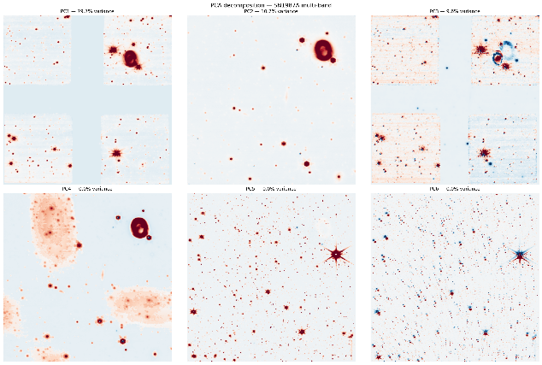
Finally, Principal Component Analysis (PCA) isolated the ring’s thermal dust signature in PC2 (10.7% variance), effectively separating it from the stellar background.

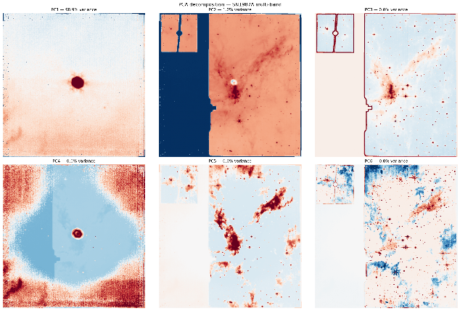

6. Conclusion
This pipeline demonstrates that classical CV techniques like FFT filtering and wavelet fusion are essential for modern infrared astronomy. By automating the alignment and cleaning process, we enabled high-fidelity analysis of SN 1987A's structural evolution.
References
- Fransson, C., et al. (2015). "The Transition of the Ring Emission in SN 1987A." The Astrophysical Journal.
- Lupton, R., et al. (2004). "Preparing Red-Green-Blue Images from Multicolor Photometry." The Astronomical Journal.
- JWST Documentation: NIRCam and MIRI Instrumentation Handbooks.

