**AALIKKUMAR VELU**

#93, Legsby Avenue, Grimsby, DN32 0NE,

United Kingdom

Mobile: +44 74 96481043

Email: [aalikkumar@gmail.com](mailto:aalikkumar@gmail.com)

**CAREER OBJECTIVE**

To be a part of a world class organization in which I can contribute my knowledge and skills in Finance related areas with an emphasis on Management Accounting, Financial Accounting and Financial Analysis, and be an asset to my colleagues and to the organization as a whole.

**HIGHLIGHTS OF PROFESSIONAL SKILLS**

* More than12 Years of Professional Work Experience in different areas including Finance, Accounts, MIS Reports, Inventory, Cash Management, Audit, Payroll, etc.
* Hands on Experience of SAP, FIS, ACCPAC, and Quick Books
* Excellent at designing and implementing new Internal Controls and improving existing Internal Controls to ensure their objectives at their best
* Excellent at representing an organization with Professional Appearance and Manner
* Willing to learn and handle any assigned task
* Introduced and successfully implemented automation of various repetitive manual tasks

**QUALIFICATIONS**

* **B. Com** – Completed Bachelor of Commerce, in Year 2005 from University of Colombo, Sri Lanka.
* **SOCPA**- Saudi Organizations Certified Public Accountant in Year 2016, KSA
* **CPM** - Associate Member of Institute of Certified Professional Managers in Year 2009
* **CMA** – Completed professional level 1 in year 2007 & **CIMA** – Partly qualified

**WORK EXPERIENCES**

At Present: Working as a supermarket in charge at SPAR Supermarket, Nuns corner, Grimsby, UK from October 2021 to Date.

Worked as a fulltime partner in our own business UV Distribution from December 2019 to October 2021

**Professional Work Experience**

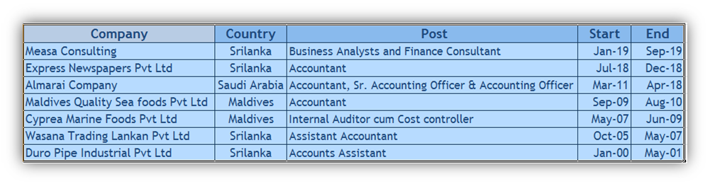

* Payroll Reconciliation
* Preparation of Monthly Bank Reconciliation
* Handling all tax works – VAT & NBT
* Handling and Monitoring Petty Cash Fund, its replenishments
* Carry out monthly accounts closing activities
* Carrying out monthly physical stock count
* Sales return report-based branches
* Approval of expense vouchers
* Provide complete and accurate management information to plant operations.
* Weekly meetings with location manager to discuss and review the flash reports and to explain them the reasons for unusual occurrences if there is any
* Weekly internal audit on Petty cash, Inventory and Fixed asset.
* Preparation of Management reports on KPIs covering **Production volume, Output Kg per man Hrs., LIP monitoring, NPL, Flock, Eggs, Feeds, Mortality**, etc. and circulating to management following the Almarai internal financial reporting calendar on weekly and monthly basis
* Monitoring of Balance Sheets Accounts particularly relating to flock valuations including capitalization, amortization, disposals, etc.
* Responsible for manufacturing division (**VIM**) Vendor Invoice Management System.
* Preparation of Monthly Profit and Loss Accounts and circulating to management following the Almarai internal financial reporting calendar on monthly basis
* Analysis and monitoring of inventory/stock on monthly basis
* Management of fixed asset information between operations and shared services.
* Carrying out entire period end closing activities including JVs in SAP complying with the timelines given by Shared Services Department
* Preparation and monitoring of Fix Asset Register and monitoring of movements of Fix Assets and its documentation
* Preparation of monthly KPI monitoring sheet and circulating to management
* Preparation of Payroll reconciliation on monthly basis

**Quarterly Reporting**

* Carry out quarterly physical stock count and its necessary documentation complying with FPRC policies following Almarai internal financial reporting calendar
* Preparation of Quarterly Profit and Loss Accounts and circulating to management following the Almarai internal financial reporting calendar

**Annual Reporting**

* Preparation and presentation of Annual Budget, Forecasts, and related Schedules
* Preparation and presentation of KPIs including Flock, Egg, Mortalities, and Feed Volumes
* Preparation of Annual Profit and Loss Accounts and circulating to management following the Almarai internal financial reporting calendar

**Internal Controls**

* Continuously reviewing existing internal controls from the perspective of its effectiveness and completeness to ensure those internal controls serves the objectives which were expected of those and suggest improvements wherever seems appropriate.
* Suggest and implement new internal controls wherever there is none in place and there is an immediate need of it after discussion with farm management
* Preparation and presentation of monthly, quarterly, and annual financial statement for management and regulatory authorities.
* Preparing Budgets, Forecasts, and trend analysis
* Monitoring Petty Cash transactions and fund requirements
* Monitoring cash and bank reconciliations on weekly and monthly basis
* Carry out monthly accounts closing activities
* Conducting internal audits and taking corrective measures on timely basis
* Analysis of financial reports on periodical basis by comparing actual results with budget and forecast and provide explanations thereon
* Preparing detailed analysis of variations with history
* Preparing monthly royalty statement

**Auditing**

* Verify invoices, Purchase orders, Receipts, debit note, credit notes& monitoring daily transaction
* Reviewing of Payroll Sheets
* Verify all payment Vouchers, marking cash counts with cashier and giving approval to cash reimbursement
* Verifying Export, local sales, cash collections and Control & monitoring of debtors Ledger
* Preparing Monthly Reconciliations of outstanding balances

**Costing**

* Calculating costing for packing materials
* Preparation and presentation of KPIs including Fish grade, export quantity, by product, wastages, and Volumes
* Preparing shipment cost
* Preparing daily, weekly and monthly purchase cost and production cost
* Producing Daily business reports to the management which includes company’s daily transactions such as sales, purchases, stock, bank balance and trade receivables & payables etc.
* Maintaining General Ledgers, Cash Book, Debtors, Creditors, and Sales Register
* Preparation of Monthly & weekly Bank’s and debtor’s reconciliation
* Handling all tax works – VAT, PAYE, WHT and Income tax for Companies & Personal
* Assist to preparation of Monthly Financial Reports
* Preparation of Monthly Bank Reconciliation and Payroll Reconciliation
* Maintaining General Ledgers, Cash Book, Debtors, Creditors, and Sales Register
* Assist to preparation of Monthly Financial Reports
* Preparation of Monthly Bank Reconciliation and Payroll Reconciliation

**TRAININGS**

Attended various trainings, seminars and workshops organized by Almarai Company

Business Report Writing, Time Management, Planning Organizing & Time Management, Microsoft Excel Advance, Creative Problem Solving & Decision Making, Business Ethics & Etiquette Teamwork and Team Building, Presentation Skills, Managing Change, ISO Awareness Online Training, Emotional Intelligence, Performance Appraisal, Public Speaking, Basic Leadership, Business Writing, Project Management Part 2, Project Management Part 1, Communication Effectiveness and Get Things Done

**COMPUTER LITERACY**

* Windows 98/2000, Windows XP, Windows 7,8 and 10
* Microsoft Office 1997, XP, 2003, 2007, 2010

**PERSONAL DATA**

Name : Velu Aalikkumar

Address : 93, Legsby Avenue, Grimsby, DN32 0NE, UK

Date of Birth : 08th June 1979

Passport No : N8295816 (Exp. Date: 29.04.2029)

NIC : 197916003609

Father’s Name : Arumugam Velu

Nationality : Sri Lankan

Marital Status : Married