 | ภาควิชาวิศวกรรมคอมพิวเตอร์ คณะวิศวกรรมศาสตร์  มหาวิทยาลัยเทคโนโลยีราชมงคลธัญบุรี | รหัสวิชา 04-624-201  ชื่อวิชา Machine Learning
ชื่อ นายสิทธิกร บุญณะ รหัสนักศึกษา 116630462039-4 กลุ่ม 1

ใบงานที่ 2 Convolutional Neural Network
และการประยุกต์ใช้งาน CNN
วัตถุประสงค์
- เพื่อให้นักศึกษาเข้าใจหลักการทำงานของ Convolutional Neural Network (CNN) และแนวทางการประยุกต์ใช้ในงานจริงทั้งด้านการจำแนกและการพยากรณ์
- เพื่อให้นักศึกษาสามารถพัฒนาผังการทำงาน ประมวลผล และแสดงผลลัพธ์ เพื่อพัฒนาระบบต้นแบบร่วมกับ CNN ในการจำแนกและการพยากรณ์ได้อย่างถูกต้อง
-------------------------------------------------------------------------------------------
LAB1: CNN Basic for classify digits
Objective:
- Apply CNN to classify digits.
Contents:
- Load the digits dataset.
- Split the data into training and testing sets.
- Train CNN models.
- Evaluate each model using accuracy.
Output:
- Display sample predictions
- - Compare the results of different network sizes in a table (1–10 Convolutional layers with 10–1000 nodes per layer.)

Code:
import tensorflow as tf
from tensorflow.keras import layers, models
import numpy as np
import matplotlib.pyplot as plt
import pandas as pd
from sklearn.model_selection import train_test_split
from sklearn.metrics import accuracy_score
import os
physical_devices = tf.config.list_physical_devices('GPU')
if len(physical_devices) > 0:
tf.config.experimental.set_memory_growth(physical_devices[0], True)
def load_data():
print("Loading MNIST Dataset...")
(x_train, y_train), (x_test, y_test) = tf.keras.datasets.mnist.load_data()
x_train = x_train.reshape((-1, 28, 28, 1)).astype('float32') / 255.0
x_test = x_test.reshape((-1, 28, 28, 1)).astype('float32') / 255.0
y_train = tf.keras.utils.to_categorical(y_train, 10)
y_test = tf.keras.utils.to_categorical(y_test, 10)
x_train, x_val, y_train, y_val = train_test_split(x_train, y_train, test_size=0.1,
random_state=42)
return (x_train, y_train), (x_val, y_val), (x_test, y_test)
def build_cnn_model(num_layers, num_filters, input_shape=(28, 28, 1)):
model = models.Sequential()
for i in range(num_layers):
if i == 0:
model.add(layers.Conv2D(num_filters, (3, 3), activation='relu', padding='same', input_shape=input_shape))
else:
model.add(layers.Conv2D(num_filters, (3, 3), activation='relu', padding='same'))
if i % 2 == 0:
model.add(layers.MaxPooling2D((2, 2), padding='same'))
model.add(layers.Flatten())
model.add(layers.Dense(128, activation='relu'))
model.add(layers.Dense(10, activation='softmax')) # Output 10 digits
model.compile(optimizer='adam',
loss='categorical_crossentropy',
metrics=['accuracy'])
return model

def main():
(x_train, y_train), (x_val, y_val), (x_test, y_test) = load_data()
layers_to_test = [1, 2, 3]
filters_to_test = [32, 64]
results = []
print(f"\nStarting Experiment...")
print(f"Layers to test: {layers_to_test}")
print(f"Filters (Nodes) to test: {filters_to_test}")
best_model = None
best_acc = 0
for l in layers_to_test:
for f in filters_to_test:
print(f"\n--- Training CNN: {l} Layers, {f} Filters ---")
try:
model = build_cnn_model(num_layers=l, num_filters=f)
history = model.fit(x_train, y_train, epochs=3, batch_size=64,
validation_data=(x_val, y_val), verbose=1)
test_loss, test_acc = model.evaluate(x_test, y_test, verbose=0)
print(f"Result: Accuracy = {test_acc:.4f}")
results.append({
'Conv Layers': l,
'Filters/Nodes': f,
'Test Accuracy': test_acc
})
if test_acc > best_acc:
best_acc = test_acc
best_model = model
except Exception as e:
print(f"Error training {l} layers, {f} filters: {e}")
print("\n" + "="*50)
print(" Experiment Results: CNN Architecture Comparison")
print("="*50)
df_results = pd.DataFrame(results)

if not df_results.empty:
pivot_table = df_results.pivot(index='Conv Layers', columns='Filters/Nodes',
values='Test Accuracy')
print(pivot_table)
else:
print("No results to display.")
print("="*50)
if best_model:
print("\nDisplaying Sample Predictions from Best Model...")
predictions = best_model.predict(x_test[:10])
predicted_labels = np.argmax(predictions, axis=1)
true_labels = np.argmax(y_test[:10], axis=1)
plt.figure(figsize=(15, 3))
for i in range(10):
plt.subplot(1, 10, i+1)
plt.imshow(x_test[i].reshape(28, 28), cmap='gray')
color = 'green' if predicted_labels[i] == true_labels[i] else 'red'
plt.title(f"P:{predicted_labels[i]}\nT:{true_labels[i]}", color=color)
plt.axis('off')
plt.show()
if __name__ == "__main__":
main()

Flowchart:
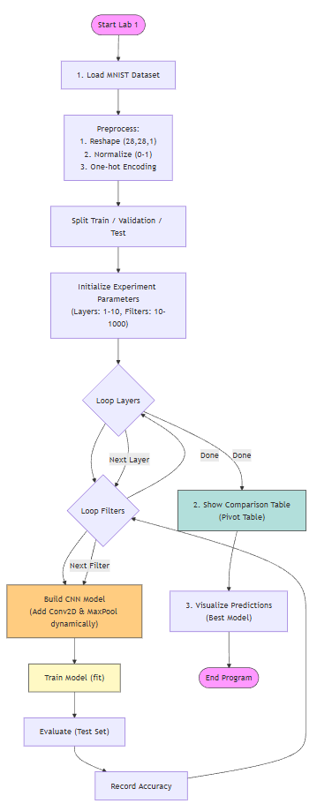
Result:

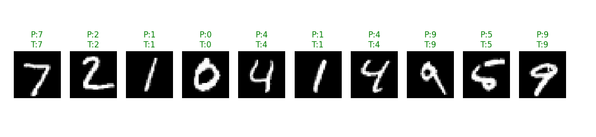

LEB 2: CNN on the Face recognition.
Objective:
- Apply CNN to Face recognition.
Contents:
- Load face recognition library.
- Split the data into training and testing sets.
- Train CNN models.
- Evaluate each model using accuracy.
Output:
- Display sample predictions.
- Compare the results of different network sizes in a table (1–10 Convolutional layers with 10–1000 nodes per layer)
Code:
import tensorflow as tf
from tensorflow.keras import layers, models
import numpy as np
import matplotlib.pyplot as plt
import pandas as pd
from sklearn.model_selection import train_test_split
from sklearn.datasets import fetch_lfw_people
from sklearn.metrics import accuracy_score
import os
physical_devices = tf.config.list_physical_devices('GPU')
if len(physical_devices) > 0:
tf.config.experimental.set_memory_growth(physical_devices[0], True)
def load_data():
print("Loading LFW Faces Dataset...")
try:
lfw_people = fetch_lfw_people(min_faces_per_person=70, resize=0.4)
n_samples, h, w = lfw_people.images.shape
X = lfw_people.images
y = lfw_people.target
target_names = lfw_people.target_names
n_classes = target_names.shape[0]
print(f"Dataset Stats: {n_samples} samples, Image Size: {h}x{w}, Classes: {n_classes}")
print(f"Classes: {target_names}")
X = X.reshape(n_samples, h, w, 1)
if np.max(X) > 1.0:
X = X / 255.0
x_train, x_test, y_train, y_test = train_test_split(X, y, test_size=0.25, random_state=42)

return (x_train, y_train), (x_test, y_test), (h, w, 1), target_names, n_classes
except Exception as e:
print(f"Error loading LFW dataset: {e}")
return None, None, None, None, None
def build_cnn_model(num_layers, num_filters, input_shape, num_classes):
model = models.Sequential()
for i in range(num_layers):
if i == 0:
model.add(layers.Conv2D(num_filters, (3, 3), activation='relu', padding='same', input_shape=input_shape))
else:
model.add(layers.Conv2D(num_filters, (3, 3), activation='relu', padding='same')) if i % 2 == 0:
model.add(layers.MaxPooling2D((2, 2), padding='same'))
model.add(layers.Dropout(0.25))
model.add(layers.Flatten())
model.add(layers.Dense(128, activation='relu'))
model.add(layers.Dropout(0.5))
model.add(layers.Dense(num_classes, activation='softmax'))
model.compile(optimizer='adam',
loss='categorical_crossentropy',
metrics=['accuracy'])
return model
def main():
(x_train, y_train), (x_test, y_test), input_shape, target_names, n_classes = load_data()
if x_train is None:
return

layers_to_test = [1, 2, 3]
filters_to_test = [32, 64]
results = []
print(f"\nStarting Experiment on Face Recognition...")
best_model = None
best_acc = 0
for l in layers_to_test:
for f in filters_to_test:
print(f"\n--- Training CNN: {l} Layers, {f} Filters ---")
try:
model = build_cnn_model(l, f, input_shape, n_classes)
history = model.fit(x_train, y_train, epochs=10, batch_size=32, validation_data=(x_test, y_test), verbose=1)
test_loss, test_acc = model.evaluate(x_test, y_test, verbose=0)
print(f"Result: Accuracy = {test_acc:.4f}")
results.append({
'Conv Layers': l,
'Filters/Nodes': f,
'Test Accuracy': test_acc
})
if test_acc > best_acc:
best_acc = test_acc
best_model = model
except Exception as e:
print(f"Error training {l} layers, {f} filters: {e}")
print("\n" + "="*50)
print(" Experiment Results: CNN Face Recognition")
print("="*50)
df_results = pd.DataFrame(results)
if not df_results.empty:
pivot_table = df_results.pivot(index='Conv Layers', columns='Filters/Nodes', values='Test Accuracy')

print(pivot_table)
print("="*50)

if best_model:
print("\nDisplaying Sample Predictions from Best Model...")
predictions = best_model.predict(x_test[:5])
predicted_ids = np.argmax(predictions, axis=1)
true_ids = np.argmax(y_test[:5], axis=1)
plt.figure(figsize=(15, 4))
for i in range(5):
plt.subplot(1, 5, i+1)
plt.imshow(x_test[i].reshape(input_shape[0], input_shape[1]), cmap='gray')

pred_name = target_names[predicted_ids[i]].split()[-1] # Last name
true_name = target_names[true_ids[i]].split()[-1]
color = 'green' if predicted_ids[i] == true_ids[i] else 'red'
plt.title(f"P:{pred_name}\nT:{true_name}", color=color)
plt.axis('off')
plt.show()

if __name__ == "__main__":
main()

Flowchart:
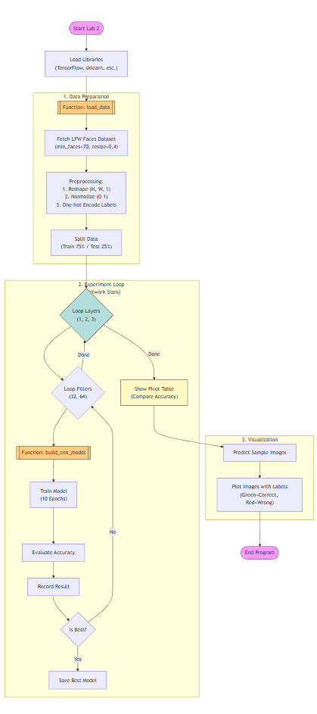
Result:

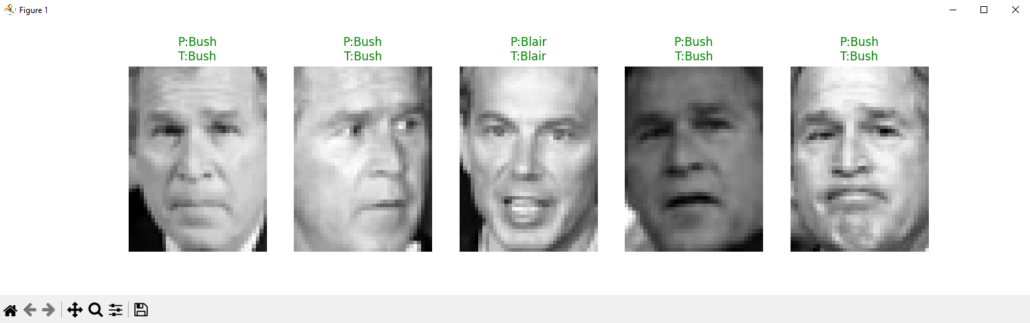

LEB 3: CNN on Iris.csv. Classification.
Link: https://www.kaggle.com/datasets/saurabh00007/iriscsv
Objective:
- Apply CNN to Iris.csv.
Contents:
- Load the iris.csv data from directory dataset.
- Split the data into training and testing sets.
- Train CNN models.
- Evaluate each model using accuracy.
Output:
- Compare the results of different learning rates in a table (10⁻², to 10⁻⁵).
- Compare the results of different network sizes in a table (1–10 Convolutional layers with 10–1000 nodes per layer)

Code:
import tensorflow as tf
from tensorflow.keras import layers, models
import numpy as np
import pandas as pd
import matplotlib.pyplot as plt
from sklearn.model_selection import train_test_split
from sklearn.preprocessing import LabelEncoder, StandardScaler
from sklearn.metrics import accuracy_score
import os

# ตั้งค่า GPU
physical_devices = tf.config.list_physical_devices('GPU')
if len(physical_devices) > 0:
tf.config.experimental.set_memory_growth(physical_devices[0], True)

def load_data(file_path):
print(f"Loading Dataset from {file_path}...")
try:
df = pd.read_csv(file_path)

# แยก Features และ Labels
# สมมติว่า Column สุดท้ายคือ Label (Species)
X = df.iloc[:, 1:-1].values # ตัด Id (ถ้ามี) และ Label
y = df.iloc[:, -1].values

# ถ้ารูปแบบไฟล์ Iris มาตรฐานมักจะมี Id เป็น column แรก หรือไม่มีเลย
# ลองเช็คว่า column แรกเป็นตัวเลขเรียงกันไหม ถ้าใช่ให้ตัดออก
if 'Id' in df.columns or 'id' in df.columns:
X = df.iloc[:, 1:-1].values
else:
X = df.iloc[:, :-1].values

# Encode Label
le = LabelEncoder()
y = le.fit_transform(y)
num_classes = len(np.unique(y))

# Scale Data
scaler = StandardScaler()
X = scaler.fit_transform(X)

# Reshape for Conv1D: (Samples, Features, 1)
# เรามี 4 Features (SepalLength, SepalWidth, PetalLength, PetalWidth)
X = X.reshape(X.shape[0], X.shape[1], 1)

# One-hot encoding
y = tf.keras.utils.to_categorical(y, num_classes)

# Split
x_train, x_test, y_train, y_test = train_test_split(X, y, test_size=0.2, random_state=42)

print(f"Data Shape: {X.shape}, Classes: {num_classes}")
return (x_train, y_train), (x_test, y_test), num_classes, le

except Exception as e:
print(f"Error loading Iris dataset: {e}")
return None, None, None, None

def build_cnn1d_model(num_layers, num_filters, input_shape, num_classes, learning_rate=0.001):
model = models.Sequential()

# 1. Add Conv1D Layers
for i in range(num_layers):
if i == 0:
model.add(layers.Conv1D(num_filters, kernel_size=2, activation='relu', padding='same', input_shape=input_shape))
else:
model.add(layers.Conv1D(num_filters, kernel_size=2, activation='relu', padding='same'))

# MaxPool 1D (Optional, Iris features are few so maybe skip or use size 1/2)
# เนื่องจาก Feature น้อย (4) ถ้า pool มากไปจะเหลือ 0 ทำให้ error
# ใส่ Pool แค่ layer แรกๆ หรือไม่ใส่เลยสำหรับข้อมูลน้อยๆ
if i == 0 and input_shape[0] > 2:
model.add(layers.MaxPooling1D(pool_size=2, padding='same'))

model.add(layers.Flatten())
model.add(layers.Dense(64, activation='relu'))
model.add(layers.Dense(num_classes, activation='softmax'))

optimizer = tf.keras.optimizers.Adam(learning_rate=learning_rate)

model.compile(optimizer=optimizer,
loss='categorical_crossentropy',
metrics=['accuracy'])
return model

def main():
# Path to Iris.csv
file_path = os.path.join(os.path.dirname(__file__), '..', 'dataset', 'Iris.csv')

if not os.path.exists(file_path):
print(f"File not found: {file_path}")
# ลองหาแบบ relative path ปกติ
file_path = 'dataset/Iris.csv'
if not os.path.exists(file_path):
print(f"File strictly not found at {file_path}. Please check path.")
return

# 1. Load Data
(x_train, y_train), (x_test, y_test), num_classes, le = load_data(file_path)

if x_train is None: return

input_shape = (x_train.shape[1], 1)

# --- Experiment 1: Learning Rates ---
print("\n" + "="*50)
print(" Experiment 1: Different Learning Rates")
print(" (Fixed Architecture: 2 Layers, 32 Filters)")
print("="*50)
lrs_to_test = [0.01, 0.001, 0.0001, 0.00001] # 10^-2 to 10^-5
results_lr = []
for lr in lrs_to_test:
print(f"Testing Learning Rate: {lr}")
model = build_cnn1d_model(num_layers=2, num_filters=32, input_shape=input_shape, num_classes=num_classes, learning_rate=lr)
model.fit(x_train, y_train, epochs=50, batch_size=16, verbose=0) # Silent training
loss, acc = model.evaluate(x_test, y_test, verbose=0)
print(f" -> Accuracy: {acc:.4f}")
results_lr.append({'Learning Rate': lr, 'Accuracy': acc})

df_lr = pd.DataFrame(results_lr)
print("\nResults Table (Learning Rate):")
print(df_lr)

# --- Experiment 2: Network Sizes ---
print("\n" + "="*50)
print(" Experiment 2: Network Sizes (Layers & Nodes)")
print(" (Fixed Learning Rate: 0.001)")
print("="*50)

layers_to_test = [1, 2, 3] # สามารถเพิ่มถึง 10 ได้
filters_to_test = [16, 32, 64, 128] # สามารถเพิ่มถึง 1000 ได้
results_size = []

for l in layers_to_test:
for f in filters_to_test:
print(f"Testing: {l} Layers, {f} Filters...")
try:
model = build_cnn1d_model(num_layers=l, num_filters=f, input_shape=input_shape, num_classes=num_classes)
model.fit(x_train, y_train, epochs=30, batch_size=16, verbose=0)
loss, acc = model.evaluate(x_test, y_test, verbose=0)
results_size.append({'Layers': l, 'Filters': f, 'Accuracy': acc})
except Exception as e:
print(f"Error: {e}")

df_size = pd.DataFrame(results_size)
pivot_size = df_size.pivot(index='Layers', columns='Filters', values='Accuracy')
print("\nResults Table (Network Sizes):")
print(pivot_size)
print("="*50)

if __name__ == "__main__":
main()
Flowchart:
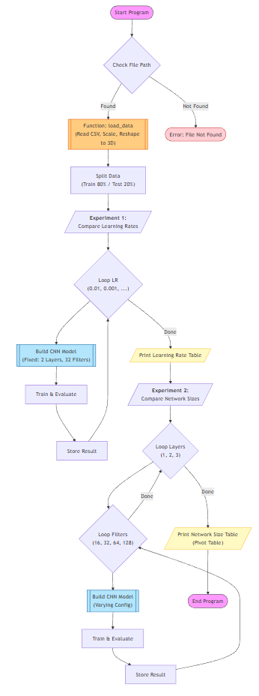

Result:

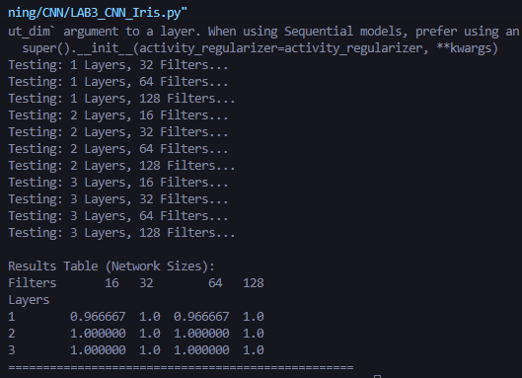

LEB 4: CNN on Microscopic Fungi Classification
Link: https://www.kaggle.com/datasets/anshtanwar/microscopic-fungi-images
Objective:
- Apply CNN to Fungi classify.
Contents:
- Load the Fungi dataset from directory.
- Split the data into training and testing sets.
- Train CNN models.
- Evaluate each model using accuracy.
Output:
- Classification accuracy on the test set.
- Compare the results of different network sizes in a table (1–10 Convolutional layers with 10–1000 nodes per layer)
- Compare the results of different learning rates in a table (10⁻², to 10⁻⁵)

Code or Algorithms:
import tensorflow as tf
from tensorflow.keras import layers, models
import numpy as np
import pandas as pd
import matplotlib.pyplot as plt
import os
import pathlib

# ตั้งค่า GPU
physical_devices = tf.config.list_physical_devices('GPU')
if len(physical_devices) > 0:
tf.config.experimental.set_memory_growth(physical_devices[0], True)

def get_dataset_paths():
# หา path ของ dataset
base_dir = os.path.dirname(__file__)
dataset_dir = os.path.join(base_dir, '..', 'dataset', 'fungi')

# Check
if not os.path.exists(dataset_dir):
# Fallback path if running from root
dataset_dir = 'dataset/fungi'

train_dir = os.path.join(dataset_dir, 'train')
valid_dir = os.path.join(dataset_dir, 'valid')
test_dir = os.path.join(dataset_dir, 'test')

return train_dir, valid_dir, test_dir

def load_data(img_size=(150, 150), batch_size=32):
train_dir, valid_dir, test_dir = get_dataset_paths()

print(f"Loading data from: {train_dir}")

if not os.path.exists(train_dir):
print(f"Error: Directory not found!")
return None, None, None, None

# Load using image_dataset_from_directory
train_ds = tf.keras.utils.image_dataset_from_directory(
train_dir,
seed=123,
image_size=img_size,
batch_size=batch_size,
label_mode='categorical'
)

val_ds = tf.keras.utils.image_dataset_from_directory(
valid_dir,
seed=123,
image_size=img_size,
batch_size=batch_size,
label_mode='categorical'
)

test_ds = tf.keras.utils.image_dataset_from_directory(
test_dir,
seed=123,
image_size=img_size,
batch_size=batch_size,
label_mode='categorical'
)

class_names = train_ds.class_names
num_classes = len(class_names)
print(f"Found {num_classes} classes: {class_names}")

# Optimize datasets
AUTOTUNE = tf.data.AUTOTUNE
train_ds = train_ds.cache().shuffle(1000).prefetch(buffer_size=AUTOTUNE)
val_ds = val_ds.cache().prefetch(buffer_size=AUTOTUNE)
test_ds = test_ds.cache().prefetch(buffer_size=AUTOTUNE)

return train_ds, val_ds, test_ds, class_names

def build_cnn_model(num_layers, num_filters, input_shape, num_classes, learning_rate=0.001):
model = models.Sequential()

# Rescaling Layer
model.add(layers.Rescaling(1./255, input_shape=input_shape))

# Conv Layers
for i in range(num_layers):
if i == 0:
model.add(layers.Conv2D(num_filters, (3, 3), activation='relu', padding='same'))
else:
model.add(layers.Conv2D(num_filters, (3, 3), activation='relu', padding='same'))

if i % 2 == 0:
model.add(layers.MaxPooling2D((2, 2)))

model.add(layers.Flatten())
model.add(layers.Dense(64, activation='relu'))
model.add(layers.Dense(num_classes, activation='softmax'))

optimizer = tf.keras.optimizers.Adam(learning_rate=learning_rate)

model.compile(optimizer=optimizer,
loss='categorical_crossentropy',
metrics=['accuracy'])
return model

def main():
IMG_SIZE = (150, 150)
BATCH_SIZE = 32

train_ds, val_ds, test_ds, class_names = load_data(IMG_SIZE, BATCH_SIZE)

if train_ds is None: return

input_shape = IMG_SIZE + (3,)
num_classes = len(class_names)

# --- Experiment 1: Learning Rates ---
print("\n" + "="*50)
print(" Experiment 1: Different Learning Rates")
print(" (Fixed Architecture: 2 Layers, 32 Filters)")
print("="*50)

lrs_to_test = [0.01, 0.001, 0.0001, 0.00001]
results_lr = []

for lr in lrs_to_test:
print(f"Testing Learning Rate: {lr}")
model = build_cnn_model(num_layers=2, num_filters=32, input_shape=input_shape, num_classes=num_classes, learning_rate=lr)

# Train (Short epochs for demo)
model.fit(train_ds, validation_data=val_ds, epochs=3, verbose=1)

loss, acc = model.evaluate(test_ds, verbose=0)
print(f" -> Accuracy: {acc:.4f}")
results_lr.append({'Learning Rate': lr, 'Accuracy': acc})

df_lr = pd.DataFrame(results_lr)
print("\nResults Table (Learning Rate):")
print(df_lr)

# --- Experiment 2: Network Sizes ---
print("\n" + "="*50)
print(" Experiment 2: Network Sizes (Layers & Nodes)")
print(" (Fixed Learning Rate: 0.001)")
print("="*50)

layers_to_test = [1, 2, 3]
filters_to_test = [32, 64]
results_size = []

best_model = None
best_acc = 0

for l in layers_to_test:
for f in filters_to_test:
print(f"\nTesting: {l} Layers, {f} Filters...")
try:
model = build_cnn_model(num_layers=l, num_filters=f, input_shape=input_shape, num_classes=num_classes)
model.fit(train_ds, validation_data=val_ds, epochs=3, verbose=1)

loss, acc = model.evaluate(test_ds, verbose=0)
results_size.append({'Layers': l, 'Filters': f, 'Accuracy': acc})

if acc > best_acc:
best_acc = acc
best_model = model

except Exception as e:
print(f"Error: {e}")

df_size = pd.DataFrame(results_size)
if not df_size.empty:
pivot_size = df_size.pivot(index='Layers', columns='Filters', values='Accuracy')
print("\nResults Table (Network Sizes):")
print(pivot_size)
print("="*50)

# Output Predictions
if best_model:
print("\nSample Predictions from Best Model:")
plt.figure(figsize=(15, 5))
for images, labels in test_ds.take(1):
predictions = best_model.predict(images)
for i in range(5):
ax = plt.subplot(1, 5, i + 1)
plt.imshow(images[i].numpy().astype("uint8"))

pred_label = class_names[np.argmax(predictions[i])]
true_label = class_names[np.argmax(labels[i])]

color = 'green' if pred_label == true_label else 'red'
plt.title(f"P:{pred_label}\nT:{true_label}", color=color)
plt.axis("off")
plt.show()

if __name__ == "__main__":
main()

Flowchart :
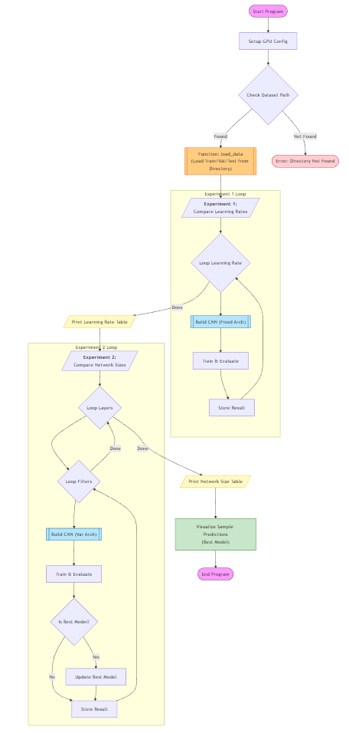
Result:
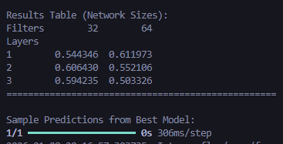
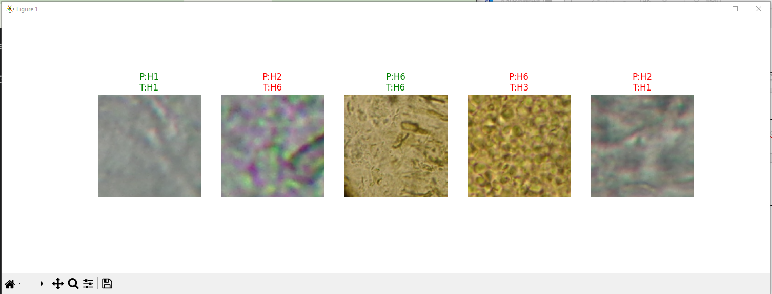

LEB 5: CNN for Blood Cells
Link: https://www.kaggle.com/datasets/unclesamulus/blood-cells-image-dataset
Objective:
- Apply CNN to Blood Cells classify.
Contents:
- Load the Blood Cells dataset from directory.
- Split the data into training and testing sets.
- Train CNN models.
- Evaluate each model using accuracy
Output:
- Classification accuracy on the test set.
- Compare the results of different network sizes in a table (1–10 Convolutional layers with 10–1000 nodes per layer)
- Compare the results of different learning rates in a table (10⁻², to 10⁻⁵).

Code or Algorithms:

import tensorflow as tf
from tensorflow.keras import layers, models
import numpy as np
import pandas as pd
import matplotlib.pyplot as plt
import os

# ตั้งค่า GPU
physical_devices = tf.config.list_physical_devices('GPU')
if len(physical_devices) > 0:
tf.config.experimental.set_memory_growth(physical_devices[0], True)

def get_dataset_path():
base_dir = os.path.dirname(__file__)
dataset_dir = os.path.join(base_dir, '..', 'dataset', 'bloodcells')

if not os.path.exists(dataset_dir):
# Fallback
dataset_dir = 'dataset/bloodcells'

return dataset_dir

def load_data(img_size=(150, 150), batch_size=32):
dataset_dir = get_dataset_path()
print(f"Loading data from: {dataset_dir}")

if not os.path.exists(dataset_dir):
print(f"Error: Directory not found!")
return None, None, None

# Load and split using validation_split
# Subset 'training' -> Train set
train_ds = tf.keras.utils.image_dataset_from_directory(
dataset_dir,
validation_split=0.2, # 20% for test
subset="training",
seed=123,
image_size=img_size,
batch_size=batch_size,
label_mode='categorical'
)

# Subset 'validation' -> Test set (in this context)
test_ds = tf.keras.utils.image_dataset_from_directory(
dataset_dir,
validation_split=0.2,
subset="validation",
seed=123,
image_size=img_size,
batch_size=batch_size,
label_mode='categorical'
)
class_names = train_ds.class_names
num_classes = len(class_names)
print(f"Found {num_classes} classes: {class_names}")
AUTOTUNE = tf.data.AUTOTUNE
train_ds = train_ds.cache().shuffle(1000).prefetch(buffer_size=AUTOTUNE)
test_ds = test_ds.cache().prefetch(buffer_size=AUTOTUNE)
return train_ds, test_ds, class_names
def build_cnn_model(num_layers, num_filters, input_shape, num_classes, learning_rate=0.001):
model = models.Sequential()
model.add(layers.Rescaling(1./255, input_shape=input_shape))

for i in range(num_layers):
if i == 0:
model.add(layers.Conv2D(num_filters, (3, 3), activation='relu', padding='same'))
else:
model.add(layers.Conv2D(num_filters, (3, 3), activation='relu', padding='same'))
if i % 2 == 0:
model.add(layers.MaxPooling2D((2, 2)))
model.add(layers.Flatten())
model.add(layers.Dense(64, activation='relu'))
model.add(layers.Dense(num_classes, activation='softmax'))
optimizer = tf.keras.optimizers.Adam(learning_rate=learning_rate)
model.compile(optimizer=optimizer,
loss='categorical_crossentropy',
metrics=['accuracy'])
return model
def main():
IMG_SIZE = (150, 150)
BATCH_SIZE = 32
train_ds, test_ds, class_names = load_data(IMG_SIZE, BATCH_SIZE)
if train_ds is None: return
input_shape = IMG_SIZE + (3,)
num_classes = len(class_names)
print("\n" + "="*50)
print(" Experiment 1: Different Learning Rates")
print(" (Fixed Architecture: 2 Layers, 32 Filters)")
print("="*50)
lrs_to_test = [0.01, 0.001, 0.0001, 0.00001]
results_lr = []
for lr in lrs_to_test:
print(f"Testing Learning Rate: {lr}")
model = build_cnn_model(num_layers=2, num_filters=32, input_shape=input_shape, num_classes=num_classes, learning_rate=lr)
mode = model.fit(train_ds, epochs=3, verbose=1) # 3 epochs for speed
loss, acc = model.evaluate(test_ds, verbose=0)
print(f" -> Accuracy: {acc:.4f}")
results_lr.append({'Learning Rate': lr, 'Accuracy': acc})
df_lr = pd.DataFrame(results_lr)
print("\nResults Table (Learning Rate):")
print(df_lr)
print("\n" + "="*50)
print(" Experiment 2: Network Sizes (Layers & Nodes)")
print(" (Fixed Learning Rate: 0.001)")
print("="*50)
layers_to_test = [1, 2, 3]
filters_to_test = [32, 64]
results_size = []
best_model = None
best_acc = 0
for l in layers_to_test:
for f in filters_to_test:
print(f"\nTesting: {l} Layers, {f} Filters...")
try:
model = build_cnn_model(num_layers=l, num_filters=f, input_shape=input_shape, num_classes=num_classes)
model.fit(train_ds, epochs=3, verbose=1)
loss, acc = model.evaluate(test_ds, verbose=0)
results_size.append({'Layers': l, 'Filters': f, 'Accuracy': acc})
if acc > best_acc:
best_acc = acc
best_model = model
except Exception as e:
print(f"Error: {e}")
df_size = pd.DataFrame(results_size)
if not df_size.empty:
pivot_size = df_size.pivot(index='Layers', columns='Filters', values='Accuracy')
print("\nResults Table (Network Sizes):")
print(pivot_size)
print("="*50)
if best_model:
print("\nSample Predictions from Best Model:")
plt.figure(figsize=(15, 5))
for images, labels in test_ds.take(1):
predictions = best_model.predict(images)
for i in range(5):
ax = plt.subplot(1, 5, i + 1)
plt.imshow(images[i].numpy().astype("uint8"))
pred_label = class_names[np.argmax(predictions[i])]
true_label = class_names[np.argmax(labels[i])]
color = 'green' if pred_label == true_label else 'red'
plt.title(f"P:{pred_label}\nT:{true_label}", color=color)
plt.axis("off")
plt.show()
if __name__ == "__main__":
main()

Flowchart :

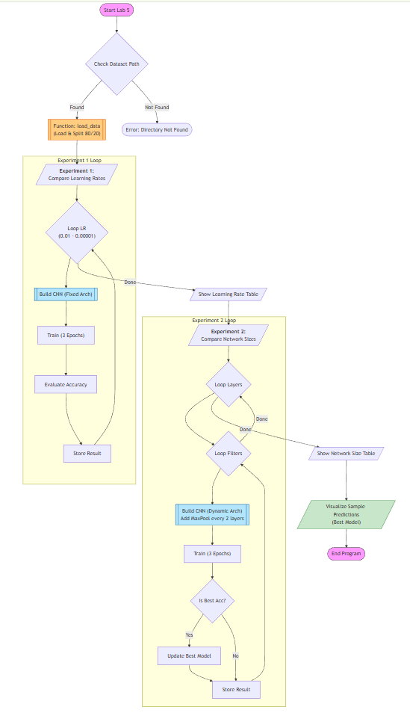
Result:
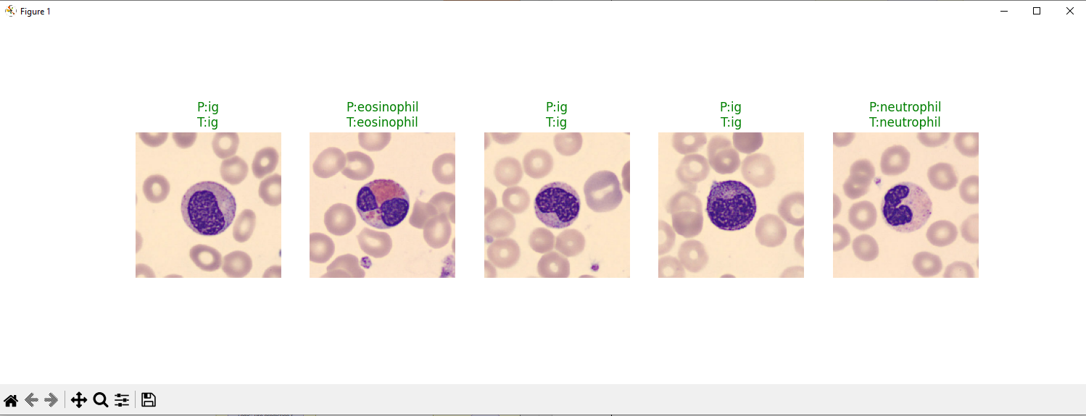

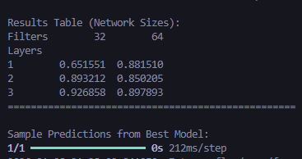

LEB 6: CNN with Smoothed COVID-19 Data.
LINK: https://www.kaggle.com/datasets/hosammhmdali/covid-19-dataset
Objective:
- Apply CNN to Smoothed COVID-19 Data (.CSV) (THA).
Contents:
- Load the smoothed COVID-19 dataset from a CSV file.
- Preprocess the data and split it into training and testing sets.
- Construct and train CNN models (1-10 convolutional layers with 10–1000 nodes per layer).
- Evaluate the performance of each CNN model using the accuracy metric.
Output:
- Accuracy score of each CNN for comparison across different layers and nodes.
- Time-series plots comparing: Actual, Smoothed Trend, and CNN Forecast for 3-month and 6-month forecasting horizons, like the provided example figure.

Code or Algorithms:
import tensorflow as tf
from tensorflow.keras import layers, models
import numpy as np
import pandas as pd
import matplotlib.pyplot as plt
from sklearn.preprocessing import MinMaxScaler
from sklearn.metrics import mean_absolute_error, mean_squared_error
import os

# ตั้งค่า GPU
physical_devices = tf.config.list_physical_devices('GPU')
if len(physical_devices) > 0:
tf.config.experimental.set_memory_growth(physical_devices[0], True)

def load_data():
base_dir = os.path.dirname(__file__)
file_path = os.path.join(base_dir, '..', 'dataset', 'covid', 'owid-covid-data.csv')

if not os.path.exists(file_path):
# Fallback
file_path = 'dataset/covid/owid-covid-data.csv'
if not os.path.exists(file_path):
print(f"Error: File not found at {file_path}")
return None

print(f"Loading data from {file_path}...")
df = pd.read_csv(file_path)

# 1. Filter for Thailand
df_tha = df[df['iso_code'] == 'THA'].copy()

# 2. Select target: new_cases_smoothed
# Fill NaN with 0 for early days
df_tha['new_cases_smoothed'] = df_tha['new_cases_smoothed'].fillna(0)

# Sort by date
df_tha['date'] = pd.to_datetime(df_tha['date'])
df_tha = df_tha.sort_values('date')

data = df_tha['new_cases_smoothed'].values.reshape(-1, 1)
dates = df_tha['date'].values

print(f"Loaded Thailand data: {len(data)} days.")
return data, dates

def create_sequences(data, lookback_window=30):
X, y = [], []
for i in range(len(data) - lookback_window):
X.append(data[i:i+lookback_window])
y.append(data[i+lookback_window])
return np.array(X), np.array(y)

def build_cnn1d_regression(num_layers, num_nodes, input_shape):
model = models.Sequential()

for i in range(num_layers):
if i == 0:
model.add(layers.Conv1D(num_nodes, kernel_size=3, activation='relu', padding='same', input_shape=input_shape))
else:
model.add(layers.Conv1D(num_nodes, kernel_size=3, activation='relu', padding='same'))

if i % 2 == 0:
model.add(layers.MaxPooling1D(pool_size=2, padding='same'))

model.add(layers.Flatten())
model.add(layers.Dense(64, activation='relu'))
model.add(layers.Dense(1, activation='linear')) # Regression

model.compile(optimizer='adam', loss='mse', metrics=['mae'])
return model

def calculate_accuracy(y_true, y_pred):
# Custom "Accuracy" for regression: 1 - (MAE / Mean)
mae = mean_absolute_error(y_true, y_pred)
mean_val = np.mean(y_true)
if mean_val == 0: return 0
accuracy = (1 - (mae / mean_val)) * 100
return max(0, accuracy)

def main():
# 1. Load Data
data, dates = load_data()
if data is None: return

# 2. Preprocess
scaler = MinMaxScaler(feature_range=(0, 1))
data_scaled = scaler.fit_transform(data)

LOOKBACK = 30
X, y = create_sequences(data_scaled, LOOKBACK)

# Split Train/Test (Time series split, no shuffle)
split_size = int(len(X) * 0.8)
X_train, y_train = X[:split_size], y[:split_size]
X_test, y_test = X[split_size:], y[split_size:]

print(f"Train size: {len(X_train)}, Test size: {len(X_test)}")

input_shape = (LOOKBACK, 1)

# --- Experiment: Network Sizes ---
print("\n" + "="*50)
print(" Experiment: Network Sizes (Layers & Nodes)")
print("="*50)

layers_to_test = [1, 2, 3]
nodes_to_test = [32, 64, 128]
results = []

best_model = None
best_acc = 0

for l in layers_to_test:
for n in nodes_to_test:
print(f"Testing: {l} Layers, {n} Nodes...")
model = build_cnn1d_regression(l, n, input_shape)

model.fit(X_train, y_train, epochs=20, batch_size=32, verbose=0)

loss, mae = model.evaluate(X_test, y_test, verbose=0)

# Predict for accuracy calculation
pred_scaled = model.predict(X_test, verbose=0)
pred = scaler.inverse_transform(pred_scaled)
actual = scaler.inverse_transform(y_test)

acc = calculate_accuracy(actual, pred)

results.append({'Layers': l, 'Nodes': n, 'Accuracy (%)': acc})

if acc > best_acc:
best_acc = acc
best_model = model

df_results = pd.DataFrame(results)
pivot_table = df_results.pivot(index='Layers', columns='Nodes', values='Accuracy (%)')
print("\nResults Table (Forecast Accuracy %):")
print(pivot_table)
print("="*50)

# --- Forecasting (3 & 6 Months) ---
if best_model:
print("\nGenerating Forecasts...")

# Helper to forecast n steps
def forecast_future(model, last_sequence, n_steps):
future_forecast = []
curr_seq = last_sequence.copy()

for _ in range(n_steps):
# Predict next point
# curr_seq shape (LOOKBACK, 1) -> (1, LOOKBACK, 1)
next_pred = model.predict(curr_seq.reshape(1, LOOKBACK, 1), verbose=0)[0, 0]
future_forecast.append(next_pred)

# Update sequence: remove first, add pred
curr_seq = np.roll(curr_seq, -1)
curr_seq[-1] = next_pred

return np.array(future_forecast).reshape(-1, 1)

# Use the very last data sequence to predict into unknown future
last_seq = data_scaled[-LOOKBACK:]

# 3 Months ~ 90 Days
forecast_3m = forecast_future(best_model, last_seq, 90)
forecast_3m = scaler.inverse_transform(forecast_3m)

# 6 Months ~ 180 Days
forecast_6m = forecast_future(best_model, last_seq, 180)
forecast_6m = scaler.inverse_transform(forecast_6m)

# Plotting
plt.figure(figsize=(12, 6))

# Plot only last 365 days of actual data for clarity
plt.plot(dates[-365:], scaler.inverse_transform(data_scaled)[-365:], label='Actual (Smoothed)', color='blue')

# Generate future dates
last_date = dates[-1]
dates_3m = pd.date_range(start=last_date, periods=91)[1:]
dates_6m = pd.date_range(start=last_date, periods=181)[1:]

plt.plot(dates_6m, forecast_6m, label='6-Month Forecast', color='red', linestyle='--')
plt.plot(dates_3m, forecast_3m, label='3-Month Forecast', color='orange', linestyle='--')

plt.title('COVID-19 Thailand: Smoothed Cases vs CNN Forecast')
plt.xlabel('Date')
plt.ylabel('New Cases Smoothed')
plt.legend()
plt.grid(True)
plt.show()

if __name__ == "__main__":
main()AI

Flowchart:
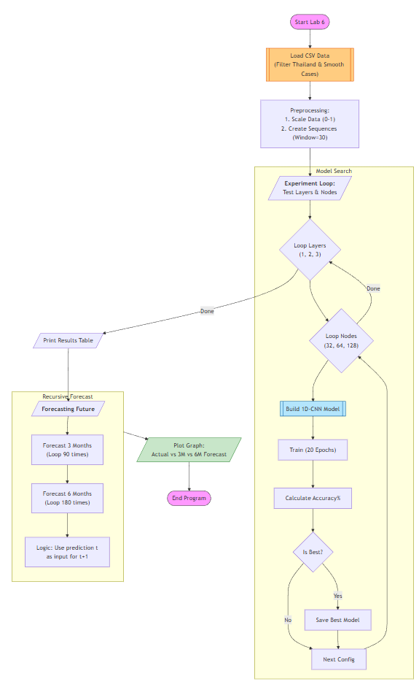

Result:
