CleanGuard
Mobile-First Restroom Environmental Monitoring Platform
학교 및 기숙사 화장실 동파 방지 및 환경 관리 플랫폼

1. System Architecture
CleanGuard is a layered IoT-to-dashboard system. ESP8266 sensor nodes publish JSON readings over HTTP to a PHP REST API, which validates and stores them in MySQL. A Raspberry Pi periodically reads that stored data, runs the AI prediction model, and writes its results back into MySQL through the same database layer. The React dashboard (desktop and mobile) never queries MySQL directly and never runs AI inference — it only calls REST endpoints and renders the JSON they return.
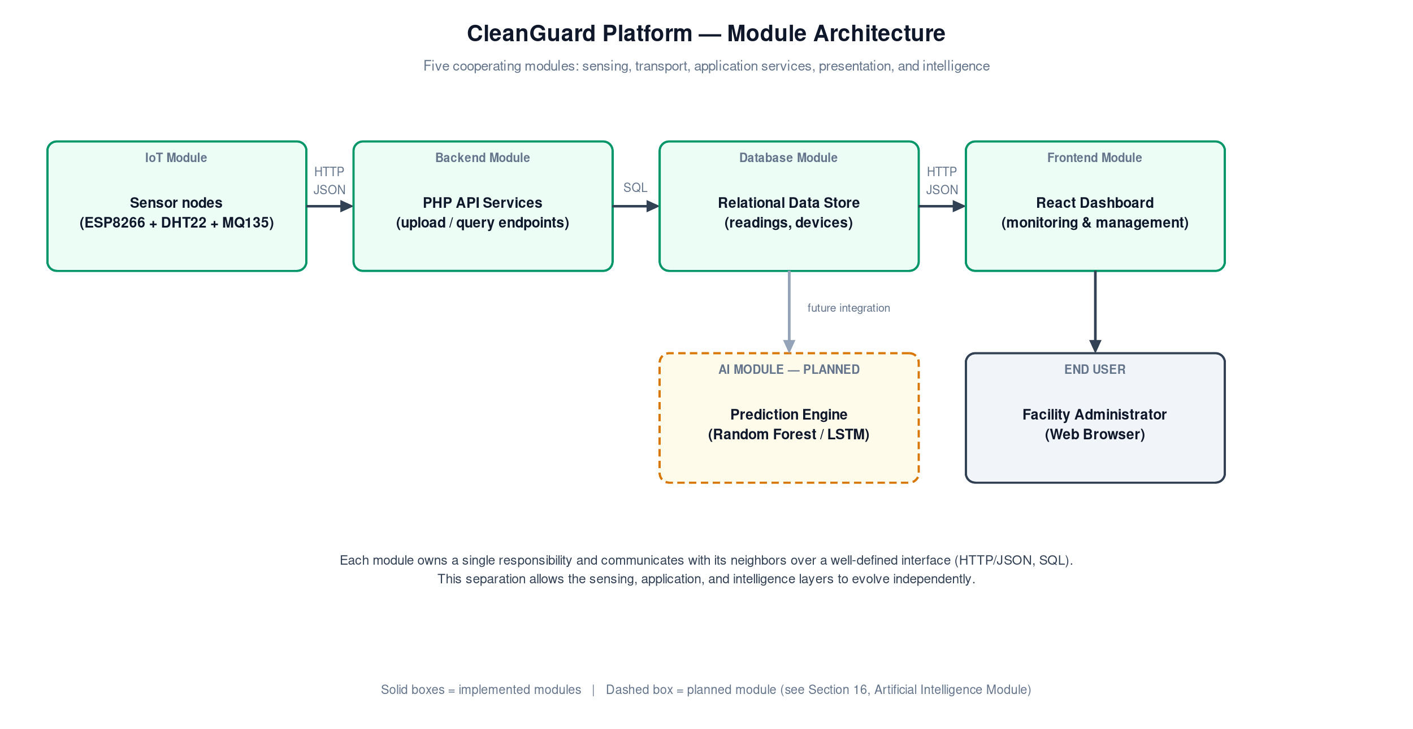
Figure 1 — System architecture and data flow: sensor nodes, transport, backend, storage, edge AI, and presentation.
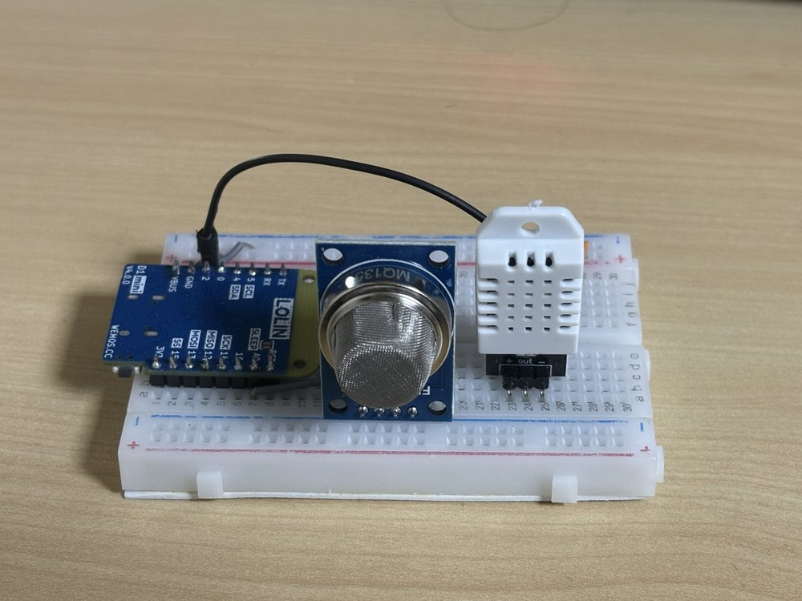
Figure 2 — ESP8266 (Wemos D1) node with a DHT22 temperature/humidity sensor and an MQ-135 air-quality sensor, the physical source of every reading in Figure 1.
Layer | Technology | Responsibility
Sensing | ESP8266 + DHT22 + MQ-135 | Reads temperature, humidity, and air quality; uploads JSON over HTTP.
Transport | HTTP / JSON | Carries sensor uploads and all API requests and responses.
Backend | PHP REST endpoints | Validates requests, executes SQL, returns JSON (e.g. getSensors.php, getAIStatus.php).
Storage | MySQL | Persists devices, sensor_data, and AI prediction data.
Edge AI | Raspberry Pi + AI model | Reads sensor_data; predicts window, faucet, leak, and freeze status; writes to restroom_sencor_fake_data.
Presentation | React 19 + Vite | Calls REST endpoints and renders results; no direct database access, no inference.

2. University Monitoring Screen
The main dashboard is the platform's primary monitoring interface. From a single screen, administrators see the live condition of every monitored restroom across the university, refreshed automatically in Live and Test mode.
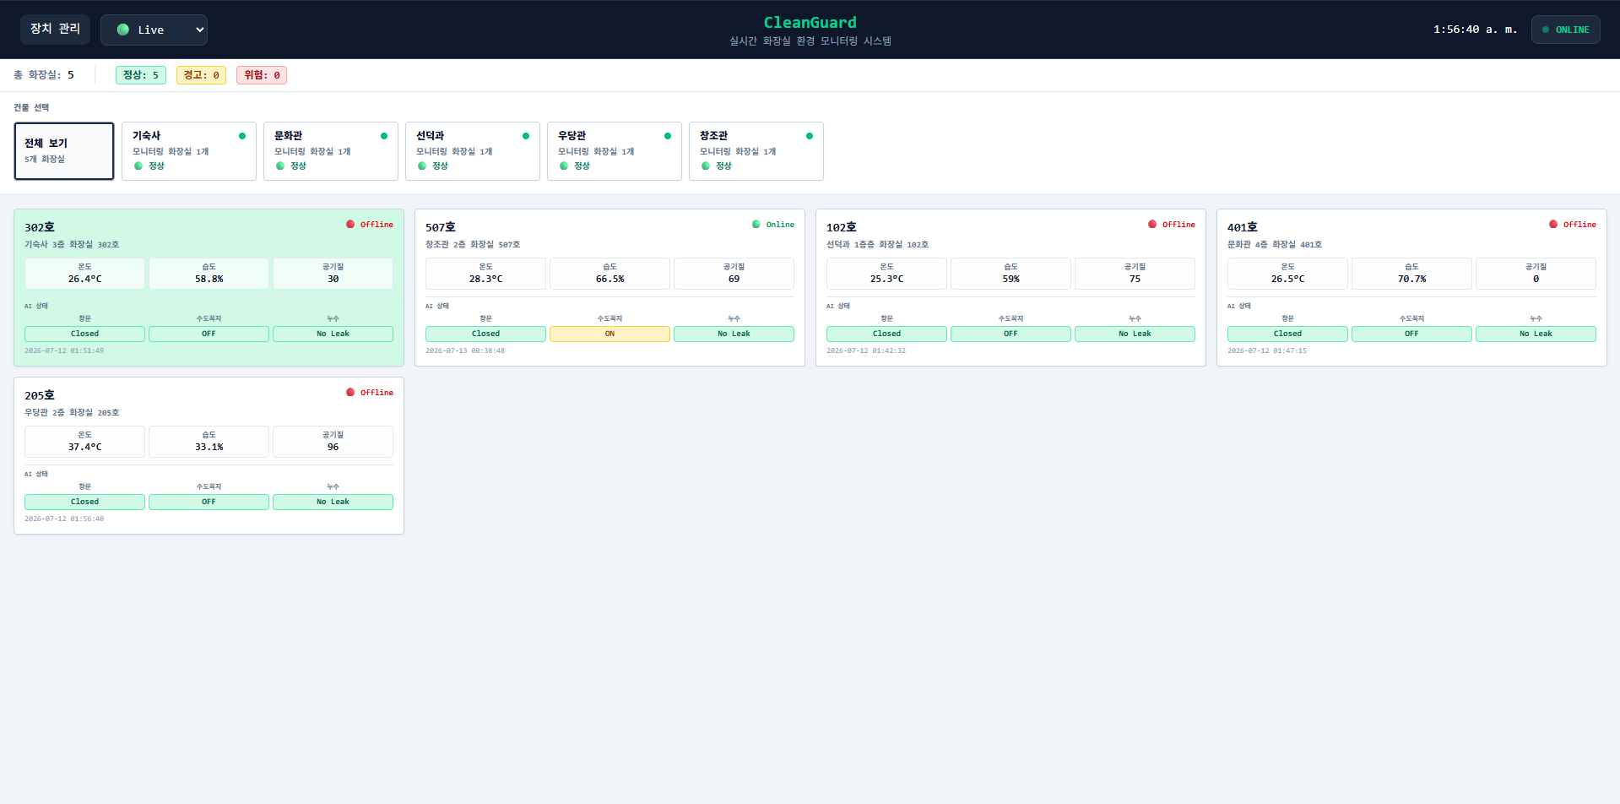
Figure 3 — University monitoring dashboard: summary counts, building selector, and real-time restroom status.
Element | What It Shows
Summary bar | Total restroom count and Normal / Warning / Danger totals across the university.
Building selector | "전체 보기" for all buildings, or a chip per building (Section 3).
Restroom cards | One card per monitored restroom, with device ID and room name.
Status color | Green / Yellow / Red badge reflecting the current Normal / Warning / Danger classification.
Temperature, Humidity, Air Quality | Latest reading from that restroom's sensor node.
Live monitoring | Live and Test modes auto-refresh every few seconds; no manual reload needed.
AI Analysis section | Window, Faucet, and Leak status.

3. Building Monitoring Screen
Selecting a building chip in the building selector (Figure 3) filters the restroom grid to that building only, without leaving the screen or navigating to a different route — the University Monitoring Screen and the Building Monitoring Screen are the same component (BuildingSelector + restroom grid) in two filter states.
In the current deployment only one building (기숙사) and one device are registered, so Figure 3 already shows that building selected; the filtering logic itself applies to any number of buildings without code changes, since it filters the same restroom list on the client by the selected building name.
Behavior | Description
Selecting "전체 보기" | Shows every monitored restroom across all buildings.
Selecting a building chip | Filters the grid to that building's restrooms only.
Chip status dot | Reflects the worst status (Normal / Warning / Danger) among that building's restrooms.
Chip restroom count | Number of restrooms currently monitored in that building.

4. Restroom Detail Screen
Selecting a restroom card opens a detail view for one restroom: current readings, a historical trend chart, device information, and the AI Analysis section (Section 5). The same detail view is shared between desktop and mobile (Section 6); Figure 4 shows the mobile rendering.
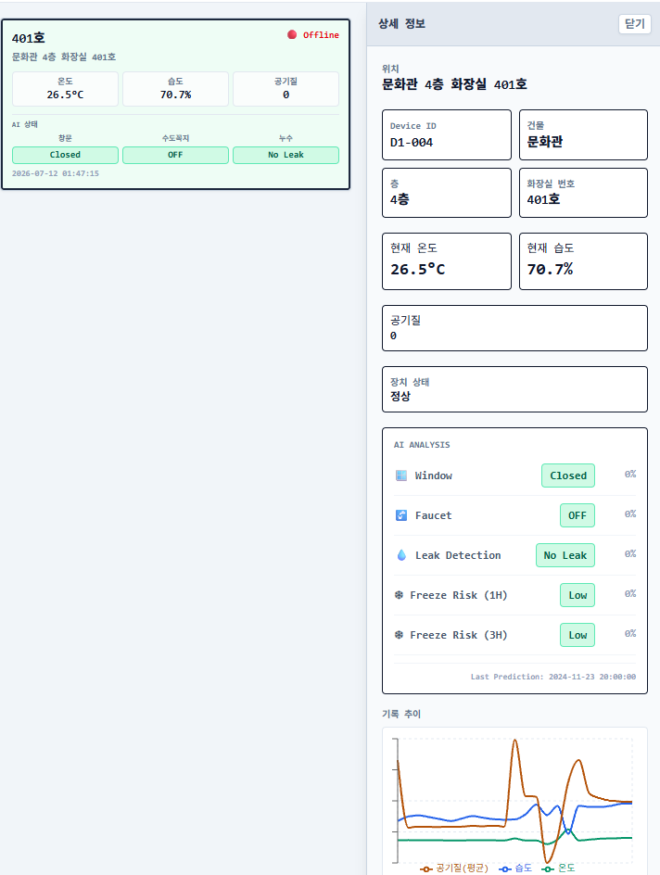
Figure 4 — Restroom detail screen: device information, live readings, historical chart, and AI Analysis.
Field | Description
Device information | Device ID, building, floor, and restroom number.
Temperature / Humidity | Current readings for the selected restroom.
Air quality | Current MQ-135 reading for the selected restroom.
Historical chart | Recent temperature / humidity / air-quality trend for this device.
Current status | Normal / Warning / Danger classification, matching the dashboard's color code.
AI Analysis section | Window, Faucet, and Leak status plus Freeze Risk (1H / 3H), each with a confidence score (Section 5).

5. AI Analysis
ESP8266 nodes continuously upload readings to sensor_data in MySQL. A Raspberry Pi runs the AI model against that data and writes its results into a dedicated table, restroom_sencor_fake_data. The dashboard reads and displays those results through one endpoint, getAIStatus.php — it does not run the AI model itself and performs no calculation on the prediction values.
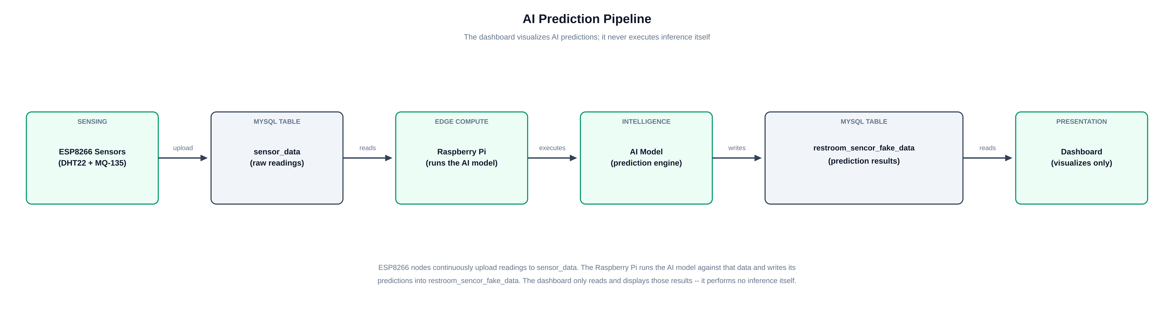
Figure 5 — AI prediction pipeline: sensing, edge inference, and dashboard visualization are separate stages.

5.1 AI Predictions
The following predictions are produced by the AI model and displayed as returned; the reviewer's proposed workflow additionally lists an odor/smell classification, which is not part of the current AI model or database schema and is listed as future work (Section 9).
Prediction | Output
Window Detection | Open / Closed, with a confidence score.
Faucet Detection | ON / OFF, with a confidence score.
Leak Detection | Leak / No Leak, with a confidence score.
Freeze Risk (1 Hour) | Low / Medium / High risk level, with a confidence score.
Freeze Risk (3 Hours) | Low / Medium / High risk level, with a confidence score.
When no prediction row exists yet for a device, the dashboard shows "Waiting for AI prediction..." (Live/Test) or "No AI prediction available." (History) rather than a fabricated value (Figure 4).

6. Mobile Application
CleanGuard is now presented primarily as a smartphone application, one of the most significant changes in this revision. Below a phone-width breakpoint, the dashboard automatically switches to a dedicated mobile layout: full-screen pages with a sticky header, touch-sized restroom cards, and native-style back navigation replace the desktop side panel. Every mobile screen calls the same PHP/MySQL REST API as the desktop version — no functionality is duplicated or reimplemented for mobile.
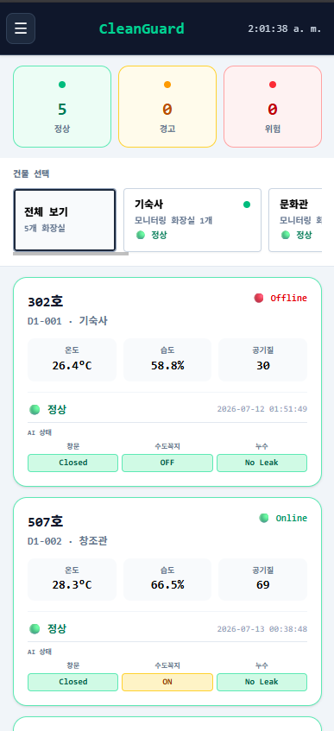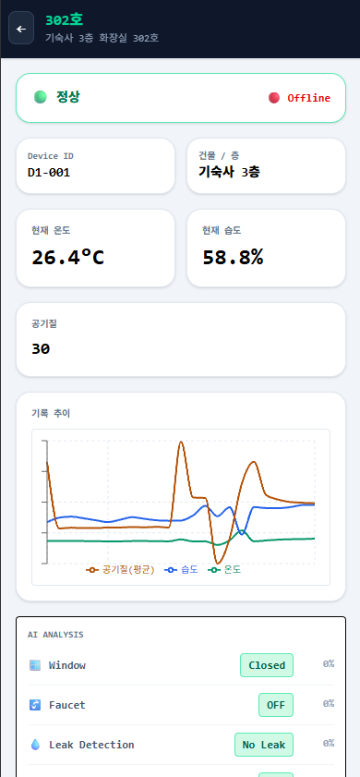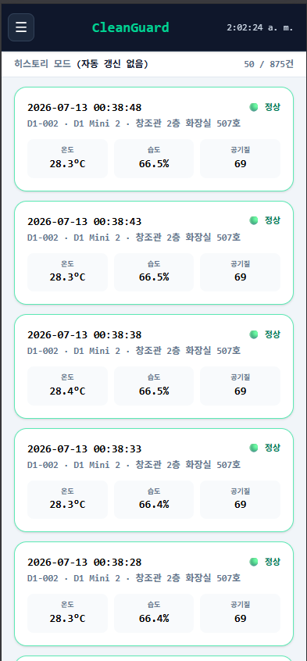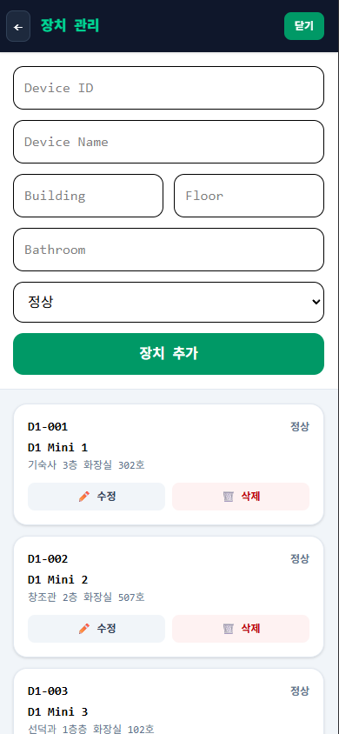
Figure 6 — Mobile application: main dashboard, detail page, history page, and device management
Screen | Purpose
Main dashboard | Summary cards, building selector, and scrollable restroom list (Figure 6, left).
Detail page | Full-screen restroom detail, reached by tapping a card; reused across Live / Test / History
History page | Paginated log of past readings
Device management | Add / edit / delete sensor nodes from a phone
AI Analysis | Same real-time prediction results shown on desktop, adapted to a mobile card
Responsive Design & Tablet Support
• Layout switches automatically by viewport width (useIsMobile hook); no separate app build is required.
• Navigation is touch-first: tap targets sized for fingers, back-arrow navigation instead of desktop side panels.
• Tablet-optimized layout is planned but not yet implemented; tablets currently render the desktop layout (Section 9).

7. History Mode
History Mode replaces Live/Test's auto-refreshing view with a paginated log of past sensor readings across all devices. Selecting a historical record opens the same detail panel used in Live/Test (Section 4), matched to its own AI prediction by timestamp rather than showing the latest prediction: getAIStatus.php looks up the restroom_sencor_fake_data row whose created_at is within 300 seconds of the selected record's timestamp. If no prediction falls within that window, the panel reports that none is available instead of attaching an unrelated result.
Behavior | Description
Auto-refresh | Disabled; the operator explicitly loads more records instead of a live poll.
Pagination | Record count bar ("표시 중: N / 총 M건" desktop, "N / M건" mobile), loaded in pages.
Record selection | Opens the shared detail panel for that specific historical reading.
AI prediction match | Nearest restroom_sencor_fake_data row within +/-5 minutes of the record's timestamp.
No match found | Panel shows "No AI prediction available." rather than a mismatched or simulated result.
The mobile History screen is shown in Figure 6 (center panel).

8. Device Management
Device Management provides full CRUD (Create, Read, Update, Delete) control over registered sensor nodes, available on both desktop (table view) and mobile (card-list view, Figure 6 right panel). This lets administrators register new hardware, correct a device's building/floor/room assignment, or retire a device without editing the database directly.
Operation | Endpoint | Description
Create | addDevice.php | Registers a new device (ID, building, floor, room, status).
Read | getDevices.php | Lists all registered devices for the management view.
Update | updateDevice.php | Edits a device's building / floor / room / status metadata.
Delete | deleteDevice.php | Removes a device from the devices table.

9. Current Implementation

9.1 Implemented
Feature | Status
Live Mode | Delivered
Test Mode | Delivered
History Mode | Delivered
Historical Charts | Delivered
University / Building Monitoring | Delivered
Device Management (CRUD) | Delivered
Mobile Application | Delivered
Responsive UI | Delivered
AI Prediction Visualization (Window / Faucet / Leak / Freeze 1H / Freeze 3H) | Delivered

9.2 Future Work
Item | Goal
Odor / smell AI prediction | Extend the AI model and prediction table to include an odor classification, matching the reviewer's proposed workflow.
Per-building 3-metric operational summary | Add the reviewer's proposed operational-status / monitoring-status / AI-status counts per building.
Improve AI accuracy | Expand training data and retrain the prediction models.
Automatic Raspberry Pi synchronization | Remove manual steps from the sensing-to-prediction pipeline.
Notifications | Push alerts to staff when a restroom enters Warning or Danger status.
Authentication | Role-based login for administrators and maintenance staff.
Tablet-optimized layout | Dedicated tablet breakpoint between the mobile and desktop layouts.
Multi-campus deployment | Extend the building / device model to additional campuses.
CleanGuard delivers an end-to-end restroom monitoring platform across desktop and mobile: live and historical sensor data, full device management, and AI-based window, faucet, leak, and freeze-risk predictions surfaced directly on the dashboard the moment the Raspberry Pi produces them. This revision reorganizes that same implementation around the reviewer's requested screen-by-screen workflow while keeping every claim traceable to real code, real screenshots, and the real database schema.

