**I. Requirements**

- MATLAB (2008 or later) and Psychtoolbox(http://psychtoolbox.org/). Please be advised that MATLAB often suffers compatibility issues, so you might need to replace some functions with new ones if you are using a very recent version of MATLAB.

**II .Function Definition**

**1. Pre-training session**

>> SIMUL_arbitration_fmri3(sub_code, 1, 'pre', color_case, test_switch);

- The code executes stimuli/goal image randomization (~10 seconds) before starting a pre-training session.

**2. Main sessions**

>> SIMUL_arbitration_fmri3(sub_code, sess_num, 'fmri', color_case, test_switch);

- Main experiment.

**3. Experimental parameters (in SIMUL_arbitration_fmri3.m)**

(1) Task parameters: find the section “%% options type2”.

sec_reward_display=2; % The reward is displayed for 2 secs.

sec_limit_decision=4; % Making no choice in 4 s had a computer make a random choice to proceed.

sec_stim_interval=[1 4]; % The states were intersected by a variable temporal interval drawn from a uniform distribution between 1 to 4 s.

(2) Keyboard button mapping: find the section “%% key code definition”.

**III. Example Script (for your wrapper function)**

sub_code=’JohnOD’; % subject name

color_case = ceil(rand(1)*6); % random digit 1-6 for stimuli/goal image randomization

test_switch = 'real'; % ‘real’ for a real experiment, ‘test’ for a quick test

% pre-training session

session_opt=’pre’;

sess_num=1;

SIMUL_arbitration_fmri3(sub_code, 1, 'pre', color_case, test_switch);

% main sessions

session_opt=’fmri’;

for sess_num =[1:1:5]

% session

SIMUL_arbitration_fmri3(sub_code, sess_num, 'fmri', color_case, test_switch);

% wait to start a next session

disp('please wait for instructions.');

continue_key = 71; % this is key 'G'

press = 0;

while press == 0;

[~, ~, kb_keycode] = KbCheck;

if find(kb_keycode)==continue_key;

press = 1;

end

end

end

disp('THANK YOU - EXPERIMENT FINISHED');

**IV. Output Data Structure (ex. sub_code=’JohnOD’)**

After running each session, you will see the following output files:

**1. Output files for pre-training session**

- JohnOD_pre_1.mat : has all variables used in the training session (redundant, so mostly you don’t need to see this).

- JohnOD_pre_info.mat : contains behavioral data.

**2. Output files for main sessions**

- JohnOD_fmri_#.mat : has all variables used for the session # (redundant, so mostly you don’t need to see this).

- JohnOD_fmri_info.mat : contains behavioral data for all sessions. This file is updated after each session.

**3. Data structure of the output file, “JohnOD_fmri_info.mat”**

- HIST_behavior_info{1,#}: behavioral data for the session # (all you need for behavioral analyses)

- HIST_behavior_info_Tag: a brief explanation for the above variable (all you need for behavioral analyses)

- HIST_block_condition{1,#}: block condition information (redundant)

- HIST_block_condition_Tag: a brief explanation for the above variable (redundant)

- HIST_event_info{1,#}: time stamps for each individual event (might be useful for fMRI analyses)

- HIST_event_info_Tag: a brief explanation for the above variable (might be useful for fMRI analyses)

**4. Tips on data analyses**

- For behavioral experiments, all you need is the variable “HIST_behavior_info” in “JohnOD_fmri_info.mat”.

- For neuroimaging experiments, all you need is the variable “HIST_behavior_info” and “HIST_event_info” in “JohnOD_fmri_info.mat”.

**V. Contact**

- For technical questions, contact Sang Wan Lee ([swlee@caltech.edu](mailto:swlee@caltech.edu)).

- Please do NOT distribute the image set for the stimuli, the MATLAB function files, or the sample instruction (page3-4) without Sang Wan Lee ([swlee@caltech.edu](mailto:swlee@caltech.edu)) and John O’Doherty ([jdoherty@caltech.edu](mailto:jdoherty@caltech.edu))’s consent.

**Sample Instructions (fMRI)**

In this experiment, we want to study how people make decisions.

**Overview:** The task is a two-stage decision task, in which you need to make two sequential choices (by pressing ‘‘LEFT’’ or ‘‘RIGHT’’ button) to obtain a monetary outcome (coin) at the end stage. The two choices will be followed by a coin delivery. You will get to keep the money you “earned” at the end of the experiment.

**Task:** Your jobis to collect as many coins as possible. The higher the total amount, the greater is the probability that you will win money when you finish the experiment. During the first two stages, you can choose to press the left or right button according to the given state. Each state is represented by a different fractal image. The first state (image) is always the same.

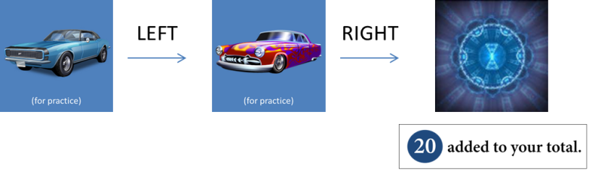  
<Two sequential choice task – one trial>

States and choices: Your choice in the first state determines which state will be your second state. Your choice in the second state determines a monetary outcome (coin). In the first state, you should make a choice that gives you a better chance of meeting a second state which has a higher chance of a good outcome; in the second state, you should make a choice that gives you a better chance of a good outcome. Making no choice in 4sec will have a computer make a random choice to proceed and that trial will be marked as a penalizing trial.

  
<Example of 5 states in which you need to make a choice. Fractal pictures will be shown in main sessions>

Coins you should collect: There are 4 kinds of coins: for example, red coins that make you earn 40 points, blue for 20 points, yellow for 10 points, darkgray for 0 points.

  
<An example of coin colors. In the experiment, color might be different with these colors>

Boxes for your coin collection: You will be given a collecting box, whose color may change over trials. The red, blue, and yellow boxes are very specific; you get the amount on the coin only if you find a coin whose color is the same color as your collecting box. For example, finding a red coin when your box is blue won’t make you win 40; you will get NOTHING. But the white box is flexible; it accepts *any* coin color,

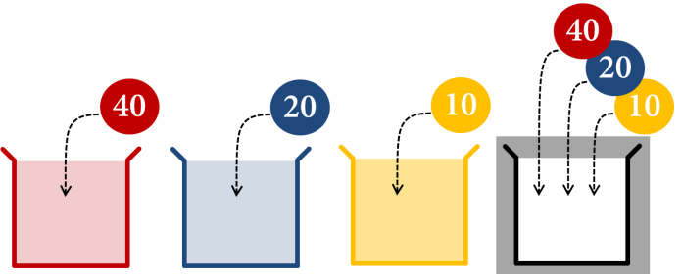

<Collecting boxes in different colors and the coins they will accept>

A few examples:

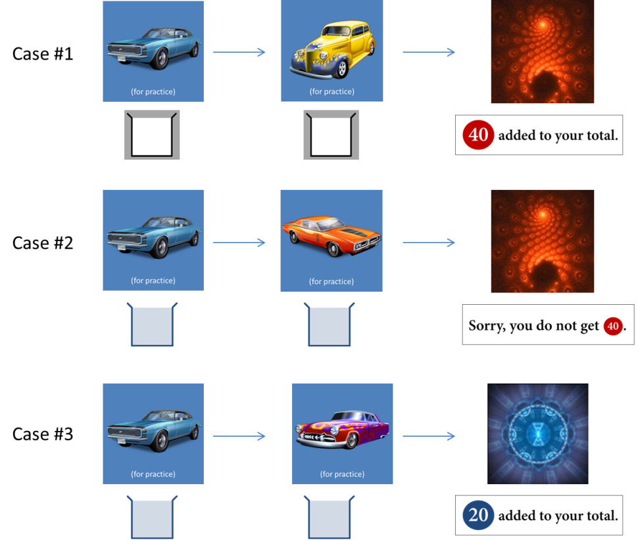

<Case study: (case #1) you can collect any color coins when your box is green-striped. (case #2) you can’t put the red coin in your blue box. (case #3) you can put the blue coin in your blue box.>

**Experiment:** The experiment consists of six sessions - one practice session + five main scanning sessions.  
In the practice session, the green-striped box will be given during the first 80 trials. Then the color of the box will change over the remaining 20 trials. The practice session won’t count, but be advised that the more you learn in the practice session, the higher chance of winning you have in the main session. You will need to roughly learn (1) better choices for each state and (2) an association between states and color of coins. Try to explore states as much as possible.  
In the main sessions, the box of the color may or may not change. In order to collect as many coins as possible, you will need to use the information you have acquired in the practice session.

**Rewards:** Your initial endowment is $30. At the end of the experiment, we will randomly select one trial from all main sessions and pay you the amount that you have earned. One point corresponds to $1. For example, if the trial#37, in which you collected 40 points, is selected, then you would receive extra $40, whereas if the trial#42, in which you collected 10, is selected, then you would receive extra $10. Therefore in order to win as much money as possible you should do your best in every trial.

**Good luck!**