**通达物流系统设计方案**

|  |  |  |  |  |
| --- | --- | --- | --- | --- |
| **版本号** | **日期** | **修改人** | **审阅人** | **摘要** |
| V1.0 | 2020/8/7 | xxx |  | 初稿 |
|  |  |  |  |  |
|  |  |  |  |  |
|  |  |  |  |  |
|  |  |  |  |  |

**技术研发中心**

**2020.08**

目录

**一、 设计背景** **3**

1.1、编写目的 3

1.2、使用范围 3

1.3、功能概述 3

1.4、非功能约束 4

**二、 系统部署图与场景用例设计** **4**

2.1、系统部署图 5

2.2 系统用例图 6

**三、 核心功能设计** **10**

3.1抢单功能 10

3.2下单抢单交互功能 11

3.3订单状态变化 11

## 设计背景

通达是某上市公司全资投资成立的一家物流快递公司，主要进行同城快递业务，公司刚刚成立，组建20人技术部门，准备两个月后系统开发完成上线，你是后端架构师，请你完成系统顶层架构设计，并组织架构评审会议。

### 1.1、编写目的

本文档目的是做什么的

### 1.2、使用范围

本文档哪些人使用

### 1.3、功能概述

* 用户通过app发起快递下单请求并支付
* 快递员通过自己的App上报自己的地理位置，每30秒上报一次
* 系统收到快递请求后，向距离用户直线距离5km内的所有快递员发送通知
* 快递员需要进行抢单，第一个抢单的快递员得到配单，系统向其发送用户详细地址
* 快递员到用户处收取快递，并记录到系统中：已收件
* 快递员将快递送到目的地，并记录到系统中：已送达

### 1.4、非功能约束

预计上线后三个月日单超过1万，一年日单超过50万

## 系统部署图与场景用例设计

系统采用微服务架构进行系统开发以及上线部署运营，预估系统架构需要部署以下服务器：网关服务器，微服务服务器，负载均衡，分布式缓存，消息队列服务器，消息消费者服务器，数据库服务器。

### 2.1、系统部署图

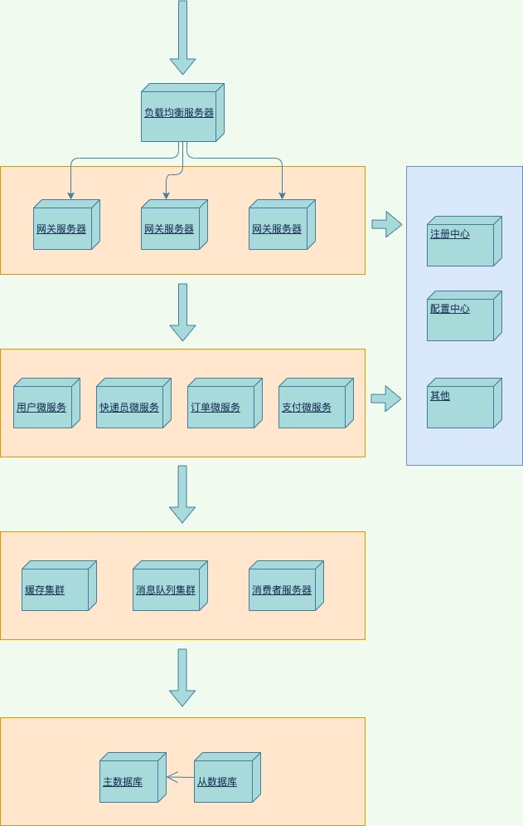

整个系统采用分层架构模式，首先是接入层负载均衡，对请求进行接入处理；然后把请求路由负载到网关层进行服务的路由转发，权限认证，日志监控等；业务逻辑层对业务进行计算存储，通过调用基础服务层各个组件提高系统的并发和性能设计；最终数据存储到数据库中，数据库采用主从模式进行读写分离，提高数据的读取性能。

### 2.2 系统用例图

2.2.1 用户用例图

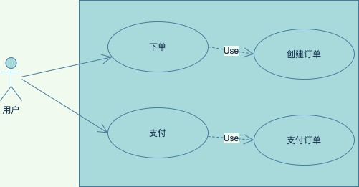

**1、用户下单用例**

用户向订单微服务发起下单请求，参数包括快递的收货地址、目的地址、联系方式、订单金额等，订单微服务收到请求后验证参数的正确性，完成验证后插入订单记录，返回创建成功。否则返回异常信息。

**2、用户支付用例**

订单创建后，用户向支付微服务发起支付请求，参数包括订单号、用户身份等，支付微服务接到请求后调用订单微服务验证订单的有效性，验证成功后创建支付流水记录，并发起第三方支付请求，用户支付成功后，收到第三方支付回调请求，更新流水记录状态，发送下单成功消息到消息队列中，等待订单微服务和消息消费服务器监听并处理此类消息。

%3CmxGraphModel%3E%3Croot%3E%3CmxCell%20id%3D%220%22%2F%3E%3CmxCell%20id%3D%221%22%20parent%3D%220%22%2F%3E%3CmxCell%20id%3D%222%22%20value%3D%22%E7%B3%BB%E7%BB%9F%22%20style%3D%22shape%3DumlActor%3BverticalLabelPosition%3Dbottom%3BverticalAlign%3Dtop%3Bhtml%3D1%3BoutlineConnect%3D0%3Brounded%3D0%3Bsketch%3D0%3BstrokeColor%3D%236c8ebf%3BfillColor%3D%23dae8fc%3B%22%20vertex%3D%221%22%20parent%3D%221%22%3E%3CmxGeometry%20x%3D%2240%22%20y%3D%221140%22%20width%3D%2230%22%20height%3D%2260%22%20as%3D%22geometry%22%2F%3E%3C%2FmxCell%3E%3CmxCell%20id%3D%223%22%20value%3D%22%22%20style%3D%22html%3D1%3Brounded%3D0%3Bsketch%3D0%3BfillColor%3D%23dae8fc%3BstrokeColor%3D%236c8ebf%3B%22%20vertex%3D%221%22%20parent%3D%221%22%3E%3CmxGeometry%20x%3D%22165%22%20y%3D%221060%22%20width%3D%22395%22%20height%3D%22230%22%20as%3D%22geometry%22%2F%3E%3C%2FmxCell%3E%3CmxCell%20id%3D%224%22%20value%3D%22%E5%8F%91%E9%80%81%E9%80%9A%E7%9F%A5%22%20style%3D%22ellipse%3BwhiteSpace%3Dwrap%3Bhtml%3D1%3Brounded%3D0%3Bsketch%3D0%3BstrokeColor%3D%23457B9D%3BfillColor%3D%23A8DADC%3BfontColor%3D%231D3557%3B%22%20vertex%3D%221%22%20parent%3D%221%22%3E%3CmxGeometry%20x%3D%22200%22%20y%3D%221135%22%20width%3D%22140%22%20height%3D%2270%22%20as%3D%22geometry%22%2F%3E%3C%2FmxCell%3E%3CmxCell%20id%3D%225%22%20value%3D%22%E8%AE%A1%E7%AE%97%E9%99%84%E8%BF%91%E7%94%A8%E6%88%B7%22%20style%3D%22ellipse%3BwhiteSpace%3Dwrap%3Bhtml%3D1%3Brounded%3D0%3Bsketch%3D0%3BstrokeColor%3D%23457B9D%3BfillColor%3D%23A8DADC%3BfontColor%3D%231D3557%3B%22%20vertex%3D%221%22%20parent%3D%221%22%3E%3CmxGeometry%20x%3D%22400%22%20y%3D%221080%22%20width%3D%22140%22%20height%3D%2270%22%20as%3D%22geometry%22%2F%3E%3C%2FmxCell%3E%3CmxCell%20id%3D%226%22%20value%3D%22%22%20style%3D%22endArrow%3Dopen%3BendFill%3D1%3BendSize%3D12%3Bhtml%3D1%3BstrokeColor%3D%23457B9D%3BfillColor%3D%23A8DADC%3BfontColor%3D%231D3557%3B%22%20edge%3D%221%22%20source%3D%222%22%20target%3D%224%22%20parent%3D%221%22%3E%3CmxGeometry%20width%3D%22160%22%20relative%3D%221%22%20as%3D%22geometry%22%3E%3CmxPoint%20x%3D%22260%22%20y%3D%221100%22%20as%3D%22sourcePoint%22%2F%3E%3CmxPoint%20x%3D%22420%22%20y%3D%221100%22%20as%3D%22targetPoint%22%2F%3E%3C%2FmxGeometry%3E%3C%2FmxCell%3E%3CmxCell%20id%3D%227%22%20value%3D%22Use%22%20style%3D%22endArrow%3Dopen%3BendSize%3D12%3Bdashed%3D1%3Bhtml%3D1%3BstrokeColor%3D%23457B9D%3BfillColor%3D%23A8DADC%3BfontColor%3D%231D3557%3BexitX%3D1%3BexitY%3D0.5%3BexitDx%3D0%3BexitDy%3D0%3B%22%20edge%3D%221%22%20source%3D%224%22%20target%3D%225%22%20parent%3D%221%22%3E%3CmxGeometry%20width%3D%22160%22%20relative%3D%221%22%20as%3D%22geometry%22%3E%3CmxPoint%20x%3D%22350%22%20y%3D%221140%22%20as%3D%22sourcePoint%22%2F%3E%3CmxPoint%20x%3D%22420%22%20y%3D%221100%22%20as%3D%22targetPoint%22%2F%3E%3C%2FmxGeometry%3E%3C%2FmxCell%3E%3CmxCell%20id%3D%228%22%20value%3D%22%E5%AD%98%E5%82%A8%E9%80%9A%E7%9F%A5%E6%B6%88%E6%81%AF%22%20style%3D%22ellipse%3BwhiteSpace%3Dwrap%3Bhtml%3D1%3Brounded%3D0%3Bsketch%3D0%3BstrokeColor%3D%23457B9D%3BfillColor%3D%23A8DADC%3BfontColor%3D%231D3557%3B%22%20vertex%3D%221%22%20parent%3D%221%22%3E%3CmxGeometry%20x%3D%22400%22%20y%3D%221200%22%20width%3D%22140%22%20height%3D%2270%22%20as%3D%22geometry%22%2F%3E%3C%2FmxCell%3E%3CmxCell%20id%3D%229%22%20value%3D%22Use%22%20style%3D%22endArrow%3Dopen%3BendSize%3D12%3Bdashed%3D1%3Bhtml%3D1%3BstrokeColor%3D%23457B9D%3BfillColor%3D%23A8DADC%3BfontColor%3D%231D3557%3B%22%20edge%3D%221%22%20source%3D%224%22%20target%3D%228%22%20parent%3D%221%22%3E%3CmxGeometry%20width%3D%22160%22%20relative%3D%221%22%20as%3D%22geometry%22%3E%3CmxPoint%20x%3D%22250%22%20y%3D%221060%22%20as%3D%22sourcePoint%22%2F%3E%3CmxPoint%20x%3D%22410%22%20y%3D%221060%22%20as%3D%22targetPoint%22%2F%3E%3C%2FmxGeometry%3E%3C%2FmxCell%3E%3C%2Froot%3E%3C%2FmxGraphModel%3E

%3CmxGraphModel%3E%3Croot%3E%3CmxCell%20id%3D%220%22%2F%3E%3CmxCell%20id%3D%221%22%20parent%3D%220%22%2F%3E%3CmxCell%20id%3D%222%22%20value%3D%22%E7%B3%BB%E7%BB%9F%22%20style%3D%22shape%3DumlActor%3BverticalLabelPosition%3Dbottom%3BverticalAlign%3Dtop%3Bhtml%3D1%3BoutlineConnect%3D0%3Brounded%3D0%3Bsketch%3D0%3BstrokeColor%3D%236c8ebf%3BfillColor%3D%23dae8fc%3B%22%20vertex%3D%221%22%20parent%3D%221%22%3E%3CmxGeometry%20x%3D%2240%22%20y%3D%221140%22%20width%3D%2230%22%20height%3D%2260%22%20as%3D%22geometry%22%2F%3E%3C%2FmxCell%3E%3CmxCell%20id%3D%223%22%20value%3D%22%22%20style%3D%22html%3D1%3Brounded%3D0%3Bsketch%3D0%3BfillColor%3D%23dae8fc%3BstrokeColor%3D%236c8ebf%3B%22%20vertex%3D%221%22%20parent%3D%221%22%3E%3CmxGeometry%20x%3D%22165%22%20y%3D%221060%22%20width%3D%22395%22%20height%3D%22230%22%20as%3D%22geometry%22%2F%3E%3C%2FmxCell%3E%3CmxCell%20id%3D%224%22%20value%3D%22%E5%8F%91%E9%80%81%E9%80%9A%E7%9F%A5%22%20style%3D%22ellipse%3BwhiteSpace%3Dwrap%3Bhtml%3D1%3Brounded%3D0%3Bsketch%3D0%3BstrokeColor%3D%23457B9D%3BfillColor%3D%23A8DADC%3BfontColor%3D%231D3557%3B%22%20vertex%3D%221%22%20parent%3D%221%22%3E%3CmxGeometry%20x%3D%22200%22%20y%3D%221135%22%20width%3D%22140%22%20height%3D%2270%22%20as%3D%22geometry%22%2F%3E%3C%2FmxCell%3E%3CmxCell%20id%3D%225%22%20value%3D%22%E8%AE%A1%E7%AE%97%E9%99%84%E8%BF%91%E7%94%A8%E6%88%B7%22%20style%3D%22ellipse%3BwhiteSpace%3Dwrap%3Bhtml%3D1%3Brounded%3D0%3Bsketch%3D0%3BstrokeColor%3D%23457B9D%3BfillColor%3D%23A8DADC%3BfontColor%3D%231D3557%3B%22%20vertex%3D%221%22%20parent%3D%221%22%3E%3CmxGeometry%20x%3D%22400%22%20y%3D%221080%22%20width%3D%22140%22%20height%3D%2270%22%20as%3D%22geometry%22%2F%3E%3C%2FmxCell%3E%3CmxCell%20id%3D%226%22%20value%3D%22%22%20style%3D%22endArrow%3Dopen%3BendFill%3D1%3BendSize%3D12%3Bhtml%3D1%3BstrokeColor%3D%23457B9D%3BfillColor%3D%23A8DADC%3BfontColor%3D%231D3557%3B%22%20edge%3D%221%22%20source%3D%222%22%20target%3D%224%22%20parent%3D%221%22%3E%3CmxGeometry%20width%3D%22160%22%20relative%3D%221%22%20as%3D%22geometry%22%3E%3CmxPoint%20x%3D%22260%22%20y%3D%221100%22%20as%3D%22sourcePoint%22%2F%3E%3CmxPoint%20x%3D%22420%22%20y%3D%221100%22%20as%3D%22targetPoint%22%2F%3E%3C%2FmxGeometry%3E%3C%2FmxCell%3E%3CmxCell%20id%3D%227%22%20value%3D%22Use%22%20style%3D%22endArrow%3Dopen%3BendSize%3D12%3Bdashed%3D1%3Bhtml%3D1%3BstrokeColor%3D%23457B9D%3BfillColor%3D%23A8DADC%3BfontColor%3D%231D3557%3BexitX%3D1%3BexitY%3D0.5%3BexitDx%3D0%3BexitDy%3D0%3B%22%20edge%3D%221%22%20source%3D%224%22%20target%3D%225%22%20parent%3D%221%22%3E%3CmxGeometry%20width%3D%22160%22%20relative%3D%221%22%20as%3D%22geometry%22%3E%3CmxPoint%20x%3D%22350%22%20y%3D%221140%22%20as%3D%22sourcePoint%22%2F%3E%3CmxPoint%20x%3D%22420%22%20y%3D%221100%22%20as%3D%22targetPoint%22%2F%3E%3C%2FmxGeometry%3E%3C%2FmxCell%3E%3CmxCell%20id%3D%228%22%20value%3D%22%E5%AD%98%E5%82%A8%E9%80%9A%E7%9F%A5%E6%B6%88%E6%81%AF%22%20style%3D%22ellipse%3BwhiteSpace%3Dwrap%3Bhtml%3D1%3Brounded%3D0%3Bsketch%3D0%3BstrokeColor%3D%23457B9D%3BfillColor%3D%23A8DADC%3BfontColor%3D%231D3557%3B%22%20vertex%3D%221%22%20parent%3D%221%22%3E%3CmxGeometry%20x%3D%22400%22%20y%3D%221200%22%20width%3D%22140%22%20height%3D%2270%22%20as%3D%22geometry%22%2F%3E%3C%2FmxCell%3E%3CmxCell%20id%3D%229%22%20value%3D%22Use%22%20style%3D%22endArrow%3Dopen%3BendSize%3D12%3Bdashed%3D1%3Bhtml%3D1%3BstrokeColor%3D%23457B9D%3BfillColor%3D%23A8DADC%3BfontColor%3D%231D3557%3B%22%20edge%3D%221%22%20source%3D%224%22%20target%3D%228%22%20parent%3D%221%22%3E%3CmxGeometry%20width%3D%22160%22%20relative%3D%221%22%20as%3D%22geometry%22%3E%3CmxPoint%20x%3D%22250%22%20y%3D%221060%22%20as%3D%22sourcePoint%22%2F%3E%3CmxPoint%20x%3D%22410%22%20y%3D%221060%22%20as%3D%22targetPoint%22%2F%3E%3C%2FmxGeometry%3E%3C%2FmxCell%3E%3C%2Froot%3E%3C%2FmxGraphModel%3E2.2.2 系统用例图

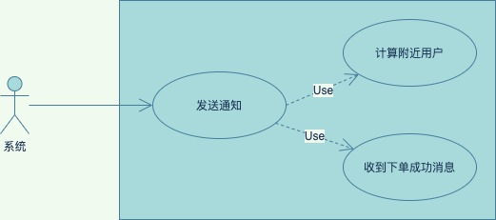

**1、系统发送通知用例**

消息消费服务器收到下单成功后的消息后，计算用户直径范围5KM内的快递员，并向所有目标快递员推送订单信息。

%3CmxGraphModel%3E%3Croot%3E%3CmxCell%20id%3D%220%22%2F%3E%3CmxCell%20id%3D%221%22%20parent%3D%220%22%2F%3E%3CmxCell%20id%3D%222%22%20value%3D%22%E7%B3%BB%E7%BB%9F%22%20style%3D%22shape%3DumlActor%3BverticalLabelPosition%3Dbottom%3BverticalAlign%3Dtop%3Bhtml%3D1%3BoutlineConnect%3D0%3Brounded%3D0%3Bsketch%3D0%3BstrokeColor%3D%236c8ebf%3BfillColor%3D%23dae8fc%3B%22%20vertex%3D%221%22%20parent%3D%221%22%3E%3CmxGeometry%20x%3D%2240%22%20y%3D%221140%22%20width%3D%2230%22%20height%3D%2260%22%20as%3D%22geometry%22%2F%3E%3C%2FmxCell%3E%3CmxCell%20id%3D%223%22%20value%3D%22%22%20style%3D%22html%3D1%3Brounded%3D0%3Bsketch%3D0%3BfillColor%3D%23dae8fc%3BstrokeColor%3D%236c8ebf%3B%22%20vertex%3D%221%22%20parent%3D%221%22%3E%3CmxGeometry%20x%3D%22165%22%20y%3D%221060%22%20width%3D%22395%22%20height%3D%22230%22%20as%3D%22geometry%22%2F%3E%3C%2FmxCell%3E%3CmxCell%20id%3D%224%22%20value%3D%22%E5%8F%91%E9%80%81%E9%80%9A%E7%9F%A5%22%20style%3D%22ellipse%3BwhiteSpace%3Dwrap%3Bhtml%3D1%3Brounded%3D0%3Bsketch%3D0%3BstrokeColor%3D%23457B9D%3BfillColor%3D%23A8DADC%3BfontColor%3D%231D3557%3B%22%20vertex%3D%221%22%20parent%3D%221%22%3E%3CmxGeometry%20x%3D%22200%22%20y%3D%221135%22%20width%3D%22140%22%20height%3D%2270%22%20as%3D%22geometry%22%2F%3E%3C%2FmxCell%3E%3CmxCell%20id%3D%225%22%20value%3D%22%E8%AE%A1%E7%AE%97%E9%99%84%E8%BF%91%E7%94%A8%E6%88%B7%22%20style%3D%22ellipse%3BwhiteSpace%3Dwrap%3Bhtml%3D1%3Brounded%3D0%3Bsketch%3D0%3BstrokeColor%3D%23457B9D%3BfillColor%3D%23A8DADC%3BfontColor%3D%231D3557%3B%22%20vertex%3D%221%22%20parent%3D%221%22%3E%3CmxGeometry%20x%3D%22400%22%20y%3D%221080%22%20width%3D%22140%22%20height%3D%2270%22%20as%3D%22geometry%22%2F%3E%3C%2FmxCell%3E%3CmxCell%20id%3D%226%22%20value%3D%22%22%20style%3D%22endArrow%3Dopen%3BendFill%3D1%3BendSize%3D12%3Bhtml%3D1%3BstrokeColor%3D%23457B9D%3BfillColor%3D%23A8DADC%3BfontColor%3D%231D3557%3B%22%20edge%3D%221%22%20source%3D%222%22%20target%3D%224%22%20parent%3D%221%22%3E%3CmxGeometry%20width%3D%22160%22%20relative%3D%221%22%20as%3D%22geometry%22%3E%3CmxPoint%20x%3D%22260%22%20y%3D%221100%22%20as%3D%22sourcePoint%22%2F%3E%3CmxPoint%20x%3D%22420%22%20y%3D%221100%22%20as%3D%22targetPoint%22%2F%3E%3C%2FmxGeometry%3E%3C%2FmxCell%3E%3CmxCell%20id%3D%227%22%20value%3D%22Use%22%20style%3D%22endArrow%3Dopen%3BendSize%3D12%3Bdashed%3D1%3Bhtml%3D1%3BstrokeColor%3D%23457B9D%3BfillColor%3D%23A8DADC%3BfontColor%3D%231D3557%3BexitX%3D1%3BexitY%3D0.5%3BexitDx%3D0%3BexitDy%3D0%3B%22%20edge%3D%221%22%20source%3D%224%22%20target%3D%225%22%20parent%3D%221%22%3E%3CmxGeometry%20width%3D%22160%22%20relative%3D%221%22%20as%3D%22geometry%22%3E%3CmxPoint%20x%3D%22350%22%20y%3D%221140%22%20as%3D%22sourcePoint%22%2F%3E%3CmxPoint%20x%3D%22420%22%20y%3D%221100%22%20as%3D%22targetPoint%22%2F%3E%3C%2FmxGeometry%3E%3C%2FmxCell%3E%3CmxCell%20id%3D%228%22%20value%3D%22%E5%AD%98%E5%82%A8%E9%80%9A%E7%9F%A5%E6%B6%88%E6%81%AF%22%20style%3D%22ellipse%3BwhiteSpace%3Dwrap%3Bhtml%3D1%3Brounded%3D0%3Bsketch%3D0%3BstrokeColor%3D%23457B9D%3BfillColor%3D%23A8DADC%3BfontColor%3D%231D3557%3B%22%20vertex%3D%221%22%20parent%3D%221%22%3E%3CmxGeometry%20x%3D%22400%22%20y%3D%221200%22%20width%3D%22140%22%20height%3D%2270%22%20as%3D%22geometry%22%2F%3E%3C%2FmxCell%3E%3CmxCell%20id%3D%229%22%20value%3D%22Use%22%20style%3D%22endArrow%3Dopen%3BendSize%3D12%3Bdashed%3D1%3Bhtml%3D1%3BstrokeColor%3D%23457B9D%3BfillColor%3D%23A8DADC%3BfontColor%3D%231D3557%3B%22%20edge%3D%221%22%20source%3D%224%22%20target%3D%228%22%20parent%3D%221%22%3E%3CmxGeometry%20width%3D%22160%22%20relative%3D%221%22%20as%3D%22geometry%22%3E%3CmxPoint%20x%3D%22250%22%20y%3D%221060%22%20as%3D%22sourcePoint%22%2F%3E%3CmxPoint%20x%3D%22410%22%20y%3D%221060%22%20as%3D%22targetPoint%22%2F%3E%3C%2FmxGeometry%3E%3C%2FmxCell%3E%3C%2Froot%3E%3C%2FmxGraphModel%3E

2.2.3 系统用例图

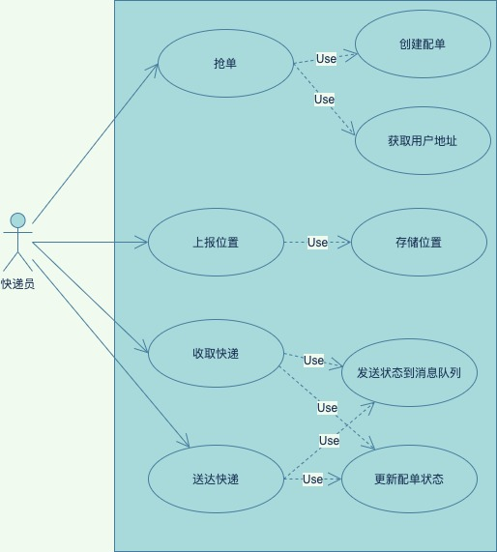

**1、快递员抢单用例**

快递员收到系统推送的可抢订单后，发起抢单请求。抢单请求包括订单号、快递员身份等参数，订单微服务校验订单的状态，快递员可用配额后等，如果验证通过，锁定此订单号，获取用户地址，创建配单。否则抢单失败，标记不可抢。

**2、快递员上报位置用例**

快递员每隔30s向快递员微服务发送位置请求，收到请求后把快递员的位置信息存储在缓存中。

**3、快递员取件用例**

快递员上门收取快递，修改配单状态已收件。发送订单状态已收件到消息队列中。

**4、快递员取件用例**

快递员送到目的地，修改配单状态已送达。发送订单状态已送达到消息队列中。

## 核心功能设计

### 3.1抢单功能

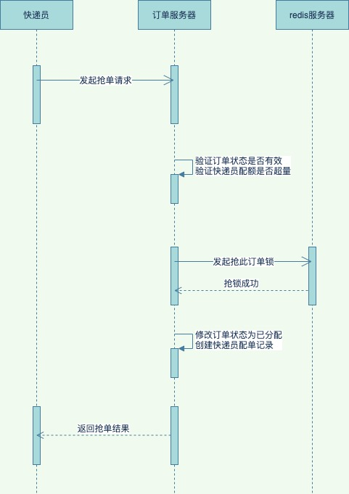

### 3.2下单抢单交互功能

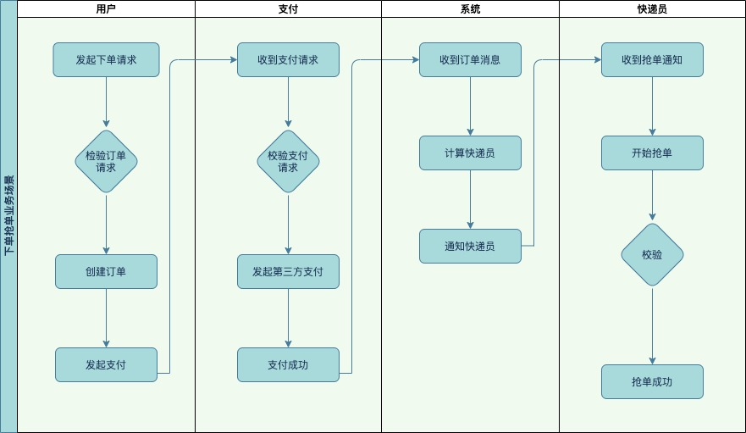

%3CmxGraphModel%3E%3Croot%3E%3CmxCell%20id%3D%220%22%2F%3E%3CmxCell%20id%3D%221%22%20parent%3D%220%22%2F%3E%3CmxCell%20id%3D%222%22%20value%3D%22%22%20style%3D%22endArrow%3Dnone%3Bhtml%3D1%3BstrokeColor%3D%23457B9D%3BfillColor%3D%23A8DADC%3BfontColor%3D%231D3557%3B%22%20edge%3D%221%22%20parent%3D%221%22%3E%3CmxGeometry%20width%3D%2250%22%20height%3D%2250%22%20relative%3D%221%22%20as%3D%22geometry%22%3E%3CmxPoint%20x%3D%22385%22%20y%3D%22460%22%20as%3D%22sourcePoint%22%2F%3E%3CmxPoint%20x%3D%22435%22%20y%3D%22460%22%20as%3D%22targetPoint%22%2F%3E%3C%2FmxGeometry%3E%3C%2FmxCell%3E%3C%2Froot%3E%3C%2FmxGraphModel%3E

### 3.3订单状态变化

