RushTester User’s Manual

- About RushTester
RushTester is “Stress Testing Program” for Axis Server Platform(Axis Server Platform is product of WINIXINFO). You can make Stress to Axis Server with many connections and continuous queries.

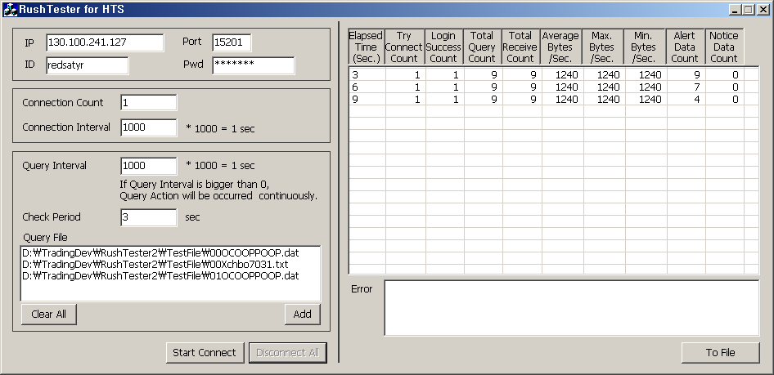

- How to use RushTester
2.1 Set Axis Server’s Connection Information
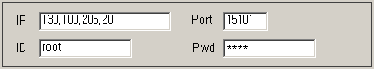
IP : Axis Server IP
Port : Axis Server Port
ID : Connection User’s ID
Pwd : Connection User’s Password

  - Set Connection Option
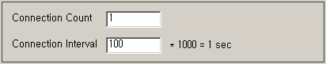
Connection Count : Server Connection Count
Connection Interval : Each Connection’s Interval time.
* If “Connection Count” is 2 and “Connection Interval” value is 100, do first connection and second connection will occur after 0.1 second.

  - Set Query Option
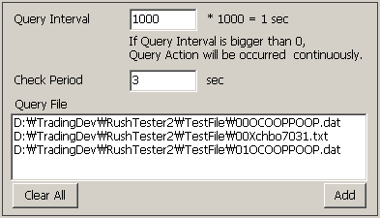
Query Interval : Each connections do continuous with Query Interval Time.
Check Period : Check Connection & Data Transaction and display information with every defined time.
Query File : Register Query File with “Add” Button, and Clear Query File with “Clear All” Button.
If query file is multi-defined, query action will be occurred sequentially.

  - Start Connect
“Start Connect” Button : Start stress test.
“DisConnect All” Button : Disconnect stress test connections.
This button is enabled on connection.

- How to make Query File

3.1 File Name
N(2) + X(1) + TRANNAME(8) + “dat”

N: The Index for making same TRANNAME with different
query value.
Index value is ‘00’ to ’99’.
X : The flag of FML transaction.
‘O’ = FML Transaction, ‘X’=No FML(structure type)

3.2 The context of Query File

This file must have all input data of query

Ex 1) “00XPIBO0104.dat”
000660
Ex 2) “00OPIBOPOOP.dat”
1031\r000660\t1021\t1022\t1023

- How to get Connection Information
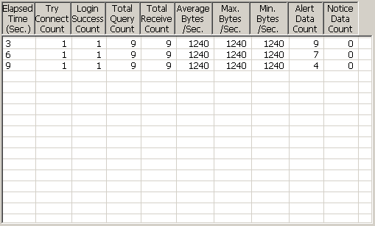
If you set “Check Period Sec”, connection & query information will be displayed every defined time.

