**Republic of the Philippines**

**CENTRAL LUZON STATE UNIVERSITY**

**COLLEGE OF ENGINEERING**

**Department of Information Technology**

**INVENTORY AND POINT OF SALE SYSTEM FOR**

**NOAH’S ARK VETERINARY CLINIC**

**BACSA, JEYNARD O.**

**FERRIA, KING CYRUS P.**

**MIMBAN, JAN CIDBERT L.**

**PALOLAN, KIM CDRICK R.**

**VILLASEÑOR, ARVY R**

**IN PARTIAL FULLFILMENT OF THE REQUIRMENT**

**IN COMSCI225 – SYSTEM ANALYSIS AND DESIGN**

**May 3, 2019**

**CHAPTER I**

**INTRODUCTION**

Noah’s Ark is a Veterinary Clinic in Abar 1st San Jose City Nueva Ecija and Dr. Maricar F. Gaoyen owns it. It is a clinic for animals wherein they offer their services to their client by checking up the customer’s pets if they are healthy and properly groom and also Noah’s ark clinic vaccinates animals. They serve customer who have pets, which need checkups. They also offer services like grooming their pets, selling accessories and foods for their pets, medicine for animals, taking care of animals like an animal center and also they vaccinate against diseases and operates some injured animals.

The Noah’s Ark Veterinary Clinic lacks in managing their inventory and monitoring their sales, they have an existing system to hold their products and stocks but it is not suitable for monitoring and managing their products like medicines, foods and accessories. The Noah’s Ark Veterinary Clinic cannot fully monitor their products because the system they are using is not fit for managing products, monitoring stocks and monitoring sales. They are also unaware that they have an over stocks and under stocks of products.

The shop have an existing inventory system but that software is not suitable for monitoring and managing their products in their clinic. The developers will develop a system called Inventory and Point of sales System that will monitor and manage of the inventory of Noah’s Ark Veterinary Clinic which is the stocks, sales, accessories, foods and medicines. The Inventory and Point of Sales System for Noah’s Ark Veterinary Clinic is a system that make process and procedures that oversee their products like foods, medicines and accessories. It also oversee their services and maintenance of stocks. This system will help the clinic manage and monitor their products medicines accessories and sales. Using the Inventory and Point of Sales System, it can achieve better management of their business, specially their stocks and products. The developers find this system as the solution for the improperly managed products and sales of Noah’s Ark clinic.

1. **STATEMENT OF THE PROBLEM**

It has been noted that the Noah’s Ark Veterinary Clinic does not have an existing system that can manage or monitor their products and they lack of manpower. This may result to data loss, no back up, inaccurate records, manual documentations error and wasted hours in tracking down items that are stored in the wrong locations. Table 1 shows the current issue and the weight represent the worse problem to the least.

|  |  |
| --- | --- |
| **Issues** | Weight |
| Overstocked products is improperly monitored | 4 |
| Cannot monitor under stocked pet foods, medicine and accessories | 3 |
| Difficulty in product & services management | 2 |
| Failure to keep track of stock | 1 |

**Table 1.**Current Issues

1. **OBJECTIVE OF THE STUDY**

The main objective of this study is to design and develop an Inventory and Point of Sales System for Noah’s Ark Veterinary Clinic.

Specifically, it aims to:

* Manage and monitor the products, services and sales.
* Track purchases inventory and sales transaction.
* Generate daily, weekly, and monthly report of the sales.

1. **SCOPE AND LIMITATIONS**

* **Account Management Module**

This is where the user must login to access the system. The user will set a username and password of their own and there will be only one account for this system because this system is stand-alone. The user will input their username and password to use the system and there will be recovery if ever the user forgot their username and password for the account management module.

* **Data Management Module**

This is where the user can create information which is categorized for foods as medicines, foods and accessories. For services there are grooming, check-up, vaccination and operation. Also in this module, the user can update any incorrect data. The system also allows the user to delete any data that is incorrectly inputted.

* **Transaction and Monitoring module**

In this module, the user will monitor information for the transaction of the products. When the costumer bought products from the clinic, the cashier will enlist the items bought by the costumer and input it in the system. The data will be stored in the system. In that way, the stocks and the transaction for the products will be managed properly. The point of sales (POS) consist of details about what is the most selling product in the store and capable of collecting more information. Report module also need the point of sales to generate a report and instead of manually checking the stocks to determine what you should add, the point of sales will be able to do this for you.

* **Generate report module**

In this module, the system will give the user report for the date of the transactions and the report for the quantity of the products sold in the clinic in order for the system to monitor the stocks and the transaction in the clinic. It can also create a report for the user; it can generate what date the products were sold.

Limitations:

The focus of the proposed system is to create a computerized Inventory and point of sales system for Noah’s ark veterinary clinic and it is only intended for Noah’s ark Veterinary clinic only. This system is dedicated for monitoring and managing an inventory and sales. Also the system cannot add another account and the system don’t have an auto save data. It is a stand-alone system.

1. **IMPORTANCE OF THE STUDY**

This study will help Noah’s Ark Veterinary Clinic to have more control and manage over their stocks, records and to observe their sales.

**Head Veterinarian**

-The system will be beneficial for the Head Veterinarian because it will provide them less hassle to update their sales and inventory stocks. It will be easier for them to transact with the supplier and their deliveries.

**Veterinarians/Veterinarian Assistant/Groomers**

-Veterinarians are the beneficiaries of this system because it will reduce their time consumed in managing inventory and computing daily/weekly/monthly sales, and it will also help them track the items that are short in stocks.

**Customers**

-One of the beneficiary is costumers. The system will provide them ease to transact faster and lessen their time and effort in ordering for the products they are buying in the clinic.

**Developers**

-The developers will also have benefits of this system for this system will help them to learn more about developing monitoring system and make them more knowledgeable about developing an inventory system.

**CHAPTER II**

**REVIEW OF RELATED LITERATURE, AND EXISTING ALTERNATIVES**

This chapter represents the review of related literature and studies that contain relevance to the research proposal about inventory and point-of-sale system.

According to the design and development of point-of-sale and inventory by Dela Rosa, et al*.* The proposed study will include the comparison of monitoring stocks and current sales such as products management, tracking inventory and generating reports. This system is a stand*-alone type of application*. Atkins, I. (2016) stated that a good inventory management system provides up-to-date info on what you have in stock, what’s on route, and what is selling fast. It has all the information needed to spot theft, cut losing products and expand winners, and increase small business’s profits. Having an inventory system, small stores or even larger business can monitor all their daily transactions. An inventory System is a tracking that informs the user of the amount of raw materials, supplies or final products which are readily available (Jorgensen, 2012). It helps the user to keep track of all the products that are available whether it is a small store, a large office or a product development factory.

Inventory Management System were created to help dealerships implement, maintain, and fine-tune their inventory plans (Zierden, 2009). This study is a *stand-alone type of application*. It can make a significant contribution on inventory management efforts. This strategy helps a lot to come up with a successful outcome.According to Kaye Morris (2010), manual inventory management system, a *stand-alone type of application*, can help sales and production managers control costs by identifying lost sales due to inventory shortages; inventory overrides on products that are not selling; losses due to employee’s theft or damage, To make this process faster, more efficient and more effective, the computer has been developed to help the user.

Based on Host Merchant Services (2017), that the benefits of Point-of-Sales operation is the key factor for managing operations. “They save time and employee hours by automating the inventory process; as transactions are made, items sold are deducted in real-time from the system’s database”. It helps small business to save money and time. Point-of-Sales also prevent losses, helps to reduce the risk of shrink because of product inflow and outflow of deliveries and transactions. Point-of-Sale can also use to alert when product runs low or is out of stock. This alert can vary on every product, allowing you to define exactly when it is time to reorder. Product low-stock and out-of-stock alerts customer service that who can use the information of customers question about the product availability estimated arrival times, and suggested replacement of the products. One of the trendies task is marking down the price of the products on inventory. With the use of this system, companies can performs markdowns easily. Unlike traditional inventory control management, markdowns generated through a Point-of-Sale system can be created automatically at the time of transaction. And POS system can also provide reports detailing about the relationship of every products between changes on inventory and time.

According to Bugarin, et al. that their inventory management system’s objective is to design and develop that will enable them to easily manage and monitor their business transactions. Their system is a web*-based type of application.* The proposed study will include the comparison of improving management and control the system development process and security for confidential files of records of the business and also to minimize the human intervention on sales and inventory monitory. As defined by Carolina Barcode Inc. (2013), a Point-of-Sale system is a computer software and hardware networked to track sales and inventory as they occur. Point-of-Sales systems will solve a multitude of problems in your business. This is the system that can control the transactions between retailer and the customer.

According to Distor (1995), on Proposed Sales Monitoring System, the accelerated work structure of the company and proper monitoring are essential in order to keep track of the company’s sales activity. The system developed for this study aims to come up with an efficient an accurate mechanized system of preparing invoices that will keep track of the daily transactions and generate reports.

The proposed system will keep track of all the products of the store between what are needed and what are demanded which is similar to the project above which is the Design and Develop of Point-of-Sale and Inventory by Dela Rosa, et al. . Both systems decrease the wastes valuable man hours in recording everyday transactions manually and also generating reports. By using an inventory system tasks will be easy and simple to automate. The advantage of the system we’re conducting is , it’s a user friendly and easy to monitor the products, services and sales. It’s a stand-alone type of application.**CHAPTER III**

**METHODOLOGY**

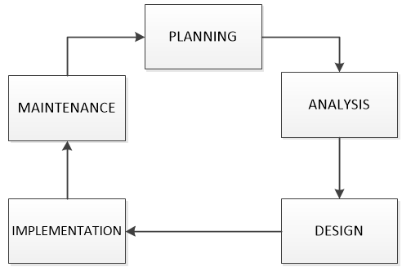

**Figure 1.0** SDLC Model

In figure 1.0 developing the Inventory and point of Sales system, the developers followed the System Development Life Cycle (SDLC) which consists of five (5) steps: Planning, Analysis, Design, Implementation and Maintenance.

**A. Planning**

Gathering information is important. With the use of interview the developers will identify the problems that client encounters in the current system that they are using.

The developers will conduct an interview to gather relevant information. The client will discussed how their current system works in managing their stocks.

The following questions was used:

* Do you have an existing system for managing your stocks?
* What does your system do?
* Do you have problem managing your stocks?
* Do you have a laptop?
* What are the specifications the laptop that you use?

The developers created the Fishbone diagram to identify the problems that that current system has.

After conducting interviews, the developers will use the gathered data and problems that have been identified to create the review and assessment of the current system that will be used in developing the proposed system. The review and assessment will be manifest using Fishbone Diagram to illustrate the problems encountered in the current system, Process Flow diagram to specify the process of the existing system, Context Diagram to reveal how the data will circulate between the entities involved and Gantt chart to plan the documentation of the proposed system

**Gant chart**

|  |  |  |  |  |  |  |  |  |  |  |  |  |  |  |
| --- | --- | --- | --- | --- | --- | --- | --- | --- | --- | --- | --- | --- | --- | --- |
| **ACTIVITIES** | | | | | | | | | | | | | | |
| Identifying problems opportunities and objectives. |  |  |  |  |  | |  |  |  |  |  |  |  |  |
| Determining Human Information Requirements. |  |  |  |  |  | |  |  |  |  |  |  |  |  |
| Analyze System Needs. |  |  |  |  |  | |  |  |  |  |  |  |  |  |
| Designing the Recommended System. |  |  |  |  |  | |  |  |  |  |  |  |  |  |
| **weeks** | 1 | 2 | 3 | 4 | 5 | | 6 | 7 | 8 | 9 | 10 | 11 | 12 | 13 |
| **months** | Feb | March | | | | April | | | | | May | | | |

Figure 2.0 Gant chart

Legend:

|  |  |
| --- | --- |
|  |  |
|  |  |
|  |  |

Incomplete -

Partially complete -

Complete -

**B. Analysis**

The developers will analyze the information from the conducted interview to list down all the problems and create a list of features for what the systems need. The developers conducted feasibility study which consists of the Technical, Economic and Operational feasibility aspects to ensure that the system that will be developed is enough for what the company needs and reach all the requirements. Developers also created process flow diagram of the existing system.

System Requirement Checklist was also produced by the developers. System Requirement Checklist will show what will be the following inputs, outputs, process, control and performance that the proposed system should have.

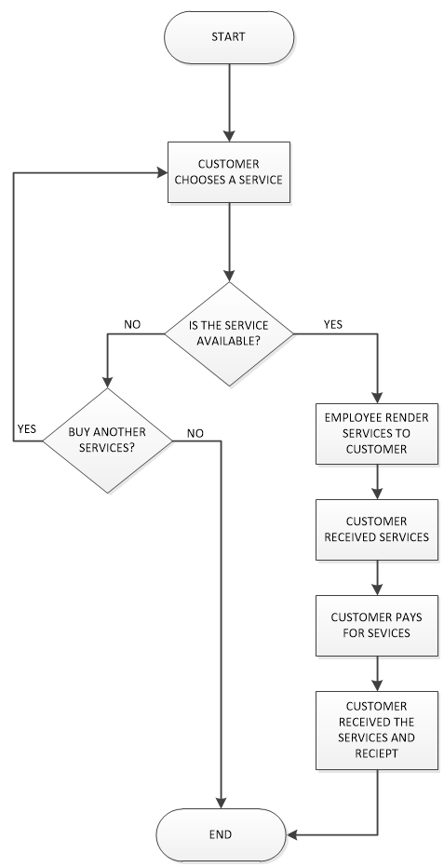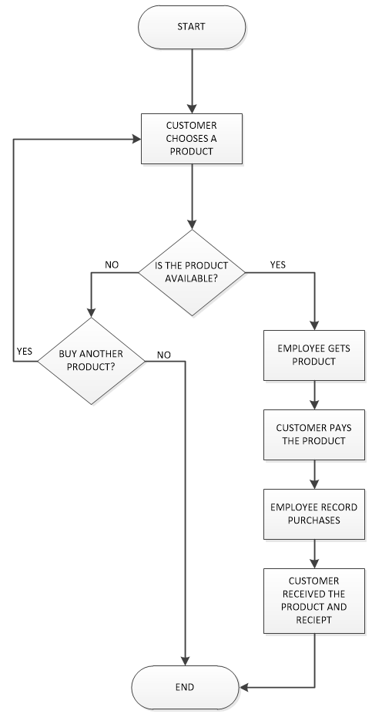

Figure 3.0 Current process flowchart.

In Figure 3.0 shows the current operation on the managing of inventory. After customer chooses a product, Employee check the ordered product if it is available or not. Once knowing that there is an available product, customer buys the product and employee record the purchases. Ordered product is being recorded by their staffs and bought products record their receipt and the customer receive the product and restock the items.

**C. Design**

The system and database design was be prepared by the developers. The developers used context diagram and data flow diagram to illustrate the system design. The system was built with a friendly user interface to make it easier for the user to utilize the system.

In addition, the database design was created using an entity relationship diagram and relational data model.

**D. Implementation**

Java Language will be used in developing the proposed system. WAMMP will be installed in the user’s computer to serve as the database monitoring transactions.

The developers will perform a testing before the system will be presented to the client. If there is a bug, then the developers will be responsible in fixing it.

If the proposed system will be successfully developed and free from bugs and errors, the developers will present the system to the user and explain the functionalities that the system possessed. The developers will guide each user on how to connect with the system on a step by step process.

**E. System Support and Maintenance**

* **User Training**

The users of the system should have a courage to learn on how to interact in the system. The developers will help them to gain knowledge on how to interact with the system and how to use the system’s functionalities properly.

* **System Security Measures**

The users of the program must be aware that daily sales and monthly sales are confidential information that should be strongly protected. Unauthorized personnel should be forbidden in accessing the system so that leaking of private data will be prevented.

* **Data Backup and Recovery Strategies**

System failure may be occurred, so data backup is important to avoid data loss. Data backup and recovery strategies is highly recommended to ensure that the important information will never be loss. Always backup the important information regularly in case the system and hardware will fail in functioning.

**CHAPTER IV**

**RESULTS AND DISCUSSION**

1. **Planning**

|  |  |  |  |  |  |  |  |  |  |  |  |  |  |  |
| --- | --- | --- | --- | --- | --- | --- | --- | --- | --- | --- | --- | --- | --- | --- |
| **ACTIVITIES** | | | | | | | | | | | | | | |
| Identifying problems opportunities and objectives. |  |  |  |  |  | |  |  |  |  |  |  |  |  |
| Determining Human Information Requirements. |  |  |  |  |  | |  |  |  |  |  |  |  |  |
| Analyze System Needs. |  |  |  |  |  | |  |  |  |  |  |  |  |  |
| Designing the Recommended System. |  |  |  |  |  | |  |  |  |  |  |  |  |  |
| **weeks** | 1 | 2 | 3 | 4 | 5 | | 6 | 7 | 8 | 9 | 10 | 11 | 12 | 13 |
| **months** | Feb | March | | | | April | | | | | May | | | |

**Figure 4.0.** Gant chart

After conducting multiple interviews at Noah’s Ark Veterinary Clinic, the researchers discovered that Noah’s Ark Veterinary clinic have a software for managing their inventory but it’s not suitable for managing an inventory and also the receipts and recording are done through manual process.

The following are the answers from questions the researchers asked:

1. Do you have an existing system for managing your stocks?

* Yes but we are having a hard time monitoring the sales and its very messy because the items are not categorized.

1. What does your system do?

* It can only add, update and delete products.

1. Do you have problem managing your stocks?

* Yes like it’s not categorized, I can only add edit delete the products, I can’t monitor the products well.

1. Do you have a laptop?

* Yes, we only have 1 laptop so all of the data that’s being made is centralized.

1. What are the specifications the laptop that you use?

* Our laptop is Acer with the following specs:

Windows 10, 4 GB ram, 500 GB storage, cor™i3-5005u, 2.00GHz.

The answers that have been collected on Noah’s Ark Veterinary clinic interview conducted by the developers have given the idea on how the current software flows or help on their clinic. The owner of the Noah’s Ark pet Veterinary clinic are selling foods, medicines and accessories.

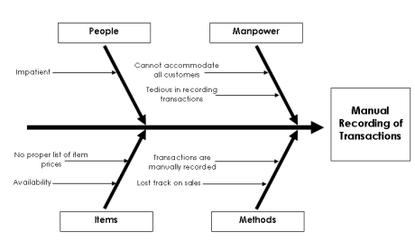**Fishbone diagram**

Figure 5.0 Fishbone diagram

In this figure 2, it explain what are the problems of the Noah’s Ark Veterinary clinic encounter. Some of the customers are impatient due to lack of tracking their records especially to those who have background records in that clinic, therefor the clinic is having a crowded customer but the bigger problem is tracking their sales and managing their products because of having no proper list of their items.

1. **Analysis**

In this phase, the developers gathered data through interview and notice that the Clinics process of adding a product is being listed first in a paper or a notebook in that the owner consumes a lot of time monitoring their products and business.

**FEASIBILITY STUDY**

This feasibility study was conducted to test whether the proposed system is technically, economically and operationally feasible.

**TECHNICAL FEASIBILITY STUDY**

It is technically feasible because the Noah’s Ark Veterinary Clinic’s existing specification of their laptop is capable of running the Inventory and Point of Sales System. The developers oversee and scan their existing specification of laptop and confirmed that the Noah’s Ark laptop can hold the system. The developers also confirmed that the processor, video card, RAM, storage, OS of their laptop is good enough to run the system so the developers conclude that it is technically feasible. In this table 2 illustrate the specification of Noah’s Ark laptop.

|  |  |
| --- | --- |
| **Components** | **EXISTING SPECIFICATION** |
| PROCESSOR | Intel(R) Core(TM) i3-5005U CPU 2.00GHz |
| VIDEOCARD | Intel HD Graphics Family |
| RAM | 4GB |
| STORAGE | 500 GB |
| OS | Windows 10 64-BIT |

Table 2. Existing Specification

**OPERATIONAL FEASIBILITY STUDY**

The user will be benefited n a way that instead of using a record book and software not fit to be an inventory, the propose system will help them to make an organized Inventory and Point of Sales and track the items fast, so that they will be able to a lot more on their products and making other tasks. This propose system will make their Noah’s Ark Veterinary Clinic more organized in their Inventory and Sales. Tthe Noah’s Ark Veterinry Clinic is owned by Dr. Maricar F. Gaoyen, 31 years old head Veterinarian. This Noah’s Ark Veterinary Clinic is located at Abar 1st, San Jose City N.E. with her staffs. Dr.Maricar F. Gaoyen is a college graduate in Bachelor of Science in Veterinary Medicine (BSVM). Both Dr. Maicar F. Gaoyen and her Staffs has a background in using computer and they are familiar with a software like the proposed system and they are using an Inventory software there. The Owner along with her staff are computer literate so it will be easy for them to learn and use the system. So it will be easy for the clinic to use and manipulate the proposed system. The staff’s and owner are also willing to learn on how to use the system in its maximum capability. Therefore, the proposed system is operationally feasible. Table 3 will illustrate their user profile in the system.

Table 3. User profile

|  |  |  |  |
| --- | --- | --- | --- |
| **NAME** | **AGE** | **ROLE** | **SYSTEM ROLE** |
| Maricar F. Gaoyen | 31 | Manager/Owner/Head Veterinarian | ADMIN |
| Diadem G. Lumerio | 28 | Veterinarian | USER |
| Dana M. Fernandez | 30 | Veterinarian | USER |
| Chester N. dongga-as | 29 | Veterinarian | USER |
| Agosto Soriano | 25 | Assistant Veterinarian/groomer | USER |
| Dandan Tajodloy | 24 | Assistant Veterinarian/groomer | USER |

**ECONOMIC FEASIBILITY STUDY**

It is economically feasible, the proposed system proved that the Noah’s Ark Veterinary Clinic can benefit in a way that it improves the productivity of process and saving time consuming for managing their products and they also have an existing laptop so they don’t have to spend money for the proposed system. Also they will save enormous time consuming and less effort in data entry and to be also accurate and faster access to data for timely decisions. In this study, the developers will determine if the Noah’s ark shop can support the system proposed. Most of the software are free to download. Inventory and Point of Sales system will run using the **JAVA** and using **XAMP** it will create a database that can store data.

Tangible benefits:

* Increase the speed of process for transactions.
* Lessen the consuming time for managing products.
* Lessen the time in data entry.
* All resources needed is almost free.
* Reduce paper works.
* Reduce the money consumption for physical storage.

Intangible benefits:

* Fast access to data for timely decision’s.
* Increasing job satisfactory.
* Maintain a good customer service.
* More accurate at computing the sales.

**System requirements checklist**

**Input**

The Inventory and Point of Sales System will enable the user to add the information such as foods, medicines, orders list and accessories for the Noah’s ark veterinary clinic and the system will also enable to record all of the bought items and receipt. Therefore, the employee and the manager will less hassle to monitor and save data from this system.

**Output**

The Inventory and Point of Sale System for Noah’s Ark Veterinary Clinic will focuses on keeping the information’s of their products details, services details and also the total earnings of the clinic and bills of the customers.

**Process**

The system’s process will start by logging in of the user. The user must input the set username and password. After inputting the username and password the user can access the system and can view the products such as foods, medicines and accessories which employee and manager can update, add and delete a product. Only the manager can make the reset and forgot password function.

**Control**

The developers develop a login account for the security and privacy to prevent a unauthorized access to the system and also the developers develop a forgot and reset password in case they forgot their password.

**Performance**

The system is a user-friendly which it will make the users easy to use the system and less time consuming recording the information’s. This system will also help the employee and manager to keep track on everything to easily monitor and manage the products and sales.

**Process Flow Diagram**

**Figure 6.0.** Flowchart

Figure 1.1 & 1.2 shows the current operation on the managing of inventory. After customer chooses a product, Employee check the ordered product if it is available or not. Once knowing that there is an available product, customer buys the product and employee record the purchases. Ordered product is being recorded by their staffs and bought products record their receipt and the customer receive the product and restock the items.

1. **Design**

In this phase developers will show the system design and the database. System Design includes Process Flow Diagram, Context Diagram, Context diagram (top level), exploded diagrams, Usecase diagram, entity relational diagram (ERD) and relational diagram (RD).

**Process flow diagram (manual process for products and services)**



**FIGURE 7.0** flowchart

Figure 7.0 shows the current operation on the managing of inventory. After customer chooses a product, Employee check the ordered product if it is available or not. Once knowing that there is an available product, customer buys the product and employee record the purchases. Ordered product is being recorded by their staffs and bought products record their receipt and the customer receive the product and restock the items.

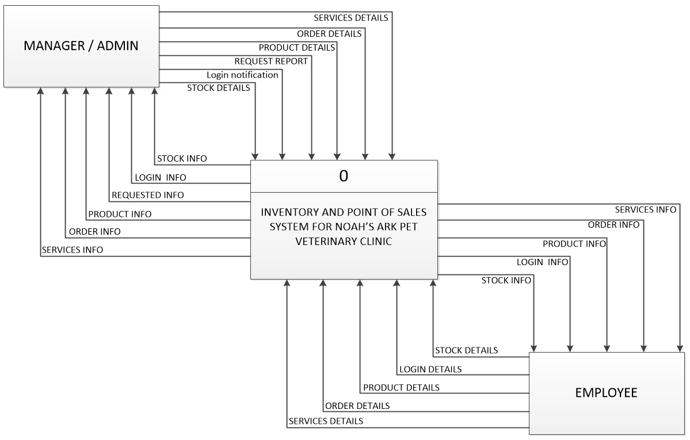**Context Diagram (Proposed System)**

Figure 8.0 Data Flow Diagram: Context Diagram

In this figure 2 show the data flows into the system and out as an information to the entities. The entities “MANAGER/ADMIN” and “EMPLOYEE” both inputs the following into the system: Order details, Product details, Login details, Stock details but only the manager/admin can Request Report and receive report. Both entities receive the following output from the system: Order verified, Product verified, Login verified and Stock verified.

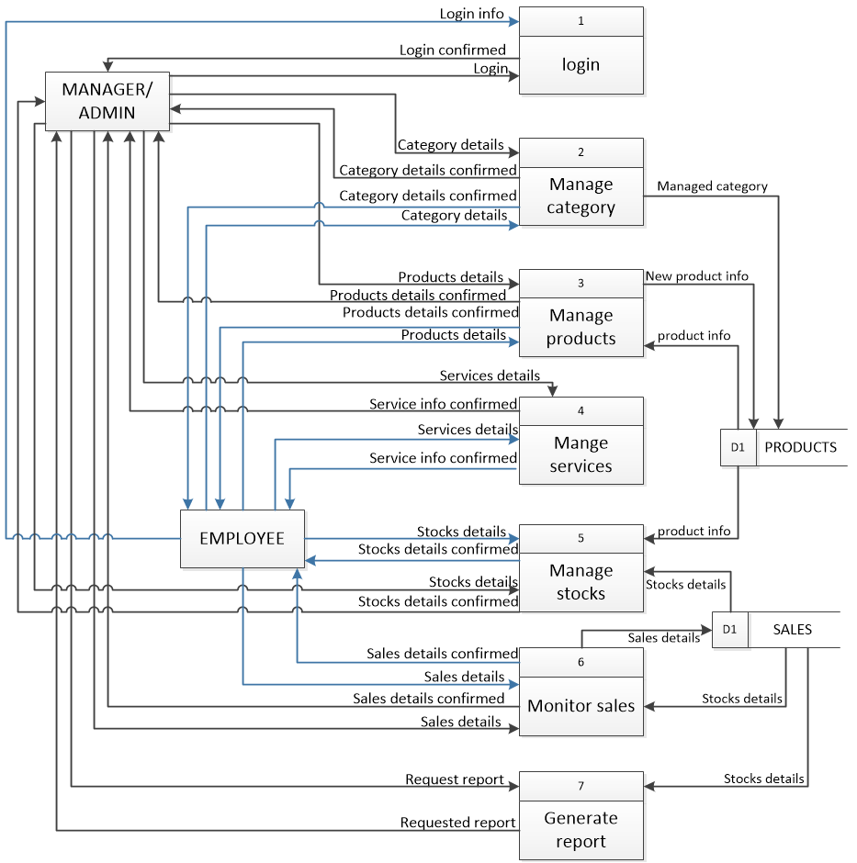**Context Diagram (top level)**

Figure 9.0 Data Flow Diagram (Top Level)

figure 9.0 shows the Data Flow Diagram (top level) the manager can make the login, reset the account and do the forgot password feature but the employee can only know the login info. Both Manager and Employee can create and view new record, stocks, monitor sales,manage services and products which are stored in d1 products on the other hand the Manager can request a report not the employees. the sales is also managed by the emploee and manager which is stored in d2 sales.

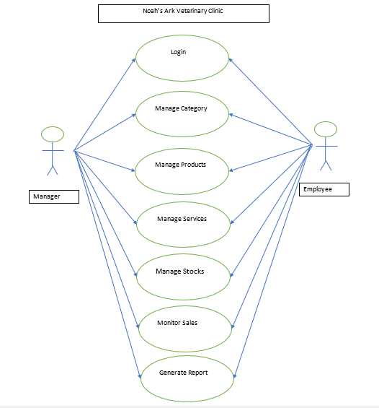**Use Case Diagram**

Figure 10.0 Use Case Diagram

Figure 8 shows the Use Case Diagram of the Inventory and Point of Sale System for Noah’s Ark Veterinary Clinic. This diagram shows the different kind of users as actors in the system. There are two actors: Manager and employee where employee and Manager can only login, request stocks for details, request product details, request order details and generate report. The manager can only check the login details.

