
O-RAN.WG1.TS.Use-Cases-Detailed-Specification-R005-v20.00
Technical Specification

O-RAN Work Group 1 (Use Cases and Overall Architecture)

Use Cases Detailed Specification

Copyright © 2026 by the O-RAN ALLIANCE e.V.
The copying or incorporation into any other work of part or all of the material available in this specification in any form without the prior written permission of O-RAN ALLIANCE e.V. is prohibited, save that you may print or download extracts of the material of this specification for your personal use, or copy the material of this specification for the purpose of sending to individual third parties for their information provided that you acknowledge O-RAN ALLIANCE as the source of the material and that you inform the third party that these conditions apply to them and that they must comply with them.

O-RAN ALLIANCE e.V., Buschkauler Weg 27, 53347 Alfter, Germany
Register of Associations, Bonn VR 11238, VAT ID DE321720189

Contents
Foreword 5
Modal verbs terminology 5
Introduction 5
1 Scope 6
2 References 6
2.1 Normative references 6
2.2 Informative references 8
3 Definition of terms, symbols and abbreviations 9
3.1 Terms 9
3.2 Symbols 10
3.3 Abbreviations 10
4 Use cases 12
4.1 Context-based dynamic HO management for V2X 12
4.1.1 Background and goal of the use case 12
4.1.2 Entities/resources involved in the use case 12
4.1.3 Solutions 13
4.1.4 Required data 16
4.2 Flight path based dynamic UAV radio resource allocation 16
4.2.1 Background and goal of the use case 17
4.2.2 Entities/resources involved in the use case 18
4.2.3 Solutions 18
4.2.4 Required data 21
4.3 Radio resource allocation for UAV application scenario 21
4.3.1 Background and goal of the use case 21
4.3.2 Entities/resources involved in the use case 23
4.3.3 Solutions 23
4.3.4 Required data 26
4.4 QoE optimization 26
4.4.1 Background and goal of the use case 26
4.4.2 Entities/resources involved in the use case 26
4.4.3 Solutions 27
4.4.4 Required data 36
4.5 Traffic steering 37
4.5.1 Background and goal of the use case 37
4.5.2 Entities/resources involved in the use case 38
4.5.3 Solutions 39
4.5.4 Required data 50
4.6 Massive MIMO optimization 52
4.6.1 Background and goal of the use case 52
4.6.2 Entities/resources involved in the use case 53
4.6.3 Solutions 55
4.6.4 Required data 67
4.7 RAN sharing 70
4.7.1 Background and goal of the use case 70
4.7.2 Entities/resources involved in the use case 71
4.7.3 Solutions 72
4.7.4 Required data 77
4.8 QoS based resource optimization 78
4.8.1 Background and goal of the use case 78
4.8.2 Entities/resources involved in the use case 78
4.8.3 Solutions 79
4.8.4 Required data 82
4.9 RAN slice SLA assurance 82
4.9.1 Background and goal of the use case 83
4.9.2 Entities/resources involved in the use case 83
4.9.3 Solutions 83
4.9.4 Required data 94
4.10 Multi-vendor slices 97
4.10.1 Background and goal of the use case 97
4.10.2 Entities/resources involved in the use case 98
4.10.3 Solutions 98
4.10.4 Required data 113
4.11 Dynamic spectrum sharing (DSS) 114
4.11.1 Background and goal of the use case 114
4.11.2 Entities/resources involved in the use case 116
4.11.3 Solutions 116
4.11.4 Required data 120
4.12 NSSI resource allocation optimization 122
4.12.1 Background and goal of the use case 122
4.12.2 Entities/resources involved in the use case 124
4.12.3 Solutions 124
4.12.4 Required data 127
4.13 Local indoor positioning in RAN 128
4.13.1 Background and goal of the use case 128
4.13.2 Entities/resources involved in the use case 128
4.13.3 Solutions 129
4.13.4 Required data 131
4.14 Massive SU/MU-MIMO grouping optimization 132
4.15 O-RAN signalling storm protection 132
4.15.1 Background and goal of the use case 132
4.15.2 Entities/resources involved in the use case 133
4.15.3 Solutions 133
4.15.4 Required data 144
4.16 Congestion prediction and management 144
4.17 Industrial IoT optimization 145
4.18 BBU pooling to achieve RAN elasticity 145
4.19 Integrated SON function within the O-RAN framework 145
4.19.1 Background and goal of the use case. 145
4.19.2 Entities/resources involved in the use case 146
4.19.3 Solutions 148
4.19.4 Required data 166
4.20 Shared O-RU 167
4.20.1 Background and goal of the use case 167
4.20.2 Entity/resources involved in the use case 178
4.20.3 Solution 186
4.20.4 Required data 337
4.21 Network energy saving 339
4.21.1 Background and goal of the use case 339
4.21.2 Entities/resources involved in the use case 340
4.21.3 Solutions 341
4.21.4 Required data 391
4.22 MU-MIMO optimization 410
4.22.1 Background and goal of the use case 410
4.22.2 Entities/resources involved in the use case 410
4.22.3 Solutions 411
4.22.4 Required data 413
4.23 Sharing Non-RT RIC data with the core 414
4.24 Industrial vision SLA assurance 414
4.24.1 Background and goal of the use case 414
4.24.2 Entities/resources involved in the use case 415
4.24.3 Solutions 415
4.24.4 Required data 418
4.25 Void 419
4.26 Interference detection, prediction and optimization 419
4.26.1 Background and goal of the use case 419
4.26.2 Entities/resources involved in the use case 419
4.26.3 Solutions 420
4.26.4 Required data 437
4.27 Communication and computing integrated networks 438
4.27.1 Background and goal of the use case 438
4.27.2 Entities/resources involved in the use case 442
4.27.3 Solutions 444
4.27.4 Required data 453
4.28 RAN intent-driven management services 456
4.28.1 Background and goal of the use case 456
4.28.2 Entities/resources involved in the use case 457
4.28.3 Solutions 457
4.28.4 Required data 462
4.29 Resiliency 462
4.30 NTN connected mode mobility 463
4.30.1 Background and goal of the use case 463
4.30.2 Entities/resources involved in the use case 466
4.30.3 Solutions 468
4.30.4 Required Data 475
4.31 Anomaly management 476
Annex A (informative): Additional information 477
A.1 Traffic steering use case A1 interface usage example 477
Annex (informative): Change history/Change request (history) 479

Foreword
This Technical Specification (TS) has been produced by WG1 of the O-RAN ALLIANCE.
The content of the present document is subject to continuing work within O-RAN and may change following formal O-RAN approval. Should the O-RAN ALLIANCE modify the contents of the present document, it will be re-released by O-RAN with an identifying change of version date and an increase in version number as follows:
version xx.yy.zz
where:
xx: the first digit-group is incremented for all changes of substance, i.e. technical enhancements, corrections, updates, etc. (the initial approved document will have xx=01). Always 2 digits with leading zero if needed.
yy: the second digit-group is incremented when editorial only changes have been incorporated in the document. Always 2 digits with leading zero if needed.
zz: the third digit-group included only in working versions of the document indicating incremental changes during the editing process. External versions never include the third digit-group. Always 2 digits with leading zero if needed.

Modal verbs terminology
In the present document "shall", "shall not", "should", "should not", "may", "need not", "will", "will not", "can" and "cannot" are to be interpreted as described in clause 3.2 of the O-RAN Drafting Rules (Verbal forms for the expression of provisions).
"must" and "must not" are NOT allowed in O-RAN deliverables except when used in direct citation.

Introduction
This document provides O-RAN WG1 detailed use case descriptions. Any multi-WG use case defined in O-RAN is expected to be documented in “O-RAN WG1 Use Case Analysis Report” and if the use case is to be studied further, it will be covered in this document in detail, and then in relevant WGs.

1 Scope
The present document specifies the top-level use cases as defined by O-RAN WG1 UCTG (Use Case Task Group). For each use case, the document describes the motivation, resources, steps involved, and the data requirements. These top-level use cases are further detailed in relevant WGs along with the requirements for O-RAN components and their interfaces.

2 References

2.1 Normative references
References are either specific (identified by date of publication and/or edition number or version number) or non-specific. For specific references, only the cited version applies. For non-specific references, the latest version of the referenced document (including any amendments) applies. In the case of a reference to a 3GPP document, a non-specific reference implicitly refers to the latest version of that document in Release 18, or the latest 3GPP release prior to Release 18 that includes that document.
NOTE: While any hyperlinks included in this clause were valid at the time of publication, O-RAN cannot guarantee their long-term validity.
The following referenced documents are necessary for the application of the present document.
- 3GPP TS 22.261: “Service requirements for the 5G system; Stage 1”
- 3GPP TS 23.501: “System architecture for the 5G System (5GS); Stage 2”
- Void
- 3GPP TS 28.530: “Management and orchestration; Concepts, use cases and requirements”
- 3GPP TS 28.541: “Management and orchestration; 5G Network Resource Model (NRM); Stage 2 and stage 3”
- 3GPP TS 28.552: “Management and orchestration; 5G performance measurements”
- 3GPP TS 28.554: “Management and orchestration; 5G end to end Key Performance Indicators (KPI)”
- 3GPP TS 28.622: “Telecommunication management; Generic Network Resource Model (NRM) Integration Reference Point (IRP); Information Service (IS)”
- 3GPP TS 28.624: “Telecommunication management; State management data definition Integration Reference Point (IRP); Requirements”
- 3GPP TS 28.625: “Telecommunication management; State Management Data Definition Integration Reference Point (IRP); Information Service (IS)”
- 3GPP TS 28.626: “Telecommunication management; State management data definition Integration Reference Point (IRP); Solution Set (SS) definitions”
- 3GPP TS 37.340: “Evolved Universal Terrestrial Radio Access (E-UTRA) and NR; Multi-connectivity; Overall Description; Stage 2”
- 3GPP TS 38.211: “NR; Physical channels and modulation”
- 3GPP TS 38.213: “NR; Physical layer procedures for control”
- ETSI EN 302 637-2: “Intelligent Transport Systems (ITS); Vehicular Communications; Basic Set of Applications; Part 2: Specification of Cooperative Awareness Basic Service”, Release 1, November 2010
- ETSI EN 302 637-3: “Intelligent Transport Systems (ITS); Vehicular Communications; Basic Set of Applications; Part 3: Specifications of Decentralized Environmental Notification Basic Service”, Release 1, November 2014
- GSMA NG.116: “Generic Network Slice Template”, Version 2.0, October 2019
- ITU-T X.731: “Information technology - Open Systems Interconnection - Systems management: State management function”
- RFC 8348: “A YANG Data Model for Hardware Management”
- 3GPP TS 28.313: “Management and orchestration; Self-Organizing Networks (SON) for 5G networks”
- 3GPP TS 28.532: “Management and orchestration; Generic management services”
- 3GPP TS 23.502: “Procedures for the 5G System (5GS); Stage 2”
- ETSI GS NFV IFA013: “Management and Orchestration; Os-Ma-nfvo reference point - Interface and Information Model Specification”, v4.4.1, Release 4, March 2023
- ETSI GS NFV IFA008: “Management and Orchestration; Ve-Vnfm reference point - Interface and Information Model Specification”, v4.3.1, Release 4, May 2022
- O-RAN WG5.O-DU-O1: “O1 Interface specification for O-DU”, Version R003-V09, December 9, 2023
- O-RAN.WG6.ORCH-USE-CASES: “Cloudification and Orchestration Use Cases and Requirements for O-RAN Virtualized RAN”
- O-RAN.WG10.OAM-Architecture: “O-RAN Working Group 10, O-RAN Operations and Maintenance Architecture”
- O-RAN.WG4.MP: “O-RAN Working Group 4 (Open Fronthaul Interfaces WG), Management Plane Specification”
- O-RAN.WG4.CUS.0-v02.00: “O-RAN Fronthaul Working Group, Control, User and Synchronization Plane Specification”
- 3GPP TS 36.423: “Evolved Universal Terrestrial Radio Access Network (E-UTRAN); X2 application protocol (X2AP)”
- 3GPP TS 36.314: “Evolved Universal Terrestrial Radio Access (E-UTRA); Layer 2 – Measurements”
- 3GPP TS 38.314: “NR; Layer 2 Measurements”
- 3GPP TS 32.425: “Telecommunication management; Performance Management (PM); Performance measurements; Evolved Universal Terrestrial Radio Access Network (E-UTRAN)”
- 3GPP TS 36.300: “Evolved Universal Terrestrial Radio Access (E-UTRA) and Evolved Universal Terrestrial Radio Access Network (E-UTRAN); Overall description; Stage 2”
- 3GPP TS 23.401: “General Packet Radio Service (GPRS) enhancements for Evolved Universal Terrestrial Radio Access Network (E-UTRAN) access”
- 3GPP TS 23.203: “Policy and charging control architecture”
- 3GPP TS 36.214: “Evolved Universal Terrestrial Radio Access (E-UTRA); Physical layer; Measurements”
- 3GPP TS 36.331: “Evolved Universal Terrestrial Radio Access (E-UTRA); Radio Resource Control (RRC); Protocol specification”
- O-RAN.WG11.TS.Security-Requirements-Specification.0-R004-v11.00: “Security Requirements and Controls Specifications”
- 3GPP TS 28.623: “Telecommunication management; Generic Network Resource Model (NRM) Integration Reference Point (IRP); Solution Set (SS) definitions”
- 3GPP TS 28.662: “Telecommunication management; Generic Radio Access Network (RAN) Network Resource Model (NRM) Integration Reference Point (IRP); Information Service (IS)”
- O-RAN.WG6.TS.O-CLOUD-IM: “O-RAN Work Group 6 (Cloudification and Orchestration Workgroup), O-Cloud Information Model”
- 3GPP TS 28.310: “Management and orchestration; Energy efficiency of 5G”, V19.1.0 (2025-06)
- O-RAN.WG10.TS.O1-Interface: “O-RAN O1 Interface Specification”
- O-RAN.WG10.TS.O1NRM: “O1 Network Resource Model”
- O-RAN.WG3.TS.UCR-R004: “Use Cases and Requirements”
- O-RAN.WG3.TS.E2SM-CCC: “E2 Service Model (E2SM) Cell Configuration and Control”
- O-RAN.WG10.TS.O1PMeas: “O-RAN O1 Performance Measurements Specification”
- O-RAN.WG3.TS.E2SM-KPM: “E2 Service Model (E2SM) KPM”
- O-RAN.WG2.TS.Use-Case-Requirements-R004: “Non-RT RIC & A1/R1 interface: Use Cases and Requirements”
- O-RAN.WG4.TS.CUS.0-R004: “Control, User and Synchronization Plane Specification”
- 3GPP TS 28.558: “Management and orchestration; UE level measurements for 5G system”
- 3GPP TS 38.331: “NR; Radio Resource Control (RRC) protocol specification”

2.2 Informative references
References are either specific (identified by date of publication and/or edition number or version number) or non-specific. For specific references, only the cited version applies. For non-specific references, the latest version of the referenced document (including any amendments) applies. In the case of a reference to a 3GPP document, a non-specific reference implicitly refers to the latest version of that document in Release 18, or the latest 3GPP release prior to Release 18 that includes that document.
NOTE: While any hyperlinks included in this clause were valid at the time of publication, O-RAN cannot guarantee their long-term validity.
The following referenced documents are not necessary for the application of the present document, but they assist the user with regard to a particular subject area.
[i.1] 3GPP TR 21.905: “Vocabulary for 3GPP Specifications”
[i.2] 3GPP TR 37.817: “Evolved Universal Terrestrial Radio Access (E-UTRA) and NR; Study on enhancement for Data Collection for NR and EN-DC”
[i.3] 3GPP TR 38.889: “Study on NR-based access to unlicensed spectrum”
[i.4] 3GPP TR 38.913: “Study on Scenarios and Requirements for Next Generation Access Technologies”
[i.5] ETSI ES 203 228: “Environmental Engineering (EE); Assessment of mobile network energy efficiency”, V1.3.1, October 2020
[i.6] Chih-Lin I, Guanding Yu, Shuangfeng Han, Geoffrey Ye Li, “Green and Software-defined Wireless Networks: From Theory to Practice”, Cambridge University Press, 2019
[i.7] ETSI White Paper No. 54, “Evolving NFV towards the next decade”, May, 2023
[i.8] ETSI GS MEC 003: “Multi-access Edge Computing (MEC); Framework and Reference Architecture”
[i.9] ITU-T Y.IMT2020-CNC-req, Recommendation, “Requirements of coordination of computing and networking for IMT-2020 and beyond”
[i.10] 3GPP TS 28.538: “Management and orchestration; Edge Computing Management (ECM)”
[i.11] https://www.synopsys.com/automotive/autonomous-driving-levels.html
[i.12] 3GPP TS 22.186: “Enhancement of 3GPP support for V2X scenarios; Stage 1”
[i.13] 3GPP TR 26.928: “Extended Reality (XR) in 5G”
[i.14] 3GPP TR 38.885: “NR; Study on NR Vehicle-to-Everything (V2X)”
[i.15] 3GPP TS 28.312: “Management and orchestration; Intent driven management services for mobile networks”
[i.16] TMF921: “Intent Management API User Guide v5.0.0”
[i.17] O-RAN.WG1.TR.RIC4NTN-R005-v02.00: “O-RAN Work Group 1 (Use Cases and Overall Architecture), RIC Enabling NTN Deployments”

3 Definition of terms, symbols and abbreviations

3.1 Terms
For the purposes of the present document, the terms and definitions [given in [i.1] and the following] apply. A term defined in the present document takes precedence over the definition of the same term, if any, in [i.1].
A1: Interface between Non-RT RIC and Near-RT RIC to enable policy-driven guidance of Near-RT RIC applications/functions, and support AI/ML workflow.
A1 policy: Type of declarative policies expressed using formal statements that enable the Non-RT RIC function in the SMO to guide the Near-RT RIC function, and hence the RAN, towards better fulfilment of the RAN intent.
A1 enrichment information: Information utilized by Near-RT RIC that is collected or derived at SMO/Non-RT RIC either from non-network data sources or from network functions themselves.
E2: Interface connecting the Near-RT RIC and one or more O-CU-CPs, one or more O-CU-UPs, and one or more O-DUs.
E2 node: A logical node terminating E2 interface. In the present document, O-RAN nodes terminating E2 interface are:
- for NR access: O-CU-CP, O-CU-UP, O-DU or any combination.
- for E-UTRA access: O-eNB.
FCAPS: Fault, Configuration, Accounting, Performance, Security.
Intent: Formal specification of all requirements including goals and constraints given to a system.
NOTE: This definition aligns with the definitions in 3GPP TS 28.312 [i.15], clause 3.1. and TMF921 [i.16].
Intents: A declarative policy to steer or guide the behavior of RAN functions, allowing the RAN function to calculate the optimal result to achieve stated objective.
Near-RT RIC: O-RAN Near-Real-Time RAN Intelligent Controller: A logical function that enables near-real-time control and optimization of RAN elements and resources via fine-grained data collection and actions over E2 interface.
Non-RT RIC: O-RAN Non-Real-Time RAN Intelligent Controller: A logical function that enables non-real-time control and optimization of RAN elements and resources, AI/ML workflow including model training and updates, and policy-based guidance of applications/features in Near-RT RIC.
O-CU: O-RAN Central Unit: A logical node hosting O-CU-CP and O-CU-UP.
O-CU-CP: O-RAN Central Unit – Control Plane: A logical node hosting the RRC and the control plane part of the PDCP protocol.
O-CU-UP: O-RAN Central Unit – User Plane: A logical node hosting the user plane part of the PDCP protocol and the SDAP protocol.
O-DU: O-RAN Distributed Unit: A logical node hosting RLC/MAC/High-PHY layers based on a lower layer functional split.
O-RU: O-RAN Radio Unit: A logical node hosting Low-PHY layer and RF processing based on a lower layer functional split. This is similar to 3GPP’s “TRP” or “RRH” but more specific in including the Low-PHY layer (FFT/iFFT, PRACH extraction).
O1: Interface between management entities (SMO/EMS/MANO) and O-RAN managed elements, for operation and management, by which FCAPS management, software management, file management can be achieved.
O2: Interface between management entities and the O-Cloud for supporting O-RAN virtual network functions.
RAN: Generally referred as Radio Access Network. In terms of this document, any component below Near-RT RIC per O-RAN architecture, including O-CU/O-DU/O-RU.
RAN management intent handler: An authorized SMO service producer which understands, can process and ensure fulfilment of RAN management intents.
RAN management intent owner: An authorized SMO service consumer, responsible for formulating the RAN management intents as per its own goals and requirements and consuming intent-based services.
Shared O-RU: An O-RU that is able to be configured to operate with one or more O-DUs operated by one or more mobile network operators.

3.2 Symbols
Void

3.3 Abbreviations
For the purposes of the present document, the abbreviations [given in [i.1] and the following] apply. An abbreviation defined in the present document takes precedence over the definition of the same abbreviation, if any, in [i.1].
AI/ML Artificial Intelligence/Machine Learning
AISG Antenna Interface Standards Group
CAM Cooperative Awareness Message
CHO Conditional Handover
DENM Decentralized Environmental Notification Message
EFC Earth Fixed Cell
EMC Earth Moving Cell
eNB eNodeB (applies to LTE)
gNB gNodeB (applies to NR)
GNSS Global Navigation Satellite System
KPI Key Performance Indicator
LEO Low Earth Orbit
MIMO Multiple Input, Multiple Output
mTLS Multiplexed Transport Layer Security
NACM NETCONF Access Control Model
NGSO Non-Geostationary Orbit
NRT Neighbor Relation Table
NTN Non-Terrestrial Networks
O-CU O-RAN Central Unit
O-DU O-RAN Distributed Unit
O-RU O-RAN Radio Unit
PBCH Physical Broadcast Channel
PCI Physical Cell Identity
PRB Physical Resource Block
QoE Quality of Experience
RACH Random Access Channel
RAN Radio Access Network
rApps RAN Applications
RIC O-RAN RAN Intelligent Controller
RLF Radio Link Failure
RMIH RAN Management Intent Handler
RMIO RAN Management Intent Owner
RRC Radio Resource Control
RTT Round Trip Time
SA Service and Slice Subnet Assurance
SAN Satellite Access Network
SCC Satellite Control Center
SIB System Information Block
SINR Signal-to-Interference-plus-Noise Ratio
SME Service Management and Exposure
SMO Service Management and Orchestration
SMOS SMO Service
SMTC SS/PBCH Block Measurement Timing Configuration
SO Service and Slice Subnet Orchestration
SS Synchronization Signal
TLS Transport Layer Security
UAV Unmanned Aerial Vehicle
V2X Vehicle to Everything

4 Use cases

4.1 Context-based dynamic HO management for V2X
This use case provides the background, motivation, and requirements for the context-based dynamic HO management for V2X use case, allowing operators to adjust radio resource allocation policies through the O-RAN architecture, reducing latency and improving radio resource utilization.

4.1.1 Background and goal of the use case
V2X communication allows for numerous potential benefits such as increasing the overall road safety, reducing emissions, and saving time. Part of the V2X architecture is the V2X UE (SIM + device attached to vehicle) which communicates with the V2X Application Server (V2X AS). The exchanged information comprises Cooperative Awareness Messages (CAMs), (from UE to V2X AS) [15], radio cell IDs, connection IDs, and basic radio measurements (RSRP, RSPQ, etc.)
As vehicles traverse along a highway, due to their high speed and the heterogeneous natural environment V2X UEs are handed over frequently, at times in a suboptimal way, which can cause handover (HO) anomalies: e.g., short stay, ping-pong, and remote cell. Such suboptimal HO sequences substantially impair the functionality of V2X applications. Since HO sequences are mainly determined by the Neighbour Relation Tables (NRTs), maintained by the xNBs, there is hardly room for UE-level customization.
This UC aims to present a method to avoid and/or resolve problematic HO scenarios by using past navigation and radio statistics in order to customize HO sequences on a UE level. To this end, the AI/ML functionality that is enabled by the Near-RT RIC is employed.

4.1.2 Entities/resources involved in the use case
- Non-RT RIC:
  - Retrieve necessary performance, configuration, and other data for constructing/training relevant AI/ML models that will be deployed in Near-RT RIC to assist in the V2X HO management function. For example, this could be a clustering algorithm that classifies traffic situations and radio conditions that (probably) do or do not lead to HO anomalies.
  - Support deployment and update of AI/ML models into Near-RT RIC xApp.
  - Support communication of intents and policies (system-level and UE-level) from Non-RT RIC to Near-RT RIC.
  - Support communication of non-RAN data to enrich control functions in Near-RT RIC (enrichment data).
- Near-RT RIC:
  - Support update of AI/ML models retrieved from Non-RT RIC.
  - Support interpretation and execution of intents and policies from Non-RT RIC.
  - Support necessary performance, configuration, and other data for defining and updating intents and policies for tuning relevant AI/ML models.
  - Support communication of configuration parameters to RAN.
- RAN:
  - Support data collection with required granularity to SMO over O1 interface.
  - Support near-real-time configuration-based optimization of HO parameters over E2 interface.
  - Report necessary performance, configuration, and other data for performing real-time V2X HO optimization in the Near-RT RIC over E2 interface.
- V2X application server:
  - Support data collection with required granularity from V2X UE over V1 interface.
  - Support communication of real-time traffic related data about V2X UE to Non-RT RIC as enrichment data.

4.1.3 Solutions

4.1.3.1 Context-based dynamic handover management for V2X
The context of the context-based dynamic handover management for V2X use case is captured in table 4.1.3.1-1.

Table 4.1.3.1-1: Context-based dynamic handover management for V2X
Use Case Stage | Evolution / Specification | <<Uses>>  Related use
Goal | Drive V2X UE HOs in RAN according to defined intents, policies, and configuration while enabling AI/ML-based solutions.
Actors and Roles | Non-RT RIC: RAN policy control function.  Near-RT RIC: RAN policy enforcement function.  RAN: Policy enforcement for configuration updates.  SMO: Termination point for O1 interface.  V2X AS: Termination point for V1 interface and enrichment data provider.
Assumptions | All relevant functions and components are instantiated.  A1, O1, E2 interface connectivity is established.
Pre-conditions | Network is operational.  SMO has established the data collection and sharing process, and Non-RT RIC has access to this data.  Non-RT RIC analyzes the historical data from RAN and V2X AS for training the relevant AI/ML models to be deployed or updated in the Near-RT RIC, as well as AI/ML models required for real-time optimization of configuration and policies.
Begins when | Operator specified trigger condition or event is detected.
Step 1 (M) | Non-RT RIC deploys/updates the AI/ML model in the Near-RT RIC via O1 or Non-RT RIC assigns/update the AI/ML model for the Near-RT RIC xApp via A1.
Step 2 (M) | Non-RT RIC communicates relevant policies/intents and enrichment data to the Near-RT RIC over the A1 interface. The enrichment data from the non-RAN data can include V2X UE location, trajectory, navigation information, GPS data, CAMs, DENMs.
Step 3 (M) | The Near-RT RIC receives the relevant info from the Non-RT RIC over the A1 interface and from the RAN over the E2 interface, interprets the policies and updates the AI/ML models.
Step 4 (M) | The Near-RT RIC infers optimal RAN configuration (UE-specific NRTs) according to the trained AI/ML models and communicates the result to the RAN over E2 interface.
Step 5 (M) | RAN deploys the configuration received from the Near-RT RIC over the E2 interface.
Step 4 | If required, Non-RT RIC can configure specific performance measurement data to be collected from RAN to assess the performance of the V2X HO management function in Near-RT RIC, or to assess the outcome of the applied policies and configuration.
Ends when | Operator specified trigger condition or event is satisfied.
Exceptions | None identified.
Post Conditions | Non-RT RIC monitors the performance of the V2X HO related function in Near-RT RIC by collecting and monitoring the relevant performance KPIs and counters from the RAN and the V2X AS.
@startuml
skinparam ParticipantPadding 5
skinparam BoxPadding 10
skinparam defaultFontSize 12
Autonumber
Box “Service Management and Orchestration” #gold
Participant SMO as “Orchestration”
Boundary Collector
Control CTRL as “Resource Controller”
Database DL as “Data Lake”
Participant NON as “Non-RT RIC”
Collections MLTH as “ML Training Host(s)”
end box
Box “O-RAN” #lightpink
Participant RIC as “Near-RT RIC”
Participant OCU as “O-CU”
Participant ODU as “O-DU”
End box
Box “External” #lightcyan
Participant V2X as “V2X Application Server”
End box
ODU-> Collector : <<O1 Perf./trace management >> SMO data collection
OCU-> Collector : <<O1 Perf./trace management >> SMO data collection
RIC -> Collector : <<O1 Perf./trace management >> SMO data collection
Hnote over NON
Assume trained models are available in SMO
Endhnote
SMO -> NON : <<SMO internal>> Deploy NonRT_Model1
NON -> NON : Execute NonRT_Model1
NON -> RIC : <<A1>> Traffic Steering Policy (create/update/delete)
SMO -> RIC : <<O1 Software management>> Deploy NearRT_Model1
SMO -> RIC : <<O1 Software management>> Deploy NearRT_Model2
RIC -> ODU: <<E2>> Subscription request to initiate data collection
ODU -> RIC : <<E2>> Model inference data collection
RIC -> OCU: <<E2>> Subscription request to initiate data collection
OCU -> RIC : <<E2>> Model inference data collection
RIC -> NON : <<A1>> Subscription request to initiate data collection
NON -> V2X : <<ENR>> Subscription request to initiate data collection
V2X -> NON : <<ENR>> Model inference data collection
NON -> RIC : <<A1>> Model inference data collection
RIC -> ODU : <<E2>> Subscription Request:{Measurement report for UE}
ODU -> RIC : <<E2>> Report:{Measurement report for UE}
RIC -> OCU : <<E2>> Subscription Request:{Measurement report for UE}
OCU -> RIC : <<E2>> Report:{Measurement report for UE}
RIC -> NON : <<A1>> Subscription Request:{Measurement report for UE}
NON -> V2X : <<ENR>> Subscription Request:{Measurement report for UE}
V2X -> NON : <<ENR>> Report:{Measurement report for UE}
NON -> RIC : <<A1>> Report:{Measurement report for UE}
RIC -> RIC : Detect V2X UE
RIC -> RIC : <<NearRT_xApp1>> Monitor UE performance
RIC -> RIC : Execute NearRT_Model1 to detect/predict anomalous HO situation
Alt if HO anomaly score < threshold
RIC -> RIC : Execute NearRT_Model2 to find substitute UE specific substitute NRTs
RIC -> OCU : <<E2>> RICControlRequest, ControlmessageIE: {xNB, cell_iD, UE_ID_NRT, Action = deploy}
OCU -> RIC : <<E2>> RICControlResponse: {successful/failure}
End
ODU-> Collector : <<O1 Perf./trace management>> SMO data collection
OCU-> Collector : <<O1 Perf./trace management>> SMO data collection
RIC -> Collector : <<O1 Perf./trace management >> SMO data collection
SMO -> SMO: Update NearRT_model2
SMO -> RIC : <<O1 Software management>> Deploy NearRT_Model2
@enduml

The flow diagram of the context-based dynamic handover management for V2X use case is given in figure 4.1.3.1-1.

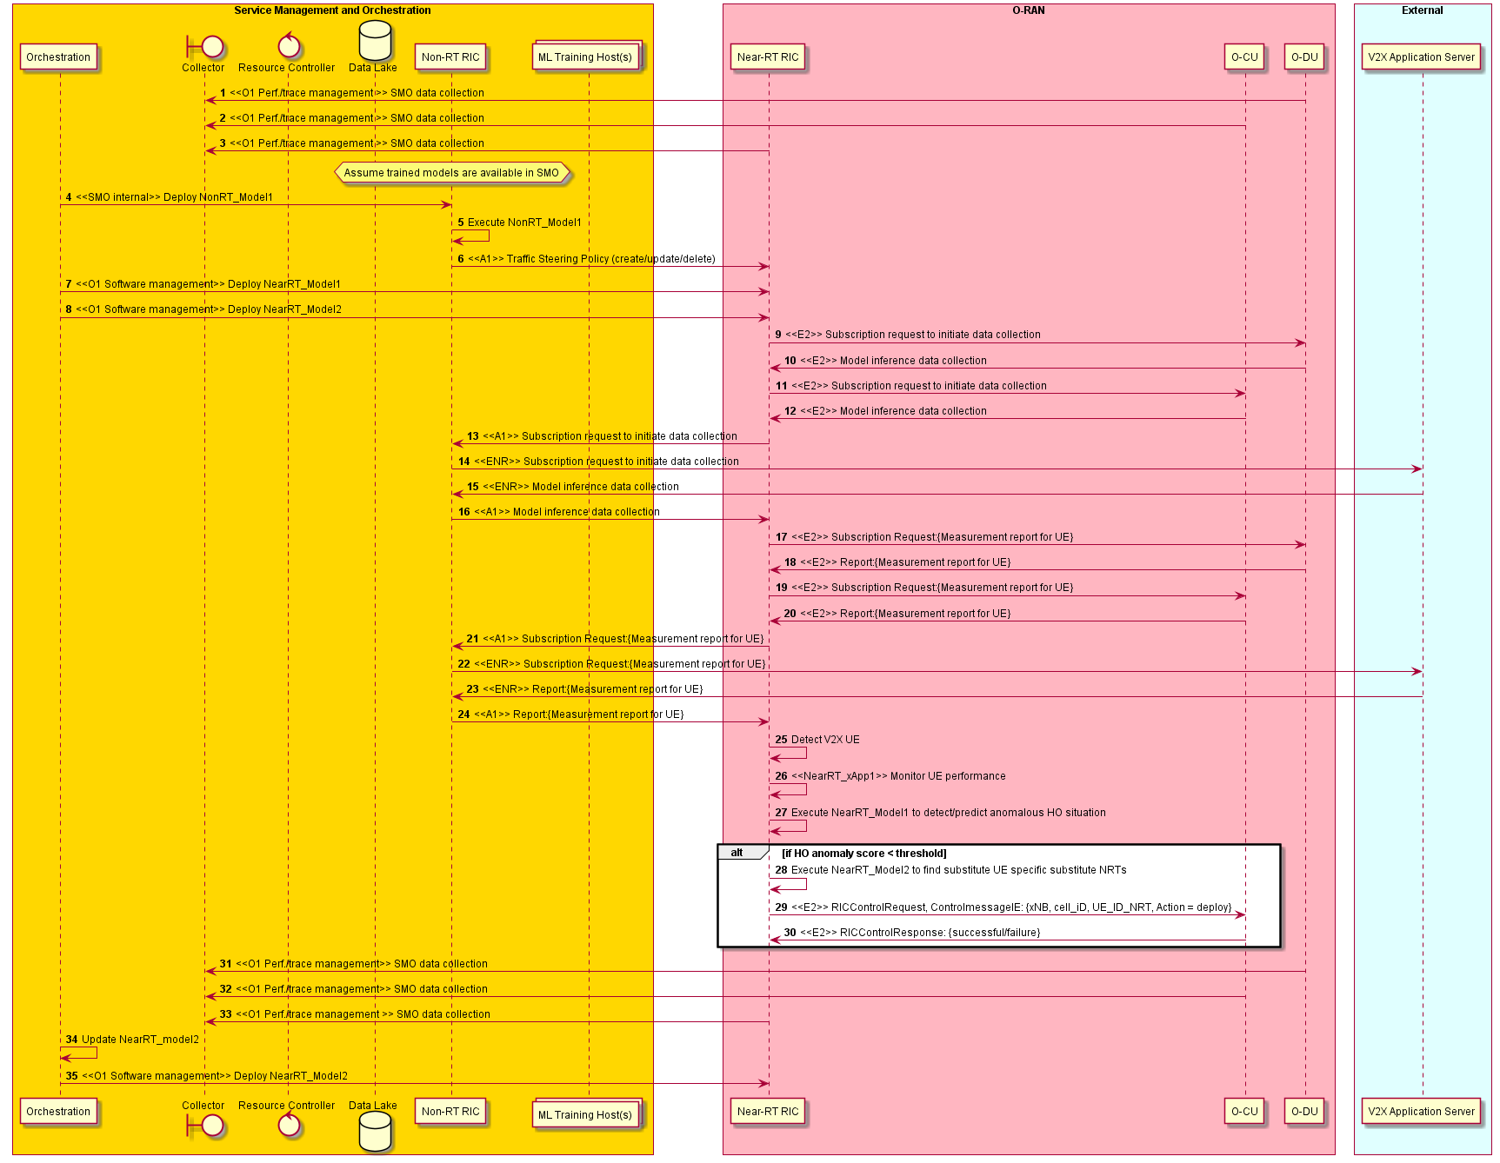
Figure 4.1.3.1-1: Context-based dynamic handover management for V2X flow diagram

4.1.4 Required data
The measurement counters and KPIs (as defined by 3GPP) shall be appropriately aggregated by cell, QoS type, slice, etc.
- Measurement reports with RSRP/RSRQ/CQI information for serving and neighboring cells.
- UE connection and mobility/handover statistics with indication of successful and failed handovers and error codes etc.
- V2X related data: position, velocity, direction, navigation data, CAMs, DENMs as specified in ETSI EN 302 637-3 [16] and in [i.5].

4.2 Flight path based dynamic UAV radio resource allocation
This use case provides the background, motivation, and requirements for the support the use case of flight path based dynamic UAV radio resource allocation, allowing operators to adjust radio resource allocation policies through the O-RAN architecture, reducing unnecessary handover and improving radio resource utilization.

4.2.1 Background and goal of the use case
The field trials’ results show that the coverage for low altitude is good and can provide various services for terrestrial UEs with good performance. However, since the site along the flight is mainly for terrestrial UEs, the altitude of the UAV is always not within the main lobe of the ground station antenna. And the side lobes give rise to the phenomenon of scattered cell associations particularly noticeable in the sky. The cell association pattern on the ground is ideally contiguous area where the best cell is most often the one closest to the UE. As the UE move up in height, the antenna side lobes start to be visible, and there is a possibility of the best cell no longer being the closest one. The cell association pattern in this particular scenario becomes fragmented especially at the height of 300m and above. Hence, at higher altitudes, several challenges that lead to a different radio environment are:
- LOS propagation/uplink interference
- Poor KPI caused by antenna side lobes for base stations
- Sudden drop in signal strength
These challenges directly impact on the mobility performance of the drone and the service experience of the user. Hence, we would like to support the use case of flight path based dynamic UAV radio resource allocation to resolve the above issues.
Non-Real-Time RIC can retrieve necessary of aerial vehicles related measurement metrics from network based on UE’s measurement report and SMO, and flight path information of aerial vehicle, climate information, flight forbidden/limitation area information and space load information etc. from application, e.g., UTM (Unmanned Traffic Management) for constructing/training relevant AI/ML model that will be deployed in RAN. For example, this could be UL/DL interference from/to aerial vehicles, the detection of aerial vehicle UEs, and available radio resource (e.g., frequency, cell, beam, BWP, numerology) prediction. And the Near-Real-Time RIC can support deployment and execution of AI/ML models from Non-RT RIC. Based on this, the Near-Real-Time RIC can perform the radio resource allocation for on-demand coverage for UAV considering the radio channel condition, flight path information and other application information.
The architectural context of the flight path based dynamic UAV radio resource allocation use case is shown in figure 4.2.1-1.

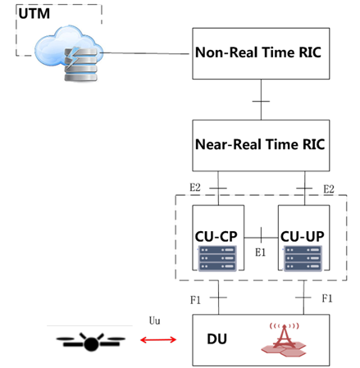
Figure 4.2.1-1: Use case of flight path based dynamic UAV radio resource allocation
Since there is no effective functional module in current eNB/gNB to retrieve the application information, perform machine learning and training based on both the acquired application information and radio environment information, and execute AI/ML models based on above information. And in the O-RAN architecture, the flight path based dynamic UAV radio resource allocation mechanism can be supported by the RIC function module, i.e., Non-Real-Time RIC and Near-Real-Time RIC. Therefore, we provide the description of O-RAN support use case for flight path based dynamic UAV radio resource.

4.2.2 Entities/resources involved in the use case
- Non-RT RIC:
  - Retrieve necessary of O-RAN support for aerial vehicles related measurement metrics from network level measurement report and SMO (can acquire data from application) for constructing/training relevant AI/ML model that will be deployed in Near-RT RIC to assist in the O-RAN support for aerial vehicles function. For example, this could be UL/DL interference from/to aerial vehicles, the detection of aerial vehicle UEs, and available radio resource (e.g. frequency, cell, beam, BWP, numerology) prediction.
  - Training of potential ML models for O-RAN support for aerial vehicles, which can respectively autonomously control UL/DL interference from/to aerial vehicles, detect the UE of aerial vehicles, and predict available radio resource (e.g. frequency, cell, beam, BWP, numerology) for aerial vehicles.
  - Send policies/intents to Near-RT RIC to drive the O-RAN support for aerial vehicles at RAN level in terms of expected behavior.
- Near-RT RIC:
  - Support update of AI/ML models from Non-RT RIC.
  - Support execution of the AI/ML models from Non-RT RIC.
  - Support interpretation and execution of intents and policies from Non-RT RIC to derive O-RAN support for aerial vehicles at RAN level in terms of expected behavior.
  - Support perform the radio resource allocation for on-demand coverage for UAV considering the radio channel condition, flight path information and other application information via the AI/ML models from Non-RT RIC.
  - Sending aerial vehicles performance report to Non-RT RIC for evaluation and optimization.
- RAN:
  - Support data collection with UE performance report over O1 interface.
  - Support non-real-time optimization of radio resources allocation parameters over O1 interface.
- Application server:
  - Provide application information, e.g. flight path information of aerial vehicle, climate information, flight forbidden/limitation area information and space load information.

4.2.3 Solutions

4.2.3.1 Flight path based dynamic UAV radio resource allocation
The context of the flight path based dynamic UAV radio resource allocation use case is captured in table 4.2.3.1-1.
Table 4.2.3.1-1: Flight path based dynamic UAV radio resource allocation
Use Case Stage | Evolution / Specification | <<Uses>>  Related use
Goal | In the O-RAN architecture, the flight path based dynamic UAV radio resource allocation mechanism can be supported, which can perform the radio resource allocation for on-demand coverage for UAV considering the radio channel condition, flight path information and other application information.
Actors and Roles | Non-RT RIC: RAN policy control function.  Near-RT RIC: RAN policy enforcement function.  RAN: Implementation of updated configuration parameters.  Application server: Generates RAN side UE-level policies.
Assumptions | All relevant functions and components are instantiated.  A1/O1 interface connectivity is established with Non-RT RIC.
Pre-conditions | Near-RT RIC and Non-RT RIC are instantiated with A1 interface connectivity being established between them.  A certificate is shared between Near-RT RIC and Non-RT RIC for model related data exchange.  E2 interface is established between Near-RT RIC and CU/DU.
Begins when | Operator specified trigger condition or event is detected.
Step 1 (M) | Application server sends the application data to Non-RT RIC.
Step 2 (M) | Non-RT RIC deploys/updates AI/ML models in the Near-RT RIC via O1 or Non-RT RIC assigns/update the AI/ML model for the Near-RT RIC xApp via A1.
Step 3 (M) | Non-RT RIC sends relevant policies/intents and enrichment data to the Near-RT RIC over the A1 interface.
Step 4 (M) | The Near-RT RIC receives the relevant info from the Non-RT RIC over the A1 interface and from the RAN over the E2 interface, interprets the policies and updates the AI/ML models.  And the Near-RT RIC converts policy to specific configuration parameter commands.
Step 5 (M) | RAN executes the command to modify the configuration parameters RAN executes the command to modify the configuration parameters.
Ends when | Operator specified trigger condition or event is satisfied.
Exceptions | None identified.
Post Conditions | Non-RT RIC collects relevant performance data from eNB/gNB, to observe the data transmission performance improvement brought by the wireless resource configuration optimization policy.
@startuml
skinparam ParticipantPadding 5
skinparam BoxPadding 10
skinparam defaultFontSize 12
Autonumber

Box “Service Management and Orchestration” #gold
Boundary Collector as collect
Participant “Non-RT RIC” as non
End box

Box “O-RAN” #lightpink
Participant near as “Near-RT RIC”
Participant ran as “O-CU/O-DU”
End box

Box “External” #lightcyan
Participant “Application Server” as app
End box

ran --> collect: <<O1>> Data collection
collect--> non : Retrieval of data
app --> non : Data retrieval of application data

group ML workflow
non -> non : Training of ML models
non -> non : Deploy internal ML models
non -> near : <<O1>> Deploy or update ML models
end

app --> non : Data retrieval of application data
non -> near : <<A1>> Radio resource allocation/update policies/intents for UAV UE
non -> near : <<A1>> Enrichment data
near -> ran : <<E2>> Radio resource configuration update for UAV UE

group Performance evaluation and optimization
ran -> collect: <<O1>> Data collection
collect-> non : Data retrieval of RAN and other data
non -> non : Performance monitoring & evaluation
non -> non : Model re-training/update
end
@enduml

The flow diagram of the flight path based dynamic UAV radio resource allocation use case is given in figure 4.2.3.1-1.

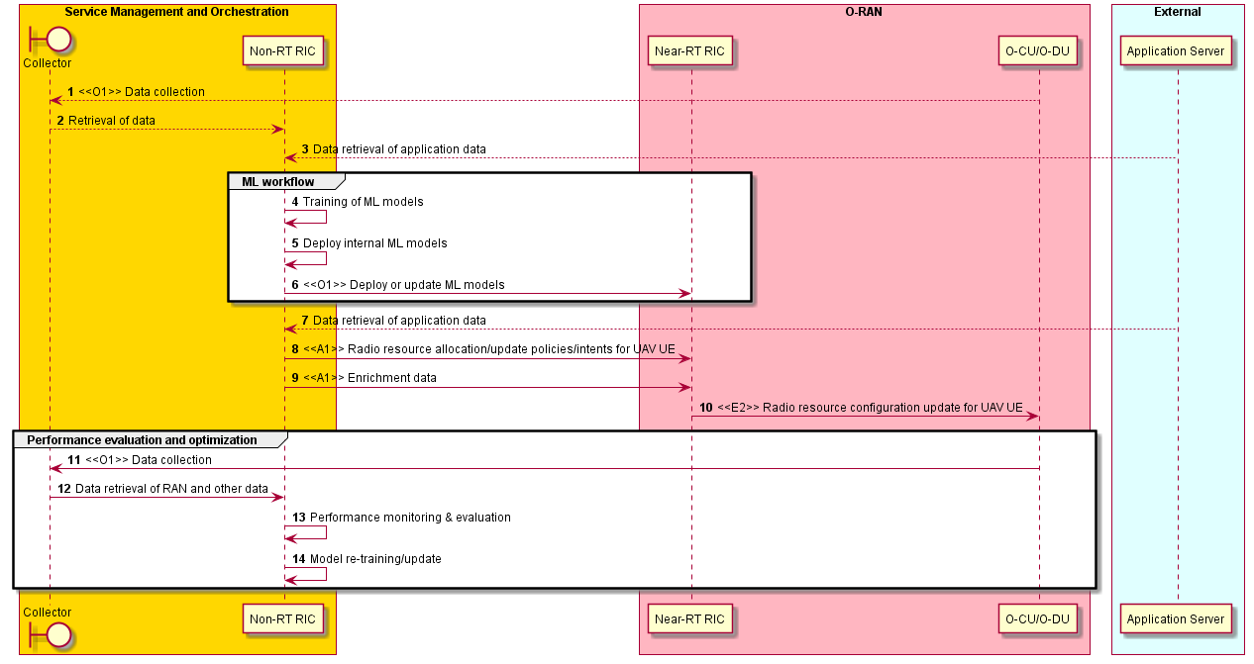
Figure 4.2.3.1-1: Use case of flight path based dynamic UAV radio resource allocation flow diagram

4.2.4 Required data
Multi-dimensional data are expected to be retrieved for AI/ML model training and policies generation.
- Network level measurement report, including:
- UE level radio channel information, mobility related metrics
- UE level location information
- Aerial vehicles related measurement metrics collected from SMO (can acquire data from application or network, e.g., flight path information of aerial vehicle, climate information, flight forbidden/limitation area information and space load information).

4.3 Radio resource allocation for UAV application scenario
This use case provides the background, motivation, and requirements for the UAV control vehicle use case, allowing operators to adjust radio resource allocation policies through the O-RAN architecture, reducing latency and improving radio resource utilization.

4.3.1 Background and goal of the use case
As shown in figure 4.3.1-1, this scenario refers to a rotor UAV flying at low altitude and low speed, and carrying cameras, sensors and other devices mounted. The operation terminals work in the 5.8GHz to remote control the UAV for border/forest inspection, high voltage/base station inspection, field mapping, pollution sampling, and HD live broadcast. At the same time, the UAV mobile control stations and the anti-UAV weapons jointly provide the service of fighting against illegal UAVs to ensure low-altitude safety in special areas. The UAV operation terminals, the anti-UAV weapons, and the UAV mobile control stations are connected with the UAV control vehicle using 5G network.
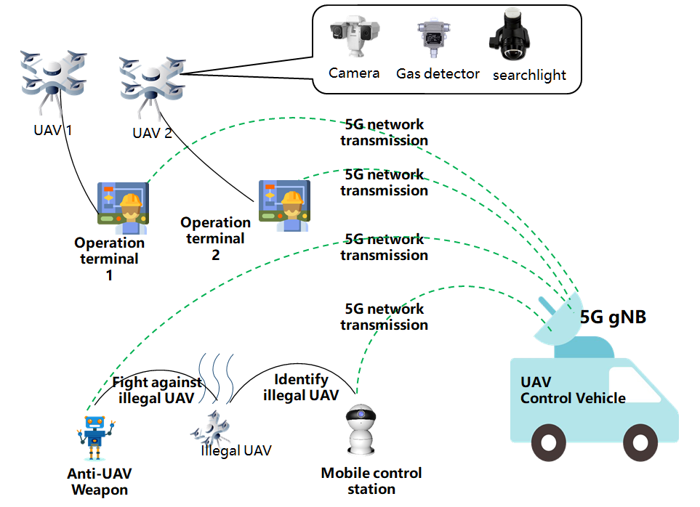
Figure 4.3.1-1: UAV control vehicle application scenario
UAV control vehicle deploys network equipment, including O-CU, O-DU, the Non-RT RIC function modules and application server (in this use case it is an edge computing service platform) to provide reliable network services through 5G networks. The data transmitted over the network includes control data and application data. The control data includes navigation commands, configuration changes, flight status data reporting, etc. Control data requires low latency and low bandwidth requirements. The application data includes 4K high-definition video data, which has obvious uplink and downlink service asymmetry, and the uplink has high requirements on network bandwidth. The UAV control vehicle deploys edge computing services on the 5G gNB side to implement local processing of video and control information. At the same time, real-time data services can be provided with the third-party applications by a video server. The Near-RT RIC function module provides radio resource management functions of the gNB side.

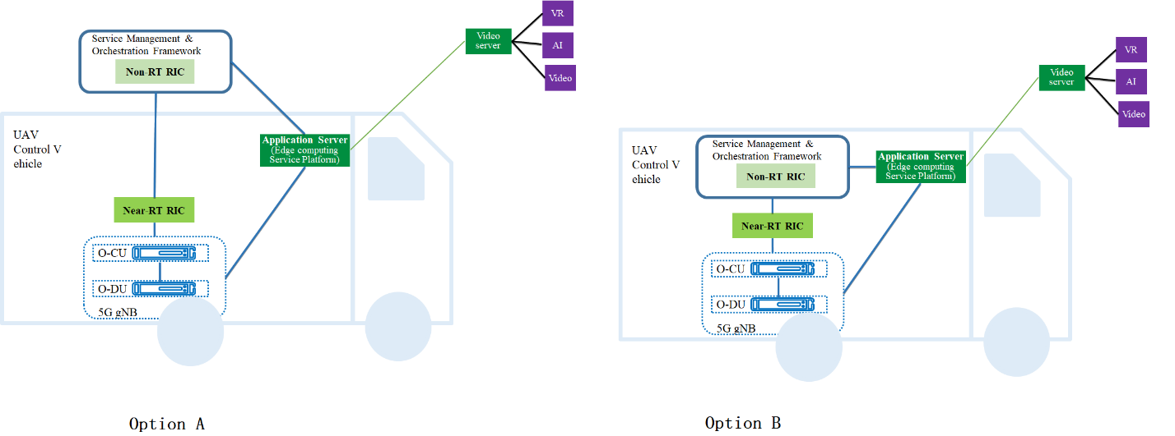
Figure 4.3.1-2: Network architecture for UAV control vehicle application scenario
The 5G network supports real-time high-definition video transmission and remote low-latency control of UAV, and finally provides various industry services such as inspection, security, surveying, and mapping. In the UAV control vehicle application scenario, there are a small amount of control data interaction requirements between the terminal and the network interaction, as well as the large bandwidth requirements for uploading HD video.
The service asymmetry raises new requirements for resource allocation of the gNB. At the same time, the existing network operation and maintenance management platform (OSS system) can only optimize the parameters of a specific group of UEs, but not individual users. In the O-RAN architecture, the radio resource requirements for different terminals are sent to the gNB for execution by means of the RIC function module.
The UAV control vehicle has flexible layout features. In this use case, the application service and content are deployed on the edge computing platform instead of the core network; the RIC function module is used to schedule radio resources instead of the core network's QoS mechanism. In this way, the load and overhead of the core network can be reduced, the forwarding and processing time of data transmission can be reduced.
As shown in figure 4.3.1-2, this scenario involves two options of network architecture. Option A is that gNB and Near-RT RIC are deployed on the control vehicle, Non-RT RIC and core network are deployed on the central cloud. The control vehicle is connected to the core network and Non-RT RIC via fiber optics. Option B is a private network, all the modules, including the gNB, Near-RT RIC, Non-RT RIC and the necessary core network function modules, are deployed in the control vehicle.

4.3.2 Entities/resources involved in the use case
- Non-RT RIC:
  - Support sending resource allocation requirements to Near-RT RIC.
  - Support receiving UE-level radio resource adjustment requirements from the application server.
  - Support communication between Non-RT RIC and Near-RT RIC with UE-level policies.
- Near-RT RIC:
  - Support for receiving resource allocation requests from Non-RT RIC.
  - Support for the interpretation and execution of the resource allocation policies received from Non-RT RIC.
  - Support communication with RAN of configuration parameters.
- RAN:
  - Support resource allocation requests from the Near-RT RIC.
  - Support sending terminal registration information to RAN application server and Near-RT RIC.
  - Support non-real-time optimization of radio resources allocation parameters over O1 interface.
  - Support for adjustment of the resource configuration parameters for a specific UE.
- Application server:
  - Support receiving terminal registration information from E2 nodes via SMO.
  - Support collection of user plane data uploaded from RAN.
  - Support sending UE-level radio resource adjustment requirements to Non-RT RIC.

4.3.3 Solutions

4.3.3.1 UAV control vehicle
The context of the UAV control vehicle use case is captured in table 4.3.3.1-1.
Table 4.3.3.1-1: UAV control vehicle
Use Case Stage | Evolution / Specification | <<Uses>>  Related use
Goal | In the UAV control vehicle scenario, the UE-level radio resource configuration optimization is achieved through the delivery of policies and configuration parameters.
Actors and Roles | Non-RT RIC: RAN policy control function.  Near-RT RIC: RAN policy enforcement function.  RAN: Implementation of updated configuration parameters.  Application server: Generates UE-level resource allocation requirements.
Assumptions | All relevant functions and components are instantiated.  A1/O1 interface connectivity is established with Non-RT RIC.
Pre-conditions | The Non-RT RIC sends an instruction through the interface, informing the RAN to allocate the default resource, and establish the cell.  The RAN notifies the Near-RT RIC and application server of the accessed terminal (UE) information.
Begins when | Operator specified trigger condition or event is detected.
Step 1 (M) | Application server sends requirements of radio resource allocation adjustment to Non-RT RIC.  This request can be sent at any time, or it can be sent at regular intervals.
Step 2 (M) | Non-RT RIC converts the requirements to resource adjustment policy and distributes the policy to the Near-RT RIC.
Step 3 (M) | Near-RT RIC converts policy to specific configuration parameter commands.
Step 4 (M) | RAN executes the command to modify the configuration parameters.
Step 5 (M) | The specified UE adjusts the uplink rate.
Ends when | Operator specified trigger condition or event is satisfied.
Exceptions | None identified.
Post Conditions | The RAN operates using the newly deployed parameters/models.
@startuml
skinparam ParticipantPadding 5
skinparam BoxPadding 10
skinparam defaultFontSize 12
Autonumber

Box “Service Management and Orchestration” #gold
participant “Non-RT RIC” as non
End box

Box “O-RAN” #lightpink
Participant near as “Near-RT RIC”
Participant ran as “O-CU/O-DU”
End box

Box “External” #lightcyan
Participant “Application Server” as app
End box

non->near: <<A1>> Resource allocation request
near->ran: <<E2>> Resource allocation command
ran->ran: Cell establishment
ran->near: <<E2>> Terminal registration
near->non: <<A1>>Terminal registration
non->app: Terminal registration

app->app: data analysis based on the retrieved user plane data from RAN

group Policy of wireless resource configuration optimization
app->non: Radio resource allocation requirement
non->near: <<A1>> Radio resource allocation policy
near->ran: <<E2>> Adjust configuration parameter command
ran->ran: Adjust resource allocation
end

@enduml

The flow diagram of the UAV control vehicle use case is given in figure 4.3.3.1-1.
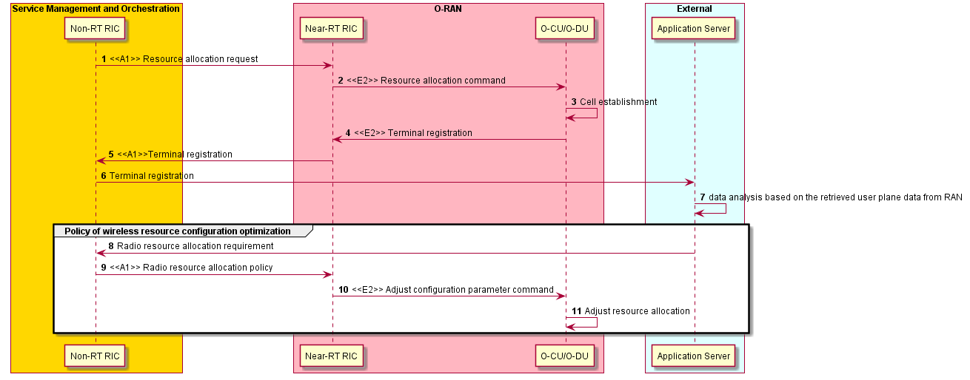
Figure 4.3.3.1-1: UAV control vehicle

4.3.4 Required data
Multi-dimensional data are expected to be retrieved for policy generation and performance improvements brought by the policy:
- The number of terminals accessed, the identification information such as a UE ID that distinguishes each UAV connected with UAV the control vehicle, and the resource information assigned by default.
- UE-level radio resource allocation information, such as the number of PRB resources used in PDSCH/PUSCH scheduling.

4.4 QoE optimization
This use case provides the background and motivation for the O-RAN architecture to support real-time QoE optimization. Moreover, some high-level description and requirements over Non-RT RIC, A1 and E2 interfaces are introduced.

4.4.1 Background and goal of the use case
The highly demanding 5G native applications like cloud VR are both bandwidth consuming and latency sensitive. However, for such traffic-intensive and highly interactive applications, current semi-static QoS framework cannot efficiently satisfy diversified QoE requirements especially taking into account potentially significant fluctuation of radio transmission capability. It is expected that QoE estimation/prediction from application level can help deal with such uncertainty and improve the efficiency of radio resources, and eventually improve user experience. RAN analytics information as RAN service can be exposed to an external application or MEC. It is envisioned to be helpful for the application to improve the user experience.
The main objective is to ensure QoE optimization be supported within the O-RAN architecture and its open interfaces. Multi-dimensional data, e.g., user traffic data, QoE measurements, network measurement report, can be acquired and processed via ML algorithms to support traffic recognition, QoE prediction, QoS enforcement decisions. ML models can be trained offline and model inference will be executed in a real-time manner. Focus should be on a general solution that would support any specific QoE use case (e.g., cloud VR, video, etc.).

4.4.2 Entities/resources involved in the use case
- Non-RT RIC:
  - Retrieve necessary QoE related measurement metrics from network level measurement report and SMO (can acquire data from application) for constructing/training relevant AI/ML model that will be deployed in Near-RT RIC to assist in the QoE optimization function. For example, this could be application classification, QoE prediction, and available bandwidth prediction.
  - Training of potential ML models for predictive QoE optimization, which can respectively autonomously recognize traffic types, predict quality of experience, or predict available radio bandwidth.
  - Send policies/intents to Near-RT RIC to drive the QoE optimization at RAN level in terms of expected behavior.
- Near-RT RIC:
  - Support update of AI/ML models from Non-RT RIC.
  - Support execution of the AI/ML models from Non-RT RIC, e.g., application classification, QoE prediction, and available bandwidth prediction.
  - Support interpretation and execution of intents and policies from Non-RT RIC to derive the QoE optimization at RAN level in terms of expected behavior.
  - Sending QoE performance report to Non-RT RIC for evaluation and optimization.
- RAN:
  - Support network state and UE performance report with required granularity to SMO over O1 interface.
  - Support QoS enforcement based on messages from A1/E2, which are expected to influence RRM behavior.
- Application server/MEC:
  - Request/subscribe RAN analytics information from Near-RT RIC.

4.4.3 Solutions

4.4.3.1 AI/ML model training and distribution
The context of the model training and distribution is captured in table 4.4.3.1-1.
Table 4.4.3.1-1: Model training and distribution
Use Case Stage | Evolution / Specification | <<Uses>>  Related use
Goal | Model training and distribution
Actors and Roles | Non-RT RIC, Near-RT RIC, SMO, application server
Assumptions | All relevant functions and components are instantiated.  A1/O1 interface connectivity is established with Non-RT RIC.
Pre-conditions | Near-RT RIC and Non-RT RIC are instantiated with A1 interface connectivity being established between them.  A certificate is shared between Near-RT RIC and Non-RT RIC for model related data exchange.  Editor’s note: Security related procedure is not defined in the present document.
Begins when | Operator specified trigger condition or event is detected.
Step 1 (M) | QoE related measurement metrics from SMO (can acquire data from application) and network level measurement report either for instantiating training of a new ML model or modifying existing ML model.
Step 2 (M) | Non-RT RIC does the model training, obtains QoE related models, and can deploy QoE policy model internally. An example of QoE-related models that can be used at the Near-RT RIC is provided as follows:  - Application classification model (optional and can refer to 3rd party’s existing functionality)  - QoE prediction model  - QoE policy model  - Available BW prediction model
Step 3 (M) | Non-RT RIC deploys/updates the AI/ML model in the Near-RT RIC via O1 or Non-RT RIC assigns/update the AI/ML model for the Near-RT RIC xApp via A1.
Step 4 (M) | Near-RT RIC stores the received QoE related ML models in the ML model inference platform and based on requirements of ML models.
Step 5 (O) | If required, Non-RT RIC can configure specific performance measurement data to be collected from RAN to assess the performance of AI/ML models and update the AI/ML model in Near-RT RIC based on the performance evaluation and model retraining.
Ends when | Operator specified trigger condition or event is satisfied.
Exceptions | None identified.
Post Conditions | Near-RT RIC stores the received QoE related ML models in the ML model inference platform and execute the model for QoE optimization function in Near-RT RIC.

@startuml
skinparam ParticipantPadding 5
skinparam BoxPadding 10
skinparam defaultFontSize 12

Box “Service Management and Orchestration” #gold
Boundary “Collector” as smo
Participant “Non-RT RIC” as non
End box

Box “O-RAN” #lightpink
Participant near as “Near-RT RIC”
Participant ran as “O-CU/O-DU”
End box

Box “External” #lightcyan
Participant “Application Server” as app
End box

ran --> smo : <<O1>> Data collection
smo --> non : Retrieval of collected data
app --> non : Data retrieval of application data

group ML workflow
non -> non : Training of ML models
non -> non : Deploy internal ML models
non -> near: <<O1>> Deploy AI/ML models
end

group Performance evaluation and optimization
ran -> smo : <<O1>> Data collection
smo -> non : Data retrieval of RAN
non -> non : Performance monitoring & evaluation
non -> non : Model re-training/update
non -> near: <<O1>> or <<A1>> Update AI/ML models
end
@enduml

The flow diagram of the model training and distribution is given in figure 4.4.3.1-1.

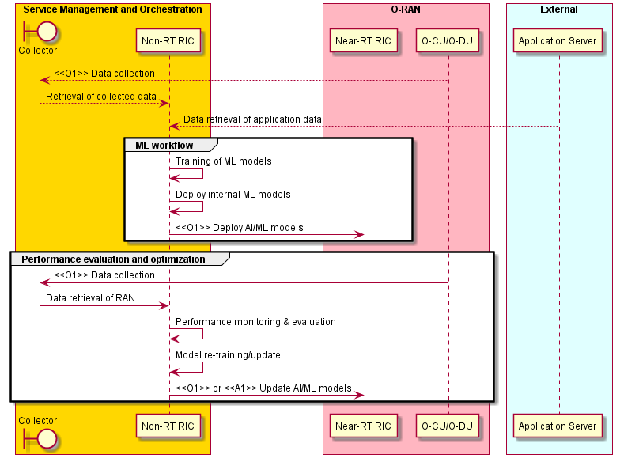
Figure 4.4.3.1-1: Model training and distribution flow diagram

4.4.3.2 Policy generation and performance evaluation
The context of the policy generation and performance evaluation is captured in table 4.4.3.2-1.
Table 4.4.3.2-1: Policy generation and performance evaluation
Use Case Stage | Evolution / Specification | <<Uses>>  Related use
Goal | Policy generation and performance evaluation
Actors and Roles | Non-RT RIC, Near-RT RIC, SMO
Assumptions | All relevant functions and components are instantiated.  A1/O1 interface connectivity is established with Non-RT RIC.
Pre-conditions | QoE related models have been deployed in Non-RT RIC and Near-RT RIC respectively.
Begins when | The network operator/manager want to generate QoE policy or optimize QoE related AI/ML models.
Step 1 (M) | Non-RT RIC evaluates the collected data and generates the appropriate QoE optimization policy.
Step 2 (M) | Non-RT RIC sends the QoE optimization policy to Near-RT RIC via A1 interface.
Step 3 (M) | Near-RT RIC receives the policy from the Non-RT RIC over the A1 interface and from the RAN over the E2 interface. And the Near-RT RIC inferences the QoE related AI/ML models and converts policy to specific E2 control or policy commands.
Step 4 (M) | Near-RT RIC sends the E2 control or policy commands towards RAN for QoE optimization.
Step 5 (M) | RAN enforces the received control or policy from the Near-RT RIC over the E2 interface.
Step 6 (O) | If required, Non-RT RIC can configure specific performance measurement data to be collected from RAN to assess the performance of the QoE optimization function in Near-RT RIC, or to assess the outcome of the applied A1 policies. And then update A1 policy and E2 control or policy.
Ends when | Operator specified trigger condition or event is satisfied.
Exceptions | None identified.
Post Conditions | Non-RT RIC monitors the performance of the QoE optimization related function in Near-RT RIC by collecting and monitoring the relevant performance KPIs and counters from RAN.

@startuml
skinparam ParticipantPadding 5
skinparam BoxPadding 10
skinparam defaultFontSize 12
Box “Service Management and Orchestration” #gold
Boundary “Collector” as smo
Participant “Non-RT RIC” as non
End box
Box “O-RAN” #lightpink
Participant near as “Near-RT RIC”
Participant ran as “O-CU/O-DU”
End box

ran --> smo : <<O1>> Data collection
smo --> non : Data retrieval

group A1 policies
non -> non : Performance monitoring
non -> non : QoE optimization policy generation
non -> near : <<A1>> QoE optimization policy
end

group E2 control & Policy
ran -> near: <<E2>> Data collection
near -> near : ML model inference
near -> near : E2 control or policy generation
near -> ran: <<E2>> Control or policy message
end

group Performance evaluation and optimization
ran -> smo: <<O1>> Data collection
smo -> non: Data retrieval
non -> non: Performance monitoring
non -> non: Update A1 policy
non -> near : <<A1>> policy update
ran -> near : <<E2>> Data collection
near -> near: Update E2 control or policy
near -> ran: <<E2>> Control or policy update
end
@enduml

The flow diagram of the policy generation and performance evaluation is given in figure 4.4.3.2-1.

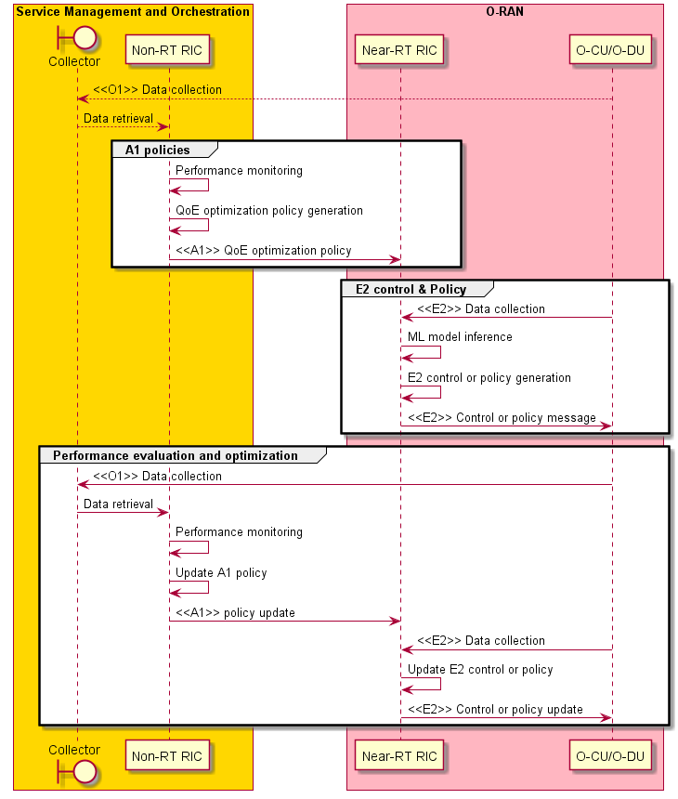
Figure 4.4.3.2-1: Policy generation and performance evaluation flow diagram

4.4.3.3 RAN performance analytics
The context of the RAN performance analytics is captured in table 4.4.3.3-1.
Table 4.4.3.3-1: RAN performance analytics
Use Case Stage | Evolution / Specification | <<Uses>>  Related use
Goal | Expose RAN analytics information to external applications or MEC.
Actors and Roles | Non-RT RIC, Near-RT RIC, SMO, application server/MEC
Assumptions | All relevant functions and components are instantiated.  A1/O1 interface connectivity is established with Non-RT RIC.
Pre-conditions | QoE related models have been deployed in Non-RT RIC and Near-RT RIC respectively.  Editor’s note: Security related procedure is not defined in the present document.
Begins when | The application server or MEC wants to request/subscribe RAN analytics information
Step 1 (M) | Application server or MEC sends RAN analytics information request to Near-RT RIC or subscribes RAN analytics information from Near-RT RIC to get periodic or event triggered RAN performance.
Step 2 (M) | Near-RT RIC receives the request or subscription from application server or MEC. Upon the request, the Near-RT RIC subscribes and receives the measurement data from O-CU/O-DU. Based on it, with QoE related AI/ML models, the Near-RT RIC infers the RAN analytics information, and exposes it to application server or MEC via the response or notification command. Such information, e.g., performance analytics could be used for QoE optimization.
Ends when | Application server gets response or sends subscription deletion toward the Near-RT RIC.
Exceptions | None identified.
Post Conditions | Application server executes logic control, e.g., TCP transmission window adjustment, video coding rate selection to improve QoE.

@startuml
skinparam ParticipantPadding 5
skinparam BoxPadding 10
skinparam defaultFontSize 12

Box “Service Management and Orchestration” #gold
Boundary “Collector” as smo
Participant “Non-RT RIC” as non
End box

Box “O-RAN” #lightpink
Participant near as “Near-RT RIC”
Participant ran as “O-CU/O-DU”
End box

Box “External” #lightcyan
Participant “Application Server” as app
End box

ran --> smo : <<O1>> Data collection
smo --> non : Retrieval of collected data
app --> non : Data retrieval of application data

group ML workflow
non -> non : Training of ML models
non -> non : Deploy internal ML models
non -> near: <<O1>> Deploy AI/ML models
end

group Performance evaluation and optimization
ran -> smo : <<O1>> Data collection
smo -> non : Data retrieval of RAN
non -> non : Performance monitoring & evaluation
non -> non : Model re-training/update
non -> near: <<O1>> or <<A1>> Update AI/ML models
end
@enduml

The flow diagram of the RAN performance analytics is given in figure 4.4.3.3-1.
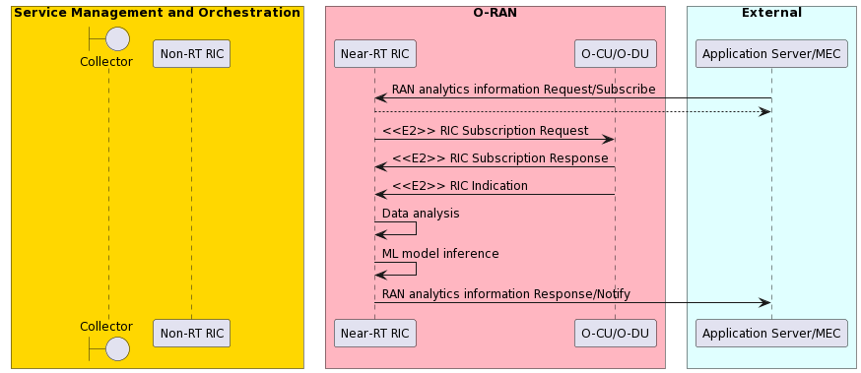
Figure 4.4.3.3-1: RAN performance analytics flow diagram

4.4.4 Required data
Multi-dimensional data are expected to be retrieved by Non-RT RIC for AI/ML model training and policies/intents generation. Network level measurement data from O-CU/O-DU are also expected to report to Near-RT RIC for RAN analytics information inference.
- Network level measurement report, including:
- UE level radio channel information, mobility related metrics, e.g., CQI, SINR, MCS
- L2 measurement report related to traffic pattern, e.g., throughput, latency, packets per-second, inter frame arrival time
- RAN protocol stack status: e.g., PDCP buffer status
- Cell level information: e.g., DL/UL PRB occupation rate
- QoE related measurement metrics collected from SMO (can acquire data from application or network).
- User traffic data, which can be obtained via a proprietary interface from existing data collection equipment and is currently out of the scope of A1 or E2.
RAN analytics information:
RAN analytics information exposed by Near-RT RIC to application server includes but is not limited to:
- UE level information, e.g.:
  - Predicted RAN performance, e.g., maximum/average traffic rate, maximum/average latency, average packet loss rate
  - Prediction related information, e.g., confidence, validity period
- Cell level information.

4.5 Traffic steering
This use case provides the motivation, description, and requirements for traffic steering use case, allowing operators to specify different objectives for traffic management such as optimizing the network/UE performance, or achieving balanced cell load.

4.5.1 Background and goal of the use case

4.5.1.1 Common aspects & background of all traffic steering use cases
Traffic steering is a technology that directs the traffic of a UE (User Equipment) to the desired path, RAT (Radio Access Technology), or frequency band as specified by the network operator. This is achieved by handover, cell re-selection the UE to an appropriate carrier and/or by configuring the serving frequency combination using carrier aggregation or dual connectivity, in accordance with the operator's objectives and policies. 5G systems support many different combinations of access technologies namely; LTE (licensed band), NR (licensed band), NR-U (unlicensed band), Wi-Fi (unlicensed band) [i.3]. Several different multi-access deployment scenarios are possible with 5GC to support wide variety of applications and satisfy the spectrum requirements of different service providers;
- Carrier aggregation between licensed band NR (primary cell) and NR-U (secondary cell)
- Dual connectivity between licensed band NR (primary cell) and NR-U (secondary cell)
- Dual connectivity between licensed band LTE (primary cell) and NR-U (secondary cell)
- Dual connectivity between licensed band NR (primary cell) and Wi-Fi (secondary cell)
NOTE: The scenario of dual connectivity between NR and Wi-Fi is not defined in the present document.
The rapid traffic growth and multiple frequency bands utilized in a commercial network make it challenging to steer the traffic in a balanced distribution. Further in a multi-access system there is need to switch the traffic across access technologies based on changes in radio environment and application requirements and even split the traffic across multiple access technologies to satisfy performance requirements. The different types of traffic and frequency bands in a commercial network make it challenging to handle the complex QoS aspects, bearer selection (Master Cell Group (MCG) bearer, Secondary Cell Group (SCG) bearer, split bearer), bearer type change for load balancing, achieving low latency and best in class throughput in a multi-access scenario with 5GC networks as specified in 3GPP TS 37.340 [12]. Typical controls are limited to adjusting the cell reselection and handover parameters; modifying load calculations and cell priorities; and are largely static in nature when selecting the type of bearers and QoS attributes.
Further, the RRM (Radio Resource Management) features in the existing cellular network are all cell-centric. Even in different areas of within a cell, there are variations in radio environment, such as neighbouring cell coverage, signal strength, interference status, etc. However, base stations based on traditional control strategies treat all UEs in a similar way and are usually focused on average cell-centric performance, rather than UE-centric.
Such current solutions suffer from following limitations:
- It is hard to adapt the RRM control to diversified scenarios including multi-access deployments and optimization objectives.
- The traffic management strategy is usually passive, rarely taking advantage of capabilities to predict network and UE performance. The strategy needs to consider aspects of steering, switching, and splitting traffic across different access technologies in a multi-access scenario.
- Non-optimal traffic management, with slow response time, due to various factors such as inability to select the right set of UEs for control action. This further results in non-optimal system and UE performance, such as suboptimal spectrum utilization, reduced throughput and increased handover failures.

Based on the above reasons, the main objective of this use case is to allow operators to flexibly configure the desired optimization policies, utilize the right performance criteria, and leverage machine learning to enable intelligent and proactive traffic management.

4.5.1.2 Spectral efficiency-aware traffic steering
To accurately determine the optimal serving frequency combination for each UE, information such as the bandwidth, MIMO configuration, real-time cell load, UE field strength information, and spectral quality of each cell (i.e., spectral efficiency) is required. While other information can be obtained within the RAN through serving cell and neighbour information, Xn-based exchange information, and measurement reports reported by the UE, spectral efficiency, which is influenced by interference resulting from the geographical distribution of base stations and UEs, is challenging to acquire in the short term at the base station. As an appropriate alternative, rApp on Non-RT RIC can predict spectral efficiency through long-term time series learning of values derived from network operation. This prediction is based on results from RAN PM (Performance Management) counters. Additionally, the predicted spectral efficiency of each cell can be periodically provisioned to the RAN in the form of CM (Configuration Management) for various operations to achieve traffic steering. Both PM and CM are defined over the O1 interface.
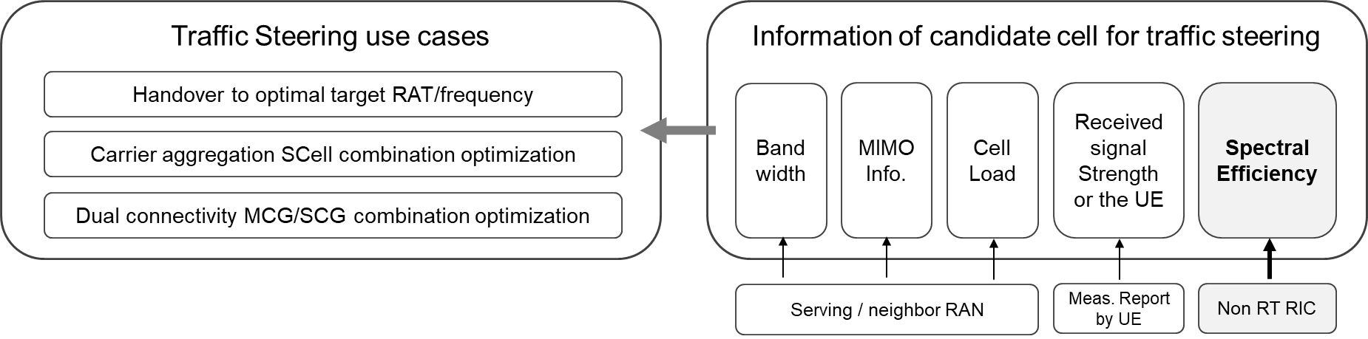
Figure 4.5.1.2-1: Use case examples of spectral efficiency-aware traffic steering

4.5.2 Entities/resources involved in the use case

4.5.2.1 Traffic steering general case
- Non-RT RIC:
  - Retrieve necessary performance, configuration, and other data for defining and updating policies to guide the behavior of traffic management function in Near-RT RIC. For example, the policy could relate to specifying different optimization objectives to guide the carrier/band preferences at per-UE or group of UE granularity.
  - Support communication of policies to Near-RT RIC.
  - Support communication of measurement configuration parameters to RAN.
- Near-RT RIC:
  - Support interpretation and enforcement of policies from Non-RT RIC.
- E2 nodes:
  - Support data collection with required granularity to SMO over O1 interface.

4.5.2.2 Spectral efficiency-aware case
- SMO:
  - Collect the necessary configurations, performance indicators, and measurement reports data from RAN nodes triggered by Non-RT RIC as required.
  - Transmit traffic steering configuration parameters including predicted spectral efficiency to RAN.
- Non-RT RIC & rApp:
  - Retrieve necessary performance, configuration, and other data to determine predicted spectral efficiency.
  - rApp provides the predicted spectral efficiency and configuration to determine the optimal carrier/cell for maximizing throughput.
- O-CU-CP & O-DU:
  - Collect and report to SMO PMs (i.e., per cell COUNTER) related to cell signal quality.
  - Apply the predicted spectral efficiency configured by SMO to determine the optimal carrier/cell.

4.5.3 Solutions

4.5.3.1 Policy-based traffic steering
The context of the traffic steering use case is captured in table 4.5.3.1-1.
Table 4.5.3.1-1: Traffic steering
Use Case Stage | Evolution / Specification | <<Uses>>  Related use
Goal | Drive traffic management in RAN in accordance with defined intents, policies, and configuration.
Actors and Roles | Non-RT RIC: RAN policy control function.  Near-RT RIC: RAN policy enforcement function.  E2 nodes: Control plane and user plane functions.  SMO/Collection & Control: Termination point for O1 interface.
Assumptions | All relevant functions and components are instantiated.  A1 interface connectivity is established with Non-RT RIC.  O1 interface connectivity is established with SMO/ Collection & Control.
Pre-conditions | Network is operational.  SMO/ Collection & Control has established the data collection and sharing process, and Non-RT RIC has access to this data.  Non-RT RIC monitors the performance by collecting the relevant performance events and counters from E2 nodes via SMO/ Collection & Control.
Begins when | Operator specified trigger condition or event is detected.
Step 1 (O) | If required, Non-RT RIC configures additional, more specific, performance measurement data to be collected from E2 nodes to assess the performance.
Step 2 (M) | Non-RT RIC decides an action and communicates relevant policies to Near-RT RIC over A1. The example policies can include:  - QoS targets  - Preferences on which cells to allocate control plane and user plane  - Bearer handling aspects including bearer selection, bearer type change
Step 3 (M) | The Near-RT RIC receives the relevant info from Non-RT RIC over A1 interface, interprets the policies and enforces them.
Step 4 (M) | Non-RT RIC decides that conditions to continue the policy is no longer valid.
Ends when | Non-RT RIC deletes the policy.
Exceptions | None identified.
Post Conditions | Non-RT RIC monitors the performance by collecting the relevant performance events and counters from E2 nodes via SMO.
@startuml
skinparam ParticipantPadding 5
skinparam BoxPadding 10
Autonumber

Box “Service Management and Orchestration” #gold
participant “Collection & Control” as smo
participant “Non-RT RIC” as non
end box

Box “O-RAN” #lightpink
participant “Near-RT RIC” as near
participant “E2 Nodes” as ran
end box

ran -> smo : <<O1>> Data collection
smo -> non : Data retrieval

non -> non : Performance monitoring and evaluation
non -> non : Performance trigger for traffic steering

group O1 Data collection
non -> smo: Request additional measurements
smo -> ran: <<O1>> PM measurement configuration
ran -> smo : <<O1>> Data collection
smo -> non : Data retrieval
end

non -> non : Decision of optimization action

group A1 Policies
non -> near : <<A1>> Traffic management policy create message
near -> ran : <<E2>> Traffic management enforcement
end

ran -> smo : <<O1>> Data collection
smo -> non : Data retrieval of RAN and non-RAN data
non -> non : Performance monitoring and evaluation
non -> non : Decision to remove policy
group A1 Policies
non -> near : <<A1>> Traffic management policy delete message
near -> ran : <<E2>> Traffic management policy deletion
end
@enduml

The flow diagram of the traffic steering use case is given in figure 4.5.3.1-1.

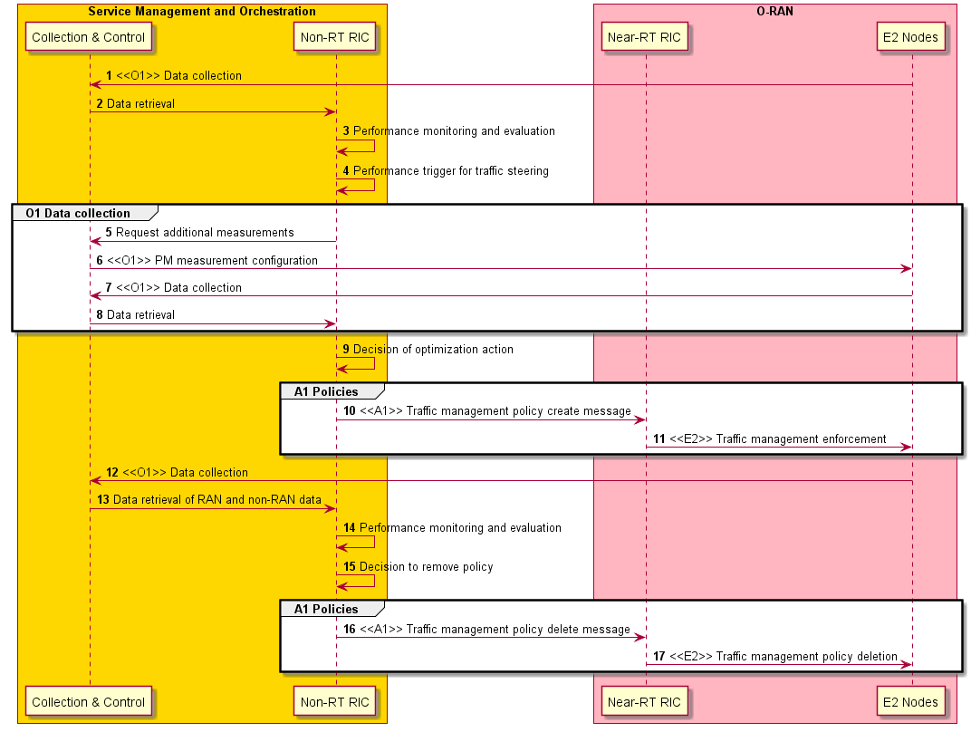
Figure 4.5.3.1-1: Traffic steering use case flow diagram

4.5.3.2 Enrichment information based traffic steering
In this variation, when the Near-RT detects cell congestion, it requests via A1-EI to Non-RT RIC analytics that can be used as additional information to assist in its efforts at alleviating that congestion.
The context of the enrichment information-based traffic steering use case is captured in table 4.5.3.2-1.
Table 4.5.3.2-1: Enrichment information-based traffic steering
Use Case Stage | Evolution / Specification | <<Uses>>  Related use
Goal | Drive traffic management in RAN in accordance with defined enrichment information and associated decision control.
Actors and Roles | - Non-RT RIC: RAN analytics and enrichment information framework.  - “UE location” rApp: Capable of calculating the geo-location of UEs with a prediction on the granularity of seconds time scale (e.g., based on timing advance and RRC measurements), aggregating and trending those over time to learn mobility patterns, and using these to predict a UE’s future location based on its recent location history.  - “Traffic steering” rApp: Determines set of UEs connected to requested cell and requests UE location rApp analytics, forwarding the same to the Near-RT RIC.  - Near-RT RIC: Detects breaches in expected performance and requests enrichment information from Non-RT RIC to aid in mitigation efforts. Also performs RAN decision control based on network telemetry and the enrichment information provided by Non-RT RIC.  - E2 nodes: Control plane and user plane RAN functions.  - SMO/ Collection & Control: Termination point for O1 interface.
Assumptions | - All relevant functions and components are instantiated.  - A1 interface connectivity is established between Near-RT RIC and Non-RT RIC.  - O1 interface connectivity is established between RAN E2 nodes and SMO/ Collection & Control.  - Near-RT RIC is capable of detecting a breach in cell performance and determine the usefulness of predictive data.
Pre-conditions | - Network is operational.  - Network data collection pipelines have been engineered for necessary data volumes and Non-RT RIC has access to this data.  - Both rApps have registered via R1 the data types that they produce and the data types they consume.  - UE location rApp has been trained to recognize the UE mobility patterns in the local area such that, given a UE identifier, it can quickly determine whether that UE is or is not following a known mobility pattern.  - Traffic steering rApp has subscribed to, and Non-RT RIC/SMO is collecting on its behalf, the relevant performance events and counters from E2 nodes via SMO/ Collection & Control.
Begins when | Near-RT RIC detects a cell performance breach (e.g., due to UE capacity considerations) and determines it might be useful to have additional information from the Non-RT RIC regarding UE candidates for handover.
Step 1 (M) | Near-RT RIC requests of the Non-RT RIC the enrichment information corresponding to the UE_Traj_Pred R1 data type for the congested cell.
Step 2 (M) | Non-RT RIC leverages R1 to subscribe to UE_Traj_Pred data type from the traffic steering rApp.
Step 3 (M) | Traffic steering rApp subscribes to relevant network data for the cell in question.
Steps 4-8 (M) | Non-RT RIC/SMO interact with the O-RAN network to collect the requested network data and deliver to the traffic steering rApp.
Step 9 (M) | Traffic steering rApp determines from network data which UEs are connected to the cells in question.
Step 10 (M) | Traffic steering rApp leverages R1 to subscribe to UE location prediction data type (UeLocPred) for those UEs connected to the cells in question and that also meet other criteria known to the traffic steering rApp.
Step 11 (M) | Non-RT RIC leverages R1 to have UE location rApp produce the requested data type instances for the specified UEs.
Step 12 (M) | UE location rApp subscribes to relevant network data for the UEs in question.
Steps 13-17 (M) | Non-RT RIC/SMO interact with the O-RAN network to collect the requested network data and deliver to the UE location rApp.
Step 18 (M) | UE location rApp determines from network data, trended over time, the UE location prediction over a particular future time window (e.g., 10-30 seconds) for the UE along with a confidence value for that prediction.
Steps 19-20 (M) | UE location rApp leverages R1 to return the UeLocPred instances to the Non-RT RIC, which in turn delivers to the traffic steering rApp.
Step 21 (M) | Traffic steering rApp determines from UE location prediction analytics the predicted locations of the specified UEs within the next 10-30 seconds, maps those locations into a historical RF measurements map overlaying cell boundaries to physical geography, and determines the subset of UEs predicted to be leaving the oversubscribed cell within the next 10-30 seconds anyway, and hence which would perhaps be candidates for expedited handover.
Step 22 (M) | Traffic steering rApp leverages R1 to generate UE trajectory prediction (UE_Traj_Pred) data based on its analysis.
Step 23 (M) | Non-RT RIC leverages A1-EI to forward the UE trajectory prediction data to the Near-RT RIC as the corresponding A1 enrichment information type.
Step 24 (M) | The Near-RT RIC interprets the information content received across the A1-EI interface and determines whether and how to use that EI in its congestion mitigation activities. (As a further optimization, it can be useful for the Near-RT RIC to also understand what type of activity the UE is engaged in.)
Step 25 (M) | Near-RT RIC continues monitoring cell performance and decides that congestion has been resolved.
Step 26 (M) | Near-RT RIC requests the Non-RT RIC to discontinue UE_Traj_Pred data production for the target cell.
Step 27 (M) | Non-RT RIC leverages R1 to unsubscribe to UE_Traj_Pred data type from the traffic steering rApp.
Step 28 (M) | Traffic steering rApp leverages R1 to unsubscribe to the UE location prediction data type for the corresponding UEs.
Step 29 (M) | Non-RT RIC leverages R1 to unsubscribe to UELocPred data type from the UE location rApp.
Steps 30-32 (M) | UELocPred rApp unsubscribes to the relevant network data.
Ends when | UE location prediction rApp ceases to produce the UE location prediction data for the corresponding UEs and to collect the associated network data.
Exceptions | None identified.
Post Conditions | Near-RT RIC continues to monitor RAN performance.
@startuml
skin rose
skinparam ParticipantPadding 5
skinparam BoxPadding 10
Autonumber

Box “Service Management and Orchestration” #gold
participant “Collection & Control” as smo
end box

Box “Non-RT RIC” #yellow
participant “Non-RT RC FW” as fw
participant “Traffic Steering rApp” as tsrapp
participant “UE Location rApp” as uerapp
end box

Box “O-RAN” #lightpink
participant “Near-RT RIC” as near
participant “E2 Nodes” as ran
end box

near -> fw : <<A1-EI>> request UE_Traj_Pred
fw -> tsrapp : <<R1>> request UE_Traj_Pred

tsrapp -> fw : <<R1>> request network data

group Optional – If no other rApp is collecting
fw -> smo : internal
smo -> ran : Request <<O1>> data
ran -> smo : <<O1>> data collection
smo -> fw : internal
end

fw -> tsrapp : <<R1>> data distribution

tsrapp -> tsrapp : Determine UEs\nof interest

tsrapp -> fw : <<R1>> request UeLocPred (UE list)
fw -> uerapp : <<R1>> request UeLocPred (UE list)

uerapp -> fw : <<R1>> request network data

group Optional – If no other rApp is collecting
fw -> smo : internal
smo -> ran : request <<O1>> data
ran -> smo : <<O1>> data collection
smo -> fw : internal
end

fw -> uerapp : <<R1>> data distribution

group Repeat per UE
uerapp -> uerapp : Predict UE location
end

group Prediction could be returned per UE or by some grouping of UE
uerapp -> fw : <<R1>> UeLocPred (UE list) data
fw -> tsrapp : <<R1>> data distribution

tsrapp -> tsrapp : analyze results

tsrapp -> fw : <<R1>> UE_Traj_Pred (UE list) data
fw -> near : <<A1>> UE_Traj_Pred data
end

near -> ran : <<E2>> congestion\nmitigation

near -> near : Determine congestion cleared
near -> fw : <<A1-EI>> cease UE_Traj_Pred

fw -> tsrapp : <<R1>> cease\UE_Traj_Pred
tsrapp -> fw : <<R1>> cease\UELocPred
fw -> uerapp : <<R1>> cease\nUELocPred

uerapp -> fw : <<R1>> cease network data

group Optional – If no other rApp is collecting
fw -> smo : internal
smo -> ran : cease <<O1>> data
end

@enduml

The flow diagram of the enrichment information-based traffic steering use case is given in figure 4.5.3.2-1.

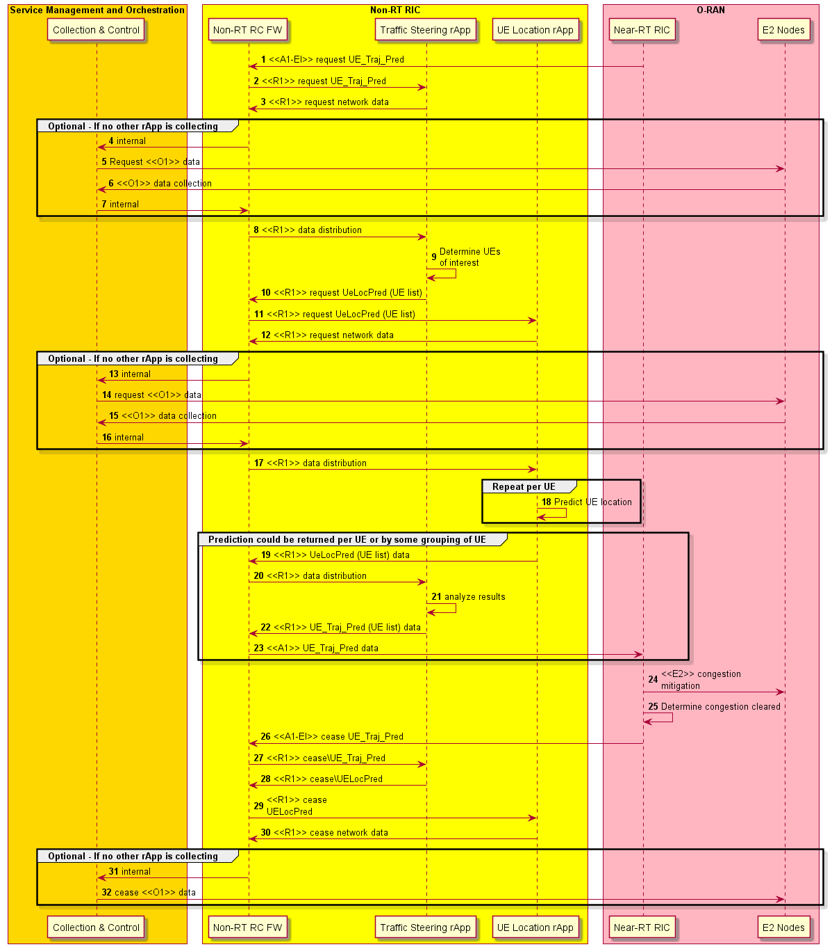
Figure 4.5.3.2-1: Enrichment information-based traffic steering use case flow diagram

4.5.3.3 Spectral efficiency-aware traffic steering
The context for the spectral efficiency optimization use case is captured in table 4.5.3.3-1.
Table 4.5.3.3-1: Spectral efficiency optimization
Use Case Stage | Evolution / Specification | <<Uses>>  Related use
Goal | Enable traffic steering by configuring SE-optimized parameters and actions controlled by Non-RT RIC.
Actors and Roles | SMO, Non-RT RIC, O-RAN NFs, rApp
Assumptions | All relevant functions and components are instantiated, and O1, R1 connectivity is in place.
Pre-conditions | Network is operational.  SMO has processed the collected data, and Non-RT RIC has access to this data.  O1 is established between the SMO and O-CU-CP. Non-RT RIC monitors the performance by collecting the relevant performance events and counters from O-RAN nodes from SMO. The SMO communicates O1 settings to the O-CU-CP.
Begins when | Network (RAN) is in normal operational state, providing regular PM reports.
Step1 (M) | User configures rApp for operation.
Step 2, 3 (M) | RAN (O-CU-CP/O-DU) provides regular interval performance measurements.
Step 4 (M) | The rApp can receive Performance Measurement (PM) and configuration information from the Non-RT RIC via R1 interface within the SMO.
Apply Logic | Applicable PM inputs are provided to rApp as inputs for the prediction logic to apply.
Step 5 (M) | New configuration settings for spectral efficiency are provided.  The new settings are made available to the RAN NF OAM for communication to the RAN.
Step 6, 6-1 (M) | The new settings are made available to the O-CU-CP, O-DU.
Step 7 (O) | The RAN can perform traffic steering such as SCell addition, change, or release for Carrier Aggregation (CA) based on updated configurations.
Ends when | Operator turns the feature off.
Exceptions | None identified.
Post Conditions | None.

@startuml
skinparam sequenceMessageAlign center

box "Operator Personnel" #LightCyan
actor "Planner" as Planner
end box

box "Service Management and Orchestration" #Gold
participant "RAN NF OAM" as OAM
participant "Non-RT RIC" as RIC
participant "rApp" as rApp
end box

box "RAN" #LightPink
participant "O-CU-CP" as CU
participant "O-DU" as DU
end box

' --- Sequence Start ---

Planner -> rApp : **1** Configure rApp

== START - Triggering Optimization ==

CU -> OAM : **2** «O1» Data collection
DU -> OAM : **3** «O1» Data collection
OAM -> rApp : **4** «R1» Data retrieval PM

== Apply rApp logic ==

note over rApp : Apply logic

== Setup new configuration for spectral efficiency ==

rApp -> OAM : **5** «R1» Provide new configuration settings to apply
OAM -> CU : **6** «O1» CM configuration
OAM -> DU : **6-1** «O1» CM configuration

CU <-> DU : **7** perform Dual Connectivity
CU <-> DU : **8** perform Carrier Aggregation

@enduml

The flow diagram of the spectral efficiency optimization use case is given in figure 4.5.3.3-1.

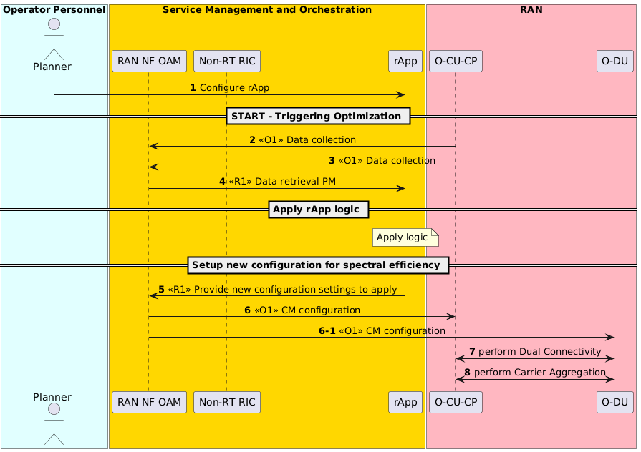
Figure 4.5.3.3-1: Spectral efficiency optimization flow diagram

4.5.4 Required data

4.5.4.1 Traffic steering general case
The measurement counters and KPIs (as defined by 3GPP and will be extended for O-RAN use cases) shall be appropriately aggregated by cell, QoS type, slice, etc.
- Measurement reports with RSRP/RSRQ/CQI information for serving and neighboring cells. In multi-access scenarios this will also include intra-RAT and inter-RAT measurement reports, cell quality thresholds, CGI reports and measurement gaps on per-UE or per-frequency.
- UE connection and mobility/handover statistics with indication of successful and failed handovers, etc.
- Cell load statistics such as information in the form of number of active users or connections, number of scheduled active users per TTI, PRB utilization, and CCE utilization.
- Per user performance statistics such as PDCP throughput, RLC or MAC layer latency, etc.
- UE level measurements useful in calculating UE location, such as RRC and timing advance measurements.

4.5.4.2 Spectral efficiency-aware case
Table 4.5.4.2-1: Spectral efficiency-aware case data requirements
Requirement | Category | Parameters | Source | Applicable Interface | Reference
Req-4.5.001 | Network configuration management | Node identification | O-CU-CP | O1 | 3GPP TS 28.541 [5], clause 4.3.2, gNBId
Req-4.5.002 | Network configuration management | Cell identification | O-CU-CP | O1 | 3GPP TS 28.541 [5], clauses 4.3.2 & 4.3.4, pLMN + gNBId + cellLocalId
Req-4.5.003 | Network load and data performance | DL measurement reports – RSRP  Per cell RSRP value (of the bin) | O-CU-CP | O1
Req-4.5.004 | Network configuration management | Target gNB identification | O-CU-CP | O1 | 3GPP TS 28.541 [5], clause 4.3.2, gNBId
Req-4.5.005 | Network configuration management | Target cell identity | O-CU-CP | O1 | 3GPP TS 28.541 [5], clauses 4.3.2 & 4.3.4, PLMN + gNBId + cellLocalId
Req-4.5.006 | Network configuration management | Target NR ARFCN | O-CU-CP | O1 | 3GPP TS 28.541 [5], clause 4.3.38, absoluteFrequencySSB
Req-4.5.007 | Network load and data performance | DL wideband CQI | O-DU | O1 | 3GPP TS 28.552 [6], clause 5.1.1.11
Req-4.5.008 | Network configuration management | CQI table index  Indicates the CQI table (Table 1, 2, 3, or 4) as specified in 3GPP TS 38.214, Table 5.2.2.1. | O-DU | O1
Req-4.5.009 | Network load and data performance | Received Rank Indicator  Per cell RI value reported with CQI index | O-DU | O1
Req-4.5.010 | Network configuration management | Per RSRP SE  Predicted per cell, SE value, representing relationship between RSRP and SE | SMO | O1

4.6 Massive MIMO optimization
This use case provides the motivation, description, and requirements for Non-RT and Near-RT loop massive MIMO beamforming optimization use case. Massive MIMO system configuration can allow operators to optimize the network performance and QoS by e.g. Non-RT and Near-RT loop balancing cell loads or reducing inter-cell interference and control electromagnetic (EM) emissions.

4.6.1 Background and goal of the use case

4.6.1.1 Common aspects & background of all Massive MIMO optimization use cases
Massive MIMO (mMIMO) is among the key levers to increase performance and QoS in 5G networks. Capacity enhancement is obtained by means of beamforming of the transmitted signals, and by spatially multiplexing data streams for both single user (SU) and for multi-user (MU) MIMO. Beamforming increases the received signal power, while decreasing the interference generated on other users, hence resulting in higher SINR and user throughputs. Beamforming can be codebook based (mainly for FDD), or non-codebook based (TDD). Grid of Beams (GoB) with the corresponding beam sweeping has been introduced to allow beamforming the control channels used during initial access, mainly for high frequency (but can be used also for the sub-6 GHz band) MIMO operation. The codebook and the GoB define the span of the beams, namely the horizontal and vertical aperture in which beamforming is supported, and therefore the coverage area and the shape of the cell. Massive MIMO can be deployed in 5G macro-cells as well as in heterogeneous network, where macro-cells and 3D-MIMO small cells co-exist and complement each other for better aggregated capacity and coverage. In order to obtain an optimal beamforming and cell resources (Tx power, PRB) configuration, one will have to look at a multi-cell environment instead of a single cell. Moreover, different vendors can have different implementations in terms of the number of beams, the horizontal/vertical beam widths, azimuth and elevation range, to achieve the desired coverage. In a multi-node/multi-vendor scenario, centralized monitoring and control is required to offer optimal coverage, capacity and mobility performance as well as control over EM emissions in order to comply with regulatory requirements. Additionally, the number of such combinations of adjustable parameters is in the thousands, hence it is prohibitive for the traditional human expert system to work out the optimal configuration, and a new method is in need.
State of the art solutions suffer from the following problems:
mMIMO macro- and small-cells benefit from a flexible way of serving users in their coverage area thanks to beamforming. However, the coverage area itself is defined by (vendor specific) fixed mMIMO system parameters such as the azimuth and elevation angle range, or the GoB parameters. Hence due to user and traffic distribution and terrain topology, the mMIMO cell can suffer from e.g.
- High inter-cell interference
- Unbalanced traffic between neighboring cells
- Low performance of cell edge users
- Poor handover performance
Moreover, load balancing functions can be activated in the network nodes, e.g. gNB adapting mobility parameters in order to distribute load between the beams of the neighbor cells, relying on load information exchange over network interfaces. This approach however is partly limited by the cell footprint statically fixed at the initial configuration.
The objective of this use case is to allow the operator to flexibly configure a mMIMO system parameters by means of policies and configuration assisted by machine learning techniques, according to objectives defined by the operator.

4.6.1.2 Cell shaping optimization
Traditionally network coverage in a cellular network is defined by the coverage provided by the union of all the cells in the network. The individual coverage of a cell is determined by aspects including frequency band, radio emission power, orientation and tilt of the antenna, etc. The coverage of a given radio site would include one or multiple cells or sectors, and the coverage if each of these cells/ sectors is relatively static in nature.
One of the challenges for operators in deploying their networks is maximizing the efficiency of the available spectrum. Because spectrum is both very scarce and expensive, enhancing this efficiency can significantly help improve the operations and business for the wireless network operator.
As the traffic profile evolves during the day and driven by special circumstances and events, it has become necessary to have the ability to dynamically modify the shapes of the cells to tune the cell coverage to the evolving traffic needs.
The shape of the cell corresponds to the shape of the coverage provided by the sector carrier.
Cell shaping is designed for FDD or for TDD mid-band deployments for NR and LTE (if and when O-RAN looks into LTE). It allows the adjustment of cell footprint by adjusting by configuring the vertical and horizontal coverage width of the common beam into combinations to describe a valid supported shape as driven by O-RU capabilities and then refined through further adjustments with the tilt. The data beams, which carry user traffic, impact the serving cell shape changes from the cell shaping optimization. The configurable cell shape allows for coverage control, interference reduction, and better power utilization. However, with the increased optimization comes the challenge of more complexity.
Cell shaping optimizes the shape of the cell and/or sector carrier via different configuration combinations of electrical tilt and/or digital tilt, horizontally and/or vertically, as well as through adjustments of the beam width. The optimization leverages algorithms to consider the network configuration and conditions in both the acting and the neighbour cells. The benefits from NR and LTE cell shaping include:
- Dynamic, adaptation of the network changes and traffic distribution with beam width optimization.
- Reduction and/or improvements of interference to optimize quality and cell overlapping.
- Intra-frequency load balancing.
- The ability to execute different policies according to operator needs.

4.6.2 Entities/resources involved in the use case

4.6.2.1 Non-RT massive MIMO GoB beam forming optimization
- Non-RT RIC:
  - Retrieve necessary configurations, performance indicators, measurement reports, user activity information and other data from SMO and RAN directly for the purpose of constructing/training relevant AI/ML models that will be deployed in Non-RT RIC to assist in the massive MIMO optimization function.
  - Retrieve necessary user location related information, e.g., GPS coordinates, from the application layer for the purpose of constructing/training relevant AI/ML models.
  - Use the trained AI/ML model to infer the user distribution and traffic distribution of multiple cells and predict the optimal configuration of massive MIMO parameters for each cell/beam according to a global optimization objective designed by the operator. The massive MIMO configurable parameters includes horizontal beam width, vertical beam width, beam azimuth and downtilt, maximum and average transmitted power per beam/direction as specified in 3GPP TS 28.541 [5].
  - Send the optimal beam pattern configuration to SMO configuration components.
  - Retrain the AI/ML model and re-optimize the beam pattern configurations based on the monitored performance.
  - Execute the control loop periodically or event-triggered.
- SMO:
  - Collect the necessary configurations, performance indicators, and measurement reports data from RAN nodes triggered by Non-RT RIC if required.
  - Configure the optimized beam parameters via O1 interface.
  - Monitor the performance of all the cells; when the optimization objective fails, initiate fall-back procedure; meanwhile, trigger the AI/ML model re-training, data analytics and optimization in Non-RT RIC.
- E2 nodes:
  - Collect and report to SMO and/or to Near-RT RIC KPI related to user activity, traffic load, coverage and QoS performance, per beam/area, handover, and beam failures statistics.
  - Collect and report to SMO and/or to Near-RT RIC information about beam and resource utilization.
  - Apply beam management strategies following SMO and Near-RT RIC configuration and constraints.

4.6.2.2 Near-RT beam-based mobility robustness optimization
- SMO:
  - Trigger bMRO configuration. (O)
  - Send bMRO configuration target to Near-RT RIC.
  - Send GoB beam pattern related information (beam pattern configuration, beam pattern configuration list, beam pattern configuration switch timing/condition, beam pattern identifier etc.) to the Near-RT RIC.
- Near-RT RIC:
  - Retrieve necessary configurations, performance indicators, measurement reports and other data from E2 nodes for the purpose of training of relevant AI/ML models.
  - Use the trained AI/ML models to infer the correlation between the Grid-of-Beam configuration, handover, and beam failure statistics of multiple cells and beams, and to predict the optimal configuration of mobility parameters (e.g., beam individual offsets for beam mobility) for each cell/beam pair optionally according to a global optimization objective designed by the operator and retrieved from the SMO.
  - Send the optimal beam mobility parameter configurations to E2 nodes as specified in 3GPP TS 28.541 [5].
  - Monitor the performance of the AI/ML model based on configurations, performance indicators, and measurement reports received from the RAN.
  - Retrain the AI/ML model and re-optimize the beam mobility configurations based on the monitored performance and/or based on a switch of the Grid-of-Beam configuration.
  - Execute the control loop periodically or event triggered.
  - Retrieve GoB beam pattern related information from the SMO.
- E2 nodes:
  - Collect and report to Near-RT RIC KPIs related to Grid-of-Beam configuration, handover, and beam failure statistics.
  - Apply L3 beam mobility parameter configuration following Near-RT RIC configuration as specified in 3GPP TS 28.541 [5].
  - Send GoB beam pattern related information to the Near-RT RIC.

4.6.2.3 NR cell shaping optimization
- SMO:
  - Collect the necessary configurations, performance indicators, and measurement reports data from RAN nodes triggered by Non-RT RIC as required.
  - Configure the optimized cell shape per cell level for MIMO beam parameters and tilt via the O1 interface.
  - Monitor the performance of all the cells to determine when to trigger for new data analytics and optimization in Non-RT RIC.
- Non-RT RIC & rApp:
  - Retrieve necessary performance, configuration, and other data for defining and updating cel shaping policy.
  - rApp provides the target optimal pattern settings and configuration to create an optimal cell shape characteristics to be applied to the SMO configuration, as to be applied by the RAN.
- RAN:
  - Collect and report to SMO KPIs and PMs related to user activity, evolution of radio conditions, traffic load, coverage and QoS performance, per cell/beam/areas.
  - Collect and report to SMO information and statistics about beam and resource utilization.
  - Apply beam management strategies following SMO configuration instructions and constraints.

4.6.3 Solutions

4.6.3.1 Non-RT massive MIMO GoB beam forming optimization
The context of the massive MIMO beamforming optimization is captured in table 4.6.3.1-1.
Table 4.6.3.1-1: Massive MIMO GoB beam forming optimization
Use Case Stage | Evolution / Specification | <<Uses>>  Related use
Goal | Enable flexible optimization of the multi-cell M-MIMO beamforming performance (capacity and coverage) by means of configuration parameter change with operator-defined objectives and allow for AI/ML-based solutions.
Actors and Roles | Non-RT RIC acting as massive MIMO beamforming configuration optimization decision making function.  SMO acting as the RAN data collection and parameter configuration function.  RAN acting as configuration enforcement function.
Assumptions | O1 interface connectivity is established between RAN and SMO. Network is operational.
Pre-conditions | SMO has processed the collected data and Non-RT RIC has access to this data.
Begins when | Operator specified trigger condition or event is detected.
Step 1 (O) | If required, SMO can initiate the specific measurement data collection request towards RAN for AI/ML model training or to assess the outcome of the applied configuration.
Step 2 (M) | Non-RT RIC retrieve the data from SMO components and trains the AI/ML model with the collected data from the application, the RAN nodes. Trained AI/ML models are deployed and inferenced for long-term configuration parameters optimization.
Step 3 (M) | Upon trigger from Non-RT RIC with the optimized beam parameters, SMO configures the parameters towards the RAN via O1 interface. The relevant parameters can include:  - horizontal beam width, vertical beam width, beam azimuth and downtilt  - maximum and average transmitted power per beam/direction
Step 4 (M) | SMO monitors the network performance. If the algorithm performance is unsatisfactory in terms of predefined objective/requirement, SMO initiates fallback mechanism to restore previous configuration. It can also gather necessary information and data to retrain and update the AI/ML model or trigger the optimization in Non-RT RIC.
Ends when | Operator specified trigger condition or event is satisfied.
Exceptions | None identified.
Post Conditions | The RAN operates using the newly deployed parameters/models.
@startuml

skinparam ParticipantPadding 5
skinparam BoxPadding 10
skinparam defaultFontSize 12
Autonumber

Box "Personnel" #lightblue
Actor "Radio \nPlanner" as RP
End box

box "Service Management & \nOrchestration Framework" #gold
Participant "Non-RT RIC" as NonRTRIC
Participant SMO
end box

box "O-RAN Components" #lightpink
collections "O-RAN Nodes" as ORANnodes
end box

box "Application Framework" #lightseagreen
Participant APP
end box

activate RP
activate APP
activate NonRTRIC
activate SMO
activate ORANnodes
|||

RP -> NonRTRIC: Triggering \nCriteria

group Data Collection
ORANnodes -> SMO : e.g. UE level Measurement report, \nUE-specific Beam ID
SMO -> NonRTRIC: Data retrieval of RAN and other data \ne.g. KPIs, Beam Pattern Configuration Table
end

group AI/ML Flow
NonRTRIC -> SMO: Initiate data collection
SMO -> ORANnodes: configure additional KPI/PM jobs
ORANnodes -> SMO: KPI/PM report
SMO -> NonRTRIC: Additional KPI/PM data
APP -> NonRTRIC: e.g. UE GPS info
NonRTRIC -> NonRTRIC: AI/ML model training
NonRTRIC -> NonRTRIC: AI/ML model inference
end

group Configuration Update
NonRTRIC -> SMO: Updated M-MIMO Configuration
SMO -> ORANnodes: configure new M-MIMO parameters
end

group Performance Monitoring
ORANnodes -> SMO: KPI/PM report
SMO -> NonRTRIC: KPI/PM data
NonRTRIC -> NonRTRIC: Performance monitoring and evaluation
NonRTRIC -> SMO: Fallback (e.g. restore configuration)
NonRTRIC -> NonRTRIC: Model retraining and update
end

@enduml

The flow diagram of the massive MIMO beamforming optimization is given in figure 4.6.3.1-1.

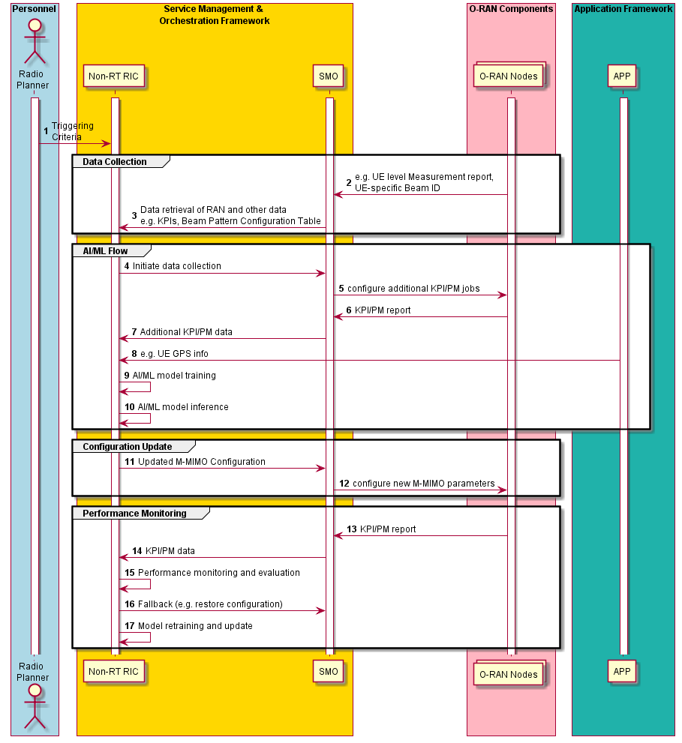
Figure 4.6.3.1-1: Massive MIMO beamforming optimization flow diagram

4.6.3.2 Near-RT massive MIMO beam-based mobility robustness optimization
The context of the massive MIMO beam-based mobility robustness optimization is captured in table 4.6.3.2-1.
Table 4.6.3.2-1: Beam-based mobility robustness optimization
Use Case Stage | Evolution / Specification | <<Uses>>  Related use
Goal | Enable flexible optimization of the beam-based mobility robustness optimization by means of configuration parameter change with operator-defined objectives and allow for AI/ML-based solutions.
Actors and Roles | Near-RT RIC acting as bMRO function, data collection function, and AI/ML model training function.  E2 nodes acting as configuration enforcement function.
Assumptions | E2 connectivity is established between Near-RT RIC and E2 nodes. O1 connectivity is established between Near-RT RIC and SMO. Network is operational.
Pre-conditions | Active Grid-of-Beams beam pattern is defined.
Begins when | Operator specified trigger condition is set or event is detected or periodically.
Step 1 (M) | Near-RT RIC collects necessary data from E2 nodes and related GoB beam pattern Information and trains the AI/ML model with the collected data.
Step 2 (M) | Trained AI/ML models are executed in Near-RT RIC and infer for configuration parameter optimization based on the operator target.
Step 3 (M) | Continuously or upon trigger (e.g., change in the mMIMO beam pattern configuration, manual trigger etc.), Near-RT RIC configures optimized parameters in E2 nodes (e.g., bCIO-s).
Step 4 (M) | Near-RT RIC monitors the network performance. If the algorithm performance is unsatisfactory in terms of predefined objective/requirement, Near-RT RIC initiates fallback mechanism to restore previous/default configuration. It can also gather necessary information and data to retrain and update the AI/ML model or trigger the optimization.
Ends when | Operator specified trigger condition or event is satisfied.
Exceptions | None identified.
Post Conditions | The E2 Nodes operate using the newly deployed parameters.
@startuml
skinparam ParticipantPadding 5
skinparam BoxPadding 10
skinparam defaultFontSize 12
Autonumber

Box “SMO” #gold
Participant SMO as “Operator/SMO”
end box

Box “O-RAN” #lightpink
Participant NearRTRIC as “Near-RT RIC”
Participant ORANnodes as "E2 Nodes"
End box

group Data Collection
ORANnodes -> NearRTRIC : <<E2>> KPI/PM report
Hnote over NearRTRIC
GoB Beam Pattern Information is available
Endhnote
end

group AI/ML Flow
ORANnodes -> NearRTRIC: <<E2>> KPI/PM report
Hnote over NearRTRIC
GoB Beam Pattern Information is available
Endhnote
NearRTRIC -> NearRTRIC: AI/ML model training
NearRTRIC -> NearRTRIC: AI/ML model inference
end

group Configuration Update
group alt 1
Hnote over NearRTRIC
GoB Beam Pattern Change
Endhnote
end
group alt 2
SMO -> NearRTRIC: <<O1>> Optimization Trigger:\nNew optimization target
end
group alt 3
NearRTRIC -> NearRTRIC: Optimization Trigger:\nPerformance degradation
end
NearRTRIC -> ORANnodes: <<E2>> Configure new mobility parameters
end

group Performance Monitoring
ORANnodes -> NearRTRIC: <<E2>> KPI/PM report
NearRTRIC -> NearRTRIC: Performance monitoring and evaluation
NearRTRIC -> NearRTRIC: Fallback configuration (O)
NearRTRIC -> NearRTRIC: Model retraining and update
end

@enduml

The flow diagram of the massive MIMO beam-based mobility robustness optimization is given in figure 4.6.3.2-1.

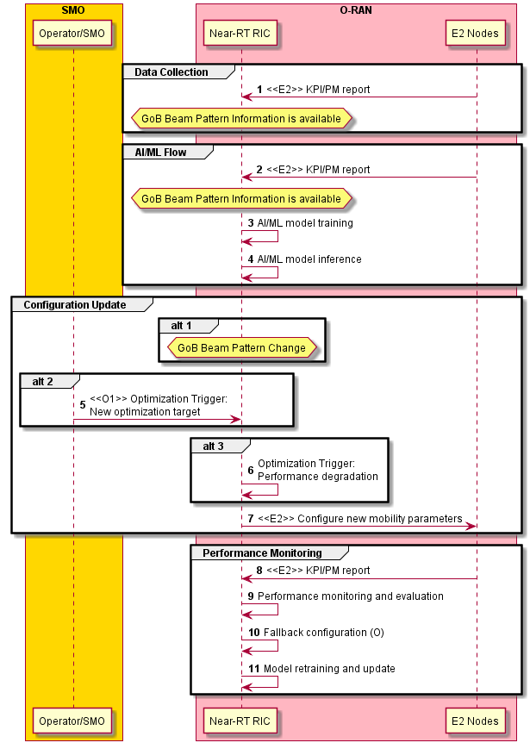
Figure 4.6.3.2-1: Massive MIMO beam-based mobility robustness optimization flow diagram

NOTE on, :
One of the necessary inputs for training and inference of the bMRO function is the (current) GoB beam pattern (or alternative beam pattern) that is determined externally (in the SMO, in the Non-RT RIC, in the E2 nodes, or in the Near-RT RIC by another function). The relevant GoB beam pattern information shall be made available to the Near-RT RIC bMRO function both for training and inference. Depending on implementation, this can be achieved by transmission from the SMO (over O1), or by transmission from the E2 nodes (over E2), or by combined transmission from the SMO and the E2 nodes (or by communication between two Near-RT RIC functions). Moreover, depending how the relevant GoB beam pattern information is defined, the necessary information can be even transmitted separately and asynchronously (e.g., SMO transmits a list of GoB beam patterns for the next, longer time period, while the E2 nodes transmit the exact times of beam pattern change and indicate the ID of the beam pattern in the list).

4.6.3.3 NR cell shaping optimization
The context for the cell shaping optimization use case is captured in table 4.6.3.3-1.
Table 4.6.3.3-1: Cell shaping optimization
Use Case Stage | Evolution / Specification | <<Uses>>  Related use
Goal | Detect optimization opportunities for cell shape optimizations and apply new configuration settings to ensure the optimization cells shapes.
Actors and Roles | SMO, Non-RT RIC, O-RAN NFs, rApp
Assumptions | All relevant functions and components are instantiated, and O1, R1, OFH interface connectivity is in place.
Pre-conditions | Network is operational.  SMO has processed the collected data, and Non-RT RIC has access to this data.  O1 is established between the SMO and RAN Nodes. Non-RT RIC monitors the performance by collecting the relevant performance events and counters from O-RAN nodes from SMO.
Begins when | Network is in normal operational state, providing regular PM and KPI reports.
Step1 (M) | Network provides regular interval performance measurements, and in one such report there are criteria to optimize the shape of the cells.
Step 2 (O) | Alternate scenario 1 – Automated intervention: Triggering for new cell shape to be applied triggered automatically based on network criteria and performance measurements.
Step 3 (O) | Alternate scenario 2 – Manual Intervention: Triggering for new cell shape to be applied is triggered by manual operator / radio planning intervention.
Step 4 (M) | Once criteria have been triggered field data is provided to the rApp via the Non-RT RIC to determine what new settings to set.
Step 5 (M) | Applicable field inputs are provided to rApp as inputs for the optimization logic to apply.
Step 6 (M) | Based on rApp logic, new configuration settings for cell shape are provided.
Step 7 (M) | The new settings are made available to the SMO for communication to the RAN.
Step 8-12 (M) | The SMO communicates the new O1 settings to the O-DU and O-RU as driven by hybrid or hierarchical management options - via O1 and M-plane.
Ends when | Operator specified or rApp trigger changes and event are satisfied.
Exceptions | None identified.
Post Conditions | None.

@startuml
skin rose
skinparam ParticipantPadding 5
skinparam BoxPadding 10
skinparam defaultFontSize 14

autonumber

Box "Operator Personnel" #Lightcyan
Actor planner as "Planner"
End box

Box “SMO Framework“ #gold
participant smo as "SMO"
participant non_RT_RIC
participant rApp
End box

Box “RAN” #lightpink
participant odu as “O-DU“
participant oru as “O-RU“
End box

== START - Triggering Optimization ==

Note over smo
Criteria triggered for cell shaper optimization.
Two scenarios:
1 - automated based on observed network conditions
2 - manual, driven by radio planning
End note

===== Scenario 1 - Automated ==
odu -> smo: O1 - Notify SMO criteria triggered

===== Scenario 2 - Operator intervention ==
planner -> smo: Notify SMO to apply new cell shaper settings

===== Common flow ==
smo -> non_RT_RIC: Data retrieval - pms, metrics
non_RT_RIC-> rApp: R1 - Criteria triggered for rApp

== Apply rApp logic ==

Note over rApp
Apply logic to
re-configure
to target cell shape
End note

rApp -> non_RT_RIC: R1 - Provide new configuration settings to RAN

== Setup new configuration for cell shaper ==
non_RT_RIC-> smo: Provide new configuration settings to apply

smo -> odu: O1 - Provide new configuration settings to ODU

odu -> oru: OFH - Provide new configuration settings to ORU

@enduml

The flow diagram of the cell shaping optimization is given in figure 4.6.3.3-1.

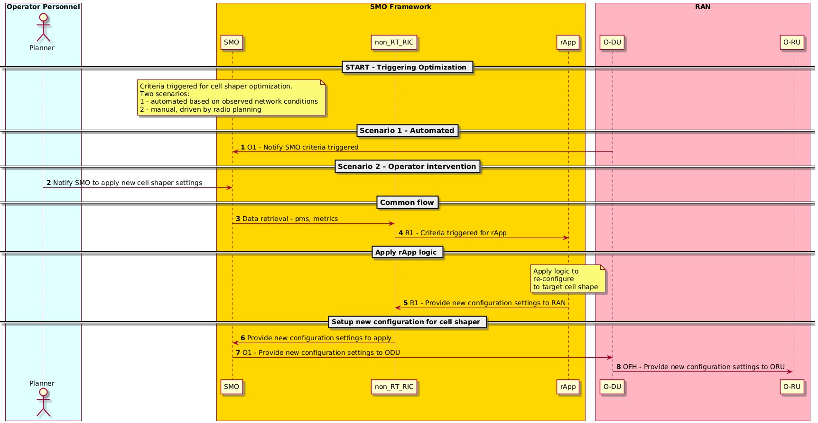
Figure 4.6.3.3-1: Cell shaping optimization flow diagram

4.6.4 Required data

4.6.4.1 Non-RT massive MIMO GoB beam forming optimization
There are different types of data that are required from different parts of the network, and the following list summarizes with some examples:
- Environment data: Cell site information (location), inter-site distance, BS system configuration, (e.g. operating frequency, bandwidth, frame structure, transmit power, default beam weight configuration); complete set of massive MIMO configurations, i.e., horizontal beamwidth adjustable range, vertical beamwidth adjustable range, azimuth angle adjustable range, elevation angle adjustable range.
- From RAN to SMO and/or Near-RT RIC
  - Measurement reports with RSRP/RSRQ/CQI/SINR per beam information for the UEs in cells of interest; the time granularity of data collection shall be configurable and satisfy the requirement of the AI/ML model.
  - Network KPIs: e.g., cell downlink/uplink traffic load, RRC connection attempts, average RRC connected UE, maximum RRC connected UE, average active connections (downlink/uplink), DL/UL throughput, DL/UL spectral efficiency, NI (Noise Interference); beam resource usage (transmitted power per beam/directions and associated PRB usage), beam based handover and beam failure statistics
- From application to SMO
  - User location related information, e.g., GPS coordinates for the purpose of constructing/training relevant AI/ML models.

4.6.4.2 Near-RT massive MIMO beam-based mobility robustness optimization
1) Beam-specific handover related KPMs, as specified in 3GPP TS 28.552 [6] and in 3GPP TS 28.622 [8] from E2 nodes, similar to:
- Too early handovers
- Too late handovers
- Attempted handovers
- Successful handovers
- Failed handovers
- The time granularity is an integer multiple of 1 second as specified in 3GPP TS 28.622 [8].
2) The beam pattern information supplied externally is not defined in the present document.

4.6.4.3 NR cell shaping optimization
Table 4.6.4.3-1: Cell shaping optimization data requirements
- Requirement | - Category | - Parameters | - Source | - Applicable Interface | - Reference
- Req-4.6.001 | - Network Configuration Management | - Node Id: Node identification | - O-DU | - O1 | - 3GPP TS 28.541 [5], clause 4.3.1, gnbId + gnbDUId
- Req-4.6.002 | - Network Configuration Management | - Sector Id: Sector identification | - O-DU | O1
- Req-4.6.003 | - Network Configuration Management | - Cell Id: Cell identification | - O-DU | - O1 | - 3GPP TS 28.541 [5], clauses 4.3.1, 4.3.5, gnbId + cellLocalId
- Req-4.6.004 | - Network Configuration Management | - Antenna Latitude | - O-DU | - O1
- Req-4.6.005 | - Network Configuration Management | - Antenna Longitude | - O-DU | - O1
- Req-4.6.006 | - Network Configuration Management | - Antenna Azimuth (direction) | - O-DU | - O1
- Req-4.6.007 | - Network Configuration Management | - Antenna Elevation (Height) | - O-DU | - O1 | - 3GPP TS 28.662 [41], clause 4.3.2
- Req-4.6.008 | - Network Configuration Management | - Antenna – Remote Electrical Tilt subunit mapping | - O-DU/O-RU | - O1
- Req-4.6.009 | - Network Configuration Management | - Antenna – Remote Electrical Tilt subunit mapping | - O-DU/O-RU | - OFH MP | - O-RAN.WG4.MP [28], clause 14.4.2
- Req-4.6.010 | - Network Configuration Management | - Remote Electrical Tilt per antenna | - O-DU/O-RU | - O1 | - 3GPP TS 28.662 [41], clause 4.3.2, retTiltValue
- Req-4.6.011 | - Network Configuration Management | - Remote Electrical Tilt per antenna | - O-DU/O-RU | - OFH MP | - O-RAN.WG4.MP [28], clause 14.4.3 and  - AISG specifications
- Req-4.6.012 | - Network Configuration Management | - Digital tilt per antenna | - O-DU/O-RU | - O1
- Req-4.6.013 | - Network Configuration Management | - Digital tilt per antenna | - O-DU/O-RU | - OFH MP | - O-RAN.WG4.MP [28], clause 14.4.3 and  - AISG specifications
- Req-4.6.014 | - Network Configuration Management | - Broadcast and Cellular Broadcast (BCB) per cell level | - O-DU | - O1 | - 3GPP TS 28.541 [5], clause 4.3.1, gnbId + gnbDUId
- Req-4.6.015 | - Network Configuration Management | - Horizontal coverage width | - O-DU | - O1
- Req-4.6.016 | - Network Configuration Management | - Horizontal coverage width | - O-DU | - OFH MP
- Req-4.6.017 | - Network Configuration Management | - Vertical coverage width | - O-DU | - O1
- Req-4.6.018 | - Network Configuration Management | - Vertical coverage width | - O-DU | - OFH MP
- Req-4.6.019 | - Network Configuration Management | - Supported coverage combinations of vertical / horizontal options (radio specific capabilities) | - O-RU | - O1
- Req-4.6.020 | - Network Configuration Management | - Supported coverage combinations of vertical / horizontal options (radio specific capabilities) | - O-RU | - OFH MP
- Req-4.6.021 | - Network Configuration Management | - Digital tilt per carrier | - O-DU/O-RU | - O1
- Req-4.6.022 | - Network Configuration Management | - Digital tilt per carrier | - O-DU/O-RU | - OFH MP

4.7 RAN sharing
This use case provides the motivation, description, and requirements for RAN sharing use case. The goal of this use case is to enable multiple operators to share the same O-RAN infrastructure, while allowing them to remotely configure and control the shared resources via a remote O1, O2 and E2 interface.

4.7.1 Background and goal of the use case
RAN sharing is envisioned as an efficient and sustainable way to reduce the network deployment costs, while increasing network capacity and coverage. Among the different RAN sharing models that have been experimented so far, a special focus is put here on the evaluation of the compatibility of the “geographical split” RAN sharing model with the O-RAN architecture. In such a model, a coverage area is split between two or more operators; each operator manages the RAN in a specific area, while sharing its RAN infrastructure and computing resources with its partner operators.
Specifically, this use case analyzes the Multi-Operator RAN (MORAN) sharing scenario, wherein each operator utilizes a separate carrier in order to achieve more freedom and independency on the control of the radio resources. Accordingly, the goal of this use case is to propose a sharing-compliant O-RAN architecture that lets operators to configure the shared network resources independently from configuration and operating strategies of the other sharing operators. Specifically, it is proposed that a home operator (operator A) makes available its O-RAN infrastructure and computing resources to host the Virtual RAN Functions (VNF) of a second operator (operator B), allowing it to configure and control such remote VNFs via a remote O1, O2 and E2 interface.
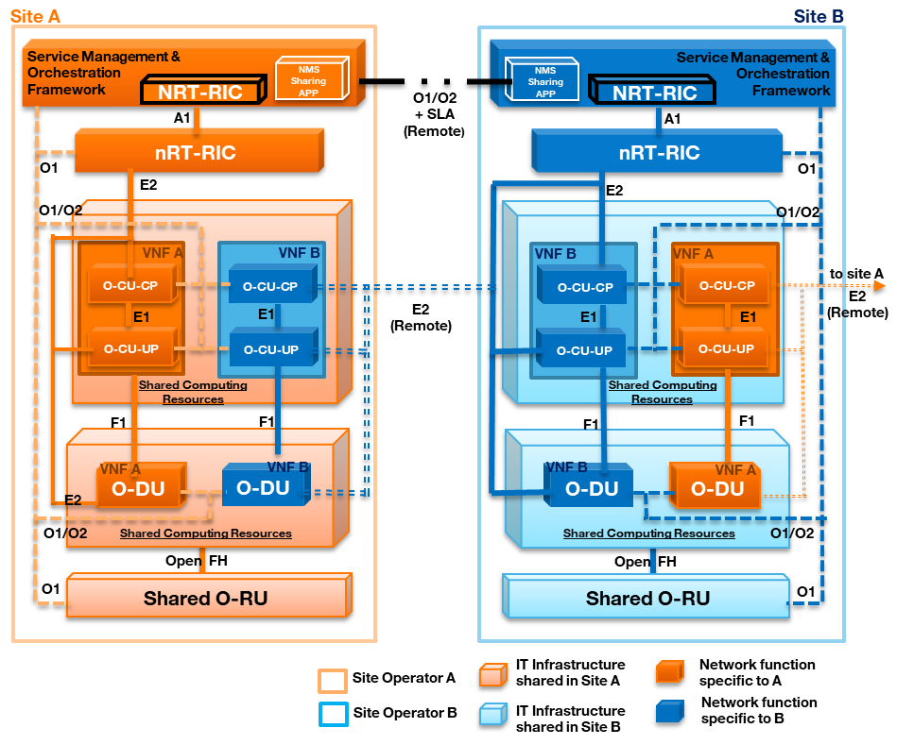
Figure 4.7.1-1: MORAN use case in O-RAN
The logic architecture of the proposed MORAN use case is shown in figure 4.7.1-1. It is assumed that operator A owns the site A and shares the PHY layer (LOW) with operator B (Shared O-RU). Indeed, multiple PLMN IDs are broadcasted, while each operator operates in a different carrier. Moreover, the computing resources of the site A are shared among multiple VNFs, belonging to operator A and operator B, respectively.
Each VNF represents a logic implementation of the O-DU and O-CU functionalities and is controlled by each partner operator in an independent manner. While operator A can directly orchestrate and configure its VNFs, operator B needs to control its VNFs in a remoted manner. The challenge here is to enable operator B to configure and control resources in an infrastructure that is owned by another operator.
Accordingly, it is assumed that operator B can monitor and control the remote radio resources via the RIC node of site B, using an “E2 remote” interface. Note that in the proposed architecture, the RIC nodes are not shared and kept independent at the site A and B respectively.
However, it is assumed that operator B cannot directly orchestrate its VNFs in site A, but it is allowed to communicate the desired initial VNF configuration via an extended O1, O2 interface, hereafter referred to as “O1, O2 + SLA” interface (O1, O2 remote). Note that the O1, O2 nomenclature is used hereafter to refer to both O1 and O2 messages.
The “O1, O2 remote” interface is connected to a specific “sharing orchestration application”, referred to as “SMO-sharing App”, that is located at the Service Management & Orchestration Framework of each operator. Specifically, the “SMO-sharing App” at site A acts as an SLA (Service Level Agreement) monitoring and filter entity: it checks that O1, O2 requests coming from operator B are in line with a predefined SLA and finally configures the VNF of operator B, according to the initial O1, O2 request.

4.7.2 Entities/resources involved in the use case
- SMO-sharing App (site A):
  - SLA monitoring: checks that orchestration/management requests sent by operator B are in line with the SLA.
  - Remote provisioning and initial VNF deployment: asks the IMF to instantiate the VNFs for operator B.
  - Remote management operations via “O1, O2 remote”: configures the VNF of operator B via the Orchestrator, according to “O1, O2 remote” requests sent by operator B.
  - Forwards RAN related data, collected from the hosted VNFs, to the SMO-sharing App (site B) over the “O1, O2 remote” interface.
- SMO-sharing App (site B):
  - Detects the “SMO-sharing App” in site A towards which to forward “O1, O2 remote” requests.
  - Sends “O1, O2 remote” commands for initial deployment and configuration of remote VNFs.
  - Forwards RAN related data of operator B, collected in site A, to the Non-RT RIC.
- IMF (site A): creates VNFs for operator B in site A on initial request of the SMO-sharing App (site A).
- RAN (site A):
  - Supports data collection from the hosted VNFs with radio state report over “E2 remote” interface.
  - Supports data collection from hosted VNFs with UE KPI report over “O1, O2 remote” interface.
- Non-RT RIC (site B):
  - Configures the initial network policy template, e.g., default scheduling policy, of the remote VNFs.
  - Elaborates RAN data collected by “SMO-sharing App”, e.g., scheduling performance metrics, and sends A1 policy/intentions to the remote virtual O-DU/O-CU (VNF_B) via the Near-RT RIC.
- Near-RT RIC (site B):
  - Monitors and collects E2-related parameters from the remote VNFs.
  - Detects the “E2 remote” interface towards the VNFs hosted in site A.

4.7.3 Solutions

4.7.3.1 RAN sharing
The context of the RAN sharing use case is captured in table 4.7.3.1-1.
Table 4.7.3.1-1: RAN sharing use case
Use Case Stage | Evolution / Specification | <<Uses>>  Related use
Goal | Enable two operators to share the same O-RAN infrastructure, while allowing them to remotely configure and control the shared resources via a remote “O1”, “O2” and “E2” interface.
Actors and Roles | Sharing-SMO App handles remote orchestration operations via “O1, O2 remote” interface. Non-RT RIC (operator B): updates configuration of VNFs hosted in site A. Near-RT RIC (operator B): execute remote E2 commands via “E2 remote” interface. RAN (site A): collects and reports RAN statistics to the RIC of operator B (RIC_B) for its VNFs hosted in site A.
Assumptions | All relevant functions and components are instantiated.  A1, O1, O2, E2 interface connectivity is established with local SMO, Non-RT RIC and Near-RT RIC, respectively.  “O1, O2 remote” and “E2 remote” end-to-end connectivity is established with remote SMO and remote Near-RT RIC, respectively. The remote interfaces have been secured through appropriate end-to-end security mechanisms (security configuration details are out of scope of this use case).  Non-RT RIC_B and Near-RT RIC_B are aware of the presence of O-DU_B and O-CU_B in the site A. Near-RT RIC_B is aware of the “E2 remote” interface, to be used to control the remote VNFs hosted in site A.
Pre-conditions | An SLA sharing agreement is established between the home (operator A) and host operator (operator B). The SLA defines the amount of physical resources (CPU, memory, etc.), that can be allocated to the host operator and the type of admissible orchestration operations that can be remotely executed by the host operator. Such SLA is translated in appropriate SLA monitoring-check controls to be executed by the SMO-sharing App.
Begins when | Phase 1-2: Host operator (operator B) asks to provision and instantiate an O-DU_B and O-CU_B in the site of the home operator (operator A).  Phase 3: Host operator wants to send a new instruction to the shared RAN over the “E2 remote” interface.
Step 1 (M) | SMO-sharing App_B sends a request to SMO-sharing App_A for provisioning and deploying a remote virtual O-DU_B and O-CU_B in the site A.
Step 2 (M) | SMO-sharing App_A checks that the request is in line with the predefined SLA and ask the IMF (via the Orchestrator) to instantiate the VNFs for the O-CU_B and O-DU_B.
Step 3 (O) | IMF creates VNF for operator B in site A as for the request of the SMO-sharing App_A.
Step 4 (M) | SMO-sharing App_B notifies SMO-sharing App_A the request to install a default network policy template, e.g., RB scheduling policy, in the remote VNFs.
Step 5 (M) | SMO-sharing App_A checks that operator B request is in line with the SLA and configures (via the Orchestrator) the O-DU_B/ O-CU_B via an O1 configuration command.
Step 6 (M) | RAN related data from VNF_B in site A are collected at SMO Collector and forwarded to the SMO-sharing App_A, which in turns forwards them to the Non-RT RIC_B, via the SMO-sharing App_B.
Step 7 | Non-RT RIC_B decides to update the default network policy of the remote VNFs, e.g., scheduling policy of O-DU_B/O-CU_B and sends an A1 update policy request to the Near-RT RIC_B.
Step 8 | Near-RT RIC_B configures the remote O-DU_B/O-CU_B accordingly, over the “E2 remote” interface.
Ends when | The VNFs of operator B in site A are instantiated with success and no update-requests are sent by the host operator (operator B).
Exceptions | None identified.
Post Conditions | RIC of operator B monitors relevant radio KPI from the remote O-CU_B and O-DU_B and decides to reconfigure the scheduling policy as for Step 7.
@startuml
skinparam ParticipantPadding 5
skinparam BoxPadding 10
skinparam defaultFontSize 14
autonumber

Box “O-RAN (Site A)” #lightpink
Participant OCU as “O-CU_B” <<(Z,lime) VNF>>
Participant ODU as “O-DU_B” <<(Z,lime) VNF>>
End box

Box “Cloud Platform \nInfrastructure” #lightseagreen
participant IMF
End box

Box “Service Management and Orchestration \n(Site A)” #gold
Boundary Collector
Participant SMO_a as “Orchestration_A”
Participant smos_a as “SMO-Sharing_APP_A”
end box

Box “Service Management and Orchestration\n(Site B)” #gold
Participant smos_b as “SMO-Sharing_APP_B”
Participant SMO_b as “Orchestration_B”
Participant NON_b as “Non-RT RIC_B”
end box

Box “O-RAN (Site B)” #lightpink
Participant RIC as “Near-RT RIC_B”
End box

== STARTUP ==
Hnote over smos_a,smos_b
Assuming "O1/O2 remote" interface
estabilished between SMO-Sharing_APP_A
and SMO-Sharing_APP_B
endrnote
smos_b -> smos_a: VNF_B_initial \n provisioning request \n over "O1/O2 remote" \n (O2 command)
smos_a -> smos_a: Provisioning Admission \n Control Verification
smos_a -> SMO_a: <<SMO Internal>> \n VNF_B instantiantion \n request
SMO_a -> IMF: Instiantiate VNF_B \n over O2
IMF -> OCU **: Create O-CU_B \n over O2
IMF -> ODU **: Create O-DU_B \n over O2
IMF -> SMO_a: Notify \nVNF_B instiantiated
SMO_a -> smos_a: <<SMO Internal>>\nForward notification \nVNF_B instiantiated
smos_a -> smos_b: Forward notification \nVNF_B instiantiated \n over "O1/O2 remote"
smos_b -> SMO_b: Notify VNF_B \n instiantiated \n in site A

== CONFIGURATION ==
SMO_b -> smos_b: Initial Remote \n VNF configuration \n request
smos_b -> smos_a: VNF_B configuration request \nover "O1/O2 remote" \n(O1 command)\n(binary code, \n MAC Scheduler template...)
smos_a -> smos_a: Conversion of Conf. Request \nin local O1 command
smos_a -> SMO_a: << SMO Internal >> \nConfigure VNF_B
SMO_a -> OCU: Configure O-CU_B \nover O1
SMO_a -> ODU: Configure O-DU_B \nover O1

Hnote over RIC,OCU
Assuming "E2 remote" interface estabilished between near RT-RIC and remote O-CU and O-DU
endrnote

== RUNNING ==
RIC -> OCU:<<E2>> Subscribtion over "E2 remote"
RIC -> ODU:<<E2>> Subscribtion over "E2 remote"
ODU-> RIC : <<E2>> Report over "E2 remote"
OCU-> RIC : <<E2>> Report over "E2 remote"
ODU-> Collector : <<O1 Perf./trace management>> SMO data collection
OCU-> Collector : <<O1 Perf./trace management>> SMO data collection
Collector -> smos_a: << SMO Internal >> \nForward VNF_B RAN data
smos_a -> smos_b: Forward VNF_B RAN data\n over "O1/O2 remote"
smos_b -> NON_b: << SMO Internal >> \n Forward VNF_B RAN data
NON_b -> NON_b: Evaluate VNF_B RAN \n performance

Alt if need to update VNF_B network policy
NON_b -> RIC: Scheduling_update \npolicy/intent message \n over A1
RIC -> RIC : "E2 remote" \nInterface\n detection
RIC -> OCU: Update configuration command over "E2 remote"
RIC -> ODU: Update configuration command over "E2 remote"
end
@enduml

The flow diagram of the VNF configuration procedure for VNF_B hosted in site A is given in figure 4.7.3.1-1.
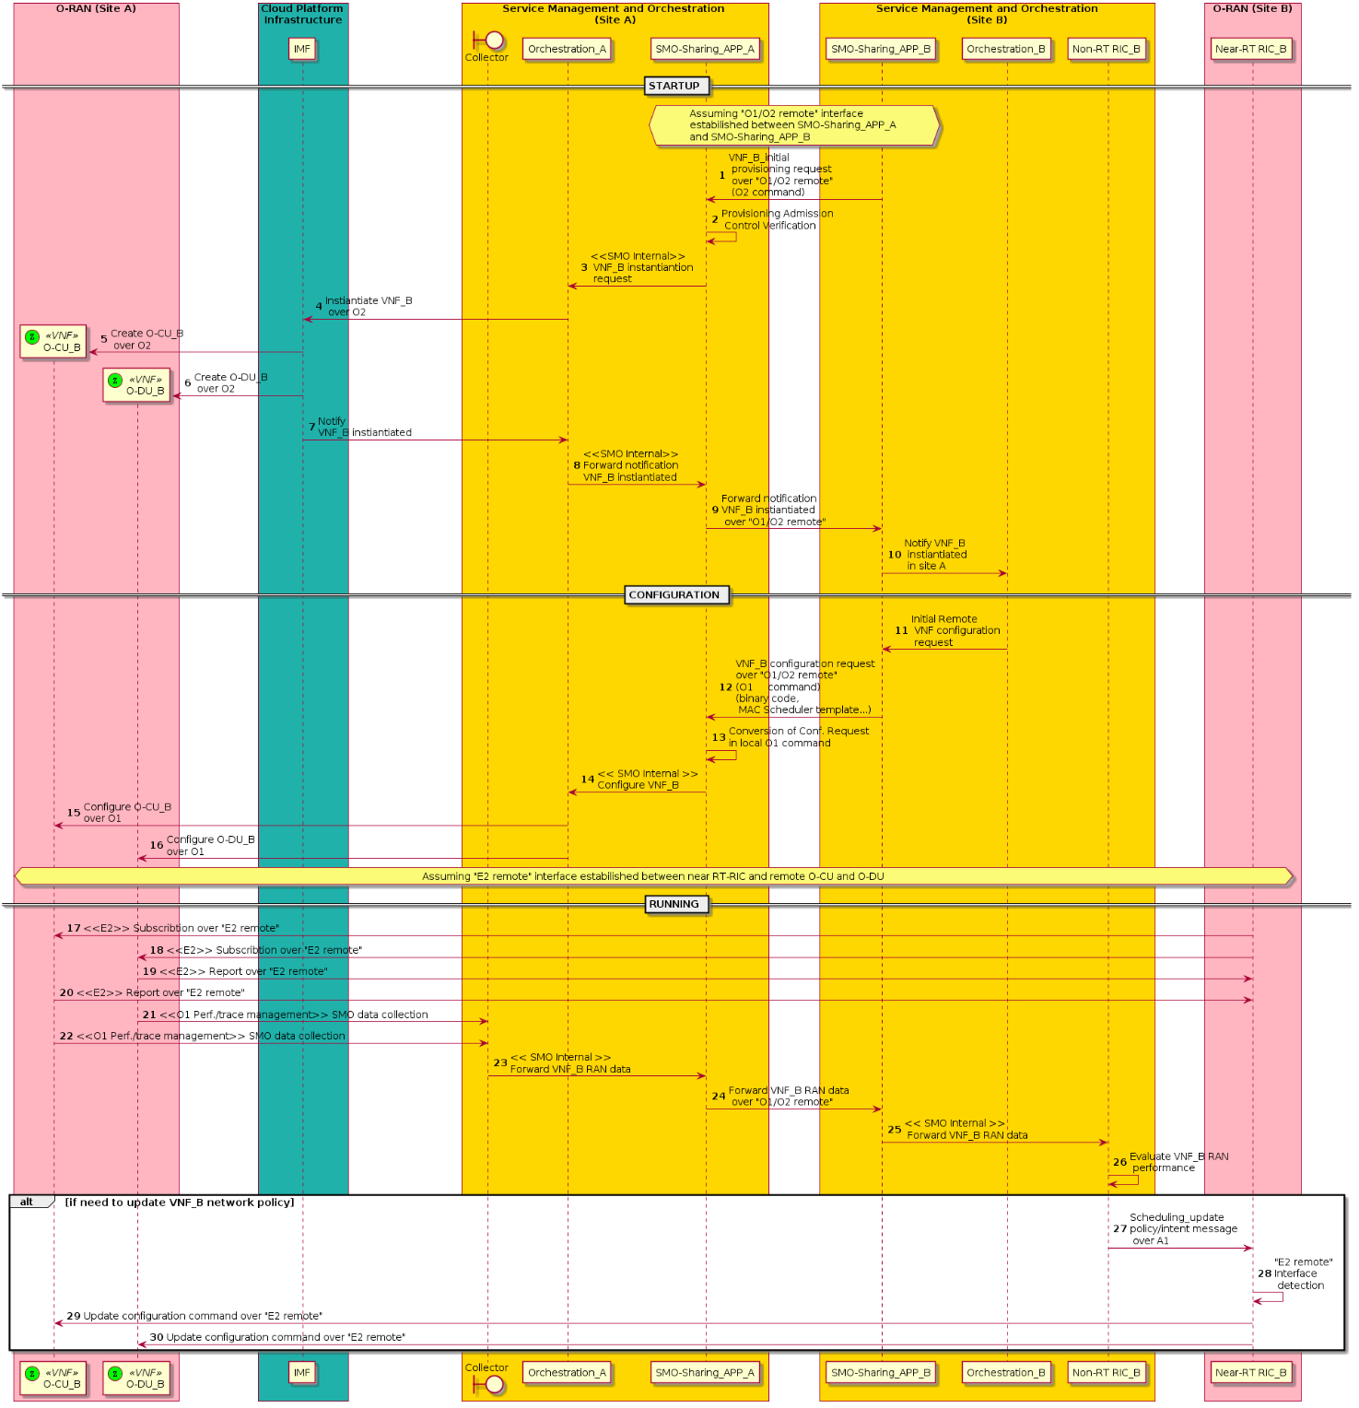
Figure 4.7.3.1-1: VNF configuration procedure for VNF_B hosted in site A

4.7.4 Required data
Multi-dimensional data are expected to be handled by the SMO-sharing App:
- SLA data needs to be converted in a set of condition steps to be matched for each request of the host operator (operator B).
- SMO needs to handle O1, O2 messages sent by the host operator, converting them in local O1, O2 commands.
The RAN of the home operator needs to report to the RIC_B the network state of the served UEs that belong to the host operator.

4.8 QoS based resource optimization
This use case provides the background and motivation for the O-RAN architecture to support RAN QoS based resource optimization. Moreover, some high-level description and requirements over Non-RT RIC and A1 interfaces are introduced.

4.8.1 Background and goal of the use case
QoS based resource optimization can be used when the network has been configured to provide some kind of preferential QoS for certain users. One such scenario can be related to when the network has been configured to support e2e slices. In this case, the network has functionality that ensures resource isolation between slices as well as functionality to monitor that slice Service Level Specifications (SLS) are fulfilled.
In RAN, it is the scheduler that ensures that Physical Resource Block (PRB) resources are isolated between slices in the best possible way and also that the PRB resources are used in an optimal way to best fulfill the SLS for different slices. The desired default RAN behavior for slices is configured over O1. For example, the ratio of physical resources (PRBs) reserved for a slice is configured at slice creation (instantiation) over O1. Also, QoS can be configured to guide the RAN scheduler how to (in real-time) allocate PRB resources to different users to best fulfill the SLS of a specific slice. In the NR NRM this is described by the resource partition attribute.
Instantiation of a RAN sub-slice will be prepared by rigorous planning to understand to what extent deployed RAN resources will be able to support RAN sub-slice SLS. Part of this procedure is to configure RAN functionality according to above. With this, a default behavior of RAN is obtained that will be able to fulfill slice SLSs for most situations. However, even through rigorous planning, there will be times and places where the RAN resources are not enough to fulfill SLS given the default configuration. To understand how often (and where) this happens, the performance of a RAN slice will continuously be monitored by SMO. When SMO detects a situation when RAN SLS cannot be fulfilled, Non-RT RIC can use A1 policies to improve the situation. To understand how to utilize A1 policies and how to resolve the situation, the Non-RT RIC will use additional information available in SMO.
Take an emergency service as an example of a slice tenant. For this example, it is understood (at slice instantiation) that 50% of the PRBs in an area can be enough to support the emergency traffic under normal circumstances. Therefore, the ratio of PRBs for the emergency users is configured to 50% as default behavior for the pre-defined group of users belonging to the emergency slice. Also, QoS is also configured in CN and RAN so that video cameras of emergency users get a minimum bitrate of 500 kbps.
Now, suppose a large fire is ongoing and emergency users are on duty. Some of the personnel capture the fire on video on site. The video streams are available to the emergency control command. Because of the high traffic demand in the area from several emergency users (belonging to the same slice), the resources available for the emergency slice is not enough to support all the traffic. In this situation, the operator has several possibilities to mitigate the situation. Depending on SLAs towards the emergency slice compared to SLAs for other slices, the operator could reconfigure the amount of PRB reserved to emergency slice at the expense of other slices. However, there is always a risk that emergency video quality is not good enough irrespective if all resources are used for emergency users. It might be that no video shows sufficient resolution due to resource limitations around the emergency site.
In this situation, the emergency control command decides, based on the video content, to focus on a selected video stream to improve the resolution. The emergency control system gives the information about which users to up- and down-prioritized to the e2e slice assurance function (through e.g. an Edge API) of the mobile network to increase bandwidth for selected video stream(s). Given this additional information, the Non-RT RIC can influence how RAN resources are allocated to different users through a QoS target statement in an A1 policy. By good usage of the A1 policy, the emergency control command can ensure that dynamically defined group of UEs provides the video resolution that is needed.

4.8.2 Entities/resources involved in the use case
- Non-RT RIC:
  - Monitor necessary QoS related metrics from network function and other SMO functions.
  - Send policies to Near-RT RIC to drive QoS based resource optimization at RAN level in terms of expected behavior.
- Near-RT RIC:
  - Support interpretation and execution of A1 policies for QoS based resource optimization.
- RAN:
  - Support network state and UE performance report with required granularity to SMO over O1 interface.
  - Support QoS enforcement based on messages from E2, which are expected to influence RRM behavior.

4.8.3 Solutions

4.8.3.1 QoS based resource optimization
The context of the QoS based resource optimization is captured in table 4.8.3.1-1.
Table 4.8.3.1-1: QoS based resource optimization
Use Case Stage | Evolution / Specification | <<Uses>>  Related use
Goal | Drive QoS based resource optimization in RAN in accordance with defined policies and configuration.
Actors and Roles | Non-RT RIC: Creates A1 policies.  Near-RT RIC: Enforces A1 policies.  RAN: Policy enforcement.  SMO: Termination point for O1 interface.
Assumptions | All relevant functions and components are instantiated and configured according wanted default behavior.  A1 interface connectivity is established with Non-RT RIC.  O1 interface connectivity is established with SMO.  The default configuration will handle most situations.
Pre-conditions | Network is operational with default configuration.  SMO has established the data collection and sharing process, and Non-RT RIC has access to this data.  Non-RT RIC analyzes the data from RAN to understand the current resource consumption.
Begins when | Non-RT RIC observes that resources are close to congestion in a certain area.
Step 1 (O) | If needed, Non-RT RIC orders additional RAN observability, SMO configures additional observability over O1.
Step 2 | Non-RT RIC evaluates RAN resource utilization for all users in a slice in specific area.
Step 3 | Non-RT RIC asks for additional information from additional SMO functionality, e.g. e2e slice assurance function.
Step 4 | Non-RT RIC determines dynamic group of users for which QoS target shall be changed.
Step 5 | Non-RT issues A1 policy/policies with QoS target based on information from other SMO functionality.
Ends when | Non-RT RIC (through O1 observability) understands that situation of resource constraints within the slice is resolved, and the deployed policies are deleted over A1.
Exceptions | None identified.
Post Conditions
@startuml
skinparam ParticipantPadding 5
skinparam BoxPadding 10
Autonumber

Box “Service Management and Orchestration” #gold
participant “Collection & Control” as smo
participant “Non-RT RIC” as non
end box

Box “O-RAN” #lightpink
participant “Near-RT RIC” as near
participant “E2 Nodes” as ran
end box

Box “External enrichment server” #lightcyan
Entity sliceuserdata as “Slice user data”
End box

ran -> smo : <<O1>> Data collection
non-> non: Evaluation of resource consumption
non-> non: Indication of approaching congestion in certain area

group O1 configuration
non -> smo: Request additional measurements
smo -> ran: <<O1>> PM measurement configuration
ran -> smo : <<O1>> Data collection
smo -> non : Additional data retrieval
end

non -> non: Detailed evaluation of situation
non -> smo: Request additional info on priorities
smo -> sliceuserdata: Request Non-RAN info on priorities
sliceuserdata –> smo: Non-RAN information on priorities
smo–> non: Additional information on priorities

group A1 Policies
non -> near : <<A1>> QoS based resource optimization policy create message
near -> ran : <<E2>> QoS based resource optimization enforcement
end

ran -> smo: <<O1>> Data collection (incl specific data)
smo -> non: Data retrieval of RAN and non-RAN data
non -> non: Detailed evaluation of congestion situation to understand the effect of policy
non -> non: Evaulation of congestion situation to understandwhen gone

group A1 policies
non -> near: <<A1>> QoS target policy delete message
end
@enduml

The flow diagram of the QoS based resource optimization is given in figure 4.8.3.1-1.

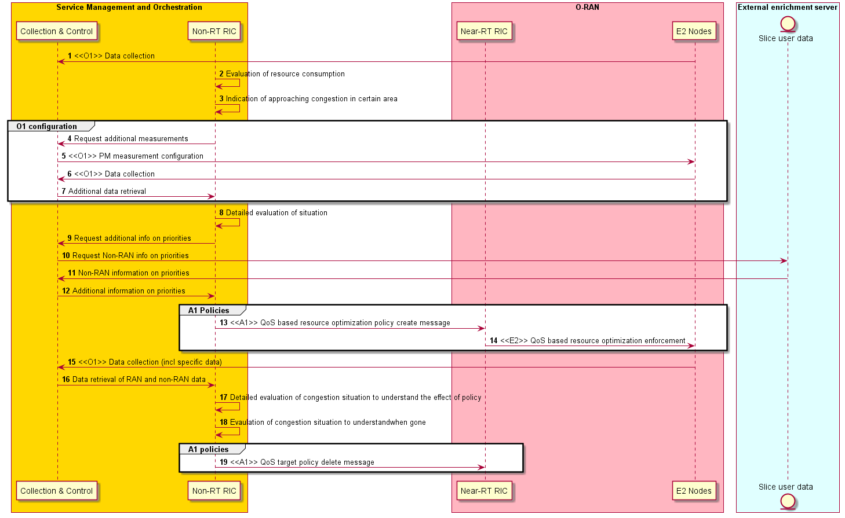
Figure 4.8.3.1-1: QoS based resource optimization flow diagram

4.8.4 Required data
For this use case, different kind of observability need to be reported to Non-RT RIC. First Non-RT RIC shall monitor resource consumption in the area. As long as resource consumption is low, the RAN scheduler will be able to give all users in an area the needed resources. When resource consumption in an area increases above a threshold, the risk of that the default configuration of RAN will not be enough to fulfil the requirements. At this point, the Non-RT RIC need to be able to configure more detailed reporting for individual UEs that the Non-RT RIC is interested in. This detailed observability shall provide the Non-RT RIC better insight in performance for specific users and therefore includes observability of e.g., user throughput and delay. With this more detailed observability, the Non-RT RIC can understand when pre-configured priorities are not enough for the scheduler to solve the problem and when additional (non-RAN) information to solve the prioritization is needed.

4.9 RAN slice SLA assurance
The 3GPP standards architected a sliceable 5G infrastructure which allows creation and management of customized networks to meet specific service requirements that can be demanded by future applications, services, and business verticals. Such a flexible architecture needs different requirements to be specified in terms of functionality, performance and group of users which can greatly vary from one service to the other. The 5G standardization efforts have gone into defining specific slices and their Service Level Agreements (SLAs) based on application/service type as specified in 3GPP TS 23.501 [2]. Since network slicing is conceived to be an end-to-end feature that includes the core network, the transport network and the Radio Access Network (RAN), these requirements shall be met at any slice subnet during the life-time of a network slice as specified in 3GPP TS 28.530 [4], especially in RAN side. Exemplary slice performance requirements are specified in terms of throughput, energy efficiency, latency, and reliability at a high level in SDOs such as 3GPP TS 22.261 [1] and GSMA NG.116 [17]. These requirements are defined as a reference for SLA/contractual agreements for each slice, which individually need proper handling in NG-RAN.
Although network slicing support is started to be defined with 3GPP Release 15, slice assurance mechanisms in RAN needs to be further addressed to achieve deployable network slicing in an open RAN environment. It is necessary to assure the SLAs by dynamically controlling slice configurations based on slice specific performance information. Existing RAN performance measurements as specified in 3GPP TS 28.552 [6] and information model definitions as specified in 3GPP TS 28.541 [5] are not enough to support RAN slice SLA assurance use cases. This use case is intended to clarify necessary mechanisms and parameters for RAN slice SLA assurance.

4.9.1 Background and goal of the use case
In the 5G era, network slicing is a prominent feature which provides end-to-end connectivity and data processing tailored to specific business requirements. These requirements include customizable network capabilities such as the support of very high data rates, traffic densities, service availability and very low latency. According to 5G standardization efforts, the 5G system can support the needs of the business through the specification of several service needs such as data rate, traffic capacity, user density, latency, reliability, and availability. These capabilities are always provided based on a Service Level Agreement (SLA) between the mobile operator and the business customer, which brought up interest for mechanisms to ensure slice SLAs and prevent its possible violations. O-RAN’s open interfaces and AI/ML based architecture will enable such challenging mechanisms to be implemented and help pave the way for operators to realize the opportunities of network slicing in an efficient manner.

4.9.2 Entities/resources involved in the use case
- Non-RT RIC:
  - Retrieve RAN slice SLA target from respective entities such as SMO, NSSMF
  - Long term monitoring of RAN slice performance measurements
  - Training of potential AI/ML models that will be deployed in Non-RT RIC for slow loop optimization and/or Near-RT RIC for fast loop optimization
  - Support deployment and update of AI/ML models into Near-RT RIC
  - Receive slice control/slice SLA assurance rApps from SMO
  - Create A1 policies based on RAN intent A1 feedback
  - Retrieve UE specific performance reports
  - Send A1 policies and enrichment information to Near-RT RIC to drive slice assurance
  - Send O1 reconfiguration requests to SMO for slow-loop slice assurance
- Near-RT RIC:
  - Near real-time monitoring of slice specific RAN performance measurements
  - Support deployment and execution of the AI/ML models from Non-RT RIC
  - Receive slice SLA assurance xApps from SMO
  - Send UE specific performance reports to SMO/Non-RT RIC
  - Support interpretation and execution of policies from Non-RT RIC
  - Perform optimized RAN (E2) actions to achieve RAN slice requirements based on O1 configuration, A1 policy, and E2 reports
- E2 nodes:
  - Support slice assurance actions such as slice-aware resource allocation, prioritization, etc.
  - Support slice specific performance measurements through O1
  - Support slice specific performance reports through E2

4.9.3 Solutions

4.9.3.1 Creation and deployment of RAN slice SLA assurance models and control apps
The context of the creation and deployment of RAN slice SLA assurance models and control apps is captured in table 4.9.3.1-1.
Table 4.9.3.1-1: Creation and deployment of RAN slice SLA assurance models and control apps
Use Case Stage | Evolution / Specification | <<Uses>>  Related use
Goal | Training and distribution of the model, or distribution of control apps.
Actors and Roles | Non-RT RIC, Near-RT RIC, SMO
Assumptions | All relevant functions and components are instantiated.  A1, O1 interface connectivity is established.
Pre-conditions | Near-RT RIC and Non-RT RIC are instantiated with A1 interface and connectivity has been established between them.  O1 interface has been established between SMO and Near-RT RIC.
Begins when | A RAN slice is activated.
Step 1 (M) | Non-RT RIC retrieves a RAN slice SLA from SMO (NSSMF).
Step 2a | Non-RT RIC starts to collect performance measurements (PMs) via O1. Examples of the PMs are CSI, PRB usage, L2 throughput, RAN latency, etc. Applicable PMs are specified in 3GPP TS 28.552 [6]. | Step 2 and 3 are mandatory in case of using the AI/ML model
Step 2b (O) | Non-RT RIC starts to collect Enrichment Information (EIs) from external applications. Examples of the external applications are public safety application triggering slice priority during an emergency event, or location-based enrichment information, etc.
Step 2c | Non-RT RIC analyzes collected PMs and/or EIs for long term monitoring, such as during the day or over the weekend.
Step 3 | Non-RT RIC does the model training using the collected data in step 2 and obtains RAN slice SLA assurance models.
Step 4a | In case of using the AI/ML model, Non-RT RIC deploys the trained model internally for slow loop optimization and/or distributes it to the Near-RT RIC via O2 for fast loop optimization. | Step 4a or 4b is mandatory
Step 4b | In case of using the control app, the control app is deployed by SMO to Non-RT RIC for slow loop optimization and/or Near-RT RIC via O2 for fast loop optimization.
Step 5 (M) | Non-RT RIC receives feedback internally or from Near-RT RIC via A1 to update the model or control apps based on it.
Ends when | A RAN slice is deactivated.
Exceptions | None identified.
Post Conditions | None identified.
@startuml
skinparam ParticipantPadding 5
skinparam BoxPadding 10
skinparam defaultFontSize 12
Autonumber

Box “Service Management and Orchestration” #gold
Participant SMO as “SMO Functions”
Boundary Collector
Participant NON as “Non-RT RIC”
end box

Box “O-RAN” #lightpink
Participant RIC as “Near-RT RIC”
Participant E2NODES as “E2 Nodes”
End box

Box “External” #lightcyan
Participant APP as “App”
End box

SMO-> NON : RAN Slice SLA Retrieval
E2NODES-> Collector : <<O1>> Data Collection
RIC-> Collector : <<O1>> Data Collection

group opt
APP-> Collector : Enrichment information collection
end

Collector-> NON : Retrieval of RAN and non-RAN data

group opt
NON-> NON : Training of AI/ML models
end

NON-> NON : Deploy internal app
NON-> RIC : <<O2>> Deploy xApp
Collector-> NON : Retrieval of RAN and non-RAN data
NON-> NON : Performance monitoring & evaluation

group opt
NON-> NON : Model re-training / update
NON-> RIC : <<O2>> Update xApp
end

@enduml

The flow diagram of the creation and deployment of RAN slice SLA assurance models and control apps is given in figure 4.9.3.1-1.
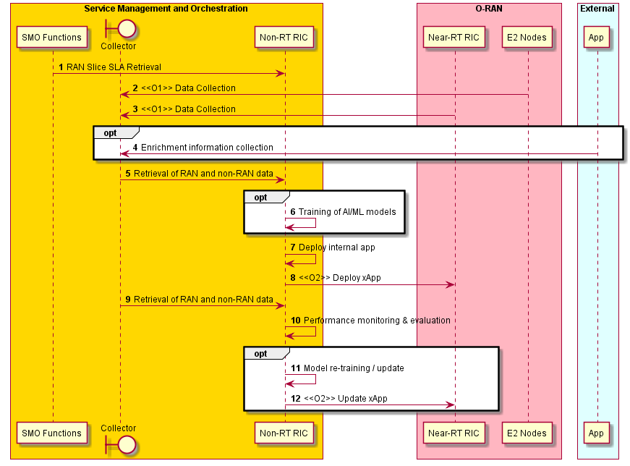
Figure 4.9.3.1-1: Creation and deployment of RAN slice SLA assurance models and control apps flow diagram

4.9.3.2 Slow loop RAN slice SLA optimization
The context of the slow loop RAN slice SLA optimization is captured in table 4.9.3.2-1.
Table 4.9.3.2-1: Slow loop RAN slice SLA optimization
Use Case Stage | Evolution / Specification | <<Uses>>  Related use
Goal | Slow loop RAN slice SLA optimization
Actors and Roles | Non-RT RIC, Near-RT RIC, SMO, RAN
Assumptions | All relevant functions and components are instantiated.  A1, O1, E2 interface connectivity is established.
Pre-conditions | Near-RT RIC and Non-RT RIC are instantiated with A1 interface connectivity being established between them.  O1 interfaces are established between SMO and Near-RT RIC, and SMO and RAN nodes.  RAN slice SLA assurance models or control apps have been deployed in Non-RT RIC and Near-RT RIC respectively.
Begins when | A RAN slice is activated.
Step 1a | Non-RT RIC decides that RAN shall be reconfigured based on long term trends collected via O1 using PMs and/or EIs.  Examples of the PMs are layer 2 throughput, PRB usage, CSI, RAN latency. | Config update step 1a or 1b is mandatory
Step 1b | Non-RT RIC decides to create slice specific A1 policies based on RAN slice SLA requirements and/or operator-defined RAN intents, A1 feedback from Near-RT RIC, EI from external app server and O1 based long term trends.  The policies include scope identifiers (e.g., S-NSSAI, flow ID, cell ID) and/or policy statements (e.g. slice specific KPI targets). | Policy update
Step 2a | The model or control app in Non-RT RIC requests SMO to update slice configuration of Near-RT RIC and/or RAN nodes through O1. | Config request
Step 2b | SMO sends the updated slice configuration to Near-RT RIC and/or RAN nodes via O1. Examples of the slice configuration are the number of allocated PRBs, number of flows, slice priorities. | Config delivery  step 2b or 2c is mandatory
Step 2c | Non-RT RIC sends the updated A1 policies to Near-RT RIC. | Policy delivery
Step 3a | Near-RT RIC and RAN nodes process and execute the updated slice configuration. | Config execution  step 3a or 3b is mandatory
Step 3b | Near-RT RIC receives the updated A1 policy, controls RAN nodes based on the A1 policy and sends the feedback to Non-RT RIC via A1. | Policy execution
Ends when | A RAN slice is deactivated.
Exceptions | None identified.
Post Conditions | None identified.
@startuml
skinparam ParticipantPadding 5
skinparam BoxPadding 10
skinparam defaultFontSize 12
Autonumber

Box “Service Management and Orchestration” #gold
Participant SMO as “SMO Functions”
Boundary Collector
Participant NON as “Non-RT RIC”
end box

Box “O-RAN” #lightpink
Participant RIC as “Near-RT RIC”
Participant E2NODES as “E2 Nodes”
End box

Box “External” #lightcyan
Participant APP as “App”
End box

SMO-> NON : RAN Slice SLA Retrieval
SMO-> NON : Slice specific O1 configuration data of Near-RT RIC and E2 Nodes
E2NODES-> Collector : <<O1>> Data Collection
RIC-> Collector : <<O1>> Data Collection

group Opt: Enrichment information collection
APP-> Collector : Enrichment information collection
end

Collector-> NON : Retrieval of RAN and non-RAN data

NON-> NON : Performance monitoring and evaluation
NON-> NON : Trigger for RAN slice SLA assurance

group Opt: Additional data collection
NON-> Collector : Request additional measurements
Collector-> E2NODES : <<O1>> PM measurement configuration
E2NODES-> Collector : <<O1>> Data Collection
Collector-> NON : Retrieval of RAN data
end

NON-> NON : Decision for RAN slice SLA assurance

group Alt 1: O1 Configuration update
NON-> NON : Creation of slice specific configuration
NON-> SMO : Request for slice specific RAN configuration update
SMO-> RIC : <<O1>> Configuration update
SMO-> E2NODES : <<O1>> Configuration update
end

group Alt 2: A1 Policy generation
NON-> NON : RAN slice SLA assurance policy generation
NON-> RIC : <<A1>> RAN slice SLA assurance policy creation
RIC-> RIC : E2 policy generation
RIC-> E2NODES : <<E2>> RAN slice SLA assurance enforcement
E2NODES-> RIC : <<E2>> Data collection
RIC-> NON : <<A1>> RAN slice SLA assurance policy feedback
end

E2NODES-> Collector : <<O1>> Data Collection
Collector-> NON : Retrieval of RAN and non-RAN data
NON-> NON : Performance monitoring and evaluation

group Opt: A1 Policy removal
NON-> NON : Decision to remove RAN slice SLA policy
NON-> RIC : <<A1>> RAN slice SLA assurance policy removal
End
@enduml

The flow diagram of the slow loop RAN slice SLA optimization is given in figure 4.9.3.2-1.

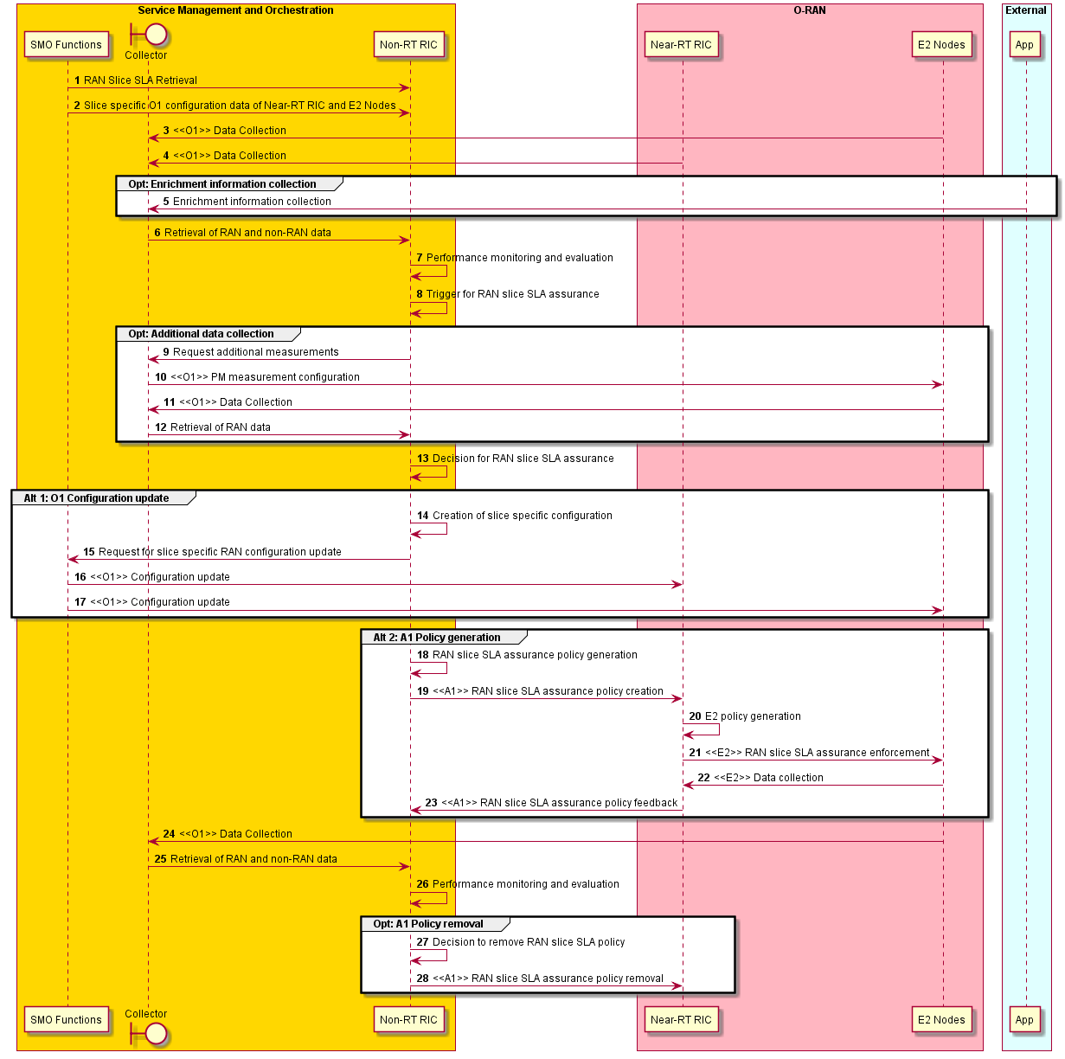
Figure 4.9.3.2-1: Slow loop RAN slice SLA optimization flow diagram

4.9.3.3 Fast loop RAN slice SLA optimization
The context of the fast loop RAN slice SLA optimization is captured in table 4.9.3.3-1.
Table 4.9.3.3-1: Fast loop RAN slice SLA optimization
Use Case Stage | Evolution / Specification | <<Uses>>  Related use
Goal | Fast loop RAN slice SLA optimization
Actors and Roles | Non-RT RIC, Near-RT RIC, SMO, RAN
Assumptions | All relevant functions and components are instantiated.  A1, O1, E2 interface connectivity is established.
Pre-conditions | Near-RT RIC and Non-RT RIC are instantiated with A1 interface connectivity being established between them.  O1 interfaces are established between SMO and Near-RT RIC, and SMO and RAN nodes.  RAN slice SLA assurance models or control apps have been deployed in Near-RT RIC.
Begins when | A RAN slice is activated.
Step 1 | Non-RT RIC decides to generate a policy for Near-RT RIC slice SLA assurance based on RAN slice SLA requirements and/or operator-defined RAN intents, A1 feedback from Near-RT RIC, EI from external app server and O1 based long term trends.
Step 2 | Near-RT RIC receives slice specific O1 configuration and A1 policies from SMO and Non-RT RIC respectively. The former is static and default, the latter is dynamic, optimized and converted from slice SLA. The policies consist of scope identifiers (e.g., S-NSSAI, flow ID, cell ID) and policy statements (e.g., slice specific KPI targets).  In case of using EIs, Near-RT RIC also receives the EIs from Non-RT RIC via A1-EI interface.
Step 3 | Near-RT RIC starts to collect PMs via E2. Examples of the PMs are CSI, PRB usage, L2 throughput, RAN latency, etc. Applicable PMs are specified in 3GPP TS 28.552 [6].
Step 4 | The model or control app in Near-RT RIC analyzes collected PMs, A1 policies from Non-RT RIC (and optionally EIs from A1-EI interface) to guide RAN nodes via E2 to meet the slice SLA.
Step 5 | Near-RT RIC sends A1 feedback to Non-RT RIC.
Ends when | A RAN slice is deactivated.
Exceptions | None identified.
Post Conditions | None identified.
@startuml

skinparam ParticipantPadding 5
skinparam BoxPadding 10
skinparam defaultFontSize 12
Autonumber

Box “Service Management and Orchestration” #gold
Participant SMO as “SMO Functions”
Boundary Collector
Participant NON as “Non-RT RIC”
end box

Box “O-RAN” #lightpink
Participant RIC as “Near-RT RIC”
Participant E2NODES as “E2 Nodes”
End box

Box “External” #lightcyan
Participant APP as “App”
End box

SMO-> NON : RAN Slice SLA Retrieval
SMO-> NON : Slice specific O1 configuration data of Near-RT RIC and E2 Nodes
E2NODES-> Collector : <<O1>> Data Collection
RIC-> Collector : <<O1>> Data Collection

group Opt: Enrichment information collection
APP-> Collector : Enrichment information collection
end

Collector-> NON : Retrieval of RAN and non-RAN data

NON-> NON : Performance monitoring and evaluation
NON-> NON : Trigger for RAN slice SLA assurance

group Opt: Additional data collection
NON-> Collector : Request additional measurements
Collector-> E2NODES : <<O1>> PM measurement configuration
E2NODES-> Collector : <<O1>> Data Collection
Collector-> NON : Retrieval of RAN data
end

NON-> NON : Decision for near real time RAN slice SLA assurance

group A1 Policy generation
NON-> NON : RAN slice SLA assurance policy generation
NON-> RIC : <<A1>> RAN slice SLA assurance policy creation
end

group Opt: A1 Enrichment information transfer
NON-> RIC : <<A1>> RAN slice SLA assurance related enrichment information
end

E2NODES-> RIC : <<E2>> Data collection
RIC-> RIC : Performance monitoring and evaluation
RIC-> RIC : Trigger for near real time RAN slice SLA assurance

group Opt: Additional near real time data collection
RIC-> E2NODES : <<E2>> Request additional measurements
E2NODES-> RIC : <<E2>> Data collection
end

group Near real time slice SLA assurance
RIC-> RIC : E2 control or policy generation
RIC-> E2NODES : <<E2>> RAN slice SLA assurance enforcement
E2NODES-> RIC : <<E2>> Data collection
RIC-> RIC : Performance monitoring and evaluation
end

group A1 policy feedback
RIC-> NON : <<A1>> RAN slice SLA assurance policy feedback
end

@enduml

The flow diagram of the fast loop RAN slice SLA optimization is given in figure 4.9.3.3-1.

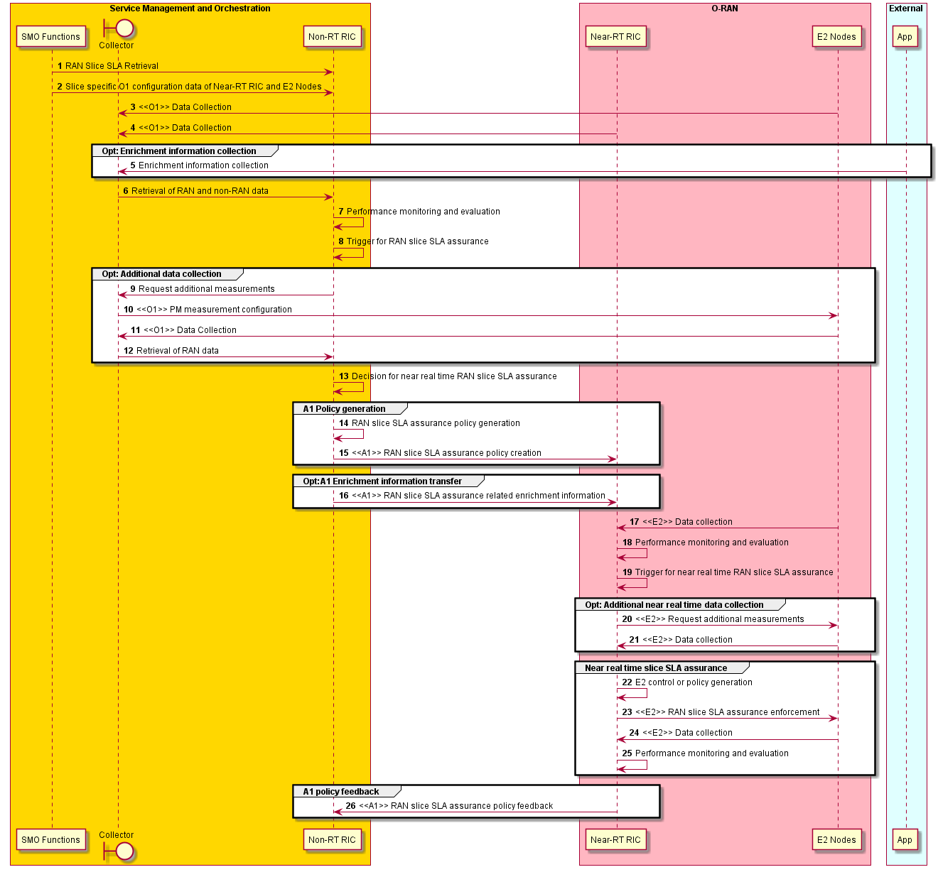
Figure 4.9.3.3-1: Fast loop RAN slice SLA optimization flow diagram

4.9.4 Required data
The data requirements for RAN slice SLA assurance use case are specified below. The required data specified in table 4.9.4-1 shall be supported by the associated interfaces specified in the table.
Table 4.9.4-1: Required data for RAN slice SLA assurance use case
Requirement | Category | Parameters / Measurements | Source | Reference | Interface
Req-4.9.001 | CQI related measurements | Wideband CQI distribution | O-DU | 3GPP TS 28.552 [6], clause 5.1.1.11.1 | O1
Req-4.9.002 | UE throughput related measurements | Average DL / UL UE throughput in gNB | O-DU | 3GPP TS 28.552 [6], clauses 5.1.1.3.1, 5.1.1.3.3 | O1
Req-4.9.003 | UE throughput related measurements | Scheduled IP throughput in DL/UL | O-DU | 3GPP TS 36.314 [31], clauses 4.1.6.1, 4.1.6.2 | O1
Req-4.9.004 | RRC connection related measurements | Mean / max number of RRC connections | O-CU | 3GPP TS 28.552 [6], clauses 5.1.1.4.1, 5.1.1.4.2 | O1
Req-4.9.005 | RRC connection related measurements | Attempted / successful RRC connection establishments | O-CU | 3GPP TS 28.552 [6], clauses 5.1.1.15.1, 5.1.1.15.2 | O1
Req-4.9.006 | DRB related measurements | Number of DRBs attempted to / successfully setup | O-CU | 3GPP TS 28.552 [6], clauses 5.1.1.10.1, 5.1.1.10.2 | O1
Req-4.9.007 | PDU session management related measurements | Number of PDU sessions requested to / successfully / failed to setup | O-CU | 3GPP TS 28.552 [6], clauses 5.1.1.5.1, 5.1.1.5.2, 5.1.1.5.3 | O1
Req-4.9.008 | Number of active UEs | Mean number of active UEs in the UL / DL per cell | O-DU | 3GPP TS 28.552 [6], clauses 5.1.1.23.1, 5.1.1.23.3 | O1
Req-4.9.009 | Radio resource utilization related measurements | Mean DL / UL PRB used for data traffic | O-DU | 3GPP TS 28.552 [6], clauses 5.1.1.2.5, 5.1.1.2.7 | O1
Req-4.9.010 | PDCP data volume measurements | DL / UL PDCP PDU data volume | O-CU | 3GPP TS 28.552 [6], clauses 5.1.3.6.1.1, 5.1.3.6.1.2 | O1
Req-4.9.011 | PDCP data volume measurements | Data volume in DL/UL | O-CU | 3GPP TS 36.314 [31], clauses 4.1.8.1, 4.1.8.2 | O1
Req-4.9.012 | Average user plane delay | UL PDCP packet average delay | O-CU | 3GPP TS 28.558 [52], clause 6.3.1.1.5 | O1
Req-4.9.013 | Average user plane delay | Average delay DL air-interface | O-CU | 3GPP TS 28.552 [6], clause 5.1.1.1.1 | O1
Req-4.9.014 | Average user plane delay | Average delay UL on over-the-air interface | O-CU | 3GPP TS 28.552 [6], clause 5.1.1.1.3 | O1
Req-4.9.015 | Average user plane delay | Average delay DL in gNB-DU | O-DU | 3GPP TS 28.552 [6], clause 5.1.3.3.3 | O1
Req-4.9.016 | Average user plane delay | Average delay DL on F1-U | O-CU | 3GPP TS 28.552 [6], clause 5.1.3.3.2 | O1
Req-4.9.017 | Average user plane delay | Average delay DL in CU-UP | O-CU | 3GPP TS 28.552 [6], clause 5.1.3.3.1 | O1
Req-4.9.018 | Average user plane delay | Average over-the-air interface packet delay in the UL per DRB per UE | O-CU | 3GPP TS 38.314 [32], clause 4.2.1.2.2 | O1
Req-4.9.019 | Average user plane delay | Average delay DL air-interface | O-CU | 3GPP TS 28.558 [52], clause 6.3.1.1.1 | O1
Req-4.9.020 | Packet drop measurements | DL RLC SDU packet drop rate in gNB-DU | O-DU | 3GPP TS 28.552 [6], clause 5.1.3.2.2 | O1
Req-4.9.021 | Packet loss rate measurements | UL / DL F1-U packet loss rate | O-CU | 3GPP TS 28.552 [6], clauses 5.1.3.1.2, 5.1.3.1.3 | O1
Req-4.9.022 | Packet loss rate measurements | Packet Uu loss rate in the DL per DRB per UE | O-CU | 3GPP TS 38.314 [32], clause 4.2.1.5.1 | O1
Req-4.9.023 | Configuration | NRCellCU | O-CU | 3GPP TS 28.541 [5], clause 4.3.4 | O1
Req-4.9.024 | Configuration | NRCellDU | O-DU | 3GPP TS 28.541 [5], clause 4.3.5 | O1
Req-4.9.025 | Configuration | GNBDUFunction | O-DU | 3GPP TS 28.541 [5], clause 4.3.1 | O1
Req-4.9.026 | Configuration | GNBCUCPFunction | O-CU | 3GPP TS 28.541 [5], clause 4.3.2 | O1
Req-4.9.027 | Configuration | GNBCUUPFunction | O-CU | 3GPP TS 28.541 [5], clause 4.3.3 | O1
Req-4.9.028 | Configuration | RRMPolicy_ | O-CU | 3GPP TS 28.541 [5], clause 4.3.43 | O1

4.10 Multi-vendor slices
This use case “multi-vendor slices” is a case that vO-DU and vO-CU functions composing each slice is provided from different vendor. In this sub-clause, concept, motivation and benefits of introducing “multi-vendor slices” are explained and candidate solutions are studied.

4.10.1 Background and goal of the use case
Proposed use case enables multiple slices with functions provided from multi-vendors, such as slice #1 is composed with DU and CU provided from vendor A and slice #2 is composed with DU and CU provided from vendor B (see figure 4.10.1-1).
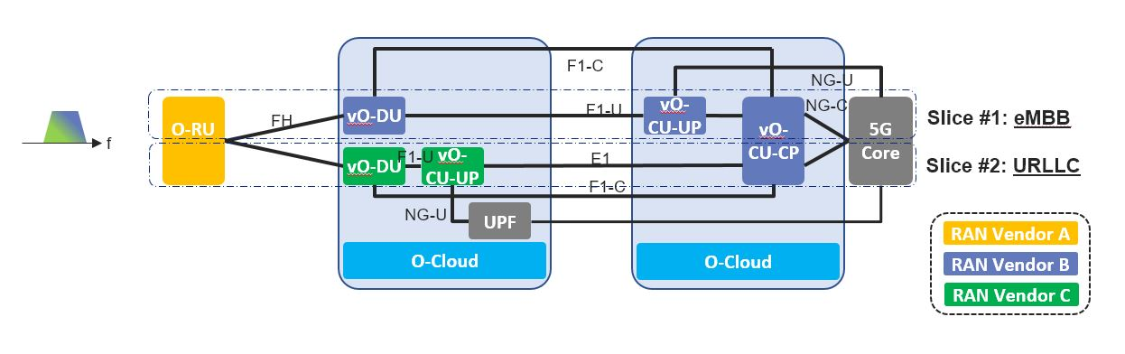
Figure 4.10.1-1: Multi-vendor slices
To support multi-vendor slicing, there are many possible configurations to realize this use case; all of which share that one O-RU is connected to one or more O-DUs. For example, one possible configuration might be one where a single cell is shared by two O-DUs, and another possible configuration is where two cells are allocated to two different O-DUs in a Shared O-RU configuration. Under those possible configurations, it is desired to keep frequency efficiency.
When providing multiple slices, it is assumed that suitable vO-DU/scheduler and vO-CU treat each slice respectively. A vendor who providing vO-DU and vO-CU function can have a strength of a customized scheduler for a certain service. With accomplishment of multi-vendor circumstances, following benefits can be expected.
- More flexible and time to market deployment
Operator can maximize options to choose suitable vO-DU/scheduler and vO-CU to offer various slice. For example, some vendor has a strength of a scheduler for eMBB service and the other has a strength of scheduler for URLLC service. Or vendor A can provide vO-DU/scheduler and vO-CU suitable for URLLC earlier than vendor B, therefore operator can choose vO-DU and vO-CU functions from vendor A to meet their service requirement.
Also, when operator will add a new service/slice, new functions from a new vendor can be introduced with less consideration for existing vendor if multi-vendor circumstance was realized. This can lead to expand vendor’s business opportunities rapidly.
- Flexible deployment when sharing RAN equipment among operators
When operators want to share RAN equipment and resources, RAN vendors and their placement of each RAN functions can be different. If multi-vendor circumstance was introduced, then it can relax restrictions among operators to share RAN equipment and resources. This can lead to expand opportunity reaching agreement of RAN sharing among operators. With expansion of RAN sharing, CAPEX and OPEX by operator will be optimized and additional investment can be done more.
- Reducing supply chain risk
If existing vendor providing a certain pair of vO-DU and vO-CU functions would withdraw of their market due to business reason, operator can deploy new vO-DU and vO-CU functions alternatively from other vendor under this multi-vendor circumstance. This can reduce a risk for operators’ business continuity.

4.10.2 Entities/resources involved in the use case
- SMO multi-vendor slice App:
  - Configures vO-DU and vO-CU.
  - Configures O-RU to connect to vO-DU.
- Near-RT RIC:
  - Shares MAC related data unique for UE among vO-DUs.
  - Supports communication of configuration parameters to RAN.
- E2 nodes (vO-CU, vO-DU, O-RU):
  - Primary vO-DU processes SRB (Signalling Radio Bearer), DRB (Data Radio Bearer) and other vO-DU related functions. Secondary vO-DU processes only DRB related functions. Note that vO-DU and vO-CU are created as part of network slice creation procedure.

4.10.3 Solutions

4.10.3.1 Data transmission call flow example for multi-vendor slices use case
The context of data transmission call flow example for multi-vendor slices use case is captured in table 4.10.3.1-1.
Table 4.10.3.1-1: Data transmission call flow example for multi-vendor slices use case
Use Case Stage | Evolution / Specification | <<Uses>>  Related use
Goal | UE communicates on slice #1 and #2 respectively.
Actors and Roles | - SMO multi-vendor slice App configures vO-DU and v-O-CU with radio resource assignment (via Orchestrator) and collects KPI data.  - Near-RT RIC configures vO-DU and vO-CU for resource assignment and shares MAC related information unique for UE among vO-DUs.  - Primary vO-DU processes SRB (Signalling Radio Bearer), DRB (Data Radio Bearer). Secondary vO-DU processes only DRB.
Assumptions | - All relevant functions and components are instantiated.  - Slice #1 is created over primary vO-DU and vO-CU with logical channel ID #1 and #2, and slice #2 is created over secondary vO-DU and vO-CU with logical channel ID #3.  - O-RU is shared between primary vO-DU and secondary vO-DU with one component carrier.  - CU-CP is shared between primary vO-CU-UP and secondary vO-CU-UP.  - TDD operation is assumed.  - UE tries to transmit data on slice #1 and #2.
Pre-conditions | - Slice #1 and #2 are created and activated on primary vO-DU, vO-CU and secondary vO-DU, vO-CU respectively.  - Slice #1 is tied with scheduling request resource 1 and logical channel ID #1 and #2, and slice #2 is tied with scheduling request resource 2 and logical channel ID #3  - Primary vO-DU and secondary vO-DU know which timing/resource block they can utilize on for slice #1 and #2 respectively by direction from SMO via O1 interface.  - UE has already performed RACH procedure with primary vO-DU.
Begins when | UE tries to perform registration procedure with RRC Connection Request message.
Step 1 (M) | [UE performs registration procedure]  UE sends RRC Connection Request message to primary vO-DU and vO-CU through O-RU. Primary vO-CU and vO-DU responds with RRC Connection Setup. UE sends RRC connection Setup Complete message.  Primary vO-DU sends initial RRC message and shared information such as C-RNTI to Near RT-RIC. Near RT-RIC determines to transfer it to secondary vO-DU over E2 interface. Other registration procedure is performed.
Step 2 (M) | [PDU session establishment]  UE starts PDU session establishment procedure with PDU session establishment request message with primary vO-DU and vO-CU.  UE initiates PDU session establishment procedure with S-NSSAI 2 for slice #2 via primary vO-DU. UE context modification is made at secondary vO-DU.
Step 3 (M) | [U-plane data transmission between primary vO-DU and O-RU]  At allocated timing/resources, primary vO-DU sends Scheduling Command message to O-RU to start transfer and receive DL and UL Data.  UE sends Scheduling Request message on PUCCH with scheduling request resource 1 to primary vO-DU over open fronthaul.  Primary vO-DU responds with UL Grant message to the UE. | O-RAN.WG4.CUS.0-v02.00 [29], “Figure 6‑5: C-plane and U-plane message transfer procedure (DL & UL shown)”
Step 4 (M) | [Buffer notification and transmission user data]  UE notices buffer with Buffer Status Request message to primary vO-DU.  Primary vO-DU acknowledges with UL Grant message.  UE sends user data on PUSCH with logical channel ID #1 and #2.  Primary vO-DU acknowledges with Ack or Nack.  UE repeats step 3 until buffer becomes empty.
Step 5 (M) | [U-plane data transmission between secondary vO-DU and O-RU]  At allocated timing/resources, secondary vO-DU sends Scheduling Command message to O-RU to start transfer and receive DL and UL Data.  UE sends Scheduling Request message on PUCCH with scheduling request resource 2 to secondary vO-DU over open fronthaul. Secondary vO-DU responds with UL Grant message to the UE. | O-RAN.WG4.CUS.0-v02.00 [29], “Figure 6‑5: C-plane and U-plane message transfer procedure (DL & UL shown)”
Step 6 (M) | [Buffer notification and transmission user data]  UE notices buffer with Buffer Status Request message to secondary vO-DU.  Secondary vO-DU acknowledges with UL Grant message.  UE sends user data on PUSCH with logical channel ID #3.  Secondary vO-DU acknowledges with Ack or Nack.  UE repeats step 5 until buffer becomes empty.
Step 7 (M) | [Collect data]  RAN related data from RAN nodes are collected at SMO Collector via O1 interface.
Ends when | UE finishes data transmission until buffer becomes empty.
Exceptions | None identified.
Post Conditions | None identified
@startuml
skinparam ParticipantPadding 5
skinparam BoxPadding 10
skinparam defaultFontSize 12
Autonumber

Box “SMO” #gold
Boundary Collector
end box

Box “O-RAN” #lightpink
Participant NRTRIC as “Near-RT RIC”
Participant OCUCP as “O-CU-CP”
Participant pOCUUP as “pO-CU-UP”
Participant pODU as “pO-DU”
Participant sOCUUP as “sO-CU-UP”
Participant sODU as “sO-DU”
Participant ORU as “O-RU”
End box

Participant UE as “UE”

note right of UE #aqua
SRR: Scheduling Request Resource
LCID: Logical Channel ID
end note

Hnote over Collector, sODU
pO-DU and sO-DU are allocated resources for fronthaul usage from SMO
endrnote

Hnote over Collector, sODU
Slice #1 and #2 are created
endrnote

Hnote over OCUCP,UE
UE performed RACH procedure with primary vO-DU and vO-CU
endrnote

|||
== Registration ==
UE-> pODU : RRC Connection Request
pODU-> OCUCP: <<F1>>Initil RRC message
OCUCP-> pODU: <<F1>>DL RRC message transfer
pODU-> UE : RRC Connection Setup
UE-> pODU : RRC Connection Setup Complete
pODU-> OCUCP: <<F1>>UL RRC message transfer(shared Info)

pODU-> NRTRIC: <<E2>RAN UE ID, Relay Cell ID, shared Info(C-RNTI, etc.)

note over NRTRIC
Determine to transfer it to sO-DU
end note

NRTRIC-> sODU: <<E2>>Relay above information

Hnote over sOCUUP,UE
Other Registration procedure complete
endrnote

|||
== PDU Session setup ==
Hnote over sOCUUP,UE
PDU session establishement procedure on Primary DU (Slice #1 / N-SSAI 1)
endrnote

note over pODU
pODU is allocated
resources from RIC
end note

pODU -> ORU: C-plane(Scheduling Command)
UE -> ORU: PDU Session Establishment Req.(S-NSSAI 2)
ORU -> pODU: U-plane(UL IQ data)
pODU -> OCUCP: PDU Session Establishment Req.(S-NSSAI 2)
OCUCP -> sODU: UE ContextSetup Req
sODU -> OCUCP: UE ContextSetup Rsp
pODU -> ORU: C-plane(Scheduling Command)
OCUCP -> pODU: RRC Reconf / PDU Session Establishment Accept
pODU -> ORU: U-plane(DL IQ data)
ORU -> UE: RRC Reconfiguration
UE -> ORU: RRC Reconfiguration Complete
ORU -> pODU: U-plane
pODU -> OCUCP: PDU Session resource setup Rsp
OCUCP -> sODU: UE Context Modification Req(RRC Reconf Comp Ind)
sODU -> OCUCP: UE Context Modifiation Rsp

|||
@enduml

The data transmission call flow example for multi-vendor slices use case – part 1 of 2 is given in figure 4.10.3.1-1.

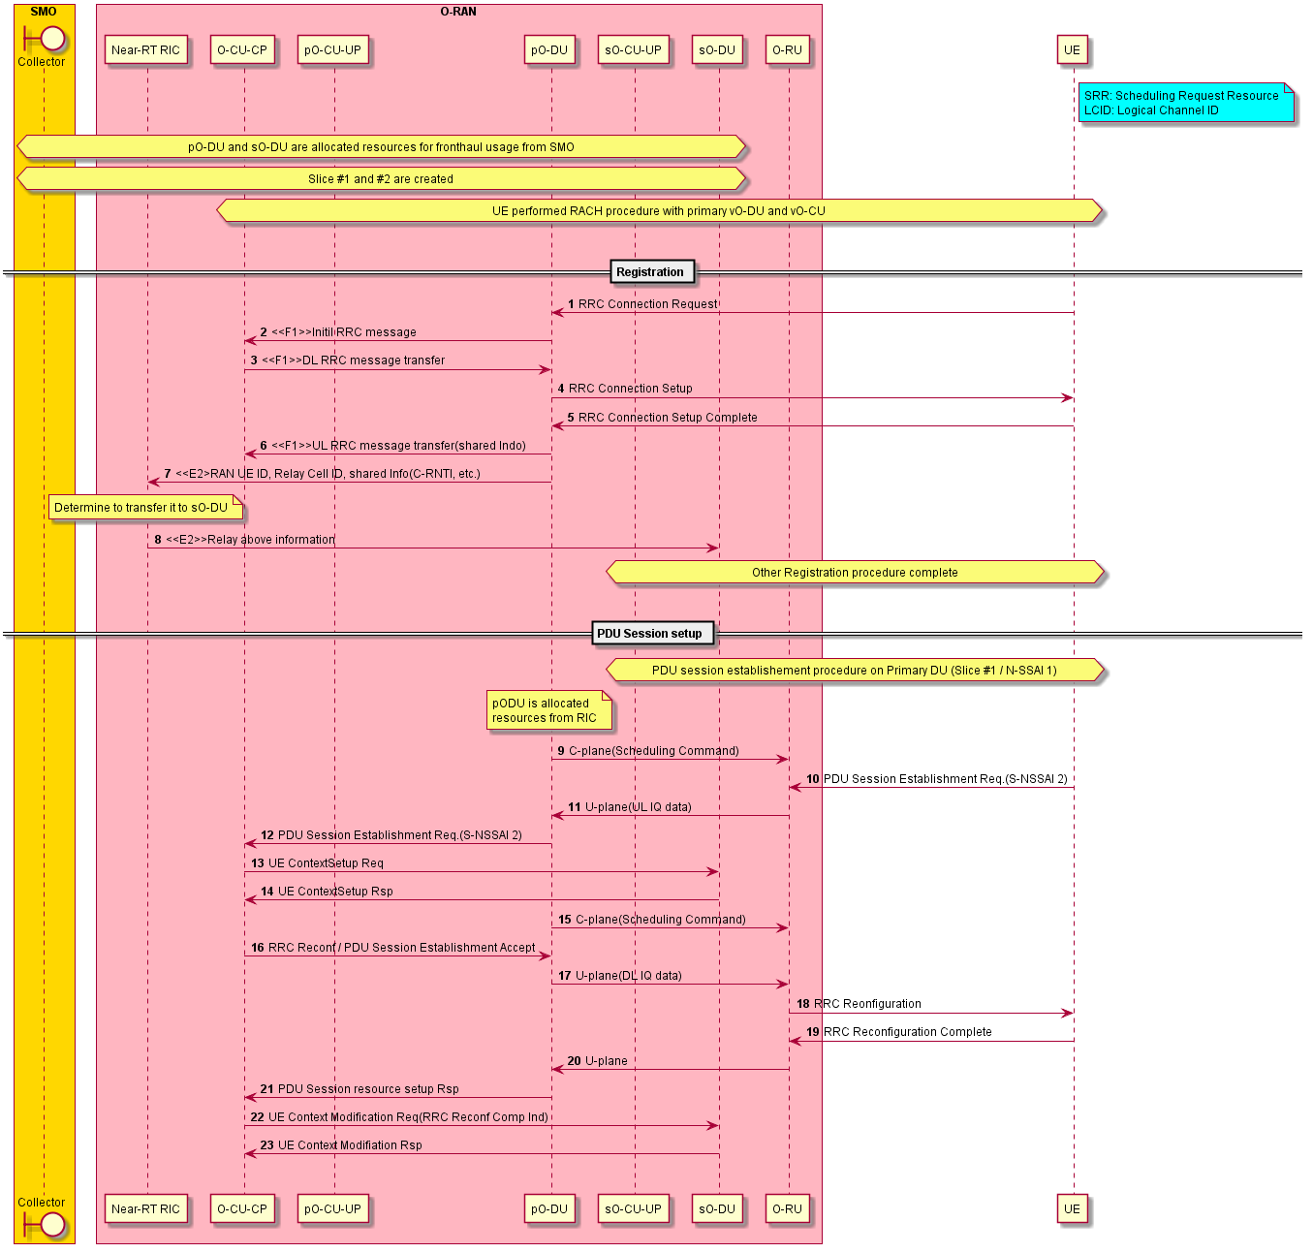
Figure 4.10.3.1-1: Data transmission call flow example for multi-vendor slices use case – part 1 of 2
@startuml
skinparam ParticipantPadding 5
skinparam BoxPadding 10
skinparam defaultFontSize 12
Autonumber

Box “SMO” #gold
Boundary Collector
end box

Box “O-RAN” #lightpink
Participant NRTRIC as “Near-RT RIC”
Participant OCUCP as “O-CU-CP”
Participant pOCUUP as “pO-CU-UP”
Participant pODU as “pO-DU”
Participant sOCUUP as “sO-CU-UP”
Participant sODU as “sO-DU”
Participant ORU as “O-RU”
End box

Participant UE as “UE”

|||
== Data transmission on slice #1 ==
note over pODU
pO-DU is allocated
resources from RIC
end note

note over UE
SRR 1 is selected
since UE tries to
send data on slice #1
end note

pODU -> ORU: Scheduling Command

alt UE sends data on slice #1
UE -> ORU : Scheduling Request (LCGID 1/2)
ORU -> pODU: U-plane
pODU -> ORU: U-plane
ORU -> UE : UL Grant (DCI0)

loop until buffer empty
UE -> ORU : Buffer Status Reporting
ORU -> pODU: U-plane
pODU -> ORU: U-plane
ORU -> UE : UL Grant
UE -> ORU : User Data on PUSCH(LCGID 1/2)
ORU -> pODU: U-plane
pODU -> ORU: U-plane
ORU -> UE : Ack / Nack
end
end

|||
== Data transmission on slice #2 ==
note over sODU
sO-DU is allocated
resources from RIC
end note

note over UE
SRR 2 is selected
since UE tries to
send data on slice #2
end note

sODU -> ORU: Scheduling Command

alt UE sends data on slice #2
UE -> ORU : Scheduling Request (LCGID 3)
ORU -> sODU: U-plane
sODU -> ORU: U-plane
ORU -> UE : UL Grant (DCI0)

loop until buffer empty
UE -> ORU : Buffer Status Reporting
ORU -> sODU: U-plane
sODU -> ORU: U-plane
ORU -> UE : UL Grant
UE -> ORU : User Data on PUSCH(LCGID 3)
ORU -> sODU: U-plane
sODU -> ORU: U-plane
ORU -> UE : Ack / Nack
end
end

|||
@enduml

The data transmission call flow example for multi-vendor slices use case – part 2 of 2 is given in figure 4.10.3.1-2.

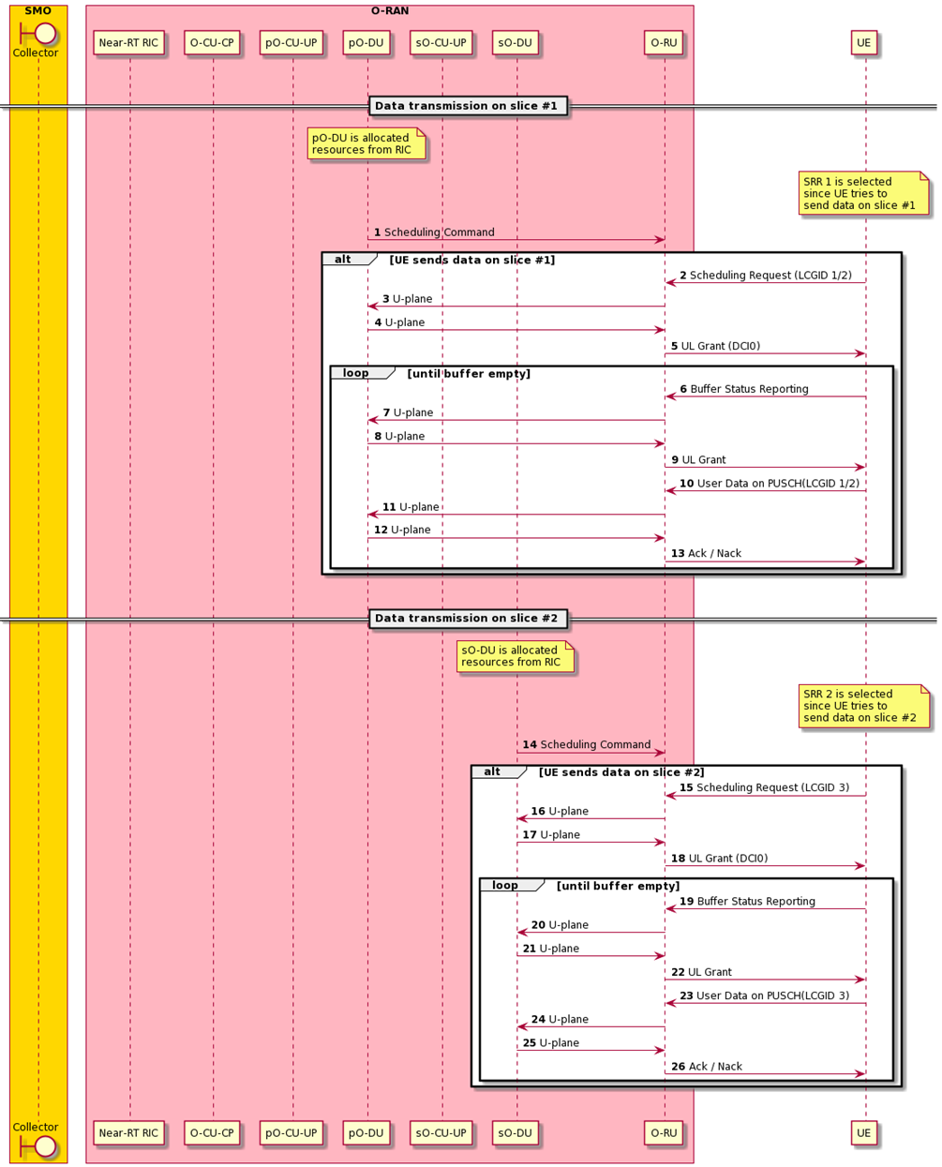
Figure 4.10.3.1-2: Data transmission call flow example for multi-vendor slices use case – part 2 of 2

4.10.3.2 Data transmission call flow example for RAN sharing use case
The context of data transmission call flow example for RAN sharing use case is captured in table 4.10.3.2-1.
Table 4.10.3.2-1: Data transmission call flow example for RAN sharing use case
Use Case Stage | Evolution / Specification | <<Uses>>  Related use
Goal | UE communicates on secondary vO-DU and vO-CU with PLMN #2.
Actors and Roles | - SMO multi-vendor slice App configures vO-DU and v-O-CU with radio resource assignment (via Orchestrator) and collects KPI data.  - Near-RT RIC configures vO-DU and vO-CU for resource assignment and shares MAC related information unique for UE among vO-DUs.  - Primary vO-DU processes SRB (Signalling Radio Bearer), DRB (Data Radio Bearer). Secondary vO-DU processes only DRB.
Assumptions | - All relevant functions and components are instantiated.  - PLMN #1 is assigned to primary vO-DU and vO-CU, and PLMN #2 is assigned to secondary vO-DU and vO-CU respectively.  - O-RU is shared between primary vO-DU and secondary vO-DU with one component carrier.  - CU-CP is shared between primary vO-CU-UP and secondary vO-CU-UP.  - TDD operation is assumed.  - UE tries to transmit data with PLMN #2.
Pre-conditions | - PLMN #1 and #2 are assigned to primary vO-DU, vO-CU and secondary vO-DU, vO-CU respectively  - Primary vO-DU and vO-CU advertise PLMN #1 and #2 over the air.  - Primary vO-DU and secondary vO-DU know which timing/resource block they can utilize on for PLMN #1 and #2 respectively by direction from SMO via O1 interface.  - UE has already performed RACH procedure with primary vO-DU.
Begins when | UE tries to perform registration procedure with RRC Connection Request message.
Step 1 (M) | [UE performs registration procedure with PLMN #2]  UE sends RRC Connection Request message to primary vO-DU and vO-CU through O-RU. Primary vO-CU and vO-DU responds with RRC Connection Setup. UE sends RRC connection Setup Complete message with PLMN#2 in selected PLMN-identity.  Primary vO-DU sends initial RRC message with PLMN-identity and shared information such as C-RNTI to Near RT-RIC. Near RT-RIC determines to transfer it to secondary vO-DU over E2 interface. Other registration procedure is performed through secondary vO-DU.
Step 2 (M) | [PDU session establishment]  UE starts PDU session establishment procedure with PDU session establishment request message through secondary vO-DU and vO-CU.
Step 3 (M) | [U-plane data transmission between secondary vO-DU and O-RU]  At allocated timing/resources, secondary vO-DU sends Scheduling Command message to O-RU to start transfer and receive DL and UL Data.  UE sends Scheduling Request message on PUCCH with scheduling request resource 2 to secondary vO-DU over open fronthaul.  Secondary vO-DU responds with UL Grant message to the UE. | O-RAN.WG4.CUS.0-v02.00 [29], “Figure 6‑5: C-plane and U-plane message transfer procedure (DL & UL shown)”
Step 4 (M) | [Buffer notification and transmission user data]  UE notices buffer with Buffer Status Request message to secondary vO-DU.  Secondary vO-DU acknowledges with UL Grant message.  UE sends user data on PUSCH with logical channel ID #2.  Secondary vO-DU acknowledges with Ack or Nack.  UE repeats step 3 until buffer becomes empty.
Step 5 (M) | [Collect data]  RAN related data from RAN nodes are collected at SMO Collector via O1 interface.
Ends when | UE finishes data transmission until buffer becomes empty.
Exceptions | None identified.
Post Conditions | None identified.
@startuml
skinparam ParticipantPadding 5
skinparam BoxPadding 10
skinparam defaultFontSize 12
Autonumber

Box “SMO” #gold
Boundary Collector
end box

Box “O-RAN” #lightpink
Participant NRTRIC as “Near-RT RIC”
Participant OCUCP as “O-CU-CP”
Participant pOCUUP as “pO-CU-UP”
Participant pODU as “pO-DU”
Participant sOCUUP as “sO-CU-UP”
Participant sODU as “sO-DU”
Participant ORU as “O-RU”
End box

Participant UE as “UE”

|||
== Data transmission on slice #1 ==
note over pODU
pO-DU is allocated
resources from RIC
end note

note over UE
SRR 1 is selected
since UE tries to
send data on slice #1
end note

pODU -> ORU: Scheduling Command

alt UE sends data on slice #1
UE -> ORU : Scheduling Request (LCGID 1/2)
ORU -> pODU: U-plane
pODU -> ORU: U-plane
ORU -> UE : UL Grant (DCI0)

loop until buffer empty
UE -> ORU : Buffer Status Reporting
ORU -> pODU: U-plane
pODU -> ORU: U-plane
ORU -> UE : UL Grant
UE -> ORU : User Data on PUSCH(LCGID 1/2)
ORU -> pODU: U-plane
pODU -> ORU: U-plane
ORU -> UE : Ack / Nack
end
end

|||
== Data transmission on slice #2 ==
note over sODU
sO-DU is allocated
resources from RIC
end note

note over UE
SRR 2 is selected
since UE tries to
send data on slice #2
end note

sODU -> ORU: Scheduling Command

alt UE sends data on slice #2
UE -> ORU : Scheduling Request (LCGID 3)
ORU -> sODU: U-plane
sODU -> ORU: U-plane
ORU -> UE : UL Grant (DCI0)

loop until buffer empty
UE -> ORU : Buffer Status Reporting
ORU -> sODU: U-plane
sODU -> ORU: U-plane
ORU -> UE : UL Grant
UE -> ORU : User Data on PUSCH(LCGID 3)
ORU -> sODU: U-plane
sODU -> ORU: U-plane
ORU -> UE : Ack / Nack
end
end

|||
@enduml

The data transmission call flow example for RAN sharing use case is given in figure 4.10.3.2-1.

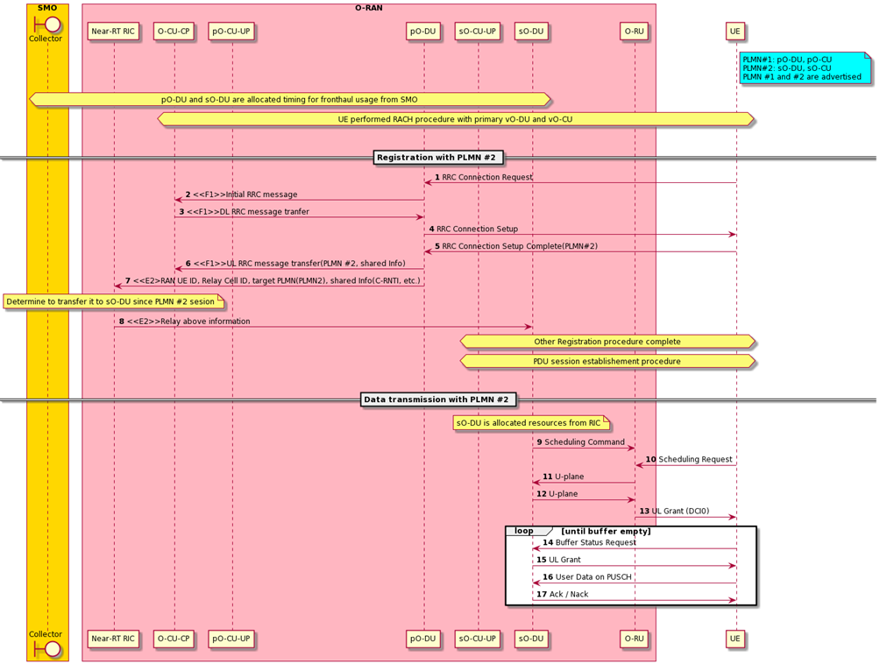
Figure 4.10.3.2-1: Data transmission call flow example for RAN sharing use case

4.10.4 Required data
The measurement counters and KPIs (as defined by 3GPP and will be extended for O-RAN use cases) shall be appropriately aggregated by cell, QoS type, slice, etc.
- Per-UE CSI
- Per slice performance statistics such as PDCP throughput, PRB usage

4.11 Dynamic spectrum sharing (DSS)
This use case provides the background, motivation, and requirements to realize Dynamic Spectrum Sharing (DSS) over the O-RAN architecture. This is to enable operators to adapt radio resource allocation policies and control to dynamically share radio spectrum between 4G and 5G networks.

4.11.1 Background and goal of the use case
As we transition from 4G to 5G, the spectral resources used for 5G deployment is a key consideration and this situation varies from one operator to another. Though, new C-band resources between 3-6 GHz and mmWave bands have been acquired by operators, these bands suffer from great propagation and penetration loss, limiting their coverage to those users close to the cell, this situation worsens in the UL as the UE device is power constrained. A cost-effective way to address this is the 5G deployment on lower bands (i.e., below 2GHz), which are also used in 4G LTE deployments today. Operating on lower bands along with non-standalone mode of 5G deployment helps to cover large geography, enables seamless mobility between 4G and 5G while being sensitive to overall cost of deployment. In addition, DSS offers the advantage of dynamically sharing the available spectrum adapting to the varying workloads of the 4G and 5G network.
DSS is compelling considering the need for operators to dynamically share already deployed spectral resources between LTE and NR devices without degrading the QoE of the current 4G subscribers while offering the same level of coverage and necessary QoS to NR devices, under the assumption that the two networks will co-exist in the near term. The objective of this use case is to propose DSS in the context of the O-RAN architecture, specifically to realize it as an application in the RIC framework.
This would particularly benefit vRAN implementations when the 4G/5G CU/DU are from different vendors and one could leverage RAN data over O-RAN’s framework for traffic prediction, DSS related resource management and conduct control functions. Towards this, the intelligent control functions are identified, which can be realized as a DSS application to augment the L3/L2/L1 control functions specified as part of LTE-NR coexistence in 3GPP TS 23.501 [2] and in 3GPP TS 37.340 [12].
The architectural context set for this discussion is shown in figure 4.11.1-1. DSS enables 4G and 5G UEs to operate over the same spectrum identified as X (typically low band), while 5G itself could operate on new bands Y (typically high band) not used by current 4G deployment. In a typical setting, Y would offer higher capacity, low latency and smaller coverage, while X would be used to offer reasonable capacity along with larger coverage. 3GPP specifications offers DSS support over X2/Xn interface to enable dynamic sharing of the spectrum resource in addition to the L2/L1 adaptation for 5G-NR to co-exist with LTE.
Considering the scenario of incremental deployment - in the 5G NSA mode, the 5G UE is required to have dual connectivity capability and be able to connect to eNBs on LTE bands for control plane requirements and user plane connectivity towards the LTE and/or 5G depending on deployment requirements. In the scenario where gNB only operates on 5G C or mmWave bands, the sharing of the LTE frequency band between 4G and 5G UEs can be solely fulfilled by eNB MAC scheduler, as the UE is expected to be dual stacked. While, if the gNB is required to operate on lower LTE bands as well, then spectral sharing needs to be coordinated between the LTE and 5G schedulers.
When DSS is enabled in the SA mode, 5G UE would be capable of operating on lower LTE bands (below 2GHz), C and mmWave bands and connects only to the gNBs. The sharing of the LTE bands between LTE and 5G data channels are achieved by both 4G scheduler and 5G scheduler using resource management and interference mitigation functions in the RIC between them.
The use case proposes to conduct DSS related policy, configuration, resource management and control functions using the Non-RT and Near-RT functions over open interfaces proposed by O-RAN.
An abstracted view of how DSS application can be realized using the Non-Real-Time and Near-Real-Time RIC components is shown in figure 4.11.1-2. The DSS over RIC can be realized as multiple applications considering its multiple optimization and operational objectives. One possible logical breakdown is as a traffic prediction and resource management application (DSS-App) managing the shared spectrum resource adapting to dynamic 4G and 5G specific workload requirements in various local contexts, and another application (RAT-App) to configure, control and monitor DSS related functions in the CU/DU corresponding to the LTE and 5G cells. The DSS-App engineers at the Non-RT RIC level translates the global DSS policies based on workload requirements for a region and time-of-day to spectrum sharing policies such as max/min bandwidth threshold at a local level (e.g. edge or central office). The RAT-App at the Non-RT RIC level also translates the DSS-App’s resource policies to RAT specific configuration and policies at the Near-RT RIC and the CU/DU entities. The DSS-App at the Near-RT RIC uses the data collected by the RAT-App to make dynamic resource sharing decisions that are enforced by the RAT-App using the E2 control APIs.

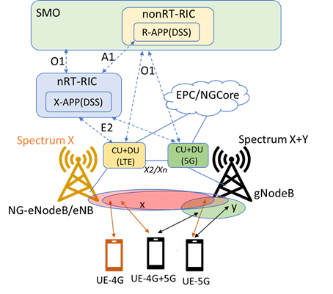
Figure 4.11.1-1: RIC-based DSS architecture
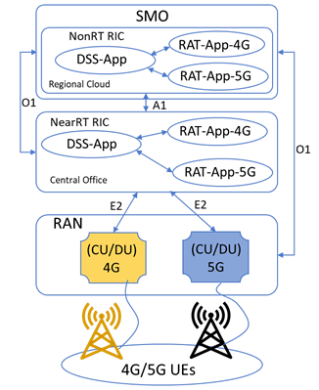
Figure 4.11.1-2: RIC-based DSS realization
The main goal of the Non-RT DSS-App is to provide long-term scheduling policy to 4G and 5G scheduler considering business, user, spatial and temporal workload factors.
The main functionality of Non-RT RAT-App is to translate the global DSS policies from Non-RT DSS-App to RAT specific policies to the RAT-App in the Near-RT RIC over A1.
The main functionalities of the Near-RT DSS-App include policy translation between Non-RT DSS-App to RAT specific configuration to the Near-RT RAT-App. Furthermore, it is actively involved in closed loop decision using the KPIs from the RAN adapting to the needs of the 4G and 5G cells.
The main functionality of Near-RT RAT-App is to perform RAT specific configuration, control and data subscription over E2 interface with RAN (CU/DU components).

4.11.2 Entities/resources involved in the use case
- Non-RT RIC:
  - Receive SMO’s DSS specific service requirement for the RAN and translate them into resource sharing policies.
  - Provide long-term policies in terms of scheduling guidance to 4G and 5G scheduler over A1 to Near-RT RIC, considering business, user, spatial and temporal workload factors, policies related to expected performance and actions when it deviates based on KPIs from the 4G and 5G network.
  - Develop and train AI/ML models with the help of SMO functions for the Near-RT RIC to predict the short-term traffic demand for 4G and 5G network based on near-real-time metrics from RAN. Deployment of these ML model over O1 and xApps over O2 to the Near-RT RIC.
  - Receive policy feedback from Near-RT RIC and update policy and re-train ML models whenever required.
- Near-RT RIC:
  - Support deployment, execution, and ability to update DSS xApps from Non-RT RIC.
  - Support interpretation of policies related to RAT specific resource allocation.
  - Translate RAT specific SLA policy to configuration, control, and data subscription over E2 interface to E2 nodes (O-CU, O-DU).
  - Share resource allocation performance and policy feedback report with Non-RT RIC for further evaluation and optimization over O1/A1.
- RAN:
  - Support discovery of DSS related configuration of E2 nodes over E2 interface.
  - Share the data collection over O1 interface.
  - Support resource management related metrics collection over E2 interface.
  - Support control and policy enforcement from Near-RT RIC over E2 interface.

4.11.3 Solutions

4.11.3.1 Dynamic spectrum sharing for 4G and 5G
The context of the dynamic spectrum sharing for 4G and 5G is captured in table 4.11.3.1-1.
Table 4.11.3.1-1: Dynamic spectrum sharing for 4G and 5G
Use Case Stage | Evolution / Specification | <<Uses>>  Related use
Goal | Enable operators to dynamically share spectrum in the existing 4G deployment with 5G systems, based on the dynamic loads of both networks and resource sharing policies.
Actors and Roles | Non-RT RIC: Spectrum resource sharing policy function.  Near-RT RIC: Executes resource sharing models and algorithms, translating RAT specific policy to configuration, control and data subscription over E2 interface with RAN.  RAN: Executes resource sharing enforcement rules and policies, collects and reports RAN statistics and performance over E2 and O1.
Assumptions | All relevant functions and components are instantiated. DSS xApps are deployed over O1 with initial configuration.  A1, E2 interface connectivity is established with Non-RT RIC and RAN respectively.  Data report, policy and control subscription established on E2 interface.
Pre-conditions | Network is operational.  SMO has established the data collection and sharing interface with Non-RT RIC.  Non-RT RIC analyzes the historical data from RAN, develops, trains with help of SMO functions and deploys the relevant AI/ML models or algorithm as xApps to the Near-RT RIC.
Begins when | Operator specified trigger condition or event is detected.
Step 1 (M) | Near-RT RIC collects DSS related RAN function capabilities and configuration parameters from RAN over E2 interface.
Step 2 (M) | Non-RT RIC communicates DSS relevant policies to the Near-RT RIC over the A1 interface.
Step 3 (M) | Near-RT RIC communicates RAT specific DSS relevant configuration, control policies to RAN over the E2 interface.
Step 4 (M) | RAN deploys the configuration and control policies received from the Near-RT RIC over the E2 interface.
Step 5 (M) | Near-RT RIC collects relevant observability data from RAN, executes xApp and outputs the optimal resource allocation and cell level resource scheduling decisions to RAN over E2 and policy feedback to Non-RT RIC over A1.
Step 6 (M) | RAN deploys the updated control policies received from the Near-RT RIC over the E2 interface and continues reporting data to SMO over O1 and E2 as configured.
Step 7 (M) | Non-RT RIC adjusts the policy based on PM data from SMO and feedback from Near-RT RIC.
Step 8 (M) | Non-RT RIC updates the resource sharing policy to Near-RT RIC over A1.
Step 9 (O) | Non-RT RIC re-trains/updates the AI/ML model with new data and performance, and deploys the new model or new model configurations to Near-RT RIC.
Ends when | Operator specified trigger condition or event is satisfied.
Exceptions | None identified.
Post Conditions | Non-RT RIC monitors loads and relevant KPI performance metrics of eNB/gNB to observe the resource sharing efficiency and sets up new policies based on the metrics and business needs.  Near-RT RIC executes the resource sharing model or algorithm. RAN operates with the scheduling guidance from RIC and reports performance data to RIC.
@startuml
skinparam ParticipantPadding 5
skinparam BoxPadding 10
skinparam defaultFontSize 12
Autonumber

Box "Service Management and Orchestration" #gold
participant "SMO Functions" as SMO
Boundary Collector
participant "Non-RT RIC\nDSS/RAT APP" as non
End box

Box "O-RAN" #lightpink
Participant RIC as "Near-RT RIC\nDSS/RAT APP"
Participant E2N1 as "E2 Node RAT1\n (4G)"
Participant E2N2 as "E2 Node RAT2\n (5G)"
End box

SMO -> non: <<SMO Internal>> DSS Policies (service requirement, region)
Collector <- RIC: <<O1>> DSS related data report
Collector <- E2N1: <<O1>> DSS related data report
Collector <- E2N2: <<O1>> DSS related data report

Collector -> non: <<SMO Internal>> DSS related Data for model development
non -> non: Resource prediction model development/training
non -> SMO: <<SMO Internal>> Publish trained model
SMO -> RIC: <<O1>> Deploy trained model
RIC <- E2N1: <<E2>> Service update: RAN configuration and operation parameters
RIC <- E2N2: <<E2>> Service Update: RAN configuration and operation parameters
non -> RIC: <<A1>> Policies: Cell site identity, DSS band & modality, static/dynamic, \nRAT SLA requirement, slice priority
RIC -> E2N1: <<E2>> Subscription/Policy/Control: DSS RAT Configuration -\nBand, UL/DL, semi-static/dynamic configuration resource apportionment
RIC -> E2N2: <<E2>> Subscription/Policy/Control: DSS RAT Configuration -\nBand, UL/DL, semi-static/dynamic configuration resource apportionment

loop
RIC <- E2N1: <<E2>> report: load, performance, mobility, scheduling bitmap
RIC <- E2N2: <<E2>> report: load, performance, mobility, scheduling bitmap
rnote over RIC: Model & Algorithm Execution
RIC -> E2N1: <<E2>> Control/policy: 1) Resource configuration 2) scheduling coordination
RIC -> E2N2: <<E2>> Control/policy: 1) Resource configuration 2) scheduling coordination
non <- RIC: <<A1>>Policy feedback: right/under/over provisioning
Collector <- E2N1: <<O1>> DSS related data report
Collector <- E2N2: <<O1>> DSS related data report
Collector -> non: <<SMO Internal>> DSS related Data

rnote over non
Monitoring, evaluation and Policy adjustment
endrnote

non -> RIC: <<A1>> Updated sharing policies

group opt
non-> non : Model re-training / update

non -> SMO: <<SMO Internal>> Publish re-trained model
SMO -> RIC: <<O1>> Deploy re-tained model
end
end loop

@enduml

The flow diagram of the dynamic spectrum sharing for 4G and 5G is given in figure 4.11.3.1-1.

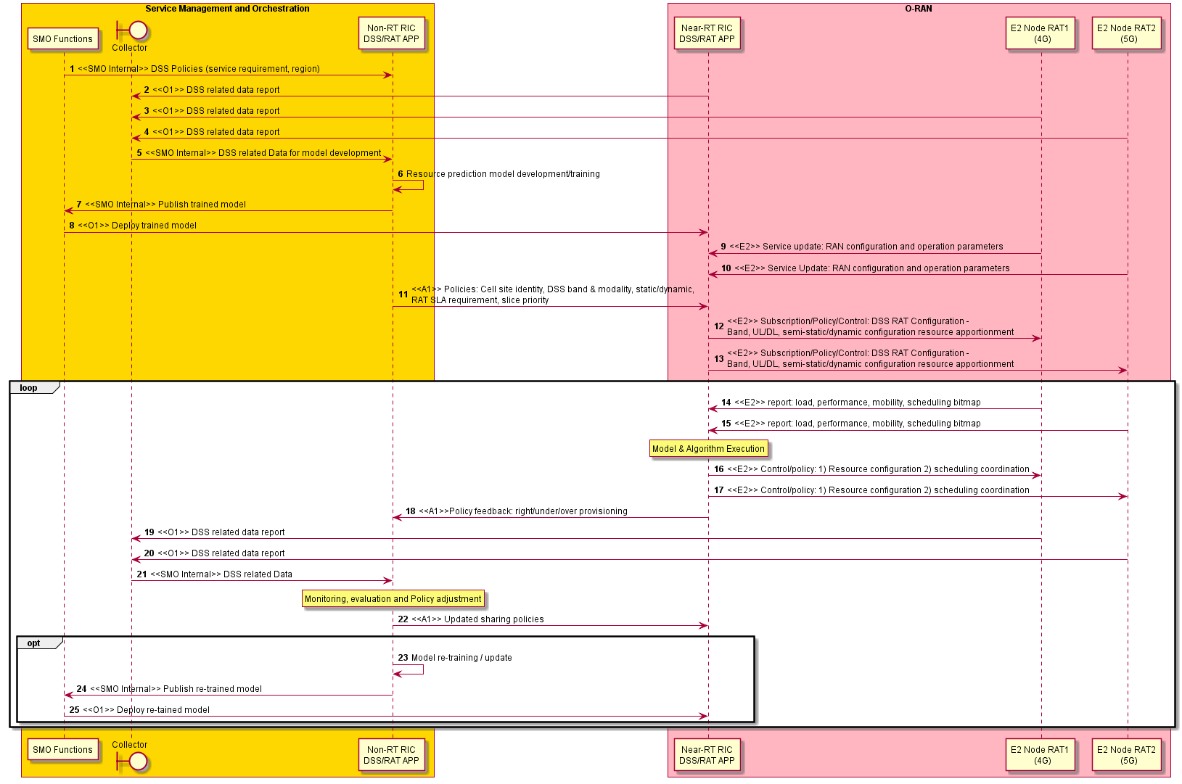
Figure 4.11.3.1-1: Dynamic spectrum sharing for 4G and 5G flow diagram

4.11.4 Required data
Multiple observability data from RAN need to be reported to SMO, Non-RT RIC and Near-RT RIC for DSS to operate. The required data for DSS use case is captured in table 4.11.4-1.
Table 4.11.4-1: Required data for DSS use case
Category | Parameters / Measurements | RAT | Source / Interface | Reference
4G/5G DSS configuration and operation parameters | Geography location (e.g., cell site) | 4G/5G | External server
 | DSS modality (static, semi-static (MBSFN), dynamic (sub-frame level)) | 4G/5G | E2 | 3GPP TS 38.211 [13], 3GPP TS 38.213 [14]
 | Cell configuration information (e.g., FDD/TDD, band, signaling/RS allocation bitmap) | 4G/5G | E2 | 3GPP TS 36.423 [30], 3GPP TS 38.211 [13], 3GPP TS 38.213 [14]
4G/5G scheduling information | Physical resource block used/reserved/requested/blocked bitmap information | 4G/5G | E2 | 3GPP TS 36.423 [30]
4G/5G cell load statistics | Number of active UEs (total, UL/DL, per QCI) | 4G | E2 and O1 | 3GPP TS 36.314 [31]
 | Mean/Max number of active UEs (DL/UL, total, per DRB(mapped 5QI)) | 5G | E2 and O1 | 3GPP TS 38.314 [32], 3GPP TS 32.425 [33]
 | Traffic demand/buffer size (total, per QCI/5QI) | 4G/5G | E2 and O1
 | PRB usage (DL, UL, total, per QCI/5QI) | 4G/5G | E2 and O1 | 3GPP TS 36.314 [31], 3GPP TS 36.423 [30], 3GPP TS 28.552 [6]
 | PDCCH CCE usage | 4G/5G | E2 and O1 | 3GPP TS 36.423 [30]
 | RRC connection number | 5G | E2 and O1 | 3GPP TS 28.552 [6], 3GPP TS 32.425 [33]
4G/5G QoS configuration and parameters | QoS classes | 4G/5G | E2 | 3GPP TS 23.501 [2] (5G), 3GPP TS 36.300 [34], 3GPP TS 23.401 [35],  3GPP TS 23.203 [36] (4G)
 | Slice types | 5G | E2 | 3GPP TS 23.501 [2]
UE performance statistics | Scheduled IP throughput (DL, UL, per QCI) | 4G | E2 and O1 | 3GPP TS 36.314 [31]
 | Data volume (DL/UL per CQI) | 4G | E2 and O1 | 3GPP TS 36.314 [31]
 | UL/DL PDCP SDU data volume | 5G | E2 and O1 | 3GPP TS 28.552 [6]
 | PDCP packet delay DL/UL per CQI/QCI | 4G/5G | E2 and O1 | 3GPP TS 36.314 [31] (4G)
UE mobility statistics | RSRP/RSRQ/SINR/RSSI | 4G/5G | E2 and O1 | 3GPP TS 36.214 [37], 3GPP TS 36.331 [38]
 | UE location information | 45/5G | External Server
 | UE capability | 4G/5G | E2 and O1 | 3GPP TS 36.331 [38]

4.12 NSSI resource allocation optimization
This use case provides the background, motivation, description, and requirements for the NSSI resource allocation optimization use case, allowing operators to optimize the allocation resources to NSSI(s) with wide range service requirements.

4.12.1 Background and goal of the use case
5G networks are becoming increasingly complex with the densification of millimeter wave small cells, and various new services, such as eMBB (enhanced Mobile Broadband), URLLC (Ultra Reliable Low Latency Communications), and mMTC (massive Machine Type Communications) that are characterized by high speed high data volume, low speed ultra-low latency, and infrequent transmitting low data volume from huge number of emerging smart devices, respectively. It is a challenging task for 5G networks to allocate resources dynamically and efficiently among multiple network nodes to support the various services. However, as eMBB, URLLC, and mMTC services in 5G are typically realized as NSI (Network Slice instance). Therefore, the resources allocated to NSSI (Network Slice Subnet Instance) to support the O-RAN nodes can be optimized according to the service requirements.
As the new 5G services have different characteristics, the network traffic tends to be sporadic, where there can be different usage pattern in terms of time, location, UE distribution, and types of applications. For example, most IoT sensor applications can run during off-peak hours or weekends. Special events, such as sport games, concerts, can cause traffic demand to shoot up at certain time and locations. Therefore, NSSI resource allocation optimization function trains the AI/ML model, based on the huge volume of performance data collected over days, weeks, months from O-RAN nodes. It then uses the AI/ML model to predict the traffic demand patterns of 5G networks in different times and locations for each network slice, and automatically re-allocates the network resources ahead of the network issues surfaced.
The resource quota policies associated with RAN NFs (E2 nodes) included in the respective NSSIs enable 5G network providers to optimize or prioritize the utilization of the RAN resources across slices and supports the flexibility to share resources optimally across critical service slices during resource surplus or scarcity. For example, an NSSI allocated for premium service can receive a major share of the resources compared to a slice allocated for a standard/best-effort service. Another such example is the scenario of additional resource allocation for emergency services. An important consideration here is that the NSSI resource quota policies focus on maximization of resource utilization across the NSSIs. The resource quota policies can be used as a constraint for resource allocation that defines the range of resources that can be allocated per slice. One use case for applying such a constraint is the analysis and decision based on history of resource allocation failure that can be reflected in the RAN node measurements. Here resource quota policy can be provisioned to control the minimum, maximum and dedicated resources that need to be allocated based on the historical pattern.
The NSSI resource allocation optimization on the Non-RT RIC is shown in figure 4.12.1-1, and can consist of the following steps:
- Monitoring: monitor the radio network(s) by collecting data via the O1 interface, for example including the following performance measurements that are measured on per S-NSSAI (3GPP TS 28.552 [6] shall apply):
- Mean DL PRB used for data traffic (3GPP TS 28.552 [6], clause 5.1.1.2.5 shall apply)
- Mean UL PRB used for data traffic (3GPP TS 28.552 [6], clause 5.1.1.2.7 shall apply)
- Average DL UE throughput in gNB (3GPP TS 28.552 [6], clause 5.1.1.3.1 shall apply)
- Average UL UE throughput in gNB (3GPP TS 28.552 [6], clause 5.1.1.3.3, shall apply)
- Number of PDU sessions requested to setup (3GPP TS 28.552 [6], clause 5.1.1.5.1 shall apply)
- Number of PDU sessions successfully setup (3GPP TS 28.552 [6], clause 5.1.1.5.2 shall apply)
- Distribution of DL UE throughput in gNB (3GPP TS 28.552 [6], clause 5.1.1.3.2 shall apply)
- Distribution of UL UE throughput in gNB (3GPP TS 28.552 [6], clause 5.1.1.3.4 shall apply)
- Number of DRBs successfully setup (3GPP TS 28.552 [6], clause 5.1.1.10.2 shall apply)
NOTE 1: The above measurements are indicative and are subject to change based on the progress of this use case in O-RAN.
NOTE 2: Monitoring of the measurements related to O-Cloud (or transport network) that can be required for NSSI resource optimization is not defined in the present document.
- Analysis & decision: consisting of the following steps:
2a. Utilize AI/ML models to analyze the measurements and predict the future traffic demand, including the RRMPolicyRatio IOC limits, for each NSSI for a given time and location.
2b. Determine the actions needed to add or reduce the resources (e.g. capacity, VNF resources, slice subnet attributes (3GPP TS 28.541 [5] shall apply, etc.) for the RAN NFs (E2 nodes included in the respective NSSI at the given time, and location.

- Execution: execute the actions to reallocate the NSSI resources that include:
3a. Re-configure the NSSI attributes, including RRMPolicyRatio IOC (3GPP TS 28.541 [5] shall apply) via the OAM Functions in SMO which uses O1 interface to configure the E2 nodes.
3b. Update the cloud resources via the O2 interface.
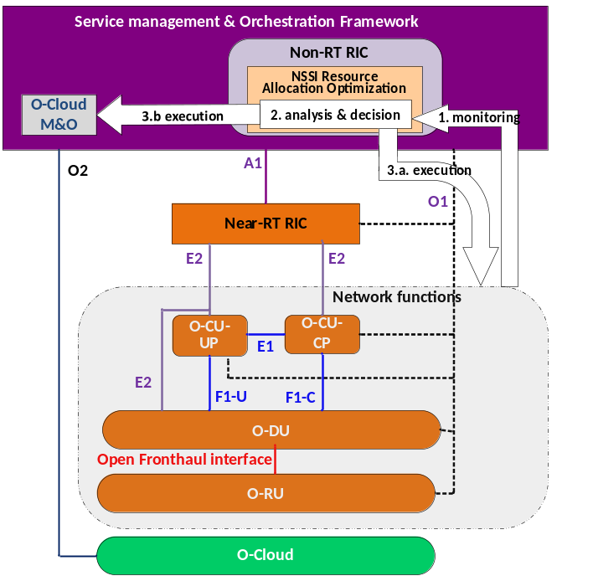
Figure 4.12.1-1: The realization of NSSI resource allocatıon optimization over Non-RT RIC
For association of resource quota policies for the RAN NFs (E2 nodes) per NSSI or group of NSSIs, RRMPolicyRatio IOC (realization of abstract IoC RRMPolicy_) is currently being specified in 3GPP TS 28.541 [5] which allows definition of maximum, minimum and dedicated values for the percentage of resources to be used per RRMPolicyMemberList – that is group of members with specific plmnID and sNSSAI (applied at NRCellDU, NRCellCU, GNBDUFunction, GNBCUCPFunction or in GNBCUUPFunction) via RRMPolicyManagedEntity.

4.12.2 Entities/resources involved in the use case
- SMO:
  - Pre-provision the default NSSI resource quota policy as constraint for NSSI resource allocation optimization. This information is optionally used by the Non-RT RIC in case the resource quota that needs to be allocated per slice is not specified during the slice creation and for conflict resolution at the time of resource scarcity.
- Non-RT RIC:
  - Collect the performance measurements related to NSSI resource usage from the O-RAN nodes via the O1 interface.
  - Train the AI/ML model based on the analysis of historical performance measurements, to predict of the traffic demand patterns of NSSI at different times and locations.
  - Determine the time/date and locations (i.e. which O-RAN nodes) to add or reduce the resources (e.g. capacity, VNF resources, slice subnet attributes (3GPP TS 28.541 [5] shall apply), RRMPolicyRatio IOC, etc.) for a given NSSI based on inference.
  - Perform the following action(s) to optimize the NSSI resource allocation, at the time determined by the model.
    - Re-configure the NSSI attributes via the O1 interface.
    - Update the cloud resources via the O2 interface.
- RAN nodes (O-CU-CP, O-CU-UP, O-DU, O-RU):
  - Support the performance measurement collection with required granularity over O1 interface.
  - Support the configuration related to the NSSI resource allocation update over O1 interface.

4.12.3 Solutions

4.12.3.1 NSSI resource allocation optimization
The context of the NSSI resource allocation optimization is captured in table 4.12.3.1-1.
Table 4.12.3.1-1: NSSI resource allocation optimization
Use Case stage | Evolution/Specification | <<Uses>>  Related use
Goal | To automatically optimize the NSSI resource allocation by leveraging the AI/ML model that was trained via the analysis of performance measurements collected from the RAN nodes.
Actors and Roles | SMO: Pre-Provision the default resource quota policy as constraint for resource allocation optimization and monitor runtime context change.  Non-RT RIC: Analysis of performance measurements and AI/ML model training  RAN nodes (O-CU-CP, O-CU-UP, O-DU, O-RU): performance measurements collection and configuration changes execution.  O-Cloud M&O: The cloud resources modification via the O2 interface.  OAM functions: Part of SMO which manages the O1 based OAM functionality.  O-Cloud: Manages virtualization infrastructure and virtualized resources.
Assumptions | - All relevant functions and components are instantiated.  - Non-RT RIC is able to receive performance measurements from RAN nodes via the O1 interface.
Pre-conditions | - RAN is operational.  - OAM function is pre-provisioned with default NSSI resource quota policy - Non-RT RIC has been collecting the RAN performance measurements from RAN nodes.
Begins when | An AI/ML model has been trained based on the analysis of performance measurements predict of the traffic demand patterns of NSSI at different times and locations, resource quora per slice.
Step 1 (M) | Non-RT RIC collects the RAN performance measurements from RAN nodes.
Step 2 (M) | i. Non-RT RIC utilizes the AI/ML models to analyze the measurements and predict future the traffic demand for each NSSI for a given time and location.  ii. Non-RT RIC determines the action based on model inference to update the NSSI resources that can include the following information:  a) the time/date  b) locations (e.g. gNB ID)  c) NSSI ID  d) slice subnet attributes  e) VNF resources update (e.g. scaling in/out)  f) NSSI resource quota policy to be enforced per slice over O1 interface
Step 3 (M) | Non-RT RIC executes the action at the time determined by the model inference by performing the following operations:  a) Re-configure the slice subnet attributes, including RRMPolicyRatio IOC (3GPP TS 28.541 [5] shall apply) via the OAM functions in SMO which uses O1 interface to configure the E2 nodes.  b) Request O-Cloud M&O to update the O-Cloud resources via the O2 interface.  The execution of these steps is carried out by SMO based on the recommendation of the Non-RT RIC.
Ends when | All the steps identified above are successfully completed.
Exceptions | One of the steps identified above fails.
Post Conditions | Near-RT RIC continues monitoring the NSSI resource usages.
@startuml
skinparam ParticipantPadding 5
skinparam BoxPadding 10
skinparam defaultFontSize 12
Autonumber

Box “Service Management and Orchestration” #gold
participant “Non-RT RIC” as non
participant mo as “NFO”
participant “OAM Functions” as oam End box

Box “O-RAN” #lightpink
Participant e2 as “E2 nodes”
Participant ocloud as “O-Cloud”
End box

oam->oam: Pre-provisioning of default\n NSSI Resource quota policy\n per slice
group **1** Monitoring
e2->oam: Collection of NSSI\n Performance Measurements\n via the O1 interface
oam->non: Collection of NSSI PM data\n via SMO internal interface
end

group **2** Analysis
non->non: **2.i** Utilize the AI/ML model to predict the \ntraffic demand for each NSSI \nfor a given time and location
non->non: **2.ii** Determine the action based on model inference \nto update the NSSI resources
end

group **3** Execution: executes the action at the time determined by the model inference
non->oam: **3.a** Re-configure the \nslice subnet attributes
oam->e2: Re-configure the slice subnet \nattributes via the O1 interface
non->mo: **3.b** Request NFO update
mo->ocloud: NFO Request O-Cloud\n to update the\n VNF resources\n (e.g. scale in/out)\n via the O2 interface
ocloud->ocloud: Request to update \n the VNF resources\n (e.g. scale in/out)
end

@enduml

The flow diagram of the NSSI resource allocation optimization is given in figure 4.12.3.1-1.

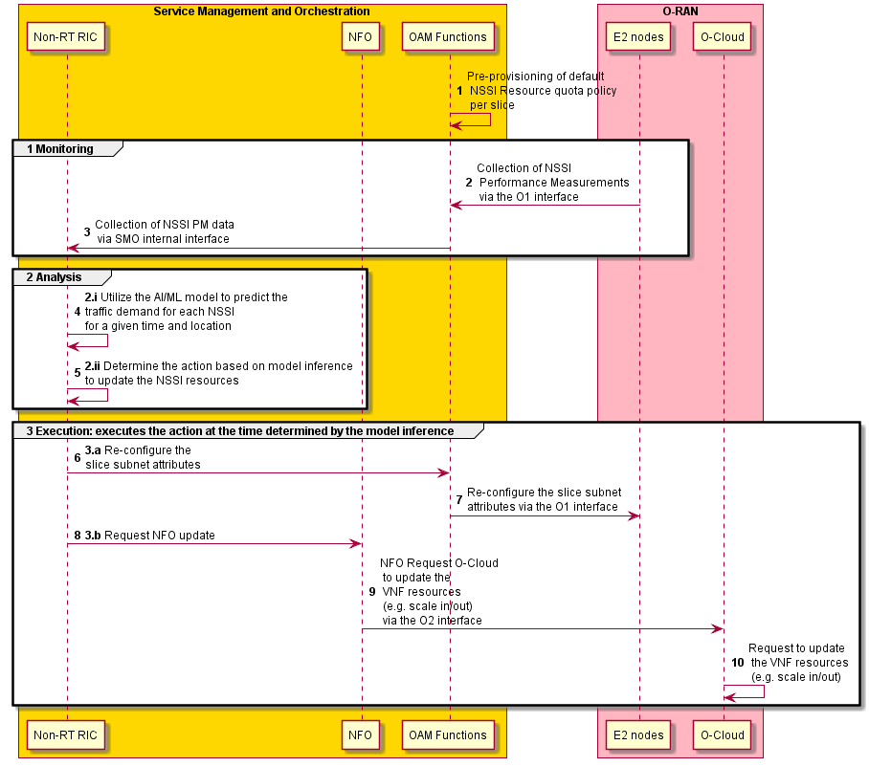
Figure 4.12.3.1-1: NSSI resource allocation optimization flow diagram

4.12.4 Required data
The measurement counters, as specified in 3GPP TS 28.552 [6], which are measured on per S-NSSAI include:
- Mean DL PRB used for data traffic (3GPP TS 28.552 [6], clause 5.1.1.2.5 shall apply)
- Mean UL PRB used for data traffic (3GPP TS 28.552 [6], clause 5.1.1.2.7 shall apply)
- Average DL UE throughput in gNB (3GPP TS 28.552 [6], clause 5.1.1.3.1 shall apply)
- Average UL UE throughput in gNB (3GPP TS 28.552 [6], clause 5.1.1.3.3 shall apply)
- Number of PDU sessions requested to setup (3GPP TS 28.552 [6], clause 5.1.1.5.1 shall apply)
- Number of PDU sessions successfully setup (3GPP TS 28.552 [6], clause 5.1.1.5.2 shall apply)
- Distribution of DL UE throughput in gNB (3GPP TS 28.552 [6], clause 5.1.1.3.2 shall apply)
- Distribution of UL UE throughput in gNB (3GPP TS 28.552 [6], clause 5.1.1.3.4 shall apply)
- Number of DRBs successfully setup (3GPP TS 28.552 [6], clause 5.1.1.10.2 shall apply)
NOTE: The above measurements are indicative and are subject to change based on the progress of this use case in O-RAN. The monitoring of the measurements related to O-Cloud (or transport network) that can be required for NSSI resource optimization is not defined in the present document.

4.13 Local indoor positioning in RAN
This use case provides the background and motivation for the O-RAN architecture to support local indoor positioning.

4.13.1 Background and goal of the use case
Real-time indoor positioning based on cellular network has aroused attention with the development of 5G vertical industries, individuals and operators. NR positioning is introduced by 3GPP Rel.16. The Location Management Function (LMF) resides in core network request the NG-RAN node to report positioning measurements, which is used by LMF to compute the location of UE. The messages between LMF and the NG-RAN need the AMF to route transparently. However, this long route messages between the NG-RAN node and centralized LMF can suffer network jitters and leads to un-real-time UE location results.
The main objective is to ensure local positioning be supported within the O-RAN architecture and its open interfaces. In the context of O-RAN architecture, the positioning function can be deployed as a positioning xApp in the Near-RT RIC. The positioning xApp computes the UE location and optional velocity based on the positioning measurement obtained via the E2 interface. The local indoor positioning results can be acquired via positioning xApp to support positioning applications (e.g., indoor navigation, electric security fence, etc.).

4.13.2 Entities/resources involved in the use case
- Non-RT RIC:
  - Retrieve necessary positioning-related indicators (e.g., RSSI, labeled user location by manual or by minimal drive test, etc.) from positioning measurement report or network level measurement report or enrichment information from SMO (can acquire data from application). The data is for constructing/training relevant AI/ML model that will be deployed in Near-RT RIC to assist in the position computation function.
  - Training of potential ML models for real-time positioning optimization, which can be used to compute the position, correct positioning errors, and predict motion.
  - Send policies/intents to Near-RT RIC to drive the positioning optimization at RAN level.
- Near-RT RIC:
  - Support selection of positioning algorithms (e.g., according to QoS requirements, etc.).
  - Support the calculation of positioning results based on the measurements from RAN.
  - Support update of AI/ML models from Non-RT RIC.
  - Support execution of the AI/ML models from Non-RT RIC, e.g., positioning result calculation.
  - Sending positioning results to Non-RT RIC for evaluation and optimization.
- RAN:
  - Support positioning related measurement report over E2 interface.
  - Support positioning related measurement report over O1 interface.
- Application server:
  - Request/subscribe RAN analytics information from Near-RT RIC.
  - Support positioning related enrichment information (e.g., labeled user location by manual or by minimal drive test, etc.) to SMO.

4.13.3 Solutions

4.13.3.1 Local indoor positioning in RAN (1)
The context of the local indoor positioning in RAN (1) is captured in table 4.13.3.1-1.
Table 4.13.3.1-1: Local indoor positioning in RAN (1)
Use Case Stage | Evolution / Specification | <<Uses>>  Related use
Goal | Expose positioning results to external applications.
Actors and Roles | Near-RT RIC, SMO, application server
Assumptions | All relevant functions and components are instantiated.
Pre-conditions | Editor’s note: Security related procedure is not defined in the present document.
Begins when | The application server wants to request/subscribe RAN positioning results of target UE.
Step 1 (M) | Application server sends positioning request of target UE to Near-RT RIC or subscribes positioning results from Near-RT RIC to get periodic or event triggered position reporting.
Step 2 (M) | Near-RT RIC receives the request or subscription from application server and requests or subscribes measurements to RAN through E2 interface. The Near-RT RIC selects the positioning algorithm based on the request or the measurement data from RAN.
Step 3 (M) | RAN reports the measurements to Near-RT RIC according to the request or subscription.
Step 4 (M) | Near-RT RIC calculates the positioning results based on the measurement report from RAN, using the selected positoning algorithm.
Step 5 (M) | Near-RT RIC sends the response or notification command to expose radio performance analytics towards application server.
Ends when | Application server gets response or sends subscription deletion toward the Near-RT RIC.
Exceptions | None identified.

The flow diagram of the local indoor positioning in RAN (1) is given in figure 4.13.3.1-1.
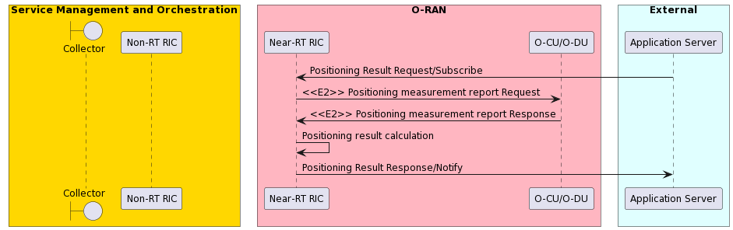
Figure 4.13.3.1-1: Local indoor positioning in RAN (1) flow diagram

4.13.3.2 Local indoor positioning in RAN (2)
The context of the local indoor positioning in RAN (2) is captured in table 4.13.3.2-1.
Table 4.13.3.2-1: Local indoor positioning in RAN (2)
Use Case Stage | Evolution / Specification | <<Uses>>  Related use
Goal | Expose positioning results to external applications.
Actors and Roles | Non-RT RIC, Near-RT RIC, SMO, application server
Assumptions | All relevant functions and components are instantiated.  A1/O1 interface connectivity is established with Non-RT RIC.
Pre-conditions | Positioning related models have been deployed in Non-RT RIC and Near-RT RIC respectively.  Editor’s note: Security related procedure is not defined in the present document.
Begins when | The application server wants to request/subscribe RAN positioning results of target UE.
Step 1 (M) | Application server sends positioning request of target UE to Near-RT RIC or subscribes positioning results from Near-RT RIC to get periodic or event triggered position reporting.
Step 2 (M) | Near-RT RIC receives the request or subscription from application server and requests or subscribes measurements to RAN through E2 interface. The Near-RT RIC selects the positioning algorithm based on the request or the measurement data from RAN and can update the positioning related models from Non-RT RIC.
Step 3 (M) | RAN reports the measurements to Near-RT RIC according to the request or subscription.
Step 4 (M) | Near-RT RIC calculates the positioning results based on the positiong report from RAN, usingthe selected positoning algorithm.
Step 5 (M) | Near-RT RIC sends the response or notification command to expose radio performance analytics towards application server. Near-RT RIC can also pass the positioning results to the Non-RT RIC for further analysis.
Ends when | Application server gets response or sends subscription deletion toward the Near-RT RIC.
Exceptions | None identified.

The flow diagram of the local indoor positioning in RAN (2) is given in figure 4.13.3.2-1.
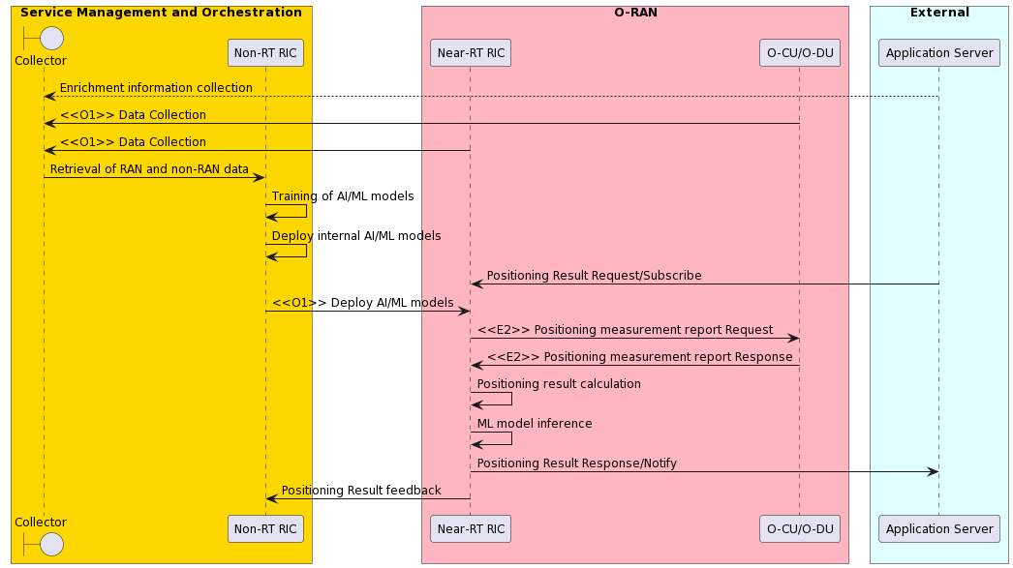
Figure 4.13.3.2-1: Local indoor positioning in RAN (2) flow diagram

4.13.4 Required data
Multi-dimensional data are expected to be retrieved by Non-RT RIC for AI/ML model training and policies/intents generation.
- Network level measurement report, including UE level radio channel information, mobility related metrics, e.g., RSRP, RSSI, etc.
- Positioning measurement report, including UE level E-CID, OTDOA, UTDOA, TOA, RSSI, AOA, etc.
- Enrichment information (optional) collected from SMO (can acquire data from application), can including labeled user location by manual or by minimal drive test, etc.
Near-RT RIC required data to select the positioning algorithm and calculate the positioning results.
- Positioning measurement report, including UE level E-CID, OTDOA, UTDOA, TOA, RSSI, AOA, etc.
- Performance requirements in positioning requests (optional) such as QoS.

4.13.4.1 RAN analytics information
Radio performance analytics data are expected to be exposed by Near-RT RIC to application server.
- UE positioning results, including location coordinates, coordinate system, position methods used (in the case of success indication provided), failure cause (in the case of failure indication provided), achieved location QoS accuracy (optional).
- Velocity estimation (optional).

4.14 Massive SU/MU-MIMO grouping optimization
Void

4.15 O-RAN signalling storm protection
This use case provides the background, motivation, and requirements for the O-RAN signaling storm protection use case, allowing protecting the mobility network against signaling storms initiated by devices.

4.15.1 Background and goal of the use case
Society is increasingly dependent on network connectivity at any time and in any place and increasing diversity of device types ranging from complex devices such as smart phone to very simple and low-cost IoT devices are connecting to the network. The sheer number of connected devices, as well as the wide range of device types, makes the mobility network subject to accidental or intentional attacks that can disrupt the regular usage of the network. Given that life-critical applications are moving to wireless networks, such network disruptions are not only an inconvenience but can have impact on life and health of individuals. The O-RAN architecture offers an opportunity to address such security challenges in customizable and creative ways by utilizing the Near-RT RIC xApps and Non-RT RIC rApps.
Currently, the main defense mechanism standardized in 3GPP against attacks coming from the devices toward the network is based on configuration of the devices themselves and trust that the devices will indeed comply with restrictions defined by mobility standards. One such defense mechanism is the back-off timer that restricts the number of repeated device registrations, thus preventing devices from overloading the network with attaches. If this trust is breached there are no other options for defending the network rather than rejecting (denying service) randomly to both benign and malicious devices, a state which is equivalent to DDoS. Unfortunately, even today the network has few hundreds of device types that under certain conditions accidently breach this trust and allow devices to aggressively attach to the network in a rate of few thousand times per hour (the maximum allowed number by standard is less than 20 attaches per hour). An attacker that finds a way to manipulate vulnerabilities in a large set of these devices remotely can cause an attach storm that could lead to a long outage of large parts of the network. Furthermore, this attacker can continue this attack over many hours, each time picking few thousand of devices from a large pool of millions of vulnerable devices connected to the same carrier network; the network carrier will not be able to stop this attack without intelligent and fine-grained controls to act against a certain patterns of behavior.
Fortunately detecting these aggressive devices is possible as their behavior is very different from the other devices in the network. What the network really needs is to apply dynamic restriction over these devices to prevent them from overloading the control plane of the network. This restriction should be smart enough to still allow benign devices to register to the network without interruption. Having smart security control at the RAN can stop such attack and without overloading deeper parts of the network in the core.
The goal of this use case is utilizing O-RAN to detect and mitigate signaling storms DDoS quick and as close to the network edge, thus minimizing affected network nodes. The Near-RT RIC would detect these signaling storms by analyzing signaling events from RAN nodes it controls. When such a storm is detected the Near-RT RIC creates fine grained filters, which cover the aggressive UEs that cause the storm. These UEs registration requests will then be blocked/throttled while the behaving UEs will continue to get service as usual. In some cases, the attack can be spread across many locations. It could be that the volume of signaling per location has not crossed a critical threshold but the moderate increase in many locations do cause an overload of central nodes such as the network core elements. In this case a network-wide view is required; thus, the Non-RT performs the network-wide analysis and in the case of a network signaling storm, it pushes policies to the local Near-RT RIC to adjust detection parameters to reduce the moderate increase of signaling from a set of one or more E2 nodes. This combined view of both Non-RT RIC and Near-RT RIC ensures quick reaction to local signaling storms as well as response to widely distributed attacks.
While flows in this use case focus on the signaling storm scenario, they could be easily extended to include other attack scenarios both in terms of detection and mitigation. For example, the scenario where rogue devices report false CQI measurements that indicate high values while the real channel quality is poor. When exploited by attackers and applied to large set of devices this attack can cause to waste of radio resources and eventually to DoS. Detection of the attack can be achieved by analyzing anomalous CQI reports, or abnormal volume of NACK messages based on signaling messages. For mitigation actions either rejecting the rogue devices or limiting radio resources can be applied.

4.15.2 Entities/resources involved in the use case
- Non-RT RIC in SMO domain:
  - Maintains overall view of network wide phenomenon of signaling storms using signaling storm detection rApp. The detection of distributed signaling storms that spread over many geographical locations and are more difficult to be observed locally. This overall view is broken down by location and corresponding policies are pushed to specific instances of Near-RT RIC to respond to abnormal signaling activity in affected geographical areas, over the A1 interface.
  - Uses enrichment data from non-RAN source (i.e., 5G core or probing framework) to maintain global view and support more accurate detection and classification of attacks.
  - Utilizes AI/ML models in the signaling storm detection rApp that monitor network-level signaling behavior to support signaling anomalies detection.
- Near-RT RIC in RAN domain:
  - Monitors E2 interface for connection establishment messages and identifies abnormal levels of signaling activity using the signaling storm detection xApp.
  - Signaling storm mitigation xApp utilizes policies over E2 to enforce appropriate mitigation action (e.g., reject, throttle, alert) over misbehaving UEs connection establishment.
  - Signaling storm detection xApp utilizes AI/ML models that monitor cell-level signaling behavior to support signaling anomalies detection.
  - Applies appropriate detection policy based on policies received from Non-RT RIC (e.g., false-positive levels, UE thresholds, throttling ratios).
- E2 nodes in RAN domain:
  - Support sending connection establishment messages over the E2 interface.
  - Support control and policy enforcement from Near-RT RIC over E2 interface

4.15.3 Solutions

4.15.3.1 Mode 1 – Local signaling storm protection policy
The context of the local signaling storm protection policy is captured in table 4.15.3.1-1.
Table 4.15.3.1-1: Local signaling storm protection policy
Use Case Stage | Evolution / Specification | <<Uses>>  Related use
Goal | Detect localized signaling storms based on “default parameters” and apply policy to mitigate the attack.
Actors and Roles | Near-RT RIC: Detection of local cell-level signaling storms; execution of mitigation policies and controls, maintenance of cell-level normal behavior models.  E2 nodes: Execute mitigation policies, collects and reports RAN signaling events and policy specific statistics over E2.
Assumptions | All relevant functions and components are instantiated. Signaling storms detection and signaling storm mitigation xApps are deployed over E2 with initial configuration.  E2 interface connectivity is established with Non-RT RIC and RAN respectively.  Data report, policy and control subscription established on E2 interface.
Pre-conditions | Network is operational.  SMO has established the data collection and sharing interface with Non-RT RIC.  Near-RT RIC already established relevant detection mechanisms of normal signaling behavior and adjusted detection parameters accordingly. Non-RT RIC analyzes the historical data from RAN, develops, trains with help of SMO functions and deploys the models or algorithm as part of the signaling storm detection xApp to the Near-RT RIC.
Begins when | Network is in normal state (attack is described later on).
Step 1 (M) | Signaling storm detection xApp subscribes on connection establishment signaling messages report from the RAN over the E2 interface.
Step 2 (M) | E2 node sends report to signaling storm detection xApp.
Step 3 (M) | Near-RT RIC signaling storm detection xApp monitors reports to detect aggressive UEs that act with abnormal signaling.
Steps 4-7 (M) | UEs send establish connection messages and E2 node accepts these requests.
Step 8 (M) | E2 node sends a connection establishment reports.
Step 9 (M) | Signaling storm detection xApp detects aggressive activity.
Step 10 (M) | Signaling storm detection xApp updates signaling storm mitigation xApp.
Step 11 (M) | Near-RT RIC signaling storm mitigation xApp creates a filter to block/throttle signaling messages from the aggressive UEs. Filter is applied in the E2 nodes as POLICY + REPORT to track filter activity. Near-RT RIC shall notify the Non-RT RIC to avoid conflicts.
Step 12 (M) | Aggressive UE sends connection establishment message.
Step 13 (M) | E2 node evaluate policy with respect to the connection establishment message.
Step 14 (M) | E2 node rejects/throttles connection establishment request.
Step 15 (M) | Near-RT RIC signaling storm mitigation xApp receives relevant signaling messages that the POLICY filter blocked/ throttled to track changes in attack status and aggressive devices (list of UEs blocked, blocked signaling volume, trend).
Step 16 (M) | Near-RT RIC signaling storm mitigation xApp is finds that some devices are no longer aggressive or no longer present. It decides to update filter by updating the E2 node POLICY.
Step 17-19 (M) | Near-RT RIC signaling storm detection xApp detects a new set of aggressive devices and updates the signaling storm mitigation xApp, which updates the filter by updating the E2 node POLICY.
Step 20-21 (M) | Near-RT RIC signaling storm mitigation xApp evaluates signaling level and decides that there is no more aggressive UE activity. The xApp removes the E2 node policy.
Ends when | Attack is over and signaling messages level is back to normal.
Exceptions | None identified.
Post Conditions | Return to normal signaling activity monitoring (step 1).
@startuml
skinparam ParticipantPadding 5
skinparam BoxPadding 10
skinparam defaultFontSize 12
Autonumber

Box “Service Management and Orchestration” #gold
boundary “OAM Functions” as coll
participant “Non-RT RIC” as non
end box

Box "O-RAN" #lightpink
Participant "Near-RT RIC Detection xApp" as det
Participant "Near-RT RIC Mitigation xApp" as mit
Participant "E2 Nodes" as ran
End box

Box “External Enrichment Server” #lightcyan
Participant "Core Probing Framework" as ext
End box
Participant UE as ue

ext -> coll: EI's collection
ran -> coll: <<O1>> alarms & metrics
coll -> non: Signalling statistics

group Signaling Storm Detection
det -> ran: <<E2>> Subscription Request:REPORT{connection establishment messages}
ran -> det: <<E2>> Report: {connection establishment messages}
det -> det: Detect aggressive devices
ue -> ran: Establish connection request
ran -> ue: Establish connection accept
ue -> ran: Establish connection request
ran -> ue: Establish connection accept
ran -> det: <<E2> Report: {connection establishment messages}
det -> det: Detect aggressive devices
det -> mit: Decision to apply policy filter
mit -> ran: <<E2>> Subscribe REPORT+POLICY: {policy apply filter}
ue -> ran: Establish connection request
ran -> ran: Evaluate policy
ran -> ue: Establish connection reject
ran -> mit: <<E2>> Report: {connection establishment messages}
mit -> ran: <<E2>> Send Policy: {update policy filter - remove some UEs}
ran -> det: <<E2>> Report: {connection establishment messages}
det -> mit: Decision to apply policy filter
mit -> ran: <<E2>> Send Policy: {update policy filter - add some UEs}
ran -> mit: <<E2>> Report: {connection establishment messages}
mit -> ran: <<E2>> Send Policy: {Remove policy filter}
end

@enduml

The flow diagram of the local signaling storm protection policy is given in figure 4.15.3.1-1.

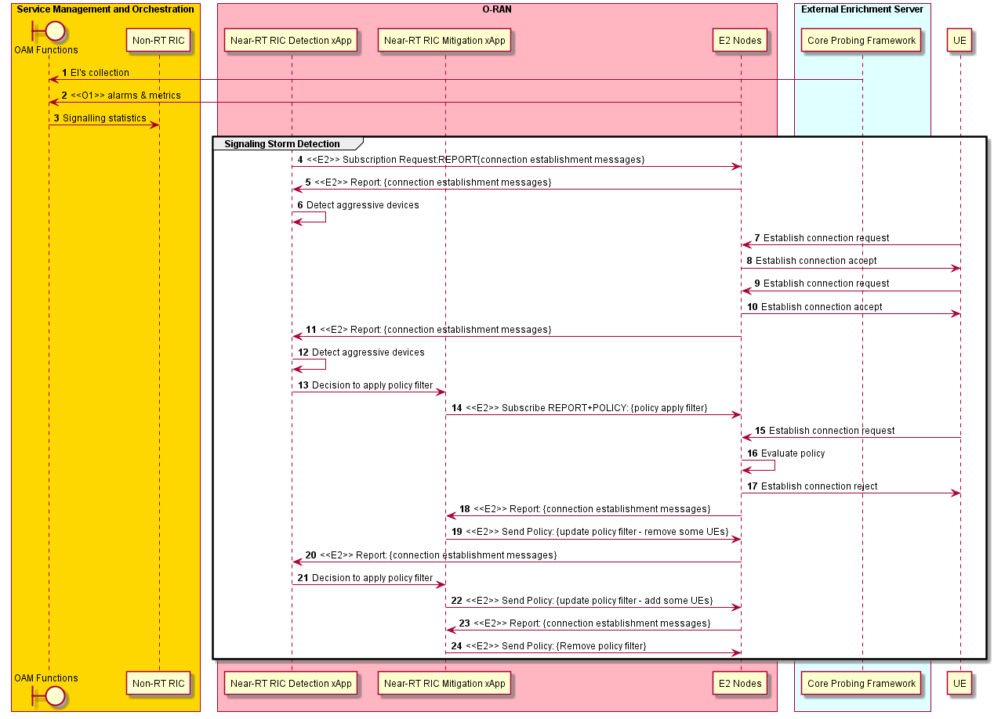
Figure 4.15.3.1-1: Local signaling storm protection policy flow diagram

4.15.3.2 Mode 1 – Local signaling storm protection insert-control (optional)
The context of the local signaling storm protection insert-control is captured in table 4.15.3.2-1.
Table 4.15.3.2-1: Local signaling storm protection insert-control
Use Case Stage | Evolution / Specification | <<Uses>>  Related use
Goal | Detect localized signaling storms based on “default parameters” and apply control to mitigate the attack.
Actors and Roles | Near-RT RIC: Detection of local cell-level signaling storms; execution of mitigation policies and controls, maintenance of cell-level normal behavior models.  E2 nodes: Execute UE level mitigation policies, collects and reports RAN signaling events and policy specific statistics over E2.
Assumptions | All relevant functions and components are instantiated. Signaling storms detection and signaling storm mitigation xApps are deployed over E2 with initial configuration.  E2 interface connectivity is established with Non-RT RIC and RAN respectively.  Data report, policy and control subscription established on E2 interface.
Pre-conditions | Network is operational.  SMO has established the data collection and sharing interface with Non-RT RIC.  Near-RT RIC already established relevant detection mechanisms of normal signaling behavior and adjusted detection parameters accordingly. Non-RT RIC analyzes the historical data from RAN, develops, trains with help of SMO functions and deploys the models or algorithm as part of the signaling storm detection xApp to the Near-RT RIC.
Begins when | Network is in normal state (attack is described later on).
Step 1 (M) | Signaling storm detection xApp subscribes on connection establishment signaling messages report from the RAN over the E2 interface.
Step 2 (M) | E2 node sends report to signaling storm detection xApp.
Step 3 (M) | Near-RT RIC signaling storm detection xApp monitors reports to detect aggressive UEs that act with abnormal signaling.
Steps 4-7 (M) | UEs send establish connection messages and E2 node accepts these requests.
Step 8 (M) | E2 node sends a report indicating aggressive devices behavior.
Step 9 (M) | Signaling storm detection xApp detects aggressive activity.
Step 10 (M) | Signaling storm detection xApp updates signaling storm mitigation xApp.
Step 11 (M) | Signaling storm mitigation xApp updates subscription to INSERT-CONTROL. Use control filter to block/throttle aggressive UEs by rejecting some of the messages.
Step 12 (M) | E2 node receives another connection establishment from an aggressive UE.
Step 13 (M) | E2 node forwards the message to the signaling storm mitigation xApp.
Step 14 (M) | Signaling storm mitigation xApp determines that message is from an aggressive device.
Step 15 (M) | Signaling storm mitigation xApp sends a reject/throttle message to the E2 node.
Step 16 (M) | E2 node rejects/throttles connection establishment request.
Step 17 (M) | Signaling storm mitigation xApp continues to monitor its control filter.
Step 18 (M) | Near-RT RIC DDoS mitigation xApp evaluates signaling level and decides that there is no more aggressive UE activity. The xApp updates subscription back to REPORT.
Ends when | Attack is over and signaling messages level is back to normal.
Exceptions | None identified.
@startuml
skinparam ParticipantPadding 5
skinparam BoxPadding 10
skinparam defaultFontSize 12
Autonumber

Box “Service Management and Orchestration” #gold
boundary “OAM Functions” as coll
participant “Non-RT RIC” as non
end box

Box "O-RAN" #lightpink
Participant " Near-RT RIC Detection xApp" as det
Participant " Near-RT RIC Mitigation xApp" as mit
Participant "E2 Nodes" as ran
End box

Box “External Enrichment Server” #lightcyan
Participant "Core Probing Framework" as ext
End box
Participant UE as ue

ext -> coll: EI's collection
ran -> coll: <<O1>> alarms & metrics
coll -> non: Signalling statistics

group Signaling Storm Detection
det -> ran: <<E2>> Subscription Request:REPORT{connection establishment messages}
ran -> det: <<E2>> Report: {connection establishment messages}
det -> det: Detect aggressive devices
ue -> ran: Establish connection request
ran -> ue: Establish connection accept
ue -> ran: Establish connection request
ran -> ue: Establish connection accept
ran -> det: <<E2> Report: {connection establishment messages}
det -> det: Detect aggressive devices
det -> mit: Decision to apply control filter
mit -> ran: <<E2>> Update Subscription: INSERT{connection establishment messages}
ue -> ran: Establish connection request
ran -> mit: <<E2>> Establish connection request
mit -> mit: Evaluate filter
mit -> ran: <<E2>> Establish connection reject
ran -> ue: Establish connection reject
mit -> mit: Monitor control filter
mit -> ran: Update subscription: REPORT{connection establishment messages}
end

@enduml

The flow diagram of the local signaling storm protection insert-control is given in figure 4.15.3.2-1.
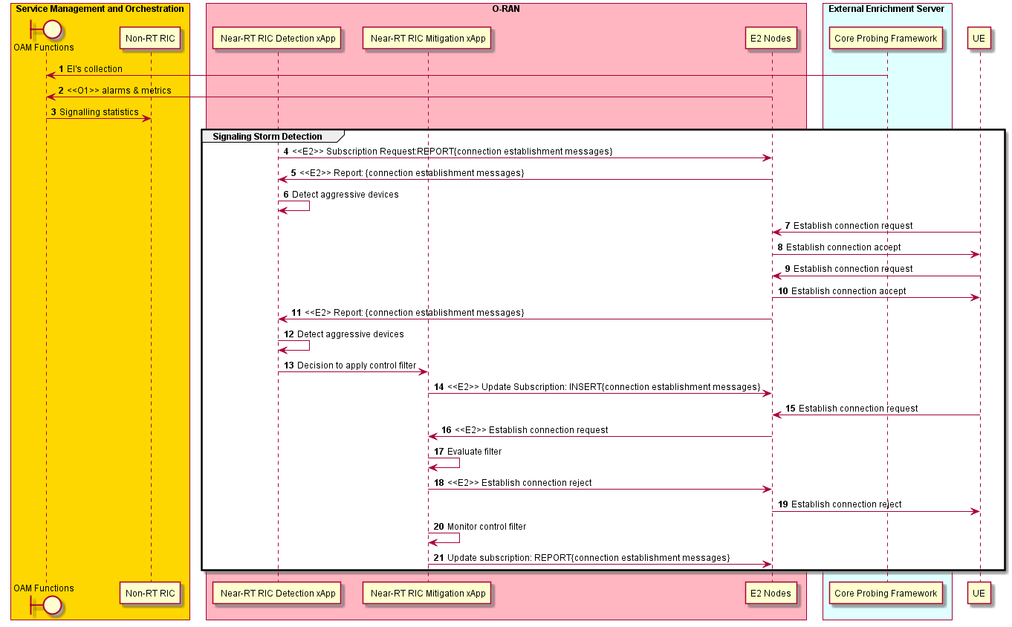
Figure 4.15.3.2-1: Local signaling storm protection insert-control flow diagram

4.15.3.3 Mode 2 – Distributed signaling storm protection
The context of the distributed signaling storm protection is captured in table 4.15.3.3-1.
Table 4.15.3.3-1: Distributed signaling storm protection
Use Case Stage | Evolution / Specification | <<Uses>>  Related use
Goal | Detect distributed signaling using Non-RT RIC and A1 policy initiates mode 2 handling in Near-RT RIC with “stricter parameters” mitigation.
Actors and Roles | Non-RT RIC: Detection of network-level distributed signaling storms, maintenance of cell-level, network slice level and node level normal behavior models.  Near-RT RIC: Detection of local cell-level signaling storms; execution of mitigation policies and controls, maintenance of cell-level normal behavior models.  RAN: Executes UE level or network slice level mitigation policies, collects and reports RAN signaling events and policy specific statistics over E2.
Assumptions | All relevant functions and components are instantiated. Signaling storms detection and signaling storms mitigation xApps are deployed over E2 with initial configuration.  A1, E2 interface connectivity is established with Non-RT RIC and RAN respectively.  Data report, policy and control subscription established on E2 interface.
Pre-conditions | Network is operational.  SMO has established the data collection and sharing interface with Non-RT RIC.  Non-RT RIC and Near-RT RIC already established relevant detection mechanisms of normal signaling behavior and adjusted detection parameters accordingly. Non-RT RIC analyzes the historical data from RAN, develops, trains with help of SMO functions and deploys the models or algorithm as xApps to the Near-RT RIC.
Begins when | Network is in normal state when (attack is described later on).
Step 1 (M) | OAM functions start to collect Enrichment Information (EIs) from external sources (e.g. network core probing framework).
Step 2 (M) | OAM functions start to collect alarms & metrics from E2 nodes.
Step 3 (M) | OAM functions sends signaling statistics based on collected information to Non-RT RIC.
Step 4 (M) | Non-RT RIC uses AI/ML model to analyze overall network signaling activity levels based on signaling statistics.
Step 5 (M) | Non-RT RIC applies initial configurations to all Near-RT RIC elements regarding detection and mitigation parameters, including: accepted signaling volume thresholds, throttle/block ratio, accepted false negative levels, filter pause periods, etc.
Step 6 (M) | Non-RT RIC detects distributed signaling storm activity originated from a list of locations.
Step 7 (M) | Non-RT RIC updates configuration to a stricter one in the relevant Near-RT RIC locations over A1 interface.
Step 8 (M) | Near-RT RIC performs detection and mitigation as described in 3.15.3.1 or 3.15.3.2 with stricter configuration (e.g. lower thresholds).
Step 9 (M) | Non-RT RIC determines that distributed signaling storm attack is over based on signaling statistics information.
Step 10 (M) | Non-RT RIC updates Near-RT RICs back to initial configuration parameters over the A1 interface.
Step 11 (M) | Near-RT RIC signaling storm detection xApp observed aggressive behavior where temporal identifiers cannot be correlated with the underlying devices.
Step 12 (M) | Near RT RIC alarms the OAM functions over O1.
Step 13 (M) | OAM functions report suspicious behavior to Non-RT RIC.
Step 14 (M) | Non-RT RIC sends enrichment information to Near-RT RIC over A1-EI to support detection of aggressive devices.
Step 15 (M) | Near-RT RIC performs detection and mitigation as described in 3.15.3.1 or 3.15.3.2 with stricter configuration (e.g. lower thresholds).
Step 16 (M) | Non-RT RIC evaluates data and decides that there is no more distributed signaling storm activity.
Step 17 (M) | Non-RT updates configuration of relevant Near-RT RICs over the A1 back to normal.
Ends when | Attack is over and signaling messages level is back to normal.
Exceptions | None identified.
Post Conditions | Non-RT RIC monitors network-level signaling messages statistics.  Near-RT RIC monitors cell-level signaling messages statistics.
@startuml
skinparam ParticipantPadding 5
skinparam BoxPadding 10
skinparam defaultFontSize 12
Autonumber

Box “Service Management and Orchestration” #gold
boundary “OAM Functions” as coll
participant “Non-RT RIC” as non
end box

Box "O-RAN" #lightpink
Participant "Near RT RIC" as near
Participant "E2 Nodes" as ran
End box

Box “External Enrichment Server” #lightcyan
Participant "Core Probing Framework" as ext
End box

ext -> coll: EI's collection
ran -> coll: <<O1>> alarms & metrics
coll -> non: Signalling statistics
group Near-RT RIC Configuration
non -> non: AI/ML model to analyze overall network signaling activity levels
non -> near: <<A1>> Initial parameters configuration
end
group Distributed Signaling StormProtection
non -> non: Detect distributed signalling storm
non -> near: <<A1>> Configure stricter parameters
group Signaling Storm Detection
near -> near: Perfroms detection and mitigation
end
non -> non: Evaluate EIs. DDoS is over.
non -> near: <<A1>> Update configuration back to normal
end
group Uncorrelated Identifiers Signaling Storm
near -> near: Identify aggressive behavior with uncorrelated identifiers
near -> coll: <<O1>> Report suspicious behavior
coll -> non: Report suspicious behavior
non -> near: <<A1-EI>> Reconfigure parameters
group Signaling Storm Detection
near -> near: <<E2>> Performs detection and mitigation
end
non -> non: Evaluate EIs. DDoS is over.
non -> near: <<A1>> Update configuration back to normal
end

@enduml

The flow diagram of the distributed signaling storm protection is given in figure 4.15.3.3-1.

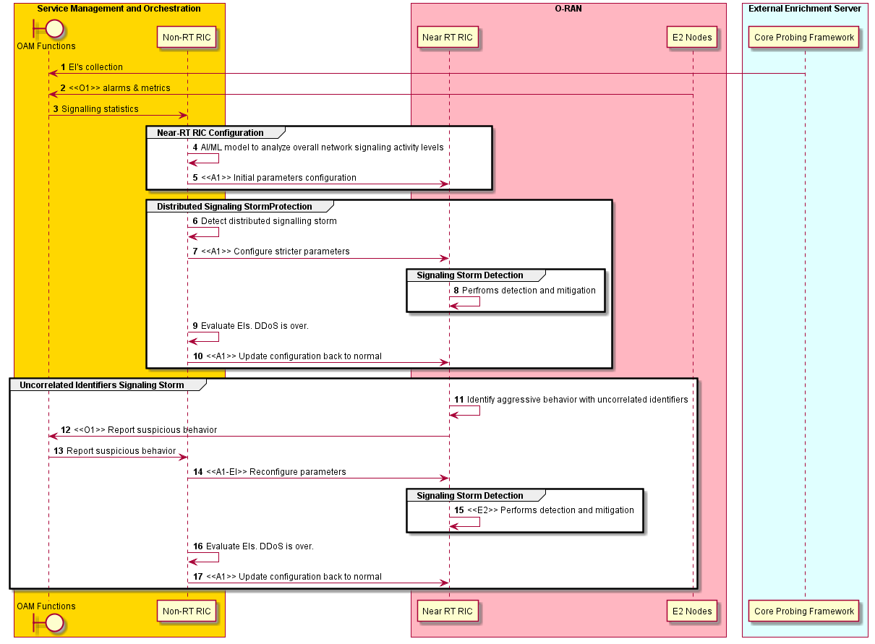
Figure 4.15.3.3-1: Distributed signaling storm protection flow diagram

4.15.4 Required data
The measurement counters, detection within the Near-RT RIC is based upon analyzing per UE connection establishment messages events that include the following data:
- Basic registration event parameters: timestamp, cell ID, temporary ID (e.g., C-RNTI, 5G-GUTI)
- RAN parameters to correlate between a UE and registration events: e.g. RSRP/RSRQ, timing advance, beam ID
Tracking status of ongoing attack by monitoring statistics of active filters that include the following data:
- Number of UEs in the filter, number of requests blocked, trend (change over last x periods of time)
Enrichment information from a non-RAN source regarding network-wide DDoS information:
- Overloaded regions, overloaded sites, severity (% above normal)

4.16 Congestion prediction and management
Void

4.17 Industrial IoT optimization
Void

4.18 BBU pooling to achieve RAN elasticity
Void

4.19 Integrated SON function within the O-RAN framework
This use case provides the motivation, description, and requirements for enabling the O-RAN framework to support a minimum SON function set. This use case enables realization of SON functions in the O-RAN architectural framework to help operators address issues seen from vendor specific SON implementation in earlier generation of cellular networks.

4.19.1 Background and goal of the use case.
SON (Self-Organizing Network) functionalities reduces the cost of running a mobile network by providing control on aspects of network configuration and control and thus eliminating manual configuration of network elements right from initial deployment through the network operation. SON also helps better network performance and customer experience and can significantly improve OPEX-to-revenue ratio and help in realizing avoidable CAPEX.
SON is an automation technology that enables the network to set itself up and self-manage resources and configuration to achieve optimal performance. The SON functions are handled by SON algorithms either individually or in groups. SON algorithms perform functionalities like monitoring the network(s) by collecting management data including MDAS (Management Data Analytics Service) data, analysis of the data to determine issues in the network(s) and their resolution. SON intends to achieve the following:
Self-configuration: Aids in seamlessly integrating into the network through automatic configuration of key parameters (initial PCI and ANR functions).
Self-optimization: Aids in enhanced network performance through near real time optimization of radio & network configurations. It is valuable throughout the lifetime of the network and includes SON functionalities such as Mobility Load Balancing [MLB], Mobility Robustness Optimization [MRO], Random Access Channel [RACH] Optimization, etc.
Self-healing: It allows adjacent cells to maintain network quality in case a cell/sector fails, providing resiliency (reliability) in the face of unforeseen outage conditions. It is relevant throughout the lifetime of the network and includes SON functions such as cell outage detection, compensation and recovery.
The definitions for the SON functionality are specified in 3GPP TS 28.313 [20] but the realization of the SON functions is left to implementation. The SON coordination function for detecting, preventing and resolving conflicts or negative influences between multiple SON functions when there is an attempt to change some (same or associated) network configuration parameters of some (same or associated) nodes is also specified in 3GPP TS 28.313 [20]. Based on the deployment of SON algorithm, the SON solution can be termed as Centralized SON (C-SON – where the SON algorithms are executed in the 3GPP management system), Distributed SON (D-SON - where SON algorithms are executed in the network function layer) and Hybrid SON (where SON algorithm execution is spread across the network function layers and the management layers).
The objective of this use case is to enable the realization of SON functions in the O-RAN architecture framework i.e., as rApps, xApps or as management entity functions through open interfaces in a way that inter vendor interoperability issues can be addressed.
NOTE: Other deployment options other than the ones mentioned in this use case are also possible.
The scope of the integrated SON use case covers the following functions:
- Self configuration:
- PCI initial allocation and conflict resolution
- ANR (Automatic Neighbor Relations)
- Self optimization:
- Mobility Load Balancing (MLB)
- Mobility Robustness Optimization (MRO)
- Coverage and Capacity Optimization (CCO)
- RACH Optimization (RO)
Editor’s note: R1 interface needs to be shown in the UMLs.

4.19.2 Entities/resources involved in the use case

4.19.2.1 SON inventory and deployment management
1) SMO
- Support SON inventory and deployment management for Non-RT RIC(s), Near-RT RIC(s) and E2 node(s).
- Support collection of SON configurations from Non-RT RIC(s), Near-RT RIC(s) and E2 node(s).
- Support decision making on setup of the SON functions in Non-RT RIC(s), Near-RT RIC(s) and E2 node(s).
- Configure Non-RT RIC(s), Near-RT RIC(s) and E2 node(s) based on the decided SON function deployment model.
2) Non-RT RIC
- Support exposure of SON functionalities and configurations.
- Support configuration and setup of the SON functions from SMO.
3) Near-RT RIC
- Support exposure of SON functionalities and configurations.
- Support configuration and setup of the SON functions from SMO via O1 interface.
4) E2 node
- Support exposure of SON functionalities and configurations.
- Support configuration and setup of the SON functions from SMO via O1 interface.

4.19.2.2 Self configuration (PCI conflict detection/resolution, ANR)
1) SMO
- Configure self configuration SON functionality (PCI conflict detection/resolution, ANR) in Non-RT RIC, Near-RT RIC or E2 node.
- Configure/reconfigure the respective SON related parameters and measurements in the Non-RT RIC, Near-RT RIC and E2 node.
- Support collection of measurements or notifications from the respective O-RAN nodes.
2) Non-RT RIC
- Retrieve necessary data from SMO.
- Support setup of SON function and configuration of relevant SON data inputs from SMO.
- Support AI/ML training and inference and provide output via O1 or A1 to the relevant O-RAN nodes.
3) Near-RT RIC
- Support setup of SON function and configuration of relevant SON data inputs from SMO.
- Configure and receive necessary input data for AI/ML training of SON functions.
- Support notifications to SMO related to SON functions.
- Support AI/ML training and inference and provide output to E2 node via E2 interface.
- Support inputs from Non-RT RIC for AI/ML training and conversion of policies via A1 into E2 inputs.
4) E2 node
- Support setup of SON function and configuration of relevant SON data inputs from SMO.
- Support configuration and retrieval of necessary SON function related data for AI/ML model training via E2/O1 interfaces.
- Support policies or configuration changes or relevant inputs via E2/O1 interface to execute RRM functionalities for the respective SON functions.
- Support notifications to SMO related to SON functions.
- Support AI/ML model inference and execute relevant RRM functionalities.

4.19.2.3 Self optimization (MLB, MRO, CCO, RO)
1) SMO
- Configure the self optimization (MLB, MRO, CCO, RO) SON functionality in Non-RT RIC, Near-RT RIC or E2 node.
2) Non-RT RIC
- Support setup of SON function and configuration of relevant SON data inputs from SMO.
- Configuration and collection of cell load related information, HO related reports, CCO related measurement reports (RLF (Radio Link Failure), MDT (Minimization Drive Test), RCEF (RRC Connection Establishment Failure)), RACH performance reports for constructing relevant AI/ML models to assist in the self optimization SON functionality.
- Support AI/ML model training and inference based on the input data received.
- Re-configure inter-site/inter-rat cell reselection parameters, HO related parameters, CCO related control parameters and RACH parameters based on AI/ML output.
- Generate relevant A1 policies to execute any RRM function for the configured SON function.
3) Near-RT RIC
- Support setup of SON function and configuration of relevant SON data inputs from SMO.
- Configuration and collection of load reports, HO related reports (HO failure and RLF), CCO related measurement reports (RLF, MDT, RCEF), RACH performance reports from E2 nodes over E2 interface.
- Support AI/ML model training and inference based on the input data received via O1 and E2.
- Re-configure HO related, cell reselection parameters, CCO related control parameters and RACH parameters based on AI/ML output.
- Support initiation of RRM functions like HO initiation, trigger cell reselection at E2 node via E2 policies or controls based on AI/ML output.
- Support conversion of A1 policy into relevant E2 actions for executing RRM function for a specific SON function.
4) E2 node
- Support setup of SON function and configuration of relevant SON data inputs from SMO.
- Report Measurement Report (MR), HO related information, coverage information, RACH performance over E2/O1 interface.
- Support reconfiguration of HO related parameters, cell reselection parameters, CCO related parameters, RACH parameters based on inputs via E2 or O1 interface.
- Support initiation of RRM functions like HO initiation, cell reselection, etc. based on inputs received via E2/O1 interface.

4.19.3 Solutions

4.19.3.1 SON inventory and deployment management
The context of the SON inventory and deployment management is captured in table 4.19.3.1-1.
Table 4.19.3.1-1: SON inventory and deployment management
Use Case Stage | Evolution / Specification | <<Uses>>  Related use
Goal | - Management of SON configurations of Non-RT RIC, Near-RT RIC and E2 node by the SMO.  - Management of deployment of SON functions in Non-RT RIC, Near-RT RIC and E2 node by the SMO.
Actors and Roles | - SMO acting as controller for the SON inventory and deployment management.  - Non-RT RIC, Near-RT RIC and E2 node acting as supporting entities by providing the required information and adhering to SON configuration by SMO.  - Operator providing the necessary inputs to SMO for decision making on the SON function deployment.
Assumptions | - O1 interface connectivity between the SMO and E2 node and Near-RT RIC is established.  - E2 interface connectivity is established between E2 node and Near-RT RIC.  - A1 interface connectivity is established between Near-RT RIC and Non-RT RIC.  - Network is operational.
Pre-conditions | - SMO is unaware of the SON configurations of the O-RAN nodes.  - SMO has necessary inputs from operator to decide the deployment of SON functions in the respective O-RAN nodes.  - O-RAN nodes are capable of providing their SON configurations to SMO.
Begins when | Network becomes operational and operator configures the SMO for SON inventory and deployment management.
Step 1, 2, 3 (M) | - Operator sets the SON targets and the SON function deployment model.  - SMO analyzes the SON targets and the SON deployment model and notifies the operator on the decision.  - SMO inspects the SON inventory and decides on the need for retrieval of SON configuration from O-RAN nodes.
Step 4, 5, 6, 7, 8, 9 (O) | - If required, SMO initiates request to retrieve the configuration from O-RAN nodes in a loop until all the necessary configurations are retrieved.  - Based on the retrieved configuration, SMO re-evaluates the SON deployment model and notifies the operator if any changes to SON deployment model.
Step 10, 11, 12 (O) | - Alternatively, SMO can decide to configure the O-RAN nodes with the necessary SON functions by deploying rApps or xApps to cater to the SON deployment model.  - SMO can notify the operator on the rApp and xApp deployments if needed.
Step 13 - 17 (O) | Based on the revised deployment model, SMO communicates the changes to the SON configurations and the SON function setup to the O-RAN nodes.
Step 18 (M) | The O-RAN nodes collect data, analyze, and decide if any changes are needed to the configuration and notify operator for any modifications done.  This is done in a loop until SON targets are met.
Step 19 – 27 (M) | If the SON functions need to be terminated based on inputs from operator, then SMO initiates deletion of SON configurations in the respective O-RAN nodes and notifies the operator when the termination is completed.
Ends when | The SON functions are terminated by the operator or when the SON targets are met.
Exceptions | None identified.
Post Conditions | SMO, Non-RT RIC, Near-RT RIC and E2 nodes interwork with each other seamlessly adhering to the SON function setup input from SMO.
@startuml
skinparam ParticipantPadding 5
skinparam BoxPadding 10
skinparam defaultFontSize 12
Autonumber

@startuml
box "Personnel" #lightblue
actor "Operator" as RP
end box

box "Service Management & \nOrchestration Framework" #gold
participant SMO
participant "Non-RT RIC" as NonRTRIC
end box

box "O-RAN Components" #lightpink
collections "Near-RT RIC" as NearRTRIC
collections "O-RAN Nodes" as ORANnodes
end box

autonumber

RP -> SMO: Triggering Criteria (SON targets \n and SON Deployment Model)

== Planning phase ==

ref over SMO, NonRTRIC : Analyze & Decide SON targets\n and SON Deployment Model \n

opt Operator's expectation on visibility exists
SMO -> RP : Notify (progress, deployment model)
end

== Configuration / deployment phase ==

SMO -> SMO : Inspect SON related inventory data
opt need for inventory update identified
loop for each entity whose inventory data needs to be updated
alt rApp entity
|||
ref over NonRTRIC, SMO : Obtain information about deployed rApps\n
else xApp entity
SMO -> NearRTRIC : <<O1>> Read on MOI
NearRTRIC --> SMO : <<O1>> Success
else O-RAN Node
SMO -> ORANnodes : <<O1>> Read on MOI
ORANnodes --> SMO : <<O1>> Success
end
end
end

ref over SMO, NonRTRIC : Re-evaluate SON deployment model\n

opt Deployment model needs to be revised
ref over SMO, NonRTRIC : Revise SON deployment model\n
opt Operator's expectation on visibility exists
SMO -> RP : Notify (progress, deployment model)
end
end
ref over SMO, NonRTRIC : Decide SON configuration\n

opt Operator's expectation on visibility exists
SMO -> RP : Notify (progress, SON configuration)
end

opt Deployment model needs new entities
loop for each new entity
alt rApp entity
SMO <-> NonRTRIC : <<O1>> Deploy (rApp)
else xApp entity
SMO <-> NearRTRIC : <<O1>> Deploy (xApp)
end
end

opt Operator's expectation on visibility exists
SMO -> RP : Notify (progress, deployed entities)
end
end

opt need for configuration update identified
loop for each entity whose configuration needs to be updated
alt rApp entity
|||
ref over NonRTRIC, SMO : Modify rApp Configuration\n
else xApp entity
SMO -> NearRTRIC : <<O1>> Modify MOI (attribute values)
NearRTRIC --> SMO : <<O1>> Success
else O-RAN Node
SMO -> ORANnodes : <<O1>> Modify MOI (attribute values)
ORANnodes --> SMO : <<O1>> Success
end
end
end

opt Operator's expectation on visibility exists
SMO -> RP : Notify (progress)
end

== Active phase ==

loop while SON control loop is active
|||
ref over SMO, NonRTRIC, NearRTRIC, ORANnodes : Collect data\n
ref over SMO, NonRTRIC, NearRTRIC, ORANnodes : Analyze data\n
ref over SMO, NonRTRIC, NearRTRIC, ORANnodes : Decide on necessary actions\n
ref over SMO, NonRTRIC, NearRTRIC, ORANnodes : Act / apply changes\n

opt Operator's expectation on visibility exists
SMO -> RP : Notify (progress, state of SON targets)
end
end

== Termination phase ==

RP -> SMO: Triggering Criteria (SON termination)
loop for each impacted SON entity
alt rApp entity
alt entity no longer needed
|||
ref over NonRTRIC, SMO : Terminate rApp\n
else entity still needed
|||
ref over NonRTRIC, SMO : Modify rApp Configuration\n
end
NonRTRIC --> SMO : <<O1>> Success
else xApp entity
alt entity no longer needed
SMO -> NearRTRIC : Terminate (xApp instance id)
SMO -> NearRTRIC : Delete MOI (instance id)
else entity still needed
SMO -> NearRTRIC : Modify MOI (attribute values)
end
NearRTRIC --> SMO : <<O1>> Success
else O-RAN Node
SMO -> ORANnodes : <<O1>> Modify MOI (attribute values)
ORANnodes --> SMO : <<O1>> Success
end
end

opt Operator's expectation on visibility exists
SMO -> RP : Notify (progress)
end
@enduml

The flow diagram of the SON inventory and deployment management is given in figure 4.19.3.1-1.

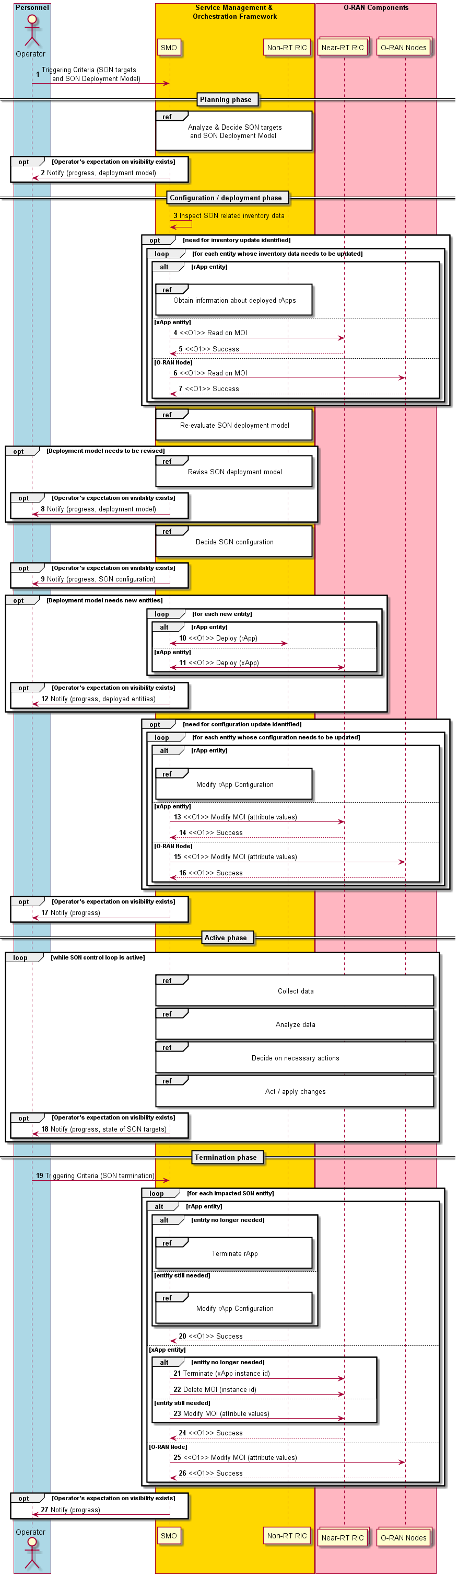
Figure 4.19.3.1-1: SON inventory and deployment management flow diagram

4.19.3.2 Self configuration (PCI conflict detection/resolution, ANR)
The context of the self configuration is captured in table 4.19.3.2-1.
Table 4.19.3.2-1: Self configuration
Use Case Stage | Evolution / Specification | <<Uses>>  Related use
Goal | Enable flexible deployment of the self configuration SON functions like PCI conflict detection/resolution, ANR by means of configuration parameter change, regulating RRM function actions and allowing AI/ML-based solutions.
Actors and Roles | - SMO acting as parameter configuration function.  - Non-RT RIC/ Near-RT RIC: Configuration decision making function.  - E2 node: Configuration enforcement function, and measurement reporting function.
Assumptions | - O1 interface connectivity between the SMO and E2 node, Near-RT RIC is established.  - E2 interface connectivity is established between E2 node and Near-RT RIC.  - A1 interface connectivity is established between Near-RT RIC and Non-RT RIC.  - Network is operational.
Pre-conditions | SMO has configured the SON functions and required initial parameters in the respective O-RAN nodes via SON inventory and deployment management as shown in clause 4.19.3.1.
Begins when | Operator enables the self configuration SON functions like PCI conflict detection/resolution, ANR and E2 node becomes operational.
Step 1a, 1b, 1c (O) | - Non-RT RIC initiates the specific measurement data collection request towards SMO and SMO towards E2 node for AI/ML model training and for analysis of data for optimization.  - E2 node sends the configured measurement data via O1 interface to SMO and Non-RT RIC retrieves the required data from SMO.
Step 2a, 2b, 2c, 2d, 2e, 2f (O) | - Non-RT RIC can train the AI/ML model with the collected data from O1 interface and constantly monitors the performance of the E2 node(s) for optimization.  - Based on the output of the AI/ML processing the Non-RT RIC can trigger modification of configuration parameters through SMO via O1 interface to E2 node.  - Optionally Non-RT RIC can also generate and send A1 policies for initiation of HO etc. to Near-RT RIC. Near-RT RIC converts the A1 policies to E2 actions and forwards them to E2 nodes.  - Non-RT RIC continues to monitor the performance of the E2 nodes and re-trains the AI/ML model in a loop.
Step 3a, 3b (O) | - Near-RT RIC initiates the specific measurement data collection request towards E2 node. Near-RT RIC can use the collected data for optionally AI/ML model training and for analysis of data for optimization.  - E2 node sends the configured measurement data via E2 interface to Near-RT RIC.
Step 4a, 4b, 4c, 4d (O) | - Near-RT RIC can train the AI/ML model with the collected data from E2 interface and constantly monitors the performance of the E2 node(s) for optimization.  - Upon trigger from the AI/ML processes, Near-RT RIC performs reconfiguration of parameters.  - Optionally Near-RT RIC can request initiation of certain E2 node actions like HO or cell reselection, etc.  - Near-RT RIC continues to monitor the performance of the E2 nodes and re-trains the AI/ML model in a loop.
Step 5 (O) | E2 node receives required inputs from SMO/Non-RT RIC and Near-RT RIC for execution of self configuration SON functions.
Step 6a, 6b (O) | - Based on the inputs received and the inputs from inbuilt RRM algorithm, E2 node reconfigures parameters related to self configuration.  - E2 node can initiate certain RRM actions like HO or cell reselection, etc.
Ends when | E2 node becomes non-operational or when the operator disables the self configuration SON functions.
Exceptions | One of the steps identified above fails.
Post Conditions | SMO/ Non-RT RIC, Near-RT RIC continues real time close loop optimization of self configuration SON functions.  The E2 node operates using the newly deployed parameters.
@startuml
skinparam ParticipantPadding 5
skinparam BoxPadding 10
skinparam defaultFontSize 12
Autonumber

@startuml
skin rose
skinparam ParticipantPadding 5
skinparam BoxPadding 10
skinparam lifelineStrategy solid

box "Service Management & \nOrchestration Framework" #gold
participant "SMO" as smo
Participant "Non-RT RIC" as nonrt
end box

box "O-RAN Components" #lightpink
participant “Near-RT RIC” as ric
collections “E2 Nodes” as e2node
endbox

note over smo #white: Operator configures \nSON Function deployment\nand initial SON Parameters
hnote over smo, e2node #white: Self Configuration SON Functions (PCI Conflict Detection/Resolution, ANR) is configured in Non-RT RIC/ Near-RT RIC or E2 Node \n via SON Inventory and Deployment Management procedure as shown in figure 4.19.3.1-1

alt Deployment Option 1
'group Self Configuration SON Functions in Non-RT RIC Loop
loop Until all SON Functions in Non-RT RIC are configured

smo->e2node: 1a. <<O1>> Data collection request for Self Configuration SON functions
e2node->smo: 1b. <<O1>> Data collection for Self Configuration SON functions
smo->nonrt: 1c. Data retrieval

nonrt->nonrt: 2a. AI/ML Model training and inference
nonrt->smo: 2b. Request for Reconfiguraton of \n Self Configuration SON Parameters
nonrt->e2node: 2c. <<O1>> Reconfiguration of Self Configuration related SON Parameters
opt
nonrt->ric: 2d. <<A1>> Send A1 policies related to \n Self Configuration related SON Functions
ric->e2node: 2e. <<E2>> Request E2 services corresponding to A1 policy
end
nonrt->nonrt: 2f. Performance monitoring \n and re-training
end
'end

else Deployment Option 2
'group Self Configuration SON Functions in Near-RT RIC Loop
loop Until all SON Functions in Near-RT RIC are configured

ric->e2node: 3a. <<E2>> Data collection request for Self Configuration SON functions
e2node->ric: 3b. <<E2>> Data collection for Self Configuration SON functions

ric->ric: 4a. AI/ML Model training and inference
ric->e2node: 4b. <<E2>> Reconfiguration of Self Configuration related SON Parameters
opt
ric->e2node: 4c. <<E2>> Request Initiation of RRM Actions like HO, Cell Reselection etc
end
ric->ric: 4d. Performance monitoring \n and re-training
end
'end

else Deployment Option 3
'group Self Configuration SON Functions in E2 Node Loop
loop Until all SON Functions in E2 Node are configured

hnote over smo, e2node #white: 5. Receive required inputs for executing Self Configuration SON Function from SMO/ Non-RT RIC/ Near-RT RIC

e2node->e2node: 6a. Reconfiguration of Parameters related \nto Self Configuration SON Function
e2node->e2node: 6b. Initiate RRM Actions like \nHO, Cell Reselection etc
end
end
@enduml

The flow diagram of the self configuration is shown in figure 4.19.3.2-1.

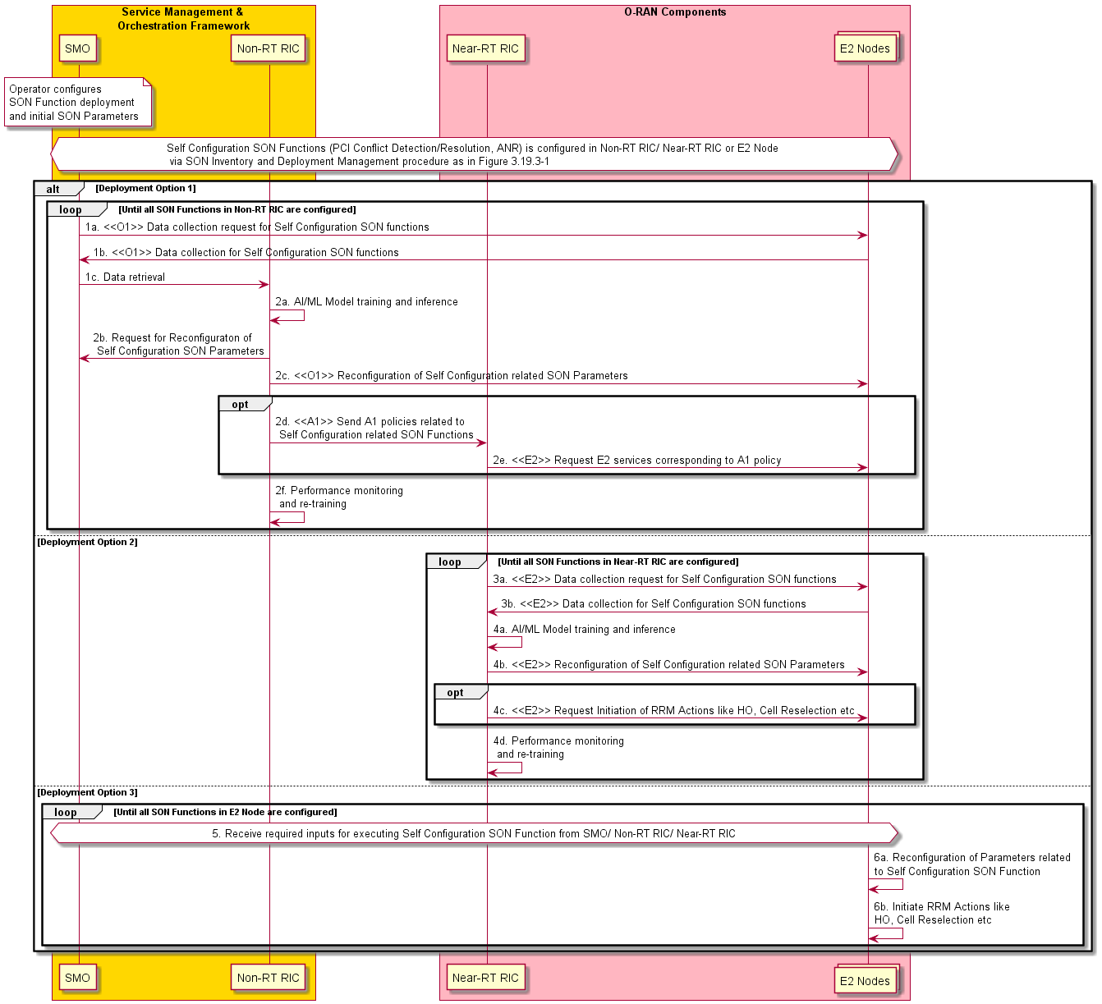Figure 4.19.3.2-1: Self configuration

4.19.3.3 Self optimization (MLB, MRO, CCO, RO)
The context of the self optimization is captured in table 4.19.3.3-1.
Table 4.19.3.3-1: Self optimization
Use Case Stage | Evolution / Specification | <<Uses>>  Related use
Goal | Enable flexible optimization of the self optimizing SON functions like MRO, MLB, CCO and RACH by means of configuration parameter change, regulating RRM function actions and allowing AI/ML-based solutions.
Actors and Roles | - SMO acting as parameter configuration function.  - Non-RT RIC/ Near-RT RIC: Self optimization decision making function.  - E2 node: Configuration enforcement function, and measurement reporting function.
Assumptions | - O1 interface connectivity between the SMO and E2 node, Near-RT RIC is established.  - E2 interface connectivity is established between E2 node and Near-RT RIC.  - A1 interface connectivity is established between Near-RT RIC and Non-RT RIC.  - Network is operational.
Pre-conditions | SMO has configured the SON functions and required initial parameters in the respective O-RAN nodes via SON inventory and deployment management as shown in clause 4.19.3.1.
Begins when | Operator enables the optimization functions for SON functions like MRO, MLB, CCO or RACH and E2 node becomes operational.
Step 1a, 1b, 1c (O) | - Non-RT RIC initiates the specific measurement data collection request towards SMO and SMO towards E2 node for AI/ML model training and for analysis of data for optimization.  - E2 node sends the configured measurement data via O1 interface to SMO and Non-RT RIC retrieves the required data from SMO.
Step 2a, 2b, 2c, 2d, 2e, 2f (O) | - Non-RT RIC can train the AI/ML model with the collected data from O1 interface and constantly monitors the performance of the E2 node(s) for optimization.  - Based on the output of the AI/ML processing the Non-RT RIC can trigger modification of configuration parameters through SMO via O1 interface to E2 node.  - Optionally Non-RT RIC can also generate and send A1 policies for initiation of HO etc to Near-RT RIC. Near-RT RIC converts the A1 policies to E2 actions and forwards them to E2 nodes.  - Non-RT RIC continues to monitor the performance of the E2 nodes and re-trains the AI/ML model in a loop.
Step 3a, 3b (O) | - Near-RT RIC initiates the specific measurement data collection request towards E2 node. Near-RT RIC can use the collected data to optionally train the AI/ML model and for analysis of data for optimization.  - E2 node sends the configured measurement data via E2 interface to Near-RT RIC.
Step 4a, 4b, 4c, 4d (O) | - Near-RT RIC can train the AI/ML model with the collected data from E2 interface and constantly monitors the performance of the E2 node(s) for optimization.  - Upon trigger from the AI/ML processes, Near-RT RIC performs reconfiguration of parameters related to self optimization.  - Optionally Near-RT RIC can request initiation of certain E2 node Actions like HO or cell reselection, etc.  - Near-RT RIC continues to monitor the performance of the E2 nodes and re-trains the AI/ML model in a loop.
Step 5 (O) | E2 node receives required inputs from SMO/Non-RT RIC and Near-RT RIC for execution of self optimization SON functions.
Step 6a, 6b (O) | - Based on the inputs received and the inputs from inbuilt RRM algorithm E2 node reconfigures parameters related to self optimization.  - E2 node can initiate certain RRM Actions like HO or cell reselection, etc.
Ends when | E2 node becomes non-operational or when the operator disables the optimization functions for SON functions like MRO, MLB, CCO or RACH.
Exceptions | One of the steps identified above fails.
Post Conditions | SMO/Non-RT RIC, Near-RT RIC continues real time close loop optimization of self optimization SON functions.  The E2 node operates using the newly deployed parameters.
@startuml
skinparam ParticipantPadding 5
skinparam BoxPadding 10
skinparam defaultFontSize 12
Autonumber

@startuml
skin rose
skinparam ParticipantPadding 5
skinparam BoxPadding 10
skinparam lifelineStrategy solid

box "Service Management & \nOrchestration Framework" #gold
participant "SMO" as smo
Participant "Non-RT RIC" as nonrt
end box

box "O-RAN Components" #lightpink
participant “Near-RT RIC” as ric
collections “E2 Nodes” as e2node
endbox

note over smo #white: Operator configures \nSON Function deployment\nand SON initial Parameters
hnote over smo, e2node #white: Self Optimization SON Functions (MRO/ MLB/ CCO/ RO) is configured in Non-RT RIC/ Near-RT RIC or E2 Node \n via SON Inventory and Deployment Management procedure as shown in figure 4.19.3.1-1

alt Deployment Option 1
'group Self Optimization SON Functions in Non-RT RIC Loop
loop While Self Optimization in Non-RT RIC is active

smo->e2node: 1a. <<O1>> Data collection request for Self Optimization SON functions
e2node->smo: 1b. <<O1>> Data collection for Self Optimization SON functions
smo->nonrt: 1c. Data retrieval

nonrt->nonrt: 2a. AI/ML Model training and inference
nonrt->smo: 2b. Request for Reconfiguraton of \n Self Optimization SON Parameters
smo->e2node: 2c. <<O1>> Reconfiguration of Self Optimization related SON Parameters
opt
nonrt->ric: 2d. <<A1>> Send A1 policies related to \n Self Optimization related SON Functions
ric->e2node: 2e. <<E2>> Request E2 services corresponding to A1 policy
end
nonrt->nonrt: 2f. Performance monitoring \n and re-training
end
'end

else Deployment Option 2
'group Self Optimization SON Functions in Near-RT RIC Loop
loop While Self Optimization in Near-RT RIC is active

ric->e2node: 3a. <<E2>> Data collection request for Self Optimization SON functions
e2node->ric: 3b. <<E2>> Data collection for Self Optimization SON functions

ric->ric: 4a. AI/ML Model training and inference
ric->e2node: 4b. <<E2>> Reconfiguration of Self Optimization related SON Parameters
opt
ric->e2node: 4c. <<E2>> Request Initiation of RRM Actions like HO, Cell Reselection etc
end
ric->ric: 4d. Performance monitoring \n and re-training
end
'end

else Deployment Option 3
'group Self Optimization SON Functions in E2 Node Loop
loop While Self Optimization in E2 Node is active

hnote over smo, e2node #white: 5. Receive required inputs for executing Self Optimization SON Functions from SMO/ Non-RT RIC/ Near-RT RIC

e2node->e2node: 6a. Reconfiguration of Parameters related \nto Self Optimization SON Functions
e2node->e2node: 6b. Initiate RRM Actions like \nHO, Cell Reselection etc
end
end
@enduml

The flow diagram of the self optimization is given in figure 4.19.3.3-1.

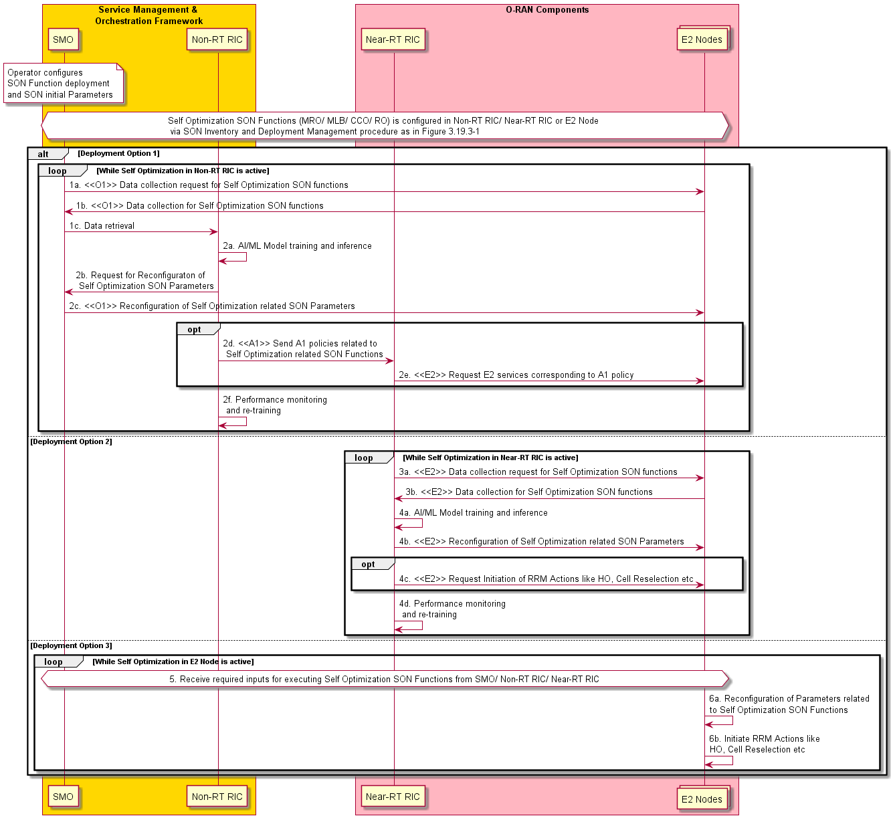
Figure 4.19.3.3-1: Self optimization

4.19.4 Required data

4.19.4.1 Self configuration (PCI conflict detection/resolution, ANR)
1) SMO
- Network topology, GPS coordinates of the E2 nodes, PCI allocation range as inputs from operator
- Information on PCI confusion or PCI conflict from E2 node via O1 interface
- Neighbor information (PCI, ECGI, PLMN, TANAC, TAC, frequency bands) based on network topology as input from operator
2) Non-RT RIC/Near-RT RIC and E2 node
- 3GPP RRC measurement reports with PCI information of the neighboring cells via E2 interface
- PCI allocation range via O1 interface from SMO
- Information on PCI confusion or PCI conflict from E2 node via O1 interface
- Neighbour cell relation table information of the neighboring cells via E2 interface
- 3GPP XN, X2 and NG mobility related messages via E2 interface from E2 node

4.19.4.2 Self optimization (MLB, MRO, CCO, RO)
1) Non-RT RIC/Near-RT RIC and E2 node
- MLB - Load reports from Xn/X2/F1/E1 interface resource status reporting procedures and Xn, X2 and NG mobility messages defined in 3GPP via E2 interface from E2 node.
- MLB - HO trigger control parameters available as specified in 3GPP TS 28.313 [20], clause 7.1.5 to E2 node via E2 interface or O1 interface.
- MRO - Xn, X2 and NG HO reports, RLF reports, NG uplink and downlink RRC transfer messages, UE history information, coverage, and quality information and XN/NG/X2 mobility related messages defined in 3GPP via E2 interface from E2 node.
- MRO - HO target and control parameters available as specified in 3GPP TS 28.313 [20], clause 7.1.2 to E2 node via E2 interface or O1 interface.
- CCO – RLF, MDT, measurement reports and RCEF related reports defined in 3GPP via E2 interface from E2 node.
- CCO related control parameters and control information available as specified in 3GPP TS 28.313 [20], clause 7.2.3 to E2 node via E2 interface or O1 interface.
- RACH optimization – PRACH parameters available over XN/X2 interface, contention detection per RACH attempt, number of RACH preambles per SSB, information on SSB threshold per RACH attempt defined in 3GPP via E2 interface from E2 node.
- HO target and control parameters available as specified in 3GPP TS 28.313 [20] to E2 node via E2 interface or O1 interface.

4.20 Shared O-RU

4.20.1 Background and goal of the use case

4.20.1.1 Common aspects & background for all Shared O-RU use cases
This use case provides the background, motivation, and requirements for the lower layer split multi node support, allowing to share an O-RU between multiple O-DU nodes, including single operator and multi-operator use cases.
Shared O-RU use cases deliver a range of different benefits depending on specific scenarios. Shared O-RU support for Single-MNO use cases delivers important resiliency and load balancing capabilities. Shared O-RU support for multiple-MNO use cases delivers important network sharing capabilities to complement established MOCN, MORAN and DAS approaches.
Shared O-RU use cases cover the class 2 BBU pooling specified in clause 4.18.
Shared O-RU use cases are associated with RAN sharing use case. In particular, RAN sharing depicts a Shared O-RU configuration, specified in clause 4.7.
Shared O-RU feature also serves to support the Multi-Vendor (MV) network slicing use case, its operation, and scenarios, specified in clause 4.10. Multi-vendor network slicing has implications to the front-haul as well. The multi-vendor slicing use case will use dynamic resource allocation aspects of the Shared O-RU feature.
The following sub-clauses describe different configurations and deployment scenarios for Shared O-RU. They also describe use cases to accomplish key functionality such as a resiliency use case.
The Shared O-RU will have common solutions that span the sub-use cases. The clauses that follow describe different aspects, configurations, and deployment scenarios for Shared O-RU; however, they will likely share common solutions which are described in the solution clause.
Expected use cases that accomplish a purpose between actors comprise the sub-use cases: such as software upgrade of a Shared O-RU, start up of a Shared O-RU, recovery from failed primary O-DUs that are sharing a O-RU, rehoming of a Shared O-RU in a network.
State management:
The Shared O-RU supports lock/unlock operations (administrative state) of a Shared O-RU administrative state management and these are used throughout the sub-use cases. State management of administrative, operation and availability state are specified in ITU-T X.731 [18] and in 3GPP TS 28.624 [9], in 3GPP TS 28.625 [10] (for all classes in the NRM), and in 3GPP TS 28.626 [11]. Some of the sub-use cases can use them, some cannot. Role-based admission control. The host can change administrative state of the O-RU while the tenant cannot. The Shared O-RU sub-use cases shall be as specified in RFC 8348 [19] which is similar to what is specified in ITU-T X.731 [18].

4.20.1.2 Resource portioning use case of Shared O-RU for Single-MNO
This sub-use case describes the procedures of how to decide on the partitioning of a Shared O-RU. The actors are the sharing co-ordinator, SMO, and the resource partitioning rApp (Shared O-RU). The sharing co-ordinator recovers the inventory from the SMO and decides on how to partition the resources of a Shared O-RU. The sharing co-ordinator uses the rApp to partition the resources of a Shared O-RU between multiple O-DUs. The outcome is that rApp has details on how a Shared O-RU’s resource are to be partitioned.

4.20.1.3 Start-up use case of a Shared O-RU for Single-MNO
This sub-use case describes the start-up of a Shared O-RU. The actors are the SMO, the O-DUs, the Shared O-RU, and their interactions that are needed for a Shared O-RU to boot up and enter into operation. The outcome is that the Shared O-RU is operating with the necessary software version and has established network connectivity with the O-DUs and, for hybrid deployments, the SMO. The start-up for a Shared O-RU is the basis of the other Shared O-RU sub-use cases.

4.20.1.4 Configuration use case of a Shared O-RU for Single & Multi-MNO
This sub-use case describes the configuration of a Shared O-RU. The configuration is invoked after the start-up use case has completed. Configuration can occur with different actors in hybrid vs hierarchical management mode. The common aspects of the Shared O-RU configuration are configured by the O-DU when in hierarchical management mode and by the SMO in hybrid management mode. The common aspects include the security, operational, transmission, and connectivity related parameters. The O-DUs are always responsible for configuring the partitioned carrier information on the Shared O-RU through the open front-haul interface. The use case enables the SMO to be notified of the configured carrier parameters.
This sub-use case includes the configuration of multi-operator role-based access control (configuration) for the management sessions associated with a tenant operator. The Shared O-RU uses the PLMN-Id associated with the management account and used in other aspects of the Shared O-RU’s configuration to prevent a tenant from reading configuration associated with a second tenant’s partitioned resources or subscribing to performance measurements associated with a second tenant’s partitioned resources.
This sub-use case also describes the procedures of how a sharing co-ordinator can confirm that a tenant operator is complying with the sharing agreements that cover operation of a Shared O-RU.
The outcome is that the Shared O-RU has been configured with the configuration parameters necessary for operation.

4.20.1.5 Supervision use case of a Shared O-RU for Single-MNO
This sub-use case applies to the running/operation of Shared O-RU.
This sub-use case describes the supervision operations of the Shared O-RU. This sub-use case is triggered after the O-DUs have configured the partitioned carrier information of a Shared O-RU. It is invoked during run-time. The actors are the SMO, O-DUs, and Shared O-RU. The objective that the use case accomplishes is the establishment of watchdog supervision of the Shared O-RU by multiple O-DUs. Supervision enables the Shared O-RU to autonomously cease transmitting on a partitioned carrier if it loses supervision with the O-DU responsible for that carrier.

4.20.1.6 Performance management use case of a Shared O-RU for Single-MNO
This sub-use case applies to the running/operation of Shared O-RU.
This sub-use case describes the performance management operations of the Shared O-RU. This sub-use case is triggered after the O-DUs have configured the partitioned carrier information of a Shared O-RU. It is also invoked during run-time. The actors are the O-DUs, and Shared O-RU. The objective that the use case accomplishes is for each O-DU to establish subscriptions to receive performance management notifications regarding operation of the fronthaul between the O-DUs and Shared O-RU.
The sub-use case also describes how performance management logs, data and files are passed from the Shared O-RU to the connected O-DUs and data from O-DUs to SMO. Performance measurement data should be supported in three basic ways by the O-DU:

- Active push by a producer (O-DU) – A producer (O-DU) could push performance data to a consumer (SMO).
  - Streaming – A persistent connection between consumer & producer exists without having to renegotiate between the data reports to send a steady flow of data. This is like 3GPP performance streaming reporting (as specified in 3GPP TS 28.532 [21], clause 11.5). Once the WebSocket is opened, the meta-data about the streams is exchanged, and the consumer can then receive the serialized data.
  - Event notifications – Performance measurement information sent by event notifications will reestablish a new connection between a consumer and producer for each data reporting. This is how 5GC SBA works (as specified in 3GPP TS 23.501 [2] and in 3GPP TS 23.502 [22] services). The data is sent as a payload of a notification.
- Active collection by a consumer – The consumer (SMO) could also actively collect data from a producer (O-DU).
  - Configuration management read only attributes – Reuse of configuration management approach where attribute conveying the value of performance data is read by the consumer like any other configuration management attribute.
  - Data scraping – Use of data scraping common to cloud native implementations where a collector reads the data from a pre-defined URI.
- File-based reporting – File based reporting is used for low-priority or background collection for large amounts of performance data.
  - File upload by producer – In this method, there is no artificial delay, the data is reported whenever it is available. However, it involves action by the producer.
  - File download by consumer – It removes the burden from the producer, but relies upon either periodic polling, or file ready notification from the producer about the data being ready for download. This is how 3GPP file-based reporting works as specified in 3GPP TS 28.532 [21], clause 11.6 and in ETSI GS NFV IFA008 [24] and ETSI GS NFV IFA013 [23] specifications.

For the Shared O-RU:
- Active push by Shared O-RU (producer) – The Shared O-RU pushes performance data to the O-DU.
  - Event notifications – The Shared O-RU sends performance measurement information through event notifications to the O-DU by establishing a new connection for each data reporting session.
- Active collection by O-DU (consumer) – The O-DU can actively collect data from the Shared O-RU.
  - Attributes - The performance data is read by the O-DU. The O-DU can invoke a Remote Procedure Call (RPC) towards O-RU giving the O-RU all information it needs to send PM file. Then, the O-RU acts as sftp client and performs file upload to pointed to location.

NOTE 1: The Shared O-RU does not support streaming-based reporting.
NOTE 2: The Shared O-RU cannot act as a sftp server but can act as a sftp client. Thus, the Shared O-RU can upload files to a designated location.

4.20.1.7 Antenna Line Device (ALD) control use case of a Shared O-RU for Single-MNO
This sub-use case applies to the running/operation of Shared O-RU.
This sub-use case describes the operation of antenna line devices with the Shared O-RU. This sub-use case is triggered after the O-DUs have configured the partitioned carrier information of a Shared O-RU. The actors are one of the O-DUs, and Shared O-RU. The objective that the use case accomplishes is for the selected O-DU to operate the ALD controller and control the ALD connected to the Shared O-RU.
ALD control is an end-to-end operation from the operator using the SMO at one end issuing operations to the O-DU and realising that ALD operation through the O-RU on through to the terminating ALD device at the other end.
Because there is a single ALD controller, and the Shared O-RU can be connected to multiple O-DUs, one of them needs to be nominated as the ALD controller.
There are many types of operations for ALD control. These include but not limited to software update of ALD devices, setting of RET mechanical/electrical tilt setting, reset of ALD devices, etc.

4.20.1.8 Basic resiliency use case (active O-DU failure) for Single-MNO
This sub-use case describes system recovery from a failure (operational state = disabled) of the active O-DU#1 or O-DU switchover may be triggered by SMO in reactions to failure or due to operator’s activity for a Shared O-RU in Single-MNO deployment. A switch of the active O-DU to standby O-DU is done. This sub-use case only applies to the hierarchical management of the O-RU.
The actors are the SMO, O-CU, O-DUs, and Shared O-RU. The actors work together to recover operation from O-DU(s) failures.
This basic resiliency sub-use case, covers failure of the active O-DU#1 that is unable to provide service. For example, when SMO detects that O-DU is out of service, the SMO assumes operational state for such O-DU as “disabled” and triggers recovery action for cells served by such O-DU. This use case covers a flow of operations that occurs in this situation.
This use case is triggered when the active O-DU fails (operational state = disabled).
This use case describes the switch-over of the other O-DU to become the new active O-DU.

4.20.1.9 Antenna calibration sub-use case of a Shared O-RU for Single-MNO
This sub-use case applies to the running/operation of Shared O-RU.
This sub-use case describes the operation of antenna calibration using a Shared O-RU. This sub use case is triggered after the O-DUs have configured the partitioned carrier information of a Shared O-RU. The actors are the O-DUs, and Shared O-RU. The objective that the use case accomplishes is for the Shared O-RU to be able to perform antenna calibration when connected to multiple O-DUs.
It is typically initiated from the Shared O-RU when it detects that antenna calibration is necessary, which then sends a notification to the O-DU.
If supported by the O-RU, the O-DU may also set an automatic antenna calibration setting which enables the Shared O-RU to automatically perform antenna calibration.

4.20.1.10 Rehoming use case of a Shared O-RU for Single-MNO
This sub-use case describes how a Shared O-RU is rehomed within a network and paired with new parent O-DUs. Rehoming is the process of associating new management (parent) O-DUs with a Shared O-RU. This might be a virtual rehoming in a cloud native deployment, management-requested parent rehoming, or a physical move of the Shared O-RU whereby the Shared O-RU is connected and communicating to new parent O-DUs.
Rehoming is typically done deliberately. Resiliency flows has some similarity to the rehoming flow; however, the difference is that resiliency is a reaction to a fault in the system, whereas rehoming is typically a planned activity.
Some typical reasons why rehoming is done is as follows:
- Replanning or changing a network – Altering a network resulting from physical construction work or network optimization may cause an MNO to replan their network necessitating a Shared O-RU to rehome.
- New greenfield network – When a new greenfield pocket deployment is created within a brownfield deployment rehoming might happen.
- Service management-level operations – The MNO may trigger a rehoming operation for the Shared O-RU which can happen for a variety of purposes.
- Physical move a Shared O-RU – The Shared O-RU is physically moved from one location to another.
- Evolving a network – The site might be changed from a non-Shared O-RU configuration to a Shared O-RU configuration which will require rehoming as at least there is a new second O-DU now connected to the O-RU.
- Partnership with a new MNO – Changing from a Single-MNO type configuration to a Multi-MNO configuration may require the Shared O-RU to be rehomed.
- Maintenance activities – When troubleshooting a failure, or other various maintenance activities may cause a Shared O-RU to be rehomed.
- Parent failure – The failure of a parent O-DU(s) may result in rehoming of a Shared O-RU being necessary.
To illustrate an example of rehoming, suppose there is a Shared O-RU with identity #700 that currently exists in an edge cloud with CloudID #20 with parents, O-DU #1 and O-DU #2. And it is physically moved to a different edge cloud CloudID #900 and then subsequently reconnected to new different parent O-DUs, O-DU #19 and O-DU #24. Rehoming is a software-based operation, however, to physically move a Shared O-RU would also require the associated physical front-haul connections to be made.
O-CUs and O-DUs can also be rehomed to new management entities (SMO). However, this sub-use case will only focus on when a Shared O-RU is rehomed to new O-DU parents. There are two basic forms of rehoming, one that is a physical move of the Shared O-RU and other is a deliberate management level operation:

Physical rehoming – In this kind of rehoming, the Shared O-RU is physically moved from one location to another. There are two cases where after the physical move, the Shared O-RU has either new O-DU parents or stays with the original O-DU parents. For a Shared O-RU this means that the front-haul connections will be separated and reconnected. This may also entail LCM operations, where a Shared O-RU is decommissioned and then subsequently recommissioned and reinstalling with new parent O-DU. These would fall into common LCM operations. Physical rehoming can also happen during maintenance operations, where a Shared O-RU might be disconnected and reconnected to new parent O-DUs for a variety of reasons.

Management initiated rehoming – Management initiated and coordinated rehoming of a Shared O-RU is when the Shared O-RU is given new O-DU parents done at the SMO. This may happen for a variety of reasons and is expected to be an intentionally planned activity. The management entity of the Shared O-RU may be the O-DU in the hierarchical case or SMO in a hybrid configuration. The new parent O-DU may have different carrier support, capabilities, and capacities of than the former parent; for example, it might be more energy efficient with less capabilities or it might an expanded more powerful O-DU.

4.20.1.11 Reset use case of a Shared O-RU for Single-MNO
The reset of a Shared O-RU sub-use case describes the operations related to taking a Shared O-RU out of service and resetting it.
There are some important aspects to reset of Shared O-RU. Only the Shared O-RU host would have permissions to perform the reset operation.
In a multiple MNO configuration, reset operations would need to be coordinated between operators. The Shared O-RU host operator has the permission to perform the reset of a Shared O-RU. It would expect that the Shared O-RU host operator would try to coordinate with the Shared Resource Operator (SRO). This can entail something as simple as those two operators talking to each other; it can also entail automated coordination between management entities of these operators. The reset of a Shared O-RU would impact Availability, Reliability, and Maintenance (ARM) metrics, and uptime KPIs.
The reset of a Shared O-RU operation is the basis for maintenance activities, debugging operations, the physically moving, physical rehoming, and recovery from malfunctions of the Shared O-RU.
There are situations where the Shared O-RU would autonomously reset itself. When the Shared O-RU has lost M-plane connectivity to all of its connected O-DUs the Shared O-RU would autonomously reset itself. This would be the same as if the O-RU was not in a shared configuration.
A software update will result in a reset of the Shared O-RU. The software update of a Shared O-RU is expected to be coordinated between the Shared O-RU host and the SRO.
Before removing the Shared O-RU from service, the Shared O-RU carriers and its associated cells on O-DU/O-CU shall be deactivated.

4.20.1.12 Advanced resiliency sub-use cases of a Shared O-RU for Single-MNO
Advanced resiliency sub-use cases provide descriptions for the resiliency operations where any of O-DUs or Shared O-RU have either partially failed (for instance, when the availability status is “degraded” for any of them), completely failed (when the operational state is ”disabled”), or when there are failures detected in the interfaces (like the FH-C/U/S/M plane, F1, E2, and O1).

The key actors in this scenario are the SMO, O-CU, O-DUs, and Shared O-RU. These entities may collaborate to recover or maintain operations in the event of partial O-DU(s) failures, software issues, interface disruptions, power outages, connectivity failures, and loss of synchronization.
This use case shall be triggered when at least one of the aforementioned failures occurs in the network.

4.20.1.13 Load-balancing sub-use case of a Shared O-RU
Load-balancing is a use case where relevant actors can reallocate Shared O-RU resources based on triggers, metrics, or policies.
A key actor is a policy-enforcer that makes Shared O-RU resource allocation decisions based on inputs from measurements. For example, measurements can indicate the amount of traffic on each of the two O-DUs connected to the Shared O-RU. The policy-enforcer decides when a reallocation of Shared O-RU resources is needed. For example, if the policy-enforcer observes that one O-DU has a disproportionate amount of traffic (e.g., more users per MHz) than the other O-DU, the policy-enforcer makes a decision to re-allocate a component carrier from one O-DU to the other O-DUs.
The policy-enforcer role could be played by the SMO/Non-RT RIC or the Near-RT RIC, depending on the time granularity of load balancing decision-making needed. There are limitations that are governed from the air interface which will influence the mechanisms and time granularity for load balancing. Policies can reflect a variety of triggers or mechanisms to be used to balance traffic or carriers. These might include guaranteed bandwidth, O-DU computational load/capacity (processor occupancy), and time of day triggers among others. Whatever the policy rules are and how often they are evaluated, the policy-enforcer would evaluate the situation, probably periodically, and make a resource re-allocation decision.

4.20.1.14 Coordinated reset of a Shared O-RU sub-use case for Multi-MNO
The coordinated reset of a Shared O-RU sub-use case describes the operations related to resetting a Shared O-RU when there are multiple Shared Resource Operator (SRO) O-DUs connected to the Shared O-RU.
In a multiple MNO configuration, reset operations would need to be coordinated between operators. The active Shared O-RU Host (SOH) operator coordinates the reset of a Shared O-RU. The definition of the active SOH is a SOH that has a state = active. The active SOH can perform a reset on its own volition. The active Shared O-RU Host (SOH) coordinates the reset operation; thus, the SROs can request a reset of the Shared O-RU to be performed by the active SOH. So, the active SOH approves or rejects a reset request of the Shared O-RU coming from other SROs. If the request is accepted by the active SOH, the x would inform all the other SROs x. Then the SOH would perform the reset of the Shared O-RU. If the SOH rejects the operation, then the SOH that originated the SRO that the command was rejected. The SOH can reject a command for example in the middle of a software update or other possible conditions that might prohibit a reset. The reset of a Shared O-RU would impact availability, reliability, and maintenance (ARM) metrics, and uptime KPIs.
The reset of a Shared O-RU operation is the basis for maintenance activities, debugging operations, the physically moving, physical rehoming, and recovery from malfunctions of the Shared O-RU.
Before removing the Shared O-RU from service, the Shared O-RU carriers and its associated cells on O-DU/O-CU shall be deactivated.
The reset of a Shared O-RU is a “hard reset”.
There can be other variations of coordinated reset of a Shared O-RU possibly based on a policy.

4.20.1.15 Management of Shared O-RU during O-DU software update sub-use case for Shared O-RU for Single & Multi-MNO
As part of WG6 Cloudification and Orchestration Use Cases and Requirements for O-RAN, a generic case of software upgrade of network function is described. In the practical implementation context, a variety of strategies are incorporated for updating the network function with a new software version, with the objective of minimizing the impact of modifications and mitigating any disruptions to the overall service delivered to end users. These strategies include well-established practices such as Canary update, Rolling update, Blue/Green update etc. The choice of a specific approach relies on various factors such as the extent of the changes, the associated risk potential, and the cost of incorporating the change. Moreover, such changes necessitate careful consideration of dependencies and the need to re-provision and optimize resources accordingly. Furthermore, it is crucial to incorporate contingency/mitigation plans in the event that the software update does not align with the intended plan for implementing the changes.
This sub-use case focuses on the management of Shared O-RU during the software update of O-DU. It is a critical consideration for Shared O-RU, particularly when O-RU resources are shared between the updated O-DU and existing O-DUs. To address this, well-defined procedures are necessary to identify the specific O-RU that can be shared, determine the particular O-DU with which the O-RU resources can be shared, and optimize the shared resources effectively. Prior to the software update, it can be essential to identify the candidate O-DU and associated O-RU resources that requires evacuation, thereby necessitating the provisioning of target RAN nodes. Moreover, in the event of performance degradation or negative impact on performance indicators following the completion of O-DU software update and activation, it is essential to establish efficient risk mitigation strategies and evaluate possibility of rolling back the introduced changes.
Here the consideration of the Shared O-RU arises from the need to minimize the impact of the software update of O-DU. This is achieved by validating the update with minimal traffic or allocating minimal resources, thereby effectively reducing the footprint of affected end users. Utilizing a Shared O-RU effectively fulfils this objective which otherwise can require deployment of dedicated O-RUs solely for validating the O-DU software update. An additional aspect to be considered is the prevention of Shared O-RU restart following a software update at the O-DU level. This is particularly relevant as a software update on the O-DU can entail the establishment of m-lane connections and initiation of the call home procedure, both of which typically require an O-RU restart to be initiated.
A high-level view of the software update scenario of O-DU wherein the software (SW) updated O-DU shares the O-RU resources with an existing O-DU is shown in figure 4.20.1.15-1.
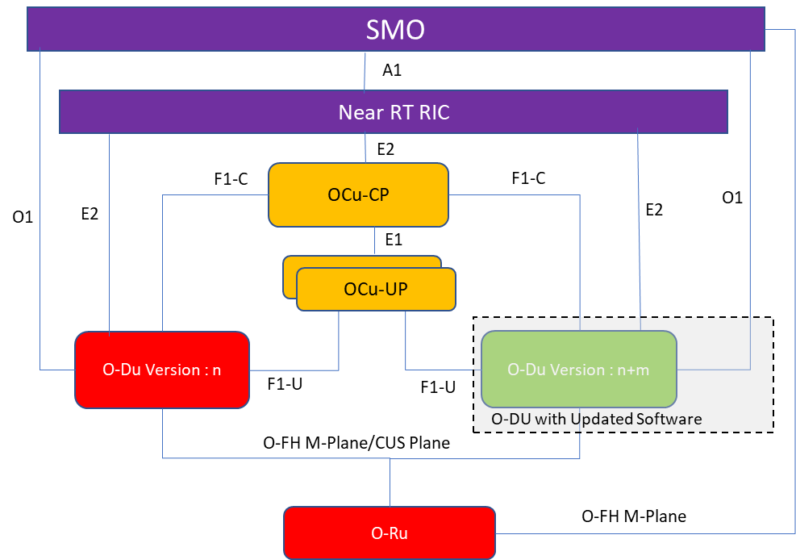
Figure 4.20.1.15-1: Shared O-RU management scenario during O-DU software update
Shared O-RU management scenario during O-DU software update follows a high-level approach as given below:
- Selection of O-DU node for software update based on inventory, FM/PM data
- Deployment and call-home procedures of O-DU
- O-DU registration with O-CU, Near-RT RIC
- Common aspect provisioning on Shared O-RU (e.g., ODU-ID, User account) based on SW updated O-DU
- Selection of the policy for load sharing (e.g., load balancing policy, or selection based on cells having low priority user sessions, S-NSSAI, anticipated traffic, etc.) with the SW updated O-DU
- O-RU initiates m-plane connection establishment with SW updated O-DU
- Translation of the load sharing policy to O-RU configuration
- Inactivation and evacuation of component carriers selected for allocation to SW updated O-DU
- Provisioning of O-RU with carrier configuration details by SW updated O-DU (e.g., end points, list entries)
- Activation of carrier configuration associated with SW updated O-DU
- Initiate KPI and functional log monitoring of SW updated O-DU and associated O-RU resources
- O-DU SW update mitigation : In case of degraded KPIs reverse SW update process of O-DU
It is to be noted that this sub-use case does not differentiate based on the extent of change introduced to the O-DU through the software upgrade because it primarily depends on the implementation context.
This use case does not enforce a specific policy for the SW update as this depends on the particular deployment and implementation choice. Such policies are typically incorporated to define the rules, control logic, constraints, and thresholds to be considered during the particular change being initiated. As an example, if an implementation scenario calls for such flexibility, the component carrier shifting could be omitted by utilizing appropriate SW update policy and limit only to the general health check after O-DU SW update.
This use case introduces couple of new actors such as O-DU SW change management rApp. An O-DU SW update lifecycle can be managed using these optional functions or using appropriate implementation specific extensions of SMO function.
Currently this use case considers only single operator Shared O-RU scenario. The impact of SW update on multi-operator Shared O-RU scenarios is not in scope of the current version of this sub-use case.

4.20.1.16 Resource partitioning sub-use case for Multi-MNO configuration
This sub-use case describes the procedures of how to decide on the partitioning of a Shared O-RU in a Multi-MNO configuration where one O-DU belongs to an owner operator (MNO) and at least one other O-DU belongs to a participating operator (MNO). The actors are the owner operator MNO sharing co-ordinator, the participating operator MNO sharing co-ordinator, the owner operator SMO, the participating operator MNO SMO, the owner operator resource partitioning rApp, and participating operator MNO resource partitioning rApp. The owner operator MNO sharing co-ordinator retrieves the inventory from the owner operator SMO and decides on how to partition the resources of a Shared O-RU. The owner operator MNO sharing co-ordinator uses the owner operator resource partitioning rApp to partition the resources of a Shared O-RU between multiple O-DUs. The outcome is that the owner operator resource partitioning rApp has details on how a Shared O-RU’s resource are to be partitioned.

4.20.1.17 Start-up sub-use case of for Multi-MNO configuration
This sub-use case describes the start-up of a Shared O-RU in a Multi-MNO configuration where one O-DU belongs to an owner operator (MNO) and at least one other belongs to a participating operator (MNO). The actors are the owner operator SMO, participating operator SMO, the connected O-DUs, the Shared O-RU, and their interactions that are needed for a Shared O-RU to boot up and enter into operation. The outcome is that the Shared O-RU is operating with the necessary software version and has established network connectivity with the O-DUs and, for hybrid deployments, the corresponding SMOs. The start-up for a Shared O-RU is a basis for some of the other Shared O-RU sub-use cases.

4.20.1.18 Supervision sub-use case for Multi-MNO configuration
This sub-use case applies to the running or operation of Shared O-RU in a Multi-MNO configuration where one O-DU belongs to an owner operator (MNO) and at least one O-DU belongs to a participating operator (MNO).
This sub-use case describes the supervision operations of the Shared O-RU. It is triggered after the connected O-DUs have configured the partitioned carrier information of a Shared O-RU. It is invoked during run-time. The actors are the owner operator SMO, participating operator SMO, the connected O-DUs, and Shared O-RU. The objective that the use case accomplishes is the establishment of watchdog supervision of the Shared O-RU by multiple O-DUs. Supervision enables the Shared O-RU to autonomously cease transmitting on a partitioned carrier if it loses supervision with the O-DU responsible for that carrier.

4.20.1.19 Antenna Line Device (ALD) control sub-use case for Multi-MNO configuration
This sub-use case applies to the running or operation of Shared O-RU in a Multi-MNO configuration where one O-DU belongs to an owner operator (MNO) and at least one other belongs to a participating operator (MNO).
This sub-use case describes the operation of Antenna Line Devices (ALD) with the Shared O-RU. This sub-use case is triggered after the connected O-DUs have configured the partitioned carrier information of a Shared O-RU. The actors are one of the O-DUs, and Shared O-RU. The objective that the use case accomplishes is for the selected O-DU to operate as the ALD controller and control the ALD connected to the Shared O-RU.
ALD control is an end-to-end operation from a technician using the owning operator or participating operator SMO at one end issuing operations to the O-DU and realising that ALD operation through the O-RU on through to the terminating ALD device at the other end.
Because there is a single ALD controller, and the Shared O-RU can be connected to multiple O-DUs, one of them needs to be nominated as the ALD controller. It is expected that an O-DU of the owning operator would be the ALD controller (but not necessarily).
There are many types of operations for ALD control. These include but not limited to software update of ALD devices, setting of RET mechanical/electrical tilt setting, TMA updates, reset of ALD devices, etc.
NOTE: Only the host O-DU (of the owner operator) can control the ALD and the participating operator O-DU would not be able to control the ALD devices.

4.20.1.20 Antenna calibration sub-use case for Multi-MNO configuration
This sub-use case applies to the running or operation of Shared O-RU in a Multi-MNO configuration where one O-DU belongs to an owner operator (MNO) and at least O-DU other belongs to a participating operator (MNO).
This sub-use case describes the operation of antenna calibration using a Shared O-RU. This sub-use case is triggered after the O-DUs have configured the partitioned carrier information of a Shared O-RU. The actors are the connected O-DUs, and Shared O-RU. The objective that the use case accomplishes is for the Shared O-RU to be able to perform antenna calibration when connected to multiple O-DUs.

4.20.1.21 Rehoming use case of a Shared O-RU for Multi-MNO
This is rehoming the Shared O-RU in a Multi-MNO configuration where different O-DU (parents of the Shared O-RU) are now under the management of different MNOs. Some considerations among others in the Multi-MNO configuration are that there might be different configuration, security concerns, role based access privileges, physical security, coordination between the two MNOs technicians when performing maintenance activities that require rehoming the Shared O-RU.

For the Multi-MNO configuration, the three basic forms of rehoming, physical rehoming where the Shared O-RU is physically moved (with original O-DU parents or new O-DU parents), and management initiated rehoming caused from management level planned activities still apply to the Multi-MNO case.

4.20.1.22 Performance management use case of a Shared O-RU for Multi-MNO
This sub-use case applies to the running/operation of Shared O-RU.
This sub-use case describes the performance management operations of the Shared O-RU in a Multi-MNO configuration. Here the Shared O-RU is connected to O-DUs that are owned by different MNOs. This sub-use case is triggered after the O-DUs have configured the partitioned carrier information of a Shared O-RU. It is also invoked during run-time. The actors are the O-DUs, and Shared O-RU. The objective that the use case accomplishes is for each O-DU to establish subscriptions to receive performance management notifications regarding operation of the fronthaul between the O-DUs and Shared O-RU.
The sub-use case also describes how performance management logs, data and files are passed from the Shared O-RU to the connected O-DUs and data from O-DUs to SMO. Performance measurement data and telemetry information should be supported in three basic ways.
The same mechanisms described in performance measurement reporting for Single-MNO are also supported in a Multi-MNO configuration. The O-DU supported active push through streaming and event notification methods. The O-DU supports active collection by a consumer through attribute based and data scraping. The O-DU supports file-based reporting. The Shared O-RU supports active push through event notifications and active collection from O-DU via RPC and sftp. See clause 4.20.1.6 for further details. The main difference between the Single-MNO configuration and the Multi-MNO configuration is that there are additional considerations for sending performance information to two different mobile network operators. This entails aspects of security and support for different subscription filters. As such, two MNOs may want different collected data, may have different security controls based on role-access, different subscription filters and session operation. For example, one MNO might employ NetConf and another MNO Virtual Event Streaming (VES) messaging.

4.20.1.23 Antenna calibration sub-use case of a Shared O-RU for Multi-MNO
This sub-use case applies to the running/operation of Shared O-RU. This sub-use case describes the operation of antenna calibration using a Shared O-RU in a Multi-MNO configuration. This sub-use case is triggered after the O-DUs have configured the partitioned carrier information of a Shared O-RU. The actors are the O-DUs, and Shared O-RU. The objective that the use case accomplishes is for the Shared O-RU to be able to perform antenna calibration when connected to multiple O-DUs in a Multi-MNO configuration.
This sub-use case is essentially the same as for the Single-MNO configuration except the O-DUs which are connected to different operators may coordinate.

4.20.1.24 Dynamic resource shifting
Dynamic resource shifting is a Shared O-RU sub-use case related to how resources are moved to achieve improvements in performance. In this case, the resources that are shifted are fractions of radio spectrum utilized by cells. These resources correspond to PRBs and can be dynamically addressed by bandwidth parts. See 3GPP TS 38.211 [13], clause 4.4.5.
This sub-use case describes how radio spectrum resources can be shifted between cells that use overlapping spectrum and are served by Shared O-RU. This is performed automatically and dynamically (autonomously) without the need to perform time-consuming cell reconfiguration process.
The process of dynamic resource shifting is controlled by Near-RT RIC based on traffic-related KPIs or operator-defined parameters. Exact triggers for RIC to request for dynamic resource shifting are out of scope of this specification.
Important drivers for this use case are as follows:
- The use case shall deliver truly dynamic frequency resource shifting between cells.
- The use case shall preserve power consumption usage at the UE level.
- The use case shall utilize existing radio link control procedures.

4.20.1.25 Static resource shifting use case for Single-MNO
The Shared O-RU resource shifting use case describes how cell(s)/carrier(s) and their resources are optimally reallocated between O-DUs to achieve performance improvements, and resource optimization.
Static resource shifting is initiated by the SMO based on pre-configured triggers or policies, where it describes about how cell(s)/carrier(s) are moved between O-DUs. Two or more O-DUs connected to an O-RU utilize their respective carrier frequency resources exclusively during designated time periods, with potential optimization based on various resource reallocation requirements. O-RU configured with respective carrier frequency resources associated with two O-DUs, enabling the transfer of throughput between cells/carriers. This process involves the reconfiguration of cell and carrier resources between O-DUs to optimize performance.
Important drivers for this use case are as follows:
- The use case should provide mechanism for cell resource shifting between O-DUs.
- The use case shall utilize the existing cell/carrier configuration scenarios.

4.20.2 Entity/resources involved in the use case

4.20.2.1 General aspects of entity/resources for Shared O-RU
The following sub-clauses describe the entity/resources that are important and key players for each of the sub-use cases for Shared O-RU. Many of the sub-use cases will have a similar set of actors/entities/resources involved in realise the operation related to that sub-use case.
In general, the identification of entity/resources serve as the basis for understanding a service model. The actors are trying to accomplish a particular goal, and the actions between the actors are the services that are the basis of a service model. The service model is a basis for an information model.
Sometimes, the actors in the sub-use cases perform differing operations, and sometimes there is a variable number of entities depending on the function.

4.20.2.2 Resource partitioning use case of Shared O-RU for Single-MNO
- Sharing co-ordinator:
  - Recovers the inventory of Shared O-RUs and O-DUs and determines how to partition the resources of a Shared O-RU between multiple different O-DUs.
- SMO:
  - Provides inventory of Shared O-RUs and O-DUs.
  - Configures call home identities in external transport systems.
- Shared O-RU orchestration rApp:
  - Supports partitioning of individual carriers of a Shared O-RU between multiple different O-DUs operated by different operators.

4.20.2.3 Start-up use case of a Shared O-RU for Single-MNO
- Shared O-RU:
  - Performs call home and triggers establishment of network management session.
- SMO:
  - Recovers the software inventory of Shared O-RU and decides whether to upgrade operational software of Shared O-RU (hybrid management model).
- O-DU:
  - Recovers the software inventory of Shared O-RU and decides whether to upgrade operational software of Shared O-RU (hierarchical management model).

4.20.2.4 Configuration use case of a Shared O-RU for Single & Multi-MNO
- SMO:
  - Responsible for Shared O-RU common configuration (hybrid management model).
  - Responsible for receiving notifications of modifications to Shared O-RU’s configuration (Multi-MNO deployment model).
- O-DU:
  - Responsible for Shared O-RU common configuration (hierarchical management model).
  - Responsible for Shared O-RU carrier configuration.
- Shared O-RU orchestration rApp:
  - Responsible for determining which O-DU performs Shared O-RU common configuration (hierarchical management model).
  - Responsible for receiving notifications of modifications to Shared O-RU’s configuration (Multi-MNO deployment model).
- Shared O-RU:
  - Responsible for notifying any subscriber of its modified configuration.
- Sharing coordinator:
  - Confirms that the Shared O-RU’s configuration complies with a sharing agreement (Multi-MNO deployment model).

4.20.2.5 Supervision use case of a Shared O-RU for Single-MNO
- Shared O-RU:
  - Responsible for operating supervision on a per O-DU basis.
  - Responsible for de-activating carriers associated with O-DU if there is supervision failure by O-DU.
  - Responsible for signalling alarm to subscribers if O-DU supervision is lost.
- O-DU:
  - Responsible for repeatedly resetting the Shared O-RU’s supervision timer.
- SMO:
  - Responsible for subscribing to alarm notifications (hybrid management model).
  - Responsible for forwarding alarm notifications to Shared O-RU orchestration rApp.

4.20.2.6 Performance management use case of a Shared O-RU
- Shared O-RU:
  - Responsible for generating performance management notifications on a per partitioned carrier basis.
- O-DU:
  - Responsible for subscribing to receive performance management notifications from Shared O-RU.
- SMO:
  - The operator, or SMO, or another entity is an endpoint for the performance measurement data or reports.

4.20.2.7 Antenna Line Device (ALD) control use case of a Shared O-RU for Single-MNO
The following actors are involved in the ALD control use case.
- Antenna line device control rApp (for the Shared O-RU):
  - Responsible for determining which O-DU is responsible for ALD controller aspects.
- O-DU:
  - Responsible for implementing ALD controller.
- Shared O-RU (hardware):
  - Responsible for bridging between OFH and HDLC.
- ALD (one or more ALD devices):
  - Responsible for terminating HDLC.

4.20.2.8 Basic resiliency use case (active O-DU failure) for Single-MNO
The description below outlines the actors involved:
- Shared O-RU:
  - The Shared O-RU helps in detection of the O-DU connectivity/availability seen from O-RU perspective during a resiliency recovery operation. For example, when the active O-DU fails, the Shared O-RU informs other available and subscribed NetConf clients about the connection failure towards previously active O-DU.
- O-DUs (host/tenant/ & other O-DUs):
  - All the O-DUs connected to the Shared O-RU are actors that are relevant in some way during a resiliency operation. The active O-DU is main O-DU that performs the basic LCM and FCAPS functionality and terminates HDLC stack for ALDs operations connected to O-RU. In the various resiliency situations, where the active O-DU fails, then the other O-DU(s) connected to the Shared O-RU get involved in restoring the services for end users.
- O-CU:
  - O-CU receives cell related configurations from SMO and available cell details from O-DU(s). Based on the available resources reported by O-DU and desired availability of cells received from SMO, the O-CU activates or deactivates the cells in the O-DU using F1 interface.
- SMO:
  - Based on operator’s decision, the SMO assigns initial O-DU roles (active, standby).
  - The SMO makes high-level decisions related to failures and the various resiliency situations. For example, in a case where a O-DU is taken out of service, it might be intentionally removed, or physically removed permanently, which has impact to the Shared O-RU operation.

4.20.2.9 Antenna calibration use case of a Shared O-RU for Single-MNO
The following are the principal actors in the antenna calibration use case for a Shared O-RU.
- Antenna calibration rApp (Shared O-RU):
  - This App is responsible for determining which O-DU is responsible for the antenna calibration operation.
- O-DU:
  - Responsible for supporting Shared O-RU antenna calibration operation.
- Shared O-RU (HW):
  - Responsible for implementing antenna calibration.

4.20.2.10 Rehoming use case of a Shared O-RU for Single-MNO
The following are the principal actors in the rehoming use case:
- Shared O-RU:
  - The Shared O-RU is the entity that is being rehomed.
- Original O-DUs:
  - The original O-DU(s) are the O-DUs that the Shared O-RU were originally attached to.
- New O-DUs attached to:
  - These are the new O-DU(s) that the Shared O-RU will now be attached to.
- SMO:
  - It is also possible to rehome to a O-RU to a new management system (SMO). As such, the O-RU can be rehomed to a different SMO. For a hybrid configuration this would mean the O-RU is connected to a different SMO.

4.20.2.11 Reset use case of a Shared O-RU for Single-MNO
The following are the principal actors in the [shut down/reset] of a Shared O-RU use case.
- Shared O-RU:
  - The Shared O-RU is the entity that is being affected by the operation ([shutdown/reset]).
- The [primary/host] O-DU:
  - The [primary/host] O-DU for the Shared O-RU is the managing entity that will execute the command.
- SMO:
  - The operator using the SMO can issue the shut-down/reset command, and starts the use case for the operation.

4.20.2.12 Advanced resiliency sub-use cases of a Shared O-RU for Single-MNO
The following description details the actors involved in the advanced resiliency sub-use cases of a Shared O-RU:
- Shared O-RU:
The Shared O-RU acts as actor in M-plane session supervision towards O-DU. As such O-RU detects M-plane link breaks and reports them in form of alarms towards other NetConf clients who still have active M-plane links with O-RU.
NOTE: If there is no client with active M-plane session available - the O-RU performs autonomous reset.
- O-DUs (active/stand-by):
  - All the O-DUs connected to the Shared O-RU are actors during a resiliency operation. The active O-DU performs the LCM, FCAPS functionality, and ALD operations with the O-RU. In various resiliency scenarios, when the active O-DU fails, the SMO may decide to trigger the O-DU role change (active/standby) to restore service availability for end users.
- SMO:
  - Based on operator’s decision, the SMO assigns initial O-DU roles (active, stand-by). The SMO may then decide to perform switch between O-DU’s roles for specific O-DUs initially “paired” by operator based on alarms/performance counters/operator’s decision.
NOTE: The sub-use cases assume the hierarchical deployment scenarios.

4.20.2.13 Load-balancing sub-use case of a Shared O-RU
The following description details the actors involved in the resiliency use case of a Shared O-RU:
- Shared O-RU:
  - The Shared O-RU is actor that has its resources adjusted by the policy enforcer.
- O-DUs (host/tenant/ & other O-DUs):
  - All the O-DUs connected to the Shared O-RU are actors that are relevant because they perform the load balancing working with the O-RU. They can also provide measurements relevant to the load-balancing policy.
- Policy enforcer (SMO, RIC, etc):
  - The policy enforcer is an actor that executes the load-balancing policy. The policy defines the characteristics, triggers, and timing of how and when load-balancing occurs.

4.20.2.14 Coordinated reset of a Shared O-RU sub-use case for Multi-MNO
The following description details the actors involved in the coordinate reset of a Shared O-RU use case:
- Shared O-RU:
  - The Shared O-RU is actor that would be reset from the host O-DU.
- Shared O-RU Host (SOH):
  - The SOH coordinates and issues the coordinate reset of a Shared O-RU.
- Shared Resource Operators (non-SOH SROs):
  - All the O-DUs connected to the Shared O-RU are actors that are relevant because they can request a coordinate reset also for the Shared O-RU.
- SMO/Operator:
  - The SMO operator can initiate a coordinated reset for the Shared O-RU.
- Partner SMO/Partner operator
  - The SMO/partner operator can initiate a coordinated reset for the Shared O-RU.

4.20.2.15 Management of Shared O-RU during O-DU software update sub-use case for Shared O-RU for Single & Multi-MNO
The following description details the actors involved in the management of Shared O-RU during the SW update of O-DU subusecase:
- Shared O-RU:
  - The Shared O-RU which has its resources shared with the SW updated O-DU and other O-DUs.
- O-DU SW change management rApp:
  - The rApp that supports SMO and Non-RT RIC in managing the SW change of the O-DU. This is an optional functionality which can alternately be implemented as an extended capability in one of the existing SMO functions. The capabilities of the O-DU SW change management rApp includes but not limited to the following:
    - Validation of change management plan & impact assessment.
    - Identification of the candidate Shared O-RU resources that can be shared based on the change plan and associated policies.
    - Identification of the candidate O-DU for SW update.
    - Translation of change management plan to O-DU and O-RU configurations.
    - Recommendation of the configuration for Shared O-RU provisioning for m-plane setup with updated O-DU.
    - Recommendation of configuration for traffic evacuation of Shared O-RU and O-DU before the O-DU SW update.
    - Monitoring and management of SW update by coordinating with other SMO functions, Shared O-RU and rApps.
    - Management of fallout scenarios and recovery.
- Shared O-RU orchestration rApp:
  - Supports partitioning of individual carriers of a Shared O-RU between updated O-DU and other O-DUs. This is an optional functionality which can alternately be implemented as an extended capability in one of the existing SMO functions.
- SMO:
  - Maintains inventory of Shared O-RUs and O-DUs.
  - Configures O-DUs and O-RUs with the support of the rApps.
  - Subscribe to alarms, notifications and measurements from O-DU and O-RU.
  - Sharing of alarm, notification and measurements from O-DU and O-RU with the rApps.
- O-DU SW planner: Personnel:
  - Prepares O-DU SW change management strategy and associated plan. Based on the strategy and plan O-DU SW planner identifies the right software version, prepares target O-DU identification policies (for e.g., least loaded O-DU), Shared O-RU load sharing criteria (e.g., component carrier to be allocated), identifies carrier evacuation criteria, etc.
- Sharing coordinator: Personnel:
  - Confirms that the Shared O-RU’s configuration complies with a sharing policy defined as per the O-DU SW change management requirement.
- Updated O-DU:
  - Responsible for load sharing the O-RU resources such as component carriers with other active O-DUs.
- Original O-DUs:
  - The original O-DU(s) are the O-DUs that the Shared O-RU were originally attached to.

4.20.2.16 Resource partitioning use case of Shared O-RU for Multi-MNO configuration
- Owning operator sharing coordinator:
  - Recovers the inventory of Shared O-RUs and O-DUs and determines how to partition the resources of a Shared O-RU between multiple different O-DUs.
- Owning operator SMO:
  - Provides inventory of Shared O-RUs and O-DUs.
  - Configures call home identities in external transport systems.
- Shared O-RU owning operator orchestration rApp:
  - Supports partitioning of individual carriers of a Shared O-RU between multiple different O-DUs operated by different operators.
- Participating operator SMO:
  - Handles management of participating operator O-DU.

4.20.2.17 Start-up use case of a Shared O-RU for Multi-MNO configuration
- Shared O-RU:
  - Performs call home and triggers establishment of network management session.
- Owning operator SMO:
  - Recovers the software inventory of Shared O-RU and decides whether to upgrade operational software of Shared O-RU (hybrid management model).
- Participating operator SMO:
  - Handles management of participating operator O-DU.
- Owning operator O-DU:
  - Recovers the software inventory of Shared O-RU and decides whether to upgrade operational software of Shared O-RU (hierarchical management model).
- Participating operator O-DU:
  - Expected to be a Shared O-RU Operator (SRO). The participating operator O-DU handles configuration of its component carriers with the Shared O-RU that it is connected to and has a communication link up.

4.20.2.18 Supervision use case of a Shared O-RU for Multi-MNO configuration
- Shared O-RU:
  - Responsible for operating supervision on a per O-DU basis.
  - Responsible for de-activating carriers associated with O-DU if there is supervision failure by O-DU.
  - Responsible for signaling alarm to subscribers if O-DU supervision is lost.
- Owning operator O-DU:
  - Responsible for repeatedly resetting the Shared O-RU’s supervision timer.
- Participating operator O-DU:
  - Expected to be a Shared O-RU Operator (SRO). Has a heartbeat timer with the Shared O-RU that it is connected to and has a communication link up.
- Owning operator SMO:
  - Responsible for subscribing to alarm notifications (hybrid management model).
  - Responsible for forwarding alarm notifications to Shared O-RU orchestration rApp.
- Participating operator SMO:
  - Handles management of participating operator O-DU.

4.20.2.19 Antenna Line Device (ALD) control use case of a Shared O-RU for Multi-MNO configuration
The following actors are involved in the ALD control use case.
- Owning operator antenna line device control rApp (for the Shared O-RU):
  - Responsible for determining which O-DU is responsible for ALD controller aspects.
- Owning operator O-DU:
  - Responsible for implementing ALD controller.
- Participating operator O-DU:
  - Expected to be a Shared O-RU Operator (SRO). Does not perform any operations directly with ALD until it becomes host under failure situations.
- Participating operator SMO:
  - Handles management of participating operator O-DU.
- Shared O-RU (hardware):
  - Responsible for bridging between OFH and HDLC.
- ALD (one or more ALD devices):
  - Responsible for terminating HDLC.

4.20.2.20 Antenna calibration use case of a Shared O-RU for Multi-MNO configuration
The following are the principal actors in the antenna calibration use case for a Shared O-RU.
- Owning operator antenna calibration rApp (Shared O-RU):
  - Responsible for determining which O-DU is responsible for configuring common aspects of antenna calibration.
- Owning operator O-DU:
  - Responsible for supporting Shared O-RU coordinated calibration.
- Participating operator O-DU:
  - Expected to be a Shared O-RU Operator (SRO). The participating operator O-DU and does not perform calibration operations.
- Shared O-RU (HW):
  - Responsible for implementing coordinated calibration.

4.20.2.21 Rehoming use case of a Shared O-RU for Multi-MNO
The following are the principal actors in the rehoming use case for Multi-MNO:
- Shared O-RU:
  - The Shared O-RU is the entity that is being rehomed.
- Original O-DUs:
  - The original O-DU(s) (the owning operator O-DU and participating operator O-DU) are the O-DUs that the Shared O-RU were originally attached to. These O-DUs belong to different MNOs (the owning MNO and participating MNO).
- New O-DUs attached to:
  - These are the new O-DU(s) (the owning operator O-DU and participating operator O-DU) that the Shared O-RU will now be attached to. These O-DUs belong to different MNOs. The new O-DU(s) could be different O-DUs than the original O-DU(s).
- Owning operator SMO:
  - The owning operator SMO connects the owning operator O-DU to the Shared O-RU.
- Participating operator SMO:
  - The participating operator SMO connects the participating operator O-DU which is connected to the Shared O-RU.

4.20.2.22 Performance management use case of a Shared O-RU for Multi-MNO
- Shared O-RU:
  - Responsible for generating performance management notifications on a per partitioned carrier basis.
- Managing operator O-DU:
  - Responsible for subscribing to receive performance management notifications from Shared O-RU.
- Participating operator O-DU:
  - The O-DU of the participating operator that is also connected to the Shared O-RU.
- Managing operator SMO:
  - The managing operator SMO, or another entity is an endpoint for the performance measurement data or reports.
- Participating operator SMO:
  - The SMO of the participating operator which is an endpoint for the performance measurement data or reports from the participating operator O-DU.

4.20.2.23 Antenna calibration use case of a Shared O-RU for Multi-MNO
The following are the principal actors in the antenna calibration use case for a Shared O-RU.
- Antenna calibration rApp (Shared O-RU) of owning operator (SMO):
  - The owning operator App is responsible for telling the owning operator O-DU that it is responsible for the antenna calibration operation.
- Owning operator O-DU, participating operator O-DU:
  - The owning operator O-DU is responsible for supporting Shared O-RU antenna calibration operation.
- Shared O-RU (HW):
a) Responsible for implementing antenna calibration.

4.20.2.24 Dynamic resource shifting use case of a Shared O-RU
The following are the principal actors in the dynamic resource shifting use case:
- Shared O-RU:
  - The Shared O-RU is the entity that serves cells to the air.
- O-DU1, O-DU2:
  - Responsible for processing of user data and radio resource handling.
- SMO:
  - Responsible for configuration of Near-RT RIC, O-DUs and O-RU (used architecture does not matter for this sub-use case).
- Near-RT RIC:
  - Responsible for control of dynamic resource shifting between cells served by cooperating O-DUs.

4.20.2.25 Static resource shifting use case for Single-MNO
The following are the actors in the static resource shifting use case:
- Shared O-RU:
  - The Shared O-RU is the entity that serves cells to the air.
  - The Shared O-RU terminates open fronthaul interface towards O-DU(s) and optionally towards SMO.
- O-DU1, O-DU2:
  - Responsible for processing of user data and handle radio resources.
  - O-DU(s) terminate open fronthaul interface towards O-RU.
  - O-DU(s) terminate F1 interface towards O-CU.
- O-CU:
  - O-CU terminates F1 interface towards O-DU(s).
  - O-CU is responsible for RRC protocol handling for UEs.
- SMO:
  - Responsible for configuration of O-CU, O-DUs and O-RU (depending on deployment SMO configures O-RU directly or through O-DU).
  - In hybrid deployment SMO terminates open fronthaul interface towards O-RU.

4.20.3 Solution

4.20.3.1 General aspects of solutions for all Shared O-RU use cases
The following clauses describe solutions that apply to each of the sub–use cases. They describe different solutions for key aspects of Shared O-RU operation, such as the start-up, configuration, supervision, and performance management among other things. There are a few general aspects of each of these solutions that share similar goals, assumptions, actors, and roles and are captured in table 4.20.3.1-1.
Table 4.20.3.1-1: General aspects of solutions for all Shared O-RU use cases
Use Case Stage | Evolution / Specification | <<Uses>> Related use
Common Goals | All the following sub-use cases involve either getting the Shared O-RU operational or keeping it operational. Each of the sub-use cases explore a different aspect of these two common goals. Each of the sub-use cases has a different specific goal and is trying to accomplish a particular dimension of Shared O-RU operation. This sub-use case is only applicable to the hierarchical configuration.  Bringing into operation – Many of the sub-use cases have the goal to get the Shared O-RU operational and capable of supporting over the air traffic. These include the resource partitioning, start-up, configuration, and supervision sub-use cases. They are “day 0” related use cases.  Maintaining service – The other set of sub-use cases are related to maintaining service. These include the supervision, performance, and resiliency sub-use cases. These use cases relate to the continued operation of the Shared O-RU, thus “day 2” operation.
Common Actors | The Shared O-RU and the multiple O-DUs that the Shared O-RU is connected to are common actors that apply to all the following sub–use cases.  The common configurations that apply to the sub-use cases many also involve the management system between two operators.  Some actors can be controlled by different operators and / or provided by different solution providers.
Common Assumptions | For the following sub-use cases it is assumed that all relevant functions and components are instantiated.  Inventory management systems identify Shared O-RU and the available O-DUs as inventory elements.  For all of the sub-use cases, an O-RU resources are statically partitioned between O-DUs (static configuration)

All the sub-use cases also apply a set of common configurations. These sub-use cases are intended to apply to Single Operator (MNO) and Multiple Operator (MNO) configurations. The configurations will be important to service providers, wireless operators as they roll out new networks. Those configurations can then be further broken down into either hybrid or hierarchical configurations. In a hierarchical configuration the SMO performs configuration and FCAPS/LCM with the O-DU which in does that for the O-RUs. In a hybrid configuration, the SMO can perform operations with either the O-DU and/or the O-RU. The O-DUs that share the O-RU can be from either common or different vendors. It can be envisaged that many more possible configurations or variations of those basic configurations could be supported by the following sub-use cases. For example, more than just two O-DUs. Sub-use cases present solutions that are intended to apply to all these possible configurations. Exceptions can arise from the variations of the resiliency sub-use case.
The collection of the sub-use cases either bring a Shared O-RU into operation by performing vital aspects of getting a Shared O-RU initially working; or they try to keep a Shared O-RU operational. Additionally, these sub-use cases apply to some other use cases such as class 2 BBU pooling (BBU pooling to achieve RAN elasticity use case), RAN sharing, and advanced multi-vendor multi-operator network slicing operation (multi-vendor slices). Support for different configuration, resiliency operation and, supervision that apply to Shared O-RU will often be relevant to these other related use cases as well. These other related use cases can use the following sub-use cases as building blocks operations because they provide basic goals and objectives to getting a Shared O-RU operational and keeping it running. Thus, the sub-use cases are likely be applicable to many those use cases outside of just this Shared O-RU use case.

4.20.3.2 Resource partitioning use case of Shared O-RU for Single-MNO
The following describes the solution for the resource partitioning sub-use case for a Shared O-RU.
The context of the resource partitioning use case of Shared O-RU is captured in table 4.20.3.2-1.
For mTLS, TLS and NACM security for this Shared O-RU sub-use case see requirements SEC-CTL-SharedORU-1, SEC-CTL-SharedORU-3 and SEC-CTL-SharedORU-4 in the O-RAN.WG11.TS.Security-Requirements-Specification.0-R004-v11.00 [39], clause 5.1.9.2.
Table 4.20.3.2-1: Resource partitioning use case of Shared O-RU
Use Case Stage | Evolution / Specification | <<Uses>>  Related use
Goal | rApp has details on how a Shared O-RU’s resource are to be partitioned.
Actors and Roles | SMO provides inventory details of Shared O-RU and O-DUs.  Sharing co-ordinator recovers inventory and decides on partitioning of carriers between O-DUs.  Sharing co-ordinator uses resource partitioning rApp to partition resource configuration of a Shared O-RU between O-DUs.
Assumptions | All relevant functions and components are instantiated.  Inventory management systems identify Shared O-RU carrier capabilities and available O-DUs.
Begins when | Sharing co-ordinator decides to share an O-RU between multiple O-DUs.
Pre-conditions | Inventory system is up to date.
Step 1 (M) | Sharing co-ordinator recovers O-RU and O-DU inventory and decides on resource partitioning.
Step 2 (M) | Sharing co-ordinator resource partitioning rApp to partition Shared O-RU between multiple O-DUs.
Step 3 (M) | rApp signals O-DU identity(ies) to configuration management system.
Step 4 (M) | Configuration management system configures transport systems with call home identity(ies) for O-DU(s). | O-RAN.WG4.MP [28], clause 6.2.5
Ends when | rApp has details on how Shared O-RU’s resource are to be partitioned.
Exceptions | None identified.
Post Conditions | None identified.

@startuml
!pragma teoz true

skin rose
skinparam ParticipantPadding 5
skinparam BoxPadding 10
skinparam defaultFontSize 14
autonumber

Box "Personnel" #Lightblue
Actor planner as "Sharing Co-ordinator"

End box

Box "Service Management and Orchestration\nShared O-RU Operator" #gold
Participant INV as "Inventory\nManagement"
Participant CFG as "Configuration\nManagement"
Participant R_APP as "Resource\nParitioning\nrApp (shared O-RU)"
end box

Box "External"
Participant TRANS as "DHCP\nServer"
End box

== RESOURCE PARTITIONING ==

planner <--> INV: Recover inventory and decide on \n resource partitioning

planner <--> R_APP: Partition shared O-RU between multiple o-DUs
R_APP --> CFG: Set call home identity(ies)

CFG-->TRANS: Configure DHCP options for call home

@enduml

The flow diagram of the resource partitioning use case is given in figure 4.20.3.2-1.
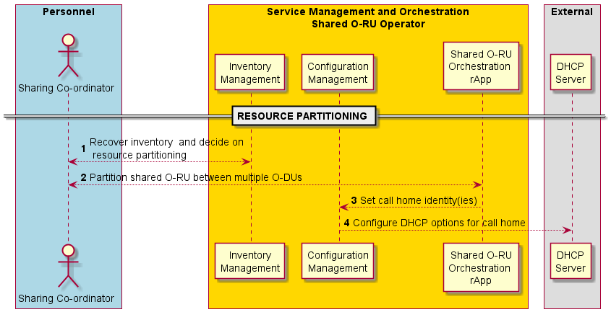
Figure 4.20.3.2-1: Resource partitioning use case

4.20.3.3 Start-up use case of Shared O-RU for Single-MNO
The following describes the solution for the start-up sub-use case for a Shared O-RU.
The context of the Shared O-RU start-up use case is captured in table 4.20.3.3-1.
Table 4.20.3.3-1: Shared O-RU start-up use case
Use Case Stage | Evolution / Specification | <<Uses>>  Related use
Goal | The Shared O-RU is operating with the necessary software version and has established network connectivity with the O-DU(s) and, for hybrid deployments, the SMO.
Actors and Roles | Shared O-RU calls home and establishes network management session.  SMO is responsible for software management for the Shared O-RU when operating in hybrid management mode.  O-DU is responsible for software management for the Shared O-RU when operating in hierarchical management mode.
Assumptions | None.
Begins when | Shared O-RU powers on.
Pre-conditions | Transport systems (DHCP server) has been configured with call home configuration information.
Step 1 (M) | Establish synchronization:  Each O-DU and Shared O-RU establish synchronisation with a timing source, for example PTP (IEEE 1588) or Sync-E. See NOTE 1, NOTE 2.
Step 2 (M) | Synchronization State Change Notification:  After the O-RU has a synchronisation source, all subscribed O-DU(s) are notified through a Synchronisation State Change Notification. We expect the O-RU to be in the sync state “LOCKED”.  The Synchronisation State Change Notification goes from Shared O-RU to all subscribed O-DU(s).  It is possible that the synchronisation procedure can happen in parallel to the other steps of the start-up sub-use case. Thus, many of the other steps in this use case can happen as the synchronization procedure occurs. Even though this is shown as “step 2” this can complete after other steps.
Step 3 (ALT) | [Shared O-RU operated in hybrid management mode]  Shared O-RU calls home and triggers establishment of network management session with SMO. | O-RAN.WG4.MP [28], clause 6.3 and/or clause 6.9.2
Step 4 (ALT) | [Shared O-RU operated in hierarchical management mode]  Shared O-RU calls home and triggers establishment of network management session with O-DU#1. | O-RAN.WG4.MP [28], clause 6.3
Step 5 (ALT) | [Shared O-RU operated in hierarchical management mode]  Shared O-RU calls home and triggers establishment of network management session with O-DU#2. | O-RAN.WG4.MP [28], clause 6.3
Step 6 (ALT) | [Shared O-RU operated in hybrid management mode]  SMO recovers software inventory. | O-RAN.WG4.MP [28], clause 8.4
Step 7 (O) | [Shared O-RU operated in hybrid management mode and software update required]  SMO triggers download of new software. | O-RAN.WG4.MP [28], clause 8.5
Step 8 (O) | [Shared O-RU operated in hybrid management mode and software update required]  O-RU downloads software files. | O-RAN.WG4.MP [28], clause 8.5
Step 9 (O) | [Shared O-RU operated in hybrid management mode and software update required]  SMO triggers the installation and activation of the software. | O-RAN.WG4.MP [28], clauses 8.6 and 8.7
Step 10 (O) | [Shared O-RU operated in hybrid management mode and software update required]  SMO brings active software into operation. | O-RAN.WG4.MP [28], clause 8.7
Step 11 (ALT) | [Shared O-RU operated in hierarchical management mode]  O-DU recovers software inventory. | O-RAN.WG4.MP [28], clause 8.4
Step 12 (O) | [Shared O-RU operated in hierarchical management mode and software update required]  O-DU triggers download of new software. | O-RAN.WG4.MP [28], clause 8.5
Step 13 (O) | [Shared O-RU operated in hierarchical management mode and software update required]  O-RU downloads software files. | O-RAN.WG4.MP [28], clause 8.5
Step 14 (O) | [Shared O-RU operated in hierarchical management mode and software update required]  O-DU triggers the installation and activation of the software. | O-RAN.WG4.MP [28], clauses 8.6 and 8.7
Step 15 (O) | [Shared O-RU operated in hierarchical management mode and software update required]  O-DU brings active software into operation. | O-RAN.WG4.MP [28], clause 8.7
Ends when | The Shared O-RU is operating with the necessary software version and has established network connectivity with the O-DU and, for hybrid deployments, the SMO.
Exceptions | None identified.
Post Conditions | None identified.
NOTE 1: It is expected the O-RU and all O-DUs connected it would share the same synchronisation source otherwise, the O-DUs will drift in timing.
NOTE 2: For more details on O-RU sync and O-RU loss of sync, see O-RAN.WG4.MP [28], clause 15.3.3.
@startuml
!pragma teoz true

skin rose
skinparam ParticipantPadding 5
skinparam BoxPadding 10
skinparam defaultFontSize 14

Box “Service Management and Orchestration\nShared O-RU Operator” #gold

Participant CFG as “Configuration\nManagement”
Participant SWM as “Software\nManagement”
Participant FS as “File\nServer”

end box

Box “O-RAN\nShared O-RU Operator” #lightpink
Participant ODU1 as “O-DU\n(#1) “
Participant ODU2 as “O-DU\n(#2) “

participant ORU as “O-RU\n(Shared)”
End box

autonumber

== STARTUP ==

Note over ODU1, ORU
Synchronization Timing is established for O-Dus and Shared O-RU
End Note
ORU -> ODU1: <<OFH>> Synchroniztion state change notification
ORU -> ODU2: <<OFH>> Synchroniztion state change notification

group Shared O-RU Call Home

alt call home to SMO (Hybrid Management)
ORU<->CFG: <<OFH>> Call Home & Network management session establishment
end
alt call home to ODU (Hierarchical or Hybrid management)
ORU<->ODU1: <<OFH>> Call Home & Network management session establishment
ORU<->ODU2: <<OFH>> Call Home & Network management session establishment
end

end

group Shared O-RU Software Management
alt Hybrid Software Management
SWM<->ORU: Recover software inventory
opt software update required
SWMàORU: Trigger Software Download
FS<--ORU: Software Download
SWM<-->ORU: Install & Activate Software
SWM<-->ORU: Bring Software into operation

end
end
alt Hierarchical Software Management
ODU1<->ORU: Recover software inventory
opt software update required
ODU1-->ORU: Trigger Software Download
FS<--ORU: Software Download
ODU1<-->ORU: Install & Activate Software
ODU1<-->ORU: Bring Software into operation

end

end

end

@enduml

The flow diagram of the Shared O-RU start-up use case is given in figure 4.20.3.3-1.

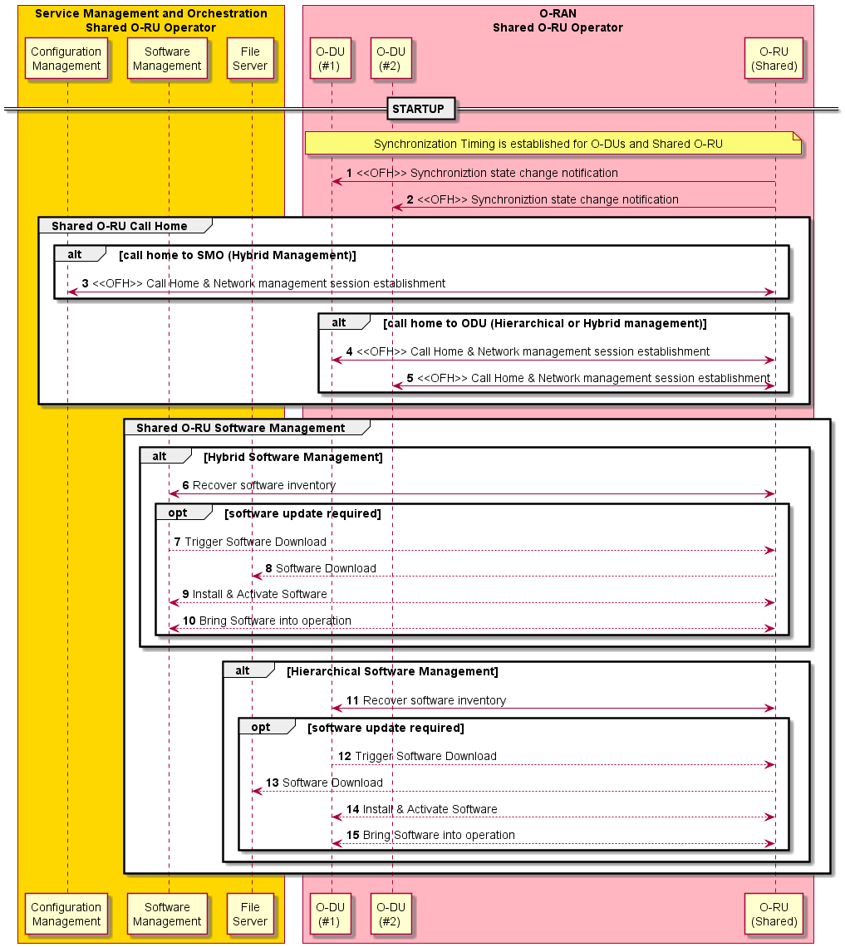
Figure 4.20.3.3-1: Shared O-RU start-up use case

4.20.3.4 Configuration use case of a Shared O-RU for Single & Multi-MNO
The following describes the solution for the configuration sub-use case for a Shared O-RU.
The context of the Shared O-RU configuration use case is captured in table 4.20.3.4-1.
Table 4.20.3.4-1: Shared O-RU configuration use case
Use Case Stage | Evolution / Specification | <<Uses>>  Related use
Goal | The Shared O-RU is configured to operate with multiple O-DUs.
Actors and Roles | SMO responsible for Shared O-RU common configuration when operating in hybrid management mode.  SMO optionally can subscribe to receive notifications of modifications to Shared O-RU’s configuration.  When operating in hierarchical management mode, rApp is responsible for determining which O-DU is responsible for common configuration aspects.  Shared O-RU responsible for role-based access control based on PLMN-Id.  O-DU is responsible for Shared O-RU carrier configuration and optionally, when operating in hierarchical management mode, the Shared O-RU common configuration.  Sharing co-ordinator can check the Shared O-RU’s committed configuration complies with any sharing agreement.
Assumptions | None.
Begins when | Shared O-RU has started up and has been configured with correct software version.
Pre-conditions | None.
Step 1 (O) | [Shared O-RU operated in hierarchical management mode]  rApp determines which O-DU is responsible for common configuration of Shared O-RU.
Step 2 (M) | rApp triggers the configuration of the common aspects of the Shared O-RU.
Step 3 (M) | Non-RT RIC triggers the configuration of the common aspects of the Shared O-RU.
Step 4 (ALT) | [Hybrid or neutral host management mode]  SMO uses OpenFronthaul interface to configure common aspects of Shared O-RU. | O-RAN.WG4.MP [28], clause 9
Step 5 (ALT) | [Hierarchical management mode]  SMO uses O1 interface to configure Shared O-RU’s common aspects via O-DU.
Step 6 (ALT) | [Hierarchical management mode]  O-DU uses OpenFronthaul interface to configure common aspects of Shared O-RU. | O-RAN.WG4.MP [28], clause 9
Step 7 (O) | Shared O-RU calls home to tenant’s O-DU (multi-operator).
Step 8 (O) | Shared O-RU calls home to tenant’s SMO (multi-operator).
Step 9 (O) | rApp triggers the configuration of the carrier aspects of the Shared O-RU (non-neutral host).
Step 10 (O) | Non-RT RIC triggers the configuration of the carrier aspects of the Shared O-RU.
Step 11 (O) | SMO configures O-DU#1 and partitioned carrier information #1.
Step 12 (O) | O-DU#1 configures partitioned carrier information #1 on Shared O-RU non-neutral host). | O-RAN.WG4.MP [28], clause 9
Step 13 (O) | Tenant’s SMO configures O-DU#2 and partitioned carrier information #2 (multi-operator).
Step 14 (M) | O-DU#2 configures partitioned carrier information #2 on Shared O-RU. | O-RAN.WG4.MP [28], clause 9
Step 15 (O) | Shared O-RU implements role-based access control based oplmn-id#2.
Step 16 (O) | The Shared O-RU notifies SMO of its modified configuration. | O-RAN.WG4.MP [28], clause 9.4
Step 17 (O) | SMO signals Non-RT RIC information pertaining to changed configuration.
Step 18 (O) | Non-RT RIC signals changed configuration to Shared O-RU orchestration rApp.
Step 19 (O) | Sharing co-ordinator checks that the changed configuration compliance with the sharing agreement.
Step 20 (O) | Host sharing co-ordinator indicates non-compliance with tenant sharing co-ordinator and remedial actions agreed (out of band exchange).
Ends when | The Shared O-RU is configured with common aspects and partitioned carrier#1 for O-DU#1 and partitioned carrier #2 for O-DU#2.
Exceptions | None identified.
Post Conditions | See NOTE.
NOTE: Before activation of carriers, O-RU needs to have sync state “LOCKED” with its sync source. For more details, see O-RAN.WG4.MP [28], clause 15.3.3.
@startuml
!pragma teoz true

skin rose
skinparam ParticipantPadding 5
skinparam BoxPadding 10
skinparam defaultFontSize 14
autonumber

Box "Personnel\nShared O-RU Host" #Lightblue
Actor planner as "Sharing Co-ordinator"

End box

Box “Service Management and Orchestration\nShared O-RU Operator” #gold
Participant CFG as "Configuration\nManagement"
Participant R_APP as "Shared O-RU\nOrchestration \nrApp"
Participant SMO_a as “Non-RT\nRIC”
end box

Box “O-RAN\nShared O-RU Operator” #lightpink
Participant ODU1 as “O-DU\n(#1)”

participant ORU as "O-RU\n(Shared)"
End box

Box "O-RAN Tenant\nOperator PLMN-ID#2" #lightpink
Participant ODU2 as "O-DU\n(#2)"

End box

Box "Service Management and Orchestration\nTenant Operator PLMN-ID#2" #gold
Participant CFG_b as "Configuration\nManagement"

end box

Box "Personnel\nTenant Operator" #lightblue
Actor planner2 as "Sharing Co-ordinator"
End box

== CONFIGURATION ==
group Configure common aspects of shared O-RU

opt Hierarchical Management
Hnote over R_APP
1. Decide on O-DU(#1)
or O-DU(#2) for
common management
end note
end
autonumber 2
R_APP -> SMO_a: <<R1>> Configure\nShared O-RU\nCommon aspects including any tenant account (with plmn-id)
SMO_a->CFG: Configure Shared O-RU Common Aspects including any tenant account (with plmn-id)
alt Hybrid or Neutral-Host Management
CFG->ORU: <<OFH>> Configure Shared O-RU common aspects including any tenant account (with plmn-id)
end
alt Hierarchical Management
CFG->ODU1: <<O1>> Configure Shared O-RU common aspects including any tenant account (with plmn-id)
&ODU1->ORU: <<OFH>> Configure Shared O-RU\ncommon aspects including\nany tenant account (with plmn-id)
end
end

opt Call home to tenant
ORU->ODU2: <<OFH>> Call Home & Network\nmanagement session\nestablishment using\naccount linked to plmn-id#2
opt Call home to tenant SMO
ORU->CFG_b: <<OFH>> Call Home & Network management session \nestablishment using account linked to plmn-id#2

end

end

group Configure carrier aspects of shared O-RU

opt non-neutral host
R_APP -> SMO_a: <<R1>> Configure\nShared O-RU\nCarrier aspects
SMO_a->CFG: Configure Shared O-RU Carrier Aspects

CFG -> ODU1: <<O1>> Configure O-DU ID#1 and partitioned carrier information #1
ODU1->ORU: <<OFH>> Configure O-DU ID#1 and\npartitioned carrier information #1

end

group tenant configuration of carrier aspects
CFG_b -> ODU2: <<O1>> Configure\nShared O-RU\ncarrier#2 aspects\nPLMN-ID#2
ODU2->ORU: <<OFH>> Configure carrier#2\nPLMN-ID#2
Hnote over ORU
15. O-RU implements
enhanced role based
access control
based on plmn-id#2
end note
end

end
autonumber 16

opt notification of committed configuration
ORU->CFG: <<OFH>> Notification of Configuration Update
CFG->SMO_a: Notification of Configuration Update
SMO_a->R_APP: <<R1>> Configuration Update

planner <--> R_APP: Sharing Co-ordinator confirms compliance to partioning rules

opt Non-Compliant partitioning
Hnote over planner, planner2
20. Indication of non-compliance and agreement on remdial action (out of band exchange)
end note
end
end

Note over ORU
Before activation of carriers, O-RU needs to have sync lock with its sync source
End Note

@enduml

The flow diagram of the Shared O-RU configuration use case is given in figure 4.20.3.4-1.

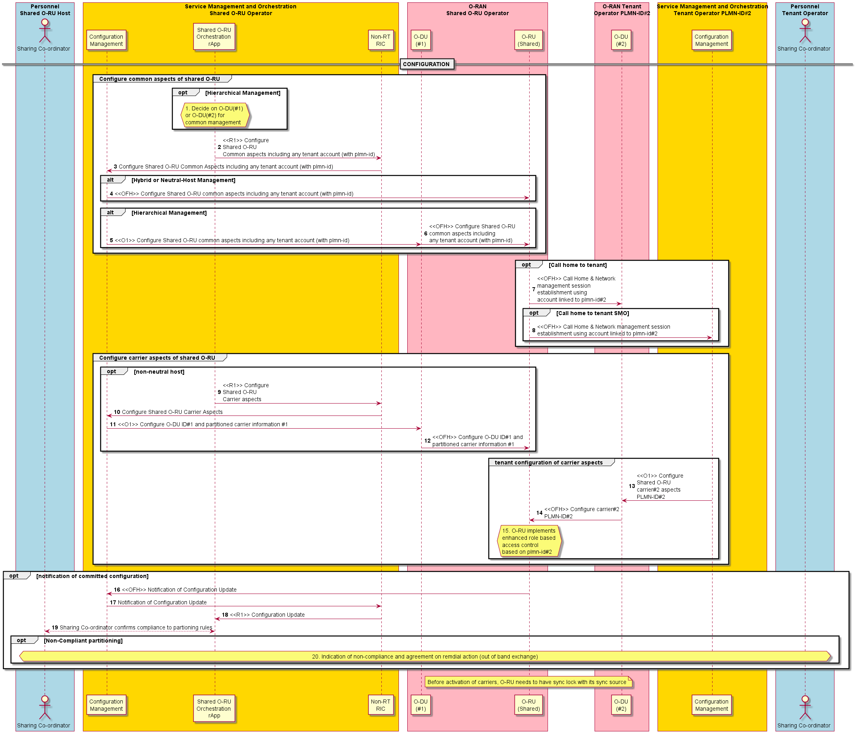
Figure 4.20.3.4-1: Shared O-RU configuration use case

4.20.3.5 Supervision use case of a Shared O-RU for Single-MNO
The following describes the solution for the supervision sub-use case for a Shared O-RU.
The context of the supervision use case of a Shared O-RU is captured in table 4.20.3.5-1.
Table 4.20.3.5-1: Supervision use case of a Shared O-RU
Use Case Stage | Evolution / Specification | <<Uses>>  Related use
Goal | The Shared O-RU operates watchdog timers with each of its O-DUs and ceases transmitting on a partitioned carrier associated with an O-DU if is watchdog timer to that O-DU expires.
Actors and Roles | Shared O-RU operates watchdog timers and deactivates any carriers associated with an expired watchdog timer.  O-DU repeatedly resets the Shared O-RU’s supervision timer.  SMO forwards any alarms to Shared O-RU rApp.
Assumptions | O-DUs are operating fronthaul control and user plane for their respective partitioned carriers.  SMO has subscribed to receive alarm notifications (hybrid management model).
Begins when | An O-DU subscribes to receive supervision notifications.
Step 1 (Loop) | O-DU#1 performs supervision operations.
Step 2 (O) | Shared O-RU detects supervision failure with O-DU#1 and ceases transmitting on partitioned carrier associated with O-DU.
Step 3 (O) | Shared O-RU sends alarm notification to Fault Management
Step 4 (O) | Fault management sends alarm notification to Non-RT RIC.
Step 5 (O) | Non-RT RIC sends alarm notification to Shared O-RU orchestration rApp.
Step 6 (Loop) | O-DU#2 performs supervision operations.
Step 7 (O) | Shared O-RU detects supervision failure with O-DU#2 and ceases transmitting on partitioned carrier associated with O-DU.
Step 8 (O) | Shared O-RU sends alarm notification to fault management.
Step 9 (O) | Fault management sends alarm notification to Non-RT RIC.
Step 10 (O) | Non-RT RIC sends alarm notification to Shared O-RU orchestration rApp.
Ends when | O-DU terminates subscription to supervision notification.
Exceptions | None identified.
Post Conditions | None identified.
@startuml
!pragma teoz true

skin rose
skinparam ParticipantPadding 5
skinparam BoxPadding 10
skinparam defaultFontSize 14
autonumber 1

Box "Service Management and Orchestration\nShared O-RU Operator" #gold
Participant FM as "Alarm\nManagement"
Participant R_APP as "Shared O-RU\nOrchestration \nrApp"
Participant SMO_a as "Non-RT\nRIC"
end box

Box "O-RAN\nShared O-RU Operator" #lightpink
Participant ODU1 as "O-DU\n(#1)"
Participant ODU2 as "O-DU\n(#2)"

participant ORU as "O-RU\n(Shared)"
End box

== RUNNING ==

hnote over ODU1, ORU
<<OFH>> Fronthaul Control & User Plane for partitioned carrier #1
end note

hnote over ODU2, ORU
<<OFH>> Fronthaul Control & User Plane for partitioned carrier #2
end note

group Per O-DU Supervision

loop odu #1 supervision
ODU1<->ORU: <<OFH>> Supervision Operation O-DU #1
end

opt Supervision failure to odu-id#1
hnote over ORU
2. cease transmitting
partitioned carrier #1
end note

autonumber 3

opt SMO has subscribed to reveive alarm notifications
ORU->FM: (Opt) <<OFH>> O-DU Supervision Alarm O-DU#1
FM->SMO_a: Alarm Indication
SMO_a->R_APP: <<R1>> Alarm\nIndication
end
end

loop odu #2 supervision
ODU2<->ORU: <<OFH>> Supervision Operation O-DU #2
end

opt Supervision failure to odu-id#2
hnote over ORU
7. cease transmitting
partitioned carrier #2
end note
opt SMO has subscribed to reveive alarm notifications
autonumber 8
ORU->FM: (Opt) <<OFH>> O-DU Supervision Alarm O-DU#2
FM->SMO_a: Alarm Indication
SMO_a->R_APP: <<R1>> Alarm\nIndication
end
end

end

@enduml

The flow diagram of the supervision use case of a Shared O-RU is given in figure 4.20.3.5-1.

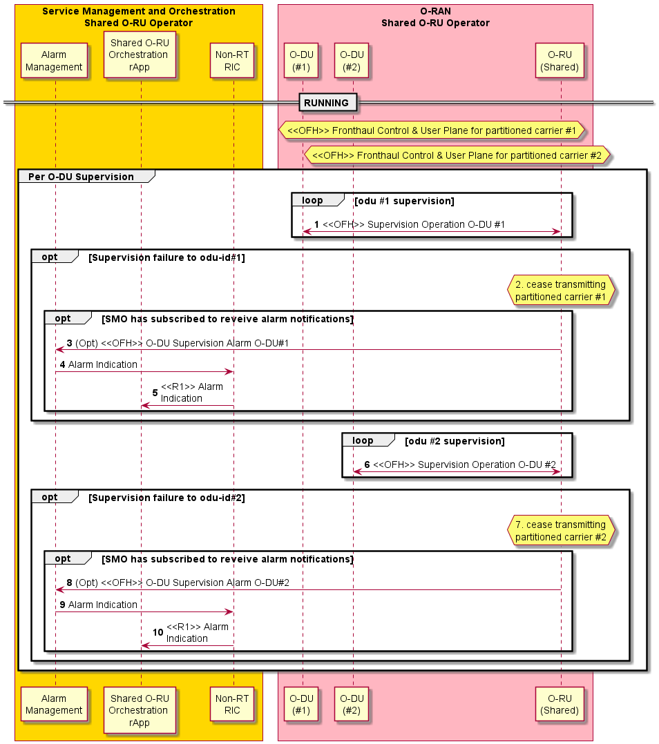
Figure 4.20.3.5-1: Supervision use case of a Shared O-RU

4.20.3.6 Performance management use case of a Shared O-RU for Single-MNO
The following describes the solution for the performance management sub-use case for a Shared O-RU.
The context of the performance management use case of a Shared O-RU is captured in table 4.20.3.6-1.
Table 4.20.3.6-1: Performance management use case of a Shared O-RU
Use Case Stage | Evolution / Specification | <<Uses>>  Related use
Goal | Each O-DU has established subscriptions to receive performance management notifications regarding operation of the fronthaul between the O-DUs and Shared O-RU.  The O-DU and Shared O-RU are able to report performance measurement data towards their consumers in a Multi-MNO configuration.
Actors and Roles | Shared O-RU generates performance management notifications on a per partitioned carrier basis.  O-DU subscribes to receive performance management notifications from Shared O-RU.
Assumptions | O-DU has configured performance management metrics for respective partitioned carrier.
Begins when | Fronthaul control and user plane is operational between O-DU and Shared O-RU.
Step 1 (M) | O-DU#1 subscribes to receive PM notifications from Shared O-RU.
Step 2 (M) | O-DU#2 subscribes to receive PM notifications from Shared O-RU.
Step 3 (loop) | Shared O-RU sends PM notification to O-DU#1.
Step 4 (loop) | Shared O-RU sends PM notification to O-DU#2.
O-DU to SMO performance operations
Step 1 (O) | PM event notification reporting  The O-DU (producer) sends performance data to the SMO (consumer) through an event notification.
Step 2 (O) | Streaming PM reports  The O-DU establishes a persistent connection to the SMO (consumer) and sends performance data.
Step 3 (O) | Attribute-based or URI-based collection  Performance data is read by the consumer (SMO) through configuration management attribute. Alternatively, the O-DU can support a data scraping method where a collector (SMO) reads the data from a pre-defined URI.
Step 4 (O) | Producer or PM file upload (file upload)  O-DU uploads a PM file to the SMO.  See NOTE 1.
Step 5 (O) | Consumer downloads PM file (file download)  O-DU issues file ready notification to SMO about the data being ready for download, or SMO periodically polls the O-DU. Afterwards, the SMO (consumer) can download the PM file.
O-RU to O-DU performance operations (in hierarchical configuration)
Step 1 (O) | PM event notification reporting  The O-RU sends performance data to the O-DU through an event notification. The notification is sent to a subscriber of performance data.
Step 1 (M) | O-DU requests for O-RU to start sending PM data  O-DU invokes an RPC to give PM credentials, target URI, and periodicity notification interval to the Shared O-RU. This includes all the necessary information for the O-RU to perform a file transfer to an endpoint periodically.  See NOTE 2.
Step 2 (M) | Shared O-RU uploads PM file  The Shared O-RU periodically uploads a performance file to the target URI using the PM credentials given by the O-DU.
O-RU to SMO performance operations (in hybrid configuration)
Step 1 (O) | PM event notification reporting  The O-RU sends performance data to the SMO through an event notification via M-plane.
Step 1 (O) | SMO requests for O-RU to start sending PM data  SMO invokes an RPC to give PM credentials, target URI, and periodicity notification interval to the Shared O-RU. This includes all the necessary information for the O-RU to perform a file transfer to an endpoint periodically.
Step 2 (O) | Shared O-RU uploads PM file  The Shared O-RU uploads performance file to target URI using PM credentials given by the SMO.
Ends when | - Subscriptions setup: O-DU terminates subscription to performance management notification.  - O-DU to SMO sending PM data: Use case ends with the producer (O-DU) sending performance data to the consumer (SMO).  - O-RU sending performance data: Use case ends with the producer (O-RU) starting to send performance data to the subscriber.
Exceptions | None identified.
Post Conditions | The consumer has received performance data and may perform post processing operations on the data.
NOTE 1: When the O-DU sends performance files received from a Shared O-RU, they are converted to the proper 3GPP format before sending to SMO. See O-RAN WG5.O-DU-O1 [25].
NOTE 2: The O-DU establishes a framework for the Shared O-RU to send PM files. This operation is performed only once, thereafter, the Shared O-RU sends the PM files periodically.
@startuml
!pragma teoz true

skin rose
skinparam ParticipantPadding 5
skinparam BoxPadding 10
skinparam defaultFontSize 14
autonumber 1

Box “Owning Operator\n Service Management and Orchestration (SMO)” #gold
Participant PMS as “Performance Management\nService”
end box

Box “O-RAN\nShared O-RU Operator” #lightpink
Participant ODU1 as “O-DU\n(#1)”
Participant ODU2 as “O-DU\n(#2)”
participant ORU as “O-RU\n(Shared)”
End box

== SUBSCRIPTION SETUP ==

hnote over ODU1, ORU
<<OFH>> Fronthaul Control & User Plane for partitioned carrier #1
end note

hnote over ODU2, ORU
<<OFH>> Fronthaul Control & User Plane for partitioned carrier #2
end note

group Per O-DU Performance Management

ODU1<->ORU: <<OFH>> Subscribe to receive PM notifications for partitioned carrier #1
ODU2<->ORU: <<OFH>> Subscribe to receive PM notifications for partitioned carrier #2

loop Shared O-RU performance management
ORU->ODU1: <<OFH>> PM Notification (partitioned carrier #1)
ORU->ODU2: <<OFH>> PM Notification (partitioned carrier #2)
end
end

== SUBSCRIPTION SETUP ==

== ODU TO SMO PERFORMANCE OPERATIONS ==
Autonumber 1

Alt O-DU Notification-based Reporting
ODU1->PMS: <<O1>> PM Event Notification Reporting
Else O-DU Streaming-based Reporting
ODU1->PMS: <<O1>> Streaming PM Reports
Else Consumer Actively Collects
PMS->ODU1: <<O1>> Attribute based or URI based collection
Else O-DU File-based Reporting
ODU1->PMS: <<O1>> Producer PM File Upload (File Upload)
Else O-DU File-based Reporting
PMS->ODU1: <<O1>> Consumer Downloads PM File (File Download)
End

== ODU TO SMO PERFORMANCE OPERATIONS ==

== ORU TO ODU PERFORMANCE OPERATIONS (Hierarchical Config) ==
Autonumber 1

Opt O-RU Notification-based Reporting
ORU->ODU1: <<OFH>> PM Event Notification Reporting
End

Autonumber 1

Group O-DU Actively Collects PM
ODU1->ORU: <<OFH>> ODU invokes RPC to give PM Credentials, Periodicity, & Target URI
ORU-->ODU1: <<OFH>> ORU uploads Performance File to Target URI using PM Credentials
End

== ORU TO ODU PERFORMANCE OPERATIONS (Hierarchical Config) ==

== ORU TO SMO PERFORMANCE OPERATIONS (Hybrid Config) ==
Autonumber 1

Opt O-RU Notification-based Reporting
ORU->PMS: <<OFH>> PM Event Notification Reporting
End

Autonumber 1

Group SMO Actively Collects PM
PMS->ORU: <<OFH>> SMO invokes RPC to give PM Credentials, Periodicity, & Target URI
ORU->PMS: <<OFH>> ORU uploads Performance File to Target URI using PM Credentials
End

== ORU TO SMO PERFORMANCE OPERATIONS (Hybrid Config) ==

@enduml

The flow diagram of the performance management use case of a Shared O-RU is given in figure 4.20.3.6-1.
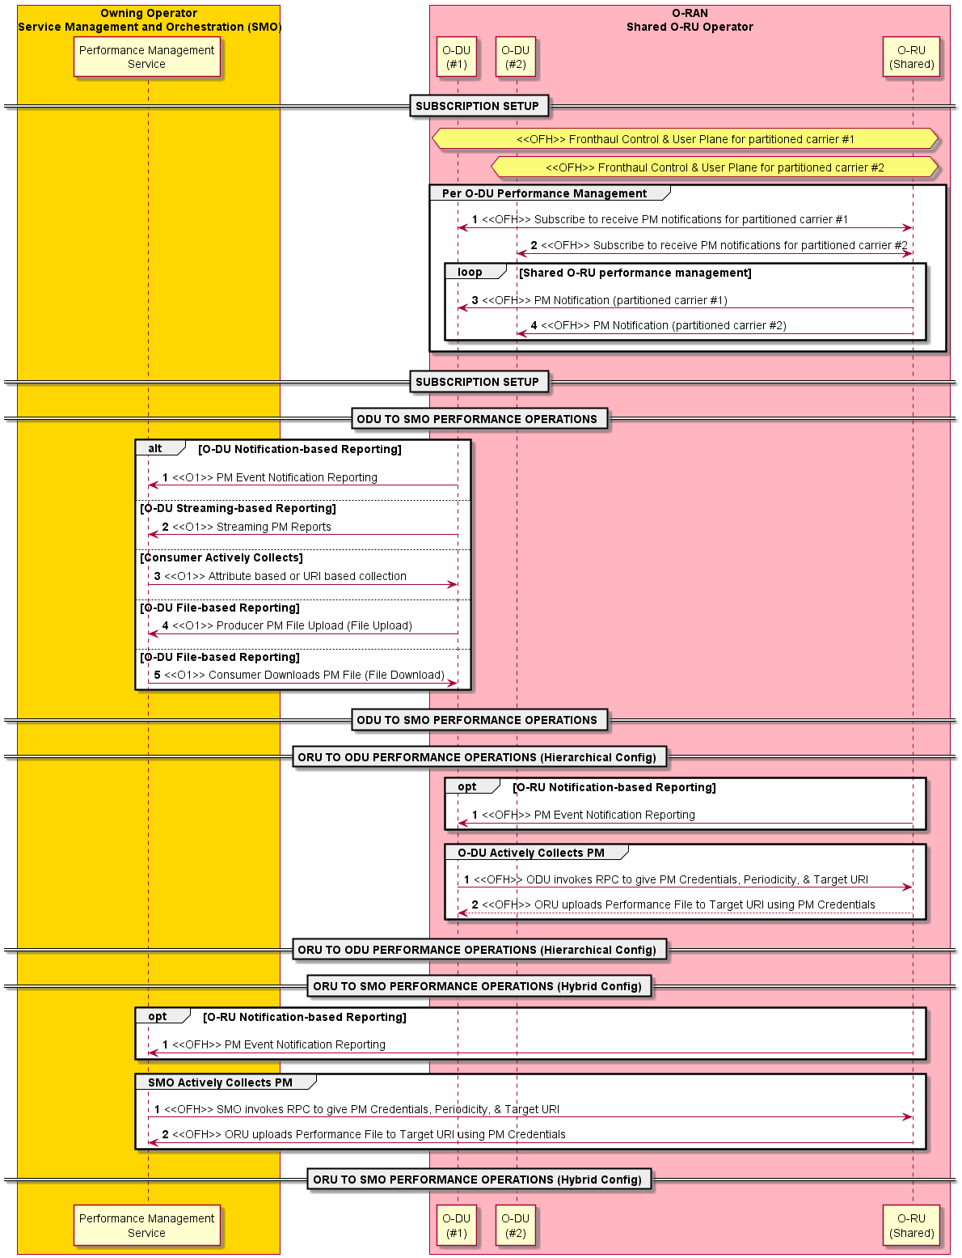
Figure 4.20.3.6-1: Performance management use case of a Shared O-RU for Single-MNO

4.20.3.7 Antenna Line Device (ALD) control use case of a Shared O-RU for Single-MNO
The following describes the solution for the ALD control sub-use case for a Shared O-RU.
The context of the antenna line device control use case of a Shared O-RU is captured in table 4.20.3.7-1.
Table 4.20.3.7-1: Antenna line device control use case of a Shared O-RU
Use Case Stage | Evolution / Specification | <<Uses>>  Related use
Goal | The ALD connected to Shared O-RU is configured to operate with ALD controller.
Actors and Roles | rApp is responsible for determining which O-DU is responsible for ALD controller aspects.  O-DU is responsible for implementing ALD controller.  O-RU is responsible for bridging between OFH and HDLC.  ALD is responsible for terminating HDLC.
Assumptions | None.
Begins when | Shared O-RU has started up and has been configured with correct software version.
Pre-conditions | None.
Step 1 (M) | rApp determines which O-DU is responsible for performing ALD controller functionality.
Step 2 (M) | rApp triggers the configuration of the ALD controller for Shared O-RU.
Step 3 (M) | Non-RT RIC triggers the configuration of ALD controller for Shared O-RU.
Step 4 (M) | SMO uses O1 interface to configure ALD controller in O-DU.
Step 5 (M) | O-DU uses OpenFronthaul interface to configure ALD aspects of Shared O-RU. | O-RAN.WG4.MP [28], clause 9
Step 6 (M) | O-DU uses OpenFronthaul interface to signal ALD. | O-RAN.WG4.MP [28], clause 14.4
Step 7 (M) | Shared O-RU provides interworking between OFH and HDLC. | O-RAN.WG4.MP [28], clause 14.4
Ends when | ALD connected to Shared O-RU is configured correctly.
Exceptions | None identified.
Post Conditions | None identified.
@startuml
!pragma teoz true

skin rose
skinparam ParticipantPadding 5
skinparam BoxPadding 10
skinparam defaultFontSize 14
autonumber

Box "Service Management and Orchestration\nShared O-RU Operator" #gold
Participant CFG as "Configuration\nManagement"
Participant R_APP as "Shared O-RU\nOrchestration \nrApp"
Participant SMO_a as "Non-RT\nRIC"
end box

Box "O-RAN\nShared O-RU Operator" #lightpink
Participant ODU1 as "O-DU(#1)\nALD Controller"

participant ORU as "O-RU\n(Shared)"
participant ALD as "ALD"
End box

== CONFIGURATION ==
group Configure ALD aspects of shared O-RU

Hnote over R_APP
1. Decide on O-DU(#1)
or O-DU(#2) for
ALD Control
end note

autonumber 2
R_APP -> SMO_a: <<R1>> Configure\nShared O-RU\nALD aspects
SMO_a->CFG: Configure Shared O-RU ALD Aspects

CFG->ODU1: <<O1>> Configure Shared O-RU ALD aspects
&ODU1->ORU: <<OFH>> Configure Shared O-RU ALD aspects

end
== RUNNING ==

group ALD Operation for shared O-RU

ODU1<->ORU: <<OFH>> HDLC-over-OFH
&ORU<->ALD: HDLC
end
@enduml

The flow diagram of the antenna line device use case is given in figure 4.20.3.7-1.
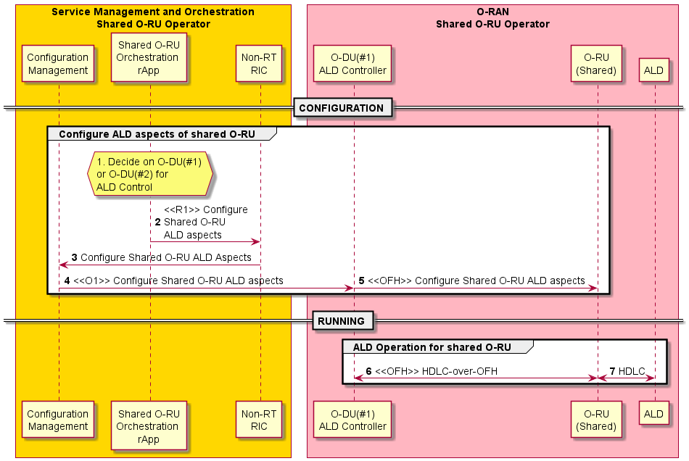
Figure 4.20.3.7-1: Antenna line device use case

4.20.3.8 Basic resiliency use case (active O-DU failure) for Single-MNO
The following describes the solution for the basic resiliency sub-use case for a Shared O-RU.
The context of the basic resiliency use case of a Shared O-RU is captured in table 4.20.3.8-1.
Table 4.20.3.8-1: Resiliency use case of a Shared O-RU
Use Case Stage | Evolution / Specification | <<Uses>>  Related use
Goal | The goal of this sub-use case is to handle situations related to resiliency operations with the Shared O-RU when the O-DU is out of service.  This is a service impacting use case.
Actors and Roles | Shared O-RU  The Shared O-RU handles the fronthaul and air interfaces and  the reporting of performance counters and failures.  O-DUs (active/standby O-DUs)  All the O-DUs connected to the Shared O-RU are actors that are involved in basic resiliency scenario.  O-CU:  O-CU receives cell related configurations from SMO and available cell details from O-DU(s). Based on the available resources reported by O-DU and desired availability of cells received from SMO, the O-CU activates or deactivates the cells in the O-DU using F1 interface.  SMO:  The SMO configures the role of O-DUs as active or standby O-DUs and informs these roles to Shared O-RU through O-DU in  hierarchical deployment. It makes high-level decisions related to conditions listed in clause 4.20.1.8.
Assumptions | It is assumed that when active O-DU fails, there is still at least one standby O-DU having active NetConf session with the Shared O-RU.  It is assumed that the resiliency operations are intended to take over the Shared O-RU operation and recover the service to the end user.
Begins when | There are many possible scenarios that trigger the basic resiliency use case as described in clause 4.20.1.8.  In this basic resiliency use case, only the complete failure of a O-DU is considered.  The purpose of the resiliency use case is to keep the Shared O-RU & O-DU system operational in the case of a failure of the active O-DU.  This use case begins when the active O-DU encounters a failure (operational state = disabled).
Pre-conditions | The Shared O-RU has the NetConf connectivity with two or more O-DUs.  CU plane monitoring has been properly configured which sets up a communication monitoring interval for the interface between the Shared O-RU and active O-DU.  O-DUs have subscribed to alarm notifications successfully.
Basic resiliency use case – Initial system setup
Step 1.1 (M) | The SMO may configure O-DU#1 to take active role in controlling the Shared O-RU. It then configures the cells and corresponding carrier resources (including NRCGI(s) for the cells) via the O1 interface.
Step 1.2 (M) | O-DU configures the carriers in O-RU, corresponding to the carrier resources outlined in step 1.
Step 1.3 (M) | The SMO may configure O-DU#2 to take standby role via O1 interface.
Step 1.4 (M) | SMO may provide O-CU with information via the O1 interface regarding which cell(s) (NRCGI(s)) associated with O-DU#1 need to be activated. See NOTE 1, NOTE 2, NOTE 3, NOTE 4.
Basic resiliency use case – O-DU#1 failure detection
Step 2 (M) | Active O-DU fails  Active O-DU (the one serving as the active role) is no longer operational. The O-DU is no longer able to provide service. The O-DU has operational state = disabled. The Shared O-RU losses communication with the active O-DU. See NOTE 5.
Step 3 (M) | O-RU raises alarms to subscribers  The Shared O-RU raises the loss of connectivity alarm to subscriber(s). The simple case shows that the O-DU#1 and O-DU#2 are subscribers. The Shared O-RU raises an alarm to subscribers (O-DUs) that are still active that is O-DU #2, connected and subscribed.
Step 4 (M) | Alarm forwarded  The Shared O-RU alarm is forwarded to the managing entity, such as the SMO. It is possible that the SMO will make the decision for making the standby O-DU#2 into the active O-DU.
Step 5 (M) | SMO provides O-CU with information regarding which cell(s) (NRCGI(s)) associated with O-DU#2 need to be made inactive and/or removed.
Recover Shared O-RU operation
Step 6.1 (M) | The SMO may configure O-DU#2 to take standby role via O1 interface. See NOTE 6.
Step 6.2 (M) | O-DU#2 becomes the active O-DU to recover Shared O-RU operation. See NOTE 7.
Step 6.3 (M) | O-DU configures the carriers in O-RU, corresponding to the carrier resources outlined in step 6.1. See NOTE 8.
Step 6.4 (M) | SMO provides O-CU with information regarding which cell(s) (NRCGI(s)) associated with O-DU#2 need to be activated. See NOTE 1, NOTE 2, NOTE 9, NOTE 10, NOTE 11.
Ends when | The use case ends when the standby O-DU, O-DU#2 shown in the flow diagram has taken over for the previously active O-DU, O-DU #1.
Exceptions | There are many possible exceptions. Some of these include:  If the Shared O-RU fails during a switch over.  If the standby O-DU#2 also becomes unavailable when it is due to become active.  If any event messaging for the flow is lost.  If configuration was not done properly.  If the standby O-DU losses the configuration data from the configuration replica.  If the active O-DU returns to service while the standby O-DU is trying to become the active O-DU.  If the connectivity, or functionality of the management system (SMO) becomes unavailable.
Post Conditions | Successful post condition – On a successful post-condition, the Shared O-RU is connected to the newly active O-DU, the newly active O-DU is operational and has properly synced with the O-RU.  Failure post condition – If one of the various exception cases occurs, there are a variety of failure post conditions. If no O-DUs are available and the O-RU is orphaned no service is available and the O-RU shall shut down operations. If misconfiguration occurs the O-RU will respond accordingly. If there are ever two active O-DUs, the Shared O-RU will operate accordingly.
NOTE 1: When cells and corresponding carriers are configured and available for service, the O-DU informs O-CU about cells availability using F1 interface. O-CU requests O-DU to activate the cell(s) (NRCGI(s)), using the associated messages exchanged via the F1 interface. O-DU activates the carrier in O-RU that are associated with the specific cell(s) (NRCGI(s)) requested for activation.
NOTE 2: O-DU activates carriers related to cell(s) requested by O-CU. O-DU uses the F1 interface to inform O-CU about activation status for cells requested.
NOTE 3: Shared O-RU becomes operational with O-DU#1 with cell on air and ready to serve UEs.
NOTE 4: SMO collects alarms and performance management data from O-DU#1.
NOTE 5: The active O-DU can be no longer operational for a variety of reasons. (see the “Begins when” section).
NOTE 6: There might be multiple other O-DUs, but only one active O-DU. The management system, SMO, shall know and coordinate and ensure that there is only one active O-DU.
NOTE 7: There are preconditions that are relevant and necessary for this to happen. It is necessary that a call home
between the O-RU and standby O-DU, and the replication of the configuration information has occurred, and that the
standby O-DU has the configuration of the active O-DU.
NOTE 8: The new active O-DU has control only of its carriers. The new O-DU does not handle ALDs.
NOTE 9: Shared O-RU operations are restored with O-DU#2, subsequently services to the users are reestablished, i.e., CUS-plane is up and running.
NOTE 10: SMO collects the alarms and performance management data from O-DU#2.
NOTE 11: The transition of the active role from O-DU#2 back to O-DU#1 involves the same steps as the initial transition from the O-DU#1 to O-DU#2, with the exception of which O-DU is to be activated. This activity is initiated based on a trigger from the SMO and/or the operator's decision.

@startuml
!pragma teoz true

skin rose
skinparam ParticipantPadding 5
skinparam BoxPadding 10
skinparam defaultFontSize 14
autonumber

Box "Personnel\nShared O-RU Host" #Lightblue
Actor operator as "Operations Actor"

End box

Box “Service Management and Orchestration\nShared O-RU Operator” #gold
Participant SMO_a as "Shared O-RU Resiliency\nrApp"
end box

Box “O-RAN\nShared O-RU Operator” #lightpink
Participant OCU as "O-CU"

Participant ODU1 as “O-DU\n(#1)”

Participant ORU as "O-RU\n(Shared)"

Participant ODU2 as "O-DU\n(#2)"

End box

Note over operator, ODU2
<B>PRECONDITIONS:</B>
Timing setup, all have same sync source
Call home procedure between ORU & (standby) O-DU#2 is done
End Note

== BEGIN BASIC RESILIENCY USE CASE ==
Note over SMO_a, ODU2
BASIC RESILIENCY USE CASE – INITIAL SYSTEM SETUP
end Note

Autonumber 1.1
group SMO (non RT RIC) configures Cells and O-DUs with Active and Standby operations
SMO_a -> ODU1 : <<O1>> Configures O-DU#1 to take active role
ODU1 -> ORU : <<FH>> Configuration of Carriers
SMO_a -> ODU2 : <<O1>> Configures O-DU#2 to take standby role
SMO_a -> OCU : <<O1>> Cell(s) to be activated
Note over OCU, ORU
Cell(s) and carriers activation process
End note
Note over OCU, ORU
Cell(s) and corresponding carriers activated
End note
end

Note over ODU1, ORU
Shared O-RU is operational, connected, in service
(M-Plane, CU-Plane are up and running)
End Note

Note over SMO_a, ODU1
SMO collects alarms and performance counters from O-DU#1
End note

Note over SMO_a, ODU2
BASIC RESILIENCY USE CASE - O-DU#1 FAILURE DETECTION
end Note

Autonumber 2
ODU1 -> ODU1 : ODU #1 Fails (Operational State = disabled)

note left
Active ODU for
the Shared O-RU fails
end note

ORU --> ODU2 : <<OFH>> O-RU raises alarms to Subscriber
ODU2 --> SMO_a : <<O1>> O-RU alarm (forwarded)
SMO_a -> OCU : <<O1>> Remove Cell(s)

Note over SMO_a, ODU2
BASIC RESILIENCY USE CASE - RECOVER SHARED O-RU OPERATION
end Note

Autonumber 6.1

group SMO triggers O-DU switch for recovering the Shared O-RU operation
SMO_a -> ODU2 : <<O1>> Configures O-DU#2 to take active role
ODU2 <- ODU2 : Standby ODU#2 becomes\n the active O-DU
ODU2 --> ORU : <<OFH>> Configuration of Carriers
SMO_a -> OCU : <<O1>> Cell(s) to be activated
Note over OCU, ORU
Cell(s) and carriers activation process
End note
Note over OCU, ORU
Cell(s) and corresponding carriers activated
End note
End

Note over ORU, ODU2
Shared O-RU is operational again, connected, in service
(M-Plane, CUS-Plane is up and running)
end Note

Note over SMO_a, ODU2
SMO collects alarms and performance counters from O-DU#2
end note

Note over SMO_a, ODU1
Active role transition from O-DU#2 to O-DU#1 involves same steps transitioned
from O-DU#1 to O-DU#2, except which O-DU to be activated. This activity is
based on trigger from SMO and/or operator’s decision.
end note

== END BASIC RESILIENCY USE CASE ==

@enduml

The flow diagram of the basic resiliency use case is given in figure 4.20.3.8-1.
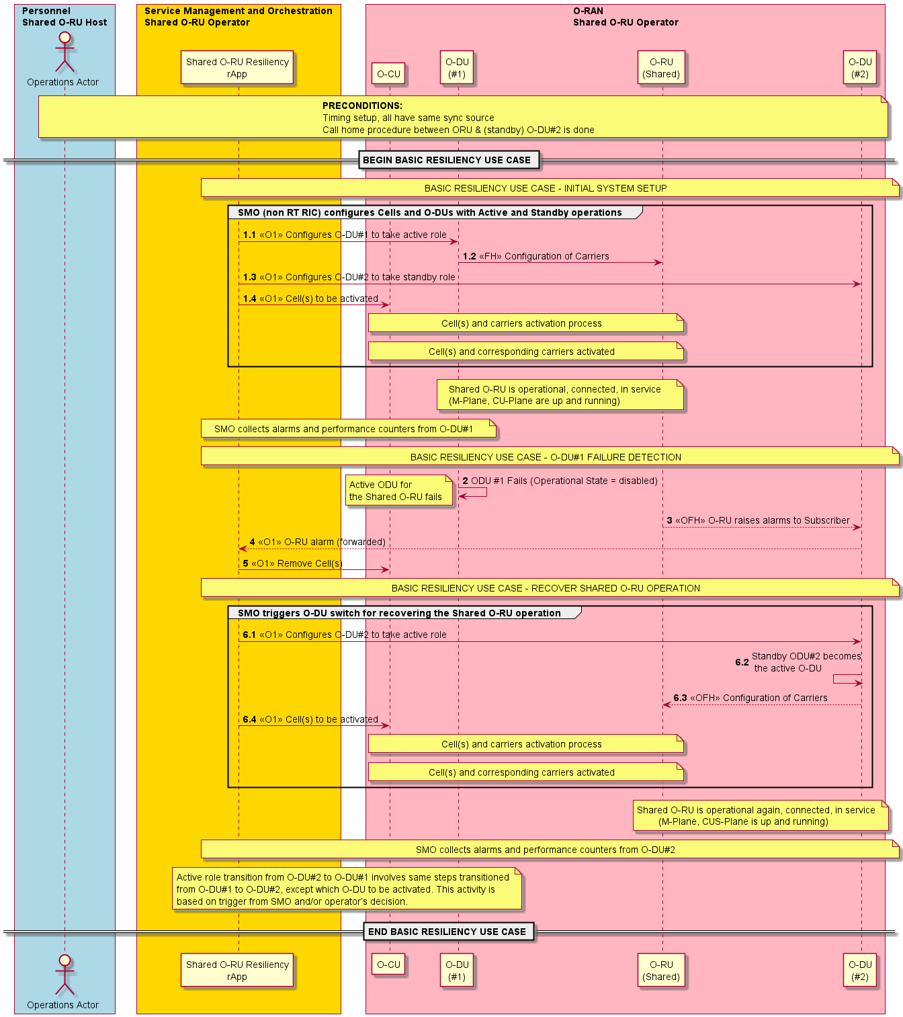
Figure 4.20.3.8-1: Basic resiliency use case

4.20.3.9 Antenna calibration use case of a Shared O-RU for Single-MNO
The following describes the solution for the antenna calibration sub-use case for a Shared O-RU in a Single-MNO configuration.
The step-by-step details of the antenna calibration use case of a Shared O-RU are captured in table 4.20.3.9-1.
Table 4.20.3.9-1: Antenna calibration use case of a Shared O-RU
Use Case Stage | Evolution / Specification | <<Uses>>  Related use
Goal | The host O-DU performs an antenna calibration procedure with the Shared O-RU.  The O-DU reports antenna calibration results to the SMO.
Actors and Roles | Shared O-RU performs the antenna calibration procedure.  O-DU (host) can request for antenna calibration procedure with Shared O-RU.  SMO can receive results from calibration.
Assumptions | O-DU has connectivity to O-RU.  All actors are operational and have initialized.  Fronthaul control and user plane is operational between O-DU and Shared O-RU.
Begins when | 1. The Shared O-RU has detected that antenna calibration is required.  2. The O-DU initiates an antenna calibration procedure.
Step 1.1 (O) | Recalibration required (O-RU initiated)  The Shared O-RU has detected that antenna calibration is needed and sends an antenna calibration needed notification to the host O-DU over the open FH. In this case, the O-RU initiates the calibration procedure.
Step 1.2 (O) | Calibration request  The host O-DU requests for antenna calibration procedure to start for Shared O-RU.
Step 1 (M) | Calibration request (O-DU initiated)  The host O-DU requests for antenna calibration procedure to start for Shared O-RU. In this case the O-DU initiates the calibration procedure.
Step 2 (M) | Calibration operation at O-RU  Shared O-RU performs antenna calibration procedure.
Step 3 (M) | Calibration response  Shared O-RU responds with antenna calibration results.
Step 4 (M) | Calibration results  The O-DU returns antenna calibration results to SMO.
Ends when | (1) Antenna calibrated: Antenna calibration procedure has finished, and results reported.
Exceptions | The O-RU may indicate a calibration failure, which is reported to the O-DU. The O-DU logs the failure and notifies north-bound entities.
Post Conditions | None.
@startuml
!pragma teoz true

skin rose
skinparam ParticipantPadding 5
skinparam BoxPadding 10
skinparam defaultFontSize 14
autonumber 1

Box “Service Management\nand Orchestration (SMO)” #gold
Participant SMO as “Antenna Calibration\nService”
end box

Box “O-RAN\nShared O-RU Operator” #lightpink
Participant ODU1 as “O-DU\n(#1) Host”
Participant ODU2 as “O-DU\n(#2)”
participant ORU as “O-RU\n(Shared)”
End box

== ANTENNA CALIBRATION PROCEDURE BEGIN (Hybrid) ==

hnote over ODU1, ORU
<<OFH>> Fronthaul Control & User Plane for partitioned carrier #1
end note

hnote over ODU2, ORU
<<OFH>> Fronthaul Control & User Plane for partitioned carrier #2
end note

alt ORU Initiated Calibration
Autonumber 1.1
ORU->ODU1: <<OFH>> Recalibration Needed Notification
ODU1->ORU: <<OFH>> Request Antenna Calibration Procedure
Else ODU Initiated Calibration
Autonumber 1
ODU1->ORU: <<OFH>> Request Antenna Calibration Procedure
End

ORU->ORU: Perform\nAntenna\nCalibration\nProcedure
ORU->ODU1: <<OFH>> Respond Antenna Calibration Procedure Results
ODU1->SMO: <<O1>> Respond Antenna\nCalibration Procedure Results

== ANTENNA CALIBRATION PROCEDURE END (Hybrid) ==

@enduml

The flow diagram of the antenna calibration use case of a Shared O-RU for Single-MNO is given in figure 4.20.3.9-1.

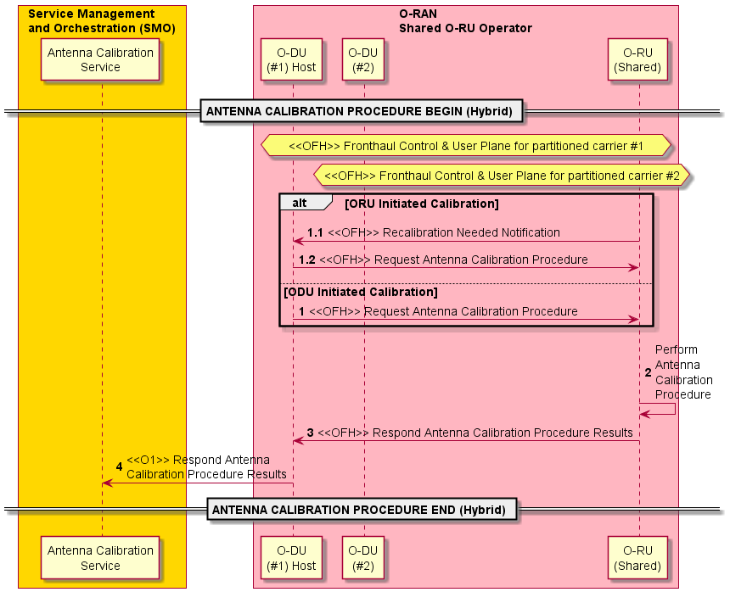

Figure 4.20.3.9-1: Antenna calibration use case of a Shared O-RU for Single-MNO

4.20.3.10 Rehoming use case of a Shared O-RU for Single-MNO
The following will describe the solution for the rehoming sub-use case for a Shared O-RU.
The context of the rehoming use case of a Shared O-RU for Single-MNO is captured in table 4.20.3.10-1.
Table 4.20.3.10-1: Rehoming use case of a Shared O-RU for Single-MNO
Use Case Stage | Evolution / Specification | <<Uses>>  Related use
Goal | A Shared O-RU is rehomed and is able to pair with new O-DU or existing (previous) O-DU parents.
Actors and Roles | Shared O-RU is the element that is rehomed.  Host O-DU (old) is the original Shared O-RU parent.  SRO O-DU (old) is another original O-DU Shared O-RU is connected to.  Host O-DU (new) is the new Shared O-RU parent.  SRO O-DU (new) is another new O-DU Shared O-RU is connected to.  SMO can receive results from calibration.
Assumptions | The Shared O-RU is in a deployment with the original (old) O-DUs and will be moved to the new ones or could stay with original O-DUs (as parents).  (Typically) the operator will plan a Shared O-RU rehoming activity before they actually perform the operations related to the move.
Begins when | This use case starts with any of these three situations:  Case #1 starts when the Shared O-RU is physically moved to a new location (however still connected to original O-DUs).  Case #2 starts when the Shared O-RU is physically moved to a new location but is connected to new O-DUs.  Case #3 starts when the Shared O-RU stays in same physical location but is connected to new O-DUs (management-initiated rehoming).
Case #1 – O-RU is physically moved with same O-DU parents
Step 1 (M) | Shared O-RU is disconnected from original O-DUs  The Shared O-RU is physically disconnected (fiber disconnected) from the existing O-DU parents.  Then, the Shared O-RU is physically moved to a new location.
Step 2 (M) | Shared O-RU is reconnected to original O-DUs  The Shared O-RU is either physically reconnected (different fiber) or connected at the transport layer (with the original fiber) to the original O-DU parents, and the following sub-use cases are triggered as a result:  - Shared O-RU startup sub-use case  - Configuration sub-use case  - Resource partitioning sub-use case  - Reset sub-use case supervision sub-use case
Case #2 – O-RU is physically moved with new O-DU parents
Step 1 (M) | Shared O-RU is disconnected from original O-DUs  The Shared O-RU is physically disconnected (fiber disconnected) from the former O-DU parents.  Then, the Shared O-RU is physically moved to a new location.
Step 2 (M) | Shared O-RU is connected to new O-DUs  The Shared O-RU is either physically reconnected (different fiber) or connected at the transport layer (with the original fiber) to new O-DU parents, and the following sub-use cases are triggered as a result:  - Shared O-RU startup sub-use case  - Configuration sub-use case  - Resource partitioning sub-use case  - Reset sub-use case supervision sub-use case
Case #3 – Management initiated rehoming
Step 1 (M) | Management initiated rehoming for Shared O-RU  Shared O-RU already has physical front-haul connections in place.  SMO initiates rehoming operation with connected O-DUs to the Shared O-RU.
Step 2 (M) | Shared O-RU starts up  The Shared O-RU starts up with the new O-DU parents, and the following sub-use cases are triggered as a result:  - Shared O-RU startup sub-use case  - Configuration sub-use case  - Resource partitioning sub-use case  - Reset sub-use case supervision sub-use case
Ends when | The Shared O-RU has been moved and connected to the appropriate O-DUs, and is operational again.
Exceptions | None.
Post Conditions | None.

@startuml
!pragma teoz true

skin rose
skinparam ParticipantPadding 5
skinparam BoxPadding 10
skinparam defaultFontSize 14
autonumber 1

Box “Service Management\nand Orchestration (SMO)” #gold
Participant CFG as "Configuration\nManagement"
Participant SMO as “Shared O-RU\nOrchestration\nrApp”
end box

Box “O-RAN\nShared O-RU Operator” #lightpink
Participant ODU1 as “O-DU\n(#1) Host”
Participant ODU2 as “O-DU\n(#2)”
Participant ORU as “O-RU\n(Shared)”
End box

== BEGIN CASE #1 PHYSICAL REHOMING OF THE SHARED O-RU SAME O-DUs ==

hnote over ODU1, ORU
The O-RU FH is disconnected
from O-DU #1, O-DU #2
end note

ORU -> ORU: O-RU FH is \ndisconnected

hnote over ORU
The O-RU is
physically moved
to a new location
end note

hnote over ODU1, ORU
The O-RU FH is reconnected
to O-DU #1, O-DU #2
end note

ORU -> ORU: O-RU FH is \nconnected

hnote over ODU1, ORU
The O-RU Starts up with O-DU1 and O-DU2
end note

Ref over CFG, ORU: Shared O-RU Startup Sub Use Case \n Configuration Sub Use Case\n Resource Partitioning Sub Use Case\n Reset Sub Use Case\n Supervision Sub Use Case

== END PHYSICAL REHOMING OF THE SHARED O-RU SAME O-DUs ==

@enduml
The flow diagram of the rehoming use case of a Shared O-RU for Single-MNO is given in figure 4.20.3.10-1.

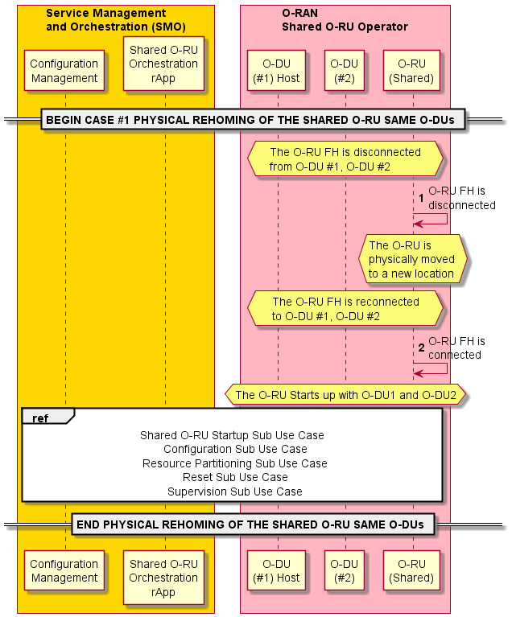
Figure 4.20.3.10-1: Rehome by physically moving Shared O-RU with same O-DU for Single-MNO
@startuml
!pragma teoz true

skin rose
skinparam ParticipantPadding 5
skinparam BoxPadding 10
skinparam defaultFontSize 14
autonumber 1

Box “Service Management\nand Orchestration (SMO)” #gold
Participant CFG as "Configuration\nManagement"
Participant SMO as “Shared O-RU\nOrchestration\nrApp”
end box

Box “O-RAN\nShared O-RU Operator” #lightpink
Participant ODU1 as “O-DU\n(#1) Host”
Participant ODU2 as “O-DU\n(#2)”
Participant ODU3 as “O-DU\n(#3) Host”
Participant ODU4 as “O-DU\n(#4)”
participant ORU as “O-RU\n(Shared)”
End box

== BEGIN CASE #2 PHYSICAL REHOMING OF THE SHARED O-RU ==

Opt Configuration\npreparation
Alt Hybrid\n Type
hnote over CFG
Preparation for
SMO & O-RU
end note
Else Hierarchical Type
Hnote over CFG
Preparation
for O-DU
End note
End
End

hnote over ODU1, ORU
The O-RU FH is disconnected
from O-DU #1, O-DU #2
end note

ORU -> ORU: O-RU FH is \ndisconnected

hnote over ORU
The O-RU is physically
moved to a new location
end note

hnote over ODU3, ORU
The O-RU FH is reconnected
to O-DU #3, O-DU #4
end note

ORU -> ORU: O-RU FH is \nconnected

hnote over ODU3, ORU
The O-RU Starts up with O-DU3 and O-DU4
end note

Ref over SMO, ORU: Shared O-RU Startup Sub Use Case \n Configuration Sub Use Case\n Resource Partitioning Sub Use Case\n Reset Sub Use Case\n Supervision Sub Use Case

== END PHYSICAL REHOMING OF THE SHARED O-RU NEW O-DUs ==

== BEGIN CASE #3 MANAGEMENT INITIATED REHOMING OF THE SHARED O-RU ==

SMO -> ODU1: Rehoming Operation
SMO -> ODU3: Rehoming Operation

Ref over SMO, ORU: Shared O-RU Startup Sub Use Case \n Configuration Sub Use Case\n Resource Partitioning Sub Use Case\n Reset Sub Use Case\n Supervision Sub Use Case

== END MANAGEMENT INITIATED REHOMING OF THE SHARED O-RU ==

@enduml

The flow diagram of the rehoming use case of a Shared O-RU for Single-MNO is given in figure 4.20.3.10-2.

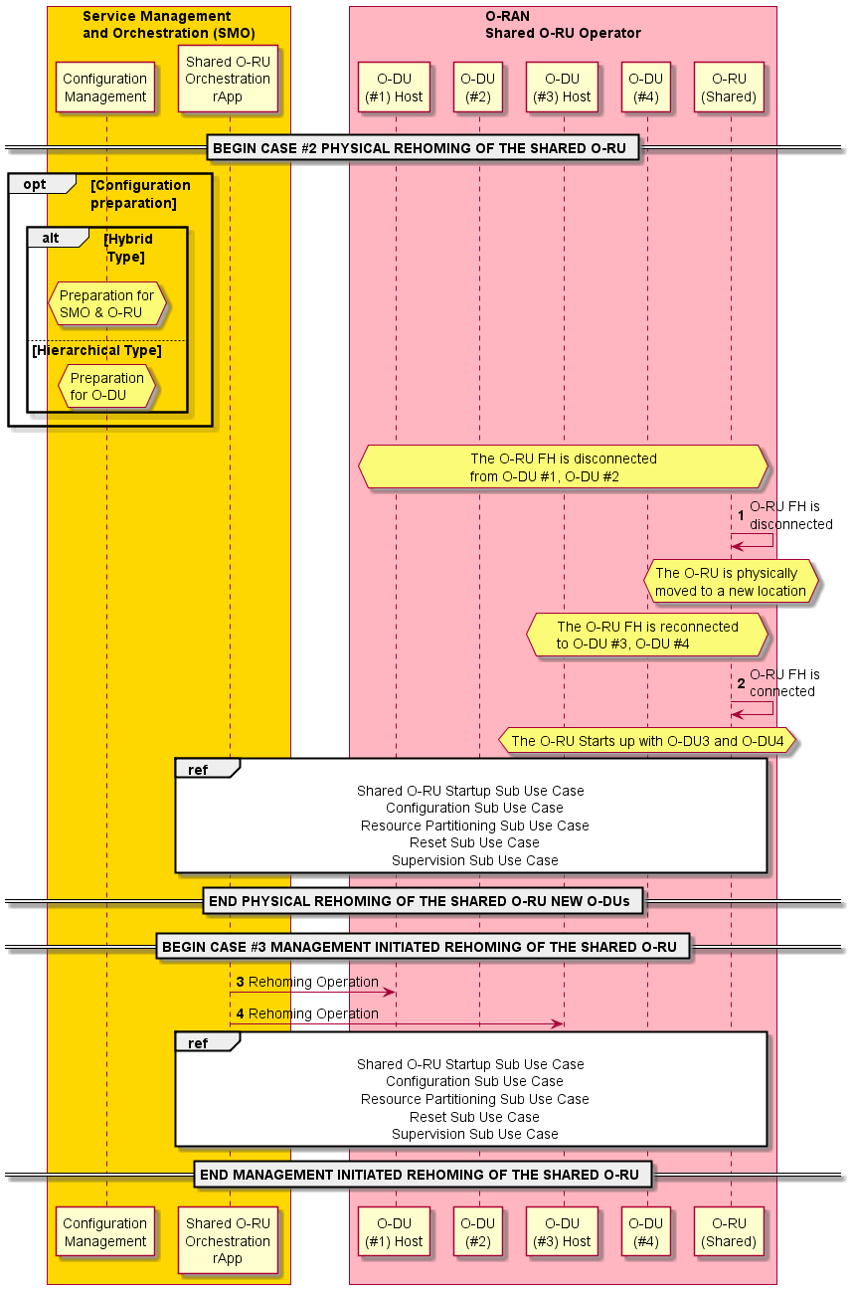
Figure 4.20.3.10-2: Rehome by physically moving Shared O-RU with new O-DUs for Single-MNO

4.20.3.11 Reset use case of a Shared O-RU for Single-MNO
The following describes the solution for the reset sub-use case for a Shared O-RU.
The context of the reset use case of a Shared O-RU is captured in table 4.20.3.11-1.
Table 4.20.3.11-1: Reset use case of a Shared O-RU
Use Case Stage | Evolution / Specification | <<Uses>>  Related use
Goal | The goal of this sub-use case is to describe the flow related to reset of Shared O-RU for a Single-MNO operator configuration.  This is a service impacting use case.
Actors and Roles | Shared O-RU:  The Shared O-RU is a key actor. It undergoes reset in this use case. The Shared O-RU can be reset by intention/request or autonomously.  O-DUs (host/tenant/ &other O-DUs):  All the O-DUs connected to the Shared O-RU are actors are involved in the reset operation. O-DU#1 has the role of the Shared O-RU host, it also has a role of Shared Resource Operator (SRO). O-DU#2 is only an SRO.  SMO:  The SMO is informed by the O-DU that O-RU has been reset or issues a reset.
Assumptions | It is assumed that there is always at least one O-DU still operational with the Shared O-RU.  This use case describes the flow for a Single-MNO operator configuration.
Begins when | The reset of a Shared O-RU use case can be invoked when there is a direct request to reset the Shared O-RU, or it can be reset autonomously.  There are many possible reasons why a Shared O-RU can need to be intentionally reset. Maintenance, software upgrade, network failure, power outages, communication link issues are just some of the many possible situations where the active O-RU would be reset.
Pre-conditions | The Shared O-RU has connectivity to one or more O-DUs (and one of them is serving the primary role).  The Shared O-DU has been configured originally by the active O-DU, and also carriers for the standby O-DUs.  O-DUs have subscribed to alarm notifications successfully.
Step 1 (M) | [Shared O-RU reset flow]  Reset request from SMO  A reset request is communicated from the SMO to the Shared O-RU host (O-DU #1). The reset request can be originated from the SMO for a variety of reasons.
Step 2 (M) | Reset request from O-DU  The reset request is communicated onward from the Shared O-RU host (O-DU #1) to the Shared O-RU through the open front-haul interface.
Step 3 (M) | Reset reply  The Shared O-RU RPC Reply Acknowledge is sent from the Shared O-RU to the Shared O-RU host (O-DU #1).
Step 4 (M) | Shared O-RU reset  Once invoked, the Shared O-RU goes through its reset sequence to complete the reset operation.
Step 5 (M) | Reset response  The Shared O-RU host (O-DU #1) informs the SMO with a reset response.
Step 6 (M) | [Autonomous reset flow]  Autonomous Shared O-RU reset  The Shared O-RU is autonomously reset.
Step 7 (M) | O-DU initial detects loss of connection.  The Shared O-DU host (O-DU #1) detects loss of polling as a result of the autonomous O-RU reset. It can also detect a call home signal from a Shared O-RU that just had a valid M-plane session.
Step 8 (M) | O-DU determines loss of connection.  The O-DU can deduce that O-RU has a lost connection with broken polling with the O-DU. The O-DU does not know if the O-RU was performing a reset or if there was other reason for the lost connection, for example, a broken optical fiber. The O-DU can only report lost connection to O-RU in such a case.  The O-DU redetects the Shared O-RU through a call home from the Shared O-RU. Then the Shared O-RU Start up sequence of that sub-use case happens (see the ref flow). Afterwards, the O-DU can read the reset cause from the Shared O-RU.
Step 9 (M) | O-DU informs SMO.  When the O-DU #1 starts sensing call home signals from O-RU, O-DU can deduce that O-RU has returns to service after a reset. Afterwards, the O-DU #1 can read the restart cause. Then, the Shared O-DU host can report to SMO that O-RU is re-detected and what was the reason why the O-RU reset. Then O-DU can fill update its aggregated model with details obtained from the O-RU and populate this information to SMO.  Step 14 When O-DU redetects, the SMO can clear the alarm.
Ends when | The use case ends the Shared O-RU has reset whether by reset or by autonomous reset.
Exceptions | There are many possible exceptions. Some of these include:  The Shared O-RU was not able to successfully reset.  The O-DU #1 was not able to properly detect lost connection with the Shared O-RU through loss of polling or call home signal was never sent.  The O-DU #1 was not able to establish a restore connection to the Shared O-RU after reset.
Post Conditions | Successful post condition – On a successful post-condition, the Shared O-RU is reset, and has restored connectivity to the Shared O-RU host (O-DU #1).  Failure post condition – One of the failure exceptions has been encountered.
@startuml
!pragma teoz true

skin rose
skinparam ParticipantPadding 5
skinparam BoxPadding 10
skinparam defaultFontSize 14
autonumber 1

Box "Service Management and Orchestration\nShared O-RU Operator" #gold
Participant R_APP as "Shared O-RU\nOrchestration \nrApp"
end box

Box "O-RAN\nShared O-RU Operator" #lightpink
Participant ODU1 as "O-DU\n(#1)"
Participant ODU2 as "O-DU\n(#2)"

participant ORU as "O-RU\n(Shared)"
End box

== RESET OF SHARED O-RU SUB USE CASE ==

hnote over ODU1, ORU
Shared O-RU Reset Operation
end note

R_APP->ODU1: <<O1>> Reset Request to Shared O-RU Host
ODU1->ORU: <<OFH>> Reset Request
ORU->ODU1: <<OFH>> Reset rpc-reply Acknowledge

ORU->ORU : Shared\n O-RU Reset\n sequence
Ref over ORU : Start-up Sub-Use\n Case for Shared O-RU

ODU2->ODU2: Detect Loss of \nM-Plane \n Connection\nor Call Home Signal
ODU2->ODU2: Determines Lost\n Connection to O-RU

ODU2->R_APP: <<O1>> Shared O-RU Communication Lost Alarm
ODU2-->R_APP: O-RU Redetected with Restart Cause

ODU1->R_APP: <<O1>> Reset Response

== END RESET OF SHARED O-RU SUB USE CASE ==

== AUTONOMOUS RESET OF SHARED O-RU SUB USE CASE ==

ORU->ORU : Autonomous \nShared\n O-RU Reset
ODU1->ODU1: Detect Loss of \nM-Plane \n Connection\nor Call Home Signal
ODU1->ODU1: Determines Lost\n Connection to O-RU

ODU1->R_APP: <<O1>> Shared O-RU Communication Lost Alarm

ORU->ODU2: About to Reset notification
ODU2->ODU2: Detect Loss of \nM-Plane \n Connection\nor Call Home Signal
ODU2->ODU2: Determines Lost\n Connection to O-RU

ODU2->R_APP: <<O1>> Shared O-RU Communication Lost Alarm

Ref over ORU : Start-up Sub-Use\n Case for Shared O-RU

ODU1-->R_APP: O-RU Redetected with Restart Cause
ODU2-->R_APP: O-RU Redetected with Restart Cause

== END AUTONOMOUS RESET OF SHARED O-RU SUB USE CASE ==

@enduml

The flow diagram of the reset use case is given in figure 4.20.3.11-1.
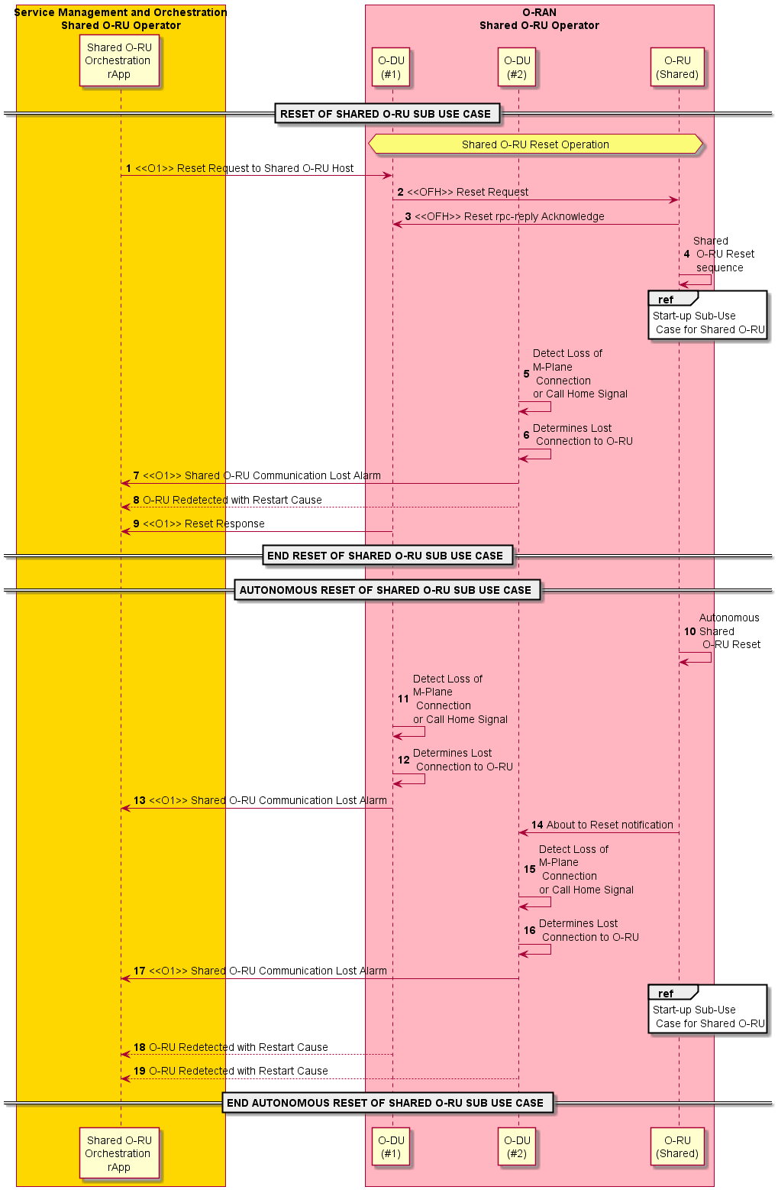
Figure 4.20.3.11-1: Reset use case

4.20.3.12 Advanced resiliency sub-use cases of a Shared O-RU for Single-MNO
Advanced resiliency sub-use cases describe interactions between actors for resiliency operations.

4.20.3.12.1 Advanced resiliency sub-use case with 1 O-DU active + 1 O-DU standby (1+1)
The context of the advanced resiliency sub-use case with 1 O-DU active + 1 O-DU standby (1+1) is captured in table 4.20.3.12.1-1.
Table 4.20.3.12.1-1: Advanced resiliency sub-use case with 1 O-DU active + 1 O-DU standby (1+1)
Use Case Stage | Evolution / Specification | <<Uses>>  Related use
Goal | The objective of this sub-use case is to manage resiliency operations involving the active and stand-by O-DUs with the Shared O-RU. This includes system behaviour in situations such as partial O-DU failures, interface failures, and power outages related to the O-DU. This ensures to restore the service availability to end users.  This is a service impacting use case.
Actors and Roles | Shared O-RU:  The Shared O-RU handles the fronthaul and air interfaces and the reporting of performance counters and failures.  O-DUs (active/stand-by O-DUs):  O-DUs may receive configurations from SMO. The O-DU may report performance counters and alarms to SMO. The O-DU is also responsible for configuring and collecting the performance data and alarms from O-RU(s) in hierarchical deployment. This use case focusses on active / stand-by role change for O-DUs to minimize service disruption.  O-CU:  O-CU receives cell related configurations from SMO and available cell details from O-DU(s). Respectively to available resources reported by O-DU and desired availability of cells received from SMO. The O-CU activates or deactivates the cells in the O-DU using F1 interface.  SMO:  The SMO configures the role of O-DUs as active and standby O-DUs and informs these roles to Shared O-RU through O-DU in hierarchical deployment or directly in case of hybrid deployment. SMO also makes high-level decisions about O-DU role change based on e.g., received alarms and degraded performance.
Assumptions | The assumptions are based on the premise that there will always be at least one O-DU remains operational with the Shared O-RU.
Begins when | This use case is triggered when the SMO detects the partial failure related to active O-DU based on alarms or service performance degradation. The use case may also be triggered due to various interfaces malfunction or service degradation.
Pre-conditions | - The Shared O-RU is on.  - Prior carrier activation (step 6) O-RU's sync-state is "locked".  - All actors are connected to same sync source.
Step 1 (M) | The SMO may configure O-DU#1 to take active role in controlling the Shared O-RU. It then configures the cells and corresponding carrier resources (including NRCGI(s) for the cells) via the O1 interface.
Step 2 (M) | O-DU configures the [tr]x-array-carrier(s) in O-RU, corresponding to the carrier resources outlined in step 1.
Step 3 (M) | The SMO may configure O-DU#2 to take stand-by role via O1 interface.
Step 4 (M) | SMO may provide O-CU with information regarding which cell(s) (NRCGI(s)) associated with O-DU#1 need to be activated.
Step 5 (M) | When cells and corresponding carriers are configured and available for service, the O-DU informs O-CU about cells availability using F1 interface.
Step 6 (M) | O-CU requests O-DU#1 to activate the cell(s) (NRCGI(s)), using the associated messages exchanged via the F1 interface.
Step 7 (M) | O-DU#1 activates the [tr]x-array-carrier(s) in O-RU that are associated with the specific cell(s) (NRCGI(s)) requested for activation in step 6.
Step 8 (M) | O-DU#1 activates the cell(s) as requested by O-CU in step 6.
Step 9 (M) | O-DU#1 uses the F1 interface to inform O-CU about activation status for cells requested in step 6.  See NOTE 1.
Advanced resiliency use case for partial failure (interface or node)/performance degrade scenarios. SMO makes a high-level decision to make the Shared O-RU remains operational by initiating an O-DU switch
Step 10.1 (M) | See NOTE 2 and NOTE 3.  The SMO set the administrative state of the O-DU#1 to “locked” and its operational state is set to “disabled”.  See NOTE 4.
Step 10.2 (M) | SMO removes the cell(s) configuration from O-DU#1. This results in removal of the associated carrier resources from Shared O-RU.  See NOTE 5.
Step 10.3 (M) | O-DU#1 may send the RPCs to the O-RU via fronthaul M-plane to deactivate and remove the U-plane configurations related to cell(s) mentioned in Step 9.1.  See NOTE 6.
Step 10.4 (M) | O-DU#1 informs O-CU about the cell(s) removal using associated messages via F1 interface.  See NOTE 7.
Step 10.5 (M) | The SMO configures the cells (including NRCGI) and corresponding carrier resources to O-DU#2 via O1 interface.
Step 10.6 (M) | O-DU configures the [tr]x-array-carrier(s) in O-RU, corresponding to the carrier resources outlined in step 10.5.
Step 10.7 (M) | SMO provides O-CU with information regarding which cell(s) (NRCGI(s)) associated with O-DU#2 need to be activated.
Step 10.8 (M) | O-DU#2 informs O-CU, about the added cell(s) (NRCGI(s)) that are ready for activation via F1 interface using the associated messages.
Step 10.9 (M) | O-CU requests O-DU#2 to activate the cell(s) (NRCGI(s)), using the associated messages exchanged via the F1 interface.
Step 10.10 (M) | O-DU#2 activated [tr]x-array-carriers related to cells (NRCGI) requested by O-CU in step 10.9.
Step 10.11 (M) | O-DU#2 activates the cell(s) that were specified by O-CU in step 10.9.
Step 10.12 (M) | O-DU#2 informs O-CU about the cell(s) that are activated using associated messages via F1 interface.  See NOTE 8, NOTE 9 and NOTE 10.
Ends when | This use case ends when roles are changed as per SMO's request (or when their process ends with non-recoverable error).
Exceptions | There are several exceptions that may occur during this process. These include:  - Shared O-RU fails during a switch over.  - If the standby O-DU #2 also becomes unavailable when it is due to become active.  - If same event messaging for the flow is lost.  - If configuration provided to O-DU or O-CU is improper.  - If the connectivity or functionality of the management system (SMO) becomes unavailable.
Post Conditions | Successful post condition – O-DU's roles are changed successfully, services for end users are available.  Failure post condition– O-RU does not have active O-DU connected and services for end user are not available.
NOTE 1: Shared O-RU becomes operational with O-DU#1 with cell on air and ready to serve UEs.
NOTE 2: SMO collects alarms and performance management data from O-DU#1.
NOTE 3: When analysing the active alarms and performance counters, SMO may detect a partial failure of O-DU#1. Scenario continues in case of partial failure is detected.
NOTE 4: The meanings of administrate and operational states are defined in ITU-T X.731 [18].
NOTE 5: If the above role change is due to M-plane failure between O-DU#1 and Shared O-RU, then O-DU#1 would not have access to O-RU and hence cannot remove carriers.
NOTE 6: If M-plane failure occurs between O-DU#1 and Shared O-RU, then the O-DU#1 would not have access to O-RU and cannot deactivate and remove carriers.
NOTE 7: If F1 interface failure occurs between O-CU and O-DU#1, then the O-DU#1 would not have access to O-CU and hence it cannot request for cell(s) removal.
NOTE 8: Shared O-RU operations are restored with O-DU#2 and begins providing services to the users, i.e., CUS-plane is up and running.
NOTE 9: SMO collects the alarms and performance management data from O-DU#1 (if it is only partial failure and not lost communication, list of available PM counters reported by O-DU#1 will probably be reduced (when compared to the list available from fully operational O-DU)) and O-DU#2.
NOTE 10: The transition of the active role from O-DU#2 back to O-DU#1 involves the same steps as the initial transition from the O-DU#1 to O-DU#2, with the exception of which O-DU is to be activated. This activity is initiated based on a trigger from the SMO and/or the operator's decision.
@startuml
!pragma teoz true
skin rose
skinparam ParticipantPadding 5
skinparam BoxPadding 10
skinparam defaultFontSize 14
skinparam sequenceMessageAlign center
autonumber
Box "Personnel\nShared O-RU Host" #Lightblue
Actor operator as "Operations Actor"
End box
Box “Service Management and Orchestration\nShared O-RU Operator (non RT RIC)” #gold
Participant SMO_a as "Shared O-RU Resiliency\nSMO(non-RT RIC)"
End box
Box “O-RAN\nShared O-RU Operator” #lightpink

Participant OCU as "O-CU"

Participant ODU1 as “O-DU\n(#1)”

participant ORU as "O-RU\n(Shared)"

Participant ODU2 as "O-DU\n(#2)"
End box
Note over operator, ODU2
<B>PRECONDITIONS:</B>
Shared O-RU is on
Prior carrier activation (step 6) O-RU's sync-state is "locked"
All have same sync source
End Note
== BEGIN ADVANCED RESILIENCY USE CASE ==
group SMO (non RT RIC) configures Cells and O-DUs with Active and Standby operations
SMO_a -> ODU1 : <<O1>> Configures O-DU#1 to take active role and configures cell(s) and \ncorresponding carrier(s)resources (including NRCGI(s) for the cell(s))
ODU1 -> ORU : <<FH>> [tr]x-array-carrier(s) configuration
SMO_a -> ODU2 : <<O1>> Configures O-DU#2 to take standby role
SMO_a -> OCU : <<O1>> Provides O-CU with information about which \ncell(s)(NRCGI(s)) to be activated
OCU <- ODU1 : <<F1>> Cell(s) (NRCGI(s)) ready for activation
OCU -> ODU1 : <<F1>> Request for cell(s) (NRCGI(s)) activation
ODU1 -> ORU : <<FH>> Activates the [tr]x-array-carrier(s) in O-RU that \nis associated with specific Cell(s) (NRCGI(s))
ODU1 -> ODU1 : Activates cell(s) as per O-CU request
OCU <- ODU1 : <<F1>> Cell(s) activated
end
Note over ODU1, ORU
Shared O-RU is operational, connected, in service
CUS-Plane is up and running)
End Note
Note over SMO_a, ODU1
SMO collects alarms and performance counters from O-DU#1
End note
Note over SMO_a, ODU2
ADVANCED RESILIENCY USE CASE FOR PARTIAL FAILURES OF O-DU AND PARTIAL FAILURE (INTERFACE OR NODE)/PERFORMANCE DEGRADE SCENARIOS
End Note
Note over SMO_a, ORU
**Advanced Resiliency use case failure scenarios:**
SMO detects the partial failure related to O-DU#1 based on alarms or service performance degradation based on KPIs
End Note
Note over SMO_a, ODU2
SMO MAKES A HIGH LEVEL DECISION TO THE OPERATION OF THE SHARED O-RU OPERATIONAL BY INITIATING AN O-DU SWITCH
End Note
group The SMO(non-RT RIC) initiates an O-DU switch to restore the operation of the Shared O-RU
Autonumber 10.1
group SMO triggers the switch or transition of the O-DU
SMO_a -> ODU1 : <<O1>> Lock the O-DU
SMO_a -> ODU1 : <<O1>> Removes the cell(s) that were served
ODU1 -> ORU : <<FH>> Removes the [tr]x-array-carrier(s) \nconfigurations of related cell(s)
OCU <- ODU1 : <<F1>> Cell(s) removal
SMO_a -> ODU2 : <<O1>> Configures O-DU#2 to take active role and configures cell(s) and corresponding carrier(s)resources (including NRCGI(s) for the cell(s))
ODU2 -> ORU : <<FH>> [tr]x-array-carrier(s) configuration
SMO_a -> OCU : <<O1>> Provides O-CU with information about which \ncell(s) (NRCGI(s)) to be actived
OCU <- ODU2 : <<F1>> Cell(s) (NRCGI(s)) ready for activation
OCU -> ODU2 : <<F1>> Request for cell(s) (NRCGI(s)) activation
ODU2 -> ORU : <<FH>> Activates the [tr]x-array-carrier(s) in O-RU that is \n associated with specific Cell(s) (NRCGI(s))
ODU2 <- ODU2 : Activates cell(s) as per O-CU request
OCU <- ODU2 : <<F1>> Cell(s) activated
end
Note over ODU2, ORU
Shared O-RU is operational again,connected, in service
(CUS-Plane is up and running)
End Note
Note over SMO_a, ODU2
SMO collects alarms and performance counters from O-DU#2
End note
Note over SMO_a, ODU1
Active role transition from O-DU#2 to O-DU#1 involves same steps transitioned
from O-DU#1 to O-DU#2, except which O-DU to be activated. This activity is
based on trigger from SMO and/or operator’s decision.
End note
End
== END ADVANCED RESILIENCY USE CASE ==
@enduml

The flow diagram of the advanced resiliency sub-use case with 1 O-DU active + 1 O-DU standby (1+1) is given in figure 4.20.3.12.1-1.

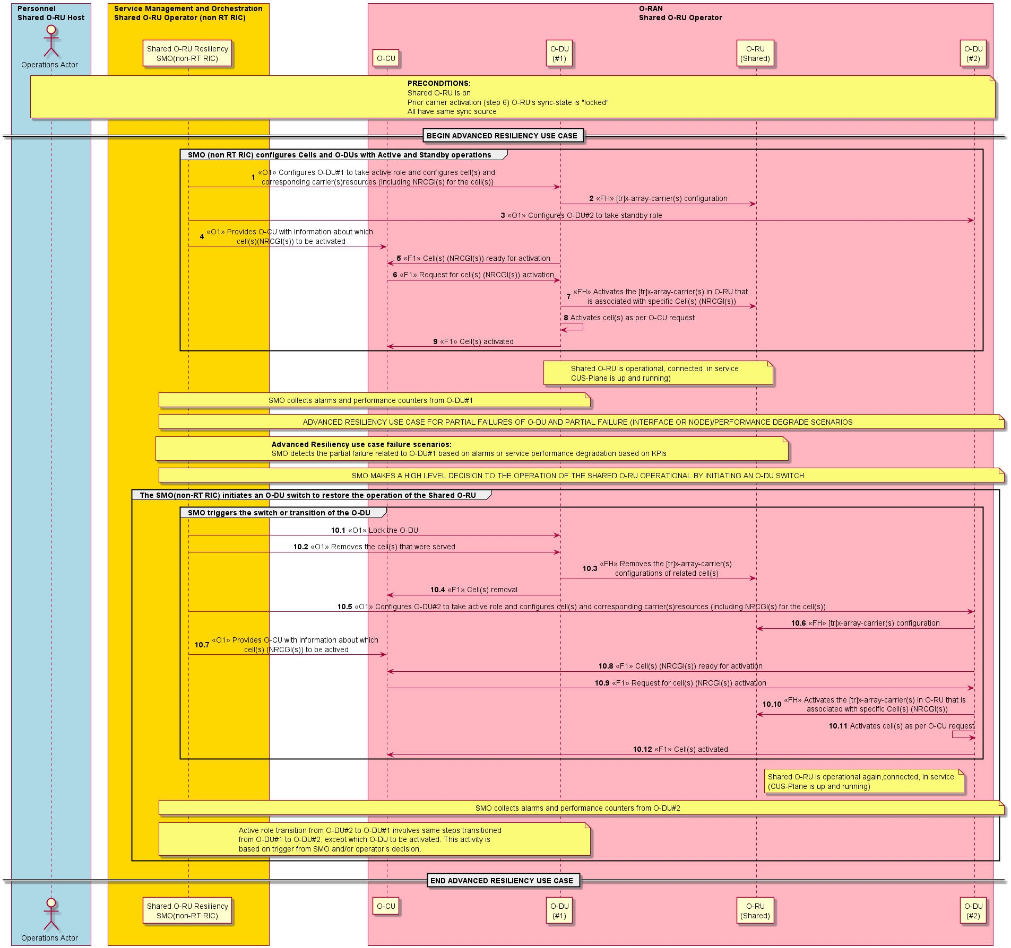
Figure 4.20.3.12.1-1: Advanced resiliency sub-use case implementation flow for 1 active + 1 standby O-DUs with various resiliency situations

4.20.3.13 Load-balancing sub-use cases of a Shared O-RU
The load-balancing sub-use cases describes the flow of how actors involved execute a policy to load-balance the resources of the O-DUs and Shared O-RU coordinated through a policy enforcer (actor).

4.20.3.14 Coordinated reset of a Shared O-RU sub-use cases for Multi-MNO
The coordinated reset of a Shared O-RU sub-use cases describes the flow of how actors coordinate to reset Shared O-RU.
The context of the coordinated reset of a Shared O-RU sub-use cases is captured in table 4.20.3.14-1.
Table 4.20.3.14-1: Coordinated reset of a Shared O-RU sub-use cases
Use Case Stage | Evolution / Specification | <<Uses>>  Related use
Goal | Coordinated reset of a Shared O-RU.
Actors and Roles | Host SMO – The connected host SMO to the host O-DU.  Partner SMO – The partner operator SMO. It connects to the SROs.  Host O-DU – Host O-DU connected to the Shared O-RU.  Operator O-DU – The SRO O-DU connected to the Shared O-RU.  Shared O-RU – The target Shared O-RU that will be reset.
Assumptions | None.
Begins when | There are four basic variations of a coordinated reset of a Shared O-RU. These are described in the following steps and diagrams.  - Coordinated reset of a Shared O-RU initiated by host personnel  - Coordinated reset of a Shared O-RU initiated by SRO personnel  - Coordinated reset of a Shared O-RU autonomously initiated by host O-DU  - Coordinated reset of a Shared O-RU autonomously initiated by SRO O-DU
Pre-conditions | None.
Coordinated reset of Shared O-RU initiated by host personnel
Step 1 (M) | Reset request from operator  The request for the coordinated reset of a Shared O-RU is initiated from the host operator and is received by the host operator SMO.
Step 2 (M) | Host SMO informs partner SMOs  The host operator SMO informs associated SMOs that the coordinated reset of a Shared O-RU has been initiated. Associated SMOs are other SMOs which are connected to O-DUs that are connected to the affected Shared O-RU. See NOTE 1, NOTE 2.
Step 3.1 (ALT) | Reset request from host SMO to host O-DU (hierarchal mode)  The request for the coordinated reset of the target Shared O-RU is sent from the host operator SMO to the host O-DU over the O1 interface. See NOTE 3.
Step 3.2 (ALT) | Reset request from host O-DU to Shared O-RU (hierarchical mode)  In hierarchical mode, the coordinated reset request of the target Shared O-RU is sent from the host O-DU to the target Shared O-RU through the fronthaul as an RPC request.
Step 3.3 (ALT) | Reset request from host SMO to Shared O-RU (hybrid mode)  In hybrid mode, the coordinated reset request of the target Shared O-RU is sent from the host SMO to target Shared O-RU as an RPC request via the M-plane. See NOTE 4.
Step 4 (M) | Shared O-RU notifies the host O-DU  The affected Shared O-RU notifies the host O-DU (hierarchical mode) or host SMO (hybrid mode). See NOTE 5, NOTE 6, NOTE 7.
Step 5 (M) | Host O-DU notifies the SMO  The host O-DU informs the host SMO with a “Shared O-RU reset initiated” notification.
Step 6 (M) | Shared O-RU notifies other connected O-DUs  The target Shared O-RU notifies other connected O-DUs as SROs. This is a notification message originating from the Shared O-RU with no specific ordering.
Step 7 (M) | O-DU notifies associated SMO  The O-DU (SRO) informs its associated SMO with a “Shared O-RU reset initiated” notification.
Step 8 (M) | Shared O-RU notifies other connected O-DUs  The target Shared O-RU notifies other connected O-DUs as SROs. This is a notification message originating from the Shared O-RU with no specific ordering.
Step 9 (M) | O-DU notifies associated SMO  The O-DU (SRO) informs its associated SMO with a “Shared O-RU reset initiated” notification.
Step 10 (M) | Shared O-RU notifes connected host O-DU  The target Shared O-RU notifies the host O-DU (hierarchical mode) or host SMO (hybrid mode) with a reset response. This is an RPC reply-acknowledgement.
Step 11 (M) | Host O-DU notifies the SMO  The host O-DU informs the host operator SMO that the Shared O-RU has executed the reset with a “Shared O-RU Reset Executed” notification.
Step 12 (M) | Shared O-RU reset & startup  The Shared O-RU resets; and then initiates its start-up sequence.
Coordinated reset of Shared O-RU initiated by SRO personnel
Step 1 (M) | Reset procedure initiated  The partner operator has identified a need to reset the target Shared O-RU and initiates a reset procedure.
Step 2 (M) | Identify host  The host for the target Shared O-RU is identified.
Step 3 (M) | Reset coordination  Coordination between the operators can occur, so that the partner operator can indicate to the host the need for a reset.
Step 4 (M) | Reset request from operator  The reset request from the partner operator is sent to the partner SMO.
Step 5 (M) | Identify host  The partner SMO identifies the proper host SMO for the target Shared O-RU.
Step 6 (M) | Reset request (coordination)  The partner shared operator SMO sends a request to the host SMO to initiate a coordinate reset of the target Shared O-RU.
Step 7 (M) | Reset response (coordination)  The host SMO responds to the partner shared operator SMO regarding the initiation of a coordinate reset of the target Shared O-RU.
Step 8.1 (ALT) | Reset request from host SMO to host O-DU (hierarchal mode)  The request for the coordinated reset of the target Shared O-RU is sent from the host operator SMO to the host O-DU over the O1 interface. See NOTE 8.
Step 8.2 (ALT) | Reset request from host O-DU to SHARED O-RU (hierarchical mode)  In hierarchical mode, the coordinated reset request of the target Shared O-RU is sent from the host O-DU to the target Shared O-RU through the fronthaul as an RPC request.
Step 8.3 (ALT) | Reset request from host SMO to Shared O-RU (hybrid mode)  In hybrid mode, the coordinated reset request of the target Shared O-RU is sent from the host SMO to target Shared O-RU as an RPC request via the M-plane. See NOTE 9.
Step 9 (M) | Shared O-RU notifies the host O-DU  The affected Shared O-RU notifies the host O-DU (hierarchical mode) or host SMO (hybrid mode). See NOTE 10, NOTE 11, NOTE 12.
Step 10 (M) | Host O-DU notifies the SMO  The host O-DU informs the host SMO with a “Shared O-RU reset initiated” notification.
Step 11 (M) | Shared O-RU notifies other connected O-DUs  The target Shared O-RU notifies other connected O-DUs as SROs. This is a notification message originating from the Shared O-RU with no specific ordering.
Step 12 (M) | O-DU notifies associated SMO  The O-DU (SRO) informs its associated SMO with a “Shared O-RU reset initiated” notification.
Step 13 (M) | Shared O-RU notifies other connected O-DUs  The target Shared O-RU notifies other connected O-DUs as SROs. This is a notification message originating from the Shared O-RU with no specific ordering.
Step 14 (M) | O-DU notifies associated SMO  The O-DU (SRO) informs its associated SMO with a “Shared O-RU reset initiated” notification.
Step 15 (M) | Shared O-RU notifies connected host O-DU  The target Shared O-RU notifies the host O-DU (hierarchical mode) or host SMO (hybrid mode) with a reset response. This is an RPC reply-acknowledgement.
Step 16 (M) | O-DU notifes the SMO  The host O-DU informs the host operator SMO that the Shared O-RU has executed the reset with a “Shared O-RU Reset Executed” notification.
Step 17 (M) | Shared O-RU reset & startup  The Shared O-RU resets; and then initiates its start-up sequence.
Coordinated reset of Shared O-RU autonomously initiated by host O-DU
Step 1 (M) | Reset request from host O-DU to Shared O-RU  The reset request goes from the host O-DU to Shared O-RU through the fronthaul as an RPC request.
Step 2 (M) | Reset notification from host O-DU to SMO  The notification of a coordinated reset for a Shared O-RU goes from host O-DU to the host operator SMO over the O1 interface.
Step 3 (M) | Host SMO informs partner SMOs (coordination)  The host operator SMO informs associated SMOs that the coordinated reset of a Shared O-RU has been initiated. Associated SMOs are other SMOs which are connected to O-DUs that are connected to the affected Shared O-RU
Step 4 (M) | Partner SMOs respond to host SMO (coordination)  The associated SMO responds to the host operator SMO regarding the Shared O-RU reset.
Step 5 (M) | Shared O-RU notifies connected O-DUs  The affected Shared O-RU notifies connected O-DUs including the host O-DU, SOH and other connected O-DUs, SROs. This is a notification message originating from the Shared O-RU and sent to all connected O-DUs.
Step 6 (M) | Host O-DU notifes host SMO  The host O-DU notifies the host SMO with a Shared O-RU Reset Initiated message that is triggered from the reset requested by host notification sent from the Shared O-RU.
Step 7 (M) | Shared O-RU notifies connected O-DUs  The affected Shared O-RU notifies connected O-DUs including the host O-DU, SOH and other connected O-DUs, SROs.
Step 8 (M) | O-DU (SRO) notifies the operator SMO  The O-DU (SRO) informs its associated operator SMO that the Shared O-RU has initiated a reset.
Step 9 (M) | Shared O-RU notifies connected O-DUs  The affected Shared O-RU notifies connected O-DUs including the host O-DU, SOH and other connected O-DUs, SROs.
Step 10 (M) | O-DU (SRO) notifes the operator SMO  The O-DU (SRO) informs its associated operator SMO that the Shared O-RU has initiated a reset.
Step 11 (M) | Shared O-RU notifies connected host O-DU  The affected Shared O-RU notifies the host O-DUs with a Reset Response. This is an RPC reply-acknowledgement.
Step 12 (M) | Host O-DU notifies the host SMO with reset executed  The host O-DU informs the host operator SMO that the Shared O-RU has executed the reset with a “Shared O-RU Reset Executed” notification.
Step 13 (M) | Shared O-RU reset & startup  The Shared O-RU resets; and then initiates its start-up sequence.
Coordinated reset of Shared O-RU autonomously initiated by SRO O-DU
Step 1 (M) | Reset request  The SRO O-DU has determined that the target Shared O-RU needs to be reset. The SRO O-DU sends a reset request to its associated SMO.
Step 2 (M) | Reset request (coordination)  The partner shared operator SMO sends a request to the host SMO to initiate a coordinate reset of the target Shared O-RU.
Step 3 (M) | Reset response (coordination)  The host SMO responds to the partner shared operator SMO regarding the initiation of a coordinate reset of the target Shared O-RU.
Step 4.1 (ALT) | Reset request from host SMO to host O-DU (hierarchal mode)  The request for the coordinated reset of the target Shared O-RU is sent from the host operator SMO to the host O-DU over the O1 interface. See NOTE 13.
Step 4.2 (ALT) | Reset request from host O-DU to Shared O-RU (hierarchical mode)  In hierarchical mode, the coordinated reset request of the target Shared O-RU is sent from the host O-DU to the target Shared O-RU through the fronthaul as an RPC request.
Step 4.3 (ALT) | Reset request from host SMO to Shared O-RU (hybrid mode)  In hybrid mode, the coordinated reset request of the target Shared O-RU is sent from the host SMO to target Shared O-RU as an RPC request via the M-plane. See NOTE 14.
Step 5 (M) | Shared O-RU notifies the host O-DU  The affected Shared O-RU notifies the host O-DU (hierarchical mode) or host SMO (hybrid mode). See NOTE 15, NOTE 16, NOTE 17.
Step 6 (M) | Host O-DU notifies the SMO  The host O-DU informs the host SMO with a “Shared O-RU reset initiated” notification.
Step 7 (M) | Shared O-RU notifies other connected O-DUs  The target Shared O-RU notifies other connected O-DUs as SROs. This is a notification message originating from the Shared O-RU with no specific ordering.
Step 8 (M) | O-DU notifies associated SMO  The O-DU (SRO) informs its associated SMO with a “Shared O-RU reset initiated” notification.
Step 9 (M) | Shared O-RU notifies other connected O-DUs  The target Shared O-RU notifies other connected O-DUs as SROs. This is a notification message originating from the Shared O-RU with no specific ordering.
Step 10 (M) | O-DU notifies associated SMO  The O-DU (SRO) informs its associated SMO with a “Shared O-RU reset initiated” notification.
Step 11 (M) | Shared O-RU notifies connected host O-DU  The target Shared O-RU notifies the host O-DU (hierarchical mode) or host SMO (hybrid mode) with a reset response. This is an RPC reply-acknowledgement.
Step 12 (M) | O-DU notifies the SMO  The host O-DU informs the host operator SMO that the Shared O-RU has executed the reset with a “Shared O-RU Reset Executed” notification.
Step 13 (M) | Shared O-RU reset & startup  The Shared O-RU resets; and then initiates its start-up sequence.
Ends when | The target Shared O-RU has been reset.
Exceptions | None identified.
Post Conditions | Success: The target Shared O-RU has been reset.  Failure: The target Shared O-RU fails to be reset.
NOTE 1: There are other use cases exploring operator to operator coordination and in 3GPP specifications as well. These are the exposure of management services (SMO Services).
NOTE 2: There might be some coordination between SMOs such that the host SMO would not initiate a coordinated reset if the partner SMOs objected, this would be part of the SMO decomposition work. Thus, there might be other transactions happening between the SMOs before step 4.
NOTE 3: Once the coordinate reset request is issued from the host SMO, the operation will be executed and can no longer be rejected by the system. This implies that any OSS/SMO coordination has finalized before reaching this step.
NOTE 4: Step 3.3 is specifically for hybrid mode configuration where the SMO could be a host and thus initiate a coordinated reset of a Shared O-RU as an RPC request.
NOTE 5: These set of notification messages originating from the Shared O-RU and are sent to all connected O-DUs.
NOTE 6: The notification messages sent to all connected O-DUs in steps 4, 6, and 8 happen in an unspecified order.
NOTE 7: In both hybrid and hierarchal mode, the Shared O-RU will inform all the connected O-DUs of a reset requested by host notification.
NOTE 8: Once the coordinate reset request is issued from the host SMO, the operation will be executed and can no longer be rejected by the system. This implies that any OSS/SMO coordination has finalized before reaching this step.
NOTE 9: Step 8.3 is specifically for hybrid mode configuration where the SMO could be a host and thus initiate a coordinated reset of a Shared O-RU as an RPC request.
NOTE 10: These set of notification messages originating from the Shared O-RU and are sent to all connected O-DUs.
NOTE 11: The notification messages sent to all connected O-DUs in steps 9, 11, and 13 happen in an unspecified order.
NOTE 12: In both hybrid and hierarchal mode, the Shared O-RU will inform all the connected O-DUs of a reset requested by host notification.
NOTE 13: Once the coordinate reset request is issued from the host SMO, the operation will be executed and can no longer be rejected by the system. This implies that any OSS/SMO coordination has finalized before reaching this step.
NOTE 14: Step 4.3 is specifically for hybrid mode configuration where the SMO could be a host and thus initiate a coordinated reset of a Shared O-RU as an RPC request.
NOTE 15: These set of notification messages originating from the Shared O-RU and are sent to all connected O-DUs.
NOTE 16: The notification messages sent to all connected O-DUs in steps 5, 7, and 9 happen in an unspecified order.
NOTE 17: In both hybrid and hierarchal mode, the Shared O-RU will inform all the connected O-DUs of a reset requested by host notification.
@startuml
!pragma teoz true

skinparam ParticipantPadding 5
skinparam BoxPadding 10
skinparam defaultFontSize 14
autonumber 1

Box "Personnel\nShared\n O-RU Host" #Lightblue
Actor Operator1 as "Operations\n Actor1"
End box

Box "Personnel\nShared\n O-RU SRO" #Lightblue
Actor Operator2 as "Operations\n Actor2"
End box

Box “Service Management\n and Orchestration\nShared O-RU Host” #gold
Participant SMO_a as "Shared O-RU\nrApp"
End box

Box “Service Management\n and Orchestration\nShared O-RU Operator” #gold
Participant SMO_b as "Shared O-RU\nrApp"
End box

Box "O-RAN\nShared O-RU Operator" #lightpink
Participant ODU1 as "O-DU\nSRO#1"
Participant ODU2 as "O-DU\nSRO#2"
Participant Host as “O-DU\nHost”
participant ORU as "O-RU\n(Shared)"
End box

== COORDINATED RESET OF SHARED O-RU INITIATED BY HOST PERSONNEL ==

Opt Reset requested by host

Operator1 -> SMO_a: Reset request from operator

SMO_a -> SMO_b: Reset request\n (coordination)

Autonumber 3.1
Alt Reset request in Hierarchical Mode
SMO_a -> Host: <<O1>> Reset request to Shared O-DU Host
Host -> ORU: <<FH>> Reset Request\n(RPC Reset)
Else Reset request in Hybrid Mode
SMO_a -> ORU: Reset request to Shared O-DU Host (RPC Reset)
end

Autonumber 4
Par
ORU --> Host: <<FH>> Reset requested\nby Host (Notification)
Host -> SMO_a: <<O1>> Shared O-RU Reset initiated
ORU --> ODU2: <<FH>> Reset requested\nby Host (Notification)
ODU2 -> SMO_b: <<O1>> Shared O-RU Reset initiated
ORU --> ODU1: <<FH>> Reset requested by Host (Notification)
ODU1 -> SMO_b: <<O1>> Shared O-RU Reset initiated
End

ORU -> Host: <<FH>> Reset Response\n(rpc-reply ACK)
Host -> SMO_a: Shared O-RU Reset executed
ORU -> ORU: Reset &\nStartup\n of Shared\n O-RU

End

== COORDINATED RESET OF SHARED O-RU INITIATED BY HOST PERSONNEL ==

== COORDINATED RESET OF SHARED O-RU INITIATED BY SRO PERSONNEL ==

Autonumber 1

Opt Reset triggered by SRO (coordinated by Host)

Operator2 -> Operator2: Reset procedure\n initiated
Operator2 -> Operator2: Identify Host

Operator2 -> Operator1: Reset\ncoordination
Operator2 -> SMO_b: Reset request from operator
SMO_b -> SMO_b: Identify Host
SMO_b -> SMO_a: Reset request\n (coordination)
SMO_a -> SMO_b: Reset response\n (coordination)

Autonumber 8.1
Alt Reset request in Hierarchical Mode
SMO_a -> Host: <<O1>> Reset request to Shared O-DU Host
Host -> ORU: <<FH>> Reset Request\n(RPC Reset)
Else Reset request in Hybrid Mode
SMO_a -> ORU: Reset request to Shared O-DU Host (RPC Reset)
end

Autonumber 9
Par
ORU --> Host: <<FH>> Reset requested\nby Host (Notification)
Host -> SMO_a: <<O1>> Shared O-RU Reset initiated
ORU --> ODU2: <<FH>> Reset requested\nby Host (Notification)
ODU2 -> SMO_b: <<O1>> Shared O-RU Reset initiated
ORU --> ODU1: <<FH>> Reset requested by Host (Notification)
ODU1 -> SMO_b: <<O1>> Shared O-RU Reset initiated
End

ORU -> Host: <<FH>> Reset Response\n(rpc-reply ACK)
Host -> SMO_a: Shared O-RU Reset executed
ORU -> ORU: Reset &\nStartup\n of Shared\n O-RU
End

== COORDINATED RESET OF SHARED O-RU INITIATED BY SRO PERSONNEL ==

@enduml

The flow diagram of the coordinated reset sub-use case 1 (personnel triggered) is given in figure 4.20.3.14-1.
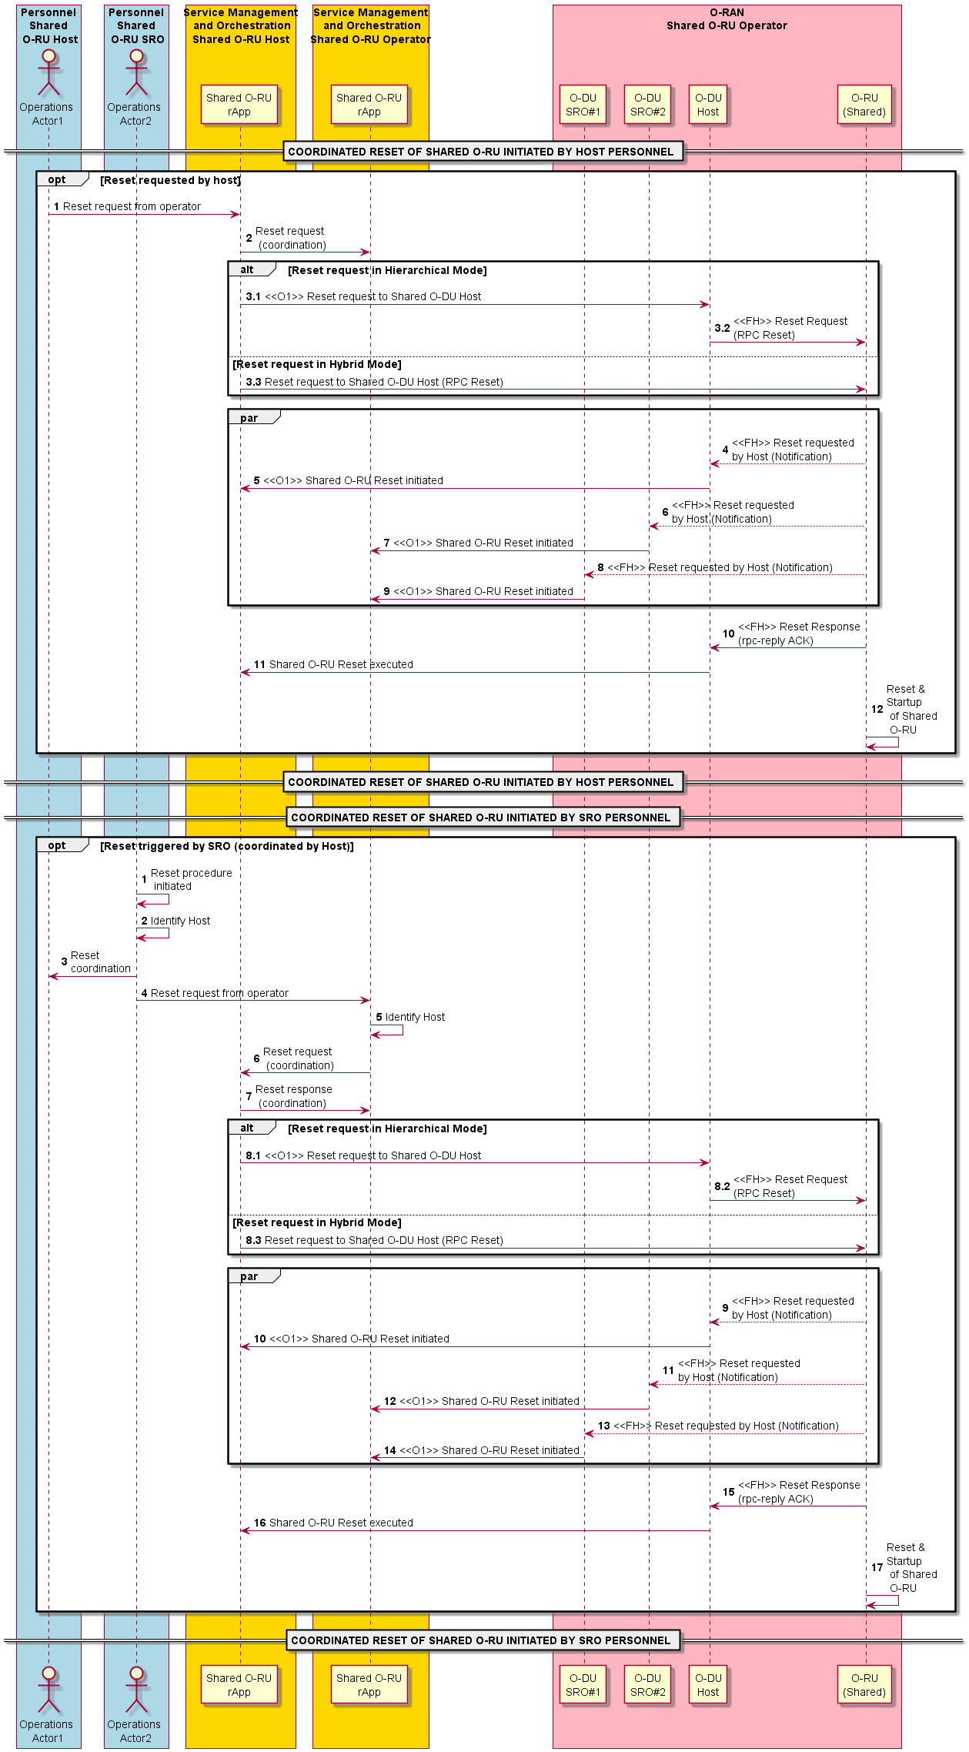
Figure 4.20.3.14-1: Coordinated reset sub-use case 1 (personnel triggered)
@startuml
!pragma teoz true

skinparam ParticipantPadding 5
skinparam BoxPadding 10
skinparam defaultFontSize 14
autonumber 1

Box "Personnel\nShared\n O-RU Host" #Lightblue
Actor Operator1 as "Operations\n Actor1"
End box

Box "Personnel\nShared\n O-RU SRO" #Lightblue
Actor Operator2 as "Operations\n Actor2"
End box

Box “Service Management\n and Orchestration\nShared O-RU Host” #gold
Participant SMO_a as "Shared O-RU\nrApp"
End box

Box “Service Management\n and Orchestration\nShared O-RU Operator” #gold
Participant SMO_b as "Shared O-RU\nrApp"
End box

Box "O-RAN\nShared O-RU Operator" #lightpink
Participant ODU1 as "O-DU\nSRO#1"
Participant ODU2 as "O-DU\nSRO#2"
Participant Host as “O-DU\nHost”
participant ORU as "O-RU\n(Shared)"
End box

== COORDINATED RESET OF SHARED O-RU AUTONOMOUSLY INITIATED BY HOST O-DU ==

Autonumber 1

Opt Reset triggered by SRO O-DU#1

Host -> ORU: <<FH>> Reset Request\n(RPC Reset)

Host -> SMO_a: Reset initiated
SMO_a -> SMO_b: Reset request\n (coordination)
SMO_b -> SMO_a: Reset response\n (coordination)

Par
ORU -> Host: <<FH>> Reset requested\nby Host (Notification)
Host -> SMO_a: <<O1>> Shared O-RU Reset initiated
ORU -> ODU2: <<FH>> Reset requested\nby Host (Notification)
ODU2 -> SMO_b: <<O1>> Shared O-RU Reset initiated
ORU -> ODU1: <<FH>> Reset requested by Host (Notification)
ODU1 -> SMO_b: <<O1>> Shared O-RU Reset initiated
End

ORU -> Host: <<FH>> Reset Response\n(rpc-reply ACK)
Host -> SMO_a: Shared O-RU Reset executed
ORU -> ORU: Reset &\nStartup\n of Shared\n O-RU

End

== COORDINATED RESET OF SHARED O-RU AUTONOMOUSLY INITIATED BY HOST O-DU ==

== COORDINATED RESET OF SHARED O-RU AUTONOMOUSLY INITIATED BY SRO O-DU ==

Autonumber 1

Opt Reset triggered by SRO O-DU#1
ODU1 -> SMO_b: Reset request\n (coordination)
SMO_b -> SMO_a: Reset request\n (coordination)
SMO_a -> SMO_b: Reset response\n (coordination)

Autonumber 4.1
Alt Reset request in Hierarchical Mode
SMO_a -> Host: <<O1>> Reset request to Shared O-DU Host
Host -> ORU: <<FH>> Reset Request\n(RPC Reset)
Else Reset request in Hybrid Mode
SMO_a -> ORU: Reset request to Shared O-DU Host (RPC Reset)
End

Autonumber 5
Par
ORU --> Host: <<FH>> Reset requested\nby Host (Notification)
Host -> SMO_a: <<O1>> Shared O-RU Reset initiated
ORU --> ODU2: <<FH>> Reset requested\nby Host (Notification)
ODU2 -> SMO_b: <<O1>> Shared O-RU Reset initiated
ORU --> ODU1: <<FH>> Reset requested by Host (Notification)
ODU1 -> SMO_b: <<O1>> Shared O-RU Reset initiated
End

ORU -> Host: <<FH>> Reset Response\n(rpc-reply ACK)
Host -> SMO_a: Shared O-RU Reset executed
ORU -> ORU: Reset &\nStartup\n of Shared\n O-RU

End

== COORDINATED RESET OF SHARED O-RU AUTONOMOUSLY INITIATED BY SRO O-DU ==

@enduml
The flow diagram of the coordinated reset sub-use case 2 (autonomous) is given in figure 4.20.3.14-2.
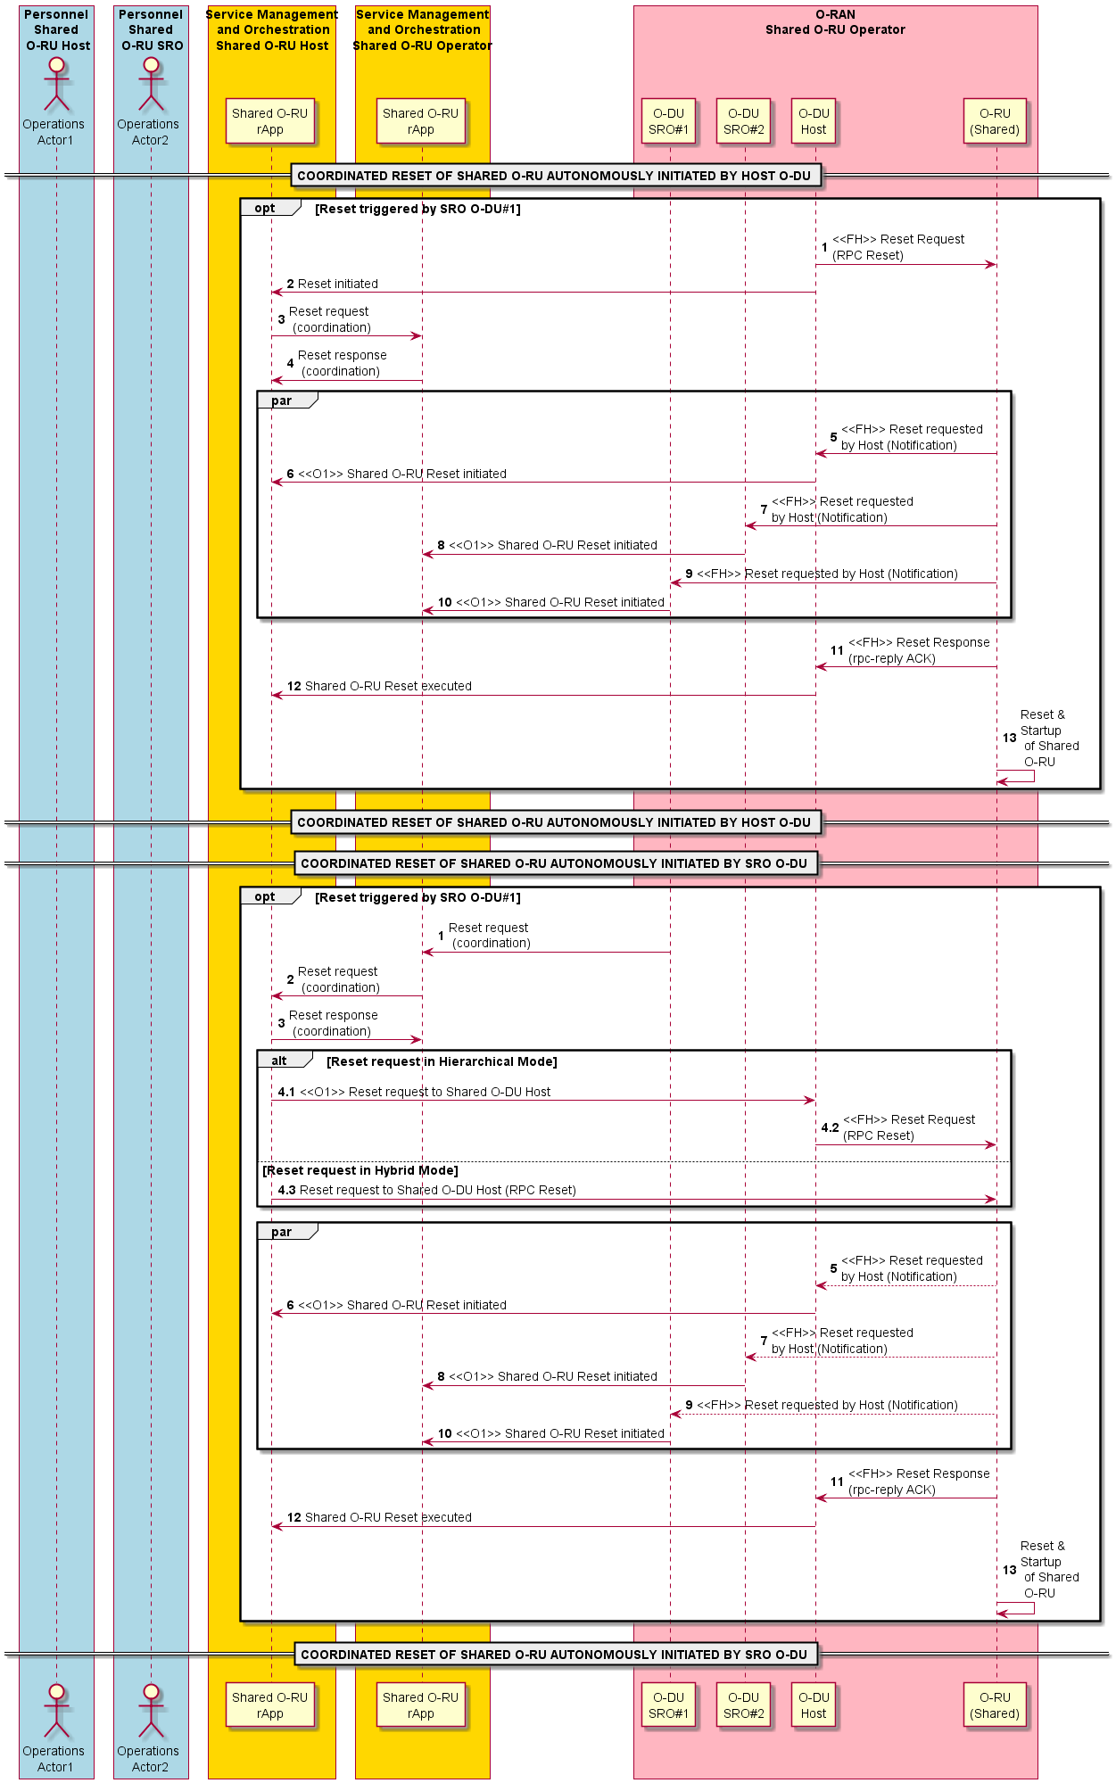
Figure 4.20.3.14-2: Coordinated reset sub-use case 2 (autonomous)

4.20.3.15 Management of Shared O-RU during O-DU software update sub-use case for Shared O-RU for Single & Multi-MNO
This sub-use case describes the Shared O-RU management scenarios associated with various stages in the O-DU software update such as planning, deployment, and monitoring. The detailed steps for each of these stages are described in the subsequent clauses.

4.20.3.15.1 Shared O-RU management during O-DU SW change management planning
The context of the Shared O-RU management during O-DU SW change management planning is captured in table 4.20.3.15.1-1.
Table 4.20.3.15.1-1: Shared O-RU management during O-DU SW change management planning
Use Case Stage | Evolution / Specification | <<Uses>>  Related use
Goal | Management scenarios associated with Shared O-RU during the O-DU SW change management planning.
Actors and Roles | - SMO: Maintains up-to-date information about the deployed RAN nodes including inventory, FM and PM data that help to identify appropriate Shared O-RU resources that can be allocated for validating the O-DU SW update.  - O-DU SW planner: Personnel who prepares deployment strategy of O-DU SW and associated plan based on the Shared O-RU resources that need to be allocated for validation.  - O-DU SW change management rApp: The rApp that supports SMO and Non-RT RIC in managing the O-DU SW update based on the plan prepared by the planner.  - Non-RT RIC: Facilitates communication between rApps and SMO services over R1 interface.
Assumptions | - SW updated O-DU shares the O-RU resources with an existing O-DU.  - SW updated O-DU and existing O-DUs address different set of component carriers and does not have common component carriers among them.  - SW updated O-DU is considered for single operator Shared O-RU scenario.
Begins when | O-DU SW planner identifies changes in O-DU software that need to be validated and rolled out on the RAN node deployment with limited service disruption.
Pre-conditions | - O-DU SW planner received the O-DU software change specification (for example a document detailing the changes in the O-DU software with information about impact of change and priority).  - O-DU SW planner collected the information about the RAN nodes from the SMO Topology Exposure & InVentory Management (TE&IV) service.  - O-DU SW planner collected the performance indicators and health/fault details of the RAN nodes from the SMO.  - O-DU SW planner identified the KPIs, PMJobs and scaling parameters of O-DU and Shared O-RU that need to be modified or redefined. This is to ensure that any temporary degradation during the software update does not result in false alarms or unintended actions.
Step 1 (O) | O-DU SW planner designs the change management plan for SW update based on the information collected from SMO services.  The plan can include but not limited to  - The version of O-DU software to be used for SW update.  - The policy to select the target O-DU (e.g., least loaded cell, particular S-NSSAI, random or specific O-DU ID).  - Evacuation policies of currently occupied component carriers associated with the Shared O-RU which need to be reallocated based on the O-DU SW update.  - The traffic-distribution or component carrier allocation policy between target O-DU and existing O-DU.  - Performance and fault indicators with threshold values, monitoring schedule for the updated O-DU.  - Mitigation policy in case of a SW update failure or any disruptions.  The availability of plan can be notified to the subscribed SMO services and rApps (for example O-DU SW change management rApp).  See NOTE.
Step 2 (M) | The O-DU SW planner initiates SW update of O-DU through the O-DU SW change management rApp with reference to the change management plan prepared and made available to the O-DU SW change management rApp.
Step 3 (O) | O-DU SW change management rApp collects the change management plan for O-DU software update.
Step 4 (O) | O-DU SW change management rApp validates the change management plan.
Step 5 (ALT) | Upon successful validation, the O-DU SW change management rApp prepares the provisioning configurations for the Shared O-RU and O-DU (target and existing), along with the execution steps for the software update, for the designated RAN nodes.
Step 6 (O) | O-DU SW change management rApp notifies the O-DU SW planner about the execution steps, target RAN nodes and configuration changes.
Step 7 (O) | O-DU SW planner verifies and sends approval to the O-DU SW change management rApp.
Step 8 (O) | Prepares detailed execution plan which can be notified to the subscribed SMO services and rApps.
Step 9 (ALT) | If the validation of the change management plan failed, a notification is sent to the O-DU SW planner with the reason for failure.
Ends when | The change management plan for SW update is ready for execution. The execution can be auto triggered, or it can be manually initiated by the O-DU SW planner.
Exceptions | None.
Post Conditions | None.
NOTE: It is optional to store the change management plan for SW update in SMO TE&IV. The change management plan can be stored in alternate SMO functions registered with and authorized by SMO data management and exposure functions based on the implementation choice.
@startuml
!pragma teoz true

skin rose
skinparam ParticipantPadding 5
skinparam BoxPadding 10
skinparam defaultFontSize 14
autonumber

Box "Personnel" #Lightblue
Actor planner as "O-DU SW planner"

End box

Box "Service Management and Orchestration\nShared O-RU Operator" #gold
Participant CAN_APP as “O-DU SW Change Management rApp”
end box

== CHANGE MANAGEMENT PLANNING ==

planner <--> CAN_APP: Prepare change management plan for O-DU SW update
planner --> CAN_APP: Request change management for O-DU SW update
CAN_APP -> CAN_APP : Validate the plan
Alt If Validation Successful
CAN_APP --> CAN_APP: Identify target RAN Nodes ,\nExecution steps
CAN_APP --> planner: Notify planner about Execution steps
planner --> CAN_APP: Confirm Execution steps
CAN_APP -> CAN_APP: Update Execution steps \n as Approved
Else If Validation Failed
CAN_APP --> planner : Notification of change management\n initiation failure
end

@enduml

The O-DU SW update change management planning sequence diagram is given in figure 4.20.3.15.1-1.
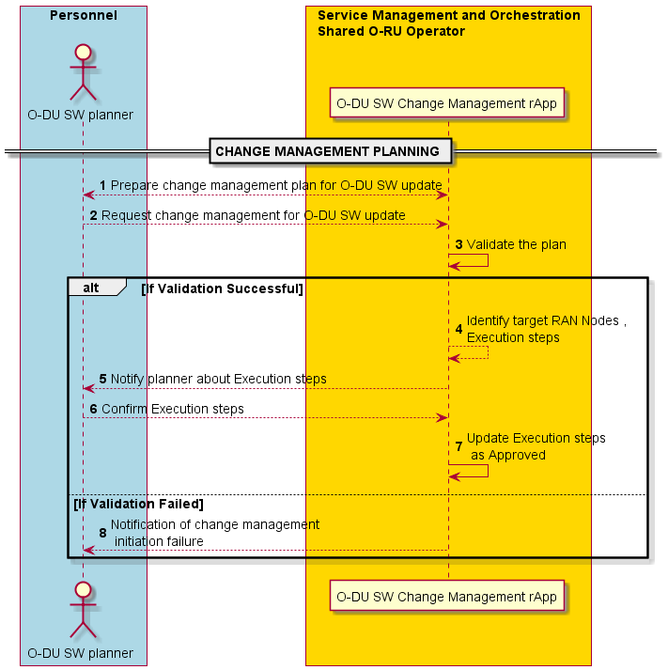
Figure 4.20.3.15.1-1: O-DU SW update change management planning sequence diagram

4.20.3.15.2 Shared O-RU management during O-DU SW update
The context of the Shared O-RU management during O-DU SW update is captured in table 4.20.3.15.2-1.
Table 4.20.3.15.2-1: Shared O-RU management during O-DU SW update
Use Case Stage | Evolution / Specification | <<Uses>>  Related use
Goal | Shared O-RU management during O-DU SW update.
Actors and Roles | - SMO: Facilitates the execution of O-DU SW update and associated Shared O-RU provisioning by enabling interaction across SMO services, rApps and RAN nodes – These services include but not limited to – TE&IV, OAM functions, O2 related functions.  - O-RU sharing co-ordinator retrieves change management plan for O-DU SW update and decides on partitioning of carriers between O-DUs.  - Sharing co-ordinator uses Shared O-RU orchestration rApp to partition resource configuration of a Shared O-RU between O-DUs.  - O-DU SW change management rApp: The rApp that supports SMO and Non-RT RIC in managing the O-DU SW update based on the plan prepared by the O-DU SW planner.  - Non-RT RIC: Facilitates communication between rApps and SMO services over R1 interface.  - O-DU(#n): An active O-DU in the RAN being managed by the SMO.  - O-DU (updated): O-DU updated with new SW based on the change management plan.
Assumptions | - SW updated O-DU shares the O-RU resources with an existing O-DU.  - SW updated O-DU and existing O-DUs address different set of component carriers and does not have common component carriers among them.  - SW updated O-DU and existing O-DUs do not have common cell IDs.  - SW update for O-DU is considered for single operator Shared O-RU scenario.
Begins when | O-DU SW change management rApp receives confirmation about the O-DU SW update and Shared O-RU provisioning steps.
Preconditions | O-DU software update and Shared O-RU provisioning steps approved by the O-DU SW planner and made available to the O-DU SW change management rApp.
Step 0 (Ref) | - O-DU SW change management rApp, based on the change management plan identifies software version to be updated and recommends (via R1 interface) to SMO the specifics of change like the software version and O-DU identifier.  - For software update of an existing O-DU, the designated O-DU (updated) is updated using O-RAN.WG6.ORCH-USE-CASES [26], clause 3.2.4 (steps 1 to 4)
Step 1 (M) | Initial provisioning of O-DU (updated) as per change management plan– Refer to O-RAN.WG10.OAM-Architecture [27], clause 4.2.1  See NOTE 1.
Step 2 (M) | O-DU SW change management rApp request (via R1 and SMO/Non-RT RIC) Shared O-RU orchestration rApp to facilitate resource sharing between O-DU (updated) and existing O-DUs based on the change management plan.  See NOTE 2.
Step 3 (M) | Shared O-RU orchestration r-App initiates configuration of the Shared O-RU common aspects
Step 4-6 (M) | Common aspect provisioning of Shared O-RU as per WG1 Use Cases Detailed Specification, clause 4.20.1.1 which include the include the security, operational, transmission, and connectivity related parameters.
Step 7 (M) | Based on the call home procedure, Shared O-RU establishes management session with O-DU (updated).  See NOTE 3.
Step 8-10 (O) | Notification of configuration update to SMO OAM functions and subsequently to Shared O-RU orchestration rApp.  See NOTE 4.
Step 11-13 (O) | Carrier aspect provisioning to deactivate and evacuate component carriers designated for the O-DU (updated) from the existing O-DU i.e., O-DU (#1).
Step 14-15 (O) | Carrier aspect provisioning to activate component carriers designated for the O-DU (updated).
Step 16-18 (O) | Notification of committed carrier aspect configuration to SMO OAM functions.
Step 19-20 (O) | Notification of configuration aspect to Shared O-RU orchestration rApp.
Step 21 (O) | Notification to sharing coordinator to validate the committed configuration.
Step 22 (O) | Validation of committed configuration by Shared O-RU orchestration rApp.
Step 23 (O) | Validation of committed configuration by O-DU SW change management rApp based on the change management plan.
Step 24 (O) | O-DU SW change management rApp coordinates with OAM functions to provision KPIs, PM jobs or scaling parameters used for assessing the health of the RAN nodes so that any variations anticipated due to O-DU SW update does not lead to false alarms or unintended actions.
Ends when | Committed configuration associated with the Shared O-RU is accepted by sharing coordinator and validation of the configuration is acknowledged by the O-DU SW change management rApp.  SMO TE&IV service is updated with inventory details about the O-DU (updated) and Shared O-RU.
Exceptions | None.
Post Conditions | - SW updated O-DU is ready for health & sanity check and is actively handling UE sessions.
NOTE 1: It is assumed that based on the O-DU (updated) provisioning procedure SMO TE&IV is updated with the inventory information of O-DU (updated) as per change management plan.
NOTE 2: Refer to the resource partitioning use case described in WG1 Use Cases Detailed Specification, clause 4.20.3.2.
NOTE 3: After O-DU (updated) deployment, before M-plane connection establishment, there is a possibility of race condition depending on when the Shared O-RU attempts call-home and the readiness of O-DU (updated) to process the call-home requests. There are two potential scenarios and associated approaches for addressing this.
- Scenario 1: O-DU (updated) is ready for establishing M-plane connection when call home signals are still being sent by Shared O-RU
  - In the O-RAN operations yang model (o-ran-operations.yang) there are two parameters that govern the call-home connection attempts –
    - re-call-home-no-ssh-timer : A common timer used by the O-RAN equipment to trigger the repeated call-home procedure to all identified call-home servers to which the O-RAN equipment has not already an established NETCONF connection.
    - max-call-home-attempts : counter to repeat call-home procedures. In case counter is set with value zero O-RU shall not repeat call-home procedure.
In order for the deployed O-DU (updated) to be ready to receive and process call-home requests from the shared O-RU, the above parameters shall be optimized, so that adequate time is allocated for the O-DU (updated) to become operational.
- Scenario 2: O-DU (updated) becomes ready after a long-time duration and Shared O-RU is not performing call home procedure anymore due to expiration of the timers.
- In the O-RAN operations yang model (o-ran-operations.yang) restart-call-home RPC allows any active 'call home O-RU controller' having necessary permissions to instruct O-RU to re-activate call-home procedures. By triggering this request through an existing ‘call-home O-RU controller’, the O-RU will initiate call home towards all known ‘call-home O-RU controllers’ that do not currently have an active M-plane session.
NOTE 4: The steps for hybrid scenario are not shown explicitly, but it is similar to hierarchical scenario. Refer to WG1 Use Cases Detailed Specification, clause 4.20.3.4 for details.
@startuml
!pragma teoz true

skin rose
skinparam ParticipantPadding 5
skinparam BoxPadding 10
skinparam defaultFontSize 14
autonumber

Box "Personnel\nShared O-RU Host" #Lightblue
Actor planner as "Sharing Co-ordinator"

End box

Box “Service Management and Orchestration\nShared O-RU Operator” #gold
Participant OAM as “OAM Functions”
Participant R_APP as "Shared O-RU\nOrchestration \nrApp"
Participant CAN_APP as “O-DU SW\nChange Management \nrApp”
Participant NRT as “Non-RT\nRIC”
Participant NFO as “O2 Related \nFunctions”
end box

Box “O-RAN\nShared O-RU Operator” #lightpink
Participant ODU1 as “O-DU\n(#1)”

participant ORU as "O-RU\n(Shared)"
Participant ODU2 as "O-DU\n(Updated)"
End box

== O-DU SW UPDATE ==
Ref over CAN_APP, NFO
O-DU Deployment – Refer WG6 Orchestration Use Case
Clauses 3.2.1, 3.2.4
End Ref

CAN_APP <--> OAM : <<R1>> Initial provisioning of O-DU \n(Updated) as per Change management plan
Ref over OAM, ODU2
Initial provisioning of O-DU (Updated) - Refer WG10 OAM Architecture Clause 4.2.1
End Ref

CAN_APP <--> R_APP : <<R1>> O-RU sharing request \n(shared O-RU between updated O-DU and \n existing O-DUs)as per the change management \nplan
Ref over planner,R_APP
Resource partitioning as per WG1 Use Case Detailed Spec Clause 4.20.3.2
End Ref

group Configure common aspects of shared O-RU
R_APP -> OAM : <<R1>> Configure Shared O-RU Common aspects
Alt If Hybrid or Neutral-Host Management
OAM->ORU: <<OFH>> Configure Shared O-RU common aspects (including O-DU(Updated) IP Address for Call home)
Else If Hierarchical Management
OAM->ODU1: <<O1>> Configure Shared O-RU common aspects (including O-DU(Updated) IP Address for Call home)
ODU1->ORU: <<OFH>> Configure Shared O-RU\ncommon aspects
end
end
opt Call home to O-DU(Updated)- Loop till NetConf session established
Hnote over OAM,ORU
Check call-home attempts, re-initiate call-home if max call home attemts expired, adjust the call home timer with long delay
End note

ORU->ODU2: <<OFH>> Call Home & Network\nmanagement session establishment
End

ODU2->OAM: <<O1>>Notification of Configuration update (ORU-ID)(WG10 OAM Architecture Specification Clause 4.2.1)
OAM->NRT: Configuration Update Notification (ORU-ID)
NRT->R_APP: <<R1>>Configuration Update Notification (ORU-ID)
Hnote over OAM
Steps for Hybrid case not shown, but similar to Hierarchical case
End note

group Configure carrier aspects of shared O-RU
R_APP -> OAM: <<R1>> Configure Shared O-RU Carrier aspects
OAM -> ODU1: <<O1>> Configure O-DU#1 and partitioned carrier information (CC designated for O-DU(Updated) marked as inactive)
ODU1->ORU: <<OFH>> Update \npartitioned carrier information

OAM -> ODU2: <<O1>> Configure O-DU (Updated) and partitioned carrier information (Designated CC marked as active)
ODU2->ORU: <<OFH>> Configure \npartitioned carrier information

end

opt notification of committed configuration
alt Hybrid Management
ORU->OAM: <<OFH>> Notification of Configuration Update
Else Hierarchical Management
ORU->ODU2: <<OFH>> Notification of \n Configuration Update
ODU2->OAM: <<O1>> Notification of Configuration Update
End

OAM->NRT: Notification of Configuration Update
NRT->R_APP: <<R1>> Configuration Update
planner <--> R_APP: Sharing Co-ordinator confirms compliance to partioning rules
R_APP <--> OAM : Validates sanity of configuration
CAN_APP <--> OAM : Validates the configuration against change management plan
CAN_APP <--> OAM : Provisioning of KPIs, PM Jobs and Scaling Parameters to avoid false alarms,unintended actions
End

@enduml

The O-DU SW update sequence diagram is given in figure 4.20.3.15.2-1.
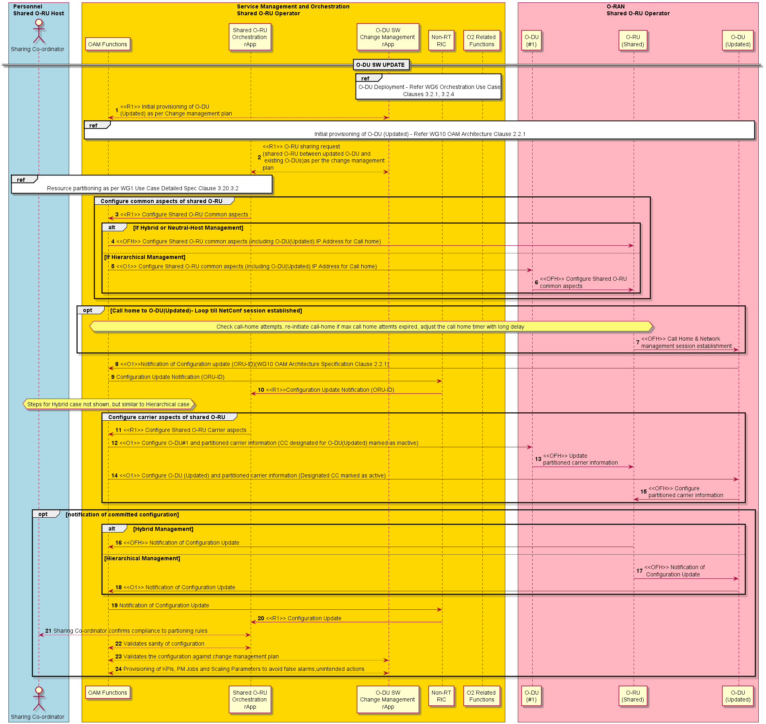
Figure 4.20.3.15.2-1: O-DU SW update sequence diagram

4.20.3.15.3 Shared O-RU management during O-DU SW update monitoring and mitigation
The context of the Shared O-RU management during O-DU SW update monitoring and mitigation is captured in table 4.20.3.15.3-1.
Table 4.20.3.15.3-1: Shared O-RU management during O-DU SW update monitoring and mitigation
Use Case Stage | Evolution / Specification | <<Uses>>  Related use
Goal | Shared O-RU management during O-DU SW update monitoring and mitigation.
Actors and Roles | - SMO: Facilitates the monitoring, and mitigation of O-DU SW update and associated Shared O-RU provisioning by enabling interaction across SMO services, rApps and RAN nodes – These services include but not limited to – TE&IV, OAM functions, O2 related functions.  - O-DU SW planner: Personnel who prepares O-DU SW change management strategy and associated plan based on the identified change in the O-DU software.  - O-DU SW change management rApp: The rApp that supports SMO and Non-RT RIC in managing the O-DU SW update and associated Shared O-RU provisioning based on the plan prepared by the O-DU SW planner and subsequent health monitoring to decide on mitigation actions.  - Shared O-RU orchestration rApp is used to rebalance the Shared O-RU resources based on the health monitoring and mitigation action selection by the O-DU SW change management rApp.  - Non-RT RIC: Facilitates communication between rApps and SMO services over R1 interface.  - O-DU(#n): An active O-DU in the RAN being managed by the SMO.  - O-DU (updated): A new O-DU deployed through SW change management procedure.
Assumptions | - Software updated O-DU shares the O-RU resources with an existing O-DU.  - Software updated O-DU and existing O-DUs address different set of component carriers and does not have common component carriers among them.  - Software updated O-DU and existing O-DUs do not have common cell IDs.  - Software update of O-DU is considered for single operator Shared O-RU scenario.
Begins when | O-DU SW planner subscribes to the health monitoring events for the updated RAN nodes, based on access granted by SMO external exposure service  OR  As per the predefined plan O-DU SW change management rApp initiates health check of the SW updated O-DU
Pre-conditions | - Successfully completed the SW update of target O-DU  - Planned Shared O-RU resources allocated to O-DU (updated) and activated  - O-DU (updated) sharing O-RU resources with an existing O-DU  - O-DU (updated), existing O-DUs, Shared O-RU are ready for monitoring of KPIs and actively handling the UE sessions
Step 1 (O) | O-DU SW planner subscribes to change management events from O-DU SW change management rApp via SMO/Non-RT RIC.
Step 2 (M) | O-DU SW change management rApp subscribes to PM/FM data from O-DU (updated) and existing O-DU, i.e O-DU (#1) through R1 interface.
Step 3 (M) | Non-RT RIC forwards the subscription request to OAM function.
Step 4 (M) | OAM function subscribes to the FM/PM data updates for O-DU (updated) and existing O-DU, i.e O-DU (#1) via O1 interface.
Step 5 (M) | O-DU (updated) subscribes to FM/PM data updates from Shared O-RU based on the O-DU_ID of O-DU (updated) as the filter criteria.
Step 6 (M) | Notification of FM/PM data from Shared O-RU to O-DU (updated) over OFH.
Step 7 (M) | Notification of FM/PM data from O-DU (updated) to OAM functions over O1.
Step 8 (M) | OAM function forwards notification of FM/PM data received from O-DU (updated) to Non-RT RIC through SMO internal interface.
Step 9 (M) | Non-RT RIC notifies O-DU SW change management rApp about FM/PM data received from O-DU (updated).
Step 10 (M) | O-DU SW change management rApp evaluates FM/PM data against the change management plan.
Step 11 (O) | If the health and sanity of the O-DU (updated) and Shared O-RU are not as per plan, O-DU SW change management rApp analyses mitigation action based on evaluation of the FM/PM data.
Step 12 (O) | If the health and sanity of the O-DU (updated) is not as per plan O-DU SW change management rApp sends change management report consisting of sanity, health details and mitigation action(s) to O-DU SW planner.  See NOTE 1.
Step 13 (O) | O-DU SW planner verifies the mitigation action and sends approval if action is within the scope of the plan.
Step 14 (O) | If mitigation involves provisioning of Shared O-RU, O-DU SW change management rApp recommends to Shared O-RU orchestration rApp re-provisioning of O-RU resources based on recommended action.  See NOTE 2.
Step 15 (O) | Shared O-RU orchestration rApp recommends re-configuration to OAM functions over R1 interface.
Step 16 (O) | Non-RT RIC forwards configuration request to OAM functions.
Step 17 (O) | OAM functions initiates configuration of O-DU (updated) and partitioned carrier information.
Step 18 (O) | O-DU (updated) initiates reconfiguration of partitioned carrier information on Shared O-RU. This can include required evacuation procedures if applicable.
Step 19 (O) | OAM functions initiates configuration of O-DU (#n) and partitioned carrier information on the O-RU shared with O-DU (updated).
Step 20 (O) | O-DU (#n) initiates reconfiguration of partitioned carrier information on Shared O-RU.
Step 21 (O) | O-DU (#n) sends notification about configuration update to OAM functions over O1 interface
Step 22 (O) | O-DU (updated) sends notification about configuration update to OAM functions over O1 interface.
Step 23 (O) | O-DU SW change management rApp sends revised report to O-DU SW planner.
Ends when | to O-DU SW planner validates the change management report and certifies the O-DU SW update.  SMO TE&IV service is updated with inventory details about the O-DU (updated) and Shared O-RU.
Exceptions | NA
Post Conditions | SW updated O-DU is functioning as per the change management plan.
NOTE 1: Sanity check and health check are assumed to be implementation specific and depends on the pre-defined change management plan for O-DU SW update. In general, the sanity check assesses whether the SW update satisfies the designated performance and connectivity objectives, while also ensuring compliance with the policies established in accordance with the plan. On the other hand, the health check examines the responsiveness and overall condition of the updated O-DU.
NOTE 2: The mitigation action depends on the change management plan and specific implementation strategy. This can include but not limited to readjustment of component carriers in Shared O-RU between O-DU (updated) and other O-DUs.

@startuml
!pragma teoz true

skin rose
skinparam ParticipantPadding 5
skinparam BoxPadding 10
skinparam defaultFontSize 14
autonumber

Box "Personnel\nShared O-RU Host" #Lightblue
Actor planner as "O-DU SW Planner"
End box

Box “Service Management and Orchestration\nShared O-RU Operator” #gold
Participant OAM as “OAM Functions”
Participant R_APP as "Shared O-RU\nOrchestration \nrApp"
Participant CAN_APP as “O-DU \nSW Change Management \nrApp”
Participant NRT as “Non-RT\nRIC”
end box

Box “O-RAN\nShared O-RU Operator” #lightpink
Participant ODU1 as “O-DU\n(#1)”
participant ORU as "O-RU\n(Shared)"
Participant ODU2 as "O-DU\n(Updated)"
End box

Opt Monitoring of O-DU SW update health
planner <--> CAN_APP: Subscription of O-DU (Updated)& O-DU (#1) Health Updates
CAN_APP -> NRT : <<R1>> Subscribe to O-DU(Updated) & O-DU (#1) \nPM/FM Data Updates
NRT -> OAM : Subscribe to O-DU(Updated)& O-DU (#1) PM/FM Data Updates
OAM <--> ODU2 : <<O1>> Subscribe to O-DU(Updated) FM/PM Data Updates
ODU2 <--> ORU : <<OFH>> Subscribe to FM/PM Data Updates \ncorresponding to ODU_ID of O-DU(Updated)
ORU <--> ODU2: <<OFH>> Notification of FM/PM data
ODU2 <--> OAM : <<O1>> Notification of FM/PM data
OAM <-->NRT: Notification of FM/PM data
NRT ->CAN_APP : <<via R1>> Notification of FM/PM data
CAN_APP -> CAN_APP : Evaluation of FM/PM data \n against the change management plan
End
Opt If Mitigation Required based on health evaluation of O-DU (Updated)
CAN_APP -> CAN_APP : Analysis of the mitigation action \nbased on evaluation
CAN_APP <--> planner : Notification of change management report with health and mitigation action
planner <--> CAN_APP : Approval of the mitigation action
CAN_APP -> R_APP : <<via R1>> Recommendation for \nre-provisioning based on mitigation \naction
R_APP <--> NRT : <<via R1>> Recommendation for re-configuration
NRT -> OAM : Recommendation for re-configuration
OAM -> ODU2: <<O1>> Configure O-DU (Updated) and partitioned carrier information
ODU2->ORU: <<OFH>> Configure \npartitioned carrier information
OAM -> ODU1: <<O1>> Configure O-DU (Updated) and partitioned carrier information
ODU1->ORU: <<OFH>> Configure \npartitioned carrier information
ODU1 -> OAM : <<O1>> Notification of configuration update
ODU2 -> OAM : <<O1>> Notification of configuration update
CAN_APP <--> planner : Notification of change management report
End
@enduml

The O-DU SW update monitoring and mitigation sequence diagram is given in figure 4.20.3.15.3-1.
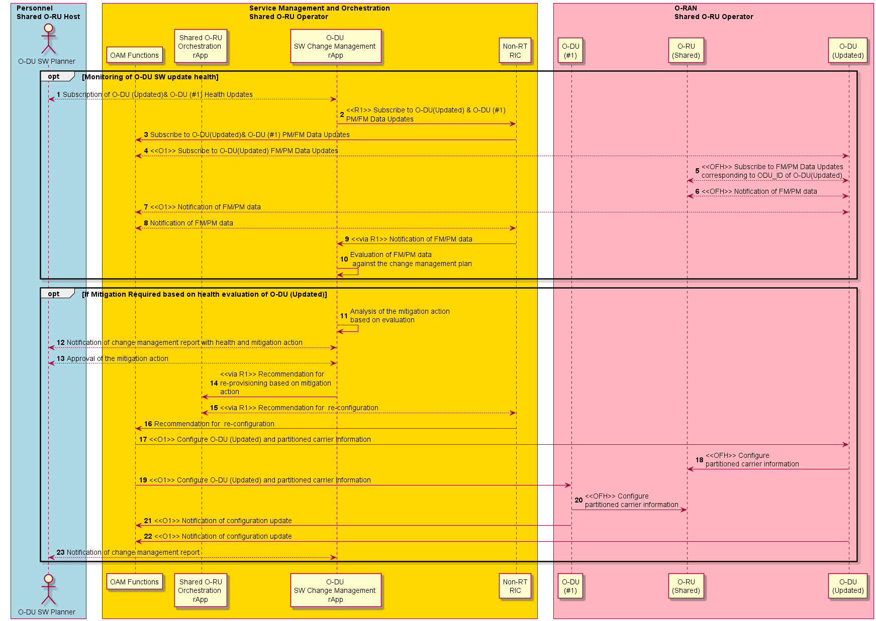
Figure 4.20.3.15.3-1: O-DU SW update monitoring and mitigation sequence diagram

4.20.3.16 Resource partitioning use case of Shared O-RU for Multi-MNO configuration
The following describes the solution for the resource partitioning sub-use case for a Shared O-RU in a Multi-MNO configuration.
The context of the resource partitioning use case of Shared O-RU is captured in table 4.20.3.16-1.
Table 4.20.3.16-1: Resource partitioning use case of Shared O-RU
Use Case Stage | Evolution / Specification | <<Uses>>  Related use
Goal | rApp has details on how a Shared O-RU’s resource are to be partitioned.
Actors and Roles | Owning operator Service Management & Orchestration (SMO) provides inventory details of Shared O-RU and O-DUs.  Owning operator sharing coordinator recovers inventory and decides on partitioning of carriers between O-DUs.  Owning operator sharing coordinator uses resource partitioning rApp to partition resource configuration of a Shared O-RU between O-DUs.
Assumptions | All relevant functions and components are instantiated.  Inventory management systems identify Shared O-RU carrier capabilities and available O-DUs.
Begins when | Owning operator sharing coordinator decides to share an O-RU between multiple O-DUs.
Pre-conditions | Inventory system is up to date.
Step 1 (M) | Owning operator sharing coordinator recovers O-RU and O-DU inventory and decides on resource partitioning.
Step 2 (M) | Owning operator sharing coordinator resource partitioning rApp to partition shared O-RU between multiple O-DUs.
Step 3 (M) | rApp signals O-DU identity(ies) to owning operator configuration management system.
Step 4 (M) | Owning operator configuration management system configures transport systems with call home identity(ies) for O-DU(s). | O-RAN.WG4.MP [28], clause 6.2.5
Step 5 (M) | Participating operator sharing coordinator recovers O-RU and O-DU inventory and decides on resource partitioning.
Step 6 (M) | Participating operator sharing coordinator resource partitioning rApp to partition Shared O-RU between multiple O-DUs.
Step 7 (M) | rApp signals O-DU identity(ies) to participating operator configuration management system.
Step 8 (M) | Participating operator configuration management system configures transport systems with call home identity(ies) for O-DU(s). | O-RAN.WG4.MP [28], clause 6.2.5
Ends when | Owning operator rApp has details on how shared O-RU’s resource are to be partitioned.
Exceptions | None identified.
Post Conditions | None identified.
@startuml
!pragma teoz true

skin rose
skinparam ParticipantPadding 5
skinparam BoxPadding 10
skinparam defaultFontSize 14
autonumber

Box "Personnel" #Lightblue
Actor planner as "Sharing Co-ordinator"

End box

Box "Owning Operator\nService Management & Orchestration (SMO)" #gold
Participant INV as "Inventory\nManagement"
Participant CFG as "Configuration\nManagement"
Participant R_APP as "Resource\nParitioning\nrApp (shared O-RU)"
end box

Box "Participating Operator\nService Management & Orchestration (SMO)" #gold
Participant INV_PO as "Inventory\nManagement"
Participant CFG_PO as "Configuration\nManagement"
Participant R_APP_PO as "Resource\nParitioning\nrApp (shared O-RU)"
end box

Box "External"
Participant TRANS as "DHCP\nServer"
End box

== RESOURCE PARTITIONING SUB USE CASE ==

planner --> INV: Recover inventory\n and decide on \n resource partitioning

planner --> R_APP: Partition shared O-RU between multiple O-DUs
R_APP --> CFG: Set call\n home identity(ies)

CFG-->TRANS: Configure DHCP options for call home

planner --> INV_PO: Recover inventory\n and decide on \n resource partitioning

planner --> R_APP_PO: Partition shared O-RU between multiple O-DUs
R_APP_PO --> CFG_PO: Set call\n home identity(ies)

CFG_PO --> TRANS: Configure DHCP options for call home

== END RESOURCE PARTITIONING SUB USE CASE ==

@enduml
The flow diagram of the resource partitioning use case for Multi-MNO configuration is given in figure 4.20.3.16-1.
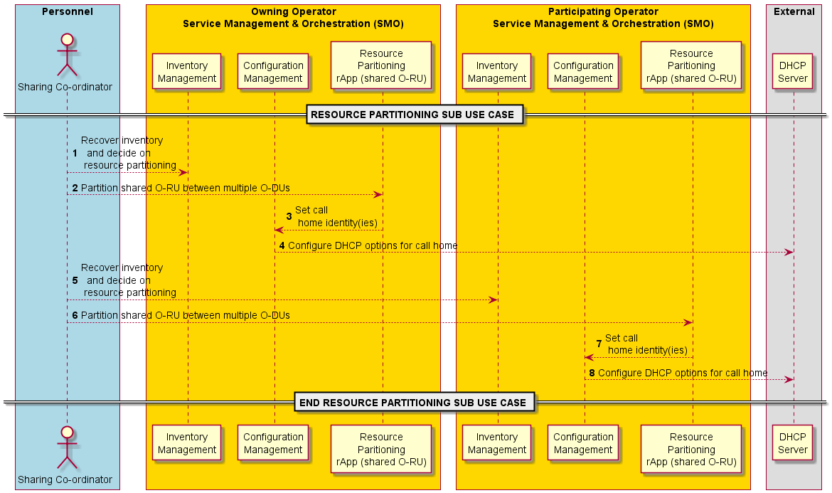
Figure 4.20.3.16-1: Resource partitioning use case for Multi-MNO

4.20.3.17 Start-up use case of Shared O-RU for Multi-MNO configuration
The following describes the solution for the start-up sub-use case for a Shared O-RU for Multi-MNO configuration.
The context of the Shared O-RU start-up use case is captured in table 4.20.3.17-1.
Table 4.20.3.17-1: Shared O-RU start-up use case
Use Case Stage | Evolution / Specification | <<Uses>>  Related use
Goal | The Shared O-RU is operating with the necessary software version and has established network connectivity with the O-DU(s) and, for hybrid deployments, the SMO.
Actors and Roles | Shared O-RU calls home and establishes network management session.  Owning operator SMO is responsible for software management for the Shared O-RU when operating in hybrid management mode.  O-DU is responsible for software management for the Shared O-RU when operating in hierarchical management mode.  Participating operator SMO handles communication to its connected O-DU.  RAN NF OAM SMO services – provides RAN NF OAM related services for FCAPS and LCM type functions.
Assumptions | None.
Begins when | Shared O-RU powers on.
Preconditions | Transport systems (DHCP server) has been configured with call home configuration information.
Step 1 (M) | Establish synchronization:  Each O-DU and Shared O-RU establish synchronisation with a timing source, for example PTP (IEEE 1588) or Sync-E. See NOTE 1, NOTE 2.
Step 2 (M) | Synchronization state change notification:  After the O-RU has a synchronisation source, all subscribed O-DU(s) are notified through a synchronisation state change notification. We expect the O-RU to be in the sync state “LOCKED”.  The synchronisation state change notification goes from Shared O-RU to all subscribed O-DU(s).  It is possible that the synchronisation procedure can happen in parallel to the other steps of the start-up sub-use case. Thus, many of the other steps in this use case can happen as the synchronization procedure occurs. Even though this is shown as “step 2” this can complete after other steps.
Step 3 (ALT) | [Shared O-RU operated in hybrid management mode]  Shared O-RU establishes a network management session with owning operator SMO. | O-RAN.WG4.MP [28], clause 6.3 and/or clause 6.9.2
Step 4 | [Shared O-RU operated in hierarchical management mode]  Shared O-RU calls home and triggers establishment of network management session with owning operator O-DU#1. | O-RAN.WG4.MP [28], clause 6.3
Step 5 (ALT) | [Shared O-RU operated in hybrid management mode]  Shared O-RU establishes network management session with participating operator SMO. | O-RAN.WG4.MP [28], clause 8.4
Step 6 | [Shared O-RU operated in hierarchical management mode]  Shared O-RU calls home and triggers establishment of network management session with participating operator O-DU#2. | O-RAN.WG4.MP [28], clause 6.3
Step 7 | [Shared O-RU operated in hybrid management mode]  SMO recovers software inventory request from Shared O-RU.
Step 8 | [Shared O-RU operated in hybrid management mode]  SMO recovers software inventory response from Shared O-RU.
Step 9 (O) | [Shared O-RU operated in hybrid management mode and software update required]  SMO triggers download of new software. | O-RAN.WG4.MP [28], clause 8.5
Step 10 (O) | [Shared O-RU operated in hybrid management mode and software update required]  O-RU downloads software files. | O-RAN.WG4.MP [28], clause 8.5
Step 11 (O) | [Shared O-RU operated in hybrid management mode and software update required]  SMO triggers the installation of the software. | O-RAN.WG4.MP [28], clause 8.6
Step 12 (O) | [Shared O-RU operated in hybrid management mode and software update required]  SMO triggers the activation of the software. | O-RAN.WG4.MP [28], clause 8.7.2
Step 13 (O) | [Shared O-RU operated in hybrid management mode and software update required]  SMO brings active software into operation.  A O-RU reset is required to take the activated software into operation. | O-RAN.WG4.MP [28], clause 8.7.3
Step 14 (ALT) | [Shared O-RU operated in hierarchical management mode]  Owning operator O-DU#1 recovers software inventory request. | O-RAN.WG4.MP [28], clause 8.4
Step 15 | [Shared O-RU operated in hierarchical management mode]  Owning operator O-DU#1 recovers software inventory response. | O-RAN.WG4.MP [28], clause 8.4
Step 16 (O) | [Shared O-RU operated in hierarchical management mode and software update required]  Owning operator O-DU#1 triggers download of new software. | O-RAN.WG4.MP [28], clause 8.5
Step 17 (O) | [Shared O-RU operated in hierarchical management mode and software update required]  O-RU downloads software files. | O-RAN.WG4.MP [28], clause 8.5
Step 18 (O) | [Shared O-RU operated in hierarchical management mode and software update required]  Owning operator O-DU#1 triggers the installation of the software. | O-RAN.WG4.MP [28], clause 8.6
Step 18 (O) | [Shared O-RU operated in hierarchical management mode and software update required]  Owning operator O-DU#1 triggers activation of the software. | O-RAN.WG4.MP [28], clause 8.7
Step 19 (O) | [Shared O-RU operated in hierarchical management mode and software update required]  Owning operator O-DU#1 brings active software into operation. | O-RAN.WG4.MP [28], clause 8.7
Ends when | The Shared O-RU is operating with the necessary software version and has established network connectivity with the O-DU and, for hybrid deployments, the owning operator SMO.
Exceptions | None identified.
Post Conditions | None identified.
NOTE 1: It is expected the O-RU and all O-DUs connected it would share the same synchronisation source otherwise, the O-DUs will drift in timing.
NOTE 2: For more details on O-RU sync and O-RU loss of sync, see O-RAN.WG4.MP [28], clause 15.3.3.
@startuml
!pragma teoz true

skin rose
skinparam ParticipantPadding 5
skinparam BoxPadding 10
skinparam defaultFontSize 14

Box “Owning Operator\n Service Management and Orchestration (SMO)” #gold
Participant CFG as “Configuration\nManagement”
Participant SWM as “Software\nManagement”
Participant FS as “File\nServer”
end box

Box “Participating Operator\nSMO” #gold
Participant CFG_PO as “Configuration\nManagement”
end box

Box “O-RAN\nShared O-RU Operator” #lightpink
Participant ODU1 as “O-DU\n(#1) “
Participant ODU2 as “O-DU\n(#2) “

participant ORU as “O-RU\n(Shared)”
End box

autonumber

== BEGIN STARTUP FOR MULTI-MNO SUB USE CASE ==

Note over ODU1, ORU
Synchronization Timing is established for O-Dus and Shared O-RU
End Note
ORU -> ODU1: <<OFH>> Synchronization state\n change notification
ORU -> ODU2: <<OFH>> Synchronization\n state change notification

group Shared O-RU Call Home

alt Call Home to Owning Operator SMO (Hybrid Management)
ORU<-CFG: <<OFH>> Network management session establishment

else Call Home to Owning Operator ODU (Hierarchical Management)
ORU<-ODU1: <<OFH>> Call Home & Network management\n session establishment
End

alt Call Home to Participating Operator SMO (Hybrid Management)
ORU<-CFG_PO: <<OFH>> Network management session establishment
Else Call Home to Participating Operator ODU (Hierarchical Management)
ORU<-ODU2: <<OFH>> Call Home & Network management\n session establishment
end

group Shared O-RU Software Management
alt Hybrid Software Management
SWM->ORU: Recover software inventory (request)
SWM<-ORU: Recover software inventory (response)
opt software update required
SWM --> ORU: Trigger Software Download
FS-->ORU: Software Download
SWM-->ORU: Install Software
SWM-->ORU: Activate Software
SWM<--ORU: Bring Software into operation
end
else Hierarchical Software Management
ODU1->ORU: Recover software inventory (request)
ODU1<-ORU: Recover software inventory (response)
opt software update required
ODU1-->ORU: Trigger Software Download
FS-->ORU: Software Download
ODU1-->ORU: Install Software
ODU1-->ORU: Activate Software
ODU1<--ORU: Bring Software into operation
end

end

end

== END STARTUP FOR MULTI-MNO SUB USE CASE ==

@enduml

The flow diagram of the Shared O-RU start-up use case is given in figure 4.20.3.17-1 for Multi-MNO.
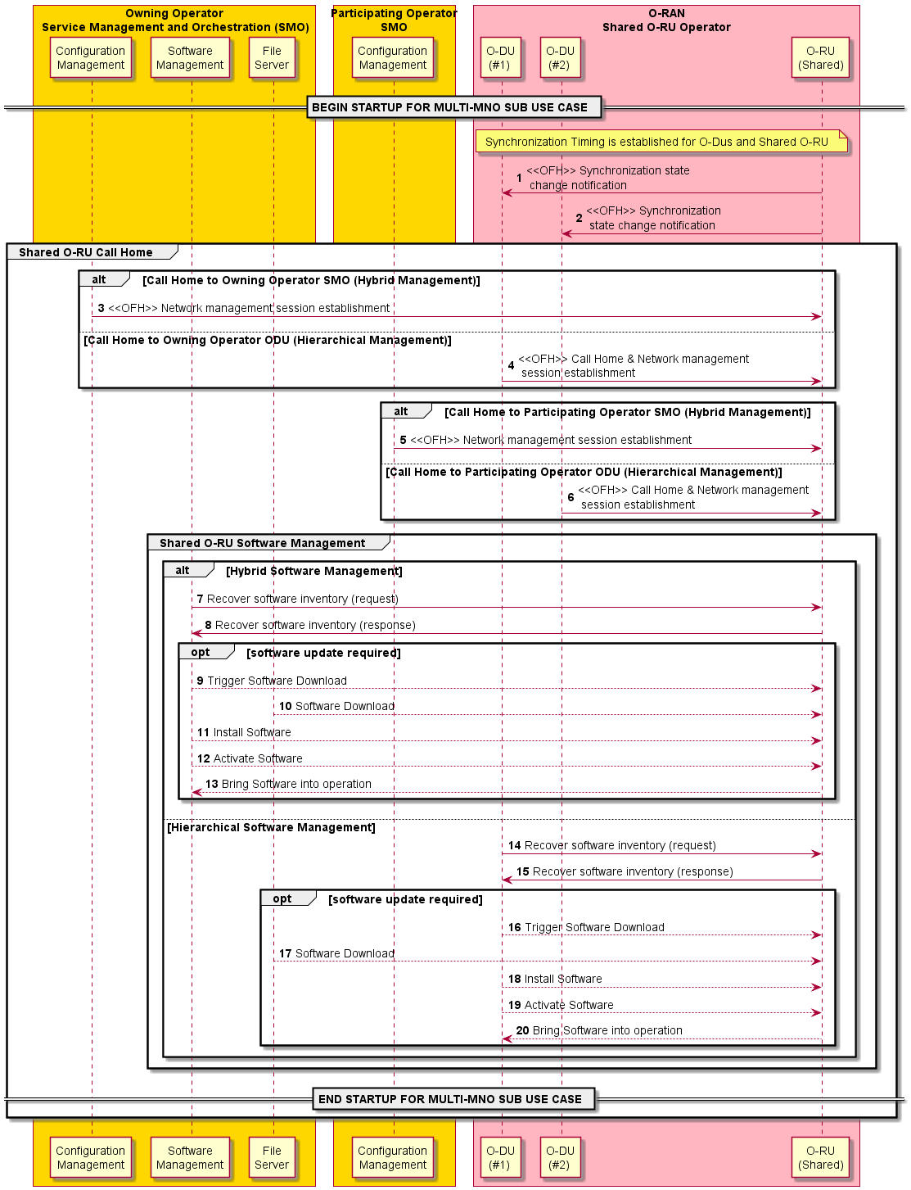
Figure 4.20.3.17-1: Shared O-RU start-up use case for Multi-MNO

4.20.3.18 Supervision sub-use case of a Shared O-RU for Multi-MNO configuration
The following describes the solution for the supervision sub-use case for a Shared O-RU for a Multi-MNO configuration.
The context of the supervision use case of a Shared O-RU is captured in table 4.20.3.18-1.
Table 4.20.3.18-1: Supervision sub-use case of a Shared O-RU
Use Case Stage | Evolution / Specification | <<Uses>>  Related use
Goal | The Shared O-RU operates watchdog timers with each of its O-DUs and ceases transmitting on a partitioned carrier associated with an O-DU if is watchdog timer to that O-DU expires.
Actors and Roles | Shared O-RU operates watchdog timers and deactivates any carriers associated with an expired watchdog timer.  O-DU repeatedly resets the Shared O-RU’s supervision timer.  SMO forwards any alarms to Shared O-RU rApp.
Assumptions | O-DUs are operating fronthaul control and user plane for their respective partitioned carriers.  SMO has subscribed to receive alarm notifications (hybrid management model).
Begins when | An O-DU subscribes to receive supervision notifications.
Step 1 (Loop) | O-DU#1 initiates supervision operations.
Step 2 (Loop) | O-RU response from supervision operations.
Step 3 (O) | O-DU#1 detects that it has lost communication sessions to the Shared O-RU. It raises a communication alarm to the owning operator SMO.
Step 4 (O) | Cease transmission – Shared O-RU detects supervision failure with O-DU#1 and ceases transmitting on partitioned carrier associated with O-DU of the owning operator RAN network.
Step 5 (O) | Shared O-RU sends alarm notification to owning operator fault management in SMO.
Step 6 (O) | Owning operator fault management sends alarm notification to owning operator Non-RT RIC.
Step 7 (O) | Owning operator Non-RT RIC sends alarm notification to owning operator Shared O-RU orchestration rApp.
Step 8 (Loop) | O-DU#2 initiates supervision operations.
Step 9 (Loop) | O-RU response from supervision operations.
Step 10 (O) | O-DU#2 detects that it has lost communication sessions to the Shared O-RU. It raises a communication alarm to the owning operator SMO.
Step 11 (O) | Cease transmission – Shared O-RU detects supervision failure with O-DU#2 and ceases transmitting on partitioned carrier associated with O-DU from the participating operator RAN network.
Step 12 (O) | Shared O-RU sends alarm notification to the participating operator fault management.
Step 13 (O) | Participating operator fault management sends alarm notification to participating operator Non-RT RIC.
Step 14 (O) | Participating operator Non-RT RIC sends alarm notification to participating operator Shared O-RU orchestration rApp.
Ends when | O-DU terminates subscription to supervision notification.
Exceptions | None identified.
Post Conditions | None identified.
@startuml
!pragma teoz true

skin rose
skinparam ParticipantPadding 5
skinparam BoxPadding 10
skinparam defaultFontSize 14
autonumber 1

Box "Owning Operator\nService Management and Orchestration" #gold
Participant FM as "Alarm\nManagement"
Participant R_APP as "Shared O-RU\nOrchestration \nrApp"
Participant SMO_a as "Non-RT\nRIC"
end box

Box "Participating Operator\nService Management and Orchestration" #gold
Participant FM_PO as "Alarm\nManagement"
Participant R_APP_PO as "Shared O-RU\nOrchestration \nrApp"
Participant SMO_PO as "Non-RT\nRIC"
end box

Box "O-RAN\nShared O-RU Operator" #lightpink
Participant ODU1 as "O-DU\n(#1)"
Participant ODU2 as "O-DU\n(#2)"

participant ORU as "O-RU\n(Shared)"
End box

== START SUPERVISION SUB USE CASE MULTI-MNO ==

hnote over ODU1, ORU
<<OFH>> Fronthaul Control & User Plane
for partitioned carrier #1
end note

hnote over ODU2, ORU
<<OFH>> Fronthaul Control & User Plane
for partitioned carrier #2
end note

group Per O-DU Supervision

loop odu #1 supervision
ODU1->ORU: <<OFH>> Supervision Operation O-DU #1 Req
ODU1<-ORU: <<OFH>> Supervision Operation O-DU #1 Rsp
end

opt Supervision failure to odu-id#1

ODU1->FM: <<O1>> O-DU detects O-RU session lost and sends Alarm notification
ORU->ORU: Cease\n transmitting\n partitioned\n carrier #1

opt SMO has subscribed to receive alarm notifications
ORU->FM: (Opt) <<OFH>> O-DU Supervision Alarm O-DU#1
FM->SMO_a: Alarm Indication
SMO_a->R_APP: <<R1>> Alarm\nIndication
end
end

loop odu #2 supervision
ODU2->ORU: <<OFH>> Supervision\n Operation O-DU #2 Req
ODU2<-ORU: <<OFH>> Supervision\n Operation O-DU #2 Rsp
end

opt Supervision failure to odu-id#2

ODU2->FM: <<O1>> O-DU detects O-RU session lost and sends Alarm notification

ORU->ORU: Cease\n transmitting\n partitioned\n carrier #2

opt SMO has subscribed to receive alarm notifications

ORU->FM: (Opt) <<OFH>> O-DU Supervision Alarm O-DU#2
FM->SMO_a: Alarm Indication
SMO_a->R_APP: <<R1>> Alarm\nIndication
end
end

end

== END SUPERVISION SUB USE CASE MULTI-MNO ==

@enduml

The flow diagram of the Shared O-RU supervision use case is given in figure 4.20.3.18-1 for Multi-MNO.

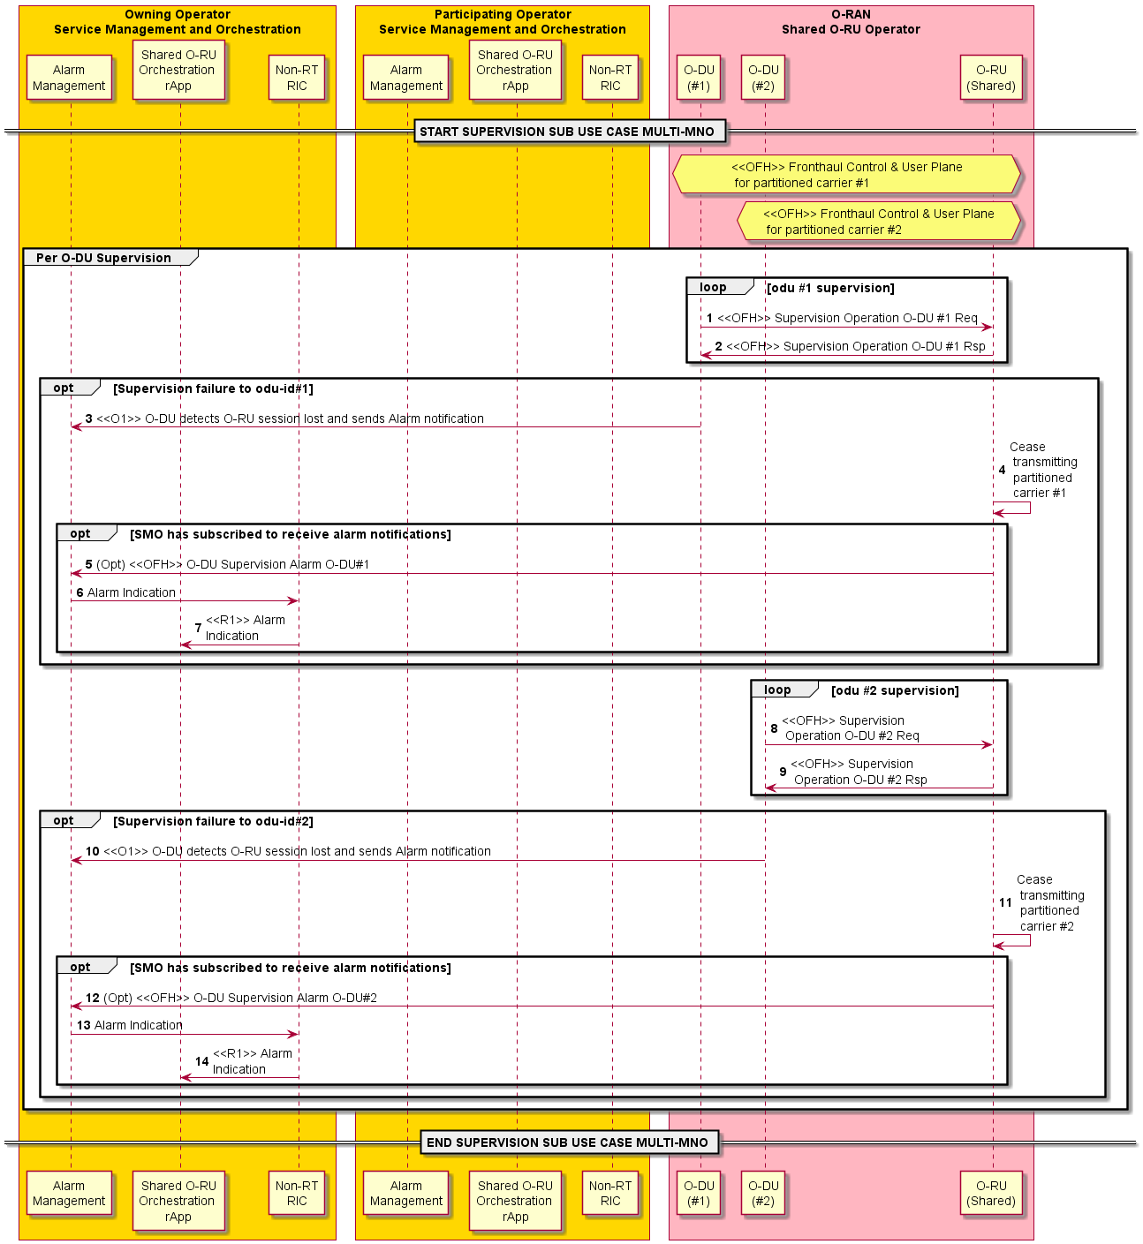
Figure 4.20.3.18-1: Supervision use case of a Shared O-RU in Multi-MNO

4.20.3.19 Antenna Line device (ALD) control sub-use case of a Shared O-RU for Multi-MNO configuration
The following describes the solution for the ALD control sub-use case for a Shared O-RU for Multi-MNO configuration.
The context of the antenna line device control use case of a Shared O-RU is captured in table 4.20.3.19-1.
Table 4.20.3.19-1: Antenna line device control use case of a Shared O-RU
Use Case Stage | Evolution / Specification | <<Uses>>  Related use
Goal | The ALD connected to Shared O-RU is configured to operate with ALD controller.
Actors and Roles | Owning operator rApp is responsible for determining which O-DU is responsible for ALD oontroller aspects.  O-DU is responsible for implementing ALD oontroller.  O-RU is responsible for bridging between OFH and HDLC.  ALD is responsible for terminating HDLC.
Assumptions | None.
Begins when | Shared O-RU has started up and has been configured with correct software version.
Pre-conditions | None.
Step 1 (M) | Owning operator rApp determines which O-DU is responsible for performing ALD controller functionality.
Step 2 (M) | Owning operator rApp triggers the configuration of the ALD controller for Shared O-RU.
Step 3 (M) | Owning operator Non-RT RIC triggers the configuration of ALD controller for Shared O-RU.
Step 4 (M) | Owning operator SMO uses O1 interface to configure ALD controller in O-DU.
Step 5 (M) | O-DU uses open fronthaul interface to configure ALD aspects of Shared O-RU. | O-RAN.WG4.MP [28], clause 9
Step 6 (M) | Participating operator rApp triggers the configuration of the ALD controller for Shared O-RU.
Step 7 (M) | Participating operator Non-RT RIC triggers the configuration of ALD controller for Shared O-RU.
Step 8 (M) | O-DU uses open fronthaul interface to signal ALD request. | O-RAN.WG4.MP [28], clause 14.4
Step 9 (M) | O-DU uses open fronthaul interface to signal ALD response. | O-RAN.WG4.MP [28], clause 14.4
Step 10 (M) | Shared O-RU provides interworking between OFH and HDLC request. | O-RAN.WG4.MP [28], clause 14.4
Step 11 (M) | Shared O-RU provides interworking between OFH and HDLC response. | O-RAN.WG4.MP [28], clause 14.4
Ends when | ALD connected to Shared O-RU is configured correctly.
Exceptions | None identified.
Post Conditions | None identified.

@startuml
!pragma teoz true

skin rose
skinparam ParticipantPadding 5
skinparam BoxPadding 10
skinparam defaultFontSize 14
autonumber

Box "Owning Operator\nService Management and Orchestration" #gold
Participant CFG as "Configuration\nManagement"
Participant R_APP as "Shared O-RU\nOrchestration \nrApp"
Participant SMO_a as "Non-RT\nRIC"
end box

Box "Participating Operator\nService Management and Orchestration" #gold
Participant CFG_PO as "Configuration\nManagement"
Participant R_APP_PO as "Shared O-RU\nOrchestration \nrApp"
Participant SMO_PO as "Non-RT\nRIC"
end box

Box "O-RAN\nShared O-RU Operator" #lightpink
Participant ODU1 as "O-DU(#1)\nALD Controller"
Participant ODU2 as "O-DU(#2)"

participant ORU as "O-RU\n(Shared)"
participant ALD as "ALD"
End box

== START ALD CONTROL SUB USE CASE FOR MULTI-MNO ==

== CONFIGURATION ==
group Configure ALD aspects of shared O-RU

Hnote over R_APP
1. Decide on O-DU(#1)
or O-DU(#2) for
ALD Control
end note

autonumber 2
R_APP -> SMO_a: <<R1>> Configure\nShared O-RU\nALD aspects
SMO_a->CFG: Configure Shared O-RU ALD Aspects

CFG->ODU1: <<O1>> Configure Shared O-RU ALD aspects
&ODU1->ORU: <<OFH>> Configure Shared O-RU ALD aspects

R_APP_PO -> SMO_PO: <<R1>> Configure\nShared O-RU\nALD aspects
SMO_PO->CFG_PO: Configure Shared O-RU ALD Aspects

end
== RUNNING ==

group ALD Operation for shared O-RU

ODU1->ORU: <<OFH>> HDLC-over-OFH Req
ODU1<-ORU: <<OFH>> HDLC-over-OFH Resp
ORU->ALD: HDLC
ORU<-ALD: HDLC
end

== END ALD CONTROL SUB USE CASE FOR MULTI-MNO ==

@enduml

The flow diagram of the antenna line device sub-use case is given in figure 4.20.3.19-1.
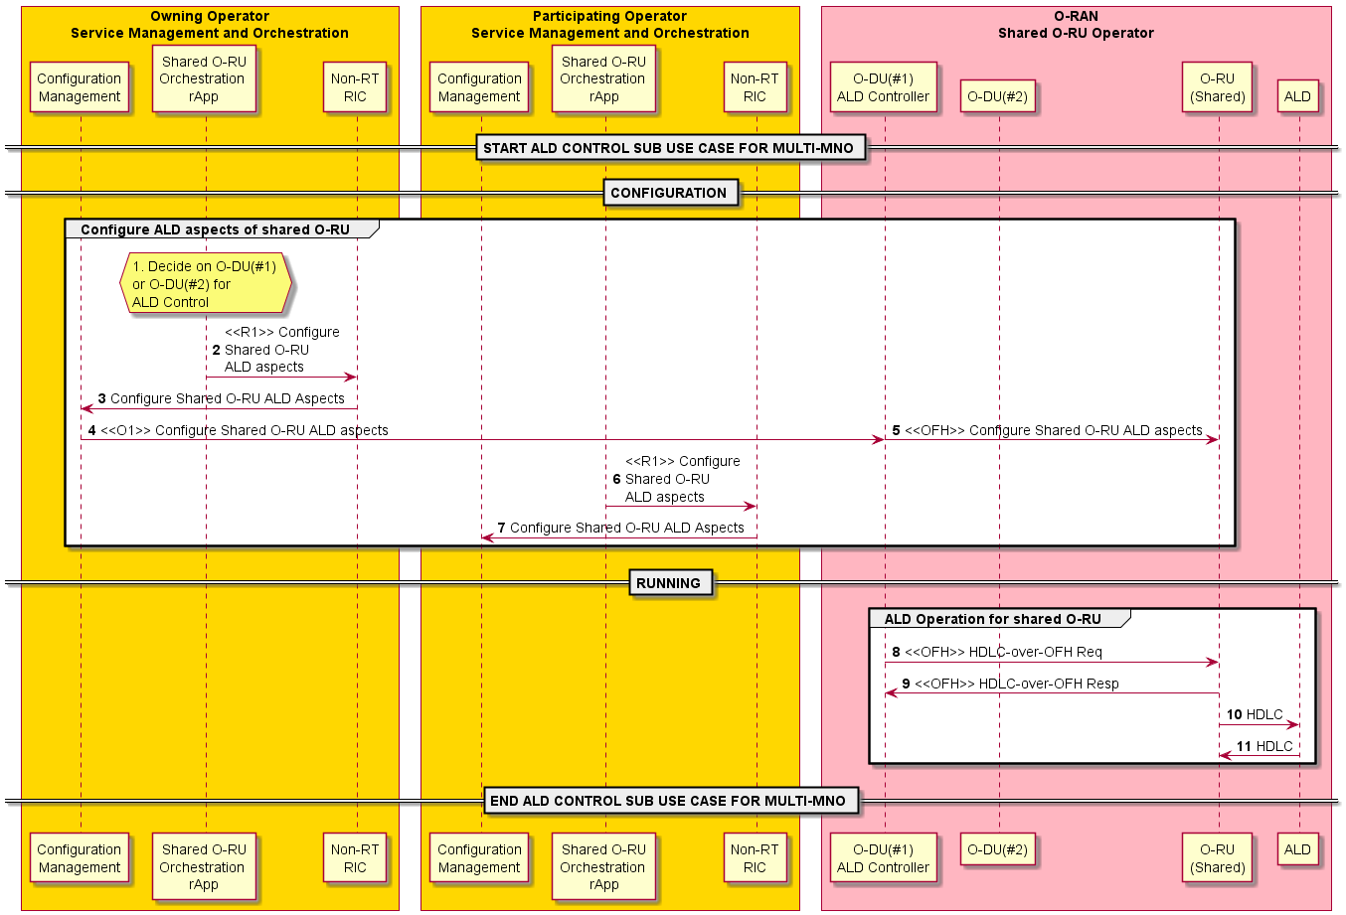
Figure 4.20.3.19-1: Antenna line device sub-use case for multi-MNO

4.20.3.20 Antenna calibration use case of a Shared O-RU for Multi-MNO configuration (deferred)
The following will describe the solution for the antenna calibration sub-use case for a Shared O-RU.

4.20.3.21 Rehoming use case of a Shared O-RU for Multi-MNO
The following describes the solution for the rehoming sub-use case for a Shared O-RU in a Multi-MNO configuration.
The step-by-step details of the rehoming use case of a Shared O-RU is in table 4.20.3.21-1.
Table 4.20.3.21-1: Rehoming use case of a Shared O-RU in Multi-MNO
Use Case Stage | Evolution / Specification | <<Uses>>  Related use
Goal | A Shared O-RU is rehomed and is able to pair with new O-DU or existing (previous) O-DU parents in a Multi-MNO setting.
Actors and Roles | Shared O-RU is the element that is rehomed.  Host O-DU (old) is the original Shared O-RU parent.  SRO O-DU (old) is another original O-DU Shared O-RU is connected to. This is owned by the participating operator.  Host O-DU (new) is the new Shared O-RU parent.  SRO O-DU (new) is another new O-DU Shared O-RU is connected to. This is owned by the participating operator.  SMO can receive results from calibration.
Assumptions | The Shared O-RU is in a deployment with the original (old) O-DUs and will be moved to the new ones or stays with the original O-DUs  (Typically) the operator will plan a Shared O-RU move before they actually perform the operations related to the move.
Begins when | This use case starts with any of these three situations:  Case #1 starts when the Shared O-RU is physically moved to a new location (however still connected to original O-DUs).  Case #2 starts when the Shared O-RU is physically moved to a new location but is connected to new O-DUs.  Case #3 starts when the Shared O-RU stays in same physical location but is connected to new O-DUs (management-initiated rehoming).
Case #1 – O-RU is physically moved with same O-DU parents
Step 1 (M) | Shared O-RU is disconnected from original O-DUs  The Shared O-RU is physically disconnected (fiber disconnected) from the existing O-DU parents.  Then, the Shared O-RU is physically moved to a new location.
Step 2 (M) | Shared O-RU is reconnected to original O-DUs  The Shared O-RU is either physically reconnected (different fiber) or connected at the transport layer (with the original fiber) to reconnected to the original O-DU parents, and the following sub-use cases are triggered as a result:  - Shared O-RU startup sub-use case for Multi-MNO configuration  - Configuration sub-use case  - Resource partitioning sub-use case for Multi-MNO configuration  - Coordinated reset sub-use case for Multi-MNO configuration  - Supervision sub-use case for Multi-MNO configuration
CASE #2 – O-RU is physically moved with new O-DU parents
Step 1 (M) | Shared O-RU is disconnected from original O-DUs  The Shared O-RU is physically disconnected (fiber disconnected) from the former O-DU parents.  Then, the Shared O-RU is physically moved to a new location.
Step 2 (M) | Shared O-RU is connected to new O-DUs  The Shared O-RU is either physically reconnected (different fiber) or connected at the transport layer (with the original fiber) to new O-DU parents, and the following sub-use cases are triggered as a result:  - Shared O-RU startup sub-use case for Multi-MNO configuration  - Configuration sub-use case  - Resource partitioning sub-use case for Multi-MNO configuration  - Coordinated reset sub-use case for Multi-MNO configuration  - Supervision sub-use case for Multi-MNO configuration
Case #3 – Management initiated rehoming
Step 1 (M) | Management initiated rehoming for Shared O-RU  Shared O-RU already has physical front-haul connections in place.  Main operator SMO Initiates rehoming operation with O-DUs connected to the Shared O-RU.  Participating operator SMO initiates rehoming operation with O-DUs connected to the Shared O-RU.
Step 2 (M) | Shared O-RU starts up  The Shared O-RU starts up with the new O-DU parents, and the following sub-use cases are triggered as a result:  - Shared O-RU startup sub-use case for Multi-MNO configuration  - Configuration sub-use case  - Resource partitioning sub-use case for Multi-MNO configuration  - Coordinated reset sub-use case for Multi-MNO configuration  - Supervision sub-use case for Multi-MNO configuration
Ends when | The Shared O-RU has been moved and connected to the appropriate O-DUs, and is operational again.
Exceptions | None.
Post Conditions | None.

@startuml
!pragma teoz true

skin rose
skinparam ParticipantPadding 5
skinparam BoxPadding 10
skinparam defaultFontSize 14
autonumber 1

Box “ Owning Operator\n Service Management\n and Orchestration (SMO)” #gold
Participant CFG as "Configuration\nManagement"
Participant SMO as “Management\nService”
end box

Box “Participating Operator\n Service Management\n and Orchestration (SMO)” #gold
Participant SMO2 as “Management\nService”
end box

Box “O-RAN\nShared O-RU Operator” #lightpink
Participant ODU1 as “O-DU\n(#1) Host”
Participant ODU2 as “O-DU\n(#2)”
Participant ODU3 as “O-DU\n(#3) Host”
Participant ODU4 as “O-DU\n(#4)”
Participant ORU as “O-RU\n(Shared)”
End box

== BEGIN CASE #1 PHYSICAL REHOMING OF THE SHARED O-RU SAME O-DUs ==

hnote over ODU1, ORU
The O-RU FH is disconnected
from O-DU #1, O-DU #2
end note

ORU -> ORU: O-RU FH is \ndisconnected

hnote over ORU
The O-RU is
physically moved
to a new location
end note

hnote over ODU1, ORU
The O-RU FH is reconnected
to O-DU #1, O-DU #2
end note

ORU -> ORU: O-RU FH is \nconnected

hnote over ODU1, ORU
The O-RU Starts up with O-DU1 and O-DU2
end note

Ref over CFG, ORU: Shared O-RU Startup Sub Use Case for Multi-MNO Configuration\n Configuration Sub Use Case\n Resource Partitioning Sub Use Case for Multi-MNO Configuration \n Reset Sub Use Case for Multi-MNO Configuration\n Supervision for Multi-MNO Configuration Sub Use Case

== CASE #1 REHOMING PROCEDURE END ==

== CASE #2 PHYSICAL REHOMING OF THE SHARED O-RU TO NEW O-DUs ==

Opt Configuration\npreparation
Alt Hybrid\n Type
hnote over CFG
Preparation for
SMO & O-RU
end note
Else Hierarchical Type
Hnote over CFG
Preparation
for O-DU
End note
End
End

hnote over ODU1, ORU
The O-RU FH is disconnected
from O-DU #1, O-DU #2
end note

ORU -> ORU: O-RU FH is \ndisconnected

hnote over ORU
The O-RU is physically
moved to a new location
end note

hnote over ODU3, ORU
The O-RU FH is reconnected
to O-DU #3, O-DU #4
end note

ORU -> ORU: O-RU FH is \nconnected

hnote over ODU3, ORU
The O-RU Starts up with O-DU3 and O-DU4
end note

Ref over SMO, ORU: Shared O-RU Startup Sub Use Case for Multi-MNO Configuration\n Configuration Sub Use Case\n Resource Partitioning Sub Use Case for Multi-MNO Configuration \n Coordinated Reset Sub Use Case for Multi-MNO Configuration \n Supervision for Multi-MNO Configuration Sub Use Case

== CASE #2 REHOMING PROCEDURE END ==

== BEGIN CASE #3 MANAGEMENT INITIATED REHOMING OF THE SHARED O-RU ==

SMO -> ODU1: Rehoming Operation
SMO2 -> ODU2: Rehoming Operation
SMO -> ODU3: Rehoming Operation
SMO2 -> ODU4: Rehoming Operation

Ref over SMO, ORU: Shared O-RU Startup Sub Use Case for Multi-MNO Configuration\n Configuration Sub Use Case\n Resource Partitioning Sub Use Case for Multi-MNO Configuration \n Reset Sub Use Case for Multi-MNO Configuration\n Supervision for Multi-MNO Configuration Sub Use Case

== END MANAGEMENT INITIATED REHOMING OF THE SHARED O-RU ==

@enduml

The flow diagram of the rehoming use case of a Shared O-RU for Multi-MNO is given in figure 4.20.3.21-1.

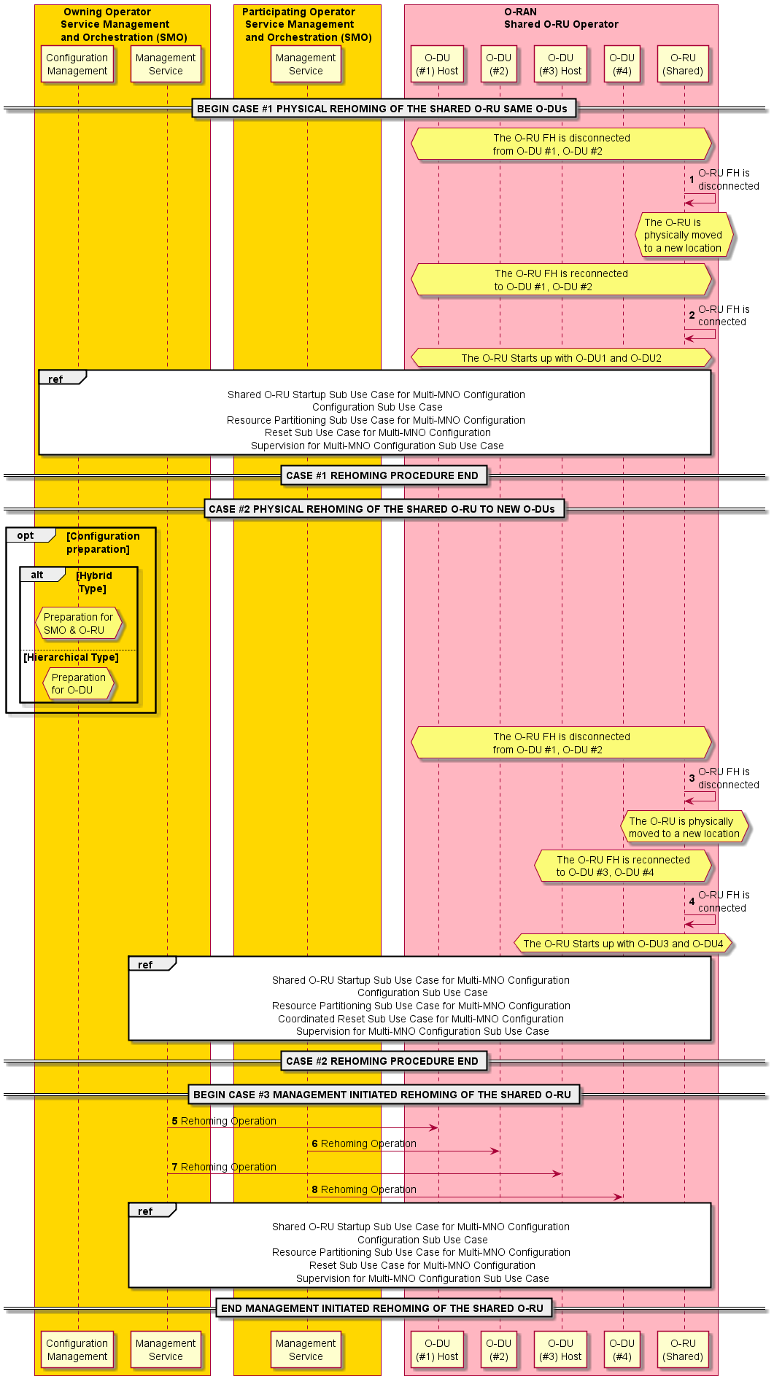
Figure 4.20.3.21-1: Rehoming use case of a Shared O-RU for Multi-MNO

4.20.3.22 Performance management use case of a Shared O-RU for Multi-MNO
The following describes the solution for the performance management sub-use case for a Shared O-RU in a Multi-MNO configuration.
The context of the performance management sub-use case of a Shared O-RU in a Multi-MNO configuration is captured in table 4.20.3.22-1.
Table 4.20.3.22-1: Performance management sub-use case of a Shared O-RU in a Multi-MNO
Use Case Stage | Evolution / Specification | <<Uses>>  Related use
Goal | Each O-DU has established subscriptions to receive performance management notifications regarding operation of the fronthaul between the O-DUs and shared O-RU.  The O-DU and Shared O-RU are able to report performance measurement data towards their consumers in a Multi-MNO configuration.
Actors and Roles | Shared O-RU generates performance management notifications on a per partitioned carrier basis  O-DU subscribes to receive performance management notifications from Shared O-RU.
Assumptions | O-DU has configured performance management metrics for respective partitioned carrier.
Begins when | Fronthaul control and user plane is operational between O-DU and Shared O-RU.
Step 1 (M) | O-DU#1 subscribes to receive PM notifications from Shared O-RU.
Step 2 (M) | O-DU#2 subscribes to receive PM notifications from Shared O-RU.
Step 3 (loop) | Shared O-RU sends PM notification to O-DU#1.
Step 4 (loop) | Shared O-RU sends PM notification to O-DU#2.
O-DU to SMO performance operations
Step 1 (O) | PM event notification reporting  The O-DU (producer) sends performance data to the SMO (consumer) through an event notification.
Step 2 (O) | Streaming PM reports  The O-DU establishes a persistent connection to the SMO and sends performance data.
Step 3 (O) | Attribute-based or URI-based collection  Performance data is read by the consumer (SMO) through configuration management attribute. Alternatively, the O-DU can support a data scraping method where a collector (SMO) reads the data from a pre-defined URI.
Step 4 (O) | Producer or PM file upload (file upload)  O-DU uploads a PM file to the SMO.  See NOTE 1.
Step 5 (O) | Consumer downloads PM file (file download)  O-DU issues file ready notification to SMO about the data being ready for download, or SMO periodically polls the O-DU. Afterwards, the SMO (consumer) can download the PM file.
O-RU to O-DU performance operations (in hierarchical configuration)
Step 1 (O) | PM event notification reporting  The O-RU sends performance data to the O-DU through an event notification. The notification is sent to a subscriber of performance data.
Step 2 (O) | O-DU requests for O-RU to start sending PM data  O-DU invokes an RPC to give PM credentials, target URI, and periodicity notification interval to the Shared O-RU. This includes all the necessary information for the O-RU to perform a file transfer to an endpoint.  See NOTE 2.
Step 3 (O) | Shared O-RU uploads PM file  The Shared O-RU periodically uploads a performance to the target URI using the PM credentials given by the O-DU.
O-RU to SMO performance operations (in hybrid configuration)
Step 1 (O) | PM event notification reporting  The O-RU sends performance data to the SMO through an event notification via M-plane. The notification is sent to a subscriber of performance data.
Step 2 (O) | SMO requests for O-RU to start sending PM data  SMO invokes an RPC to give PM credentials, target URI, and periodicity notification interval to the Shared O-RU. This includes all the necessary information for the O-RU to perform a file transfer to a endpoint.
Step 3 (O) | Shared O-RU uploads PM file  The Shared O-RU uploads performance file to target URI using PM credentials given by the SMO.
Ends when | (1) Subscription setup: O-DU terminates subscription to performance management notification.  (2) O-DU to SMO sending PM data: Use case ends with the producer (O-DU) sending performance data to the consumer (SMO).  (3) O-RU sending performance data: Use case ends with the producer (O-RU) starting to send performance data to the subscriber.
Exceptions | None identified.
Post Conditions | The consumer has received performance data and may perform post processing operations on the data.
NOTE 1: When the O-DU sends performance files received from a Shared O-RU, they are converted to the proper 3GPP format before sending to SMO. See O-RAN WG5.O-DU-O1 [25].
NOTE 2: The O-DU establishes a framework for the Shared O-RU to send PM files. This operation is performed only once, thereafter, the Shared O-RU sends the PM files periodically.
@startuml
!pragma teoz true

skin rose
skinparam ParticipantPadding 5
skinparam BoxPadding 10
skinparam defaultFontSize 14
autonumber 1

Box “Owning Operator\n Service Management and Orchestration (SMO)” #gold
Participant PMS as “Performance Management\nService”
end box

Box “Participating Operator\n Service Management and Orchestration (SMO)” #gold
Participant PMS2 as “Performance Management\nService”
end box

Box "O-RAN\nShared O-RU Operator" #lightpink
Participant ODU1 as "O-DU\n(#1)"
Participant ODU2 as "O-DU\n(#2)"

participant ORU as "O-RU\n(Shared)"
End box

== SUBSCRIPTION SETUP ==

hnote over ODU1, ORU
<<OFH>> Fronthaul Control & User Plane for partitioned carrier #1
end note

hnote over ODU2, ORU
<<OFH>> Fronthaul Control & User Plane for partitioned carrier #2
end note

group Per O-DU Performance Management

ODU1<->ORU: <<OFH>> Subscribe to receive PM notifications for partitioned carrier #1
ODU2<->ORU: <<OFH>> Subscribe to receive PM notifications for partitioned carrier #2

loop Shared O-RU performance management
ORU->ODU1: <<OFH>> PM Notification (partitioned carrier #1)
ORU->ODU2: <<OFH>> PM Notification (partitioned carrier #2)
end
end

== SUBSCRIPTION SETUP ==

== ODU TO SMO PERFORMANCE OPERATIONS ==
Autonumber 1

Alt O-DU Notification-based Reporting
ODU1->PMS: <<O1>> PM Event Notification Reporting
Else O-DU Streaming-based Reporting
ODU1->PMS: <<O1>> Streaming PM Reports
Else Consumer Actively Collects
PMS->ODU1: <<O1>> Attribute based or URI based collection
Else O-DU File-based Reporting
ODU1->PMS: <<O1>> Producer PM File Upload (File Upload)
Else O-DU File-based Reporting
PMS->ODU1: <<O1>> Consumer Downloads PM File (File Download)
End

Alt O-DU Notification-based Reporting
ODU2->PMS2: <<O1>> PM Event Notification Reporting
Else O-DU Streaming-based Reporting
ODU2->PMS2: <<O1>> Streaming PM Reports
Else Consumer Actively Collects
PMS2->ODU2: <<O1>> Attribute based or URI based collection
Else O-DU File-based Reporting
ODU2->PMS2: <<O1>> Producer PM File Upload (File Upload)
Else O-DU File-based Reporting
PMS2->ODU2: <<O1>> Consumer Downloads PM File (File Download)
End

== ODU TO SMO PERFORMANCE OPERATIONS ==

== ORU TO ODU PERFORMANCE OPERATIONS (Hierarchical Configuration) ==
Autonumber 1

Opt O-RU Notification-based Reporting
ORU->ODU1: <<OFH>> PM Event Notification Reporting
End

Autonumber 1

Group O-DU Actively Collects PM
ODU1->ORU: <<OFH>> ODU invokes RPC to give PM Credentials & Target URI
ORU->ODU1: <<OFH>> ORU uploads Performance File to Target URI using PM Credentials
End

Opt O-RU Notification-based Reporting
ORU->ODU2: <<OFH>> PM Event Notification Reporting
End

Autonumber 1

Group O-DU Actively Collects PM
ODU2->ORU: <<OFH>> ODU invokes RPC to give PM Credentials & Target URI
ORU->ODU2: <<OFH>> ORU uploads Performance File to Target URI using PM Credentials
End

== ORU TO ODU PERFORMANCE OPERATIONS (Hierarchical Configuration) ==

== ORU TO ODU PERFORMANCE OPERATIONS (Hybrid Configuration) ==
Autonumber 1

Opt O-RU Notification-based Reporting
ORU->PMS: <<OFH>> PM Event Notification Reporting
End

Autonumber 1

Group SMO Actively Collects PM
PMS->ORU: <<OFH>> SMO invokes RPC to give PM Credentials & Target URI
ORU->PMS: <<OFH>> ORU uploads Performance File to Target URI using PM Credentials
End

Autonumber 1

Opt O-RU Notification-based Reporting
ORU->PMS2: <<OFH>> PM Event Notification Reporting
End

Autonumber 1

Group SMO Actively Collects PM
PMS2->ORU: <<OFH>> SMO invokes RPC to give PM Credentials & Target URI
ORU->PMS2: <<OFH>> ORU uploads Performance File to Target URI using PM Credentials
End

== ORU TO ODU PERFORMANCE OPERATIONS (Hybrid Configuration) ==

@enduml

The flow diagram of the performance management sub-use case of a Shared O-RU in a Multi-MNO is given in figure 4.20.3.22-1.
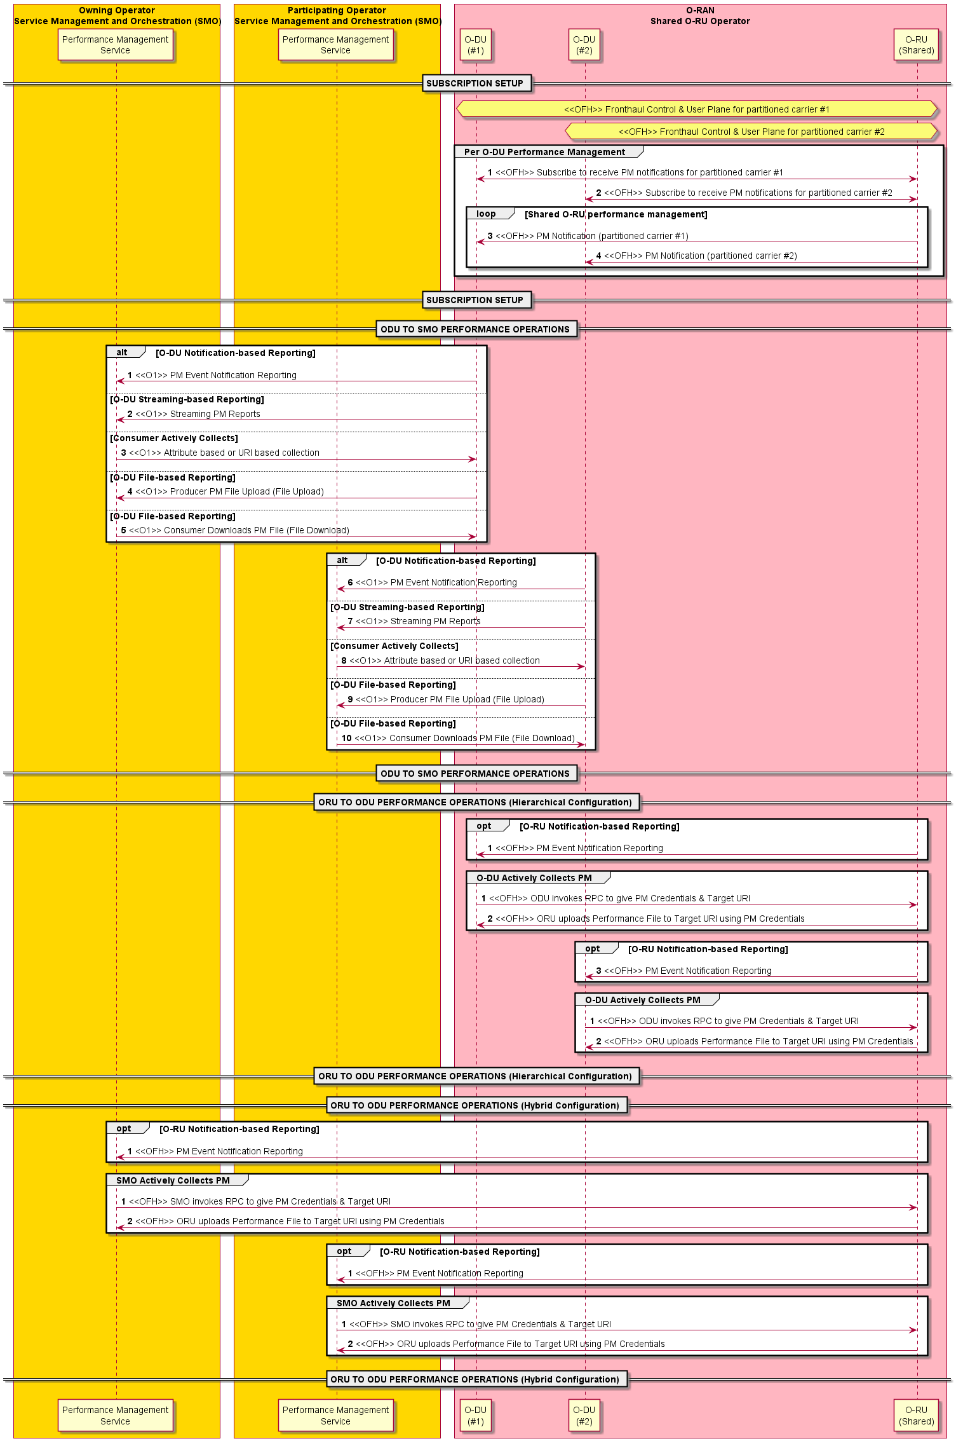
Figure 4.20.3.22-1: Performance management use case of a Shared O-RU for Multi-MNO

4.20.3.23 Antenna calibration use case of a Shared O-RU for Multi-MNO
The following describes the solution for the antenna calibration sub-use case for a Shared O-RU in a Multi-MNO configuration.
The step-by-step details of the antenna calibration use case of a Shared O-RU are captured in table 4.20.3.23-1.
Table 4.20.3.23-1: Antenna calibration of a Shared O-RU in Multi-MNO
Use Case Stage | Evolution / Specification | <<Uses>>  Related use
Goal | The host O-DU performs an antenna calibration procedure with the shared O-RU in a Multi-MNO configuration.  The owning operator O-DU reports antenna calibration results to the SMO.
Actors and Roles | Shared O-RU performs the antenna calibration procedure.  Owning operator O-DU (host) that requests for antenna calibration procedure with Shared O-RU.  Participating operator O-DU is owned by the participating operator.  Owning operator SMO can receive results from calibration.  Participating operator SMO can also receive results from calibration.
Assumptions | All O-DUs have connectivity to O-RU.  All actors are operational and have initialized.  Fronthaul control and user plane is operational between all O-DUs and Shared O-RU.
Begins when | 1. The Shared O-RU has detected that antenna calibration is required.  2. The Owning operator O-DU initiates an antenna calibration procedure.
Step 1.1 (O) | Recalibration required (O-RU initiated)  The Shared O-RU has detected that antenna calibration is needed and sends an antenna calibration needed notification to the owning operator host O-DU over the open FH. In this case, the O-RU initiates the calibration procedure.
Step 1.2 (O) | Calibration request  The host O-DU of the owning operator requests for antenna calibration procedure to start for Shared O-RU.
Step 1.1 (M) | Host O-DU informs SMO  The owning operator SMO together with host O-DU (owning operator) informs that an antenna calibration operation is needed.
Step 1.2 (M) | SMO to SMO negotiation  Through exposure of management services, the owning operator SMO negotiates with the participating operator SMO that the host O-DU would like to perform an antenna calibration operation. Here, the participating operator SMO may object to the antenna calibration operation.
Step 1.3 (O) | Host O-DU initiates antenna calibration  If agreed to proceed, owning operator SMO together with host O-DU (owning operator) initiates an antenna calibration operation.
Step 1.4 (M) | SMO informs participating operator O-DU  The participating operator SMO informs its O-DU that the antenna calibration operation will be initiated by the owning operator (host) O-DU.
Step 1.5 (M) | Calibration request (O-DU initiated)  The host O-DU of the owning operator requests for antenna calibration procedure to start for Shared O-RU. In this case the O-DU initiates the calibration procedure.
Step 2 (M) | Calibration operation at O-RU  Shared O-RU performs antenna calibration procedure.
Step 3 (M) | Calibration response  The Shared O-RU responds with antenna calibration results to the owning operator O-DU.
Step 4 (M) | Calibration results  The owning operator O-DU returns antenna calibration results to owning operator SMO.
Step 5 (M) | Calibration results to O-DU #2  Shared O-RU notifies the participating operator O-DU with antenna calibration results.
Step 6 (M) | Calibration results  The participating operator O-DU returns antenna calibration results to the participating operator SMO.
Ends when | (1) Antenna calibrated: Antenna calibration procedure has finished, and results reported.
Exceptions | The O-RU may indicate a calibration failure, which is reported to the owning operator O-DU. The O-DU logs the failure and notifies north-bound entities.
Post Conditions | None.
@startuml
!pragma teoz true

skin rose
skinparam ParticipantPadding 5
skinparam BoxPadding 10
skinparam defaultFontSize 14
autonumber 1

Box “ Owning Operator\n Service Management\n and Orchestration (SMO)” #gold
Participant SMO as “Antenna Calibration\nService”
end box

Box “Participating Operator\n Service Management\n and Orchestration (SMO)” #gold
Participant SMO2 as “Management\nService”
end box

Box “O-RAN\nShared O-RU Operator” #lightpink
Participant ODU1 as “O-DU\n(#1) Host”
Participant ODU2 as “O-DU\n(#2)”
participant ORU as “O-RU\n(Shared)”
End box

== ANTENNA CALIBRATION PROCEDURE BEGIN (Hybrid) ==

hnote over ODU1, ORU
<<OFH>> Fronthaul Control & User Plane for partitioned carrier #1
end note

hnote over ODU2, ORU
<<OFH>> Fronthaul Control & User Plane for partitioned carrier #2
end note

alt ORU Initiated Calibration
Autonumber 1.1
ORU->ODU1: <<OFH>> Recalibration Needed Notification
ODU1->ORU: <<OFH>> Request Antenna Calibration Procedure
Else ODU Initiated Calibration
Autonumber 1.1
ODU1<->SMO: <<O1>> Antenna Calibration Required
SMO<->SMO2: Antenna Calibration Required
ODU1<->SMO: <<O1>> Antenna Calibration Required
SMO2->ODU2: <<O1>> Antenna Calibration Initiated
ODU1->ORU: <<OFH>> Request Antenna Calibration Procedure
End

Autonumber 2
ORU->ORU: Perform\nAntenna\nCalibration\nProcedure
ORU->ODU1: <<OFH>> Respond Antenna Calibration Procedure Results
ODU1->SMO: <<O1>> Respond Antenna\nCalibration Procedure Results

ORU->ODU2: <<OFH>> Antenna Calibration Procedure Results
ODU2->SMO2: <<OFH>> Antenna Calibration Procedure Results

== ANTENNA CALIBRATION PROCEDURE END (Hybrid) ==

@enduml

The flow diagram of the antenna calibration use case of a Shared O-RU for Multi-MNO is given in figure 4.20.3.23-1.

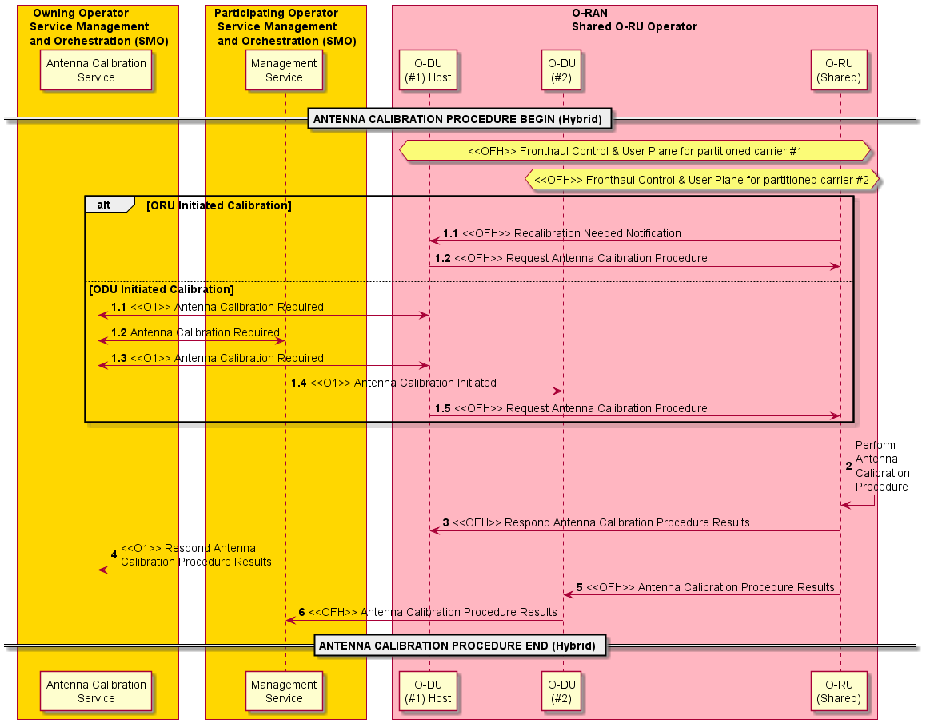
Figure 4.20.3.23-1: Antenna calibration use case of a Shared O-RU for Multi-MNO

4.20.3.24 Dynamic resource shifting use case of a Shared O-RU
The following will describe the solution for dynamic resource shifting sub-use case for a Shared O-RU.
Table 4.20.3.24-1: Dynamic resource shifting use case of a Shared O-RU
Use Case Stage | Evolution / Specification | <<Uses>>  Related use
Goal | Cooperating O-DUs serve cells overlapping spectrum in a way, so that frequency resources effectively used by each O-DU can be dynamically shifted between O-DUs and interference is avoided at air interface. There is no impact to regular procedures performed between O-DUs and UEs and UE energy consumption is not increased.
Actors and Roles | Shared O-RU serves radio functions to the air.  O-DU performs radio resource handling.  SMO configures other actors.  Near-RT RIC coordinates dynamic shifting of spectrum resources between O-DUs.
Assumptions | O-RU is configured to serve for 2 or more O-DUs.  O-DUs are configured respectively – including dedicated set of bandwidth parts in UL and DL alike.  Near-RT RIC knows how bandwidth parts are configured to O-DUs.  Near-RT RIC is receiving traffic-related statistics from O-DUs.  Near-RT RIC is provided with traffic shaping policy for cells that use overlapping spectrum.
Begins when | Near-RT RIC decides to change bandwidth effectively used by cells served by O-DUs.
Step 1 (M) | Near-RT RIC provides O-DUs with updated lists of bandwidth parts O-DUs are allowed to utilize.
Step 2 (M) | O-DUs respectively confirm reception of updated list of permitted bandwidth parts to Near-RT RIC.
Step 3 (loop) | O-DUs use actual list of permitted bandwidth parts for scheduling in downlink and uplink respectively.
Ends when | Update of list of permitted bandwidth parts confirmed to Near-RT RIC.
Exceptions | It is feasible that list of permitted bandwidth parts is updated to some (not all) of cooperating O-DUs.
Post Conditions | Lists of permitted bandwidth parts are successfully updated for desired O-DUs.
@startuml
!pragma teoz true

skin rose
skinparam ParticipantPadding 5
skinparam BoxPadding 10
skinparam defaultFontSize 14

Box “SMO” #gold
Participant RAPP as “rApp”
end box

Box “Near Real Time RIC” #gold
Participant XAPP as “xApp”
end box

Box “O-RAN\nShared O-RU Operator” #lightpink
Participant ODU1 as “O-DU\n(#1)”
Participant ODU2 as “O-DU\n(#2)”
participant ORU as “O-RU\n(Shared)”
End box

== INITIATION ==
note over RAPP, ORU: Configuration and service activation

loop
== COLLECTION OF COUNTERS ==
XAPP<-ODU1: Traffic related counters
XAPP<-ODU2: Traffic related counters

== DYNAMIC RESOURCE SHIFTING ==
autonumber 1
Opt
XAPP->ODU1: <<E2>> Update: list of permitted BWPs
XAPP<-ODU1: <<E2>> Ack
end

Opt
XAPP->ODU2: <<E2>> Update: list of permitted BWPs
XAPP<-ODU2: <<E2>> Ack
end

ODU1->ORU: <<FH CU-Plane>> User traffic and signalling
ODU2->ORU: <<FH CU-Plane>> User traffic and signalling

end

@enduml

The flow diagram of the dynamic resource shifting sub-use case for Shared O-RU is given in figure 4.20.3.24-1.

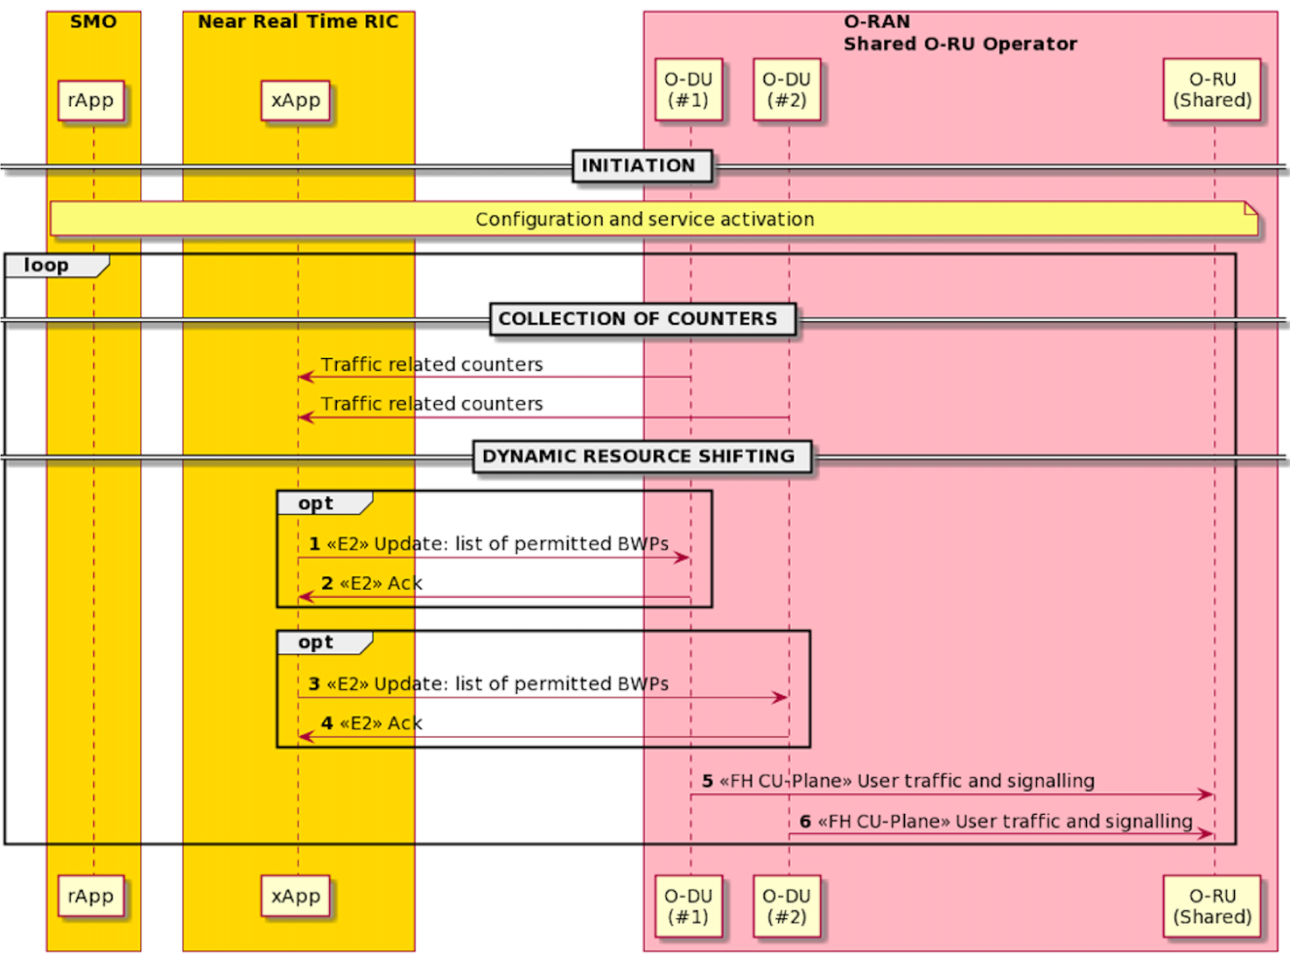
Figure 4.20.3.24-1: Dynamic resource shifting sub-use case for Shared O-RU

4.20.3.25 Static resource shifting use case for Single-MNO
The following will describe the solution for static resource shifting sub-use case for a Shared O-RU.
Table 4.20.3.25-1: Static resource shifting use case of a Shared O-RU
Use Case Stage | Evolution / Specification | <<Uses>>  Related use
Goal | Cooperating O-DUs serve cells using a designated chunk of spectrum at a time, allowing carrier frequency resources to be effectively reallocated between O-DUs and ensuring interference is avoided at the air interface.  This is a service impacting use case.
Actors and Roles | Actors:  Shared O-RU  O-DUs  O-CU  SMO  Roles:  Please refer to 4.20.2.25.
Initiation
Assumptions | - O-RU is configured to have connectivity with 2 or more O-DUs.  - O-DUs are configured respectively for connectivity with Shared O-RU.  - Fronthaul M-plane (Netconf session) sessions are established between Shared O-RU and O-DUs as per provided configurations.  - SMO knows the capabilities of O-DUs.  - SMO is receiving traffic-related statistics from O-DUs.  - SMO manages the entire process and ensures coordination between O-DUs.  - SMO configures the initial roles and resources for O-DUs and O-RU.
Collection of counters
 | O-DUs report PM counters to SMO (Non-RT RIC). PM counters are used by SMO as trigger to decide if static resource shifting shall be applied.
Static resource shifting
Deactivation and removal of cell(s) and carrier(s) associated with O-DU#1
Begins when | SMO decides to start static resource shifting for specific cell(s) served by O-DUs through Shared O-RU.
Step 1 (M) | SMO requests O-CU to deactivate cell(s) served by O-DU#1.
Step 2 (M) | O-CU informs O-DU#1 about the cell(s) to be deactivated via F1 interface.
Step 3 (M) | O-DU#1 maps mentioned above cell(s) with corresponding carrier(s) that need to be deactivated on Shared O-RU.
Step 4 (M) | For carriers determined in Step 3, O-DU#1 performs carrier deactivation with O-RU.
Step 5 (M) | Once O-DU#1 knows that relevant carriers(s) are deactivated, it replies to O-CU’s request for cell deactivation received in Step 2.
Step 6 (M) | O-CU replies to SMO’s request for cell deactivation received in Step 1.
Step 7.1 (M) | Hierarchical deployment – Cell(s) and carrier(s) removal  SMO requests O-DU#1 to remove specific inactive cell(s) and related carrier(s) from configuration.
Step 7.2 (M) | O-DU#1 maps requested cell(s) with carrier(s) that needs to be removed from O-RU’s configuration.
Step 7.3 (M) | O-DU#1 informs O-CU about cell(s) being subject of removal.
Step 7.4 (M) | O-DU#1 performs config update scenario to O-RU to remove configuration related to carrier(s) determined in Step 7.2.
Step 7.5 (M) | O-DU#1 responds to SMO’s request for cell removal received in Step 7.1.
Step 8.1 (M) | Hybrid deployment – Cell(s) and carrier(s) removal  SMO requests O-RU to remove specific carriers.
Step 8.2 (M) | O-RU notifies O-DU that specific carriers have been removed.
Step 8.3 (M) | O-DU#1 performs carrier-to-cell mapping.
Step 8.4 (M) | O-DU#1 informs SMO about change in resource availability.
Step 8.5 (M) | For cells that have lost their related carriers completely O-DU#1 informs O-CU about cells are no longer operational.
Step 8.6 (M) | O-RU responds to SMO’s request for carrier(s) removal.
Step 8.7 (M) | SMO requests O-DU#1 to remove affected cells.
Step 8.8 (M) | O-DU#1 responds to SMO’s request.
Configuration of cell(s) and carrier(s) associated with O-DU#2
Step 9.1 (M) | Hierarchical deployment – Cell(s) and carrier(s) configuration  SMO configures the cell(s) and related carriers to O-DU#2.
Step 9.2 (M) | Based on provided configuration O-DU#2 maps the cell(s) with related carrier(s) that needs to be configured to O-RU.
Step 9.3 (M) | O-DU#2 provides O-RU with configuration for carrier(s) known from Step 9.1.
Step 9.4 (M) | For cells having their related carriers configured to O-DU, the O-DU#2 informs O-CU about cell(s) being ready to be used.
Step 9.5 (M) | For configured cells requested in Step 9.1 the O-DU#2 sends cell(s) configuration notification to SMO.
Step 10.1 (M) | Hybrid deployment – Cell(s) and carrier(s) removal  SMO requests O-RU to configure carrier(s).
Step 10.2 (M) | O-RU sends carrier(s) configuration change notification to O-DU#2.
Step 10.3 (M) | O-RU sends carrier(s) configuration change notification to SMO.
Step 10.4 (M) | SMO requests O-DU#2 to configure cell(s) and informs O-DU#2 about mapping between cells and carriers.
Step 10.5 (M) | For cells with properly mapped carriers the O-DU#2 informs O-CU about cell(s) that are available and ready for activation.
Step 10.6 (M) | O-DU#2 to SMO’s request provided in Step 10.4.
Step 11 (M) | SMO requests O-CU to activate specific cells.
Step 12 (M) | O-CU requests O-DU#2 to activate specific cell(s) mentioned in Step 11.
Step 13 (M) | O-DU#2 maps requested cell(s) with carrier(s) that needs to be activated to O-RU.
Step 14 (M) | O-DU#2 requests O-RU to activate carriers determined in Step 13.
Step 15 (M) | O-RU responds to O-DU#2 with carrier(s) activation notification.
Step 16 (M) | O-DU#2 responds to O-CU with cell(s) activation response.
Step 17 (M) | O-CU responds to SMO with cell(s) activated notification.
Ends when | Shifting of cell(s) and associated carrier(s) from O-DU#1 to O-DU#2 is accomplished.
Exceptions | Error at any of listed steps.
Post Conditions | Frequency resources are used by cells and related carriers handled by O-DU#2.
@startuml
!pragma teoz true

skin rose
skinparam ParticipantPadding 5
skinparam BoxPadding 10
skinparam defaultFontSize 14

Box “SMO” #gold
Participant RAPP as “rApp”
end box

Box “O-RAN\nShared O-RU Operator” #lightpink
Participant OCU as “O-CU”
Participant ODU1 as “O-DU\n(#1)”
Participant ODU2 as “O-DU\n(#2)”
participant ORU as “O-RU\n(Shared)”
End box

== INITIATION ==
note over RAPP, ORU: Configuration and service activation

== COLLECTION OF COUNTERS ==
RAPP<-ODU1: Traffic related counters
RAPP<-ODU2: Traffic related counters

== STATIC RESOURCE SHIFTING ==
== DEACTIVATION AND REMOVAL OF CELL(S) ASSOCIATED WITH O-DU#1 ==

autonumber 1

Opt
RAPP->OCU: <<O1>> Deactivates cell(s) on O-DU#1
Activate OCU
OCU->ODU1: <<F1>> Cell(s) deactivation
Activate ODU1
ODU1->ODU1: Cell–carrier(s) mapping
ODU1<->ORU: <<OFH>> Carrier(s) deactivation
OCU<-ODU1: <<F1>> Cell(s) deactivation response
Deactivate ODU1
RAPP<-OCU: <<O1>> Cell(s) deactivation-notification
Deactivate OCU

autonumber 7.1

Alt Hierarchical Deployment - Carrier(s) removal
RAPP->ODU1: <<O1>> Cell(s) / carrier(s) deletion
Activate ODU1
ODU1->ODU1: Cell to carrier mapping
OCU<->ODU1: <<F1>> Cell(s) removal
ODU1<->ORU: <<OFH>> Carrier(s) removal
RAPP<-ODU1: <<O1>> Cell(s) / carrier(s) deletetion notification

Deactivate ODU1

autonumber 8.1

else Hybrid Deployment - Carrier(s) removal
Activate RAPP
RAPP->ORU: <<OFH>> Delete carrier(s)
Activate ORU

ORU->ODU1: <<OFH>> Configuration change notification

Activate ODU1

ODU1->ODU1: Carrier to cell mapping
ODU1->RAPP: <<O1>> Configuration change notification
OCU<->ODU1: <<F1>> Cell(s) removal
Deactivate ODU1
RAPP<-ORU: <<OFH>> Carriers deleted

Deactivate ORU
RAPP->ODU1: <<O1>> Delete cell(s)
Activate ODU1
RAPP<-ODU1: <<O1>> Cell(s) deleted – notification
Deactivate ODU1
Deactivate RAPP
end Alt

== CONFIGURATION OF CELL(S) AND CARRIER(S) ASSOCIATED WITH O-DU#2 ==

autonumber 9.1

Alt Hierarchical Deployment
RAPP->ODU2: <<O1>> Configure cell(s)
Activate ODU2
ODU2->ODU2: Cell to carrier mapping
ODU2<->ORU: <<OFH>> Carrier configuration
ODU2<->OCU: <<F1>> Cell(s) ready to be used
RAPP<-ODU2: <<O1>> Cell(s) configured – notification
Deactivate ODU2

autonumber 10.1

else Hybrid Deployment
Activate RAPP

Activate ORU
RAPP->ORU: <<OFH>> Configure carrier(s)
ORU->ODU2: <<OFH>> Configuration change notification
RAPP<-ORU: <<OFH>> Carrier(s) configured – notification
Deactivate ORU

RAPP->ODU2: <<O1>> Configure cell(s) and cell(s) to carrier(s) mapping
Activate ODU2
ODU2->OCU: <<F1> Cell(s) ready to be used
RAPP<-ODU2: <<O1>> Cell(s) configured – notification
Deactivate ODU2

Deactivate RAPP
end Alt

autonumber 11

RAPP->OCU: <<O1>> Activate cell(s) on ODU2
Activate OCU
OCU->ODU2: <<F1>> Activate cell(s)
Activate ODU2
ODU2->ODU2: Cell(s) to carrier(s) mapping
ODU2->ORU: <<OFH>> Carrier activation
ODU2<-ORU: <<OFH>> Carrier activation - notification
OCU<-ODU2: <<F1>> Cell(s) activation response
Deactivate ODU2
RAPP<-OCU: Cell(s) activated - notification
Deactivate OCU
end

@enduml

The flow diagram of the static resource shifting sub-use case for Shared O-RU is given in figure 4.20.3.25-1.

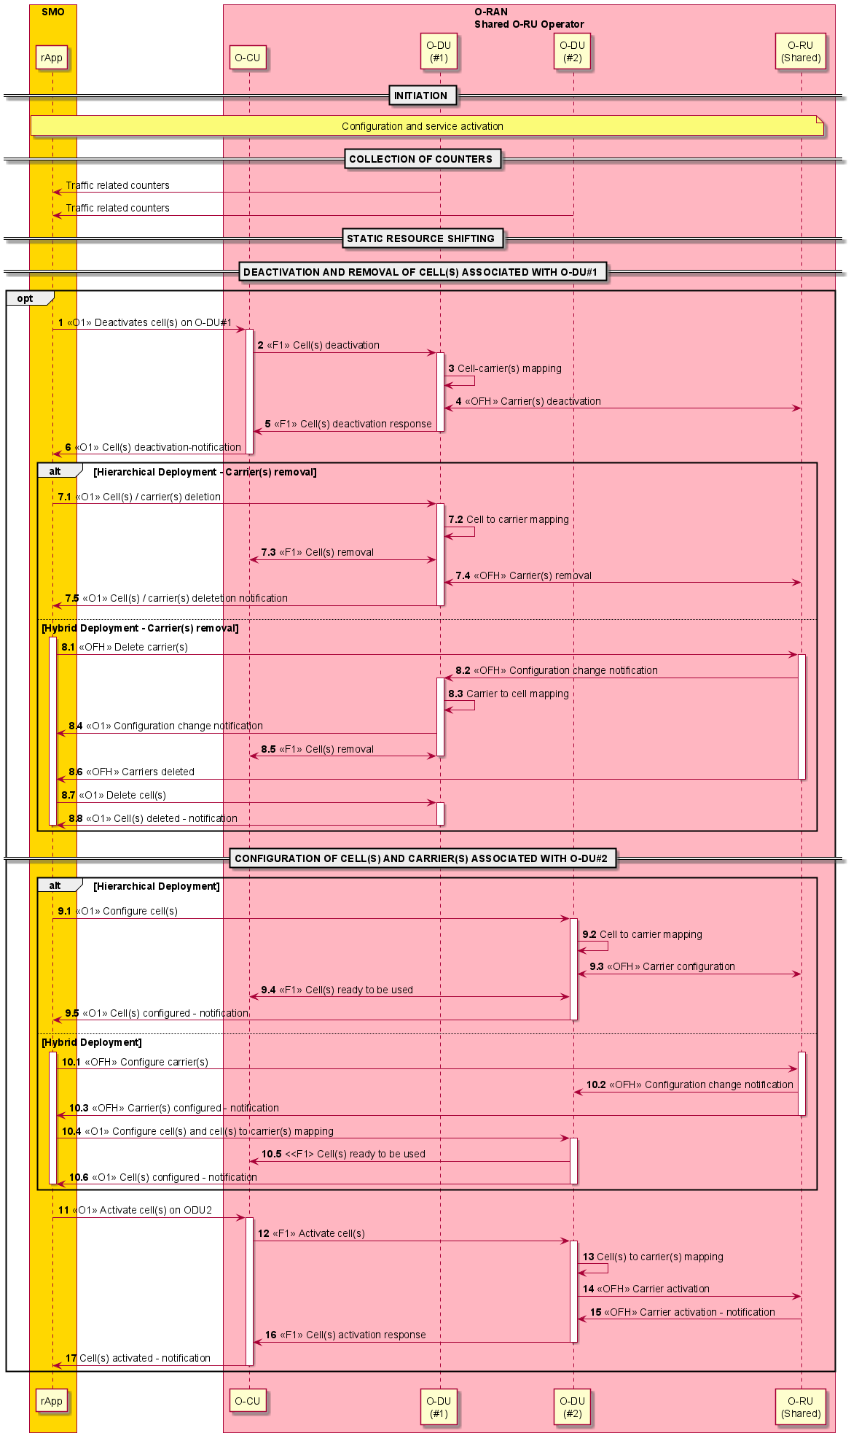
Figure 4.20.3.25-1: Static resource shifting sub-use case for Shared O-RU

4.20.4 Required data

4.20.4.1 Required data for all Shared O-RU use cases
The following required data is relevant to the following sub-use cases: resource partitioning, start-up, configuration, supervision, performance management, ALD control, antenna calibration, rehoming, and shutdown:
- Inventory system maintains inventory data for the Shared O-RUs because it needs to be able to identify Shared O-RUs.
- The resource partitioning rApp maintains carrier resource information because it needs to be able to partition the Shared O-RU carrier resources between different O-DU nodes.
- In hierarchical management mode, the configuration rApp maintains the active/standby state & status for O-DUs because needs to determine which O-DU is responsible for configuring the common aspects of a Shared O-RU.
- The supervision needs to include the O-DU identity because the Shared O-RU needs to be able to support supervision on a per O-DU basis.
- Alarm data needs to be kept at the Shared O-RU because the Shared O-RU needs to be able to terminate transmissions associated with an O-DU when it loses supervision with that O-DU and to continue to operate with other O-DUs. There will be a history of alarm data.
- Shared O-RU measurement counters and KPIs (as defined by O-RAN.WG4.MP [28]) shall be available on a per O-DU basis.
- O-DU needs to include its O-DU identity to enable supervision operation on a per O-DU basis.
- The ALD control rApp maintains data to keep track which O-DU is responsible for ALD controller functionality because it needs to be able to select which O-DU is responsible for ALD controller functionality.

4.20.4.2 Required data for Single-MNO configurations
The following data applies for single operator configurations when used by the other Shared O-RU sub-use cases:
- Non-RT RIC needs to be able to partition the Shared O-RU carriers between O-DU nodes operated by the same MNO.

4.20.4.3 Required data for Multi-MNO configurations
The following data applies for multi-operator configurations when used by the other Shared O-RU sub-use cases:
- The resource partitioning rApp needs to be able to partition the Shared O-RU carrier resources between different O-DU nodes of different MNOs.
- Shared O-RU needs to be able to associate management accounts with an MNO.
- The Shared O-RU needs to be able to implement role-based access control on a per-MNO basis.
- The Shared O-RU needs to associate carrier resources with MNOs.
- Measurement counters and KPIs (as defined by O-RAN WG4) need to be available on a per MNO basis.
- Tenant SMO needs to be able to support common Shared O-RU configuration defined by host operator.

4.20.4.4 Required data for resiliency use cases
The following data is used by the resiliency use case:
- The supervision needs to include the O-DU identity because the Shared O-RU needs to be able to support supervision on a per O-DU basis.
- Alarm data needs to be kept at the Shared O-RU because the Shared O-RU needs to be able to terminate transmissions associated with an O-DU when it loses supervision with that O-DU and to continue to operate with other O-DUs. There will be a history of alarm data.
- The configuration data from the active O-DU is passed to the standby O-DU.
- The configuration information of carriers of the standby O-DU are configured for the O-RU.
- The management system has the state & status data regarding which O-DU is and shall be active.
- The management system has the state & status data regarding which O-DUs are and shall be standby.
- The management system has the alarm history and alarm information for the Shared O-RU.
NOTE: There are many different situations and variations of the resiliency sub-use cases. Some of them need not require all the above data.

4.20.4.5 Required data for Shared O-RU management during O-DU SW update sub-use case for Shared O-RU
The following data is used by SW update of O-DU and associated Shared O-RU provisioning:
- The configuration data for provisioning the SW updated O-DU based on the change management plan for SW update.
- The configuration information of carriers of the SW updated O-DU configured on the Shared O-RU.
- The management system has state and status details of O-DUs to identify the right candidate to be used for SW update.
- The management system has state and status details of SW updated O-DU to verify the status and health of the SW update.
- The management system has the alarm history and alarm data of the Shared O-RU to verify functionality and sanity of the SW updated O-DU.
- Non-RT RIC needs to be able to partition the Shared O-RU carriers between SW updated O-DU and other O-DU nodes operated by the same MNO.
- Alarm data and performance data needs to be kept at Shared O-RU to verify the sanity of O-DU SW update
- O-DU SW change management rApp maintains the change management plan data for O-DU SW update to initiate & supervise the SW update process and to validate the sanity of the deployment against the plan.
- Historical configuration and software details of the O-DU is maintained for SW update so that the mitigation step of the SW update can bring the O-DU to the situation before SW update.

4.20.4.6 Required data for Shared O-RU - Dynamic resource shifting
The following data is used to perform dynamic resource shifting:
- The resource partitioning xApp maintains cell resource information because it needs to be able to partition frequency resources between different O-DU nodes.
- O-DU measurement counters and KPIs related to served traffic shall be available for Near-RT RIC on a per O-DU basis.
- Near-RT RIC needs to be able to dynamically update list of allowed bandwidth parts per O-DU nodes in a way so that each O-DU exclusively uses subset of shared bandwidth.
- The configuration information of cells served by O-DUs needs to be known to Near-RT RIC.

4.20.4.7 Required data for Shared O-RU - Static resource shifting
The following data is used to perform static resource shifting:
- The resource optimization rApp may maintain cell resource information because it needs to be able to reallocate the cell and associated carrier frequency resources between different O-DU nodes.
- O-DU measurement counters shall be available for SMO (Non-RT RIC) on a per O-DU and per cell basis via O1 interface.
- The configuration information of cell(s) served by O-DUs needs to be known to SMO (Non-RT RIC).

4.21 Network energy saving
This clause provides the motivations, descriptions, and proposed solutions for different energy efficiency and energy saving features (sub-use cases). While there are energy savings by improving base station hardware efficiency and by the evolution of radio access technologies, the EE/ES use case primarily addresses enhancements in software efficiency and optimized configuration/control of various elements and functions, which are often AI/ML based.

4.21.1 Background and goal of the use case
The RAN is responsible for a major part of the Energy Consumption (EC) of a mobile network, and the O-RU accounts for the largest part of the energy consumption of the RAN. The rarefication of fossil fuel-based energy resources and the urgent need to reduce CO₂ emissions make the EC a strategic topic for network operators, in addition to being a significant component of the operators’ OPEX.
EC can be reduced by improving the Energy Efficiency (EE) of the network, and by introducing different Energy Saving (ES) mechanisms. Several ES mechanisms are related to switching off certain components in the network and differ from one another by their scope, time scale and network area. Applicable ES methods are for instance strongly load dependent. Optimization efficiency might be further improved by AI/ML based configuration thereof.
RAN functions related to network energy saving solutions have been studied in 3GPP RAN3 in Rel.17 as part of the Study on Enhancement for Data Collection for NR and EN-DC. The outcome is documented in 3GPP TR 37.817 [i.2]. 3GPP RAN2 and RAN3 might specify enhancements for the Minimization of Drive Tests (MDT) procedures and/or signaling procedures that rely on Xn signaling in Rel.18. While 3GPP RAN WGs work on solutions with ML model inference within the gNB, O-RAN specifies solutions that benefit from ML model inference in the Near-RT or Non-RT RIC (e.g., optimizing the network in larger service areas). For EE related network management, use cases, requirements and solutions are specified in 3GPP TS 28.310 [43]. Furthermore, EC measurements and KPIs for 5G networks, network functions, NG-RAN and gNBs such as energy efficiency and energy consumption KPIs and performance measurements are specified in 3GPP TS 28.554 [7]. Centralized and distributed ES management functions are specified in 3GPP TS 28.541 [5]. 3GPP TS 28.310 [43] specified the framework on how the operator may configure the energy source and supply information (external power source information) with the information obtained from sources external to 3GPP e.g., energy supplier.
EE can be considered for the whole network (i.e., end-to-end), for a sub-network or per single network element. Within a network element it could be applicable per specific radio resource management mechanism or per radio or transport network link. Network wise EE is defined as the ratio between the data volume delivered in the network and the network EC observed during the time-period required to deliver such data, with possible adaptations to account for different deployment scenarios and load situations (ETS ES 203 228 [i.5], 3GPP TR 38.913 [i.4]). 3GPP has launched a study item within Rel-18 (RP-213554: “Study on network energy saving for NR”) that will include among others, an evaluation methodology and KPIs for EC and ES gains and their impact on network and UE performance and EE. To assess EE and ES associated to radio resource management mechanisms and links, appropriate KPIs are necessary.
In a timescale of minutes, hours and above, and when the cell load is low, ES can be achieved by switching off one or more carriers or the cell. In a timescale from seconds to minutes, ES can be achieved by switching off RF channels (including possibly antennas) of a massive MIMO system. Tx and Rx parts might be switched independently. In a very short time scale corresponding to a symbol, subframe or frame, Advanced Sleep Modes (ASM) can be considered. RF channel on/off switching can be used at medium load and ASM might be usable even at high load. Lastly, ES solutions can be applied to the O-Cloud, namely to the O-CU and O-DU, and can cover mechanisms such as scale in/out processes, workload placement or hardware processors’ sleep modes etc. AI/ML is useful for all the above mechanisms with the important role of determining the switch off/on time that maximizes ES gain.
RF channel switch off/on (also known as RF channel reconfiguration) enables the dynamic, policy-driven activation/deactivation of a subset of RF/antenna resources in the O-RU, allowing: 1. Major reduction in power consumption and 2. Near-instantaneous restoration (wakeup) of all RF chains if demand rises or coverage is threatened. Modern O-RUs and massive MIMO radios are built with a high number of TRX (transceiver) chains and associated digital processing. In periods of low load (night/off-peak, rural/edge cells, etc.), a significant portion of these resources are underutilized, but still consume most of the energy of a fully active radio.
Advanced Sleep Mode feature is expected to reduce O-RU power consumption by partially switching off certain components. The impact of ASM on O-DU and O-CU energy consumption is not specified in the current document. Using multi-dimensional data—such as traffic load, user service type, and energy efficiency measurements—the SMO and/or Near-RT RIC can configure cell parameters, including SSB periodicity, to enable and optimize sleep mode operations.
Furthermore, the energy source and supply information may be used as an input data for SMO framework. This framework, leveraging a Non-RT RIC platform with rApps, may use the energy source and supply information to analyze and prepare policy and/or configuration changes to activate the appropriate energy saving methods in the O-RU, thereby minimizing power consumption.
In addition to the above-mentioned energy saving methods, the O-RU energy saving could be achieved by optimizing its Power Amplifier (PA) operating region according to the traffic scheduling requirements, to reduce the O-RU power consumption. To facilitate this, the SMO framework analyses various network data and KPIs to prepare policy or configuration changes for the O-DU. The O-DU then evaluates the conditions specified in the policies or applies the configuration changes provided by the SMO. When those conditions are satisfied or based on requested configuration changes, the O-DU configures the maximum output power of the O-RU via fronthaul M-plane or C-plane interface. The O-RU subsequently optimizes its power amplifier parameters according to the configured maximum output power. This could result in a reduction of PA power consumption, thereby achieving energy saving in O-RU and enhance the overall energy efficiency of the O-RAN network.

4.21.2 Entities/resources involved in the use case
Editor’s note: If possible, single common description for all sub-use cases.
The following is an exhaustive list of entities across all the identified solutions for this use case. All the entities may not be applicable for every solution.
- Energy saving rApp:
- Collect configurations, performance indicators and measurement reports (e.g., cell load related information and traffic information, EE/EC measurement reports, geolocation information, and energy source and supply information configured by either operator or available through SMO or exposed via O-RAN networks) from Non-RT RIC/SMO framework.
- Utilize the collected data for EE/ES optimization (e.g., if carriers or cells need to be switched off/on), and initiate O1 configuration updates, A1 policy updates, and/or open FH M-plane configuration updates through R1 interface.
- Non-RT RIC/SMO framework:
- Collect configurations, performance indicators, measurement reports, and energy source and supply information from network functions via O1 and optionally via open FH M-plane from O-RUs and provide this information to energy saving rApp.
- Determine and signal updated configuration or policy for network energy saving use case (provided by energy saving rApp) to E2 nodes, and/or Near-RT RIC, and optionally O-RU.
- NF node:
- Report cell configuration, performance indicators and measurement reports (e.g., cell load related information and traffic information, EE/EC measurement reports).
- Perform actions required for EE/ES optimization per the configuration updates or policies received from Non-RT RIC/rApp and/or Near-RT RIC/xApp.
- O-RU node:
- Report EC and EE related information.
- Perform actions required to perform EE/ES optimization per the configuration updates received from the O-DU or SMO depending on the hierarchical or hybrid deployment.
- Receives the energy source and supply information from energy supplier in an operator specific implementation and forward the same to SMO through O-DU, if the O-RU is provisioned to support the external power source information exposure.
- Near-RT RIC:
- Collect configurations, performance indicators and measurement reports (e.g., cell load related information and traffic information, EE/EC measurement reports) from E2 nodes.
- Receive EE/ES related policies via A1 interface for consideration during optimization.
- Determine and signal updated configuration or policy for network energy saving use case to E2 nodes.
- Receive external power source information for the O-RU/NF node via O1/SMO.
- Energy supplier control panel (external enrichment provider):
- This is the external power source entity that manages the various energy sources such as grid power supply, battery back-up, generator, and renewable energy sources such as solar power, windmill, etc.
- Collect the energy source and supply information and expose them to operator in vendor specific implementation.
- Switch the energy source from one to another, for example, switch the energy source from grid supply to solar power or generator power or battery back-up.
- Operator:
- A telecom operator who collects the energy source and supply information from energy supplier control panel in a vendor specific deployment and implementation.
- Configure the energy source and supply information to SMO framework in a vendor specific implementation as described in clauses 5.1.6 and 8 of 3GPP TS 28.310 [43].

4.21.3 Solutions
Editor’s note: Sub-use case specific solutions with detailed descriptions in fully separate clauses.

4.21.3.1 Carrier and cell switch off/on
Mobile networks often utilize multiple frequency layers (carriers) to cover the same service area. At low load, ES can be achieved by switching off one or more carriers or entire cells without impairing the network performance. The switch off/on decision can be made by an AI/ML model, deployed in Non-RT RIC/SMO (including option for deployment in an rApp) or at Near-RT RIC. Among others, the AI/ML models' functionality can include prediction of future traffic, user mobility, and resource usage and can also predict expected energy efficiency enhancements, resource usage, and network performance for different ES optimization states. Before switching off/on carrier(s) or cell(s), the E2 node can perform some preparation actions for off switching (e.g., to enable, disable, modify carrier aggregation and/or dual connectivity, to trigger HO traffic and UEs from cells/carriers to other cells or carriers, informing neighboring nodes via X2/Xn interface etc.) as well as for on switching (e.g., cell probing, informing neighboring nodes via X2/Xn interface etc.).

4.21.3.1.1 Solution 1: rApp-based solution (O1-based)
The following entities are applicable to this solution: Energy saving rApp, Non-RT RIC/SMO framework, E2 node(s) and O-RU node(s).
A solution for carrier and cell switch off/on: use case through rApp-based solution is captured in table 4.21.3.1.1-1.
Table 4.21.3.1.1-1: Carrier and cell switch off/on: AI/ML inference via Non-RT RIC
Use Case Stage | Evolution / Specification | <<Uses>>  Related use
Goal | Enable carrier and cell switch off/on energy saving functions in the network by means of configuration parameter change and actions controlled by Non-RT RIC and allow for AI/ML-based solutions.
Actors and Roles | - Energy saving rApp  - Non-RT RIC/SMO framework  - E2 node(s)  - O-RU node(s)
Assumptions | O1 interface connectivity is established towards E2 nodes, Non-RT RIC and SMO.  Open FH M-plane interface is established between E2 node and O-RU and/or SMO and O-RU directly.  Network is operational.
Pre-conditions | Operator has set the targets for energy saving functions in the Non-RT RIC.
Begins when | Operator enables the optimization functions for carrier and cell switch off/on energy saving functions and E2 node and O-RU become operational.
Step 1 (M) | SMO initiates specific measurement data collection request towards E2 node and O-RU.
Step 2 (M) | E2 node and O-RU send the configured measurement data to SMO periodically or event based.
Step 3 (M) | Energy saving rApp retrieves the collected measurement data for processing.
Step 4 (M) | Energy saving rApp constantly monitors  - performance and energy consumption of the E2 node(s)  - energy consumption of O-RU(s)  - cell utilization and throughput metrics  rApp determines configuration changes for carrier(s) and cell(s) switch off/on use case. AI/ML inference may be used to make the decision.
Step 5 (M) | Energy saving rApp requests Non-RT RIC/SMO framework to make configuration changes to E2 node(s) and O-RU(s).
Step 6 (M) | SMO instructs E2 node via O1 interface to apply the received request(s) for configuration changes from the rApp. O-RU is informed about the updated O-RU configuration via open FH M-plane interface either by E2 node, or by SMO directly. E2 node / O-RU notify SMO once cell or carrier switch off/on is completed.
Step 7 (M) | Energy saving rApp continuously analyzes energy saving objectives and if energy saving objectives are not achieved, it can decide to initiate fallback mechanism, for example, reverting changes over O1 interface for carrier and cell switch off/on optimization.
Ends when | E2 node becomes non-operational or when the operator disables the optimization functions for energy saving.
Exceptions | None.
Post Conditions | Non-RT RIC continues close loop monitoring of energy saving function at E2 node and O-RU.  E2 node(s) and O-RU(s) operate using the configuration provided by the energy saving rapp via Non-RT RIC/SMO framework.

@startuml
Skin rose
skinparam defaultFontSize 12
autonumber

Box "Service Management & \n Orchestration Framework" #gold

Participant "Collection & Control" as SMO
Participant "Non-RT RIC" as NRTRIC

End box

Box "O-RAN Nodes" #lightpink
Participant "Near-RT RIC" as RTRIC
Participant "E2-Nodes" as E2NODES
Participant "O-RUs" as ORUs
End box

group Data Collection
autonumber 1.1
SMO -> E2NODES : <<O1>> Data collection request for Energy Saving
E2NODES -> ORUs : <<FH>> Data collection request for Energy Saving

autonumber 2.1
ORUs -> E2NODES : <<FH>> Measurement Data Collection for Energy Saving
E2NODES -> SMO : <<O1>> Measurement Data Collection for Energy Saving
autonumber 3
SMO -> NRTRIC : Data retrieval

end

group Data Analysis Training and Inference
autonumber 4.1

NRTRIC -> NRTRIC : Performance and Energy Consumption Monitoring \n(E2 Node(s) & O-RU(s))
NRTRIC -> NRTRIC : AI/ML Model training and inference

end

autonumber 5
group Actor Decision Making
NRTRIC -> SMO : Request to prepare and execute \nfor carrier(s) and cell(s) switch off/on

autonumber 6.1

alt via O1
SMO <-> E2NODES : <<O1>> E2-Node parameter configurations and actions for carrier(s) and cell(s) switch off/on \npreparation & execution and notification of execution.
E2NODES <-> ORUs : <<FH>> Update O-RU Configurations \nand notification of update

else via OFH-MP
SMO <-> E2NODES : <<O1>> E2-Node parameter configurations and actions for carrier(s) and cell(s) switch off/on \npreparation & execution \nand notification of execution.
SMO <-> ORUs: <<OFH-MP>> Update O-RU Parameters configuration and notification of update

end
autonumber 7

NRTRIC -> NRTRIC : Performance analysis of AI/ML model \n(with possible actions, e.g. fallback, re-training)
end

@enduml

The flow diagram of the carrier and cell switch off/on using O1-based solution is given in figure 4.21.3.1.1-1.

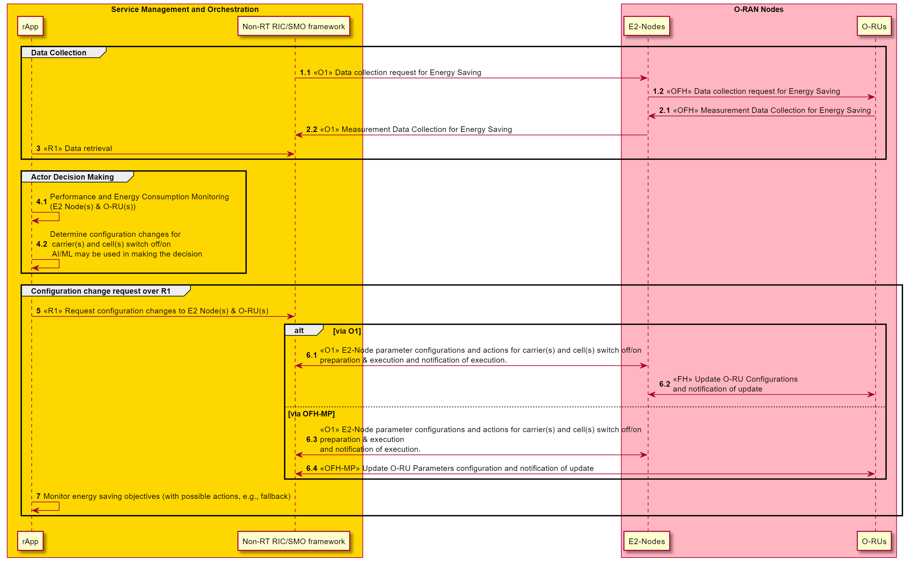
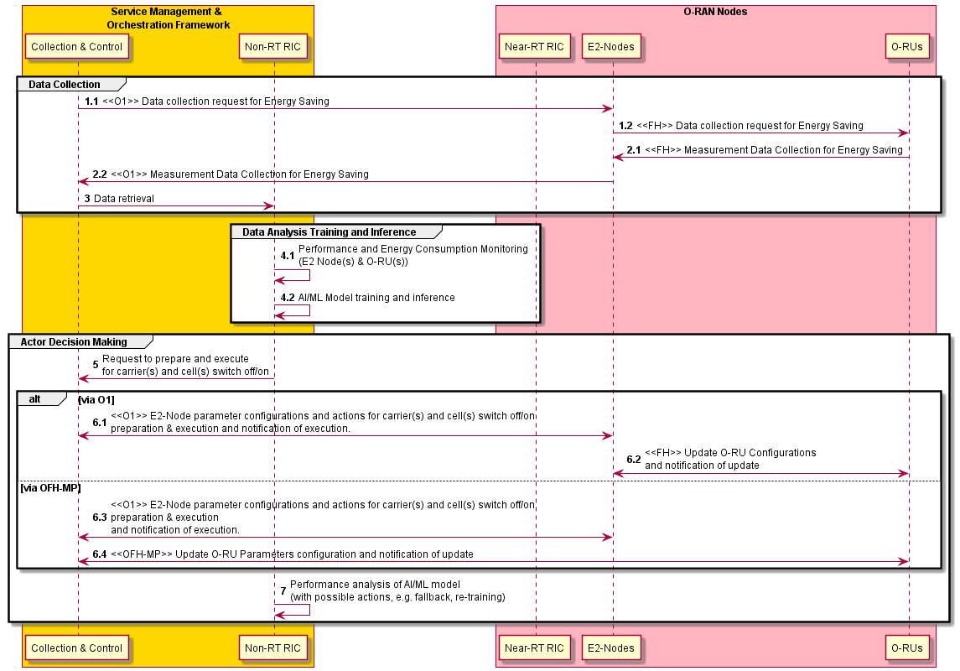
Figure 4.21.3.1.1-1: Carrier and cell switch off/on flow diagram: AI/ML inference via Non-RT RIC

4.21.3.1.2 Solution 2: rApp and xApp-based solution (A1 and E2-based)
The following entites are applicable to this solution: Energy saving rApp, Non-RT RIC/SMO framework, Near-RT RIC, E2 node and O-RU node.
A solution for carrier and cell switch off/on through rApp and xApp-based solution is captured in table 4.21.3.1.2-1.
Table 4.21.3.1.2-1: Carrier and cell switch off/on: AI/ML inference via Near-RT RIC
Use Case Stage | Evolution / Specification | <<Uses>>  Related use
Goal | Enable carrier and cell switch off/on energy saving functions in the network by means of configuration parameter change and actions controlled by Near-RT RIC and allow for AI/ML-based solutions.
Actors and Roles | - Energy saving rApp  - Non-RT RIC/SMO framework  - Near-RT RIC  - E2 node(s)  - O-RU node(s)
Assumptions | O1 interface connecting the SMO with E2 node and Near-RT RIC is established.  E2 interface connectivity is established between E2 node and Near-RT RIC.  A1 interface is established between Non-RT RIC and Near-RT RIC. Open FH M-plane interface is established between E2 node(s) and O-RU(s).  Network is operational.
Pre-conditions | Operator has set the targets for energy saving function in the Non-RT RIC.
Begins when | Operator enables the optimization functions for carrier and cell switch off/on energy saving functions and E2 node and O-RU become operational.
Step 1 (M) | SMO initiates specific measurement data collection request towards E2 node and O-RU.
Step 2 (M) | E2 node and O-RU send the configured measurement data to SMO periodically or event based.
Step 3 (M) | Energy saving rApp retrieves the collected measurement data for processing
Step 4 (M) | Energy saving rApp constantly monitors  - performance and energy consumption of the E2 node(s)  - energy consumption of O-RU(s)  Energy saving rApp determines A1 policy for carrier(s) and cell(s) switch off/on use case. AI/ML model inference may be used to make the decision.
Step 5 (M) | rApp requests A1 policy function to create or update A1 policy for energy saving.  A1 policy function requests Near-RT RIC to create or update A1 policy for energy saving.
Step 6 (M) | Near-RT RIC constantly monitors  - performance and energy consumption of the E2 node(s)  - energy consumption of O-RU(s)  Based on the optional AI/ML inference, and considering A1 policies, the Near-RT RIC can request the E2 node to prepare and execute cell or carrier switch off/on. E2 node can request O-RU node to prepare and execute cell or carrier switch off/on. E2 node will notify Near-RT RIC once cell or carrier switch off/on is completed.
Step 7 (M) | Non-RT RIC/rApp and/or Near-RT RIC/xApp monitor energy saving objectives (with possible actions, e.g., update of A1 policy, fallback).
Ends when | E2 node becomes non-operational or when the operator disables the optimization functions for energy saving.
Exceptions | None.
Post Conditions | E2 node and O-RU operate using configuration provided by the Near-RT RIC over E2 interface.

@startuml
skin rose
skinparam defaultFontSize 12
autonumber

Box "Service Management & \n Orchestration Framework" #gold

Participant "Collection & Control" as SMO
Participant "Non-RT RIC" as NRTRIC

End box

Box "O-RAN Nodes" #lightpink
Participant "Near-RT RIC" as RTRIC
Participant "E2-Nodes" as E2NODES
Participant "O-RUs" as ORUs
End box

group Data Collection
autonumber 1.1
SMO -> E2NODES : <<O1>> Data collection request for Energy Saving
E2NODES -> ORUs : <<FH>> Data collection request for Energy Saving

autonumber 2.1
ORUs -> E2NODES : <<FH>> Measurement Data Collection for Energy Saving
E2NODES -> SMO : <<O1>> Measurement Data Collection for Energy Saving
autonumber 3
SMO -> NRTRIC : Data retrieval

end

autonumber 4.1
group AI/ML workflow

NRTRIC -> NRTRIC : AI/ML Model training
NRTRIC -> RTRIC : <<O1>> or <<O2>> Deploy AI/ML model

end

autonumber 5.1
group Optimization Trigger and Policy
alt
SMO -> RTRIC : <<O1>> Optimization Trigger/Target
else
NRTRIC -> RTRIC : <<A1>> Intent based Policy
end
end

autonumber 6.1
group Actor Data Collection & Decision Making
RTRIC -> E2NODES : <<E2>> Data collection request for Energy Saving
E2NODES -> ORUs : <<FH>> Data collection request for Energy Saving
ORUs -> E2NODES : <<FH>> Measurement Data Collection for Energy Saving
E2NODES -> RTRIC : <<E2>> Measurement Data Collection for Energy Saving

RTRIC -> RTRIC: AI/ML model inference
RTRIC <-> E2NODES : <<E2>> E2-Node parameters configuration and actions \nfor carrier(s) and cell(s) switch off/on preparation & execution \n and notication of execution
E2NODES <-> ORUs: <<FH>> Update O-RU configurations \nand notification of update

end
@enduml

The flow diagram of the carrier and cell switch off/on using A1 and E2-based solution is given in figure 4.21.3.1.2-1.

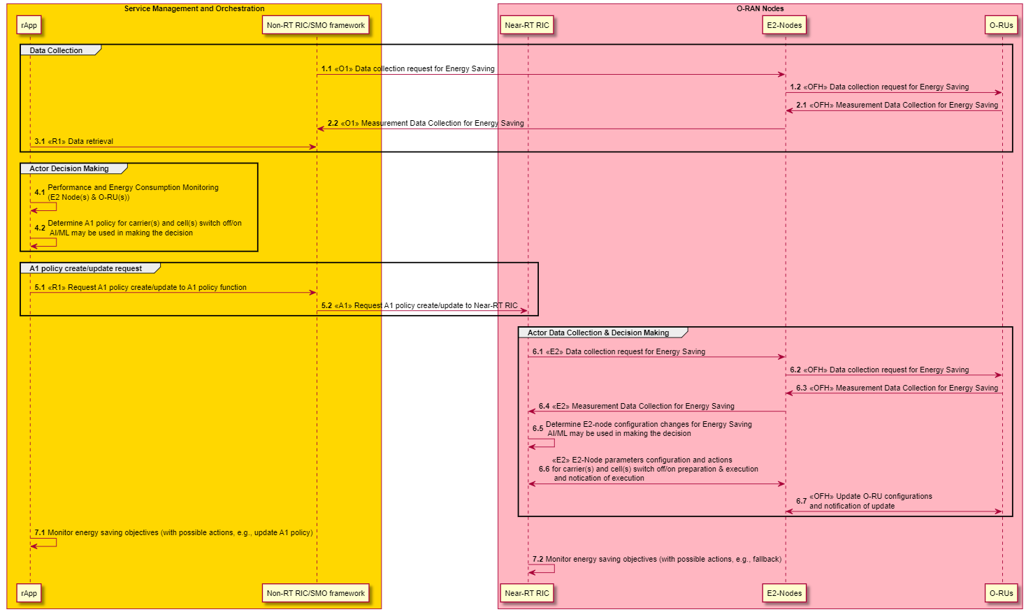
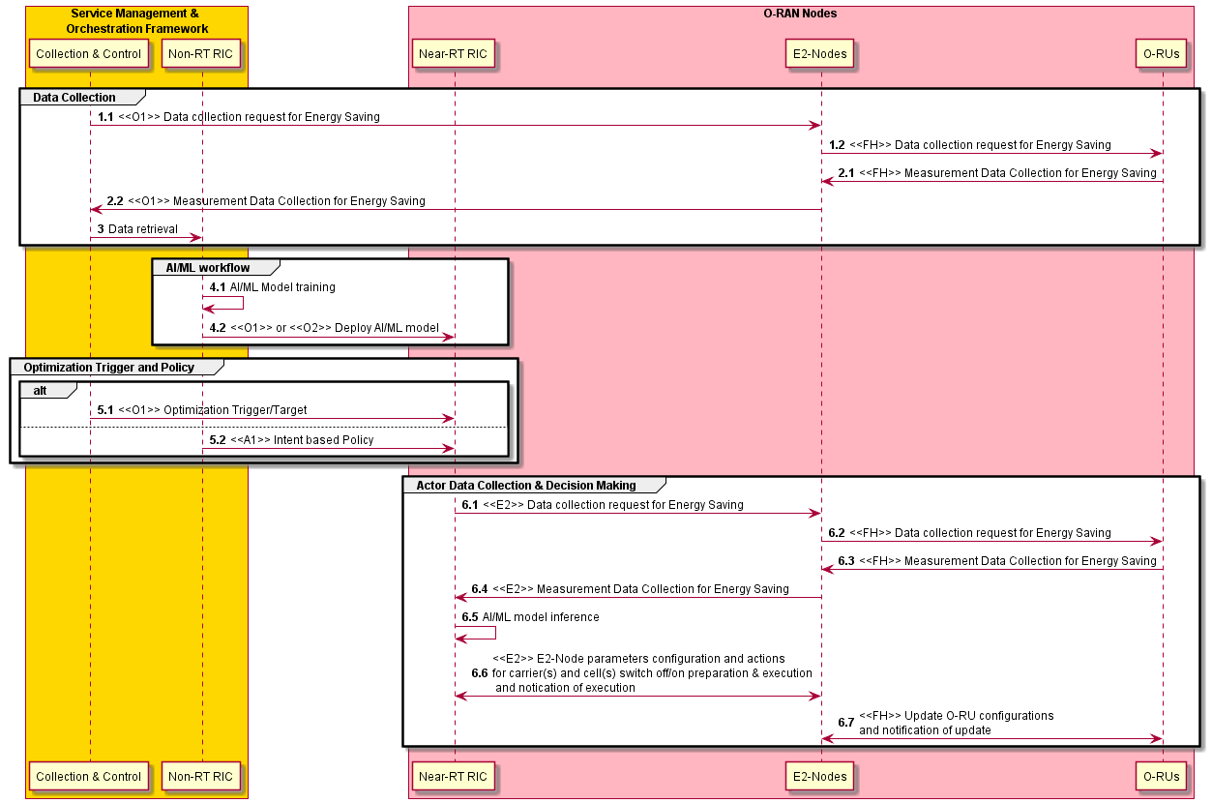
Figure 4.21.3.1.2-1: Carrier and cell switch off/on flow diagram: AI/ML inference via Near-RT RIC

4.21.3.2 RF channel reconfiguration for network energy savings
This feature aims at reducing power consumption of O-RU by reconfiguring the RF channels [27], [28]. Using AI/ML assisted solutions, rApp or xApp will trigger RF channels parameters reconfiguration, based on traffic information such as load, user location and mobility. As example, one can switch off 32 out of 64 RF channels in digital massive MIMO architecture or reduce the number of layers and/or number of multi-user scheduled UEs in a hybrid architecture. The O-RU reconfiguration can be performed using the open fronthaul M-plane from E2 node or SMO.
RF channel reconfiguration can be triggered or orchestrated by:
i. Solution: rApp-based solution (O1-based or open fronthaul M-plane control, where hybrid architecture based deployment is supported) [27]
ii. Solution: rApp/xApp-based solution (E2-based) (clause 4.6.3 of [46])

4.21.3.2.1 Solution: rApp-based solution
The following entities are applicable to this solution: energy saving rApp, Non-RT RIC/SMO, E2 node(s) and O-RU node(s).
A solution for RF channel reconfiguration-based energy saving, implemented as a use case through an rApp-based approach, is captured in table 4.21.3.2.1-1.
Table 4.21.3.2.1-1 RF channel reconfiguration: rApp-based solution
Use Case Stage | Evolution / Specification | <<Uses>>  Related use
Goal | Enable RF channel reconfiguration energy saving functions in the network by means of configuration parameter change and actions controlled by an energy Saving rApp.
Actors and Roles | - Energy saving rApp  - Non-RT RIC/SMO  - E2 node(s)  - O-RU node(s)
Assumptions | - O1 interface connectivity is established between E2 node(s) and SMO.  - Open fronthaul M-plane interface is established between O-DU and O-RU and/or SMO and O-RU directly.  - Network is operational.
Pre-conditions | Operator has set the targets for RF channel reconfiguration energy saving in the Non-RT RIC. E2 node and O-RU are operational.
Begins when | Operator enables RF channel reconfiguration energy saving functions.
Step 1 (M) | Energy saving rApp requests to collect necessary CM, PM and FM data towards SMO/Non-RT RIC function over R1 interface.
Step 2 (M) | SMO/Non-RT RIC function requests data collection, including RF channel reconfiguration (TRx control) related capabilities of the E2 node(s) and O-RU(s) over O1 interface and/or open fronthaul M-plane. | O-RAN.WG4.MP [28], clauses 20.3.1.2 and 20.3.2.2;  O-RAN.WG10.OAM-Architecture [27], clause 4.2.5.1
Step 3 (M) | E2 node(s) send the O-DU and O-RU RF channel reconfiguration related capabilities, configuration data, and configured measurement data to SMO/Non-RT RIC over O1 interface periodically or event based.
Step 4 (M) | rApp collects the configuration data, collected measurement data for processing.
Step 5 (M) | Energy saving rApp constantly monitors  - performance and energy consumption of the E2 node(s)  - energy consumption of O-RU(s)  - cell utilization and throughput metrics  rApp determines configuration changes for RF channel reconfiguration use case. AI/ML inference may be used to make the decision.
Step 6a (Alt) | SMO/Non-RT RIC will provide the policy to E2 node via O1 interface for RF channel reconfiguration (TRx control) in the specific O-RU. | O-RAN.WG10.OAM-Architecture [27], clauses 4.2.5.1 and 5.2.1
Step 6b (Alt) | SMO/Non-RT RIC will provide configuration changes to the E2 node via O1 interface to activate the RF channel reconfiguration (TRx control) feature in the specific O-RU. | O-RAN.WG10.OAM-Architecture [27], clauses 4.2.5.1 and 5.2.1
Step 7 (M) | E2 node analyzes the conditions mentioned in the policy or configuration changes and decides to activate the RF channel reconfiguration (TRx control) feature in the specific O-RU. | O-RAN.WG10.OAM-Architecture [27], clause 4.2.5.1
Step 8 (M) | E2 node sends appropriate commands to the O-RU via open fronthaul M-plane or C-plane to configure (activate) RF channel reconfiguration (TRx control) feature to the specific O-RU, i.e., O-DU configures a specific antenna mask on O-RU. | O-RAN.WG4.MP [28], clause 20.3.2.3;  O-RAN.WG4.TS.CUS.0-R004 [51], clauses 7.4.6, 16, 16.1, and 16.2
Step 9 (M) | O-RU adjusts its antenna array configuration(s) based on the E2 node provided configuration. Then the O-RU transitions to RF channel switch off/on (TRx control) based energy saving mode.
Step 10 (O) | SMO/Non-RT RIC may provide configuration changes to the E2 node via O1 interface to deactivate the RF channel reconfiguration (TRx control) feature in the specific O-RU. | O-RAN.WG10.OAM-Architecture [27], clauses 4.2.5.1 and 5.2.1
Step 11 (M) | E2 node analyzes the policy provided by SMO in Step 6a or configuration changes requested by Non-RT RIC/SMO in Step 10. Then the E2 node decides to deactivate the RF channel reconfiguration (TRx control) feature in the specific O-RU. | O-RAN.WG10.OAM-Architecture [27], clause 4.2.5.1
Step 12 (M) | E2 node sends the appropriate commands to the O-RU via open fronthaul M-plane or C-plane to configure the default antenna array configuration. This is to deactivate the RF channel reconfiguration (TRx control) feature in the O-RU. | O-RAN.WG4.MP [28], clause 20.3.2.3;  O-RAN.WG4.TS.CUS.0-R004 [51], clauses 7.4.6, 16, 16.1, and 16.2
Step 13 (M) | The O-RU adjusts its antenna array configuration and exits from the energy saving mode.
Ends when | - Load or coverage changes, or policy expires/aborts.  - E2 node and O-RU nodes become non-operational or when the operator disables the optimization functions for energy saving or when optimization criteria are no longer met.
Exceptions | O-RU/E2 node reports failure or resource is ineligible (e.g., all SSB/PRACH beams masked).
Post Conditions | - O-RU is restored to full RF channels off.  - SMO logs energy gain and status.  - Non-RT RIC continues closed loop monitoring of energy saving function at E2 node and O-RU.  - O-DU(s) and O-RU(s) operate using the configuration provided by the energy saving rApp via Non-RT RIC/SMO.

@startuml
!pragma teoz true

' ==== Styling ====
skinparam sequenceArrowThickness 2
skinparam ParticipantPadding 5
skinparam BoxPadding 10
skinparam defaultFontSize 14
skinparam sequenceMessageAlign center
skinparam NoteBackgroundColor #fff9e6
skinparam NoteBorderColor #d1b77a
skinparam BoxBorderColor #888
skinparam BoxBackgroundColor #f7f7f7

title RF channel reconfiguration based energy saving - rApp-based solution

Skin rose

' ==== Context & Roles ====
box "Operator" #Lightblue
Actor Host as host
End box

box "Service Orchestration and Management Framework" #gold
participant "Energy Saving rApp" as rApp
participant "SMO / Non‑RT RIC" as smo
end box

box “O-RAN Nodes” #lightpink
participant "E2 node(s)\n(e.g., O‑DU)" as e2
participant "O‑RU node(s)" as ru
end box

' ==== Step 1 (M) ====
rApp -> smo : <B>1</B> <<R1>> — Request CM/PM/FM data collection

' ==== Step 2 & 3 (M) ====
note over smo, ru
<B>2</B> <<O1>> Request data collection & O-DU and O-RU RF channel reconfiguration related capabilities
end note
smo <- e2 : <B>3</B> <<O1>> Deliver requested data & O-DU and O-RU \nRF channel reconfiguration related capabilities

' ==== Step 4 (M) ====
smo -> rApp : <B>4</B> <<R1>> Deliver collected configuration/measurement data

' ==== Step 5 (M) ====
Loop RF channel reconfiguration implementation
rApp -> rApp : <B>5</B> Continuous monitoring & inference
note right of rApp
Monitors:
(i) E2 node performance & energy consumption
(ii) O‑RU energy consumption
(iii) Cell utilization & throughput
Determines configuration changes for RF Channel Reconfiguration.
AI/ML inference may be used.
end note

' ==== Step 6a/6b (Alt) ====
alt Policy path
smo -> e2 : <B>6a</B> <<O1>> — Provide policy for RF Channel reconfiguration in specific O‑RU
else Direct configuration path
smo -> e2 : <B>6b</B> <<O1>> — Provide configuration to activate TRx control
end
' ==== Step 7 (M) ====
e2 -> e2 : <B>7</B> Analyze conditions/policy; decide to activate RF channel reconfiguration

' ==== Step 8 (M) ====
e2 -> ru : <B>8</B> <<OFH M‑/C‑Plane>> Configure (activate) TRx control\n(e.g., set antenna mask)

' ==== Step 9 (M) ====
ru <- ru : <B>9</B> Adjust antenna array; enter energy saving mode

' ==== Step 10 (O) — Optional deactivation request ====
opt Deactivation requested by SMO
smo -> e2 : <B>10</B> <<O1>> — Provide configuration to deactivate TRx control
' ==== Step 11 (M) ====
e2 -> e2 : <B>11</B> Evaluate (policy from 6a or request from 10);\ndecide to deactivate TRx control

' ==== Step 12 (M) ====
e2 -> ru : <B>12</B> <<OFH M‑/C‑Plane>> Configure default antenna array\n(to deactivate TRx control)
' ==== Step 13 (M) ====
ru <- ru : <B>13</B> Adjust antenna array; exit energy saving mode

deactivate rApp
end

end loop

@enduml

The flow diagram of the RF channel reconfiguration-based energy saving using rApp-based solution is given in figure 4.21.3.2.1-1.
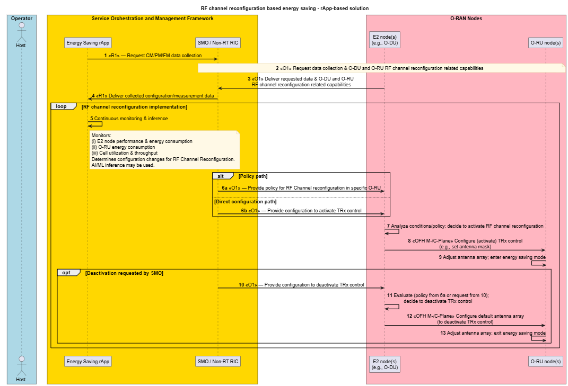
Figure 4.21.3.2.1-1: RF channel reconfiguration- based energy saving: rApp-based energy saving

4.21.3.2.2 Solution: rApp/xApp-based solution
The following entities are applicable to this solution: energy saving rApp/xApp, Near-RT RIC/SMO, E2 node and O-RU node.
A solution for RF channel reconfiguration-based energy saving implemented as a use case through an rApp/xApp-based approach, is documented in table 4.21.3.2.2-1.

Table 4.21.3.2.2-1: RF channel reconfiguration: rApp/xApp-based solution
Use Case Stage | Evolution / Specification | <<Uses>>  Related use
Goal | Enable RF channel reconfiguration energy saving functions in the network by means of configuration parameter change and actions controlled by Near-RT RIC and allow for AI/ML-based solutions.
Actors and Roles | - Energy saving xApp  - Near-RT RIC  - Non-RT RIC/SMO  - E2 node(s)  - O-RU node(s)
Assumptions | - A1 interface connectivity is established between Non-RT RIC of SMO and Near-RT RIC.  - E2 interface connectivity is established between network functions (O-DU) and Near-RT RIC.  - Open fronthaul M-plane interface is established between O-DU and O-RU and/or SMO and O-RU directly.  - SMO, Near-RT RIC, and O-DU aware of O-RU capabilities.  - Network is operational.
Pre-conditions | Operator has set the targets for energy saving in Near-RT RIC.
Begins when | Operator enables RF channel reconfiguration energy saving functions, and O-DU and O-RU become operational.
Alt  Step 1a (M) | SMO/Non-RT RIC consumes and analyzes the various measurement data like CM, PM, and FM data and KPIs or operator trigger (requested configuration changes). | Use case
Step 1b (M) | Non-RT RIC SMOF prepares A1 policy for Near-RT RIC (xApps) to optimize the RF channel reconfiguration of a specific O-RU. | O-RAN.WG2.TS.Use-Case-Requirements-R004 [50], clause 4.8.2.3.2;  Use case
Step 1c (M) | Non-RT RIC SMOF provides policy prepared in Step 1b, to Near-RT RIC via A1 interface. | O-RAN.WG2.TS.Use-Case-Requirements-R004 [50], clause 4.8.2.3.2;  Use case
Step 1d (M) | Energy saving xApp constantly monitors  - energy consumption of O-RU(s)  - cell utilization, throughput, and related performance metrics  Near-RT RIC analyzes the A1 policy that it received from Non-RT RIC in Step 1c and the above measurement data. The xApps of Near-RT RIC prepares the E2 policy or determines the configuration changes that need to be provided to O-DU, for RF channel reconfiguration use case. AI/ML inference may be used to make the decision.  The Near-RT RIC provides the E2 policy or configuration changes to O-DU for RF channel reconfiguration of a specific O-RU. | O-RAN.WG2.TS.Use-Case-Requirements-R004 [50], clause 4.8.2.3.2;  Use case
Alt  Step 2a (M) | Energy saving xApp constantly monitors  - energy consumption of O-RU(s)  - cell utilization, throughput, and related performance metrics  Near-RT RIC (xApp) analyzes the above measurement data and KPIs, and prepares the E2 policy or configuration changes for O-DU. | O-RAN.WG2.TS.Use-Case-Requirements-R004 [50], clause 4.8.2.3.2;  O-RAN.WG3.TS.UCR [46], clause 4.6.2;  Use case
Step 2b (M) | Near-RT RIC provides the policy or configuration changes (prepared in Step 2a) to O-DU via E2 interface. | O-RAN.WG3.TS.UCR [46], clause 4.6.3;  O-RAN.WG3.TS.E2SM-CCC [47], clause 8.8.2.6;  Use case
Step 3 (M) | O-DU analyzes the policy or configuration changes that it received either in Step 1d or 2b. Once the conditions mentioned in that policy are satisfied or based on the requested configuration changes, the O-DU decides to activate the RF channel reconfiguration feature in the O-RU. | Use case
Step 4 (M) | O-DU sends appropriate commands to the O-RU via fronthaul M-plane or C-plane to configure (activate) RF channel reconfiguration (TRx control) feature to the specific O-RU, i.e., O-DU configures a specific antenna mask on O-RU. | O-RAN.WG4.MP [28], clause 20.3.2.3;  O-RAN.WG4.TS.CUS.0-R004 [51], clauses 7.4.6, 16.1 and 16.2
Step 5 (M) | O-RU adjusts its antenna array configuration(s) based on the O-DU provided configuration. Then the O-RU transitions to RF channel reconfiguration (TRx control) based energy saving mode. | Use case
Step 6 (O) | Near-RT RIC analyses the O&M data and KPIs to prepare the policy or configuration changes required for O-DU to deactivate the RF channel reconfiguration (TRx control) feature and provide them to O-DU via E2 interface. | O-RAN.WG3.TS.UCR [46], clause 4.6.3;  O-RAN.WG3.TS.E2SM-CCC [47], clause 8.8.2.6;  Use case
Step 7 (M) | O-DU analyzes the policy provided by Near-RT RIC in Steps 1d or 2b or configuration changes provided by Near-RT RIC in Step 6. Then the O-DU decides to deactivate the RF channel reconfiguration (TRx control) feature in the specific O-RU. | Use case
Step 8 (M) | O-DU sends the appropriate commands to the O-RU via fronthaul M-plane or C-plane to configure the default antenna array configuration. This is to deactivate the RF channel reconfiguration (TRx control) feature in the O-RU. | O-RAN.WG4.MP [28], clause 20.3.2.3;  O-RAN.WG4.TS.CUS.0-R004 [51], clauses 7.4.6, 16.1 and 16.2
Step 9 (M) | The O-RU adjusts its antenna array configuration and exits from the energy saving mode. | Use case
Ends when | NF node (O-DU) and O-RU become non-operational or when the operator disables energy saving or when optimization criteria are no longer met.  Change in traffic or coverage.  The policy expires/aborts.
Exceptions | O-RU/O-DU reports failure or resource is ineligible (e.g., all SSB/PRACH beams masked); xApp must retry or rollback.
Post Conditions | O-RU is restored to default antenna array configuration.  SMO monitors the energy consumption status.  Near-RT RIC continues close loop monitoring of energy saving function at NF node (O-DU) and O-RU.  NF node(s) and O-RU(s) operate using the configuration provided by the energy saving xApp via Near-RT RIC.

@startuml

!pragma teoz true
skinparam sequenceArrowThickness 2
skinparam ParticipantPadding 5
skinparam BoxPadding 10
skinparam defaultFontSize 15
skinparam sequenceMessageAlign center
skinparam sequenceMessageAlign center

title RF channel reconfiguration-based energy saving - rApp/xApp based solution
Skin rose

box "Operator" #Lightblue
Actor host as "Host"
End box

Box “Service Orchestration and Management Framework” #gold
participant "MnS Consumer \n(RAN NF OAM SMOS)" as smo
participant "Non-RT RIC \n(rApps)" as rapp
end box

box “O-RAN Nodes” #lightpink
participant "Near-RT RIC \n(xApps)" as xapp
participant "O-DU node(s)" as e2odu
participant "O-RU node(s)" as RU
end box

group RF channel reconfiguration feature implementation
group Policy or configuration changes preparation for O-DU
alt Non-RT RIC provides A1 policy to near-RT RIC based on RAN datas and KPI for O-DU to optimize the O-RU power consumption
note over host, rapp : <B>1a</B> Analyze the O&M datas (CM, PM, and FM) and KPIs or operator trigger
rapp->rapp : <B>1b</B> Prepare A1 policy for \nRF channel reconfigutation
rapp<->xapp : <B>1c</B> <<A1>> Provides policy \nto near-RT RIC
note over xapp, e2odu : <B>1d</B> <<E2>> Near-RT RIC monitors the KPIs, prepare and \nprovide E2 policy or configuration changes to E2 node
else Near-RT RIC prepares the E2 policy or configuration changes to O-DU for RF channel reconfiguration in O-RU
xapp->xapp : <B>2a</B> Monitor KPIs and prepares E2 policy \nor configuration changes for O-DU
note over xapp, e2odu : <B>2b</B> <<E2>> Provides E2 policy or configuration changes to O-DU
end alt
end group

group O-DU activates the RF channel reconfiguration feature in a specific O-RU
note over e2odu: <B>3</B> O-DU analyze the policy or configuration changes and decide to activate \nRF channel reconfiguration (TRx Control) feature in the specific O-RU
note over RU : <B>4</B> <<OFH M-Plane/C-Plane>> Configures (activate) \nthe RF channel reconfiguration (TRx Control) feature
note right RU : <B>5</B> O-RU adjust antenna array configuration and \nturn off some antenna elements (RF Channels)
note right RU : O-RU enters energy saving mode
end group
group O-DU deactivates the RF channel reconfiguration feature in a specific O-RU
opt
note over xapp, e2odu : <B>6</B> <<E2>> Near-RT RIC provides configuration changes to the \nO-DU for deactivating the RF channel reconfiguration in O-RU
end opt
note over e2odu: <B>7</B> O-DU analyze the policy/configuration details and decide to deactivate \nRF channel reconfiguration (TRx Control) feature in the specific O-RU
note over RU : <B>8</B> <<OFH M-Plane/C-Plane>> Configures (deactivate) \nthe RF channel reconfiguration (TRx Control) feature
note right RU : <B>9</B> O-RU adjust antenna array configuration and \noperate with default antenna array configuration
note right RU : O-RU exits energy saving mode
end group
end loop

@enduml

The flow diagram of the RF channel reconfiguration using rApp/xApp-based energy saving is given in figure 4.21.3.2.2-1.

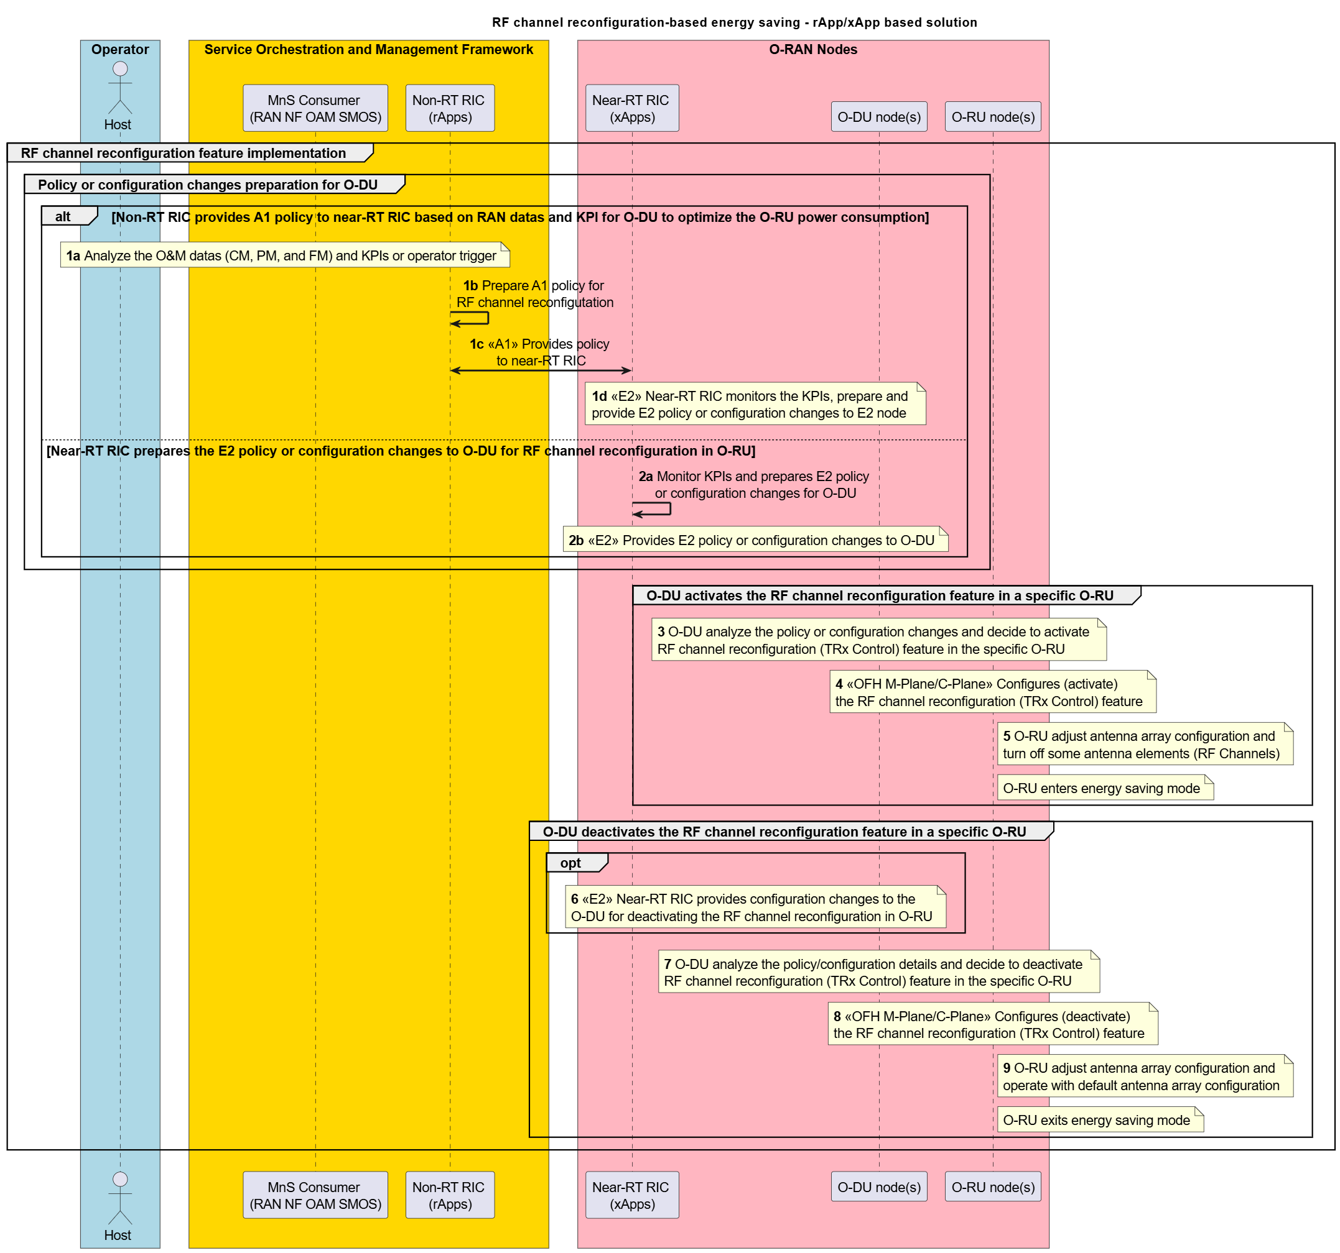
Figure 4.21.3.2.2-1: RF channel reconfiguration-based energy saving: rApp/xApp-based energy saving

4.21.3.3 Advanced Sleep Mode for network energy savings
Advanced Sleep Mode (ASM) enables power reduction or shutdown of O-RU components such as TRX chains, digital beamformers, and associated O-RU processing resources. ASM applies for both short and long periods and can use fine-grained symbol or beam masks. ASM can be triggered or orchestrated by:
i. Solution: rApp-based solution (O1-based or open fronthaul M-plane control, where hybrid architecture-based deployment is supported) (clause 4.2.5.2 of [27])
ii. Solution: rApp/xApp-based solution (E2-based) (clause 4.6.2 of [46])

4.21.3.3.1 Solution: rApp-based solution (O1-based)
The following entities are applicable to this solution: energy saving rApp, Non-RT RIC/SMO, E2 node(s), and O-RU node(s).
A solution for Advanced Sleep Mode-based energy saving, implemented as a use case through an rApp-based approach, is captured in table 4.21.3.3.1-1.
Table 4.21.3.3.1-1 Advanced Sleep Mode: O1-based solution (rApp-based energy saving)
Use Case Stage | Evolution / Specification | <<Uses>>  Related use
Goal | Enable Advanced Sleep Mode energy saving functions in the network by means of configuration parameter change and actions controlled by Non-RT RIC and allow for AI/ML-based solutions.
Actors and Roles | - Energy saving rApp  - Non-RT RIC/SMO  - E2 node(s)  - O-RU node(s)
Assumptions | - O1 interface connectivity is established between E2 node(s) and SMO.  - Open FH M-plane interface is established between E2 node and O-O-RU node and/or SMO and O-RU node directly.
Pre-conditions | Operator has set the targets for Advanced Sleep Mode energy saving functions in the Non-RT RIC.
Begins when | Operator intends to enable Advanced Sleep Mode energy saving functions and E2 node and O-RU node become operational.
Step 1 (M) | Energy saving rApp requests to collect necessary CM, PM and FM data towards SMO/Non-RT RIC function over R1 interface.
Step 2 (M) | SMO/Non-RT RIC requests data collection, including Advanced Sleep Mode (ASM) related capabilities of the E2 node(s) and O-RU(s) over O1 interface and/or open fronthaul M-plane. | O-RAN.WG4.MP [28], clauses 20.4.1 and 20.5.2;  O-RAN.WG10.OAM-Architecture [27], clause 4.2.5.2
Step 3 (M) | E2 node(s) send the configuration data, configured measurement data to SMO/Non-RT RIC periodically or event based. | O-RAN.WG10.OAM-Architecture [27], clause 4.2.5.2;  Use case
Step 4 (M) | rApp collects the configuration data, collected measurement data for processing. | O-RAN.WG4.MP [28], clauses 20.4.1 and 20.5.2
Step 5 (M) | Energy Saving rApp constantly monitors  - performance and energy consumption of the E2 node(s)  - energy consumption of O-RU(s)  - cell utilization and throughput metrics  rApp determines configuration changes for Advanced Sleep Mode use case. AI/ML inference may be used to make the decision. | Use case
Step 6a (Alt) | SMO/Non-RT RIC will provide the policy to E2 node via O1 interface for Advanced Sleep Mode in the specific O-RU. | O-RAN.WG10.OAM-Architecture [27], clauses 4.2.5.2 and 5.2.1
Step 6b (Alt) | SMO/Non-RT RIC will provide configuration changes to the E2 node via O1 interface to activate the Advanced Sleep Mode feature in the target O-RU. | O-RAN.WG10.OAM-Architecture [27], clauses 4.2.5.2 and 5.2.1
Step 7 (M) | E2 node analyzes the conditions mentioned in the policy or configuration changes and decides to activate the Advanced Sleep Mode feature in the specific O-RU. | O-RAN.WG10.OAM-Architecture [27], clause 4.2.5.2;  Use case
Step 8 (M) | E2 node sends appropriate commands to the O-RU via fronthaul M-plane or C-plane to configure (activate) Advanced Sleep Mode feature to the specific O-RU, i.e., O-DU configures a specific sleep mode on O-RU. | O-RAN.WG4.MP [28], clauses 20.4 and 20.5;  O-RAN.WG4.TS.CUS.0-R004 [51], clauses 7.4.6, 16, 16.1 and 16.3
Step 9 (M) | O-RU applies the sleep mode functionality based on the E2 node provided configuration, achieved through the deactivation of relevant hardware and/or software components. Then the O-RU transitions to Advanced Sleep Mode-based energy saving mode. | Use case
Step 10 (O) | SMO/Non-RT RIC may provide configuration changes to the E2 node via O1 interface to deactivate the Advanced Sleep Mode feature in the specific O-RU. | O-RAN.WG10.OAM-Architecture [27], clauses 4.2.5.2 and 5.2.1
Step 11 (M) | E2 node analyzes the policy provided by SMO in Step 6a or configuration changes requested by SMO/Non-RT RIC in Step 10. Then the E2 node decides to deactivate the Advanced Sleep Mode feature in the specific O-RU. | O-RAN.WG10.OAM-Architecture [27], clause 4.2.5.2;  Use case
Step 12 (M) | E2 node sends the appropriate commands to the O-RU via fronthaul M-plane or C-plane to reactivate all its components. This is to deactivate the Advanced Sleep Mode feature in the O-RU. | O-RAN.WG4.MP [28], clauses 20.4 and 20.5;  O-RAN.WG4.TS.CUS.0-R004 [51], clauses 7.4.6, 16, 16.1 and 16.3
Step 13 (M) | The O-RU reactivates the relevant hardware and/or software components that were deactivated due to the applied sleep mode in Step 9. This is to deactivate the Advanced Sleep Mode feature in the O-RU.  The O-RU exits from energy saving mode. | Use case
Ends when | - Load or coverage changes, or policy expires/aborts.  - O-DU and O-RU nodes become non-operational or when the operator disables the optimization functions for energy saving or when optimization criteria are no longer met.
Exceptions | O-RU/E2 node reports.
Post Conditions | - O-RU is restored to the initial configuration.  - SMO logs energy gain and status.  - Non-RT RIC continues closed loop monitoring of energy saving function at E2 node and O-RU.  - O-DU(s) and O-RU(s) operate using the configuration provided by the energy saving rApp via Non-RT RIC/SMO.

@startuml
!pragma teoz true

' ==== Styling ====
skinparam sequenceArrowThickness 2
skinparam ParticipantPadding 5
skinparam BoxPadding 10
skinparam defaultFontSize 14
skinparam sequenceMessageAlign center
skinparam NoteBackgroundColor #fff9e6
skinparam NoteBorderColor #d1b77a
skinparam BoxBorderColor #888
skinparam BoxBackgroundColor #f7f7f7

title Advanced Sleep Mode (ASM) based energy saving - rApp-based solution

Skin rose

' ==== Context & Roles ====
box "Operator" #Lightblue
Actor Host as host
End box

box "Service Orchestration and Management Framework" #gold
participant "Energy Saving rApp" as rApp
participant "SMO / Non‑RT RIC" as smo
end box

box “O-RAN Nodes” #lightpink
participant "E2 node(s)\n(e.g., O‑DU)" as e2
participant "O‑RU node(s)" as ru
end box

' ==== Step 1 (M) ====
rApp -> smo : <B>1</B> <<R1>> — Request CM/PM/FM data collection

' ==== Step 2 & 3 (M) ====
note over smo, ru
<B>2</B> <<O1>> Request data collection & O-DU and O-RU capabilities
end note
smo <- e2 : <B>3</B> <<O1>> Deliver requested data & O-DU and O-RU capabilities

' ==== Step 4 (M) ====
smo -> rApp : <B>4</B> <<R1>> Deliver collected configuration/measurement data

' ==== Step 5 (M) ====
Loop Advanced Sleep Mode
rApp -> rApp : <B>5</B> Continuous monitoring & inference
note right of rApp
Monitors:
(i) E2 performance & energy consumption
(ii) O‑RU energy consumption
(iii) Cell utilization & throughput
Determines configuration changes for Advanced Sleep Mode.
AI/ML inference may be used.
end note

' ==== Step 6a/6b (Alt) ====
alt Policy path
smo -> e2 : <B>6a</B> <<O1>> — Provide policy for Advanced Sleep Mode in specific O‑RU
else Direct configuration path
smo -> e2 : <B>6b</B> <<O1>> — Provide configuration to Advanced Sleep Mode \nin specific O‑RU
end
' ==== Step 7 (M) ====
e2 -> e2 : <B>7</B> Analyze conditions/policy; decide to activate Advanced Sleep Mode in specific O-RU

' ==== Step 8 (M) ====
e2 -> ru : <B>8</B> <<OFH M‑/C‑Plane>> Configure (activate) sleep mode\n(e.g., set sleep mode 1)

' ==== Step 9 (M) ====
ru <- ru : <B>9</B> Enter energy saving mode
' ==== Step 10 (O) ====
Opt Deactivation requested by SMO
smo -> e2 : <B>10</B> <<O1>> — Provide configuration to deactivate Advanced Sleep Mode
end opt
' ==== Step 11 (M) ====
e2 -> e2 : <B>11</B> Evaluate (policy from 6a or request from 10);\ndecide to deactivate Advanced Sleep Mode
' ==== Step 12 (M) ====
e2 -> ru : <B>12</B> <<OFH M‑/C‑Plane>> Deactivate Advanced Sleep Mode
' ==== Step 13 (M) ====
ru <- ru : <B>13</B> Exit energy saving mode

end loop

@enduml

The flow diagram of the Advanced Sleep Mode-based energy saving using O1-based solution is given in figure 4.21.3.3.1-1.

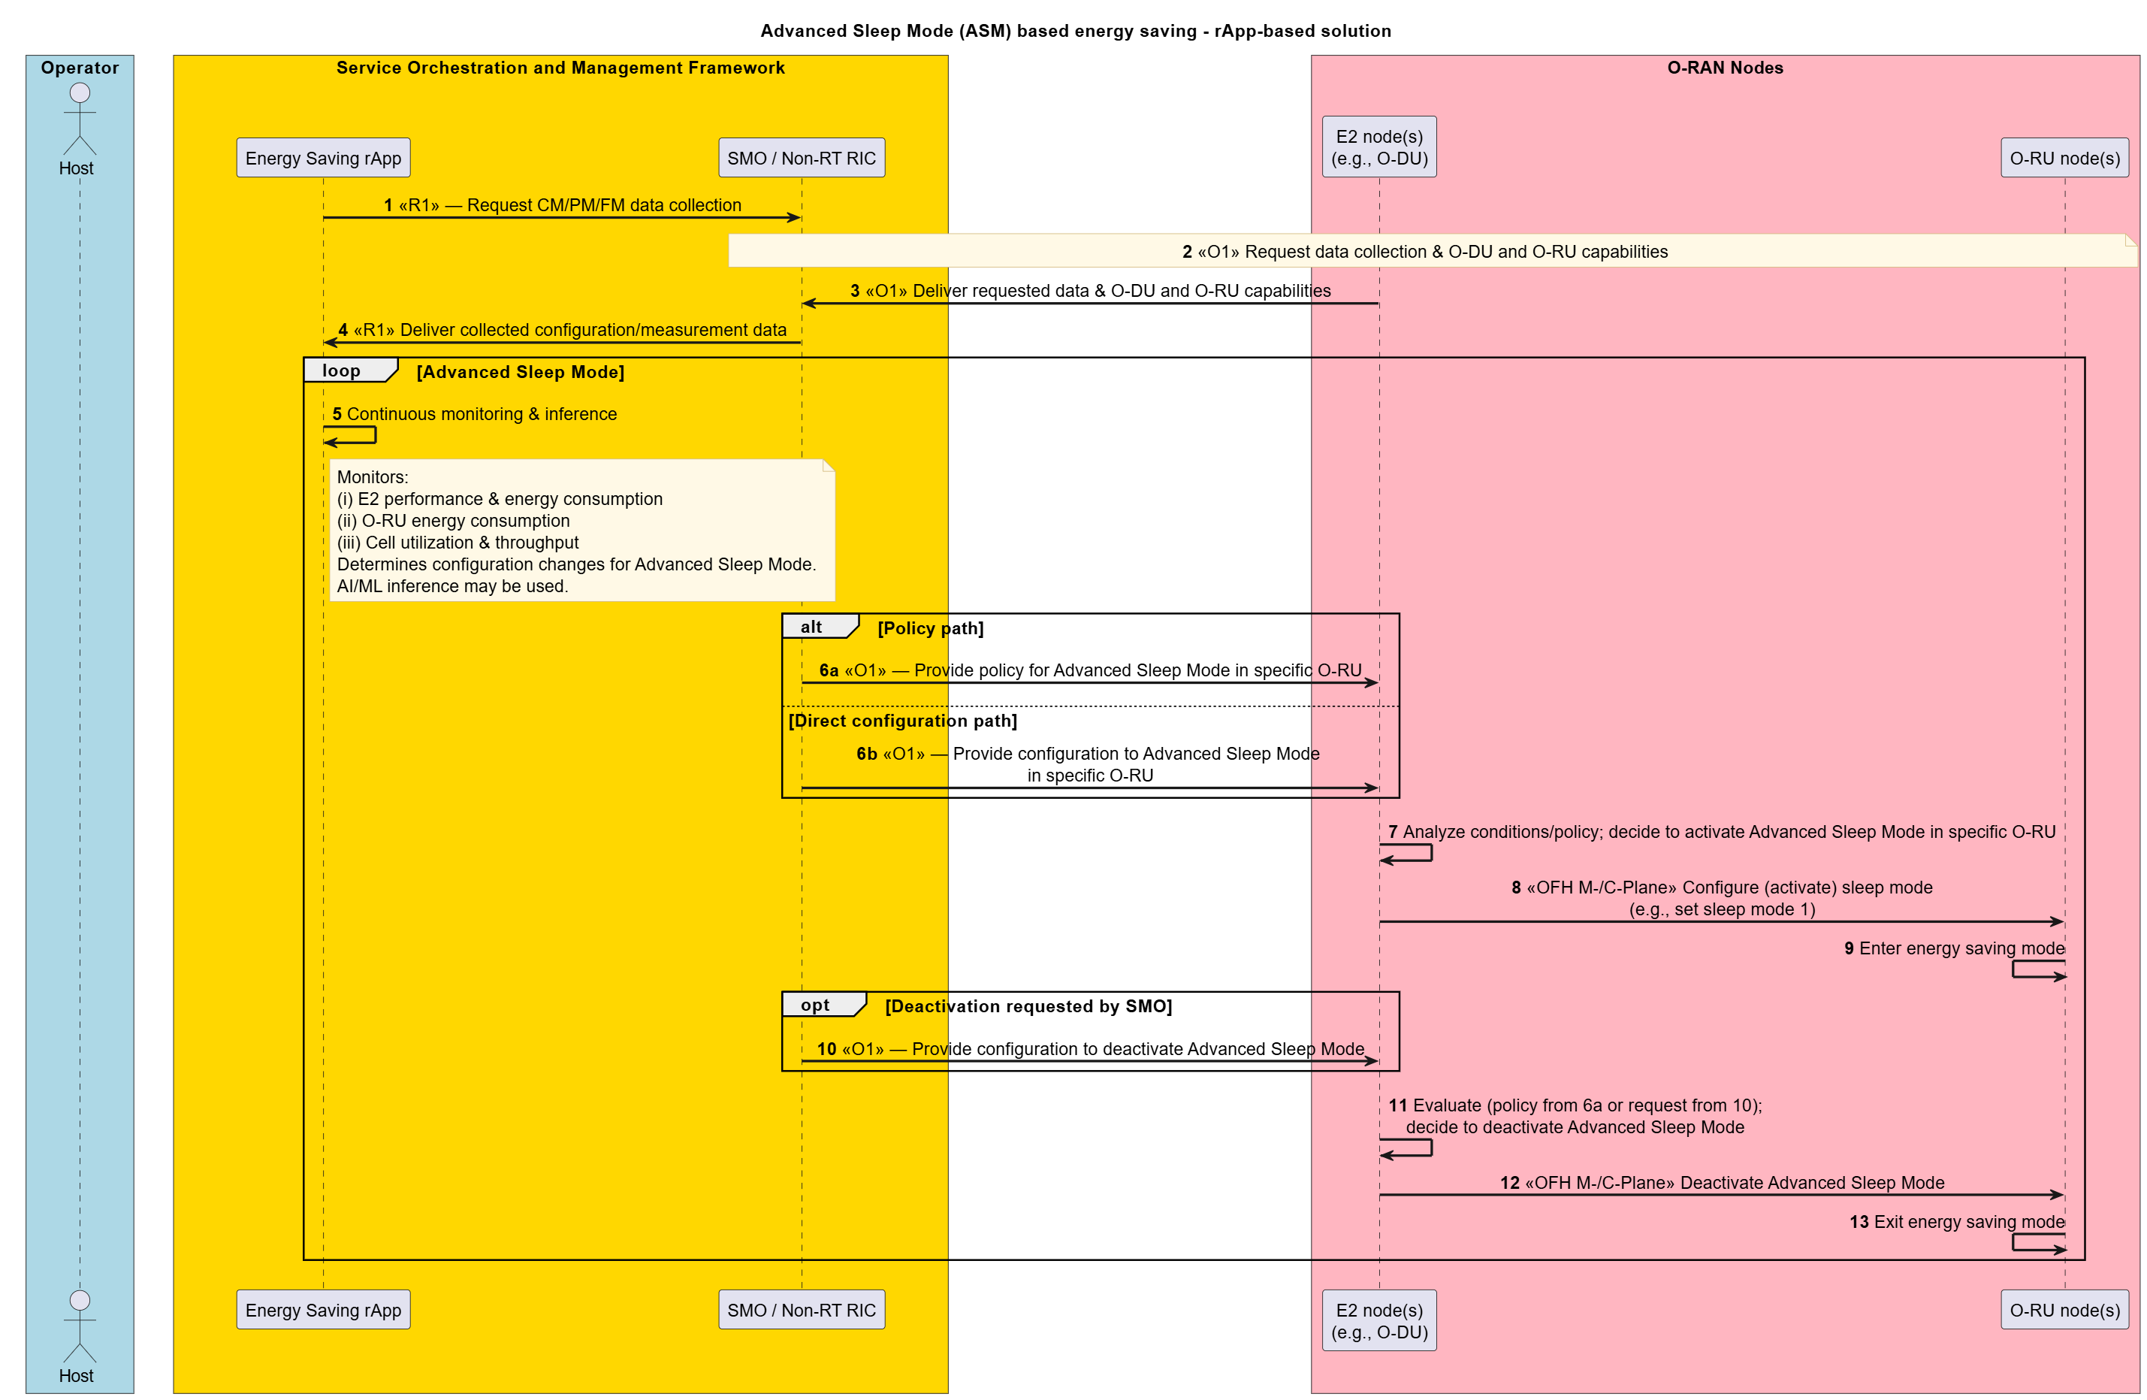
Figure 4.21.3.3.1-1: Advanced Sleep Mode-based energy saving (method #1): rApp-based energy saving

4.21.3.3.2 Solution: rApp/xApp-based solution
The following entities are applicable to this solution: energy saving rApp/xApp, Near-RT RIC/SMO, E2 node and O-RU node.
A solution for Advanced Sleep Mode-based energy saving implemented as a use case through an rApp/xApp-based approach, is documented in table 4.21.3.3.2-1.
Table 4.21.3.3.2-1: Advanced Sleep Mode: rApp/xApp-based solution
Use Case Stage | Evolution / Specification | <<Uses>>  Related use
Goal | Enable Advanced Sleep Mode energy saving functions in the network by means of configuration parameter change and actions controlled by Near-RT RIC and allow for AI/ML-based solutions.
Actors and Roles | - Energy saving xApp  - Near-RT RIC  - Non-RT RIC/SMO  - E2 node (s)  - O-RU node (s)
Assumptions | - A1 interface connectivity is established between Non-RT RIC of SMO and Near-RT RIC.  - E2 interface connectivity is established between network functions (O-DU) and Near-RT RIC.  - Open fronthaul M-plane interface is established between O-DU and O-RU and/or SMO and O-RU directly.  - SMO, Near-RT RIC, and O-DU aware of O-RU capabilities.  - Network is operational.
Pre-conditions | Operator has set the targets for energy saving functions in Near-RT RIC.
Begins when | Operator enables the optimization functions for Advanced Sleep Mode energy saving functions, and O-DU and O-RU become operational.
Alt  Step 1a (M) | SMO consumes and analyzes the various measurement data like CM, PM and FM data and KPIs or operator trigger (requested configuration changes). | Use case
Step 1b (M) | Non-RT RIC SMOF prepares A1 policy for Near-RT RIC (xApps) to optimize the Advanced Sleep Mode of a specific O-RU. | O-RAN.WG2.TS.Use-Case-Requirements-R004 [50], clause 4.8.2.3.2;  Use case
Step 1c (M) | Non-RT RIC SMOF provides policy prepared in Step 1b, to Near-RT RIC via A1 interface. | O-RAN.WG2.TS.Use-Case-Requirements-R004 [50], clause 4.8.2.3.2;  Use case
Step 1d (M) | Energy saving xApp constantly monitors  - energy consumption of O-RU(s)  - cell utilization, throughput, and related performance metrics  Near-RT RIC analyzes the A1 policy that it received from Non-RT RIC in Step 1c and the above measurement data. The xApps of Near-RT RIC function prepares the E2 policy or determines the configuration changes that need to be provided to O-DU, for Advanced Sleep Mode use case. AI/ML inference may be used to make the decision.  The Near-RT RIC provides the E2 policy or configuration changes to O-DU for Advanced Sleep Mode of a specific O-RU. | O-RAN.WG2.TS.Use-Case-Requirements-R004 [50], clause 4.8.2.3.2;  Use case
Alt  Step 2a (M) | Energy saving xApp constantly monitors  - energy consumption of O-RU(s)  - cell utilization, throughput, and related performance metrics  Near-RT RIC (xApp) analyzes the above measurement data and KPIs, and prepares the E2 policy or configuration changes for O-DU. | O-RAN.WG2.TS.Use-Case-Requirements-R004 [50], clause 4.8.2.3.2;  O-RAN.WG3.TS.UCR-R004 [46], clause 4.6.2;  Use case
Step 2b (M) | Near-RT RIC provides the policy or configuration changes (prepared in Step 2a to O-DU via E2 interface. | O-RAN.WG3.TS.UCR-R004 [46], clause 4.6.2;  O-RAN.WG3.TS.E2SM-CCC [47], clause 8.8.2.6;  Use case
Step 3 (M) | O-DU analyzes the policy or configuration changes that it received either in Step 1d or 2b. Once the conditions mentioned in that policy are satisfied or based on the requested configuration changes, the O-DU decides to activate the Advanced Sleep Mode feature in the O-RU. | Use case
Step 4 (M) | O-DU sends appropriate commands to the O-RU via fronthaul M-plane or C-plane to configure (activate) Advanced Sleep Mode feature to the specific O-RU, i.e., O-DU configures a specific sleep mode on O-RU. | O-RAN.WG4.MP [28], clauses 20.4 and 20.5;  O-RAN.WG4.TS.CUS.0-R004 [51], clauses 7.4.6, 16, 16.1 and 16.3
Step 5 (M) | O-RU apply the sleep mode functionality based on the O-DU provided configuration, achieved through the deactivation of relevant hardware and/or software components. Then the O-RU transitions to Advanced Sleep Mode-based energy saving mode. | Use case
Step 6 (O) | Near-RT RIC analyses the O&M data and KPIs to prepare configuration changes required for O-DU to deactivate the Advanced Sleep Mode feature and provide them to O-DU via E2 interface. | O-RAN.WG3.TS.UCR-R004 [46], clause 4.6.2;  O-RAN.WG3.TS.E2SM-CCC [47], clause 8.8.2.6;  Use case
Step 7 (M) | O-DU analyzes the policy provided by Near-RT RIC in Steps 1d or 2b or configuration changes provided by Near-RT RIC in Step 6. Then the O-DU decides to deactivate the Advanced Sleep Mode feature in the specific O-RU. | Use case
Step 8 (M) | O-DU sends the appropriate commands to the O-RU via fronthaul M-plane or C-plane to deactivate the sleep mode. This is to deactivate the Advanced Sleep Mode feature in the O-RU. | O-RAN.WG4.MP [28], clauses 20.4 and 20.5;  O-RAN.WG4.TS.CUS.0-R004 [51], clauses 7.4.6, 16, 16.1 and 16.3
Step 9 (M) | The O-RU reactivates the relevant hardware and/or software components that were deactivated due to the applied sleep mode in Step 5. This is to deactivate the Advanced Sleep Mode feature in the O-RU.  The O-RU exits from energy saving mode. | Use case
Ends when | E2 node and O-RU become non-operational or when the operator disables the optimization functions for energy saving or when optimization criteria are no longer met.  Change in traffic or coverage  The policy expires/aborts.
Exceptions | O-RU/O-DU reports failure or resource is ineligible (e.g., all SSB/PRACH beams masked); rApp must retry or rollback.
Post Conditions | O-RU is restored to default antenna array configuration.  SMO monitors the energy consumption status.  Near-RT RIC continues close loop monitoring of energy saving function at E2 node and O-RU.  E2 node(s) and O-RU(s) operate using the configuration provided by the energy saving xApp via Near-RT RIC.

@startuml

!pragma teoz true
skinparam sequenceArrowThickness 2
skinparam ParticipantPadding 5
skinparam BoxPadding 10
skinparam defaultFontSize 15
skinparam sequenceMessageAlign center
skinparam sequenceMessageAlign center

title Advance Sleep Mode based energy saving - rApp/xApp based solution
Skin rose

box "Operator" #Lightblue
Actor host as "Host"
End box

Box “Service Orchestration and Management Framework” #gold
participant "MnS Consumer \n(RAN NF OAM SMOS)" as smo
participant "non-RT RIC \n(rApps)" as rapp
end box

box “O-RAN Nodes” #lightpink
participant "near-RT RIC \n(xApps)" as xapp
participant "O-DU node(s)" as e2odu
participant "O-RU node(s)" as RU
end box

group Advance Sleep Mode
group Policy or configuration changes preparation for O-DU
alt Non-RT RIC provides A1 policy to near-RT RIC based on RAN datas and KPI for O-DU to optimize the O-RU power consumption
note over host, rapp : <B>1a</B> Analyze the O&M datas (CM, PM, and FM) and KPIs or operator trigger
rapp->rapp : <B>1b</B> Prepare A1 policy for \nAdvance Sleep Mode
rapp<->xapp : <B>1c</B> <<A1>> Provides policy \nto near-RT RIC
note left xapp : Near-RT RIC prepares E2 policy \nor configuration changes
note over xapp, e2odu : <B>1d</B> <<E2>> Provides E2 policy or configuration changes to O-DU
else Near-RT RIC prepares the E2 policy or configuration changes to O-DU for Advance Sleep Mode in O-RU
xapp->xapp : <B>2a</B> Prepares E2 policy or \nconfiguration changes for O-DU
note over xapp, e2odu : <B>2b</B> <<E2>> Provides E2 policy or configuration changes to O-DU
end alt
end group

group O-DU activates the Advance Sleep Mode feature in a specific O-RU
note over e2odu: <B>3</B> O-DU analyzes the policy or configuration changes and decides \nto activate Advance Sleep Mode feature in the specific O-RU
note over RU : <B>4</B> <<OFH M-Plane/C-Plane>> Configures (activate) \nthe Advance Sleep Mode feature
note right RU : <B>5</B> O-RU activates Advanced Sleep Mode
note right RU : O-RU enters energy saving mode
end group
group O-DU deactivates the Advance Sleep Mode feature in a specific O-RU
opt
note over xapp, e2odu : <B>6</B> <<E2>> Near-RT RIC provides configuration changes to the \nO-DU for deactivating the Advance Sleep Mode in O-RU
end opt
note over e2odu: <B>7</B> O-DU analyzes the policy/configuration details and decides to \ndeactivate Advanced Sleep Mode feature in the specified O-RU
note over RU : <B>8</B> <<OFH M-Plane/C-Plane>> Configures (deactivates) \nthe Advance Sleep Mode feature
note right RU : <B>9</B> O-RU deactivates Advanced Sleep Mode
note right RU : O-RU exits energy saving mode
end group
end loop

@enduml

The flow diagram of the Advanced Sleep Mode using rApp/xApp based energy saving is given in figure 4.21.3.3.2-1.

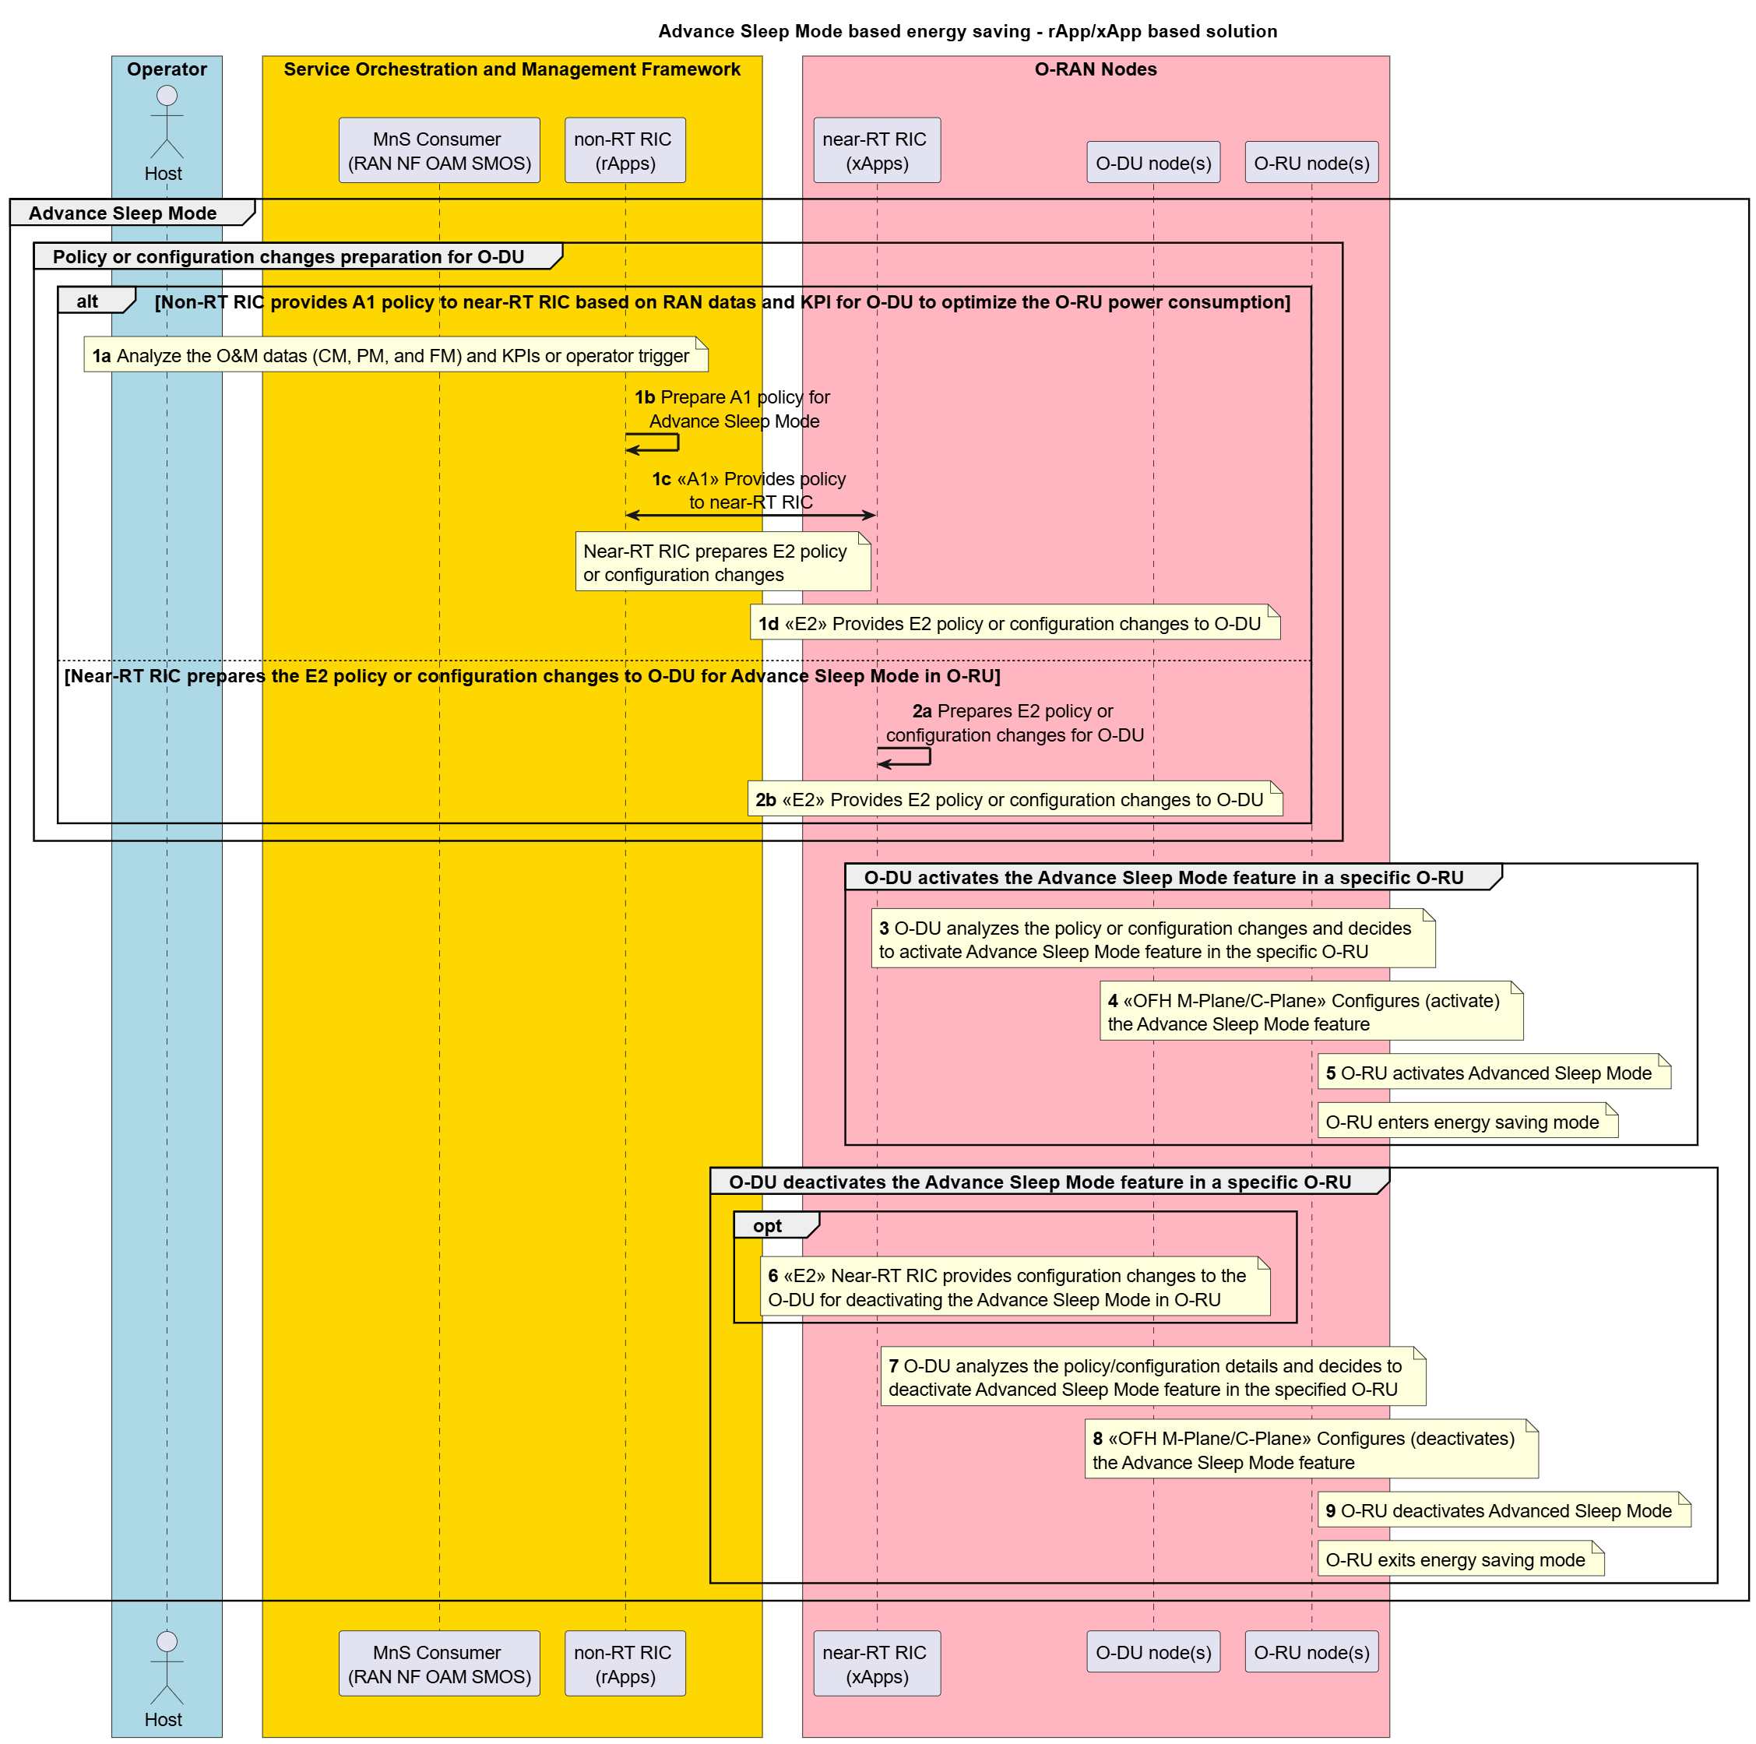
Figure 4.21.3.3.2-1: Advanced Sleep Mode-based energy saving : rApp/xApp-based energy saving

4.21.3.4 External power source coordination-based energy saving
External power source coordination-based energy saving is for SMO framework to collect the energy source and supply information (either by operator input or available to SMO framework from external producers or exposed via O-RU by energy supplier in an operator specific implementation) along with other network data. The SMO framework may use those data to configure appropriate energy saving method in O-RU according to the type of energy source and its supply. For example, when O-RU power source switched from grid supply to either battery or solar power (or any other renewable energy source) with limited energy supply. The SMO framework may analyze energy sources and their supply information like capacity and then activate the appropriate energy saving in O-RU to prolong its services. rApp-based solution (O1-based) is described in the following sub-clause.

4.21.3.4.1 Solution: rApp-based solution (O1-based)
The following entities are applicable to this solution: energy saving rApp, Non-RT RIC/SMO framework, O-DU node(s) and O-RU node(s).
A solution for external power source coordination-based energy saving: use case through rApp-based solution with energy source and supply information configured by operator and/or exposed through O-RU is captured in table 4.21.3.4.1-1.
Table 4.21.3.4.1-1: External power source coordination-based energy saving: AI/ML inference via Non-RT RIC
Use Case Stage | Evolution / Specification | <<Uses>>  Related use
Goal | Enable external power source coordination-based energy saving functions in the network by means of configuration parameter change and actions controlled by Non-RT RIC and allow for AI/ML-based solutions.
Actors and Roles | - Energy saving rApp  - Non-RT RIC/SMO framework (Non-RT RIC, external producers, DME SMOS, PMI SMOS, RAN NF SMOS, and O-RU controller)  - O-DU node  - O-RU node  - Energy supplier control panel  - Operator
Assumptions | - O1 interface connectivity is established between network functions (O-DU) and SMO.  - Open Fronthaul (FH) M-plane interface is established between O-DU and O-RU and/or SMO and O-RU directly.  - Network is operational.  - External control panel (energy supplier) can expose the energy source and supply information to the operator.  - O-RU can collect the energy source and supply information that is supplied by the energy operator based on operator specific implementation.  - O-DU and O-RU support one of the energy saving methods described in clause 16 of O-RAN.WG4.TS.CUS.0-R004 [51] and clause 20 of O-RAN.WG4.MP [28]. | O-RAN.WG4.MP [28], clause 20;  O-RAN.WG4.TS.CUS.0-R004 [51], clause 16;  Use case
Pre-conditions | - Operator has set the targets for external power source coordination-based energy saving functions in the Non-RT RIC.  - Operator may use one of the following steps to configure the energy source and supply information to SMO framework.  - Use the external producer termination of SMO framework to supply the energy source and supply information, where DME SMOS can be utilized for data exposure.  - Configures external power source information (energy source and supply information provided by energy suppliers) through a dedicated rApp that is responsible for external power source coordination-based energy saving, where DME SMOS can be utilized for data exposure.  - Configures the external power source information (energy source and supply information) to the RAN NF OAM SMOS, where DME SMOS can be utilized for data exposure. | 3GPP TS 28.310 [43], clauses 5.1.6.2, 5.2.5.1, 8.3.1, 8.3.2, and 8.3.3 and Annex C.1
Begins when | Operator enables the optimization functions for external power source coordination-based energy saving functions and NFs (O-DU and O-RU) under operational.
Step 1a (Alt) | Hierarchical deployment  O-RU exposes capabilities related to the external power source coordination-based energy saving feature via FH M-plane. | Use case
Step 1b (M) | O-DU exposes its capabilities along with associated O-RU capabilities to RAN NF OAM SMOS of SMO framework via O1 interface. | Use case
Step 2 (Alt) | Hybrid deployment  O-RU exposes capabilities related to the external power source coordination-based energy saving feature to the SMO via FH M-plane. | Use case
Step 3 (O) | Energy supplier exposes the energy source and supply information to O-RU using operator specific implementation. | Use case
Alt  Step 4a (O) | Hierarchical deployment  O-RU exposes the energy source and supply information (that it got from energy supplier as in Step 3) to O-DU via FH M-plane. | Use case
Step 4b (M) | O-DU forward the energy source and supply information (that it received from O-RU via FH M-plane in Step 4a) to RAN NF OAM SMOS of SMO framework via O1 interface. | Use case
Alt  Step 5 (O) | Hybrid deployment  O-RU exposes capabilities related to the external power source coordination-based energy saving feature to the SMO via FH M-plane. | Use case
Alt  Step 6a (M) | Energy saving rApp constantly monitors the following by leveraging the SMO framework,  - performance and energy consumption of the O-DU(s)  - energy consumption of O-RU(s)  - cell utilization and throughput metrics  - external power source(s) and capacity i.e., energy source and supply information.  rApp determines policy or configuration changes for external power source coordination-based energy saving use case. AI/ML inference may be used to make the decision.  Non-RT RIC SMOF (rApp) can provision the policy through the PMI SMOS to provide the policy or configuration changes to RAN NF OAM SMOS.  Non-RT RIC SMOF (rApp) may use the PMI SMOS to provision the policy or configuration changes to the RAN NF OAM SMOS based on the above data. | Use case
Step 6b (M) | The operator may alternatively use the PMI SMOS to provision the energy saving policy based on the performance data mentioned in Step 7a and energy source and supply information. | Use case
Step 6c (O) | SMO framework may use appropriate SMOS to decide to switch power sources depending on various KPIs and then activate appropriate energy saving method(s) in O-RU. | Use case
Alt  Step 7a (O) | Hierarchical deployment  SMO framework uses the RAN NF SMOS to provide the energy source switching command (configuration changes) to the O-DU via O1 interface, to enable O-DU to forward the energy source switching command to O-DU via FH M-plane. | Use case
Step 7b (O) | The O-DU analyzes the configuration changes that it received in the command sent by the SMO in Step 8a.  The O-DU sends an appropriate RPC command to the O-RU via FH M-plane, where it contains the energy source switching command that is to be forwarded to the energy supplier control panel. | Use case
Step 7c (O) | The O-RU forwards the command that it received from O-DU in Step 8b to the energy supplier control panel to switch the energy source based on the operator specific implementation. | Use case
Alt  Step 8a (M) | Energy saving rApp constantly monitors the following by leveraging the SMO framework,  - performance and energy consumption of the O-DUs  - energy consumption of O-RU(s)  - cell utilization and throughput metrics  - external power source(s) and capacity i.e., energy source and supply information.  rApp determines policy and/or configuration changes for external power source coordination-based energy saving use case. AI/ML inference may be used to make the decision.  rApp may provision the policy through PMI SMOS to RAN NF OAM SMOS. Alternatively, the operator may use the PMI SMOS to provision the energy saving policy based on the performance data mentioned in Step 2a and energy source and supply information.  SMO uses the RAN NF OAM SMOS to provide energy saving policy or the configuration changes to O-DU via O1 interface. | O-RAN.WG10.OAM-Architecture [27], clause 5.2.1;  O-RAN.WG10.TS.O1-Interface [44]
Step 8b (M) | O-DU analyzes the policy, or the configuration changes provided by SMO in Step 9a. If the conditions mentioned in the policy or configuration changes provided in Step 9a are met, the O-DU sends FH C-plane and/or M-plane commands to activate an appropriate energy saving feature in O-RU, based on its capability. For example, Advanced Sleep Mode, TRx control, deep hibernate etc. | O-RAN.WG4.MP [28], clause 20;  O-RAN.WG4.TS.CUS.0-R004 [51], clause 16;  Use case
Alt  Step 9a (O) | Hybrid Deployment  SMO (O-RU controller) sends an appropriate RPC command to the O-RU via OFH M-plane for switching the energy source. | Use case
Step 9b (O) | The O-RU forwards the command that it received from SMO (O-RU controller) via FH M-plane in Step 10a to the energy supplier control panel to switch the energy source based on the operator's specific implementation. | Use case
Step 10a (M) | SMO uses the RAN NF OAM SMOS to configure the O-DU via O1 interface, to make it aware of the energy saving feature activation in the specific O-RU. O-DU performs necessary configurations to the O-RU via fronthaul interface. For example, CUS plane to be terminated if the deep hibernate based energy saving to be activated in the O-RU in Step 11b. | O-RAN.WG10.OAM-Architecture [27];  Use case
Step 10b (M) | SMO (O-RU controller) configures the O-RU via fronthaul M-plane with an appropriate energy saving method supported by O-RU. For example, energy saving features such as M-plane controlled TRx control and deep hibernate. | O-RAN.WG4.MP [28], clause 20;  Use case
Step 11 (M) | When energy source and supply restore to a default one, the O-DU may deactivate the energy saving feature in the O-RU via fronthaul M-plane or C-plane. This is based on the operator trigger or configuration changes (trigger) from the SMO framework or based on the SMO provided policy in Step 9a. | Use case
Ends when | Energy supply information is not available, and O-RU becomes non-operational or when the operator disables the optimization functions for external power source coordination-based energy saving.
Exceptions | None.
Post Conditions | Non-RT RIC continues close loop monitoring of external power sources, energy supply information and energy saving function at O-DU and O-RU. O-DU (s) and O-RU(s) operate using the configuration provided by the energy saving rApp via Non-RT RIC/SMO framework.

@startuml
!pragma teoz true
skinparam sequenceArrowThickness 2
skinparam ParticipantPadding 5
skinparam BoxPadding 10
skinparam defaultFontSize 15
skinparam sequenceMessageAlign center
skinparam sequenceMessageAlign center

title Hierarchical O-RU management procedure

Title External power source coordination
Skin rose

box "Operator" #Lightblue
Actor host as "Energy source and supply information"
End box

Box “Service Orchestration and Management Framework” #gold
participant "MnS Producer \n(External producers)" as extp
participant "DME SMOS" as dme
participant "non-RT RIC \n(rApps)" as rapp
participant "PMI SMOS" as pmi
participant "MnS Consumer \n(RAN NF OAM SMOS)" as smo
participant "O-RU Controller \n(Netconf client)" as smoru
end box

box “O-RAN NF” #lightpink
box "O-DU" #lightcyan
participant "MnS Producer \n(MnF of O-DU)" as mnfodu
participant "O-RU Controller \n (Netconf client)\n(O-DU)" as client
end box
participant "NETCONF Server/\n(O-RU)" as RU
end box

Note over host, RU
<B>Pre-condition</B>:
1. External control panel (energy supplier) can provide the energy source and supply information to operator
2. Operator can configure the energy source and supply information to SMO Framework
3. O-RU has the connection with external power source control unit (Operator specific implementation)
4. External power source control unit can expose the energy source and supply information to O-RU
End note
Group Capability exposure
Alt Hierarchical deployment
client<-RU : [1a] <<FH M-Plane>> Expose the external power source coordination \nfeature capability and associated parameters
smo<-mnfodu : [1b] <<O1>> O-DU forwards the O-RU capabilities
Else Hybrid deployment
smoru<-RU : [2] <<FH M-Plane>> Expose the external power source coordination feature capability and associated parameters
End Alt
End group
group Exposing external power source information (Energy source and supply information) avaialability to SMO Framework through O-RU
opt
RU<-RU : [3] Collect the external power source \ninformation from energy supplier
alt Hierarchical deployment
client<-RU : [4a] <<FH M-Plane>> Expose the external power source information \neither through file management or NETCONF Yang
smo<-mnfodu : [4b] <<O1>> O-DU forwards the external power source information
Else Hybrid deployment
smoru<-RU : [5] <<FH M-Plane>> Expose the external power source information either through file management or NETCONF Yang
end opt
end group
group SMO analyzes the energy source and supply information and perform actions based them
alt rApp can create a policy and provision \nthrough PMI to RAN NF OAM SMOS
note over rapp,smo: [6a] rApp prepares a policy and provision through \n\tPMI SMOS to RAN NF OAM SMOS
else PMI provision operator provided \npolicy to RAN NF OAM SMOS
note over pmi,smo: [6b] Energy saving policy based on energy \nsupply and energy source information
end alt
opt
note over rapp, smoru : [6c] Decide to switch power sources \nand/or activate appropriate ES features
end opt
end group

Group External power source coordination based energy saving implementation
Alt Hierarchical deployment
opt Switch power supply source
note over pmi, mnfodu : [7a] <<O1>> Provide policy or configuration changes to O-DU for switching energy source
note over mnfodu, client : Analyze the configuration changes
client->RU : [7b] <<FH M-Plane>> Sends the energy source \nswitching command for control panel
note left RU : [7c] O-RU forward the power source switching \ncommand and/or implement requested ES
end opt
group Energy saving activation based on energy source and supply information
smo->mnfodu : [8a] <<O1>> Provide ES policy or configures O-DU
note over mnfodu, client : Analyze the policy or configuration changes
client->RU : [8b] <<FH M-Plane>> Activate appropriate ES in \nO-RU or O-RU shutdown
end group
else Hybrid deployment
opt Switch power supply source
smoru->RU : [9a] <<FH M-Plane>> Configures O-RU to switch power supply
note left RU : [9b] O-RU forward the power source switching \ncommand and/or implement requested ES
end opt
group Energy saving activation based on energy source and supply information
smoru->mnfodu : [10a] <<O1>> Updates O-DU about the energy saving \nfeature activation in the specific O-RU
note over mnfodu, client : Configures O-RU with necessary changes
smoru->RU : [10b] <<FH M-Plane>> Activate appropriate ES in O-RU or O-RU shutdown
end group
end alt
note over host, RU : [11] End energy saving when the energy source and supply restored to default one
end group
@enduml

The flow diagram of the external power source coordination-based energy saving using O1-based solution with energy source and supply information configured by the operator and exposed through O-RU is given in figure 4.21.3.4.1-1.
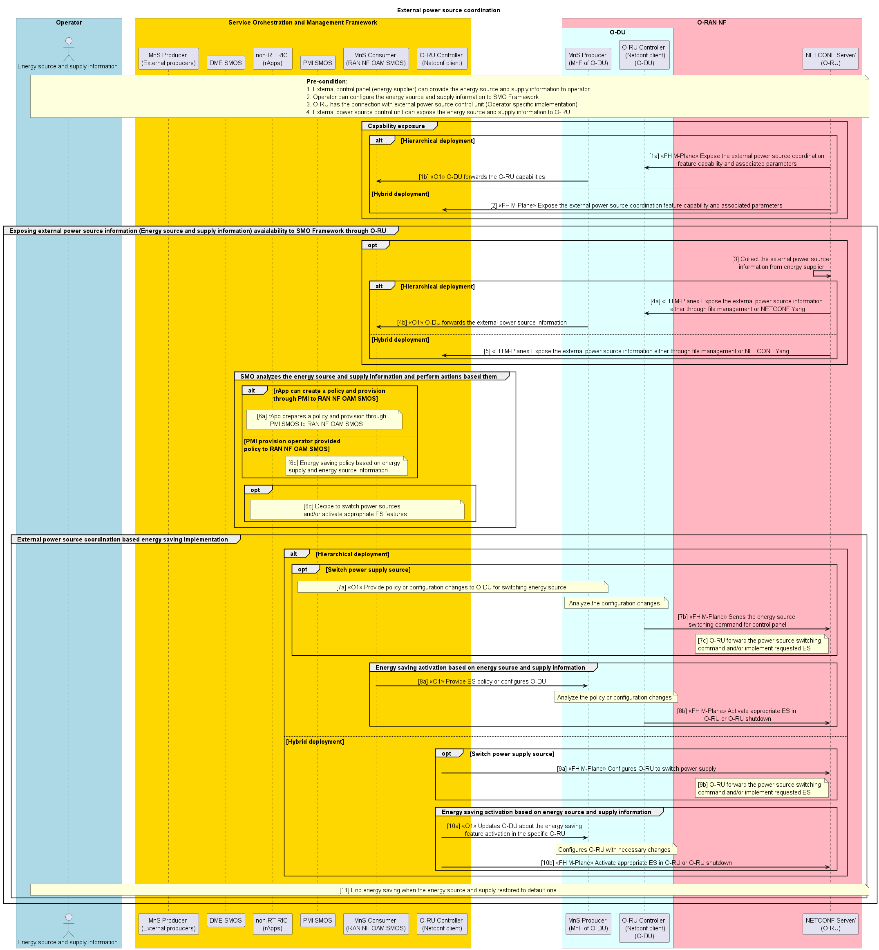
Figure 4.21.3.4.1-1: External power source coordination-based energy saving: AI/ML inference via Non-RT RIC

4.21.3.5 PA power optimization-based energy saving
Power amplifier optimization-based energy saving (maximum output power control) is for SMO framework to collect the network data and KPIs from various network functions. By leveraging this information, the SMO can dynamically prepare the policy or configuration changes and provide them to the O-DU. Once the conditions mentioned in that policy satisfied or based on configuration changes, the O-DU configures the maximum output power in O-RU, where this power value may be determined by O-DU according to the traffic scheduling requirements. The O-RU optimizes the power amplifier parameters according to the maximum output power configured by O-DU. This could result in the O-RU energy saving as the power amplifier is a major power consuming component of O-RU.

4.21.3.5.1 Solution: rApp-based solution (O1-based)
The following entities are applicable to this solution: energy saving rApp, Non-RT RIC/SMO framework, O-DU node, and O-RU node.
A solution for PA power optimization-based energy saving: use case through rApp-based solution is captured in table 4.21.3.5.1-1.
Table 4.21.3.5.1-1: PA power optimization: AI/ML inference via Non-RT RIC
Use Case Stage | Evolution / Specification | <<Uses>>  Related use
Goal | Enable energy saving by optimizing the PA operating region through configuration changes controlled by Non-RT RIC, with support for AI/ML-based solution.
Actors and Roles | - Energy saving rApp  - Non-RT RIC/SMO framework  - O-DU node  - O-RU node
Assumptions | - O1 interface connectivity is established between network functions (O-DU) and SMO.  - Open FH M-plane interface is established between O-DU and O-RU and/or SMO and O-RU directly.  - SMO performs CM, FM, and PM subscriptions to O-DU and O-RU.  - O-DU performs the CM, FM, and PM subscriptions to O-RU.  - Network is operational.
Pre-conditions | Operator has set the targets for energy saving functions in the Non-RT RIC.
Begins when | Operator enables the optimization functions for PA power optimization energy saving functions and NF and O-RU become operational.
Step 1a (M) | Hierarchical deployment  O-DU acting as the O-RU controller retrieves the PA power optimization (maximum output power control) related capabilities from the O-RU via fronthaul M-plane. | O-RAN.WG4.MP [28], clause 20.6.
Step 1b (M) | RAN NF SMOS of SMO framework retrieves the O-DU capabilities via O1 interface along with the associated O-RU capabilities that the O-DU retrieved in Step 1a. | Use case
Step 2a (M) | Hybrid deployment  RAN NF SMOS of SMO framework retrieves the O-DU capabilities via O1 interface. This enables SMO to determine applicable optimization constraints or actions. | Use case
Step 2b (M) | O-RU controller (can be part of the RAN NF SMOS) of SMO framework retrieves the PA power optimization (maximum output power control) related capabilities from the O-RU via fronthaul M-plane. | O-RAN.WG4.MP [28], clause 20.6.
Step 3 (M) | SMO framework uses appropriate SMOS(s) to analyze the RAN data and KPIs or operator trigger (requested configuration changes), and prepares policies or configuration changes for O-DU. | Use case
Step 4a (Alt) | SMO framework may use the RAN NF SMOS to provide the policy to O-DU via O1 interface for PA power optimization in the specific O-RU. | O-RAN.WG10.OAM-Architecture [27], clause 5.2.1
Step 4b (Alt) | SMO framework may use the RAN NF SMOS to provide configuration changes to the O-DU via O1 interface to activate the PA power optimization feature in the specific O-RU. | O-RAN.WG10.OAM-Architecture [27], clause 5.2.1
Step 5 (M) | O-DU analyzes the conditions mentioned in the policy or configuration changes and decides to activate the PA power optimization feature in the specific O-RU. | Use case
Step 6 (M) | O-DU sends appropriate commands to the O-RU via fronthaul M-plane or C-plane to configure the target maximum output power to the specific O-RU. | O-RAN.WG4.MP [28], clause 20.6.
Step 7 (M) | O-RU adjusts the PA parameters based on the maximum output power configured by the O-DU. Then the O-RU transitions to (PA power optimization) energy saving mode. This is to reduce PA power consumption, thereby improving the O-RU energy efficiency. | Use case
Step 8 (O) | SMO framework may use the RAN NF SMOS to provide configuration changes to the O-DU via O1 interface to deactivate the PA power optimization feature in the specific O-RU. | O-RAN.WG10.OAM-Architecture [27], clause 5.2.1
Step 9 (M) | O-DU analyzes the policy provided by SMO framework in Step 4a or configuration changes requested by RAN NF OAM SMOS of SMO framework in Step 8. Then the O-DU decides to deactivate the PA power optimization feature in the specific O-RU, i.e., O-DU configures the nominal output power to the O-RU. | Use case
Step 10 (M) | O-DU sends the appropriate commands to the O-RU via fronthaul M-plane or C-plane to configure the nominal output power. This is to deactivate the PA power optimization feature in the O-RU. | O-RAN.WG4.MP [28], clause 20.6.
Step 11 (M) | The O-RU adjusts its PA parameters according to the nominal output power configured by the O-DU in Step 10 and exits from the energy saving mode. | Use case
Ends when | O-DU and O-RU nodes become non-operational or when the operator disables the optimization functions for energy saving or when optimization criteria are no longer met.
Exceptions | None.
Post Conditions | Non-RT RIC continues closed loop monitoring of energy saving function at O-DU and O-RU.  O-DU(s) and O-RU(s) operate using the configuration provided by the energy saving rApp via Non-RT RIC/SMO framework.

@startuml
!pragma teoz true
skinparam sequenceArrowThickness 2
skinparam ParticipantPadding 5
skinparam BoxPadding 10
skinparam defaultFontSize 15
skinparam sequenceMessageAlign center
skinparam sequenceMessageAlign center

title PA Power optimization (Maximum output power control) based energy saving - non-RT RIC driven solution
Skin rose

box "Operator" #Lightblue
Actor host as "Host"
End box

Box “Service Orchestration and Management Framework” #gold
participant "non-RT RIC \n(rApps)" as rapp
participant "MnS Consumer \n(RAN NF OAM SMOS)" as smo
participant "O-RU Controller \n(Netconf client)" as smoru
end box

box “O-RAN NF” #lightpink
box "O-DU" #lightcyan
participant "MnS Producer \n(MnF of O-DU)" as mnfodu
participant "O-RU Controller/\nNetconf client\n(O-DU (CU-Plane))" as client
end box
participant "NETCONF Server/\n(O-RU)" as RU
end box

Note over RU, smo
<B>Pre-condition</B>:
1) O-RU established netconf session with O-RU Controller(s)
2) SMO subscribed for O&M data (CM, FM, and PM) to O-DU
3) O-DU subscribed for O&M data (CM, FM, and PM) to O-RU
End note
Group Capability exposure
Alt Hierarchical deployment
client<-RU : [1a] <<OFH M-Plane>> Expose the PA power optimization (maximum \noutput control) feature capability and associated parameters
smo<-mnfodu : [1b] <<O1>> O-DU exposes its own and the O-RU capabilities
Else Hybrid deployment
smo<-mnfodu : [2a] <<O1>> SMO retrieves O-DU capabilities
smoru<-RU : [2b] <<OFH M-Plane>> Expose the PA power optimization (maximum output control) feature capability and associated parameters
End Alt
End group
Loop PA power optimization feature implementation
group SMO prepare policy/configuration details
note over host, smo : [3] Analyse the RAN data and KPIs or operator trigger \nand prepare the energy saving policy/configuration \nchanges for PA power optimization
end group
Alt SMO provides policy to the O-DU
note over smo, mnfodu : [4a] <<O1>> SMO provides policy to the O-DU for \nPA power optimization of a specific O-RU
else SMO provides the configuration changes to the O-DU
note over smo, mnfodu : [4b] <<O1>> SMO provides configuration changes to the O-DU \nfor activating the PA power optimization in the O-RU
end alt
group O-DU activates the PA power optimization feature in a specific O-RU
note over mnfodu, client : [5] O-DU analyse the policy or configuration changes and decide to \nactivate PA power optimziation feature in the specific O-RU
note over client, RU : [6] <<FH M-Plane/C-Plane>> Configures (activate) the PA power optimization feature
note left RU : [7] O-RU adjust the PA parameters based \non the O-DU configured parameters
note left RU : O-RU enters energy saving mode
end group
group O-DU deactivates the PA power optimization feature in a specific O-RU
opt
note over smo, mnfodu : [8] <<O1>> SMO provides configuration changes to the O-DU \nfor deactivating the PA power optimization in O-RU
end opt
note over mnfodu, client : [9] O-DU analyse the policy or configuration details and decide to \ndeactivate PA power optimziation feature in the specific O-RU
note over client, RU : [10] <<FH M-Plane/C-Plane>> Configures (deactivate) the PA power optimization feature
note left RU : [11] O-RU adjust the PA parameters \nto operate in default operational mode
note left RU : O-RU exits energy saving mode
end group
end loop
@enduml
The flow diagram of the PA power optimization using O1-based solution is given in figure 4.21.3.5.1-1.
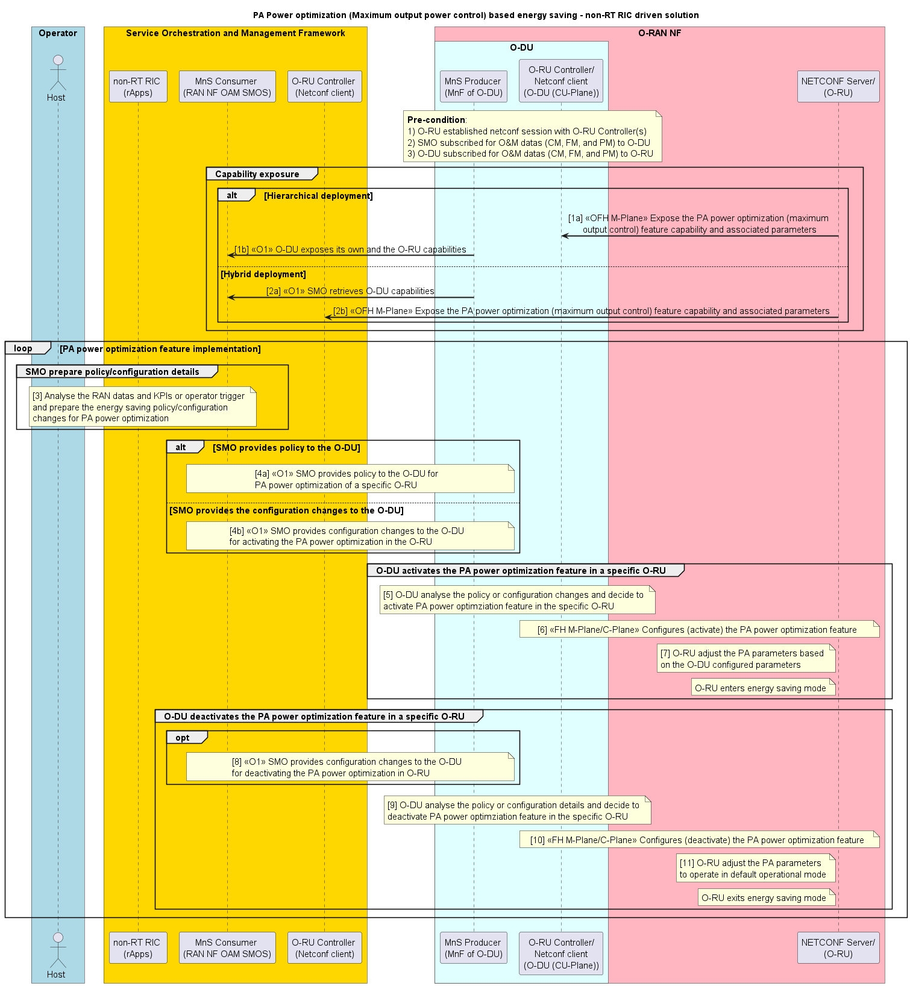
Figure 4.21.3.5.1-1: PA power optimization-based energy saving (method #1): AI/ML inference via Non-RT RIC

4.21.3.5.2 Solution: xApp-based solution (E2-based)
The following entities are applicable to this solution: energy saving xApp, Near-RT RIC/SMO framework, O-DU node and O-RU node.
A solution for PA power optimization-based energy saving: use case through xApp-based solution is captured in table 4.21.3.5.2-1.
Table 4.21.3.5.2-1: PA power optimization: AI/ML inference via Near-RT RIC
Use Case Stage | Evolution / Specification | <<Uses>>  Related use
Goal | Enable PA power optimization energy saving functions in the network by means of configuration parameter change and actions controlled by Near-RT RIC and allow for AI/ML-based solutions.
Actors and Roles | - Energy saving xApp  - Near-RT RIC  - Non-RT RIC/SMO framework  - O-DU node  - O-RU node
Assumptions | - A1 interface connectivity is established between Non-RT RIC of SMO framework and Near-RT RIC.  - E2 interface connectivity is established between network functions (O-DU) and Near-RT RIC.  - Open FH M-plane interface is established between O-DU and O-RU and/or SMO and O-RU directly.  - Network is operational.
Pre-conditions | Operator has set the targets for energy saving functions in Near-RT RIC.
Begins when | Operator enables the optimization functions for PA power optimization energy saving functions, and O-DU and O-RU become operational.
Alt  Step 1a (M) | SMO framework consumes and analyzes the various measurement data like CM, PM, and FM data and KPIs or operator trigger (requested configuration changes). | Use case
Step 1b (M) | Non-RT RIC SMOF prepares A1 policy for Near-RT RIC (xApps) to optimize the PA power consumption of a specific O-RU. | Use case
Step 1c (M) | Non-RT RIC SMOF provides policy prepared in Step 1b, to Near-RT RIC via A1 interface. | Use case
Step 1d (M) | Energy saving xApp constantly monitors  - energy consumption of O-RU(s)  - cell utilization, throughput, and related performance metrics  Near-RT RIC analyzes the A1 policy that it received from Non-RT RIC in Step 1c and the above measurement data. The xApps of Near-RT RIC function prepares the E2 policy or determines the configuration changes that need to be provided to O-DU, for PA power optimization use case. AI/ML inference may be used to make the decision.  The Near-RT RIC provides the E2 policy or configuration changes to O-DU for PA power optimization of a specific O-RU. | Use case
Alt  Step 2a (M) | Energy saving xApp constantly monitors  - energy consumption of O-RU(s)  - cell utilization, throughput, and related performance metrics  Near-RT RIC (xApp) analyzes the above measurement data and KPIs, and prepares the E2 policy or configuration changes for O-DU. | Use case
Step 2b (M) | Near-RT RIC provides the policy or configuration changes (prepared in Step 2a) to O-DU via E2 interface. | O-RAN.WG3.TS.UCR [46], clause 4.6.4;  O-RAN.WG3.TS.E2SM-CCC [47], clause 8.8.2.9;  Use case
Step 3 (M) | O-DU analyzes the policy or configuration changes that it received either in Step 1d or 2b. Once the conditions mentioned in that policy are satisfied or based on the requested configuration changes, the O-DU decides to activate the PA power optimization feature in the O-RU. | Use case
Step 4 (M) | O-DU may send the appropriate commands to the O-RU via fronthaul M-plane or C-plane to activate the PA power optimization. Here, the O-DU configures the appropriate maximum output power based on the traffic scheduling requirements and energy saving policy received from Near-RT RIC via E2 interface. | O-RAN.WG4.MP [28], clause 20.6;  Use case
Step 5 (M) | O-RU adjusts the PA parameters based on the maximum output power configured by the O-DU. Then the O-RU transitions to (PA power optimization) energy saving mode. This is to reduce PA power consumption, thereby improving the O-RU energy efficiency. | Use case
Step 6 (O) | Near-RT RIC analyses the O&M data and KPIs to prepare configuration changes required for O-DU to deactivate the PA power optimization feature and provide them to O-DU via E2 interface. | O-RAN.WG3.TS.UCR [46], clause 4.6.4;  O-RAN.WG3.TS.E2SM-CCC [47], clause 8.8.2.9;  Use case
Step 7 (M) | O-DU analyzes the policy provided by Near-RT RIC in Steps 1d or 2b or configuration changes provided by Near-RT RIC in Step 6. Then the O-DU decides to deactivate the PA power optimization feature in the specific O-RU, i.e., O-DU to configure nominal output power to O-RU. | Use case
Step 8 (O) | O-DU may send the appropriate commands to the O-RU via fronthaul M-plane or C-plane to configure the nominal output power, accordingly O-RU adjusts its PA parameters. This is to deactivate the PA power optimization feature in the O-RU and exit from the energy saving mode. | O-RAN.WG4.MP [28], clause 20.6;  Use case
Ends when | NF node (O-DU) and O-RU become non-operational or when the operator disables the optimization functions for energy saving or when optimization criteria are no longer met.
Exceptions | None.
Post Conditions | Near-RT RIC continues close loop monitoring of energy saving function at NF node (O-DU) and O-RU.  NF node(s) and O-RU(s) operate using the configuration provided by the energy saving xApp via Near-RT RIC.

@startuml
!pragma teoz true
skinparam sequenceArrowThickness 2
skinparam ParticipantPadding 5
skinparam BoxPadding 10
skinparam defaultFontSize 15
skinparam sequenceMessageAlign center
skinparam sequenceMessageAlign center

title PA Power optimization (Maximum output power control) based energy saving - near-RT RIC driven solution
Skin rose

box "Operator" #Lightblue
Actor host as "Host"
End box

Box “Service Orchestration and Management Framework” #gold
participant "MnS Consumer \n(RAN NF OAM SMOS)" as smo
participant "O-RU Controller \n(Netconf client)" as smoru
participant "non-RT RIC \n(rApps)" as rapp
end box

participant "near-RT RIC \n(xApps)" as xapp

box “O-RAN NF” #lightpink
box "O-DU" #lightcyan
participant "E2 termination" as e2odu
participant "O-RU Controller \n (Netconf client)\n(O-DU)" as client
end box
participant "NETCONF Server/\n(O-RU)" as RU
end box

Note over smo, RU
<B>Pre-condition</B>:
1. O-RU established netconf session with O-RU Controller(s)
2. SMO, near-RT RIC, and O-DU aware of O-RU capabilities
3. SMO and near-RT RIC subscribed for O&M datas (CM, FM, and PM) to O-DU
4. O-DU subscribed for O&M datas (CM, FM, and PM) to O-RU
End note

group PA power optimization feature implementation
group Policy or configuration changes preparation for O-DU
alt Non-RT RIC provides A1 policy to near-RT RIC based on RAN datas and KPI for O-DU to optimize the PA power consumption in O-RU
note over host, rapp : [1a] Analyze the O&M datas (CM, PM, and FM) and KPIs or operator trigger
rapp->rapp : [1b] Prepare A1 policy for \nPA power optimization
rapp<->xapp : [1c] <<A1>> Provides policy \nto near-RT RIC
note left xapp : Near-RT RIC prepares E2 policy \nor configuration changes
note over xapp, e2odu : [1d] <<E2>> Provides E2 policy or configuration changes to O-DU
else Near-RT RIC prepares the E2 policy or configuration changes to O-DU for PA power optimization in O-RU
xapp->xapp : [2a] Prepares E2 policy or \nconfiguration changes for O-DU
note over xapp, e2odu : [2b] <<E2>> Provides E2 policy or configuration changes to O-DU
end alt
end group

group O-DU activates the PA power optimization feature in a specific O-RU
note over e2odu, client : [3] O-DU analyze the policy or configuration changes and decide \nto activate PA power optimziation feature in the specific O-RU
note over client, RU : [4] <<FH M-Plane/C-Plane>> Configures (activate) \nthe PA power optimization feature
note left RU : [5] O-RU adjust the PA parameters based \non the O-DU configured parameters
note left RU : O-RU enters energy saving mode
end group
group O-DU deactivates the PA power optimization feature in a specific O-RU
opt
note over xapp, e2odu : [6] <<E2>> Near-RT RIC provides configuration changes to the \nO-DU for deactivating the PA power optimization in O-RU
end opt
note over e2odu, client : [7] O-DU analyze the policy/configuration details and decide to \ndeactivate PA power optimziation feature in the specific O-RU
opt
note over client, RU : [8] <<FH M-Plane/C-Plane>> Configures (deactivate) \nthe PA power optimization feature
end opt
note left RU : O-RU exits energy saving mode
end group
end loop
@enduml

The flow diagram of the PA power optimization using E2-based solution is given in figure 4.21.3.5.2-1.
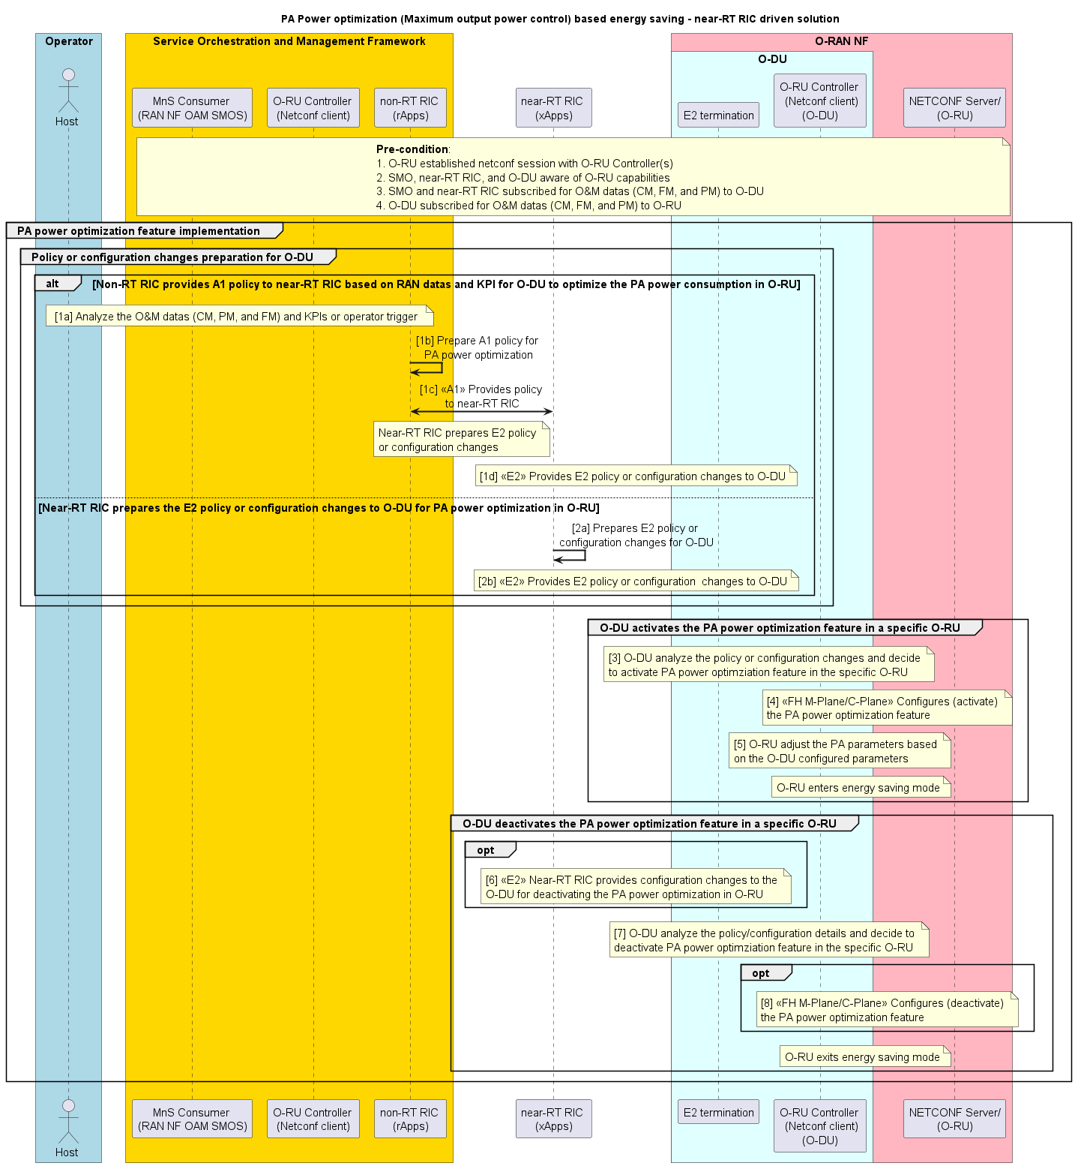
Figure 4.21.3.5.2-1: PA power optimization-based energy saving (method #2): AI/ML inference via Near-RT RIC

4.21.4 Required data

4.21.4.1 Carrier and cell switch off/on

4.21.4.1.1 Solution 1: rApp-based solution
The data requirements for this solution are specified below. The input data specified in table 4.21.4.1.1-1 shall be supported by the associated interfaces specified in the table.
Table 4.21.4.1.1-1: Required input data for energy saving use case
Requirement | Category | Parameters / Measurements | Source | Reference | Interface
Req-4.21.001 | Network load and data performance | DL PDCP SDU data volume per interface (data volume in DL delivered from O-CU-UP to O-DU, per PLMN, per QoS level, per slice, per interface (F1-U, Xn-U, X2-U)) | O-CU | 3GPP TS 28.552 [6], clause 5.1.3.6.2.3 | O1
Req-4.21.002 | Network load and data performance | UL PDCP SDU data volume per interface (data volume in UL delivered to O-CU-UP from O-DU, per PLMN, per QoS level, per slice, per interface (F1-U, Xn-U, X2-U)) | O-CU | 3GPP TS 28.552 [6], clause 5.1.3.6.2.4 | O1
Req-4.21.003 | Network load and data performance | DL Total PRB Usage | O-DU | 3GPP TS 28.552 [6], clause 5.1.1.2.1 | O1
Req-4.21.004 | Network load and data performance | UL Total PRB Usage | O-DU | 3GPP TS 28.552 [6], clause 5.1.1.2.2 | O1
Req-4.21.005 | Network load and data performance | Mean number of Active UEs, per cell (and optionally per PLMN, per slice) | O-DU | 3GPP TS 28.552 [6], clause 5.1.1.23.5 | O1
Req-4.21.006 | Network load and data performance | Average DL UE throughput in gNB per cell (and optionally per PLMN, per QoS level, per slice) | O-DU | 3GPP TS 28.552 [6], clause 5.1.1.3.1 | O1
Req-4.21.007 | Network load and data performance | Average UL UE throughput in gNB per cell (and optionally per PLMN, per QoS level, per slice) | O-DU | 3GPP TS 28.552 [6], clause 5.1.1.3.2 | O1
Req-4.21.008 | UE measurement | RSRQ measurement per SSB per cell | O-CU | 3GPP TS 28.552 [6], clause 5.1.1.31 | O1
Req-4.21.009 | UE measurement | RSRP measurement per SSB per cell | O-CU | 3GPP TS 28.552 [6], clause 5.1.1.22 | O1
Req-4.21.010 | UE measurement | SINR measurement per SSB per cell | O-CU | 3GPP TS 28.552 [6], clause 5.1.1.32 | O1
Req-4.21.011 | Energy consumption | Energy consumption | O-DU, O-RU | 3GPP TS 28.552 [6], clause 5.1.1.19.3 | O1, Open FH M-plane
Req-4.21.012 | Energy consumption | Power consumed by physical network function & its components | O-DU, O-RU | 3GPP TS 28.552 [6], clause 5.1.1.19.2 and in O-RAN.WG4.MP [28], clauses B.1, B.5 | O1, Open FH M-plane
Req-4.21.013 | Energy consumption | Transmit power | O-RU | O-RAN.WG4.MP [28], clauses B.1, B.2.1 | O1, Open FH M-plane
Req-4.21.014 | Topology | Site location and orientation per cell  siteLatitude, siteLongitude, Azimuth / orientation |  | 3GPP TS 28.623 [40]
Req-4.21.015 | Configuration | Carrier frequency per cell  arfcnDL | O-DU | 3GPP TS 28.541 [5], clause 4.3.6 | O1
Req-4.21.016 | Configuration | Carrier bandwidth per cell | O-DU | 3GPP TS 28.541 [5], clause 4.3.6 | O1
Req-4.21.017 | Configuration | cellState | O-DU | 3GPP TS 28.541 [5], clause 4.4.1 | O1

The output data specified in table 4.21.4.1.1-2 shall be supported by the associated interfaces specified in the table.
Table 4.21.4.1.1-2: Required output data for O1-based solution
Requirement | Category | Parameters / Measurements | Target | Reference | Interface
Req-4.21.018 | Carrier(s) or cell(s) indicated for energy saving action | CESManagementFunction | O-CU | 3GPP TS 28.541 [5], clause 4.3.63 | O1

4.21.4.2 RF channel reconfiguration for network energy savings

4.21.4.2.1 Solution: rApp-based solution
The data requirements for this solution are specified below. The input data specified in table 4.21.4.2.1-1 shall be supported by the associated interfaces specified in the table.
Table 4.21.4.2.1-1: Required input data for RF channel reconfiguration-based energy saving use case - O1-based solution
Requirement | Category | Parameters / Measurements | Source | Reference | Interface
Req-4.21.4.2.001 | Network load and data performance | DL PDCP SDU Data Volume per cell | O-CU-UP | O-RAN.WG10.TS.O1PMeas [48], clause A.3.1.22 | O1
Req-4.21.4.2.002 | Network load and data performance | UL PDCP SDU Data Volume per cell | O-CU-UP | O-RAN.WG10.TS.O1PMeas [48], clause A.3.1.19 | O1
Req-4.21.4.2.003 | Network load and data performance | Distribution of DL Total PRB Usage | O-DU | O-RAN.WG10.TS.O1PMeas [48], clause A.4.11.23 | O1
Req-4.21.4.2.004 | Network load and data performance | Distribution of UL Total PRB Usage | O-DU | O-RAN.WG10.TS.O1PMeas [48], clause A.4.11.24 | O1
Req-4.21.4.2.005 | Network load and data performance | Mean number of Active UEs, per cell (and optionally per PLMN, per slice) | O-DU | 3GPP TS 28.552 [6], clause 5.1.1.23.5 | O1
Req-4.21.4.2.006 | Network load and data performance | Distribution of UL UE throughput in gNB | O-DU | O-RAN.WG10.TS.O1PMeas [48], clause A.4.11.33 | O1
Req-4.21.4.2.007 | Network load and data performance | Distribution of DL UE throughput in gNB | O-DU | O-RAN.WG10.TS.O1PMeas [48], clause A.4.11.34 | O1
Req-4.21.4.2.008 | Network load and data performance | TRx Control activation | O-DU | O-RAN.WG10.TS.O1PMeas [48], clause A.4.13.14 | O1
Req-4.21.4.2.009 | Network load and data performance | TRx Control activation failure | O-DU | O-RAN.WG10.TS.O1PMeas [48], clause A.4.13.15 | O1
Req-4.21.4.2.010 | Network load and data performance | TRx Control Cumulative Activity time | O-DU | O-RAN.WG10.TS.O1PMeas [48], clause A.4.13.16 | O1
Req-4.21.4.2.011 | Energy consumption | Energy consumption | O-DU | 3GPP TS 28.552 [6], clause 5.1.1.19.3 | O1
Req-4.21.4.2.012 | Power consumption | Power consumed by physical network function & its components | O-DU | 3GPP TS 28.552 [6], clause 5.1.1.19.2 | O1
Req-4.21.4.2.013 | Configuration | cellState | O-DU | 3GPP TS 28.541 [5], clause 4.4.1 | O1
Req-4.21.4.2.014 | Topology | Site location and orientation per cell  siteLatitude, siteLongitude, Azimuth / orientation | O-DU | 3GPP TS 28.623 [40] | O1
Req-4.21.4.2.015 | Configuration | arfcnDL | O-DU | 3GPP TS 28.541 [5], clause 4.3.6 | O1
Req-4.21.4.2.016 | Configuration | bSChannelBwDL | O-DU | 3GPP TS 28.541 [5], clause 4.3.6 | O1
Req-4.21.4.2.017 | Network load and data performance | DL Total PRB Usage per cell | O-DU | 3GPP TS 28.552 [6],  clause 5.1.1.2.1 | O1
Req-4.21.4.2.018 | Network load and data performance | UL Total PRB Usage per cell | O-DU | 3GPP TS 28.552 [6],  clause 5.1.1.2.2 | O1
Req-4.21.4.2.019 | Network load and data performance | PDSCH PRB Usage per cell for MIMO | O-DU | 3GPP TS 28.552 [6],  clause 5.1.1.2.11 | O1
Req-4.21.4.2.020 | Network load and data performance | PUSCH PRB Usage per cell for MIMO | O-DU | 3GPP TS 28.552 [6],  clause 5.1.1.2.12 | O1
Req-4.21.4.2.021 | Network load and data performance | UE Throughput DL/UL | O-DU | 3GPP TS 28.552 [6], clause 5.1.1.3 | O1
Req-4.21.4.2.022 | Network load and data performance | Cell-level Coverage KPI | O-DU | 3GPP TS 28.552 [6], clauses 5.1.1.7 | O1
Req-4.21.4.2.023 | Network load and data performance | Intra-NRCell SSB Beam switch Measurement | O-DU | 3GPP TS 28.552 [6], clause 5.1.1.21 | O1
Req-4.21.4.2.024 | Network load and data performance | RSRP Measurement | O-DU | 3GPP TS 28.552 [6],  clause 5.1.1.22 | O1
Req-4.21.4.2.025 | Network load and data performance | Active UE per cell (per PLMN/slice) | O-DU | 3GPP TS 28.552 [6],  clause 5.1.1.23.5 | O1
Req-4.21.4.2.026 | Network load and data performance | SSB beam related Measurement | Beam  (O-DU) | 3GPP TS 28.552 [6], clauses 5.1.1.28 | O1
Req-4.21.4.2.027 | Network load and data performance | Transmit power utilization measurements | NRCellDU (O-DU) | 3GPP TS 28.552 [6], clauses 5.1.1.29 | O1
Req-4.21.4.2.028 | Network load and data performance | SS-RSRQ distribution per SSB | Beam  (O-DU) | 3GPP TS 28.552 [6], clauses 5.1.1.31.2 | O1
Req-4.21.4.2.029 | Network load and data performance | MU-MIMO related measurements | NRCellDU (O-DU) | 3GPP TS 28.552 [6], clauses 5.1.1.30 | O1
Req-4.21.4.2.030 | Energy consumption | Energy consumption | O-RU | 3GPP TS 28.552 [6], clause 5.1.1.19.3 | Open FH M-plane
Req-4.21.4.2.031 | Power consumption | Power consumed by physical network function & its component, especially the power amplifier | O-RU | O-RAN.WG4.MP [28], clauses B.1, B.2.1, B.5 | Open FH M-plane
Req-4.21.4.2.032 | Sleep mode details | Supported sleep modes (capabilities) by O-RU | O-RU | O-RAN.WG4.MP [28], clause 20.4.1 | Open FH M-plane
Req-4.21.4.2.033 | Sleep mode details | Minimum and Guaranteed Wakeup | O-RU | O-RAN.WG4.MP [28], clause 20.4.1 | Open FH M-plane
Req-4.21.4.2.034 | TRx Control details | Supported TRx Control masks (antenna masks) (capabilities) by O-RU (TRx Control via Open Fronthaul C-Plane) | O-RU | O-RAN.WG4.MP [28], clause 20.3.1.2 | Open FH M-plane
Req-4.21.4.2.035 | TRx Control details | Supported TRx Control masks (antenna masks) (capabilities) by O-RU (TRx Control via Open Fronthaul M-Plane) | O-RU | O-RAN.WG4.MP [28], clause 20.3.2.2 | Open FH M-plane

The output data specified in table 4.21.4.2.1-2 shall be supported by the associated interfaces specified in the table.
Table 4.21.4.2.1-2: Required output data for RF channel reconfiguration-based energy saving use case - O1-based solution
Requirement | Category | Parameters / Measurements | Target | Reference | Interface
Req-4.21.4.2.101 | NES Policy | NESPolicy | O-DU | O-RAN.WG10.TS.O1NRM [45], clause 5.3.5 | O1
Req-4.21.4.2.102 | NES Policy | NESPolicyRelation | O-DU | O-RAN.WG10.TS.O1NRM [45], clause 5.3.6 | O1
Req-4.21.4.2.103 | NES configuration | NES configuration (Open Fronthaul M-Plane) changes | O-DU, O-RU | O-RAN.WG4.MP [28], clause 20.3.2.3 | Open FH  M-plane
Req-4.21.4.2.104 | NES configuration | NES configuration (Open Fronthaul C-Plane) changes | O-DU, O-RU | O-RAN.WG4.MP [28], clause 20.3.1.3;  O-RAN.WG4.TS.CUS.0-R004 [51], clause 7.4.6, 16, 16.1, 16.2 | Open FH  C-plane

4.21.4.2.2 Solution: rApp/xApp-based solution
The data requirements for this solution are specified below. The input data specified in table 4.21.4.2.2-1 shall be supported by the associated interfaces specified in the table.
Table 4.21.4.2.2-1: Required input data for RF channel reconfiguration-based energy saving use case - A1/E2-based solution
Requirement | Category | Parameters / Measurements | Source | Reference | Interface
Req-4.21.4.2.201 | Network load and data performance | DL PDCP SDU Data Volume per cell | O-CU-UP | O-RAN.WG10.TS.O1PMeas [48], clause A.3.1.22 | O1
Req-4.21.4.2.202 | Network load and data performance | UL PDCP SDU Data Volume per cell | O-CU-UP | O-RAN.WG10.TS.O1PMeas [48], clause A.3.1.19 | O1
Req-4.21.4.2.203 | Network load and data performance | Distribution of DL Total PRB Usage | O-DU | O-RAN.WG10.TS.O1PMeas [48], clause A.4.11.23 | O1
Req-4.21.4.2.204 | Network load and data performance | Distribution of UL Total PRB Usage | O-DU | O-RAN.WG10.TS.O1PMeas [48], clause A.4.11.24 | O1
Req-4.21.4.2.205 | Network load and data performance | Mean number of Active UEs, per cell (and optionally per PLMN, per slice) | O-DU | 3GPP TS 28.552 [6], clause 5.1.1.23.5 | O1
Req-4.21.4.2.206 | Network load and data performance | Distribution of UL UE throughput in gNB | O-DU | O-RAN.WG10.TS.O1PMeas [48], clause A.4.11.33 | O1
Req-4.21.4.2.207 | Network load and data performance | Distribution of DL UE throughput in gNB | O-DU | O-RAN.WG10.TS.O1PMeas [48], clause A.4.11.34 | O1
Req-4.21.4.2.208 | Network load and data performance | TRx Control activation | O-DU | O-RAN.WG10.TS.O1PMeas [48], clause A.4.13.14 | O1
Req-4.21.4.2.209 | Network load and data performance | TRx Control activation failure | O-DU | O-RAN.WG10.TS.O1PMeas [48], clause A.4.13.15 | O1
Req-4.21.4.2.210 | Network load and data performance | TRx Control Cumulative Activity time | O-DU | O-RAN.WG10.TS.O1PMeas [48], clause A.4.13.16 | O1
Req-4.21.4.2.211 | Energy consumption | Energy consumption | O-DU | 3GPP TS 28.552 [6], clause 5.1.1.19.3 | O1
Req-4.21.4.2.212 | Power consumption | Power consumed by physical network function & its components | O-DU | 3GPP TS 28.552 [6], clause 5.1.1.19.2 | O1
Req-4.21.4.2.213 | Configuration | cellState | O-DU | 3GPP TS 28.541 [5], clause 4.4.1 | O1
Req-4.21.4.2.214 | Topology | Site location and orientation per cell  siteLatitude, siteLongitude, Azimuth / orientation | O-DU | 3GPP TS 28.623 [40] | O1
Req-4.21.4.2.215 | Configuration | arfcnDL | O-DU | 3GPP TS 28.541 [5], clause 4.3.6 | O1
Req-4.21.4.2.216 | Configuration | bSChannelBwDL | O-DU | 3GPP TS 28.541 [5], clause 4.3.6 | O1
Req-4.21.4.2.217 | Network load and data performance | DL Total PRB Usage per cell | O-DU | 3GPP TS 28.552 [6],  clause 5.1.1.2.1 | O1
Req-4.21.4.2.218 | Network load and data performance | UL Total PRB Usage per cell | O-DU | 3GPP TS 28.552 [6],  clause 5.1.1.2.2 | O1
Req-4.21.4.2.219 | Network load and data performance | PDSCH PRB Usage per cell for MIMO | O-DU | 3GPP TS 28.552 [6],  clause 5.1.1.2.11 | O1
Req-4.21.4.2.220 | Network load and data performance | PUSCH PRB Usage per cell for MIMO | O-DU | 3GPP TS 28.552 [6],  clause 5.1.1.2.12 | O1
Req-4.21.4.2.221 | Network load and data performance | UE Throughput DL/UL | O-DU | 3GPP TS 28.552 [6], clause 5.1.1.3 | O1
Req-4.21.4.2.222 | Network load and data performance | Cell-level Coverage KPI | O-DU | 3GPP TS 28.552 [6], clauses 5.1.1.7 | O1
Req-4.21.4.2.223 | Network load and data performance | Intra-NRCell SSB Beam switch Measurement | O-DU | 3GPP TS 28.552 [6], clause 5.1.1.21 | O1
Req-4.21.4.2.224 | Network load and data performance | RSRP Measurement | O-DU | 3GPP TS 28.552 [6],  clause 5.1.1.22 | O1
Req-4.21.4.2.225 | Network load and data performance | Active UE per cell (per PLMN/slice) | O-DU | 3GPP TS 28.552 [6],  clause 5.1.1.23.5 | O1
Req-4.21.4.2.226 | Network load and data performance | SSB beam related Measurement | Beam  (O-DU) | 3GPP TS 28.552 [6], clauses 5.1.1.28 | O1
Req-4.21.4.2.227 | Network load and data performance | Transmit power utilization measurements | NRCellDU (O-DU) | 3GPP TS 28.552 [6], clauses 5.1.1.29 | O1
Req-4.21.4.2.228 | Network load and data performance | SS-RSRQ distribution per SSB | Beam  (O-DU) | 3GPP TS 28.552 [6], clauses 5.1.1.31.2. | O1
Req-4.21.4.2.229 | Network load and data performance | MU-MIMO related measurements | NRCellDU (O-DU) | 3GPP TS 28.552 [6], clauses 5.1.1.30 | O1
Req-4.21.4.2.230 | Energy consumption | Energy consumption | O-RU | 3GPP TS 28.552 [6], clause 5.1.1.19.3 | Open FH M-plane
Req-4.21.4.2.231 | Power consumption | Power consumed by physical network function & its component, especially the power amplifier | O-RU | O-RAN.WG4.MP [28], clauses B.1, B.2.1, B.5 | Open FH M-plane
Req-4.21.4.2.232 | Sleep mode details | Supported sleep modes (capabilities) by O-RU | O-RU | O-RAN.WG4.MP [28], clause 20.4.1 | Open FH M-plane
Req-4.21.4.2.233 | Sleep mode details | Minimum and Guaranteed Wakeup | O-RU | O-RAN.WG4.MP [28], clause 20.4.1 | Open FH M-plane
Req-4.21.4.2.234 | TRx Control details | Supported TRx Control masks (antenna masks) (capabilities) by O-RU (TRx Control via Open Fronthaul C-Plane) | O-RU | O-RAN.WG4.MP [28], clause 20.3.1.2 | Open FH M-plane
Req-4.21.4.2.235 | TRx Control details | Supported TRx Control masks (antenna masks) (capabilities) by O-RU (TRx Control via Open Fronthaul M-Plane) | O-RU | O-RAN.WG4.MP [28], clause 20.3.2.2 | Open FH M-plane

NOTE: There is no O1 output.

4.21.4.3 Advanced Sleep Mode for network energy savings

4.21.4.3.1 Solution: rApp-based solution
The data requirements for this solution are specified below. The input data specified in table 4.21.4.3.1-1 shall be supported by the associated interfaces specified in the table.

Table 4.21.4.3.1-1: Required input data for Advanced Sleep Mode-based energy saving use case - O1-based solution
Requirement | Category | Parameters / Measurements | Source | Reference | Interface
Req-4.21.4.3.001 | Network load and data performance | DL PDCP SDU Data Volume per cell | O-CU-UP | O-RAN.WG10.TS.O1PMeas [48], clause A.3.1.22 | O1
Req-4.21.4.3.002 | Network load and data performance | UL PDCP SDU Data Volume per cell | O-CU-UP | O-RAN.WG10.TS.O1PMeas [48], clause A.3.1.19 | O1
Req-4.21.4.3.003 | Network load and data performance | Distribution of DL Total PRB Usage | O-DU | O-RAN.WG10.TS.O1PMeas [48], clause A.4.11.23 | O1
Req-4.21.4.3.004 | Network load and data performance | Distribution of UL Total PRB Usage | O-DU | O-RAN.WG10.TS.O1PMeas [48], clause A.4.11.24 | O1
Req-4.21.4.3.005 | Network load and data performance | Mean number of Active UEs, per cell (and optionally per PLMN, per slice) | O-DU | 3GPP TS 28.552 [6], clause 5.1.1.23.5 | O1
Req-4.21.4.3.006 | Network load and data performance | Distribution of UL UE throughput in gNB | O-DU | O-RAN.WG10.TS.O1PMeas [48], clause A.4.11.33 | O1
Req-4.21.4.3.007 | Network load and data performance | Distribution of DL UE throughput in gNB | O-DU | O-RAN.WG10.TS.O1PMeas [48], clause A.4.11.34 | O1
Req-4.21.4.3.008 | Network load and data performance | Advanced Sleep Mode activation | O-DU | O-RAN.WG10.TS.O1PMeas [48], clause A.4.13.17 | O1
Req-4.21.4.3.009 | Network load and data performance | Advanced Sleep Mode activation failure | O-DU | O-RAN.WG10.TS.O1PMeas [48], clause A.4.13.18 | O1
Req-4.21.4.3.010 | Network load and data performance | Advanced Sleep Mode Cumulative Activity time | O-DU | O-RAN.WG10.TS.O1PMeas [48], clause A.4.13.19 | O1
Req-4.21.4.3.011 | Energy consumption | Energy consumption | O-DU | 3GPP TS 28.552 [6], clause 5.1.1.19.3 | O1
Req-4.21.4.3.012 | Power consumption | Power consumed by physical network function & its components | O-DU | 3GPP TS 28.552 [6], clause 5.1.1.19.2 | O1
Req-4.21.4.3.013 | Configuration | cellState | O-DU | 3GPP TS 28.541 [5], clause 4.4.1 | O1
Req-4.21.4.3.014 | Topology | Site location and orientation per cell  siteLatitude, siteLongitude, Azimuth / orientation | O-DU | 3GPP TS 28.623 [40] | O1
Req-4.21.4.3.015 | Configuration | arfcnDL | O-DU | 3GPP TS 28.541 [5], clause 4.3.6 | O1
Req-4.21.4.3.016 | Configuration | bSChannelBwDL | O-DU | 3GPP TS 28.541 [5], clause 4.3.6 | O1
Req-4.21.4.3.017 | Network load and data performance | DL Total PRB Usage per cell | O-DU | 3GPP TS 28.552 [6],  clause 5.1.1.2.1 | O1
Req-4.21.4.3.018 | Network load and data performance | UL Total PRB Usage per cell | O-DU | 3GPP TS 28.552 [6],  clause 5.1.1.2.2 | O1
Req-4.21.4.3.019 | Network load and data performance | UE Throughput DL/UL | O-DU | 3GPP TS 28.552 [6], clause 5.1.1.3 | O1
Req-4.21.4.3.020 | Network load and data performance | Cell-level Coverage KPI | O-DU | 3GPP TS 28.552 [6], clauses 5.1.1.7 | O1
Req-4.21.4.3.021 | Network load and data performance | Intra-NRCell SSB Beam switch Measurement | O-DU | 3GPP TS 28.541 [5], clause 5.1.1.21 | O1
Req-4.21.4.3.022 | Network load and data performance | Active UE per cell (per PLMN/slice) | O-DU | 3GPP TS 28.552 [6],  clause 5.1.1.23.5 | O1
Req-4.21.4.3.023 | Energy consumption | Energy consumption | O-RU | 3GPP TS 28.552 [6], clause 5.1.1.19.3 | Open FH M-plane
Req-4.21.4.3.024 | Power consumption | Power consumed by physical network function & its component, especially the power amplifier | O-RU | O-RAN.WG4.MP [28], clauses B.1, B.2.1, B.5 | Open FH M-plane
Req-4.21.4.3.025 | Sleep mode details | Supported sleep modes (capabilities) by O-RU | O-RU | O-RAN.WG4.MP [28], clause 20.4.1 | Open FH M-plane
Req-4.21.4.3.026 | Sleep mode details | Minimum and Guaranteed Wakeup | O-RU | O-RAN.WG4.MP [28], clause 20.4.1 | Open FH M-plane

The output data specified in table 4.21.4.3.1-2 shall be supported by the associated interfaces specified in the table.
Table 4.21.4.3.1-2: Required output data for Advanced Sleep Mode-based energy saving use case - O1-based solution
Requirement | Category | Parameters / Measurements | Target | Reference | Interface
Req-4.21.4.3.101 | NES Policy | NESPolicy | O-DU | O-RAN.WG10.TS.O1NRM [45], clause 5.3.5 | O1
Req-4.21.4.3.102 | NES configuration | NESPolicyRelation | O-DU | O-RAN.WG10.TS.O1NRM [45], clause 5.3.6 | O1
Req-4.21.4.3.103 | NES configuration | NES configuration (FH M-Plane) changes | O-DU, O-RU | O-RAN.WG4.MP [28], clause 20.5 | Open FH  M-plane
Req-4.21.4.3.104 | NES configuration | NES configuration (FH C-Plane) changes | O-DU, O-RU | O-RAN.WG4.MP [28], clause 20.4.2;  O-RAN.WG4.TS.CUS.0-R004 [51], clause 7.4.6, 16, 16.1, 16.2. | Open FH  C-plane

4.21.4.3.2 Solution: rApp/xApp-based solution
The data requirements for this solution are specified below. The input data specified in table 4.21.4.3.2-1 shall be supported by the associated interfaces specified in the table.

Table 4.21.4.3.2-1: Required input data for Advanced Sleep Mode-based energy saving use case - A1/E2-based solution
Requirement | Category | Parameters / Measurements | Source | Reference | Interface
Req-4.21.4.3.201 | Network load and data performance | DL PDCP SDU Data Volume per cell | O-CU-UP | O-RAN.WG10.TS.O1PMeas [48], clause A.3.1.22 | O1
Req-4.21.4.3.202 | Network load and data performance | UL PDCP SDU Data Volume per cell | O-CU-UP | O-RAN.WG10.TS.O1PMeas [48], clause A.3.1.19 | O1
Req-4.21.4.3.203 | Network load and data performance | Distribution of DL Total PRB Usage | O-DU | O-RAN.WG10.TS.O1PMeas [48], clause A.4.11.23 | O1
Req-4.21.4.3.204 | Network load and data performance | Distribution of UL Total PRB Usage | O-DU | O-RAN.WG10.TS.O1PMeas [48], clause A.4.11.24 | O1
Req-4.21.4.3.205 | Network load and data performance | Mean number of Active UEs, per cell (and optionally per PLMN, per slice) | O-DU | 3GPP TS 28.552 [6], clause 5.1.1.23.5 | O1
Req-4.21.4.3.206 | Network load and data performance | Distribution of UL UE throughput in gNB | O-DU | O-RAN.WG10.TS.O1PMeas [48], clause A.4.11.33 | O1
Req-4.21.4.3.207 | Network load and data performance | Distribution of DL UE throughput in gNB | O-DU | O-RAN.WG10.TS.O1PMeas [48], clause A.4.11.34 | O1
Req-4.21.4.3.208 | Network load and data performance | Advanced Sleep Mode activation | O-DU | O-RAN.WG10.TS.O1PMeas [48], clause A.4.13.17 | O1
Req-4.21.4.3.209 | Network load and data performance | Advanced Sleep Mode activation failure | O-DU | O-RAN.WG10.TS.O1PMeas [48], clause A.4.13.18 | O1
Req-4.21.4.3.210 | Network load and data performance | Advanced Sleep Mode Cumulative Activity time | O-DU | O-RAN.WG10.TS.O1PMeas [48], clause A.4.13.19 | O1
Req-4.21.4.3.211 | Energy consumption | Energy consumption | O-DU | 3GPP TS 28.552 [6], clause 5.1.1.19.3 | O1
Req-4.21.4.3.212 | Power consumption | Power consumed by physical network function & its components | O-DU | 3GPP TS 28.552 [6], clause 5.1.1.19.2 | O1
Req-4.21.4.3.213 | Configuration | cellState | O-DU | 3GPP TS 28.541 [5], clause 4.4.1 | O1
Req-4.21.4.3.214 | Topology | Site location and orientation per cell  siteLatitude, siteLongitude, Azimuth / orientation | O-DU | 3GPP TS 28.623 [40] | O1
Req-4.21.4.3.215 | Configuration | arfcnDL | O-DU | 3GPP TS 28.541 [5], clause 4.3.6 | O1
Req-4.21.4.3.216 | Configuration | bSChannelBwDL | O-DU | 3GPP TS 28.541 [5], clause 4.3.6 | O1
Req-4.21.4.3.217 | Network load and data performance | DL Total PRB Usage per cell | O-DU | 3GPP TS 28.552 [6],  clause 5.1.1.2.1 | O1
Req-4.21.4.3.218 | Network load and data performance | UL Total PRB Usage per cell | O-DU | 3GPP TS 28.552 [6],  clause 5.1.1.2.2 | O1
Req-4.21.4.3.219 | Network load and data performance | UE Throughput DL/UL | O-DU | 3GPP TS 28.552 [6], clause 5.1.1.3 | O1
Req-4.21.4.3.220 | Network load and data performance | Cell-level Coverage KPI | O-DU | 3GPP TS 28.552 [6], clauses 5.1.1.7 | O1
Req-4.21.4.3.221 | Network load and data performance | Intra-NRCell SSB Beam switch Measurement | O-DU | 3GPP TS 28.541 [5], clause 5.1.1.21 | O1
Req-4.21.4.3.222 | Network load and data performance | Active UE per cell (per PLMN/slice) | O-DU | 3GPP TS 28.552 [6],  clause 5.1.1.23.5 | O1
Req-4.21.4.3.223 | Energy consumption | Energy consumption | O-RU | 3GPP TS 28.552 [6], clause 5.1.1.19.3 | Open FH M-plane
Req-4.21.4.3.224 | Power consumption | Power consumed by physical network function & its component, especially the power amplifier | O-RU | O-RAN.WG4.MP [28], clauses B.1, B.2.1, B.5 | Open FH M-plane
Req-4.21.4.3.225 | Sleep mode details | Supported sleep modes (capabilities) by O-RU | O-RU | O-RAN.WG4.MP [28], clause 20.4.1 | Open FH M-plane
Req-4.21.4.3.226 | Sleep mode details | Minimum and Guaranteed Wakeup | O-RU | O-RAN.WG4.MP [28], clause 20.4.1 | Open FH M-plane

NOTE: There is no O1 output.

4.21.4.4 External power source coordination-based energy saving

4.21.4.4.1 Solution: rApp-based solution
The data requirements for this solution are specified below. The input data specified in table 4.21.4.4.1-1 shall be supported by the associated interfaces specified in the table.
Table 4.21.4.4.1-1: Required input data for external power source coordination-based energy saving use case
Category | Parameters / Measurements | Source | Reference | Interface
Energy supply information | energySupplyMode | SMO | 3GPP TS 28.310 [43], clause 8.3.1.2 | O1
Energy supply information | energySourceList | SMO | 3GPP TS 28.310 [43], clause 8.3.1.2 | O1
Energy source information | energySourceType | SMO | 3GPP TS 28.310 [43], clause 8.3.2.2 | O1
Energy source information | energySourceCef | SMO | 3GPP TS 28.310 [43], clause 8.3.2.2 | O1
Energy source information | renewableEnergy | SMO | 3GPP TS 28.310 [43], clause 8.3.2.2 | O1
Energy source information | energyCompositionPercentage | SMO | 3GPP TS 28.310 [43], clause 8.3.2.2 | O1
Energy information group | energySupplyModeRefList | SMO | 3GPP TS 28.310 [43], clause 8.3.3.2 | O1
Energy information group | memberDNList | SMO | 3GPP TS 28.310 [43], clause 8.3.3.2 | O1
Energy supply information | energySupplyMode  This attribute/parameter to be specified according to the FH M-Plane yang model schema. | O-DU,  O-RU | O-RAN.WG4.MP [28] | Open FH M-plane
Energy supply information | energySourceList  This attribute/parameter to be specified according to the FH M-Plane yang model schema. | O-DU,  O-RU | O-RAN.WG4.MP [28] | Open FH M-plane
Energy source information | energySourceType  This attribute/parameter to be specified according to the FH M-Plane yang model schema. | O-DU,  O-RU | O-RAN.WG4.MP [28] | Open FH M-plane
Energy source information | energySourceCef  This attribute/parameter to be specified according to the FH M-Plane yang model schema. | O-DU,  O-RU | O-RAN.WG4.MP [28] | Open FH M-plane
Energy source information | renewableEnergy  This attribute/parameter to be specified according to the FH M-Plane yang model schema. | O-DU,  O-RU | O-RAN.WG4.MP [28] | Open FH M-plane
Energy source information | energyCompositionPercentage  This attribute/parameter to be specified according to the FH M-Plane yang model schema. | O-DU,  O-RU | O-RAN.WG4.MP [28] | Open FH M-plane
Energy consumption | Energy consumption | O-DU | 3GPP TS 28.552 [6], clause 5.1.1.19.3 | O1
Energy consumption | Energy consumption | O-RU | 3GPP TS 28.552 [6], clause 5.1.1.19.3 | Open FH M-plane
Energy consumption | Power consumed by physical network function & its components | O-DU | 3GPP TS 28.552 [6], clause 5.1.1.19.2 | O1
Energy consumption | Power consumed by physical network function & its components | O-RU | O-RAN.WG4.MP [28], clauses B.1, B.5 | Open FH M-plane
Power consumption | Power consumption | O-RU | O-RAN.WG4.MP [28], clauses B.1, B.2.1 | Open FH M-plane
Configuration | cellState | O-DU | 3GPP TS 28.541 [5], clause 4.4.1 | O1

The output data specified in table 4.21.4.4.1-2 shall be supported by the associated interfaces specified in the table.
Table 4.21.4.4.1-2: Required output data for O1-based solution
Category | Parameters / Measurements | Target | Reference | Interface
NES Policy | NESPolicy | O-DU | O-RAN.WG10.TS.O1NRM [45], clause 5.3.5 | O1
NES configuration | NES configuration changes | O-DU | O-RAN.WG10.TS.O1NRM [45], clause 5.3.6 | O1
NES configuration | NES configuration changes | O-DU, O-RU | O-RAN.WG4.MP [28], clause 20 | Open FH  M-plane
NES configuration | NES configuration (FH C-Plane) changes | O-DU, O-RU | O-RAN.WG4.TS.CUS.0-R004 [51], clause 16 | Open FH  C-plane
Energy Source configuration | Energy source configuration changes to be specified | O-DU | O-RAN.WG10.TS.O1NRM [45] | O1
Energy Source configuration | Energy source configuration changes to be specified | O-RU | O-RAN.WG4.MP [28] | Open FH M-plane

4.21.4.5 PA power optimization-based energy saving

4.21.4.5.1 Solution: rApp/xApp-based solution
The data requirements for this solution are specified below. The input data specified in table 4.21.4.5.1-1 shall be supported by the associated interfaces specified in the table.

Table 4.21.4.5.1-1: Required input data for PA power optimization-based energy saving use case
Category | Parameters / Measurements | Source | Reference | Interface
Performance measurements | O-CU-UP Performance measurements | O-CU-UP | O-RAN.WG10.TS.O1PMeas [48], clause A.3 | O1
Performance measurements | O-DU Performance measurements | O-DU | O-RAN.WG10.TS.O1PMeas [48], clauses A.4.1 to A.4.12 | O1
Energy consumption | Energy consumption | O-DU | 3GPP TS 28.552 [6], clause 5.1.1.19.3 | O1
Energy consumption | Energy consumption | O-RU | 3GPP TS 28.552 [6], clause 5.1.1.19.3 | Open FH M-plane
Energy consumption | Power consumed by physical network function & its components | O-DU | 3GPP TS 28.552 [6], clause 5.1.1.19.2 | O1
Energy consumption | Power consumed by physical network function & its component, especially the power amplifier | O-RU | O-RAN.WG4.MP [28], clauses B.1, B.5 | Open FH M-plane
Power consumption | Power consumption | O-RU | O-RAN.WG4.MP [28], clauses B.1, B.2.1 | Open FH M-plane
Configuration | cellState | O-DU | 3GPP TS 28.541 [5], clause 4.4.1 | O1
Transmitted data volume | DL Transmitted Data Volume (RLC SDU) | O-DU (NRCELLDU) | O-RAN.WG3.TS.E2SM-KPM [49], clause 7.10.1 | E2
Percentage of data volume distribution | Distribution of Percentage of DL Transmitted Data Volume to Incoming Data Volume | O-DU (NRCELLDU) | O-RAN.WG3.TS.E2SM-KPM [49], clause 7.10.3 | E2
Total number of scheduled time slots | Cell-specific DL Total transmission time duration | O-DU (NRCELLDU) | O-RAN.WG3.TS.E2SM-KPM [49], clause 7.10.10.1 | E2
Total number of scheduled time slots | Cell-specific downlink total failed transmission time duration | O-DU (NRCELLDU) | O-RAN.WG3.TS.E2SM-KPM [49], clause 7.10.10.2 | E2
Total number of scheduled time slots | Cell-specific downlink retransmission time duration | O-DU (NRCELLDU) | O-RAN.WG3.TS.E2SM-KPM [49], clause 7.10.10.3 | E2
Total number of scheduled time slots | Cell-specific downlink total SU-MIMO transmission time duration | O-DU (NRCELLDU) | O-RAN.WG3.TS.E2SM-KPM [49], clause 7.10.10.4 | E2
Total number of scheduled time slots | Cell-specific downlink total MU-MIMO transmission time duration | O-DU (NRCELLDU) | O-RAN.WG3.TS.E2SM-KPM [49], clause 7.10.10.5 | E2
Transmitted data volume | DL Transmitted Data Volume (MAC SDU) | O-DU (NRCELLDU) | O-RAN.WG3.TS.E2SM-KPM [49], clause 7.10.11 | E2

The output data specified in table 4.21.4.5.1-2 shall be supported by the associated interfaces specified in the table.
Table 4.21.4.5.1-2: Required output data for PA power optimization-based energy saving use case
Category | Parameters / Measurements | Target | Reference | Interface
NES Policy | NESPolicy - PA power optimization related attributes to be specified. | O-DU | O-RAN.WG10.TS.O1NRM [45] | O1
NES configuration | NES configuration changes - PA power optimization related attributes to be specified. | O-DU | O-RAN.WG10.TS.O1NRM [45] | O1
NES configuration | NES configuration (FH M-Plane) changes | O-DU, O-RU | O-RAN.WG4.MP [28], clause 20.6 | Open FH  M-plane
NES configuration | NES configuration (FH C-Plane) changes - To be specified. | O-DU, O-RU | O-RAN.WG4.TS.CUS.0-R004 [51] | Open FH  C-plane
NES configuration | Constraints | O-DU,  O-RU | O-RAN.WG4.TS.CUS.0-R004 [51], clause 8.1.3.3 | Open FH  C-plane
NES configuration | PRB blanking optimization | O-DU | O-RAN.WG3.TS.UCR [46], clause 4.6.4. | E2
PRB blanking policy | O-PRBBlankingPolicy | O-DU | O-RAN.WG3.TS.E2SM-CCC [47], clause 8.8.2.9. | E2

4.22 MU-MIMO optimization
This use case provides motivation, description, and requirements for a near-real-time MU-MIMO optimization control loop deployment. Deploying MU-MIMO application in the Near-RT RIC enables new solutions that can optimize UE and cell level performance in certain deployments by e.g. deriving channel estimation/prediction and UEs selections with their associated precoding coefficients, resulting in increased per UE and overall cell throughput.

4.22.1 Background and goal of the use case
MU-MIMO is one of the key technologies available for increasing UE and cell capacities using existing time/frequency resources. The use of multiple antennas enables the pointing of beams to multiple UEs with each beam spatially filtering the interference from the other beams. This has the potential to provide higher total cell capacity when there are multiple eNB/gNB antennas.
In a commercial deployment, some subscribers can be stationary, some can be pedestrian moving slowly, and some can be moving at high speed. Traditional MU-MIMO solutions are very sensitive to subscriber’s mobility and as a result the capacity gains achieved with multiple antennas is limited.
New beamforming solutions are emerging that support MU-MIMO with less time sensitivity allowing them to be implemented in the Near-RT RIC. These solutions are applicable to both downlink and uplink data channels and to TDD as well as FDD and can provide high user and cell performance for subscribers moving within a wide range of speeds.
The objective of this use case is to allow the operator to improve user throughput and overall cell capacity by deploying an application in the Near-RT RIC that can use information collected from the E2 nodes to calculate and send to the E2 nodes user selections and applicable precoding coefficients in a near real time loop. This use case will also open the door for future expansion of the MU-MIMO to supporting CoMP covering both ICIC and joint multi sites MU-MIMO.

4.22.2 Entities/resources involved in the use case
- Near-RT RIC
  - Retrieve cell configuration and UE states from E2 nodes
  - Send configurations for DL channel estimation reporting and UL SRS and DMRS to the E2 nodes
  - Retrieve DL/UL traffic, and DL/UL channel quality information from E2 nodes
  - Use the retrieved information to select the UEs to be spatially multiplexed per frequency and time resources and for each selection calculate the relevant MCS and precoder coefficients for optimal UE and cell throughput
  - Send the recommended UE selections with their resource assignments, MCS, and precoding coefficients to the E2 nodes.
- E2 nodes
  - Collect and report to Near-RT RIC information related to cell configuration, UE states, DL/UL traffic, and DL/UL channel quality.
  - Apply the configurations received from the Near-RT RIC for DL channel estimation reporting and UL SRS transmissions
  - Apply MU-MIMO parameters following Near-RT RIC recommendations (while handling time critical events separately).

4.22.3 Solutions

4.22.3.1 MU-MIMO optimization
The context of MU-MIMO optimization is captured in table 4.22.3.1-1.
Table 4.22.3.1-1: MU-MIMO optimization
Use Case Stage | Evolution / Specification | <<Uses>>  Related use
Goal | MU-MIMO optimization using Near-RT RIC control loop.
Actors and Roles | Near-RT RIC: Configures E2 nodes’ measurements, collects data from E2 nodes, performs MU-MIMO optimization function, and sends MIMO recommendations to E2 nodes.  E2 nodes: Report measurements to Near-RT RIC and execute MU-MIMO recommendations.
Assumptions | E2 connectivity is established between Near-RT RIC and E2 nodes. Network is operational.
Pre-conditions | All relevant functions and components are instantiated. MU-MIMO optimization xApp is deployed with initial configuration  All relevant subscriptions established on E2 interface.
Begins when | Pre-conditions are met.
Step 1 (M) | Near-RT RIC initiates data collection from E2 nodes (cell configuration, UE states, RRC connection, UL/DL traffic and channel information).
Step 2 (M) | E2 nodes send cell configuration, UE states, and RRC connection information to Near-RT RIC.
Step 3 (M) | E2 nodes send UL/DL traffic and channel information to Near-RT RIC.
Step 4 (O) | Near-RT RIC sends DL channel estimation reporting and UL SRS and DMRS configuration to E2 nodes.
Step 5 (M) | E2 nodes continuously send UL/DL traffic and channel information to Near-RT RIC.
Step 6 (M) | E2 nodes send updated UE states and RRC connections information to Near-RT RIC.
Step 7 (M) | Near-RT RIC uses the collected information to estimate channels and select UE groupings per ranges of frequency and time resources
Step 8 (M) | Near-RT RIC calculates MCS and precoding coefficients for each selection of UEs.
Step 9 (M) | Near-RT RIC sends optimized MU-MIMO parameters (UE selections with their resource assignments, MCS, and precoding coefficients) to E2 nodes.
Step 10 (M) | E2 nodes schedule MU-MIMO transmissions using the parameters received from the Near-RT RIC.
Step 11 (O) | Near-RT RIC sends updated DL channel estimation reporting and UL SRS and DMRS configuration to E2 nodes.
Ends when | Operator disables or uninstalls MU-MIMO optimization xApp.
Exceptions | None identified.
Post Conditions | The E2 nodes operate using the newly received parameters.
@startuml
skin rose
skinparam ParticipantPadding 5
skinparam BoxPadding 10
skinparam defaultFontSize 12
Autonumber

Box “O-RAN” #lightpink
Participant NearRTRIC as “Near-RT RIC”
Participant E2nodes as “O-CU/O-DU”
End box

NearRTRIC->E2nodes: <<E2>> Initiate data collection
E2nodes->NearRTRIC: <<E2>> Cell configuration, UE state, and RRC connection information
E2nodes->NearRTRIC: <<E2>> UL/DL traffic and channel information
group opt
NearRTRIC->E2nodes: <<E2>> DL channel estimation reporting and UL SRS and DMRS configuration
end

group MU-MIMO Optimization Loop
E2nodes->NearRTRIC: <<E2>> UL/DL traffic and channel information
E2nodes->NearRTRIC: <<E2>> RRC connections and UE states update
NearRTRIC->NearRTRIC: UE selections and Channel estimation
NearRTRIC->NearRTRIC: MU-MIMO parameters calculations
NearRTRIC->E2nodes: <<E2>> Optimized MU-MIMO parameters
E2nodes->E2nodes: Schedule MU-MIMO transmissions\nusing received parameters
group opt
NearRTRIC->E2nodes: <<E2>> Updated DL channel estimation reporting and UL SRS and DMRS configuration
end
end
@enduml

The flow diagram of MU-MIMO optimization is given in figure 4.22.3.1-1.
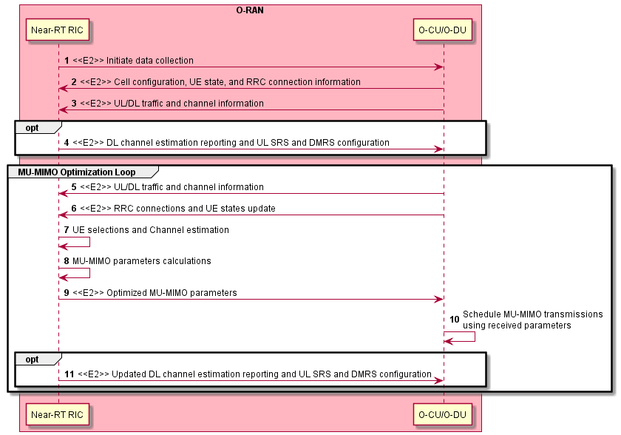
Figure 4.22.3.1-1: MU-MIMO optimization flow diagram

4.22.4 Required data
The Near-RT RIC requires different types of data from the E2 nodes as summarized below with examples:
- Cell configuration information (e.g., frequency and BW, FDD/TDD, SCS, UL-DL configuration)
- List of connected UEs
- UE connection updates (setup, release, handover)
- UE RRC state changes (connected, inactive, idle)
- UL channel information (e.g., SRS, ACK/NACK counts)
- DL channel information (e.g., CQI, RI, PMI, ACK/NACK counts)
- DL PDCP and RLC buffer status and UL BSR

4.23 Sharing Non-RT RIC data with the core
Void

4.24 Industrial vision SLA assurance
This use case provides the background and motivation for the O-RAN architecture to support industrial vision Service-Level Agreement (SLA) assurance. Moreover, some high-level description and requirements over Non-RT RIC, A1 and E2 interfaces are introduced.

4.24.1 Background and goal of the use case
Industrial vision is an image recognition technology used for work piece inspecting, processing and assembling automation, as well as the monitoring and controlling of production process by replacing human eyes with cameras for various measurements and judgments. The main feature of industrial vision system is that it needs to collect the images of the products to be tested or processed in the area with dense production lines, and then transmit the images to the vision server for detection and feed back the results.
Because the industrial vision system shall accommodate to the production speed of the production line, there are strict delay and reliability requirements for visual acquisition, transmission, judgment and execution. For example, a production line which processes 8000 work pieces per hour has an operation interval of 450ms for each product in the production line. Considering the image recognition, results execution time and the mechanical execution time, the two-way data transmission delay left for the transmission network is even less. When 5G is applied in the industrial vision business scenario, the main challenge is the assurance of image data transmission delay and reliability of 5G wireless network in an ultra-dense networking environment.
5G pre-scheduling technology is introduced to reduce the transmission delay and improve the transmission reliability. However, the traditional static pre-scheduling mechanism could not adapts to changing production environments. It always allocates fixed air interface resource according to the static configuration, regardless of the actual data arrival, resulting mis-alignment of resource allocation and uplink transmission needs, causing increased and unstable delay, waste of PRB resources and significant decline in the actual bearable traffic of the cell.
Therefore, dynamic pre-scheduling, which allocates uplink resources according to actual work piece arrival time, is deemed to be a more efficient way to enable industrial vision deployment in production line. In O-RAN, RIC can be used to dynamically optimize the pre-scheduling parameters, so that accurate matching between uplink data arrival and uplink transmission resource allocation could be achieved. This helps to reduce uplink transmission delay and improve the resource efficiency.
With enrichment information from application server/Manufacturing Execution System (MES), e.g., production-line and industrial camera configuration and image transmission delay related data, Near-RT RIC can calculate and iteratively update pre-scheduling parameter (e.g., pre-scheduling data size, pre-scheduling period and pre-scheduling start time), and send those parameters to E2 nodes vis E2 interface. Note that the configured parameters mentioned above only serve as scheduling recommendations to E2 nodes. Actual PRB scheduling depends on many other factors not captured by this use case. E2 node might for instance supersede Near-RT RIC’s recommendation in case high priority delay critical data needs to be scheduled.
One example method to transmit Non-RAN application server/MES data into Non-RT RIC is through SMO external interface. Application server/MES is registered as SMO external system, which serves as a data source outside the O-RAN domain that provides data to the SMO. By leveraging SMO external interface (the interface between the SMO and an SMO external system), production-line and industrial camera configuration and image transmission delay related data is transmitted to SMO as enrichment information, which is consumed by Non-RT RIC and bypassed to Near-RT RIC through A1.

4.24.2 Entities/resources involved in the use case
- Non-RT RIC:
  - Support communication of non-RAN data to enrich control functions in Near-RT RIC (enrichment information).
- Near-RT RIC:
  - Support communication of pre-scheduling configuration parameters to E2 node.
- E2 node:
  - Support pre-scheduling parameters configuration over E2 interface.
  - Report necessary performance, configuration, and other data for performing pre-scheduling parameter configuration in the Near-RT RIC over E2 interface.
- Application server/ MES:
  - Support communication of non-RAN data about production line information and data transmission information to Non-RT RIC as enrichment information.

4.24.3 Solutions
The context of industrial vision assurance is captured in table 4.24.3-1.
Table 4.24.3-1: Industrial vision assurance
Use Case Stage | Evolution / Specification | <<Uses>>  Related use
Goal | Meeting industrial vision service SLA requirement via dynamic pre-scheduling parameter configuration.
Actors and Roles | Non-RT RIC, Near-RT RIC, E2 node, application server/ MES
Assumptions | All relevant functions and components are instantiated.  A1, E2 interface connectivity is established.
Pre-conditions | Near-RT RIC and Non-RT RIC are instantiated with A1 interface connectivity being established between them.  E2 interface is established between Near-RT RIC and E2 node.
Begins when | Production line is started. Periodical industrial vision service is started.
Step 1 (M) | MES sends the production-line and industrial camera configuration related data to the Non-RT RIC.
Step 2 (M) | The Non-RT RIC sends the enrichment information to the Near-RT RIC over the A1 interface.
Step 3 (M) | Based on the received production-line and industrial camera configuration related enrichment information from the Non-RT RIC over the A1 interface, the Near-RT RIC sends initial time-domain pre-scheduling parameters, which includes pre-scheduling data size, pre-scheduling period and pre-scheduling start time, to the E2 node.
Step 4 (M) | Industrial vision application server sends the image data transmission delay related enrichment data to the Non-RT RIC.
Step 5 (M) | The E2 node and the Non-RT RIC sends service data transmission information, which includes relevant measurement (e.g., pre-scheduling time-domain resource utilization which is the ratio of the time-domain resource of the data to be scheduled to the total pre-scheduled time-domain resource, and the image data transmission delay related enrichment information) to the Near-RT RIC.  Near-RT RIC receives the service data transmission information and then based on those information, evaluates the performance of the pre-scheduling and iteratively updates pre-scheduling start time. Then the Near-RT RIC sends the updated pre-scheduling start time to the E2 node over E2 interface.
Step 6 (M) | Based on the pre-scheduling data size, pre-scheduling period and pre-scheduling start time received from the Near-RT RIC, E2 node pre-schedules the time-domain resource for the terminal device. Repeat step 4, 5, 6 until the situation in step “Ends when” is met.
Ends when | When the industrial vision service data transmission information (including pre-scheduling time-domain resource utilization fed back from E2 node and the image data transmission delay related enrichment information from the Non-RT RIC) becomes stable within reasonable range, the Near-RT RIC stops updating the pre-scheduling start time.
Exceptions | None identified.
Post Conditions | The Non-RT RIC monitors the service performance by collecting and monitoring the relevant performance KPIs and counters from the RAN and the application server.

@startuml
skinparam ParticipantPadding 4
skinparam BoxPadding 8
skinparam defaultFontSize 12

Box “Service Management and Orchestration” #gold
Participant non as “Non-RT RIC”
End box

Box “O-RAN” #lightpink
Participant near as “Near-RT RIC”
Participant ran as “E2 Node”
End box

Box “External” #lightblue
Participant server as “Application Server/MES”
End box

server -> non : 1 Production-line and industrial camera configuration related data
non -> near : 2 <<A1>> Enrichment information
near -> near: Calculate pre-scheduling parameters (e.g. pre-scheduling data size, period and start time）
near -> ran :3 <<E2>> Initial pre-scheduling parameters configuration
server -> server: Image data processing
loop

server -> non : 4 Image data transmission delay related enrichment data
non -> near : 5.1 <<A1>> Image data transmission delay related Enrichment Information
ran -> near : 5.2 <<E2>> Pre-scheduling time-domain resource utilization
near -> near :5.3 Evaluates performance of the pre-scheduling and updates pre-scheduling start time

alt If performance data is out of resonable range
near -> near : Pre-scheduling parameters re-calculation(e.g.,pre-scheduling start time)
near -> ran : 5.4 <<E2>> New pre-scheduling start time
ran -> ran: 6 pre-schedules the time-domain resource for the terminal device
else If performance data is stable within resonable range
note over near
Loop ends
end note
end
end
@enduml

The flow diagram of industrial vision assurance use case is given in figure 4.24.3-1.

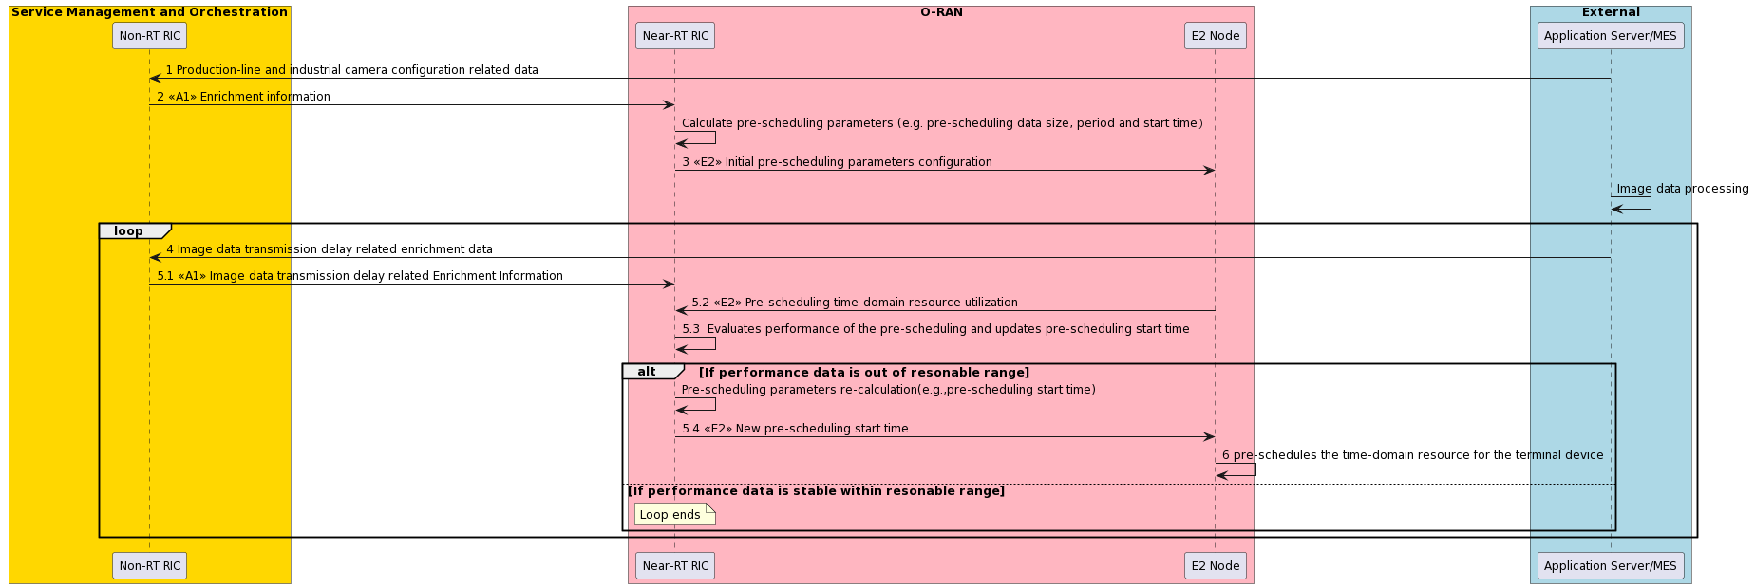
Figure 4.24.3-1: Industrial vision assurance use case flow diagram

4.24.4 Required data
Enrichment information are expected to be retrieved by Non-RT RIC for industrial vision SLA assurance. Service data transmission information from E2 node are also expected to be collected by Near-RT RIC for industrial vision assurance.
- Enrichment information:
  - Production-line and industrial vision camera configuration related data, e.g. production line speed, image color, pixel. (collected from application server/MES)
  - Service-related performance measurement metrics collected from application server, e.g., image data transmission delay. (collected from application server/MES)
- Service data transmission information: e.g., pre-schedule time-domain resource utilization, which is the ratio of the time-domain resource of the data to be scheduled to the total pre-scheduled time-domain resource. (new E2 measurements)

4.25 Void

4.26 Interference detection, prediction and optimization
This use case provides the background and motivation for the O-RAN architecture to support real-time interference detection and optimization. Moreover, some high-level description and requirements over Non-RT RIC, A1, Near-RT RIC and E2 interfaces are introduced.

4.26.1 Background and goal of the use case
LTE and 5G network are deployed based on co-frequency networking due to limited radio resources, which leads to co-frequency interference becoming the bottleneck of network performance. Heterogeneous networks as well as ultra-dense networks make inter-cell interference more complex. As a result, how to detect and/or predict, and then optimize interference is of great importance for wireless networks. Current research mainly focuses on a class of interference optimization solutions called Inter-Cell Interference Coordination (ICIC), which includes static ICIC and dynamic ICIC, assuming that inter-cell interference is available via detection and/or prediction. The principle of ICIC is to restrict the use of radio resources in individual cells in an inter-cell coordination manner, including restricting which time-frequency resources are available, or limiting their transmitting power on certain time-frequency resources. The principle of ICIC is to divide all cells in the network in several categories, then divides the UE to Cell Edge User (CEU) as well as Cell Center User (CCU), and schedule CEU to edge radio resources.
Such ICIC solutions suffer from the following limitations:
- The radio resources are allocated statically or in non-real-time, and do not support dynamic adjustment, which causes low radio resource utilization.
- ICIC depends on specific ideal cell networking structure, and the performance of interference optimization algorithm is poor for complex networking structure.
- The radio resource allocation is based on cell level, and do not support UE level or UE group level.
- The measurement data is used for post-interference analysis and optimization, with low real-time.
Besides, current research may mainly focus on interference optimization, based on the assumption that inter-cell interference is available via detection and/or prediction. In fact, interference detection and prediction is not less important than interference optimization. On the one hand, interference detection and/or prediction with high accuracy contributes to accurate and efficient interference optimization. On the other hand, interference detection and/or prediction can be utilized to optimize other transmission configurations, e.g., Modulation and Coding Scheme (MCS), not limited to radio resources allocation.
Thanks to the open interface and intelligent functionalities provided by the O-RAN architecture, multi-cell-based collaborative real-time interference detection, prediction and interference optimization schemes can be realized. Multi-dimensional data, e.g., network level measurement data, can be acquired and used for interference detection, interference prediction, interference relationships construction, and interference optimization in real time. Interference relationship construction can further take QoS related metrics into analysis, to facilitate UE service assurance through interference management. Based on the A1 policy as well as interference relationships, Near-RT RIC ensures optimal radio resource allocation for UE or UE group or RAN slice or PRBs or mMIMO beams through E2 interface towards RAN for interference optimization. In addition, based on the history interference detection, Near-RT RIC can predict interference for future data transmissions and thus facilitates MCS optimization for UE to adapt to fluctuating interference.

4.26.2 Entities/resources involved in the use case
- SMO/Non-RT RIC:
  - Generate and send interference detection, prediction and optimization policies to Near-RT RIC.
  - Retrieve QoS related metrics and send to Near-RT RIC.
  - Receive interference detection, prediction and optimization performance evaluation updates from Near-RT RIC.
  - Receive interference related network level measurement data from gNBs.
  - Generate and send radio resources configuration based on the interference optimization policy to E2 nodes.
- Near-RT RIC:
  - Retrieve necessary interference related measurement metrics from network level (cell level) measurement report through E2 interface.
  - Receive interference detection, prediction and optimization polices from Non-RT RIC, and support interpretation and execution of Non-RT RIC policies to derive the interference detection, prediction and optimization control or policy.
  - Send the controls or policies to E2 nodes through E2 interface for interference detection, prediction and optimization.
  - Send interference performance report to Non-RT RIC for evaluation and optimization
- E2 node:
  - Support network state and UE measurements with required granularity to Near-RT RIC over E2 interface.
  - Support interference configurations and enhancements based on messages from E2, which are expected to influence RRM behavior.
  - Receive interference detection, prediction results from UE and network, and report to Near-RT RIC.
  - Update RAN parameters based on radio resources configuration from the SMO/Non-RT RIC over the O1 interface.

4.26.3 Solutions

4.26.3.1 Fast loop optimization

4.26.3.1.1 Interference detection
The context of the interference detection is captured in table 4.26.3.1.1-1.
Table 4.26.3.1.1-1: Interference detection
Use Case Stage | Evolution / Specification | <<Uses>>  Related use
Goal | Interference detection
Actors and Roles | Non-RT RIC, Near-RT RIC, SMO
Assumptions | All relevant functions and components are instantiated.  A1/O1 interface connectivity is established with Non-RT RIC.
Pre-conditions | Near-RT RIC and Non-RT RIC are instantiated with A1 interface connectivity being established between them.
Begins when | Near-RT RIC triggers interference detection.
Step 1-2 (M) | Non-RT RIC generates interference detection policy and sends the policy to Near-RT RIC via A1 interface.
Step 3 (M) | Near-RT RIC receives A1 policy, converts and generates E2 control or policy. E2 control or policy includes: 1) allocated resource(s) of the reference signal for the gNB(S); 2) Information transmission strategy configured for the intra-frequency cells adjacent to the cells corresponding to the gNB(S); 3) information for UL PRBs to be monitored; 4) for example, for mMIMO deployment scenario, information for mMIMO beams to be monitored.  The reference signal can be NZP CSI-RS and ZP CSI-IM, which is used by UE(S) accessed in the gNB(S) for channel measurement, channel estimation and interference measurement respectively:  - For channel measurement and channel estimation reference signal: based on the Information transmission strategy, intra-frequency cells adjacent to the cells corresponding to the gNB(S), such as the cells corresponding to gNB(N), keep silent at the allocated resource(s) of the reference signal.  - For interference measurement reference signal: based on the Information transmission strategy, intra-frequency cells adjacent to the cells corresponding to the gNB(S), such as the cells corresponding to gNB(N), can send data at the allocated resource(s) of the reference signal.
Step 4, 6 (M) | Near-RT RIC sends E2 control or policy to the target gNBs via E2 interface, such as sending allocated resource(s) of the reference signal for the gNB(S), sending information transmission strategy to the intra-frequency cells adjacent to the cells corresponding to the gNB(S), for example the cells corresponding to gNB(N), and sending information for UL PRBs and for mMIMO deployment scenario mMIMO beams to be monitored.
Step 5,7 (M) | gNB(S) allocates resources for reference signal based on the E2 control or policy. gNB(N) allocates resources for DL data transmission to UE(N).  gNB(N) allocates resources for UL data transmission.  gNB(S) allocates resources for UL PRBs and for mMIMO deployment scenario mMIMO beams to be monitored.
Step 8-10 (M) | gNB(S) sends reference signal at allocated resources to UE(S). UE detects interference based on the reference signal configured by gNB(S) and sends the interference detection results to the Near-RT RIC through RAN.  gNB(S) detects uplink interference based on interference levels and patterns of UL PRBs among intra-frequency cells and sends the interference detection results to the Near-RT RIC.  gNB(S) detects interference levels of mMIMO beams among intra-frequency cells and sends the interference detection results to the Near-RT RIC.
Step 11-20 (O) | If required, Near-RT RIC can configure specific performance measurement data to be collected from RAN to monitor the performance of E2 control or policy and sends the result to Non-RT RIC for updating the A1 and E2 policies based on the performance evaluation results.
Ends when | Operator triggers to stop interference detection.
Exceptions | None identified.
Post Conditions

The flow diagram of the interference detection is given in figure 4.26.3.1.1-1.

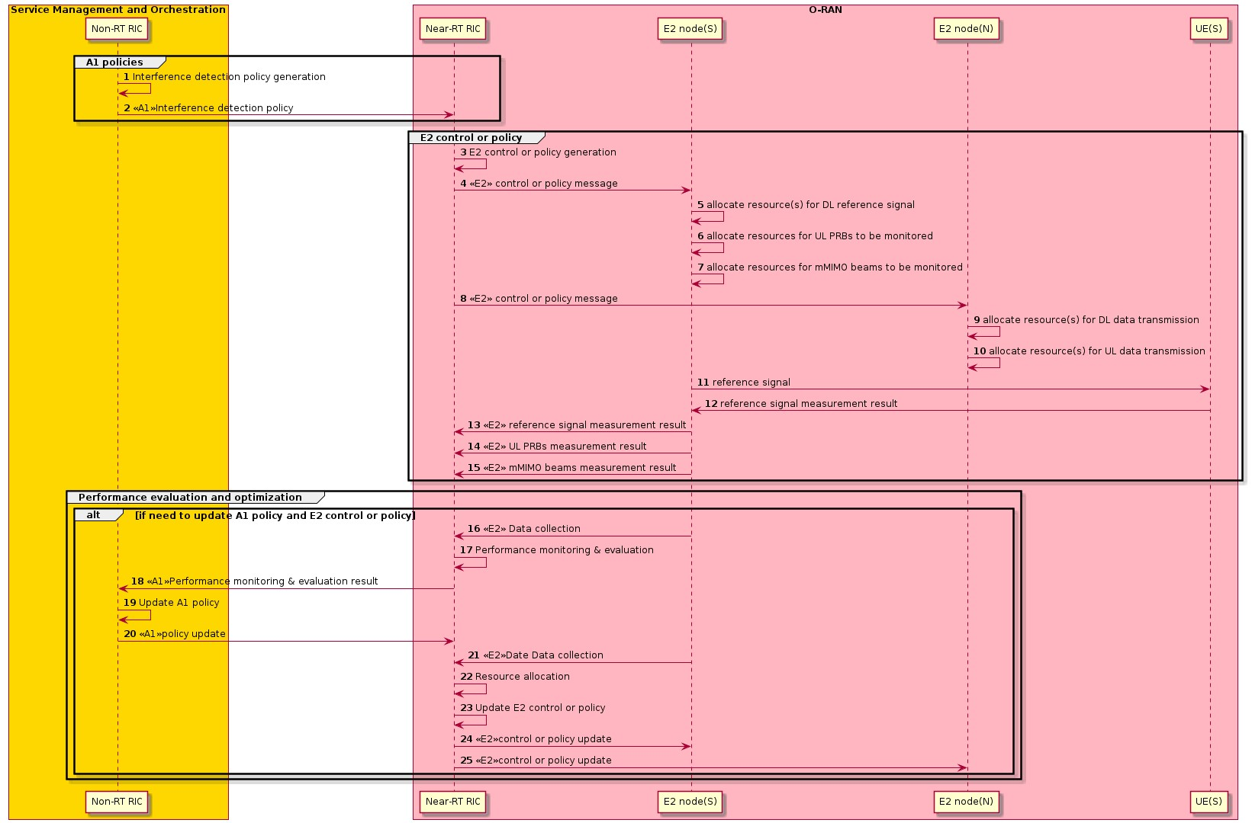
Figure 4.26.3.1.1-1: Interference detection flow diagram
@startuml
Skin rose
skinparam ParticipantPadding 5
skinparam BoxPadding 10
skinparam defaultFontSize 12
Autonumber

Box “Service Management and Orchestration” #gold
participant “Non-RT RIC” as non
end box

Box “O-RAN” #lightpink
participant “Near-RT RIC” as near
participant “E2 node(S)” as s
participant “E2 node(N)” as n
participant "UE(S)" as ues
end box

group A1 policies
non -> non : Interference detection policy generation
non -> near : <<A1>>Interference detection policy
end

group E2 control or policy
near -> near : E2 control or policy generation
near -> s : <<E2>> control or policy message
s -> s : allocate resource(s) for DL reference signal
s -> s : allocate resources for UL PRBs to be monitored
s -> s : allocate resources for mMIMO beams to be monitored
near -> n : <<E2>> control or policy message
n -> n : allocate resource(s) for DL data transmission
n -> n : allocate resource(s) for UL data transmission
s -> ues: reference signal
ues -> s: reference signal measurement result
s -> near : <<E2>> reference signal measurement result
s -> near : <<E2>> UL PRBs measurement result
s -> near : <<E2>> mMIMO beams measurement result
end

group Performance evaluation and optimization
alt if need to update A1 policy and E2 control or policy
s -> near : <<E2>> Data collection
near -> near : Performance monitoring & evaluation
near -> non : <<A1>>Performance monitoring & evaluation result
non -> non : Update A1 policy
non -> near : <<A1>>policy update
s -> near : <<E2>>Data collection
near -> near : Resource allocation
near -> near : Update E2 control or policy
near -> s : <<E2>>control or policy update
near -> n : <<E2>>control or policy update
end alt
end

@enduml

4.26.3.1.2 Interference relationships construction
The context of the interference relationships construction is captured in table 4.26.3.1.2-1.
Table 4.26.3.1.2-1: Interference relationships construction
Use Case Stage | Evolution / Specification | <<Uses>>  Related use
Goal | Interference relationships construction
Actors and Roles | Near-RT RIC, gNB
Assumptions | All relevant functions and components are instantiated.  E2 interface connectivity is established with Near-RT RIC.
Pre-conditions | Interference detection results have been sent to Near-RT RIC.
Begins when | Near-RT RIC triggers interference relationship construction.
Step 1-4 (M) | QoS related metrics from SMO and network level measurements reported by RAN through E2 interface are reported to Near-RT RIC for instantiating or modifying interference relationships.
Step 5 (M) | Near-RT RIC constructs interference relationships (e.g., interference graph) based on the received QoS related metrics from SMO and network level measurement from RAN.  Near-RT RIC constructs uplink interference relationships among intra-frequency cells based on the interference levels and patterns of UL PRBs.  Near-RT RIC constructs interference relationships among mMIMO beams located at different intra-frequency cells based on interference levels of mMIMO beams.  Near-RT RIC uses interference relationships for further interference optimization.
Step 6-8 (O) | If required, Near-RT RIC can configure specific performance measurement data to be collected from RAN to assess the performance of the interference relationships and update the interference relationships in Near-RT RIC based on the performance evaluation and model retraining.
Ends when | Operator specified trigger condition or event is satisfied.
Exceptions | None identified.
Post Conditions | Near-RT RIC stores the interference relationships for interference optimization function in Near-RT RIC.

The flow diagram of the interference relationships construction is given in figure 4.26.3.1.2-1.

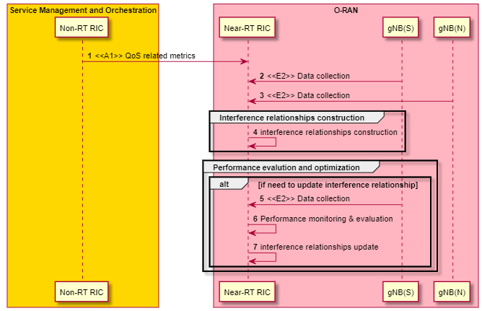
Figure 4.26.3.1.2-1: Interference relationships construction flow diagram
@startuml
Skin rose
skinparam ParticipantPadding 5
skinparam BoxPadding 10
skinparam defaultFontSize 12
Autonumber

Box “Service Management and Orchestration” #gold
participant “Non-RT RIC” as non
end box

Box “O-RAN” #lightpink
participant “Near-RT RIC” as near
participant “gNB(S)” as s
participant “gNB(N)” as n
end box

non -> near : <<A1>> QoS related metrics
near <- s : <<E2>> Data collection
near <- n : <<E2>> Data collection
group Interference relationships construction
near -> near : interference relationships construction
end
group Performance evalution and optimization
alt if need to update interference relationship
s -> near: <<E2>> Data collection
near -> near : Performance monitoring & evaluation
near -> near : interference relationships update
end alt
end
@enduml

4.26.3.1.3 Interference optimization
The context of the interference optimization is captured in table 4.26.3.1.3-1.
Table 4.26.3.1.3-1: Interference optimization
Use Case Stage | Evolution / Specification | <<Uses>>  Related use
Goal | Interference optimization policy generation and performance evaluation
Actors and Roles | Non-RT RIC, Near-RT RIC, SMO
Assumptions | All relevant functions and components are instantiated.  A1/O1 interface connectivity is established with Non-RT RIC.
Pre-conditions | Interference relationships required by interference optimization have been constructed by Near-RT RIC.
Begins when | The network operator/manager want to generate interference optimization policy based on user QoS.
Step 1 (M) | Non-RT RIC generates the appropriate interference optimization policy based on the configured QoS parameters.
Step 2 (M) | Non-RT RIC sends the interference optimization policy to Near-RT RIC via A1 interface.
Step 3 (M) | Network level measurements reported by RAN through E2 interface are reported to Near-RT RIC.
Step 4 (M) | Near-RT RIC receives the policy from the Non-RT RIC over the A1 interface and measurement data from the RAN over the E2 interface. Near-RT RIC generates radio resources configuration based on the interference relationships (e.g., interference graph) as well as A1 policy.
Step 5 (M) | Near-RT RIC sends the radio resources configuration through E2 interface towards RAN for interference optimization. RAN enforces the received control or policy from the Near-RT RIC over the E2 interface.
Step 6-12 (O) | If required, Non-RT RIC can configure specific performance measurement data to be collected from RAN to assess the performance of the QoE optimization function in Near-RT RIC, or to assess the outcome of the applied A1 policies. And then update A1 policy and E2 control or policy.
Ends when | Operator specified trigger condition or event is satisfied.
Exceptions | None identified.
Post Conditions | If required, Near-RT RIC can configure specific performance measurement data to be collected from RAN to monitor the performance of E2 control or policy and sends the result to Non-RT RIC for updating the A1 and E2 policies based on the performance evaluation results.

The flow diagram of the interference optimization is given in figure 4.26.3.1.3-1.

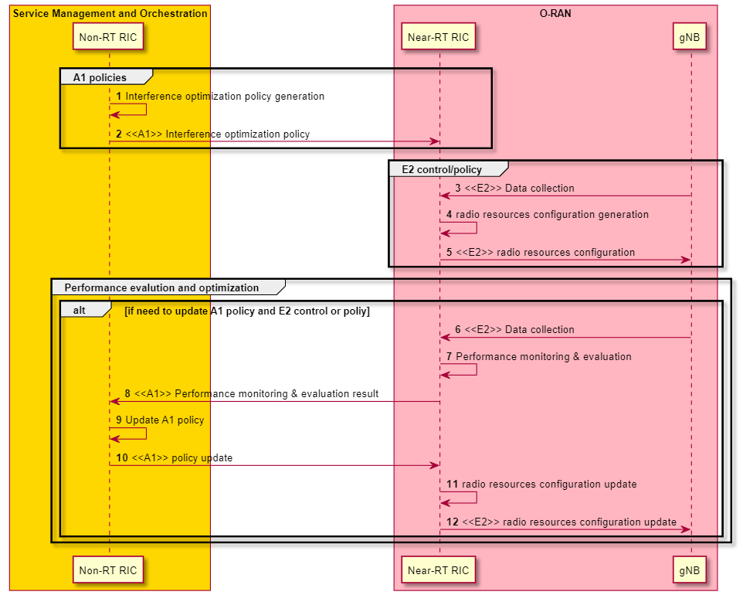Figure 4.26.3.1.3-1: Interference optimization flow diagram
@startuml
Skin rose
skinparam ParticipantPadding 5
skinparam BoxPadding 10
skinparam defaultFontSize 12
Autonumber

Box “Service Management and Orchestration” #gold
participant “Non-RT RIC” as non
end box

Box “O-RAN” #lightpink
participant “Near-RT RIC” as near
participant “gNB” as s
end box
group A1 policies
non -> non: Interference optimization policy generation
non -> near : <<A1>> Interference optimization policy
end
group E2 control/policy
near <- s : <<E2>> Data collection
near -> near: radio resources configuration generation
near -> s: <<E2>> radio resources configuration
end
group Performance evalution and optimization
alt if need to update A1 policy and E2 control or poliy
s -> near: <<E2>> Data collection
near -> near : Performance monitoring & evaluation
near -> non: <<A1>> Performance monitoring & evaluation result
non -> non: Update A1 policy
non -> near: <<A1>> policy update
near -> near : radio resources configuration update
near -> s: <<E2>> radio resources configuration update
end alt
end
@enduml

4.26.3.2 Slow loop optimization

4.26.3.2.1 Interference detection and relationships construction
The context of the interference detection and relationships construction is captured in table 4.26.3.2.1-1.
Table 4.26.3.2.1-1: Interference detection and relationships construction
Use Case Stage | Evolution / Specification | <<Uses>>  Related use
Goal | Interference detection and relationships construction
Actors and Roles | SMO/Non-RT RIC, gNB
Assumptions | All relevant functions and components are instantiated.  O1 interface connectivity is established with SMO/Non-RT RIC.  SMO/Non-RT RIC has RAN topology including the relationship of geographical location among cells.
Pre-conditions | Network level measurement data generated at gNBs through O1 interface are reported to SMO/Non-RT RIC.
Begins when | SMO/Non-RT RIC triggers interference detection and relationship construction.
Step 1 (M) | SMO/Non-RT RIC collects the interference data and RB usage rate as network level measurement data from gNBs.
Step 2 (M) | SMO/Non-RT RIC analyzes the interference relationship among cells based on the network level measurement data and the RAN topology. SMO/Non-RT RIC constructs interference relationships (e.g., interference graph) based on network level measurement data from gNBs. The interference relationships indicate a table for each cell, listing the neighboring cells that have a significant interference impact.
Step 3-5 (O) | If required, SMO/Non-RT RIC can update the interference relationships based on the network level measurement data and the RAN topology.
Ends when | Operator specified trigger condition or event is satisfied.
Exceptions | None identified.
Post Conditions | SMO/Non-RT RIC stores the interference relationships.

The flow diagram of the interference detection and relationships construction is given in figure 4.26.3.2.1-1.

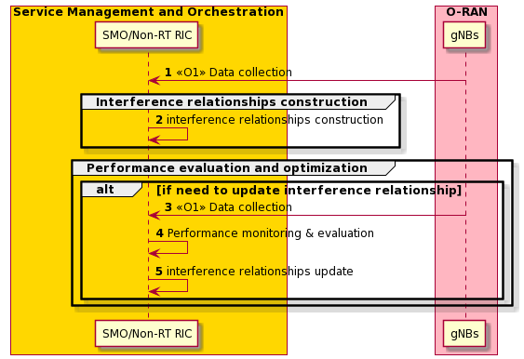
Figure 4.26.3.2.1-1: Interference detection and relationships construction flow diagram
@startuml
Skin rose
skinparam ParticipantPadding 5
skinparam BoxPadding 10
skinparam defaultFontSize 12
Autonumber

Box “Service Management and Orchestration” #gold
participant “SMO/Non-RT RIC” as non
end box

Box “O-RAN” #lightpink
participant “gNBs” as g
end box

non <- g : <<O1>> Data collection
group Interference relationships construction
non -> non : interference relationships construction
end
group Performance evaluation and optimization
alt if need to update interference relationship
g -> non: <<O1>> Data collection
non -> non : Performance monitoring & evaluation
non -> non : interference relationships update
end alt
end
@enduml

4.26.3.2.2 Interference optimization
The context of the interference optimization is captured in table 4.26.3.2.2-1.
Table 4.26.3.2.2-1: Interference optimization
Use Case Stage | Evolution / Specification | <<Uses>>  Related use
Goal | Interference optimization policy generation and performance evaluation
Actors and Roles | SMO/Non-RT RIC, gNB
Assumptions | All relevant functions and components are instantiated. O1 interface connectivity is established with SMO/Non-RT RIC.
Pre-conditions | Interference relationships required by interference optimization have been constructed by SMO/Non-RT RIC.
Begins when | The network operator/manager want to generate interference optimization policy based on the interference relationship.
Step 1-2 (M) | SMO/Non-RT RIC can monitor the pefirmance and creates cell groups for interference optimization based on the interference relationship and network level measurement data
Step 3 (M) | SMO/Non-RT RIC generates the appropriate interference optimization policy based on the network level measurement data. Non-RT RIC creates the radio resources configuration based on the interference optimization policy for each cell group.
Step 4 (M) | SMO/Non-RT RIC sends the radio resources configuration through O1 interface to the cell group. gNBs update the RAN parameters based on radio resources configuration from the SMO/Non-RT RIC over the O1 interface.
Step 5-7 (O) | If required, SMO/Non-RT RIC can update the optimization policy based on the network level measurement data and the RAN topology. SMO/Non-RT RIC updates the radio resources configuration and sends the radio resources configuration through O1 interface to the cell group.
Ends when | Operator specified trigger condition or event is satisfied.
Exceptions | None identified.
Post Conditions

The flow diagram of the interference optimization is given in figure 4.26.3.2.2-1.

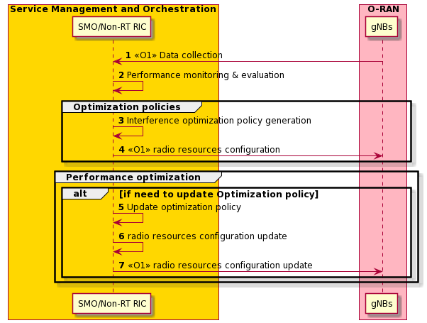
Figure 4.26.3.2.2-1: Interference optimization flow diagram
@startuml
Skin rose
skinparam ParticipantPadding 5
skinparam BoxPadding 10
skinparam defaultFontSize 12
Autonumber

Box “Service Management and Orchestration” #gold
participant “SMO/Non-RT RIC” as non
end box

Box “O-RAN” #lightpink
participant “gNBs” as g
end box

g -> non: <<O1>> Data collection
non -> non : Performance monitoring & evaluation
group Optimization policies
non -> non: Interference optimization policy generation
non -> g : <<O1>> radio resources configuration
end
group Performance optimization
alt if need to update Optimization policy
non -> non: Update optimization policy
non -> non : radio resources configuration update
non -> g: <<O1>> radio resources configuration update
end alt
end
@enduml

4.26.3.3 Intereference prediction for MCS optimization
The context of the interference prediction for MCS optimization is captured in table 4.26.3.3-1.
Table 4.26.3.3-1: Interference prediction for MCS optimization
Use Case Stage | Evolution / Specification | <<Uses>>  Related use
Goal | Interference prediction and MCS optimization
Actors and Roles | Non-RT RIC, Near-RT RIC, E2 nodes
Assumptions | All relevant functions and components are instantiated.
Pre-conditions | Near-RT RIC and Non-RT RIC are instantiated with A1 interface connectivity being established between them.  E2 nodes and Non-RT RIC are instantiated with E2 interface connectivity being established between them.
Begins when | Non-RT RIC triggers interference prediction.
Step 1-2 (M) | Non-RT RIC generates interference prediction policy and sends the policy to Near-RT RIC via A1 interface. The policy including neighborhood list of serving cell, prediction granularities and prediction steps, etc.
Step 3 (M) | Data collection from E2 node(S) for serving cell:  - Near-RT RIC initiates data collection request to E2 node(S) via E2 interface,to request uplink interference reported periodically;  - E2 node(S) collects the uplink interference on each RB in the bandwidth of the serving cell and reports the uplink interference to Near-RT RIC periodically as request.
Step 4 (M) | Data collection from E2 node(N) for neighbouring cell:  Neighbouring cell corresponding to E2 node(N) is a intra-frequency cell adjacent to the serving cell corresponding to the E2 node(S).  1) Data collection to construct uplink interference users set.  a. Near-RT RIC initiates data collection request to E2 node(N) via E2 interface, to request DL RSRP for the serving cell corresponding to E2 node(S) reported periodically.  b. E2 node(N) collects the DL RSRP and reports the DL RSRP to Near-RT RIC periodically as request.  c. Near-RT RIC constructs the uplink interference users set based on the DL RSRP. The users with high DL RSRP, whose uplink service may cause more uplink interference to the serving cell corresponding to E2 node(S) are included in the set.  2) Data collection of uplink interference users in the set.  a. Near-RT RIC initiates data collection request to E2 node(N) to request uplink interference related information (e.g., UL PRB usage rate, PHR, BSR, location and velocity) of users in the set reported.  b. E2 node(N) collects the information of users in the set and reports uplink interference related information to Near-RT RIC as request.
Step 5 (M) | Over multiple historical time periods, the collected uplink interference from the serving cell and/or uplink interference related data from the neighbouring cell, could be processed as a training data set for the AI/ML model training and/or processed as input data for the AI/ML model inference.
Step 6 (M) | Assuming the AI/ML model training using the training data set is on Non-RT RIC or on Near-RT RIC, the trained AI/ML model will be deployed in the Near-RT RIC used for the AI/ML model inference.
Step 7 (M) | Near-RT RIC performs AI/ML model inference and outputs the predicted uplink interference value based on the latest input data.
Step 8 (M) | Near-RT RIC sends the RIC control or policy with the predicted uplink interference value to E2 node(S) via E2 interface.
Step 9 (M) | E2 node(S) could use the predicted uplink interference value for UE(s) to be scheduled to estimate the uplink channel quality (e.g., SINR) at the future PUSCH transmission slot. E2 node(S) could realize this by replacing the uplink interference collected when the last uplink reference signal of the scheduled UE(s) is received by E2 node(S).  The E2 node(S) then uses the uplink channel quality (e.g., SINR) to decide the MCS in DCI sent to the scheduled UE.
Ends when | Operator triggers to stop interference prediction.
Exceptions | None identified.
Post Conditions

The flow diagram of the interference prediction is given in figure 4.26.3.3-1

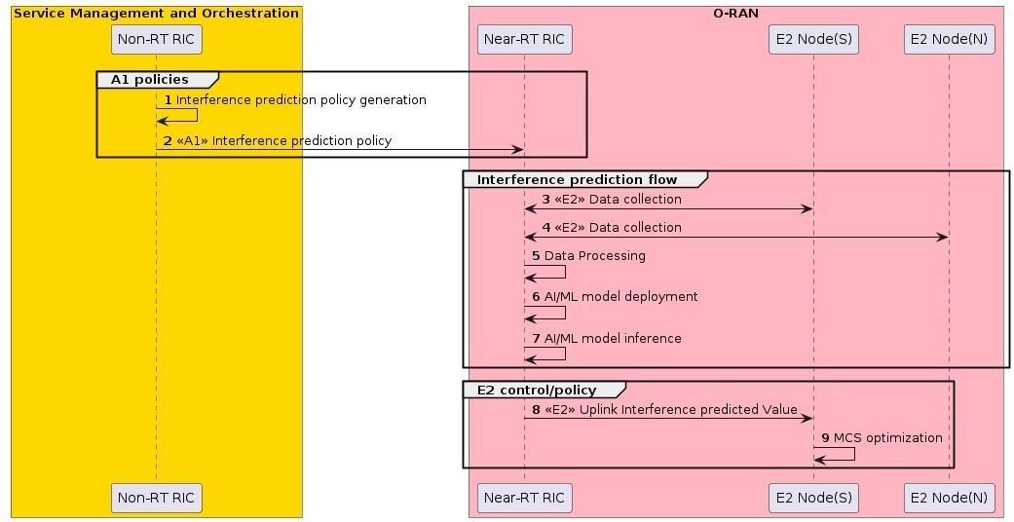.
Figure 4.26.3.3-1: Interference prediction flow diagram
@startuml
skinparam ParticipantPadding 5
skinparam BoxPadding 10
Autonumber

Box “Service Management and Orchestration” #gold
participant “Non-RT RIC” as non
end box
Box “O-RAN” #lightpink
participant “Near-RT RIC” as near
participant “E2 Node(S)” as s
participant “E2 Node(N)” as n
end box
group A1 policies
non -> non: Interference prediction policy generation
non -> near : <<A1>> Interference prediction policy
end
group Interference prediction flow
near <-> s : <<E2>> Data collection
near <-> n : <<E2>> Data collection
near -> near: Data Processing
near -> near: AI/ML model deployment
near -> near: AI/ML model inference
end
group E2 control/policy
near -> s: <<E2>> Uplink Interference predicted Value
s -> s: MCS optimization
end
@enduml

4.26.4 Required data
Multi-dimensional data are expected to be retrieved by Near-RT RIC for interference prediction, interference relationship generation, and interference optimization, including network level measurement data from O-CU/O-DU, which indicates network status, as well as QoS related metrics from SMO which indicates service requirements.
- Network level measurement report, including
- UE level information, e.g., CQI, SINR, MCS, UL/DL RSRP, DL/UL PRB usage rate, throughput, DU/UL PRB usage, mMIMO beams, BSR, PHR, location and velocity
- Cell level information: e.g., DL/UL PRB usage rate, throughput, uplink interference
- QoS related metrics collected from SMO, e.g., 5QI, throughput, latency, packet loss rate, BLER requirement etc.

4.27 Communication and computing integrated networks

4.27.1 Background and goal of the use case

4.27.1.1 Common aspects & background for communication and computing integrated networks use cases
With the development of 5G and future networks, the integration of communication and computing has become a critical trend in network architecture. Traditional communication networks have focused primarily on data transmission and connectivity, while modern network applications increasingly require substantial computational resources. Examples of these applications include Artificial Intelligence (AI), Augmented Reality (AR), Virtual Reality (VR), autonomous driving, and Industrial Internet of Things (IIoT). These applications not only require high-speed, low-latency communication but also significant computing capabilities for real-time data processing and inference.
The past decades witnessed the convergence of communication and computing trends in mobile network. Great efforts were made and good momentum were achieved. C-RAN featured by centralization, cooperative, clean and cloud were first proposed in 2009, which depicts the vision of software based virtualized RAN [i.1]. The concept of Network Function Virtualization (NFV) was initiated from 2012. It introduced the Information Technology (IT) to enable the network transformation from the traditional physical hardware network into a new software based virtualized network [i.6]. This further steers up the pace for the convergence of communication and computing in RAN. Multiple-access Edge Computing (MEC), which enables compute-intensive applications for mobile devices and access to cloud computing service at the edge of communication networks, had attracted great attention [i.7]. The virtualized/cloudification RAN infrastructure can server as perfect edge computing platform. Thanks to the well-developed IT tools/frameworks, such as the containers, kubernets, the general-purpose hardware infrastructure could be easily and dynamically shared by the RAN functionality and the edge applications, providing the converged capabilities of mobile communication and computing. Edge computing was also incorporated into 5G system in 3GPP since Release 15. However, the communication and computing services offered by the existing design, such as NFV and MEC, were designed separately and developed independently. To fulfill the gap, the coordination of computing and networking is proposed in the context of IMT-2020 and beyond, and provides network enhancements based on the functional architecture of IMT-2020, to achieve the computing and network joint optimization based on the awareness, control and management over computing resources [i.8], [i.9]. Besides the above, IETF initiated a new working group on computing aware traffic steering to study how the network edge can steer traffic between clients of a service and sites offering the services, considering the integrated network and compute resource status [i.10].
The O-RAN ALLIANCE focuses on promoting the openness and intelligence of RAN. Its architecture provides a solid foundation for the integration of communication and computing. O-RAN’s cloud-based architecture (O-Cloud) supports the virtualization of multiple network functions, including RAN functions and edge computing applications. Additionally, O-RAN’s intelligent capabilities—enabled by the Non-RT RIC and Near-RT RIC—allow for the dynamic optimization and management of both communication and computing resources. This flexibility enables O-RAN to meet the requirements of various application scenarios and network conditions.

4.27.1.2 Sub-use case 1: Multi-aspect handover optimization
CCIN enables the collaboration of communication network and computing. It is an approach of softening the boundaries between the cloud computing and networking, such that their resources can be utilized in the most efficient way. This allows the applications to leverage on such convergence of compute and network resources. Cloud based RAN solutions can play an important role in the CCIN with its potential to share some of its vacant computing resources as the edge computing platform. New age applications based on XR (see 3GPP TR 26.928 [i.13], clause 4.1.1), V2X (see 3GPP TR 38.885 [i.14]) can benefit from CCIN but they require application mobility in addition to posing stringent requirements on both communication and computing. New network architecture for CCIN needs to address these application requirements.
The types of computing resources required for different applications can be diverse based on the nature of the applications. However, the computing resources available in different entities might be of different computing resource type than what is required for specific applications. It is also possible that capabilities of a computing resource type required for specific applications is different even if an entity supports required computing resource type. Computing resource types referred here could be but not limited to the support for graphical processing unit, neural processing unit, deep processing unit, etc. An example illustration of the cloud based joint RAN + computing node used in CCIN is given below in figure 4.27.1.2-1.
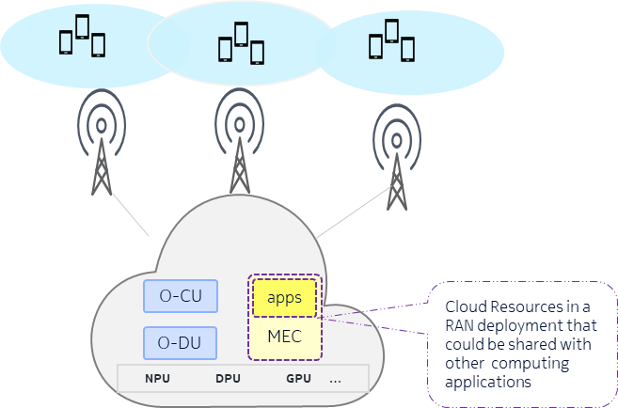
Figure 4.27.1.2-1: Example illustration of cloud based joint RAN + computing node
In CCIN, the idea is to use the vacant computing resources from the cloud-based RAN (e.g., if the network load is low), to perform some edge computing related tasks so that cloud resources are used efficiently. In particular, leveraging the proximity of the cloud-based RAN nodes to the end users/devices is a key factor to address low latency requirements of the tasks/applications. But in order to take advantage of this opportunity the following needs to be considered:
- If the vacant resources match the task requirements in terms of the type of the computing resource and related capabilities.
- If the amount of vacant resources of required type/capability suffices the task requirements
- If the nodes are within the proximity required to support the continuity of the service and service latency requirements of the applications.
In the use case of UE handover especially in the scenario where the UE needs to run applications with high computing and low latency requirements such as XR based applications the above stated challenges are more prominent. Thus, in such use case it is desirable that system considers the aspects of computing capability and availability of cloud-based RAN nodes while supporting the mobility of UE and applications in it.
In particular, it is important to create the awareness in a cloud-based RAN nodes of the information regarding the computing capability and availability of other cloud-based RAN nodes in the proximity and use these multiple aspects as part of the UE handover decisions. Proximity here means that coverage area of the cells served by source cloud-based RAN node has some overlap with the coverage area of the cells served by target cloud-based RAN node.
In order to address aforementioned use case and related challenges it is proposed to extend the CCIN framework. Such extensions focus on obtaining information about the computing capabilities of cloud-based RAN nodes and utilizing this information in UE handover decisions. This helps the handover of the UE to a target cloud-based RAN node in the proximity with computing resource types of relevant capabilities and availability required for the applications in that UE.
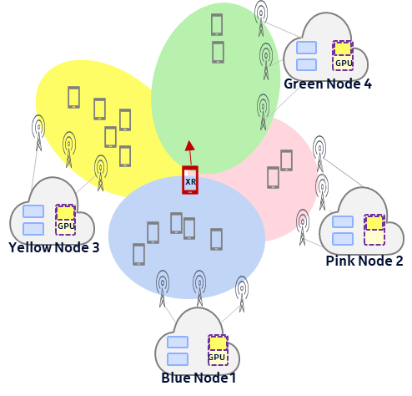
Figure 4.27.1.2-2: Example illustration of multi-aspect handover

4.27.1.3 Sub-use case 2: RAN edge computing resource information exposure
AI/ML processing for network intelligence and automation evolution, as well as new 5G edge applications supporting e.g., immersive Virtual Reality (VR), autonomous driving, and intelligent Internet of Things (IoT), etc., put an unprecedented demand on the edge computing resources. The O-Cloud architecture of O-RAN and the spatial and temporal tidal effects of RAN communication services offer great opportunities for sharing underutilized computing resources in the RAN infrastructure. This helps to improve resource utilization efficiency and reduce operators’ investment on the edge computing infrastructure.
The main objective is to provide RAN edge computing information exposure service based on O-RAN architecture and its open interface. In O-RAN, SMO is a great candidate to provide RAN edge computing information exposure service to the service consumers for using RAN edge computing capability. This helps service consumer perceive RAN edge computing resources in the O-Cloud infrastructure, such as total, allocated, reserved or available computing capacity. The service consumers might be other orchestrators, e.g., central cloud orchestrator, edge cloud orchestrator, RAN edge cloud orchestrator, device edge cloud orchestrator etc. The orchestrators could request computing information for multi-cloud collaboration, such as task migration between multiple clouds or edge intelligence. The service consumers could also be application servers, e.g., RAN service computing center serving vertical customers, VR consumers, etc., which could request computing information for application deployment using shared computing resources in a secured way.

4.27.1.4 Sub-use case 3: O-RAN and mobile devices collaborative AI/ML inference
Void

4.27.1.5 Sub-use case 4: XR rendering collaboration
Void

4.27.1.6 Sub-use case 5: Joint communication and computing optimization for V2X communications
It is expected that there will be approximately 8 million autonomous or semi-autonomous vehicles on the road by 2025 [i.11]. As an enabling technology, Vehicle-to-Everything (V2X) communication is pivotal in paving the way for the intelligent traffic system and autonomous vehicles by facilitating the exchange of crucial information among vehicles, infrastructure, and pedestrians. This exchange encompasses critical data, including real-time updates on traffic conditions, impending road hazards, and precise speed limits, to improve decision-making and prevent accidents.
Within the realm of V2X communications, the intersection is one of the most challenging scenarios. The various ways of transportation (e.g., vehicles, pedestrians) coupled with densely constructed buildings contributes to the complexity of traffic conditions, resulting in a large amount of data gathered from diverse sources for comprehensive sensing and collision avoidance. As shown in figure 4.27.1.6-1, Vehicle 1 travels straight through the intersection, while Vehicle 2 maintains a safe distance behind Vehicle 1, intending to turn left. During the drive, there are several risks.
- Vehicle 1 risks colliding with Vehicle 3.
- Vehicle 1 or Vehicle 3 risks colliding with the pedestrian 2 (if he suddenly rushes from behind Building 2 and turns left). However, either Vehicle 1 or Vehicle 3 cannot sense the pedestrian timely due to the blocking by Building 2.
- Vehicle 2 risks colliding with other vehicles and pedestrians (e.g., Vehicle 3 and pedestrian 1). Due to the blocking by Vehicle 1 and Building 1, Vehicle 2 is unable to accurately sense traffic conditions ahead and to the left in real-time and has to obtain information by exchanging information with other vehicles or infrastructures, which may result in high latency and high risk of collision.

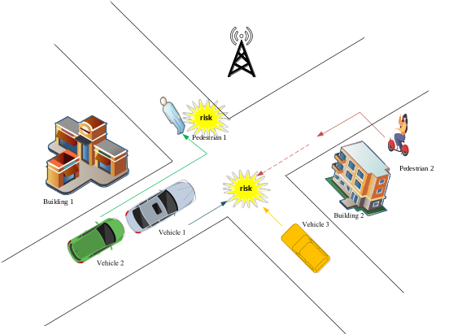
Figure 4.27.1.6-1: An illustration of the potential collisions at intersections
In collision warning scenarios, the latency requirement for data collection and computing are in a few milliseconds (e.g., the maximum end-to-end latency for cooperative collision avoidance in the advanced driving scenario is 10ms.) [i.12], so that the results and warns can be fed back to vehicles and pedestrians in a timely manner. To fulfill the strict latency demand, it is essential to process these tasks in one or several optimal computing nodes, e.g., the central cloud, edge cloud, radio edge cloud, device edge cloud, etc. Since the end-to-end latency is limited by the computing latency and network latency, the optimal offloading choice cannot be found by either optimizing the network or computing resource. Hence, joint optimization of network and computing resources is needed. For example, the road status sensing data from Vehicle 1, Vehicle 3 and Pedestrian 2 must be communicated and processed and the result fed back within milliseconds to avoid the collision between them.
To reduce network latency, it is desirable to process the data locally in vehicles. However, the computing resources of vehicles may be limited, which may not satisfy the task requirements in terms of computing resources and capabilities and could also lead to high computing latency. Therefore, it may be desired to offload all or part of the data processing to the best edge server (e.g., the server completes data processing with the lowest latency, lowest energy consumption.) through joint optimization of network and computing resources. However, since the task requirements on computing resources (e.g., the required type of computing resources) are diverse and the availability of computing resources is dynamic, it is of great importance to enable joint communication and computing resources optimization. What is worse, there are other data to be processed, such as navigation requests from other vehicles, requests for entertainment-related services from passengers, etc., which also consume limited computing and communication resources and increase the difficulties.
The main objective of the use case is to enable joint communication and computing resources optimization for V2X communications. In O-RAN, the global information on communication and computing resources is available over O1 and O2 interface, thus facilitating joint communication and computing resources optimization. With the above global information, resource scheduling policies for both communication and computing can be developed in Non-RT RIC (e.g., policies in terms of CPU frequency, bandwidth and power, etc.), and communication optimization policies can be enforced by Near-RT RIC based on the near-real-time UE level information (e.g., real-time link quality). In addition, the vacant computing resources in O-Cloud can provide edge computing services in case of low network load, which further facilitates the low-latency computing in V2X communications.

4.27.1.7 Sub-use case 6: Exposure of performance information to assist computing resource scheduling
Void

4.27.2 Entities/resources involved in the use case

4.27.2.1 General aspects of entities/resources for communication and computing integrated networks use cases
The following clauses describe the entities/resources that are important and key players for each of the CCIN sub-use cases.

4.27.2.2 Sub-use case 1: Multi-aspect handover optimization
- SMO/Non-RT RIC framework:
- Collects necessary CM/PM data from different cloud-based RAN nodes such as O-CU over O1 interface. Collects supported types of computing resources, capabilities of computing resource types, and load/availability of computing resources in different cloud-based RAN nodes such as O-CU over O2 interface.
- Provides CM data, PM data, supported types of computing resources, capabilities of computing resource types, and load/availability of computing resources of different cloud-based RAN nodes such as O-CU to rApp over R1 interface.
- Provides O1 configurations to Near-RT RIC via O1 interface or A1 policies to Near-RT RIC via A1 interface based on the request from rApp.
- rApp:
  - Retrieves necessary CM/PM data related to different cloud-based RAN nodes such as O-CU from SMO/Non-RT RIC framework.
  - Retrieves supported types of computing resources, capabilities of computing resource types, and load/availability of computing resources in different cloud-based RAN nodes such as O-CU from SMO/Non-RT RIC framework.
  - Derives the proximal computing capabilities and availability information (e.g., represented in tabular formats) for each cloud-based RAN node, use this information to create related O1 configurations or A1 policies to support multi-aspect handover optimization in Near-RT RIC.
- Near-RT RIC:
  - Performs multi-aspect handover optimization based on the O1 configurations or A1 policies received.
  - Sends E2 control or E2 policy messages to E2 nodes (O-CU) related to multi-aspect handover optimization.
- E2 nodes:
  - Support CM data read requests from SMO over O1 interface. Collect and report PM data to SMO over O1 interface.
  - Support UE handover related control and/or policy enforcement from Near-RT RIC over E2 interface.
- O-Cloud:
  - Support data requests related to supported types of computing resources, capabilities of computing resource types, and load/availability of computing resources of different cloud-based RAN nodes such as O-CU to SMO over O2 interface.

4.27.2.3 Sub-use case 2: RAN edge computing resource information exposure
1) SMO:
a) Support collection and analysis of computing related resources from O-Cloud.
b) Support RAN edge computing information service, send the RAN computing information for managed O-Cloud related computing resources to the service consumer, e.g., orchestrator/application server.
2) O-Cloud:
a) Support computing related inventory and updated resources report with required granularity to SMO over O2 interface.
3) RAN edge computing information exposure service consumer:
a) Request/subscribe RAN edge computing information from SMO.
b) The service consumer might be orchestrator/application server.

4.27.2.4 Sub-use case 3: O-RAN and mobile devices collaborative AI/ML inference
Void

4.27.2.5 Sub-use case 4: XR rendering collaboration
Void

4.27.2.6 Sub-use case 5: Joint communication and computing optimization for V2X communications
- SMO:
  - Receive available communication and computing resources information from E2 nodes and O-Cloud.
  - Expose integrated communication and computing service and/or computing service.
  - Receive integrated communication and computing service requests from external entities.
  - Generate and send joint communication and computing resource optimization policies.
- Near-RT RIC:
  - Receive communication resource optimization policies from SMO through A1 interface, and send the policies to E2 nodes over E2 interface.
  - Send communication performance report to SMO for evaluation and optimization.
  - Retrieve available communication resource information from E2 nodes over E2 interface.
- E2 nodes:
  - Report available communication resource information with required granularity to SMO over O1 interface.
  - Update RAN parameters based on communication optimization policies from the Near-RT RIC.
- O-Cloud:
  - Report available computing resource information with required granularity to SMO over O2 interface.
  - Receive workload deployment policies and/or computing resource optimization policies from SMO over O2 interface.

4.27.2.7 Sub-use case 6: Exposure of performance information to assist computing resource scheduling
Void

4.27.3 Solutions

4.27.3.1 General aspects of solutions for communication and computing integrated networks use cases
The following clauses describe solutions that apply to each of the CCIN sub–use cases.

4.27.3.2 Sub-use case 1: Multi-aspect handover optimization
The context of the multi-aspect handover optimization use case is captured in table 4.27.3.2-1.
Table 4.27.3.2-1: Multi-aspect handover optimization use case
Use Case Stage | Evolution / Specification | <<Uses>>  Related use
Goal | Configure and update the proximal computing information for multi-aspect handover optimization.
Actors and Roles | SMO/Non-RT RIC framework: Provide relevant R1 services to enable the rApp to read relevant OAM data, O2 related data and write configuration changes.  rApp: Create related O1 configurations or A1 policies to support multi-aspect handover optimization.  Near-RT RIC: Performs multi-aspect handover optimization.  E2 node: Support UE handover related control and/or policy enforcement from Near-RT RIC over E2 interface.  O-Cloud: Support data requests related to computing information.
Assumptions | Operator has set the targets for multi-aspect handover optimization in the rApp.
Pre conditions | A1/O1 interface connectivity is established with Non-RT RIC.  O1/O2 interface connectivity is established with SMO.
Begins when | Operator triggers the rApp for multi-aspect handover optimization.  rApp is set to periodically monitor network status and computing information.
Steps 1-4 (M) | rApp collects O1 related data using R1 services provided by SMO/Non-RT RIC framework.
Step 5-8 (M) | rApp collects O2 related data using R1 services provided by SMO/Non-RT RIC framework.
Step 9 (M) | Create O1 configurations which contain proximal computing capability and availability information for each O-Cloud based RAN nodes for multi-aspect handover optimization. Alternatively, create A1 policies which contain proximal computing capability and availability information for each O-Cloud based RAN nodes for multi-aspect handover optimization.
Step 10 (M) | rApp sends O1 configurations or A1 polices for multi-aspect handover optimization via R1 interface.
Step 11(M) | SMO/Non-RT RIC framework sends O1 configurations via O1 interface or A1 polices via A1 interface to Near-RT RIC.
Step 12(M) | Near-RT RIC sends E2 control or E2 policies for multi-aspect handover optimization.
Ends when | Operator stops the rApp.
Exceptions | None identified.
Post Conditions | E2 node(s) operate using the new configurations/policies.

@startuml
Skin rose
skinparam ParticipantPadding 5
skinparam BoxPadding 10
skinparam defaultFontSize 12
skinparam lifelineStrategy solid
skinparam wrapWidth 300
autonumber

box #lightseagreen
participant “O-Cloud(s)” as OCLOUDS
endbox

box #gold
participant "rApp" as rApp
Participant "SMO / Non-RT RIC Framework" as nonRTRICFramework
endbox

box "O-RAN Nodes" #lightpink
Participant "Near-RT RIC" as NearRTRIC
Participant "E2-Node(s)" as RANNodes
endbox

group O1 Data Collection
rApp -> nonRTRICFramework : <<R1>> Data collection request
nonRTRICFramework -> RANNodes : <<O1>> Data collection request
RANNodes -> nonRTRICFramework : <<O1>> Data Collection
nonRTRICFramework -> rApp : <<R1>> Data Collection
end

group O2 Data Collection
rApp -> nonRTRICFramework : <<R1>> Data collection request
nonRTRICFramework -> OCLOUDS : <<O2>> Data collection request
OCLOUDS -> nonRTRICFramework : <<O2>> Data Collection
nonRTRICFramework -> rApp : <<R1>> Data Collection
end

group Data Analysis and Inference
rApp -> rApp : Creates O1 configurations or A1 polices which contains proximal computing capability information \nand availability information for each O-Cloud based RAN nodes for multi-aspect handover optimization
end

group Policy Creation
rApp -> nonRTRICFramework : <<R1>> O1 configurations or A1 polices for multi-aspect handover optimization via R1 interface
nonRTRICFramework -> NearRTRIC : <<O1 or A1>> O1 configurations via O1 interface \nor A1 polices via A1 interface
NearRTRIC -> RANNodes : <<E2>> E2 control or E2 policies \nfor multi-aspect handover optimization
end

@enduml

The flow diagram of the multi-aspect handover optimization is given in figure 4.27.3.2-1.

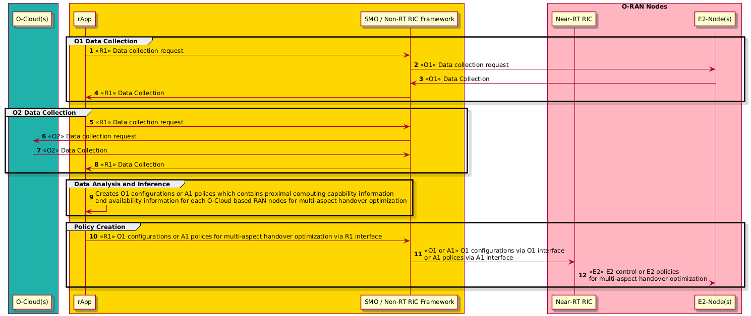
Figure 4.27.3.2-1: Multi-aspect handover optimization flow diagram

4.27.3.3 Sub-use case 2: RAN edge computing resource information exposure
The context of the RAN edge computing information exposure is captured in table 4.27.3.3-1.
Table 4.27.3.3-1: RAN edge computing information exposure
Use Case Step | Description of the step
Goal | RAN edge computing information exposure
Actors and Roles | SMO, O-Cloud, orchestrator/application server
Assumptions | All relevant functions and components are instantiated.  O2 interface connectivity is established with SMO.
Pre-conditions | SMO and O-Cloud are instantiated with O2 interface connectivity being established between them.  Editor’s note: Security related procedure is not defined in the present document.
Begins when | Orchestrators or application servers want to request/subscribe RAN edge computing information.
Step 1 (M) | Service consumer (i.e., orchestrator or application server) sends RAN edge computing information request to SMO for updated RAN edge computing resource information, or reserving RAN edge computing resources to be used.
Step 2 (M) | SMO requests or subscribes the measurement data from O-Cloud and receives computing related resource data from O-Cloud through response or periodic notifications.
Step 3 (O) | Alternatively, SMO could use AI/ML or other methods to perform computing related resource data statistics and analysis.
Step 4 (M) | Based on the received request from service consumer, SMO sends RAN edge computing information response indicating the RAN side computing related information managed by SMO, which includes updated or reserved RAN edge computing resource information.
Ends when | Orchestrators or application servers get the response.
Post Conditions

@startuml
Skin rose
skinparam ParticipantPadding 5
skinparam BoxPadding 10
skinparam defaultFontSize 12

Box “Service Consumer” #lightcyan
Participant “Orchestrator/Application Server” as app
End box
Box “Service Management and Orchestration” #gold
Participant “SMO” as smo
End box
Box “O-Cloud Platform” #lightseagreen
Participant ims as “IMS/DMS”
End box

app -> smo : 1 RAN Edge Computing Information Request
smo -> ims: 2.1 <<O2>> Data Collection Request/Subscribe
ims -> smo: 2.2 <<O2>> Data Collection Response/Notify
smo -> smo: 3 Data analysis
smo -> app: 4 RAN Edge Computing Information Response
@enduml

The flow diagram of the RAN edge computing information exposure is given in figure 4.27.3.3-1.

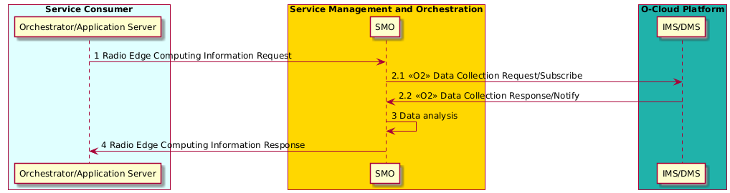
Figure 4.27.3.3-1: RAN edge computing information exposure

4.27.3.4 Sub-use case 3: O-RAN and mobile devices collaborative AI/ML inference
Void

4.27.3.5 Sub-use case 4: XR rendering collaboration
Void

4.27.3.6 Sub-use case 5: Joint communication and computing optimization for V2X communications
The context of the joint communication and computing optimization for V2X communications is captured in table 4.27.3.6-1.
Table 4.27.3.6-1: Joint communication and computing optimization for V2X communications
Use Case Stage | Evolution / Specification | <<Uses>>  Related use
Goal | Joint communication and computing optimization for V2X communications
Actors and Roles | SMO, Near-RT RIC, O-Cloud, E2 nodes, service consumer
Assumptions | All relevant functions and components are instantiated.
Pre conditions | All relevant functions and components are instantiated.
Step 1-2 (M) | SMO retrieves data from E2 nodes and O-Cloud via O1 and O2 interfaces to obtain available communication resource (e.g., network load, bandwidth) and computing resource information (e.g., resource type, available CPU/GPU frequency, storage), respectively.
Step 3-4 (M) | SMO exposes integrated communication and computing services or computing services to service consumers (e.g., vehicles or other third-party consumers).
Step 5 (M) | SMO retrieves service requests from service consumers, which indicate the V2X service requirements. The service request includes but not limited to following information:  - Service profile ID  - Service type (e.g., ID indicates service type in V2X scenarios, such as safety, advanced driving assistance)  - Computing data volume  - Location of UE  - Service end-to-end latency requirements  - UE mobility level, UE trajectory  - Uplink/downlink throughput requirements  - Computing resource requirements, including resource type, resource description, etc.  - Storage resource requirement  If the service consumer is a third-party service provider, following information should also be included in the service request:  - Maximum number of UEs  - Coverage for communication part of communication and computing services provided by RAN  - Overall uplink/downlink throughput requirements
Step 6-9 (M) | SMO performs joint communication and computing resource optimization via AI/ML inference based on service requests and generates policies. The policies include but not limited to workload deployment (e.g., offload the workload to which endpoint) and/or computing resource scheduling policies.  SMO sends the workload deployment policies including service requirements, and/or computing resource allocation policies to O-Cloud via O2 interface.  SMO sends communication optimization policies to Near-RT RIC via A1 interface to facilitate that Near-RT RIC optimized communication resources of E2 nodes.
Step 10 (M) | SMO sends notifications (e.g., service availability) to the consumer. The consumer establishes connection with the assigned endpoint and sends service load to the endpoint.
Step 11 (M) | SMO evaluates the performance (e.g., network performance, QoS of service), updates AI/ML model and /or policy accordingly.
Exceptions | None identified
Post Conditions

@startuml
skin rose
skinparam ParticipantPadding 5
skinparam BoxPadding 10
skinparam defaultFontSize 12
Autonumber

box #lightcyan
Participant "Service consumer" as consumer
endbox

box #lightseagreen
Participant "O-Cloud" as cloud
endbox

box #gold
Participant "SMO/Non-RT RIC" as SMO
endbox

box "O-RAN Nodes" #lightpink
Participant "Near RT-RIC" as RIC
Participant "E2 nodes" as e2
Endbox

SMO<-cloud: <O2> Computing resource information
SMO<-e2: <O1> Communication resource information

group service exposure
consumer->SMO: service discovery request
consumer<-SMO: service discovery response
end

consumer->SMO: service request

group Joint communication and computing resource optimization
SMO->SMO:AI/ML inference

SMO->cloud: <O2> Workload offload policy and/or computing resource optimization policy
SMO->RIC:<A1> Communication resource optimization policy
RIC->e2:<E2> Communication resource optimization policy
end
consumer<-SMO:Notifications (e.g., service availbility)
group Performance monitoring
ref over SMO,RIC,cloud, e2
Performance monitoring and evaluation
end ref
SMO->SMO: AI/ML model or policy update
end
@enduml

The flow diagram of the joint communication and computing optimization for V2X communications is given in figure 4.27.3.6-1.

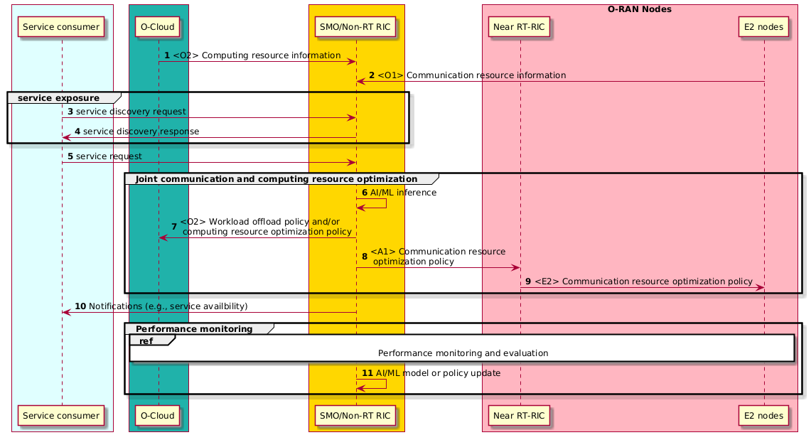
Figure 4.27.3.6-1: Joint communication and computing optimization for V2X communications flow diagram

4.27.3.7 Sub-use case 6: Exposure of performance information to assist computing resource scheduling
Void

4.27.4 Required data

4.27.4.1 Required data for communication and computing integrated networks use cases
The following clauses describe the required data that is relevant to each of the CCIN sub–use cases.

4.27.4.2 Sub-use case 1: Multi-aspect handover optimization
Table 4.27.4.2-1: Required data for multi-aspect handover optimization
Requirement | Category | Parameters / Measurements | Description | Source | Availability (Available/ Required) | Reference | Interface
Req-4.27.001 | Network configuration management | Base station identifier | Uniquely identify the base station, including PLMN identifier and other identifiers of both the serving base station and the target base station in the proximity. | O-CU | Available | 3GPP TS 28.541 [5], clause 4.3.1, gnbId | O1
Req-4.27.002 | Proximal computing capability information | Computing resource type | Identifies the type of resource, such as CPU, GPU, FPGA, NPU, DPU, AI accelerator, etc. | O-Cloud | Available | O-RAN.WG6.TS.O-CLOUD-IM [42], clause 4.2.1.4.1.2, resourceTypes | O2
Req-4.27.003 | Proximal computing capability information | Computing task type | Identifies the type of computational task, such as AI/CU/DU, FFT/IFFT/DFT/LDPC/POLAR/PDCP encryption/decryption, or user access-related processing, etc. | O-Cloud | Required |  | O2
Req-4.27.004 | Network configuration management | Location | The geographical location of both the serving base station and the target base station in the proximity. | O-CU | Available | 3GPP TS 28.541 [5], clause 5.4.1, ntnGeoArea | O1
Req-4.27.005 | Proximal computing availability information | Computing availability | The total capacity and available capacity of computing resource types for both the serving base station and the target base station in the proximity. | O-Cloud | Available | O-RAN.WG6.TS.O-CLOUD-IM [42], clause 4.2.1.4.5.2, capacity | O2

4.27.4.3 Sub-use case 2: RAN edge computing resource information exposure
Table 4.27.4.3-1: Required data for RAN edge computing information exposure
Requirement | Category | Parameters / Measurements | Source | Availability (Available/ Required) | Reference | Interface
Req-4.27.006 | Computing related resource data | CPU number for O-Cloud, cluster, or node | O-Cloud | Required |  | O2
Req-4.27.007 | Computing related resource data | vCPU number for O-Cloud, cluster, or node | O-Cloud | Required |  | O2
Req-4.27.008 | RAN edge computing information | Total capacity of computing or number of computing resources | O-Cloud | Available | O-RAN.WG6.TS.O-CLOUD-IM [42], clause 4.2.1.4.5.2, capacity | O2
Req-4.27.009 | RAN edge computing information | Allocated capacity of computing or number of computing resources | O-Cloud | Available | O-RAN.WG6.TS.O-CLOUD-IM [42], clause 4.2.1.4.5.2, capacity | O2
Req-4.27.010 | RAN edge computing information | Reserved capacity of computing or number of computing resources | O-Cloud | Available | O-RAN.WG6.TS.O-CLOUD-IM [42], clause 4.2.1.4.5.2, capacity | O2
Req-4.27.011 | RAN edge computing information | Available capacity of computing or number of computing resources | O-Cloud | Available | O-RAN.WG6.TS.O-CLOUD-IM [42], clause 4.2.1.4.5.2, capacity | O2
Req-4.27.012 | RAN edge computing information | Cloud identifier | O-Cloud | Available | O-RAN.WG6.TS.O-CLOUD-IM [42], clause 4.2.1.4.1.2, oCloudId | O2
Req-4.27.013 | RAN edge computing information | Resource identifier | O-Cloud | Available | O-RAN.WG6.TS.O-CLOUD-IM [42], clause 4.2.1.4.3.2, resourceId | O2
Req-4.27.014 | RAN edge computing information | Resource pool identifier | O-Cloud | Available | O-RAN.WG6.TS.O-CLOUD-IM [42], clause 4.2.1.4.4.2, resourcePoolId | O2
Req-4.27.015 | RAN edge computing information | Computing location | O-Cloud | Available | O-RAN.WG6.TS.O-CLOUD-IM [42], clause 4.2.1.4.31.2, locationsId | O2

4.27.4.4 Sub-use case 3: O-RAN and mobile devices collaborative AI/ML inference
Void

4.27.4.5 Sub-use case 4: XR rendering collaboration
Void

4.27.4.6 Sub-use case 5: Joint communication and computing optimization for V2X communications
Table 4.27.4.6-1: Required data for joint communication and computing optimization for V2X communications
Requirement | Category | Parameters / Measurements | Source | Availability (Available/ Required) | Reference | Interface
Req-4.27.016 | Computing resource related data | Resource type of computing resources in O-Cloud, e.g., CPU/GPU/NPU | O-Cloud | Available | O-RAN.WG6.TS.O-CLOUD-IM [42], clause 4.2.1.4.1.2, resourceTypes | O2
Req-4.27.017 | Computing resource related data | Available capacity of computing or number of computing resources | O-Cloud | Available | O-RAN.WG6.TS.O-CLOUD-IM [42], clause 4.2.1.4.5.2, capacity | O2
Req-4.27.018 | Computing resource related data | Available storage | O-Cloud | Required |  | O2
Req-4.27.019 | Computing resource related data | Cloud identifier | O-Cloud | Available | O-RAN.WG6.TS.O-CLOUD-IM [42],  clause 4.2.1.4.1.2, oCloudId | O2
Req-4.27.020 | Communication resource related data | PRB Usage | O-CU | Available | 3GPP TS 28.552 [6], clause 5.1.1.2.3，Distribution of DL Total PRB Usage | O1
Req-4.27.021 | Communication resource related data | Maximum uplink bandwidth | O-CU | Available | 3GPP TS 28.541 [5], clause 5.4.1, maxbrUl | O1
Req-4.27.022 | Communication resource related data | Maximum downlink bandwidth | O-CU | Available | 3GPP TS 28.541 [5], clause 5.4.1, maxbrDl | O1
Req-4.27.023 | Communication resource related data | Guaranteed uplink bandwidth | O-CU | Available | 3GPP TS 28.541 [5], clause 5.4.1, gbrUl | O1
Req-4.27.024 | Communication resource related data | Guaranteed downlink bandwidth | O-CU | Available | 3GPP TS 28.541 [5], clause 5.4.1, gbrDl | O1
Req-4.27.025 | Communication resource related data | Link quality | O-CU | Available | 3GPP TS 28.541 [5], clause 4.4.1, qQualMin | O1

4.27.4.7 Sub-use case 6: Exposure of performance information to assist computing resource scheduling
Void

4.28 RAN intent-driven management services
This use case provides the background and motivation for implementing intent-driven management capabilities in the O-RAN architecture to enable high-level, goal-oriented service automation and orchestration. It focuses on how an RMIO and an RMIH interact to provision, manage, and terminate RAN services based on expressed intents, without requiring the RMIO to configure low-level details.

4.28.1 Background and goal of the use case
Intent-driven management enables operators or external consumers to manage network behavior in a goal-oriented manner by specifying what outcome is desired rather than how to achieve it. This abstraction simplifies service management, accelerates deployments, and allows dynamic adaptation to changing RAN conditions.
In the RAN context, intents can express performance optimization targets, specific service-level objectives for slices (without explicitly requiring parameter configuration). An external consumer (e.g., E2E management system) or an internal SMO consumer (e.g., SO/SA or rApps) that needs to provide a RAN management intent must first discover the RAN intent handling capabilities supported by a particular RMIH within SMO. This ensures the consumer can select and formulate a suitable intent for SMO. Then, the RAN Management Intent Handler (RMIH) receives the intent, translates it into actionable configurations, and executes the necessary operations, while keeping the RAN Management Intent Owner (RMIO) informed on progress and service status.
To enable this, the SMO must support capabilities for registering and discovering RMIHs. This can be a natural add-on to the Service Management and Exposure (SME) in the SMO, where enhancements to the SME services would accommodate the registration and discovery of information specific to the RMIHs capabilities. RMIHs can register information about the intents they support, the management operations available, their reachability details, and other relevant metadata.

4.28.2 Entities/resources involved in the use case
- RAN Management Intent Owner (RMIO):
  - Defines high-level RAN service or management objectives without specifying detailed configurations.
  - Discovers available RMIHs and reviews their capabilities via the SME.
  - Formulates, sends, updates, and deletes intents as needed.
  - Evaluates intent reports received from RMIHs.
- Service Management and Exposure (SME):
  - Produces registration and discovery services for intent handling capabilities.
  - Provides RMIHs endpoints to RMIOs.
- RAN Management Intent Handler (RMIH):
  - Exposes their endpoints through SME.
  - Exposes their intent handling capabilities through SME.
  - Interprets the received RAN intents and maps them into actionable configurations.
  - Executes required operations to fulfill the intents and continuously monitors performance.
  - Reports fulfillment progress/status back to the RMIO via the SMO.

4.28.3 Solutions

4.28.3.1 RAN intent lifecycle management
The context for the intent lifecycle management is described in table 4.28.3.1-1.
Table 4.28.3.1-1: RAN intent lifecycle management
Use Case Stage | Evolution / Specification | <<Uses>>  Related use
Goal | Enable RMIOs to request handling of RAN intent.
Actors and Roles | RMIO  RMIH  SMO  SME
Assumptions | SMO has services that support capabilities for RAN management intent.  SME supports RMIH capability registration and discovery.
Pre-conditions | The SMO consumer is an authorized consumer of the SMO services.  RMIHs have registered their service capabilities in SME.
Begins when | The RMIO identifies a need for a RAN management intent.
Step 1 (M) | The RMIO queries SME for available RMIHs and their capabilities.
Step 2 (M) | The SME returns the RMIH endpoints and RMIH capabilities to the RMIO.
Step 3 (M) | The RMIO selects the appropriate RMIH.
Step 4 (M) | The RMIO formulates a RAN intent and sends it to the RMIH including subscription to intent reports.
Step 5 (M) | The RMIH validates the request.
Step 6 (M) | The RMIH sends initial acceptance/acknowledgment report to RMIO.
Step 7 (M) | The RMIH initiates execution procedures to fulfill the intent.
Step 8 (M) | The RMIH reports fulfillment status.
Step 9 (O) | The RMIO evaluates the report; if needed, it can modify the intent.
Step 10 (M) | The RMIO request intent deletion when the intent is no longer required.
Step 11 (M) | The RMIH deletes the intent and sends final confirmation to RMIO.
Ends when | The intent is deleted by the RMIO.
Exceptions | None.
Post Conditions | Service associated with the intent has been cleanly terminated.

The flow diagram of the RAN intent-driven management services use case is given in figure 4.28.3.1-1 and figure 4.28.3.1-2.

@startuml
skinparam ParticipantPadding 5
skinparam Boxpadding 10
skinparam defaultFontSize 12
Autonumber
Box External #lightcyan
participant RMIO as "RMIO"
end box
Box "Service Management and Orchestration" #gold
participant RMIH as "RMIH"
participant SME as "SME"
end box

== Capability Discovery ==
RMIO -> SME: Query available RMIHs and their capabilities
SME -> RMIO: Returning RMIH endpoints
RMIO -> RMIO: Selecting appropriate RMIH
== Intent Request ==
RMIO -> RMIH: Formulating and sending RAN management intent
RMIH -> RMIH: Validating the request
RMIH -> RMIO: Initial acceptance/acknowledgment
== Intent Execution ==
RMIH -> RMIH: Initiating execution to fulfill intent
RMIH -> RMIO: Reporting fulfillment status
group Optional Modification
RMIO -> RMIH: Requesting modification of intent if needed
end
== Intent Deletion ==
RMIO -> RMIH: Requesting intent deletion
RMIH -> RMIO: Deleting the intent and sending final report status
@enduml

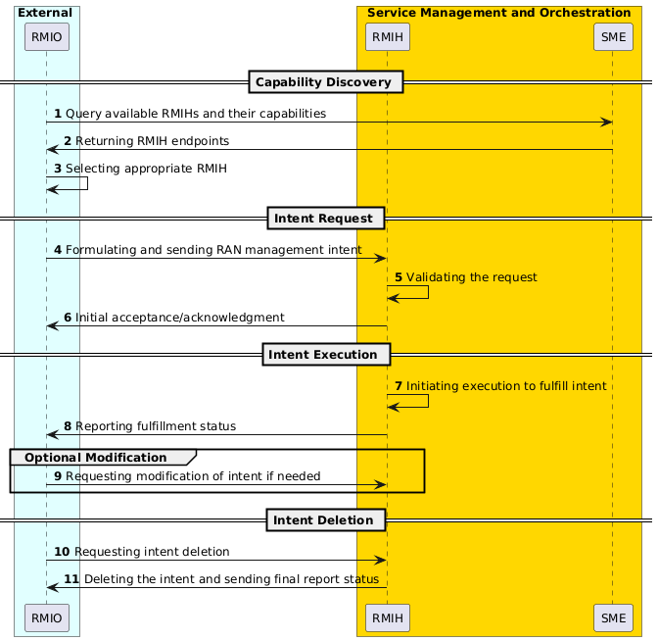
Figure 4.28.3.1-1 RAN management intent capabilities discovery use case flow diagram (external RMIO)
@startuml
skinparam ParticipantPadding 5
skinparam Boxpadding 10
skinparam defaultFontSize 12
Autonumber

Box "Service Management and Orchestration" #gold
participant RMIO as "RMIO"
participant RMIH as "RMIH"
participant SME as "SME"
end box

== Capability Discovery ==
RMIO -> SME: Query available RMIHs and their capabilities
SME -> RMIO: Returning RMIH endpoints
RMIO -> RMIO: Selecting appropriate RMIH
== Intent Request ==
RMIO -> RMIH: Formulating and sending RAN management intent
RMIH -> RMIH: Validating the request
RMIH -> RMIO: Initial acceptance/acknowledgment
== Intent Execution ==
RMIH -> RMIH: Initiating execution to fulfill intent
RMIH -> RMIO: Reporting fulfillment status
group Optional Modification
RMIO -> RMIH: Requesting modification of intent if needed
end
== Intent Deletion ==
RMIO -> RMIH: Requesting intent deletion
RMIH -> RMIO: Deleting the intent and sending final report status@enduml

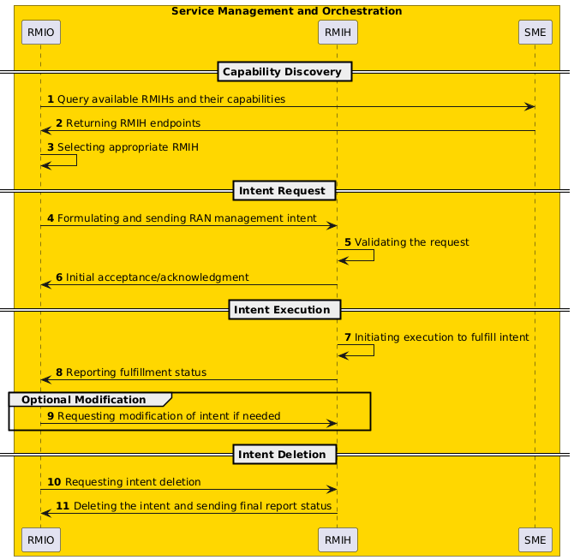
Figure 4.28.3.1-2 RAN management intent capabilities discovery use case flow diagram (RMIO in SMO)

4.28.4 Required data
The required data is measurements of metrics that are used in the intent expression to formulate intent requirements (e.g, performance metrics). Typically, also data from the inventory such as topology data is needed in the intent handling processes.

4.29 Resiliency
Void

4.30 NTN connected mode mobility
This use case provides the background, motivation and methodology for the Near-RT RIC to drive connected mode mobility of UEs when being served by a 3GPP 5G Non-Terrestrial Network (NTN), by leveraging the mobility enhancements introduced in 3GPP for NTN, such as time- and distance-based Conditional Handover (CHO), resulting in reduced signalling overhead and more robust mobility.

4.30.1 Background and goal of the use case

4.30.1.1 Common aspects & background for NTN connected mode mobility
Many upcoming 5G NTN constellations will be deployed in Low Earth Orbit (LEO), where a significant number of satellites are needed in order to achieve ubiquitous global coverage. LEO constellations are highly mobile and their network configuration is continuously changing, and as such UEs may experience frequent handovers, owing to both their own mobility but also that of the satellites overhead. In addition, in dense constellations, multiple candidate satellites may be able to serve a given coverage area, introducing the need for the network to select the appropriate target satellite to serve the incoming users. This could be influenced by a number of factors, such as feeder link availability, expected satellite visibility period, maximum number of concurrent beams, on-board power limitations, UE TX power and antenna gain, line of sight, spectrum constraints and more.
To support this, this use case covers the use of a Near-RT RIC and NTN xApp to optimize the implementation of NTN connected mode mobility, as driven by user and/or satellite motion, within an NTN Non-Geostationary Orbit (NGSO) constellation by utilizing the mobility enhancements introduced in 3GPP for NTN since Release 17. This use case is in principle formulated in a way that is largely agnostic of the NTN gNB architecture (e.g., Transparent vs Regenerative). In this scenario, users can be assumed to be practically stationary, slow moving (e.g., handheld) or fast moving (aircraft). The different scenarios represent architectures which employ (quasi) Earth-Fixed Cells (EFCs) or Earth-Moving Cells (EMCs).
The handover end-to-end call flow requires a sequence of signaling exchanges between the UE, its serving cell and a target neighboring cell to take place in order for the full procedure to be successful. In an event where the UE loses connectivity to its serving cell before it has received the required instructions to join the target cell, this could inhibit it from successfully undergoing a handover in RRC connected mode. Such an event is largely avoided in terrestrial networks by tailoring the signal measurement event on the serving cell to be triggered before its signal becomes too weak, but can become more likely to occur in 5G NTN constellations where the physical mobility of the satellites could mean that one which is currently delivering a cell to a specific location on the ground would all of a sudden become unable or ineligible to continue doing so, interrupting the procedure. This risk is only made higher by the increased control plane latencies witnessed in NTN networks, especially in transparent NTN systems where the RTT could be quite long, and when coupled with any additional processing time on the UE and RAN it might leave the UE(s) with insufficient time to receive the command to initiate the Random Access procedure prior to losing connectivity to the serving cell.
To account for such events, 3GPP has extended the capabilities of the Conditional Handover (CHO) with support for time-based and distance-based CHO configurations in the UE, in which its serving cell can preauthorize the UE to initiate the handover to a neighbor cell under conditions which are precomputed, and which provide the UE(s) with sufficient opportunity to undergo a successful handover, while not attempting it either before the neighboring cell becomes available or unnecessarily early, the latter of which would increase the frequency of handovers which are a costly procedure. This functionality is particularly relevant in NTN because the difference in signal strength owed to the UE being located at the cell center versus the cell edge is not as pronounced as it would be in terrestrial networks and is an insufficient trigger to determine the necessity for a handover to take place. The time-based and distance-based triggers on the other hand do not account for what could be a potentially ephemeral drop in signal quality of the serving cell as more traditional signal measurement triggers might, but rather communicate that there is a hard limitation to the currently serving cell’s ability to sustain service to the UE. By applying this configuration to all UEs in a cell, significant reductions in signaling overhead can be achieved compared to the regular handover scenario.
The time-based and distance-based CHO, introduced initially in 3GPP Release 17 as condEventT1 and condEventD1 in 3GPP TS 38.331 [53], have their applicability in both Earth-Moving Cell (EMC), and Earth Fixed Cell and quasi-Earth Fixed Cell (both addressed as EFC hereafter) applications, as discussed in the below sub-use cases.

4.30.1.2 Time-based CHO
Accounting for Earth-Moving Cell (EMC) based systems first, NTN constellations in NGSO employing the EMC configuration include satellites which project beams onto the Earth which are fixed to the body of the satellite itself and are effectively sweeping over the Earth underneath. Even though the individual beams can be hundreds of kilometers in diameter, the high orbital velocity of a satellite that is for instance in LEO would mean that a UE would enter into the coverage of a single beam and exit it within the order to seconds (depending on factors like satellite elevation angle, angular beam width, satellite altitude, etc.).
This is exemplified in the figure 4.30.1.2-1 below, showing a simplified representation of UE (orange point) mobility between cells illuminated by two NTN LEO satellites (blue and green points), applicable to both Transparent and Regenerative architectures, employing Earth-Moving Cells (EMCs).
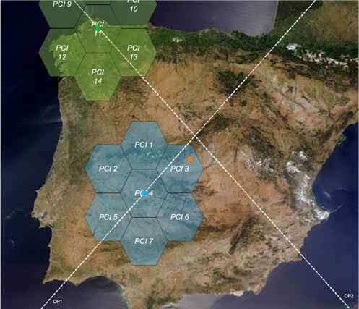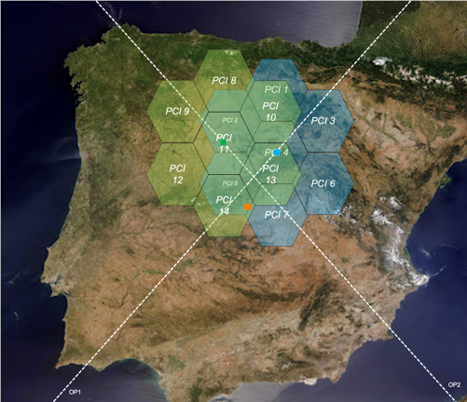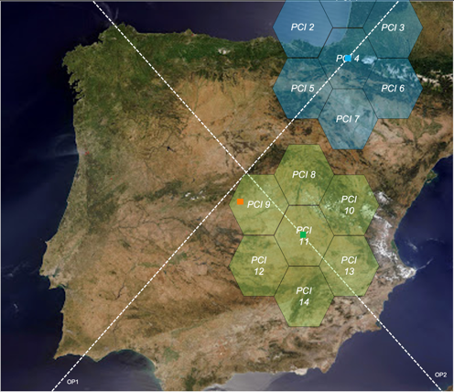
Figure 4.30.1.2-1: EMC inter-satellite handover scenario
In the first instance, the handovers occur between cells illuminated by the same satellite, exemplified as the blue satellite in figure 4.30.1.2-1. In a Regenerative architecture, these would most often involve cells which belong to the same onboard gNB and would constitute intra-gNB handovers. In Transparent architectures, the same could be the case (successive cells belong to same gNB on the ground), or the satellite could be connected via multiple feeder links to different gateways and gNBs, in which case successive beams could carry cells delivered by different gNBs and would therefore constitute an inter-gNB handover. Nevertheless, eventually the UE would be covered by one of the “outer” beams of a single satellite after which there is no further beam arriving from the same satellite. In this event, there needs to be another satellite coming either in succession in the same orbital plane or from another crossing orbital plane (the green satellite in the same figure) which can resume service to the UE with a new beam and cell. Again, depending on the architecture employed, this could either lead to an intra- or inter-gNB handover. As discussed before, signal measurement-based handover mechanisms would be insufficient to drive this type of mobility. Because of the frequency of handovers and the potential high number of UEs on the ground, significant signaling overheads would be generated as the UEs are being swept by different beams and cells. Time-based CHO was introduced in 3GPP to address exactly this.
Even if the satellites in the NTN constellation are capable of beam steering, allowing them to illuminate and track Earth-Fixed Cells (EFCs), there is still a fundamental limitation whereby a satellite in LEO would eventually fall beneath the minimum elevation angle, causing it to stop illuminating a 5G cell over the EFC, and the EFC would need to be handed over to a 5G cell served via a subsequent satellite. The two satellites could provide overlapping service with their respective cells for a short period of time during the handover of the EFC from one to the other, but they need not to, and the coverage can even be discontinuous in time as long as the associated timers (e.g., T304, T310) do not expire before the UEs in the EFC connect to the subsequent cell, causing RLF. This type of handover of entire EFCs (and constituent UEs) is applicable to Transparent architectures where different gNBs on the ground deliver successive cells via different gateways and satellites, where the same gNB delivers successive cells via different gateways and satellites, as well as in cases where two different gNBs via different gateways form feeder links with the same Transparent satellite that illuminates both of the successive cells onto the same EFC. It is also applicable to Regenerative architectures where the gNB is placed onboard the satellite, and the two gNBs/satellites deliver successive cells to the same EFC.
The figure 4.30.1.2-2 below showcases a simplified view of the above scenarios from the point of view of the satellite user links (omitting gateways and feeder links), whereby the orange UE is initially served by a cell delivered via the blue satellite (PCI 3). As the blue satellite is progressing along its orbit due North-East, it is nearing the moment where it will no longer be capable of illuminating and tracking the EFC in which the orange UE is located. At the same time, the red LEO satellite is coming into view, moving due South-East, and can resume the service to the EFC. It would deploy a new cell on top of the EFC (PCI 13), either with overlapped or discontinuous service.
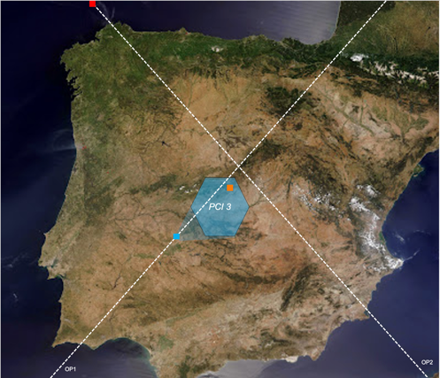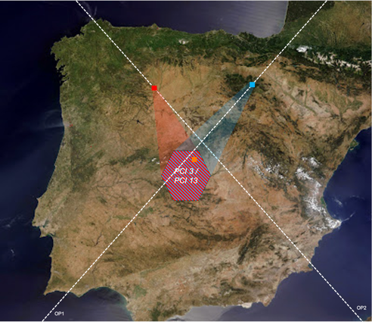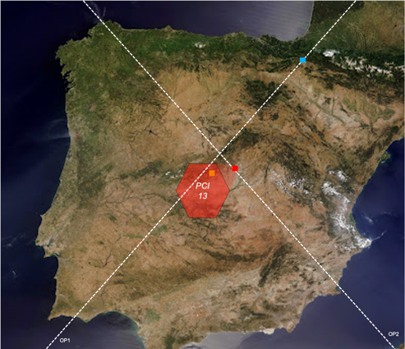
Figure 4.30.1.2-2: EFC inter-satellite handover scenario
Yet again, the need for a handover is not driven by variable signal quality by serving and candidate neighboring cells, but either by a hard limitation to the serving cell’s ability to sustain service to the EFC in question, or a higher layer decision by an NTN optimization xApp to redirect the blue satellite’s beam and power resources to provide coverage onto another EFC, even if the blue satellite could sustain coverage to the original EFC for a longer period of time. While UEs in EFCs would nominally undergo handovers less frequently compared to UEs in EMCs, risks owing to the reliability of just-in-time control plane signaling delivery and overall impacts on signaling overhead can be mitigated through the employment of time-based CHO to drive handovers, where the exact moment of handover can be precomputed and delivered ahead of time to the NTN gNB, who would signal it to the UEs in the EFC in question.

4.30.1.3 Distance-based CHO
While the ephemeral nature of satellite coverage over a given region defines the time bounds between which UEs in the region in question can be served, there are also other determinants which might cause a UE to exit coverage of one cell or beam, and necessitate a handover to another cell or beam, if present. One of these determinants is spatial in nature; namely, a UE’s physical location with respect to the spatial coverage footprint of a satellite beam via which the serving cell is illuminated will determine if the UE can continue to be served by that cell. By the same logic, a UE’s physical location with respect to that of a neighboring beam and cell will determine if the UE can be handed over to that cell.
Focusing on EMC-based systems first, this determinant can be exemplified by reusing figure 4.30.1.2-1. With considerations on whether the architecture is Transparent or Regenerative being equal to the time-based CHO EMC case, the coverage beams of NGSO satellites for which the EMC scenario applies are often approximated using hexagons, but their illumination footprints are in practice more circular in nature, with overlapping coverage towards the circular beams’ edges. Therefore, the footprint area can be nominally defined using the circular footprint’s center and radius (this holds true best when satellites are directly at zenith over a coverage region; at lower elevation angles the beam footprint illuminates the Earth’s surface at an angle, causing the effective footprint to be more oval). Focusing on figure 4.30.1.2-1, the orange UE is initially inside the satellite beam and cell with PCI 3. As the blue satellite traverses overhead along its orbital path, at one point the orange UE, even if stationary, will find itself more than the radius distance away from the moving center of the cell with PCI 3 (implicitly exiting its coverage), and less than the radius distance away from the moving center of the neighboring cell with PCI 4 (implicitly entering its coverage). With the expected slight overlap of the beams, there is a short period of time during which the UE can be expected to be in coverage of both cells. As was the case with time-based CHO, relying on signal measurements from the serving and neighboring cell(s) to drive such mobility cases is insufficient, and the legacy handover procedure can be expected to meaningfully contribute to signaling overhead and reduce the robustness of the handover procedure in an NTN scenario. For this purpose, the distance-based CHO mechanism was extended in 3GPP Release 18 to support EMC cases.
The distance-based CHO mechanism was in fact originally introduced in 3GPP Release 17 in support of EFC-based systems. In contrast to EMC, satellite beams and cells are fixed to the Earth and so, while their footprints can still be approximated as circles with a center and radius, the footprints’ centers are stationary. Nevertheless, the UEs themselves could be moving, and with them their distance from the serving and neighboring cell centers could be changing. At one point, a UE will have moved outside the effective coverage of its currently serving cell, and into that of another neighboring cell, if present, leading to a handover event.
Taking figure 4.30.1.3-1 as an example scenario, the orange UE is initially located inside the blue cell with PCI 6. After some time, due to the UE’s mobility, it will have travelled due North and crossed over into the coverage of the blue cell with PCI 3. At this point, the UE becomes closer to the center of the cell with PCI 3 than to that of the cell with PCI 6. Similar to the explanation for EFC in time-based CHO scenarios, the blue satellite could either be Regenerative and the handover between two blue cells would be an intra-gNB handover, or the blue satellite could be Transparent, potentially forming one or more feeder links to one or more gNBs, depending on which the handover could be intra- or inter-gNB.
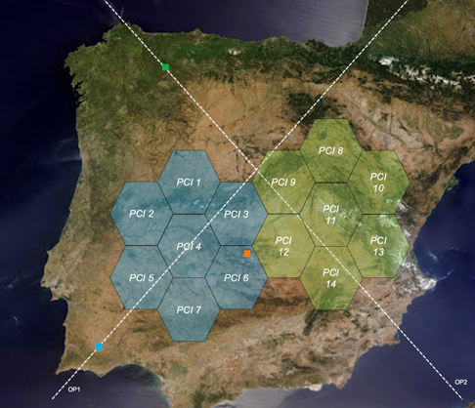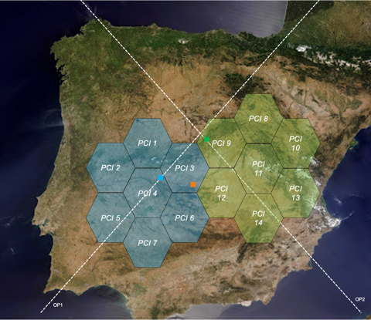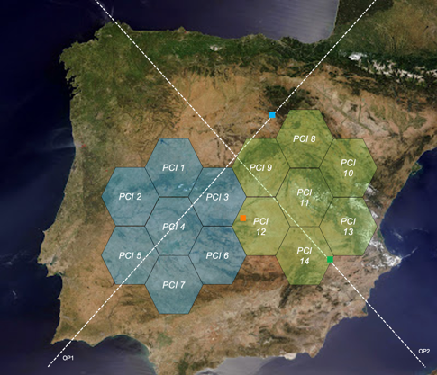
Figure 4.30.1.3-1: EFC inter-beam handover scenario
Once in the blue cell with PCI 6, after some time the orange UE might move Eastwards towards the area which is covered by the green cell with PCI 12, coming from the green satellite. Once more, the overall architecture at play would influence what type of handover this is. If the blue and green satellites are Regenerative, this would be an inter-gNB handover while if they are Transparent, the same could be the case or both might even be connected via feeder links to the same gNB, implying an intra-gNB handover.

4.30.2 Entities/resources involved in the use case

4.30.2.1 General aspects of entities/resources for NTN connected mode mobility
The following clauses describe the entities/resources that are important and key players for each of the NTN connected mode mobility sub-use cases.

4.30.2.2 Time-based CHO
1) SMO / Non-RT RIC:
a) Collect satellite information, e.g., satellite ephemeris, nowcast and forecast weather data, etc., from external application servers as enrichment information.
b) Send enrichment information to the Near-RT RIC via the A1 interface.
2) Near-RT RIC:
a) Hosting NTN xApp(s) that drive UE mobility in the constellation.
b) NTN constellation digital twin and physics modelling either as a capability offered by the Near-RT RIC to xApps, or within the NTN xApps themselves.
c) Ingestion of nowcast and forecast weather as satellite information from external application server to aid predictive channel quality modelling either collected by the Near-RT RIC and offered to xApps, or within the NTN xApps themselves.
d) Ingestion of updated satellite sas satellite information from external application server to aid digital twin modelling and NTN-specific RRC signaling to UEs.
e) Monitoring of RAN metrics via the E2 interface (leveraging relaxed control loop latency applicable to NTN systems, unlike the near-real time requirement in terrestrial networks).
f) Enactment of control via E2 interface to configure SMTC4 and SIB19 parameters in UEs, time-based and signal measurement-based Conditional Handover mobility in connected mode, and collection of coarse UE location information.
3) E2 node:
a) Support enactment of SMTC4 and SIB19 configurations, time-based and signal measurement-based Conditional Handover mobility triggers in connected mode, and collection of coarse UE location information delivered via the E2 interface from the Near-RT RIC.
b) Support recording of measurement reports from UEs and delivery to Near-RT RIC via the E2 interface.

4.30.2.3 Distance-based CHO
1) SMO / Non-RT RIC:
a) Collect satellite information, e.g., satellite ephemeris, nowcast and forecast weather data, etc., from external application servers as enrichment information.
b) Send enrichment information to the Near-RT RIC via the A1 interface.
2) Near-RT RIC:
a) Hosting NTN xApp(s) that drive UE mobility in the constellation.
b) NTN constellation digital twin and physics modelling either as a capability offered by the Near-RT RIC to xApps, or within the NTN xApps themselves.
c) Ingestion of nowcast and forecast weather as satellite information from external application server to aid predictive channel quality modelling either collected by the Near-RT RIC and offered to xApps, or within the NTN xApps themselves.
d) Ingestion of updated satellite ephemeris as satellite information from external application server to aid digital twin modelling and NTN-specific RRC signaling to UEs.
e) Monitoring of RAN metrics via the E2 interface (leveraging relaxed control loop latency applicable to NTN systems, unlike the near-real time requirement in terrestrial networks).
f) Enactment of control via E2 interface to configure SMTC4 and SIB19 parameters in UEs, distance-based and signal measurement-based Conditional Handover mobility in connected mode for EFC and EMC (the latter accompanied with ntn-NeighbourCellInfo-r18 in MeasObjectNR), and collection of coarse UE location information.
3) E2 node:
a) Support enactment of SMTC4 and SIB19 configurations, distance-based and signal measurement-based Conditional Handover mobility triggers in connected mode, and collection of coarse UE location information delivered via the E2 interface from the Near-RT RIC.
b) Support recording of measurement reports from UEs and delivery to Near-RT RIC via the E2 interface.

4.30.3 Solutions

4.30.3.1 General aspects of solutions for NTN connected mode mobility
As mentioned previously, efficient and conscious NTN connected mode mobility management is an optimization use case in and of itself and is one which is best addressed by a Near-RT RIC and constituent NTN xApp(s). This is primarily owed to the dynamic and near-real time nature of the optimization use case in question, as well as the granularity and level of control required towards the RAN (and as is enabled by the E2 interface).
One of the key prerequisites of the use case is for the Near-RT RIC and its xApps to have a means by which they can obtain the satellite ephemeris information, which is a key parameter that describes the satellites’ motion with great accuracy. This information is required for the NTN xApp(s) to have cognizance of which satellites are available over which area of the Earth, enabling them to drive NTN connected mode mobility, but also for the NTN xApp(s) to provide the ephemeris information to the E2 node for the latter to include in its scheduling, for instance for the purposes of System Information Block (SIB) 19 broadcast.
The satellite ephemeris information is itself typically updated and generated on a periodic basis by the Satellite Control Center (SCC), which is a system that is most often proprietary to the satellite constellation and operator. In an O-RAN architecture, this information could enter the system as external information, packaged as a data type for which the SCC is an external data producer. The mechanism through which this ingestion occurs is left to implementation.
Once the data is ingested into the SMO and Non-RT RIC, it would be delivered to the Near-RT RIC as A1 enrichment information, via the A1 interface. Once the information is available to the NTN xApp(s), the use case can proceed.

4.30.3.2 Time-based CHO
Addressing the EMC case first, whether the system is Transparent or Regenerative, 3GPP has not provisioned or accounted for the NTN gNBs to have the ability to keep track of which satellites, and by proxy which EMC cells, are valid neighboring candidates for handover in a continuously evolving system such as an NGSO NTN constellation. This is exemplified in the simplified figure 4.30.1.2-1 but would be even more pronounced in a denser deployment, as it would be in a real constellation.
The blue satellite in the figure, orbiting due North-East along its orbit, is the one which is initially serving the orange UE via the cell with PCI 3. Following 3GPP Release 17, the NTN gNB, as prompted by the NTN xApp via the E2 interface, can instruct the UE with GNSS capabilities to record coarse location information (with ~2 km accuracy) and report it to the NTN gNB [53], who subsequently uses the E2 interface to deliver it to the Near-RT RIC and the NTN xApp. By knowing the coarse coordinates of the UE as well as using the digital twin to derive the coverage footprints of the individual cells/beams delivered by the blue satellite, the NTN xApp can compute the remaining service time of the cell with PCI 3 after which the UE needs to be handed over to the cell with PCI 4, and subsequently to the cell with PCI 5. These derived remaining service times and handover target cells are UE-specific even within the same cell (e.g., PCI 3) as the relative location of different UEs within the same cell would define their mobility opportunities. For instance, if the UE in figure 4.30.1.2-1 was instead in the North-West corner of the cell with PCI 3 in the initial view, its target handover cell would instead be the cell with PCI 1, and the handover would need to occur sooner due to the shape of the beam and cell with PCI 3.
The NTN xApp would instruct the NTN gNB delivering the cell with PCI 3 to configure the orange UE with the T1 CHO (condEventT1 [53]) conditions that would signal to it the time interval during which it ought to attempt to connect to the cell that is subsequent to it, the one with PCI 4, as well as with appropriate SIB19 parameters to be broadcast that would contain the ntn-Config-r17 of all of the neighboring cells, itself containing the epochTime-r17 and ephemerisInfo-r17 of the blue satellite, among other parameters. Taking the cell with PCI 3 from the above figure as an example, its neighboring cells would be cells with PCI 1, PCI 4 and PCI 6.
After some time, the orange UE enters the trailing beam/cell of the blue satellite (PCI 5) after which it needs to be handed over to a cell illuminated by another satellite, in this instance the green one (first cell being one with PCI 14). The Near-RT RIC and NTN xApp would yet again combine coarse UE location information and digital twin modelling of the NTN constellation to produce the T1 CHO (condEventT1) and SIB19 parameters which aid the handover from blue cell with PCI 5 to the green cell with PCI 14. This could be coupled with another condition, such as one that is dependent on the signal quality of the neighboring cell exceeding some nominal value to ensure that the handover stands a greater chance of success (e.g., condEventA3, condEventA4, condEventA5) for which the SMTC4 configuration defined for NTN is employed (or otherwise can be used to pre-synchronize with the neighboring SS/PBCH transmissions). Furthermore, the overlapping coverage from multiple satellites also necessitates close coordination of which frequencies are employed by which cell in order to avoid interference, and the question of which are permitted to be employed is in many cases dependent on the region of the Earth that is being illuminated. Therefore, there is a further need for a higher order NTN control function, such as a Near-RT RIC and constituent NTN xApp(s), to drive this functionality.
As for the EFC case, in good time prior to the scheduled discontinuation of coverage to the EFC by the blue cell with PCI 3, the Near-RT RIC and NTN xApp would instruct via the E2 interface the NTN gNB to configure the UEs in the cell with the appropriate T1 CHO (condEventT1) configuration, potentially in conjunction with signal measurement-based CHO configurations (e.g., condEventA3, condEventA4, condEventA5). As was the case in the EMC instance, the NTN xApp will infer, if not decide itself, through the NTN digital twin and forward-looking scheduling that it will be the red satellite which will deploy a particular cell (PCI 13) at a particular moment over that EFC in order to continue providing service, and will have therefore provisioned the T1 CHO configurations in good time prior to the handover occasion taking place, taking into account any dependency on signaling delays induced by the RTT influenced by the orbital regime and Transparent vs. Regenerative nature of the constellation. Likewise, this will need to be accompanied with the updated SIB19 containing the ntn-Config-r17 which will indicate to the UE crucial information about the cell with PCI 13 and the red satellite, such as its ephemeris information, enabling the UE to synchronize with it.
In the event that there is a significant number of UEs in the blue cell with PCI 3, their handing over to the red cell with PCI 13 during the potential overlap period should be managed carefully in order to reduce the chances of preamble collisions, contention resolution delays, etc. Since the two satellite beams and cells in question are intended to cover the same EFC, the relative location of different UEs within the EFC would not play as much of a role as it did in the EMC case, as all of the UEs would be affected by the withdrawal of the blue cell with PCI 3 and illumination of the red cell with PCI 13 in the same manner and time (there is an edge case where this need not be true; if the elevation angles of the blue and red satellites cause their beam footprints and therefore cell coverages on top of the EFC at the moment of handover to be of different shapes, excluding certain UEs). In this respect, the same T1 CHO parameters could be configured for all of the UEs within the same cell. Nevertheless, in order to balance the RA load onto the red cell with PCI 13, the Near-RT RIC and NTN xApp(s) can theoretically alter the duration of any overlap or discontinuity of service to the EFC (T310 timer for RLF in UEs starts as blue cell shuts off – UEs must perform RA to the red cell prior to expiry to avoid exiting RRC connected mode) as well as tune the per-UE group RACH-Config and T1 CHO parameters to better distribute their RA across the red cell’s RACH occasions.
The solution to the time-based CHO driven mobility is described in table 4.30.3.2-1 and is covered in [i.17], clause 5.2.4.

Table 4.30.3.2-1: NTN handover management with time-based CHO
Use Case Stage | Detailed Information
Goal | Find best handover candidate satellites/cells for a UE while utilizing the least amount of radio resources in the network.
Actors and Roles | SMO, Non-RT RIC: Serves the purposes to ingest satellite information from external sources and make it available to the Near-RT RIC via A1 interface.  Near-RT RIC: NTN xApp with NTN digital twin, using E2 for REPORT and CONTROL services.  E2 nodes: NTN gNBs offering REPORT and CONTROL services.
Assumptions | All relevant functions and components are instantiated.  A1 and E2 interface connectivity are established.
Pre-conditions | Non-RT RIC contains satellite ephemeris information.  A1 interface is established between Non-RT RIC and Near-RT RIC to enable enrichment information transfer.  E2 interface connectivity is established, NTN xApp has access to live source of global weather data and is preconfigured with the SAN configuration in the NTN digital twin.
Step 1 (M) | Non-RT RIC delivers satellite information to Near-RT RIC as enrichment information via the A1 interface.
Step 2 (M) | Near-RT RIC subscribes to UE context information via E2 interface.
Step 3 (M) | E2 nodes report the UE context information via RIC INDICATION.
Step 4, 5 (O) | Near-RT RIC subscribes to periodic or event triggered coarse UE location reports via E2 interface.
Step 6, 7 (O) | Near-RT RIC asynchronously queries the E2 node via the E2 interface to obtain the coarse UE location.
Step 8 (M) | Near-RT RIC determines handover opportunities to different cells / satellites.
Step 9 (M) | Near-RT RIC generates SIB19 content indicating specific information about the neighboring cells and satellites and sends it to E2 node as RIC CONTROL via E2 interface.
Step 10 (M) | Near-RT RIC configures SMTC (inclusive of SMTC4) in E2 node via E2 interface.
Step 11 (M) | Near-RT signals per-UE time-based CHO configuration via E2 interface.
Step 12 (O) | Near-RT signals per-UE signal measurement-based CHO configuration via E2 interface.

@startuml
Skin rose
autonumber
skinparam ParticipantPadding 4
skinparam BoxPadding 8
skinparam defaultFontSize 12

Box “Service Management and Orchestration” #gold
Participant “Non-RT RIC” as non
End box

Box “O-RAN” #lightpink
Participant near as “Near-RT RIC”
Participant ran as “E2 Node”
End box

note over non:
Non-RT RIC has updated satellite
ephemeris information.
end note

non -> near: <<A1>> Enrichment information

near -> ran : <<E2>> RIC SUBSCRIPTION REQUEST (UE Context information change REPORT)
near <- ran: <<E2>> RIC INDICATION (New UEs joining cell)

opt If coarse UE location is configured
alt REPORT
near -> ran : <<E2>> RIC SUBSCRIPTION REQUEST (Coarse UE location REPORT)
near <- ran: <<E2>> RIC INDICATION (Periodic or event triggered coarse UE location report)
else QUERY
near -> ran : <<E2>> RIC QUERY REQUEST (Coarse UE location QUERY)
near <- ran: <<E2>> RIC QUERY RESPONSE (Asynchronous coarse UE location)
end
end

near -> near: Satellite passes, Near-RT RIC evaluates candidate handover opportunities
near -> ran : <<E2>> RIC CONTROL REQUEST (SIB19 cell-level Configuration CONTROL)
near -> ran : <<E2>> RIC CONTROL REQUEST (SMTC configuration for signal measurements on candidate satellite(s) CONTROL)
near -> ran : <<E2>> RIC CONTROL REQUEST (T1 CHO configuration CONTROL)

opt If enhanced with signal measurements
near -> ran : <<E2>> RIC CONTROL REQUEST (Ax CHO configuration CONTROL)
end

@enduml

The flow diagram of the NTN T1 CHO is given in figure 4.30.3.2-1.
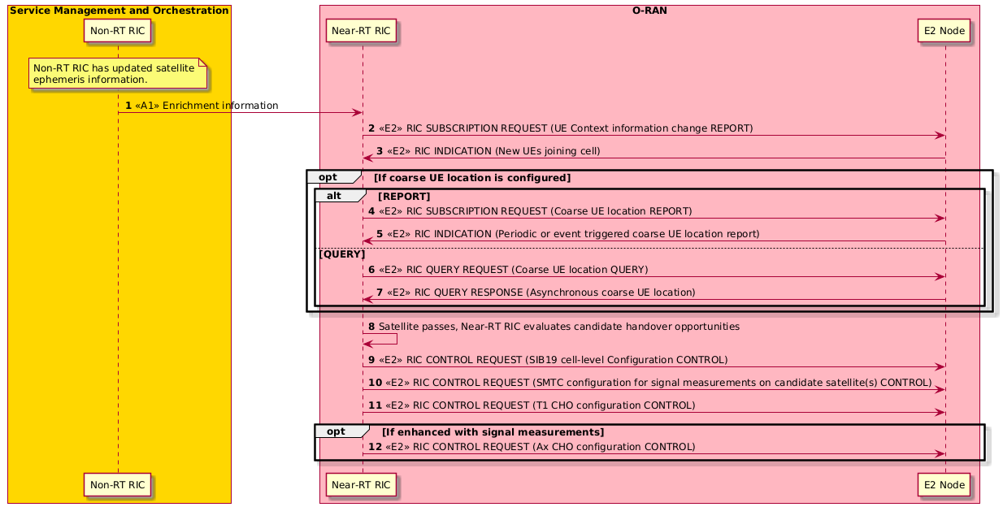
Figure 4.30.3.2-1: UML chart of NTN time-based CHO management

4.30.3.3 Distance-based CHO
Focusing again on the EMC case first, and with respect to the scenario in figure 4.30.1.2-1, the UE is initially served by the blue satellite via the beam and cell with PCI 3. It requires a mechanism by which to evaluate its distance from the moving locations which represent its current serving cell and a candidate neighboring cell in an EMC system. In 3GPP Release 18, a new CHO configuration was introduced, called D2 CHO (condEventD2 [53]), for this purpose. This allows the NTN xApp, by proxy of the E2 interface to the NTN gNB, to specify two distances, distanceThreshFromReference1-r18 and distanceThreshFromReference2-r18 alongside a hysteresis distance, to a UE in a cell. The UE is expected to use its GNSS capabilities to ascertain its location, but it also needs the two moving locations to measure and compare its distance to.
At the same time, the NTN xApp can use the E2 interface to deliver to the NTN gNB the parameters which it is supposed to broadcast to UEs in cell with PCI 3 as part of SIB19. Other than including crucial parameters such as epochTime-r17 and ephemerisInfo-r17 which are found in the ntn-Config-r17, starting from 3GPP Release 18 the SIB19 is also supposed to also include a field called movingReferenceLocation-r18. This is supposed to signal to the UEs a serving cell-specific reference location which they are supposed to measure their distance to and compare it to the distanceThreshFromReference1-r17 value provided via the D2 CHO configuration. Nominally this location can be regarded as representing the moving cell center, but strictly speaking need not be, and it is up to the NTN xApp to define what this is going to represent. The movingReferenceLocation-r18 is in its definition a static point on the ground, timestamped to the epochTime-r17 from the ntn-Config-r17, and the UE is expected to combine this with the ephemerisInfo-r17 to propagate the satellite’s orbital trajectory in the immediate future and ascertain how the movingReferenceLocation-r18 would move along with the satellite, before it receives the subsequent SIB19 broadcast with the network-updated movingReferenceLocation-r18.
The other reference location, the distance to which the UE is measuring using its GNSS-derived coordinates and comparing to the distanceThreshFromReference2-r17 value provided via the D2 CHO configuration, is delivered inside the measObjectNR, namely in the ntn-NeighbourCellInfo-r18 field, for a specific candidate neighboring cell. Within this field, the neighboring cell’s epochTime-r17, ephemerisInfo-r17, and referenceLocation-r17 are specified, where the latter is a static location which indicates the reference location at epochTime-r17, which the UE can use alongside the epehemerisInfo-r17 to propagate the satellite’s orbital trajectory in the immediate future and ascertain how the referenceLocation-r17 would move along with the satellite, as was the case with movingReferenceLocation-r18.
Once the distance to the movingReferenceLocation-r18 of the serving cell exceeds the distanceThreshFromReference1-r17, and simultaneously the distance to the referenceLocation-r17 of a neighboring candidate cell drops below the distanceThreshFromReference2-r17 (taking into account hysteresis in both cases), the UE regards itself as having satisfied the conditions for the D2 CHO, and attempts to join the neighboring cell. Nominally, the NTN xApp does not need to know the coarse location of the UEs in a cell to supply them with the D2 CHO parameters, making the D2 CHO configuration common to all UEs in the cell. Referring to the scenario in figure 4.30.1.2-1, if the UE were to be initially located inside the blue cell with PCI 4, it would be supplied with D2 CHO configurations only for the neighboring blue cells which could at some point in the future (no farther than the TimeToTrigger in the D2 CHO config) illuminate the current footprint of the cell with PCI 4. These would be the cells with PCIs 2, 5 and 7, but not the ones with PCIs 1, 3 and 6, since those wouldn’t be valid handover candidates due to the movement of the blue satellite. Then, if the serving and various neighboring cell reference locations were tied to the cell centers, the distances supplied in the D2 CHO config would relate to the serving and neighboring cells’ radii.
Moving on to EFC-based systems next and taking the scenario from figure 4.30.1.3-1 as reference, the orange UE is initially located within the blue cell with PCI 6. The NTN xApp is aware of the overall EFC topology of the network and can infer the cells which are neighbors to the cell with PCI 6. In the simplified example in the figure, these are the blue cells with PCIs 3, 4, 7 and the green cell with PCI 12. In this instance, the cell centers are not influenced by the movement of the blue and green satellites, but are instead fixed on the ground. For supporting mobility cases where the UE’s relative proximity to these reference locations is driven by the mobility of the UE itself, 3GPP introduced in Release 17 support for D1 CHO (condEventD1 [53]). Within it, the two reference locations (referenceLocation1-r17 and referenceLocation2-r17) and the distance thresholds to the two reference locations (distanceThreshFromReference1-r17 and distanceThreshFromReference2-r17) are defined right in the D1 CHO configuration and are common for all UEs in the cell. Referring again to the starting position of the orange UE, it receives a D1 CHO configuration for each of the neighboring cells. After some time, the UE moves due North sufficiently such that its distance from the center of the serving cell with PCI 6 (referenceLocation1-r17) exceeds the configured distanceThreshFromReference1-r17, while its proximity to the center of the neighboring cell with PCI 3 (referenceLocation2-r17) drops below the configured distanceThreshFromReference2-r17, taking into account hysteresis for both distances. At that point, the D1 CHO configuration for cell with PCI 3 is triggered, and the orange UE attempts to join it, where upon success it becomes configured with the D1 CHO configurations for the new set of neighboring cells (blue cells with PCIs 1,4 and 6 and green cells with PCIs 9 and 12). The triggering condition could again be coupled with another condition, such as one that is dependent on the signal quality of the neighboring cell exceeding some nominal value to ensure that the handover stands a greater chance of success (e.g. condEventA3, condEventA4, condEventA5) for which the SMTC4 configuration defined for NTN is employed (or otherwise can be used to pre-synchronize with the neighboring SS/PBCH transmissions). Yet again, after some time, the orange UE moves, this time Eastwards into the coverage footprint of the green cell with PCI 12. Here, the same conditional measurement procedure takes place, and the orange UE eventually joins the cell with PCI 12.
The solution to the distance-based CHO driven mobility is described in table 4.30.3.3-1 and is covered in [i.17], clause 5.2.4.
Table 4.30.3.3-1: NTN handover management with distance-based CHO
Use Case Stage | Detailed Information
Goal | Find best handover candidate satellites/cells for a UE while utilizing the least amount of radio resources in the network.
Actors and Roles | SMO, Non-RT RIC: Serves the purposes to ingest satellite information from external sources and make it available to the Near-RT RIC via A1 interface.  Near-RT RIC: NTN xApp with NTN digital twin, using E2 for REPORT and CONTROL services.  E2 nodes: NTN gNBs offering REPORT and CONTROL services.
Assumptions | All relevant functions and components are instantiated.  A1 and E2 interface connectivity are established.
Pre-conditions | Non-RT RIC contains satellite ephemeris information.  A1 interface is established between Non-RT RIC and Near-RT RIC to enable enrichment information transfer.  E2 interface connectivity is established, NTN xApp has access to live source of global weather data and is preconfigured with the SAN configuration in the NTN digital twin.
Step 1 (M) | Non-RT RIC delivers satellite information to Near-RT RIC as enrichment information via the A1 interface.
Step 2 (M) | Near-RT RIC subscribes to UE context information via E2 interface.
Step 3 (M) | E2 nodes report the UE context information via RIC INDICATION.
Step 4, 5 (O) | Near-RT RIC subscribes to periodic or event triggered coarse UE location reports via E2 interface.
Step 6, 7 (O) | Near-RT RIC asynchronously queries the E2 node via the E2 interface to obtain the coarse UE location.
Step 8 (M) | Near-RT RIC determines handover opportunities to different cells / satellites.
Step 9 (M) | Near-RT RIC generates SIB19 content indicating specific information about the neighboring cells and satellites and sends it to E2 node as RIC CONTROL via E2 interface.
Step 10 (M) | Near-RT RIC configures SMTC (inclusive of SMTC4) in E2 node via E2 interface.
Step 11 (O) | Near-RT signals per-UE distance-based (D1) CHO configuration for EFC via E2 interface.
Step 12 (O) | Near-RT signals per-UE distance-based (D2) CHO configuration and NTN-NeighbourCellInfo-r18 for EMC via E2 interface.
Step 13 (O) | Near-RT signals per-UE signal measurement-based CHO configuration via E2 interface.

@startuml
Skin rose
autonumber
skinparam ParticipantPadding 4
skinparam BoxPadding 8
skinparam defaultFontSize 12

Box “Service Management and Orchestration” #gold
Participant “Non-RT RIC” as non
End box

Box “O-RAN” #lightpink
Participant near as “Near-RT RIC”
Participant ran as “E2 Node”
End box

note over non
Non-RT RIC has updated satellite
ephemeris information.
end note

non -> near: <<A1>> Enrichment information

near -> ran : <<E2>> RIC SUBSCRIPTION REQUEST (UE Context information change REPORT)
near <- ran: <<E2>> RIC INDICATION (New UEs joining cell)

opt If coarse UE location is configured
alt REPORT
near -> ran : <<E2>> RIC SUBSCRIPTION REQUEST (Coarse UE location REPORT)
near <- ran: <<E2>> RIC INDICATION (Periodic or event triggered coarse UE location report)
else QUERY
near -> ran : <<E2>> RIC QUERY REQUEST (Coarse UE location QUERY)
near <- ran: <<E2>> RIC QUERY RESPONSE (Asynchronous coarse UE location)
end
end

near -> near: Satellite passes, Near-RT RIC evaluates candidate handover opportunities
near -> ran : <<E2>> RIC CONTROL REQUEST (SIB19 cell-level Configuration CONTROL)
near -> ran : <<E2>> RIC CONTROL REQUEST (SMTC configuration for signal measurements on candidate satellite(s) CONTROL)
near -> ran : <<E2>> RIC CONTROL REQUEST (T1 CHO configuration CONTROL)

opt If enhanced with signal measurements
near -> ran : <<E2>> RIC CONTROL REQUEST (Ax CHO configuration CONTROL)
end

@enduml

The flow diagram of the NTN D1 and D2 CHO is given in figure 4.30.3.3-1.
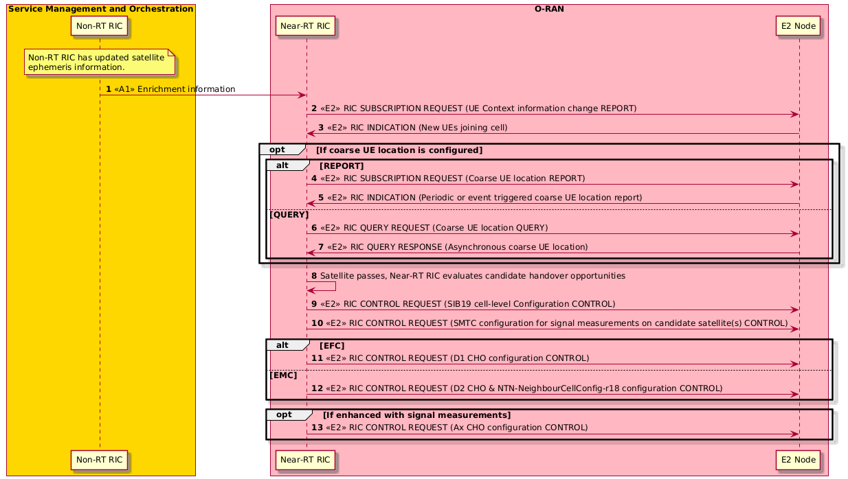
Figure 4.30.3.3-1: UML chart of NTN distance-based CHO management

4.30.4 Required Data

4.30.4.1 General required data for NTN connected mode mobility
The following clauses elaborate the required data that is relevant to all of the NTN connected mode mobility sub-use cases. The NTN EphemerisInfo information that is required at the Non-RT RIC is defined in 3GPP TS 38.331 [53], clause 6.3.2.
Table 4.30.4.1-1: Required input data for NTN connected mode mobility
Requirement | Category | Parameters / Measurements | Source | Reference | Interface
Req-4.30.001 | Channel Quality/State Information | Wideband CQI Distribution | O-DU | 3GPP TS 28.552 [6], clause 5.1.1.11.1 | E2
Req-4.30.002 | Network load and data performance | DL Total PRB Usage | O-DU | 3GPP TS 28.552 [6], clause 5.1.1.2.1 | E2
Req-4.30.003 | Network load and data performance | UL Total PRB Usage | O-DU | 3GPP TS 28.552 [6], clause 5.1.1.2.2 | E2
Req-4.30.004 | Network load and data performance | Mean number of Active UEs, per cell (and optionally per PLMN, per slice) | O-DU | 3GPP TS 28.552 [6], clause 5.1.1.23.5 | E2
Req-4.30.005 | Network load and data performance | Average DL UE throughput in gNB per cell (and optionally per PLMN, per QoS level, per slice) | O-DU | 3GPP TS 28.552 [6], clause 5.1.1.3.1 | E2
Req-4.30.006 | Network load and data performance | Average UL UE throughput in gNB per cell (and optionally per PLMN, per QoS level, per slice) | O-DU | 3GPP TS 28.552 [6], clause 5.1.1.3.2 | E2
Req-4.30.007 | UE measurement | RSRQ measurement per SSB per cell | O-CU | 3GPP TS 28.552 [6], clause 5.1.1.31 | E2
Req-4.30.008 | UE measurement | RSRP measurement per SSB per cell | O-CU | 3GPP TS 28.552 [6], clause 5.1.1.22 | E2
Req-4.30.009 | UE measurement | SINR measurement per SSB per cell | O-CU | 3GPP TS 28.552 [6], clause 5.1.1.32 | E2

4.31 Anomaly management
Void

Annex A (informative):
Additional information

A.1 Traffic steering use case A1 interface usage example
NOTE: Please refer to WG2 Use Cases and Requirements Specification for more details and up to date definitions of this use case A1 interface usage examples.
An example scenario is here used to describe the use of A1 for traffic steering, implying the Non-RT RIC sending policies for allocation of the control plane (RRC) and the user plane for different services, identified by their 5QI.
In the scenario a UE with UEid=1, belonging to a subnet slice identified by S-NSSAI=1, having a voice (5QI=1) and an MBB (5QI=9) connection established, enters an area covered by four frequency bands. The Non-RT RIC understands the requirements and characteristics of the services and decides to let the voice and RRC connection reside on the low band (here covered by a macro cell B becoming the PCell), while the MBB connection should preferably use the higher band (here provided by a smaller cell C and D becoming the SCells) and avoid the low band if possible. Cell A is used for MBB if required for coverage reasons.
Policies are sent to any cell of concern, e.g. where the UE resides and can move.
The desired use of the cells is shown in figure A.1-1.

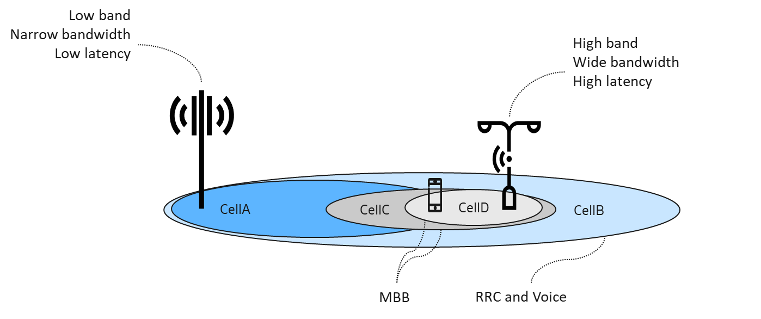
Figure A.1-1: Desired use of the cells
Two policies over A1 are needed to accomplish the desired behavior, described in JSON format below. Note that as part of the scope, the cell_id is optional, and if omitted it is up to the Near-RT RIC to locate the UE and there enforce the policy.
{
"policy_id": "1",
"scope": {
"ue_id": "1",
"slice_id": "1",
"qos_id": "1",
“cell_id”: ”X” // Policy for Cell X, where X is one of A, B, C or D
},
"statement": {
"cell_id_list": "B",
"preference": "Shall",
"primary": true // Control plane on Cell B (becoming PCell)
},
"statement": {
"cell_id_list ": "B",
"preference": "Shall",
"primary": false // Voice on Cell B
}
}

{
"policy_id": "2",
"scope": {
"ue_id": "1",
"slice_id": "1",
"qos_id": "9",
“cell_id”: ”X” // Policy for Cell X, where X is one of A, B, C or D
},
"statement": {
"cell_id_list ": {"B", “A”},
"preference": "Avoid",
"primary": false // Avoid MBB on Cell A and Cell B
},
"statement": {
"cell_id_list": {“C”, “D”},
"preference": "Prefer",
"primary": false // Prefer MBB on Cell C and Cell D
}
}

Annex (informative):
Change history/Change request (history)
Date | Revision | Description
2019.07.07 | 01.00.00 | Draft template
2019.09.18 | 01.00.01 | Addition of CR:  - ORAN-WG1.UseCasesDetailedSpecification_CR_NOK_DHO_20190909
2019.09.19 | 01.00.02 | Addition of QoE optimization use case from WG2 UCR specification
2019.09.20 | 01.00.03 | Addition of Traffic Steering use case from WG2 UCR specification
2019.09.23 | 01.00.04 | Addition of CR:  - ORAN-WG1.UAV Control Vehicle Use Case -INSPUR-20190911  Editorial changes
2019.09.27 | 01.00.05 | Addition of CR:  - ORAN-WG1.UAV_Use Case for dynamic UAV Radio Resource Allocation _CMCC_CR  Editorial changes for improved sections, consistency, typo fixes
2019.09.28 | 01.00.06 | Updates to Radio Resource Allocation for UAV Application Scenario from UC Analysis doc  Addition of CR:  - ORAN-WG1.UAV_Use Case for dynamic UAV Radio Resource Allocation _CMCC_CR_v2
2019.10.11 | 01.00.07 | Updates to the following use cases based on use case review meeting:  - Fight Path Based Dynamic UAV Radio Resource Allocation (CMCC)  - Radio Resource Allocation for UAV Application (Inspur)
2019.10.17 | 01.00.08 | Add plantuml code and diagram for OoE use case to add E2 interaction between Near-RT RIC and RAN  Modified UAV Control Vehicle use case required data to remove IMSI and replace with user identification clarification  Corrected UAV Resource Allocation plantuml code and diagram with ML model deployment over O1 (rather than A1)  Corrected QoE use case plantuml code and diagram for ML model deployment over O1 (rather than A1)  Merged updates from ORAN-WG1.Correction on UAV_UseCasesDetailedSpecification_CMCC_CR v1
2019.10.17 | 01.00 | Final version 01.00
2019.11.16 | 02.00.01 | Initial version of v2.0  Document version number update to v02.00.01
2019.11.25 | 02.00.02 | Addition of CR (new use case):  - ORAN-WG1.UseCasesDetailedSpecification_CR_ORANGE_20191120.docx
2019.12.06 | 02.00.03 | Addition of CRs:  - UAV Control Vehicle-CR-INSPUR-20191204.docx  - ORAN-WG1.UseCasesDetailedSpecification_CR_ORANGE_20191125-update-uml.docx
2019.12.08 | 02.00.04 | Addition of CRs:  - ORAN-WG1.UseCasesDetailedSpecification_CR_CMCC_20191204.docx  - ORAN-WG1.UseCasesDetailedSpecification_CR_NOK_DHO_20191203.docx
2020.01.10 | 02.00.05 | Addition of CRs:  - ORAN-WG1.UseCasesAnalysisReport_CR_Traffic_Steering_Ericsson_2020.01.08.docx  - ORAN-WG1.Usecase_QoS_based_resource_optimization_1_6-2020.docx
2020.01.22 | 02.00.06 | Editorial updates and terminology corrections
2020.02.12 | 02.00.07 | Addition of CR:  - ORAN-WG1.UCTG_CMCC_QoE Optimization Use Case  Editorial updates to plantUML diagrams to add interface names, and rearranging components per O-RAN plantUML guidelines
2020.02.13 | 02.00.08 | Addition of CR:  - ORAN-WG1.UseCasesDetailedSpecification_CR_ (UC_M-MIMO)_TIM-ORANGE-CMCC_20200114-v2
2020.02.23 | 02.00.09 | Editorial updates, O-RAN license agreement additions, update RAN Sharing diagram with latest version,
2020.03.01 | 02.00.10 | Editorial updates, fixing table of contents issues, spec naming corrections
2020.03.11 | 02.00.11 | Updates to definitions and RAN Sharing use case (update O1* to O2) based on WG1 review/approval feedback
2020.03.11 | 02.00 | Final version 02.00
2020.06.19 | 03.00.01 | Initial version of v3.0  Document version number update to v03.00.01
2020.06.20 | 03.00.02 | Addition of CR:  - O-RAN_WG1_2020.03.11-Netsia_KDDI_ATT_TEF_UCTG_CR_UCDS_SliceAssurance .docx
2020.06.20 | 03.00.03 | Addition of CR:  - INT-2020.05.21-WG1-D-CR-UCDR_MultiAccess_UC_v1.docx
2020.07.15 | 03.00.04 | Updates based on WG1 review comments (very minor editorial corrections to section 3.9)
2020.07.16 | 03.00.05 | Getting the version ready to be published externally (removal of track changes/comments)
2020.07.16 | 03.00 | Final version 03.00
2020.10.17 | 04.00.01 | Initial version of v4.0  Document version number update to v04.00.01
2020.11.01 | 04.00.02 | Addition of CR:  - STL.AO-10.14.2020-WG1(UCTG)-CR-0001-DSS-v1.2
2020.11.02 | 04.00.03 | Addition of CR:  - INT-2020.11.02-WG1(UCTG)-CR-0001-NSSI-Rsrc-Opt-D-UC-v1.3  Editorial updates/corrections
2020.11.05 | 04.00.04 | Addition of CR:  - KDDI.AO-2020.11.05-WG1-CR-0001-Multi-vendor Slices Use Case-v01
2020.11.13 | 04.00.05 | Correction of plantuml source and diagram for Multi-vendor Slices use case and other editorial updates
2020.11.13 | 04.00 | Final version 04.00
2021.02.28 | 05.00.01 | Initial version of v5.0  Document version number update to v05.00.01
2021.03.04 | 05.00.02 | To keep the same use case numbering as Use Case Analysis Report, addition of  - Use case 13 “Local Indoor Positioning in RAN”  - Use case 16 “Congestion Prediction and Management”  - Use case 17 “Industrial IoT Optimization”  - Use case 18 “BBU Pooling to achieve RAN Elasticity”  as FFS items. Use case 14 and 15 will be defined in further sub versions of this v5 specification.  Addition of CR:  - ATT.AO-2020.12.01-WG1-CR-0001-UseCaseDetailedSpecification_SSP-v04
2021.03.08 | 05.00.03 | Updating use case 14 name to “Massive SU/MU-MIMO Grouping Optimization”
2021.03.08 | 05.00.04 | Addition of CR:  - NOK-2021.02.10-ORAN-CR-0001-UseCaseDetailedSpecification_mMIMO_BF_Optimization-v01  Editorial updates
2021.03.13 | 05.00 | Final version 05.00
2021.07.10 | 06.00.01 | Initial version of v6.0  Document version number update to v06.00.01
2021.07.11 | 06.00.02 | Addition of CR:  - NOK-2021.05.03-ORAN-CR-0001-UseCaseDetailedSpecification_mMIMO_BF_Optimization
2021.07.19 | 06.00 | Final version 06.00
2021.11.11 | 07.00.01 | Initial version of v7.0  Document version number update to v07.00.01
2021.11.13 | 07.00.02 | Addition of CR:  - NC.AO-2021.07.20-WG1-CR-0001-NSSIResourceAllocationWithQuota-v04
2021.11.13 | 07.00.03 | Correction of terminology used in NSSI optimization use case
2021.11.14 | 07.00.04 | Clean version for WG1 approval
2021.11.23 | 07.00.05 | Updates to address WG1 review comments
2021.11.23 | 07.00 | Final version 07.00
2022.03.27 | 07.00.06 | Adopted new spec revision numbering per O-RAN Work Procedures  Initial version towards v08.00, starting with v07.00.06 per new revision numbering
2022.03.27 | 07.00.07 | Addition of CR:  - CMCC-2022.1.13-WG1-CR-0001-UseCasesDetailedSpecification-QOE-Optimization-v3.0
2022.03.27 | 07.00.08 | Addition of CR:  - CMCC-2022.03.10-WG1-CR-0001-UseCasesDetailedSpecification-Local-Indoor-Positioning-in-RAN-v1
2022.03.27 | 07.00.09 | Addition of placeholders for new use cases added to Use Case Analysis Rreport  - Use Case 20: Lower Layer Split Multi Node Support (Shared O-RU)  - Use Case 21: Energy Saving
2022.03.27 | 07.00.10 | Changes accepted from v07.00.09  Baseline for WG1 approval
2022.04.04 | 08.00 | Final version 08.00
2022.07.24 | 08.00.01 | Initial version towards v09.00, starting with v08.00.01 per O-RAN specification revision numbering process
2022.07.25 | 08.00.02 | Addition of CR:  - NOK.AO-2022.04.25-ORAN-CR-0001-RevisedUseCaseDetailedSpecification_EE-ES_v10  Editorial updates and corrections
2022.07.25 | 08.00.03 | Addition of CR:  - COT.AO-2022.06.29-WG1-CR-0002-UseCaseDetailedSpecification-MU-MIMO-Optimization-v05  Per UCTG Shared O-RU subgroup discussions, updating use case #20 from “Lower Layer Multi Node Support” to “Shared O-RU” for consistency with the O-RAN Shared O-RU feature
2022.07.25 | 08.00.04 | Update of the document to comply with the new O-RAN Technical Spec template
2022.07.25 | 08.00.05 | All changes accepted, clean version for WG1 approval
2022.07.27 | 08.00.06 | Addition of CR:  - CIS.AO-2022.07.21-WG1-CR-0001-UseCaseDetailedSpecification-shared-ORU-v04  Editorial corrections and updates
2022.07.27 | 08.00.07 | Updated version for WG1/TSC approval
2022.08.01 | 09.00 | Final version 09.00
2022.11.09 | 09.00.01 | Initial version towards v10.00, starting with v09.00.01 per O-RAN specification revision  numbering process  Addition of CR:  - ATT.AO-2022.04.12-ORAN-CR-0001- UseCaseDetailedSpecification_TrafficSteeringEI - Rev 2
2022.11.10 | 09.00.02 | Addition of CR:  - FJT-2022.08.25-ORAN-CR-0001- UseCaseDetailedSpecification_RANSliceSlaAssurance_ReliabilityAssurance-Rev1
2022.11.10 | 09.00.03 | Addition of CR:  - QCM.AO-2022.06.14-ORAN-CR-0001-UseCaseDetailedSpecification_ISRM-v14-clean
2022.11.10 | 09.00.04 | Addition of CR:  - NOK.AO-2022.10.27-WG1-CR-0001-UseCaseDetailedSpecification-shared-ORU-v01  Editorial updates  Addition of Section 3.23 as placeholder to align with new use case addition to O-RAN Use Cases Analysis Technical Report
2022.11.13 | 09.00.05 | Added O-RAN Release “R003” to document name, updated copyright to 2023 as the  document will be published externally in 2023.  All changes accepted, clean version for WG1 approval
2022.11.18 | 10.00 | Final version 10.00
2023.03.16 | 10.00.01 | Initial version towards v11.00, starting with v10.00.01 per O-RAN specification revision numbering process  Update of the spec to latest O-RAN TS template except for splitting the references to formative and informative. This split is planned to be made in next release of the document.
2023.03.16 | 10.00.02 | Addition of CR:  - NOK.AO-2023.02.09-WG1-CR-0001-SharedORU_CoordinatedReset-v02.00
2023.03.16 | 10.00.03 | Addition of CR:  - KDDI.AO-2023.03.07-WG1-CR-0000-UseCaseDetailedSpecification-MultiVendorSlicesAddRequirement-v02  Addition of placeholder for “use case #24: Industrial vision SLA Assurance” as this use case is approved and merged to Use Case Analysis Report
2023.03.16 | 10.00.04 | All changes accepted, clean version for WG1 approval
2023.03.24 | 10.00.05 | WG1 review comments are addressed, and approval is completed. Ready for TSC approval and publication.
2023.03.24 | 11.00 | Final version 11.00
2023.05.04 | 11.00.01 | Initial version towards v12.00, starting with v11.00.01 per O-RAN specification revision numbering process.  Addition of CR:  - JNPR-2023.05.02-WG1-CR-0012-O-RAN-Use-Cases-Detailed-Specification-ODR-References-Section-v01
2023.05.04 | 11.00.02 | Addition of CR:  - JNPR-2023.05.02-WG1-CR-0013-O-RAN-Use-Cases-Detailed-Specification-ODR-References-Section-v01
2023.05.16 | 11.00.03 | Addition of CRs:  - JNPR-2023.05.16-WG1-CR-0021-O-RAN-Use-Cases-Detailed-Specification-References-Update-v01  - JNPR-2023.05.16-WG1-CR-0022-O-RAN-Use-Cases-Detailed-Specification-References-Correction-v01
2023.05.29 | 11.00.04 | Addition of CR:  - JNPR-2023.05.17-WG1-CR-0023-O-RAN-Use-Cases-Detailed-Specification-References-Wording-v01
2023.06.06 | 11.00.05 | Addition of CR:  - JNPR-2023.05.29-WG1-CR-0025-O-RAN-Use-Cases-Detailed-Specification-ODR-Figures-References_Wording_Corrections-v01
2023.06.13 | 11.00.06 | Addition of CR:  - JNPR-2023.06.13-WG1-CR-0032-O-RAN-Use-Cases-Detailed-Specification-ODR-Tables-References-Headings-Corrections-v01
2023.06.13 | 11.00.07 | Addition of CR:  - JNPR-2023.06.13-WG1-CR-0033-O-RAN-Use-Cases-Detailed-Specification-ODR-Notes-v02
2023.06.27 | 11.00.08 | Addition of CR:  - JNPR-2023.06.27-WG1-CR-0036-O-RAN-Use-Cases-Detailed-Specification-ODR-Modal-Verbs_Shall_Shall_not_Should_Should_not_Must_Must_not-v01
2023.06.28 | 11.00.09 | Addition of CR:  - JNPR-2023.06.28-WG1-CR-0038-O-RAN-Use-Cases-Detailed-Specification-ODR-Modal-Verbs_Can_Cannot_May_Need_not-v01
2023.07.19 | 11.00.10 | Addition of CR:  - KDDI.AO-2023.03.08-WG1-CR-0002-UseCaseDetailedSpecification-update-SLA-Assurance-v01
2023.07.19 | 11.00.11 | Addition of CR:  - CMCC-2023.2.6-WG1-CR-0001-UseCasesDetailedSpecification-Industrialvision-guarantee-v3  - Addition of section 4.25 as placeholder for Use Case 25: Non-Public Network (NPN) RAN-Sharing via Midhaul for Multi-Operator Coverage
2023.07.19 | 11.00.12 | Addition of CR:  - NOK.AO-2023.06.30-WG1-CR-0002-ResiliencyUseCase-SharedORU-v02.01
2023.07.19 | 11.00.13 | Addition of CR:  - NEC-2022.12.12-WG1-CR-0008-ODU_SW_Update-shared-ORU-v08.00
2023.07.20 | 11.00.14 | - Update of the spec to latest O-RAN TS template  - Correction of font types and spacing across the spec per ODR requirements  - Editorial corrections
2023.07.20 | 11.00.15 | Clean version for WG1 approval
2023.07.27 | 11.00.16 | WG1 review comments are addressed, and approval is completed.
2023.07.27 | 11.00.17 | All changes accepted, clean version.
2023.07.27 | 12.00 | Final version 12.00
2023.11.06 | 12.00.01 | Initial version towards v13.00, starting with v12.00.01 per O-RAN specification revision numbering process.  Addition of CR:  - NOK.AO-2023.10.17-WG1-CR0004-MultiMNO-SharedORU_SubUseCase-v01.01  Addition of section 4.26 as placeholder for Use Case 26: Interference Detection and Optimization  Editorial Modifications
2023.11.06 | 12.00.02 | Clean version for WG1 approval
2023.11.16 | 12.00.03 | WG1 review comments are addressed, and approval is completed.
2023.11.16 | 12.00.04 | All changes accepted, clean version.
2023.11.16 | 13.00 | Final version 13.00
2023.11.22 | 13.00.01 | Initial version towards v14.00, starting with v13.00.01 per O-RAN specification revision numbering process.  Addition of CR:  - JNPR-2023.11.22-WG1-CR-0047-O-RAN-Use-Cases-Detailed-Specification-ODR-FFS-Concepts-v01
2024.02.26 | 13.00.02 | Addition of CRs:  - JNPR-2024.01.16-WG1-CR-0051-O-RAN-Use-Cases-Detailed-Specification-ODR-Clauses-v01  - JNPR-2024.01.16-WG1-CR-0053-O-RAN-Use-Cases-Detailed-Specification-ODR-Figures-Numbering_Capital_Letters_Editorial_Changes-v01  - JNPR-2024.01.16-WG1-CR-0054-O-RAN-Use-Cases-Detailed-Specification-ODR-Tables-Numbering_Capital_Letters_Editorial_Changes-v01 copy
2024.03.07 | 13.00.03 | Addition of CRs:  - CMCC-2023.09.12-WG1-CR-0004-UseCasesDetailedSpecification-Interference-Detection-and-Optimization-v05  - KDDI.AO-2023.11.14-WG1-CR-0004-UseCaseDetailedSpecification-update-SLA-Assurance-v01
2024.03.08 | 13.00.04 | Addition of CR:  - KDDI.AO-2023.12.11-WG1-CR-0005-UseCasesDetailedSpecification-Interference-Detection-and-Optimization-v03
2024.03.20 | 13.00.05 | Addition of CRs:  - NOK-2024.01.25-WG1UCTG-CR0009-SharedORU_SubUseCaseTitleUpdates-v01.00  - RMI.AO-2023.08.30-WG1-UCTG-CR-0002-Shared-ORU-Advanced-Resiliency-sub-use-case#1(1+1)-v01.00  - NOK.AO-2024.01.25-WG1UCTG-CR0008-SharedORU_PerformanceMgmt_SubUseCase-v01.04  - NOK.AO-2024.02.15-WG1UCTG-CR0010-SharedORU_AntennaCalibration_SubUseCase-v01.00
2024.03.22 | 13.00.06 | Clean version for WG1 approval
2024.03.31 | 13.00.07 | WG1 review comments are addressed, and approval is completed.
2024.03.31 | 13.00.08 | All changes accepted, clean version.
2024.03.31 | 14.00 | Final version 14.00
2024.06.25 | 14.00.01 | Initial version towards v15.00, starting with v14.00.01 per O-RAN specification revision numbering process.  Addition of CR:  - JNPR-2024.05.10-WG1-CR-0056-O-RAN-Use-Cases-Detailed-Specification-ODR-Capital_Letters-Editorial_Changes-Fixes-v01
2024.06.28 | 14.00.02 | Addition of CRs:  - JNPR-2024.06.03-WG1-CR-0059-O-RAN-Use-Cases-Detailed-Specification-ODR-References-v01  - NOK-2024.04.10-WG1-CR-0066-Shared_O-RU_Dynamic_Resource_Shifting-v02  - NOK.AO-2024.06.11-WG1UCTG-CR0065-SharedORU_Rehoming_SubUseCase-v03  - RMI-2023.05.17-WG1-CR-0001-Shared-ORU-Basic-Resiliency-use-case-v01
2024.07.05 | 14.00.03 | Clean version for WG1 approval
2024.07.18 | 14.00.04 | WG1 review comments are addressed, and approval is completed.
2024.07.18 | 14.00.05 | All changes accepted, clean version.
2024.07.18 | 15.00 | Final version 15.00
2024.09.10 | 15.00.01 | Initial version towards v16.00, starting with v15.00.01 per O-RAN specification revision numbering process.  Addition of CRs:  - CMCC-2024.06.03-WG1-UCTG-CR-0027-UseCasesDetailedSpecification-Use Case 26-Interference-Prediction_v2  - JNPR-2024.08.05-WG1-CR-0061-O-RAN-Use-Cases-Detailed-Specification-ODR-References-Editorial_Change-v01  - MTR.AO-2024.06.02-WG1UCTG-CR0002-Detailed-Specification-Use Case 26-Interference Detection and Optimizatio-r4
2024.11.04 | 15.00.02 | Addition of CRs:  - JNPR-2024.10.22-WG1-CR-0070-O-RAN-Use-Cases-Detailed-Specification-ETSI_PAS_Comments-v01  - DTAG-2024.09.24-WG1-CR-0003-Use case numbering-v03  - RMI.AO-2024.09.05-WG1-CR-0003-Shared-ORU-Resource-Shifting-use-case-v02
2024.11.15 | 15.00.03 | Updated copyright statement on the cover page and footer to 2025  Editorial changes to align to O-RAN TS template v02.01  Added 3GPP Release 18 related text to Normative and Informative References clauses  Editorial updates
2024.11.21 | 15.00.04 | Clean version for WG1 approval
2024.12.06 | 15.00.05 | WG1 review comments are addressed, and approval is completed.
2024.12.06 | 15.00.06 | All changes accepted, clean version.
2024.12.06 | 16.00 | Final version 16.00
2025.01.13 | 16.00.01 | Initial version towards v17.00, starting with v16.00.01 per O-RAN specification revision numbering process.  Addition of CR:  - JNPR-2024.12.10-WG1-CR-0089-O-RAN-Use-Cases-Detailed-Specification-ETSI_PAS_Comments-v01
2025.01.29 | 16.00.02 | Addition of CRs:  - JNPR.AO-2025.01.13-WG1-CR-0090-O-RAN-Use-Cases-Detailed-Specification-Reference_Correction-v01  - JNPR-2025.01.13-WG1-CR-0091-O-RAN-Use-Cases-Detailed-Specification-Removal_of_TBDs-v01
2025.03.05 | 16.00.03 | Addition of CRs:  - JNPR-2025.02.13-WG1-CR-0098-O-RAN-Use-Cases-Detailed-Specification-Rel-18-Upgrade-Normative-References-v01  - JNPR-2025.02.13-WG1-CR-0099-O-RAN-Use-Cases-Detailed-Specification-Rel-18-Upgrade-28.552-v01  - JNPR-2025.02.13-WG1-CR-0100-O-RAN-Use-Cases-Detailed-Specification-Rel-18-Upgrade-28.313-v01  - JNPR-2025.02.13-WG1-CR-0101-O-RAN-Use-Cases-Detailed-Specification-Rel-18-Upgrade-37.817-v01  - JNPR-2025.02.13-WG1-CR-0102-O-RAN-Use-Cases-Detailed-Specification-Rel-18-Upgrade-Informative-References-v01  - JNPR-2025.02.13-WG1-CR-0103-O-RAN-Use-Cases-Detailed-Specification-Rel-18-Upgrade-28.624-v01  - JNPR-2025.02.13-WG1-CR-0104-O-RAN-Use-Cases-Detailed-Specification-Rel-18-Upgrade-38.213-v01  - JNPR-2025.02.13-WG1-CR-0105-O-RAN-Use-Cases-Detailed-Specification-References-Corrections-v01  - JNPR-2025.02.13-WG1-CR-0106-O-RAN-Use-Cases-Detailed-Specification-Reference-Fix-v01
2025.03.20 | 16.00.04 | Addition of CR:  - NOK-2025.02.24- O-RAN.WG1.TS.UCDS-CR0267-ShdORU_UC_SecurityReqmtReference-v03  Editorial updates to align to O-RAN TS template v03.00
2025.03.20 | 16.00.05 | Clean version for WG1 approval
2025.03.28 | 17.00 | Final version 17.00
2025.06.19 | 17.00.01 | Initial version towards v18.00, starting with v17.00.01 per O-RAN specification revision numbering process.  Addition of CRs:  - QCM.AO-2025.05.14-WG1-CR-0001-NES_Carrier_Cell_Switch_Off_On_update_entities-v01  - QCM.AO-2025.05.14-WG1-CR-0002-NES_Carrier_Cell_Switch_Off_On_update_solutions-v01  - QCM.AO-2025.05.14-WG1-CR-0003-NES_Carrier_Cell_Switch_Off_On_required_data_update-v01  - JNPR.AO-2025.05.15-WG1-CR-0107-O-RAN-Use-Cases-Detailed-Specification-RAN_Slice_SLA_Assurance_Use_Case_Improvement-v01  - ERI.AO-2025.05.01-WG1-UCTG-CR-01- Cell Shaping Optimization-v03
2025.07.08 | 17.00.02 | Addition of CRs:  - CMCC-2025.02.12-WG1-CR-0029-O-RAN-Use-Cases-Detailed-Specification-RAN Edge Computing Resource Information Exposure-v06  - CMCC-2025.02.11-WG1-CR-0030-O-RAN-Use-Cases-Detailed-Specification-Joint Communication and Computing Optimization for V2X Communications for CCIN-v06  - CMCC.AO-2025.02.11-WG1-CR-0031-O-RAN-Use-Cases-Detailed-Specification-Multiaspect handover optimization for CCIN-v06  Editorial updates  Editorial updates to align to O-RAN TS template v05
2025.07.10 | 17.00.03 | Clean version for WG1 approval
2025.07.18 | 17.00.04 | WG1 review comments are addressed, and approval is completed.
2025.07.18 | 17.00.05 | All changes accepted, clean version.
2025.07.18 | 18.00 | Final version 18.00
2025.10.15 | 18.00.01 | Initial version towards v19.00, starting with v18.00.01 per O-RAN specification revision numbering process.  Addition of CRs:  - RMI.AO-2025.08.05-WG1-UCTG-UCDS-CR-0033-NES-External_Power_Source_Coordination_based_ES_Solution-v02  - RMI.AO-2025.08.05-WG1-UCTG-UCDS-CR-0034-NES-External_Power_Source_Coordination_based_ES_Required_data-v01  - RMI.AO-2025.08.06-WG1-UCTG-CR-0036-NES-PA_Power_Optimization_ES_O1 based solution-v01  - RMI.AO-2025.08.06-WG1-UCTG-CR-0037-NES-PA_Power_Optimization_ES_E2 based solution-v01  - RMI.AO-2025.08.06-WG1-UCTG-CR-0038-NES-PA_Power_Optimization_ES_Required_data-v01
2025.11.21 | 18.00.02 | Addition of CRs:  - ERI.AO-2025.10.01-WG1-UCTG-CR-002- Cell Shaping Optimization Updates - v02  - ERI.AO-2025.10.01-WG1-CR-175-UCTG-Intent-driven-management-v04  - RMI.AO-2025.10.15-WG1-UCTG-CR-0041-NES-RF_Channel_Reconfiguration_O1_based_solution-v05  - RMI.AO-2025.10.15-WG1-UCTG-CR-0042-NES-RF_Reconfiguration_E2_based_solution-v05  - RMI.AO-2025.10.15-WG1-UCTG-CR-0043-NES-RF_Reconfiguration_Required_data-v04  - RMI.AO-2025.10.15-WG1-UCTG-CR-0044-NES-Advanced_Sleep_Mode_O1_based_solution-v04  - RMI.AO-2025.10.15-WG1-UCTG-CR-0045-NES-Advanced_Sleep_Mode_E2_based_solution-v04  - RMI.AO-2025.10.15-WG1-UCTG-CR-0046-NES-Advanced_Sleep_Mode_Required_data-v03  Editorial corrections
2025.11.21 | 18.00.03 | Clean version for WG1 approval
2025.12.02 | 18.00.04 | WG1 review comments are addressed, and approval is completed.
2025.12.02 | 18.00.05 | All changes accepted, clean version.
2025.12.02 | 19.00 | Final version 19.00
2026.02.25 | 19.00.01 | Initial version towards v20.00, starting with v19.00.01 per O-RAN specification revision numbering process.  Addition of CRs:  - ERI.AO-2026.01.01-WG1-UCTG-CR-194- Cell Shaping Optimization Updates - v01  - SAM-2025.09.18-WG1-UCTG-CR001-TS_SE_optimization-v07
2026.03.09 | 19.00.02 | Addition of CR:  - AAL-2026.01.09-WG1.UCTG-UCDS-CR-0009-Addition of NTN Connected Mode Mobility use case-v02  Addition of clause 4.29 with void content as placeholder for Resiliency use case  Addition of clause 4.31 with void content as placeholder for Anomaly Management use case  Editorial updates
2026.03.09 | 19.00.03 | Clean version for WG1 approval
2026.03.16 | 20.00 | Final version 20.00

