 O-RAN.WG4.TS.MP.0-R005-v21.01
O-RAN Working Group 4 (Open Fronthaul Interfaces WG)

Management Plane Specification

Copyright © 2026 by the O-RAN ALLIANCE e.V.
The copying or incorporation into any other work of part or all of the material available in this specification in any form without the prior written permission of O-RAN ALLIANCE e.V. is prohibited, save that you may print or download extracts of the material of this specification for your personal use, or copy the material of this specification for the purpose of sending to individual third parties for their information provided that you acknowledge O-RAN ALLIANCE as the source of the material and that you inform the third party that these conditions apply to them and that they must comply with them.

O-RAN ALLIANCE e.V., Buschkauler Weg 27, 53347 Alfter, Germany
Register of Associations, Bonn VR 11238, VAT ID DE321720189

Technical Specification

Contents
Contents 2
Foreword 10
Modal verbs terminology 10
Executive summary 10
1 Scope 11
2 References 11
2.1 Normative references 11
2.2 Informative references 15
3 Definition of terms, symbols and abbreviations 15
3.1 Terms 15
3.2 Symbols 18
3.3 Abbreviations 18
4 General 19
4.1 Conventions 19
4.2 Void 20
4.3 Revision and compatibility handling 20
4.4 Namespace compatibility handling 21
5 High level description 21
5.1 Top level functional description, terminology, including hybrid, hierarchical 21
5.1.1 Architecture for O-RAN WG4 fronthaul functional split 21
5.1.2 M-Plane architecture model 22
5.1.3 Transport network 23
5.1.4 M-Plane functional description 24
5.1.5 Transport network considerations 25
5.2 Interfaces 25
5.3 YANG module introduction 25
5.4 Security 26
5.4.1 General 26
5.4.2 Secure Shell (SSH) 26
5.4.3 Transport Layer Security (TLS) 27
5.4.4 File Transfer Protocol (SFTP, FTPeS) 28
5.4.5 Representational State Transfer 28
6 "Start-up" installation 28
6.1 General 28
6.2 Management plane transport aspects 32
6.2.1 Transport establishment 32
6.2.2 O-RU identification in DHCP 35
6.2.3 Management plane VLAN discovery aspects 36
6.2.4 O-RU management plane IP address assignment 36
6.2.5 O-RU controller discovery 37
6.2.6 Certificate handling 39
6.2.7 Event-Collector discovery 45
6.2.8 Static routing of IP traffic 46
6.3 NETCONF call home to O-RU controller(s) 47
6.4 NETCONF connection establishment 49
6.4.0 General 49
6.4.1 NETCONF security 49
6.4.2 NETCONF authentication 49
6.4.3 User account provisioning 50
6.5 NETCONF access control 52
6.6 NETCONF capability discovery 55
6.7 Monitoring NETCONF connectivity 56
6.8 Closing a NETCONF session 60
6.9 PNF registration 60
6.9.1 Introduction 60
6.9.2 PNF registration procedure 60
6.9.3 Encoding of PNF registration notification 61
6.10 On-demand renewal of Call Home procedure 62
6.11 TLS sessions and certificate expiry 62
7 O-RU to O-DU interface management 63
7.1 O-RU interfaces 63
7.2 Transceiver 64
7.2.1 General 64
7.2.2 Transceiver presence change notification 65
7.3 C/U-Plane VLAN configuration 66
7.4 O-RU C/U-Plane IP address assignment 66
7.5 Definition of processing elements 66
7.6 O-DU verification of C/U-Plane transport connectivity 67
7.6.1 C/U-Plane transport connectivity verification 67
7.6.2 Ethernet connectivity monitoring procedure 68
7.6.3 IP connectivity monitoring procedure 70
7.7 C/U-Plane delay management 70
7.7.1 Introduction 70
7.7.2 Delay parameters 70
7.7.3 Reception window monitoring 71
7.7.4 External antenna delay control 71
7.8 O-RU adaptive delay capability 72
7.9 Measuring transport delay parameters 72
7.10 O-RU monitoring of C/U-Plane connectivity 73
7.11 Bandwidth management 73
7.12 IEEE 802.1X port based access control 73
7.12.1 Configuring port based access control 73
7.12.2 EAP authentication 74
7.12.3 Certificate time validation 74
7.13 Media Access Control (MAC) security 75
7.13.1 General 75
7.13.2 MACsec and MACsec key agreement 75
7.13.3 MACsec frame format 75
7.13.4 Controlled and uncontrolled port 77
7.13.5 MACsec bypass policy 77
8 Software management 78
8.1 General 78
8.1.1 Introduction 78
8.1.2 Software slots 78
8.1.3 Software management procedures 79
8.2 Software build 79
8.3 Software package 79
8.3.1 Software package name 79
8.3.2 File server storage of software package 79
8.3.3 Software package content and manifest.xml file 79
8.4 Software inventory 81
8.5 Download 83
8.6 Install 85
8.7 Bringing software into operation 87
8.7.1 Procedure 87
8.7.2 Software activation 87
8.7.3 Reset 89
8.8 Software update scenario 89
8.9 Factory reset 90
9 Configuration management 90
9.1 Baseline configuration 90
9.1.1 NETCONF operations 90
9.1.2 Retrieve state 90
9.1.3 Modify state 91
9.1.4 Retrieve parameters 94
9.1.5 Modify parameters 95
9.1.6 Deleting parameters 96
9.1.7 Notification framework 98
9.1.8 Transactions and configuration data validity 99
9.1.9 YANG model support for target value configuration and used-value retrieval 99
9.2 Framework for optional feature handling 100
9.3 M-Plane operational state 101
9.4 Notification of updates to configuration datastore 101
9.4.1 Introduction 101
9.4.2 Subscribing to updates from an O-RU 101
9.5 Resetting O-RU 101
9.5.1 O-RU reset procedure 101
9.5.2 O-RU controller triggered O-RU reset operation 102
9.5.3 O-RU controller triggered O-RU reset procedure 102
10 Performance management 102
10.1 General 102
10.2 Measurement configuration, activation and de-activation 103
10.3 Collection and reporting of measurement result 104
10.3.0 Introduction 104
10.3.1 NETCONF process for dynamic subscriptions 105
10.3.2 File management process 107
10.3.3 Configured subscription process 113
11 Fault management 114
11.1 Introduction 114
11.2 Alarm notification 114
11.3 Manage alarm subscription to NETCONF clients 115
11.4 Fault sources 117
11.5 Manage alarm notification to event-collector 118
11.6 Historical Alarms List 118
12 File management 118
12.1 Introduction 118
12.2 File system structure 119
12.3 File management operation: upload 120
12.4 File management operation: retrieve file list 121
12.5 File management operation: download 122
13 Synchronisation aspects 123
13.1 Introduction 123
13.2 Sync status object 124
13.3 Sync capability object 125
13.4 PTP configuration 126
13.4.1 Introduction 126
13.4.2 G.8275.1 specific parameters 127
13.4.3 G.8275.2 specific parameters 127
13.5 PTP status 127
13.6 PLFS/SyncE configuration 128
13.7 PLFS/SyncE status 129
13.8 GNSS configuration 130
13.9 GNSS status 131
14 Operations use cases 131
14.1 Supervision failure handling and supervision termination handling 131
14.1.1 Supervision failure handling 131
14.1.2 Supervision termination handling 132
14.2 Log management 133
14.2.1 Introduction 133
14.2.2 Troubleshooting log management 133
14.2.3 Security logs 138
14.3 Trace 141
14.4 Operational aspects of antenna line devices 143
14.4.1 Introduction 143
14.4.2 HDLC interworking 143
14.4.3 ALD operations 144
14.5 Operational aspects of external IO 146
14.5.1 Introduction 146
14.5.2 External input 146
14.5.3 External output 147
14.6 O-RU connectors 149
14.6.1 Introduction to O-RU connectors 149
14.6.2 Connectors related to antennas and antenna arrays 149
14.6.3 Connectors related to other O-RU functions 150
15 Details of O-RU operations 150
15.1 Retrieval of O-RU information 150
15.2 User plane message routing 151
15.2.1 Introduction 151
15.2.2 Configurable format for eAxC_ID 151
15.2.3 U-Plane endpoint addressing 152
15.2.4 General configuration scenario 153
15.3 Carrier configuration 156
15.3.1 Carrier creation 156
15.3.2 Activation, deactivation and sleep 157
15.3.3 Carrier state's relationship to synchronization state 162
15.4 Beamforming 165
15.4.1 Beamforming configuration 165
15.4.2 Pre-defined beamforming configuration 166
15.4.3 Beamforming configuration update 166
15.4.4 Tilting pre-defined beams 170
15.4.5 Dynamic beamforming control option 173
15.4.6 Multiple beamId tables support 173
15.4.7 Null steering for pre-defined beams 174
15.5 Antenna calibration 178
15.5.1 Background 178
15.5.2 Overall operation 178
15.5.3 O-RU antenna calibration capability parameter configuration 182
15.5.4 antenna-calibration-required notification parameters 182
15.5.5 Start-antenna-calibration RPC request parameters 183
15.5.6 Example antenna calibration operation 183
15.5.7 Calibration with multiple timing resource sets 186
15.5.8 antenna-calibration-multiple-time-resource-params notification parameters 186
15.6 Static configuration for PRACH and SRS 187
15.6.1 Background 187
15.6.2 Static configuration for PRACH processing 187
15.6.3 Frequency domain configuration 187
15.6.4 Time domain configuration 188
15.6.5 Operation 189
15.6.6 Static configuration for raw SRS processing 190
15.6.7 Operation 191
15.7 TDD pattern configuration 192
15.8 C-Plane message limits 192
15.9 Advanced endpoint capability report 193
15.10 U-Plane message limits 197
15.11 DRMS-BF capability and configuration management 197
15.11.1 Overview 197
15.11.2 O-RU advertised capabilities and capacity limits 197
15.11.3 O-DU configurations of parameters 199
15.11.4 DMRS-BF-EQ target value configuration 199
15.12 Description of feature SE10-MEMBER-CANDIDATE-LIST 199
15.13 Passive Intermodulation (PIM) 200
15.13.1 General 200
15.13.2 PIM Cancellation 201
15.13.3 PIM Measurements 201
16 Licensed assisted access 201
16.1 Introduction 201
16.2 LAA-initiation process 203
16.2.1 LAA module capabilities 203
16.2.2 LAA O-RU parameter configuration 204
16.3 Carrier selection 205
16.3.1 LAA measurements 205
16.3.2 LAA carrier frequency configuration 205
17 Shared cell 205
17.1 Introduction 205
17.2 Architecture 205
17.3 Start-up and Installation 207
17.4 Performance management 212
17.5 Delay management 214
17.6 Details of O-RU operations for shared cell 215
17.6.1 O-RU information for shared cell 215
17.6.2 Topology discovery procedure 217
17.6.3 Shared cell configuration on transport flow 218
17.6.4 U-plane configuration for FHM 222
17.6.5 Support of selective transmission and reception function 222
17.7 Cascade-FHM mode 223
17.7.1 Background 223
17.7.2 Shared cell configuration on cascaded FHMs 223
18 Configured subscriptions 224
18.1 Introduction 224
18.2 Description 224
18.3 Procedure 224
18.4 Notification encoding 225
18.5 Notification transport 226
18.6 Monitoring the communications channel between O-RU and Event-Collector 227
18.6.1 Background 227
18.6.2 Heartbeat encoding 228
18.6.3 Heartbeat control 228
18.6.4 Heartbeat procedure 228
19 Multi-Operator O-RU Operation 230
19.1 Introduction 230
19.2 High level shared O-RU architecture 230
19.3 Shared O-RU "start up" procedure 234
19.3.1 NETCONF server user account provisioning for shared resource operators 234
19.3.2 NETCONF call home to shared resource operator O-DUs 234
19.3.3 Enhanced sro-id based NETCONF access control 234
19.3.4 Supervision monitoring between shared O-RU and shared resource operator O-DUs 241
19.4 Shared O-RU interface management 241
19.4.1 VLAN and IP address management 241
19.4.2 Processing element configuration 242
19.4.3 Shared resource operator O-DU verification of C/U-Plane transport connectivity 242
19.5 Shared O-RU C/U-Plane delay management 242
19.5.1 Adaptive delay operation with shared O-RU 242
19.5.2 Measuring transport delay parameters with Shared O-RU 242
19.6 Shared O-RU configuration management 243
19.6.1 Carrier configuration of the shared O-RU 243
19.6.2 Notification of configuration updates to shared resource operators 243
19.7 Shared O-RU performance management 243
19.8 Shared O-RU fault management 243
19.9 Synchronisation aspects of shared O-RU 244
19.10 Co-ordinating service impacting procedures 244
19.10.1 Reset operation 244
19.10.2 Locked administrative state 244
19.10.3 Antenna calibration 244
19.11 Partitioning of shared O-RU carrier resources 244
19.11.1 Partitioning of Shared O-RU advertised resources 244
19.11.2 Partitioning of eAxC identities 244
19.11.3 Partitioning of links, endpoints and array carriers 245
19.11.4 Partitioning of static endpoints 245
19.11.5 Shared O-RU beamforming configuration 245
19.11.6 Shared O-RU with antenna line devices 245
19.12 Example shared O-RU carrier configuration and operation procedure 245
19.13 Shared O-RU and LAA operation 247
19.14 Shared O-RU operation in combination with shared cell 247
19.15 Certificate and trust anchor management 247
20 Network energy saving 248
20.1 Introduction 248
20.2 Carrier deactivation for energy saving 248
20.2.1 High level principle of carrier deactivation for energy saving 248
20.2.2 Synchronisation aspects for carrier deactivation for energy saving 248
20.3 RF channel switch off/on for energy saving 249
20.3.1 TRX control – C-Plane controlled 249
20.3.1.4 Interaction with M-Plane processing 251
20.3.2 TRX control – M-Plane controlled 251
20.3.3 Data layer control 254
20.4 Advanced sleep modes for energy saving 255
20.4.1 ASM module capabilities 255
20.4.2 Emergency wake-up procedure for ASM 256
20.4.3 Interaction with M-Plane processing 256
20.5 Deep-hibernate 256
20.5.1 Introduction 256
20.5.2 Deep-hibernate module capabilities 256
20.5.3 Configuration of deep-hibernate 256
20.6 Maximum output power control 258
20.6.1 Introduction 258
20.6.2 Maximum output power control capability 258
20.6.3 Maximum output power control configuration 259
20.6.4 Interaction with M-Plane processing 260
21 Received power measurements for shared spectrum bands 260
21.1 Introduction 260
21.2 Measurement Procedure 261
21.3 Measurement attributes 261
Annex A (normative): Common alarm definition 263
A.1 Introduction 263
Annex B (normative): Counters 275
B.1 Counter definition 275
B.1.1 General 275
B.1.2 Statistics calculation 279
B.1.3 Frequency table generation 280
B.2 Transceiver statistics 280
B.2.1 Transceiver measurements 280
B.2.2 Statistics calculation 281
B.2.3 Frequency table generation 281
B.3 Rx window statistics 281
B.3.1 Rx window measurement 281
B.4 Tx statistics 282
B.5 Energy, power and environmental statistics 282
B.5.1 Statistics calculation 282
B.5.2 Frequency Table Generation 282
B.6 Symbol RSSI statistics 283
B.6.1 Statistics calculation 283
B.6.2 Frequency Table Generation 283
B.7 Shared cell statistics 283
B.8 Tx antenna statistics 284
B.8.1 Introduction 284
B.8.2 Statistics calculation 284
B.8.3 Frequency Table Generation 284
B.9 TSSI statistics 284
B.9.1 Statistics calculation 284
B.10 RSSI statistics 284
B.10.1 Statistics calculation 284
B.11 Tx output power statistics 285
B.11.1 Statistics calculation 285
B.12 Ethernet statistics 285
B.12.1 Statistics calculation 285
B.13 PIM statistics 287
B.13.1 PIM Measurement 287
Annex C (informative): Optional multi-vendor functionality 288
C.1 Optional multi-vendor namespace 288
C.2 Optional YANG features 290
C.3 Optional features exposed using O-RAN YANG models 300
Annex D (informative): YANG module graphical representation 318
D.1 Introduction 318
D.2 System folder 318
D.2.1 o-ran-supervision.yang module 318
D.2.2 o-ran-usermgmt.yang module 318
D.2.3 o-ran-hardware.yang module 319
D.2.4 o-ran-fan.yang module 319
D.2.5 o-ran-fm.yang module 319
D.2.6 o-ran-ves-subscribed-notifications.yang module 320
D.2.7 o-ran-certificates.yang module 320
D.3 Operations folder 321
D.3.1 o-ran-operations.yang module 321
D.3.2 o-ran-file-management.yang module 322
D.3.3 o-ran-software-management.yang module 323
D.3.4 o-ran-lbm.yang module 324
D.3.5 o-ran-udp-echo.yang module 324
D.3.6 o-ran-ecpri-delay.yang module 324
D.3.7 o-ran-performance-management.yang module 325
D.3.8 o-ran-uplane-conf.yang module 339
D.3.9 o-ran-ald module 354
D.3.10 o-ran-troubleshooting module 355
D.3.11 void 355
D.3.12 o-ran-trace module 355
D.3.13 o-ran-ieee802-dot1q-cfm module 355
D.4 Interfaces folder 356
D.4.1 o-ran-interfaces.yang module 356
D.4.2 o-ran-processing-elements.yang module 356
D.4.3 o-ran-transceiver.yang module 358
D.4.4 o-ran-mplane-int.yang module 359
D.4.5 o-ran-dhcp.yang module 359
D.4.6 o-ran-externalio.yang module 361
D.4.7 o-ran-ald-port.yang module 362
D.4.8 o-ran-ethernet-forwarding.yang module 362
D.5 Sync folder 362
D.5.1 o-ran-sync.yang module 362
D.6 Radio folder 364
D.6.1 o-ran-module-cap.yang module 364
D.6.2 o-ran-delay-management.yang module 366
D.6.3 o-ran-beamforming.yang module 367
D.6.4 o-ran-laa.yang module 373
D.6.5 o-ran-antenna-calibration.yang module 373
D.6.6 o-ran-shared-cell.yang module 374
D.6.7 o-ran-laa-operations.yang module 377
D.6.8 o-ran-frequency-band-measurement.yang module 377
D.6.9 o-ran-pim.yang module 378
Annex E (normative): Corresponding YANG Module Definition 379
Annex F (informative): Out of scope functionality 381
F.1 Out of scope functionality 381
Annex G (informative): o-ran-lbm.yang and o-ran-ieee802-dot1q-cfm.yang co-ordination 382
G.1 Model structure 382
G.2 Mapping between models 383
Annex (informative): 385
Change history/Change request (history) 385

Foreword
This Technical Specification (TS) has been produced by WG4 of the O-RAN Alliance.
The present document is subject to continuing work within O-RAN and may change following formal O-RAN approval. Should the O-RAN Alliance modify the contents of the present document, it will be re-released by O-RAN with an identifying change of version date and an increase in version number as follows:
version xx.yy.zz
where:
xx: the first digit-group is incremented for all changes of substance, i.e. technical enhancements, corrections, updates, etc. (the initial approved document will have xx=01). Always 2 digits with leading zero if needed.
yy: the second digit-group is incremented when editorial only changes have been incorporated in the document. Always 2 digits with leading zero if needed.
zz: the third digit-group included only in working versions of the document indicating incremental changes during the editing process. External versions never include the third digit-group. Always 2 digits with leading zero if needed.

Modal verbs terminology
In the present document "shall", "shall not", "should", "should not", "may", "need not", "will", "will not", "can" and "cannot" are to be interpreted as described in clause 3.2 of the O-RAN Drafting Rules (Verbal forms for the expression of provisions).
"must" and "must not" are NOT allowed in O-RAN deliverables except when used in direct citation.

Executive summary
The present document defines the Management Plane for the O-RAN Open Fronthaul based on the selected lower-layer split point as defined within the Open Fronthaul Control Plane, User Plane and Synchronisation Plane specification. The present document is used in combination with a set of associated YANG models to enable operation of an O-RAN alliance defined O-RU.

1 Scope
The present document specifies the management plane protocols used over the fronthaul interface linking the O-RU (O-RAN Radio Unit) with other management plane entities, that may include the O-DU (O-RAN Distributed Unit), the O-RAN defined Service Management and Orchestration (SMO) functionality as well as other generic Network Management Systems (NMS).
The present document contains both stage 2 and stage 3 material.

2 References

2.1 Normative references
References are either specific (identified by date of publication and/or edition number or version number) or non-specific. For specific references, only the cited version applies. For non-specific references, the latest version of the referenced document (including any amendments) applies. In the case of a reference to a 3GPP document, a non-specific reference implicitly refers to the latest version of that document in Release 18, or the latest 3GPP release prior to Release 18 that includes that document.
NOTE: While any hyperlinks included in this clause were valid at the time of publication, O-RAN cannot guarantee their long-term validity.
The following referenced documents are necessary for the application of the present document.
[1] Void.
[2] O-RAN ALLIANCE O-RAN-WG4.CUS.0: "Control, User and Synchronisation Plane Specification".
[3] IETF RFC 6241: "Network Configuration Protocol (NETCONF)".
[4] IETF RFC 7950: "The YANG 1.1 Data Modeling Language".
[5] IETF RFC 6242: "Using the NETCONF Protocol over Secure Shell (SSH)".
[6] IETF RFC 4252: "The Secure Shell (SSH) Authentication Protocol".
[7] IETF RFC 4253: "The Secure Shell (SSH) Transport Layer Protocol".
[8] IETF RFC 2132: "DHCP Options and BOOTP Vendor Extensions".
[9] IETF RFC 3925: "Vendor-Identifying Vendor Options for Dynamic Host Configuration Protocol version 4 (DHCPv4)".
[10] IETF RFC 2131: "Dynamic Host Configuration Protocol".
[11] IETF RFC 4862: "IPv6 Stateless Address Autoconfiguration".
[12] Void.
[13] Void.
[14] Void.
[15] IETF RFC 8071: "NETCONF Call Home and RESTCONF Call Home".
[16] Small Form Factor Committee SFF-8472v12.1 (2021): "Management Interface for SFP+".
[17] Void.
[18] IETF RFC 862: "Echo Protocol".
[19] Void.
[20] Void.
[21] IETF RFC 5277: "NETCONF Event Notifications".
[22] Recommendation ITU-T G.8275.1 (2022): "Precision time protocol telecom profile for phase/time synchronization with full timing support from the network".
[23] Recommendation ITU-T G.810 (1996): "Definitions and terminology for synchronization networks".
[24] IEEE 1588™v2 (2008): "IEEE Standard for a Precision Clock Synchronization Protocol for Networked Measurement and Control Systems".
[25] Recommendation ITU-T Y.1731 (2023): "Operation, administration and maintenance (OAM) functions and mechanisms for Ethernet based networks".
[26] Antenna Interface Standards Group AISG 2.0 (2006): "Control interface for antenna line devices".
[27] 3GPP TS 37.462 (V15.2.0): "Iuant interface: Signalling transport".
[28] 3GPP TS 37.466 (V15.5.0): "Iuant interface: Application part".
[29] Void.
[30] Recommendation ITU-T X.733 (1992): "Information Technology – Open Systems Interconnection - System Management: Alarm Reporting Function".
[31] IETF RFC 6187: "X.509v3 Certificates for Secure Shell Authentication".
[32] 3GPP TS 36.213: "Evolved Universal Terrestrial Radio Access (E-UTRA); Physical layer procedures".
[33] IETF RFC 4361: "Node-specific Client Identifiers for Dynamic Host Configuration Protocol Version Four (DHCPv4)".
[34] Small Form Factor Committee SFF-8636v2.9.3 (2019): "Specification for Management Interface for Cabled Environment".
[35] RFC-6470: "Network Configuration Protocol (NETCONF) Base Notifications".
[36] Void.
[37] IETF RFC 8639: "Subscription to YANG Notifications".
[38] IETF RFC 7951: "JSON Encoding of Data Modeled with YANG".
[39] IETF RFC 5246: "The Transport Layer Security (TLS) Protocol Version 1.2".
[40] Void.
[41] IETF RFC 7589: "Using the NETCONF Protocol over Transport Layer Security (TLS) with Mutual X.509 Authentication", IETF, June 2015.
[42] IETF RFC 8446: "The Transport Layer Security (TLS) Protocol Version 1.3".
[43] Void.
[44] IETF RFC 4210: "Internet X.509 Public Key Infrastructure Certificate Management Protocol".
[45] IANA "Transport Layer Security (TLS) Parameters".
[46] 3GPP TS 33.210: "Network Domain Security (NDS); IP network layer security".
[47] IETF RFC 5289: "TLS Elliptic Curve Cipher Suites with SHA-256/384 and AES Galois Counter Mode (GCM)".
[48] IETF RFC 5288: "AES Galois Counter Mode (GCM) Cipher Suites for TLS".
[49] IETF RFC 7540: "Hypertext Transfer Protocol Version 2 (HTTP/2)".
[50] IEEE Std 1588™-2019: "Standard for a Precision Clock Synchronization Protocol for Networked Measurement and Control Systems".
[51] 3GPP TS 33.310: "Network Domain Security (NDS); Authentication Framework (AF)".
[52] Void.
[53] Void.
[54] IETF RFC 4217: "Securing FTP with TLS".
[55] IETF RFC 8996: "Deprecating TLS 1.0 and TLS 1.1".
[56] O-RAN.WG11.TS.SecProtSpec.0 (v14.00) "O-RAN Security Protocols Specifications".
[57] 3GPP TS 28.552: "5G performance measurements".
[58] IETF RFC 8415: "Stateless Dynamic Host Configuration Protocol (DHCP) Service for IPv6".
[59] IETF RFC 8525: "YANG Library".
[60] 3GPP TS 28.532: "Management and orchestration; Generic management services".
[61] IETF RFC 4191: "Default Router Preferences and More-Specific Routes".
[62] IETF RFC 3442: "The Classless Static Route Option for Dynamic Host Configuration Protocol (DHCP) version 4".
[63] IETF RFC 5656: "Elliptic Curve Algorithm Integration in the Secure Shell Transport Layer".
[64] IETF RFC 8341: "Network Configuration Access Control Model".
[65] ISO 13239 (2002): "Information technology -Telecommunications and information exchange between systems -High-level data link control (HDLC) procedures".
[66] 3GPP TS 38.104: "NR; Base Station (BS) radio transmission and reception".
[67] IETF RFC 6022: "YANG Module for NETCONF Monitoring".
[68] IETF RFC 8332: "Use of RSA Keys with SHA-256 and SHA-512 in the Secure Shell (SSH) Protocol".
[69] IEEE 802.1Q™ (2018): "IEEE Standard for Local and Metropolitan Area Networks-Bridges and Bridged Networks".
[70] IEEE 802.1X™ (2020): "IEEE Standard for Local and Metropolitan Area Networks-Port Based Access Control".
[71] Void.
[72] 3GPP TS 28.316: "Management and orchestration; Plug and connect; Data formats ".
[73] O-RAN ALLIANCE ORAN-WG9.XPSAAS.0: "Xhaul Packet Switched Architectures and Solutions".
[74] 3GPP TS 36.211: "Evolved Universal Terrestrial Radio Access (E-UTRA); Physical channels and modulation".
[75] 3GPP TS 38.211: "NR; Physical channels and modulation".
[76] Recommendation ITU-T G.8264 Amd1 (03/2018) "Distribution of timing information through packet networks".
[77] Recommendations ITU-T X.731 (1992): "Information Technology – Open Systems Interconnection - System Management: State Management Function".
[78] IETF RFC 3396: "Encoding Long Options in DHCPv4".
[79] IETF RFC 4251: "The Secure Shell (SSH) Protocol Architecture".
[80] IEEE 802.1CM™ (2018): "Time-Sensitive Networking for Fronthaul".
[81] Recommendation ITU-T G.781 (2024): "Synchronization layer functions for frequency synchronization based on the physical layer".
[82] 3GPP TS 28.111: "Telecommunication management; Fault Management".
[83] O-RAN.WG11.TS.SRCS.0 (v14.00) "O-RAN Security Requirements and Controls Specifications".
[84] IETF RFC 9525: "Service identity in TLS".
[85] IEEE 802.1AE (2018): "IEEE Standard for Local and Metropolitan Area Networks–Media Access Control (MAC) Security ".
[86] IETF RFC 9642: "A YANG Data Model for a Keystore".
[87] IETF RFC 2986: "PKCS #10: Certification Request Syntax Specification Version 1.7".
[88] 3GPP TS 37.461 (V15.5.0): "Iuant interface: Layer 1".
[89] IEEE 802.3 (2022): "IEEE Standard for Ethernet".
[90] IETF RFC 4191: "Default Router Preferences and More-Specific Routes".
[91] IETF RFC 8344: "A YANG Date Model for IP Management".
[92] IETF RFC 9640: "YANG Data Types and Groupings for Cryptography".
[93] IETF RFC 9325: "Recommendations for Secure Use of Transport Layer Security (TLS) and Datagram Transport Layer Security (DTLS)".
[94] IETF RFC 4344: " The Secure Shell (SSH) Transport Layer Encryption Modes".
[95] IETF RFC 3646: "DNS Configuration options for Dynamic Host Configuration Protocol for IPv6 (DHCPv6)".
[96] IETF RFC 9644: "YANG Groupings for SSH Clients and SSH Servers".
[97] IETF RFC 9645: "YANG Groupings for TLS Clients and TLS Servers".
[98] Small Form Factor Committee SFF-8690v1.5 (2024): "Tunable SFP+ Memory Map".
[99] IETF RFC5280: " Internet X.509 Public Key Infrastructure Certificate and Certificate Revocation List (CRL) Profile".
[100] Recommendation ITU-T G.8275.2 (2022): "Precision time protocol telecom profile for phase/time synchronization with partial timing support from the network".
[101] IETF RFC 6933: "Entity MIB (Version 4)".
[102] IETF RFC 4268: "Entity State MIB".
[103] IETF RFC 3433: "Entity Sensor Management Information Base".
[104] IETF RFC 2863: "The Interfaces Group MIB".

2.2 Informative references
References are either specific (identified by date of publication and/or edition number or version number) or non-specific. For specific references, only the cited version applies. For non-specific references, the latest version of the referenced document (including any amendments) applies.
NOTE: While any hyperlinks included in this clause were valid at the time of publication, O-RAN cannot guarantee their long-term validity.
The following referenced documents are not necessary for the application of the present document, but they assist the user with regard to a particular subject area.
[i.1] 3GPP TR 21.905: "Vocabulary for 3GPP Specifications".
[i.2] ONAP: "VES Event Listener 7.2".
[i.3] Metro Ethernet Forum MEF.38 (2012): "Service OAM Fault management YANG Modules".
[i.4] GitHub: "An extensible YANG validator and converter in python".
[i.5] IETF RFC 1635: "How to Use Anonymous FTP".
[i.6] O-RAN.WG1.NESUC-R003-v02.00: "Network Energy Saving Use Cases Technical Report".
[i.7] O-RAN.WG11.Certificate-Management-Framework-TR.0: "Study on Certificate Management Framework".
[i.8] WINNF-15-P-0047-V1.0.0, "SAS Functional Architecture", Wireless Innovation Forum Spectrum Sharing Committee, 7 September 2015.
[i.9] IEEE 1914.3-2023: "IEEE Standard for Radio over Ethernet Encapsulations and Mappings".

3 Definition of terms, symbols and abbreviations

3.1 Terms
For the purposes of the present document, the terms given in 3GPP TR 21.905 [i.1] and the following apply.
NOTE: A term defined in the present document takes precedence over the definition of the same term, if any, in 3GPP TR 21.905 [i.1].
Ad-Hoc O-RU Controller: O-RU controllers that are not configured by DHCP when O-RU performs M-plane transport resolution and not configured by an O-RU controller using o-ran-mplane-int YANG model
NOTE: An O-RU does not perform call home to any Ad-Hoc O-RU Controller.
Advanced Sleep Mode (ASM): Advanced sleep mode is used to achieve energy saving by disabling some fraction of the O-RU's processing for a defined or undefined period of time
alarm: representation of an error or failure that requires attention or reaction by an operator or some machine. Alarms have state. Refer to [82] for definition
antenna line: connection between O-RU and antenna
call home O-RU Controller: O-RU controllers that are configured by DHCP when O-RU performs M-plane transport resolution as part of start-up installation procedure or that are provisioned by an O-RU controller in o-ran-mplane-int.yang
cascade mode: Mode of Shared cell which is realized by several O-RUs cascaded in chain topology
Control Plane (C-Plane): refers specifically to real-time control between O-DU and O-RU, and should not be confused with the UE's control plane
data layer control: Data layer control is used to achieve energy saving in the O-RU through reducing the number of data layers independent of TRX-Control
deep-hibernate: Deep-hibernate is an O-RU operational mode used to achieve maximum energy saving by disabling all carriers. This also includes turning off the C/U/S/M Plane processing units and functions of the O-RU for a defined time period. This implies that O-RU is powered off with only the deep-hibernate timer running
DownLink (DL): data flow towards the radiating antenna (generally on the LLS interface)
Dense Wavelength Division Multiplexing (DWDM): method for increasing the bandwidth of optical fibre networks by using multiple wavelengths of light
Event-Collector: REST server to which an O-RU supporting NON-PERSISTENT-MPLANE feature can send a JSON notification, for example PNF registration. Event-collectors are configured when O-RU performs M-plane transport resolution as part of start-up installation procedure
extended Antenna-Carrier (eAxC): data flow for a single antenna (or spatial stream) for a single carrier in a single sector
fault: the (hypothesized or adjudged) cause for an error or a failure (such as system malfunctions, a defect in system design, a defect in software, or external interference). Refer to [82] for definition
FHM mode: Mode of Shared cell which is realized by FHM and several O-RUs in star topology
Hierarchical O-DU: an O-DU that is operated in isolation, or in concert with other O-DUs, e.g., in a shared O-RU deployment, such that the O-DU(s) is(are) solely responsible for the management of the O-RU
High-PHY: those portions of the PHY processing on the O-DU side of the fronthaul interface, including FEC encode/decode, scrambling, and modulation/demodulation
Hybrid O-DU: an O-DU that is operated such that it shares the responsibilities for the management of the O-RU with other non-O-DU systems, e.g. SMO
Lower Layer Split (LLS): logical interface between O-DU and O-RU when using a lower layer (intra-PHY based) functional split
Lower Layer Split Control-plane (LLS-C): logical interface between O-DU and O-RU when using a lower layer functional split
Lower Layer Split Synchronisation-plane (LLS-S): logical interface between O-DU and O-RU when using a lower layer functional split
Lower Layer Split User-plane (LLS-U): logical interface between O-DU and O-RU when using a lower layer functional split
Low-PHY: those portions of the PHY processing on the O-RU side of the fronthaul interface, including FFT/iFFT, digital beamforming, and PRACH extraction and filtering
Management Plane (M-Plane): refers to non-real-time management operations between the O-DU and the O-RU
Multi O-DU O-RU: O-RU that supports the SHARED-ORU-MULTI-ODU feature
Multi-Operator O-RU: An O-RU that supports the SHARED-ORU-MULTI-OPERATOR and SHARED-ORU-MULTI-ODU features
Network Management System (NMS): From an Open Fronthaul perspective, a generic Network Management System used to support O-RU operations
north-node: O-DU or connected O-RU closer to the O-DU for the O-RU
EXAMPLE: The cascade O-RU#1 connected to O-RU#2 is north-node for O-RU#2, when O-DU, O-RU#1 and O-RU#2 are in cascade chain topology. The O-DU in star topology connected to an FHM is north-node for the FHM.
port: end of a transport link
NOTE 3: In most cases this is an optical port.
port number: A number which identifies a port (see Port)
NOTE 1: In case of SFP/SFP+ port, port number value is 0 to N-1 where N is number of ports in the device.
NOTE 2: Numbers 0 to N-1 are assigned to ports in order following order of labels on the device (labels for ports are not necessarily numbers starting from zero).
PRACH symbol: resource in the time domain having the duration of (1/Subcarrier Spacing), following cyclic prefix (excluded) in a PRACH occasion
NOTE: Cyclic prefix and one or more of such consecutive PRACH Symbols constitute a PRACH preamble or a NPRACH symbol group defined in 3GPP TS 36.211 [74] and 3GPP TS 38.211 [75].
O-RAN Distributed Unit (O-DU): logical node hosting PDCP/RLC/MAC/High-PHY layers based on a lower layer functional split
O-RAN Radio Unit (O-RU): logical node hosting Low-PHY layer and RF processing based on a lower layer functional split
NOTE: This is similar to 3GPP's "TRP" or "RRH" but more specific in including the Low-PHY layer (FFT/iFFT, PRACH extraction).
O-RU Controller: network function that is permitted to control the configuration of an O-RU
NOTE: Examples of O-RU controllers include, an O-DU, a classical NMS, an O-RAN Service Management and Orchestration function, or other network automation platforms.
Security Proxy: a Security Application Proxy which acts as an intermediary (server/client) between O-RU and management network services, by terminating the application protocols (e.g. NETCONF over TLS/SSH, FTPeS, SFTP etc), in order to authenticate the O-RU and corresponding service in the management network
Service Management and Orchestration (SMO) system: the O-RAN defined system that is responsible for RAN domain management
shared cell: operation for the same cell by several O-RUs
shared cell network: network for several cascade O-RUs in a chain topology or the network for one FHM and several O-RUs in a star topology
shared O-RU Host: role performed by the NETCONF client associated with the operator of a Multi-Operator O-RU who determines how the resources of a Multi-Operator O-RU are partitioned between Shared Resource Operators
Shared Resource Operator: role performed by the NETCONF client associated with an operator that utilizes the carrier resources of a Multi-Operator O-RU
NOTE 1: The Shared Resource Operator is allocated a Shared Resource Operator identity by the Shared O-RU Host.
NOTE 2: A NETCONF client of an operator can simultaneously perform the Shared O-RU Host role and the Shared Resource Operator role. Alternatively, a NETCONF client of an operator can only perform the Shared O-RU Host role and not Shared Resource Operator role, in which case the operator corresponds to a neutral host operator.
software build: consistent set of software files used for a specific radio type of a defined HW version
NOTE 1: Software build is subject of versioning and maintenance.
NOTE 2: Software build is contained within a software package.
software package: archive delivered by an O-RU vendor
NOTE: It contains one or multiple builds and can be used for one or several radio products.
south-node: connected O-RU far from O-DU for the O-RU
EXAMPLE: The cascade O-RU#2 connected to O-RU#1 is south-node for O-RU#1, when O-DU, O-RU#1 and O-RU#2 are in cascade chain topology. The O-RU in star topology connected to an FHM is south-node for the FHM.
spatial stream: data flow on the DL associated with precoded data (may be same as layers or different if there is expansion in the precoding), and on UL associated with the number of outputs from the digital beamforming (sometimes called "beams")
Synchronization Plane (S-Plane): refers to traffic between the O-RU or O-DU to a synchronization controller which is generally an IEEE-1588 Grand Master (however, Grand Master functionality may be embedded in the O-DU)
Synchronization Status Message (SSM): part of Recommendations ITU-T G.781 and G.8264 standards
TRX: refers to the specific processing chain in an O-RU associated with D/A or A/D converters
NOTE: Due to digital beamforming the number of TRXs may exceed the number of spatial streams, and due to analogue beamforming, the number of TRXs may be lower than the number of array elements.
TRX Control: TRX control is used to achieve energy saving through disabling one or more O-RU array elements for a defined or undefined period of time
Transport Endpoint: for O-RU, it is identified by an O-RU interface name, plus optional alias MAC address or optional IP address and UDP-port. For O-DU, it is identified by O-DU address and optional UDP port.
Up-Link (UL): data flow away from the radiating antenna (generally on the LLS interface)
User Plane (U-Plane): refers to IQ sample data transferred between O-DU and O-RU
Virtual Connection: a connection between O-RU and O-RU controller
NOTE: This connection is established by means of autodetection procedure and is supervised by supervision procedure.

3.2 Symbols
Void.

3.3 Abbreviations
For the purposes of the present document, the abbreviations given in 3GPP TR 21.905 [i.1] and the following apply:
NOTE: An abbreviation defined in the present document takes precedence over the definition of the same abbreviation, if any, in 3GPP TR 21.905 [i.1].
ALD Antenna Line Device
ASM Advanced Sleep Mode
CA Certificate Authority
CA/RA Certificate Authority/Registration Authority
CBRS Citizens Broadband Radio Service
CCM Continuity Check Message
CMP Certificate Management Protocol
CRC Cyclic Redundancy Check
CUS Control/User/Synchronisation
DHCP Dynamic Host Configuration Protocol
DMTC DRS Measurement Timing Configuration
DRS Discovery Reference Signal
DSCP Differentiated Services Code Point
DWDM Dense Wavelength Division Multiplexing
EAP Extensible Authentication Protocol
EAPOL EAP encapsulation over LANs
FPGA Field Programmable Gate Array
FHM FrontHaul Multiplexer
FTPES File Transfer Protocol Explicit-mode Secure
GPU Graphics Processing Unit
HDLC High-level Data Link Control
ISS (MAC layer) Internal Sublayer Service
KaY Key Agreement Entity
LAA Licensed Assisted Access
LBM Loop-Back Message
LBR Loop Back Reply
LBT Listen Before Talk
LLS-M Lower Layer Split Management plane
MACsec Media Access Control Security
ME Maintenance Entity
MEP Maintenance association End Point
MKA MACsec Key Agreement
MSS Maximum Segment Size
NACM NETCONF Access Control Model
NAT Network Address Translation
NDM Non-Delay Managed
NETCONF NETwork CONFiguration Protocol
O-DU O-RAN Distributed Unit
NOTE: See clause 3.1.
O-RU O-RAN Radio Unit
PAE Port Access Entity
PIM Passive Intermodulation
PIMC PIM Cancellation
PLFS Physical Layer Frequency Synchronization
PNF Physical Network Function
RET Remote Electrical Tilt
RPC Remote Procedure Call
SAS Spectrum Access Service
SecTAG MAC Security TAG
SecY MAC Security Entity
SFP Small Form-factor Pluggable
sFTP secure File Transfer Protocol or SSH File Transfer Protocol
SLAAC StateLess Address Auto Configuration
SMO Service Management and Orchestration
SRS Sounding Reference Signal
SSH Secure Shell
TEC ThermoElectric Cooler
TLS Transport Layer Security
TRX Transceiver
T-TSC Telecom Time Subordinate Clock.
NOTE: This is what ITU-T standards refer to as a Telecom Time Slave Clock
VLAN Virtual LAN
YANG Yet Another Next Generation

4 General

4.1 Conventions
This management plane specification includes cross references to a set of associated YANG models. Text may reference particular YANG leafs, notifications and remote procedure calls (RPCs). In order to assist in readability, all cross references to YANG defined elements will keep the identical case format as defined in the corresponding YANG model, with the font-weight set to bold. This convention applies only to text and not to YANG elements embedded into figures.
If there is any conflict between the YANG models and the accompanying text description in the present document, the definition of the YANG models shall take precedence.

4.2 Void

4.3 Revision and compatibility handling
The revision statement in the YANG models shall be used to describe future revisions to the models that are backwards compatible, where backwards compatibility changes follow the rules specified in RFC 7950 [4], clause 11. The format of the namespace used in all O-RAN YANG models is "urn:o-ran:"<model-name>" :"<model-number>, where the initial <model-number> used in a newly defined YANG model is "1.0". Where the present document makes reference to models, irrespective of their backward compatibility, a generic <model-number> of "x.y" is used to enable reference to all versions of the namespace for a particular <model-name>. Backwards incompatible changes shall be addressed by incrementing the number used as part of the model name and namespace and updating the name of the model, effectively creating a new YANG model. Any backwards incompatible change to a model will change the model name from <original-model-name>.yang to <original-model-name>"x".yang, where the value "x" in the model name matches the value of "x" used in the namespace. For example, the first backwards incompatible change to o-ran-ald.yang will be included in the model named o-ran-ald2.yang and a subsequent backwards incompatible change to o-ran-ald2.yang will be included in the model named o-ran-ald3.yang.
The revision statement in all YANG models shall include a reference statement used to cross-reference to the first version of the present document where the corresponding description was introduced. For example, the reference in all revision statements for the initial O-RAN models include cross-reference to "ORAN-WG4.MP.0-v01.00".
Each time a sub-module is modified, its revision shall be updated as well as the revision of the parent module with the same revision date. An update in the revision of the parent module shall mention the modified sub-module.
The revision statement of the YANG models shall also include a description which is used to track the versioning of the YANG model. All revision statement descriptions begin with "version "<a>"."<b>"."<c>", where <a>, <b> and <c> are used to reflect the version of the YANG model, where:
<a> corresponds to the first digit of the O-RAN WG4 management plane specification version where the corresponding description was first introduced, corresponding to <x> in clause 1.
<b> is incremented when errors in the YANG model have been corrected.
<c> is incremented only in working versions of the YANG model indicating incremental changes during the editing process.
An O-RU shall use the supported-mplane-version leaf in o-ran-operations YANG model to provide the highest version of the O-RAN.WG4.MP.0 specification that the O-RU is compliant with. An O-RU declaring compliance to a version shall ensure that when its YANG library contains a YANG model listed in Tables E-1 and E-2 specified in the corresponding version of the present document, that the revision statement date of the YANG model is no earlier than the revision date as listed in the corresponding Tables E-1 and E-2 while ensuring backwards compatibility. If an O-RU indicates it supports a particular supported-mplane-version and one or more modules in its YANG library have a revision statement later than the date listed in the corresponding Tables E-1 and E-2, then an O-RU controller that supports the later module revision can exercise the functionality introduced in the later revision.
If M-Plane versions supported by the O-RU controller does not include the O-RU's M-Plane version, or if the module versions supported by the O-RU controller do not include the version of a specific module used by the O-RU, then the O-RU controller shall behave as follows to ensure backward compatibility:
- In cases where the O-RU YANG module revision is higher than that of the O-RU controller
O-RU Controllers that receive YANG library information from the O-RU with a module revision that is a higher version than the module revision currently used by the O-RU Controller can assume that models with the same namespace have been updated to ensure backwards compatibility. The O-RU Controller can continue to use its current module version and any unknown schema nodes and/or unknown notifications received from the O-RU, i.e. those introduced in later revisions, should be ignored by the O-RU Controller.
NOTE 1: This allows an O-RU to be incrementally enhanced with functionality introduced in newer versions of the O-RAN.WG4.MP.0 specification while ensuring backwards compatible operation with O-RU Controllers compliant with the present document.
- In cases where the O-RU YANG module revision is lower than that of the O-RU controller
When an O-RU Controller receives YANG library information from the O-RU with a module revision that is a lower version than the module revision supported by the O-RU Controller, the O-RU controller operate towards the O-RU according to the O-RU's model schema that may be acquired from the <get-schema> operation. The O-RU controller shall not operate towards schema nodes that are not supported by the O-RU.
NOTE 2: An O-RU Controller typically supports several selected interface versions. The set of interface versions supported by the O-RU Controller can be negotiated offline.
NOTE 3: There have been non-backwards compatibility changes made during the development of earlier versions of the present document. This means that the YANG backwards compatibility rules described above do not accommodate these specific changes. In particular:
- "ORAN-WG4.MP.0-v05.00" : Switched the mandatory cipher 3DES-CBC to AES128-CTR.
- "ORAN-WG4.MP.0-v06.00" : Switched from all O-RUs required to support IPv4 to enable IPv6 only O-RUs.
- "ORAN-WG4.MP.0-v07.00" : Added data-direction to the eaxc-measured-result list. An O-DU compliant to an earlier version of the document will ignore the leaf and not understand whether a counter corresponds to messages with dataDirection bit set to 1 or 0.
- "ORAN-WG4.MP.0-v12.00" : Switched IEEE 802.1X supplicant functionality support in O-RU from recommended to mandatory.
- "ORAN-WG4.MP.0-v16.01" : Added Simple Public Key-based SSH Client authentication by SSH server as an option for default user authentication.
- "ORAN-WG4.MP.0-v17.00" : Switched from importing ietf-crypto-types revision date 2022-12-12 to importing ietf-crypto-types revision date 2024-10-10. YANG features have been renamed in this switch, including: i) feature "p10-based-csrs" in revision date 2022-12-12 is renamed "p10-csr-format" in revision data 2024-10-10, and ii) feature "hidden-keys" in revision date 2022-12-12 is renamed " hidden-private-keys" in revision data 2024-10-10.

4.4 Namespace compatibility handling
If backwards incompatible changes have been made, the <model-number> used in the YANG model namespace shall be incremented. Following such changes, an O-RU may include multiple backwards incompatible model names and namespaces in its YANG library, for example "urn:o-ran:"<model-name>":1.0" and "urn:o-ran:"<model-name>":2.0".
The O-RAN Alliance's IPR policy defines terms regarding the modification of O-RAN defined specifications. When such modifications are necessary, the preferred approach for realizing such is for the third-party licensee to publish their own augmentations to the O-RAN defined YANG models and procedures. An O-RU that supports such third-party modifications shall include such model augmentations in its YANG library. Consequently, an O-RU Controller should be prepared to ignore any unknown models, e.g. developed according to such a procedure, as well as ignoring any unknown notifications defined in such models and received by an O-RU Controller that has subscribed to the O-RU's default event stream, as described in clause 9.1.7.2.

5 High level description

5.1 Top level functional description, terminology, including hybrid, hierarchical

5.1.1 Architecture for O-RAN WG4 fronthaul functional split
This O-RAN FH specification addresses the lower layer functional split as depicted in Figure 5.1.1-1. Refer to the O-RAN CUS plane specification [2], clause 4.2 for more details on the split architecture. The Lower-Layer Split M-plane (LLS-M) facilitates the initialisation, configuration and management of the O-RU to support the stated functional split.
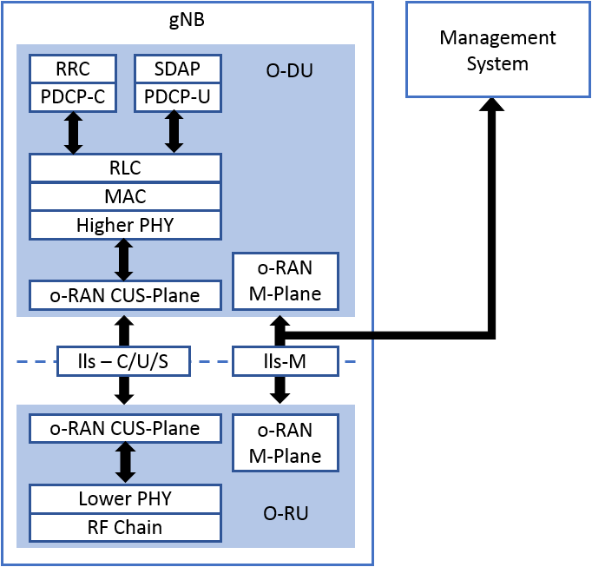
Figure 5.1.1-1: O-RAN WG4 FH functional split

5.1.2 M-Plane architecture model
A NETCONF/YANG based M-Plane is used for supporting the management features including "start up" installation, software management, configuration management, performance management, fault management and file management towards the O-RU. The M-Plane supports two architectural models:
- Hierarchical model. As shown on the left side Figure 5.1.2-1, the O-RU is managed entirely by one or more O-DU(s) using a NETCONF based M-Plane interface.
- Hybrid model. As shown on the right side of Figure 5.1.2-1, the hybrid architecture enables one or more direct logical interface(s) between management system(s) and O-RU in addition to a logical interface between O-DU and the O-RU.
In the hybrid model, the accounts of the NETCONF clients connecting to the O-RU shall be configured with one or more privilege groups that reflect the NETCONF client's responsibilities, allowing functions like O-RU software management, performance management, configuration management, carrier configuration and fault management to be managed directly by the management system(s).
NOTE 1: This avoids the situation where a NETCONF client is configured with a privilege group that does not reflect its responsibilities, and where a non-compliant client can configure aspects of an O-RU which are intended to be configured by systems associated with other NETCONF clients.
A Multi-Operator O-RU shall additionally support M-Plane architecture models which involve one or more O-DUs operated by one or more different Shared Resource Operators. Clause 19.2 describes the high level shared O-RU architecture, including hybrid and hierarchical architecture models for Multi-Operator O-RU operation with one or more different Shared Resource Operators.
O-DUs managing an O-RU using the hierarchical model are termed "hierarchical O-DUs" and O-DUs managing an O-RU using the hybrid model are termed "hybrid O-DUs". An O-DU may be designed to operate only as a hierarchical O-DU, only as a hybrid O-DU or as both a hierarchical and hybrid O-DU, i.e. when operating with different O-RUs.
NOTE 2: How an O-DU that is designed to manage an O-RU (either as a hierarchical or hybrid O-DU) is configured to operate in a specific mode with a particular O-RU is outside the scope of the present document.
In the hybrid model, the O-RU has logical connectivity with the SMO. From a physical network point of view, this connectivity could be via the hybrid O-DU, using one or more of the options described in clause 5.1.5. Direct logical communication between an O-RU and SMO can be enabled via O-RUs being assigned routable IPs or local private IPs resolved by a NAT function in the network. Refer to clause 6 for details how O-RU acquires the IP address of O-DU and SMO for the M-plane communication. As described in clause 6, there is no explicit signalling to indicate that an O-RU is operating in a hierarchical or hybrid configuration. All NETCONF servers supporting this M-Plane specification shall support multiple NETCONF sessions. All O-RUs shall be able to support both hierarchical and hybrid deployment.
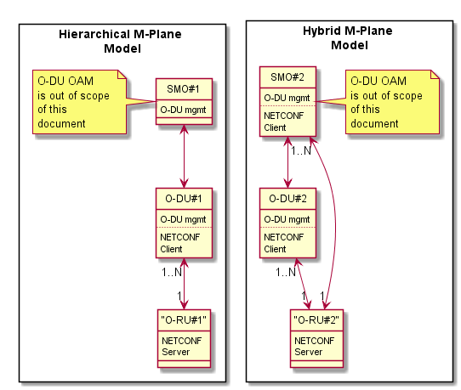
Figure 5.1.2-1: M-Plane Architecture
NETCONF/YANG is used as the network element management protocol [3] and data modelling language [4]. Use of such a standardised framework and common modelling language simplifies integration between O-DU and O-RU as well as operator network integration (in terms of running service) in case of elements sharing a common set of capabilities. The framework supports integration of products with differing capabilities enabled by well-defined published data models. NETCONF also natively supports a hybrid architecture which enables multiple clients to subscribe and receive information originating at the NETCONF server in the O-RU.

5.1.3 Transport network
Based on the transport topology, various modes of network connectivity are possible between O-RU and its peers, for example O-DU and SMO.
The basic requirement for M-Plane is to have logical connectivity between the O-RU and the elements managing it (O-DU, SMO, or so called "O-RU Controllers") as well as operational network elements such as DHCP server, CA/RA server, file server, etc. See clause 5.1.5 for detail on access technologies.
The connectivity between the O-DU and SMO is not in scope of the present document. The O-RU shall support either IPv4 or IPv6 and optionally support dual stack (IPv4 and IPv6).
NOTE: In previous versions of the present document, only IPv4 was mandatory. In order to ensure backwards compatibility with equipment supporting earlier versions of the present document, an operator and vendor can agree to use a common IP version in the O-RU, O-DU and any other O-RU controllers.

5.1.4 M-Plane functional description
The M-Plane provides the following major functionalities to the O-RU. These features are implemented using the NETCONF provided functions.
"Start-up" installation
During start-up, the O-RU shall acquire its network layer parameters either via static (pre-configured in the O-RU) or dynamically via DHCP or DHCPv6. During this process the O-RU may acquire the IP address of the O-RU controller(s), in which case the O-RU establishes the NETCONF connectivity using the "call home" feature. When the O-RU is operating in an environment which include the O-RAN defined SMO, the O-RU may acquire the IP address of the event-collector(s), in which case the O-RU performs a pnfRegistration which triggers the SMO to establish NETCONF connectivity using the information recovered from the pnfRegistration procedure. The capability exchange shall be performed between the client and server as part of the initial NETCONF Hello exchanges. Details of these steps are provided in clause 6.
NOTE 1: The use of "start up" terminology in the present document is distinct from the "start-up" capability used in a NETCONF environment to indicate that a device supports separate running and startup configuration datastores.
NOTE 2: The O-RU Controller can also be used to configure additional network layer parameters, as described in clause 6.2.1.
The present document makes specific reference to configuration which is required to be stored in "reset persistent memory". The O-RU shall use this stored configuration as its "startup" configuration.
SW management
The M-Plane is used for software download, installation, validation and activation of new SW when requested by O-RU Controller. The software download is triggered by NETCONF RPC procedures, and the actual software download is performed using sFTP with SSH or FTPES with TLS as specified in RFC 4217 [54].
Configuration management
Configuration management covers various scenarios like Retrieve Resource State, Modify Resource State, Modify Parameters and Retrieve Parameters. NETCONF get-config and edit-config RPCs shall be used for configuration parameter retrieval and updates at the O-RU
Performance management
Performance management describes the measurements and counters used to collect data related to O-RU operations. The purpose of Performance Management is optimizing the operation of the O-RU.
The measurement results are reported by two options:
- YANG Notification: This option uses the stats definition of YANG model per measurement group. In this case, get RPC and/or notification are used (see clause 10 for more details).
- File Upload: This option uses the file upload procedure defined in clause12. The measurement results are saved to a data file periodically.
Fault Management
Fault management is used for sending alarm notifications to the NETCONF Client. Fault Management allows alarm notifications to be disabled or enabled as well as alarm subscription.
File Management
File management allows the O-RU Controller to trigger an O-RU to perform upload of files stored on O-RU to O-RU Controller. The O-RU may provide different kinds of files and retrieved files can be used for various purposes. Simultaneous multiple file upload operations can be supported under the same sFTP or FTPES connection between O-RU to O-DU/SMO.

5.1.5 Transport network considerations
In certain transport deployment, where fronthaul network is isolated. i.e. the O-RU does not have direct connectivity to management services, and the O-RU requires management services that are reachable by the O-DU network element managed infrastructure. The O-DU network element should be required to provide access to those services via its infrastructure.
Examples of technologies the O-DU network element can use to provide access are:
- Ethernet Forwarding
- IP Forwarding
- Network Address and Port Translation
- Protocol Relays/Agents e.g., DHCP Relay, DNS Resolver, etc.
- Security Proxy for TLS/SSH protected application protocols, e.g., NETCONF, FTPES, etc.
NOTE: Administrators of management services should handle the difference between data observed on the wire by the management service and data observed on fronthaul interface, for example O-RU IP address in case of NAPT, O-RU X.509 certificate in case of Security Proxy, etc.
The O-DU network element is configured to provide access to such services outside fronthaul network. The method to configure O-DU network element is out of scope in this present document.

5.2 Interfaces
The M-Plane interface is defined between the O-RU Controller and the O-RU. The protocol stack of the M-Plane interface is shown in Figure 5.2-1 below. The transport network layer built on IP transport, SSH/TCP, and TLS, is used to carry the M-Plane message between the O-RU Controller and the O-RU. As an option, the O-RU may support the capability to support asynchronous notifications to be sent using HTTPS. This option enables system optimisation when the O-RU Controller corresponds to the SMO which is operating with a non-persistent NETCONF session to the O-RU.

802.1X | ARP | ICMP | DHCP |  | NDP | DHCPv6 | MPlane  ( note 1) | Notif  (note 2) | Notif  (note 3) | SFTP | FTPES | CMPv2 | UDPECHO | LBM
 |  |  |  | ICMPv6 |  | DHCPv6 | NETCONF |  | HTTP | SFTP | FTPES | HTTP | UDPECHO | LBM
 |  |  |  |  |  |  | SSH or TLS |  | TLS | SSH | TLS | (opt) TLS | UDPECHO | LBM
802.1X | ARP | ICMP | UDP |  |  | UDP | TCP |  |  |  |  |  | UDP | LBM
802.1X | ARP | IPv4 |  | IPv6 |  |  | IPv4 or IPv6 |  |  |  |  |  |  | LBM
802.1Q tagged or (opt) untagged ETH frames
Physical Layer
NOTE 1: Management Plane Configuration Management
NOTE 2: Asynchronous Notification over NETCONF
NOTE 3: Asynchronous Notification over JSON/REST (Optional)
Figure 5.2-1: M-plane protocol stack

5.3 YANG module introduction
The data models representing the M-Plane are organized as a set of reusable YANG modules. It is also the intent to reuse the publicly available and generic YANG models as much as possible instead of developing customized O-RAN specific modules. Refer to the various clauses, clause D and the repository of YANG models for more details on each of these modules.

5.4 Security

5.4.1 General
Clause 5.4 specifies the security requirements for the O-RU. The O-RU shall provide end to end security for all OAM procedures. All O-RUs shall support SSH based security described in clause 5.4.2 and TLS based security described in clause 5.4.3. Corresponding file transfer protocols are defined in clause 5.4.4, including SFTP-based transfer over SSH and FTPES-based transfer over TLS. As per requirements in [79] clause 5.3.4.1, all O-RUs should implement robust implementations of SSH and TLS transport protocols.
NOTE: It is recommended that operators use NETCONF/TLS and FTPES in production networks
A summary of the mandatory and optional O-RU authentications features is shown in Table 5.4.1-1.
Table 5.4.1-1: Mandatory and Optional Features for O-RU Authentication
Protocol | Certificate lifecycle management | PKIX (Public Key Infrastructure with X.509 Certificates) | Simple Public Key | Password-based Authentication
TLS 1.2 (Mandatory)  TLS 1.3 (Mandatory) | Mandatory to support CMPv2, optional to support vendor certificate lifecycle management | Mandatory to support / Optional to use | not specified for use with TLS | Not specified for use with NETCONF
SSHv2 (Mandatory) | Optional to support CMPv2, optional to support vendor certificate lifecycle management | Optional to support/Optional to use | Used for SSH Server authentication by SSH client (RFC 4253 [7]). Mandatory to support / Optional to use.  Used for SSH Client authentication by SSH server (RFC 4252 [6]). Optional to support / Optional to use. | Used for SSH Client authentication by SSH server. Mandatory to support / Optional to use

5.4.2 Secure Shell (SSH)
The O-RU shall support NETCONF/SSHv2 as specified in RFC 6242 [5]. If there are multiple NETCONF sessions established with a single O-RU, each session should be established over a separate SSH tunnel.
SSHv2 may be used to perform SSH client authentication, SSH server host authentication, key exchange, encryption, and integrity protection. It also derives a unique session ID that may be used by higher-level protocols. The end point (SSH client) authentication should be done as specified in RFC 4252 [6]. Clause 6.4.2 of the present document describes NETCONF authentication approach. The authentication mechanism and protocol for operators to use are as shown in Table 5.4.1-1.
SSH algorithms supported by the O-RU are advertised by the O-RU for negotiation are configurable using ssh-transport-params container in o-ran-mplane-int module and stored in reset-persistent memory.
The configuration capability advertised by the O-RU and provided in ssh-transport-params container shall be used as the default configuration for all the SSH-protocols (NETCONF, SFTP).
The SSHv2 transport level security (encryption algorithms, data integrity algorithms) shall be as specified in RFC 4253 [7]. If the O-RU supports feature ietf-ssh-common:algorithm-discovery, the O-RU shall share the list of supported algorithms in supported-algorithms/encryption-algorithms container in the ietf-ssh-common module. If the O-RU supports feature ietf-ssh-common:transport-params, the O-RU controller can restrict the set of offered encryption algorithms by providing the configuration in ssh-transport-params/encryption list in the o-ran-mplane-int module.The O-RU shall support the mandatory symmetric algorithms for encrypting transferred data as specified in clause 4.1.2.2 of [56], with the following deviation:
- support for aes256-gcm, aes128-gcm as specified in [93], aes256-ctr and aes192-ctr as specified in [94] are optional for the O-RU to support.
For data integrity, if the O-RU supports sshcmm:algorithm-discovery, the O-RU shall share the list of supported algorithms in container ../supported-algorithms/mac part of module iet-ssh-common. If the O-RU supports feature ietf-ssh-common:transport-params, the O-RU controller can restrict the set of offered data integrity algorithms by providing the configuration in ../ssh-transport-params/mac part of module o-ran-mplane-int. The O-RU shall support the mandatory message authentication codes (MACs) specified in clause 4.1.2.4 of [56], with the following deviation:
- support for hmac-sha2-512-etm, hmac-sha2-512, hmac-sha2-256-etm and umac-128 are optional for the O-RU to support.
Public key-based host authentication shall be used for authenticating the server by the clients, and username/password-based client authentication shall be done by the server as part of the SSH session establishment as specified in RFC 4253 [7]. If the O-RU supports ietf-ssh-common:algorithm-discovery, the O-RU shall share the list of supported algorithms in container ../supported-algorithms/public-key-algorithms part of module ietf-ssh-common. If the O-RU supports feature ietf-ssh-common:transport-params, the O-RU controller can restrict the set of offered host key algorithms by providing the configuration in ../ssh-transport-params/host-key part of module o-ran-mplane-int. The O-RU shall support the host key algorithms and key exchange methods for securing the Secure Shell (SSH) transport, as specified in clause 10.1 of RFC 5656 [63]. The O-RU shall support the mandatory key agreement algorithms, may support the optional key agreement algorithms and shall not support the prohibited key agreement algorithms, as specified in clause 4.1.2.1 of [56], with the following deviation:
- support for ssh-ed25519 is optional for the O-RU to support.
If the O-RU supports ietf-ssh-common:algorithm-discovery, the O-RU shall share the list of supported key exchange algorithms in container ../supported-algorithms/key-exchange-algorithms part of module ietf-ssh-common. If the O-RU supports feature ietf-ssh-common:transport-params, the O-RU controller can restrict this list by editing list in ../ssh-transport-params/key-exchange part of module o-ran-mplane-int. The O-RU shall support the mandatory key exchange methods and shall not support the prohibited key exchange methods as specified in clause 4.1.2.3 of [56], with the following deviation:
- support for diffie-hellman-group-exchange-sha256 and curve25519-sha256 are optional for the O-RU to support.
The O-RU should support the following host key algorithms as specified in RFC 8332 [68]:
- rsa-sha2-256
- rsa-sha2-512
In order to ensure backwards compatibility with equipment supporting earlier versions of the present document, a vendor may provide support for other, optional non-broken host key algorithms and key exchange methods.
NOTE 1: A "non-broken" algorithm is an algorithm without publicly available/published vulnerabilities.
As an additional option, both client and server may implement authentication based on X.509 certificates. With this option, RSA 2048 bit shall be supported for the Public Key algorithm, aes128-ctr shall be supported for the ciphering algorithm and hmac-sha2-256 shall be supported for integrity algorithm.
NOTE 2: The vendor and operator need to be prepared to replace integrity and/or ciphering algorithms if the current algorithm in use is compromised or deprecated.

5.4.3 Transport Layer Security (TLS)
An O-RU shall support Transport Layer Security (TLS) as specified in O-RAN Security Protocols Specifications [56] clause 4.2 to ensure secure and authenticated communication with O-RU Controllers. To be able to setup a mutual TLS (mTLS) connection, both parties need to have an X.509 certificate to show their identities. Clauses 6.2.6.1 and 6.2.6.2 explain how to do certificate enrolment to get a certificate issued from a Certificate Authority of operator choice. Clause 6.2.6.3 explains how vendor-signed certificates can be used, in certain conditions. A Trust Anchor (a CA certificate or a subCA in the certificate chain of the peer certificate) is needed to verify whether a peer certificate is to be trusted. The options for provisioning of Trust Anchors to an O-RU are described in clause 6.2.6.0.
TLS requirements specified in O-RAN Security Protocols Specifications [56] clause 4.2 shall apply. The specification for TLS 1.3 [42] includes a procedure for negotiating fallback to TLS 1.2 that is mandatory to support.
The O-RU shall support NETCONF over TLS as specified in RFC 7589 [49].
NETCONF server identity shall be as specified in clause 4 of RFC 9525 [84] and NETCONF client identity shall be as specified in clause 7 of RFC 7589 [41]. Each instance of a NETCONF session shall have a separate TLS session.
When no operator trust anchor(s) have been provisioned in the O-RU, i.e., during the initial bootstrapping of the O-RU, the O-RU shall trust the certificate received on first contact with a TLS peer (Trust on First Use). Once a valid operator trust anchor has been provisioned, as described in clause 6.2.6.0, the O-RU shall validate all peer certificates during TLS authentication. An O-RU shall use a valid certificate issued by an operator PKI and may use a vendor PKI to establish a mutually authenticated TLS connection for secure signalling with an O-RU Controller(s). The O-RU shall prioritize use of the operator certificate when it is available.
TLS implementations shall comply with the cipher suite requirements defined in clause 4.2.2 of the O-RAN Security Protocols Specifications [56]. TLS implementations shall follow TLS 1.2 and TLS 1.3 profiling defined in clause 4.2.2 of the O-RAN Security Protocols Specifications [56].
TLS cipher suites and TLS versions acceptable by O-RU are configurable using hello-params container in o-ran-mplane-int.yang module and stored in reset-persistent memory. The configuration provided in this hello-params container shall be used as the default configuration for all the TLS-protocols (NETCONF, FTPes, HTTPS) which may be refined by a protocol-specific YANG model.

5.4.4 File Transfer Protocol (SFTP, FTPeS)
An O-RU shall support SFTP based secure file transfer over SSH and FTPES based secure file transfer over TLS.
Security file transfer requirements specified in O-RAN Security Protocol Specifications [56] clauses 6.2 and 6.3 shall apply.

5.4.5 Representational State Transfer
An O-RU may optionally support of JSON/REST transported over HTTPS.
NOTE: JSON/REST is be used by O-RUs supporting the NON-PERSISTENT-MPLANE feature and the configured subscriptions capability described in clause 18.
HTTPS requirements specified in O-RAN Security Protocol Specifications [56] clause 6.4 shall apply.

6 "Start-up" installation

6.1 General
This clause provides the overall start-up mechanism from the power-on of O-RU to available in service.
Pre-condition:
- Power-ON for O-RU/NETCONF Server or O-RU restart operation. O-RU enables its port(s).
- O-RU controller/NETCONF Client(s) and/or event-collector is/are in operation.
- Physical interface(s) is(are) connected to a compatible Ethernet port.
Post-condition:
- O-RU is running software from slot with active = TRUE
- O-RU has marked slot with currently used software as running = TRUE
- O-RU is ready for the radio transmission to the air on at least one carrier if packet transmission is received from O-DU
- O-RU is ready for the packet transmission to the O-DU if radio reception is received at the air on at least one carrier.
- At least one O-RU Controller/NETCONF client with either "sudo" or "hybrid-odu" access privileges can control the carrier configuration of the O-RU/NETCONF server in O-RU.

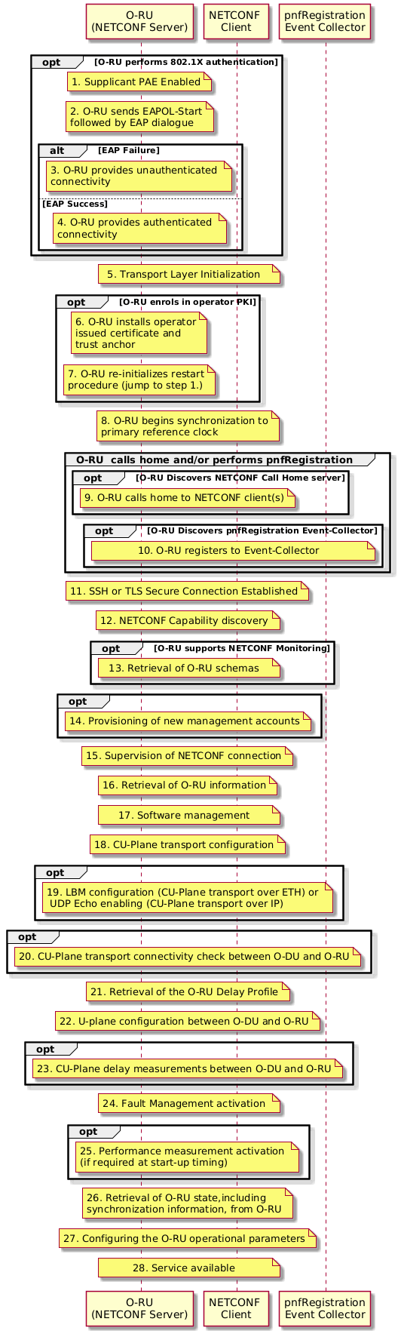
Figure 6.1-1: Overall procedure of Start-Up Installation
At the power-on of O-RU or following an O-RU restart, the following procedures are performed, as illustrated in Figure 6.1-1.
- (opt) Supplicant PAE is enabled on the port(s).
- (opt) The O-RU initiates authentication and attempts to perform an EAP authentication dialogue with a peer Authenticator PAE.
NOTE 1: This does not limit the ability of an Authenticator PAE to initiate the authentication, as defined in clause 8.1 of [70]
- (alt) EAP failure results in O-RU providing unauthenticated connectivity.
- (alt) EAP Success results in O-RU providing authenticated connectivity.
- O-RU performs M-Plane transport layer resolution (DHCP, MAC, VLAN, IP, etc.) and recovers IP address(es) of O-RU controller(s) and/or pnfRegistration event-collector.
- (opt) If DHCP response contains CA/RA address information and the O-RU has not already enrolled in the operator PKI, or the certificate issued during previous enrolment has expired, the O-RU attempts to enrol.
- (opt) After installing the operator issued certificate, the O-RU re-initialises its start-up procedure (jump to step 1).
- O-RU begins synchronisation of the O-RU against a Primary Reference Clock. Step 8 may be in parallel with step 5 for some O-RU implementation.
- (opt) O-RU performs NETCONF Call Home to discovered O-RU controller(s).
- (opt) O-RU performs pnfRegistration to discovered event-collector.
- O-RU controller performs SSH or TLS connection establishment.
- O-RU and O-RU controller perform NETCONF capability discovery.
- (opt) O-RU controller retrieves O-RU schemas using <get-schema> RPC [67].
- (opt) O-RU controller performs provisioning of new management accounts (typically only performed once during pre-staging). O-RU controller may perform provisioning of certificate-to-NETCONF username mapping information to the O-RU after account provisioning in case certificate-based client authentication is used. O-RU controller may perform provisioning of ordered cipher suite and TLS versions acceptable by O-RU (see hello-params container in o-ran-mplane-int.yang module). O-RU controller may perform provisioning of SSH algorithms (Refer to clause 5.4.2)
- O-RU and O-RU controller perform supervision of NETCONF connection.
- O-RU controller performs retrieval of O-RU information. (opt) O-RU controller retrieves O-RU S-Plane information and if necessary, it updates the O-RU's S-Plane configuration. (This step may be started any time after step 15 but needs to be completed before step 28).
- O-RU controller performs SW management.
NOTE 2: If an O-RU is running with factory default software, the O-RU functionality is permitted to comprise a sub-set of a fully operating O-RU. In such scenarios, it is recommended that the O-RU controller triggers a software update to fully functioning O-RU software.
- O-DU performs CU-Plane transport configuration.
- (opt) O-DU performs LBM configuration (CU-Plane over ETH) or enables UDP Echo (CU-Plane over IP).
- (opt) O-DU performs initial C/U-Plane transport connectivity checking between O-DU and O-RU.
- O-RU controller retrieves the O-RU delay profile from the O-RU.
- O-RU controller performs U-Plane configuration between O-DU and O-RU. C/U-Plane transport connectivity between O-DU and O-RU is configured as part of this step.
- (opt) O-DU performs C/U-Plane delay measurements between O-DU and O-RU if the O-RU supports it.
- O-RU controller performs Fault Management activation by creating a subscription to the YANG notifications defined in the o-ran-fm.yang model. Additionally, the O-RU controller uses the same YANG model to retrieve the list of O-RU's active alarms. See Clause 11 for details.
- (opt) O-RU controller activates performance measurement
- O-RU controller retrieves O-RU state, including synchronisation information, from O-RU.
- O-RU controller configures the O-RU operational parameters.
- Service available.
NOTE 3: (opt) means that the step is optional.
Additional Start-up considerations:
- The synchronisation procedures started in step 8 needs to be completed before service is available. If the O-RU's power-on S-Plane settings are incompatible with the network's S-Plane design, then at step 16 the O-RU controller should reconfigure the O-RU's S-Plane settings.
- Periodic CU-Plane connectivity check is not considered as the part of start-up. Once configured in start-up phase, CU-Plane connectivity check can later be performed periodically and at any time in run-time.
- The details of the above start-up procedure are covered in clauses 6.3 to 6.7.
Cross Reference to other clauses:
- The details of 8, 16 and 26. Synchronisation management is described in clause 13.
- The method of 13 and 26 retrieval of O-RU information is described in clause 9.
- The detail of 17. SW management is described in clause 8.
- The detail of 20. C/U-Plane transport connectivity checking between O-DU and O-RU is described in clause 7.
- The detail of 21. Retrieval of the O-RU delay profile and 23. C/U-Plane delay measurements are described in clause 7.
- The detail of 22. U-plane configuration is described in clause 15, and C/U-Plane transportation configuration is described in clause 7.
- The detail of 25. Performance management is described in clause 10.
- The detail of 24. Fault management is described in clause 11.
- The method of 27. Control to make service available is described in clause 15.

6.2 Management plane transport aspects

6.2.1 Transport establishment
This clause provides the M-plane transport establishment scenario between O-RU and O-RU controller(s), such as O-DU and/or SMO. The transport layer address of M-plane is only the target in this clause. Transport aspects of the C plane and U plane are covered in clause 7.
Pre-condition:
- Physical interface is connected to a compatible Ethernet port.
- When operating in an environment using call-home, the NETCONF server and NETCONF Client(s) have an identical NETCONF call home port configured, to ensure the NETCONF client listens on the same port used by the NETCONF Server.
Post-condition:
- Transport Layer address(es) for M-plane are known to O-RU and O-RU controllers.
- O-RU is aware of the physical port(s) for M-plane, e.g. if there are multiple ports in the O-RU.
- O-RU is aware of the VLAN(s) to be used for M-Plane, e.g. if VLANs are used in the transport network.
- Then O-RU is ready to establish TCP connection for NETCONF call home and/or for PNF registration.
For the transport establishment, there are the following alternatives, as illustrated in Figure 6.2.1-1:
- Manual transport layer address configuration in O-RU. This configuration contains the addresses for O-RU and NETCONF client(s) and/or the event-collector. The method to manually configure the O-RU is out of scope in the present document. Assuming manual configuration is successful, the NETCONF server shall be able to recover this configured information and use the client-info container in the o-ran-mplane-int.yang model to expose this information to a NETCONF client.
- If IPv4 is supported, DHCP server provides O-RU's transport layer address information together with the identity of the NETCONF client and/or the identity of the event-collector. This identity encodes either the transport layer address or FQDN of the NETCONF client or event-collector. If an FQDN is signalled, the O-RU shall use the DNS server address provided by the DHCP server, as specified in RFC 2132 clause 3.8 [8], to recover the IP address corresponding to FQDN of the NETCONF client or event-collector.
- If IPv6 is supported, Stateless Address Auto-Configuration (SLAAC) is used to configure the O-RU's transport address with the DHCPv6 server providing the identity of the NETCONF client and/or event-collector. This identity encodes either the transport layer address or FQDN of the NETCONF client or event-collector. If an FQDN is signalled, the O-RU shall use the DNS server address provided by the DHCPv6 server, as specified in RFC 3646 clause 3 [95], to recover the IP address corresponding to FQDN of the NETCONF client or event-collector.
- A NETCONF Client with suitable privileges can use the ietf-interfaces YANG module augmented by ietf-ip and o-ran-interfaces YANG modules to configure the O-RU's IPv4 and/or IPv6 ip address and associated subnet/prefix, together with port-reference and optional vlan-id. In this case the origin parameter from ietf-ip.yang module shall be set to "static". Assuming configuration is successful, the NETCONF server shall be able to operate with the configured network layer parameters provided by the NETCONF Client. The NETCONF server shall use the client-info container in the o-ran-mplane-int.yang model to expose NETCONF client information to other NETCONF clients.
NOTE: A NETCONF client can receive a hint as to whether an O-RU supports a particular IP version by using the get RPC to recover the list of interfaces supported by the O-RU and using the presence of the augmented ipv4 container or ipv6 container in the o-ran-interfaces module as an indication that a particular IP version is supported.
The O-RU uses the o-ran-dhcp.yang model to be able to expose information signalled by the DHCP server.
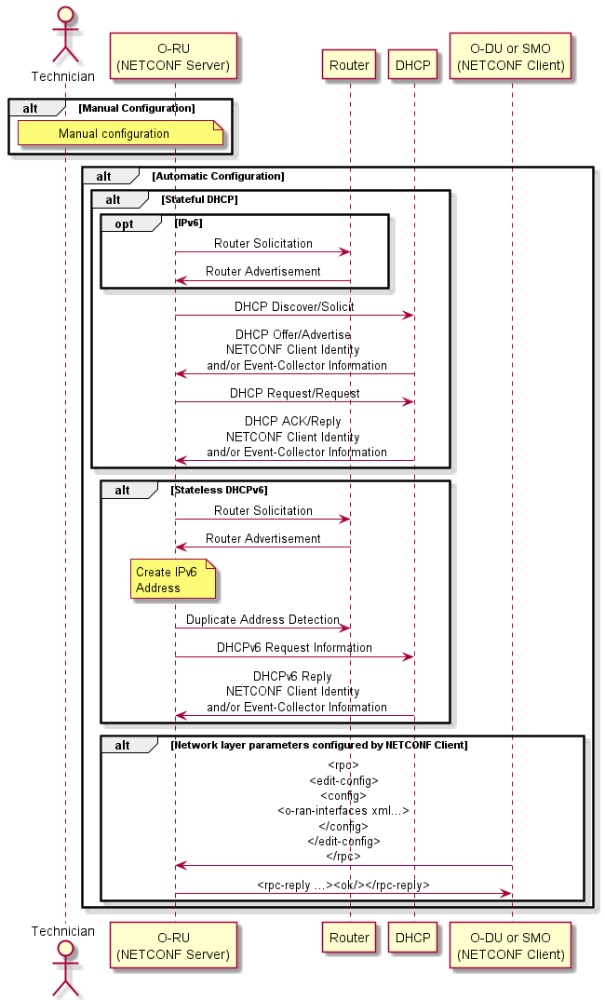
Figure 6.2.1-1: Transport Layer Establishment for M-plane
Transport Layer interface related information for M-plane contains at least the physical port number, the hardware address of the Ethernet port, VLAN-ID, local IP address, remote IP address, Default Gateway address and Subnet mask.
In the case of option b) and c), the following clauses are used:
- O-RU identification in DHCP messages from O-RU (clause 6.2.2).
- VLAN discovery aspect for M-plane (clause 6.2.3).
- IP address assignment to O-RU (clause 6.2.4).
- Discovery of address information of O-RU controller(s) and/or Event-Collector (clause 6.2.5 and/or clause 6.2.7).

6.2.2 O-RU identification in DHCP
The O-RU shall use the DHCP Vendor Class option(s) with the vendor-class-data string within the o-ran-dhcp YANG model or vendor identifying vendor class option with enterprise number and vendor-class-data to identify itself as an O-RU to DHCP servers. When the O-RU supports IPv4, it shall identify itself either 1) use option 60 Vendor Class Identifier, as specified in RFC 2132 [8], OR 2) use option 124 Vendor Identifying Vendor Class Option, as specified in RFC 3925 [9]. When the O-RU supports IPv6, it shall identify itself using the DHCPv6 Vendor Class Option 16.
O-RU can identify itself with both O-RAN registered IANA Enterprise Number and 3GPP registered Enterprise Number when using option 124 to retrieve O-RU controller, event controller and CA/RA information in DHCPv4 server. If an O-RU intends to get only O-RAN domain information, O-RU can use opt 60 or opt 124 with only O-RAN enterprise number.
NOTE: To support DHCP server implementations that are limited in their support for multiple instances of the Vendor-Specific Information Options, an operator and vendor can agree to use the O-RAN registered IANA Enterprise Number in DHCPv4/DHCPv6 messages to identify itself to signal the CA/RA server information.
DHCPv4 Vendor Class Option:
- Option: 60
- Vendor Class Identifier Option 60: string
The format of the vendor class string shall be configured to one of the following three options:
- "o-ran-ru2/<vendor>", e.g. "o-ran-ru2/vendorA".
OR
- "o-ran-ru2/<vendor>/<product-code>", e.g. "o-ran-ru2/vendorA/ORUAA100".
OR
- "o-ran-ru2/<vendor>/<product-code>/<serial-number>", e.g. "o-ran-ru2/vendorA/ORUAA100/FR1918010111".
The Vendor Class Identifier should be selected to avoid the likelihood that different vendors select identical strings, e.g. using a vendor namespace registry or ensuring that the identifier includes the <product-code> information.
DHCPv4 Vendor-Identifying Vendor Class Option:
- Option: 124
- Enterprise number: O-RAN-alliance 53148
- Vendor-Class-Data: the format of the string shall follow the rules defined for the DHCPv4 Vendor Class Option
DHCPv6 Vendor Class Option:
- Option: 16
- Enterprise number: O-RAN-alliance 53148
- Vendor-Class-Data: the format of the string shall follow the rules defined for the DHCPv4 Vendor Class Option
The DHCP Server may use the information when selecting an address pool from which to allocate an IP address to the O-RU or when selecting which management plane O-RU Controller information to configure in the O-RU.

6.2.3 Management plane VLAN discovery aspects
The O-RU is connected to one or more Ethernet ports. The transport systems may be realized such that these Ethernet ports is/are configured either as an access port, where untagged Ethernet frames are used, or as a trunk port, where multiple VLANs are configured. During start up, the O-RU is typically unable to immediately determine whether its ports are attached to remote transport equipment configured for access or trunk mode operation.
Once an O-RU completes its boot-up sequence and Ethernet connectivity is detected on at least one of its Ethernet interfaces, the O-RU starts management plane connection establishment.
The O-RU shall determine whether it is connected to an access port or a trunk port. In particular, when connected to a trunk port, the O-RU shall additionally determine the VLAN identity/ies used to support the management plane communication(s). The VLAN(s) used to support management plane communications can be identified by the DHCP server replying to the DHCP DISCOVER message, as described in clause 6.2.5, clause 6.2.7 or clause 6.2.6.1.
NOTE 1: An O-RU which supports IPv6 can infer that a VLAN is not used to support management plane communications if it receives an IPv6 Router Advertisement without either the "managed address configuration" or "other configuration" bits set.
NOTE 2: Versions prior v12.0 of the present document did not define management plane VLAN discovery based on CA/RA server identity as specified in clause 6.2.6.1. When operating with O-RUs that support an earlier version of this documents, an operator wanting to operate a VLAN that restricts access to production O-RU controllers, e.g. offering sole access to a CA/RA server, can configure a dummy NETCONF client identity to be returned to the O-RU in the DHCP OFFER message.
If the O-RU does not have previously configured management plane VLAN information, the O-RU shall attempt to discover DHCP servers on all its Ethernet ports using untagged Ethernet frames.
When the O-RU has been previously configured with management plane VLAN information, the O-RU may use this information to optimize its discovery of the VLAN ID(s) used for management plane connectivity. Previously configured management plane VLAN information includes an O-RU that stores the last VLAN(s) used for management plane connectivity, and/or an O-RU which has been previously configured with a range of management plane VLANs by a NETCONF client using the contents of the searchable-mplane-access-vlans-info container that have been stored in reset-persistent memory. The O-RU may use this information to optimize its discovery of the VLAN ID(s) used for management plane connectivity.
If the O-RU does not receive a DHCP OFFER from a DHCP server using untagged frames, or previously configured VLANs, the O-RU should attempt to contact a DHCP server using the full range of VLAN IDs (1~4094) on all its Ethernet ports.
The individual VLAN search algorithm used by an O-RU should ensure timely activation of the M-Plane while accommodating scenarios whereby there may be an intermittent or temporary connectivity problem between the O-RU and the DHCP server causing no DHCP response to be received on the M-Plane VLAN. The O-RU should repeatedly search using untagged frames and previously configured VLANs whenever it searches across the full range of VLAN IDs. The O-RU controller is able to recommend the maximum interval between repeatedly scanning for M-Plane connectivity on the untagged and configured VLANs using the scan-interval schema node.
For example, the default scan-interval is 60 seconds. If the O-RU takes 1 second to scan an individual VLAN, then after scanning every 60 out of the full range of VLAN IDs, the O-RU should repeat the scan for M-Plane connectivity on untagged and configured VLANs.

6.2.4 O-RU management plane IP address assignment
Automatic IP address assignment for the O-RU management plane can be achieved using different techniques:
- IPv4 configuration using DHCPv4, as described in RFC 2131 [10] enables DHCP servers to configure IPv4 network address(es) on the O-RU. An O-RU implementing IPv4 shall support the behaviour specified in clause 6.1 of RFC 4361 [33], using stable DHCPv4 node identifiers in their dhcp-client-identifier option.
A network realized with multiple DHCP servers should ensure that their configurations are coordinated to ensure a common default gateway is provisioned in an O-RU which receives multiple DHCPv4 responses, e.g. when received over different interfaces.
An O-RU may indicate that it supports configuration of routing information as specified in RFC 3442 [62], enabling static routes to be used by the O-RU when determining how to route uplink packets, e.g. when the O-RU supports multiple interfaces.
For O-RUs that support IPv6, both stateful and stateless address assignment procedures are supported:
- IPv6 Stateless Address Auto-Configuration (SLAAC), RFC 4862 [11] enables the O-RU to generate link-local and global addresses.
A network realized with multiple IPv6-enabled routers that support dynamic address assignment should use the extensions to Router Advertisements as specified in RFC 4191 [61] to configure the preference of the default route prefixes learnt by the O-RU using SLAAC.
- IPv6 State-full address configuration uses DHCPv6, as specified in RFC 8415 [58] and enables DHCP servers to configure IPv6 network address(es) on the O-RU. DHCPv6 is transported using UDP, using the link-local address on the O-RU and a link-scoped multicast address on the DHCP server.
NOTE 1: The above does not restrict the realisation of the DHCP server, which can be integrated with the O-DU, can be provided by the transport system, or can be accessed via a relay.
O-RUs that support more than one network interface should use a different client-identifier on each interface using a combination of Identity Association Unique Identifier and DHCP Unique Identifier, as specified in clause 6.1 of RFC 4361 [33] for DHCPv4 and clause 11 and 12 of RFC 8415 [58] for DHCPv6.
NOTE 2: An O-RU Controller can learn the particular client identifier(s) used by an O-RU by using the o-ran-dhcp YANG model.
The DHCP server should operate using static bindings, i.e. ensuring an O-RU identified by a particular client hardware address is re-allocated the same management plane IP address, e.g. after performing an O-RU reset procedure.
The O-RU shall bind operation of its NETCONF server to the assigned IP address. If an IPv6 capable O-RU operates using IPv6 Stateless Address Auto-Configuration (SLAAC), the O-RU shall bind operation of its NETCONF server to at least one configured globally unique IPv6 address.

6.2.5 O-RU controller discovery
This clause provides how to automatically discover the O-RU Controller address(es).
O-RUs that have obtained their IPv6 addresses by stateless address auto-configuration, shall use stateless DHCPv6 as specified in RFC 8415 [58], to obtain management plane configuration information.
Other O-RUs operating using stateful IPv4 or IPv6 address allocations shall obtain management plane configuration information during IP address allocation.
Other O-RUs which have had their IP address(es) manually configured, shall also have their O-RU Controller(s) manually configured.
O-RAN defined vendor specific option shall be used to signal all NETCONF client information to the O-RU using option 43 or option 125 for DHCPv4 and option 17 for DHCPv6. The O-RU shall request this option. Multiple instances of NETCONF client information may be signalled, encoded as a sequence of type/length/value fields. The O-RU shall consider these DHCP options as concatenation-requiring-options, as specified in RFC 3396 [78].
NOTE: Previous versions of the present document (prior to v15.0) did not require support of RFC3396 [78]. For previous versions, the support for RFC3396 [78] can be agreed between an operator and vendor.
The definition of the types used within the DHCPv4 option 43, option 125/DHCPv6 Option 17 depends on the vendor-class option reported by the O-RU in its DHCP messages.
When a legacy O-RU reports its vendor-class using the "o-ran-ru" prefix, the following types are defined:
- Type: 0x01 - O-RU Controller IP Address
- Type: 0x02 - O-RU Controller Fully Qualified Domain Name
When the O-RU reports its vendor-class using the "o-ran-ru2" prefix, the following types are defined:
- Type: 0x81 - O-RU Controller IP Address
- Type: 0x82 - O-RU Controller Fully Qualified Domain Name
- Type: 0x86 - O-RU Call home protocol
In all cases, the Type is followed by the length, which is the hexadecimal encoding of length of value field in octets, and the Value.
When Type corresponds to an O-RU Controller IP Address, the value encodes IPv4 address(es) in hexadecimal format. For example, a single server with IPv4 address 198.185.159.144 is encoded in an option 43 or option 125 TLV as
- Type 0x81 (or x01 for legacy)
- Length: 0x04
- Value: C6 B9 9F 90
When Type corresponds to an O-RU Controller Fully Qualified Domain Name, this encodes the string representation of domain name, using ACSII encoding (i.e. following for encoding used for the domain name in the Host Name DHCP Option 12). For example, a server with FQDN "controller.operator.com" is encoded in an option 43 or option 125 TLV as:
- Type 0x82 (or x02 for legacy)
- Length: 0x17
- Value: 63 6F 6E 74 72 6F 6C 6C 65 72 2E 6F 70 65 72 61 74 6F 72 2E 63 6F 6D
The format of the DHCPv6 option 17 follows the format of the DHCPv4 encoding, with the additional inclusion of an Enterprise Number prior to the TLV option data. The IANA allocated private enterprise number to be used with DHCPv6 option 17 is 53148.
When Type corresponds to the call home protocol, the value encodes whether an O-RU shall call home using NETCONF/SSH or NETCONF/TLS using the IANA defined ports as specified in clause 6 of RFC 8071 [15]. If no call home protocol type is provided, the O-RU shall use NETCONF/SSH. The format is encoded as follows:
- Value 00 - O-RU shall attempt to call home using NETCONF/SSH
- Value 01 - O-RU shall attempt to call home using NETCONF/TLS
For example, a DHCP server wanting to trigger the call home procedure using NETCONF/TLS encodes the option 43 or option 125 TLV as
- Type: 0x86
- Length: 0x01
- Value: 01
NOTE: A previous version of the present document defined the use of OPTION_V4_SZTP_REDIRECT and OPTION_V6_SZTP_REDIRECT DHCP options to allow an O-RU to recover NETCONF Client information. In order to ensure backwards compatibility with equipment supporting earlier versions of the present document, an operator and vendor can agree to continue to use OPTION_V4_SZTP_REDIRECT and/or OPTION_V6_SZTP_REDIRECT DHCP options to recover NETCONF Client information.

6.2.6 Certificate handling

6.2.6.0 Trust anchor provisioning
An O-RU configured to use TLS shall be provisioned with one or more trust anchor certificates that enable the O-RU to authenticate the peer’s certificate chain. The O-RU Controller may provision trust anchors to the O-RU via configuration edit of data modelled via ietf-truststore.yang.
Before an O-RU can establish a mutual TLS connection with a signalling peer, such as an O-RU Controller, the O-RU shall verify that the peer's certificate can be validated against one of the provisioned trust anchors. To validate against a trust anchor, the O-RU shall be able to be provisioned with one or more trust anchor certificates. The O-RU shall ensure that all trust anchor certificates are stored in reset persistent memory and protected from unauthorised external modification.
The O-RU shall be able to be provisioned with new trust anchors. Provisioning of trust anchors is done using one of the options in clause 5.3.11 in [83] or through configuration in ietf-truststore.
The O-RU shall be able to have an existing trust anchor replaced, e.g. because it has expired. The O-RU should support ietf-truststore YANG model to enable an O-RU Controller to manage (read, add, delete) the list of provisioned trust anchors and associated public keys.
NOTE: If the O-RU is configured for certificate enrolment, the CMPv2 Initialization Response message can be used by the discovered CA/RA server to provision one or more trust anchors to the O-RU. The CA/RA Server identity is configured by the DHCP server using techniques described in clause 6.2.6.1.
An O-RU shall trust the information that is signed or encrypted using a certificate chain leading to a configured trust anchor.
When shipped, an O-RU only trusts information that is signed or encrypted using a certificate chain leading to a pre-loaded trust anchor.

6.2.6.1 Certificate enrolment
The purpose of certificate enrolment is to provision a trusted, unique, and verifiable digital identity in the form of an X.509 certificate to the O-RU issued by an operator approved Public Key Infrastructure (PKI) system (i.e CA/RA). This certificate enables secure, authenticated, and authorized communication between O-RU and other operator-controlled network elements such as the O-DU, SMO, or other services.
An O-RU shall support certificate enrolment using CMPv2 as specified in RFC 4210 [44] and in clause 4.6 of [56] and one of the options in clause 5.3.9 of [83]. The O-RU shall support obtaining the CA/RA Server address from the DHCP server using vendor specific DHCP options. For IPv4, O-RU shall use DHCP Option 43 as specified in clause 4.2.1 of 3GPP TS 28.316 [72]. For IPv6, O-RU shall use DHCP Option 17 as specified in clause 4.2.2 of 3GPP TS 28.316 [72]. The IANA allocated private enterprise number to be used with DHCPv6 option 17 shall be 53148 (as allocated by IANA to O-RAN Alliance) or 3GPP registered IANA Enterprise Number (10415). The O-RU vendor shall inform operator about which Enterprise Number is being used.
When an O-RU is configured to enrol for an operator-signed certificate, the transport network solution, as described in clause 5.1.3, shall provide a means to reach the operator approved PKI.
When the O-RU is required to perform certificate enrolment using CMPv2, and CA/RA server is not accessible by the O-RU otherwise, the O-DU shall provide means for the O-RU to access the operator CA/RA for the O-RU certificate enrolment at the IP address conveyed as described above. Similarly, if the FQDN option is used instead, the O-DU shall provide means for the O-RU to access an operator DNS server in addition, as specified in RFC 2132 clause 3.8 [8] for IPv4 and as specified in RFC 3646 clause 3 [95] for IPv6. The access technologies described in clause 5.1.5 are examples of how such access could be provided. For certificate enrollment another option could be a Registration Authority (RA) function accessible by the O-DU (in the same domain), which is part of the operator PKI.
An O-RU shall report any discovered CA/RA server address using the o-ran-dhcp YANG model.

6.2.6.2 CMPv2 based certificate enrolment
This clause outlines the procedure by which an O-RU obtains an operator-signed certificate using the CMPv2 protocol, through a CA/RA server designated by the operator for certificate enrolment. See clause 6.2.2, herein, for the necessary O-RU configuration of the identity (IP or FQDN) of a CA/RA server designated by the operator. The O-RU initiates the enrolment by sending a CMPv2 Initialization Request (IR) message, which is digitally signed using the private key associated with its vendor-signed certificate, also referred to as the vendor credential.
The O-RU shall support the certificate management framework described in O-RAN Security Requirements and Controls Specifications [83], clause 5.3.9 and O-RAN Security Protocols Specifications [56], clause 4.6. The O-RU shall store the operator issued certificate and corresponding certificate chain in reset persistent memory. Mapping of the obtained operator issued certificate to relevant services shall be done using O-RU configuration via o-ran-certificates.yang.
The handling of certificates, including certificate profiles, shall follow the rules defined in O-RAN Security Protocols Specifications [56], clause 4.2.3. In addition:
- When an O-RU has not been provided with information regarding how to generate a certificate signing request, e.g. when the O-RU sends an Initialization Request message to signal the initial certificate enrolment, the O-RU shall generate the certificate signing request populating the Subject Distinguished Name field with a string that includes the O-RU manufacturer's name, model and serial number.
There are various characters that are not recommended to be used in the Subject Distinguished Name Field, e.g. ":" (colon, hexadecimal character 0x34), "." (period, hexadecimal character 0x2E), "_" (underscore, hexadecimal character 0x5F), "#" (hash, hexadecimal 0x23), "£" (pound, hexadecimal 0xa3), "*" (asterisk, hexadecimal 0x2a) or """ (double quote, hexadecimal 0x22). Manufacturers that include such characters in their name, model and/or serial number should ensure such characters are removed before including in the Subject Distinguished Name Field.
- In other cases, e.g. when the O-RU receives csr-info in an action statement <generate-csr> as specified in clause 6.2.6.4.3, the O-RU shall generate the certificate signing request using the provided information.
When transferring messages to the CA/RA server, the O-RU shall use the "port number of the CA/RA server" and the "path to the CA/RA directory" as signalled using the DHCP options as specified in clause 4.2.3 of 3GPP TS 28.316 [72]. If no DHCP based configuration is received by an O-RU, the O-RU shall use the default port 443 and default directory "/pkix/". As indicated in Annex G of 3GPP TS 33.310 [51], and as the operator root certificate is not pre-provisioned in the O-RU, the O-RU authenticates the IR message using the RA/CA certificates(s) included in the IR message itself.
When configured to operate with TLS, an O-RU that has a valid certificate issued by an operator PKI shall use this certificate to establish a mutually authenticated TLS connection for secure signalling with its O-RU Controller(s).

6.2.6.3 Operation with vendor-signed certificates
An O-RU should be provisioned with a unique device vendor-signed certificate and its entire certificate chain up to the root. The vendor-signed certificate serves as an identity for the O-RU during initial bootstrapping. The vendor-signed certificate is used in scenarios throughout the O-RUs life cycle where an operator-signed certificate is not provisioned, as specified in clause 6.2.6.2, or the certificate issued during previous enrolment has expired.
The vendor-signed certificate can be utilized in operational use cases, such as initial bootstrapping and certificate enrolment. Initial bootstrapping and connectivity to operator network may utilize the vendor-signed certificate with 802.1X port based access control, as described in clause 7.12.2, and NETCONF call-home as described in clause 6.4. Certificate Enrolment via CMPv2 may utilize the vendor-signed certificate, as described in clause 6.2.6.2.
Life cycle management of a vendor-signed certificate is out of scope for O-RAN standardization. It is recommended that the operator and vendor agree upon the process for life-cycle management of vendor-signed certificates.

6.2.6.4 Certificate lifecycle management

6.2.6.4.1 Introduction
An O-RU indicates its support for O-RAN defined certificate lifecycle management by including the ietf-keystore in its YANG library. Clause 6.2.6.4 applies to those O-RUs that support O-RAN defined certificate lifecycle management. The O-RU shall support the life cycle management of certificates as specified in 3GPP TS 33.310 [51] clause 7.2, including the renewal of certificates using CMPv2 before their expiry. The O-RU takes the role of a network element (NE) when following this clause.
The O-RU shall support configurations for setting the policy for certificates re-issuance using the cert-lcm-policy leaf defined in o-ran-certificates.yang. The defined policies are:
- REISSUE_ON_DEMAND
- AUTONOMOUS_REISSUANCE
NOTE: The enumeration REISSUE_ON_DEMAND refers to the on-demand triggering of the issuance of an additional certificate using the Certification Request/Response exchange, as defined in clauses 5.3.3 and 5.3.4 of RFC4210 [44]. The enumeration AUTONOMOUS_REISSUANCE refers to the autonomous updating of an existing certificate, using the Key Update Request/Response, as defined in clauses 5.3.5 and 5.3.6 of RFC 4210.
When configured with a cert-lcm-policy set to REISSUE_ON_DEMAND, the O-RU shall not autonomously initiate certificate re-issuance or re-key procedure. Instead, the O-RU Controller shall be responsible for triggering the initiation of the CMPv2 Certificate Request/Response procedure, as specified in clause 6.2.6.4.3.
An O-RU shall be configured with REISSUE_ON_DEMAND for its first certificate renewal and when new csr-info parameters are to be used, and the O-RU Controller may set the cert-lcm-policy at any time after the O-RU successfully re-issued its certificate at least once.
When configured with a cert-lcm-policy set to AUTONOMOUS_REISSUANCE, the O-RU shall autonomously initiate certificate re-key procedure, as specified in clause 6.2.6.4.2, upon reaching the configured renewal-days-before-expiry days prior to certificate expiration.
Additionally, the max-kur-attempts configuration may be used to limit the number of rekeying attempts the O-RU makes before raising the failure alarm. Likewise, the max-poll-attempts configuration may be used to control the number of polling attempts when the pki-status of 3 "waiting".
When the certificates are re-issued, trust anchors may also be updated through provisioning as specified in clause 6.2.6.0.

6.2.6.4.2 O-RU Autonomous certificate re-issuance
An O-RU shall support the capability to autonomously trigger certificate replacement by monitoring its own certificates expiry and initiating re-issuance number of days before expiry using renewal-days-before-expiry leaf defined in the o-ran-certificates.yang module.
Upon reaching the re-issuance threshold, the O-RU shall generate a new public/private key pair using the csr information such as the key size and algorithms which was used in the current certificate generation and stored in local persistent storage. Subsequently, it shall create a Key Update Request (kur) message, digitally signed using the existing private key, to authenticate the request. This kur is then submitted as part of the CMPv2 certificate rekeying procedure to the CA/RA server. The pki-failure-info, PKIStatus, and pki-free-text fields may be exposed during the procedure as notifications for consumption by the O-RU controller. This procedure is shown in Figure 6.2.6.4.2-1.
When the Certificate Re-issuance Failed alarm is raised, the operator should investigate and resolve the issue. How to solve the issue is out of scope of present document.
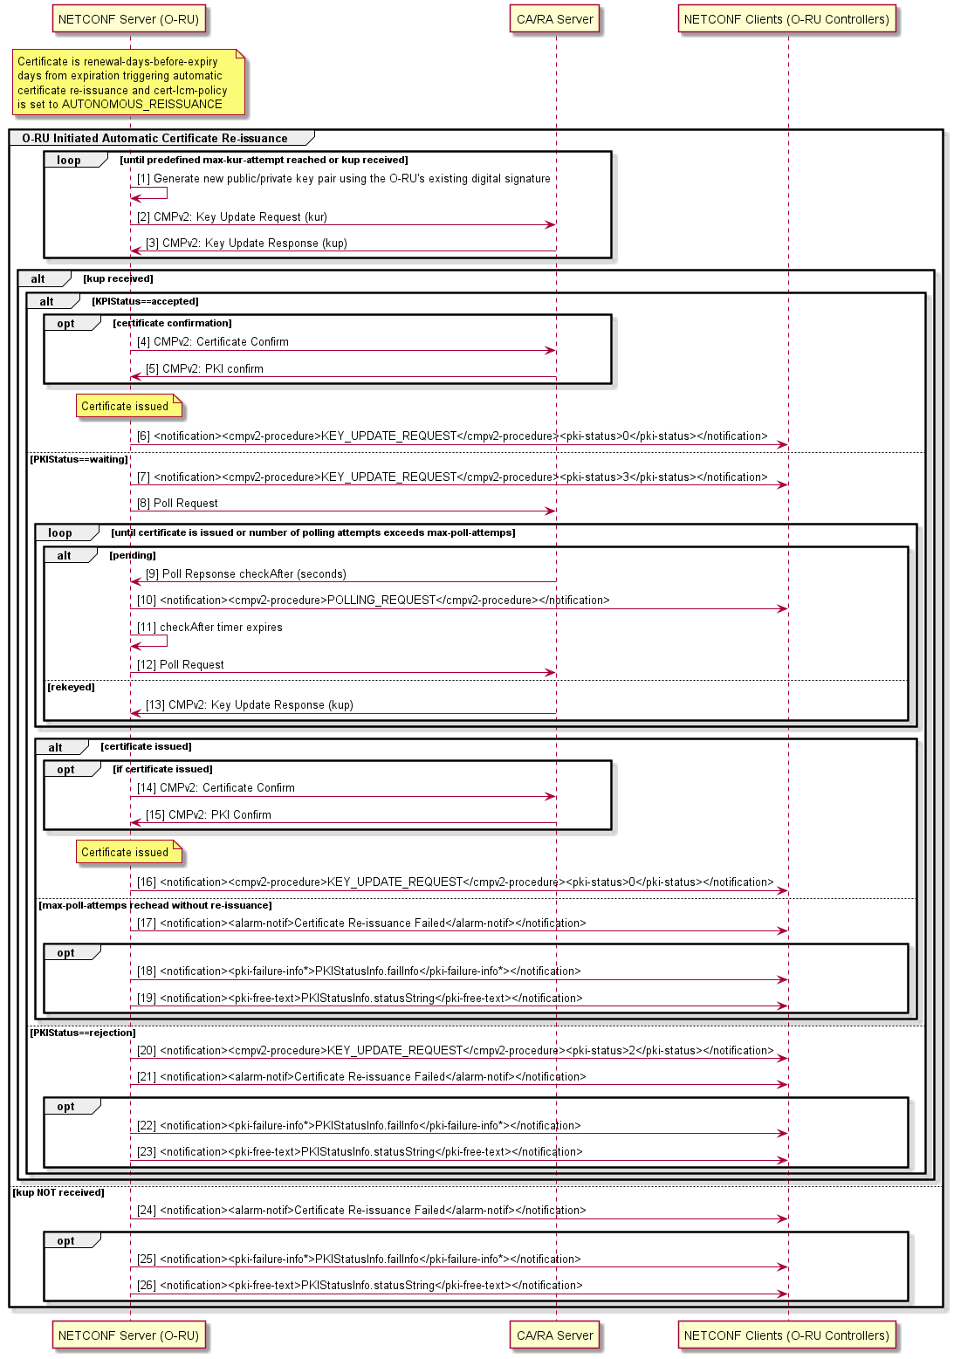
Figure 6.2.6.4.2-1: Autonomous certificate re-issuance

6.2.6.4.3 On-demand certificate re-issuance
An O-RU controller wanting to trigger the re-issuance of an additional certificate to the O-RU shall configure the cert-lcm-policy to REISSUE_ON_DEMAND. The O-RU controller may trigger the issuance of an additional certificate by using the action statement <generate-csr> defined in IETF RFC 9642 [86].After having responded with a rpc-reply <ok/>, an O-RU receiving the <generate-csr> shall recover the SubjectPublicKeyInfo from the csr-info and trigger the generation of a new key pair. After a new key pair has been generated, the O-RU shall store the csr information in non-volatile storage. The O-RU shall use the csr-info to create a certificate signing request, as specified in RFC 2986 [87], which it shall use in a CMPv2 certificate request exchange with the CA/RA server. The procedure is shown in Figure 6.2.6.4.3-1.
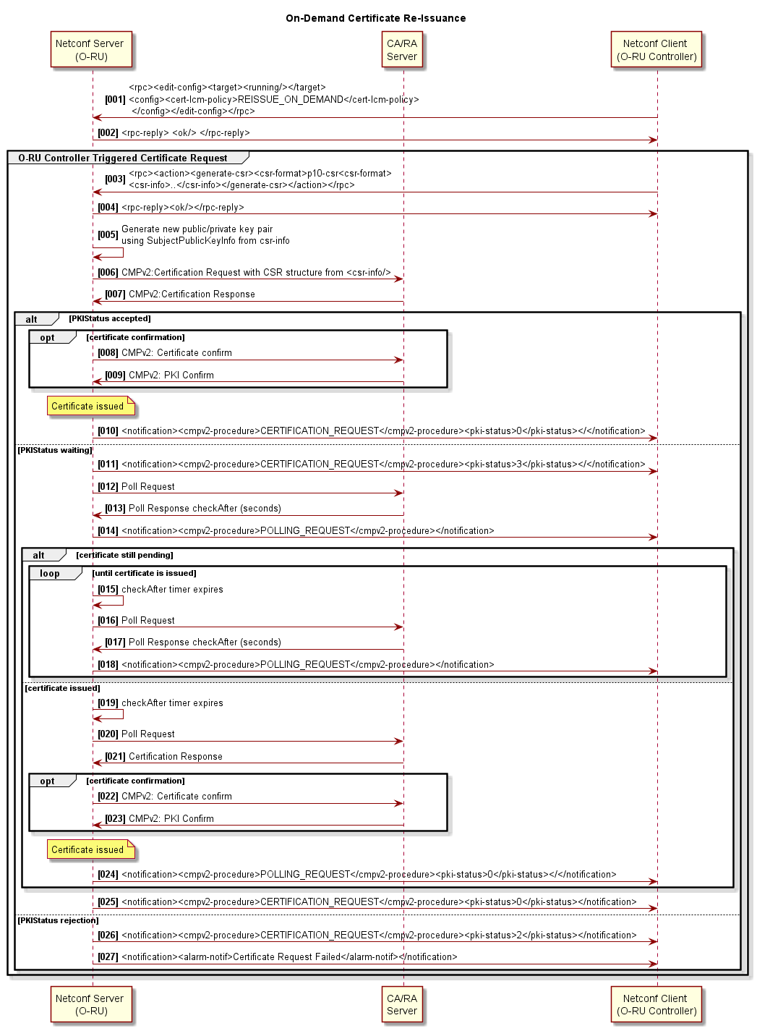
Figure 6.2.6.4.3-1: On-demand additional certificate re-issuance

6.2.6.4.4 Certificate Life Cycle Notifications
The O-RU shall support configurations for "advance certificate about to expire notification timer" for different severities.
The O-RU shall notify all the O-RU controller(s) that have subscribed to receive fault ID 39 specified in clause A.1 as follows:
- With severity as minor minor-alarm-advance-time prior to expiry [units days, default: 30];
- With severity as major major-alarm-advance-time prior to expiry [units days, default: 10]; and
- With severity as critical critical-alarm-advance-time prior to expiry [units days, default: 2].
The O-RU shall notify the subscribing O-RU controller(s) of certificate expiry using fault ID 40 as specified in clause A.1.
After the O-RU successfully completes the CMPv2 process for certificate issuance, it shall notify all the subscribing O-RU controller(s) by sending a certificate-lcm notification. If the triggered certificate issuance process fails, the O-RU shall notify all the subscribing O-RU controller(s) using faults specified in clause A.1.

6.2.6.4.5 Certificate revocation list checking
Certificate revocation checking is handled via certificate revocation lists (CRL) that are periodically updated through the processes outlined in RFC 5280 [99] and 3GPP TS 33.310 [52]. Except when operating using Trust On First Use (TOFU), as described in clause 5.4.3, when an O-RU establishes a TLS connection, if any certificate in the peer's certificate chain includes the CRL distribution point extension and the O-RU has no valid corresponding CRL, the O-RU shall download the valid CRL(s) from the CRL distribution point field(s) provided by the associated X.509 certificate(s). The O-RU shall support HTTP and should support LDAP for CRL downloading. At any time, if the O-RU is unable to connect to a signalled CRL distribution point, the O-RU shall raise alarm type 43 as described in Table A.1-1.
As the O-RU can have long lived TLS connections with one or more O-RU controllers, an O-RU with an existing TLS connection shall use the nextUpdate field associated with the downloaded CRL(s) for the purposes of downloading a new CRL before it expires. The ability to configure the time window before CRL expiry that a new CRL is downloaded is set by the crl-renewal-time-before-nextupdate leaf defined in the o-ran-certificates.yang. An O-RU shall attempt to download valid CRL(s), starting from the time epoch of (nextUpdate - crl-renewal-time-before-nextupdate). If the O-RU fails to download a valid CRL by the time of nextUpdate, the O-RU shall raise alarm type 44 as described in Table A.1-1.
NOTE: The algorithm for repeatedly attempting to download CRLs until a valid CRL is successfully downloaded is left to vendor implementation.
The operations of an O-RU when receiving an indication in an updated CRL that a certificate in the certificate chain associated with an active TLS connection has been revoked after TLS establishment is not defined in the present document.
The method of certificate revocation is out of scope of the present document.

6.2.7 Event-Collector discovery
This clause describes how an O-RU automatically discovers the Event-Collector to which it shall send its pnfRegistration notification. The support by an O-RU of PNF Registration to a discovered Event-Collector is optional and hence this clause only applies to those O-RUs that support this optional capability.
O-RUs that have obtained their IPv6 addresses by stateless address auto-configuration, shall use stateless DHCPv6, as specified in RFC 8415 [58], to obtain Event-Collector information. Other O-RUs operating using stateful IPv4 or IPv6 address allocations shall obtain Event-Collector information during IP address allocation. Other O-RUs which have had their IP address(es) manually configured, shall also have their Event-Collector(s) and Event-Collector Notification Format manually configured.
The O-RU supporting PNF Registration shall be able to recover Event-Collector information using O-RAN defined vendor specific option to signal Event-Collector information to the O-RU using option 43 or option 125 for DHCPv4 and option 17 for DHCPv6. To achieve that, the O-RU shall request the option 43 or option 125 for DHCPv4 and option 17 for DHCPv6 as defined in clause 6.2.5. If the network provides an Event-Collector for the O-RU to send its pnfRegistration notification to, a DHCPv4 server shall respond with option 43 or option 125 if so requested, and a DHCPv6 server shall respond with option 17 if so requested.
The definition of the types used within the DHCPv4 option 43 or option 125/DHCPv6 Option 17 are as follows:
- Type: 0x83 – Event-Collector IP Address
- Type: 0x84 – Event-Collector Fully Qualified Domain Name
- Type: 0x85 – Event-Collector Notification Format
In this version of the present document, the operation of an O-RU when receiving multiple instances of the Event-Collector IP Address and/or Event-Collector FQDN information is not defined.
In all cases, the Type is followed by the length, which is the hexadecimal encoding of length of value field in octets, and the Value.
When Type corresponds to an Event-Collector IP Address, the value encodes IPv4 address(es) in hexadecimal format. For example, an Event-Collector with IPv4 address 198.185.159.144 is encoded in an option 43 or option 125 TLV as:
- Type 0x83
- Length: 0x04
- Value: C6 B9 9F 90
When Type corresponds to an Event-Collector Fully Qualified Domain Name, this encodes the string representation of domain name, using ACSII encoding (i.e. following for encoding used for the domain name in the Host Name DHCP Option 12). For example, a server with FQDN "collector.operator.com" is encoded in an option 43 or option 125 TLV as:
- Type 0x84
- Length: 0x17
- Value: 63 6F 6C 6C 65 63 74 6F 72 2E 6F 70 65 72 61 74 6F 72 2E 63 6F 6D
In this version of the present document, the operation of an O-RU when receiving an Event-Collector FQDN that is subsequently resolved by the O-RU to more than one IP address (i.e. returning multiple Address records) is not defined.
The format of the DHCPv6 option 17 shall follow the format of the DHCPv4 encoding, with the additional inclusion of an Enterprise Number prior to the TLV option data. The IANA allocated private enterprise number to be used with DHCPv6 option 17 is 53148.
When Type corresponds to an Event-Collector Notification Format, the value shall encode the format the Event-Collector expects to receive asynchronous notifications. In the present document, only a single format is defined:
Value 00 - Event-Collector expects the notification to be signalled using the format as specified in the ONAP VES event listener specification [i.2].
For example, an Event-Collector expecting the pnfRegistration notification to be signalled using the ONAP defined format is encoded in the option 43 or option 125 TLV as:
- Type 0x85
- Length: 0x01
- Value: 00

6.2.8 Static routing of IP traffic
An O-RU may support static routing. This is an optional capability, and this clause only applies to those O-RUs that support static routing.
An O-RU that supports IPv4 shall support configuration of routing information as specified in RFC 3442 [62] and shall indicate its support of RFC 3442 using the rfc3442-supported leaf specified in o-ran-interfaces YANG model. An O-RU that supports IPv6 shall support configuration of default router preferences and more-specific routes as specified in RFC 4191 [90] and shall indicate its support of RFC 4191 using the rfc4191-supported leaf specified in o-ran-interfaces YANG model.

6.3 NETCONF call home to O-RU controller(s)
The O-RU aims to have NETCONF sessions with all of the call home O-RU Controller(s), either discovered using the DHCP options defined in clause 6.2.5, provisioned by an existing NETCONF client, or statically configured. An O-RU controller may attempt to autonomously initiate a NETCONF session with the O-RU, e.g. triggered by the pnfRegistration procedure. In order to support NETCONF clients corresponding to call home O-RU Controllers that either do not attempt to initiate a NETCONF session with the O-RU, or are prevented from doing so, e.g. because of Network Address Translation limitations, the O-RU shall call home to all call home O-RU Controller identities with which it does not already have an active NETCONF session.
When the O-RU discovers, or is provisioned with, a call home O-RU Controller identity represented as an FQDN, the O-RU shall use DNS to resolve the IP address(es) of the FQDN identity. If as result of the resolution of the O-RU Controller FQDN to IP address, an O-RU receives multiple A and/or AAAA records, the O-RU should cycle through the received IP addresses in the A and/or AAAA records until it is able to establish a NETCONF session with a particular O-RU Controller identity. The O-RU should report the O-RU controller IP address used in the established NETCONF session in the client-info container in the o-ran-mplane-int YANG model. As a consequence, the O-RU is expected to have a single M-Plane session established per each O-RU controller's FQDN, regardless how many A/AAAA records were returned by the DNS server for each O-RU Controller FQDN.
An O-RU that supports more than one network interface shall be able to perform O-RU Controller discovery on each of its network interfaces. If an O-RU recovers identical O-RU controller identity information on multiple network interfaces, then it should select which one out of the multiple interfaces to use for its call home operation.
NOTE 1: The operation of an O-RU that discovers different O-RU Controller identities on separate network interfaces is not currently defined in the present document.
If the O-RU is unable to establish a NETCONF session with some of the call home O-RU Controller identities, the O-RU shall use the re-call-home-no-ssh-timer to repeatedly re-perform the call home procedure to all call home O-RU Controller identities with which the O-RU does not have an established NETCONF session, cycling through the A and/or AAAA records until it is able to establish a NETCONF session with a particular call home O-RU Controller identity. The same value of timer shall be used, irrespective of whether SSH or TLS is being used to transport the NETCONF session.
NOTE 2: The O-RU can cache the returned A/AAAA records for a period of time according to the DNS time to live. The setting of the DNS time to live is an operator name server configuration parameter. As an example, if an operator knows in advance of a change in the IP address(es) used by its O-RU controller(s), the operator can configure the name server with a minimum time to live value to ensure O-RUs request the new IP address(es) in a timely fashion. Name server configuration is outside the scope of the present document.
If the O-RU is unable to trigger the establishment of NETCONF session with at least one call home O-RU Controller after having repeated the call home procedure a total of max-call-home-attempts per O-RU Controller, then the O-RU should perform an autonomous reset.
The O-RU shall call home as specified in clause 4 of RFC 8071 [15] whereby the O-RU (NETCONF Server) initiates a TCP connection to the NETCONF client. When calling home to the NETCONF clients in the container client-info, O-RU shall use the port manually configured during installation, and when calling home to the NETCONF clients in the container configured-client-info, O-RU shall use the port configured by other NETCONF Client. If no port was signalled or manually configured in the container client-info, or not configured in the container configured-client-info, O-RU shall use the port configured in call-home-ssh-port to indicate that the O-RU uses SSHv2 to secure the NETCONF connection and use the port configured in call-home-tls-port to indicate that the O-RU uses TLS to secure the NETCONF connection. If call-home-ssh-port does not exist, the O-RU shall use the IANA-assigned port 4334 to indicate that the O-RU uses SSHv2 to secure the NETCONF connection, and if call-home-tls-port does not exist, the O-RU shall use the IANA-assigned port 4335 to indicate that the O-RU uses TLS to secure the NETCONF connection. As illustrated in Figure 6.3-1, when the NETCONF client accepts a TCP connection on the allocated port, it shall initiate an SSH session/TLS connection with the NETCONF Server. Using this SSH session/TLS connection, the NETCONF client shall initiate a NETCONF session.
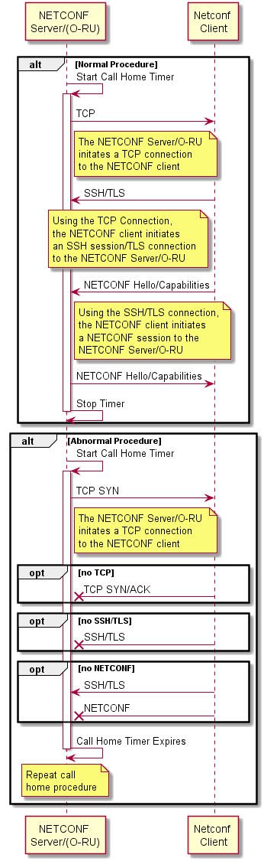
Figure 6.3-1: Outline of NETCONF call home procedure
The O-RU shall ensure that a persistent connection to all call-home O-RU controllers is maintained by actively testing the aliveness of the connection. The O-RU should support TLS heartbeat/SSH using the keep-alive mechanism as specified in clause 4.1 of RFC 8071 [15] and may support TCP keep-alive. The establishment of NETCONF client privileges is covered in clause 6.5.

6.4 NETCONF connection establishment

6.4.0 General
The authentication mechanism and protocol to use are described in Table 5.4.1-1.
The identity of the NETCONF server (O-RU) shall be verified and authenticated by the NETCONF client according to local policy for authentication described in Table 5.4.1-1 before password-based authentication data or any configuration or state data is sent to or received from the NETCONF server.
When using SSHv2, public key-based host authentication shall be used for authenticating the server (RFC 4253 [7]) by the clients. In addition, server authentication based on X.509 certificates may also be provided as specified in RFC 6187 [31].
When using TLS, X.509 certificate-based authentication shall be used for mutual authentication between the NETCONF client and NETCONF server.
NOTE: SSHv2 based public key-based host authentication requires that the SSH server (O-RU) public keys are provisioned in the NETCONF client (e.g. O-DU and/or SMO). As an alternative, RFC 4251 [79] mentions that "a possible strategy is to only accept a host key without checking the first time a host is connected, save the key in a local database, and compare against that key on all future connections to that host. ". This option simplifies the key management procedure as it does not require to pre-populate them in O-DU/SMO (SSH client) but obviously at the price of degraded security, therefore the support of this option is configurable and left to operator's choice.
In case the O-RU is not configured to perform certificate enrolment, or enrolment failed the O-RU may use its unique device vendor-signed certificate. The first NETCONF session during start-up installation using the default NETCONF account will in this case be authenticated by the O-RU controller but not by the O-RU, unless the O-RU has been provisioned with trust anchors using one of the options in clause 5.3.11 in [83].
If an O-RU is not configured with a valid, non-manufacturer trust anchor, the O-RU may skip the verification of the client certificate exchanged during the mTLS handshake.

6.4.1 NETCONF security
As specified in clause 5.4, this version of the O-RU Management Plane Specification uses TLS 1.2, TLS 1.3, or SSHv2 for mutual authentication between the NETCONF server (O-RU) and the NETCONF client (O-DU or SMO).
If multiple NETCONF sessions are established to an O-RU, those sessions shall be established over separate SSH tunnels/TLS connections.

6.4.2 NETCONF authentication
The authentication mechanism and protocol to use are described in clause 5.4.
This version of the O-RU Management Plane Specification supports SSHv2 using password authentication method for SSHv2 as specified in clause 8 of RFC 4252 [6] and client authentication based on X.509 certificates as specified in RFC 6187 [31], and TLS 1.2, or TLS 1.3, using X.509 certificate-based authentication.
The identity of the NETCONF server (O-RU) shall be verified and authenticated by the NETCONF client (O-DU or SMO) according to local policy for authentication described in Table 5.4.1-1 before authentication data or any configuration or state data is sent to or received from the server.
The identity of the NETCONF client (O-DU or SMO) shall be verified and authenticated by the NETCONF server (O-RU) according to local policy for authentication described in Table 5.4.1-1 to ensure that the incoming NETCONF client request is legitimate before any configuration or state data is sent to or received from the NETCONF client. The server shall also perform NETCONF Access Control Model (NACM) based authorization, as specified in clause 6.5, before accepting any request.
If authentication is based on X.509 certificates, for the purposes of user authentication, the mapping between certificates and user-name is provided by the subjectAltName field of the X.509 certificate, which means that the user name is coded in the subjectAltName. The username is determined from the subjectAltName using the rules as specified in RFC 7589 [41]. For the purposes of NETCONF server authentication, RFC 7589 [41] specifies server identity as specified in clause 4 of RFC 9525 [84].
Upon initial system initialisation, the O-RU is configured with a default account. The specific details of the default account are to be agreed between operator and vendor. An example of a default user account for account-type PASSWORD is one with username "oranuser". An example of a default user account for account-type CERTIFICATE is map type "san-rfc822-name" with an rfc822-name of "oranuser@o-ran.org". An example of a default user account for account-type SSHPUBLICKEY is "oranuser".
The default account may be of account-type PASSWORD, in which case a default password also needs to be defined and configured in the O-RU in alignment with clause 6.4.3.1. The default account may be of account-type SSHPUBLICKEY, in which case the default public key and associated algorithm need to be configured in the O-RU. As the default account may be operator specific, this may require that the O-RU provides facilities to configure securely this default account and cert-to-name mapping list at installation time (i.e. before the O-RU is connected to the O-RU Controller).
NOTE: The account-type SSHPUBLICKEY was first defined in v16.01 of the present document. The support for a default account type SSHPUBLICKEY can be agreed between operator and vendor, depending upon O-RU controller capabilities.
If user authentication is based on X.509v3 certificate during O-RU plug and play, to support zero touch for the first NETCONF connection, the O-RU shall support the default mapping between certificate and default NETCONF account which maps any authenticated X.509 v3 certificate to this default O-RAN account. The trust anchor for O-RU shall be provisioned automatically with online CA server during O-RU Plug and Play, and it shall be same as the trust anchor of the O-RU Controller(s), thus avoiding the need for manual configuration of the peer trust anchor for O-RU.
The default account is a member of the "sudo" privilege group (see clause 6.5 for details of groups/privileges) as it is intended to be used to create other accounts, as specified in clause 6.4.3. As the default account credential may be common across different deployments of a vendor's equipment, it is strongly recommended to only use the default account to create other operator specific user accounts on the O-RU. Clause 6.4.3.1 specifies the conditions whereby the creation of a NETCONF server account triggers the automatic disabling of the default account.
The operator and vendor shall agree how the default account can be determined by a NETCONF client operating in a multi-vendor O-RU environment based on the SSH response message sent by the O-RU. It is recommended that the vendor and operator agree on a particular format of the "SSH-protoversion-softwareversion SP comments CR LF" identification string, as defined in RFC 4253 [7] clause 4.2, used by the SSH Server in the O-RU to identify the O-RU vendor and consequently the default account to be used by the NETCONF client. Upon initial system initialisation, the NETCONF client can authenticate itself to the O-RU using SSH Authentication either with the agreed default username and password or with simple public key.
If authentication based on X.509 certificates according to [31] is supported by SSH and TLS client and server, the certificates need to be installed at initial system initialisation, or can be obtained through certificate enrolment with operator's PKI (certificate enrolment as defined by 3GPP with CMPv2 protocol between the NE and the operator's CA).
After having enrolled in an Operator PKI, when establishing a new TLS session using X.509 certificate-based authentication, the O-RU shall select a valid certificate issued by the operator PKI with the longest time to its expiration.

6.4.3 User account provisioning

6.4.3.1 General
The NETCONF client with suitable privileges may provision user accounts on the O-RU, including the accounts (users) name, password, group (see clause 6.5 for details of groups/privileges) and whether a particular account is enabled or disabled. The provisioning of new accounts is typically performed once during pre-staging, as described in step 14 of Figure 6.1-1.
- The name for the user is a string which should be between 3-32 characters. For account-type PASSWORD, the first character should be a lowercase letter. The remaining characters should be lowercase letters or numbers. For account-type CERTIFICATE or SSHPUBLICKEY, the characters should be lowercase letters, numbers, periods (ASCII code 0x2E) or @ sign (ASCII code 0x40).
- The account-type is an enumeration, indicating authentication method such as password, certificate, or simple public key.
- The password is a string between 8-128 characters. Allowed characters in the password field include lowercase and uppercase letters, numbers and the special characters: ! $ % ^ ( ) _ + ~ { } [ ] . The password leaf is present only for those user accounts associated with password-based authentication. When used, the password should follow security best practices as specified in Clause 5.3.7 in O-RAN Security Requirements and Controls Specifications [83].
- Whether an account is enabled. The YANG model ensures that at least one user account is always enabled on the O-RU.
- When the O-RU supports the SHARED-ORU-MULTI-OPERATOR feature, the user account may be associated with zero or more Shared Resource Operator IDs (sro-id). Clause 19 describes the operation of the SHARED-ORU-MULTI-OPERATOR feature in more detail. When an sro-id is configured with a user account with "carrier" group/role privileges, the multi-operator shared O-RU feature is enabled.
The new account information (user name, password, optional sro-id, account-type and whether the account is enabled) shall be stored in reset-persistent memory in O-RU.
Each account name in o-ran-usermgmt YANG model is identical to the user-name used in ietf-netconf-acm YANG model. User account provisioning shall include using the ietf-netconf-acm module to define which groups are associated with a particular user-name (see clause 6.5 for details of groups/privileges). The definition of a privilege group or set of privilege groups referred to by name(s) is(are) intended to match deployment scenarios. For example, the group name "sudo" is intended to be used when configured as a NACM group for a user-name associated with the NETCONF client of a hierarchical O-DU. Conversely, the group name "hybrid-odu" is intended to be used when configured as a NACM group for a user-name associated with the NETCONF client of a hybrid O-DU.
For client authentication based on certificate or Simple Public Key, no password needs to be provisioned. For certificate based authentication, at time of SSH or TLS connection, user's authorisation is done based on the X.509 certificate's SubjectAltName field that codes the associated account's name.
When a NETCONF client using the default account is used to successfully commit the configuration for another user account with account privileges "sudo", the NETCONF client should close existing NETCONF session as described in clause 6.8. Then, the O-RU disables the default account and default account stays disabled over the resets. The default account becomes enabled when the O-RU is reset to the factory default software by following the procedures defined in clause 8.8. Any other way to enable the default account is not precluded as O-RU vendor implementation matter.
NOTE 1: Configuring a new user account with "sudo" privileges enables that account to have full permissions over the o-ran-usermgmt.yang model which then permits that account to create other user accounts on the O-RU's NETCONF server.
The security principle defined in this clause shall follow those defined for the default account and default mapping, i.e. the O-RU Controller shall create a new mapping.
NOTE 2: Depending on the EE/CA certificate of the O-RU Controller, the map type can still be specified but with specific fingerprint of the EE/CA certificate or based on SubjectAltName of EE/CA certificate as specified in clause 6.4.2.

6.4.3.2 Certificates to NETCONF usernames mapping list provisioning
The O-RU controller with suitable privileges may provision list cert-to-name to define how certificates are mapped to NETCONF usernames at the O-RU using o-ran-certificates.yang. This list shall be stored in reset persistent memory. Each entry of the mapping list contains a certificate fingerprint, a map-type and optional username.
- The certificate fingerprint is a digest of NETCONF client end-entry (EE) certificate or a digest of a trusted certificate authority (CA) which is part of the CA certificate chain of the NETCONF client EE certificate in X.509 binary format. From security consideration, it is recommended to use EE certificate fingerprint instead of CA certificate fingerprint.
- The map-type indicates how the NETCONF username associated with the certificate should be determined. O-RU shall support map-types A and B defined in section 7 of RFC 7589 [41]. Support for other map-types is optional. Support for map-type F, "common-name", is deprecated.
- The username name is a NETCONF account's name which is specified only when map-type is 'specified'.
In case a X.509v3 certificate that is used for client authentication is updated e.g. due to it being close to expiry, the O-RU controller shall update the X.509v3 certificate and if necessary re-provision the cert-to-name entry to O-RU Configuration using o-ran-certificates.yang.

6.5 NETCONF access control
This clause defines the access control for NETCONF clients. Its motivation is that when multiple NETCONF clients (users) are defined, the NETCONF access control mechanism enables the NETCONF server to limit some operations for one client but allow full access for another client. In particular, for hybrid access configuration as introduced in clause 5, this allows the privileges associated with the NETCONF client in the hybrid O-DU to be distinct and different from the privileges associated with the NETCONF client in the SMO.
In order to support interoperable access control management, the NETCONF Server shall use the IETF NETCONF Access Control Model as specified in RFC 8341 [64].
Currently seven access control groups corresponding to different NETCONF client roles are defined and can be mapped to the user-name for a NETCONF session: "sudo", "smo", "hybrid-odu", "carrier", "nms", "fm-pm", and "swm". Table 6.5-1 maps the group/role name to different privileges. Privileges are defined per namespace for read "R", write "W" and execute "X" where "X" indicates access privilege to use RPC operations or to subscribe to Notifications. The NACM module is used to store the association between the groups and user-names and enables a user-name to be associated with multiple different groups. The configuration of the NACM module shall be stored in reset-persistent memory in O-RU.
During access control procedure, groups associated to the user are determined based on user-name that an O-RU controller provided or derived from O-RU controller's certificate. The user's access privileges are the combination (union) of the privileges associated with those groups. Refer to Table 6.5-1 for privilege details. O-RU shall support access control enforcement procedure defined in RFC 8341 [64] clause 3.4.
The NETCONF client in the hybrid O-DU should be associated with the "hybrid-odu" privilege group and the NETCONF client in the SMO should be associated with the "smo" privilege group.
A NETCONF client can perform read operations on the o-ran-usermgmt and ietf-netconf-acm YANG models to determine the group privileges its NETCONF account has been granted.
When operating with a NETCONF client with user name user-list entry containing a configured sro-id and with "carrier" privileges, e.g. a client operated by a Shared Resource Operator, a Multi-Operator O-RU shall have its read, write and execute privileges for certain models further refined based on the sro-id associated with the name of the NETCONF client as configured using the o-ran-usermgmt YANG model. Further details are described in clause 19.
Table 6.5-1: Mapping of account groupings to O-RU module privileges
Module Rules | sudo | nms | fm-pm | swm | smo | hybrid-odu | carrier
"urn:o-ran:supervision:x.y" | RWX | --- | --- | --- | RW-  (note 4) | RWX | R-X
"urn:o-ran:hardware:x.y" | RWX | RW- | --- | --- | RWX | R-- | R--
"urn:ietf:params:xml:ns:yang:ietf-hardware" | RWX | RWX | R-X | --- | RWX | R-X | R-X
"urn:o-ran:user-mgmt:x.y" | RWX  (note 1) | --X  (note 8) | --X  (note 8) | --X  (note 8) | RWX  (note 1) | RWX  (note 1) | --X  (notes 7 and 8)
"urn:o-ran:fm: x.y " | R-X | R-X | R-X | --- | R-X | R-X | R-X
"urn:o-ran:fan: x.y " | R-- | R-- | R-- | --- | R-- | R-- | R--
"urn:o-ran:sync: x.y " | RWX | RWX | R-- | --- | RWX | R-X | R-X
"urn:o-ran:delay: x.y " | RW- | R-- | R-- | --- | R-- | RW- | R--
"urn:o-ran:module-cap: x.y " | RW- | R-- | R-- | --- | R-- | RW- | R--
"urn:o-ran:udpecho: x.y " | RW- | R-- | --- | --- | RW- | R-- | R--
"urn:o-ran:operations: x.y " | RWX | RW- | R-- | --- | RWX | RWX | R-X  (note 10)
"urn:o-ran:uplane-conf: x.y " | RWX | RWX | R-- | --- | R-- | RWX | RWX  (note 6)
"urn:o-ran:beamforming: x.y" | R-X | R-X | R-- | --- | R-- | R-X | R--
"urn:o-ran:lbm: x.y " | RW- | RW- | R-- | --- | RW- | R-- | R--
"urn:o-ran:software-management: x.y " | R-X | R-X | R-- | R-X | R-X | R-- | R--
"urn:o-ran:file-management: x.y " | RWX | RWX | R-X | --- | RWX | --- | ---
" urn:o-ran:message5: x.y " | RW- | R-- | R-- | --- | R-- | RW- | R—  (note 6)
"urn:o-ran:performance-management: x.y " | RWX | RWX | RWX | --- | RWX | R-X | R-X  (note 6)
"urn:o-ran:transceiver: x.y " | RW- | RW- | R-- | --- | RW- | R-- | R--
"urn:o-ran:externalio: x.y " | RWX | RWX | --- | --- | RWX | R-- | R--
"urn:o-ran:ald-port: x.y " | RWX | RWX | --- | --- | RWX  (note 3) | RWX | ---
"urn:o-ran:interfaces: x.y " | RWX | RWX | R-- | --- | RWX | R-- | R--
"urn:ietf:params:xml:ns:yang:ietf-ip" | RW- | RW- | R-- | --- | RW- | R-- | R--
"urn:ietf:params:xml:ns:yang:ietf-interfaces" | RW- | RW- | R-- | --- | RW- | R-- | R--
"urn:o-ran:processing-elements: x.y " | RW- | RW- | R-- | --- | RW- | RW- | R--  (note 6)
" urn:o-ran:mplane-interfaces: x.y " | RW- | RW-  (note 2) | R-- | --- | RW- | R-- | R--
"urn:o-ran:dhcp: x.y " | R-- | R-- | R-- | --- | R-- | R-- | R--
"urn:o-ran:ald: x.y" | --X | --- | --- | --- | --X  (note 3) | --X | ---
"urn:o-ran:troubleshooting: x.y" | R-X | R-X | R-X | --- | R-X | --- | ---
" urn:o-ran:trace: x.y" | R-X | R-X | R-X | --- | R-X | --- | ---
"urn:o-ran:laa: x.y " | RW- | RW- | --- | --- | R-- | RW- | R--
"urn:o-ran:laa-operations: x.y " | R-X | --- | --- | --- | --- | R-X | ---
"urn:o-ran:antcal: x.y " | RWX | R-- | --- | --- | R-- | RWX | R-X
"urn:ietf:params:xml:ns:yang:ietf-netconf-acm" | RW- | R-- | R-- | R-- | RW- | RW- | R--
"urn:ietf:params:xml:ns:yang:ietf-yang-library" | R-X | R-X | R-X | R-X | R-X | R-X | R-X
"urn:ietf:params:xml:ns:yang:ietf-netconf-monitoring" | R-X | R-X | R-X | R-X | R-X | R-X | R-X
"urn:ietf:params:xml:ns:yang:ietf-netconf-notifications" | R-X | R-X | R-X | R-X | R-X | R-X | R-X
"urn:o-ran:shared-cell:x.y" | RW- | RW- | --- | --- | R-- | RW- | R--  (note 6)
"urn:o-ran:ethernet-fwd:x.y" | RW- | RW- | --- | --- | RW- | R-- | R--
"urn:ietf:params:xml:ns:yang:ietf-subscribed-notifications" | RWX | --- | --- | --- | RWX | --- | ---
"urn:o-ran:ves-sn:x.y" | RW- | --- | --- | --- | RW- | --- | ---
"urn:ieee:std:802.1X:yang:ieee802-dot1x" | RW- | RW- | R-- | --- | RW- | R-- | R--
"urn:ieee:std:802.1X:yang:ieee802-dot1x-eapol" | RW- | RW- | R-- | --- | RW- | R-- | R--
"urn:ieee:std:802.1Q:yang:ieee802-dot1q-cfm" | RW- | RW- | R-- | --- | RW- | R-- | R--
"urn:o-ran:o-ran-ieee802-dot1q-cfm" | RW- | RW- | R-- | --- | RW- | R-- | R--
"urn:ietf:params:xml:ns:yang:ietf-system" | RW-  (note 5) | RW-  (note 5) | R—  (note 5) | --- | RW-  (note 5) | R--  (note 5) | R—  (note 6)
"urn:ietf:params:xml:ns:yang:ietf-truststore" | RW- | R-- | --- | --- | RW- | R-- | R--
"urn:ietf:params:xml:ns:yang:ietf-keystore" | R-X  ^{(note 11)} | R-X  ^{(note 11)} | --- | --- | R-X  ^{(note 11)} | R-X  ^{(note 11)} | R--  ^{(note 11)}
"urn:o-ran:certificates:x.y" | RW- | --- | --- | --- | RW- | RW- | ---
"urn:o-ran:frequency-band-measurement:x.y" | R-X | R-- | --- | --- | R-X | R-X | ---
“urn:o-ran:pim:x.y” | RW- | RW- | --- | --- | RW- | RW- | RW-  (note 6)
NOTE 1: The rule list for "urn:o-ran:user-mgmt:1.0" shall additionally deny reading of the password leaf by any NETCONF client
NOTE 2: The rule list for "urn:o-ran:mplane-int:1.0" shall additionally deny the writing of the configured-client-info container for NETCONF sessions with "nms" group privileges.
NOTE 3: While the rule list for models related to Antenna Line Devices (ALD) permit SMO configuration privileges, the operation of the current architecture, including requiring the use of regular NETCONF RPCs to tunnel heartbeat messages to the ALD, may limit the scalability of scenarios where the SMO is providing for the ALD Controller function described in clause 14.4.
NOTE 4: The rule list for "urn:o-ran:supervision:x.y" shall additionally deny writing of the cu-plane-monitoring container for NETCONF sessions with "smo" group privileges.
NOTE 5: The rule list for "urn:ietf:params:xml:ns:yang:ietf-system" shall additionally deny write access to the clock container and the authentication container and deny read access to the system-state container for all group privileges.
NOTE 6: Clause 19 describes further details of how carrier privileges are refined based on sro-id for O-RUs that support the SHARED-ORU-MULTI-OPERATOR feature.
NOTE 7: The carrier rule list prohibits read and write to o-ran-usermgmt YANG model, but allows access to the sro-id leaf instance defined in o-ran-usermgmt from different data structures by reference.
NOTE 8: Execution access privilege applies to chg-password RPC only.
NOTE 9: Void.
NOTE 10: Execution access privilege applies to subscription for the notification emergency-wake-up-complete and notification deep-hibernate-activated only. Privilege to execute the deep-hibernate RPC shall be denied.
NOTE 11: The present document only supports CMPv2 as the method to issue a certificate. An O-RU controller can use the ietf-keystore model to read the installed certificate(s) and/or trigger the generation of a certificate signing request.

The O-RU shall encode the mappings defined in Table 6.5-1 in the rule list in ietf-netconf-acm.yang model. Only Multi-Operator O-RUs are required to support the "carrier" privilege group. The sudo access control group shall be supported by all O-RUs. This rule list shall be unmodifiable by any NETCONF client. O-RU shall use the same model for configuring the mapping between different user-names and groups.
NOTE: The operation of an O-RU when using other vendor defined pre-configured groups is not defined in the present document.

6.6 NETCONF capability discovery
The O-RU shall advertise its NETCONF capabilities in the NETCONF Hello message. The Hello message sent by the O-RU shall include the <session-id> element containing the session ID for the NETCONF session and shall provide an indication of support for standard features defined in NETCONF RFCs as well as support for specific namespaces.
NETCONF capabilities are exchanged between the O-RU and the NETCONF client(s). Examples of capabilities are specified in clause 8 of RFC 6241 [3] and include the following capability items:
- Writable-running Capability
- Candidate Configuration Capability and associated Commit operation
- Discard change operation
- Lock and un-lock operations
- Confirmed commit Capability
- Cancel commit operation
- Rollback on error capability
- Validate Capability
- Startup configuration capability
- URL capability
- XPATH capability
- Notifications
- Interleave capability
O-RUs shall support the "XPATH capability".
O-RUs shall support "Notifications".
- O-RUs shall support subscribing to receive event notifications, as specified in clause 2 of RFC5277 [21]
- O-RUs may support dynamic subscriptions to receive event notifications, as specified in clause 2.4 or RFC8639 [37].
The use of <create-subscription> RPC in the present document can be understood as being equivalent to the <establish-subscription> RPC for those NETCONF servers and NETCONF clients that support dynamic subscriptions as specified in RFC8639 [37].
O-RUs shall support at least one of the following capabilities:
- "writable-running capability"
- "candidate configuration capability and associated Commit operation".
In addition, an O-RU that supports "writable-running capability" should support the "rollback on error capability" and an O-RU that supports "candidate configuration capability and associated Commit operation" should support the "confirmed commit capability".
The NETCONF client uses the get RPC together with sub-tree based <filter> and XPATH based <filter> to recover particular sub-trees from the O-RU. See clause 9 for more information on NETCONF based configuration management.
In order to avoid interactions between the operation of supervision watchdog timer (see clause 6.7) and the confirmed commit timer (default value set to 600 seconds in RFC 6241 [3]), when using the NETCONF confirmed commit capability, a NETCONF client with "sudo" privileges shall ensure the confirmed-timeout is less than the supervision-notification-interval timer (default value 60 seconds in o-ran-supervision.yang).

6.7 Monitoring NETCONF connectivity
This clause provides description of NETCONF connectivity monitoring for persistent NETCONF session. Additional procedures for O-RUs that support the optional NON-PERSISTENT-MPLANE feature to monitor the communication path between the O-RU and Event-Collector are defined in clause 18.6.
When having a session with a NETCONF client that has subscribed to receive the supervision-notification, the O-RU shall operate watchdog timers (supervision timer and notification timer) to ensure that the session to the NETCONF client is persistent, as illustrated in Figure 6.7-1. The O-RU provides NETCONF Notifications to indicate to remote systems that its management system is operational.
For the O-RU that supports feature SUPERVISION-WITH-SESSION-ID, these supervision-notification messages shall also indicate the NETCONF session-id associated with the subscription to the event notification. When subscribing to receive the supervision-notification, a NETCONF client may use its own NETCONF session-id in the subscription filter criteria to indicate to the O-RU which supervision-notification events the O-RU shall forward to the NETCONF client. The session-id is provided by the NETCONF server to the NETCONF client in the initial Hello exchange, see clause 6.6.
An O-RU controller that has subscribed to the supervision-notification shall use the <supervision-watchdog-reset> RPC to indicate to O-RU the O-RU controller is operational.
NOTE 1: This supervision is intended to be used with the NETCONF client associated with the operation of the peer to the O-RU's lower layer split and clause 6.5 describes which NETCONF clients have privileges to subscribe to the supervision-notification.
A NETCONF server shall support the operation of individual supervision watchdog timers for each NETCONF client which has subscribed to supervision-notification.
The privileged NETCONF client may enable the operation of the watchdog timers by creating supervision-notification subscription. After operation of watchdog timers is enabled - the timers are considered as running.
The O-RU shall use two timers, referred generically as watchdog timers, to support the bi-directional monitoring of NETCONF connectivity:
- Notification timer:
Value: Equal to supervision-notification-interval (default value: 60s)
Operation: The O-RU sends supervision-notification to those NETCONF clients that have subscribed to receive such notifications. The O-RU sends supervision-notification, at the latest when the timer expires. The O-RU Controller confirms that NETCONF connectivity to the O-RU is operational by receiving the notification.
- Supervision timer:
Value : Equal to supervision-notification-interval (default value: 60s) + guard-timer-overhead (default value: 10s)
Operation: The O-RU identifies supervision failure operation when the timer expires. To avoid supervision timer expiration, a NETCONF client who has subscribed to receive the supervision-notification should repeatedly reset this supervision timer. Such supervision timer reset is considered by O-RU as confirmation that NETCONF connectivity to the O-RU Controller is operational.
The O-RU shall enable dedicated watchdog timers for specific NETCONF client when it receives a <create-subscription> RPC from a NETCONF client with required privileges. The notification timer shall be started when the O-RU receives a <create-subscription> RPC, but how the O-RU treats the supervision timer is up to O-RU's implementation based on the above definition. After the watchdog timers have been enabled, the O-RU shall send supervision-notification after the expiry of the notification timer. An O-RU Controller who has subscribed to the supervision-notification shall be prepared to receive the notification at any time when the watchdog timers are running.
A NETCONF client that has triggered operation of watchdog supervision by using the <establish-subscription> RPC to subscribe to the supervision-notification may cancel the subscription by using the <delete-subscription> RPC, as specified in clause 9.1.7.3. An O-RU receiving a <delete-subscription> RPC from a NETCONF client for an existing supervision-notification shall cease operation of the watchdog supervision with that NETCONF client.
NOTE 2: In case there are active carriers and watchdog supervision is active, it is not recommended to delete the subscription to the supervision-notification.
The NETCONF client should send supervision-watchdog-reset RPC in order not to cause the Supervision timer to expire, and the O-RU should send next notification timestamp as next-update-at in reply.
NOTE 3: next-update-at is just informative.
In the supervision-watchdog-reset RPC, the NETCONF client may configure new values for the watchdog timers using RPC parameters "supervision-notification-interval" and "guard-timer-overhead". When the O-RU receives the supervision-watchdog-reset RPC, it shall reset its supervision timer and notification timer. When the watchdog timers are running, the O-RU shall be prepared to receive supervision-watchdog-reset RPC at any time - also within supervision timer period.
The NETCONF client can set new value of watchdog timers without receiving supervision-notification from the O-RU. The new values are taken into use immediately with respect to supervision-watchdog-reset RPC content. The next notification should be expected not later than at the moment addressed in timestamp provided by RPC reply.
If another NETCONF client has locked the running configuration, e.g. when operating in hybrid mode of operation, and if the O-RU Controller attempts to configure a new value of the watchdog timer(s) by sending the supervision-watchdog-reset RPC, then the RPC operation to reset the watchdog timer will succeed, but the related backend implementation to modify the watchdog timer(s) may fail. In such circumstances, the O-RU may use the error-message in the RPC output to indicate to the O-RU Controller that the configuration modification has failed.
If the supervision timer expires, the O-RU shall enter "supervision failure" condition, as described in clause 14. If all NETCONF sessions to NETCONF clients with "sudo" privileges are closed, the O-RU shall immediately disable operation of the supervision timer.
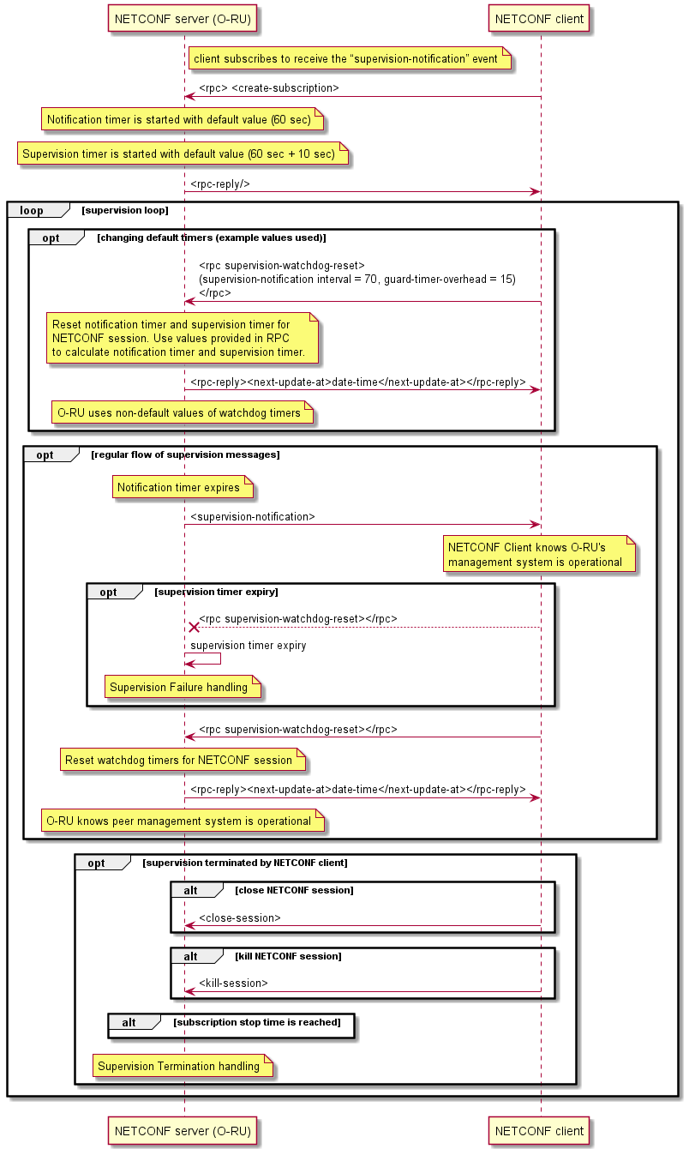
Figure 6.7-1: Monitoring NETCONF Connectivity
NOTE 4: A NETCONF client can use the create-subscription for the single supervision-notification event stream, or alternatively subscribe to the default event-stream using additional filter criteria to identify the supervision notification. In order to subscribe to multiple notifications, the appropriate create-subscription message is required. Refer to clause 11.3 for the appropriate example of create-subscription of multiple notifications.
Figure 6.7-1 illustrates the O-RU ceasing supervision operation triggered by two options:
- The supervision timer expires. In such case, the O-RU shall perform Supervision Failure handling as described in clause 14.1.1.
- The NETCONF client terminates the subscription to the supervision-notification. The NETCONF client can either close the subscription session, terminate the NETCONF session or wait for the subscription stop time to be reached. In such case the O-RU performs Supervision Termination handling as described in clause 14.1.2.

6.8 Closing a NETCONF session
A NETCONF client closes an existing NETCONF session by issuing the RPC close-session command. The O-RU shall respond and close the SSH session or TLS connection. If the NETCONF client is a Call home O-RU controller, the O-RU shall then re-commence call home procedures, as described in clause 6.3. In case the O-RU is operating in deep-hibernate mode and the hibernate-time timer is operational, as specified in clause 20.5, the O-RU shall suspend call home procedures.
Under normal operations, it is expected that at least one NETCONF session with "sudo" or "hybrid-odu" privileges are long-lived and used to repeatedly reset the O-RU's supervision watchdog timer for the NETCONF session. NETCONF clients associated with other privilege groups are not required to operate using persistent NETCONF sessions.
If a NETCONF client has been previously become known to an O-RU by being configured using NETCONF, and the NETCONF client is subsequently removed from the O-RU's configuration, e.g. by a second NETCONF client with "sudo" privileges, the NETCONF server shall force the termination of the NETCONF session to the removed client.

6.9 PNF registration

6.9.1 Introduction
The support by an O-RU of PNF Registration to a discovered Event-Collector is optional and hence clause 6.9 only applies to those O-RUs that support this optional capability. An O-RU that support pnfRegistration shall also support the Monitoring the Communications Channel between O-RU and Event-Collector as defined in clause 18.6. In case the O-RU is operating in in deep-hibernate mode and the hibernate-time timer is operational, as specified in clause 20.5, the O-RU shall suspend PNF Registration procedures.

6.9.2 PNF registration procedure
The pnfRegistration notification is a JSON encoded message sent from the O-RU to the discovered Event-Collector using REST/HTTPS. As a pre-condition to performing PNF Registration, the O-RU first receives the Event-Collector information encoded in a DHCP/DHCPv6 option as described in clause 6.2.7. The O-RU shall attempt to establish a HTTP connection to the discovered Event-Collector using TLS to authenticate the connection. It shall then signal the pnfRegistration notification over the HTTP/TLS connection. The sending of the pnfRegistration notification is repeated periodically until the SMO establishes a NETCONF session with the O-RU. These procedures are illustrated in Figure 6.9.2-1.
An O-RU that is performing the PNF registration procedure whilst simultaneously performing the call home procedure described in clause 6.3, shall be able to determine that the SMO has established a NETCONF session with the O-RU. This is identified by the O-RU analysing the source IP address from which the NETCONF originates, based on the assumption that the NETCONF session from the SMO originates from an IP address that is distinct from the IP address(es) of the call home O-RU Controller(s) to which the O-RU is simultaneously performing the call home procedure.
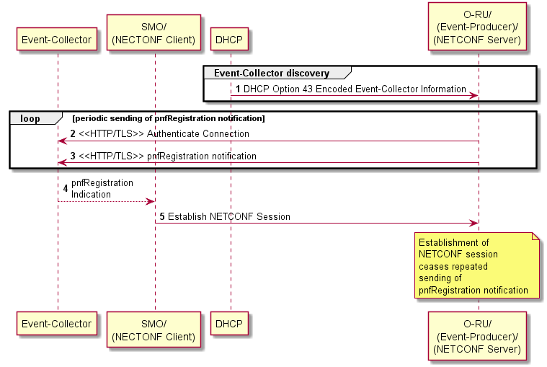
Figure 6.9.2-1: PNF Registration Procedure
The O-RU that exposes presence of feature PNF-REGISTRATION-ATTEMPTS should use the re-pnf-registration-timer to repeat the PNF registration notification. This activity is repeated by the O-RU until, either:
- The SMO establishes a new NETCONF session with the O-RU.
Or,
- After max-pnf-registration-attempts has been reached and a new NETCONF session cannot be established.
When the O-RU uses the re-pnf-registration-timer to repeatedly trigger the PNF registration notification, and the O-RU fails to trigger the PNF registration notification with at least one Event-Collector after completing the PNF Registration procedure a total of max-pnf-registration-attempts per Event-Collector, and no other NETCONF sessions exist, the O-RU should perform an autonomous reset. If there remains at least one NETCONF session connected, the O-RU shall repeat pnfRegistration notification periodically until the SMO establishes a NETCONF session with the O-RU. The values of re-pnf-registration-timer and max-pnf-registration-attempts shall be stored in the O-RU’s reset persistent memory.
Once restarted, the PNF registration process shall continue until M-Plane session is successfully re-established or the counter max-pnf-registration-attempts is reached.

6.9.3 Encoding of PNF registration notification
In the present document, the encoding of the pnfRegistration notification follows the ONAP definition [i.2].
The pnfRegistration notification shall include the IP address information necessary for a NETCONF client to establish IP connectivity to the NETCONF Server in the O-RU.
The contents of the pnfRegistration notification are derived from the O-RU's configuration database using Table 6.9.3-1. An O-RU shall support the o-ran-hardware.yang model revision 5.0.0, or later, which defines the schema nodes corresponding to unitFamily and unitType values and the o-ran-operations.yang model revision 5.0.0, or later, which defines the schema nodes corresponding to the version of pnfRegistration fields.
Table 6.9.3-1: Mapping from O-RU's Operational Data to PnfRegistration fields
PnfRegistration Notification Field | YANG Operational Data | O-RU pnfRegistration requirements
lastServiceDate | /hw:hardware/hw:component/or-hw:last-service-date | The O-RU may include the lastServiceDate field
macAddress | /if:interfaces/if:interface/o-ran-int:mac-address | The O-RU may include the macAddress field
manufactureDate | /hw:hardware/hw:component/hw:mfg-date | The O-RU may include the manufactureDate field
modelNumber | /hw:hardware/hw:component/hw:model-name | The O-RU shall include the modelNumber field
oamV4IpAddress | /if:interfaces/if:interface/ip:ipv4/ip:address/ip:ip | When the O-RU has IPv4 address assigned for management plane (as specified in clause 6.2.4), it shall include the oamV4IpAddress field ⁽note⁾
oamV6IpAddress | /if:interfaces/if:interface/ip:ipv6/ip:address/ip:ip | When the O-RU has IPv6 address assigned for management plane (as specified in clause 6.2.4), it shall include the oamV6IpAddress field ⁽note ⁾
pnfRegistrationFields Version | /o-ran-ops:operational-info/o-ran-ops:declarations/o-ran-ops:supported-pnf-registration-fields-version | The O-RU shall include the pnfRegistrationFieldsVersion field
serialNumber | /hw:hardware/hw:component/hw:serial-num | The O-RU shall include the serialNumber field
softwareVersion | /hw:hardware/hw:component/hw:software-rev | The O-RU shall include the softwareVersion field
vendorName | /hw:hardware/hw:component/hw:mfg-name | The O-RU shall include the vendorName field
NOTE: The PNF registration operation of an O-RU that uses o-ran-mplane-int YANG model to report multiple m-plane-sub-interfaces list entries of the same IP address type is not defined in the present document.

6.10 On-demand renewal of Call Home procedure
The O-RU that exposes presence of feature CALL-HOME-REACTIVATION-SUPPORTED can be triggered to re-activate timed out call-home procedure towards call home O-RU controllers. The RPC <restart-call-home> sent by any active O-RU controller having necessary permissions shall cause O-RU to re-start call home towards all not actively connected call home O-RU controllers as described in clause 6.3.
Once restarted, the call home flows shall continue until M-Plane session with lost call home O-RU controller(s) is successfully re-established or until counter max-call-home-attempts is exhausted.
For every call home O-RU controller for which supervision is recovered in(as) result of RPC <restart-call-home>, the O-RU shall cancel alarm 35 "Lost O-DU ID based Supervision" when supervision is successfully recovered
This RPC has no impact on O-RU operations with call home controllers that have M-Plane session established with O-RU.
In case O-RU is performing call home procedure towards call home O-RU controller, the RPC shall trigger the O-RU to re-initialize its internal counter based on value of node max-call-home-attempts and continues call home procedure.

6.11 TLS sessions and certificate expiry
After a certificate has been re-issued, an O-RU may continue to use M-Plane sessions (e.g. NETCONF, FTPeS) authenticated using a previously issued, un-expired certificate. New M-Plane sessions shall use the certificate with the longest time to expiration, as described in clause 6.4.2.
After having received a notification that an O-RU has been re-issued a certificate by the Operator PKI, an O-RU controller should schedule the closing of existing NETCONF session by issuing the RPC close-session command following the procedure specified in clause 6.8.
NOTE 1: The timing of the scheduled session closing can be arranged to minimize any service impacting effects.
NOTE 2: The operation of the O-RU when the certificate used to authenticate an on-going M-Plane session expires is not defined.

7 O-RU to O-DU interface management

7.1 O-RU interfaces
An O-RU has a number of network interfaces, including Ethernet, VLAN and IP interfaces. This clause describes the management of these network interfaces.
The O-RU's configuration for its interfaces is defined using the o-ran-interfaces.yang module. This module augments the standard ietf-interfaces.yang and ietf-ip.yang modules. The O-RU's interfaces are built on a layering principle where each interface has a unique name.
All interfaces are referenced by their port-number and name. The base interface corresponds to the Ethernet interface. These leafs describe the maximum transmission unit (l2-mtu), the hardware-address as well as optional alias mac addressees that may be used to transport the CU plane. An O-RU can indicate the maximum Ethernet payload size per O-RU Ethernet interface it supports by using the maximum-ethernet-payload-size leaf. The O-RU shall reject any configuration where the Ethernet payload configured using l2-mtu for an Ethernet interface exceeds the value of maximum-ethernet-payload-size.
NOTE 1: If an O-RU does not indicate a value of maximum-ethernet-payload-size in its operational state, the operator and O-RU vendor can agree on a maximum Ethernet frame size.
NOTE 2: The definition of the read-only maximum-ethernet-payload-size is different from the l2-mtu definition. The description in the YANG model defines how to map between the two and Figure 7.1-0a illustrates an example subset of configuration and operational data.
<interfaces xmlns="urn:ietf:params:xml:ns:yang:ietf-interfaces">
<interface>
<name>10Geth0</name>
<type xmlns:ianaift="urn:ietf:params:xml:ns:yang:iana-if-type">ianaift:ethernetCsmacd</type>
<enabled>true</enabled>
<l2-mtu xmlns="urn:o-ran:interfaces:1.0">
9014
</l2-mtu>
<maximum-ethernet-payload-size xmlns="urn:o-ran:interfaces:1.0">
9000
</maximum-ethernet-payload-size>
<vlan-tagging xmlns="urn:o-ran:interfaces:1.0">
true
</vlan-tagging>
</interface>
</interfaces>

Figure 7.1-0a: Example subset of configuration and operational data related Ethernet payload size
Additionally, for O-RUs that include the ieee802-dot1x and ietf-system models in their YANG library the /if:interfaces/if:interface/dot1x:pae/dot1x:port-capabilities/dot1x:supp schema node enables an O-RU Controller to configure operation of IEEE 802.1X Port based Access Control, as specified in [70].
Above the Ethernet interface are VLAN interfaces. Both Ethernet and VLAN interfaces can support IP interfaces. IP interfaces are defined using the standard ietf-ip.yang model. The O-RU controller can restrict the maximum size of IP packets using the /if:interfaces/if:interface/ip:ipv4/ip:mtu and/or the /if:interfaces/if:interface/ip:ipv6/ip:mtu leaves. Accordingly, each IP interface can have an IPv4 and/or IPv6 interface(s) defined. An O-RU may support the PER-INT-TCP-MSS feature that allows an O-RU controller to configure the TCP Maximum Segment Size (MSS). When the O-RU supports the PER-INT-TCP-MSS feature, the O-RU shall reject any configuration where the mss-adjust leaf for an interface exceeds the value of /ip:mtu configured on the same interface.
When a value of the mss-adjust leaf is configured, an O-RU shall set its value of MSS option to the configured value, independently of any MSS value derived using discovered MTU procedures. Figure 7.1-0b illustrates a subset of configuration data that enables a UDP/IP based CUS-Plane to benefit from 9000 byte payload, compared with the TCP based M-plane that is restricted to a payload of 1500 bytes.
<interfaces xmlns="urn:ietf:params:xml:ns:yang:ietf-interfaces">
<interface>
<name>10Geth0</name>
<type xmlns:ianaift="urn:ietf:params:xml:ns:yang:iana-if-type">ianaift:ethernetCsmacd</type>
<enabled>true</enabled>
<vlan-tagging xmlns="urn:o-ran:interfaces:1.0">
false
</vlan-tagging>
<ipv4 xmlns="urn:ietf:params:xml:ns:yang:ietf-ip">
<mtu>9000</mtu>
<tcp xmlns="urn:o-ran:interfaces:1.0">
<mss-adjust>1460</mss-adjust>
</tcp>
</ipv4>
<ipv6 xmlns="urn:ietf:params:xml:ns:yang:ietf-ip">
<mtu>9000</mtu>
<tcp xmlns="urn:o-ran:interfaces:1.0">
<mss-adjust>1440</mss-adjust>
</tcp>
</ipv6>
</interface>
</interfaces>

Figure 7.1-0b: Example subset of configuration data related to different IP payload size for CU-Plane and M-Plane
The O-RU shall provide operational state associated with the layer 3 configuration of these interfaces, including prefix(es), using the ietf-ip YANG model, and domain name servers and default gateway addresses, using the o-ran-dhcp YANG model. An example of such operational state for the ietf-ip YANG model is shown in Figure 7.1-1.
<ipv4 xmlns="urn:ietf:params:xml:ns:yang:ietf-ip">
<enabled>true</enabled>
<address>
<ip>10.10.0.17</ip>
<netmask>255.255.255.0</netmask>
<origin>dhcp</origin>
</address>
</ipv4>
Figure 7.1-1: Example operational data related to an IP interface
Finally, leafs associated with CoS and DSCP marking are defined, enabling independent configuration of CoS and DSCP markings for u-plane, c-plane and m-plane traffic. As a default, all user-plane flows are marked identically by the O-RU. Optionally, the interfaces can be configured to support enhanced user plane marking for up-link traffic whereby different CoS or DSCP values can be configured. This enables individual receive endpoints in the O-RU to be configured with different markings to then enable differentiated handling of up-link flows by the transport system.
Because the o-ran-interfaces model defines augments to the ietf-interfaces model, the O-RU can leverage the definition of operational state in ietf-interfaces to optionally report packet and byte counts on a per interface basis. A single RPC is defined in the o-ran-interfaces module, to enable these counters to be reset.

7.2 Transceiver

7.2.1 General
The o-ran-transceiver YANG module is used to define operational state for the pluggable transceiver module (like SFP, SFP+, SFP28, XFP and QSFP, QSFP+, QSFP28, QSFP56). Each transceiver is associated with a unique interface-name and port-number. Interfaces accessible through the transceiver are provided by the interface-name, interface-names and additional-multi-lane-reporting/interface-names leaves in the o-ran-transceiver YANG module.
A digital diagnostic monitoring interface for optical transceivers is used to allow access to device operating parameters. As specified in SFF-8472 [16] and SFF-8636 [34], data is typically retrieved from the transceiver module in a file. This file may be obtained from O-RU by the NETCONF client. See clause 9 for more details.
With QSFP form factor, the optical links may be multi-wavelengths (4xTx & 4xRx) and/or multi-fibres (Multifibre Parallel Optic (MPO)). The QSFP digital diagnostic interface as specified in SFF-8636 [34] describes the use of optical lanes and the O-RU interface management defines alarm 29 :"transceiver fault" for all media lanes.
The byte with offset i (i=0, …, 511) from the beginning of the file is the byte read from data address i of the transceiver memory at two-wire interface address 0xA0 if i<256, otherwise it is the byte read from data address i-256 of the transceiver memory at two-wire interface address 0xA2. The retrieved data is stored in the file without any conversion in binary format.
The O-RU stores data from the transceiver module on transceiver module detection during start-up. The data from the transceiver module is saved in the file. A NETCONF client can upload it by using the File Upload procedure defined in clause 12. The O-RU does not synchronise contents of the file with transceiver memory in runtime, therefore bytes representing dynamic information are expected to be outdated. The O-RU does not remove the file on transceiver module removal. If a transceiver module is inserted during File Upload procedure, then the procedure may provide a file with previous content or fail (with failure reason as listed in File Upload procedure). If the O-RU is unable to retrieve the data from the transceiver module or it is not present, then the O-RU does not create the file or removes the file created earlier
NOTE: File Upload procedure requesting non-existing file will fail.
The file name shall have the following syntax:
- sfp_{portNumber}.sffcap
where {portNumber} is the value of port-number leaf of the corresponding list of port-transceiver data. Examples: sfp_0.sffcap, sfp_1.sffcap.

7.2.2 Transceiver presence change notification
The O-DU may subscribe to transceiver presence change notifications, which report the status of the transceiver presence. The following notification is defined in the YANG model:
- transceiver-presence-change - conveys the port-transceiver-data information (transceiver-presence, name, port-number, interface-name).
The above notification is sent to the subscribed O-RU controllers whenever O-RU detects that presence of a transceiver module has changed, as illustrated in Figure 7.2.2-1.
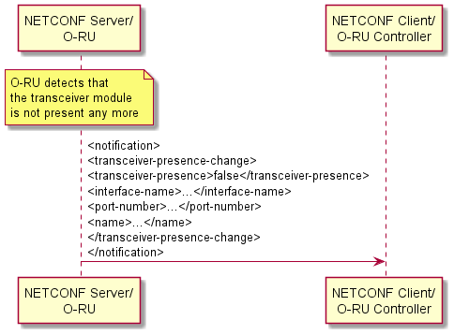
Figure 7.2.2-1: Transceiver presence change notification

7.3 C/U-Plane VLAN configuration
Within the o-ran-interfaces YANG model, each named Ethernet interface includes a leaf to indicate whether VLAN tagging is supported. By default, VLAN tagging shall be enabled on all interfaces. This permits an O-RU to autonomously discover that it is connected to a trunk port, as described in clause 6.2.3.
When an O-RU is connected to a trunk port, VLANs will also typically be assigned to the C/U plane connections. The VLAN(s) used to support C/U plane transport may be different from the VLAN(s) used to support management plane connectivity. The VLAN assigned to the U-Plane shall be the same as the VLAN assigned to the C-Plane for any given eAxC_ID. When different VLANs are used, the C/U plane VLANs shall be configured in the O-RU by the NETCONF client. In such circumstances, as defined in o-ran-interfaces, the NETCONF client shall configure separate named interfaces for each active VLAN. This configuration will define a C/U-Plane named VLAN interface as being the higher-layer-if reference for the underlying Ethernet interface and the underlying Ethernet interface is defined as being the lower-layer-if reference for the named VLAN interface.

7.4 O-RU C/U-Plane IP address assignment
In this release, the support for C/U plane transport over UDP/IP is optional and hence this clause only applies to those O-RUs that support this optional capability.
An O-RU that supports C/U plane transport over UDP/IP shall support IPv4 and/or IPv6 based transport. A NETCONF client can receive a hint as to whether an O-RU supports a particular IP version by using the get RPC to recover the list of interfaces supported by the O-RU and using the presence of the augmented ipv4 container or ipv6 container in the o-ran-interfaces YANG module as an indication that a particular IP version is supported.
The IP interface(s) used to support UDP/IP based C/U plane transport may be different than the IP interface(s) dynamically discovered using the procedures defined in clause 6.2.4. When different IP interface(s) is/are used, the C/U plane IP interfaces shall be configured in the O-RU by the NETCONF client by using the ietf-ip YANG model, as specified in RFC 8344 [91], to configure the IPv4 container and/or IPv6 container. When configured by the NETCONF client, this interface shall be configured using either a named Ethernet interface (i.e. where the interface type is set to ianaift:ethernetCsmacd) and/or a named VLAN interface (i.e. where the interface type is set to ianaift:l2vlan), depending upon whether VLANs are used to support IP based C/U plane traffic.
When a separate C/U plane IP interface is configured by the NETCONF client, additionally the NETCONF client may statically configure IP address(es) on this interface. If the NETCONF client does not statically configure an IP address, the O-RU shall be responsible for performing IP address assignment procedures on the configured interfaces. When an O-RU Controller has configured an IP interface with enabled set to true, but where the O-RU Controller has not configured a static IP address, the NETCONF client can use the autoconf container to control the O-RU's use of autoconfiguration of IPv6 addresses as specified in RFC 8344 [91] by using the create-global-addresses parameter. When an IPv6 container is configured by a NETCONF client with a create-global-addresses set to false, the O-RU shall attempt to configure a dynamic IPv6 address using IPv6 State-full address configuration using DHCPv6 as specified in RFC 8415 [58]. When an IPv4 container is configured by a NETCONF client an IP interface with enabled set to true, but where the O-RU Controller has not configured a static IP address, the O-RU shall attempt to configure a dynamic IPv4 address using DHCPv4 as specified in RFC 2131 [10].
As specified in clause 6.2.8, an O-RU that supports static routing shall route IP-based C/U plane traffic towards a destination IP address based on its routing table.

7.5 Definition of processing elements
The CU-plane application needs to be uniquely associated with specific transport flows. This association is achieved by defining an O-RU "processing element" which can then be associated with a particular C/U plane endpoint eAxC ID, as specified in [2] clause 5.4 or delay measurement operation, as specified in [2] clause 4.4.4.4. Unless specified otherwise, a common processing element is required to be configured for the control and user-plane application components associated with any individual eAxC_ID.
The O-RU management plane supports different options for defining the transport endpoint identifiers used by a particular processing element (used depending on transport environment), supporting the following 3 options:
- Processing element definition based on usage of different (alias) MAC addresses;
- Processing element definition based on a combination of VLAN identity and MAC address; and
- Processing element definition based on UDP-ports and IP addresses.
NOTE: There is no well-defined source port currently allocated by IANA for the o-ran application and hence the NETCONF client can configure this port number in the O-RU.
A processing element consists of both the local and remote transport endpoints and is used as a logical transport path. The processing element definition includes its element name which is then used by other systems to refer to a particular processing element instance.
The o-ran-interfaces YANG model is used to define feature support for C/U plane transport based on alias MAC addresses and UDP/IP. The exchange of NETCONF capabilities is used to signal which optional capabilities are supported by the O-RU, as described in Annex C.
The o-ran-processing-elements YANG model uses a processing-elements container to define a list of processing elements. Each processing element is identified by a unique element name. Each processing element references a particular interface-name used to support the data flows associated with a particular processing element. Depending upon the type of C/U plane transport session, additionally leafs are configured that specify MAC addresses, and/or VLANs and/or IP addresses and/or UDP ports used to identify a particular processing element.
If the O-RU reports the capability of supporting feature MULTIPLE-TRANSPORT-SESSION-TYPE, which indicates the O-RU supports multiple transport-session-type, the NETCONF client may configure processing-elements with more than one transport-session-type to the O-RU, using the list additional-transport-session-type-elements with the key transport-session-type. When a processing element configured by the list additional-transport-session-type-elements is referenced by other modules, the transport-session-type shall also be configured as a key to the list additional-transport-session-type-elements.
The O-RU may discard any received CU-plane messages, i.e. eCPRI/IEEE 1914 frames/packets, which are not transported using a configured processing element.

7.6 O-DU verification of C/U-Plane transport connectivity

7.6.1 C/U-Plane transport connectivity verification
As described above, there will likely be multiple C/U-plane data flows being exchanged between the O-DU and the O-RU. In order to enable checks verifying C/U-Plane end-to-end transport connectivity between the O-DU and O-RU, the O-RU shall support C/U-Plane connectivity verification capabilities using a request/reply function, as illustrated in Figure 7.6.1-1.
Using that connectivity verification procedure, bi-directional reachability/connectivity verification between tranport endpoints can be performed by the O-DU:
- During O-RU configuration, to validate the transport configuration.
- At runtime to regularly perform bi-directional network connectivity verification.
The periodicity for bi-directional connectivity verification is usually between 1 and 60 seconds.
Two different network protocols are defined for performing the bi-directional transport connectivity verification procedure:
- For C/U sessions over Ethernet: Loop-back Protocol (LBM/LBR) as specified in IEEE 802.1Q-2018 [69].
- When the O-RU is configured to support C/U sessions over IP: UDP echo, as specified in RFC 862 [18].
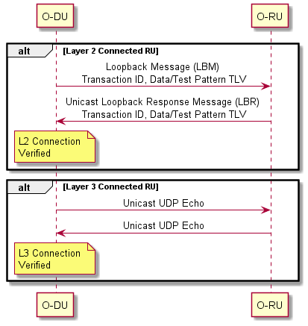
Figure 7.6.1-1: C/U Plane Transport Connectivity Verification

7.6.2 Ethernet connectivity monitoring procedure

7.6.2.1 Transport connectivity verification monitoring Procedure
When the O-RU and O-DU are operating their C/U sessions transported over Ethernet, the transport connectivity verification checks operate at the Ethernet layer. The protocol for Ethernet connectivity verification shall use the Loop-back Protocol as defined by IEEE 802.1Q-2018 [69].
For the purpose of regular connectivity verification, all transport endpoints used for C/U-plane messaging in the fronthaul network shall be configured to be part of the same Maintenance Entity (ME). The O-RU Controller shall configure each O-RU, assigning them the role of a Maintenance association End Point (MEP) for LBM.
The sending of Loop-back Messages (LBMs) is administratively initiated and stopped in the O-DU. Therefore, sending LBM requests needs to be requested by an administration entity, specifying an Ethernet interface of the O-RU responder. If administratively initiated, the O-DU shall send the LBM request. When sending the LBM request, support for setting the destination MAC address as the unicast MAC address of the specified O-RU Ethernet interface as per IEEE 802.1Q-2018 [67] is mandatory while the support for setting the destination MAC address as the group destination MAC address 01-80-C2-00-00-3x as specified in Recommendation ITU-T Y.1731 [25] clause 7.2.2, where the LSB 4 bits are derived from the md-level configuration in o-ran-lbm.yang, is optional. See also clause 10.1 of Recommendation ITU-T Y.1731 [25].
An O-RU that supports LBM configuration using the ieee802-dot1q-cfm YANG model shall include the ieee802-dot1q-cfm model in its YANG library. Such an O-RU can have a common LBM configuration datastore and operational data, exposed by both ieee802-dot1q-cfm and o-ran-lbm YANG models.
For example, an O-RU can ensure the value of replies-transmitted in o-ran-lbm YANG model to be set as identical to that value of mep-lbr-out in the ieee802-dot1q-cfm YANG model.
In case the coordination of LBM configuration happens external to the O-RU, when LBM configuration is inconsistent between two models, the LBM behaviour of the O-RU is not specified by the present document.
O-RUs that supports ieee802-dot1q-cfm.yang shall support the Notification of Updates to its Configuration Datastore functionality, as specified in clause 9.4. Hence, any NETCONF clients connected to the O-RU may configure subscriptions to receive notifications of modifications to ieee802-dot1q-cfm.yang and/or o-ran-lbm.yang configuration changes.

7.6.2.2 Validating the transport configuration
After setting up a U/C-plane session between an O-DU and an O-RU, the O-DU can test whether connectivity exists as per the configuration. To achieve that, at the time a transport endpoint becomes operational at an O-RU, it starts an LBM responder application which automatically responds to incoming LBM requests on that transport endpoint. Based on a configuration command the O-DU starts sending out a predefined number of LBM requests to its O-RU(s) at a predefined interval, storing the information received in LBM responses from the O-RU(s) in an internal database. O-RU(s) are identified by both Ethernet MAC address and the CU plane VLAN.
The O-RU shall be able to respond to Loopback Messages received from different remote Maintenance Association Endpoints, when the destination MAC address is the O-RU's MAC address. The O-RU should respond to Loopback Messages received from different remote Maintenance Association Endpoints, when the destination MAC address is a group destination MAC address as defined in clause 10.1 of [25]. In case the O-RU is operating in in deep-hibernate mode and the hibernate-time timer is operational, as specified in clause 20.5, the O-RU may suspend Loopback Message processing.
In case the configuration of the session is indeed correct, the O-DU should receive LBM responses from the O-RU(s) within a time frame dependent on the network latency and the O-RU's reaction time. If LBMs from the O-RU(s) are being received, the session is determined to be operational.

7.6.2.3 Monitor network connectivity
After the procedure described in clause 7.6.2.2 has been executed successfully, a further procedure may be executed continuously to maintain the connectivity status. To achieve this the O-DU can continually send out LBM requests at the configured interval. It also keeps track of LBM responses received.
Based on the LBM responses received the O-DU shall decide on the connectivity status. Connectivity shall be assumed to be available as long as LBM responses from the O-RU(s) are being received at the configured interval. Connectivity shall be assumed not available if no LBM response from the particular O-RU has been received for an interval that is as long as 3 x the configured LBM request interval or longer.
Optionally, for those O-RUs that advertise support for the ieee802-dot1q-cfm.yang, the O-DU can enable O-RU sending of Connectivity Check Messages (CCM) by configuring ccm-enabled to "true" on the O-RU. The O-DU can monitor network connectivity by received CCM message from the O-RU. These CCM messages are sent to a multicast destination address which encodes the maintenance domain level as specified in Table 8-18 of IEEE 802.1Q[67].

7.6.2.4 Managing ethernet connectivity monitoring procedure
An O-DU may have one or more Ethernet interfaces that have to support the Ethernet connectivity monitoring procedure. This clause describes the management of this function. The module described here is based on (i.e. a subset of) the mef-cfm module defined by the Metro Ethernet Forum [i.3]. This is to allow for a later extension of the module to the full feature set of mef-cfm.
The YANG module provided below supports the configuration and fault management of the Loop-back Protocol as defined by IEEE 802.1Q-2018 [69].
Derived from MEF CFM YANG, the subset of type definitions is defined as part of the o-ran-lbm.yang.

7.6.3 IP connectivity monitoring procedure

7.6.3.1 Monitoring procedure
If the O-RU and O-DU are connected using IP (and UDP/IP is being used to transport the C/U plane), these transport connectivity verification checks operate at layer 3. Layer 3 connection verification is based on the O-RU supporting the UDP echo server functionality, as specified in RFC 862 [18]. The NETCONF client should enable the UDP echo server in the O-RU, triggering the O-RU to listen for UDP datagrams on the well-known port 7. When a datagram is received by the O-RU, the data from it is sent back towards the sender, where its receipt can be used to confirm UDP/IP connectivity between the transport endpoints.

7.6.3.2 Managing IP connectivity monitoring procedure
This clause describes the management of the UDP echo functionality. The NETCONF client uses the enable-udp-echo leaf in the udp-echo YANG model to control operation of the UDP echo server in the O-RU. The NETCONF client is able to control the DSCP marking used by the O-RU when it echoes back datagrams using the dscp-config leaf. Additionally, the NETCONF client can recover the number of UDP Echo messages sent by the O-RU by using echo-replies-transmitted operational state.
An O-DU may have one or more IP interfaces that have to support the UDP/IP connectivity monitoring procedure. An O-RU with its UDP echo server enabled shall be able to respond to UDP datagrams originated from any valid source IP address.

7.7 C/U-Plane delay management

7.7.1 Introduction
The Intra-PHY lower layer fronthaul split has the characteristic of a stringent bandwidth and tight latency requirement. The CUS-Plane specification [2] clause 4.4 describes how the propagation delay incurred due to distance between the O-DU and O-RU is an important parameter in defining the optimisation of windowing and receive-side buffering operations. This clause describes the procedures that are used to manage the delay parameters for the fronthaul split.

7.7.2 Delay parameters
The reference points for delay management are specified in the CUS-Plane Specification [2], clauses 4.4 and 4.7. Important delay parameters related to the operation of the O-RU are referred to as the O-RU delay profile. As the delay characteristics for an O-RU may vary based on air interface properties, a table of the parameters is provided based on a combination of sub-carrier spacing (SCS) and channel bandwidth. Other parameters related to delays to external antennas may vary according to specific tx/rx-array-carriers. These parameters are shown in Table 7.7.2-1.
Table 7.7.2-1: Mapping of delay profile parameters
YANG parameter | Delay management parameters in CUS
t2a-min-up | T2a_min_up
t2a-max-up | T2a_max_up
t2a-min-cp-dl | T2a_min_cp_dl
t2a-max-cp-dl | T2a_max_cp_dl
tcp-adv-dl | Tcp_adv_dl
t-da-offset | Tda
ta3-min | Ta3_min
ta3-max | Ta3_max
t2a-min-cp-ul | T2a_min_cp_ul
t2a-max-cp-ul | T2a_max_cp_ul
ta3-min-2g | Ta3_min_2g
ta3-max-2g | Ta3_max_2g
t-au-offset | Tau
ta3-min-ack | Ta3_min_ack
ta3-max-ack | Ta3_max_ack

If the O-RU supports multiple beamforming methods, some beamforming methods can have different delay parameters from others. In this case, the O-RU uses non-default-ru-delay-profile to report the additional sets of delay profile values based on a combination of SCS and bandwidth, the O-RU may only report the parameters that differ from ru-delay-profile. The delay parameter not reported in the non-default-ru-delay-profile uses the default value defined in ru-delay-profile. The delay-profile-id shall be used to identify additional sets of delay profiles supported by the O-RU in addition to the default delay profile.
One delay profile may be common for multiple beamforming methods or may be specific to a beamforming method. Multiple BF methods used simultaneously can have the same set of delay profiles identified by the delay-profile-id.
When requested, all O-RUs shall signal the table of statically "pre-defined" values of the above parameters, for different supported combinations of SCS and channel bandwidth over the management plane interface. This will typically occur during the initial start-up phase.

7.7.3 Reception window monitoring
The O-RU shall monitor operation of its reception window, monitoring the arrival of packets received over the fronthaul interface relative to the earliest and latest allowable times as defined by the values of t2a-max-up, t2a-max-cp-dl and t2a-min-up, t2a-min-cp-dl respectively.
See clause B.3 for information on reception window counters.

7.7.4 External antenna delay control
An O-RU may optionally support the external antenna delay control by indicating that it supports the EXT-ANT-DELAY-CONTROL feature in its o-ran-wg4-features YANG model. Such an O-RU uses the ext-ant-delay-capability schema node in o-ran-module-cap YANG model to indicate to the O-RU Controller the type of external delay configuration supported by the O-RU:
- PER-O-RU: The O-RU only supports a single value of t-da-offset and a single value of t-au-offset across all tx-array-carriers and rx-array-carriers respectively.
- PER-ARRAY: The O-RU supports separate values of t-da-offset and t-au-offset across individual tx-arrays and rx-arrays respectively.
- PER-ARRAY-CARRIER: The O-RU supports separate values of t-da-offset and t-au-offset across separate tx-array-carriers and rx-array-carriers respectively.

7.8 O-RU adaptive delay capability
O-RUs may optionally support the ability to optimize their buffers based on information signalled concerning the configuration of the O-DU, e.g. including the O-DU delay profile, together with transport delay information, which may have been derived by the O-DU by using a delay measurement procedure operated by the O-DU or by other techniques. This clause describes such optional O-RU buffer optimisation functionality.
The reference parameters are specified in the CUS-Plane Specification [2], clauses 4.4. An O-RU that supports the optional adaptive timing capability shall indicate such to the O-RU Controller client by exchanging NETCONF capabilities, as described in clause 9.2 and Annex C indicating that it supports the ADAPTIVE-RU-PROFILE feature. An O-RU Controller may then provide the O-RU with the O-DU delay profile based on a combination of sub-carrier spacing (SCS) and channel bandwidth, as shown in Table 7.8-1.
Table 7.8-1: Mapping of O-DU delay profile parameters
YANG parameter | Delay management parameters in CUS
t1a-max-up | T1a_max_up
tx-max | TXmax_{O-DU}
ta4-max | Ta4_max
rx-max | RXmax_{O-DU}
t1a-max-cp-dl | T1a_max_cp_dl

In addition to the O-DU delay profile, the O-RU-Controller provides the O-RU with the transport network timing parameters, as shown in Table 7.8-2.
Table 7.8-2: Mapping of transport delay profile parameters
YANG parameter | Delay management parameters in CUS
t12-min | T12_min
t12-max | T12_max
t34-min | T34_min
t34-max | T34_max

As per [2] clause 4.7, the O-RU Controller shall configure values of t12-max and t34-max as if there is no external delay, i.e. Tau = Tda = 0 (zero). The O-RU may use this information to adapt its delay profile, ensuring that the inequalities defined in clause B of [2] are still valid
The O-RU controller should provide this information during the O-RU's start-up procedure. If an O-RU receives the adaptive delay configuration information when operating a carrier, the O-RU shall not adapt its O-RU delay profile until all carriers operating using the O-RU buffers have been disabled. Once an O-RU has adapted its O-RU profile, it shall include the newly adapted timing values when signalling its delay parameters to a NETCONF client.

7.9 Measuring transport delay parameters
An O-RU may optionally indicate that it supports the eCPRI based measurement of transport delays between O-DU and O-RU. If O-RU supports measured transport delay, it shall implement the protocol as described in the CUS-Plane Specification [2] clause 4.4.4.4.
An O-RU that supports the eCPRI based delay measurement capability, shall be able to support the operation of delay measurements whenever any processing element has been configured as described in clause 7.5. For each processing element configured, the O-RU shall be able to respond to any messages when received and keep a record of the number of responses, requests and follow-up messages transmitted by the O-RU.

7.10 O-RU monitoring of C/U-Plane connectivity
The O-RU should monitor the C/U plane connection and should raise an alarm if the logical C/U-plane connection associated with a processing-element fails. The O-RU uses a timer to monitor the C/U plane connection on a per processing-element basis. This timer is enabled only when at least one array-carrier using the processing-element is in the active state and is reset whenever it receives any C/U plane data flows associated with the particular processing-element. Because of the variety of PHY and C/U plane configurations, the O-RU cannot independently determine the minimum frequency of messages across the fronthaul interface. When an O-RU is monitoring the C/U plane, as a default, the O-RU uses a timer value of 160 milliseconds for monitoring the C/U plane connection. An O-RU may indicate that its C/U-plane monitoring timer is configurable, by the presence of the cu-plane-monitoring container in the o-ran-supervision.yang model. A NETCONF client can use the configured-cu-monitoring-interval leaf to configure the O-RU's timer value, including being able to disable the operation of C/U Plane monitoring.
If the O-RU supports this timer, then depending on how long the O-DU takes to initiate sending of C/U plane data flows, it is advisable for the NETCONF client to initially disable the operation of the timer before carrier activation. Such an approach avoids the O-RU sending spurious alarm notifications triggered by O-DU delays in initializing the sending of C/U plane data that exceed the default timer value. Once C/U plane data flows have commenced, the NETCONF client can re-configure the timer with the desired value and hence activate monitoring of the C/U plane connectivity by the O-RU.

7.11 Bandwidth management
An O-RU can indicate the maximum bitrate able to be supported on those interfaces associated with a particular physical port using the optional nominal-bitrate leaf in the o-ran-transceiver YANG module. When the sustainable bitrate able to be supported by an O-RU is less than the combined bitrates of all its physical ports, an O-RU can use the optional interface-grouping container in the o-ran-interfaces YANG model to define the maximum sustainable rate able to be supported by an interface-group-id corresponding to a group of one or more physical interfaces. The same YANG model is used to augment the ietf-interfaces defined interface list with the interface-group-id to which the interface belongs.
NOTE: The maximum sustainable bandwidth is calculated over one radio frame, meaning that the peak bandwidth can exceed the defined value over time periods shorter than one radio frame.

7.12 IEEE 802.1X port based access control

7.12.1 Configuring port based access control
The O-RU shall support IEEE 802.1X port based access control supplicant functionality.
NOTE 1: IEEE 802.1X port based authentication is useful in those deployment scenarios where the O-RU is connected to a physically secure point-to-point Ethernet LAN used to transport the fronthaul traffic.
NOTE 2: A previous version of the present document did not mandate IEEE 802.1X port-based network access control supplicant functionality in the O-RU. Operators that enable IEEE 802.1X authenticator PAE functionality in the fronthaul need to accommodate legacy O-RUs that do not support supplicant PAE functionality.
NOTE 3: The present document does not define operation of an authenticator PAE in the O-RU. When operating an O-RU in shared cell configuration (i.e. in FHM or cascade mode), operators wanting to benefit from the port based access control supplicant functionality in an O-RU will need to rely on the transport network equipment to implement the authenticator PAE functionality. Clause 17.4 of O-RAN Xhaul Packet Switched Architectures and Solutions [73], requires each port connection from the transport network equipment towards the O-RU supports IEEE 802.1X authenticator functionality.
O-RUs indicate they support IEEE 802.1X port based access control by including the ieee802-dot1x and ietf-system models in their YANG library. An O-RU Controller can use the /sys:system/dot1x:pae-system/dot1x:system-access-control parameter to enable or disable operation of IEEE 802.1X port based access control. Once configured, an O-RU shall store the system-access-control parameter in reset persistent memory. This means that, unless the O-RU has performed a factory reset procedure as described in clause 8.8, the O-RU shall always use the last configured value of system-access-control during its next start-up procedure.
NOTE 4: The leaf sys:system/dot1x:pae-system/dot1x:system-access-control in ieee802-dot1x YANG model does not have a default value and hence IEEE 802.1X operation will normally be disabled in factory software. An operator and vendor can agree that an O-RU uses a default value for this leaf in factory software.
The configuration parameters and operational data related to IEEE 802.1X are defined in the pae container defined in the ieee802-dot1x YANG model defined augmentation of ietf-interfaces YANG model. An O-RU uses the port-capabilities container to indicate to an O-RU controller its PAE capabilities on a per-port basis. An O-RU indicates it supports a supplicant on a particular port by setting the supp leaf to true. When an O-RU indicates it supports a supplicant, an O-RU controller can use the supplicant container to configure authentication timers and re-try behaviour. The O-RU controller can use the sys:system/dot1x:pae-system/o-ran-cert:credential container to configure the trust anchor and the client certificate to be used by the supplicant PAE. The O-RU shall store this supplicant and credential configuration in reset persistent memory.
When using a group destination address for transmitting or receiving EAP encapsulation over LAN (EAPOL) messages, an O-RU including the model ieee802-dot1x-eapol in its YANG library shall use the value configured for the PAE using the eapol-group-address leaf. In other cases, an O-RU shall use the IEEE Std 802.1X PAE Address, as specified in clause 11.1.1 of IEEE 802.1X [70].

7.12.2 EAP authentication
The operation of a successful EAP authentication is described in O-RAN Security Requirements and Controls Specifications [83], clause 5.2.5.5.3. An O-RU that supports IEEE 802.1X and which has its supplicant functionality enabled shall support EAP-TLS authentication. An O-RU that has a valid operator-signed certificate shall use the certificate in the EAP-TLS authentication. An O-RU that does not have a valid operator-signed certificate shall use its manufacturer installed certificate in the EAP-TLS authentication.
All O-RUs that have a supplicant enabled shall set their unauthAllowed variable to AuthFail, as specified in IEEE 802.1X [70], clause 12.5.1. Accordingly, the O-RU's PAE controlled port state machine shall enable unauthenticated connectivity on a port with supplicant enabled only after the EAP authentication procedure has failed.
NOTE: The PAE authenticator can decide to permit unauthenticated connectivity from an O-RU based on operator determined policy, e.g. based on matching the source Ethernet MAC address used by the Supplicant PAE against a register of O-RU MAC addresses. Such policies and their enforcement are outside the scope of the present document.

7.12.3 Certificate time validation
Operation of the EAP-TLS method requires the O-RU verify the certificate chain presented by the authenticator PAE, including confirming the certificate's validity periods. O-RUs using IEEE 802.1X port based access control shall be able to verify the certificate validity periods during the EAP-TLS exchange, e.g. by employing a persistent clock or using GNSS-based time synchronisation .
If the O-RU cannot verify the certificates validity, e.g. because a persistent clock has failed, the EAP authentication procedure will fail. According to clause 7.12.2, this will result in the O-RU providing un-authenticated connectivity. If the O-RU uses a persistent clock for certificate validity checking and detects a persistent clock failure, it shall, as soon as possible, set its clock to the current time recovered from available external sources, e.g. PTP or GNSS.
NOTE: The scenario corresponding to a failed clock source and resulting O-RU operation using un-authenticated connectivity, is identical to the O-RU operation prior to the introduction of IEEE 802.1X port based access control in version 10 of the present document.

7.13 Media Access Control (MAC) security

7.13.1 General
Clause 7.13 describes requirements for those O-RUs that support MACsec. The support by an O-RU of MACsec is optional and hence clause 7.13 only applies to those O-RUs that support this optional capability.
MACsec can be used in scenarios where the O-RU is not connected to a physically secure point-to-point Ethernet LAN. When configured, MACsec is used to secure the communications between the authenticated and authorised MAC Security Entity (SecY) associated with the O-RU’s PAE and the SecY in the authenticator PAE.
The present document places no restrictions on which element hosts the SecY associated with the authenticator PAE function which is a peer of the O-RU’s supplicant PAE function.

7.13.2 MACsec and MACsec key agreement
An O-RU that supports MACsec shall implement MAC Security Entity requirements as specified in clause 5.3 of IEEE 802.1AE [85], MACsec Key Agreement (MKA) functionality for authentication and cryptographic key distribution as specified in clauses 5.10 and 5.11 of IEEE 802.1X [70] and the cipher suite GCM-AES-128, as specified in clause 14.4 of IEEE 802.1AE [85].
An O-RU shall indicate it supports MACsec and MKA on a particular interface name by setting the following schema nodes to true:
- /if:interfaces/if:interface/dot1x:pae/dot1x:port-capabilities/dot1x:macsec,
- /if:interfaces/if:interface/dot1x:pae/dot1x:port-capabilities/dot1x:mka and
- /if:interfaces/if:interface/dot1x:pae/dot1x:kay/dot1x:macsec/dot1x:capable.
When an O-RU Controller configures the value of /if:interfaces/if:interface/dot1x:pae/dot1x:kay/dot1x:enable to True on an interface, the O-RU shall enable the PAE Supplicant Key Agreement entitY (KaY) on the interface. The MACsec format used between the PAE Supplicant SecY and the peer PAE Authenticator SecY shall depend on whether the interface corresponds to the base-interface of an O-RU port, or a VLAN interfaces layered above a base-interface, as specified in clause 7.13.3.
When the O-RU indicates multiple individual interfaces are MACsec capable, the O-RU shall support configuration and operation of multiple instances of the PAE Supplicant SecY on the individual interfaces.
An O-RU that has a PAE Supplicant SecY configured on a VLAN interface which has secured communication with an authenticator PAE SecY shall be able to simultaneously support the configuration of a PAE Supplicant with IEEE 802.1X on the base-interface, as described in clause 7.12.
NOTE: Clause 5.2.5.6 of the O-RAN Security Requirements Specifications [83] defines three different MACsec "encryption modes". "LAN mode MACsec" corresponds to configuring the KaY/SecY on an O-RU base interface and configuring an EAPOL group address corresponding to the Nearest non-TPMR Bridge group address, as defined in Table 11-1 of IEEE 802.1X [70]. "MACsec using EDE-CC" mode corresponds to configuring the KaY/SecY on an O-RU VLAN interface and configuring an EAPOL group address corresponding to the EDE-CC PEP Address, as defined in Table 11-1 of IEEE 802.1X [70]. The present document does not specify a solution for the third mode "WAN mode MACsec".

7.13.3 MACsec frame format
The O-RU shall use the MACsec Ethertype 88-E5 to distinguish secure frames from other insecure frames. When the PAE Supplicant with SecY is configured on an O-RU base-interface, the VLAN tag, including the priority field, shall be encapsulated within the secure data portion of the MACsec frame, as illustrated in Figure 7.13.3-1.
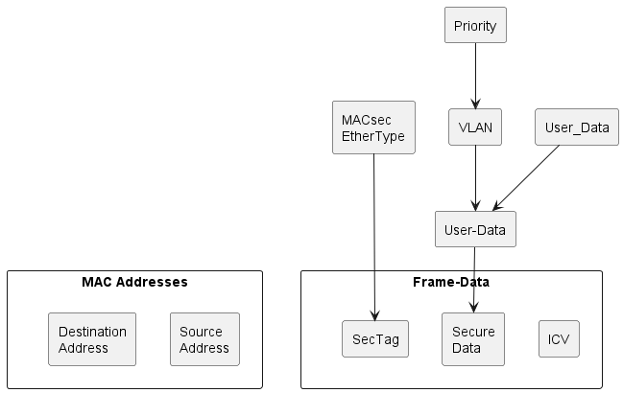
Figure 7.13.3-1: Base interface MACsec Frame, VLAN TAG and Priority Field.
When the PAE Supplicant with SecY is configured on an O-RU VLAN interface, i.e. an interface name entry which includes a vlan-id leaf, the VLAN tag, including the priority field, shall be put in a cleartext VLAN header before the SecTag and shall also include the VLAN header in the secure data, as illustrated in Figure 7.13.3-2.
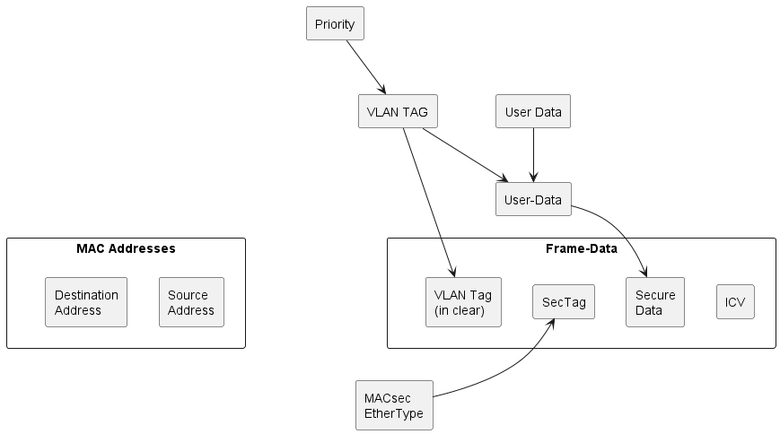
Figure 7.13.3-2: VLAN interface MACsec Frame, VLAN TAG and Priority Field.

7.13.4 Controlled and uncontrolled port
The O-RU shall permit simultaneous access to secure MAC layer Internal Sublayer Services (ISS) using the controlled port of the SecY and insecure MAC ISS using the uncontrolled port, as illustrated in Figure 7.13.4-1.
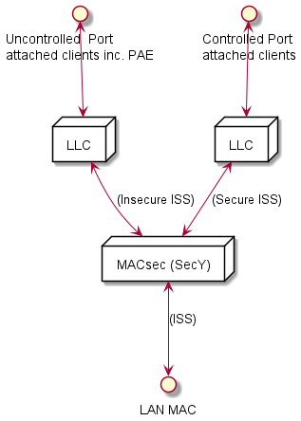
Figure 7.13.4.-1: Simultaneous access to controlled and un-controlled ports.
The O-RU shall permit operation of other protocols and entities that make use of the service provided by the SecY’s uncontrolled port to communicate independently of the operation of the MKA state machine.

7.13.5 MACsec bypass policy
An O-RU may indicate it supports MACsec bypass policies on its base-interface by including the MAC-BYPASS-POLICY in its yang library feature list. This clause applies to those O-RUs that include the feature in their YANG library.
MACsec bypass policies on the base-interface are defined to allow matching Ethernet frames egressing the O-RU to bypass MACsec protection being applied at the base-interface, instead forwarding the matching frames using the uncontrolled port. Three different types of policies are defined:
- matching on destination MAC address,
- matching on ethernet type, and
- matching on vlan-id.
O-RUs supporting MACsec bypass policy shall use the macsec-bypass-capabilities container to indicate the type(s) of MACsec bypass policy supported as well as the number of policy elements that can be configured by the O-RU controller.
For O-RUs that support the MACSEC-BYPASS-POLICY feature, an O-RU controller can use the o-ran-interfaces YANG model to configure a base-interface on which it has enabled a SecY with a macsec-bypass-policy container. This container allows an O-RU controller to configure the policies to apply to egress packets from the base-interface. When an O-RU controller enables a SecY on a base-interface and does not configure a corresponding macsec-bypass-policy, all traffic egressing the base-interface shall be protected by MACsec.
NOTE 1: The MACSEC-BYPASS-POLICY feature applies when the SecY is operating at the base-interface. Configuring SecY to operate at the VLAN-ID level automatically establishes MACsec bypass polices based on vlan-id.
NOTE 2: The MACSEC-BYPASS-POLICY feature allows an O-RU controller to configure bypass policies for the PTP Message Ethernet Type (88F7). In such a scenario, an O-RU configured with a physical port with time-transmitter-only = True that corresponds to a MACsec enabled base-interface, will use the un-controlled port for all PTP frames egressing the O-RU.

8 Software management

8.1 General

8.1.1 Introduction
The Software Management function provides a set of operations allowing the desired software package or build to be downloaded, files to be installed and slot containing installed software to be activated at O-RU.
There are two types of software management processing. Some O-RUs expect a software package (in form of a zip file) to be downloaded to O-RU, while other O-RUs expect individual files in a build to be downloaded.
The O-RUs that do not support download of an archived package and require downloading of individual files in a build can be distinguished by the existence of data node build-content-download. For such O-RU, the O-RU controller shall provide remote-file-path of file in the desired build as input for software-download RPC. Refer to clause 8.5 for details.
If the build-content-download is not exposed by an O-RU, the O-RU controller shall provide remote-file-path of the software package zip file as input for software-download RPC.
Successful software activation operation does not mean an O-RU is running the just activated software build. An O-RU reset RPC is required to trigger the O-RU to take the activated software build into operational use.
The software management functions involve the O-RU controller subscribing to receive particular YANG notifications from the O-RU. All O-RUs support the NETCONF Create-Subscription method, enabling those notifications to be transported using NETCONF notifications. In addition, those O-RUs that support the optional NON-PERSISTENT-MPLANE feature, the O-RU Controller can create a configured subscription from the O-RU, enabling those notifications to be transported over HTTPS to an Event-Collector as described in clause 18.
It is also Vendor's responsibility to handle SW Build / package / file integrity check. The O-RU controller shall be able to obtain information contained in the manifest.xml.

8.1.2 Software slots
The O-RU provides a set of so called "software slots" or "slots". Each slot provides an independent storage location for a single software build. The number of slots offered by O-RU depends on the device's capabilities. At least two writable slots shall be available at the O-RU for failsafe update operation. If the read-only slot is supported by an O-RU, the software that is present in the read only slot is termed factory default software and can be used in factory reset procedure. Refer to clause 8.9 for detailed information. Presence of read only slot is optional. The software slots are resources provided by the O-RU and as such are not the subject of creation and deletion. The size of individual software slots is fixed and determined by the O-RU's vendor and sufficient to accommodate the full software build.

8.1.3 Software management procedures
Software management procedures are described in clauses 8.4, 8.5 and 8.6. Procedures used in Software Management are covered by o-ran-software-management.yang module.

8.2 Software build
A single software build is considered as set of internally consistent files compliant within such a build. Replacement of files within a build is prohibited, as this will cause software version incompatibility. Software build is a subject of versioning and maintenance and as such cannot be broken. Whether a file is included in a build is defined in manifest.xml. The manifest.xml enables mapping from radio product type to files. Revision and name of the build in each slot is provided as result by the inventory procedure to ensure visibility of radio software installation status.
The use of compression and ciphering for the content of the software build is left to vendor implementation.

8.3 Software package

8.3.1 Software package name
The name of a software package shall conform to the following format:
"<Vendor Code><Vendor Specific Field>[#NUMBER].EXT"
Where:
- Vendor Code is a mandatory part which either has two capital characters or 1-5 digits. The vendor code prefix in the software package file name is used to avoid conflict between file names of SW packages provided by different vendors,
- Vendor Specific Field is any set of characters allowed in filename. The value shall not include character "_" (underscore) or "#" (hash). The value can be defined per vendor for the human readable information. Version information is necessary in the Vendor Specific Field which defines load version,
- NUMBER is optional and used when the software package is split into multiple files, e.g. when a zipped file is split into multi-part zip file - number after "#" indicates the part number of a split file. Numbering starts from 1 and shall be continuous,
- EXT is a mandatory part which defines the extension of filename. A vendor provides one or more software packages.
Each software package shall be compressed by zip. <EXT > in the file name shall be ".zip". The O-RUs that do not expose build-content-download shall support ZIP functionality. For O-RUs that expose build-content-download, support of ZIP functionality is implementation dependent.

8.3.2 File server storage of software package
The operator needs to manage and control which O-RU files will be stored and used in the file server. The software package can be stored on the file sever as one or more archived file(s) or as multiple files that are extracted from a software package zip file. The O-RU controller triggers the O-RU to download software file from a file server and should ensure that all the files necessary for the O-RU are transferred from the file server to the O-RU.

8.3.3 Software package content and manifest.xml file
Each software package includes:
- manifest.xml
- software files
NOTE: Those software files are intended to be installed on software slot. Those software files are intended to be used for one or several O-RU products.
An example of archive structure for the software files is:
../o-ru-sw/version1.0/xxxx
../o-ru-sw/version1.0/yyyy
../o-ru-sw/version2.0/yyyy
../o-ru-sw/version1.5/zzzz

The content of the manifest.xml file allows to maintain software update process correctly in terms of compatibility between O-RU hardware and software files to be downloaded. The content of the manifest.xml file enables the O-RU controller to trigger the installation of files of a software build designed for device based on different product code. The manifest.xml file is contained in a software package and shall not be ciphered. The format of the manifest.xml file is illustrated below using example data:
<xml>
<manifest version="1.0"> /// @version describes version of file format (not the content)
<products>
<product vendor="XX" code="0818820\.x11" name="RUXX.x11" build-Id="1"/>
<product vendor="XX" code="0818820\.x12" name="RUXX.x12" build-Id="1"/>
<product vendor="XX" code="0818818\…" name="RUYY" build-Id="2"/>
/// @vendor is as reported by O-RU
/// @code is a regular expression that is checked against productCode reported by O-RU
/// @name is optional and used for human reading - SHALL NOT be used for other purposes!
/// @buildId is value of build@id (see below)
</products>
<builds>
<build id="1" bldName="xyz" bldVersion="1.0">
/// @id is index of available builds and corresponds to attribute build-Id in the tag "product".
/// @bldName and @bldVersion are used in YANG (build-name, build-version)
<file fileName="xxxx" fileVersion="1.0" path="full-file_name-with-path-relative-to- package -root-folder" checksum="FAA898"/>
<file fileName="yyyy" fileVersion="2.0" path="full-file_name-with-path-relative-to- package -root-folder" checksum="AEE00C"/ >
/// @fileName and @fileVersion are used in YANG (name, version)
/// @fileVersion may be used as a handle to identify a specific path used when archiving different file versions
/// @path is full path (with name and extension) of a physical file, relative to package root folder, used in YANG (local-path)
/// @checksum is used to check file integrity on O-RU side
</build>
<build id="2" bldName="xyz" bldVersion="1.0">
<file fileName="xxxx" fileVersion="1.0" path="full-file_name-with-path-relative-to- package -root-folder" checksum="FAA898"/>
<file fileName="yyyy" fileVersion="2.0" path="full-file_name-with-path-relative-to- package -root-folder" checksum="AEE00C"/ >
<file fileName="zzzz" fileVersion="1.5" path="full-file_name-with-path-relative-to- package -root-folder" checksum="ABCDEF"/ >
</build>
</builds>
</manifest>
</xml>

Keywords in manifest.xml example are in bold, the keywords shall be strictly followed.
Correspondence between content of manifest.xml tags, their attributes and content of o-ran-software-management.yang is:
- XML tag "product", attribute "vendor" corresponds to content leaf "vendor-code",
- XML tag "product", attribute "code" corresponds to content of leaf "product-code",
- XML tag "product", attribute "build-Id" corresponds to content of leaf "build-id",
- XML tag "build", attribute "id" corresponds to leaf "build-id",
- XML tag "build", attribute "bldName" corresponds to content of leaf "build-name",
- XML tag "build", attribute "bldVersion" corresponds to content of leaf "build-version",
- XML tag "file", attribute "fileName" corresponds to content of leaf "name" in list "files",
- XML tag "file", attribute "fileVersion" corresponds to content of leaf "version" in list "files".

8.4 Software inventory
Pre-condition:
- M-Plane NETCONF session established.
Post-condition:
- NETCONF client successfully collected the software inventory information from NETCONF server.
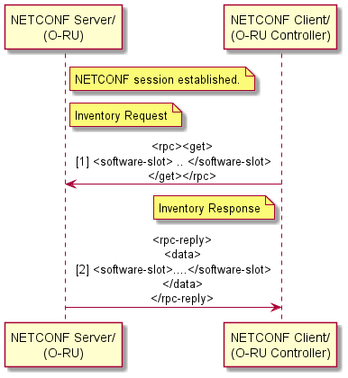
Figure 8.4-1: Inventory fetch call flow
Figure 8.4-1 illustrates the operation where Software Inventory is fetched by a NETCONF Client using the NETCONF get RPC filtered over the software-slot container. The response contains information about each software slot and its contents.
The following information is provided by software-inventory reply message:
- name - name of the software slot (the name is defined by the O-RU vendor)
- status - status of the software slot. Status of the software in the slot can be
- VALID - Slot contains a software build considered as proven valid.
- INVALID - software build in the software slot cannot be used by O-RU. The software is considered by the O-RU as damaged (e.g. wrong CRC). Failed software install operation can cause a slot status to change to "Invalid".
- NETCONF client shall not activate a software slot that is invalid. Activation of a software slot containing an invalid software build shall be rejected by O-RU.
- EMPTY - software slot does not contain any software files. NETCONF client shall not activate an empty software slot. Activation of an empty software slot shall be rejected by O-RU.
- active - indicates if the software stored in particular slot is activated at the moment.
- True - software slot is activated. Active::True can be assigned only for slots with status "Valid". At any time, only one slot in the O-RU shall be marked as active::True. The O-RU shall reject activation for software slots with status "Empty" and "Invalid".
- False - software slot is not active.
- running - informs if software stored in particular slot is used at the moment.
- True - software slot contains the software build used by the O-RU in its current run.
- False - software slot does not contain the software build used by O-RU at the moment.
- access – informs about access rights for the current slot.
- READ_ONLY – The slot is intended only for factory software. Activation of such software slot means performing a factory reset operation and a return to factory defaults settings.
- READ_WRITE – slot used for updating software.
- product-code - product code provided by the vendor, specific to the product.
- vendor-code - unique code of the vendor.
- build-id - Identity associated with the software build. This id is used to find the appropriate build-version for the product consist of the vendor-code and the product-code.
- build-name - Name of the software build.
- build-version - Version of the software build for the product consist of the vendor-code and the product-code.
- files - list of files in the software slot
- name - name of one particular file
- version - version of the file
- local-path - complete path of the file on local file system
- integrity - result of the file integrity check
- OK - file integrity is correct
- NOK - file is corrupted
If a slot contains a file with integrity::NOK, the O-RU shall mark the slot with status::INVALID. The content of a software-slot is fully under O-RU's management - including removal of the content occupying the slot (in case the slot is subject of software update procedure), control of file system consistency and so on. The slot content shall not be removed until there is a need for new software to be installed.
The empty slot parameters shall be as follows:
name: up to vendor, not empty
status: "EMPTY"
active: False
running: False
access: READ_WRITE
product-code: up to vendor
vendor code: up to vendor
build-name: null (empty string)
build-version: null (empty string)
files: empty list

8.5 Download
Pre-condition:
- M-Plane NETCONF session established.
- O-RU Controller has subscribed to receive download-event notifications.
- O-RU controller has validated presence of data node build-content-download at O-RU.
Post-condition:
- O-RU has downloaded the file specified and has successfully stored the downloaded file in the O-RU's file system.
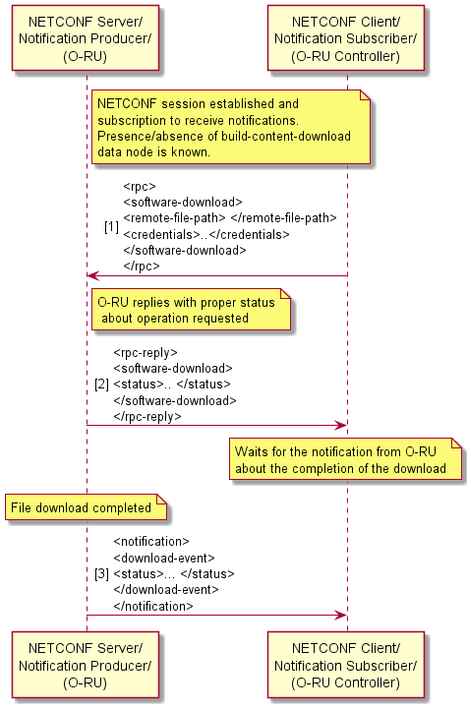
Figure 8.5-1: Software download call flow
Figure 8.5-1 illustrates the software download call flow. The following types of authentications shall be supported for software-download:
- password for RU authentication and list of public keys (see clause 5.4 in the present document) for sFTP server authentication.
Following types of authentications may be supported for software-download:
- X.509 certificate for authentication of FTPES client (O-RU) and FTPES server.
- certificate for both O-RU and sFTP server authentication.
The software-download RPC is used to trigger the downloading of software files to the O-RU. The download shall be performed using either sFTP or FTPES. Based on presence of data node build-content-download, O-RU controller shall provide either path to a file in a build or path to a software package file as input to software-download RPC. The RPC shall specify the URI of the remote location of the software files using the remote-file-path leaf, where the URI scheme is used to signal whether to use sFTP or FTPES. An O-RU Controller shall only trigger software-download using FTPES if it is using NETCONF/TLS to configure the O-RU.
The O-RU shall send an immediate rpc-reply message with one of following statuses:
- STARTED – software download operation has been started.
- FAILED – software download operation could not be proceeded, reason for failure in error-message.
The O-RU shall download the file from file server. When the O-RU completes the software download or software download fails, the O-RU shall send the download-event notification with one of the following statuses:
- COMPLETED.
- AUTHENTICATION_ERROR - source available, wrong credentials.
- PROTOCOL_ERROR – sFTP or FTPES protocol error.
- FILE_NOT_FOUND - source not available.
- APPLICATION_ERROR - operation failed due to internal reason.
- TIMEOUT - source available, credentials OK, Operation timed out (e.g. source becomes unavailable during ongoing operation).
- INTEGRITY_ERROR – file is corrupted.
An O-RU that supports integrity check at download shall expose YANG feature cINTEGRITY-CHECK-AT-SW-DOWNLOAD". O-DU can enable the feature by configuring type empty parameter integrity-check-at-download-enabled. O-RU may send download-event with status INTEGRITY_ERROR when integrity-check-at-download-enabled is presented.
NOTE: O-RU can obtain information of expected checksum either from manifest.xml or from information embedded in the file.
O-RU controller shall repeat the above procedure until all files which are required by the O-RU have been downloaded to the O-RU. To determine all files needed by O-RU, the O-RU Controller uses content of manifest.xml and relies on presence of data node build-content-download.

8.6 Install
Pre-condition:
- M-Plane NETCONF session established.
- At least one software slot with status active::False and running::False exists in O-RU.
- Software Download has been completed successfully and all files required by the O-RU are available in O-RU.
- O-RU Controller has subscribed to receive install-event notifications.
Post-condition:
- O-RU software file(s) is/are installed in the specified target software-slot.
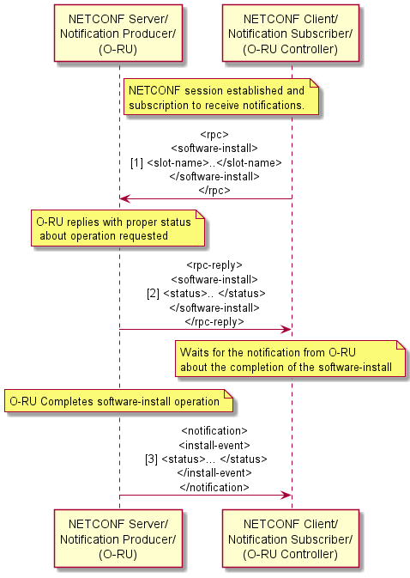
Figure 8.6-1: Software install call flow
Figure 8.6-1 illustrates the operation where the NETCONF software-install RPC is used to install the previously downloaded software (i.e. all necessary) to the specified target software-slot on O-RU.
The list of file-names in install-input shall not be empty. This slot shall have status active::False and running::False.
The O-RU shall send an immediate rpc-reply message with one of following statuses:
- STARTED - software install operation has been started.
- FAILED - software install operation could not be proceeded, reason for failure in error-message.
When O-RU completes the software install or software install procedure fails, the O-RU shall send the install-event notification with one of the following statuses:
- COMPLETED - Install procedure is successfully completed.
- FILE_ERROR - operation on the file resulted in in error, disk failure, not enough disk space, incompatible file format
- INTEGRITY_ERROR - file is corrupted.
- APPLICATION_ERROR - operation failed due to internal reason.
- TIMEOUT - install operation timed out.
When the software install commences, the O-RU shall set the slot status to INVALID. After the install procedure finishes, the O-RU shall change the slot status to its appropriate status. O-RU shall not change the status of the slot when the install procedure is ongoing or when it is interrupted (e.g. by spurious reset operation).

8.7 Bringing software into operation

8.7.1 Procedure
Two steps are required to bring O-RU software into operation. The first step uses RPC software-activate to activate software in a slot. The second step, which may be delayed as per operator's decision until a suitable time, uses a reset RPC to take the activated software into operation. The information about which slot is active shall be reset persistent.
NOTE: In certain circumstances, for example when performing a vendor defined O-RU recovery mechanism, the O-RU can start up using other software than the software in active slot before reset (e.g. factory default software).

8.7.2 Software activation
Pre-condition:
- M-Plane NETCONF session established.
- Software slot to be activated has status VALID.
- O-RU Controller has subscribed to receive activation-event notifications.
Post-condition:
- For activated slot the parameter active is set to TRUE. At the same time the parameter active for previously operational slot is set to FALSE by the O-RU. Parameter running is not changed for any of O-RU's software slots. This indicates that O-RU is still running software from previously active slot.
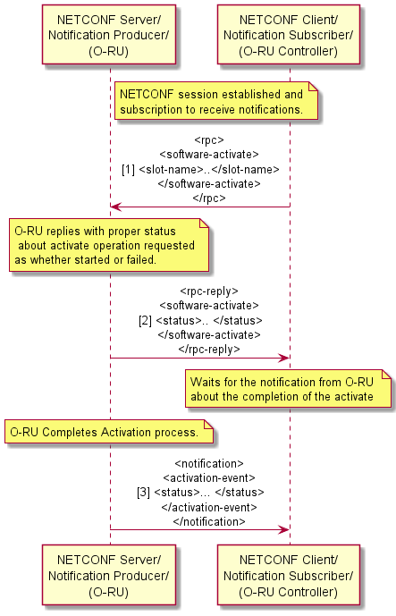
Figure 8.7.2-1: Software activation call flow.
Figure 8.7.2-1 illustrates the operations where the NETCONF software-activate RPC is used to activate the software. The name of the software-slot is specified in the activate request.
The O-RU shall send an immediate rpc-reply message with one of following statuses:
- STARTED - software activation operation has been started.
- FAILED - software activation operation could not be proceeded, reason for failure in error-message.
When the activation is completed, the O-RU shall send the activation-event notification with the status of activation. The following status is returned in the activation-event notifications.
- COMPLETED - Activation procedure is successfully completed. O-RU can be restarted via NETCONF reset rpc for the new software to be activated.
- APPLICATION_ERROR - operation failed due to internal reason.
Only one software slot can be active at any time. Thus, successful software-activate command sets active to true for the slot that was provided in the RPC and O-RU sets active to false for the previously active slot.

8.7.3 Reset
A O-RU reset is required to take the activated software into operation. See clause 9.5 for details of how an O-RU controller can trigger reset operation.

8.8 Software update scenario
An example scenario of a successful software update procedure can be as follows.
The present document does not distinguish between a software upgrade and a downgrade.
- NETCONF client performs a software inventory operation and identifies that an inactive and not-running slot for installing software is available so that it can download and install a software package.
- NETCONF client validates whether the O-RU has data node build-content-download.
- In case the O-RU does not expose build-content-download, NETCONF client, knowing target SW version, O-RU product type and manifest.xml content, determines the software package zip file(s) to be downloaded.
- In case the O-RU exposes data node build-content-download, NETCONF client, knowing target SW version, O-RU product type and manifest.xml content, determines the desired build name, build version and software files in the build to be downloaded.
- NETCONF client using the software-download RPC triggers the O-RU to download a file (if several files are required, steps 5-7 need to be performed repeatedly until all files needed by O-RU have been downloaded).
- O-RU sends RPC response that download was started.
- O-RU finishes downloading the file(s) and reports this by sending the download-event notification.
- NETCONF client requests installation of the software using software-install RPC, and provides the slot name where the software needs to be installed along with a list of filenames to be installed.
NOTE: list of files to be installed cannot be empty.
- O-RU sends RPC response that installation was started
- O-RU sets installation slot status to INVALID.
- O-RU installs the software and after successful installation (with checksum control) changes status of the slot to VALID.
- O-RU notifies the notification subscriber that the installation is finished using install-event notification.
- NETCONF client requests the O-RU to activate the slot that contains the newly installed software using the software-activate rpc.
- O-RU sends RPC response that activation was started.
- For requested slot, O-RU changes active to true and at the same time sets active to false for previously active slot.
- O-RU notifies the notification subscriber about activation finished using the activation-event notification.
- NETCONF client restarts the O-RU forcing it to use the newly installed and activated software. Refer to clause 9.5 O-RU reset for detailed information.

8.9 Factory reset
An O-RU that support a read only slot can perform this procedure. O-RU can be reset to the factory default software by activating the software-slot containing the factory default software and initiating NETCONF reset RPC. O-RU may clear persistent memory data during factory reset as vendor implementation option. Factory default software may have limited functionality and O-RU that runs on factory default SW will typically require a software update before it can be fully functional (for example carry traffic). Factory default software shall support all functionality needed to perform a software update.

9 Configuration management

9.1 Baseline configuration

9.1.1 NETCONF operations
The O-RU shall use the ietf-yang-library mode, as specified in RFC 8525 [59] to signal the namespaces of the YANG models supported by the NETCONF Server. When the O-RU signals it supports the YANG module for NETCONF Monitoring, as specified in RFC 6022 [67], an O-RU Controller shall be able to retrieve the models from the O-RU using the <get-schema> operation.
Clause 9 describes NETCONF standard operation (edit-config/get-config/get) as specified in clause 7 of RFC 6241 [3] which belongs to the CM in Module to modify/retrieve any parameters in YANG modules. Examples below use o-ran-hardware as an example YANG module.
The following scenarios are feasible for Configuration Management purposes:
- 1 phase (modify) operation using writable running datastore.
- 2 phase (modify/commit) operation using candidate datastore.
- 3 phase (modify/commit/confirm) operation using candidate datastore.
As described in clause 6.6, the NETCONF client can use sub-tree based <filter> and XPath based <filter> to recover particular sub-trees from the O-RU. When using XPath filtering, the O-RU returns a node-set which matches the criteria expressed in the XPath. An example of a get operation with XPath based filtering is shown in Figure 9.1.1-1.
<rpc message-id="101" xmlns="urn:ietf:params:xml:ns:netconf:base:1.0">
<get>
<source>
<running/>
</source>
<!-- get all critical alarms -->
<filter xmlns:o-ran-fm="urn:o-ran:fm:1.0"
type="xpath"
select="/o-ran-fm:active-alarm-list/o-ran-fm:active-alarms[o-ran-fm:fault-severity='CRITICAL']"/>
</get>
</rpc>
Figure 9.1.1-1: Example of filtering based on XPath

9.1.2 Retrieve state
O-RU Controller is able to retrieve state which is defined in o-ran-hardware by using NETCONF <get> procedure, as illustrated in Figure 9.1.2-1.
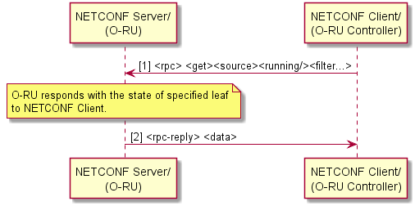
Figure 9.1.2-1: Retrieve Resource State
Preconditions:
- O-RU Controller has completed exchange of NETCONF capabilities as part of connection establishment between O-RU and O-RU Controllers.
Post conditions:
- O-RU controller has retrieved O-RU state as per <get> request.

9.1.3 Modify state
For O-RUs that support the optional hardware-state feature defined in ietf-hardware, the O-RU Controller is able to change state which can be configurable by using NETCONF <edit-config> procedure without reset, as illustrated in Figure 9.1.3-1.
The configurable state is admin-state defined in o-ran-hardware YANG model. In case of a failure, an error shall be returned. Refer to RFC 6241 [3] Appendix A for error codes. The vendor can define the behaviour after the error occurred.
The power-state is read-only state defined in o-ran-hardware.yang. This state is only exposed by the O-RUs supporting ENERGYSAVING feature and is used by O-RU to inform if unit is in energy saving state, not in energy saving state or in transition between energy saving state and non-energy saving state.
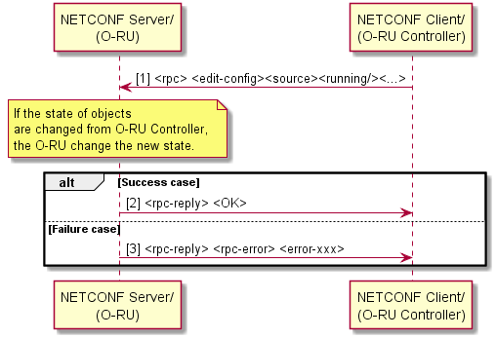
Figure 9.1.3-1: Modify Resource State without reset
The followings are the information of state transition for each state.
[admin-state]
The admin-state transition diagram for the O-RU is illustrated in Figure 9.1.3-2.
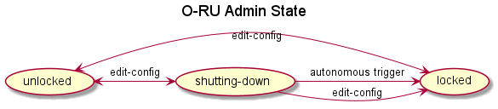
Figure 9.1.3-2: Admin State
- locked: This state indicates that any resource activation is prohibited for the O-RU and all resources have been deactivated administratively. The O-RU shall ensure all RF emissions have been shut down. When O-RU's admin state is locked, all its tx-array-carriers and rx-array-carriers parameter active are set by NETCONF server autonomously to "INACTIVE" and state are "DISABLED". When O-RU's administrative-state is LOCKED, O-RU shall reject NETCONF client’s request to set tx-array-carrier and rx-array-carrier parameter active to "ACTIVE". Antenna lines and ALD ports on the O-RU are powered off. O-RU shall reject NETCONF configuration to power on the ALD port and antenna lines.
- shutting-down: That usage is administratively limited to current instances of use. It is optional. For admin state transition using autonomous trigger from shutting-down to state locked, refer to X.731 [77] Figures 5 and 6.
- unlocked: This state indicates that any resource activation is allowed and any resources can be active. The state "unlocked" is the initial state after the reset of the O-RU.

[power-state]
The power-state transition diagram for O-RU is presented in Figure 9.1.3-3. This state can be indirectly controlled by editing the parameters energy-saving-enabled and [tr]x-array-carrier::active, as illustrated in Figure 9.1.3-3.
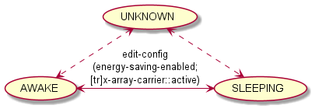
Figure 9.1.3-3: Transition diagram for power-state node
Figure 9.1.3-4: Void
- AWAKE: This value of power-state node indicates that the O-RU is operating normally, i.e. not in energy saving mode. AWAKE is the initial value of power-state node after the reset of the O-RU. AWAKE is power-state of O-RU in case energy-saving-enabled is FALSE or when at least one carrier is active.
- SLEEPING: This value of power-state node indicates that the O-RU is in energy saving mode. M-plane connection and functions are alive whereas other C/U/S functions may be autonomously stopped by the O-RU if there is no active carrier and value of energy-saving-enabled is TRUE - to reduce energy consumption.
- UNKNOWN: This value of power-state node can be exposed by the O-RU e.g. in case the O-RU does not know its power-state value is AWAKE or SLEEPING. This value of power-state node is optional.
When the value of any of the following states changes, an O-RU supporting feature hardware-state shall send the hardware-state-change notification to the notification subscriber:
- admin-state, oper-state, usage-state (as specified in ietf-hardware.yang)
- power-state, availability-state (as specified in o-ran-hardware.yang)
In case of 'oper-state' change, if the O-RU supports the feature hardware-state, the O-RU shall send two notifications to the notification subscriber(s): the hardware-state-change notification and the hardware-state-oper-disabled/enabled notification.
On receiving the notification, the notification subscriber should read the state by using get RPC operation.
[oper-state]
O-RU’s oper-state is not configurable. It reflects whether the O-RU can provide service or not.
The oper-state transition diagram for O-RU is presented in Figure 9.1.3-5.
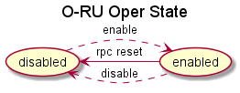
Figure 9.1.3-5: Oper State
enabled: O-RU is partially or fully operational.
disabled: O-RU is not operational. This is the initial state of oper-state after the reset of the O-RU
- O-RU Controller is able to reset the O-RU, even if the O-RU state is "disabled" or "enabled".
[availability-state]
The availability-state transition diagram for the O-RU is presented in Figure 9.1.3-6.
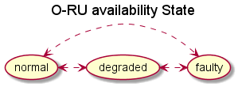
Figure 9.1.3-6: Availability State
The availability state is derived from detected and active faults and their impact to O-RU's operation. The availability state is not affected by faults caused by external reasons. The availability state may be affected by internal faults that do not result in an alarm.
- normal: There is no fault.
- degraded: When major or critical fault affecting module or any of O-RU's subcomponents (e.g. transmitter) is active.
- faulty: The critical fault affecting whole O-RU is active and O-RU cannot continue any services.
NOTE: The value of availability-state is not affected by the value of admin-state.
[usage-state]
The usage-state transition diagram for the O-RU is presented in Figure 9.1.3-7.
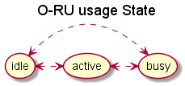
Figure 9.1.3-7: usage State
- idle: There is no array carrier configured in O-RU.
- active: There is(are) array carrier(s) configured in O-RU and it has spare capacity to configure new array carrier.
- busy: There is(are) array carrier(s) configured in O-RU and it does not have spare capacity to configure new array carrier.
NOTE: The value of usage-state is determined by the O-RU capacity occupied by all configured array carriers, regardless of their current activation status (as indicated by the active leaf) or operational state (as indicated by the state leaf). A configured array carrier is an array carrier ready for activation: its endpoint and processing element are already associated via the low-level-[tr]x-link, so that array carrier activation only requires setting its active leaf to ACTIVE.

9.1.4 Retrieve parameters
O-RU Controller is able to retrieve parameters of the YANG module by using NETCONF <get> or <get-config> procedure, as illustrated in Figure 9.1.4-1.
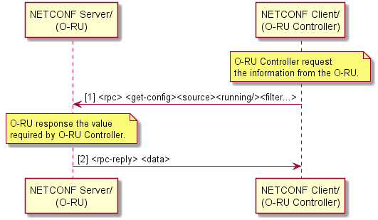
Figure 9.1.4-1: Retrieve Parameters
Preconditions:
- O-RU Controller has completed exchange of NETCONF capabilities as part of connection establishment between O-RU and O-RU Controller(s).
Post conditions:
- O-RU controller has retrieved O-RU parameters as per <get><source><running/><filter> or <get-config><source><running/><filter> request.

9.1.5 Modify parameters
Before an O-RU Controller modifies the configuration (candidate or running) of an O-RU, it shall first lock the target configuration. This prevents other NETCONF clients from changing the shared configuration database until the O-RU Controller releases the lock. If another NETCONF client has already locked the configuration datastore, then the O-RU shall respond with a NETCONF error indicating that the requested lock is denied. In such circumstances, the O-RU controller should wait for a period of time before re-attempting to modify the O-RU's configuration.
O-RU Controller is able to modify parameters of the YANG module by using the NETCONF <edit-config> procedure, as illustrated in Figure 9.1.5-1.
When supported by an O-RU, the O-RU Controller shall perform any required modify operations ONLY on the candidate configuration datastore before committing the validated configuration to the running configuration datastore. When an O-RU does not support the candidate configuration datastore, the O-RU Controller should take extreme care whenever modifying the running configuration datastore as such will likely impact system operation.
NOTE: Validation of the modified configuration is based on:
- basic YANG constraints (e.g. min-elements, range, pattern),
- XPATH based YANG constraints (e.g. "leafref", "must" and "when" statements), and
- external code which implements YANG constraints (e.g. defined in O-RAN specifications, YANG description statements, etc.).
In case of failures, an error shall be returned. Refer to RFC 6241 [3] Appendix A for error codes.
The vendor can define the behaviour after error occurred.
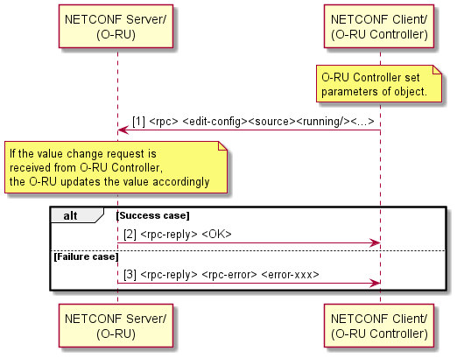
Figure 9.1.5-1: Modify Parameters
Preconditions:
- O-RU Controller has completed exchange of NETCONF capabilities as part of connection establishment between the O-RU and O-RU Controller(s).
- O-RU Controller has locked the target configuration.
Post conditions:
- O-RU controller has retrieved O-RU resource state as per <edit-config> request:
- Success case: The update is confirmed to O-RU Controller.
- Failure case: Failure reason is provided to O-RU Controller
Sequential processing is assumed. Only a single <edit-config> rpc is allowed at a time. Next <edit-config> rpc shall be performed after previous <edit-config> rpc reply.
O-RU shall be allowed to reject <edit-config> in case the content is found to be against e.g. functions supported by O-RU - like carrier configured out of band.
After the modification procedure is complete, the O-RU Controller releases the lock on the target configuration.

9.1.6 Deleting parameters
Before an O-RU Controller deletes any configuration (candidate or running) of an O-RU, it shall first lock the target configuration. This prevents other NETCONF clients from changing the shared configuration database until the O-RU Controller releases the lock. If another NETCONF client has already locked the configuration datastore, then the O-RU shall respond with a NETCONF error indicating that the requested lock is denied. In such circumstances, the O-RU controller should wait for a period of time before re-attempting to delete the O-RU's configuration.
O-RU Controller is able to delete parameters of the YANG module by using the NETCONF <edit-config> procedure with the "operation" attribute set to delete, as illustrated in Figure 9.1.6-1.
If the configuration data does not exist, an <rpc-error> element is returned with an <error-tag> value of "data-missing".
When supported by an O-RU, the O-RU Controller shall perform any required delete operations ONLY on the candidate configuration datastore before committing the validated configuration to the running configuration datastore. When an O-RU does not support the candidate configuration datastore, the O-RU Controller should take extreme care whenever modifying the running configuration datastore as such will likely impact system operation.
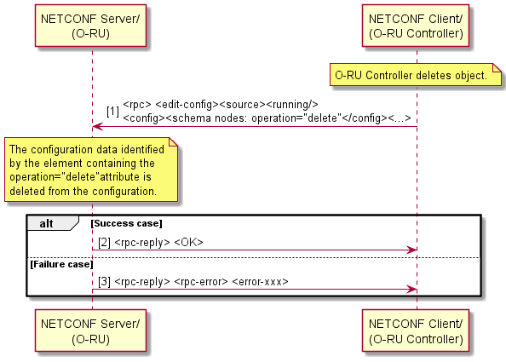
Figure 9.1.6-1: Delete Parameters
Preconditions:
- O-RU Controller has completed exchange of NETCONF capabilities as part of connection establishment between the O-RU and O-RU Controller(s).
- O-RU Controller has locked the target configuration.
Post conditions:
- O-RU controller has updated the O-RU resource state as per <edit-config> request:
- Success case: The delete is confirmed to O-RU Controller.
- Failure case: Failure reason is provided to O-RU Controller
Sequential processing is assumed. Only a single <edit-config> rpc is allowed at a time. Next <edit-config> rpc shall be performed after previous <edit-config> rpc reply.
Delete Parameters is used to:
- delete parameters of existing configuration.
After the delete procedure is complete, the O-RU Controller releases the lock on the target configuration.
When the O-RU is operating, the O-RU shall not autonomously delete configuration(s) that are created by NETCONF client(s). When the O-RU is restarted, it may lose configuration(s) that are not stored in the reset persistent memory.

9.1.7 Notification framework

9.1.7.1 General
YANG notifications are used to signal event information to notification subscribers. The present document support two types of subscriptions for receiving YANG notifications:
- dynamic, which is supported by all O-RUs, and
- configured, which is supported by O-RUs that support the NON-PERSISTENT-MPLANE feature.

9.1.7.2 Event streams
All O-RUs shall support the default "NETCONF" event stream, as specified in clause 3.2.3 of RFC 5277 [21]. In addition to the default event stream, O-RUs should support the following event streams:
- "fault-management" used to subscribe to YANG notification events defined in o-ran-fm YANG model.
- "measurement-result-stats" used to subscribe to YANG notification events defined in o-ran-performance-management YANG model.
- "supervision-notification" used to subscribe to YANG notification events defined in o-ran-supervision YANG model.

9.1.7.3 Event stream discovery and subscription
An O-RU controller discovers the O-RU's ability to process and send event notifications via capability exchange, as defined in clause 3.1 of RFC 5277 [21].
The O-RU shall support event stream discovery as defined in clause 3.2.5 of RFC 5277 [21]. Prior to initiating a dynamic subscription to an event stream, an O-RU controller can discover the O-RU's supported event streams. Refer to clause 3.2.5 of RFC 5277 [21] for detail.
All O-RUs shall support event stream subscription using the <create-subscription> RPC specified in clause 2 of RFC 5277 [21]. An O-RU may support event stream subscription using <establish-subscription> RPC specified in clause 2.4 of RFC8639 [37]. An O-RU indicates it supports <establish-subscription> by including the ietf-subscribed-notifications YANG model in its YANG library. An O-RU supporting event stream subscription using <establish-subscription> RPC shall be able to support concurrent operation of <establish-subscription> and <create-subscription> RPCs on separate NETCONF sessions.
If the O-RU supports the NON-PERSISTENT-MPLANE feature, the O-RU shall maintain the streams container as defined in clause 3.1 of RFC 8639 [37]. An O-RU controller supporting RFC 8639 [37] operating with an O-RU that supports the NON-PERSISTENT-MPLANE feature may use the streams container to recover the list of available streams supported by the O-RU.
The O-RU supported event streams can be subscribed using dynamic subscriptions and, for those O-RUs that support the NON-PERSISTENT-MPLANE feature, using configured subscriptions. These are transported using NETCONF and VES respectively.
- When no <stream> parameter is provided at creation of subscription, the default "NETCONF" stream is subscribed.
- The "NETCONF" default event stream can be subscribed to by all O-RU controllers. Events defined in the YANG modules to which the O-RU controller does not have "execute" access privileges, i.e. modules without an "X" in Table 6.5-1, shall be excluded before the events which are sent to the subscriber.
- For non-default streams, the NACM "execute" privileges defined in clause 6.5 shall be used by the O-RU to determine whether an O-RU controller has privileges to establish a subscription to a particular non-default event-stream.
An O-RU Controller that has used the <establish-subscription> RPC to subscribe to an event stream may cancel the subscription by using the <delete-subscription> RPC. An O-RU receiving a <delete-subscription> RPC for an existing subscription-id shall cease sending notification messages for this subscription.

9.1.8 Transactions and configuration data validity
An O-RU shall ensure that its configuration datastore has always been updated with any modified configuration before sending the <rpc-reply><ok/></rpc-reply> in response to a transaction that is intended to update the O-RU’s system configuration. Except when using the o-ran-uplane-conf YANG model to configure the carrier configuration as described in clause 15.3, the O-RU’s system implementation of the modification to its running configuration should occur before sending the <rpc-reply> message.
In the case of o-ran-uplane-conf YANG model based carrier configuration, because implementation of the carrier activation/deactivation/energy savings can require operation of some closed loop control system, the YANG model defines the following notifications that allow a subscribing O-RU controller to be signalled when a configuration change has been implemented:
- tx-array-carriers-state-change: used to be able to notify subscribers that the changes to a tx-array-carrier have been implemented.
- rx-array-carriers-state-change: used to be able to notify subscribers that the changes to an rx-array-carrier have been implemented.
- data-layer-control-wakeup-notification: used to be able to notify subscribers that the changes to energy-savings group have been implemented.
- mplane-trx-control-ant-mask-update: used to be able to notify subscribers that the changes to the antenna mask have been implemented.
- max-power-level-used: used to indicate max output power level that is used for a tx-array.
- predefined-beam-null-complete: used to notify subscribers that beamforming weights update due to null configuration is completed.
In the above cases, the O-RU may send the <rpc-reply><ok/></rpc-reply> before the updated configuration has been implemented. This avoids extended periods of time when the configuration would otherwise be locked while configuration changes are implemented.

9.1.9 YANG model support for target value configuration and used-value retrieval
An O-RU may support target value configuration which means that the O-DU configures a target value for a configuration and the O-RU returns its used-value which is an approximation of the target value that is suitable for the O-RU. Parameters can have individual restrictions regarding how this approximation or selection shall be done (see relevant clauses describing the parameters in CUS-plane specification).
The following steps show the general procedure to perform such target value configuration method, as illustrated in Figure 9.1.9-1.
- The O-DU configures the O-RU using <rpc><edit-config> consisting of one or more parameter(s) (e.g. eq-scale-offset-config, sinr-reference-level-config, etc.) with target value(s).
- The O-RU sets the used-value(s) in corresponding read-only parameter(s) (e.g. eq-scale-offset-used, sinr-reference-level-used) for the configured target value(s).
- The O-RU replies <rpc-reply>.
- The O-DU receives the O-RU’s rpc reply, which indicates the configuration process in steps 1 and 2 is finished. The used-value(s) of the read-only parameter(s) (e.g. eq-scale-offset-used, sinr-reference-level-used) are available.
- The O-DU retrieves the used-value(s) from the O-RU using <rpc><get> when the O-DU wants, e.g. before carrier activation.
- The O-DU receives the used-value(s) of the read-only parameter(s), so the O-DU is aware of precise value(s) selected and used by the O-RU.
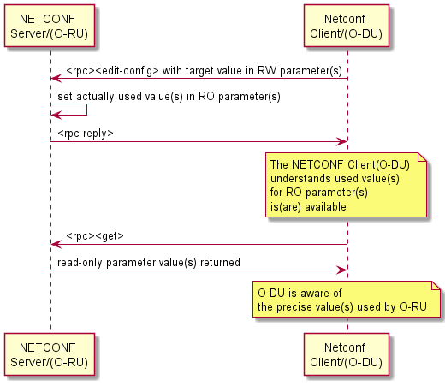
Figure 9.1.9-1: Procedure of target value configuration and used-value retrieval

9.2 Framework for optional feature handling
This clause describes the common and optional features about Configuration Management.
An O-RU may have some features which are not supported by other O-RUs, i.e. optional feature(s). In this case, the O-RU needs to inform the O-RU controller which features the O-RU can provide, and this can be achieved by exchanging NETCONF capabilities.
Some of the YANG models are optional for the O-RU to support. For example, in this version of the management plane specification, those models associated with External IO and Antenna Line Devices are not essential for the operation of the O-RAN fronthaul interface. Other mandatory models define optional feature capabilities.
Both the NETCONF Server and NETCONF Client shall use the ietf-yang-library mode, as specified in RFC 8525 [59] to signal the namespaces of the models supported by the NETCONF Server. If an O-RU/NETCONF Server does not return the namespace associated with an optional YANG model, the NETCONF Client determines that the O-RU/NETCONF Server does not support the optional capability associated with the model.
In addition, for each supported schema, the ietf-yang-library lists the YANG feature names from this module that are supported by the server. The details of optional models and features are defined in Annex C..

9.3 M-Plane operational state
The o-ran-mplane-int YANG model allows the O-RU to report the connectivity to NETCONF clients on a per sub-interface level. The client information shall include the IP address(es) for the client(s) as well as the link-layer address used to forward packets towards the various management plane clients.

9.4 Notification of updates to configuration datastore

9.4.1 Introduction
This clause defines an optional O-RU capability which allows O-RU Controllers to configure the O-RU to provide notifications of modifications to its YANG datastore. This capability can be used when the O-RU is operating in a hybrid environment with multiple simultaneous NETCONF sessions established to different O-RU controllers. Using this capability, one particular O-RU controller uses the NETCONF notifications functionality as specified in RFC 6470 [35] to enable it to be automatically signalled changes to the O-RU's configuration made by a second O-RU controller. Additionally, if the O-RU supports a vendor specific interface to allow manual configuration, this functionality can also be used to signal such configuration modifications to an O-RU Controller.

9.4.2 Subscribing to updates from an O-RU
When an O-DU receives an indication from an O-RU that it supports the optional capability to support notification of updates to its configuration data store, as a minimum, it may subscribe to the netconf-config-change notification.
An example event notification is shown in Figure 9.4.2-1, where a notification indicates that the configuration of the O-RU's timezone offset has been modified by a second O-RU controller.
<notification xmlns="urn:ietf:params:xml:ns:netconf:notification:1.0">
<eventTime>2020-03-01T08:00:14.12Z</eventTime>
<netconf-config-change xmlns= "urn:ietf:params:xml:ns:yang:ietf-netconf-notifications">
<id>102</id>
<changed-by>
<username>nms-user</username>
<session-id>1099</session-id>
<source-host>10.10.10.10</source-host>
</changed-by>
<datastore>running</datastore>
<edit>
<target>/oran-ops:operational-info/oran-ops:clock/oran-ops:timezoneutc-offset</target>
<operation>replace</operation>
</edit>
</netconf-config-change>
</notification>

Figure 9.4.2-1: Example of a netconf-config-change notification

9.5 Resetting O-RU

9.5.1 O-RU reset procedure
An O-RU reset may be triggered by an O-RU controller or autonomously triggered by an O-RU, e.g. as a result of supervision failure specified in clause 14.1.1.

9.5.2 O-RU controller triggered O-RU reset operation
The reset procedure can be used by an O-RU controller to trigger the reset of the O-RU. The reset of an O-RU shall trigger the O-RU to perform a re-start and follow the procedures defined in clause 6.

9.5.3 O-RU controller triggered O-RU reset procedure
O-RU Controller is able to trigger the reset of an O-RU by using the reset rpc, as illustrated in Figure 9.5.3-1.
Pre-condition:
- M-Plane connection is established and running between O-RU and O-RU controller.
Post-condition:
- O-RU performs reset followed by start-up sequence described in clause 6.

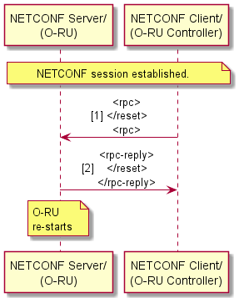
Figure 9.5.3-1: O-RU Reset Procedure

10 Performance management

10.1 General
This clause provides the description of scenarios related to performance management. It consists of 2 functions. One is for the measurement activation and the other is the collection of measurement results.
Performance management key concepts:
Measurement group: A group of measurement objects that belong to the same category, e.g. tx-stats. Each measurement-group is associated with a measurement-group identifier that is used in file management processing (See clause 10.3.2)
Measurement object: Object on which performance is measured, e.g. RX_POWER, TX_POWER. Only when combined with a report-info, it defines a metric.
Object unit: Granularity to measure the performance per measurement object, e.g. PORT_NUMBER, EAXC_ID.
Report info: Type of the measurement, e.g. MAXIMUM, MINIMUM. Only when combined with a measurement-object, it defines a metric.

10.2 Measurement configuration, activation and de-activation
The measurement activation at the start-up installation is described in clause 6.
This clause provides information about how to configure, activate and de-activate the performance measurement in an O-RU. The performance measurement schema nodes are defined in o-ran-performance-management YANG module. In case of multiple NETCONF clients, only one NETCONF client shall activate/deactivate the measurements in the O-RU. The O-RU shall support those measurements described as mandatory in clause 9.1 of the O-RAN CUS plane specification [2].
NOTE 1: The naming convention of schema nodes that report capability for each measurement-group (in container measurement-capabilities) uses an abbreviated form of the measurement-group name (enough to uniquely identify the measurement-group), ending with "-objects". e.g. transceiver-objects, rx-window-objects.
NOTE 2: The naming convention of schema nodes that are used to configure each measurement-group uses an abbreviated form of the measurement-group name (enough to uniquely identify the measurement-group), ending with "-measurement-objects". e.g. transceiver-measurement-objects, rx-window-measurement-objects.
NOTE 3: The naming convention for schema node (list) to define notification content of each measurement-group (as part of notification measurement-result-stats) uses measurement-group name, for example, ethernet-stats, tx-output-power-stats, etc.
The detail of the measurement-group(s), including measurement-object(s), object-unit(s) and report-info(s) supported by M-Plane are defined in clause Annex B.
For each measurement-group, at least one of the capabilities may be reported: supported measurement-object(s), supported report-info(s) per measurement-object and supported object-unit(s) per measurement-object.
For each active measurement, the NETCONF client shall configure measurement-interval per measurement-group using respective measurement-interval parameter. It defines performance measurement periodicity, e.g. 300, 600, 900 seconds. measurement-objects belong to a measurement-group inherit the measurement-group measurement-interval.
NETCONF client can configure a measurement-group with measurement-objects belonging to it. For each measurement-object, object-unit and report-info(s) are configured. For selected report-info, the NETCONF Client may configure additional parameters, e.g. function, bin-count, upper-bound, lower-bound.
Measurement shall be activated using parameter active per measurement-object when report-info(s) and measurement-interval for the measurement-object is/are configured. A measurement-object can be activated and deactivated at any time.
When different measurement-group(s) have intervals with a common factor, the O-RU shall synchronise the boundary of these intervals with this factor, irrespective of when the different measurement-objects are activated, as illustrated in Figure 10.2-1. All of start points of the measurement-intervals of measurement-groups shall be synchronised to zero o'clock mid-night by using an equation {full seconds (hour, minute and second) modulo 'measurement-interval' = 0}, in order to ensure the same start and end of the measurement-intervals between O-RUs. For more details see Figure 10.2-1.
- The start-time and end-time indicate the time of measurement start and end for the measurement-object at each measurement-interval.
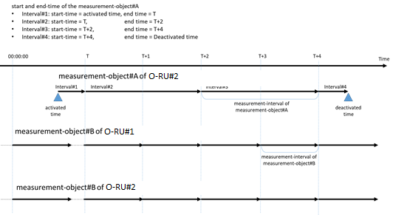

Figure 10.2-1: synchronisation of measurement-interval.
If the O-RU does not support the optional feature IMMEDIATE-PM-CONFIGURATION, the modification of the configurable parameters (except active) for the measurement-object shall be allowed only while active for the corresponding measurement-object has value FALSE. Removal of measurement-object(s) from a measurement-group configurations (by configuring schema nodes, e.g. transceiver-measurement-objects, rx-window-measurement-objects, etc.) shall be allowed only when active for those intended to be removed measurement-object(s) has value FALSE.
If the O-RU supports the optional feature IMMEDIATE-PM-CONFIGURATION, it shall support reconfiguration of measurement-groups and measurement-objects at any time including when measurement-object's active has value true. It shall support the removal of measurement-object(s) from a measurement-group configurations even when active for those has value TRUE. The reconfiguration made for such O-RU takes effect on the measurement report latest at next measurement-interval.
If the O-RU supports the feature PM-SUSPECT-REPORTING and the feature is enabled, the O-RU shall use the suspect flag and/or report-info-suspect structure to indicate an invalid measurement result in both the file output and the notification output. The O-RU should support the feature PM-SUSPECT-REPORTING when supporting the feature IMMEDIATE-PM-CONFIGURATION.
An O-RU Controller may configure multiple report-info(s) for a measurement-object. A metric is defined by a measurement-object and a report-info. The metric value is re-initialised at the beginning of each measurement-interval and suspect flag and report-info-suspect from previous measurement interval is cleared.
For the first measurement-interval, due to varying start-time (due to varying activation time), if the duration of the first interval is insufficient for the O-RU to calculate valid measurement values, the O-RU may skip sending the measurement report for the first measurement-interval.

10.3 Collection and reporting of measurement result

10.3.0 Introduction
This clause provides the description of scenarios used to collect measurement results. There are three options:
- NETCONF process: Create-subscription from NETCONF client and NETCONF notification from NETCONF server are used.
- File Management process: File upload mechanism is used to transfer the measurement file from O-RU to configured file server(s) that O-RU can reach to.
- Configured subscription process: Create configured subscription from O-RU as Event-Producer to Event-Collector.
Methods 1 and 2 are mandatory for the O-RU. Method 3 shall be supported by those O-RUs that support the optional NON-PERSISTENT-MPLANE feature. The method(s) to be used is the matter of NETCONF client.
In case of multiple NETCONF clients and/or Event-Collectors, the O-RU shall report the same notification-based measurement results to all subscribed NETCONF clients/Event-Collectors, and the O-RU shall upload file-based results to all configured fileservers.

10.3.1 NETCONF process for dynamic subscriptions
This process needs the NETCONF capability: urn:ietf:params:netconf:capability:notification:1.0.
- NETCONF client subscribes to one or more measurement group(s) and/or measurement-object(s) to collect the measurement result by sending NETCONF <create-subscription> to NETCONF server in the O-RU. In this message, startTime and stopTime for the notification may be configurable. NETCONF client can configure the notification-interval in the performance-management YANG module.
- NETCONF server sends NETCONF notification messages periodically to the client as configured by the notification-interval. The NETCONF notification message contains subscribed measurement group(s) and/or measurement-object(s). The notification-interval does not need to be same as the measurement-interval. The notification timing different from the measurement-interval is a matter to O-RU implementation.
This procedure is described in Figure 10.3.1-1.
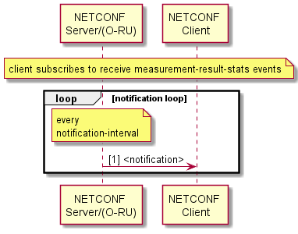
Figure 10.3.1-1: NETCONF process of Measurement Result Collection
A NETCONF client may use the create-subscription for the single event-stream "measurement-result-stats", or alternatively subscribe the default event-stream using additional filter criteria to identify those measurements of interest to the client. In order to subscribe multiple notifications, the appropriate create-subscription message is required. Refer to clause 11.3 for the appropriate example of create-subscription of multiple notifications.
In order to terminate the subscription, the NETCONF client shall send <close-session> operation from the subscription session or configuring the <stopTime> parameter when the subscription was created. If NETCONF session is terminated by <kill-session>, the subscribed notification is terminated as well.
This procedure is described in Figure 10.3.1-2.
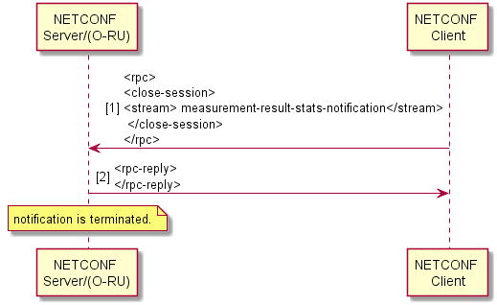
Figure 10.3.1-2: NETCONF process of Measurement Result Collection to end
When notification-interval is larger than measurement-interval, O-RUs implementing v07.00 or later of the present document may use a single notification that contains multiple stats included in the list such as multiple-transceiver-measurement-result, multiple-rx-window-measurement-result, multiple-tx-measurement-result, multiple-epe-measurement-result or multiple-symbol-rssi-measurement-result which have consecutive periods indicating start-time and end-time for the measurement.
NOTE 2: When multiple measurements stats corresponding to the same measurement-group are available in an O-RU that implements an earlier version of the present document, the O-RU is only able to include a single statistic in the notification. In such circumstances, the O-RU should report the latest available statistic in the notification.
NOTE 3: An O-RU Controller that implements an earlier version of the present document can ensure that the configuration of notification-interval and measurement-interval results in only a single measurement statistic corresponding to a specific measurement-group being reported by the O-RU in any one notification. In other cases, the O-RU Controller can use the rules defined in clause 4.3 to ignore the newly introduced schema-nodes for reporting multiple measurements.
When notification-interval is smaller than measurement-interval, one notification may not contain the stats which start-time and end-time are not applicable to the period for the notification.
For example, when notification-interval = 60min, measurement-interval for measurement-object#A= 30min and measurement-interval for measurement-object#B = 15min, one notification contains 2 measurement results for measurement-object#A with consecutive start-time and end-time, and 4 measurement results for measurement-object#B with consecutive start-time and end-time.
For the other example, when notification-interval = 15min, measurement-interval for measurement-object#A= 30min and measurement-interval for measurement-object#B = 15min, one notification contains one measurement results for measurement-object#B but not for measurement-object#A. next notification contains both measurements result for measurement-object#A and #B.
For an O-RU that supports the feature PM-SUSPECT-REPORTING and when the feature is enabled, if measurement-group(s) are configured and activated, but none of the measurement-groups have valid results during notification-interval, the O-RU shall send notification pm-reporting-failure to indicate that all the measurement results for that notification-interval are invalid.
If the measurement result for a measurement-group, or a measurement-object in a measurement-group, or an object-unit for a measurement-object in a measurement-group, or a metric from a report-info is invalid, suspect and/or report-info-suspect shall be reported as part of the notification measurement-result-stats.

When an O-RU does not support the OPTIONAL feature PM-SUSPECT-REPORTING, or if an O-RU advertises support of the feature and the O-DU chooses not to enable the OPTIONAL feature PM-SUSPECT-REPORTING,the O-RU may choose to skip reporting invalid measurement results for the respect report-info in the notification measurement-result-stats.

10.3.2 File management process
NETCONF client needs to configure a parameter of performance measurement YANG module 'enable-file-upload' to enable or disable the periodic file upload mechanism via NETCONF <edit-config>. Its default is FALSE.
In addition, the performance measurement YANG module defines file-upload-interval, remote-file-upload-path, credentials information of the file server and enable-random-file-upload as configurable parameters.
Following types of authentications shall be supported for performance file upload:
- Password for RU authentication and list of public keys (see clause 5.4 in the present document) for sFTP server authentication.
Following types of authentications may be supported for performance file upload:
- X.509 Certificate for FTPES client (O-RU) and FTPES server.
- Certificate for both O-RU and sFTP server authentication.
When the parameter enable-file-upload is set to TRUE, O-RU shall store the performance measurement files in the generic folder in O-RU, i.e. O-RAN/PM/ or o-ran/pm/. Every file-upload-interval, O-RU pushes the latest file to upload to the remote-file-upload-path of the configured SFTP/FTPES servers if enable-file-upload is set to TRUE. Otherwise, the performance measurement file is not created and uploaded. The O-RU shall use the URI scheme of the remote-file-path leaf to determine whether to use sFTP or FTPES for the file upload. The number of maximum performance files to be stored in O-RU simultaneously is a matter for O-RU implementation. The O-RU shall manage its own storage space by deleting the older files autonomously. An O-RU Controller shall only trigger file upload using FTPES if it is using NETCONF/TLS to configure the O-RU.
The O-RU shall ensure that the start-time and the end-time within the name of the performance measurement file are synchronised with the same manner as measurement-interval by using file-upload-interval.
If the parameter enable-random-file-upload is set to TRUE, the O-RU shall randomize the timing to upload SFTP or FTPES file after the performance measurement file is ready to upload. The randomized timing is an O-RU implementation matter and shall not be later than next file-upload-interval.
The file name of the performance measurement is:
C<start-time>_<end-time>_<name>.csv
- Starting with a capital letter "C".
- Format of <start-time> and <end-time> can be local time or UTC.
Local time format is YYYYMMDDHHMM+HHMM, indicating, year, month, day, hour, minute, timezone "+" or "-" , hour and minute for the time zone.
UTC format is YYYYMMDDHHMMZ, indicating, year, month, day, hour, minute and with a special UTC designator ("Z")
Time zone offset is provided by timezone-utc-offset in o-ran-operation.yang.
- <name> in ietf-hardware is used.
- "_" underscore is located between <start-time>, <end-time> and <name>.
- File extension is "csv" as csv format file.
Example of measurement file is:
- C201805181300+0900_201805181330+0900_ABC0123456.csv.
The file format of the performance measurement has following rule:
- Each line starts with an identifier. The identifier should be used to identify each measurement-group defined by its row in Table B.1.1-1, e.g. transceiver-stats should be identified by an identifier of "1", rx-window-stats should be identified by a measurement-group identifier of "2" and tx-measurement-objects should be identified by a measurement-group of "3", etc.
- After the measurement-object identifier, the name of measurement-object, start-time, end-time are appended.
- Then the object-unit and object-unit-id are appended, followed by the set of report-info are repeated in one line.
NOTE 1: If the leading identifier is not used to signal a measurement-group, the measurement-group needs to be derived from the object-unit. For example, an object-unit of "PORT_NUMBER" is used to identify the transceiver-stats measurement-group, and an object-unit of "ianahw:port" is used to identify an epe-statistics measurement group for the ianahw:port hardware class.
NOTE 2: If a measurement is referenced by multiple object-units, each object-unit and corresponding object-unit-id are appended in turn.
- When the YANG definition of the measurement-result-grouping includes one or more lists and multiple report-info parameters exist per object-unit, all of the report-info are consecutively listed until the next object-unit-id. The order of parameters, such as object-unit-id, report-info and additional information for the report-info, shall be same as the order of those listed in NETCONF notification defined in o-ran-performance-management YANG module.
- When the YANG definition of the measurement-result-grouping includes one or more containers, the container name is included in the report-info.
NOTE 3: In versions prior v13.0 of the present document, the use of the container name in the report-info was not defined and hence how such measurement reports were encoded was not specified.
When an O-RU does not support the OPTIONAL feature PM-SUSPECT-REPORTING, or if an O-RU advertises support of the feature and the O-DU chooses not to enable the OPTIONAL feature PM-SUSPECT-REPORTING,the O-RU may choose to skip reporting invalid measurement results for the respect report-info.

For an O-RU that supports the feature PM-SUSPECT-REPORTING and when the feature is enabled (pm-suspect-reporting is true), the O-RU shall indicate invalid measurement results by adding string "suspect" and/or "report-info-suspect" at the level where the invalid measurement result occurs. For measurement-group level, measurement-object level, object-unit level invalid result, "suspect" shall be added. For report-info level invalid result(s), report-info suspect structure including string "report-info-suspect", the number of invalid metric values from report-info(s) and report-info name(s) as defined in Table B.1.1-2 that have invalid metric values shall be added before those valid metric result(s). For report-info(s) with valid/normal results, their order shall be same as the order of those listed in NETCONF notification defined in o-ran-performance-management YANG module. For an O-RU that supports the feature PM-SUSPECT-REPORTING and when the feature is enabled, if measurement-group(s) is/are configured and activated, but none of the measurement-group(s) have valid results during a file-upload-interval, the O-RU shall send notification pm-reporting-failure to indicate that all the measurement results for that file-upload-interval are invalid. For that file-upload-interval, the performance measurement file is not created and uploaded
When a measurement-group's results are invalid, O-RU shall report the results with measurement-group identifier, and "suspect". Example of output is as follows:
1, suspect
When a measurement-object's results are invalid, O-RU shall report the results with measurement-object name, start time, end time, "suspect". Example of output is as follows:
1, RX_POWER, 2018-05-18T13:00:00+09:00, 2018-05-18T13:15:00+09:00,suspect
When an object-unit instance of a measurement-object's result is invalid, O-RU shall report the results with object-unit name, "suspect". Example of output is as follows:
1, RX_POWER, 2018-05-18T13:00:00+09:00, 2018-05-18T13:15:00+09:00, PORT_NUMBER, 0,suspect
When result(s) of metric(s) from report-info(s) are invalid, for report-info result part, O-RU shall begin with report-info suspect structure including string "report-info-suspect", followed by number of suspected report-info(s) and suspected report-info name string(s) as defined in Table B.1.1-2. After report-info suspect structure, valid report-info(s) and value(s) for the metric are reported.
In the following first example, metric result from report-info with name "min" is invalid, and metric results from report-info MAXIMUM and FIRST (using "max" and "first" respectively) are valid. In the following second example, metric results from report-info with name "min" and "first" are invalid, and metric result from report-info MAXIMUM (using "max") is valid.
1, RX_POWER, 2018-05-18T13:00:00+09:00, 2018-05-18T13:15:00+09:00, PORT_NUMBER, 0,report-info-suspect,1, min, max, 1.5849, 2018-05-18T13:09:54+09:00, first, 1.5749, 2018-05-18T13:02:54+09:001, RX_POWER, 2018-05-18T13:00:00+09:00, 2018-05-18T13:15:00+09:00, PORT_NUMBER, 0,report-info-suspect,2, min, first, max, 1.5849, 2018-05-18T13:09:54+09:00
Example of multiple transceiver measurements on one line is:
1, RX_POWER, 2018-05-18T13:00:00+09:00, 2018-05-18T13:15:00+09:00, PORT_NUMBER, 0, min, 0.10232, 2018-05-18T13:01:12+09:00, max, 1.5849, 2018-05-18T13:09:54+09:00
- Measurement-group identifier: 1 (transceiver-stats)
- Name of measurement-object: RX_POWER
- start-time: 2018-05-18T13:00:00+09:00 as measurement start-time.
- end-time: 2018-05-18T13:30:00+09:00 as measurement end-time
- object-unit: PORT_NUMBER
- object-unit-id: 0 (Port number 0)
- Report-Info:
- Minimum 0.10232 mW Rx input Power measured at 2018-05-18T13:01:12+09:00
- Maximum 1.589 mW Rx input Power measured at 2018-05-18T13:09:54+09:00
Example of multiple rx-window measurement results on one line is:
2, RX_LATE, 2018-05-18T13:00:00+09:00, 2018-05-18T13:30:00+09:00, EAXC_ID, 0, 123, 1, 153
- Measurement-group identifier: 2 (rx-window-stats)
- Name of measurement-object: RX_LATE
- start-time: 2018-05-18T13:00:00+09:00 as measurement start-time.
- end-time: 2018-05-18T13:30:00+09:00 as measurement end-time
- object-unit: EAXC_ID
- object-unit-id: 0 (EAXC_ID: 0)
- Count for EAXC_ID#0 : 123
- object-unit-id: 1 (EAXC_ID: 1)
- Count for EAXC_ID#1 : 153
Example of hardware class based reporting of epe statistics:
4, TEMPERATURE, 2018-05-18T13:00:00+09:00, 2018-05-18T13:15:00+09:00, or-hw:O-RU-POWER-AMPLIFIER, PA1, min, 25, max, 44, avg, 33
- Measurement-group identifier: 4 (epe-stats object)
- Name of measurement-object: TEMPERATURE
- start-time: 2018-05-18T13:00:00+09:00 as measurement start-time.
- end-time: 2018-05-18T13:30:00+09:00 as measurement end-time
- object-unit: or-hw:O-RU-POWER-AMPLIFIER (Power amplifier hardware class)
- object-unit-id: PA1 (the name associated with a power amplifier)
- Report-Info:
- minimum 25 degrees
- maximum 44 degrees
- average 33 degrees
Example of frequency bin based reporting of multiple symbol RSSI measurements:
5, ALL-UL-SYMBOLS, 2018-05-18T13:00:00+09:00, 2018-05-18T13:15:00+09:00, RX-ARRAY-CARRIER, RX-ARRAY-CARRIER1, frequency-bin-table, 0, 2046, 1, 9718, 2, 19437, 3, 15345, 4, 4092, 5, 511
- Measurement-group identifier: 5 (symbol-rssi-stats object)
- Name of measurement-object: ALL-UL-SYMBOLS
- start-time: 2018-05-18T13:00:00+09:00 as measurement start-time.
- end-time: 2018-05-18T13:30:00+09:00 as measurement end-time
- object-unit: RX-ARRAY-CARRIER
- object-unit-id: RX-ARRAY-CARRIER1 (the name associated with rx-array carrier)
- Report-Info corresponding to a frequency bin table:
- bin-id 0, value 2046
- bin-id 1, value 9718
- bin-id 2, value 19437
- bin-id 3, value 15345
- bin-id 4, value 4092
- bin-id 5, value 511
Example of combine reporting requiring multiple object-unit-id values:
6, RX_UP_UL_COMBINED, 2018-05-18T13:00:00+09:00, 2018-05-18T13:10:00+09:00, TRANSPORT, PROC_ELEMENT1, 123400, PROC_ELEMENT2, 123400
- Measurement-group identifier: 6 (shared-cell statistics object)
- Name of measurement-object: RX_UP_UL_COMBINED
- start-time: 2018-05-18T13:00:00+09:00 as measurement start-time.
- end-time: 2018-05-18T13:30:00+09:00 as measurement end-time
- object-unit: TRANSPORT
- object-unit-id: PROC_ELEMENT1 (Processing element name: "PROC_ELEMENT1")
- Count for PROC_ELEMENT1: 123400
- object-unit-id: PROC_ELEMENT2 (Processing element name: "PROC_ELEMENT2")
- Count for PROC_ELEMENT2: 102431
Example of frequency bin based reporting of VSWR measurements:
7, VSWR, 2023-10-02T13:00:00+02:00, 2023-10-02T13:30:00+02:00, ARRAY_ELEMENT, tx-array1:2, frequency-bin-table, 0, 21, 1, 37, 2, 77, 3, 11, 4, 101, 5, 1
- Measurement-group identifier: 7 (tx-antenna-stats object)
- Name of measurement-object: VSWR
- start-time: 2023-10-02T13:00:00+02:00 as measurement start-time.
- end-time: 2023-10-02T13:30:00+02:00 as measurement end-time
- object-unit: ARRAY_ELEMENT
- object-unit-id: tx-array1:2 (an array element k=2 on the tx-array named “tx-array-1”)
- Report-Info corresponding to a frequency bin table:
- bin-id 0, value 21
- bin-id 1, value 37
- bin-id 2, value 77
- bin-id 3, value 11
- bin-id 4, value 101
- bin-id 5, value 1
Example of reporting of TSSI measurements:
8, TSSI-IQ-POWER-LEVEL, 2023-10-02T13:00:00+02:00, 2023-10-02T13:30:00+02:00, CARRIER_ARRAY_ELEMENT, TX-ARRAY-CARRIER1, per-tx-array-element-index-result, tx-array-1:2, avg, -26.93, min, -39.40, max, -16.33
- Measurement-group identifier: 8 (tssi-stats-object)
- Name of measurement-object: TSSI-IQ-POWER-LEVEL
- start-time: 2023-10-02T13:00:00+02:00 as measurement start-time.
- end-time: 2023-10-02T13:30:00+02:00 as measurement end-time
- object-unit: CARRIER_ARRAY_ELEMENT
- object-unit-id: TX-ARRAY-CARRIER1 (the name associated with tx-array carrier)
- per-tx-array-element-index-result
- tx-array-1:2 (an array element k=2 on the tx-array named "tx-array-1")
- Report-Info:
- average -26.93
- minimum -39.40
- maximum -16.33
Example of reporting of RSSI measurements:
9, RSSI, 2023-10-02T13:00:00+02:00, 2023-10-02T13:30:00+02:00, CARRIER_ARRAY_ELEMENT, RX-ARRAY-CARRIER1, per-rx-array-element-index-result, rx-array-1:2, avg, -89.2, min, -106.1, max, -52.8
- Measurement-group identifier: 9 (rssi-stats-object)
- Name of measurement-object: RSSI
- start-time: 2023-10-02T13:00:00+02:00 as measurement start-time.
- end-time: 2023-10-02T13:30:00+02:00 as measurement end-time
- object-unit: CARRIER_ARRAY_ELEMENT
- object-unit-id: RX-ARRAY-CARRIER1 (the name associated with rx-array carrier)
- per-rx-array-element-index-result
- rx-array-1:2 (an array element k=2 on the rx-array named "rx-array-1")
- Report-Info:
average -89.2
minimum -106.1
maximum -52.8
Example of reporting of TX-OUTPUT-POWER measurements:
10, TX-OUTPUT-POWER, 2024-08-06T13:00:00+02:00, 2024-08-06T13:30:00+02:00, CARRIER-ARRAY-ELEMENT, TX-ARRAY-CARRIER1, per-tx-array-element-index-result, tx-array-1:0, avg, 43.01, min, 42.90, max 43.24, tx-array-1:1, avg, 43.03, min, 42.92, max, 43.26
- Measurement-group identifier: 10 (tx-output-power-stats-object)
- Name of measurement-object: TX-OUTPUT-POWER
- start-time: 2024-08-06T13:00:00+02:00 as measurement start-time.
- end-time: 2024-08-06T13:30:00+02:00 as measurement end-time
- object-unit: CARRIER-ARRAY-ELEMENT
- object-unit-id: TX-ARRAY-CARRIER1(the name associated with tx-array-carrier)
- per-tx-array-element-index-result
- tx-array-1:0 (an array element k=0 on the tx-array named "tx-array-1")
- Report-Info:
average 43.01
minimum 42.90
maximum 43.24
- tx-array-1:1 (an array element k=1 on the tx-array named "tx-array-1")
- Report-Info:
average 43.03
minimum 42.92
maximum 43.26
Example of multiple ethernet measurements on one line is:
11, RECEIVED-CRC-ERRORED-FRAMES, 2018-05-18T13:00:00+09:00, 2018-05-18T13:15:00+09:00, ETH_INTERFACE, 10Geth0.100, count, 1499
- Measurement-group identifier: 11 (ethernet-stats object)
- Name of measurement-object: IN-CRC-ERRORS
- start-time: 2018-05-18T13:00:00+09:00 as measurement start-time.
- end-time: 2018-05-18T13:30:00+09:00 as measurement end-time
- object-unit: ETH_INTERFACE
- object-unit-id: 10Geth0.100 (Ethernet interface with name 10Geth0.100)
- Report-Info:
- Count for 10Geth0.100: 1499.
When file-upload-interval is larger than measurement-interval, one performance measurement file may contain multiple lines for the stats which have consecutive periods indicating start-time and end-time for the measurement.
When file-upload-interval is smaller than measurement-interval, one performance measurement file may not contain the line for the stats which start-time and end-time are not applicable to the period for the performance measurement file.
For example, when file-upload-interval = 60 min, measurement-interval for measurement-object#A= 30 min and measurement-interval for measurement-object#B = 15 min, one performance measurement file contains 2 measurement result lines for measurement-object#A with consecutive start-time and end-time, and 4 measurement result lines for measurement-object#B with consecutive start-time and end-time as follows:
1, RX_POWER, 2018-05-18T13:00:00+09:00, 2018-05-18T13:15:00+09:00, PORT_NUMBER, 0, max, 1.5849, 2018-05-18T13:09:54+09:00
1, RX_POWER, 2018-05-18T13:15:00+09:00, 2018-05-18T13:30:00+09:00, PORT_NUMBER, 0, max, 1.4125, 2018-05-18T13:21:08+09:00
2, RX_LATE, 2018-05-18T13:00:00+09:00, 2018-05-18T13:30:00+09:00, EAXC_ID, 0, 123, 1, 153
1, RX_POWER, 2018-05-18T13:30:00+09:00, 2018-05-18T13:45:00+09:00,
PORT_NUMBER, 0, max, 1.2882, 2018-05-18T13:44:00+09:00
1, RX_POWER, 2018-05-18T13:45:00+09:00, 2018-05-18T14:00:00+09:00,
PORT_NUMBER, 0, max, 1.2022, 2018-05-18T13:49:44+09:00
2, RX_LATE, 2018-05-18T13:30:00+09:00, 2018-05-18T14:00:00+09:00, EAXC_ID, 0, 13, 1, 23

For the other example, when file-upload-interval = 15 min, measurement-interval for measurement-object#A= 30 min and measurement-interval for measurement-object#B = 15 min, one performance measurement file contains one measurement result line for measurement-object#B but not for measurement-object#A. next performance measurement file contains both measurements result for measurement-object#A and #B as follows:
C201805181300Z+0900_201805181315+0900_ABC0123456.csv.
1, RX_POWER, 2018-05-18T13:00:00+09:00, 2018-05-18T13:15:00+09:00, PORT_NUMBER, 0, max, 1.5849, 2018-05-18T13:09:54+09:00
C201805181315Z+0900_201805181330+0900_ABC0123456.csv.
1, RX_POWER, 2018-05-18T13:15:00+09:00, 2018-05-18T13:30:00+09:00,
PORT_NUMBER, 0, max, 1.4125, 2018-05-18T13:21:08+09:00
2, RX_LATE, 2018-05-18T13:00:00+09:00, 2018-05-18T13:30:00+09:00, EAXC_ID, 0, 123, 1, 153

The performance measurement files stored in O-RAN/PM or o-ran/pm/ can be uploaded on-demand. For the file upload mechanism by on-demand way, retrieve-file-list and file-upload operations are used. For more detail, refer to clause 12.

10.3.3 Configured subscription process
This optional process requires the O-RU to support configured subscriptions, as described in clause 18. The structure of the process follows the NETCONF process described in clause 10.3.1. However, instead of sending a NETCONF <create-subscription > to the NETCONF server in the O-RU to subscribe to the measurement-result-stats notifications, the NETCONF client installs the subscription via configuration of the O-RU's datastore. Based on configured subscriptions, the O-RU sends asynchronous YANG notifications over HTTPS to the configured Event-Collector.
In order to terminate the subscription, the NETCONF client shall delete the corresponding configuration in the O-RU. Immediately after the subscription is successfully deleted, the O-RU shall send to a subscription state change notification indicating that the subscription has ended to the Event-Collector.
NOTE: Unlike the NETCONF process described in clause 10.3.1, the subscription to the subscribed notifications is not terminated when the NETCONF session used to establish the subscription is terminated.

11 Fault management

11.1 Introduction
Fault management is used to manage active-alarm-list and optionally historical-alarm-list; handle alarm subscription and send alarm notifications to subscribers, which will typically be the NETCONF Client unless the O-RU supports the configured subscription capability, as described in clause 18, when the configured subscriber may be an Event-Collector.
The NETCONF Server shall manage the active-alarm-list. Alarms with fault-severity set to WARNING are excluded from this list. When the raise alarm criteria are met, an alarm is raised and it is added to the list; when clear alarm conditions are fulfilled then the alarm is cleared and removed from the active-alarm-list. Furthermore, when the element that was the fault-source of an alarm is deleted then all related alarms are removed from the active-alarm-list.
Optionally, the NETCONF Server is also responsible for managing the historical-alarm-list. Alarms with fault-severity set to WARNING are excluded from this list. When an alarm is cleared, it is added to this list with is-cleared set to "true".
The NETCONF Client can read " active-alarm-list" by get RPC operation, as illustrated in Figure 11.1-1.
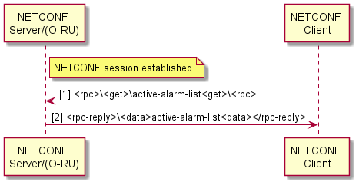
Figure 11.1-1: Read Active Alarms

11.2 Alarm notification
The O-RU shall send <alarm-notif> to a subscriber when the NETCONF Client has established a subscription to alarm notification and:
- a new alarm is added to active-alarm-list;
- an alarm is removed from the list.
Removal of alarms from the active-alarm-list due to deletion of "fault-source" element is considered as clearing and cause sending of <alarm-notif> to the notification subscriber. This applies to alarms which were explicitly related to the deleted "fault-source" element. The rationale for such is to avoid misalignment between NETCONF Clients when one NETCONF Client deletes an element.
The O-RU reports in <alarm-notif> only for new active or cancelled alarms, not all active alarms, as illustrated in Figure 11.2-1.
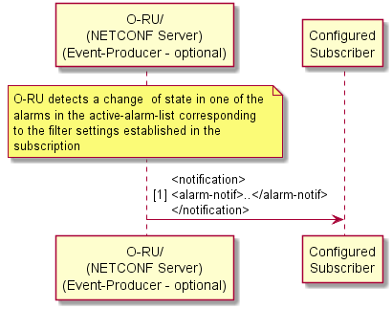
Figure 11.2-1: Alarm Notification

11.3 Manage alarm subscription to NETCONF clients
The NETCONF Client can "subscribe" to alarm notifications by sending create-subscription, as specified in clause 2.1 of RFC 5277 [21], to NETCONF Server.
RFC 5277 [21] allows <create-subscription> below:
<netconf:rpc netconf:message-id="101"
xmlns:netconf="urn:ietf:params:xml:ns:netconf:base:1.0">
<create-subscription
xmlns="urn:ietf:params:xml:ns:netconf:notification:1.0">
<filter netconf:type="subtree">
<event xmlns="http://example.com/event/1.0">
<eventClass>fault</eventClass>
<severity>critical</severity>
</event>
<event xmlns="http://example.com/event/1.0">
<eventClass>fault</eventClass>
<severity>major</severity>
</event>
<event xmlns="http://example.com/event/1.0">
<eventClass>fault</eventClass>
<severity>minor</severity>
</event>
</filter>
</create-subscription>
</netconf:rpc>

NOTE: The NETCONF Client can define the filter for alarm notification base on severity.
The appropriate example for O-RAN YANG modules for create-subscription is as follows:
Case 1) NETCONF client subscribes alarm-notif filtering fault-severity: CRITICAL, MAJOR and MINOR and measurement-result-stats filtering transceiver-stats and rx-window-stats which measurement-object is RX_ON_TIME only:
<rpc xmlns:netconf="urn:ietf:params:xml:ns:netconf:base:1.0" message-id="101">
<create-subscription
xmlns="urn:ietf:params:xml:ns:netconf:notification:1.0">
<filter netconf:type="subtree">
<alarm-notif xmlns="urn:o-ran:fm:1.0">
<fault-severity>CRITICAL</fault-severity>
</alarm-notif>
<alarm-notif xmlns="urn:o-ran:fm:1.0">
<fault-severity>MAJOR</fault-severity>
</alarm-notif>
<alarm-notif xmlns="urn:o-ran:fm:1.0">
<fault-severity>MINOR</fault-severity>
</alarm-notif>
<measurement-result-stats xmlns="urn:o-ran:performance-management:1.0">
<transceiver-stats/>
</measurement-result-stats>
<measurement-result-stats xmlns="urn:o-ran:performance-management:1.0">
<rx-window-stats>
<measurement-object>RX_ON_TIME</measurement-object>
</rx-window-stats>
</measurement-result-stats>
</filter>
</create-subscription>
</rpc>

Case 2) NETCONF client subscribes default event stream NETCONF to receive all notifications defined in O-RAN YANG modules:
<rpc xmlns:netconf="urn:ietf:params:xml:ns:netconf:base:1.0" message-id="101">
<create-subscription xmlns="urn:ietf:params:xml:ns:netconf:notification:1.0">
<stream>NETCONF</stream>
</create-subscription>
</rpc>

A high-level view of a NETCONF Client subscribing is shown in Figure 11.3-1. After the NETCONF Client requests a subscription, the server sends an alarm-notif notification to the client when there is any change in the active alarms matching the filter specified in the subscription request.
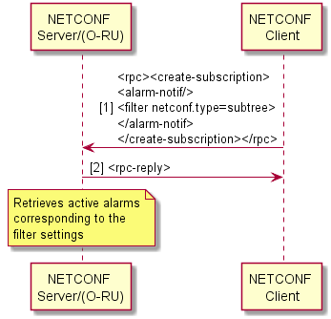
Figure 11.3-1: Manage Alarm Notification Subscription Request
To terminate the subscription, the NETCONF client shall send a <close-session> operation from the subscription's session, as illustrated in Figure 11.3-2.
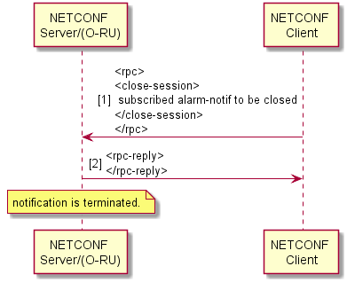
Figure 11.3-2: Terminating an Alarm Notification Subscription

11.4 Fault sources
Alarm notifications reported by NETCONF Server contain element "fault-source" which indicates the origin of an alarm. In general values of "fault-source" are derived from names defined as YANG leafs:
- Source (Examples: fan, module, PA, port)
indicates that origin of the alarm within the O-RU. Value of "fault-source" is derived from element name.
- Source (other than when an element is within the O-RU)
Value of fault-source may identify the O-RU external resource; for example, antenna line.

Alarm instance can be identified by value combination of fault-id, fault-source and fault-severity. Alarms with different "fault-id", "fault-source" or "fault-severity" are independent:
- Multiple alarms with same "fault-id" may be reported with different "fault-source".
- Multiple alarms with same "fault-source" may be reported with different "fault-id".
- Among alarms with same value of fault-id and fault-source and different value of fault-severity, only one of them can be in the active-alarm-list at a given time. When an alarm with a "fault-id" and a "fault-source" is reported with a "fault-severity", and there is already an alarm in the active-alarm-list with same fault-id, fault-source value, but with a different fault-severity, NETCONF server shall simultaneously add the alarm with new fault-severity in active-alarm-list and clear the previous alarm with different fault-severity by setting is-cleared to TRUE and shall remove the alarm with previous fault-severity from the active-alarm-list. NETCONF server shall notify subscribers of added and removed alarms.
The range of "fault-id" is separated to common and vendor specific. The common fault-ids are defined in Annex A and more numbers may be used in future. The vendor specific range for the fault-id shall be [1000 .. 65535].
Alarm notifications reported by the NETCONF Server contain names of the "affected-objects" which indicate elements affected by the fault. In case the origin of the alarm is within the O-RU, other elements than "fault-source" which do not function correctly due to the fault are reported via "affected-objects". In case the origin of the fault is outside of the O-RU, the O-RU elements which do not function correctly due to the fault are reported via "affected-objects".

11.5 Manage alarm notification to event-collector
This optional capability requires the O-RU to support configured subscriptions, as described in Clause 18. For details for alarm subscription and notification sending to event-collector, refer to Clause 18.

11.6 Historical Alarms List
The O-RU may optionally support the historical-alarm-list container, enabling alarm events with is-cleared status is "true" to be captured. The procedures for aging out entries in the historical-alarms list based on time and/or memory is left to vendor specific implementation of the O-RU.
NOTE: The persistence of historical-alarms list entries on O-RU upon reset is left to vendor specific implementation
The NETCONF Client can read historical-alarm-list by get RPC operation, as illustrated in Figure 11.6-1.
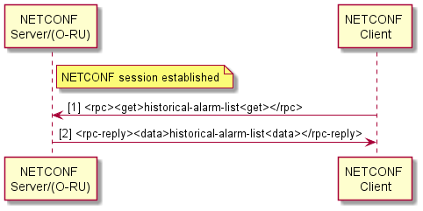
Figure 11.6-1: Read Historical Alarms
In case of multiple NETCONF clients and/or Event-Collectors, the O-RU shall report the same notification to all subscribed NETCONF clients/Event-Collectors.

12 File management

12.1 Introduction
This clause specifies File Management for the O-RU. Following operations are supported as a File Management.
- upload (see clause 12.3)
File upload from O-RU to file server triggered by O-RU Controller.
- retrieve file list (see clause 12.4)
O-RU Controller retrieves the file list in O-RU.
- download (see clause 12.5)
File download from file server to O-RU triggered by O-RU Controller
NOTE 1: file-download has different purpose with software-download specified in clause 8.5. For example, file-download can be used for Beamforming configuration in clause 15.4.
File transfers are done with sFTP or FTPES. Following types of authentications shall be supported for file management:
- Password for RU authentication and list of public keys (see clause 5.4 in the present document) for sFTP server authentication.
- X.509 Certificate for TLS between O-RU and FTPES file server. In addition to the X.509 certificate, the O-RU shall use any configured application password, appl-password, to authenticate to the FTPES server for the associated username defined in the remote-file-path.
NOTE 2: The appl-password is optional for FTPES server authentication to support scenarios where the username embedded in the remote-file-path corresponds to an anonymous account as defined in RFC 1635 [i.5].
Following types of authentications may be supported for file management:
- Certificate for both O-RU and sFTP server authentication.
Following other clauses are related with File Management:
- clause 10.3.2: File management process (can be used for on demand file upload purpose, since clause 10.3.2 covers periodic file upload).
- clause 14.2: Log management.
- clause 14.3: Trace.
- clause 15.4.3: Beamforming configuration update.
NOTE 3: The file management functions involve the O-RU controller subscribing to receive particular YANG notifications from the O-RU. All O-RUs support the NETCONF Create-Subscription method, enabling those notifications to be transported using NETCONF notifications. In addition, those O-RUs that support the optional NON-PERSISTENT-MPLANE feature, the O-RU Controller can create a configured subscription from the O-RU, enabling those notifications to be transported over HTTPS to an Event-Collector as described in clause 18.

12.2 File system structure
The file System structure of the O-RU is represented as a logical structure that is used by the file management procedures defined in the rest of this clause. If the O-RU's physical file structure differs from the logical file structure defined below, the O-RU performs the mapping between the two structures.
The O-RU shall support the standardised logical folders. Prior to version 10.0, the following standardised folders were defined:
- O-RAN/log/
- O-RAN/PM/
- O-RAN/transceiver/
And for those O-RU's supporting beamforming
- O-RAN/beamforming/
The folders listed above are inconsistent with the folders used in figures elsewhere in the present document. Because of such inconsistencies, the use of the folders listed above is not preferred. These folders may be subject to removal in a future version of the present document.
To avoid interoperability issues between case-sensitive and non-case sensitive file systems, the following additional standardised folders are defined and are preferred in the present document:
- o-ran/log/ - used to store troubleshooting and trace logs
- o-ran/pm/ - used to store performance measurement files
- o-ran/transceiver/ - used to store data recovered from the transceiver module
and for those O-RUs supporting beamforming:
- o-ran/beamforming/ - used to store beamforming configuration files
and for those O-RUs supporting O-RAN defined security logging:
- o-ran/security/ - used to store security log files
The O-RU may additionally support vendor defined folders which are out of scope of the present document.
Versions of the present document prior to v17.0 did not define the standardised folder "o-ran/security/" and consequently O-RUs compliant to versions earlier than v17.0 should use vendor defined folders for supporting security logging functionality.

12.3 File management operation: upload
This clause describes file upload method from O-RU to the fileserver. sFTP or FTPES is used for File management, and one file can be uploaded by one upload operation. The O-RU Controller triggers file upload operation to O-RU.
Simultaneous multiple file upload operations can be supported under the same FTP connection between O-RU to the fileserver. If the O-RU has a limitation with regard to the ability to upload files simultaneously, it is allowed that O-RU reports failure notification for the simultaneous upload request which exceeds its capability. The behaviour of O-RU Controller is out of scope when O-RU Controller receives failure notification from the O-RU.
Following rpc is used for upload operation.
- rpc: file-upload
- input
- local-logical-file-path: the logical path of file to be uploaded (no wildcard is allowed)
- remote-file-path: URI of file on the fileserver
- credentials: authentication credentials for file server access
- application-layer-credential: application layer level authentication credentials for file server access
- output
- status: whether O-RU accepted or rejected the upload request
- reject-reason: the human readable reason why O-RU rejects the request (only applicable if status is rejected)
In the rpc-reply, status whether the O-RU receives the upload request or rejects due to some reason (e.g. the number of limitation to upload simultaneously) is replied. If rejected, the human readable reject reason is also replied.
In notification, the result of the upload process (successfully uploaded or failed upload) is replied in addition to local-logical-file-path and remote-file-path. If failure, the human readable reason is also replied. Figure 12.3-1 shows the file upload sequence diagram.
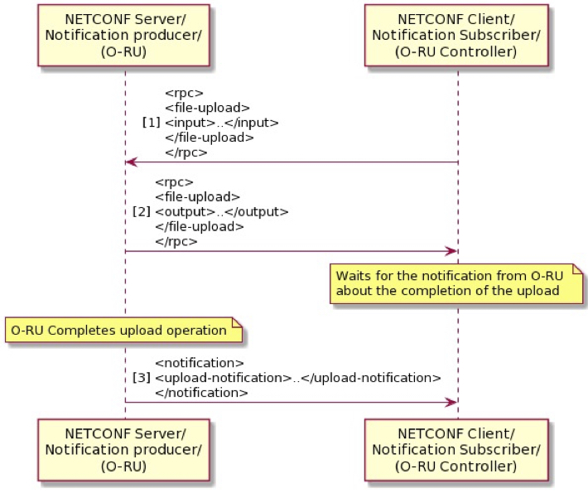
Figure 12.3-1: File Upload Sequence

12.4 File management operation: retrieve file list
This clause describes file retrieve method which the O-RU Controller retrieves the file list from the O-RU. One or multiple files' information can be retrieved by one retrieve file list operation (use of wildcard is allowed). The O-RU Controller triggers the retrieve file list operation from the O-RU.
The following rpc is used for retrieve file list operation.
rpc: retrieve-file-list
- input
- logical path: the logical path of files to be retrieved (* is allowed as wild-card)
- file-name-filter: the files which has the "file name filter" in the file name (* is allowed as wild-card)
- output
- status: whether O-RU accepted or rejected the retrieve file list request
- reject-reason: the human readable reason why O-RU rejects the request (only applicable if status is rejected)
- file list
In rpc-reply, status whether the O-RU accepts the retrieve-file-list request or rejects due to some reason is replied. If rejected, the human readable reject reason is also replied.
Figure 12.4-1 shows the retrieve file list sequence diagram.
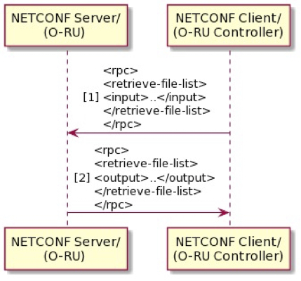
Figure 12.4-1: Retrieve File List Sequence

12.5 File management operation: download
This clause describes the file download method from O-RU Controller to O-RU. sFTP or FTPES is used for File management, and one file can be downloaded by one download operation. O-RU Controller triggers the file download operation to O-RU.
Simultaneous multiple file download operations can be supported under the same FTP connection between the O-RU and O-DU/SMO. If the O-RU has the number of limitation to download simultaneously as a capability, it is allowed that the O-RU reports a failure notification for the download request which is larger than the capability. The behaviour of the O-RU Controller is out of scope when O-DU/SMO receives failure notification from O-RU.
The following rpc is used for download operation.
rpc: file-download
- input
- local-logical-file-path: the logical path of file to be downloaded (no wildcard is allowed)
- remote-file-path: URI of file on the file server
- credentials: authentication credentials for file server access
- application-layer-credential: application layer level authentication credentials for file server access
- output
- status: whether O-RU accepted or rejected the download request
- reject-reason: the human readable reason why O-RU rejects the request (only applicable if status is rejected)
The O-RU shall reject any file-download rpc where the local-logical-file-path starts with "o-ran/log/", "o-ran/pm/", "o-ran/transceiver/" or "o-ran/security/".
In rpc-reply, status whether the O-RU receives the download request or rejects due to some reason (e.g. the number of limitation to download simultaneously) is replied. If rejected, the human readable reject reason is also replied.
In notification, the result of the download process (successfully downloaded or download is failure) is replied in addition to the local-logical-file-path and remote-file-path. If failure, the human readable reason is also replied. Figure 12.5-1 below shows the file download sequence diagram.
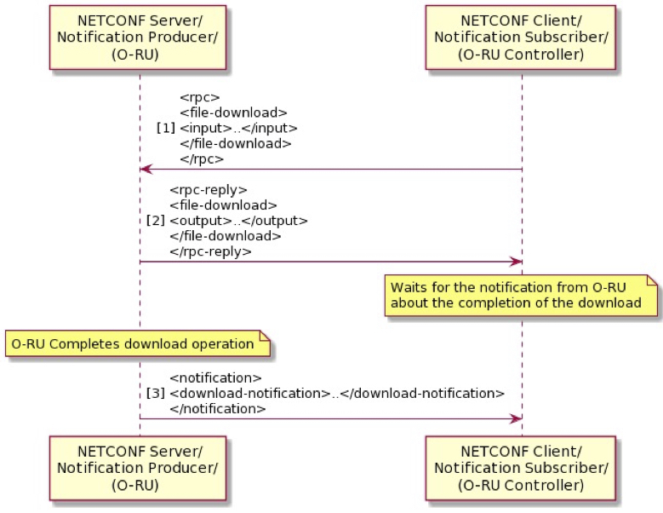
Figure 12.5-1: File Download Sequence

13 Synchronisation aspects

13.1 Introduction
This clause describes the YANG model (o-ran-sync.yang) containers that are used for the Management Plane's interactions with various aspects of the time synchronisation of the O-RU. In general, the O-RU shall manage its synchronisation status and select one or more synchronisation input source(s) (based on vendor specific implementation). Additional information regarding the interactions between M-Plane and S-Plane are described in the current specification's clause 15.3.3 and in the CUS-Plane specification [2], clause 11.4.
The o-ran-sync.yang YANG model defines configuration, status and notification containers which are used to enable O-RU controller to recover the state of the O-RU's S-Plane. Before going into the details of each of these an overview of these objects is provided here.
The YANG model defines several configuration containers. These containers comprise read/write parameters that can be read or set by the O-RU controller. The O-RU controller can read them (to determine O-RU configuration) or set them (to change the O-RU's configuration). These are:
- PTP Configuration - ptp-config: O-RU controller can set or read PTP parameters like PTP Full/Partial timing support profiles, accepted clock classes, and set network address among other parameters
- PLFS/SyncE Configuration - synce-config: This container provides SyncE information such as the acceptable list of SSMs.
- GNSS (Global Network Satellite System) Configuration - gnss-config: This container comprises leaves which define whether GNNS can be used, and if so which satellite constellation to use.
- Sync Capability - sync-capability: This is a read-only container indicates to the O-RU controller the time accuracy of the T-TSC or T-BC that is integrated into the O-RU.
The O-RU should store the above synchronisation configuration in reset persistent memory.
During the start -up installation process (see clause 6.1) the O-RU's default startup configuration settings may allow the O-RU's S-Plane to become operational without any configuration by the O-RU controller. The O-RU uses its default configuration settings to execute the PTP and/or PLFS/SyncE protocols, or GNSS settings to complete the synchronisation process (including optional features such as PER-PORT-PTP-CONFIG, PER-PORT-SYNCE-CONFIG, GNSS, ANTI-JAM). During the start-up installation flow the startup settings may be changed. This may be necessary if the default synchronisation settings are incompatible with the network implementation. If the startup configuration requires changes, the O-RU controller first retrieves the synchronisation configuration and status from O-RU, and then the O-RU controller modifies the configuration. The O-RU shall then execute the synchronisation process using the updated settings. Having these settings stored in reset persistent memory typically simplifies subsequent startup flows by enabling O-RU to start up without reconfiguration.
Once the O-RU is operational, the O-RU controller can subscribe to several synchronisation notifications which report to the O-RU controller the status of the O-RU. The following notifications are defined in the YANG model.
- synchronization-state-change - conveys the sync-state.
- ptp-state-change - conveys the ptp-status.
- synce-state-change - If SyncE or another PLFS is used, this conveys the synce-status
- gnss-state-change - If a O-RU supports GNSS capability, this conveys the gnss-status.
During normal operation, the O-DU should monitor the operational state of the O-RU's S-Plane. This is accomplished by subscribing to receive the synchronization-state-change notification. If the O-DU is notified that the O-RU's state has changed to UNLOCKED, the O-DU shall stop sending data to the O-RU and shall ignore any data from that O-RU. Clause 15.3.3 describes in more detail the interactions between S-Plane and M-Plane when synchronisation is lost and when synchronisation is recovered.
NOTE: Except for possible configuration during the start-up installation process, the synchronisation start-up and reference clock selection are accomplished via S-Plane protocols independent of M-Plane.
The remainder of this clause describes in more detail the main objects within the configuration, status, and notification containers. However, this clause does not describe all of the leafs/objects within the containers. Some items for example time-error, frequency-error, supported-reference-types are not mentioned in this clause, but are defined and described in o-ran-sync.yang.

13.2 Sync status object
This sync-state container provides synchronisation state of the module. If the O-RU Controller is interested in receiving Synchronization status state information, it may configure a subscription to the synchronization-state-change notification from the O-RU. Event notifications will be sent whenever the state of the O-RU synchronisation changes.
For an O-DU that is communicating with an O-RU, the synchronization-state-change notification is the primary mechanism by which the O-DU knows whether the O-RU is synchronised and is ready to transmit/receive when fully configured. This notification is the primary mechanism to transfer status information required to implement the flows described in clause 15.3.3.
The state diagram of O-RU synchronisation is shown in Figure 13.2-1, and is indicated by the following allowed values:
- LOCKED: O-RU is in the locked mode, as defined in Recommendation ITU-T G.810 [23].
- HOLDOVER: O-RU clock is in holdover mode.
- FREERUN: O-RU clock is not locked to an input reference and is not in the holdover mode.
Figure 13.2-1 illustrated the state transitions.
The sync-state container allows the O-RU to list via an array of the synchronisation sources, called supported-reference-types, which it can support. The allowed values are:
- GNSS
- PTP
- SYNCE
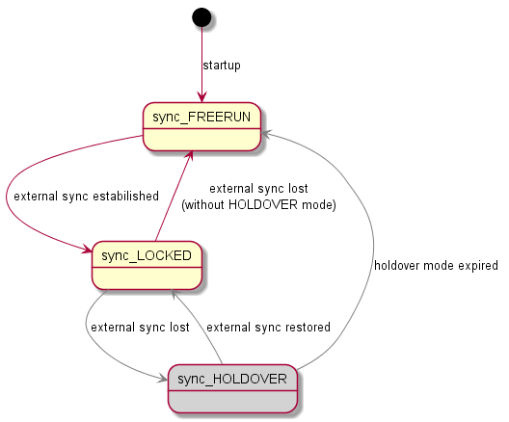
NOTE: HOLDOVER mode is optional and depends on internal O-RU design.
Figure 13.2-1: Allowed sync state transitions

13.3 Sync capability object
The module's synchronisation capability is provided via the sync-t-tsc object. This object indicates the accuracy of the O-RU's derived Telecom Subordinate Clock (T-TSC). For details on the actual capability levels, see clause 11.3 of the O-RAN WG4 CUS plane specification [2]. There are two enumerations possible:
- CLASS_B: Regular accuracy (previously referred to class B) for synchronisation is supported by the device as per IEEE 802.1CM [80] clause 6.4.1, Case 1.1.
- ENHANCED: Enhanced accuracy for synchronisation is supported by the device as per IEEE802.1CM [80] clause 6.4.1, Case 1.2.
Other leaves in this container include:
- a Boolean called boundary-clock-supported, which indicates whether the O-RU supports T-BC profiles defined in ITU-T 8275.1 [22].
- a Boolean called extended-ql-tlv-supported, which indicates whether the O-RU supports the extended Quality Level TLV defined in ITU-T 8264 [76] clause 11.3.

13.4 PTP configuration

13.4.1 Introduction
The ptp-config container contains information about the O-RU's configuration of Precision Time Protocol. This clause describes the definitions of the items contained within ptp-config.
domain-number: This parameter indicates the Domain Number for PTP announce messages. Allowed values: 0 ~ 255.
- Recommendation ITU-T G.8275.1 [22] uses domain numbers in the range 24...43, but the entire range is allowed to ensure flexibility of the M-Plane specification. For Recommendation ITU-T G.8275.2 [100] domain numbers from range 44…63 shall be used.
default: 24.
accepted-clock-classes: Contains the list of PTP acceptable Clock Classes, sorted in the descending order.
- The sender shall generate the list of acceptable clock classes. The list shall be sorted in descending order. Each accepted Clock Class value shall appear only once in the list. Depending on implementation, the receiver may interpret the list in either of two ways:
- use only the first (i.e. the maximum) item in the list, interpreting it as a threshold value for acceptable clock classes, while ignoring all other items in the list;
- use the whole list, interpreting it as an explicit list of acceptable clock classes.
default: 7, 6
clock-classes: The PTP Clock Class accepted by the O-RU. Allowed values: 0 ~ 255.
- Not all values are compliant to [22], but the entire range is allowed in M-plane specification to ensure flexibility. The values can be validated/filtered on the receiver side, if necessary.
ptp-profile: Defines which PTP profile will be used.
- Allowed values:
- G_8275_1 (multicast over Ethernet will be used, see Recommendation ITU-T G.8275.1 [22])
- G_8275_2 (unicast over IP will be used, see Recommendation ITU-T G.8275.2 [100])
delay-asymmetry: Defines the static phase error in the recovered PTP timing signal to be compensated at the O-RU. The error is defined in units of nanoseconds in the range ±10 000 ns. This is a single global value that is common for all the O-RU's ports. As specified in Recommendation ITU-T G.810 [23] and IEEE1588 [24] and [50], the sign of the parameter shall be interpreted as follows:
- If the phase error to be compensated is negative, then the recovered timing signal shall be advanced by the time interval equal to the configured value to compensate the error.
- If the phase error to be compensated is positive, then the recovered timing signal shall be delayed by the time interval equal to the configured value to compensate the error.
default: 0
Modification of this parameter may have impact on RF transmission but shall occur without unit restart.
This parameter is optional for support. If the O-RU does not support this value, the O-RU shall use the default value. If the O-RU does not support manual compensation, it shall ignore the parameter setting.
Granularity of the applied value depends on the architecture and implementation of the system clock, and therefore, may vary across vendors.

13.4.2 G.8275.1 specific parameters
This container within ptp-config, called g-8275-1-config, is used when ptp-profile is set to G_8275_1. When enabled it instantiates multicast-mac -address. The parameter defines the destination MAC address, used by the O-RU in the egress PTP messages. This is a common configuration parameter for all G.8275.1 compliant ports of the O-RU.
Allowed values:
- FORWARDABLE (means that PTP shall use 01-1B-19-00-00-00 destination MAC address)
- NONFORWARDABLE (means that PTP shall use 01-80-C2-00-00-0E destination MAC address)
default: FORWARDABLE.
sources: When PER-PORT-PTP-CONFIG optional feature is supported, this parameter contains several ITU-T G.8275.1-specific configuration parameters determining optional attributes for each of the physical ports defined by local-port-number. Descriptions for these can be found in o-ran-sync.yang.
- time-transmitter-only: (default : FALSE)
When set to TRUE, this optional parameter forces all PTP ports assigned to the physical port to act only as a TimeTransmitter one, i.e. they cannot be selected as time source for the O-RU. When set to FALSE, the O-RU can determine the port state without this restriction.
- not-time-transmitter: (default : FALSE)
When set to TRUE, this optional parameter prevents all PTP ports assigned to the physical port from acting as a TimeTransmitter one, i.e. they cannot deliver time from the O-RU. When set to FALSE, the O-RU can determine the port state without this restriction.
- local-priority: (default : 128)
This optional parameter allows configuring a common local priority for all PTP ports assigned to the physical port, used in the ITU-T G.8275.1 best PTP source selection (ABTCA). The lower the value, the higher the priority.
time-transmitter-only and not-time-transmitter shall not be set to TRUE simultaneously.

13.4.3 G.8275.2 specific parameters
This container, g-8275-2-config, within ptp-config contains G.8275.2 specific parameters. It is used with ptp-profile is set to G_8275_2. The full list of fields within this container and their meaning are listed directly in the YANG model.
local-ip-port: The parameter defines local IP address which will be used as a port for receiving ptp signal.
master-ip-configuration: The parameter defines list of IP configuration of devices acting as PTP signal source.
local-priority: The parameter defines local priority or underlying master IP address.
ip-address: This parameter defines master IP address.
log-inter-sync-period: The parameter defines number of sync message during 1 second.
Allowed values: 0 ~ -7 (this represents the value from 1 message per second to 128 messages per second).
log-inter-announce-period: The parameter defines number of announce message during 1 second
Allowed values: 0 ~ -3 (this represents the value from 1 message per second to 8 messages per second).

13.5 PTP status
The PTP Status container is used to collect operational status information of the PTP clock, controlled by the O-RU. The object may be used to display operational information, which facilitates troubleshooting, to the operator. The information in the object shall not be used by the O-DU to autonomously alter its operation. If the O-RU Controller is interested in PTP status, it may configure a subscription to the ptp-state-change notification in the O-RU. Notifications will only indicate changes to the lock-state. Before requesting or subscribing to PTP status information, the O-RU Controller shall ensure that PTP is supported by the O-RU by requesting the supported-reference-types, as defined in clause 13.2. The following list includes the related parameters of this container.
reporting-period: This parameter defines minimum period in seconds between reports, sent by the O-RU, for parameters in this container.
default: 10
lock-state: This parameter indicates whether the integrated clock is synchronising to the reference, recovered from PTP flow. The exact definition when to indicate locked or unlocked is up to specific implementation.
- LOCKED: The integrated clock is synchronising to the reference, recovered from PTP flow.
- UNLOCKED: The integrated clock is not synchronising to the reference, recovered from PTP flow.
clock-class: This parameter contains the clock class of the clock, controlled by the O-RU.
sources: This parameter contains several parameters describing the characteristics of PTP sources of the clock, controlled by the O-RU. Descriptions for these can be found in o-ran-sync.yang.
state: This parameter indicates status of the PTP port:
- PARENT: Indicates that the PTP signal from this source is currently used as a synchronisation reference.
- OK: Indicates that the PTP signal from this source can be potentially used as a synchronisation reference, i.e. Announce messages, received from this source, contain acceptable content (domain-number, clock-class, flags, etc).
- NOK: Indicates that the PTP signal from this source cannot be used as a synchronisation reference, i.e. Announce messages, received from this source, contain unacceptable content (domain number, clockclass, flags, etc).
- DISABLED: Indicates that PTP connection is not available from this PTP source.
See the related o-ran-sync YANG Model for additional information on the contents of the ptp-status container.

13.6 PLFS/SyncE configuration
The CUS-Plane Specification allows for different methods of PLFS (Physical Layer Frequency Synchronisation), however only the use of SyncE is defined in the present document. The synce-config container defines the configuration of SyncE. The following list includes the related parameters of this container.
acceptance-list-of-ssm: The parameter contains the list of SyncE acceptable Synchronisation Status Messages (SSM).
Allowed values:
- ePRTC (enhanced Primary Reference Time Clock, note 2)
- PRTC (Primary Reference Time Clock, note 2)
- ePRC (enhanced Primary Reference Clock, note 2)
- PRC (Primary Reference Clock)
- PRS (Primary Reference Source-Stratum 1)
- SSU_A (Synchronization Supply Unit A)
- SSU_B (Synchronization Supply Unit B)
- ST2 (Stratum 2)
- ST3 (Stratum 3)
- ST3E (Stratum 3E)
- eEEC (enhanced Ethernet Equipment Clock, note 2)
- EEC1 (Ethernet Equipment Clock 1)
- EEC2 (Ethernet Equipment Clock 2)
- DNU (Do Not Use)
- NONE
NOTE: These values are ignored when extended-ql-tlv-supported capability is FALSE.
ssm-timeout: The parameter contains the value of maximum duration in seconds for which the actual SSM value may be different than configured values.
sources: When PER-PORT-SYNCE-CONFIG optional feature is supported, this parameter contains several ITU-T G.781-specific configuration parameters determining more detailed attributes for each of the physical ports defined by local-port-number. Descriptions for these can be found in o-ran-sync.yang.
- - ssm-send-enable: (default : FALSE)
When set to TRUE, this optional parameter allows all SyncE ports assigned to the physical port to send SSM Quality Level, i.e. it can be used to synchronize downstream clocks. When set to FALSE, the O-RU does not send the SSM Quality Level.
- - local-priority: (default : 0)
This optional parameter allows configuring a common local priority for all SyncE ports assigned to the physical port, used in the Recommendation ITU-T G.781 [81] best SyncE source selection. The lower the value, the higher the priority, except for value 0 that removes the port from the selection process.

13.7 PLFS/SyncE status
The synce-status container is used to collect operational status information of SyncE reference on a node, controlled by O-RU. If the O-RU Controller is interested in SyncE status, it may configure a subscription to the synce-state-change notification in the O-RU. Notifications will only indicate changes to the lock-state. Before requesting or subscribing to SyncE status information, the O-RU Controller shall ensure that SyncE is supported at the O-RU by requesting the supported timing reference types, as defined earlier in clause 13.2. The following list summarizes the related parameters of this container.
reporting-period: This parameter defines minimum period in seconds between reports, sent by the O-RU, for parameters in this container.
default: 10
lock-state: This parameter indicates whether the integrated ordinary clock is synchronising to the reference, recovered from the SyncE signal. The exact definition when to indicate locked or unlocked is up to specific implementation.
- LOCKED: The integrated ordinary clock is synchronising to the reference, recovered from the SyncE signal.
- UNLOCKED: The integrated ordinary clock is not synchronising to the reference, recovered from the SyncE signal.
sources: This parameter contains characteristics of SyncE sources of the clock, controlled by the NETCONF Server, and reporting optional attributes for each of the physical ports defined by local-port-number. Descriptions for these can be found in o-ran-sync.yang.
state: This parameter indicates status of the SyncE source:
- PARENT: Indicates that the SyncE signal from this source is currently used as a synchronisation reference.
- OK: Indicates that the SyncE signal from this source can be potentially used as a synchronisation reference, i.e. SSM messages, received from this source, contain acceptable clock quality level.
- NOK: Indicates that the SyncE signal from this source cannot be used as a synchronisation reference, i.e. SSM messages, received from this source, contain unacceptable clock quality level.
- DISABLED: Indicates that SSMs are not received from this SyncE source.
quality-level: This parameter contains value of the SSM clock quality level, received in SSM messages from the SyncE source. Unit is uint8, e.g. PRC SSM QL is reported as 0x02.
ssm-quality-level: this parameter contains human-readable value of the extended clock quality level, received in SSM messages from the SyncE source. Unit is ssm-code enumeration as specified in clause 13.6 of the present document, e.g. ePRC enhanced SSM QL is reported as ePRC.
The following optional parameters can also be reported if extended-ql-tlv-supported capability is TRUE, as per Recommendation ITU-T G.8264 [76] clause 11.3. They report what is received on the port in SSM messages from the SyncE source:
- enhanced-ssm-code: Unit is uint8, e.g. ePRC enhanced SSM QL is reported as 0x23.
- originator-synce-clock-id: this parameter contains the clockIdentity of the originator clock. Unit is uint64, e.g. 0x0123456789ABCDEF.
- flag0-mixed-eec-eeec: Boolean meaning mixed EEC/eEEC (i.e. TRUE if at least one of the clocks is not an eEEC; FALSE if all clocks are eEEC).
- flag1-partial-chain: Boolean meaning means partial chain (i.e. TRUE , if the TLV has been generated in the middle of the chain and the count of the EEC/eEEC is incomplete, FALSE otherwise).
- number-of-eeec: the number of cascaded eEECs from the nearest SSU/PRC/ePRC. Unit is uint8.
- number-of-eec: the number of cascaded EECs from the nearest SSU/PRC/ePRC. Unit is uint8.
See the related o-ran-sync.yang YANG Model for the full details.

13.8 GNSS configuration
The gnss-config container defines the configuration of Global Navigation Satellite System (GNSS). The following list summarizes the related parameters of this container.
enable: This parameter defines if GNSS receiver shall be enabled or not. Allowed values: true/false;
default: false
satellite-constelation-list (sic): This parameter defines list of constellations to be used to acquire synchronisation.
Allowed values:
- GPS
- GLONASS
- GALILEO
- BEIDOU
polarity: This parameter defines pulse polarity.
Allowed values:
- POSITIVE
- NEGATIVE
default: POSITIVE
cable-delay: This parameter is used to compensate cable delay. Allowed values: 0 ~ 1000.
default: 5
NOTE: This value is given in ns (nanoseconds) it is recommended to compensate 5ns per each meter of the cable.
anti-jam-enable {if feature GNSS-ANTI-JAM}: This parameter is used to enable or disable anti-jamming. Allowed values: true/false.
default: false.

13.9 GNSS status
An O-RU supporting GNSS capability shall use the gnss-status container to report the state of its GNSS receiver. If the O-RU Controller is interested in GNSS status, it may configure a subscription to the gnss-state-change notification in the O-RU before requesting or subscribing the GNSS status information. Notifications will only provide changes to the gnss-status. The O-RU Controller shall ensure that GNSS is supported by the O-RU by requesting supported timing reference types, as defined in clause 13.2. The following list summarizes the related parameters of this container.
gnss-status: This parameter indicates the status of the GNSS receiver:
- SYNCHRONIZED: Indicates that the GNSS receiver is synchronised.
- ACQUIRING-SYNC: Indicates the GNSS receiver is functioning correctly, but has not acquired synchronisation
- ANTENNA-DISCONNECTED: Indicates the GNSS receiver is reporting that its antenna is disconnected.
- BOOTING: Indicates that the GNSS functionality is booting.
- ANTENNA-SHORT-CIRCUIT: Indicates that the GNSS receiver is reporting that its antenna is short circuited.
Additionally, when the GNSS receiver is synchronised, the O-RU can report the following additional information:
- satellites-tracked: The number of satellites being tracked by the O-RU receiver.
- altitude, latitude and longitude: The geospatial location reported by the GNSS receiver.

14 Operations use cases

14.1 Supervision failure handling and supervision termination handling

14.1.1 Supervision failure handling
This clause clarifies Supervision Failure Handling and Supervision Termination Handling.
When Supervision Failure is detected by O-RU, the O-RU shall immediately disable operation of the watchdog timers for the corresponding NETCONF session. O-RU assumes NETCONF session related to failed supervision is no longer valid. O-RU shall terminate this invalid NETCONF session by closing underlying SSH or TLS connection. Then O-RU shall start performing the call home procedure towards the NETCONF client, using the re-call-home-no-ssh-timer to repeat the call home attempts. This activity is repeated by the O-RU until, either:
- A new NETCONF session is established with the original NETCONF client.
Or,
- the original NETCONF client is no longer a "call home O-RU Controller" as defined in clause 6.3, e.g. when reperforming DHCP configuration, the O-RU Controller identity corresponding to the NETCONF client is no longer signalled by the DHCP server, and/or the NETCONF client was previously configured using the configured-client-info container and this configuration has been deleted.
Or,
- After max-call-home-attempts has been reached and a new NETCONF session cannot be established with the original NETCONF client.
Scenario 2 and 3 result in one of the two described cases:
Case #1: The O-RU is still having at least one running and valid NETCONF session with a NETCONF client that has subscribed to receive the supervision-notification and where the per-odu-monitoring container is not present in the O-RU's configuration.
The O-RU remains operational and stops performing call home to this O-RU controller.

Case #2: The O-RU does not have running NETCONF session with any NETCONF client that has subscribed to receive the supervision-notification.
The O-RU ceases all radio transmission and performs autonomous reset.
When an O-RU indicates it supports the SHARED-ORU-MULTI-ODU feature, an O-RU Controller can enable supervision operation on a per O-DU identity basis by configuring one or more odu-id parameters in the per-odu-monitoring container in o-ran-supervision YANG model. When an odu-id has been configured in the per-odu-monitoring container, the O-RU shall enable operation of watchdog supervision timers (supervision timer and notification timer) on a per odu-id basis. When enabled, an O-RU controller that has subscribed to the supervision-notification is expected to configure one of the odu-id values in the supervision-watchdog-reset rpc. Operation of watchdog supervision timers on a per O-DU identity basis does not obviate the O-RU from performing autonomous reset according to the scenario described in case #2 above.
NOTE: The format of the odu-id string is not defined and not interpreted by the shared O-RU.
Case #3: If the supervision timer associated with an odu-id expires, the O-RU shall set the state leaf of the following array carriers to DISABLED and the active leaf of the same carriers to INACTIVE:
- Any tx-array-carriers list entry including a list of odu-ids containing only expired odu-id.
- Any rx-array-carriers list entry including a list of odu-ids containing only expired odu-id.
O-RU shall raise an alarm. The specific alarm #35 "Lost O-DU ID based Supervision " is described in Annex A. The O-RU sends tx-array-carriers-state-change and rx-array-carriers-state-change notifications to any notification subscribers. O-RU shall not perform an autonomous reset unless the requirements described in case #2 are met.

14.1.2 Supervision termination handling
If NETCONF session used for the supervision subscription is terminated by NETCONF client, the O-RU disables operation of the watchdog timers for terminated NETCONF session and starts performing Call Home procedure towards call home O-RU Controllers, following specification in clause 6.3.
Before terminating its NETCONF session, a NETCONF client that has subscribed to receive supervision notification, should at least de-activate all carriers previously configured by this NETCONF client. Optionally, such a NETCONF client can also remove (full or partial) configuration applied by this NETCONF client to the O-RU.
If the per-odu-monitoring container is not present in the O-RU's configuration, in case when entering Supervision Termination handling, if the O-RU does not have running NETCONF session with any NETCONF client that has subscribed to receive the supervision-notification, the O-RU ceases all radio transmission.
If the per-odu-monitoring container is present in the O-RU's configuration, in case when entering Supervision Termination handling, the O-RU deactivates the array carriers associated with the odu-id value in its supervision-watchdog-reset rpc as specified in clause 14.1.1.

14.2 Log management

14.2.1 Introduction
There are three type of log managements, troubleshooting log, security log and trace log. They are independent each other.
Troubleshooting log file contains the logs continuously collected before <start-troubleshooting-logs> rpc. Any logs collected after <start-troubleshooting-logs> rpc are not contained.
Trace log file contains the logs continuously collected after <start-trace-logs> rpc. Any logs collected before <start-trace-logs> rpc are not contained.
Security log files contain logs of security event information. The creation and storage of security log-data by the O-RU shall always be possible, i.e., there is no O-RAN defined procedure for starting or stopping the logging of security events. An O-RU indicates it supports O-RAN defined security logging procedures by including the SECURITY-LOGGING feature in its YANG library.

14.2.2 Troubleshooting log management
By requesting trouble shooting log files an O-RU controller is able to obtain collected log data files that can be used for troubleshooting purposes.
The O-RU can provide all possible troubleshooting log files. The contents and log formats are dependent on O-RU implementation.
The number and size of files provided by O-RU is not restricted but the O-RU may keep the number and size of files reasonably small to allow completion of the whole "Troubleshooting data upload" scenario (all files) within 15 minutes (with target to complete within 3 minutes) - assuming no additional upload restrictions from connectivity bandwidth or file server implementation. It is also recommended to provide more useful files first.
NOTE 1: The detailed O-RU controller behaviour is not specified. An O-RU controller can continue the scenario till completion past the allowed time or skip requesting further files
The files should be compressed with compression method indicated by file name extension:
- .gz (DEFLATE),
- .lz4 (LZ4),
- .xz (LZMA2 - xz utils),
- .zip (DEFLATE - zlib library).
O-RU shall collect log information. The RPC <start-troubleshooting-logs> shall trigger the O-RU to start generating troubleshooting log files containing troubleshooting logs, as illustrated in Figure 14.2.2-1. Completed generation of files shall be indicated by NETCONF server to NETCONF client in form of a notification.
If an O-RU reports support for the LOG-FILTER feature, then the O-RU Controller may request selected troubleshooting log data to be generated by providing values in the filter list in the RPC <start-troubleshooting-logs>. In Troubleshooting Data Upload procedure NETCONF Server provides data, which match the provided filters in the filter list.
NOTE 2: If the filter-type/value provided in the filter list is not supported by the O-RU, the O-RU can either ignore the filter-type/value, or reply with a status of FAILURE that indicates the failure reason being the non-support of the filter-type/value.
The notification <troubleshooting-log-generated> shall be signalled to the notification subscriber after the O-RU has finished generation of all troubleshooting log files, indicating to the subscriber that the troubleshooting log files are ready to be uploaded.
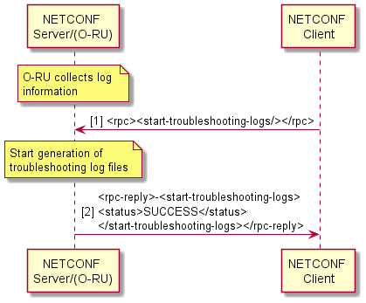
Figure 14.2.2-1: Start Generation of Troubleshooting Log Files
The O-RU shall include file names for troubleshooting log files in the <troubleshooting-log-generated> notification, with illustrative notification contents shown in Figure 14.2.2-2.
After sending the notification, the O-RU shall stop generating further troubleshooting log files unless a new RPC <start-troubleshooting-logs> is triggered. The file transfer for the generated troubleshooting log files shall be handled by the file management defined in Clause 12.
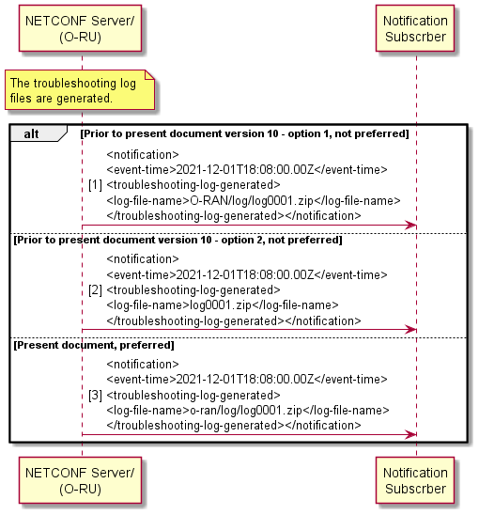
Figure 14.2.2-2: Notification Troubleshooting Log Generated
NOTE 3: Prior to version 10, the present document contained inconsistent definition of the log-file-name string between Figure 14.2.2-2 and associated YANG models. In present document previously permitted content of node log-file-name is considered as not preferred. Not preferred file formats may be subject to removal in a future version of the present document.
NETCONF client cancels generation of troubleshooting logs files using RPC <stop-troubleshooting-logs>. The NETCONF client is no longer interested in troubleshooting log files and O-RU does not need to send <troubleshooting-log-generated> notification, as illustrated in Figure 14.2.2-3.
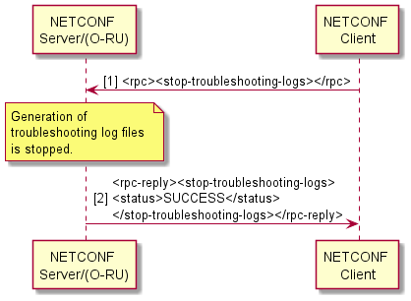
Figure 14.2.2-3: Stop Generation of Troubleshooting Logs
The overall troubleshooting log behaviour is illustrated in Figure 14.2.2-4. It contains 2 cases, successful notification case with illustrative notification contents and no notification as abnormal case.
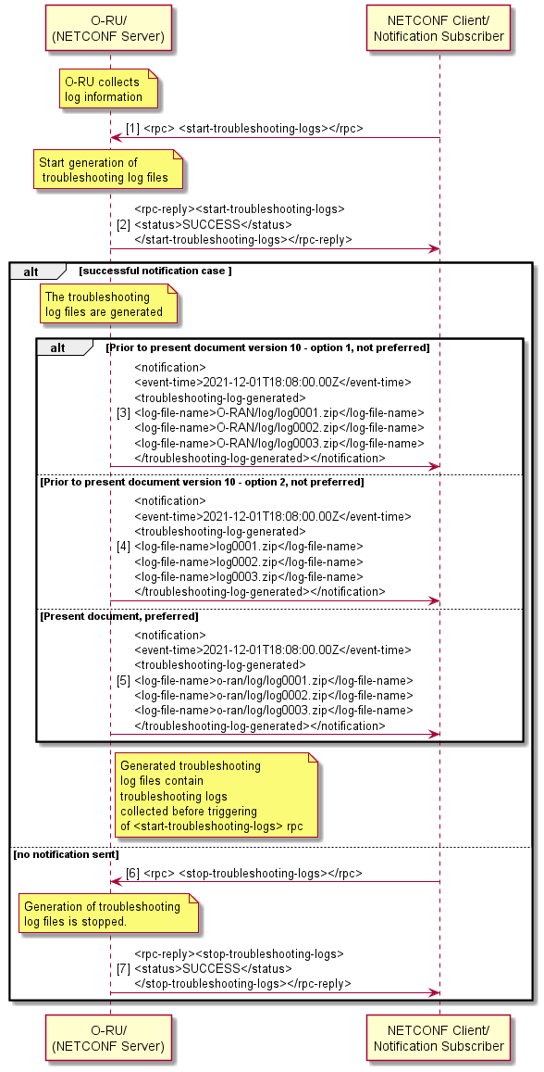
Figure 14.2.2-4: Overall Troubleshooting Log behaviour
NOTE 4: Prior to version 10, the present document contained inconsistent definition of the log-file-name string between Figure 14.2.2-4 and associated YANG models. In present document previously permitted content of node log-file-name is considered as not preferred. Not preferred file formats may be subject to removal in a future version of the present document.

14.2.3 Security logs

14.2.3.1 Security log format
An O-RU supporting the SECURITY-LOGGING feature shall ensure that the fields of individual security logs comply with the security log field requirements as specified in clause 5.3.8.8 of O-RAN Security Requirements Specifications [83]. The security logging by such an O-RU shall include the events mapped to an O-RAN Network Function in table 5.3.8.11.1-1 of [83].

14.2.3.2 Security log management
There is no defined procedure for starting or stopping the logging of security events. The security log data shall be integrity protected and persistently stored in a non-volatile memory.
An O-RU supporting the SECURITY-LOGGING feature shall support the configuration of log-data rotation functionality. Log-rotation refers to closing a first log file and opening a second new log file. A log file can be closed based on a configured time interval, using the security-log-max-duration leaf, and/or a configured maximum size, using the security-log-max-size leaf. An O-RU may expose read-only data pertaining to the maximum size of the security log storage media using the leaf security-folder-memory-size.
The O-RU controller should configure log rotation parameters such that the size of a security log file does not exceed the maximum storage available in the O-RU.
NOTE 1: How the O-RU Controller uses the value of security-folder-memory-size and/or other available information to determine the log rotation parameters is out of scope of the present document.
The O-RU controller can arbitrarily decide to trigger the rotation of the current security log by sending the rotate-security-log rpc to the O-RU. An O-RU receiving the rotate-security-log rpc shall close the current security log file and open a new security log file.
When a log file is rotated, the preserved integrity protected log file should be stored. The O-RU shall store the security log files in the o-ran/security/ folder in O-RU.
NOTE 2: The details of the process used for file integrity protection is out of scope of the present document. The use by an O-RU of an encrypted file systems and/or encrypted folders to protect security logging data at rest are out of scope of the present document.
The filename name for security logs shall be of the format:
S<start-time>_<end-time>_<name>.<ext>
- Starting with a capital letter "S".
- Format of <start-time> and <end-time> can be local time or UTC.
Local time format is YYYYMMDDHHMM+HHMM, indicating, year, month, day, hour, minute, timezone "+" or "-" , hour and minute for the time zone.
UTC format is YYYYMMDDHHMMZ, indicating, year, month, day, hour, minute and with a special UTC designator ("Z")
Time zone offset is provided by timezone-utc-offset in o-ran-operation.yang.
- <name> in ietf-hardware is used.
- "_" underscore is located between <start-time>, <end-time> and <name>.
- <ext> being the file extension. The extension shall indicate the archiving/encryption/compression method.
The O-RU Controller shall configure one or more remote-security-log-upload-path and associated credential information in the O-RU. Once a security log file is closed, the O-RU shall upload the integrity protected preserved log file to the one or more configured security log servers. After successful upload to at least one server, the O-RU marks the file as being eligible to be overwritten. The O-RU shall send the security-log-upload-notification to notification subscribers indicating the output status of the security upload procedure.
The overall security log procedure is illustrated in Figure 14.2.3.2-1.
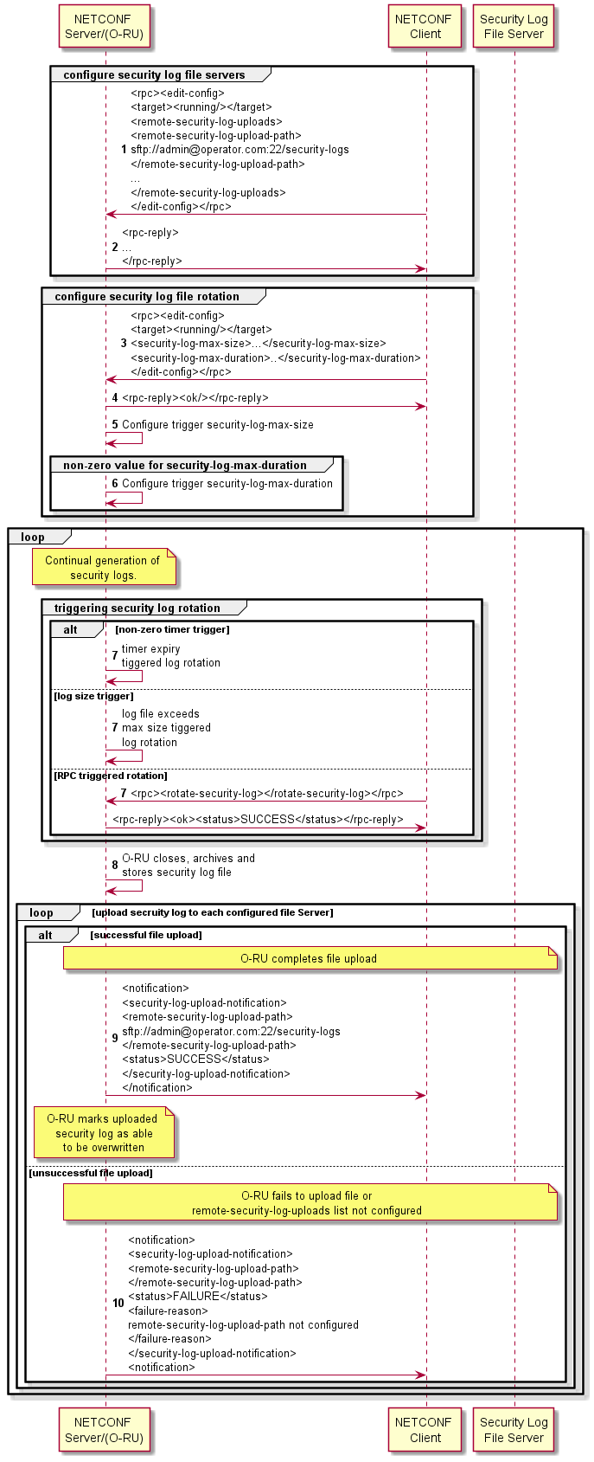
Figure 14.2.3.2-1: Security Log Operations

14.3 Trace
By requesting trace log files an O-RU controller is able to get them. Those trace log files contain collected log data files that can be used for trace purposes.
The O-RU can provide all possible trace log files. The contents and log formats are dependent on O-RU implementation.
The files should be compressed with compression method indicated by file name extension.
O-RU shall start collecting the trace logs at the moment of receiving <start-trace-logs> rpc. Notification <trace-log-generated> shall be periodically sent to O-RU controller whenever generated trace log files is(are) ready. File names of newly created log file(s) shall be included in notification. The number and size of files provided by O-RU in a single <trace-log-generated> notification is not restricted but the O-RU may keep the number and size of files reasonably small to allow completion of the whole "Trace data upload" scenario (all files from notification) within 15 minutes (with target to complete within 3 minutes) - assuming no additional upload restrictions from connectivity bandwidth or file server implementation.
NOTE 1: Timing of creating new group of trace log files is up to O-RU implementation.
After <stop-trace-logs> rpc received from O-RU controller, O-RU shall stop collecting trace logs and start generating trace log files which contain log data already collected after previous <trace-log-generated> notification.
The overall procedure is shown in Figure 14.3-1, with illustrative notification contents. Figure 14.3-1 shows the O-RU last <trace-log-generated> notification with the is-notification-last::'true' and file names of trace log files being signalled to the notification subscriber.
The file transfer mechanism for the created trace log files shall be handled by the file management described in clause 12.
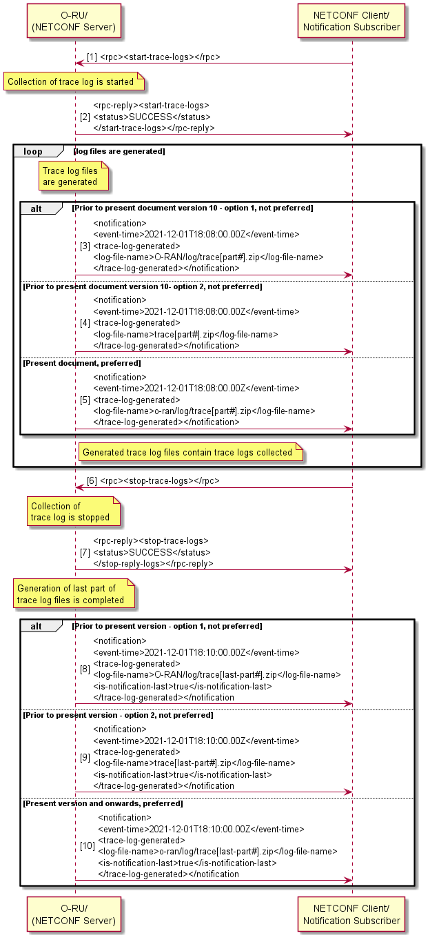
Figure 14.3-1: Overall Trace Log behaviour
NOTE 2: Prior to version 10, the present document contained inconsistent definition of the log-file-name string between Figure 14.3-1 and associated YANG models. In present document previously permitted content of node log-file-name is considered as not preferred. Not preferred file formats may be subject to removal in a future version of the present document.

14.4 Operational aspects of antenna line devices

14.4.1 Introduction
An O-RU can connect to one or more external equipment including antenna line devices such as a RET, MultiRET, MHA, RAE, etc.
- For the communication with antenna line devices, AISG 2.0 protocol [26] as Layer 7 application and HDLC protocol as Layer 2 data link are used.
- HDLC protocol as specified in ISO/IEC 13239 [65]. Detailed information can also be found in 3GPP TS 37.462 [27].
- AISG 2.0 protocol is standardised by "Control interface for antenna line devices Standard No. AISG v2.0" [26] which is an adaptation of Iuant interface application layer defined in 3GPP TS 37.466 [28].
An O-RU may provide one or more ALD ports supporting connection with Antenna Line Devices. Each ALD port shall be able to support more than one ALD (i.e. a chained ALD configuration).
Through the model O-RU may optionally inform about hardware relation between ALD port and O-RU connector(s) used by specific ALD port. In case more than one O-RU connector is used by single ALD port, O-RU may extend “overcurrent-report” notification by adding exact list of O-RU connectors for which overcurrent condition is detected.
This clause describes the communication mechanisms based on AISG 2.0 protocol as specified in AISG 2.0 [26]. For communication with external equipment, AISG 2.0 uses Application Part protocols (RETAP, TMAAP etc.) at Layer 7 and HDLC as a Layer 2 datalink protocol.

14.4.2 HDLC interworking
HDLC protocol is standardised by ISO/IEC 13239 [65]. Detailed information can also be found in 3GPP TS 37.462 [27].
NOTE: The assumed HDLC communication speed is 9 600 bits per second.
In order to handle collision detection in the HDLC branch, an O-RU supporting the ALD functionality shall support the following running counters reported using the corresponding YANG model:
- Frames with wrong FCS
- Frames without stop flag
- Number of received octets
For running counters served by the O-RU, both the O-RU and NETCONF Client shall handle wrap-over mechanism in a way, that wrap over zero is not considered as erroneous situation.
A NETCONF client can recover these counters. From the changes observed in above counters, a NETCONF Client can deduce the presence of a collision on the HDLC bus. Additional diagnostic information may be derived from how these counters are incrementing.
Additionally, the O-RU implements "RPC Status" to indicate status of last "ald-communication" RPC to requestor.
- Status - flow control indicator of last requested operation (Status of RPC).
Prior to any communication with ALD(s), the O-RU shall provide ALDs with DC power. The way of how DC power is managed is out of scope of the present document.

In order to support collision detection and flow control, Figure 14.4.2-1 defines the reference architecture with HDLC interworking functional split.
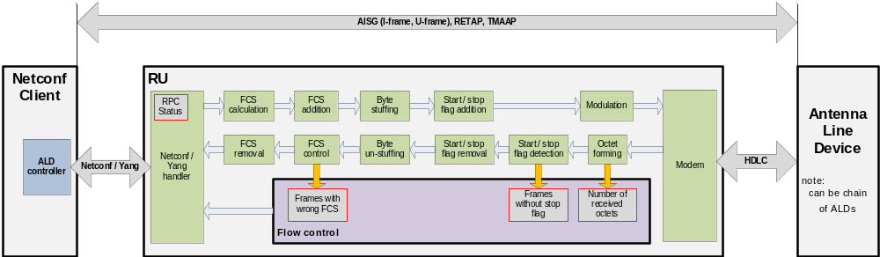
Figure 14.4.2-1: ALD Reference Architecture
The result of the above architecture is that below mentioned parts of HDLC message are processed by entities as illustrated in Figure 14.4.2-2.
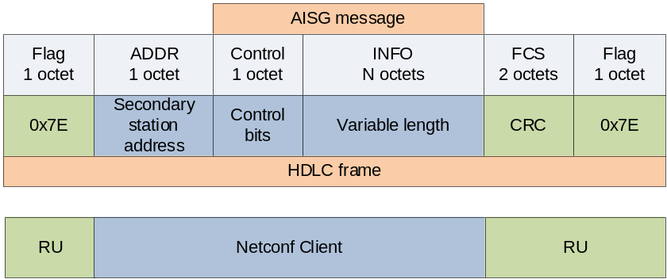
Figure 14.4.2-2: Component's responsibility split.

14.4.3 ALD operations
Figure 14.4.3-1 illustrates the ALD transfer procedure.
- The NETCONF Client sends RPC <ald-communication> to the O-RU. The RPC has following input parameters:
- leaf: port-id (uint8) - contains the identity of the ALD port. The O-RU shall output the data to (corresponds to O-RU resources provided to NETCONF Client as inventory information).
- leaf: ald-req-msg (up to 1 200 bytes) - may contain HDLC address, control bits and payload (see: 3GPP TS 37.462 for details).
The O-RU shall perform HDLC communication with the ALD as specified in [27] clause 4.5 "Message timing".
- Immediately after the requested payload is sent to the ALD over the desired ALD port, the O-RU switches the ALD port into reception mode.
- Bits received within reception window are formed to octets and inserted as payload into ald-resp-msg.
- The O-RU responds to the NETCONF Client using the <rpc-reply> message containing following parameters:
- leaf: port-id (uint8)
- leaf: status
- leaf: ald-resp-msg (up to 1 200 bytes)
- leaf: frames-with-wrong-crc (4 bytes)
- leaf: frames-without-stop-flag (4 bytes)
- leaf: number-of-received-octets (4 bytes)
In case there is no response from the ALD received within the reception window, the record "ald-resp-msg" in <rpc-reply> sent by the O-RU shall be empty.
- After reception, the O-RU shall wait a minimum of 3ms before the next transmission as per 3GPP TS 37.462, clause 4.5 "Message timing".
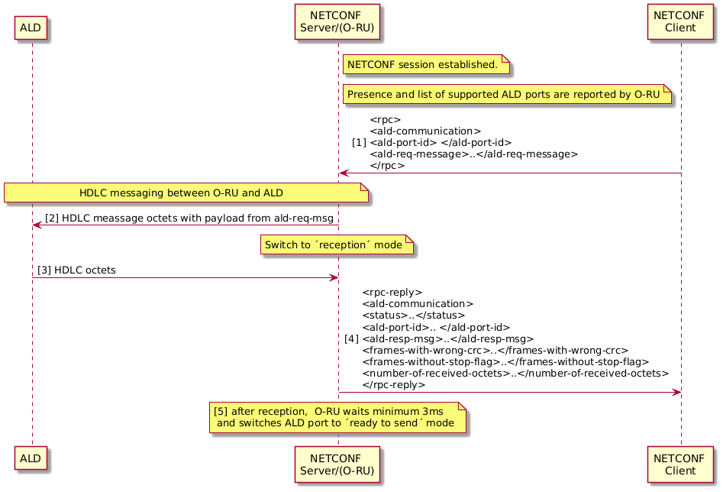
Figure 14.4.3-1: ALD Message Transfer
General scenario for HDLC link establishment
Precondition:
M-Plane connectivity between NETCONF Client and NETCONF Server is successfully established. NETCONF Server reports presence of the supported HDLC Primary Devices.
Procedure:
- NETCONF Client triggers DC voltage on desired ALD ports using NETCONF <edit-config> RPC. After DC is turned on - NETCONF Client shall wait at least 3 s.
- NETCONF Client performs HDLC bus scan using desired HDLC Primary Device offered by O-RU.
- NETCONF Client determines presence of HDLC Secondary Devices connected to the ALD port.
- NETCONF Client assigns HDLC addresses to desired HDLC Secondary Devices using HDLC Secondary Device unique id obtained from step 3-4 or from other pre-configured sources.
- NETCONF Client initiates link establishment with secondary devices by sending SNRM command and the secondary device answers with UA command which will be used in ald-resp-msg.
- NETCONF Client starts polling procedure for every HDLC-addressed Secondary Device.
NETCONF Client shall skip step 1. in the procedure if dc-control-support is reported with value false for the ALD port. NETCONF client may skip step 2 and/or 3 in the procedure. HDLC speed alignment between ALD ports and secondary device(s) that supports multiple speeds is performed prior to step 2, 3, 4. For detail of speed alignment, refer to [88] clause 4.1.
Postcondition:
Detected and addressed HDLC Secondary Devices are available for configuration.

14.5 Operational aspects of external IO

14.5.1 Introduction
An O-RU can connect to one or more input and output ports for external device supervision and control.
The External IO has the following functions:
- INPUT: Supervising external devices.
- OUTPUT: Controlling external devices.
Also, external IO function includes signalling to get the O-RU and O-RU controller in sync, enables port monitoring on the O-RU and provides notification from the O-RU to an O-RU controller, and provides control from an O-RU controller to the O-RU and enables output port controlling on the O-RU.
The O-RU only implements external IO yang module if the O-RU supports External IO aspect.
Through the model O-RU may optionally inform about hardware relation between External IO and O-RU connector(s) used by specific External IO. Separate O-RU connectors may be reported for single External IO.
A change in condition of the external IO shall not affect other O-RU services such as RF transmission / reception behaviour.

14.5.2 External input
This clause explains single external input line case. For multiple external inputs case, same behaviour for each input shall be processed individually.
For input, the O-RU and O-RU controller shall support two scenarios, as illustrated in Figure 14.5.2-1.
- To retrieve input state from O-RU controller and respond the input state from the O-RU to O-RU controller.
- To send notification from the O-RU to O-RU controller when input state is changed.
The value shall be:
- TRUE: Circuit is open.
- FALSE: Circuit is closed
When nothing is connected to the line the value shall be TRUE.
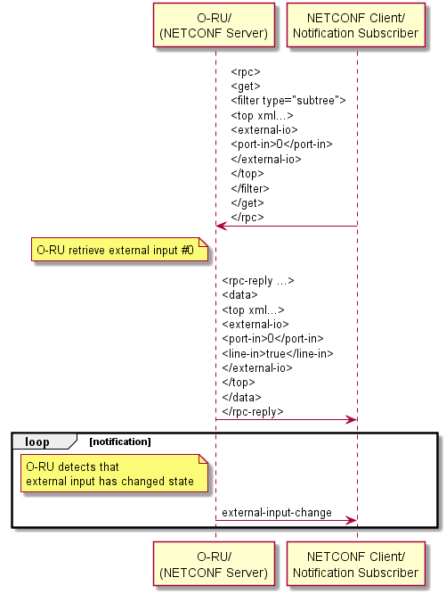
Figure 14.5.2-1: Retrieve external line-in

14.5.3 External output
This clause explains single external output line case. For multiple external outputs case, same behaviour for each output shall be processed individually.
For output, the O-RU and O-RU controller shall support two scenarios, as illustrated in Figures 14.5.3-1 and 14.5.3-2.
- To retrieve output state from O-RU controller and respond the output state from the O-RU to O-RU controller.
- To send edit-config from the O-RU to O-RU controller when output state change is required.
The value shall be:
- TRUE: Circuit is open.
- FALSE: Circuit is closed
The default values shall be TRUE.

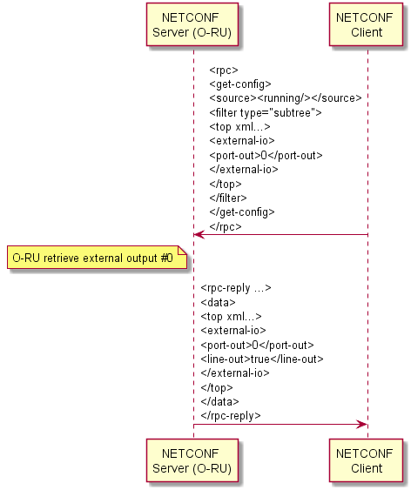
Figure 14.5.3-1: Retrieve external line-out
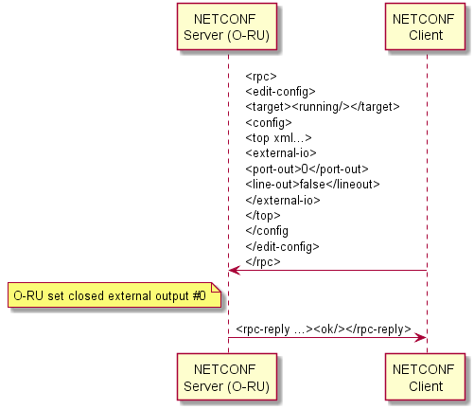
Figure 14.5.3-2: Control external line-out

14.6 O-RU connectors

14.6.1 Introduction to O-RU connectors
The O-RU may indicate presence and label of its physical connectors of specific type. The O-RU connectors can be exposed through o-ran-hardware.yang module as objects of class "O-RU-CONNECTOR". In the present document, coaxial antenna connectors serving for antenna feeders and beamforming-calibration lines are introduced.

14.6.2 Connectors related to antennas and antenna arrays

14.6.2.1 Antenna connectors
This clause describes usage of antenna connectors related to feeders (used to carry air interface signals between O-RU and external antennas or external antenna arrays) and beamforming calibration lines (used by O-RU i.e. to handle supplementary signals needed for external antenna arrays calibration).
Exposed O-RU Connectors of class "O-RU-ANTENNA-CONNECTOR" are based on class "O-RU-CONNECTOR" and are used in o-ran-uplane-conf.yang module to show how feeders and beamforming calibration lines are related to antenna arrays and their array elements. This allows to align configuration with physical cabling that technicians need to connect between O-RU and external physical antenna array.

14.6.2.2 Distinguishable types of antenna connectors

14.6.2.2.1 Feeder
Exposed O-RU connectors of class "O-RU-FEEDER" are based on class "O-RU-ANTENNA-CONNECTOR". Objects of this class are intended to represent physical connectors for coaxial feeders between O-RU and external antennas or antenna arrays. The feeder connector can be referenced by single array element of specific array, however in case the array element is shared between tx-array and rx-array or by multiband arrays, such O-RU connector is expected to be referenced by each of arrays containing array element fed with RF signals through such connector.
For this class of O-RU connectors, name shown in the model shall be identical to the label of physical connector visible on the O-RU's enclosure.

14.6.2.2.2 Beamforming calibration
Exposed O-RU connectors of class "O-RU-BF-CAL" are based on class "O-RU-ANTENNA-CONNECTOR". Objects of this class are intended to represent physical connectors for supplementary coaxial cables used in antenna calibration process for external antenna arrays. The beamforming calibration connector is to be referenced by group of array elements belonging to single array. This is also possible, that there will be references to few groups of array elements belonging to different antenna arrays (e.g. related tx-array and rx-array or arrays for different bands that share array elements).
For this class of O-RU connectors, name shown in the model shall be identical to the label of physical connector visible on the O-RU's enclosure.

14.6.3 Connectors related to other O-RU functions

14.6.3.1 Overview
This clause describes usage of other types of O-RU connectors physically available on O-RU's enclosure.
Exposed O-RU Connectors of classes described in this clause are based on class "O-RU-CONNECTOR" and are used in o-ran-ald-port.yang and o-ran-externalio.yang module to show how these connectors are related to internal O-RU elements.

14.6.3.2 RS-485 connectors
Exposed O-RU connectors of class "RS-485" are based on class "O-RU-CONNECTOR". Objects of this class are intended to represent physical connectors for RS-485 interface used e.g. for communication between O-RU and Antenna Line Devices.
For this class of O-RU connectors, name shown in the model shall be identical to the label of physical connector visible on the O-RU's enclosure.

14.6.3.3 External IO connectors
Exposed O-RU connectors of class "O-RU-EXTIO" are based on class "O-RU-CONNECTOR". Objects of this class are intended to represent physical connectors for externally available input / output lines that may optionally be offered by the O-RU.
For this class of O-RU connectors, name shown in the model shall be identical to the label of physical connector visible on the O-RU's enclosure.

15 Details of O-RU operations

15.1 Retrieval of O-RU information
This clause provides handling for O-RU controller(s) to retrieve O-RU information from O-RU. The further actions such as SW Management, U-plane configuration and Performance Management use these retrieved O-RU information.
The following information, for example, can be retrieved from the O-RU:
hw/hardware/component
- retrieve mfg-name - the name of the O-RU manufacturer
- retrieve serial-num –- the serial number of the O-RU
- retrieve software-rev - the version of the O-RU software build
o-ran-hardware/hardware/component/
- retrieve product-code - the O-RAN defined product code
o-ran-operations/operational-info/declarations
- retrieve supported-mplane-version - the version of the O-RAN M-Plane interface
- retrieve supported-cusplane-version - the version of the O-RAN CUS-Plane interface
- retrieve supported-header-mechanism - the type of C/U plane headers supported by the O-RU
o-ran-operations/operational-state
- retrieve restart-cause – the reason for the last restart
o-ran-sync/sync
- retrieve sync-state – the synchronisation state of the O-RU
The detail of O-RU information, see corresponding YANG modules in Annex D.

15.2 User plane message routing

15.2.1 Introduction
The purpose of U-Plane configuration is to define the relationship between U-Plane application endpoints in the O-DU and those in the O-RU. After such relationships are defined, the application endpoints are able to exchange IQ data using the U-Plane application protocol defined in clause 5.4 of [2].
Precondition:
- M-Plane connectivity is established between NETCONF Client and NETCONF Server.

15.2.2 Configurable format for eAxC_ID
The eAxC_ID is used by C/U-plane application to manage eCPRI communication between desired C/U-Plane application components in O-DU and O-RU.
As defined in clause 5.1.3.2.7 of [2], the eAxC_ID consists of four parameters: DU_Port_ID, RU_Port_ID, CC_ID and BandSector_ID. Order of parameters in eAxC_ID shall follow definitions in CUS-Plane spec. In this version of the O-RAN WG4 specification, the length of eAxC_ID is constant and equal to 16 bits. To enable optimal sharing of the 16 bits between these four parameters, the assignment of eAxC_ID bits to parameters is not fixed. As a consequence, there is a need for NETCONF client to configure the bit assignment to parameters mappings using the M-Plane interface.
NOTE 1: [2] refers to the eAxC_ID parameters as DU_Port_ID, RU_Port_ID, CC_ID and BandSector_ID and the present document and associated YANG models refer to the eaxc-id parameters as du-ports, ru-ports, cc-ids and band-sectors.
To handle flexible bit assignment, configurable bitmasks are defined for each parameter.
NOTE 2: Flexible configuration means, that bits of eAxC_ID can be assigned to parameters in runtime.
Rules to be followed by NETCONF Client when configuring bit assignments:
- notation used for parameters forming eAxC_ID is from the LSB.
- each parameter uses consecutive bits.
- each parameter can occupy 0-16 bits.
- single bit of eAxC_ID cannot be assigned to more than one parameter.
RPC edit-config shall be used to configure bit assignments to O-RU.
Bit assignment change for parameters related to an existing carrier is not allowed. (Impacted carriers need to be deactivated and deleted prior to any change in eAxC_ID configuration, and then be subsequently created and activated.)
An example of bit assignment usage where 3 bits are assigned to the BAND-SECTOR-ID, 3 bits for CC-ID, 7 bit for DU-PORT-ID and 3 bits for RU-PORT-ID is shown below:
<o-du-port-bitmask>1111111000000000</o-du-port-bitmask>
<band-sector-bitmask>0000000111000000</band-sector-bitmask>
<ccid-bitmask>0000000000111000</ccid-bitmask>
<ru-port-bitmask>0000000000000111</ru-port-bitmask>
Configuration of e-axcid for a given low-level-[tr]x-endpoint requires four bitmask values: o-du-port-bitmask, band-sector-bitmask, ccid-bitmask, and ru-port-bitmask. One specific combination of these four bitmask values defines one eAxC_ID format. An O-RU shall be configured with a single eAxC_ID format. An O-RU controller may configure different O-RUs with different eAxC_ID formats.

15.2.3 U-Plane endpoint addressing
Parameter "eaxc-id" for low-level-tx-endpoint and low-level-rx-endpoint, defined using an unsigned 16-bit integer, shall follow the eaxc-id addressing schema defined in clause 15.2.2. Refer to the eaxc-id parameter description in CUS plane specification clause 5.1.3.2.7 of [2].
The NETCONF Client shall assign unique values to the "eaxc_id" addresses to all low-level-rx-endpoint elements and low-level-tx-endpoint elements, within the O-RU when operating in the same direction (Tx or Rx), even when these operate across different named interfaces of the O-RU.
More precisely, the same eaxc-id cannot be simultaneously assigned to multiple low-level-rx-endpoints or to multiple and low-level-tx-endpoints. Clarifying eaxc-id assignment by example, and unless otherwise specified, within the same O-RU (considering a 2 × 2 MIMO):
Case 1: Allowed eaxc-id assignment (same antenna ports used for Tx and Rx)
- low-level-rx-endpoint (name 1) - eaxc-id=1
- low-level-tx-endpoint (name 1) - eaxc-id=1
- low-level-rx-endpoint (name 2) - eaxc-id=2
- low-level-tx-endpoint (name 2) - eaxc-id=2
Case 2: Allowed eaxc-id assignment (separate antenna ports used for Tx and Rx)
- low-level-rx-endpoint (name 1) - eaxc-id=1
- low-level-tx-endpoint (name 1) - eaxc-id=2
- low-level-rx-endpoint (name 2) - eaxc-id=3
- low-level-tx-endpoint (name 2) - eaxc-id=4
Case 3: Prohibited eaxc-id assignment (separate antenna ports used for Tx and Rx)
- low-level-rx-endpoint (name 1) - eaxc-id=1
- low-level-tx-endpoint (name 1) - eaxc-id=2
- low-level-rx-endpoint (name 2) - eaxc-id=1
- low-level-tx-endpoint (name 2) – eaxc-id=2
The O-RU shall reject any configuration that corresponds to a prohibited eaxc-id assignment.

15.2.4 General configuration scenario
Below is the general scenario to be followed by a NETCONF Client in order to properly configure communication between C/U-Plane endpoints in the O-DU and O-RU.
Operations can be performed in other order (including combining some of them in one request) than provided below assumed the highlighted rules are followed and result (overall configuration) of each request sent by NETCONF Client is valid.
Selected highlighted rules below:
- eaxc-id shall be unique for all low-level-[tr]x-endpoints within the O-RU in the same direction (Tx or Rx) and linked with any low-level-rx-link or low-level-tx-link.
- at the moment of creation, every low-level-rx-link shall be linked to an existing rx-array-carrier, an existing low-level-rx-endpoint and an existing processing-element (or an existing transport-qualified-processing-element when the processing element is configured by the list additional-transport-session-type-elements). In this latter case, the O-RU shall use the /user-plane-configuration/low-level-rx-links/transport-qualified-processing-element schema nodes instead of the /user-plane-configuration/low-level-rx-links/processing-element schema node, an O-RU Controller shall still configure the processing-element schema node in the low-level-rx-links list with a leafref to valid ru-element, but this shall not be used by the O-RU.
- at the moment of creation, every low-level-tx-link shall be linked to an existing tx-array-carrier, an existing low-level-tx-endpoint and an existing processing-element (or an existing transport-qualified-processing-element when the processing element is configured by the list additional-transport-session-type-elements). In this latter case, the O-RU shall use the /user-plane-configuration/low-level-tx-links/transport-qualified-processing-element schema nodes instead of the /user-plane-configuration/low-level-tx-links/processing-element schema node, an O-RU Controller shall still configure the processing-element schema node in the low-level-tx-links list with a leafref to valid ru-element, but this shall not be used by the O-RU.
In the selected highlighted rules, the word "existing" includes nodes created in the same edit-config operation.
The O-RU shall support configuration of [tr]x-array-carrier(s), low-level-[tr]x-endpoint(s), processing element(s) and low-level-[tr]x-link(s) in the same RPC edit-config.
The O-RU shall support configuration of [tr]x-array-carrier(s), low-level-[tr]x-endpoint(s), processing element(s) and low-level-[tr]x-link(s) in the separate RPC edit-config(s).
NOTE: The above requirements are not limited to low-level-[tr]x-link configuration.
- NETCONF Client determines the presence of following operational data offered by NETCONF Server:
- tx-array(s) - by fetching the list of tx-arrays in o-ran-uplane-conf.yang
- rx-array(s) – by fetching the list of rx-arrays in o-ran-uplane-conf.yang
- endpoint-type(s) – by fetching list endpoint-types in o-ran-uplane-conf.yang
- static-low-level-tx-endpoint element(s) – by fetching the list static-low-level-tx-endpoints in o-ran-uplane-conf.yang
- static-low-level-rx-endpoint element(s) – by fetching the list static-low-level-rx-endpoints in o-ran-uplane-conf.yang
- endpoint-capacity-sharing-group(s)- by fetching list endpoint-capacity-sharing-groups in o-ran-uplane-conf.yang if it is reported
- endpoint-bf-profile-group(s) - by fetching list endpoint-bf-profile-group in o-ran-uplane-conf.yang if O-RU supports YANG feature BF-DELAY-PROFILE
- interface(s)– by fetching list of interfaces in o-ran-interfaces.yang
- O-RU's connector(s) – by fetching list of related-o-ru-connectors (if exist) in o-ran-uplane-conf.yang
- NETCONF Client determines capabilities exposed by endpoint-type(s), static-low-level-tx-endpoint(s) and static-low-level-rx-endpoint(s). Additionally. NETCONF Client determines capabilities exposed by endpoint-capacity-sharing-groups and specific parameters proprietary to [tr]x-array(s).
- For operational data determined in step 1) NETCONF Client examines the relationship between:
- static-low-level-tx-endpoint(s) and tx-array(s) in o-ran-uplane-conf.yang
- static-low-level-rx-endpoint(s) and rx-array(s) in o-ran-uplane-conf.yang
- endpoint-type and all static-low-level-[tr]x-endpoint(s) of this endpoint-type
- each endpoint-capacity-sharing-group and member static-low-level-[tr]x-endpoint(s)
- each endpoint-type and all endpoint-bf-profile-group(s) it supports
- each static-low-level-tx-endpoint and interface
- each static-low-level-rx-endpoint and interface
- tx-array(s), rx-array(s) and their elements in o-ran-uplane-conf.yang
- o-ru-connector(s) and [tr]x-array in o-ran-uplane-conf.yang (if available)
- interface(s) and port(s) in ietf-interfaces.yang (with o-ran port-reference augmentation)
NOTE 2: NETCONF Client retrieves the content of o-ran-beamforming.yang module to obtain knowledge regarding beamforming-related parameters that apply for particular NETCONF Server. This step is optional, as o-ran-beamforming.yang module exists only in case NETCONF Server supports beamforming. Obtained parameters are needed by Netconf Client to perform beamforming control.
- NETCONF Client determines the endpoint's ability of all supported beamforming methods list and related delay profiles. Information about beamforming method lists supported by endpoints is exposed through parameter endpoint-bf-profile-group. If the beamforming method list does not report its associated supported-delay-profile, it uses the default bandwidth-scs-delay-state list to find its delay parameter values. Each bf-profile-id is used to identify an endpoint-bf-profile-group which indicates a list of beamforming methods that can be used simultaneously, and delay profiles associated with each list of beamforming methods. When O-RU indicates support for a combination of BF-METHOD(s) and associated delay-profile per endpoint, all endpoints supporting the same combination of BF-METHOD(s) shall advertise the same delay-profile value. Multiple bf-profile-id(s) capabilities can be exposed by endpoint-types.
- NETCONF Client determines each static-low-level-rx-endpoint's ability to support non-time managed and/or time managed traffic. Information about managed delayed traffic type supported by an endpoint-type is exposed through parameter managed-delay-support (enumeration) and it indicates whether the endpoints of this particular endpoint-type can support time managed traffic (MANAGED), non-time managed traffic (NON_MANAGED), or both (BOTH).
- NETCONF Client determines and selects static-low-level-rx-endpoint(s) and static-low-level-tx-endpoint(s), that are suitable for the desired O-DU cell configuration to be used for configuring array carriers.
Example considerations for selection are listed below:
- Transport aspect: static-low-level-rx-endpoint and static-low-level-tx-endpoint selected should be accessible via the intended interface(s), extra consideration is needed for optional interface restrictions declared by static-low-level-[tr]x-endpoints
- Antenna array: O-DU's intention of which antenna array is going to be used by the O-DU cell related configuration will be input for selection
- Type of traffic: O-DU's intention of type of traffic to be used on endpoint, for example, non-time managed traffic or time managed traffic will be input for selection
- Beamforming type: O-DU's intention for beamforming type to be used for UL and DL will impact selection
- NETCONF Client performs C/U-Plane transport configuration between O-DU and O-RU. NETCONF Client configures interfaces and creates processing-elements related to the interfaces offering access to selected endpoints (suitable in terms of capabilities and able to process signals related with desired [tr]x-array) and ports (suitable in terms of capabilities and able to transfer signals from/to a desired interface). Details of configuring interfaces and processing-elements are described in clause 7.
- Once transport layer is configured, O-DU may perform initial verification of C/U Plane Transport Connectivity as described in clause 7.6 - with respect to content of list "restricted-interfaces" every selected endpoint is reachable through.
- NETCONF Client creates low-level-tx-endpoints and low-level-rx-endpoints referring to static-low-level-tx-endpoints and static-low-level-rx-endpoints determined and selected in step 6) as suitable for desired array-carrier configuration. NETCONF Client assigns unique eaxc-id(s) values to every created low-level-[tr]x-endpoint. Obtained information from step 2)-5) shall be respected when NETCONF Client configures low-level-[tr]x-endpoints referenced to static-low-level[tr]x-endpoints by parameter name.
NOTE 3: Uniqueness of eaxc-id is mandatory within the O-RU in the same direction (Tx or Rx) even across interface elements having relationship to low-level-rx-endpoint elements or low-level-tx-endpoint elements.
In case NETCONF Client wants particular value of eAxC_ID to be used for non-time managed traffic, NETCONF Client shall assign this eAxC_ID to parameter "eaxc-id" belonging to low-level-rx-endpoint, that is capable to support non-time managed traffic (as per reference to capabilities exposed by corresponding static-low-level-rx-endpoint corresponding to low-level-rx-endpoint by name).
When assigning eAxC_ID to a low-level-rx-endpoint, NETCONF Client shall also configure whether the low-level-rx-endpoint is to work in non-time-managed mode (when applicable) or not using non-time-managed-delay-enabled. NETCONF client shall not change time management types of a low-level-rx-endpoint in case there is traffic served by the endpoint. Configuration is assumed to be static for run-time.
When NETCONF server declares that an endpoint supports multiple bf-profile-id(s), NETCONF Client may configure configured-bf-profile-id in the list of low-level-[tr]x-endpoint to one of the values reported in bf-profile-group reported in the related endpoint-type and the O-RU shall use it. If the NETCONF Client does not configure configured-bf-profile-id per endpoint, the O-RU shall use the beamforming method determined by section type supported by endpoint and default delay profile.
- NETCONF Client creates tx-array-carrier(s) and rx-array-carrier(s). The tx-array-carriers and rx-array-carriers can be configured with type set to LTE, NR or DSS-LTE-NR. The configuration of array carrier with type DSS-LTE-NR is only allowed when the O-RU supports Dynamic Spectrum Sharing (DSS) feature as indicated by feature DSS_LTE_NR in o-ran-module-cap.yang. If the O-RU indicates it supports the feature DSS_LTE_NR but does not support Section Extension 9, then instead of configuring a carrier as DSS-LTE-NR, the O-DU shall configure DSS by using different eAxC ids (i.e. different endpoints) as described in CUS plane specification clause 7.2.6 of [2].
Table 15.2.4-1: Centre Bandwidth Calculation
Type | N_{RB} | Centre of channel bandwidth  (same as F_{REF} as defined in clause 5.4.2.1 of 3GPP TS 38.104 [66])
LTE or DSS | N_{RB}mod2=1 | Between (k-1) RE and k RE of n_{PRB} RB
LTE or DSS | N_{RB}mod2=0 | Between the highest RE of (n_{PRB}-1) RB and k RE of n_{PRB} RB
NR | N_{RB}mod2=1 | Centre of k^{th} RE of n_{PRB} RB
NR | N_{RB}mod2=0 | Centre of k^{th} RE of n_{PRB} RB

The parameters k, n_{PRB} and N_{RB} referenced here are specified in Table 5.4.2.2-1 of 3GPP TS 38.104.
- NETCONF Client creates low-level-[tr]x-link(s) to make relationship between low-level-[tr]x-endpoint(s), [tr]x-array-carriers and processing-elements belonging to transport. Respective TX path and RX path linkage shall be followed. This is illustrated in Figure 15.2.4-1.
NOTE 4: C/U-Plane traffic can be prioritized by reference user-plane-uplink-marking indicated by low-level-rx-link in o-ran-uplane-conf.yang. The reference is to o-ran-processing-element.yang, where it is linked to up-marking-name. Further the up-marking-name points to o-ran-interfaces.yang, where it ends up pointing to priority depending on actually used u-plane transport (either PCP for Ethernet or DSCP for IP). For details regarding priorities see [2], clause 5.3.
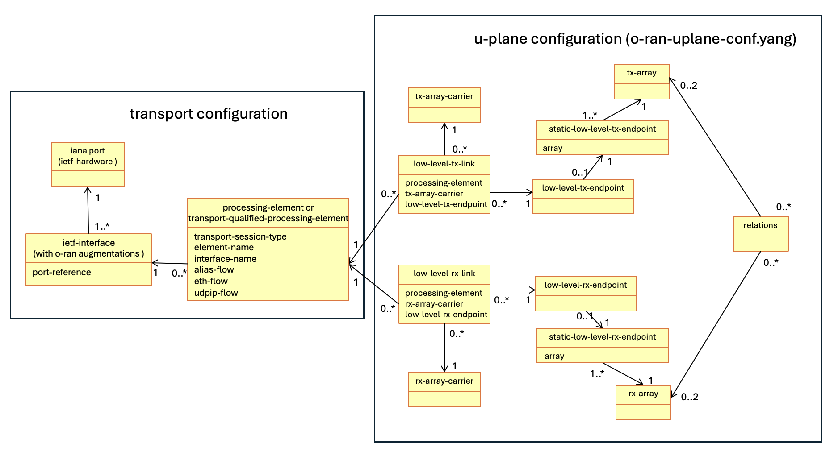
Figure 15.2.4-1: Diagram showing relations between CU-Plane and carrier management elements
Detailed contents of objects shown in "u-plane configuration" box in Figure 15.2.4-1 are defined in the o-ran-uplane-conf.yang module.
High level sequences about carrier creation are described in clause 15.3.1.

15.3 Carrier configuration

15.3.1 Carrier creation
This clause provides high level scenario for carrier creation procedure. Precondition for below steps are steps 1 to 6 from clause 15.2.4. The below steps are covered by steps 7 and 9 to 11 in clause 15.2.4 where those steps are described with more details.
- NETCONF Client creates the tx-array-carriers in relation to the desired tx-arrays.
NOTE 1: Generally the number of tx-array-carriers is the same as multiple of the desired number of tx-arrays and the number of component carriers.
- NETCONF Client creates the rx-array-carriers in relation to the desired rx-arrays.
NOTE 2: Generally the number of rx-array-carriers is the same as multiple of the desired number of rx-arrays and the number of component carriers.
- NETCONF Client creates the processing-elements related to interfaces offering access to endpoints.
- NETCONF Client creates low-level-tx-endpoints and low-level-rx-endpoints related to desired static-low-level-tx endpoints and static-low-level-rx-endpoints respectively.
- NETCONF Client creates the low-level-tx-links containing relationship to the existing tx-array-carriers, low-level-tx-endpoints and existing processing-elements.
- NETCONF Client creates the low-level-rx-links containing the relationship to existing rx-array-carriers, low-level-rx-endpoints and existing processing-elements.
With the above steps successfully performed, the relationship between C/U-Plane application endpoints at O-DU and O-RU is configured.

15.3.2 Activation, deactivation and sleep
The NETCONF Client performs activation of a tx/rx-array-carrier by setting the value of the parameter active at tx-array-carrier element /rx-array-carrier element to "ACTIVE".
The NETCONF Client performs deactivation of a tx/rx-array-carrier by setting the value of the parameter active at tx-array-carrier element / rx-array-carrier element to "INACTIVE"
Communication between related O-DU and O-RU's C/U-Plane endpoints is enabled under condition, that for corresponding tx-array-carrier or rx-array-carrier value of parameter active is "ACTIVE" and value of parameter state is "READY". Otherwise, communication is disabled.
The NETCONF Client can put the tx-array-carrier / rx-array-carrier to sleep by setting value of parameter active in the corresponding tx-array-carrier element / rx-array-carrier element to "SLEEP".
A particular tx-array-carrier / rx-array-carrier is in sleep mode when value of its parameter active is "SLEEP" and value of its parameter state is "READY". To save energy, O-RU may disable all array elements of tx-array / rx-array associated with the tx-array-carrier / rx-array-carrier in sleep mode provided there is no impact to operation of other tx-array-carriers / rx-array-carriers. This means that, the O-RU may disable tx-array / rx-array array elements only if all affected tx-array-carriers / rx-array-carriers (associated with the tx-array / rx-array or any tx-array / rx-array that shares elements with the tx-array / rx-array) are in sleep mode, as defined in this clause. For any newly activated tx-array-carrier / rx-array-carrier, the O-RU shall use the antenna mask (refer to clause 20.3.2), if an antenna mask is configured, for the tx-array / rx-array associated with the tx-array-carrier / rx-array-carrier.
If a tx-array-carrier / rx-array-carrier is assigned to a tx-array / rx-array all of whose array elements are at that time disabled due to sleep mode as defined in this clause, O-RU shall enable all those array elements of the tx-array / rx-array to allow array carrier activation.
O-RU shall not autonomously change [tr]x-array-carrier::active to "ACTIVE".
For detailed description of tx-array-carriers and rx-array-carriers, refer to description substatement in YANG models.
Figure 15.3.2-0a shows the flow for successful carrier activation and illustrates the communication between the O-RU and O-DU during carrier activation procedure.
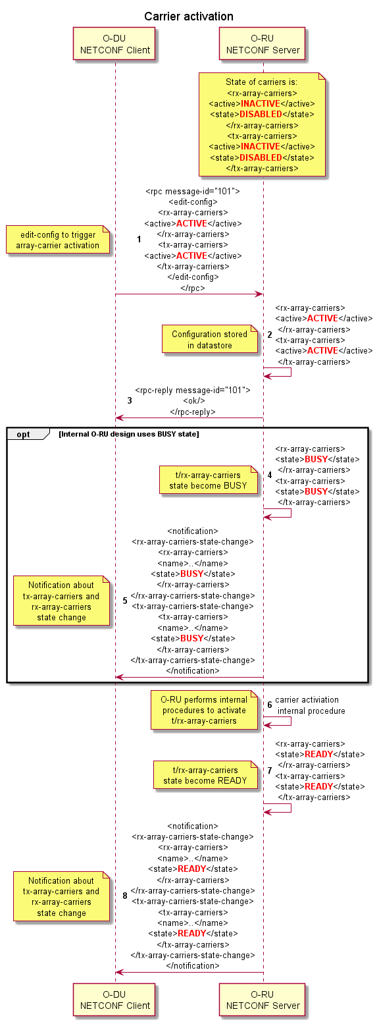
Figure 15.3.2-0a: Carrier activation sequence
Figure 15.3.2-0b shows a flow for carrier deactivation and illustrates the communication between the O-RU and O-DU during carrier deactivation procedure.

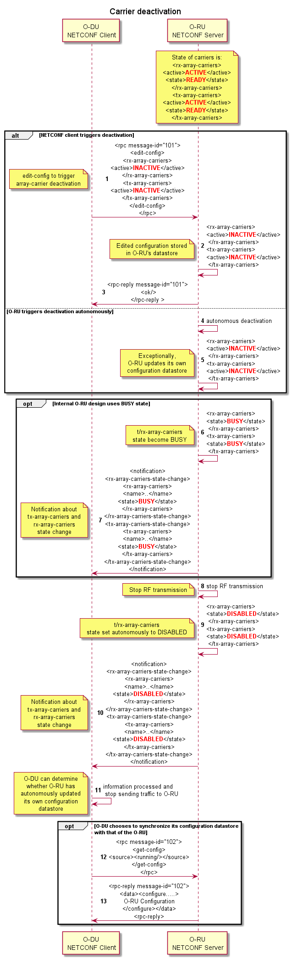
Figure 15.3.2-0b: Carrier deactivation sequence
The O-RU may optionally expose parameter availability-status for configured [tr]x-array-carrier(s). This availability-status parameter is intended to supplement parameter state. Refer to [77] clause 8.1.2.3 for definition of availability status and values. This allows O-RU to provide the current status about various conditions related to a [tr]x-array-carrier, as shown in Table 15.3.2-1.
Table 15.3.2-1: Availability Status
Value of availability-status | Current condition of [tr]x-array-carrier | Notes
(empty) | There are no faults that impact the [tr]x-array-carrier state
FAILED | There is at least one fault related to source internal to array carrier resources that made the ACTIVE [tr]x-array-carrier to turn to INACTIVE and/or makes INACTIVE [tr]x-array-carrier not able to become ACTIVE.
DEPENDENCY | There is at least one fault related to source external to array carrier resources that made the ACTIVE [tr]x-array-carrier to turn to INACTIVE and/or makes INACTIVE [tr]x-array-carrier not able to become ACTIVE. | Example of fault related to external source can be the one related to lost synchronisation source.

Figure 15.3.2-1 shows possible transitions and values combination to be followed by "active" and "state". Combination or transitions outside of below diagram is not allowed.
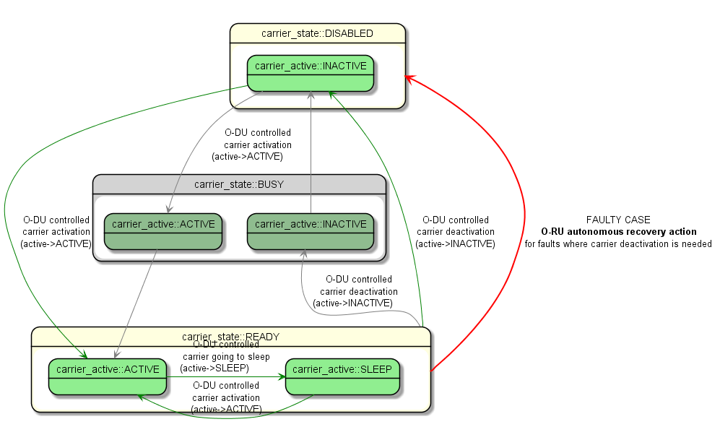
Figure 15.3.2-1: Diagram showing all possible transitions and combination of "active" and "state" parameters
NOTE: BUSY state is only available during transition and existence of this state depends on internal O-RU design.
In the above diagram, O-RU may autonomously deactivate array carriers due to some faults which can impact array carrier state. In such case, for the O-RUs that support array carrier availability-status and are unlocked, the availability-status for the array-carriers shall be set to either FAILED and/or DEPENDENCY.For the locked O-RU (admin-state locked), its array carrier state handling is described in clause 9.1.3 section admin-state.
For a O-RU that supports array carrier availability-status, if a fault occurs affecting an array carrier's resources, availability-status of the array carrier shall be updated regardless of the value of active (ACTIVE or INACTIVE).
When [tr]x-array-carrier's availability-status, or state or both is/are changed, notification [tr]x-array-carriers-state-change shall be sent to subscribers. The changed state (state and/or availability-status)shall be indicated in the notification.

15.3.3 Carrier state's relationship to synchronization state

15.3.3.1 Synchronization state and carrier state transitions
The O-RU shall update tx-array-carrier and rx-array-carrier states based on the O-RU's sync-state. The flow chart shown in Figure 15.3.3.1-1 illustrate the possible transitions and associated parameters values for the two array-carrier in the possible synchronization state. When the O-RU implements HOLDOVER, tx-array-carrier and rx-array-carrier possible states and transitions shall be the same for sync LOCKED and HOLDOVER mode. When O-RU transitions to the FREERUN state the only possible tx-array-carrier and rx-array-carrier state is DISABLE/INACTIVE. Figure 15.3.3.1-1 shows possible transitions and according to parameters value combination.
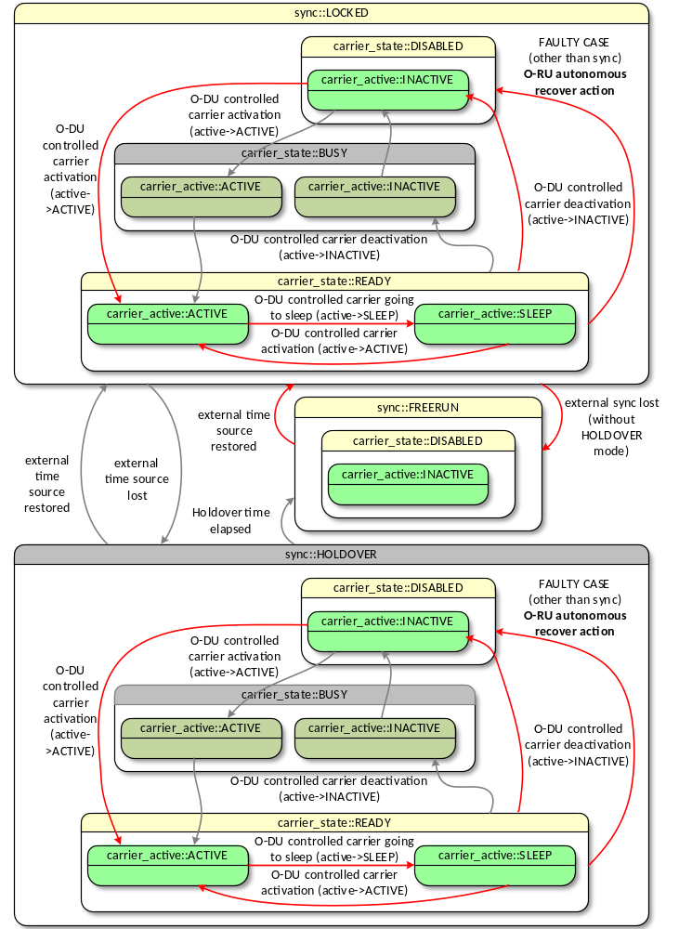
Figure 15.3.3.1-1: Combination of tx-array-carrier/rx-array-carrier transitions and allowed states compared to sync state
When an O-RU changes its synchronization state sync-state to FREERUN, it shall perform carrier deactivation of all active tx-array-carrier(s) and rx-array-carrier(s). The O-RU shall communicate the synchronization-state-change, tx-array-carriers-state-change and rx-array-carriers-state-change notifications to all notification subscribers.
The following two sections describe the tx-array-carrier/rx-array-carrier behaviour and O-RU/O-DU communication when synchronization is lost, and when synchronization is restored.

15.3.3.2 Synchronization lost and HOLDOVER mode expired
Figure 15.3.3.2-1 shows the tx-array-carrier and rx-array-carrier behaviour and illustrates the communication between the O-RU and O-DU when O-RU loose synchronization and enters to FREERUN mode. The process can be divided into 5 steps as shown in Figure 15.3.3.2-1and briefly described below.
- If the O-RU implements the optional HOLDOVER state, once the O-RU detects that it has lost connection to its timing source and its sync-state moves to HOLDOVER, the O-RU will send a synchronization-state-change notification to one (or more) subscribed O-DU(s) indicating that the O-RU is in HOLDOVER. If the O-RU does not implement HOLDOVER, then this step is skipped.
- After the O-RU HOLDOVER timer expires, or if the O-RU does not implement HOLDOVER, the O-RU moves the sync-state to FREERUN.
- The O-RU sends a synchronization-state-change notification to all subscribed O-DUs indicating that the O-RU is in FREERUN.
- The O-RU deactivates all active array-carriers, stops RF transmission and ceases sending traffic to O-DU.
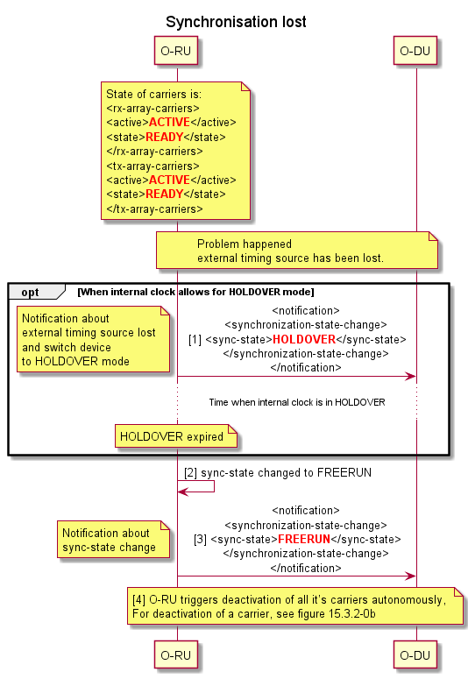
Figure 15.3.3.2-1: Synchronisation lost scenario

15.3.3.3 External timing source restored
Figure 15.3.3.3-1 shows how tx-array-carrier and rx-array-carrier can be reactivated when external timing source is restored, and it illustrates the communication between O-RU and O-DU to restore operation between O-RU and O-DU.
The restoration process can be divided into 4 steps as shown in Figure 15.3.3.2-1 and described below.
- Once the O-RU detects that synchronization has been restored, it changes the sync-state to LOCKED, and then sends a synchronization-state-change notification to all subscribed O-DUs.
- The O-RU then waits for the O-DU reaction.
- O-DU triggers activation of all O-RUs carriers. For activation of a carrier, see figure 15.3.2-0a.
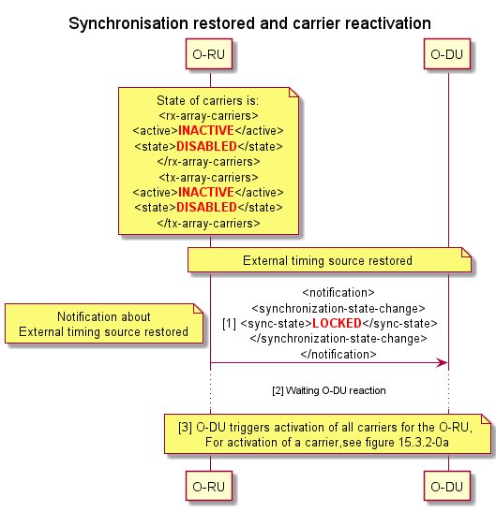
Figure 15.3.3.3-1: Synchronisation restored and carrier reactivation scenario

15.4 Beamforming

15.4.1 Beamforming configuration
The beamforming functionality allows the O-RU to influence the angle of the main lobe of the signal which is radiated from/received by the O-RU. Beamforming support is optional, and an O-RU shall indicate that it supports such functionality by indicating that it supports the "urn:o-ran:beamforming:x.y" namespace.
A multi-band capable O-RU shall be able to support independent beamforming configuration on each of its supported tx-arrays and/or rx-arrays depends on O-RU antenna configuration.
An O-RU indicates the support of a beamforming mode of operation per endpoint. Endpoints capable of either BF or non-BF operation are distinguished by the capabilities exposed by endpoint-types in endpoint-beam-capacity grouping.
Arrays capable of BF operation are distinguished by the relation to the endpoints and the reference from o-ran-beamforming yang module.

15.4.2 Pre-defined beamforming configuration
In case the O-RU supports beamforming, the o-ran-beamforming.yang and o-ran-uplane-conf.yang modules are used to report the pre-defined relationship between supported beams to a NETCONF client. A capabilities-group is used to uniquely identify separate tx-arrays and/or rx-arrays supported by an O-RU with the beamforming configuration referencing the set of tx-arrays and rx-arrays that are associated with this capabilities-group.
A default service area of the O-RU is determined as the grid of pre-defined beams. When O-RU updates beamforming configuration as described in clause 15.4.3, the grid of pre-defined beams can be newly defined. In this case, the default service area is changed accordingly.
O-RU may support new service area by applying tilt-offset to the given default service area in elevation and/or azimuth domains as described in clause 15.4.3.

15.4.3 Beamforming configuration update
This clause provides the method to modify and to apply the beamforming configuration (weights, attributes and/or beam properties). The modification of the beamforming information is allowed only if O-RU supports the feature "MODIFY-BF-CONFIG" used for defining the modification of beamforming configuration.
The beamforming configuration is stored in the O-RU and comes from the O-RU's software, treated in clause 8. The O-RU shall locate the beamforming configuration file in the generic folder, i.e. O-RAN/beamforming/ or o-ran/beamforming/.
To modify the beamforming configuration, the following steps are applied.
- NETCONF client can retrieve the file list of the O-RU's folder: O-RAN/beamforming/ or o-ran/beamforming/.
- NETCONF client can trigger the upload of the beamforming configuration file from the O-RU's folder.
- Operator can recover the uploaded file and edit the beamforming configuration file offline.
- NETCONF client can download the file to the original folder.
The modified beamforming configuration file shall not have the same name as any other file in the folder. Its file name is the matter of implementation.
The beam properties in o-ran-beamforming YANG module contain coarse-fine, coarse-fine-beam-relation and neighbour-beam for each beam-id. This information is received from the O-RU as O-RU's capability at O-RU start-up and typically are used by the scheduler in O-DU. A NETCONF client (O-RU Controller) can modify the beamforming information via file described in this clause. When the beamforming configuration (weight, attribute and beam properties) is modified via file, the configuration of the beam properties list in the o-ran-beamforming YANG module should be modified together via the same file if affected by the modified weight and/or attribute.
An O-RU supporting the modification of beamforming configuration shall support the storage of at least two beamforming files per capabilities-group supported. For each capabilities-group, one file corresponds to the pre-defined (factory, read-only) beamforming configuration and at least one file corresponds to a modified (read-write) beamforming file. The O-RU has the responsibility to remove existing file and prepares space for new file when the NETCONF client file-download rpc is issued. When the O-RU only supports the storage of a single modified (read-write) beamforming file per band of operation, i.e. number-of-writeable-beamforming-files (sic) = 1 the file-download operation for the modified beamforming configuration needs to be done while neither tx-array-carriers nor rx-array-carriers are configured in the O-RU to avoid the removal of the modified beamforming configuration file for the current active software.
If the O-RU supports the capability to store two or more modified beamforming configuration files per band of operation in the O-RU, i.e. number-of-writeable-beamforming-files > 1, the NETCONF file-download operation can be performed without any timing limitation. That is because the modified beamforming configuration file for the beamforming configuration can be kept during the file-download operation. To apply the new modified beamforming configuration, the following steps are applied:
- The NETCONF client can download the file to the beamforming folder if the O-RU supports the capability number-of-writeable-beamforming-files > 1.
- If the O-RU doesn’t support in-service-bf-update, the NETCONF client shall deactivate tx-array-carriers and rx-array-carriers in the U-Plane configuration by setting "INACTIVE" for the active parameters if they are ACTIVE. When the supported capability in-service-bf-update is advertised by the O-RU, and if the NETCONF client supports the beamforming configuration update in service and when NULL-STEERING is not enabled, i.e when null-control-method is not configured, the NETCONF client can activate the modified beamforming configuration without deactivating and deleting tx-array-carriers and rx-array-carriers in the U-Plane configuration.
- Optionally, the NETCONF client shall delete tx-array-carriers and rx-array-carriers and the capability in-service-bf-update shall not be supported, if O-RU does not support the capability update-bf-non-delete.
- Alternatively, the NETCONF client can trigger the download of the modified beamforming configuration file to the folder if the O-RU's capability is number-of-writeable-beamforming-files =1.
- Regardless of whether or not to deactivate tx-array-carriers and rx-array-carriers, the NETCONF client shall activate the modified beamforming configuration by using:
- activate-beamforming-config-by-capability-group rpc and selecting the modified beamforming configuration file and the capabilities-group for which this modified configuration applies.
- If a NETCONF client subscribes to the notification capability-group-beamforming-information-update in advance, the O-RU sends such notification to the notification subscriber. Then the NETCONF client can subsequently retrieve beam properties in o-ran-beamforming YANG module via NETCONF <get> operation. If the O-RU supports in-service-bf-update and completes the update beamforming, and the O-RU applies the new update beamforming information to the tx-array-carriers and rx-array-carriers, the O-RU sends the notification to the NETCONF client that have subscribed to receive the notification.
NOTE: In service updating of beamforming weights without carrier deactivation entails an uncertainty of beamforming weight usage limited to the time between O-RU sending notifications to the time the NETCONF client receives the notification. This uncertainty could cause an interruption of user data traffic, so should be done with caution. Disabling the active carriers prior to making any configuration changes and then re-enabling the carriers after configuration changes are completed does not involve this uncertainty.
- Optionally, the NETCONF client shall create tx-array-carriers and rx-array-carriers again, if the O-RU does not support the capability update-bf-non-delete.
- The NETCONF Client shall activate tx-array-carriers and rx-array-carriers in the U-Plane configuration by setting "ACTIVE" for active parameters. If the NETCONF client did not deactivate tx-array-carriers and rx-array-carriers (in the step 2 of the procedure), the NETCONF client doesn’t need to activate tx-array-carriers and rx-array-carriers.
Then the new edited beamforming information is applied to the new tx-array-carriers and rx-array-carriers in the U-Plane configuration.
[Abnormal handling] If the O-RU fails to activate the edited beamforming configuration file correctly, i.e. rpc error for rpc activate-beamforming-config-by-capability-group, the O-RU shall revert back to the pre-defined/factory beamforming configuration file and report this to the NETCONF client.
At the reset rpc, the beamforming configuration information is switched to the pre-defined beamforming configuration. Even though the reset operation is issued, the O-RU may store the modified beamforming configuration file in the folder, which is not used, if O-RU supports the capability persistent-bf-files to store them in the reset-persistent memory.
The file format of the beamforming configuration is O-RU implementation specific.
Figures 15.4.3-1 and 15.4.3-2 show two methods to successfully modify the file of beamforming configuration information plus the method how to apply the modified file for beamforming configuration conformation to use.
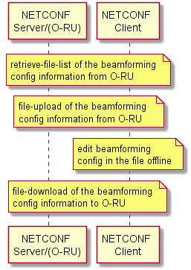
Figure 15.4.3-1: Method to Modify the File of Beamforming Configuration Information
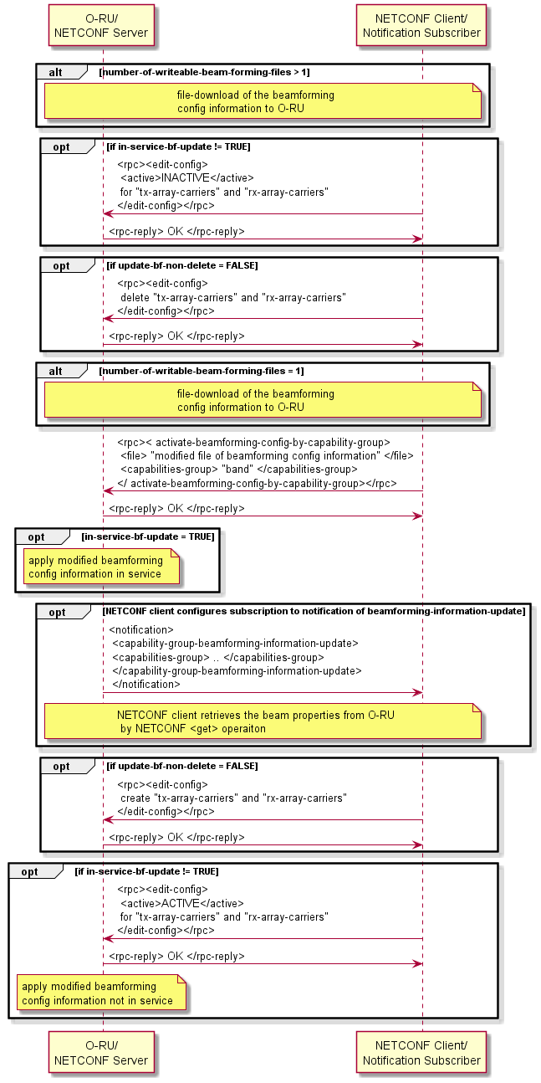
Figure 15.4.3-2: Method to Apply the modified file for Beamforming Configuration Information

15.4.4 Tilting pre-defined beams
This clause describes the optional capability by which the O-RU's pre-defined beams may be tilted by using the "BEAM-TILT" feature defined in the o-ran-beamforming YANG model. This capability is an O-RU specific functionality, enabling adaptation of the service area associated with an O-RU without the need for operation of additional ALDs described in clause 14, or modifying the beamforming configuration using the "MODIFY-BF-CONFIG" feature described in clause 15.4.3.
NOTE 1: The operation of the feature "BEAM-TILT" is independent to the operation of the "MODIFY-BF-CONFIG". When the "MODIFY-BF-CONFIG" feature is used to define a new default service area, the "BEAM-TILT" feature can be used to apply tilt-offsets to the newly defined service area.
O-RU can change the service area by applying a tilt-offset to the elevation and/or azimuth pointing angles for the pre-defined beams. This feature allows to shift beam characteristic of all predefined-beams in elevation and/or azimuth direction (i.e. changing the service area or sector coverage) while preserving the beam adjacency among the beams within grid of beams.
NOTE 2: elevation-tilt-offset-angle values smaller than 0 represents an up-shift of the default service area towards the zenith (i.e. corresponding to a decrease in zenith angle) and values larger than 0 represent a down-shift of the default service area away from the zenith (i.e. corresponding to an increase in zenith angle).
Figure 15.4.4-1 shows the sequence diagram for predefined-beam-tilt-offset-information. To shift service area of the O-RU in a different direction, O-RU controller shall check whether the O-RU supports feature BEAM-TILT feature during capabilities negotiation of the NETCONF session. In the case that O-RU supports the BEAM-TILT feature, the O-RU shall ensure that at least one of the elevation-tilt-offset-granularity and azimuth-tilt-offset-granularity is greater than zero value from O-RU. Tilting is a per band operation and hence the parameters are defined per band. If O-RU supports BEAM-TILT feature, O-RU controller can configure the values of elevation-tilt-offset-angle and/or azimuth-tilt-offset-angle and the configuration values should meet the ranges and granularity information retrieved from predefined-beam-tilt-offset-information.
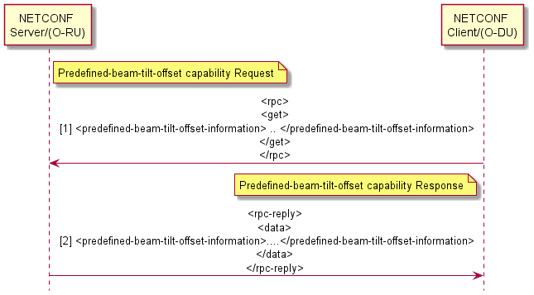
Figure 15.4.4-1: Sequence diagram for predefined-beam-tilt-offset-information
Depending on O-RU's implementation, the O-RU may need some time to complete the change of service area according to the updated elevation-tilt-offset-angle and/or azimuth-tilt-offset-angle for a particular band-number. The O-RU shall report its capability via the parameter, run-time-tilt-offset-supported. For O-RU with run-time-tilt-offset-supported = FALSE, changing the values in elevation-tilt-offset-angle and/or azimuth-tilt-offset-angle for a specific band shall be allowed only if all tx-array-carriers/rx-array-carriers corresponding to the band is INACTIVE. When the service area change is completed in O-RU, the O-RU delivers the notification predefined-beam-tilt-offset-complete to inform the O-RU Controller which then may request to activate tx-array-carriers/rx-array-carriers in O-RU. For O-RU with run-time-tilt-offset-supported = TRUE, neither changing the state of tx-array-carriers/rx-array-carriers nor delivering notification predefined-beam-tilt-offset-complete is required. When NULL-STEERING feature is enabled (null-control-method is configured), for the O-RU with run-time-tilt-offset-supported = TRUE, [tr]x-array-carriers shall be deactivated before reconfiguration digital tilt. See clause 15.4.7.5 for details.

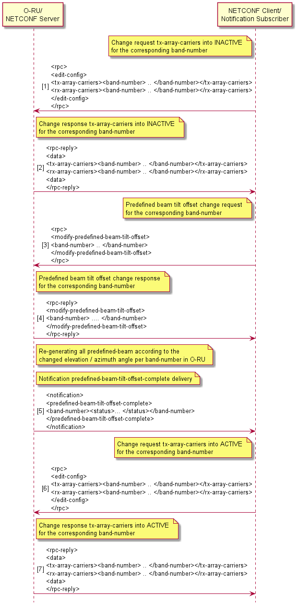
Figure 15.4.4-2: Procedure for the predefined-beam-tilt-offset

15.4.5 Dynamic beamforming control option
As option, O-RU may support dynamic beamforming control mode. Support for this type of beamforming control can be recognized in the case of weights-based dynamic beamforming from value of parameter rt-bf-weights-update-support (TRUE), and in the case of attributes-based dynamic beamforming from the value of parameter beamforming-trough-attributes-supported (TRUE), in o-ran-beamforming.yang module
In dynamic beamforming control mode DU updates content of lookup table in O-RU using eCPRI C-Plane messages. For details of eCPRI messaging, see ORAN-WG4.CUS specification, clause "Scheduling and Beamforming Commands".
Dynamically updated content of lookup table is further addressed by DU in the same way as it is done for static beamforming - by requesting particular Beam ID to be applied.
In case dynamic beamforming control is supported, O-RU indicates following supplementary information using parent leaf "static-properties" in o-ran-beamforming.yang module:
- beamforming type (frequency domain, time domain, hybrid).
- beamforming weight compression format (optional).
- available range of Beam IDs, that can be dynamically updated by DU.
- supported time and frequency granularity for time domain and hybrid beamforming control.
NOTE: Neighbourhood relations between beams produced by beam IDs controlled by DU are unknown to O-RU, hence are not exposed.
In the case of weights-based dynamic beamforming, to properly calculate beamforming weights DU needs to know antenna array geometry. This information DU obtains by reading the content of o-ran-uplane-conf.yang (list of tx-arrays and rx-arrays with their child parameters). Details of beamforming weight calculations are not a subject for M-Plane activity and as such are intentionally not covered in the present document.

15.4.6 Multiple beamId tables support

15.4.6.1 Introduction
The O-RU may choose to support multiple beamId tables instead of supporting a single global beamId table in the O-RU by advertising O-RU support for M-Plane feature MULTIPLE-BEAMID-TABLES-SUPPORTED. The O-DU may choose to enable or disable this feature using the O-DU configurable flag multiple-beamId-tables-support-enabled.

15.4.6.1 O-RU advertised parameters and restrictions
- The maximum number of beamId tables which can be supported by the O-RU is advertised by the O-RU using the parameter max-beamId-tables-supported within ru-capabilities.
NOTE: If max-beamId-tables-supported is advertised as 1, it implies that O-RU supports single global beamId table.
- Each beamId table is identified by a unique beamId table index. Multiple beamId tables supported by the O-RU are expected to be linearly indexed from 1 to 255. The list of beamId tables supported are advertised by the O-RU using a leaf-list tx-array-beamId-table-indexes/rx-array-beamId-table-indexes per capabilities[] list entry per tx-array and per rx-array respectively.
- The maximum number of entries advertised by the O-RU in the leaf-list tx-array-beamId-table-indexes/rx-array-beamId-table-indexes shall be restricted by the O-RU level parameter max-beamId-tables-supported advertised by the O-RU which is a global value for the entire O-RU.

15.4.6.2 O-DU configuration and restrictions
- When O-DU configures tx-array-carrier and/or rx-array-carrier, O-DU shall associate configured-tx-beamId-table-index/configured-rx-beamId-table-index with each tx-array-carrier and/or rx-array-carrier respectively.
- The O-DU configured [tr]x-array-carrier(s) are expected to be configured based on parameters specified in capabilities[] list and hence configured-[tr]x-beamId-table-index value used for a given [tr]x-array-carrier is expected to be chosen from leaf-list [tr]x-array-beamId-table-indexes advertised by the O-RU per tx-array/rx-array.

15.4.6.3 Restrictions, assumptions, and other impacts
- To ensure that legacy single beamId table is also supported by the O-RU after O-DU enables the feature MULTIPLE-BEAMID-TABLES-SUPPORTED, the first list entry in tx-array-beamId-table-indexes/rx-array-beamId-table-indexes shall always point to default global beamId table which shall be of size 32767.
- O-RU shall use the beamId table configured for the array carrier associated with the endpoint receiving the beamId value in a C-plane message.
- Per beamforming method beamId range is defined separately per beamId table. The new ranges are defined in defined in o-ran-beamforming.yang as a leaf-list parameter beamforming-params-for-mul-beamId-tables advertised by the O-RU. The range values initial-beam-id and max-number-of-beam-ids defined for each beamforming type shall be same for each beamId table supported by the O-RU. Since the first list entry points to the global beamId table, the first entry in beamforming-params-for-mul-beamId-tables shall contain ranges for the global beamId table.

15.4.7 Null steering for pre-defined beams

15.4.7.1 Overview
For some specific deployments, there is a need to reduce transmission on certain direction(s) in order to protect digital devices located on the ground and/or reduce interference for those devices to ensure their operation. Null steering is a directional interference mitigation feature. It utilizes beamforming technology to reduce EIRP towards given directions. Null steering function is applicable for pre-defined beams.

15.4.7.2 Capability reporting
O-RU declares support for null steering by exposing YANG feature NULL-STEERING using its YANG library. O-RU supporting the feature NULL-STEERING declares null steering capabilities related to null position configuration, for example, azimuth angle range, zenith angle range and angle granularity for tx-arrays that support the functionality.
There are two types of null(s): null point and elevation null stripe. A null point is a null at a certain zenith and azimuth angle. Elevation null stripe is null at a zenith angle for all azimuth angles.
Maximum total value of null point(s) width and/or maximum total value of elevation null stripe(s) width supported may be declared per tx-array using max-total-null-width and/or max-total-null-stripe-width. When max-total-null-width and/or max-total-null-stripe-width is/are not declared for an array, it implies that the array does not support null point or elevation null stripe configuration. Maximum joint sum of widths for null points and null may be declared using max-total-null-and-null-stripe-width. If max-total-null-and-null-stripe-width is not declared, only the separate limits for null points and null stripes apply. If declared, both the joint limit and the separate limits shall be respected.
There are two null steering control methods: NULL-PER-ARRAY; NULL-PER-ARRAY-CARRIER. O-RU that declares support for NULL-STEERING shall declare null steering control method(s) it supports.
O-RU declares support for beam-id scope configuration by exposing YANG feature BEAM-ID-SCOPE-NULLING and declares capability to have different beam-id ranges for referring nulled and non-nulled BFW(s) by exposing YANG feature TARGET-BEAM-RANGE. Feature TARGET-BEAM-RANGE enables simultaneously using of nulled and non-nulled BFWs for a given beam-id-range in the container beam-id-ranges-in-scope.

15.4.7.3 Null steering configuration
To define a null point, both zenith and azimuth angle shall be specified. Those angle values should be in the range of respective reported capabilities.
To define an elevation null stripe, a zenith angle value shall be specified, without specifying an azimuth angle value. The zenith angle value should be in the range of the O-RU reported capability.
Zenith angle and azimuth angel for a null point or elevation null stripe uses array coordinate system as defined in CUS plane specification [2] Clause 12.5.2.
Each null point and elevation null stripe can have a parameter null-width defined as a unitless integer, it can only have value larger or equal to 1, default is 1. A larger value of null-width shall result in a wider null. Sum of the null-width values of all configured null points for tx-array-carriers using the same tx-array shall not exceed max-total-null-width for the tx-array. The same principle is applicable for elevation null stripe.
There are two null steering control method(s): NULL-PER-ARRAY; NULL-PER-ARRAY-CARRIER. O-RU controller may enable null steering functionality by configuring null-control-method to the null steering control method to be used by the O-RU based on capability reported.
For O-RU that supports null steering control method NULL-PER-ARRAY-CARRIER, tx-array-carrier may be configured with null point(s) and/or elevation null stripes if tx-array referred by the tx-array-carrier reported null configuration capabilities. The total value of width for all null points and elevation null stripes configured to tx-array-carriers associated to the same tx-array are restricted by the respective capabilities max-total-null-width and max-total-null-stripe-width of the tx-array. If the joint limit max-total-null-and-null-stripe-width is declared, both the joint limit and the separate limits shall be respected.
Null points and elevation null stripes configuration on a tx-array or a tx-array-carrier is only applicable when corresponding null steering control method is configured to be used for the O-RU using null-control-method.
When null-control-method is NULL-PER-ARRAY-CARRIER, null point(s) and elevation null stripe(s) defined per tx-array-carrier shall be used by O-RU. Even if a tx-array-carrier is transmitting in the direction of to-be-protected devices, if the tx-array-carrier is operating in a frequency range that does not impact the to-be-protected devices, no null point or elevation null stripe needs to be defined for the tx-array-carrier.
null-freq may be configured to indicate the frequency that is used to calculate position of the null point/elevation null stripe.
If the O-RU supports YANG feature BEAM-ID-SCOPE-NULLING, O-DU may configure beam-id-ranges-in-scope to define beam-id ranges that are in the scope of null steering. When beam-id-ranges-in-scope is configured, O-RU shall only null beam-ids in the ranges configured while beam-ids that is not in any defined beam-id ranges are not applicable for null steering function. When beam-id-ranges-in-scope is not configured, O-RU determines which pre-defined beams are in the scope for null steering.
O-RU declares support of feature TARGET-BEAM-RANGE to indicate support of defining a target beam id range to be used by O-DU to refer to nulled BFWs. When nulled and non-nulled BFW are referred using different beam-id ranges, both nulled and non-nulled BFWs for the same original beam-id range can be used simultaneously.
For the O-RU that supports TARGET-BEAM-RANGE, O-RU shall support the configuration without target-first-beam-id configured or target-first-beam-id is configured with the same value as first-beam-id.
- For O-RU that supports feature TARGET-BEAM-RANGE:
- When configured, target-first-beam-id specifies the first beam-id value to be used to refer to nulled BFWs for the defined beam-id-range.
- If target-first-beam-id has different value than first-beam-id, O-DU can use beam-id values between first-beam-id to (first-beam-id+ num-of-ids-1) to refer to non-null BFW(s) for those beams. To access nulled BFWs, O-DU uses beam-id values between target-first-beam-id to (target-first-beam-id+ num-of-ids-1).
- O-DU may and is allowed to configure the target-first-beam-id value with the same value as the first-beam-id. O-DU may not configure target-first-beam-id. In both cases, beam-id values between first-beam-id to (first-beam-id+ num-of-ids-1) are used to access the nulled BFW for the beam-id-range.
- For O-RU that does not support feature TARGET-BEAM-RANGE:
- The beam-id values between first-beam-id to (first-beam-id+ num-of-ids-1) are used to access the nulled BFW for the beam-id-range.

15.4.7.4 Null steering activation and deactivation
To configure null-control-method to value NULL-PER-ARRAY-CARRIER, all tx-array-carrier(s) with null steering configuration need to be deactivated(set active to INACTIVE). To configure null-control-method to NULL-PER-ARRAY, all tx-array-carrier(s) that associated with an tx-array that has null steering configuration need to be deactivated(set active to INACTIVE).
When null-control-method has value NULL-PER-ARRAY-CARRIER, to add/remove/modify null point and/or elevation null stripe for a tx-array-carrier, the tx-array-carrier needs to be deactivated first. After reconfiguration, O-RU controller can set the tx-array-carrier's active to ACTIVE.
When null-control-method has value NULL-PER-ARRAY, to reconfigure null point(s) and elevation null stipes under a tx-array, all tx-array-carriers associated to the tx-array need to be deactivated (set active to INACTIVE).
Time for nulling of BFWs for pre-define beams is vendor specific. For example, it can happen when null-control-method is set to NULL-PER-ARRAY or is set to NULL-PER-ARRAY-CARRIER, or when the first tx-array-carrier associated to the tx-array is activated (active is set to ACTIVE), or when null points and/or elevation null stripes are configured, or when the tx-array-carrier is activated. When O-RU has performed nulling of BFW(s), a notification predefined-beam-null-complete is sent to event subscriber.
When null-control-method has value NULL-PER-ARRAY-CARRIER, for a tx-array-carrier with null steering configuration, nulled BFWs for the tx-array-carrier are available to be used when the tx-array-carrier's active/state is ACTIVE/READY and nulling is completed. For a tx-array-carrier with null steering configuration, O-RU nulls beamforming weights for pre-defined beams based on tx-array-carrier's null steering configuration. Tx-array-carrier(s) having null configurations that are associated with same tx-array may result in different set of nulled BFWs.
When null-control-method has value NULL-PER-ARRAY, for a tx-array with null steering configuration, its pre-defined beams (all or defined in the beam-id-ranges-in-scope) are nulled. The nulled BFWs ensure nulled result for the configured intended null(s). Same set of nulled BFWs can be referred by the O-DU for all activated (ACTIVE/READY) tx-array-carriers that are associated with the same tx-array.
O-DU may use original pre-defined beam-id(s) to refer to nulled BFWs when O-RU does not support TARGET-BEAM-RANGE; or when target-first-beam-id is not configured; or when target-first-beam-id is configured with same value as first-beam-id for a beam range. When O-RU supports TARGET-BEAM-RANGE and target-first-beam-id is configured to different value as first-beam-id, originally beam id range is used to refer to original BFW(s) and target beam id range is used to refer to nulled BFW(s).
An example sequence diagram for configuring null position on tx-array is shown as follows:
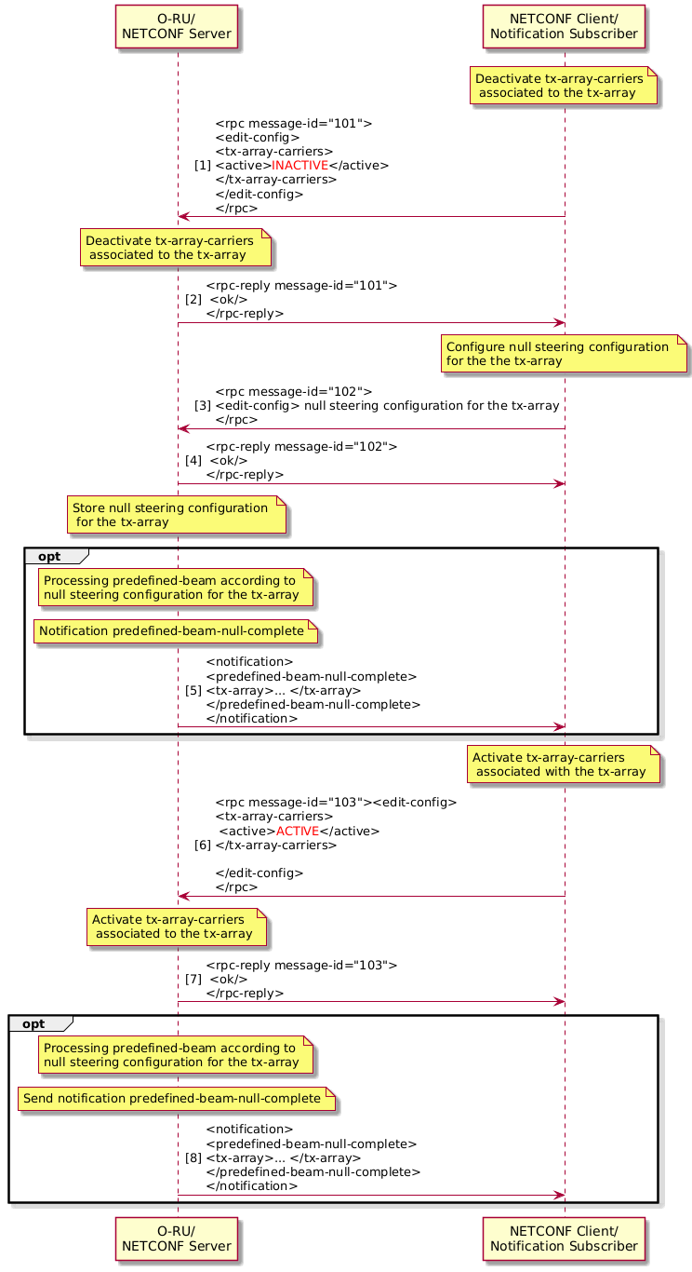
Figure 15.4.7.4-1: Example diagram for configuring null position on tx-array

15.4.7.5 Interaction with other features
Null steering feature is considered enabled when null-control-method is configured. When null steering feature is enabled, usage of features that may operate on the same set of BFWs are impacted.
NULL-STEERING feature defines null position relevant to antenna array’s physical position. BEAM-TILT is a digital tilt feature which does not impact antenna's physical position, NULL-STEERING feature's null position configuration is independent to BEAM-TILT feature configuration. But BEAM-TILT and NULL-STEERING may operate on the same set of BFWs, the usage of BEAM-TILT is thus impacted when null steering feature is enabled. When NULL-STEERING feature is enabled (null-control-method is configured), for O-RU that has run-time-tilt-offset-supported = true, functionality to run time reconfigure BEAM-TILT configuration shall not be used. In this case, to reconfigure digital tilt for [tr]x-array-carriers that associated with [tr]x-array, [tr]x-array-carriers shall be deactivated before reconfiguration.
For the same reason, for an O-RU that supports in-service-bf-update (implies supporting update-bf-non-delete), when NULL-STEERING is enabled, to activate new BFW file for the O-RU, [tr]x-array-carriers shall be deactivated first.
On the other hand, NULL-STEERING has no impact on usage of feature MULTIPLE-BEAMID-TABLES-SUPPORTED.

15.5 Antenna calibration

15.5.1 Background
Some antennas need to be calibrated to ensure their intended performance. Antenna calibration operation is an optional capability whose operation is dependent on O-RU design, i.e. different O-RUs may support different types of calibration, periodic vs on-demand, different calibration duration, short/medium/long, etc. In this clause, a common framework is defined which can accommodate various types of antenna calibration implementations.
In this framework, the NETCONF client (O-DU) retrieves resource requirements for antenna calibration operation, e.g. timing and number of iterations/steps, from O-RU by getting the antenna-calibration-capabilities container defined in the o-ran-antenna-calibration YANG model. The O-DU can subscribe to antenna-calibration-required notifications to receive indications from the O-RU that calibration is required. When the O-RU indicates antenna calibration is required, or when the NETCONF Client decides to calibrate the O-RU, the NETCONF Client allocates time resources for antenna calibration and configures them in the O-RU using the start-antenna-calibration RPC request. The NETCONF client shall allocate the time resources for the calibration operation ensuring that these meet the minimum time necessary as reported by the O-RU using the antenna-calibration-capabilities. When available, the NETCONF client (O-DU) shall ensure that the frequency resources indicated in the dl-calibration-frequency-chunk and ul-calibration-frequency-chunk lists in the antenna-calibration-required notification are reserved for calibration operation, otherwise the NETCONF client shall consider that the full bandwidth of the carrier is being reserved for calibration operation.
The O-RU shall perform antenna calibration operation using the time resources allocated in the start-antenna-calibration RPC and frequency resources declared in antenna-calibration-required notification and shall notify the completion of the antenna calibration operation to the notification subscriber. The O-DU should be configured to not schedule user data using the time frequency resources identified for antenna calibration operation. The O-DU may schedule data during calibration operation using time frequency resources not identified for calibration operation. When the O-DU is scheduling user data during calibration process using resources not used for calibration, it shall only schedule DL user data in DL calibration symbols and UL user data in UL calibration symbols.

15.5.2 Overall operation

15.5.2.1 General
During the O-RU "start-up" procedure, the NETCONF client (O-DU) retrieves the O-RU's antenna calibration capability information including antenna calibration capability related parameters defined in o-ran-antenna-calibration.yang model. These parameters describe the O-RU's time resource requirements for calibration and the O-RU's capability of performing "self-calibration". The O-RU time resource requirements are described using the parameters number-of-calibration-symbols-per-block-dl and number-of-calibration-symbols-per-block-ul. One symbol block corresponds to a set of consecutive symbols in time required for the calibration operation, and it is the basic time unit of calibration. Sets of symbol blocks are grouped into one calibration step and the O-RU shall indicate how many symbol blocks constitute one calibration step using the number-of-calibration-blocks-per-step-dl and number-of-calibration-blocks-per-step-ul parameters. The O-RU indicates these parameters separately for downlink and uplink calibration. The O-RU shall also indicate the minimum time gap required between consecutive symbol block allocations (interval-between-calibration-blocks), number of calibration steps needed (number-of-calibration-steps) and the minimum required time gap between consecutive calibration step allocations (interval-between-calibration-steps). Based on these parameters, the O-DU shall be able to allocate the time resources required for antenna calibration operation meeting the necessary time resources indicated by the O-RU. If the O-RU supports mixed numerology, the highest possible numerology supported by the O-RU shall be used as the common reference per component carrier according to the CUS plane definition for slot indexing with mixed numerologies.

15.5.2.2 Initiation
Either the O-RU or O-DU may initiate calibration operation. The trigger condition for the O-DU and/or O-RU to initiate calibration is out of scope of the present document. The NETCONF client is assumed to have subscribed to the notifications defined in the o-ran-antenna-calibration YANG model. When an O-RU determines that it needs to perform antenna calibration operation, it notifies the notification subscriber using the notification antenna-calibration-required, including a list of frequency ranges corresponding to the minimum frequency resources required for calibration, or, when the O-RU supports the optional O-RU-COORDINATED-ANT-CAL feature, by using the antenna-calibration-coordinated notification.
Upon reception of the antenna-calibration-required notification, the O-DU can allocate time frequency resources for calibration and can send the start-antenna-calibration RPC request, including the time resource allocation information for the antenna calibration. This operation is referred as 'O-RU initiated antenna calibration' operation.
When coordinated-calibration-support is set to true, this indicates that the O-RU is able to determine a priori the time-frequency resources required for antenna self-calibration and the O-RU uses antenna-calibration-coordinated notification to indicate these to the O-DU instead of antenna-calibration-required notification. When the coordinated-calibration is supported and permitted, i.e. coordinated-calibration-support is true and coordinated-calibration-allowed is true, the O-RU may perform a coordinated self-calibration procedure. An O-RU may also report the optional capability of configured-preparation-timer-supported which indicates that it supports configuration of the preparedness timer that controls how far in advance of the coordinated self-calibration procedure the O-RU is required to send the notification of impacted resources. If configured by the NETCONF Client, the O-RU shall send the antenna-calibration-coordinated notification at least coordinated-ant-calib-prep-timer seconds before the operation of the coordinated antenna calibration procedure. If such an optional capability is not supported, the O-RU shall indicate that time-frequency resources are sent to a subscribed O-DU at least 60 seconds before the operation of the coordinated antenna calibration procedure. SFN wrap around will occur multiple times during these 60 seconds, this is handled according to statements in clause 15.5.2.4.
The O-DU shall not send a start-antenna-calibration RPC request when a coordinated antenna calibration period is in progress. The O-RU is allowed to reject such a request if it is received during a coordinated antenna calibration period. An O-DU receiving an antenna-calibration-coordinated notification can beneficially use the indicated time-frequency resources to adapt its operation during the antenna calibration operation, e.g. consider the time-frequency resources as reserved for calibration. If no UL and/or DL frequency-chunk lists are provided in the notification, the O-DU may consider the full bandwidth of all configured UL and/or DL carriers reserved for calibration operation. If such U-Plane resources are scheduled by the O-DU, the operation of the O-RU may be degraded, including performance of the calibration procedure and handling of DL and UL U-plane traffic and any associated performance counters.
The O-DU may also autonomously initiate calibration operation, using the same start-antenna-calibration RPC request, i.e. without receiving the antenna-calibration-required notification message from O-RU. This operation is referred as 'O-DU initiated antenna calibration' operation. If the O-RU has indicated the need for the calibration through sending the antenna-calibration-required notification, the O-DU shall consider that the use of frequency resources indicated using frequency range list within the notification as being affected during the calibration operation and if no frequency list is available, consider the full bandwidth of all configured carriers reserved is affected during calibration.
After receiving "start-antenna-calibration RPC request" (antenna calibration start command), the O-RU shall send an RPC reply (antenna calibration start response) including ACCEPTED status to the NETCONF client, if the O-RU is able to start the calibration operation according to the time resources allocation information in the RPC request. Otherwise, the O-RU shall include a REJECTED status in the RPC reply, with a suitable error reason such as "resource mask mismatch with O-RU antenna calibration capability", "overlapped DL and UL masks", "insufficient memory", "O-RU internal reason" (if no other error reason matches the error condition) etc. If the O-RU does not receive a start-antenna-calibration RPC request within 60 seconds after triggering the sending of the first antenna-calibration-required notification, the O-RU shall raise a major alarm "Triggering failure of antenna calibration" (see Annex fault details). After the alarm is raised, the O-RU may resend the antenna-calibration-required notification multiple times. The O-RU shall not re-send the antenna-calibration-required notification in periods shorter than 60 seconds.

15.5.2.3 Self-calibration operation
When the alarm "triggering failure of antenna calibration" alarm remains uncancelled, if self-calibration is supported and permitted, i.e. self-calibration-support is true and self-calibration-allowed is true, the O-RU may perform a self-calibration procedure. The O-RU shall wait a minimum 60 seconds after raising a major alarm and receiving no start-antenna-calibration RPC request from the NETCONF client before initiating its self-calibrate procedure. When self-calibration is not supported or not permitted, i.e. self-calibration-support is false or self-calibration-allowed is false, the O-RU may upgrade the severity of the alarm to critical according to clause 11.4.
During the self-calibration, i.e. when O-RU exposes self-calibration-support with value TRUE and when O-DU sets self-calibration-allowed with value TRUE to O-RU, there could be no coordination of time-frequency resources between the O-RU and O-DU. The O-DU can continue to schedule user data during calibration process using the resources identified in antenna-calibration-required notification without impacting the operation of the calibration procedure. Scheduled user data will be affected by ongoing calibration procedure.

15.5.2.4 Calibration completion
The O-RU shall indicate completion of all types of calibration procedures (i.e. rpc triggered, self-calibration and co-ordinated self-calibration) using the antenna-calibration-result notification (Calibration results) to the notification subscriber. If a self-calibration or co-ordinated self-calibration procedure completes but with status set to FAILURE, the O-RU may upgrade the severity of the alarm to critical.
In some situations, SFN wrap around may happen causing O-DU and O-RU to interpret the 'start-sfn' parameter to point to different GPS seconds elapsed since GPS epoch. To avoid this situation, the O-DU to may decide not to schedule any user-plane data on the calibration time-frequency resources in all SFN cycles until the O-DU receives an antenna-calibration-result notification message from the O-RU. Once the calibration is complete, the O-DU schedules user data and sends C/U-Plane message as in normal operation state.

15.5.2.5 Antenna calibration procedure
Figure 15.5.2.5-1 shows the overall operation for antenna calibration.
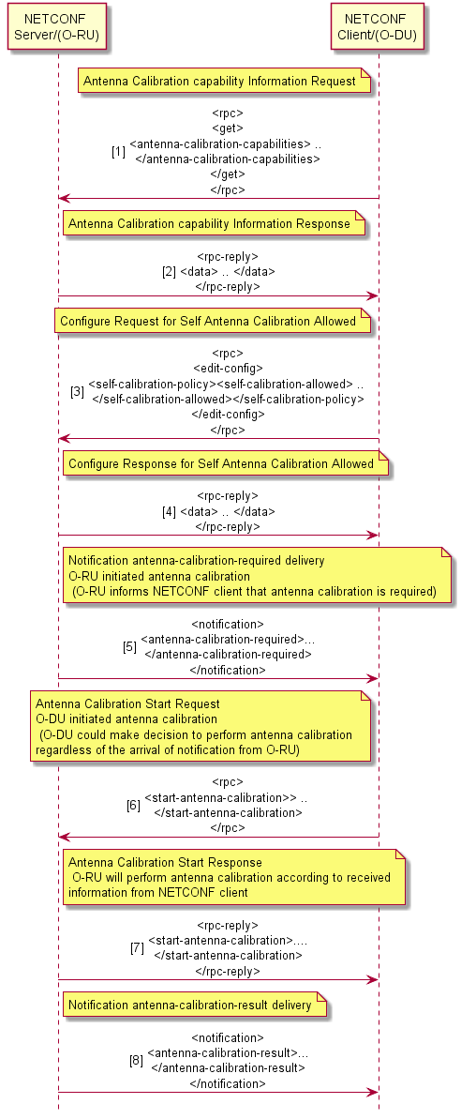
Figure 15.5.2.5-1: Overall of antenna calibration operation

15.5.3 O-RU antenna calibration capability parameter configuration
The antenna calibration framework is a generic framework designed to support various vendor specific implementations of O-RU calibration. Therefore, the framework does not describe the details of how the O-RU calibrates its antenna, rather it defines a generic framework with necessary message flows and parameters for ensuring that the time and frequency resources required for calibration are coordinated between the O-DU and O-RU. The following parameters describe the O-RU's time resource needed for calibration.
- self-calibration-support: Boolean value indicates whether O-RU is capable of supporting self-calibration.
- number-of-calibration-symbols-per-block-dl: indicates how many consecutive symbols are required for DL antenna calibration operation, i.e. the size of DL Symbol-block.
- number-of-calibration-symbols-per-block-ul: indicates how many consecutive symbols are required for UL antenna calibration operation, i.e. the size of UL Symbol-block.
- interval-between-calibration-blocks: if a time interval is required between consecutive antenna calibration operation, this indicates the required time value as unit of symbols. A common value is used here for the intervals between DL-DL blocks, UL-UL blocks, DL-UL blocks and UL-DL blocks, which is the largest minimum interval required between any two adjacent calibration blocks. It shall be any value that O-RU implementation requires within this parameter range.
- number-of-calibration-blocks-per-step-dl: indicates how many blocks are required for one step of DL antenna calibration operation.
- number-of-calibration-blocks-per-step-ul: indicates how many blocks are required for one step of UL antenna calibration operation.
- interval-between-calibration-steps: if a time interval is required between consecutive steps of antenna calibration operation, define indicates the required time value as unit of radio frames. It can be any value that the O-RU implementation requires within the defined parameter range.
- number-of-calibration-steps: shows how many steps is required for whole DL/UL antenna calibration operation.
Figure 15.5.3-1 shows the relationship between the various antenna calibration capabilities parameters described above.
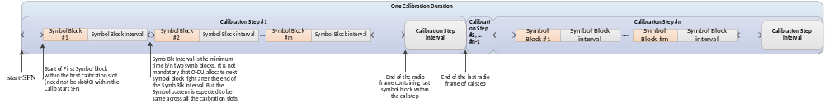
Figure 15.5.3-1: Relationship among Antenna Calibration Capability parameters

15.5.4 antenna-calibration-required notification parameters
If the O-RU initiates the calibration operation, the O-RU notifies the notification subscriber (O-DU) using the antenna-calibration-required notification message, including the O-RU's frequency resource requirements. The O-RU is able to indicate non-contiguous frequency "chunks" necessary for calibration using the dl-calibration-frequency-chunk and ul-calibration-frequency-chunk lists. These lists use the parameters below to describe the frequency resources required for calibration:
- start-calibration-frequency-dl: indicates the lowest frequency value in Hz of the frequency range is required for DL antenna calibration operation.
- end-calibration-frequency-dl: indicates the highest frequency value in Hz of the frequency range is required for DL antenna calibration operation.
- start-calibration-frequency-ul: indicates the lowest frequency value in Hz of the frequency range is required for UL antenna calibration operation.
- end-calibration-frequency-ul: indicates the highest frequency value in Hz of the frequency range is required for UL antenna calibration operation.

15.5.5 Start-antenna-calibration RPC request parameters
The NETCONF Client sends the "start-antenna-calibration RPC request" including the time resource allocation parameters. These parameters indicate the exact symbols, slots, and frames that can be used for calibration.
NOTE: Because the NETCONF Client (O-DU) allocates the time resources for calibration with the knowledge of UL and DL configuration, dynamic TDD operation is implicitly supported.
The resource allocation information about symbol, slot, and frame are indicated using bitmasks for downlink and uplink calibration separately. The start SFN of the first calibration step is sent to the O-RU to synchronise the calibration starting point at both O-DU and O-RU. When indicated, the O-RU shall use the frequency resources indicated using the frequency ranges in the "NETCONF antenna-calibration-required notification" message for calibration.
Table 15.5.5-1 lists the parameters configured in the O-RU using the "start-antenna-calibration RPC request".
Table 15.5.5-1: Antenna Calibration Parameters
Parameters | Type / Range | Descriptions
symbol-bitmask-dl | string | Bitmask indicating DL calibration symbol within a calibration slot. First character in the string indicates first symbol, next character in the string indicates second symbol and so on. Value 1 indicates that the symbol is allocated for calibration and 0 means the symbol shall not be used for calibration.
symbol-bitmask-ul | string | Bitmask indicating UL calibration symbol within a calibration slot. First character in the string indicates first symbol, next character in the string indicates second symbol and so on. Value 1 indicates that the symbol is allocated for calibration and 0 means the symbol shall not be used for calibration.
slot-bitmask-dl | string | Bitmask indicating DL calibration slot within a calibration frame. First character in the string indicates first slot, next character in the string indicates second slot and so on. Value 1 indicates that the slot is allocated for calibration and 0 means the slot shall not be used for calibration.
slot-bitmask-ul | string | Bitmask indicating UL calibration slot within a calibration frame. First character in the string indicates first slot, next character in the string indicates second slot and so on. Value 1 indicates that the slot is allocated for calibration and 0 means the slot shall not be used for calibration.
frame-bitmask-dl | string | Bitmask indicating DL calibration frame within a calibration step. First character in the string indicates first radio frame equal to the start-SFN, next character in the string indicates the next frame and so on. Value 1 indicates that the frame is allocated for calibration and 0 means the frame shall not be used for calibration.
frame-bitmask-ul | string | Bitmask indicating UL calibration frame within a calibration step. First character in the string indicates first radio frame equal to the start-SFN, next character in the string indicates the next frame and so on. Value 1 indicates that the frame is allocated for calibration and 0 means the frame shall not be used for calibration.
calibration-step-size | uint8 | Number of frames within a calibration step.
calibration-step-number | uint8 | Number of calibration steps.
start-sfn | unt16 | SFN number of the first calibration step.

15.5.6 Example antenna calibration operation
This clause illustrates an example of antenna calibration operation. For simplicity, the O-RU is the initiator in this example, but either O-RU or O-DU could initiate antenna calibration operation. In this example, the TDD configuration is assumed as shown in Figure 15.5.6-1.
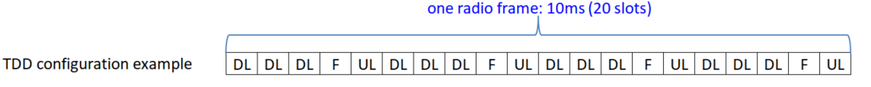
DL = Downlink slot
UL = Uplink slot
F = Flexible slot

Figure 15.5.6-1: Example of TDD configuration
This example illustrates calibration operation where an O-RU requires DL and UL antenna calibration operation in o-ran-antenna-calibration.yang with 2 calibration steps; within each step, 64 DL calibration blocks with 4 continuous DL symbols in each calibration block and 32 UL calibration blocks with 1 continuous UL symbol in each calibration block are required. Between each calibration block, a length of minimum 3 symbols interval is required, and a length of minimum 5 frames interval is required between consecutive calibration steps.
Once antenna calibration operation is required by the O-RU, an antenna-calibration-required notification is sent to the notification subscriber (O-DU), including the O-RU's frequency resources requirement in a list of frequency ranges in Hz, which in this example uses a single chunk of frequencies from 1.8GHz to 1.82GHz. The O-DU considers that the frequency range indicated in the antenna-calibration-required notification will be subsequently used during antenna calibration. The O-DU allocates time resources for antenna calibration based on the TDD configuration together with the O-RU DL and UL antenna calibration capability, then configure the antenna calibration using the start-antenna-calibration RPC request. In this example, 64 DL calibration blocks in each calibration step are allocated in 4 frames, within each frame, 8 DL slots are allocated and within each DL slot, 2 calibration blocks are allocated for DL calibration. In parallel, 32 UL calibration blocks in each calibration step are allocated in 4 frames, within each frame, 4 UL slots are allocated and within each UL slot, 2 calibration blocks are allocated for UL calibration. To guarantee the interval between 2 calibration steps, the size of each calibration step is set to 10 frames. At least 3 symbols interval between each calibration block is also guaranteed in symbol bitmasks. The O-DU may allocate larger intervals than O-RU requires as shown in this example where a 9 symbols interval is allocated instead of the minimum of 3 symbols after second UL symbol block in all UL calibration slots.
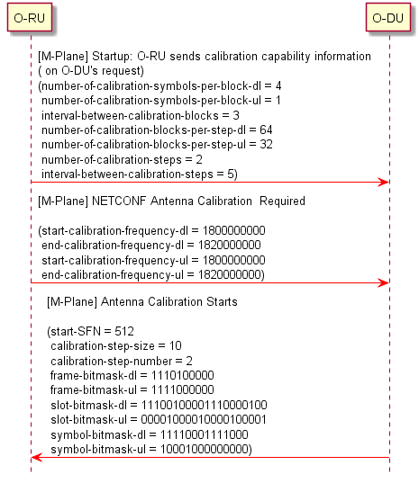
Figure 15.5.6-2: Example of message exchange

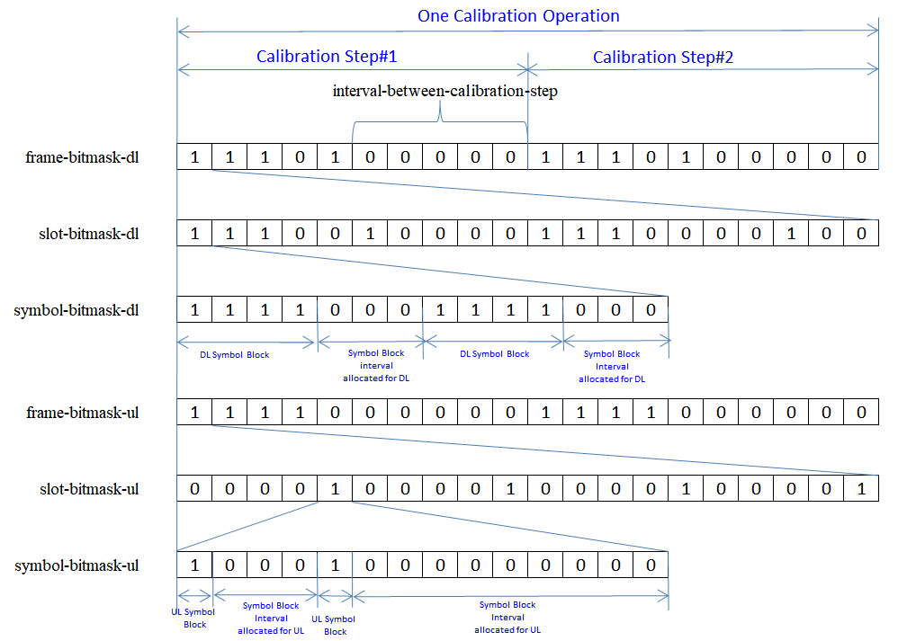
Figure 15.5.6-3: Time domain bitmask information from O-DU

15.5.7 Calibration with multiple timing resource sets
The O-RU may indicate its ability to support multiple time resource configuration sets for antenna calibration by support of the feature O-RU-COORDINATED-ANT-CAL-MULTIPLE-TIME-RESOURCE in o-ran-antenna-calibration.yang module. The feature is intended to extend the antenna calibration framework to support multiple time resources instead of single time resource supported. This capability can be used by the O-RU to specify unique calibration time resources for different calibration types. O-RU which supports this capability, exposes a list of time resources (antenna-calibration-multiple-time-resource-list). O-RU indicates desired set of time resources in 'antenna-calibration-multiple-time-resource' notification using specific value of 'antenna-calibration-time-resource-index' parameter.
This feature applies to O-RU initiated calibration where O-RU supporting this feature can use new notification 'antenna-calibration-multiple-time-resource' containing the parameter 'antenna-calibration-time-resource-index', defined in clause 15.5.8. Based on the index value in the notification respective antenna calibration time resource values should apply while initiating "start-antenna-calibration RPC request". O-RU can use this calibration feature only in case O-DU configured parameter 'coordinated-calibration-multiple-time-resources-allowed' is set to TRUE.
NOTE: At any point in time only one calibration timing resources should be indicated the O-RU.

15.5.8 antenna-calibration-multiple-time-resource-params notification parameters
If the O-RU supports O-RU-COORDINATED-ANT-CAL-MUL-TIMING-RES-CONFIG, to initiate the calibration operation, the O-RU notifies the notification subscriber (O-DU) using the antenna-calibration-multiple-time-resource-params notification message. Remaining parameter list of this notification includes the frequency resources required for calibration same as 'antenna-calibration-required' described in clause 15.5.3:

- antenna-calibration-time-resource-index: key value to index the list 'antenna-calibration-multiple-time-resource-list' based on the calibration duration required by the O-RU.

15.6 Static configuration for PRACH and SRS

15.6.1 Background
PRACH and raw SRS are periodic. Their location in time and frequency resources is constant for all periods. This makes it feasible to configure PRACH and raw SRS with M-Plane in a sense that handling PRACH and / or raw SRS processing by assigned low-level-rx-endpoints does not require real-time control through C-Plane messages.
Static configuration of PRACH and SRS with M-Plane needs to cover following aspects:
- Configuration of frequency resources assigned to PRACH / SRS
- Configuration of time resources assigned to PRACH / SRS (including PRACH / SRS periodicity)
- Configuration of compression, iFFT and SCS
- Assignment of HW resources (low-level-rx-endpoints) for processing of PRACH / SRS
Static configurations shall be provided to the O-RU as part of carrier configuration - before the configured carrier is activated. Static PRACH / SRS configuration provided for already active carrier shall be rejected by the O-RU.
NOTE: In case a static-low-level-rx-endpoint exposes parameter static-config-supported with value NONE - such endpoint does not offer support for static configuration of PRACH nor SRS reception.
In case the configuration provided to O-RU contains records for TDD pattern(s), PRACH patterns and/or SRS patterns, the O-RU validates consistency between patterns. Configuration where there is collision between patterns detected, shall be rejected by the O-RU.

15.6.2 Static configuration for PRACH processing
The O-RU exposes its ability to support static PRACH configuration by support of the feature PRACH-STATIC-CONFIGURATION-SUPPORTED in o-ran-module-cap.yang module. Presence of this feature means, that at least one of static-low-level-rx-endpoints offered by the O-RU supports static configuration for PRACH. From the model perspective, static PRACH configuration is supported by static-low-level-rx-endpoints having the parameter static-config-supported exposed as PRACH. Such static-low-level-rx-endpoint can be referenced by low-level-rx-endpoint designated for reception of PRACH. Specific PRACH configuration may be utilized by the low-level-rx-endpoint according to the optional parameter static-prach-configuration.
NOTE: A single low-level-rx-endpoint can only reference to single instance of static-prach-configuration. However, a single static-prach-configuration may be referenced by many low-level-rx-endpoints.
If parameters related to static PRACH configuration are set by NETCONF Client – real-time C-Plane control for PRACH opportunities shall not be provided to the O-RU, allowing for static configuration to be utilized.

15.6.3 Frequency domain configuration
The meaning of frequency-related parameters is illustrated using Figure 15.6.3-1.
NOTE: Parameter offset-to-absolute-frequency-center belongs to low-level-rx-endpoint.
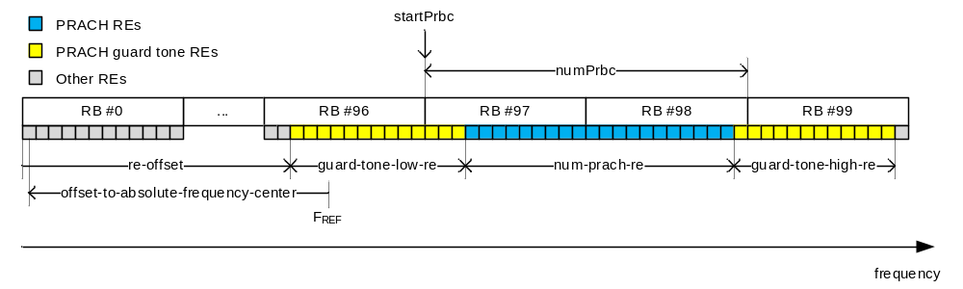
Figure 15.6.3-1: Relation between frequency-related parameters of the PRACH occasion
Relations between parameters allow to calculate startPrbc and numPrbc. For details of startPrbc and numPrbc, see O-RAN CUS-Plane Specification [2], clause 7.5.3.4 and 7.5.3.6.

15.6.4 Time domain configuration
Meaning of parameters is illustrated using Figure 15.6.4-1.
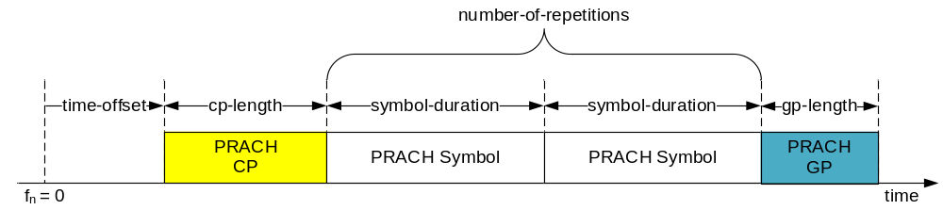
Figure 15.6.4-1: Timing-related parameters of single PRACH occasion
Figure 15.6.4-1 shows a single PRACH occasion containing 2 PRACH Symbols.
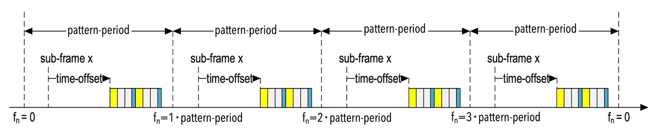
Figure 15.6.4-2: Timing-related parameters of one PRACH pattern
Figure 15.6.4-2 shows a single PRACH pattern containing two occasions of 2 PRACH Symbols (reuse of occasion shown on figure for single PRACH occasion for simplified view).
The corresponding parameters for Figure 15.6.4-2 are: ("number-of-prach-occasions" = 2, "number-of-repetitions" = 2)
NOTE 1: time-offset is defined with reference to parameters frame-number and sub-frame-id under static-prach-configuration. This parameter applies for the first occasion of a PRACH pattern. For subsequent occasions of the same PRACH pattern, the O-RU utilizes the parameters cp-length, gp-length and beam-id to determine the time boundaries. The parameters are taken from the list occasion-parameters such that, the first occasion uses the first set of elements from the list. Subsequent occasions use consecutive sets of parameters. The number of sets of parameters in this list is equal to value of the parameter number-of-occasions.
One static-prach-configuration instance allows to configure a set of PRACH patterns. For a single PRACH configuration, all corresponding PRACH patterns repeat over the period defined by the pattern-period parameter for such PRACH configuration. The PRACH patterns of single PRACH configuration shall not overlap in terms of time and frequency.
At most one PRACH pattern shall start in a subframe (subframes in different frames are distinguished).
PRACH pattern shall not cross boundary between subframes except PRACH pattern for long PRACH format with one occasion that spans boundary between subframes.
An O-RU shall reject any configuration where the number of patterns in single static PRACH configuration exceeds the number exposed by capability parameter max-prach-patterns in o-ran-uplane-conf.yang module.

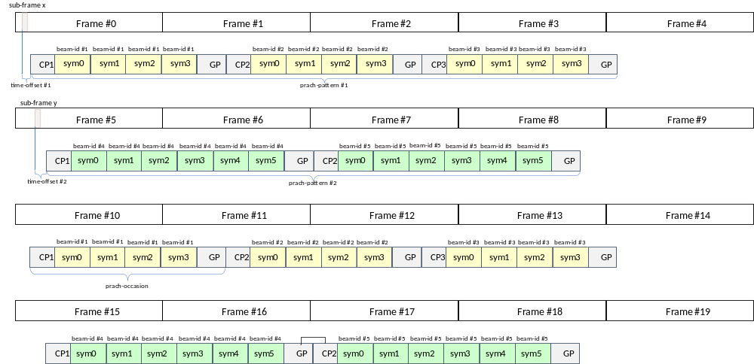
Figure 15.6.4-3: Example PRACH configuration formed of two PRACH patterns having different number of PRACH Symbols
NOTE 2: PRACH occasions are expanded for visual clarity.
NOTE 3: Figure 15.6.4-3 shows a theoretical configuration – not necessarily standardised by 3GPP. This is to demonstrate the flexibility of the solution of static PRACH configuration offered by M-Plane configuration.
The above configuration uses 2 prach-patterns:
- Pattern #1 is having: number-of-repetitions = 4, number-of-occasions = 3
- Pattern #2 is having: number-of-repetitions = 6, number-of-occasions = 2
For the PRACH configuration shown in Figure 15.6.4-3, the parameter pattern-period = 10 as this is the number of frames after which PRACH pattern repeats.
NOTE 4: Such a static PRACH configuration can be supported by static-low-level-rx-endpoints having parameter max-prach-patterns ≥ 2 as this configuration consists of 2 patterns.

15.6.5 Operation
Static PRACH configuration shall be set and rx-endpoints shall be linked to it before rx-array-carrier activation. On carrier activation, the O-RU starts receiving RF signals corresponding to the configured prach-patterns list. Specifically, the O-RU receives RF signals corresponding to the prach-pattern p when:
mod( $n_{f}$, pattern-period ) = frame-number_{p} and
$n_{sf}$ = sub-frame-id_{p} and
t = time-offset_{p}
where:
$n_{f}$ is the system frame number,
mod( x, y ) is remainder of division of x by y,
$n_{sf}$ is the subframe number within system frame $n_{f}$,
t is the time since start of subframe $n_{sf}$,
frame-number, sub-frame-id_{p} and time-offset_{p} are parameters of prach-pattern p,
pattern-period is a parameter of PRACH configuration.
Offset to the start of pattern periods can be configured either in low-level-rx-endpoint or in static-prach-configuration with sfn-number parameter. If the value is provided in static-prach-configuration, then it takes the precedence over the value configured in low-level-rx-endpoint.
Once the RF signal corresponding to the PRACH Symbol $n_{r}$ in PRACH occasion $n_{o}$ is received and processed, the O-RU sends the corresponding IQ values in a U-plane message or messages with header fields set as follows:
frameId = mod( floor( $n_{f}$ / pattern-period ) • pattern-period + frame-number_{p}, 256 )
NOTE: This corresponds to $n_{f}$ value captured when prach-pattern p started
subframeId = sub-frame_{p},
slotId = zero-based PRACH occasion number within PRACH pattern,
symbolId = zero-based PRACH Symbol number within PRACH occasion,
sectionId = 4095,
startPrbu = floor( ( re-offset_{p} + guard-tone-low-re ) / 12 ),
numPrbu = ceil( (re-offset_{p} + guard-tone-low-re + num-prach-re ) / 12 ) - startPrbu.
Where:
$n_{f}$ is the system frame number,
mod( x, y ) is remainder of division of x by y,
floor( x ) is largest integer smaller than or equal to x,
ceil( x ) is smallest integer greater than or equal to x,
frame-number_{p}, sub-frame-number_{p} and re-offset_{p} are parameters of prach-pattern p.
pattern-period, guard-tone-low-re and num-prach-re are parameters of PRACH configuration.
If data section is subdivided due to application level fragmentation, resulting values of startPrbu and numPrbu shall be calculated as per general rules. If multiple PRACH Symbols are scheduled at the same time at different re-offset frequencies, the O-RU shall send corresponding data sections in one U-Plane message following message size restrictions.

15.6.6 Static configuration for raw SRS processing
The O-RU exposes its ability to support static raw SRS configuration by support of the feature SRS-STATIC-CONFIGURATION-SUPPORTED in o-ran-module-cap.yang module. Presence of this feature means, that at least one of static-low-level-rx-endpoints offered by the O-RU supports static configuration for raw SRS reception. From the model perspective, static SRS configuration is supported by static-low-level-rx-endpoints having the parameter static-config-supported exposed as SRS. Such static-low-level-rx-endpoint can be referenced by a low-level-rx-endpoint designated for reception of SRS. Specific SRS configuration may be utilized by the low-level-rx-endpoint according to the optional parameter static-srs-configuration.
NOTE: A single low-level-rx-endpoint can only reference to single instance of static-srs-configuration. However, a single static-srs-configuration can be referenced by many low-level-rx-endpoints.
If parameters related to static SRS configuration are set by NETCONF Client – real-time C-Plane control for SRS shall not be provided to the O-RU, allowing for static configuration to be utilized.
Static SRS configuration is used to configure NDM (Non-Delay Managed) raw SRS (Sounding Reference Signal) patterns in a static manner, such that raw SRS U-Plane traffic can be processed by the O-RU without receiving C-Plane messages conveying real-time raw SRS configuration. Raw SRS may capture non-beamformed (beam-id = 0) or beamformed (beam-id != 0) signals and uses non-delay managed U-Plane messages.
One static-srs-configuration instance allows to configure a set of SRS patterns. For a single SRS configuration, all SRS patterns repeat over the period defined by pattern-period parameter for such SRS configuration. SRS patterns corresponding to a single SRS configuration shall not overlap in terms of time and frequency.
An O-RU shall reject any configuration where the number of patterns in single static SRS configuration exceeds the number exposed by capability parameter max-srs-patterns in o-ran-uplane-conf.yang module.

15.6.7 Operation
Static SRS configuration shall be set and rx-endpoints shall be linked to it before rx-array-carrier activation. On carrier activation, the O-RU starts receiving RF signals corresponding to the configured srs-patterns list. Specifically, the O-RU receives RF signal and sends corresponding U-plane messages as if, for each configured srs-pattern p, each rx-endpoint linked with the SRS configuration received C-plane messages with fields:
dataDirection = 0 (RX),
payloadVersion = 0,
filterIndex = 0,
frameId = mod( $n_{f}$, 256 ),
subframeId = sub-frame-id_{p},
slotId = slot-id_{p,}
startSymbolId = start-symbol-id_{p,}
numberOfSections = 1,
sectionId = 4095,
rb = 0,
symInc = 0,
startPrbc = start-prbc_{p},
numPrbc = num-prbc_{p},
reMask = 0xFFF,
numSymbol = num-symbol_{p},
ef=0,
beamId = beam-id_{p,}
where:
$n_{f}$ is the system frame number,
mod( x, y ) is remainder of division of x by y,
sub-frame-id_{p} slot-id_{p}, start-symbol-id_{p}, beam-id_{p}, start-prbc_{p} and num-prbc_{p} are parameters of srs-pattern p.

15.7 TDD pattern configuration
The O-RU exposes its ability to support TDD pattern configuration by support of the feature CONFIGURABLE-TDD-PATTERN-SUPPORTED in o-ran-module-cap.yang module. Presence of this feature means, that at least one of static-low-level-[tr]x-endpoints offered by the O-RU supports configuration for TDD pattern, so that these static-low-level-[tr]x-endpoints can be used (through low-level-[tr]x-endpoints) by [tr]x-array-carriers having configurable TDD pattern assigned.
Configured TDD pattern shall not be violated by C-Plane and U-Plane messages. In case configuration provided to O-RU contains records for TDD pattern(s), PRACH patterns and/or SRS patterns, O-RU validates consistency between patterns. Configuration where there is collision between patterns detected, shall be rejected by O-RU.
From the model perspective, configuration for TDD pattern is supported by static-low-level-[tr]x-endpoints having parameter configurable-tdd-pattern-supported exposed as TRUE. Such static-low-level-[tr]x-endpoint can be respectively referenced by low-level-[tr]x-endpoint designated to serve for [tr]x-array-carrier having preconfigured TDD pattern assigned. Specific configuration of the TDD pattern may be utilized by [tr]x-array-carrier according to the optional parameter configurable-tdd-pattern.
Absence of leaf configurable-tdd-pattern at [tr]x-array-carrier means, that such [tr]x-array-carrier has no configurable-tdd-pattern assigned.
A configurable TDD pattern can be assigned to a [tr]x-array-carrier under the condition, that all static-low-level-[tr]x-endpoints serving such an [tr]x-array-carrier expose value of capability configurable-tdd-pattern-supported as TRUE.
A single [tr]x-array-carrier can only reference to single instance of configurable-tdd-pattern. Whereas a single configurable-tdd-pattern shall be referenced by all cooperating [tr]x-array-carriers serving for a specific [tr]x-array. Linkage between tx-array-carriers and rx-array-carriers configured to use the same configurable-tdd-pattern shall be assured by the entity responsible for configuration provisioning to O-RU. For example, ensuring that all cooperating [tr]x-array-carriers use static-low-level-[tr]x-endpoints (through low-level-[tr]x-endpoints) having the same value of tdd-group. The practical implication of this is that static-low-level-[tr]x-endpoints exposing the same value of parameter tdd-group shall be used by low-level-[tr]x-endpoints serving for [tr]x-array-carriers having the same TDD switching points and the same directions to the air interface granted by TDD patterns they are configured to use.
NOTE 1: M-Plane model allows an O-RU to be configured with more than one TDD patterns. This is capability can be used by O-RUs having more than one [tr]x-array.
A single TDD pattern configuration consists of list of records. Each single record contains details for frame-offset and direction of signal that shall be applied at the moment a specific frame-offset occurs at air interface. Supported directions are UL (uplink), DL (downlink) and GP (neither uplink nor downlink).
NOTE 2: Assignment of configurable-tdd-pattern to a [tr]x-array-carrier is only possible in case all following conditionals are met:
- O-RU supports feature CONFIGURABLE-TDD-PATTERN-SUPPORTED.
- all static-low-level-[tr]x-endpoint configured to serve for a specific [tr]x-array-carrier have capability configurable-tdd-pattern set to TRUE.

15.8 C-Plane message limits
The O-RU exposes its ability to support C-Plane message limits by including support of the feature CPLANE-MESSAGE-PROCESSING-LIMITS in o-ran-wg4-features.yang module. Refer to clause 7.8.2.2 of CUS-Plane specification to understand details of this feature. The presence of this feature means, that in addition to an O-RU’s “per-endpoint processing limits” e.g. endpoint-section-capacity, endpoint-beam-capacity, endpoint-prb-capacity, an O-RU may also have “per-cplane message limits”. To support this feature on a per endpoint basis, a new flag ‘cplane-message-processing-limits-required’ is added to ‘endpoint-types’ to indicate an endpoint's requirement to support C-Plane message processing limits. The flag shall be set to true for the endpoints to which C-Plane message processing limits apply. An additional configuration flag 'cplane-message-processing-limits-enabled' is added to low-level-[tr]x-endpoints (applicable only for endpoints to which C-Plane limit requirement is exposed by O-RU) to enable the O-DU to use this feature on a per endpoint basis.
- If the O-DU supports C-Plane message processing limits, it can choose to indicate it adheres to the limits by configuring schema node 'cplane-message-processing-limits-enabled= true'. In such case, the O-DU shall follow limits specified by the parameters, e.g. 'max-beams-per-slot-with-cplane-limits' and 'max-highest-priority-sections-per-slot-with-cplane-limits' when forming C-Plane messages.
- If O-DU does not support C-Plane message processing limits by configuring schema node 'cplane-message-processing-limits-enabled= false' OR O-RU does not indicate it supports the CPLANE-MESSAGE-PROCESSING-LIMITS YANG feature, no C-Plane message limits shall apply and O-RU continues to use endpoint capacity limits specified in existing endpoint by per-endpoint limits e.g. endpoint-section-capacity, endpoint-beam-capacity, endpoint-prb-capacity.

15.9 Advanced endpoint capability report
Both endpoint-types and endpoint-capacity-sharing-groups provide an optional method for advanced endpoint capability and capacity reporting by using supported-configuration-combinations. The report is provided through supported-configuration-combinations which allows the O-RU to convey its supported configurations of endpoint UL/DL signal transmission/reception and processing as a function of different combinations. In short, the O-RU may report a different processing capacity dependent on a specified set of configurations. This clause describes the data structure of supported-configuration-combinations and provides examples of its usage.
Figure 15.9-1 depicts the data structure in a condensed format. As shown supported-configuration-combinations is a three-level list consisting of the levels: supported-configuration-combinations, set, config. The parameter supported-configuration-combinations will henceforth be referred to as combination for the sake of brevity.
An entry of config provides a specific configuration with several parameters to represent the processing capacity of one or more internal components of the O-RU when these are configured to a certain state via endpoint mapping. The parameters carrier-types and center-from-freqoffset may be omitted to indicate that their value does not affect the O-RU's resource usage, i.e. a wildcard entry.
An entry of set provides a list of one or more config entries. The value of max-overlapping-instances indicates the number of config entries which may be activated simultaneously in time, including multiple activations of the same config entry within a set. When max-overlapping-instances is 1 the O-DU can only utilize one config entry from the set. Simultaneously overlapping is defined by the DL or UL signals overlapping in time when transmitted or received by the O-RU at the antenna connector. The config entries are indirectly activated when the O-RU receives C-plane messages which can be processed by the capabilities reported in those entries.
NOTE: When Section Type 3 C-plane messages are received the O-RU may rely on fields such as filterIndex, timeOffset, frameStructure and freqOffset to map to internal processing resources.
An entry of combination provides a list of one or more sets from which one or more config entries (dependent on the value of max-overlapping-instances of the specific set) may be activated at an overlapping moment in time. At any overlapping moment in time only a single combination entry shall be applied to the O-RU. I.e. config entries from different combination entries shall not be activated simultaneously. The combination entry which the O-DU intents to utilize shall be conveyed to the O-RU via combination-configuration as part of the general carrier configuration procedure. Optionally the O-DU may convey its intent to utilize a subset of sets and configs of the selected combination via the same parameter. If the list of configurations is not populated by the O-DU, the O-RU shall assume that the combination entry will be utilized to the greatest extent possible.
In all cases the activation of a particular configuration is performed indirectly by a combination of M-plane configuration and received C-plane messages as they are mapped to the internal processing resources of the O-RU. In cases where conflicts arise between the capabilities of the endpoint conveyed via supported-configuration-combinations and other endpoint level capabilities it is the most restrictive capacity restriction option that shall apply. In other words, all applicable restrictions shall be met.
Once the supported combinations are advertised by the O-RU, the O-DU is expected to comply with a given combination capability advertised by the O-RU. However, if the O-DU for any reason violates the O-RU advertised capabilities, the O-RU shall send an alarm notification, e.g. 'fault-id = 31' to subscribers following the procedures defined in clause 11 and Table A.1-1.

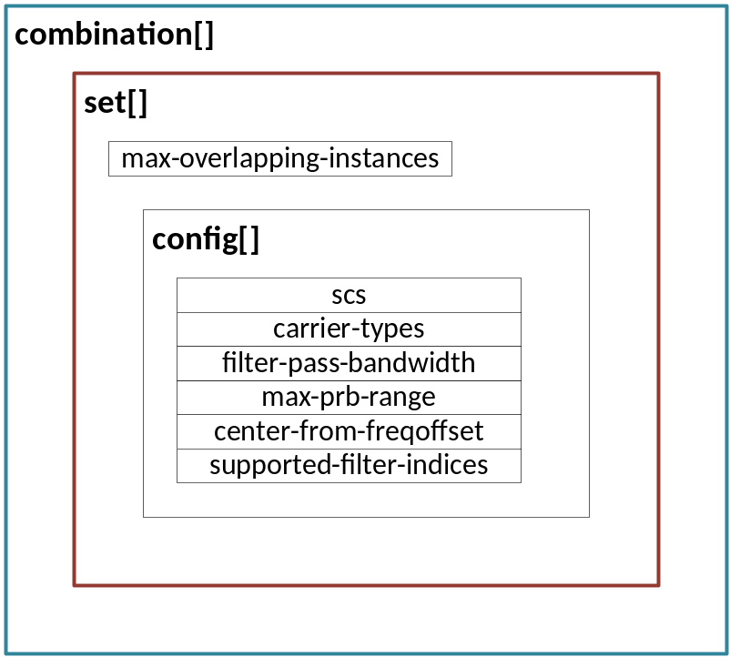
Figure 15.9-1: Supported configuration combinations group list overview
The config listed parameter center-from-freqoffset indicates whether deriving a new carrier center from a C-plane section type 3 message (as defined in [2] clause 15.4.1) is expected to be enabled for the activate configuration. It shall be enabled via the endpoint level parameter center-from-freqoffset-enabled. If an endpoint supports this capability, it shall report so by setting center-from-freqoffset-supported to TRUE.
The config listed parameter filter-pass-bandwidth conveys the maximum size of the passband filter relative to the host carrier center, as defined by center-of-channel-bandwidth, and therefore defines the frequency range from which PRBs can be extracted with the endpoint. In turn, the O-DU configures the expected occupied bandwidth to the O-RU via occupied-bandwidth, e.g. refer to [2] clause 15.4.1, 15.4.2 and 15.4.3. A list of supported filter pass bandwidths is provided in supported-filter-pass-bandwidths.
The config leaf-list parameter supported-filter-indices conveys the filter indices supported or intended by the config. As an example, the O-RU may use the parameter to restrict an endpoint to only support NB-IoT or a specific NB-IoT channel such as NPUSCH.
A static-low-level-rx-endpoint intended to support a NB-IoT carrier with an NPUSCH and two NPRACH channels may be conveyed in a single combination entry, as illustrated in Figure 15.9-2.

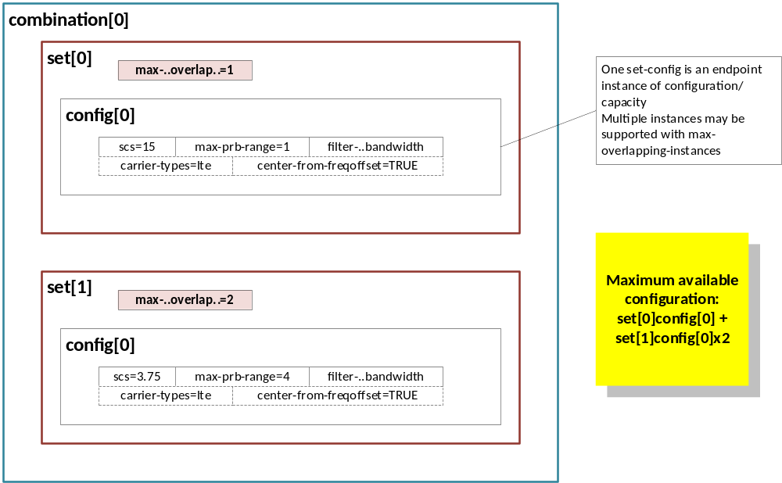
Figure 15.9-2: Example a static-low-level-rx-endpoint indirectly indicating support for a single NB-IoT carrier support with one NPUSCH and two NPRACH channels
A static-low-level-rx-endpoint may additionally support an LTE carrier and PRACH, however, not at the same time as an NB-IoT carrier. In which case, an additional combination entry may be listed to convey support for either NB-IoT or an LTE carrier as shown in Figure 15.9-3.
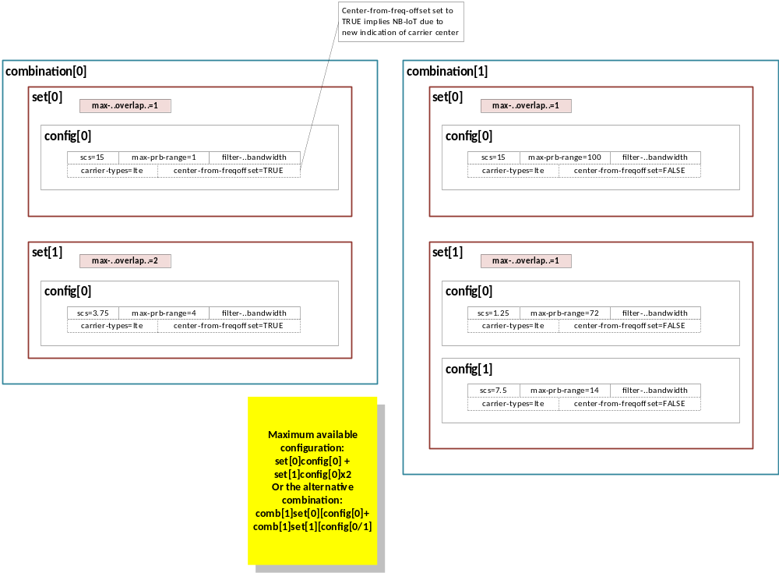
Figure 15.9-3: Example A static-low-level-rx-endpoint indirectly indicating support for either a NB-IoT and LTE carrier, however, not both at the same time
Finally, an endpoint capability report may be structured to indicate a large degree of flexibility in terms of active configs as illustrated in combination-1 of Figure 15.9-4 which shows any three combinations of the listed configs may be utilized. Whereas combination-0 can only support a single instance of a 15 kHz channel.
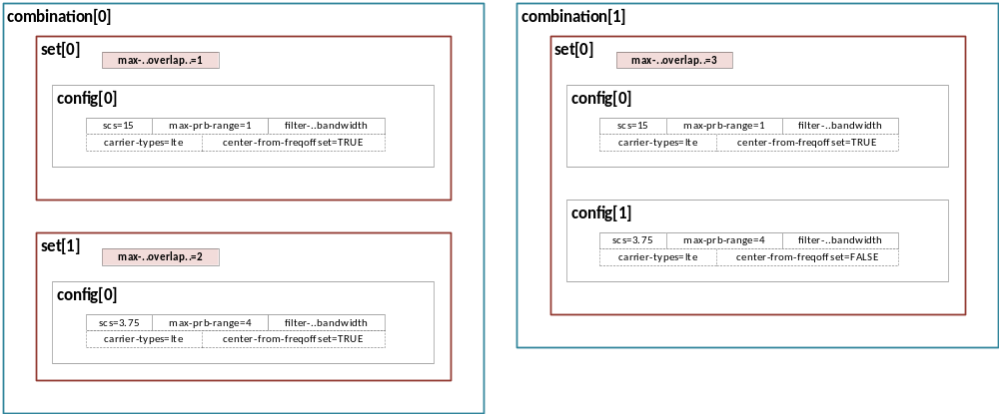
Figure 15.9-4: Example A static-low-level-rx-endpoint indirectly indicating support for a NB-IoT carrier with more flexibility in the right-hand side combination

15.10 U-Plane message limits
O-RU may indicate that its endpoints have U-Plane message processing limits, as specified in clause 8.5.1 of [2], by including feature UPLANE-MESSAGE-PROCESSING-LIMITS in o-ran-wg4-features.yang. The presence of this feature means, an O-RU may expose data node uplane-message-processing-limits-required per static-low-level-tx-endpoint via endpoint-types. uplane-message-processing-limits-required indicates whether an endpoint has U-Plane message processing limits or not.
- If O-DU supports feature UPLANE-MESSAGE-PROCESSING-LIMITS and supports the leaf max-section-headers-per-uplane-message , it should set uplane-message-section-header-limit-enabled to 'true' and should comply with O-RU limit specified by the parameters max-section-headers-per-uplane-message when forming U-Plane messages.
- When the O-DU does not configure the leaf uplane-message-section-header-limit-enabled to 'true', O-RU shall process the U-Plane messages that exceed the limits even though the O-RU may operate with degraded performance or capacity, (refer to [2] clause 8.5.1 for more details).
- When U-Plane message exceeds the limit reported by O-RU, O-RU may raise alarm to indicate the degraded performance or capacity. For details about alarm notification 'fault-id = 31', refer to Table A.1-1.

15.11 DRMS-BF capability and configuration management

15.11.1 Overview
The DMRS based beamforming method is beamforming method where the O-RU computes beamforming or beamforming + equalization weights based on DMRS configuration from O-DU. The DMRS-BF feature comprises of new O-RU advertised feature capabilities, O-RU advertised limits and O-DU configurations which are described in detail in the following clauses.

15.11.2 O-RU advertised capabilities and capacity limits
To support the DMRS based beamforming feature O-RU advertises to the O-DU a set of capability parameters which are mandatory to be supported by the O-RU and few other are optional. To support DMRS-BF new section type, new section extensions and various new functionalities have been added to the fronthaul CUS-Plane specification, each sub-functionality requires the O-RU to advertise a set of capabilities and maximum capacity limits. Below table intends to summarize all the parameters advertised by the O-RU and there scope i.e. at what granularity the parameters are advertised by the O-RU. Refer to Table C.2-1, feature numbers 67 to 77 and 81 for DMRS-BF related features in o-ran-wg4-features.yang.
Table 15.11.2-1: DMRS-BF O-RU advertised capabilities and capacity limits
S.No  (feature num.param num) | O-RU advertised DMRS-BF Capability/Limit  parameter name | Scope of parameter
1.1 | rrm-meas-supported | Per endpoint-type
1.2 | max-ipn-unalloc-reports-supported | Per endpoint-type
1.3 | max-ipn-unalloc-symbols-supported | Per endpoint-type
1.4 | max-ipn-alloc-reports-supported | Per endpoint-type
1.5 | alloc-ipn-per-dmrs-sym-grp-supported | Per endpoint-type
2.1 | equalization-data-scaling | O-RU level
2.2 | eq-scale-offset-min | Per endpoint-type
2.3 | eq-scale-offset-max | Per endpoint-type
3.1 | supported-symb-reorder-capability | Per endpoint-type
3.2 | max-num-symbol-reordering-pattern-per-slot | Per endpoint-type
3.3 | up-symbolId-type-supported | Per endpoint-type
4.1 | ta3-min-2g | Per non-default-ru-delay-profile and ru-delay-profile
4.2 | ta3-max-2g | Per non-default-ru-delay-profile and ru-delay-profile
5.1 | sinr-reporting-supported | Per endpoint-type
5.2 | supported-sinr-resolutions  sinr-max-data-layers,  sinr-per-prb (listleaf),  sinr-slot-mask (listleaf) | Per endpoint-type
5.3 | sinr-reference-level-min | Per endpoint-type
5.4 | sinr-reference-level-max | Per endpoint-type
5.5 | sinr-compression-method | Per endpoint-type  Per entry in supported-sinr-compression-methods
5.6 | sinr-bitwidth | Per endpoint-type  Per entry in supported-sinr-compression-methods
5.7 | sinr-block-size | Per endpoint-type  Per entry in supported-sinr-compression-methods
6.1 | supported-entry-types | Per endpoint-type
6.2 | max-user-groups-per-slot | Per endpoint-type, per group of endpoints sharing a capacity
6.3 | max-entries-per-slot | Per endpoint-type, per group of endpoints sharing a capacity
6.4 | max-dmrs-configs-per-user-group-incl-first-last-prb | Per endpoint-type
6.5 | max-dmrs-configs-per-user-group-excl-first-last-prb | Per endpoint-type
6.6 | dmrs-symbol-mask | Per endpoint-type
6.7 | max-dmrs-ant-port-number | Per dmrs-symbol-mask
6.8 | max-user-data-layers | Per dmrs-symbol-mask
6.9 | list of supported pairs of { low-papr-type and hopping-mode } | Per endpoint-type
6.10 | list of supported pairs of { d-type, pusch-dmrs-muxing-supported } | Per endpoint-type
6.11 | different-transform-precoding-in-user-group-supported | Per endpoint-type
6.12 | different-cdm-without-data-in-user-group-supported | Per endpoint-type
7.1 | se-10-bgt-11b-supported | Per endpoint-type
7.2 | se10-member-candidate-list | Per endpoint
8 | user-group-self-assembly-mode | Per endpoint-type
9 | continuity-block-sizes-supported | Per endpoint-type
10.1 | ueid-max-layer-bits | O-RU level
10.2 | max-num-ues-supported | O-RU level
10.3 | max-num-ueids | O-RU level
11 | simultaneous-sinr-and-dmrs-sending-supported | Per endpoint-type
12.1 | ue-time-partial-overlap-supported | Per endpoint-type
12.2 | ue-freq-partial-overlap-supported | Per endpoint-type
13 | max-user-groups-per-ue-in-time | Per endpoint-type

15.11.3 O-DU configurations of parameters
Following O-RU capability advertisement, the O-DU is required to configure a set of parameters with restrictions on the scope of configuration. Below table intends to summarize all the parameters configured by the O-DU to enable the sub-functionalities/features advertised by the O-RU. Along with the parameter list the table also captures the scope of configuration of all the parameters to be configured by the O-DU.
Table 15.11.3-1: DMRS-BF configurations
S.No  (feature num.param num) | Configuration parameter | Configuration Scope
1.1 | rrm-meas-enabled | Per endpoint
2.1 | eq-scale-offset-config | Per endpoint
2.2 | eq-scale-offset-used | Per endpoint
3.1 | se26-usage-enabled | Per endpoint
4.1 | config-symb-reorder-method | Per O-RU
4.2 | config-symb-reorder-upSymbId-type | Per O-RU
5.1 | sinr-reporting-enabled | Per endpoint
5.2 | sinr-per-prb | Per endpoint
5.3 | sinr-slot-mask | Per endpoint
5.4 | sinr-reference-level-config | Per endpoint
5.5 | sinr-reference-level-used | Per endpoint
5.6 | sinr-compression-method | Per endpoint
5.7 | sinr-bitwidth | Per endpoint
5.8 | sinr-block-size | Per endpoint
6 | user-group-mode | Per rx-array-carrier
7.1 | continuity-block-size-configured | Per rx-array-carrier
8.1 | ueid-layer-bits-configured | Per O-RU
9.1 | port-reduced-dmrs-data-sending-enabled | Per rx-array-carrier
9.2 | point-a-offset-to-absolute-frequency-center | Per rx-array-carrier
10 | ueid-persistence-enabled | Per O-RU
11 | bf-methods | Per endpoint

15.11.4 DMRS-BF-EQ target value configuration
For DMRS-BF-EQ, there are two parameters, eq-scale-offset-config (see clause 8.1.3.4 in CUS-plane specification [2]) and sinr-reference-level-config (see clause 7.2.11 in CUS-plane specification [2]), that use the method of target value configuration and used-value retrieval described in clause 9.1.9.
The O-DU configures a target value for each of the parameters eq-scale-offset-config and sinr-reference-level-config as part of endpoint creation or reconfiguration including these two parameters. It is important for the O-DU to know (with sufficiently high precision) the actual values used, but it is possible that the O-RU cannot implement the target values precisely. The O-RU will instead report and use the value it is able to support but close to the target value. To report the used-values, the O-RU sets the read-only parameters eq-scale-offset-used and sinr-reference-level-used to the values that the O-RU used. The O-DU can retrieve the used-values before carrier activation and will then be aware of the precise value (to the precision of the M-plane data formats for each used-value) used by the O-RU.
Refer to clause 9.1.9 for procedure details.

15.12 Description of feature SE10-MEMBER-CANDIDATE-LIST
Support for the feature SE10-MEMBER-CANDIDATE-LIST enables the O-RU to explicitly advertise one or multiple entries in the list se10-member-candidate-[tr]x-lists. This list is advertised separately for TX endpoints and RX endpoints at the O-RU level. Each static-low-level-tx-endpoint and each static-low-level-rx-endpoint supporting Section Extension 10 points to one entry from the list se10-member-candidate-tx-lists/ se10-member-candidate-rx-lists using the parameter se10-member-candidate-list respectively. By virtue of an endpoint belonging to a given se10-member-candidate-[tr]x-list entry, the endpoints can be used as member eAxC_ID entry in the O-DU configured [tr]x-eaxc-id-group. Below tables explains the advertisement of shared list by the O-RU and association of shared list entry per endpoint.
Table 15.12-1: Example of O-RU level global member list advertisement
se10-member-candidate-rx-lists index | Member static-low-level-rx-endpoint of member-candidates list
1 | static-low-level-rx-endpoint-1  static-low-level-rx-endpoint-2  static-low-level-rx-endpoint-3  static-low-level-rx-endpoint-4 (note)  static-low-level-rx-endpoint-8 (note)
2 | static-low-level-rx-endpoint-3  static-low-level-rx-endpoint-5  static-low-level-rx-endpoint-6  static-low-level-rx-endpoint-7  static-low-level-rx-endpoint-8 (note)  static-low-level-rx-endpoint-9
NOTE: These endpoints may also be representative endpoints, See table 15.12-2

Table 15.12-2: Example of O-RU advertised static-low-level-rx-endpoint and a given member-candidates list association
O-RU advertised representative endpoint (endpoints supporting SE-10) | Associated se10-member-candidate-[tr]x-lists index
static-low-level-rx-endpoint-4 | 1 or 2 (note)
static-low-level-rx-endpoint-8 | 1 or 2
NOTE: In this example static-low-level-rx-endpoint-4 can represent list se10-member-candidate-rx-lists index 2 but cannot be a member of se10-member-candidate-rx-lists index 2

Based on se10-member-candidate-list declared for endpoint that support Section Extension 10 by the O-RU, the O-DU configures a list tx/rx-eaxc-id-group, where each entry of this list comprises of representative-tx/rx-eaxc-id as the key/index of the list, where each list entry comprises of a list of member-tx/rx-eaxc-id (s) from one specific entry advertised in se10-member-candidate-list[] by the O-RU.
NOTE: O-DU while configuring a given rx-eaxc-id-group[] entry, the O-DU excludes representative endpoint from the configured member-list
Table 15.12-3: Example for O-DU configured representative and associated member list based on O-RU advertised se10-member-candidate-list-ref[]
rx-eaxc-id-group[] indexed by representative-rx-eaxc-id as key | O-DU configured member-rx-eaxc-id within rx-eaxc-id-group[] entry with members picked from se10-member-candidate-list[] list advertised by the O-RU
low-level-rx-endpoint-4 | low-level-rx-endpoint-1  low-level-rx-endpoint-2  low-level-rx-endpoint-3  low-level-rx-endpoint-8
low-level-rx-endpoint-8 | low-level-rx-endpoint-5  low-level-rx-endpoint-6  low-level-rx-endpoint-7  low-level-rx-endpoint-9

15.13 Passive Intermodulation (PIM)

15.13.1 General
This clause describes the requirements and scope of PIM-related mechanisms relevant to the M-Plane. The following mechanisms are optionally supported by O-RUs to implement PIM-related functions:
- PIM Cancellation.
- PIM Measurements.
An O-RU supporting optional capabilities related to PIM shall include o-ran-pim model in its YANG library. This clause applies to O-RUs that support these optional capabilities.

15.13.2 PIM Cancellation
PIM Cancellation is a digital signal processing technique that aims to remove unwanted passive intermodulation products. An O-RU may optionally support PIM Cancellation. The O-RU exposes its ability to support PIM Cancellation by reporting the following nodes in the pimc-capabilities container:
- pimc-control-methods-supported: indicates the supported PIMC control types. The allowed values are ARRAY-ELEMENT and ARRAY-CARRIER. An O-RU may support more than one PIMC control types. If the list is empty, then the O-RU doesn't support PIMC.
To enable PIM Cancellation, the O-RU Controller shall configure the pimc-control-method leaf in the pimc-general-configuration container to one of the PIMC control types reported by the O-RU in the pimc-capabilities container.
If the O-RU Controller configured pimc-control-method leaf with value ARRAY-ELEMENT, then the O-RU controller may enable PIM Cancellation on selected rx-array elements by providing the configuration in the pimc-array-element-configuration list. In this case, the O-RU cancels the PIM on the total frequency range supported by the rx-array element.
If the O-RU Controller configured pimc-control-method leaf with value ARRAY-CARRIER, then the O-RU controller may enable PIM Cancellation on selected rx-array-carriers by setting the pimc-enabled leaf to true in rx-array-carriers in the o-ran-uplane-conf module. In this case, the O-RU cancels the PIM on the frequency range configured for the rx-array-carrier for all the array elements associated with that rx-array-carrier.

15.13.3 PIM Measurements
PIM Measurements capability allows the provision of metrics for unwanted passive intermodulation products. An O-RU may optionally support PIM Measurements.
PIM Measurements are provided with the Performance Management counters, refer to clause B.13.1

16 Licensed assisted access

16.1 Introduction
Licensed-assisted access (LAA) leverages the carrier-aggregation (CA) functionality. With LAA, CA is performed between licensed and unlicensed component carriers (CCs). This enables the LAA system to opportunistically benefit from using unlicensed spectrum (e.g. UNII bands in the 5 GHz spectrum) to enhance the aggregated capacity of the O-RU with the objective of enhancing the downlink throughput.
Several modifications in the RAN are needed to enable LAA in the O-DU and O-RU such as listen-before-talk (LBT), discontinuous transmission, carrier-selection, discovery reference signal (DRS) transmission, etc. This clause is focused on the LAA-related messages and procedures needed in the M-plane. The C-plane related messages are defined in clause 7.2.5.2 of the CUS-plane spec [2].
This version of the M-plane spec supports only LAA based on Rel. 13 of the 3GPP specs, where transmission on the unlicensed spectrum can be done only in the downlink direction. The support of eLAA Rel. 14 (i.e. enabling UL transmission on the unlicensed spectrum) may be included in a later version of the M-plane spec.
The modifications at M-plane to Support LAA can be summarized as follows:
- LAA-initiation process: O-DU learns about O-RU capabilities and configures it.
- O-RU LAA Support: The O-RU indicates it supports LAA by including support for the "urn:o-ran:laa:x.y" and "urn:o-ran:laa-operations:x.y" namespaces in its ietf-yang-library model as specified in RFC 8525 [59].
- O-RU LAA Capability Information: When the LAA feature is enabled, leafs corresponding to LAA-related O-RU capabilities, such as the number of supported LAA SCarriers, maximum LAA buffer size, etc, are conveyed via the M-plane to the O-DU as part of the o-ran-module-cap.yang module.
- O-RU LAA Configuration: The NETCONF client configures the unlicensed LAA component carrier with the LAA-related parameters such as the energy-detection threshold, DRS measurement timing configuration (DMTC) period, etc. as part of the o-ran-uplane-config.yang module. The configuration of the number of LAA SCarriers, multi-carrier type, etc. is performed using the o-ran-laa.yang Module.
- For explanation of the LAA-initiation process, refer to Figure 6.1-1 in clause 6, where the O-RU LAA capability info is conveyed within the "Retrieval of O-RU information" step, while the O-RU LAA configurations are conveyed in "Configuring the O-RU operational parameters" step in Figure 6.1-1.
- Carrier-selection: Selecting the best channel in the unlicensed band, both initially and dynamically over time, as illustrated in Figure 16.1-1.

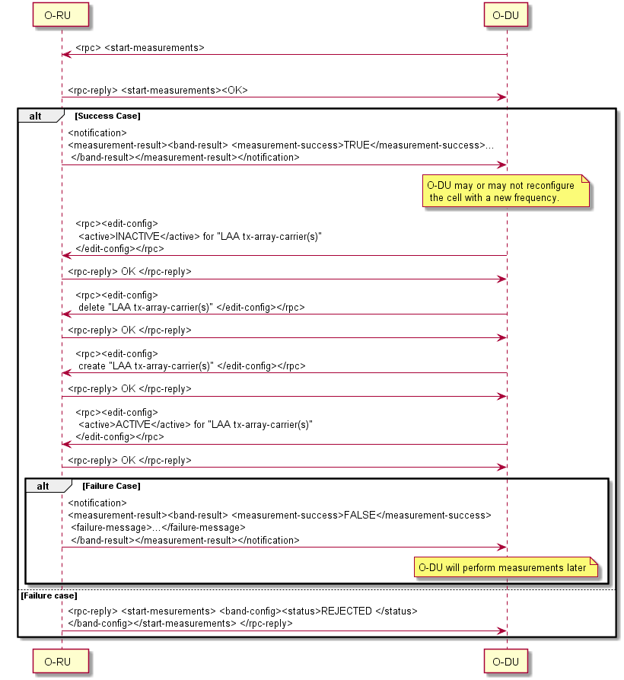
Figure 16.1-1: Carrier-Selection Call-flow

16.2 LAA-initiation process

16.2.1 LAA module capabilities
During LAA-initiation, the O-RU reports its LAA capabilities to the NETCONF client. These capabilities are sent at the start up as part of the o-ran-module-cap.yang module. The attributes included are:
- sub-band-frequency-ranges: The unlicensed sub-bands (e.g. 46A, 46B, etc.) that are supported at the O-RU and their frequency ranges
- number-of-laa-scarriers (uint8): Number of LAA SCarriers that the O-RU can support.
- maximum-laa-buffer-size (uint16): Maximum O-RU buffer size in Kilobytes (KB) per CC. This parameter is needed at the O-DU to know how much data can be sent in advance and stored at the O-RU to address the LBT uncertainty.
- maximum-processing-time (uint16): Maximum O-RU Processing time in microseconds at the O-RU to handle the received/transmitted packets from/to the O-DU. This parameter is needed at the O-DU to determine the time where it needs to send the data to the O-RU.
- self-configure (Boolean): Capability to manage the contention window at the O-RU. Based on the CUS-spec, there are two modes of operation for LAA, 1) when the contention window is managed by the O-DU, and 2) when the contention window is managed by the O-RU. This field is set to True if the O-RU can manage the contention window locally.

16.2.2 LAA O-RU parameter configuration
The second stage of the LAA-initiation process is the configuration message (using RPC edit-config). In this message, the O-DU configures the O-RU with the required parameters in the downlink direction. LAA parameters can be configured by Netconf Client after capability exchange is finished. It can also be sent as needed, to reconfigure the O-RU with new parameters (e.g. ed-threshold-pdsch, etc.). The attributes of this message (o-ran-laa.yang Module) include:
- number-of-laa-scarriers (uint8): Number of LAA SCarriers to be used at the O-RU. This number should be less than or equal the number reported by the O-RU in its module capabilities.
- multi-carrier-type (Enumeration): This value indicates the list of multi carrier types (A1, A2, B1, B2) as specified in clause 15.1.5 of 3GPP TS 36.213 [32].
- multi-carrier-tx (Boolean): This value indicates whether self-deferral is activated or not. "True" indicates transmission on channel access win (i.e. no self-deferral). "False" indicates mutual transmission on multiple carriers.
- multi-carrier-freeze (Boolean): This value indicates if the absence of other technology in the unlicensed band can be guaranteed. This attribute can only be used when the multi-carrier-type is A1. "False" indicates that absence of other technology is not guaranteed.
- laa-ending-dwpts-supported (Boolean): This value indicates whether LAA ending in Downlink Pilot Time Slot (DwPTS) is supported.
- laa-starting-in-second-slot-supported (Boolean): This value indicates LAA starting in second slot is supported.
LAA carrier configurations (o-ran-uplane-conf.yang Module) include:
- ed-threshold-pdsch (int8): This value indicates the energy detection (ED) threshold for LBT for PDSCH and for measurements in dBm.
- ed-threshold-drs (int8): This value indicates the ED threshold for LBT for DRS in dBm.
- tx-antenna-ports (uint8): This value indicates the Tx antenna ports for DRS.
- transmission-power-for-drs (int8): This value indicates the offset of CRS power to reference signal power (dB).
- dmtc-period (enumeration): This value indicates DMTC period in milliseconds.
- dmtc-offset (uint8): This value indicates DMTC offset in Subframes.
- lbt-timer (uint16): This value indicates LBT Timer in milliseconds.
If Self Configure capability is set to "true", the following parameters are also needed to be configured. For every traffic priority class, the O-DU needs to configure maximum CW usage counter. This value indicates the maximum value of counter which shows how many max congestion window value is used for back off number of each priority class traffic. This value, as specified in clause 15.1.3 of 3GPP TS 36.213 [32], is represented as K. Based on the 3GPP specification, this value is selected by O-RU from the set of values {1, 2, …, 8}.

16.3 Carrier selection

16.3.1 LAA measurements
The function of the message "rpc start-measurements" is to order the O-RU to start measurements. This message can be used for carrier selection initially or dynamically over time. O-RU sends RPC response where status=ACCEPTED (positive case) or REJECTED (negative case). O-RU performs measurement and delivers result with respect to max response time. If result is not ready on time - O-RU sends notification with "measurement-success"=FALSE and with appropriate failure reason. For every configured band, the O-RU informs the NETCONF client whether the measurement was successful or not. For bands with successful measurements, the O-RU reports the occupancy ratio and average RSSI for each channel. For bands with failure measurements, the O-RU includes the reason (e.g. TIMEOUT when the O-RU is not able to finish the measurement for this specific band).
The occupancy ratio of a given channel is defined as the percentage of the busy duration (i.e. measured signal power is larger than the energy-detection threshold) to the total measurement duration of this specific channel. The energy-detection threshold is specified in the o-ran-uplane-conf.yang module using the ed-threshold-pdsch leaf. Note that this threshold is the same as the energy-detection threshold used for LBT for PDSCH transmission. The total measurement duration per channel is specified in o-ran-laa-operation module using the duration-per-channel leaf. The range of the occupancy ratio is from 0% (no signal is detected over the total measurement duration per channel) to 100% (i.e. channel was always occupied during measurement).
The average RSSI of the measured channel is the measured power of this specific channel averaged over the total measurement duration per channel. This parameter is reported to the NETCONF client in dBm and takes a value from the range 0 dBm to -128 dBm.

16.3.2 LAA carrier frequency configuration
After receiving the measurements, the NETCONF client configures the O-RU with the new channel(s), if needed. To start radio transmission and reception with a new centre frequency, for every component carrier (CC) that needs to be re-configured with a new centre frequency, the O-DU shall first deactivate the TX carrier, delete it, then create a new TX carrier (using the new centre carrier frequency as well as any other new configurations), and then activate the TX carrier again to start OTA operation. The procedure for deactivating/deleting/creating/activating the carrier is explained in clause 15.3: Carrier Configuration, in the M-plane specification and elaborated in Figure 15.2.4-1.
NOTE 1: The creation of LAA carriers is identical to the creation of regular carriers but in the unlicensed bands. O-RU responds to the configuration request with success or failure.
NOTE 2: The carrier-selection algorithm at the O-DU (i.e. selecting the "best" channel based on the reported measurements from the O-RU) is an implementation issue and is out of the scope of the present document.

17 Shared cell

17.1 Introduction
This clause specifies the support of the "Shared Cell" O-RU use case. The features of C/U-Plane aspects are described in clause 13 of [2]. The M-Plane aspects necessary to support Shared Cell are described in this clause 17.

17.2 Architecture
The NETCONF client (O-RU Controller) establishes M-Plane connection individually to each O-RU, where the O-RUs are operating in either cascade mode or FHM mode, as illustrated in Figure 17.2-1.
In Figure 17.2-1, solid lines indicate C/U-plane interface and dotted lines indicate M-plane interface. Therefore, from the M-Plane point of view, the same architecture model can be applied as specified in clause 5.1.2. New functionality which is required to be added, together with existing functionality which is required to be enhanced are specified in clauses 17.3 to 17.6. There are no changes to the functionality described in the following clauses and their associated YANG models:
- Clause 8 : Software management
- Clause 11 : Fault management
- Clause 12 : File management
A NETCONF client with suitable privileges is able to trigger a reset procedure for each O-RU. It is strongly recommended that when triggering the reset procedures for multiple O-RUs, a NETCONF client should order the procedures such that a reset of an individual O-RU does not affect the operation of other O-RUs operating in either cascade or FHM mode. This can be achieved by correct ordering of the triggering of the reset procedure between the different O-RUs. For example, when triggering a reset involving multiple O-RUs operating in cascade mode, the ordering of the reset trigger sent by the NETCONF client should be done beginning with the last (most-southern) O-RU to the first (most northern) O-RU in chain. In configuration where FHM is used - when FHM reset is needed, O-RUs connected through this FHM should be reset first, then FHM reset can be performed. It is strongly recommended to disable carriers affected by such a reset procedure prior to the triggering of the reset to minimize the impact on C/U-plane traffic as much as possible. In case an O-RU connected through FHM requires to be reset - the reset does not impact to other O-RUs.
NOTE: There is no difference between Hierarchical M-plane architecture and Hybrid M-plane architecture from the point of reset ordering in either cascade mode (chain topology), or FHM mode (tree topology).
Using this approach, a NETCONF client can performs software management on multiple O-RUs. Since this procedure may require the reset of the O-RU to update the appropriate software file(s) for the O-RUs, the NETCONF client is recommended to order the software management procedures such that the reset procedure issued against one O-RU shall not impact the other O-RUs or FHM.
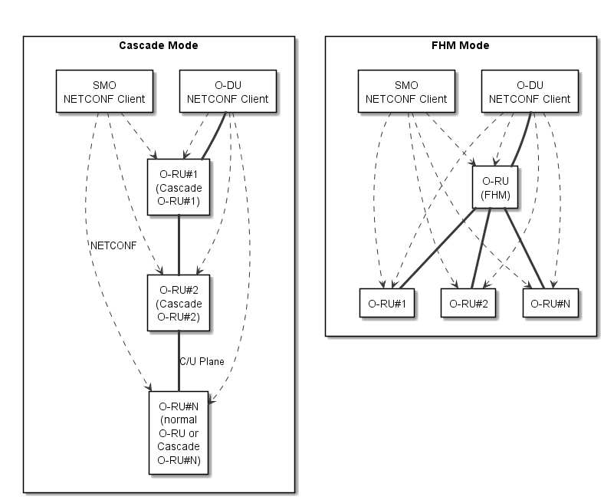
Figure 17.2-1: M-Plane Connection

17.3 Start-up and Installation
This clause provides the consideration regarding the shared cell specific additional mechanism for the overall start-up mechanism for "O-RUs with Copy and Combine function" and for "O-RUs without Copy and Combine function".
Each O-RU establishes M-Plane connection individually to the NETCONF client in the O-RU Controller. The procedures through Transport Layer initialisation (DHCP process and VLAN scanning) and supervision of NETCONF connection are the same as Figure 6.1-1 in clause 6 for both “O-RUs with Copy and Combine function” and “O-RUs without Copy and Combine function”.
For the transport layer initialisation, the following assumptions are made:
- The order of each O-RU's M-plane establishment is not restricted because of the network transparency at O-RU (FHM and Cascade).
- For simplification, the network should be configured using a common management plane vlan-id or untagged interface for all O-RUs within one shared cell network managed by same NETCONF client. As a result, the same vlan-id is learned by VLAN scanning by all O-RUs within the shared cell network.

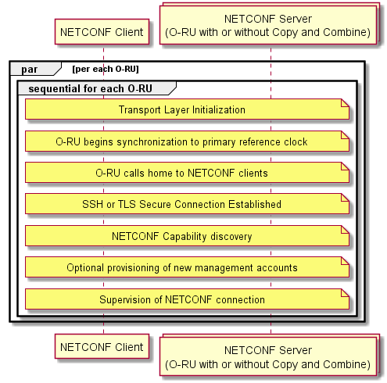
Figure 17.3-1: NETCONF establishment of the start-up
In the step "retrieval of O-RU information", the NETCONF client retrieves the O-RUs' capability from the NETCONF servers by using individual M-plane connection in parallel. The Copy and Combine related capability is defined in clause 17.6.1.
After the retrieval of O-RU information, the NETCONF client performs the topology discovery procedure in order to discover the topology of NETCONF servers within one shared cell network. (See clause 17.6.2)
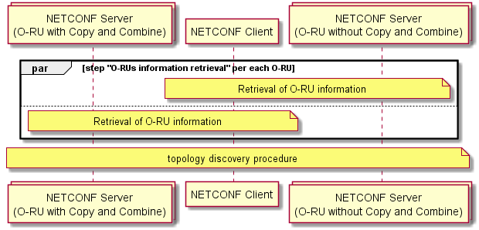
Figure 17.3-2: RU information retrieval and topology detection at the start-up
The NETCONF client performs software management per O-RU as described in clause 8.
As described in clause 17.2, as the reset procedure is required during the software management procedure, it is recommended that the NETCONF client resets the O-RU while taking account of the topology of O-RUs and whether a reset of one O-RU will affect other O-RUs in the chain or star topology.
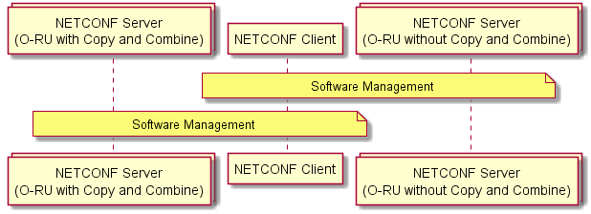
Figure 17.3-3: Software management per O-RU
After the software management steps are completed for all NETCONF servers, the NETCONF client performs shared cell configuration. (See clause 17.6.3.)
The NETCONF client performs transport configuration, connectivity check configuration, C/U-plane transport connectivity check procedure, Retrieval of the O-RU Delay Profile and U-plane configuration procedures for all O-RUs.
In the present document, the only processing element definition used for supporting shared cell is the Ethernet-type-flow which is a combination of VLAN identity and MAC address. The vlan-id(s) used for C/U-plane transport-flows is/are common to all O-RUs operating within one shared cell network.
The Ethernet bridging functionality in an O-RU with Copy and Combine function is able to bridge the Ethernet Loopback messages between the O-DU and other O-RUs configured as part of the shared cell operation. For more details, see clause 17.6.2.
The u-plane configuration in o-ran-uplane-conf module shall have identical configuration except config-false instances' names and low-level-tx(rx)-endpoints' names for all O-RUs operating within the one shared cell network. The value of gain in tx-array-carriers can be independently configured per O-RU (, i.e. a common value is not mandatory).
The u-plane configuration in o-ran-uplane-conf module is no longer required for O-RU (FHM). Instead, shared-cell-copy-uplane-config and shared-cell-combine-uplane-config in o-ran-shared-cell.yang module are used. (See clause 17.6.4)
NOTE: In this version of the specification, only eCPRI headers are supported for the C/U-Plane protocol (, i.e. support of the IEEE 1914.3 header, as specified in [i.9], is not defined).
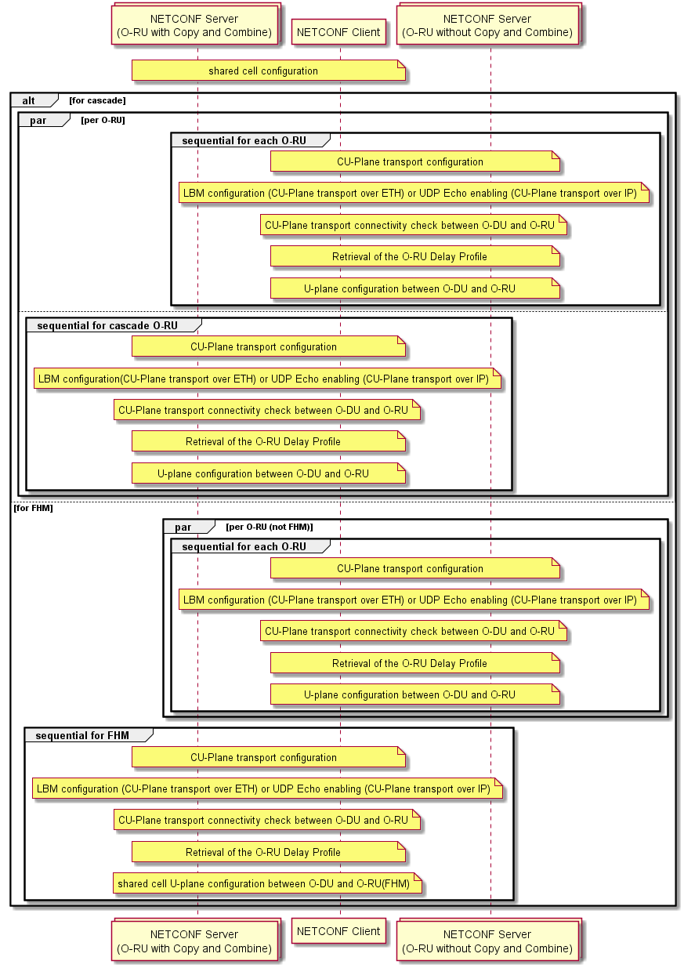
Figure 17.3-4: shared cell configuration and u-plane configuration
The NETCONF client performs further steps for the regular start-up procedure as described in clause 6.
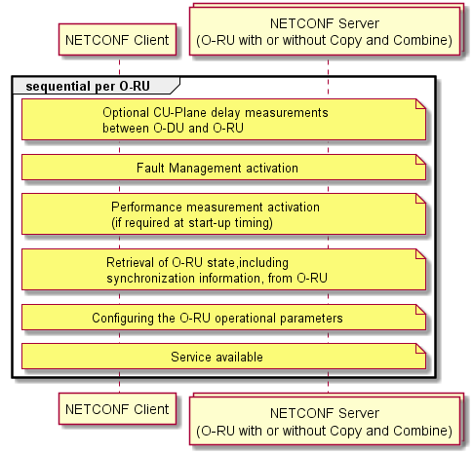
Figure 17.3-5: further steps for start-up procedure

17.4 Performance management
This clause provides description of the specific part of Performance Management for shared cell.
NOTE 1: Clause 9.1 of CUS specification [2] indicates whether a particular performance measurement is mandatory or optional for Cascade/FHM O-RU.
transceiver-stats:
O-RU (Cascade / FHM) has multiple connections to O-DU and O-RU (Cascade/Normal). The baseline O-RU models permit O-RUs to be defined with multiple ports and multiple transceiver modules. Transceiver module is defined by o-ran-transceiver which refers the port-number for these interfaces. Refer to clause 17.6.1 O-RU Information for Shared Cell. In this case, the O-RU (Cascade / FHM) reports transceiver-stats per port-number.
Rx-window-stats:
O-RU (Cascade) monitors rx-window-stats per eaxc-id, per transport or per hardware component (O-RU) because it receives data flow from the north-node. An FHM has no radio transmission/reception functionality and hence cannot support RX_ON_TIME, RX_EARLY, RX_LATE, RX_ON_TIME_C, RX_EARLY_C, RX_LATE_C in rx-window-stats.
NOTE 2: This version of the specification does support rx-window-stats to monitor the downlink reception window and does not support monitoring by an O-RU of the uplink traffic from south-node.
Tx-stats:
O-RU (Cascade / FHM) monitors tx-stats per eaxc-id, per transport or per hardware component (O-RU) because it transmits data flow to the north-node.
NOTE 3: This version of the specification does support tx-stats to monitor uplink traffic and does not support monitoring by an O-RU of the downlink traffic to south-node.
Shared-cell-stats:
Cascade O-RU/FHM monitors shared-cell-stats on per TRANSPORT object-unit.
NOTE 4: Monitoring by an O-RU of the uplink traffic from south-node can be achieved using shared-cell-stats.
Epe-statistics:
O-RU (Cascade / FHM) monitors epe-statistics per hardware component.
Symbol-rssi-stats:
O-RU monitors symbol-rssi-stats per rx-array-carrier.
NOTE 5: O-RU without radio transmission/reception capability (FHM) does not support monitoring of symbol-rssi-stats
Tx-antenna-stats:
O-RU monitors tx-antenna-stats per tx-array element, or connector and band number.
NOTE 6: O-RU without radio transmission/reception capability (FHM) does not support monitoring of tx-antenna-stats.
Tssi-stats:
O-RU monitors tssi-stats per carrier_array_element.
NOTE 7: O-RU without radio transmission/reception capability (FHM) does not support monitoring of tssi-stats-object.
Rssi-stats:
O-RU monitors rssi-stats per carrier_array_element.
NOTE 8: O-RU without radio transmission/reception capability (FHM) does not support monitoring of rssi-stats-object.
Tx-output-power-stats:
O-RU monitors tx-output-power-stats per tx-array-carrier, tx-array-element, connector, carrier_array_element or array-carrier-connector.
NOTE 9: O-RU without radio transmission/reception capability (FHM) does not support monitoring of tx-output-power-stats.
ethernet-stats:
O-RU (Cascade / FHM) has multiple connections to O-DU and O-RU (Cascade/Normal). The baseline O-RU models permit O-RUs to be defined with multiple ethernet ports. Refer to clause 17.6.1 O-RU Information for Shared Cell. In this case, the O-RU (Cascade / FHM) reports ethernet-stats per port-number.
Table 17.4-1: Measurement-group of O-RU (Cascade / FHM)
Measurement-group | measurement-units
transceiver-stats | port-number (multiple)
rx-window-stats | eaxc-id, transport or hardware component (O-RU)
tx-stats | eaxc-id, transport or hardware component (O-RU)
shared-cell-stats | transport
epe-statistics | hardware component
symbol-rssi-stats | rx-array-carrier
tx-antenna-stats | tx-array element, or connector and band number
tssi-stats | carrier_array_element
rssi-stats | carrier_array_element
tx-output-power-stats | tx-array-carrier, tx-array-element, connector, carrier-array-element or array-carrier-connector
ethernet-stats | ethernet inteface name (multiple)

For more detail, refer to the counters specified in Annex B.

17.5 Delay management
In the shared cell environment, the use of O-RU Adaptive Delay capability is not permitted. The O-DU and each O-RU have their own delay parameters and supported transmission window and reception window. Also, the topology of the O-RU configuration can be detected by the topology discovery procedure.
The O-DU can determine the delay budget between itself and the O-RUs considering the O-RUs' topology and delay parameters and its own transmission window and reception window. During this discovery, the required processing time of the O-RU is also considered. The O-RU processing time includes the copy operation for downlink operation, and the combine operation for uplink operation, and the delay periods for the copy and combine operations are defined as t-copy and t-combine in o-ran-shared-cell.yang module:
- t-copy: Corresponding to the maximum FHM or cascade O-RU processing delay between receiving an IQ sample over the fronthaul interface from the north-node, coping it and transmitting it over the fronthaul interface to the south-node.
- t-combine: Corresponding to the maximum FHM or cascade O-RU processing delay between receiving an IQ sample over the fronthaul interface from the south-node(s), combing them and transmitting it over the fronthaul interface to the north-node.
Therefore, based on the above information, the O-DU can determine how many O-RUs are configured to operate in a shared cell instance.
After the delay budget between the O-DU and the furthest (southern-most) O-RU in the chain is determined, multiple O-RUs can be configured to operate in between the O-DU and the furthest O-RU. The time budget between the O-DU and the furthest O-RU is constant and is shared for all O-RUs operating in cascade mode.
For combine function operation, the O-RU shall await the successful reception of the eCPRI frame(s) from the south-node(s). Once the FHM receives the eCPRI frame from all of the south-nodes, the O-RU (FHM) can perform the combine operation. Once the cascade O-RU receives the eCPRI frame from the south-node, the O-RU can perform the combine operation using the eCPRI frame and received radio information. The maximum time an O-RU is permitted to wait for the required eCPRI frames is set by the ta3-prime-max configured by NETCONF client. If the O-RU cannot commence the combination procedure until a time after the configured ta3-prime-max minus t-combine, e.g. due to the delayed reception of eCPRI frame(s), the O-RU shall discard the delayed eCPRI frames if received and combine other received frames (for FHM mode) or radio information (for Cascade mode). The configurable ta3-prime-max shall be equal to or less than ta3-prime-max-upper-range which is the capability of O-RU, related to the internal memory for combine operation. The detail for C/U-plane aspects is described in clause 13.4.3 of [2].
The ta3-prime-max schema node is relevant to the timing on each symbol. The scs schema node indicates each symbol timing. The capability of supported SCSes is reported by leaf-list scs-supported. Among them the intended SCSes should be informed to FHM/Cascade O-RU as scs schema node, associating with eaxc-id. SCS in an eaxc-id can be different from that of another eaxc-id. SCS in an eaxc-id can be also plural. FHM/Cascade O-RU reports the capability of supporting multiple SCS in a single eaxc-id as the feature MULTIPLE-SCS-IN-EAXC, and O-DU should check before configuring multiple SCS in a single eaxc-id.
- ta3-prime-max: The latest time that FHM or cascade O-RU is allowed to send UL U-plane message to north-node relative to reception timing at O-RU antenna.
- ta3-prime-max-upper-range: The upper limit for the configurable ta3-prime-max value. This is the capability information of O-RU that comes from the O-RU internal memory for the combine operation.
Clause 13.5.3 of the CUS specification [2] introduces new parameters for controlling combine operations:
t-combine-net: is the read-only processing delay as the reported by the FHM/Cascade O-RU
tx-duration: is a configurable parameter by O-DU or a calculated parameter by FHM/Cascade O-RU, corresponding to the message transmission duration.
Where:

the sum of t-combine-net processing delay and the maximum tx-duration transmission duration corresponds to the t-combine duration.
NOTE: CUS Plane [2] refers to these parameters as T_Combine_net, Tx_Duration and T_Comb.
An FHM/Cascade O-RU can signal to an O-RU Controller that it supports these parameters by indicating it supports the ENHANCED-T-COMBINE YANG feature. The O-DU configures such an FHM/Cascade O-RU to use the new parameters by setting the enhanced-t-combine-enabled to 'true'. In this case, the FHM/Cascade O-RU shall use t-combine-net and tx-duration to calculate the T_waiting (Refer to 13.5.3 of [2]) instead of t-combine. If enhanced-t-combine-enabled is set to ' true' and if no value of tx-duration is configured by the O-DU, the FHM/Cascade O-RU shall calculate tx-duration from shared-cell-combine-entities, ensuring that the maximum amount of calculation does not exceed the symbol duration without cyclic prefix designated by ta3-prime-max.
When multiple SCSes are supported by FHM/Cascade O-RU, there are multiple combine delays according to SCSes or configured tx-duration per SCS. This capability may be exposed by FHM/Cascade O-RU through combine-delay-per-scs.

17.6 Details of O-RU operations for shared cell

17.6.1 O-RU information for shared cell
This clause provides the function detail of O-RU operations for a shared cell.
Interfaces to south-node of O-RU with Copy and Combine function
Cascade O-RU may have one additional transport interface to south-node and FHM may have more than one additional transport interfaces to south-nodes, illustrated in Figure 17.6.1-1.
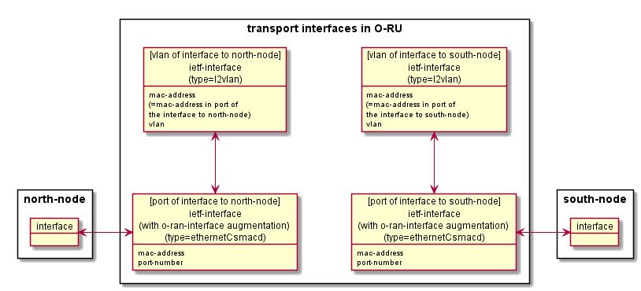
Figure 17.6.1-1: Transport Interfaces of both side of O-RU
Both the interface to north-node and the interface to south-node can be defined by ietf-interface YANG model with type = ethernetCsmacd, augmented by o-ran-interface for mac-address and port-number. Transceiver module is defined by o-ran-transceiver which refers the port-number for these interfaces. The maximum number of the interfaces is just the number of physical interfaces within the O-RU.
NOTE: The present document defines the use of IEEE 802.1X port based access control, as described in clause 7.12. In order to use IEEE 802.1X, a supplicant PAE in an O-RU needs to signal with an authenticator PAE. The present document does not define operation of an authenticator PAE in an O-RU, instead only defining operation of the supplicant PAE functionality. Operators wanting to benefit from IEEE 802.1X when operating a shared cell configuration need to consider which network element(s) is/are responsible for supporting the authenticator PAE function.
The role of interfaces shall be detected by topology discovery procedure described in clause 17.6.2.
If the O-RU has any interfaces to south-node and if they are utilized for shared cell scenario, the NETCONF client shall configure the higher layer ietf-interface (type = l2vlan) including configuring the corresponding mac-address and C/U-plane vlan-id configuration for each ietf-interface (type = ethernetCsmacd) to south-node, in addition to the higher layer ietf-interface (type = l2vlan) configured for the ietf-interface (type =ethernetCsmacd) to north-node in clause 7.3.
If an interface to a south-node is not used for shared cell scenario, the NETCONF client does not need to configure the higher layer ietf-interface (type = l2vlan) for it.
Capability of O-RU with Copy and Combine function
The configuration for Copy and Combine function is defined in the o-ran-shared-cell.yang module. The presence of this yang module signalled in O-RU's YANG library indicates that O-RU can support the copy and combine function. The shared-cell-module-cap container includes the information for the internal maximum processing delay for both the copy function and the combine function required for delay management operations. The shared-cell-module-cap container also includes the information defining the maximum numbers of copy and combine functions supported. This information is used by the NETCONF client to determine how many south-nodes can be supported and how many eaxc-ids can be used for copy and combine procedures. It also contains the information defining the compression capability supported by the FHM. It contains scs-supported capability of FHM in the present document.
For the cascade mode, the cascade O-RU shall support normal O-RU operations, i.e. radio transmission and reception. For the FHM mode, the FHM does not have the capability for radio transmission and reception. The o-ran-shared-cell.yang module defines the feature FHM to indicate that O-RU acts as FHM and does not have the capability of radio transmission and reception.
Yang modules for FHM mode
Especially for the FHM mode, some of the yang modules are not necessary because the FHM does not have the capability for radio transmission and reception. The following yang modules are not applicable for O-RU (FHM). For more detail, see clause C.1.
- o-ran-ald module and o-ran-ald-port: Antenna Line device is directly connected to O-RU.
- o-ran-laa-operations and o-ran-laa: out-scope for LAA and radio transmission related only.
- o-ran-module-cap: radio transmission related parameters only.
- o-ran-beamforming: radio transmission (beamforming) specific parameters only.
- o-ran-uplane-conf: radio transmission (uplane configuration) specific parameters only.

17.6.2 Topology discovery procedure
The O-DU shall determine the topology (adjacency relationships) of O-RUs for the shared cell. In this version of the specification, only Ethernet based transport of C/U sessions for shared cells is supported. The shared cell topology discovery procedure operates at the Ethernet layer, using the LBM/LBR connectivity checking procedure defined in clause 7.6 to fill the Ethernet Forwarding Information Base (FIB), and is based on the O-DU recovering the FIB. The transparent bridge functionality is used in the shared cell capable O-RUs operating in FHM and/or cascade mode.
In a typical operation, an O-DU performs a two-stage procedure for determining the topology:
- In a first stage, the O-DU performs Ethernet connectivity monitoring on all discovered O-RU MAC addresses, using the procedures defined in clause 7.6.1. The sending of the Ethernet Loopback responses from the discovered MAC addresses ensures that the transparent bridges in the O-RUs operating in FHM and cascade mode automatically learns the MAC addresses switched through these devices.
NOTE: In addition to Ethernet connectivity monitoring, DHCP discovery, call home and M-plane connection establishment can also be used to populate information in the FIB and so may be sufficient when an O-RU only has a single port configured for interfacing to its north-node.
- In a second stage, the O-DU uses the o-ran-ethernet-forwarding.yang module to discover which MAC addresses have been learnt by the Ethernet bridge functionality. The O-DU uses the individual Ethernet forwarding table entries to determine the adjacency relationships.
If the topology of the cascade architecture does not ensure that Ethernet frames sent between a south-node and a north-node are bridged by an O-RU, the O-DU needs information in addition to the O-RU FIB to perform topology discovery. How an O-DU becomes aware that additional information is required, together with the definition of such information, is outside the scope of the present document.
Figure 17.6.2-1 illustrates an example of the MAC address configuration for a set of O-RUs configured in cascade mode and FHM mode of operations, together with the associated Transparent Bridge FIB tables.
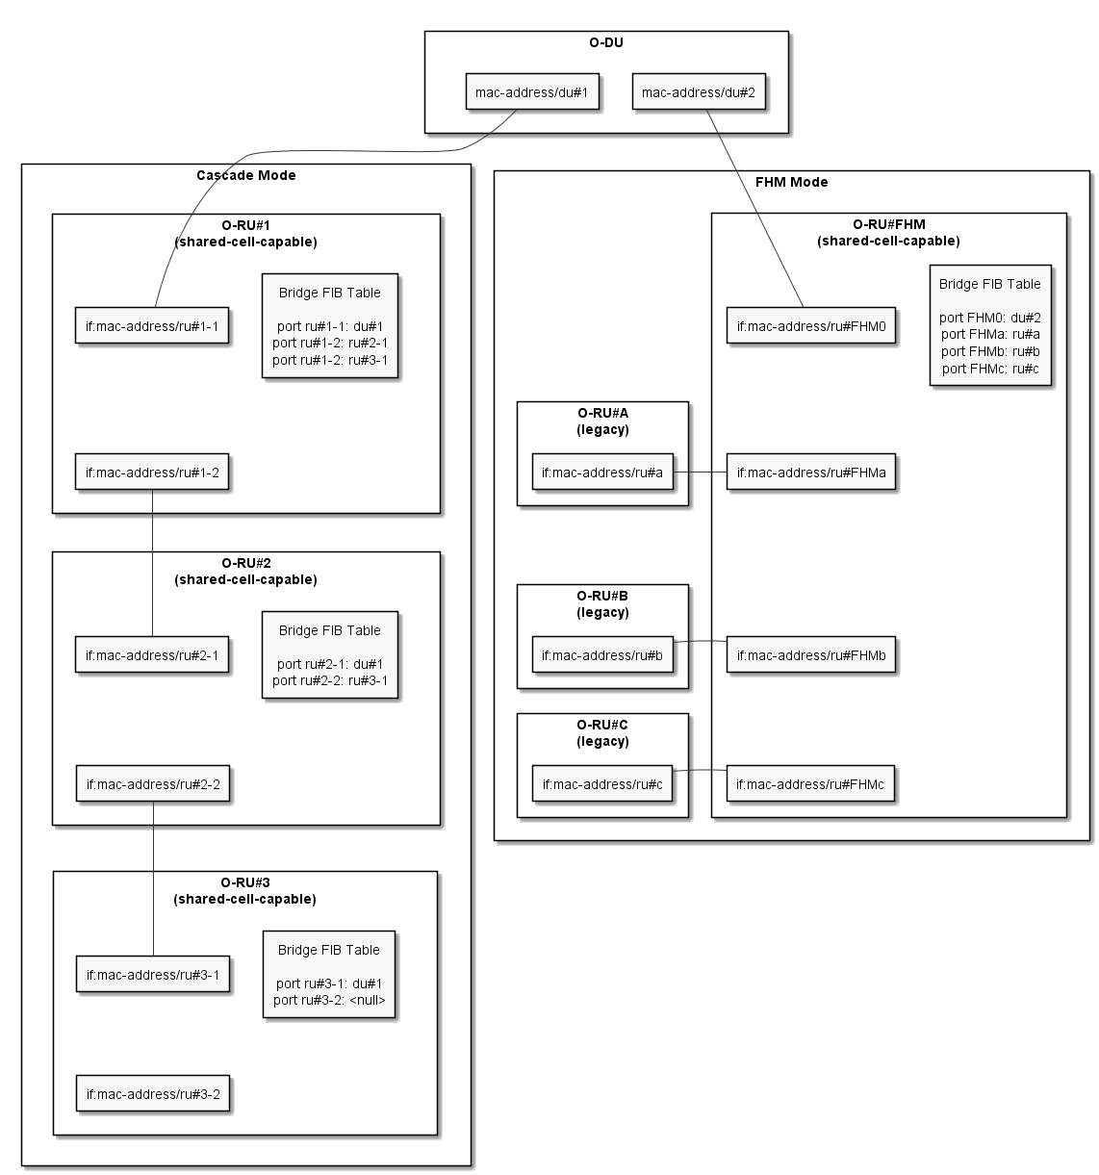
Figure 17.6.2-1: Bridge FIB table entries learned from LBM/LMR connectivity check procedures

17.6.3 Shared cell configuration on transport flow
Shared cell configuration consists shared-cell-copy-entities and shared-cell-combine-entities. Both define the transport-flows for the processing elements of the interface to north-node and the interface to south-node. The container shared-cell-combine-entities contains the ta3-prime-max and scs to be used in delay management as described in clause 17.5.
As per conventional o-ran-processing-element.yang, the transport-flow (eth-flow) of the processing element is a combination of o-du-mac-address, ru-mac-address and vlan-id for legacy eth-flow.
The present document introduces 2 more eth-flow options for shared cell scenario:
- The transport-flow definition for the interface to north-node: north-eth-flow is a combination of north-node-mac-address, ru-mac-address and vlan-id.
- The transport-flow definition for the interface to south-node: south-eth-flow is a combination of south-node-mac-address, ru-mac-address and vlan-id.
Either legacy eth-flow or north-eth-flow can be used for last (southern) O-RUs in tree or chain topology. The leaf o-du-mac-address, north-node-mac-address, south-node-mac-address and ru-mac-address are configured as follows:
- For FHM or Cascade O-RU which performs DL Copy function and UL Combine function:
- north-eth-flow for the interface to north-node:
- north-node-mac-address: MAC address of the north-node (O-DU)
- ru-mac-address: MAC address of the interface to north-node in FHM/Cascade O-RU
- vlan-id
- south-eth-flow for the interface to south-node:
- south-node-mac-address: MAC address of the south-node (O-RU)
- ru-mac-address: MAC address of the interface to south-node in FHM/Cascade O-RU
- vlan-id
NOTE 1: Same vlan-id is configured on both sets of processing elements.
- For Cascade O-RU in the last node, which does not Cascasde O-RU in the last node, which doesn't
perform DL Copy function and UL Combine function:
- north-eth-flow for the interface to north-node:
- north-node-mac-address: MAC address of the north-node
- ru-mac-address: MAC address of the interface to north-node in O-RU
- vlan-id
or
- eth-flow for the interface to north-node:
- o-du-mac-address: MAC address of the north-node
- ru-mac-address: MAC address of the interface to north-node in O-RU
- vlan-id
- For O-RU in the last node, but not cascade O-RU:
- eth-flow for the interface to north-node:
- o-du-mac-address: MAC address of the north-node
- ru-mac-address: MAC address of the interface to north-node in O-RU
- vlan-id
Copy and Combine functions are disabled if not configured, meaning the functions are disabled by default.
Figure 17.6.3-1 illustrates the shared cell configuration and transport configuration.
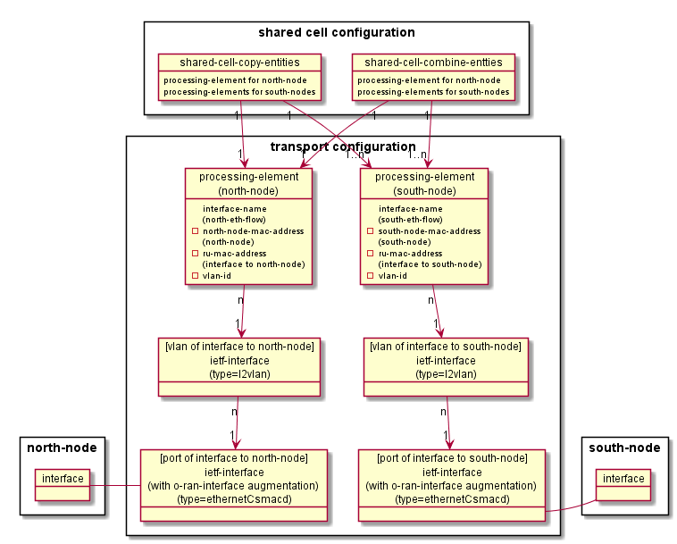
Figure 17.6.3-1: Relation of Shared Cell Copy and Combine Entities and Transport Configuration
For the cascade O-RU, the processing element for north-node shall be connected to the low-level-[tr]x-links in u-plane configuration as in Figure 15.2.4-1 in clause 15.2.4. In the FHM, there is no radio transmission, so no low-level-[tr]x-links exists. Figure 17.6.3-2 illustrates the example of topology diagram and shared cell copy/combine entities. Each thick blue line indicates the transport-flow in the processing element.
Figure 17.6.3-2: Example of Topology and Shared cell Copy/Combine entities
The following is the information for this example of topology configuration.
FHM mode:
- One transport-flow for north-node corresponds to the two transport-flows for south-nodes: O-RU#2a and 2b respectively. O-RU#2a and #2b have same u-plane configuration.
- Two transport-flows for north-node correspond to the two times two transport-flows for south-nodes: O-RU#2x and #2y respectively. O-RU#2x and #2y have same u-plane configuration.
Cascade mode:
- Two transport-flows for north-node correspond to two transport-flows for south-node and own u-plane-configuration. O-RU#1 and O-RU#2 have same u-plane configuration.
NOTE 2: "two transport-flows" above is just the example scenario that two optical physical lines are used for fronthaul connection, which has been supported in the present document.
The total capacity of the interfaces to north-node for FHM is assumed that required traffic can be transported for multiple shared cells. O-RU Controller shall ensure that the capacity of any link shall not be exceeded due to copy and combine configuration.
Information only for the C/U-plane behaviour as the background at COMMON/SELECTIVE-BEAM-ID shared cell copy and combine mode.
For the traffic from the north-node to O-RU (FHM / cascade), there are DL C-plane and U-plane traffic and UL C-plane traffic in the transport interface. When operating with COMMON shared cell copy and combine mode, all C/U-plane traffic received from north-node is copied and forwarded to the south-node(s). For the traffic from south-node, there is UL U-plane traffic only in each transport interface to south-node. When operating with COMMON shared cell copy and combine mode, all U-plane traffic received from the south-node(s) is combined and forwarded to the north-node. It is assumed that common compression mechanism for uplink is configured by M-plane for all O-RUs in one shared cell network.
When operating with SELECTIVE-BEAM-ID shared cell copy and combine mode, some selected C/U-plane traffic received from the north-node are copied and forwarded to the south-node and some selected U-plane traffic received from south-node are combined and forwarded to the north-node. This version of the specification supports SELECTIVE-BEAM-ID.

17.6.4 U-plane configuration for FHM
FHM does not have u-plane configuration defined in o-ran-uplane-conf.yang module. Instead, FHM has shared-cell specific u-plane configuration in shared-cell-copy-entities/shared-cell-combine-entities for DL Copy function and UL Combine function, See clause 13.2 of CUS specification [2] for the details of those functions.
DL Copy function is performed on the received CU-Plane message to make multiple its messages to the specific south nodes. Different eAxC flow can arrive at its specific south node differently, so transport-flow is associated with eaxc-id, which is unique in shared-cell-copy-entities per data direction (DL/UL). The shared-cell-copy-uplane-config is the eaxc-id list used by DL C-plane, DL U-plane and UL C-plane traffic.
UL Combine function is performed on the received U-Plane messages from the specific multiple south nodes to make a message to a single north node on the certain timing. Combine function extracts IQ data per RE from U-Plane message and combine multiple IQ data into a single IQ data. The shared-cell-combine-uplane-config includes the compression method of the UL U-plane messages from O-RUs within the shared cell network in shared cell combine function. The compression method is configurable per eaxc-id. It also contains downlink-radio-frame-offset, downlink-sfn-offset and n-ta-offset to define the uplink timing of t=0 for the configured ta3-prime-max. In addition, number-of-prb is also contained for the cases that all PRBs in numPrbc are controlled by C-plane message or tx-duration is calculated by FHM.
FHM may have multiple sets of shared cell networks as described in Figure 17.6.3-2. E.g. O-RU#2a and O-RU#2b are one shared cell network. O-RU#2x and O-RU#2y are another shared cell network. These two shared cell networks are separated transport layer level definitions using separate processing-element/transport-flows. Nevertheless, the O-RU Controller shall ensure that the eaxc-id allocation for the shared cell networks shall be unique per link (downlink or uplink) in one O-RU (FHM). NETCONF client (O-RU Controller) shall ensure to allocate unique eaxc-id for O-RU(s) per link within the shared cell network(s) in one O-RU (FHM).
NOTE 1: shared-cell-copy-uplane-config and shared-cell-combine-uplane-config are not applicable to the cascade mode. Instead, o-ran-uplane-conf.yang module is applied.
NOTE 2: If the FHM supports the C/U-plane monitoring timer described in clause 7.10, then depending on how long the O-DU takes to initiate sending of C/U plane data flows, it may be advisable for the NETCONF client to initially disable the operation of the timer for the FHM before carrier activation to O-RUs that are south-nodes for the FHM. Such an approach avoids the FHM sending spurious alarm notifications triggered by O-DU delays in initializing the sending of C/U plane data that exceed the default timer value. Once C/U plane data flows have commenced, the NETCONF client can re-configure the timer with the desired value and hence activate monitoring of the C/U plane connectivity by the FHM.

17.6.5 Support of selective transmission and reception function
This clause describes M-Plane support for selective transmission and reception function which is specified in clause 13.3 of [2]. There are two things to be introduced for supporting the function from M-Plane perspective:
- Feature which indicates FHM support for selective transmission and reception function.
- Configuration parameters which indicate the mapping information between global beamId, O-RU(s) and O-RU local beamId.
If FHM indicates the feature "SELECTIVE-BEAM-ID" to O-DU, O-DU can configure the mapping information between global beamId, O-RU(s) and O-RU local beamId to the FHM to use selective transmission and reception function. For configuring the information, mapping-table-for-selective-beam-id is used.

17.7 Cascade-FHM mode

17.7.1 Background
The introduction of Cascade-FHM mode is described in clause 13.7 of [2]. This clause describes mainly shared cell configuration on cascaded FHMs. For other common parts, like start-up procedures, topology discovery procedure etc., refer to relevant parts in clause 17. In this version of the specification, the maximum level of cascaded FHMs is limited to 2. The first cascade FHM nearest to O-DU is named FHM#1, the second FHM is named FHM#2.

17.7.2 Shared cell configuration on cascaded FHMs
The NETCONF client shallconfigure shared cell copy entities and shared cell combine entities on FHM#1 and FHM#2 respectively.
In Figure 17.7.2-1 there are two types of FHM to FHM traffic: 1) Type 1: the cell of traffic is on O-RUs of both FHM#1 and FHM#2. For example, the Cell#1 of Same cell scenario; 2) Type 2: the cell of traffic is only on O-RUs of FHM#2. For example, the Cell#2 of Two cells Scenario. In this scenario a single SCS per FHM is assumed. When multiple SCS are used in FHM, shared-cell-combine-entities are increased accordingly.
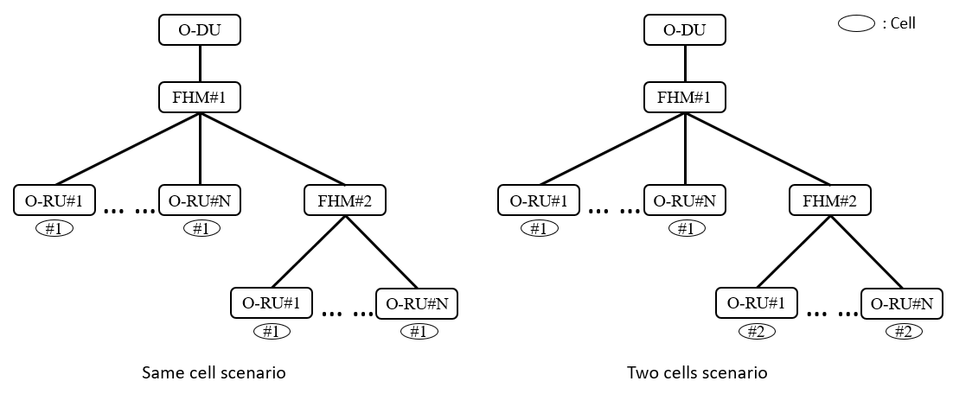
Figure 17.7.2-1: Typical cell scenarios in Cascade-FHM mode
For Type 1, taking Cell#1 of Same cell scenario as example, the shared cell configuration on FHM#1 and FHM#2 are as follows:
FHM#1:
- In DL direction, it needs one element of shared-cell-copy-entities with one of south nodes connecting to FHM#2 and other south nodes connecting to the O-RUs serving FHM#1, and with north node connecting to O-DU. NETCONF Client selects eaxc-ids carried by the CU-Plane messages who will go to FHM#2 and fills them to eaxc-id list of shared-cell-copy-uplane-config.
- In UL direction, it needs one element of shared-cell-combine-entities with one of south nodes connecting to FHM#2 and other south nodes connecting to the O-RUs serving FHM#1, and with north node connecting to O-DU. NETCONF Client selects eaxc-ids carried by the U-Plane messages who are from FHM#2 and fills them to eaxc-id list of shared-cell-combine-uplane-config.
FHM#2:
- In DL direction, it needs one element of shared-cell-copy-entities with north node connecting to FHM#1 and south nodes connecting to the O-RUs serving FHM#2. NETCONF Client selects eaxc-ids carried by the CU-Plane messages who are from FHM#1 and fills them to eaxc-id list of shared-cell-copy-uplane-config.
- In UL direction, it needs one element of shared-cell-combine-entities with north node connecting to FHM#1 and south nodes connecting to the O-RUs serving FHM#2. NETCONF Client selects eaxc-ids carried by the U-Plane messages who will go to FHM#1 and fills them to eaxc-id list of shared-cell-combine-uplane-config.
For Type 2, taking Cell#2 of Two cells scenario as example, the shared cell configuration on FHM#1 and FHM#2 are as follows:
FHM#1:
- In DL or UL direction, existing only one south node which connects to FHM#2 and other steps are no difference with FHM#1 of Type 1;
NOTE: In Two cells scenario, there will be two elements of shared-cell-copy-entities in DL direction in FHM#1, one is for Cell#1 and another is for Cell#2. Similarly, there will be two elements of shared-cell-combine-entities in UL direction in FHM#1, one is for Cell#1 and another is for Cell#2.
FHM#2:
- There is no difference with FHM#2 of Type 1.
Both FHM#1 and FHM#2 do not need to have u-plane configuration defined in o-ran-uplane-conf.yang module since no radio transmission on the two FHMs.

18 Configured subscriptions

18.1 Introduction
The support by an O-RU of configured subscriptions is an optional capability, advertised by the O-RU indicating it supports the ietf-subscribed-notifications YANG model as specified in RFC 8639 [37] in its YANG library together with the configured feature. This capability enables an O-RU Controller to install a subscription via configuration of the O-RU's datastore. Importantly, the lifetime of such a configured subscription is not limited to the lifetime of the NETCONF session used to establish it, enabling a configured subscription to persist even when an O-RU has been temporarily disconnected from the network. An O-RU may store configured subscription information in its reset-persistent memory.
The ietf-subscribed-notifications YANG model defines a transport agnostic mechanism for subscribing to and receiving content from an event stream in an O-RU. An O-RU that supports configured subscriptions shall also support the encode-json feature together with the augmentation of the ietf-subscribed-notifications YANG model by the o-ran-ves-subscribed-notifications YANG model.

18.2 Description
An O-RU controller can discover the event-streams supported by an O-RU. The O-RU Controller may then establish a configured subscription to a particular event-stream. The same NACM privileges defined in clause 6.5 shall be used by the O-RU in determining whether an O-RU controller has privileges to establish a configured subscription to a particular event-stream.
Based on configured subscriptions, the O-RU shall send asynchronous notifications over HTTPS to the configured Event-Collector. This capability can be used with any existing YANG notification, e.g. defined in YANG models published by the O-RAN Alliance or imported from other organisations.

18.3 Procedure
The overall procedure is illustrated in Figure 18.3-1.
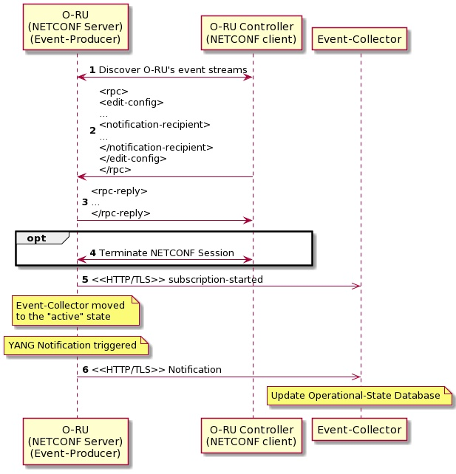
Figure 18.3-1:Message sequence exchange for provisioning a configured notification
Pre-condition:
A NETCONF sessions is established between the O-RU and an O-RU Controller.
- The O-RU controller gets the streams container and discovers the event-streams supported by an O-RU.
- The O-RU controller uses the "edit-config" RPC to configure a subscription to an event-stream. The RPC includes the receiver container augmented with the notification-recipient schema node that encodes the URI of the Event-Collector.
- If the O-RU controller has the correct privileges, the O-RU accepts the configured subscription.
- As the lifetime of the configured subscription is not limited by the lifetime of the NETCONF session, the O-RU controller may terminate the NETCONF session without causing the subscription to be suspended.
- After a subscription is successfully established, the O-RU immediately sends a "subscription-started" notification to the Event-Collector, as specified in clause 2.5 of RFC 8639 [37].
- Upon an event that triggers a YANG notification, the O-RU sends a notification over HTTPS , according to clause 2.5 of RFC8639.
Post-condition:
The Event-Collector is able to update its operational-state datastore with the information received in the notification.

18.4 Notification encoding
The O-RU shall support JSON encoding as specified in RFC 7951 [38]. An example notification object generated using the o-ran-file-management.yang model and encoded following RFC 7951 [38] is illustrated in Figure 18.4-1.
{ "ietf-restconf:notification": {
"eventTime": "2020-11-11T20:20:00Z",
"o-ran-file-management:file-upload-notification": {
"local-logical-file-path": "o-ran/pm /C201805181300+0900_201805181330+0900_ABC0123456.csv",
"remote-file-path": "sftp://nms-user@10.10.10.10/home/pm/ C201805181300+0900_201805181330+0900_ABC0123456.csv",
"status": "SUCCESS"
}
}
}
Figure 18.4-1:Example of a JSON encoded YANG Notification

18.5 Notification transport
As described in RFC 8639 [37] clause 2.5.7, an O-RU supporting configured subscriptions shall provide a YANG data model capturing the necessary transport-specific configuration parameters. O-RAN compliant Event-Producers shall support the o-ran-ves-subscribed-notifications YANG model.
For transport, the notification JSON objects encoded according to clause 18.4 are further encapsulated in VES events. In order to enable the notifications sent to the Event-Collector to retain their native notification format/schema as defined in O-RAN, IETF and other YANG models, the ONAP/VES header is used to enable the decoupling of the notification payload from the overall VES event format, as illustrated in Figure 18.4-1.
The VES common header shall include the following fields:
- The value of the eventName field shall be set to " ORU-YANG/<model-identifier>:<notification-identifier>".
- The value of the eventID field shall be set to "stndDefined-ORU-YANG-nnnnnnnnn", where nnnnnnnnn represents the integer key for the event.
- The value of the sourceName and reportingEntityName fields shall both be set to the value of the ru-instance-id leaf defined in the o-ran-operations YANG model.
Figure 18.5-1 illustrates an example of a JSON encoded VES Event Carrying a YANG Notification.

{ "event": {
"commonEventHeader": {
"version": "4.1",
"vesEventListenerVersions": "7.2",
"domain": "stndDefined",
"eventName": "ORU-YANG/o-ran-file-management:file-upload-notification",
"eventID": "stndDefined-ORU-YANG-000000249",
"sequence": 0,
"priority": "Normal",
"sourceName": "vendorA_ORUAA100_FR1918010111",
"reportingEntityName": "vendorA_ORUAA100_FR1918010111",
"stndDefinedNamespace": "urn:o-ran:file-management:1.0"
"startEpochMicrosec": 1605126000000000,
"lastEpochMicrosec": 1605126000000000
},
"stndDefinedFields": {
"schemaReference": "https://gerrit.o-ran-sc.org/r/gitweb?p=scp/oam/modeling.git;a=blob;f=data-model/yang/published/o-ran/ru-fh/o-ran-file-management.yang",
"data": {
"ietf-restconf:notification": {
"eventTime": "2020-11-11T20:20:00Z",
"o-ran-file-management:file-upload-notification": {
"local-logical-file-path": "o-ran/pm /C201805181300+0900_201805181330+0900_ABC0123456.csv",
"remote-file-path": "sftp://nms-user@10.10.10.10/home/pm/ C201805181300+0900_201805181330+0900_ABC0123456.csv",
"status": "SUCCESS"
}
}
},
"stndDefinedFieldsVersion": "1.0"
}
}}
Figure 18.5-1:Example of a JSON encoded VES Event Carrying a YANG Notification
The VES events carrying the notifications are sent to the Event-Collector over HTTPS with a POST operation following the VES specification [i.2]. The complete protocol stack is illustrated in Figure 18.5-2.
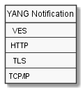
Figure 18.5-2: Protocol stack for O-RAN VES transport of YANG notifications

18.6 Monitoring the communications channel between O-RU and Event-Collector

18.6.1 Background
An O-RU controller can use the NETCONF monitoring capability described in clause 6.7 to trigger the repeated sending of a supervision-notification by the O-RU to a subscribed O-RU Controller to ensure the channel is operational and able to transport asynchronous notifications using NETCONF. An equivalent capability is required to be supported by those O-RUs that support configured subscriptions transported using JSON/HTTPS, to enable the monitoring of the communications channel from the O-RU to the Event-Collector. The format of the heartbeat notifications is identical to the Event-Collector Notification Format determined for the operation of pnfRegistration as described in clause 6.2.7, i.e. in this version of the specification, this capability adopts the ONAP defined guidelines for Heartbeat, as defined in [i.2].

18.6.2 Heartbeat encoding
The VES common header shall include the following fields:
- The value of the sourceName and reportingEntityName fields shall both be set to the value of the ru-instance-id leaf defined in the o-ran-operations YANG model.
An example heartbeat encoding is illustrated in Figure 18.6.2-1.
{ "event": {
"commonEventHeader": {
"version": "4.1",
"vesEventListenerVersions": "7.2",
"domain": "heartbeat",
"eventID": "heartbeat-00000001",
"eventName": "heartbeat-oru",
"sequence": 0,
"priority": "Normal",
"sourceName": "vendorA_ORUAA100_FR1918010111",
"reportingEntityName": "vendorA_ORUAA100_FR1918010111",
"startEpochMicrosec": 1605126000000000,
"lastEpochMicrosec": 1605126000000000
},
"heartbeatFields": {
"heartbeatFieldsVersion": "3.0",
"heartbeatInterval": "60"
}
}}
Figure 18.6.2-1: Example of a JSON encoded VES Event Carrying a Heartbeat Notification

18.6.3 Heartbeat control
Control of the heartbeat does not use the configured subscriptions capability. An O-RU controller configures heartbeat operation using the o-ran-supervision YANG model. An O-RU Controller shall configure the heartbeat-recipient-id to the address(es) of the Heartbeat Event-Collector and optionally configure the heartbeat-interval leaf to a non-default heartbeat interval. In order to terminate operation of the monitoring the communications channel between O-RU and the Event-Collector, the O-RU Controller shall delete the configuration in the event-collector-monitoring container.

18.6.4 Heartbeat procedure
Figure 18.6.4-1 illustrates the message sequence exchange for heartbeat operation.
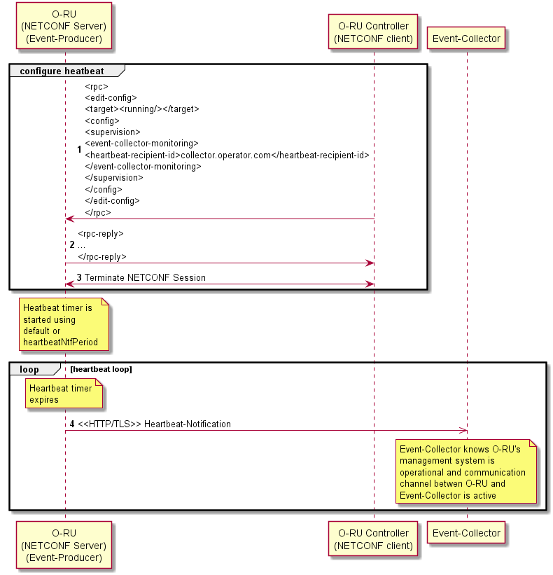
Figure 18.6.4-1: Message sequence exchange for heartbeat operation
In contrast to the monitoring of NETCONF connectivity described in clause 6.7 which define O-RU procedures when monitoring of NETCONF connectivity fails, there is no equivalent O-RU functionality defined if an O-RU determines that monitoring of the communications channel between O-RU and event-collector fails, e.g. if the O-RU is unable to establish a TLS connection to the event-collector.
Operation of the SMO when it determines that the monitoring of the communications channel between an O-RU and event-collector fails is out of scope of the present document.

19 Multi-Operator O-RU Operation

19.1 Introduction
The support by an O-RU of Multi-Operator O-RU operation is an optional capability, advertised by the O-RU indicating it supports the SHARED-ORU-MULTI-OPERATOR feature in its o-ran-wg4-features YANG model. All O-RUs that support the SHARED-ORU-MULTI-OPERATOR feature shall also support the SHARED-ORU-MULTI-ODU feature. These capabilities enable an O-RU to connect to multiple O-DUs that belong to different Shared Resource Operators.
The Multi-Operator O-RU architecture enables a Shared Resource Operator to configure an agreed subset of shared O-RU resources independently from configuration and operating strategies of the other Shared Resource Operators. More specifically, a Shared O-RU Host makes available its shared O-RUs to enable connectivity to the O-DUs of one or more Shared Resource Operators allowing these Shared Resource Operators to configure and control such Shared O-RU.
NOTE: How a Shared O-RU Host defines the partitioning of shared O-RU resources and communicates that information to a Shared Resource Operator is outside the scope of the present document.

19.2 High level shared O-RU architecture
When an O-RU is being configured by an independent Shared Resource Operator, a separate O-RU Controller associated with the Shared O-RU Host is required to configure the common aspects of the shared O-RU. Such a deployment is illustrated in Figure 19.2-1. When the Shared O-RU Host also operates an O-DU, the shared O-RU host may operate the M-Plane in either hybrid or hierarchical approach, as illustrated in Figures 19.2-2 and 19.2-3 respectively. In either case, the Shared O-RU Host uses a NETCONF client with "sudo" privileges, as defined in clause 6.5, to configure the shared O-RU. Each Shared Resource Operator uses NETCONF clients with " carrier" privileges that have parallel M-Plane connections with the shared O-RU.
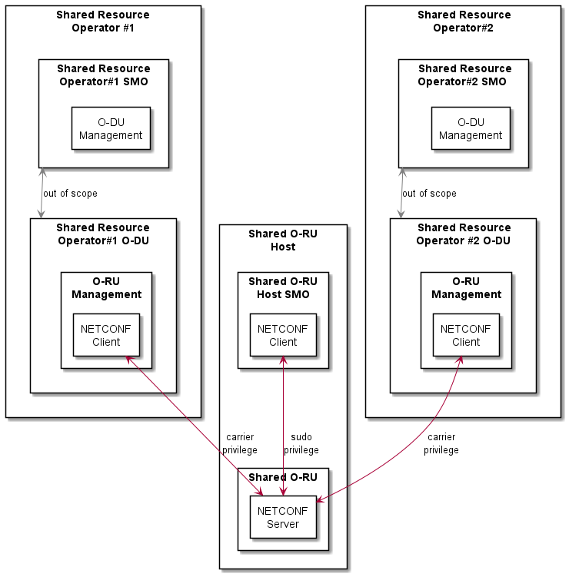
Figure 19.2-1: Shared O-RU M-Plane Architecture where Shared O-RU Host is independent of Shared Resource Operator(s).
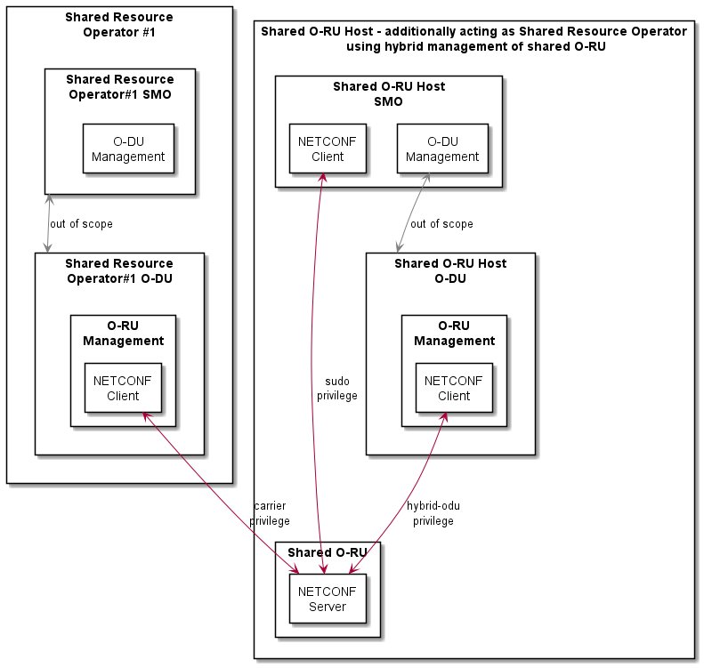

Figure 19.2-2: Shared O-RU M-Plane Architecture where the Shared O-RU Host is additionally a Shared Resource Operator managing Shared O-RU using hybrid approach
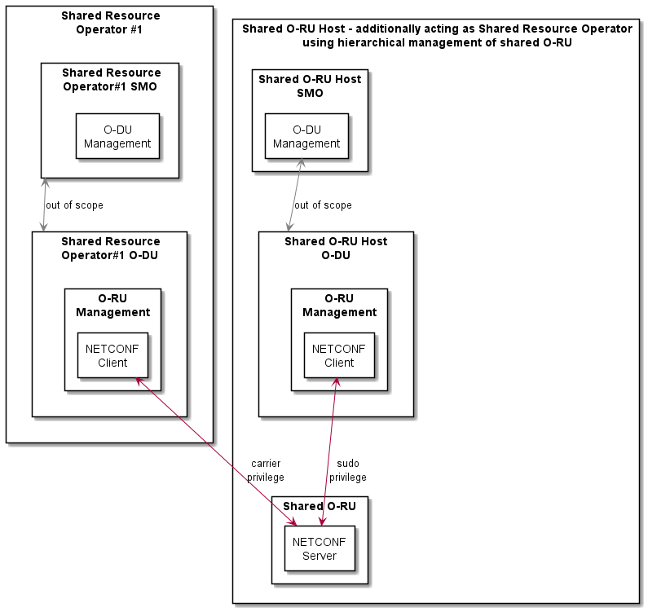

Figure 19.2-3: Shared O-RU M-Plane Architecture where the Shared O-RU Host is additionally a Shared Resource Operator managing Shared O-RU using hierarchical approach
As illustrated in Figures 19.2-1, 19.2-2 and 19.2-3, from an Open Fronthaul perspective, the Shared O-RU is able to be deployed in variety of architectures.
Clause 5.1.2 requires all O-RUs to support multiple NETCONF sessions, with the number of simultaneous sessions exposed using the maximum-simultaneous-netconf-sessions schema node in o-ran-operations YANG model. A Multi-Operator O-RU that is able to support (n) simultaneous NETCONF sessions, shall be able to support (m) Shared Resource Operators, where the cumulative NETCONF sessions operated by the (m) Shared Resource Operators is less than (n).

19.3 Shared O-RU "start up" procedure

19.3.1 NETCONF server user account provisioning for shared resource operators
The Shared O-RU Host shall use the procedures defined in clause 6.4 and the o-ran-usermgmt YANG model to configure separate user accounts on the shared O-RU's NETCONF server for each Shared Resource Operator. The user account for a Shared Resource Operator that is not also a Shared O-RU Host should only be configured with "carrier" access control group, as defined in clause 6.5. A user account is identified as being associated with a Shared Resource Operator by having one or more configured sro-ids. The sro-id is allocated by the Shared O-RU Host to the Shared Resource Operator(s) and is used in partitioning shared O-RU resources.
NOTE 1: How a Shared O-RU Host communicates NETCONF user account information, including sro-id information, to a Shared Resource Operator is outside the scope of the present document.
NOTE 2: The format of the sro-id string is not defined and not interpreted by the shared O-RU. In one example, the operators can agree to use a PLMN-Id corresponding to the Shared Resource Operator as the sro-id.

19.3.2 NETCONF call home to shared resource operator O-DUs
The user account provisioning procedures defined in clauses 6.4.3 and 19.3.1 should be performed before the shared-O-RU calls home to the shared resource operator O-DUs.
NOTE 1: This avoids the possibility of the shared resource operator using the default account procedures in clause 6.4.2, e.g. by leveraging knowledge of a default account credential that is common across different deployments of a vendor's equipment.
The procedures defined in clauses 6.2.5 and 6.3 are used by the Shared O-RU Host to trigger the establishment of the NETCONF session with a NETCONF client of the Shared O-RU Host. The Shared O-RU Host can subsequently use the o-ran-mplane-int YANG model and the configured-client-info container to configure the Multi-Operator O-RU with NETCONF client information corresponding to the individual Shared Resource Operator(s) of the shared O-RU. Standard DHCP-based procedure, as specified in clause 5.1.4, still apply to retrieve NETCONF client information corresponding to the individual Shared Resource Operator(s) of the shared O-RU.
NOTE 2: How the Shared O-RU Host becomes aware of information to identify the Shared Resource Operator's NETCONF clients to be used with a specific shared O-RU is out of scope of the present document.
If the O-RU supports static routing as specified in clause 6.2.8, the O-RU shall use its routing table to route the M-Plane traffic towards the Shared Resource operator's O-RU Controller/NETCONF client.
Following procedures defined in clause 6.3, this will trigger the Multi-Operator O-RU to perform additional call home procedures to any configured clients, which in this scenario will be the NETCONF clients corresponding to individual Shared Resource Operators.

19.3.3 Enhanced sro-id based NETCONF access control
The resource configuration framework defines particular named list entries in the shared O-RU's configuration that can be allocated to an sro-id. The enhanced NACM privileges defined in this clause enable the Shared Resource Operator to configure the shared O-RU's list entries that have been previously configured by the Shared O-RU Host with the shared resource operator's sro-id.
The O-RU NETCONF access control techniques defined in clause 6.5 are enhanced for operation with NETCONF clients corresponding to Shared Resource Operators of a shared O-RU, i.e. those where the user account of the NETCONF client has been configured with an sro-id. Specifically, the NETCONF access control read permissions for group name "carrier" are further refined for the following YANG models:
- urn:o-ran:processing-elements:x.y
- urn:o-ran:uplane-conf:x.y
- urn:o-ran:performance-management:x.y
- urn:o-ran:message5:x.y
- urn:o-ran:shared-cell:x.y
For the above models, the read privileges for specific node-instance-identifiers defined in Table 19.3.3-1 through Table 19.3.3-5 are refined based on the sro-id(s) associated with the user account of the NETCONF client. Normal NACM rules shall apply to any node-instance identifier not listed in the table.
Table 19.3.3-1: Refined NETCONF Access Control Read Privileges for the "carrier" group with YANG module o-ran:processing-elements:x.y
Restricted node-instance-identifier | Refined privileges for "carrier" group for NETCONF clients with user name user-list entry containing a configured sro-id
o-ran-elements:processing-elements/o-ran-elements:ru-elements | A NETCONF client with user name user-list entry containing a configured sro-id shall only have read privileges for those list entries where the o-ran-elements:processing-elements/o-ran-elements:ru-elements/o-ran-elements:sro-id leaf matches the sro-id of the NETCONF client.

Table 19.3.3-2: Refined NETCONF Access Control Read Privileges for the "carrier" group with YANG module o-ran:uplane-conf:x.y
Restricted node-instance-identifier | Refined privileges for "carrier" group for NETCONF clients with user name user-list entry containing a configured sro-id
o-ran-uplane-conf:user-plane-configuration/o-ran-uplane-conf:low-level-tx-links | A NETCONF client with user name user-list entry containing a configured sro-id shall only have read privileges for those list entries where the o-ran-uplane-conf:user-plane-configuration/o-ran-uplane-conf:low-level-tx-links/o-ran-uplane-conf:sro-id leaf-list includes the sro-id of the NETCONF client.
o-ran-uplane-conf:user-plane-configuration/o-ran-uplane-conf:low-level-rx-links | A NETCONF client with user name user-list entry containing a configured sro-id shall only have read privileges for those list entries where the o-ran-uplane-conf:user-plane-configuration/o-ran-uplane-conf:low-level-rx-links/o-ran-uplane-conf:sro-id leaf-list includes the sro-id of the NETCONF client.
o-ran-uplane-conf:user-plane-configuration/o-ran-uplane-conf:low-level-tx-endpoints | A NETCONF client with user name user-list entry containing a configured sro-id shall only have read privileges for those list entries where the o-ran-uplane-conf:user-plane-configuration/o-ran-uplane-conf:low-level-tx-endpoints/o-ran-uplane-conf:sro-id leaf-list includes the sro-id of the NETCONF client.
o-ran-uplane-conf:user-plane-configuration/o-ran-uplane-conf:low-level-rx-endpoints | A NETCONF client with user name user-list entry containing a configured sro-id shall only have read privileges for those list entries where the o-ran-uplane-conf:user-plane-configuration/o-ran-uplane-conf:low-level-rx-endpoints/o-ran-uplane-conf:sro-id leaf-list includes the sro-id of the NETCONF client.
o-ran-uplane-conf:user-plane-configuration/o-ran-uplane-conf:tx-array-carriers | A NETCONF client with user name user-list entry containing a configured sro-id shall only have read privileges for those list entries where the o-ran-uplane-conf:user-plane-configuration/o-ran-uplane-conf:tx-array-carriers/o-ran-uplane-conf:sro-id leaf-list includes the sro-id of the NETCONF client.
o-ran-uplane-conf:user-plane-configuration/o-ran-uplane-conf:rx-array-carriers | A NETCONF client with user name user-list entry containing a configured sro-id shall only have read privileges for those list entries where the o-ran-uplane-conf:user-plane-configuration/o-ran-uplane-conf:rx-array-carriers/o-ran-uplane-conf:sro-id leaf-list includes the sro-id of the NETCONF client.

Table 19.3.3-3: Refined NETCONF Access Control Read Privileges for the "carrier" group with YANG module o-ran:performance-management:x.y
Restricted node-instance-identifier | Refined privileges for "carrier" group for NETCONF clients with user name user-list entry containing a configured sro-id
o-ran-pm:performance-measurement-objects/o-ran-pm:rx-window-measurement-objects | A NETCONF client with user name user-list entry containing a configured sro-id shall only have read privileges for those list entries where the o-ran-pm:performance-measurement-objects/o-ran-pm:rx-window-measurement-objects/o-ran-pm:tr-measured-result/o-ran-pm:name  leaf refers to an o-ran-elements:processing-elements/o-ran-elements:ru-elements list entry where the o-ran-elements:processing-elements/o-ran-elements:ru-elements/o-ran-elements:sro-id leaf represents the sro-id of the NETCONF client or where the o-ran-pm:performance-measurement-objects/o-ran-pm:rx-window-measurement-objects/o-ran-pm:eaxc-measured-result/o-ran-pm:eaxc-id leaf matches a value of eaxcid in the container o-ran-uplane-conf:user-plane-configuration/o-ran-uplane-conf:low-level-rx-endpoints/o-ran-uplane-conf:e-axcid where the sro-id in o-ran-uplane-conf:user-plane-configuration/o-ran-uplane-conf:low-level-rx-endpoints/o-ran-uplane-conf:sro-id matches the sro-id of the NETCONF client or where the o-ran-pm:performance-measurement-objects/o-ran-pm:rx-window-measurement-objects/o-ran-pm:eaxc-measured-result/o-ran-pm:eaxc-id leaf matches a value of eaxcid in the container o-ran-uplane-conf:user-plane-configuration/o-ran-uplane-conf:low-level-tx-endpoints/o-ran-uplane-conf:e-axcid where the sro-id in o-ran-uplane-conf:user-plane-configuration/o-ran-uplane-conf:low-level-tx-endpoints/o-ran-uplane-conf:sro-id matches the sro-id of the NETCONF client.
o-ran-pm:performance-measurement-objects/o-ran-pm:tx-measurement-objects | A NETCONF client with user name user-list entry containing a configured sro-id shall only have read privileges for those list entries where the o-ran-pm:performance-measurement-objects/o-ran-pm:tx-measurement-objects/o-ran-pm:tr-measured-result/o-ran-pm:name  leaf refers to an o-ran-elements:processing-elements/o-ran-elements:ru-elements list entry where the o-ran-elements:processing-elements/o-ran-elements:ru-elements/o-ran-elements:sro-id leaf represents the sro-id of the NETCONF client or where the o-ran-pm:performance-measurement-objects/o-ran-pm:tx-measurement-objects/o-ran-pm:eaxc-measured-result/o-ran-pm:eaxc-id leaf matches a value of eaxcid in the container o-ran-uplane-conf:user-plane-configuration/o-ran-uplane-conf:low-level-rx-endpoints/o-ran-uplane-conf:e-axcid where the sro-id in o-ran-uplane-conf:user-plane-configuration/o-ran-uplane-conf:low-level-rx-endpoints/o-ran-uplane-conf:sro-id matches the sro-id of the NETCONF client or where the o-ran-pm:performance-measurement-objects/o-ran-pm:tx-measurement-objects/o-ran-pm:eaxc-measured-result/o-ran-pm:eaxc-id leaf matches a value of eaxcid in the container o-ran-uplane-conf:user-plane-configuration/o-ran-uplane-conf:low-level-tx-endpoints/o-ran-uplane-conf:e-axcid where the sro-id in o-ran-uplane-conf:user-plane-configuration/o-ran-uplane-conf:low-level-tx-endpoints/o-ran-uplane-conf:sro-id matches the sro-id of the NETCONF client.

NOTE: The enhanced sro-id based NACM privileges in Table 19.3.3-3 do not limit the privileges of a NETCONF client associated with an sro-id to read Rx and Tx performance management results when the object-unit-id is configured as RU. A Shared O-RU Host can exclude such value of object-unit-id from the configuration of the o-ran-performance-management YANG model to avoid enabling a first Shared Resource Operator from recovering aggregate O-RU level performance data that may include performance data related to the resources of a second Shared Resource Operator.
Table 19.3.3-4: Refined NETCONF Access Control Read Privileges for the "carrier" group with YANG module o-ran:message5:x.y
Restricted node-instance-identifier | Refined privileges for "carrier" group for NETCONF clients with user name user-list entry containing a configured sro-id
o-ran-msg5:ecpri-delay-message/o-ran-msg5:message5-sessions/o-ran-msg5:session-parameters | A NETCONF client with user name user-list entry containing a configured sro-id shall only have read privileges those list entries where the o-ran-msg5:ecpri-delay-message/o-ran-msg5:message5-sessions/o-ran-msg5:session-parameter/o-ran-msg5:processing-element-name  leaf refers to an o-ran-elements:processing-elements/o-ran-elements:ru-elements list entry where the o-ran-elements:processing-elements/o-ran-elements:ru-elements/o-ran-elements:sro-id leaf represents the sro-id of the NETCONF client.

Table 19.3.3-5: Refined NETCONF Access Control Read Privileges for the "carrier" group with YANG module o-ran:shared-cell:x.y
Restricted node-instance-identifier | Refined privileges for "carrier" group for NETCONF clients with user name user-list entry containing a configured sro-id
o-ran-sc:shared-cell/o-ran-sc:shared-cell-config/o-ran-sc:shared-cell-copy-entities | A NETCONF client with user name user-list entry containing a configured sro-id shall only have read privileges for those list entries where the o-ran-sc:shared-cell/o-ran-sc:shared-cell-config/o-ran-sc:shared-cell-copy-entities/o-ran-sc:sro-id leaf-list includes the sro-id of the NETCONF client.
o-ran-sc:shared-cell/o-ran-sc:shared-cell-config/o-ran-sc:shared-cell-combine-entities | A NETCONF client with user name user-list entry containing a configured sro-id shall only have read privileges for those list entries where the o-ran-sc:shared-cell/o-ran-sc:shared-cell-config/o-ran-sc:shared-cell-combine-entities/o-ran-sc:sro-id leaf-list includes the sro-id of the NETCONF client.
o-ran-sc:shared-cell/o-ran-sc:shared-cell-config/o-ran-sc:shared-cell-copy-entities-selective-beam-id | A NETCONF client with user name user-list entry containing a configured sro-id shall only have read privileges for those list entries where the o-ran-sc:shared-cell/o-ran-sc:shared-cell-config/o-ran-sc:shared-cell-copy-entities-selective-beam-id /o-ran-sc:sro-id leaf-list includes the sro-id of the NETCONF client.
o-ran-sc:shared-cell/o-ran-sc:shared-cell-config/o-ran-sc:shared-cell-combine-entities-for-selective-beam-id | A NETCONF client with user name user-list entry containing a configured sro-id shall only have read privileges for those list entries where the o-ran-sc:shared-cell/o-ran-sc:shared-cell-config/o-ran-sc:shared-cell-combine-entities-for-selective-beam-id /o-ran-sc:sro-id leaf-list includes the sro-id of the NETCONF client.

For example, if the Shared O-RU has been configured to operate with two Shared Resource Operators, sro-id "23415" and sro-id "23410", then when a NETCONF client of the first Shared Resource Operator attempts to read the processing element configuration of the shared O-RU it can receive a reply as shown Figure 19.3.3-1, where the O-DU of the first Shared Resource Operator has an Ethernet MAC-address of 11:95:a0:af:5f:b9 and VLAN 100 is being used for the control and user-plane traffic between the shared O-RU and the O-DU of the first Shared Resource Operator.
<rpc-reply message-id="101" xmlns="urn:ietf:params:xml:ns:netconf:base:1.0">
<data>
<processing-elements xmlns="urn:o-ran:processing-element:1.0">
<ru-elements>
<name>element1</name>
<sro-id>23415</sro-id>
<transport-flow>
<interface-name>10Geth0.100</interface-name>
<eth-flow>
<ru-mac-address>00:e0:fe:00:23:30</ru-mac-address>
<vlan-id>100</vlan-id>
<o-du-mac-address>11:95:a0:af:5f:b9</o-du-mac-address>
</eth-flow>
</transport-flow>
<ru-elements>
<processing-elements>
</data>
</rpc-reply>
Figure 19.3.3-1: example rpc-reply to a first sro-id "23415"
Conversely, if the NETCONF client of the second Shared Resource Operator attempts to read the processing element configuration it can receive a reply as shown in Figure 19.3.3-2, where the O-DU of the second Shared Resource Operator has an Ethernet MAC-address of 5a:2a:a7:61:98:f0 and VLAN 200 is being used for the control and user-plane traffic between the Shared O-RU and the O-DU of the second Shared Resource Operator.
<rpc-reply message-id="101" xmlns="urn:ietf:params:xml:ns:netconf:base:1.0">
<data>
<processing-elements xmlns="urn:o-ran:processing-element:1.0">
<ru-elements>
<name>element2</name>
<sro-id>23410</sro-id>
<transport-flow>
<interface-name>10Geth0.200</interface-name>
<eth-flow>
<ru-mac-address>00:e0:fe:00:23:30</ru-mac-address>
<vlan-id>200</vlan-id>
<o-du-mac-address>5a:2a:a7:61:98:f0</o-du-mac-address>
</eth-flow>
</transport-flow>
<ru-elements>
<processing-elements>
</data>
</rpc-reply>
Figure 19.3.3-2: example rpc-reply to a second sro-id "23410"
In addition to the enhanced read access privileges, the NETCONF server of the shared O-RU shall implement additional write access privileges for the following YANG model:
- urn:o-ran:uplane-conf:x.y
- urn:o-ran:pim:x:y
For the above model, the write privileges for specific node-instance-identifiers are refined based on the sro-id associated with the user account of the NETCONF client, as described in the Table 19.3.3-6 through Table 19.3.3-8.
Table 19.3.3-6: Refined NETCONF Access Control Write Privileges for the "carrier" group with YANG module o-ran:uplane-conf:x.y
Restricted node-instance-identifier | Refined privileges for "carrier" group for NETCONF clients with user name user-list entry containing a configured sro-id
o-ran-uplane-conf:user-plane-configuration/o-ran-uplane-conf:low-level-tx-links/o-ran-uplane-conf:name | The NETCONF client shall be prohibited from writing to this schema node for all list entries.
o-ran-uplane-conf:user-plane-configuration/o-ran-uplane-conf:low-level-tx-links/o-ran-uplane-conf:sro-id | The NETCONF client shall be prohibited from writing to this schema node for all list entries.
o-ran-uplane-conf:user-plane-configuration/o-ran-uplane-conf:low-level-tx-links | A NETCONF client with user name user-list entry containing a configured sro-id shall be prohibited from creating list entries. A NETCONF client with user name user-list entry containing a configured sro-id shall only have write privileges to enable updating of those list entries where the o-ran-uplane-conf:user-plane-configuration/o-ran-uplane-conf:low-level-tx-links/o-ran-uplane-conf:sro-id leaf-list includes the sro-id of the NETCONF client.
o-ran-uplane-conf:user-plane-configuration/o-ran-uplane-conf:low-level-rx-links/o-ran-uplane-conf:name | The NETCONF client shall be prohibited from writing to this schema node for all list entries.
o-ran-uplane-conf:user-plane-configuration/o-ran-uplane-conf:low-level-rx-links/o-ran-uplane-conf:sro-id | The NETCONF client shall be prohibited from writing to this schema node for all list entries.
o-ran-uplane-conf:user-plane-configuration/o-ran-uplane-conf:low-level-rx-links | A NETCONF client with user name user-list entry containing a configured sro-id shall be prohibited from creating list entries. A NETCONF client with user name user-list entry containing a configured sro-id id shall only have write privileges to enable updating of those list entries where the o-ran-uplane-conf:user-plane-configuration/o-ran-uplane-conf:low-level-rx-links/o-ran-uplane-conf:sro-id leaf-list includes the sro-id of the NETCONF client.
o-ran-uplane-conf:user-plane-configuration/o-ran-uplane-conf:low-level-tx-endpoints/o-ran-uplane-conf:sro-id | The NETCONF client shall be prohibited from writing to this schema node for all list entries.
o-ran-uplane-conf:user-plane-configuration/o-ran-uplane-conf:low-level-tx-endpoints | A NETCONF client with user name user-list entry containing a configured sro-id shall be prohibited from creating list entries. A NETCONF client with user name user-list entry containing a configured sro-id id shall only have write privileges to enable updating of those list entries where the o-ran-uplane-conf:user-plane-configuration/o-ran-uplane-conf:low-level-tx-endpoints/o-ran-uplane-conf:sro-id leaf-list includes the sro-id of the NETCONF client.
o-ran-uplane-conf:user-plane-configuration/o-ran-uplane-conf:low-level-rx-endpoints/o-ran-uplane-conf:sro-id | The NETCONF client shall be prohibited from writing to this schema node for all list entries.
o-ran-uplane-conf:user-plane-configuration/o-ran-uplane-conf:low-level-rx-endpoints | A NETCONF client with user name user-list entry containing a configured sro-id shall be prohibited from creating list entries. A NETCONF client with user name user-list entry containing a configured sro-id id shall only have write privileges to enable updating of those list entries where the o-ran-uplane-conf:user-plane-configuration/o-ran-uplane-conf:low-level-rx-endpoints/o-ran-uplane-conf:sro-id leaf-list includes the sro-id of the NETCONF client.

Table 19.3.3-7: Refined NETCONF Access Control Write Privileges for the "carrier" group with YANG module o-ran:uplane-conf:x.y (continued)
Restricted node-instance-identifier | Refined privileges for "carrier" group for NETCONF clients with user name user-list entry containing a configured sro-id
o-ran-uplane-conf:user-plane-configuration/o-ran-uplane-conf:tx-array-carriers/o-ran-uplane-conf:sro-id | The NETCONF client shall be prohibited from writing to this schema node for all list entries.
o-ran-uplane-conf:user-plane-configuration/o-ran-uplane-conf:tx-array-carriers | A NETCONF client with user name user-list entry containing a configured sro-id shall be prohibited from creating list entries. A NETCONF client with user name user-list entry containing a configured sro-id id shall only have write privileges to enable updating of those list entries where the o-ran-uplane-conf:user-plane-configuration/o-ran-uplane-conf:tx-array-carriers/o-ran-uplane-conf:sro-id leaf-list includes the sro-id of the NETCONF client.
o-ran-uplane-conf:user-plane-configuration/o-ran-uplane-conf:rx-array-carriers/o-ran-uplane-conf:sro-id | The NETCONF client shall be prohibited from writing to this schema node for all list entries.
o-ran-uplane-conf:user-plane-configuration/o-ran-uplane-conf:rx-array-carriers | A NETCONF client with user name user-list entry containing a configured sro-id shall be prohibited from creating list entries. A NETCONF client with user name user-list entry containing a configured sro-id id shall only have write privileges to enable updating of those list entries where the o-ran-uplane-conf:user-plane-configuration/o-ran-uplane-conf:rx-array-carriers/o-ran-uplane-conf:sro-id leaf-list includes the sro-id of the NETCONF client.

Table 19.3.3-8: Refined NETCONF Access Control Write Privileges for the "carrier" group with YANG module o-ran:pim:x.y
Restricted node-instance-identifier | Refined privileges for "carrier" group for NETCONF clients with user name user-list entry containing a configured sro-id
o-ran-pim:pim/o-ran-pim: pimc-general-configuration | The NETCONF client shall be prohibited from writing to this schema node for all list entries.
o-ran-uplane-conf:user-plane-configuration/o-ran-uplane-conf:rx-array-carriers/o-ran-pim:pimc-enabled | A NETCONF client with user name user-list entry containing a configured sro-id id shall only have write privileges to enable updating the pimc-enabled leaf of those o-ran-uplane-conf:user-plane-configuration/o-ran-uplane-conf:rx-array-carriers list entries where the o-ran-uplane-conf:user-plane-configuration/o-ran-uplane-conf:rx-array-carriers/o-ran-uplane-conf:sro-id leaf-list includes the sro-id of the NETCONF client.

19.3.4 Supervision monitoring between shared O-RU and shared resource operator O-DUs
An O-RU Controller associated with a Shared Resource Operator shall use the per O-DU monitoring capability specified in clause 14.1.1. The Shared O-RU Host shall configure the per-odu-monitoring container in o-ran-supervision YANG model with the sro-id and odu-id values agreed to be used by the Shared Resource Operator.

19.4 Shared O-RU interface management

19.4.1 VLAN and IP address management
The procedures defined in clauses 7.3 and 7.4 are used by the Shared O-RU Host to manage the VLAN and IP address configuration of the shared O-RU.

19.4.2 Processing element configuration
The procedures defined in clause 7.5 are used by the Shared O-RU Host to configure the processing elements in the shared O-RU. The optional sro-id leaf shall be used by the Shared O-RU Host to configure a particular ru-elements list entry as being uniquely associated with a particular Shared Resource Operator.
NOTE 1: How the Shared O-RU Host becomes aware of information to identify the remote CU-Plane endpoints corresponding to the address(es) used by individual Shared Resource Operator O-DUs for control and user-plane traffic and included in the configuration of an ru-elements list entry is out of scope of the present document.
The Shared Resource Operator O-DU needs to become aware of the local endpoint(s) in the O-RU configured for use in processing element(s) used by a particular Shared Resource Operator. One approach for the Shared Resource Operator O-DU to become aware of such information is for the NETCONF client of the Shared Resource Operator O-DU to subscribe to receive notifications due to updates of the O-RU's configuration datastore, using the techniques described in clause 6.4.
NOTE 2: Any other approaches by with the operator of a Shared Resource Operator O-DU becomes aware of information related to the configured processing elements is out of scope of the present document.

19.4.3 Shared resource operator O-DU verification of C/U-Plane transport connectivity
The procedures defined in clause 7.6 are used by the Shared O-RU Host to configure the operation of C/U plane transport connectivity checks. These checks are able to be simultaneously performed between the individual Shared Resource Operator O-DUs and the shared O-RU. A Shared Resource Operator O-DU is able to recover details of the configured Maintenance End Point (MEP) and other necessary information on the Shared O-RU by reading the configuration associated with the o-ran-lbm YANG model.

19.5 Shared O-RU C/U-Plane delay management

19.5.1 Adaptive delay operation with shared O-RU
Clause 14.2 of [2] specifies that the Shared O-RU Host configures shared O-RU aspects related to delay management. When a shared O-RU indicates that it supports the optional ADAPTIVE-RU-PROFILE feature, the Shared O-RU Host can decide not to employ such a feature. If the Shared O-RU Host decides to use the ADAPTIVE-RU-PROFILE feature, the Shared O-RU Host shall be responsible for configuring the adaptive-delay-configuration container.
NOTE 1: How the Shared O-RU Host determines the parameters to use in the o-du-delay-profile container and/or the transport-delay container is out of scope of the present document.
NOTE 2: Operation of the optional O-RU adaptive delay capability defined in clause 7.8 requires carriers to be disabled prior to the O-RU adapting its delay profile. If used by the Shared O-RU Host, how the shared O-RU host co-ordinates disablement of carriers amongst the Shared Resource Operators is out of scope of the present document.

19.5.2 Measuring transport delay parameters with Shared O-RU
As defined in clause 7.9, an O-RU that supports the optional eCPRI based delay measurement capability shall be able to support simultaneous operation of delay measurements over any configured processing element. Where these processing elements correspond to remote endpoints from different Shared Resource Operator O-DUs, the operation of eCPRI delay measurements will allow each Shared Resource Operator O-DU to recover the necessary timing compensation information from the O-RU.

19.6 Shared O-RU configuration management

19.6.1 Carrier configuration of the shared O-RU
The "carrier" NACM privileges defined in clauses 6.5 and 19.3.3 prevent a NETCONF client with "carrier" privileges, and whose user account is configured with an sro-id, from creating particular named list entries for the following lists:
- o-ran-uplane-conf:user-plane-configuration/o-ran-uplane-conf:low-level-tx-links
- o-ran-uplane-conf:user-plane-configuration/o-ran-uplane-conf:low-level-rx-links
- o-ran-uplane-conf:user-plane-configuration/o-ran-uplane-conf:low-level-tx-endpoints
- o-ran-uplane-conf:user-plane-configuration/o-ran-uplane-conf:low-level-rx-endpoints
- o-ran-uplane-conf:user-plane-configuration/o-ran-uplane-conf:tx-array-carriers
- o-ran-uplane-conf:user-plane-configuration/o-ran-uplane-conf:rx-array-carriers
A NETCONF client with "carrier" privileges and whose user account is configured with an sro-id shall only be permitted to update list entries after the list entry has been created and configured with a sro-id associated with the Shared Resource Operator.

19.6.2 Notification of configuration updates to shared resource operators
All Multi-Operator O-RUs shall support the Notification of Updates to its Configuration Datastore functionality, as described in clause 9.4. Hence, any Shared Resource Operator may configure subscriptions to receive notifications of modifications to a shared O-RU's datastore, according to the defined NETCONF access control privileges for NETCONF client of the Shared Resource Operator. In particular, such an approach can be used by a Shared Resource Operator to determine when the shared O-RU host has configured o-ran-uplane-conf list entries which include the Shared Resource Operator's sro-id.

19.7 Shared O-RU performance management
The NETCONF client of a Shared Resource Operator is identified by using a user list entry in o-ran-usermgmt YANG model that contains a configured sro-id. Such a NETCONF client shall have restricted access privileges to the o-ran-performance-management YANG model as described in clause 19.3.3.
An O-RU supporting the SHARED-ORU-MULTI-OPERATOR feature should support the GRANULARITY-TRANSPORT-MEASUREMENT and/or the GRANULARITY-EAXC-ID-MEASUREMENT features. These allow the O-RU to report rx-window-measurement-objects on a per ru-element and/or eaxcid basis, meaning window measurements pertain to the transport flows and/or eaxcids associated with a particular Shared Resource Operator.
A Shared O-RU Host can configure multiple remote-file-uploads list entries corresponding to the individual file servers of different Shared Resource Operators. However, there is currently no role-based access control applied to file management based performance management reporting, as specified in clause 10.3.2. If access to configured measurement results needs to be controlled on a per Shared Resource Operator basis, file management based performance management should not be used.

19.8 Shared O-RU fault management
There is no role-based access control applied to O-RU fault management. Any NETCONF client, including those corresponding to Shared Resource Operator NETCONF client, are able to recover the active-alarm-list from the shared O-RU and are able to subscribe to receive notifications of future alarms as described in clause 11.

19.9 Synchronisation aspects of shared O-RU
Clause 14.3 of [2] specifies the synchronisation aspects of shared O-RU. Each individual Shared Resource Operator should subscribe to receive the notifications defined in the o-ran-sync YANG model.

19.10 Co-ordinating service impacting procedures

19.10.1 Reset operation
The various procedures required to be performed by Shared O-RU Host may necessitate performing reset of the shared O-RU. The Shared O-RU Host should co-ordinate such procedures with the individual Shared Resource Operators.
NOTE: How the Shared O-RU Host performs such co-ordination is out of scope of the present document.

19.10.2 Locked administrative state
The Shared O-RU Host can configure the admin-state of the shared O-RU which permits the Shared O-RU Host to set the admin-state to locked. The Shared O-RU Host should co-ordinate any changes to the admin-state of the shared O-RU with the individual Shared Resource Operators.
NOTE: How the Shared O-RU Host performs such co-ordination is out of scope of the present document.

19.10.3 Antenna calibration
When the shared O-RU supports antenna calibration, the Shared O-RU Host shall be responsible for co-ordinating the operation of the antenna calibration procedure with individual Shared Resource Operators.
NOTE: How the Shared O-RU Host performs such co-ordination is out of scope of the present document.

19.11 Partitioning of shared O-RU carrier resources

19.11.1 Partitioning of Shared O-RU advertised resources
O-RU capabilities as a whole shall be advertised by the O-RU (e.g. parameters defined in o-ran-module-cap.yang, o-ran-beamforming.yang) at start-up to each SRO and Shared O-RU Host. Hence, each SRO sharing the O-RU shall be aware of complete O-RU resources. These O-RU resources shall be partitioned between multiple SROs based on pre-defined agreement (outside the scope of the present document). Each SRO is expected to configure and use it's partitioned O-RU resources so that the maximum O-RU capacity is not exceeded. To clarify this with an example, value of parameters 'max-gain' and 'min-gain' in o-ran-uplane-conf YANG model, shall not be exceeded when multiple SROs use the same tx-array for the carriers configured by each of them.

19.11.2 Partitioning of eAxC identities
The eAxC-IDs shall be unique within the shared O-RU in the same direction (Tx or Rx) even across different processing elements that may correspond to connection to different Shared Resource Operators. The Shared O-RU Host partitions the eAxC-IDs between different Shared Resource Operators.
NOTE: How the Shared O-RU Host decides on the eAxC-ID partitioning policy and how the partition policy information is signalled to the respective Shared Resource Operators is out of scope of the present document.
The procedures described in clause 19.6.2 can be used by the Shared O-RU Host to confirm whether a Shared Resource Operator is adhering to the eAxC-ID partitioning policy.

19.11.3 Partitioning of links, endpoints and array carriers
The Shared O-RU Host creates the list entries for low-level-tx-links, low-level-rx-links, low-level-tx-endpoints, low-level-rx-endpoints, tx-array-carriers and rx-array-carriers, including unique configured name and one or more configured sro-id. The sro-id is used to partition links and array carriers between separate Shared Resource Operators.

19.11.4 Partitioning of static endpoints
The Shared O-RU Host allocates static-low-level-rx-endpoints and static-low-level-tx-endpoints to individual Shared Resource Operators. This allocation may take into account Shared Resource Operator requirements related to static configuration for PRACH and SRS as well as TDD pattern configuration. To allocate a static-low-level-tx-endpoint to a Shared Resource Operator, the Shared O-RU Host shall configure the low-level-tx-endpoints list entry with the name of the static-low-level-tx-endpoint and the sro-id of the Shared Resource Operator. To allocate a static-low-level-rx-endpoint to a Shared Resource Operator, the Shared O-RU Host shall configure a low-level-rx-endpoints list entry with the name of the static-low-level-rx-endpoint and the sro-id of the Shared Resource Operator.
The procedures described in clause 19.6.2 can be used by the Shared O-RU Host to confirm whether a Shared Resource Operator is adhering to the static endpoint partitioning policy.

19.11.5 Shared O-RU beamforming configuration
When the shared O-RU supports the o-ran-beamforming YANG model, the allocation of array carrier resources and band configuration to individual Shared Resource Operators will refer to any corresponding static beamforming configuration of the shared O-RU.
In this version of the specification, the operation of a shared O-RU with rt-bf-weights-update-support set to true is not defined.

19.11.6 Shared O-RU with antenna line devices
When the shared O-RU is connected to one or more antenna line devices as described in clause 14.4, the shared O-RU host shall be responsible for the operation of the antenna line devices.
NOTE 1: How the details of the configuration of the one or more antenna line devices are shared with the respective Shared Resource Operators is out of scope of the present document.
The Shared O-RU Host may be required to co-ordinate antenna line operations with the different Shared Resource Operators, e.g. remote electrical tilt.

NOTE 2: How the Shared O-RU Host coordinates such operations is out of scope of the present document.

19.12 Example shared O-RU carrier configuration and operation procedure
An example procedure for configuring a shared O-RU is as follows:
- The Shared O-RU Host is assigned "sudo" privileges. The Shared O-RU Host allocates an sro-id to the Shared Resource Operator and creates account(s) for the Shared Resource Operator's NETCONF client(s) on the O-RU's NETCONF server which includes the sro-id. The Shared O-RU Host communicates the account information to the Shared Resource Operator. Optionally, the Shared O-RU Host can subscribe to be notified of updates to the O-RU's configuration datastore, using the techniques specified in clause 9.4
- The Shared O-RU Host configures the list of ru-elements for the Shared Resource Operator based on agreed O-DU transport identifiers. Each such element has the corresponding sro-id parameter set to the value allocated to the Shared Resource Operator.
NOTE 1: How the Shared O-RU Host becomes aware of information to identify the remote CU-Plane endpoints corresponding to the address(es) used by individual Shared Resource Operator O-DUs for control and user-plane traffic and included in the configuration of an ru-elements list entry is out of scope of the present document.
- The Shared O-RU Host creates the tx-array-carriers and rx-array-carriers list entries in relation to the agreed tx-arrays and rx-arrays for use by the Shared Resource Operator. Each of the list entries will have the corresponding sro-id allocated to the Shared Resource Operator configured in the list of sro-ids associated with the array carriers.
NOTE 2: Configuring the tx-array-carriers and rx-array carriers list entries includes mandatory leaves which are specific to the Shared Resource Operator's configuration. The Shared O-RU Host can agree with the Shared Resource Operator how it will configure any mandatory parameters in its initial list configuration.
- The Shared O-RU Host creates low-level-tx-endpoints and low-level-rx-endpoints related to agreed partitioned static-low-level-tx endpoints and static-low-level-rx-endpoints respectively. Each of the list entries will have the corresponding sro-id allocated to the Shared Resource Operator configured in the list of sro-ids associated with the endpoints.
NOTE 3: Configuring the low-level-tx-endpoints and low-level-rx-endpoints list entries includes mandatory leaves which are specific to the Shared Resource Operator's configuration. The Shared O-RU Host can agree with the Shared Resource Operator how it will configure any mandatory parameters in its initial configuration.
NOTE 4: The Shared O-RU Host and the Shared Resource Operator can agree how information describing the list entries created in steps 2, 3 and 4 are to be shared. In one example, information is shared out of band between the two operators. In a second example, the operators can agree that the Shared Resource Operator will use a GET RPC to read the list entries configured by the Shared O-RU Host. Using this second approach, the NACM privileges ensure that the Shared Resource Operator only has permissions to read list entries that have been configured with its sro-id.
- The Shared Resource Operator enters the pre-configured list entry information into its management systems.
- The Shared O-RU Host configures the configured-client-info container with IP address(es) of the NETCONF client(s) used by the Shared Resource Operator. This triggers the shared O-RU to call home to the configured client. The Shared Resource Operator uses the shared account information to establish a NETCONF session to the shared O-RU.
- The Shared Resource Operator uses the NETCONF session to complete the configuration of the relevant o-ran-uplane-conf defined list entries for tx-array-carriers, rx-array-carriers, low-level-tx-endpoints and low-level-rx-endpoints. As the list entries are all configured with the sro-id of the Shared Resource Operator, then the NACM privileges described in clause 19.3.3 permit the Shared Resource Operator to over-write the initial mandatory parameters configured by the Shared O-RU Host with its required operational values. If the Shared O-RU Host subscribed to be notified of modifications to the O-RU’s configuration store in step 1, then the Shared O-RU Host will be automatically notified of the committed changes to the shared O-RU’s configuration by the Shared Resource Operator.
- The Shared O-RU Host can read the modified configuration of the shared O-RU and the information used to determine whether the configuration by the Shared Resource Operator adheres to pre-agreed sharing policies.
NOTE 5: How to determine whether the configuration adheres to a pre-agreed policy as well as any response triggered by determining that a configuration does not adhere to a pre-agreed policy are not defined in the present document.
With the above steps successfully performed, the relationship between C/U-Plane application endpoints at Shared Resource Operator's O-DU and shared O-RU is configured.
- The Shared O-RU Host and Shared Resource Operator can subscribe to receive notifications of O-RU alarms.
- The Shared O-RU Host configures the performance measurements performed by the shared O-RU.
NOTE 6: The Shared O-RU Host and the Shared Resource Operator can agree how information describing the configured performance measurements are to be shared. In one example, information is shared out of band between the two operators. In a second example, the operators can agree that the Shared Resource Operator will use a GET RPC to read the performance management configuration. Using this second approach, the NACM privileges ensure that the Shared Resource Operator only has permissions to read performance management configuration associated with the ru-elements list entries and/or exacid values associated with the Shared Resource Operator's sro-id.
- The Shared Resource Operator can subscribe to receive notifications related to the shared O-RU's performance management counters. The NACM privileges defined in clause 19.3.3 restricts the Shared Resource Operator to only be able to recover measurements associated with the ru-elements list entries and/or exacid values associated with the Shared Resource Operator's sro-id.
- The Shared Resource Operator performs carrier activation by setting the value of the parameter "active" at tx-array-carrier element / rx-array-carrier element to "ACTIVE" for those list entries configured with the sro-id of the Shared Resource Operator.
- The Shared Resource Operator performs shared resource operator supervision as specified in clause 19.3.4. If an O-RU enters shared resource supervision failure, then as described in clause 19.3.4, the shared O-RU will deactivate any carriers uniquely associated with the sro-id of the Shared Resource Operator and raise an alarm notification indicating that it has lost SRO based supervision.

19.13 Shared O-RU and LAA operation
Operation of M-Plane procedures as specified in clause 16 by a Shared Resource Operator using a NETCONF account with "carrier" privileges is not defined in the present document.
NOTE: This does not prevent the Shared O-RU Host from configuring LAA operation to operate in combination with its own component carriers.

19.14 Shared O-RU operation in combination with shared cell
Operation of M-plane procedures as specified in clause 17 by a Shared Resource Operator using a NETCONF account with "carrier" privileges is restricted based on the sro-id configured in the user-list entry for the NETCONF account. A shared O-RU that indicates it supports the o-ran-shared-cell model in its YANG library shall support the partitioning of copy and combine entities on an sro-id basis and limit read access to those list-entries where the configured sro-id matches that of the NETCONF account, as specified in clause 19.3.3.
The present document further restricts all write access to the shared-cell YANG model from NETCONF accounts with user name user-list entry containing a configured sro-id and "carrier" privileges. As a consequence, the Shared O-RU Host shall be responsible for configuring shared cell copy and combine parameters on behalf of each Shared Resource Operator.
NOTE: How the Shared O-RU Host co-ordinates the configuration of copy and combine parameters between one or more Shared Resource Operators is outside the scope of the present document.

19.15 Certificate and trust anchor management
For mTLS, both the client and the server need to have access to a trust anchor to verify the peer.
NOTE : It is the responsibility of the Shared Resource Operator and Shared O-RU Host to develop Trust Anchor management processes. Such processes are outside the scope of the present document.
As explained in clause 6.2.6.0, a shared O-RU needs to be able to trace the peer's certificate path to a valid trust anchor. Also, the peer needs to be able to trace the shared O-RU's certificate path to a valid trust anchor. Peers of a shared O-RU include O-RU controllers operated by either the Shared O-RU Host or a Shared Resource Operator (SRO).
In order to achieve mutual authentication:
- The shared O-RU shall be enrolled with the Shared O-RU Host PKI as defined in clause 6.2.6.1 and enable new trust anchors to be provisioned as defined in clause 6.2.6.0.
- An O-RU controller operated by the Shared O-RU Host should be enrolled with the Shared O-RU Host PKI and be provided with the trust anchor of the Shared O-RU Host PKI
- An O-RU controller owned by an SRO should be enrolled with that SRO's PKI and provide capabilities to be provisioned with new trust anchors.
This allows a Shared O-RU Host to install the trust anchor(s) corresponding to SRO PKI(s) involved in the shared O-RU operation. This enables the O-RU to authenticate the O-RU controllers of all SROs and also allows all SROs involved in shared O-RU operation to install the trust anchor of the Shared O-RU Host PKI, enabling the O-RU controllers to authenticate the shared O-RU.

20 Network energy saving

20.1 Introduction
This clause describes the requirements and scope of energy savings techniques relevant to the lower layer split M-Plane interface. The following techniques are optionally supported by O-RUs to implement energy savings:
- Carrier deactivation.
- RF channel switch off/on (C-Plane controlled and M-Plane controlled).
- Advanced sleep modes.
- Deep hibernate.
- Max output power control.

20.2 Carrier deactivation for energy saving

20.2.1 High level principle of carrier deactivation for energy saving
This clause provides basic description of how an O-RU's carrier can be deactivated to achieve the energy savings within an O-RU.
In order to achieve the energy saving, NETCONF Client uses the existing parameter [tr]x-array-carrier::active to activate or de-activate [tr]x-array-carriers. NETCONF Client configures the parameter to INACTIVE to deactivate specific carrier. This causes the parameter [tr]x-array-carrier::state transition to DISABLED (can go through BUSY). In a result, power consumption of O-RU is reduced because O-RU does not need to process C-Plane and U-plane traffic.
Additionally, when [tr]x-array-carriers are inactive and when energy-saving-enabled is set to true, the O-RU may turn off circuitry associated with carrier processing to further reduce power consumption.
NOTE 1: The actual reduced value of power consumption depends on the O-RU's implementation.
NOTE 2: Prior to version 14 of the present document, the O-RU operation when active is set to SLEEP was not defined. Clause 15.3.2 now defines O-RU operation for such cases.
NOTE 3: For details about how parameters energy-saving-enabled and [tr]x-array-carrier::active interact - see clause 9.1.3 "Modify state".

20.2.2 Synchronisation aspects for carrier deactivation for energy saving
When power-state of o-ran-hardware is SLEEPING, C/U/S functions on O-RU may be stopped to reduce energy consumption. If O-RU stops S-plane function, a certain period which depends on the O-RU implementation will be required to make carrier activation again. NETCONF client should set energy-saving-enabled to FALSE to ensure O-RU is ready to immediately activate a carrier.

20.3 RF channel switch off/on for energy saving

20.3.1 TRX control – C-Plane controlled

20.3.1.1 Introduction
TRX control via C-Plane messages is used to achieve energy saving through disabling one or more O-RU array elements for a defined or undefined period of time. For example, an O-DU can switch off 32 out of 64 array elements of a massive MIMO antenna array. The TRX control capability is described below.

20.3.1.2 TRX control module capabilities
The O-RU exposes the capability to support energy saving through disabling some or all of the O-RU's array elements by including support of the feature TRX-CONTROL in its o-ran-wg4-features.yang YANG module. If the feature is supported, then an O-RU controller can use the NETCONF session to recover the associated O-RU TRX control capability information and parameters. These capability attributes are defined for each [tr]x-arrays. These capabilities can be recovered by an O-RU controller at the O-RU start up as part of the o-ran-uplane-conf.yang YANG module operations. The attributes are:
- trx-control-capability-info: A container in o-ran-uplane-conf.yang YANG module with capabilities that are specific to TRX Control for each [tr]x-arrays. The parameters in the container include the following:
- supported-trx-control-masks: A list of TRX control configurations that are supported by the O-RU which are reported with their corresponding mask-name and antenna-mask values. Refer to the O-RAN CUS plane specification [2], clause 16.2 for more details on the usage of antenna masks. The absence of the list supported-trx-control-masks indicates that any combination of antenna mask is supported by the O-RU for a particular [tr]x-array.
- sleep-mode-type: This value indicates the sleep modes supported by the O-RU for a particular [tr]x-array as specified in the O-RAN CUS plane specification [2], Table 16.1-1.
- wake-up-duration: This value indicates the reported wake-up time (in microseconds) for each individual sleep mode for the TRX(s) corresponding to a particular [tr]x-array. The O-DU can convert the wake-up duration in microseconds to the respective number of slots based on the SCS(s) supported by the O-RU (for more details, refer to O-RAN CUS plane specification [2], clause 16.1).
- wake-up-duration-guaranteed: The capability of the O-RU to guarantee the complete wake-up operation or to become active within the duration reported in wake-up-duration. The guaranteed wake-up time indicate a wake-up duration that is invariant to any O-RU condition. This field shall be reported as "FALSE" if the O-RU cannot assure the wake-up time, in which case the value reported in wake-up-duration is considered as the minimum wake-up duration. For sleep-mode-type reported as "SLEEP_MODE_0", the wake-up-duration-guaranteed shall be reported as "TRUE". Refer to the O-RAN CUS plane specification [2], clause 16.6 for more details on the differences between guaranteed and minimum wake-up durations.
- defined-duration-sleep-supported: The capability of the O-RU to support the defined sleep functionality as specified in O-RAN CUS plane specification [2], clause 16.4.
- undefined-duration-sleep-supported: The capability of the O-RU to support the un-defined sleep functionality as specified in O-RAN CUS plane specification [2], clause 16.5.
- energy-saving-capability-common-info: A container in o-ran-module.cap.yang YANG module used to expose the O-RU capabilities common to both TRX control and advanced sleep modes. The parameters in the container include the following:
- ST8-ready-message-supported: The capability of the O-RU to support the "ready" message via Section Type 8 command. This message is used to indicate the O-RU readiness after waking up from a commanded sleep mode having a non-guaranteed wake-up time. Refer to the O-RAN CUS plane specification [2], clauses 7.5.3.55 and 16.6.2 for more details on the ST8 ready command.
- sleep-duration-extension-supported: The capability of the O-RU to support the extension of a defined sleep interval. Refer to the O-RAN CUS plane specification [2], clause 16.8 for more details on the sleep extension.
- emergency-wake-up-command-supported: The capability of the O-RU to support emergency wake-up procedure. Refer to the clause 20.3.1.3 for more details on the emergency wake-up procedure.

20.3.1.3 Emergency wake-up procedure for TRX control
This clause describes the optional capability by which the O-RU's CU plane processing units and/or array elements and/or other components that were put to sleep by a TRX Control command (or ASM command) can be woken up by the NETCONF client as specified in O-RAN CUS plane specification [2], clause 16.11. The O-RU exposes this ability to support emergency wake-up by including the leaf emergency-wake-up-command-supported in o-ran-module-cap.yang YANG module.
A NETCONF client can send a <emergency-wake-up> RPC in order to wake-up the O-RU's CU plane processing units and/or array elements and/or other components that have been put to sleep by a TRX Control command as illustrated in Figure 20.3.1.3-1.
In the case of Shared O-RU (O-RUs that support the SHARED-ORU-MULTI-OPERATOR feature), only the Shared O-RU Host can send a <emergency-wake-up> RPC which may include one or more optional sro-ids. Therefore, only the CU plane processing units and/or array elements that are specific to the O-DU that is associated with the received sro-id are woken-up. If sro-id is not included in the RPC, the O-RU shall wake-up all the CU plane processing units and/or array elements irrespective of the O-DU.
Subsequently, a notification shall be sent by the O-RU to all subscribed O-DUs when the emergency wake-up procedure is complete, after which the O-DUs may activate carriers (if needed) and then operate the C-Plane and U-Plane to support user traffic. In the case of Shared O-RU (O-RUs that support the SHARED-ORU-MULTI-OPERATOR feature), separate notification shall be sent for each sro-id received in the RPC.

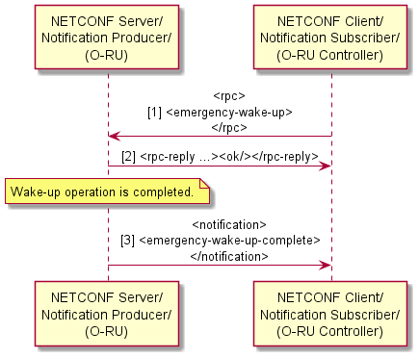
Figure 20.3.1.3-1 Emergency Wake-up Procedure

20.3.1.4 Interaction with M-Plane processing
An O-RU supporting RF channel switch off/on for energy saving shall be able to disable C/U plane monitoring (see clause 7.10). For example, an O-RU may support the cu-plane-monitoring container in its o-ran-supervision.yang model, allowing an O-DU to disable C/U plane monitoring operation.
Operation of other M-plane procedures, including measuring of transport delay (clause 7.9), C/U plane transport connectivity verification (clause 7.6) and O-RU synchronisation (clause 13) shall not be affected by network energy savings functionality.

20.3.2 TRX control – M-Plane controlled

20.3.2.1 Introduction
TRX control via M-Plane messages is used to achieve energy saving through disabling one or more O-RU array elements for an undefined period of time (until a next command is received). For example, an O-DU can switch off 32 out of 64 array elements of a massive MIMO antenna array. The TRX control capability and configuration are described in clauses 20.3.2.2 and 20.3.2.3.
NOTE: Clause 15.3.2 specifies another set of conditions allowing O-RU to save energy by disabling array elements.

20.3.2.2 TRX control capability
The O-RU exposes the capability to support energy saving through disabling some or all of the O-RU’s antenna array elements by including support of the feature MPLANE-TRX-CONTROL in its o-ran-wg4-features.yang YANG module. If the feature is supported, then an O-RU controller can use the NETCONF session to recover the associated O-RU TRX control capability information and parameters. These capability attributes are defined for each [tr]x-arrays. These capabilities can be recovered by an O-RU controller at the O-RU start up as part of the o-ran-uplane-conf.yang YANG module operations. The attributes are:
- mplane-trx-control-txarr-capability-info: A container in o-ran-uplane-conf.yang YANG module with capabilities that are specific to TRX Control for each tx-arrays. The parameters in the container include the following:
- mplane-trx-control-supp-antenna-masks: A grouping which contains the list mplane-supported-trx-control-masks, which is a list of TRX control configurations that are supported by the O-RU which are reported with their corresponding antenna-mask values. Refer to the O-RAN CUS plane specification [2], clause 16.2 for more details on the usage of antenna masks. The absence of the list mplane-supported-trx-control-masks indicates that any combination of antenna mask is supported by the O-RU for a particular [tr]x-array. If an antenna mask list is present, an all-ones antenna mask shall be included in the list to assure all array elements can be turned on.
NOTE: If the mplane-supported-trx-control-masks contains a single all-ones antenna mask, that means the only valid antenna mask to configure is all array elements activated, meaning the TRX Control capability is not present.
- mplane-trx-control-rxarr-capability-info: A container in o-ran-uplane-conf.yang YANG module with capabilities that are specific to TRX Control for each rx-array. The parameters in the container include the following:
- mplane-trx-control-supp-antenna-masks: Same as this parameter description within mplane-trx-control-txarr-capability-info above.

20.3.2.3 TRX control configuration
To support [tr]x-array level O-DU controlled antenna array configuration, new O-RU level node array-config-group is introduced. For M-Plane TRX control the node contains two lists tx-array-antenna-mask-config and rx-array-antenna-mask-config, one each for specifying tx-array and rx-array configuration for TRX control respectively. The list is indexed using array-name and contains parameters antenna-bitmask and antenna-bitmask-index. These two parameters per tx-array and rx-array list entry may be used by the O-RU controller to perform TRX Control. It is problematic if TRX Control commands are issued for sub-arrays of a larger array due to the potential interaction of multiple TRX Control commands affecting the same array elements which are part of multiple [tr]x-arrays. Therefore, the antenna mask configuration shall be done for the largest tx or rx array that is advertised by the O-RU, not for the tx-array or rx-array which is a subset of the largest array (multiple non-overlapping largest arrays are possible). The effect of the configuration command shall be to impact the largest array (whether that largest array has any carriers assigned to it or not).
For the case where the O-RU advertises mplane-supported-trx-control-masks list, RPC edit-config shall be used to configure a specific antenna mask value by specifying a given antenna-bitmask-index for the [tr]x-array using the YANG parameter [tr]x-array-antenna-mask-config .
EXAMPLE 1: configuration of a given 32-bit tx antenna mask by specifying the antenna-index:
<tx-array-antenna-mask-config>
<array-name> tx-array-1 </array-name>
<antenna-bitmask-index> 1 </antenna-bitmask-index>
</tx-array-antenna-mask-config>
For the case where the O-RU does not advertise mplane-supported-trx-control-masks list for a given [tr]x-array, the RPC edit-config shall be used to configure a specific antenna-bitmask value for the [tr]x-array using the YANG parameter [tr]x-array-antenna-mask-config .
EXAMPLE 2: configuration of a 32-bit tx antenna mask is shown below:
<tx-array-antenna-mask-config>
<array-name> tx-array-1 </array-name>
<antenna-bitmask >11111111000000000000000011111111</antenna-bitmask >
</tx-array-antenna-mask-config>

NOTE: Binary values are encoded with a base-64 encoding (see reference [4]) so the above mask would actually be represented as "/wAA/w==".
Prior to any M-Plane TRX Control antenna mask or associated antenna index being configured, the value of the antenna mask shall be considered to be all-ones, meaning all array-elements are enabled.
Because updating an antenna mask via M-Plane is an asynchronous operation, the O-RU shall notify all notification subscribers that the [tr]x-array specific commanded mask or antenna mask index has been implemented, using the mplane-trx-control-ant-mask-update notification, as detailed in the Figure 20.3.2.3-1.
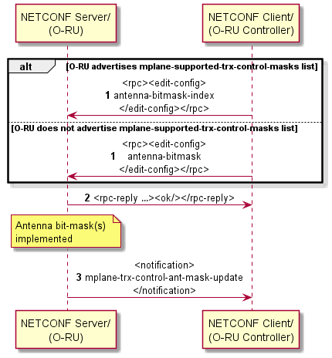
Figure 20.3.2.3-1 – TRX control configuration (M-Plane controlled)
To reduce unexpected transient related to the turning-off process, the O-DU may send zero-value beamforming weights for any array element to be turned off prior to issuing the edit-config command turning off any array-elements, and may keep them at zero-value while the array-elements are off.
To reduce unexpected transient related to the turning-on process, the O-DU may send zero-value beamforming weights for any disabled array element to be turned on prior to issuing the edit-config command turning on the array-elements, and may keep them at zero-value until receiving the notification that the new antenna mask activating those array elements is received.
When TRX Control has disabled all array elements in a [tr]x-array, the O-RU may disable CU-Plane processing associated with all array-carriers using that [tr]x-array, and the O-DU should assume that the CU-Plane processing for those array-carrier has been halted by the O-RU.

20.3.2.4 Interaction with M-Plane processing
An O-RU supporting M-Plane controlled TRX Control for energy saving shall be able to disable C/U plane monitoring (see clause 7.10). For example, an O-RU may support the cu-plane-monitoring container in its o-ran-supervision.yang model, allowing an O-DU to disable C/U plane monitoring operation.
Operation of other M-plane procedures, including measuring of transport delay (clause 7.9), C/U plane transport connectivity verification (clause 7.6) and O-RU synchronization (clause 13) shall not be affected by this network energy savings feature’s functionality.

20.3.2.5 Interaction with C-Plane TRX Control and ASM
An O-DU using M-Plane TRX Control for energy saving shall be able to also use C-Plane TRX Control when an O-RU supports both. However, the O-DU shall ensure the current M-Plane-commanded antenna mask (using antenna-mask or antenna-index pointing to O-RU advertised supported antenna mask) is all-ones (all array elements active) prior to issuing any C-Plane TRX Control commands, and the O-DU shall ensure the current C-Plane-commanded antenna mask is all-ones (all array-elements active) prior to issuing any M-Plane TRX Control commands.
An O-DU using M-Plane TRX Control for energy saving shall be able to also use C-Plane ASM when an O-RU supports both. However, the O-DU shall ensure the current M-Plane-commanded antenna mask is all-ones (all array elements active) prior to issuing any C-Plane ASM commands, and the O-DU shall ensure the current C-Plane-commanded ASM conditions are terminated prior to issuing any M-Plane TRX Control commands.
NOTE: The antenna mask is considered to be all-ones prior to any M-Plane or C-Plane TRX Control command being issued.

20.3.3 Data layer control

20.3.3.1 Introduction
Data layer control is used to achieve energy saving through reducing the number of data layers independent of TRX-Control. For example, the energy consumption of an O-RU can be reduced by turning off certain HW components like processing units of FPGA/GPUs or CPU/GPU cores or by running at a lower clock speed along with reduced processing requirements [i.6]. The methodology of data layer control using endpoint switch off/on is described in clause 20.3.3.2.

20.3.3.2 Capability and configuration of data layer control
This clause provides basic description of how an O-RU's data layers can be reduced to achieve the energy savings within an O-RU. The O-RU exposes the capability to support energy saving by including support of the feature MPLANE-DATA-LAYER-CONTROL in its o-ran-wg4-features.yang YANG module. The support of this feature means an O-RU shall advertise the data node energy-sharing-group-id per static-low-level-[tr]x-endpoints. Multiple endpoints that have the same energy-sharing-group-id value signifies that these endpoints share common underlying HW components.
When an O-RU indicates it supports the MPLANE-DATA-LAYER-CONTROL feature, a global configuration leaf-list parameter energy-sharing-groups-disabled is available in the o-ran-uplane-conf YANG model. An O-RU Controller may turn off a group of data layers by adding one or more energy-sharing-group-id into the energy-sharing-groups-disabled list. When one or more energy-sharing-group-id is included in the energy-sharing-groups-disabled list, the O-RU shall switch off the underlying HW components common to that energy-sharing-group-id thereby resulting in energy savings. If an endpoint has multiple energy-sharing-group-id, the underlying HW components associated with the endpoint shall be turned off if any of the energy-sharing-group-id corresponding to the endpoint is added to the leaf-list energy-sharing-groups-disabled. The O-RU controller shall trigger data layer control only for the energy-sharing-group of endpoints all of whose eAxC-id values are currently not being used by the O-DU (i.e. not referenced, either directly or indirectly, within any CU-plane messages, e.g. by using Section Extension 10).
An O-RU controller may turn on a group of data layers by removing the energy-sharing-group-id from the energy-sharing-groups-disabled list. When the energy-sharing-group-id is removed from the energy-sharing-groups-disabled list, the O-RU shall switch on the underlying HW components common to that energy-sharing-group-id. If an endpoint has multiple energy-sharing-group-id, the underlying HW components associated with the endpoint shall be turned on only if all the energy-sharing-group-id corresponding to the endpoint are removed from the leaf-list energy-sharing-groups-disabled. Subsequently, when the wake-up procedure is complete a notification shall be sent by the O-RU to all subscribed O-RU controllers as detailed in the Figure 20.3.3.2-1.
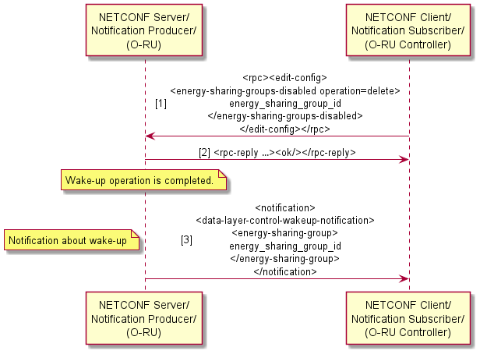
Figure 20.3.3.2-1 - Data layer control wake-up notification

20.4 Advanced sleep modes for energy saving

20.4.1 ASM module capabilities
The O-RU exposes its ability to support energy saving by disabling some part of the processing, which impacts the O-RU’s array elements (based on the command scope of the received ST4 message) by including support of the feature ADVANCED-SLEEP-MODE in o-ran-wg4-features.yang YANG module. If the feature is supported, then an O-RU controller can use the NETCONF session to recover the O-RU ASM capabilities. These capability attributes are defined for each [tr]x-arrays. These capabilities can be recovered by an O-RU controller at the O-RU start up as part of the o-ran-uplane-conf.yang YANG module. The attributes are:
- asm-capability-info: A container in o-ran-uplane-conf.yang YANG module with capabilities that are specific to Advanced sleep modes for each [tr]x-arrays. The parameters in the container include the following:
- sleep-mode-type: This value indicates the sleep mode supported by the O-RU for a particular [tr]x-array as specified in the O-RAN CUS plane specification [2], Table 16.1-1.
- wake-up-duration: This value indicates the reported wake-up time (in microseconds) for a particular sleep mode for a particular [tr]x-array. The O-DU can convert the wake-up duration in microseconds to the respective number of slots based on the SCS(s) supported by the O-RU (for more details, refer to O-RAN CUS plane specification [2], clause 16.1).
- wake-up-duration-guaranteed: The capability of the O-RU to guarantee full wake-up operation within the time reported in wake-up-duration. This field shall be reported as "FALSE" if the O-RU cannot assure the wake-up time, in which case the value reported in wake-up-duration is considered as the minimum wake-up time. For sleep-mode-type reported as "SLEEP_MODE_0", the wake-up-duration-guaranteed shall be reported as "TRUE". Refer to the O-RAN CUS plane specification [2], clause 16.6 for more details on the differences between guaranteed and minimum wake-up durations.
- defined-duration-sleep-supported: The capability of the O-RU to support the defined sleep functionality as specified in O-RAN CUS plane specification [2], clause 16.4.
- undefined-duration-sleep-supported: The capability of the O-RU to support the un-defined sleep functionality as specified in O-RAN CUS plane specification [2], clause 16.5.
NOTE: The leafs sleep-mode-type, wake-up-duration, wake-up-duration-guaranteed, defined-duration-sleep-supported, undefined-duration-sleep-supported defined in this clause are distinct from the leafs of the same name defined in clause 20.3.1.2.
- The container energy-saving-capability-common-info as defined in clause 20.3.1.2 is also applicable for ASM.

20.4.2 Emergency wake-up procedure for ASM
The O-RU shall support emergency wake-up procedure for Advanced sleep modes similar to TRX control as described in clause 20.3.1.3.

20.4.3 Interaction with M-Plane processing
An O-RU supporting advanced sleep modes for energy saving shall be able to disable C/U plane monitoring (see clause 7.10). For example, an O-RU may support the cu-plane-monitoring container in its o-ran-supervision.yang model, allowing an O-DU to disable C/U plane monitoring operation.
Operation of other M-plane procedures, including measuring of transport delay (clause 7.9), C/U plane transport connectivity verification (clause 7.6) and O-RU synchronisation (clause 13) shall not be affected by network energy savings functionality.

20.5 Deep-hibernate

20.5.1 Introduction
Deep-hibernate is an O-RU mode used to achieve relatively higher energy saving by disabling all carriers and stopping the C/U/S/M functions and corresponding processing units when compared to power-state defined in clause 9.1.3 or advanced sleep mode defined in clause 20.4.

20.5.2 Deep-hibernate module capabilities
The O-RU exposes its ability to support deep hibernate functionality by including support of the feature DEEP-HIBERNATE in its o-ran-wg4-features.yang YANG module. The support of this feature means an O-RU shall advertise the data node max-hibernate-time-duration and optionally advertise data node min-hibernate-time-duration.

20.5.3 Configuration of deep-hibernate
This clause provides description of how deep-hibernate can be activated in the O-RU.
An O-RU Controller shall send an RPC <deep-hibernate> to activate the deep-hibernate in O-RU, which initiates the corresponding timer. The RPC shall include the hibernate-time duration.
Before the O-DU sends the deep-hibernate RPC, the O-DU shall ensure that all [tr]x-array-carrier(s) shall be deactivated as defined in Figure 15.3.2-0b. If an O-RU receives a deep-hibernate RPC while one or more [tr]x-array-carriers are active, then it shall reject the RPC, including in the error-message the reason why deep-hibernation cannot be activated.
If the deep-hibernate RPC is accepted by the O-RU, the O-RU shall cease processing control-plane, user-plane and synchronization plane operations. If accepted, the O-RU shall send a notification to all subscribed O-RU Controllers to indicate the deep-hibernate is activated, where the notification shall also indicate the hibernate-time. Upon receiving notification from an O-RU, a subscribed O-RU Controller shall send the RPC <close-session> to the O-RU. The O-RU shall suspend all NETCONF call home operations and/or PNF Registration operations after deep-hibernate mode activated.
Once all NETCONF sessions are terminated, the M-Plane functions on O-RU shall then be stopped to reduce the further energy consumption and O-RU enters deep-hibernate. The O-RU shall not respond to any incoming NETCONF session while in deep-hibernate mode.
NOTE: If any NETCONF session is not closed by NETCONF Client then the O-RU behavior is unspecified.
At the end of hibernate-time, the O-RU shall perform a re-start and follow the procedures defined in Figure 6.1-1. Upon restart, the O-RU shall set the restart-cause to DEEP-HIBERNATE-RESTART using o-ran-operations.yang YANG module. In case of autonomous O-RU restart while in deep-hibernate mode, e.g. because of some software failure, the O-RU is not expected to continue the deep-hibernate mode.
In the case the O-RU is operating as a Shared O-RU as described in clause 19, an O-DU operating with "carrier" privileges as defined in Table 6.5-1 shall be prohibited from sending the RPC <deep-hibernate>. How the Shared O-RU Host coordinates with other O-DU(s) for the deep-hibernate activation is out of scope of the present document.
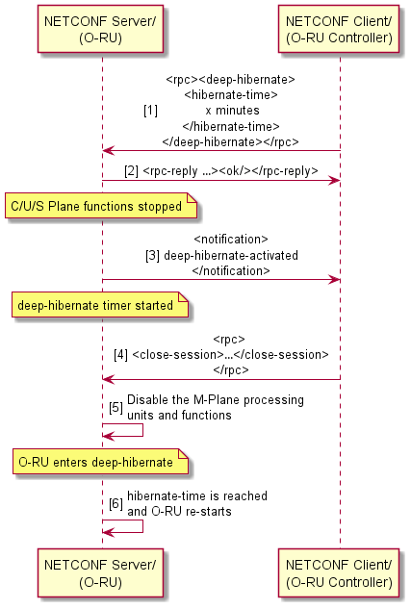
Figure 20.5.3-1 – Deep hibernate operation

20.6 Maximum output power control

20.6.1 Introduction
Maximum output power control is an energy saving method used to reduce power consumption in O-RU. To achieve this, the number of scheduled PRBs may be restricted by the O-DU, allowing the O-RU to adapt Power Amplifier (PA) accordingly.

20.6.2 Maximum output power control capability
The O-RU exposes the capability to save energy through adjusting the maximum tx power by reporting support of the feature MAX-POWER-CONTROL in its o-ran-wg4-features.yang YANG module. O-RU supporting MAX-POWER-CONTROL reports capabilities using following YANG schema nodes:

- max-power-control-methods-supported: The control methods used to define the capabilities supported by the O-RU at two granularities:
- MAX-POWER-PER-TX-ARRAY-CONTROL: Enable the O-DU to configure the power reduction for each tx-array.
- MAX-POWER-PER-TX-ARRAY-CARRIER-CONTROL: Enables the O-DU to configure the power reduction for each tx-array-carrier.
- supported-max-power-level: List of supported maximum output power levels per tx-array for energy saving.
- index: The leaf indicates the level of maximum output power control. If index = 0, it means this tx-array is in the normal mode.
- array-max-power-reduction: The leaf indicates the reduced upper power compared to the rated maximum power per tx-array for the index. For normal mode, this value shall be mapped to 0.

20.6.3 Maximum output power control configuration
The maximum output power is controlled by the O-RU Controller through configuration of the max-power-level-index parameter or carrier-max-power-reduction. The O-DU restricts the number of scheduled PRBs upper limit based on network load or predictive analysis, with implementation specifics excluded from this document.
To control the maximum output power, the O-RU Controller shall configure the max-power-control-method value according to the methods exposed by the O-RU in max-power-control-methods-supported, MAX-POWER-PER-TX-ARRAY-CONTROL or MAX-POWER-PER-TX-ARRAY-CARRIER-CONTROL.
- If method MAX-POWER-PER-TX-ARRAY-CONTROL is selected: The O-DU may only configure the max-power-level-index if the related tx-array reports supported-max-power-level. In this mode, the O-RU controller should select and configure the leaf max-power-level-index per tx-array, then the O-RU calculates and applies the corresponding level with array-max-power-reduction. The O-RU controller shall also ensure that maximum power level that is scheduled to be transmitted at the tx-array is less than the configured maximum tx power. Refer to the CUS-Plane specification [2] clause 8.1.3.3 for the restrictions on input IQ power level.
- If method MAX-POWER-PER-TX-ARRAY-CARRIER-CONTROL is selected: The O-DU may only configure the carrier-max-power-reduction if the related tx-array reports supported-max-power-level. In this mode, the O-RU controller should configure the power reduction via carrier-max-power-reduction per tx-array-carrier. Then the O-RU calculates and applies the corresponding carrier-max-power-reduction per related tx-array-carrier. The O-RU controller shall also ensure that maximum power that is scheduled to be transmitted at the tx-array-carrier is less than one scheduled for the configured maximum tx power. Refer to the CUS-Plane specification [2] clause 8.1.3.3 for the restrictions on input IQ power level.
If any O-RU abnormality or traffic abnormality is detected, O-RU controller can transfer the O-RU from energy saving mode to normal mode through set max-power-level-index to 0 per tx-array or set carrier-max-power-reduction to 0 per tx-array-carrier, and the O-DU should lift scheduling constraints after maximum power level recovery is completed.
If the O-DU chooses to retrieve the currently used power-level, the O-DU shall read the read-only max-power-level-used parameter. The O-RU shall set this parameter to indicate the currently used energy saving level per tx-array, where the default value should be normal mode.
When the maximum power control procedure has been completed, a notification shall be sent by the O-RU with the current max-power-level-used to all subscribed O-RU controllers as detailed in the Figure 20.6.3-1.
When the O-DU configures array-max-power-reduction or carrier-max-power-reduction to a new value, then the O-DU shall adhere to the following constraints:
- If the new value results in increased power reduction, then the O-DU shall reduce the power (e.g., by scheduling less PRBs) for the affected carriers before requesting the new configuration.
- If the new value that results in decreased power reduction, then the O-DU shall not increase the power (e.g., by scheduling more PRBs) for the affected carriers before it received max-power-level-used notification.
The O-RU may not guarantee service performance between reception of a request for configuration of array-max-power-reduction/carrier-max-power-reduction to a new value and sending of the max-power-level-used notification that signals implementation of the change.
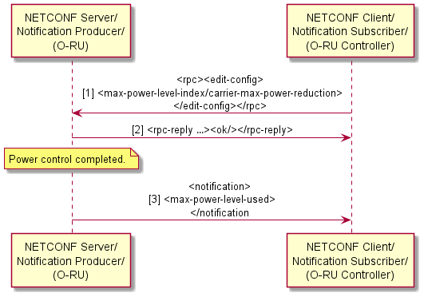

Figure 20.6.3-1 – Maximum power control

20.6.4 Interaction with M-Plane processing
In the case of Shared O-RU, if different O-DUs configure carrier-max-power-reduction for carriers related to the same tx-array, then the values of carrier-max-power-reduction can be agreed via offline negotiation, which is outside the scope of the present document.

21 Received power measurements for shared spectrum bands

21.1 Introduction
There exists some spectrum that is designated as shared spectrum. To improve the sharing experience, received power measurements can be beneficial in understanding the level to which the shared spectrum is being used. Citizens Broadband Radio Service (CBRS) is an example of such a shared spectrum allocation, corresponding to 150MHz of spectrum in the 3.5GHz band (3550 MHz to 3700 MHz) in the United States. CBRS band is lightly licensed and the use is expected to reduce the cost of data transmissions. The CBRS architecture introduces the Spectrum Access System (SAS) function that is responsible for authorisation and manages use of the shared spectrum [i.8]. To help inform the SAS of the wireless environment, the O-RU can optionally support measurements of shared spectrum bands. An O-RU supporting such optional capability shall include the o-ran-frequency-band-measurement model in its YANG library. This clause 21 applies to O-RUs that support this optional capability.
NOTE: This clause 21 defines the use of NETCONF-based procedures between an O-RU and an O-RU controller for performing measurements of shared spectrum bands. Signalling between the O-RU Controller and the SAS are out of scope of the present document.

21.2 Measurement Procedure

An O-RU controller can use the received-power-measurement-request RPC to trigger the O-RU to start measurements, as illustrated in Figure 21.2-1.
The O-RU can report its capabilities to the NETCONF client. These capabilities are defined in o-ran-frequency-band-measurement.yang module. The attributes included are:
- measurement-bands-supported: The supported requency range for which an O-RU can perform the received power measurement.
- in-service-measurement: Indicates whether O-RU can support measurements when tx-array carriers are active in measurement band.
- in-service-measurement-only-carrier-freq: Indicate an O-RU only support measurement on frequency range as carrier is configured on when in-service-measurement is TRUE.
- supported-measurement-points: Indicates which measurement point(s) are supported by the O-RU. Defined measurement points are NO_ARRAY, ONE_ARRAY and MULTIPLE_ARRAYS. Depending on the reported measurement points, the O-RU supports measurements without an rx-array name provided (NO_ARRAY), with a single rx-array name provided (ONE_ARRAY) and/or with multiple rx-array names provided (MULTIPLE_ARRAYS). If ONE_ARRAY or MULTIPLE_ARRAY is reported by the O-RU, then the O-RU controller shall configure the rx-array name(s) as the measurement point in the rx-array leaf-list in the received-power-measurement-request rpc.

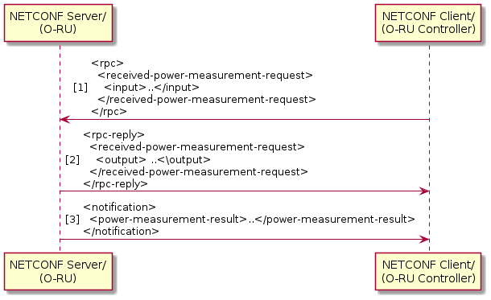
Figure 21.2-1: CBRS measurement flow

21.3 Measurement attributes
Following received-power-measurement-request rpc is used to trigger the measurement and subsequent notification of the measurement results.
- rpc: received-power-measurement-request
- input
- measurement-bandwidth: This is the measurement unit.
- measurement-start-frequency: This is the start frequency range requested for measurement. For band n48, the limited range is 3550...3700MHz.O-RU can report the measurement of continuous spectrum or the limited discontinuous spectrum. When the O-RU does not have a spectrum grant from the CBRS system, received power shall be measured and reported over the entire CBRS band in segments that do not exceed 10 MHz per measurement report. When the O-RU has a spectrum grant from the CBRS system, received power shall be measured and reported over one or more frequency ranges that do not exceed 10 MHz per measurement report.
- rx-array: The measurement point for which the O-RU shall provide measurements. The supported values depend on the supported-measurement-points capability. If multiple rx-array names are provided, then the rx-arrays shall be allocated in the same sector and for each measurement (identified by measurement-start-frequency), only one value of received-power shall be reported.
- output
- status: whether O-RU accepted or rejected the measure request.
- error-message: The detailed error message when the operation is failed. If the requested range is out of O-RU's Instantaneous BandWidth(IBW) then it can output status as FAILED with a detailed error-message.
- wait-time: Declare the expected time for report delivery in notification.
- measurement-id: Identify an RPC for one measurement.
- notification: power-measurement-result
- status: whether O-RU accepted or rejected the measure request.
- error-message: The detailed error message when the operation is failed.
- measurement-id: Identify an RPC for one measurement.
- received-power-measurement: This list indicates the List of RSSI measurements.
If O-RU controller uses "rpc received-power-measurement-request" to request measurement report, then O-RU performs and reports received power measurements over the requested-spectrum band in segments of measurement-bandwidth per measurement report. O-RU sends RPC response where status= SUCCEED or FAILED. O-RU performs measurement and delivers result to O-RU controller. O-RU sends error-message when status = FAILED and with appropriate failure reason.
For CBRS, O-RU performs the received power measurement in segments with 5 or 10MHz measurement bandwidth per measurement report. The range bounded by measurement-start-frequency as the lower bound and measurement-start-frequency+ measurement-bandwidth as the upper bound expresses the frequency range used in making the measurement. Measurement bandwidth is fixed during each measurement. The possible expression range of the measurement parameter for CBRS is -100 dBm... -25dBm. When the measurement result in O-RU is out of the range:
- O-RU should report -100 dBm when result is lower than -100dBm.
- O-RU should report -25 dBm when result is higher than -25dBm.

Annex A (normative): Common alarm definition

A.1 Introduction
This clause contains common alarms which may be supported.
Alarms that are not applicable in given HW design or SW configuration shall not be reported. For example, alarms related to fan monitoring are applicable to HW variants with fans.
In many cases fault detection method is HW specific. It is assumed that fault detection method is reliable to avoid undetected alarms and false alarms. It is also expected that the NETCONF Server is applying mechanisms to avoid unreasonably fast toggling of alarms' state, for example use time filtering.
The field that are mandatory for alarm-notif notifications are:
- fault-id;
- fault-source;
- fault-severity;
- is-cleared; and
- event-time.
The common alarms table has following columns:
NOTE 1: The table columns do not represent the entire set of alarm fields defined in the o-ran-fm.yang model.
Fault id - Numerical identifier of fault type of the alarm. This ID shall be used in <alarm-notif> message (fault-id parameter).
Fault Name - Name of the fault. It may be used in the alarm-notif notification.
Meaning - Description of alarm, describes high level meaning of the alarm. This field is informative.
Start condition - Defines conditions that O-RU shall follow for raising the alarm. If specific filtering time is needed, then it shall be defined in this column.
Cancel condition - Defines conditions that O-RU shall follow for ceasing the alarm. If specific filtering time is needed, then it shall be defined in this column.
NETCONF Server actions on fault detection - Defines actions of the NETCONF Server when fault has been detected. This field is informative. Word ‘None’ in this field means no action is expected.
NETCONF Server actions on fault recovery - Defines actions of NETCONF Server after fault detection determines the fault is recovered. This field is informative. Word ‘None’ in this field means no action is expected.
NETCONF Client recovery actions - Describes gNB level recovery actions of the NETCONF Client after alarm has been indicated by NETCONF Server. This field is informative only; actions taken by the NETCONF Client are not restricted nor defined in the present document. NETCONF Client recovery action "Reset" refers to NETCONF Client forcing reset of O-RU.
Source - Defines possible sources of the alarm (fault is localized to this source within O-RU). Alarm sources may directly reference a defined component or may use a predefined textual description. If the fault source can be represented by an object in the model, then the YANG instance-identifier should be set as the value. XML format can also be used. The following list provides examples of mapping between fault sources and XML encodings, describing the names of components that may be alarm sources:
- Module (hardware component is O-RAN-RADIO): < hardware xmlns= "urn:o-ran:hardware:1.0"><component><o-ran-name/></component></hardware>
- Fan supervision: <fan-tray xmlns= "urn:o-ran:fan:1.0"><fan-state><name/></fan-state></fan-tray>
- GNSS: <sync xmlns= "urn:o-ran:sync:1.0"><gnss-status><name/></gnss-status></sync>
- External input: <external-io xmlns= "urn:o-ran:externalio:1.0"><input><name/></input></external-io>
- External output: <external-io xmlns= "urn:o-ran:externalio:1.0"><output><name/></output></external-io>
- ALD port: <ald-ports-io xmlns= "urn:o-ran:ald-port:1.0"><ald-port><name/></ald-port></ald-ports-io>
- Port transceiver: <port-transceivers xmlns= "urn:o-ran:transceiver:1.0"><port-transceiver-data><name/></ port-transceiver-data ></port-transceivers>
- Ethernet interface: <interfaces xmlns= "urn:ietf:params:xml:ns:yang:ietf-interfaces"><interface><name/></interface></interfaces>
- Processing element: <processing-elements xmlns= "urn:o-ran:processing-element.1.0"><ru-elements><name/></ru-elements></processing-elements>
- Low level tx link: <o-ran-uplane-conf xmlns= "urn:o-ran:uplane-conf.1.0"><low-level-tx-links><name/></low-level-tx-links></ o-ran-uplane-conf>
- Low level rx link: <o-ran-uplane-conf xmlns= "urn:o-ran:uplane-conf.1.0"><low-level-rx-links><name/></low-level-rx-links></o-ran-uplane-conf>
- Tx array: <o-ran-uplane-conf xmlns= "urn:o-ran:uplane-conf.1.0"><tx-arrays><name/></tx-arrays></o-ran-uplane-conf>
- Rx array: <o-ran-uplane-conf xmlns= "urn:o-ran:uplane-conf.1.0"><rx-arrays><name/></rx-arrays></o-ran-uplane-conf>
- Tx array carrier: <o-ran-uplane-conf xmlns= "urn:o-ran:uplane-conf.1.0”><tx-array-carriers><name/></tx-array-carriers></o-ran-uplane-conf>
- O-DU supervision: <o-ran-supervision xmlns= "urn:o-ran:supervision:1.0"><per-odu-monitoring><odu-id/></per-odu-monitoring></o-ran-supervision>
- Connector (hardware component derived from "O-RU-CONNECTOR"): <hardware xmlns= "urn:ietf:params:xml:ns:yang:ietf-hardware"><component><name/></component></hardware>
- Component (hardware component): <hardware xmlns= "urn:ietf:params:xml:ns:yang:ietf-hardware"><component><name/></component></hardware>
The following list provides mapping between fault sources and predefined textual descriptions used to define the fault sources:
- Antenna line: array's name:array element, where array's name follows either Tx array or Rx array name as defined above and array element is an ordinal number defining element within an array (see k in clause 12.5.3 Identification and Ordering of Array Elements in [2]).
EXAMPLE 1: "tx-array-1:0" (alarm on the array element k=0 on the tx-array named "tx-array-1")
EXAMPLE 2: "rx-array-2:15" (alarm on the array element k=15 on the rx-array named "rx-array-2")
- Tx array carrier per antenna line: array carrier's name/array’s name:array element, where array carrier's name follows Tx array carrier name as defined above, and array's name follows Tx array name as defined above and array element is an ordinal number defining element within an array (see k in clause 12.5.3 Identification and Ordering of Array Elements in [2]).
EXAMPLE 1: "tx-array-carrier-1/tx-array-1:0" (alarm of tx-array-carrier named "tx-array-carrier-1" on the array element k=0 on tx-array named "tx-array-1" )
EXAMPLE 2: "tx-array-carrier-3/tx-array-2:15 " (alarm of tx-array-carrier named “tx-array-carrier-3” on the array element k=15 on tx-array named "tx-array-2" )
If an alarm is caused by an external device (fault localized external to the O-RU, e.g. caused by an Antenna Line Device), then fault source may not fit to any of the fault sources described above and additional text in an alarm notification is needed to clearly describe what may be a possible fault source.
NOTE 2: Alarms, especially those defined in vendor specific range, may use other fault sources, which are not described above.

Severity - Defines severity of the alarm as specified in ITU X.733 [30].
- Critical - sub-unit for which alarm has been generated is not working and cannot be used.
- Major - sub-unit for which alarm has been generated is degraded, it can be used but performance might be degraded.
- Minor - sub-unit for which alarm has been generated is still working.
Alarm Type - Indicates the type of alarm, where the type of alarm is as specified in 3GPP TS 28.111 [82], Clause 7.4.1, but where the YANG enumeration of alarm-type in o-ran-fm.yang YANG model differs from the YANG eventType typedef enumeration in _3gpp-common-fm.yang YANG model. In text used in column Alarm Type in Table A.1-1: Common O-RU Alarms and in o-ran-fm.yang enumeration alarm-type ´-´ are used while in 3GPP 28.111 Clause 7.4.1 row alarmType allowed values ´_´ are used. For example, O-RAN alarm-type enumeration of "COMMUNICATIONS-ALARM" corresponds to a 3GPP eventType enumeration of "COMMUNICATIONS_ALARM"..
The table of alarms in Annex A includes alarm-type values for the common alarms

Table A.1-1: Common O-RU Alarms
Fault id | Fault Name | Meaning | Start condition | Cancel condition | NETCONF Server actions on fault detection | NETCONF Server actions on fault recovery | NETCONF Client recovery actions | Source | Severity | Alarm Type
1 | Unit temperature is high | Unit temperature is higher than expected. | Unit temperature exceeded HW implementation specific values. | Unit temperature is below HW implementation specific values. | SW implementation specific. | None. | None. | Module | Minor  (e.g. above threshold1)  or Major  (e.g. above threshold2) | ENVIRONMENTAL-ALARM
2 | Unit dangerously overheating | Unit temperature is dangerously high. | Unit temperature exceeded HW implementation specific value for reasonably long filtering time (e.g. 1 minute). | Unit temperature is below HW implementation specific value for reasonably long filtering time (e.g. 1 minute).  AND  Ambient temperature is below predefined HW implementation specific value | Unit deactivates all carriers to prevent HW damage. | None. | None. | Module | Critical | ENVIRONMENTAL-ALARM
3 | Ambient temperature violation | Calculated ambient temperature value goes outside the allowed ambient temperature range. | Calculated ambient temperature goes outside the allowed HW specific ambient temperature range. | Calculated ambient temperature not any more outside the allowed HW specific ambient temperature range | SW implementation specific. | None. | None. | Module | Minor | ENVIRONMENTAL-ALARM

Fault id | Name | Meaning | Start condition | Cancel condition | NETCONF Server actions on detection | NETCONF Server actions on cancel | NETCONF Client recovery actions | Source | Severity | Alarm Type
4 | Temperature too low | During start-up: The temperature inside the unit is too low. Heating of unit is ongoing. Wait until the alarm is cancelled.  During runtime: The temperature inside the module is too low. | Unit temperature is below HW implementation specific value. | Unit temperature is x Celsius above HW implementation specific value.  Additionally: cancellation of critical alarm (reported during start-up) is mandatory within x minutes. | HW implementation specific (e.g. enable heating).  (note 1) | HW implementation specific (e.g. disable the heating).  (note 2) | None. | Module | Critical during start-up  Minor during runtime | ENVIRONMENTAL-ALARM
5 | Cooling fan broken | Fan(s) do not run. | HW implementation specific. | HW implementation specific. | None. | None. | None. | Fan supervision | Critical (if cooling is severely degraded)  Major (otherwise) | EQUIPMENT-ALARM
6 | No fan detected | Unit cannot identify the used fan type or the fan is not installed at all. | HW implementation specific. | HW implementation specific. | SW implementation specific. | None. | None. | Fan supervision | Minor | EQUIPMENT-ALARM
7 | Tuning failure | A filter has not been able to tune on an appropriate sub-band properly. | HW implementation specific. | HW implementation specific. | None. | None. | None. | Antenna line | Critical | EQUIPMENT-ALARM
8 | Filter unit faulty | Major failure has been detected by the filter. | HW implementation specific. | HW implementation specific. | None. | None. | None. | Antenna line | Critical | EQUIPMENT-ALARM
9 | Transmission quality deteriorated | The TX signal quality may be out of specification limits. | HW and SW implementation specific. | HW and SW implementation specific. | None. | None. | None. | Antenna line | Major | QUALITY-OF-SERVICE-ALARM
10 | RF Module overvoltage protection faulty | Module's overvoltage protection is broken. | HW implementation specific. | None. | None. | None. | None. | Module | Minor | EQUIPMENT-ALARM
11 | Configuring failed | Configuration failed because of a HW or SW fault. | SW or HW fault detected during configuration. | None. | None. | None. | Reset. | Module | Critical | PROCESSING-ERROR-ALARM
12 | Critical file not found | Critical configuration file is missing. | Critical configuration file is detected missing. | None. | None. | None. | Reset. | Module | Critical | PROCESSING-ERROR-ALARM
13 | File not found | Non-critical configuration file is missing. | Non-critical configuration file is detected missing. | None. | None. | None. | None. | Module | Major | PROCESSING-ERROR-ALARM
14 | Configuration file corrupted | conflicting or corrupted configuration data. | conflicting or corrupted configuration data detected. | Unit detects that previously missing file is present. | None. | None. | None. | Module or antenna line | Major | PROCESSING-ERROR-ALARM
15 | Unit out of order | The Unit is out of order because of a software or hardware fault. | HW and SW implementation specific. | HW and SW implementation specific. | None. | None. | Reset. | Module | Critical | EQUIPMENT-ALARM
16 | Unit unidentified | The permanent memory in the module is corrupted and the module product code or serial number is missing, or the module product code is unknown. | Not able to read data from information storage or data is such that module identity or serial number is missing or module identity is unknown. | None. | None. | None. | None. | Module | Major | PROCESSING-ERROR-ALARM
17 | No external sync source | The Unit lost lock to all incoming clocks. | HW implementation specific. | HW implementation specific. | None. | None. | Reset or none. | Module | Major | EQUIPMENT-ALARM
18 | Synchronisation Error | Unit is out of synchronisation. | HW implementation specific (note 6). | HW implementation specific. | Unit shuts down all RF emission to prevent environment distortion and deactivates all carriers. | None. | Reset or none. | Module | Critical | EQUIPMENT-ALARM
19 | TX out of order | TX path is not usable. | HW implementation specific. | HW implementation specific. | None. | None. | Reset or none. | Antenna line | Critical | EQUIPMENT-ALARM
20 | RX out of order | RX path is not usable. | HW implementation specific. | None. | None. | None. | Reset or none. | Antenna line | Critical | EQUIPMENT-ALARM
21 | Increased BER detected on the optical connection | Increased bit error rate has been detected on the optical link which results in sporadic errors in downlink baseband processing. | HW implementation specific (the detected BER on optical link is degrading RF operation). | HW implementation specific (the detected BER on optical link is not degrading RF operation). | Module Agent starts HW implementation specific recovery to keep the RF operation ongoing. | Module Agent stops HW implementation specific recovery actions. | None. | Module | Major | QUALITY-OF-SERVICE-ALARM
22 | Post-test failed | Power-on self-test failed at start-up. | HW and SW implementation specific. | None. | Unit reset x times for recovery. | None. | None. | Module | Critical | PROCESSING-ERROR-ALARM
23 | FPGA SW update failed | The FPGA software update has failed. | FPGA SW checksum is not correct match after FPGA SW update is detected. | None. | None. | None. | None. | Module | Major | PROCESSING-ERROR-ALARM
24  (note 3) | Unit blocked | Unit is administratively locked. | Parameter admin-state of the Module element is set to "locked". | Parameter admin-state of the Module Element is set to "unlocked" or "shutting-down" | Refer to clause 9.1.3 for description. | None. | None. | Module | Critical | EQUIPMENT-ALARM
25 | Reset Requested | Unit detected a transient problem which significantly affects operation that requires a reset as a recovery. | HW implementation specific | None. | None. | None. | Reset. | Module | Critical | EQUIPMENT-ALARM
26 | Power Supply Faulty | Input power to module has fault, unstable or broken. | HW implementation specific | None | None | None | Reset or None | Module | Minor, , Major or Critical | EQUIPMENT-ALARM
27 | Power Amplifier faulty | One or more power amplifiers in module has fault, unstable or broken | HW implementation specific | None | None | None | Reset or None | Tx-array and/or antenna line | Major (Performance of Tx array and/or antenna line is degraded because of power amplifier issue  )  Or  Critical (Tx array and/or antenna line is not working because of power amplifier issue  ) | EQUIPMENT-ALARM
28 | C/U-plane logical Connection faulty | One of logical C/U-plane connection has fault, unstable or broken. | One of C/U-plane processing elements detects the error of C/U-plane connection faulty, (when the O-RU's CU plane monitoring timer expires). | C/U Plane connection recovered, or the carrier related fault source deactivated/removed. | None | None | None or reset. | processing-element | Major | COMMUNICATIONS-ALARM
29 | Transceiver Fault | Unit has detected a transceiver fault | HW and SW implementation specific. | None. | None | None. | None. | Module or port transceiver | Critical | EQUIPMENT-ALARM
30 | Interface Fault | Unit has detected a fault with one of its interfaces | HW and SW implementation specific. | None. | Unit reset x times for recovery. | None. | None. | Module | Major or Critical | EQUIPMENT-ALARM
31 | Unexpected C/U-plane message content fault | C/U-plane message content was faulty for undetermined reason. | C/U-plane detects unexpected message content. | Carrier that uses the fault source is disabled/removed | SW implementation specific | None | None | Specific to  low-level-[tr]x-endpoint  in the C/U-Plane message | Major, Minor or Warning | COMMUNICATIONS-ALARM
32 | Triggering failure of antenna calibration | O-RU has previously sent a notification antenna-calibration-required and has not received a start-antenna-calibration RPC | Major - O-RU has not received an RPC trigger for start antenna calibration within 60 seconds after triggering the sending of the antenna-calibration-required notification  Critical - After O-RU specific number of repetitions based on O-RU implementation/ Failure of O-RU self-calibration | Arrival of RPC antenna calibration start/Success of O-RU self-calibration | Major-None,  Critical-Reset or None | None | Major -Send RPC antenna calibration start/self-calibration  Critical- Reset | Module | Major/ Critical | PROCESSING-ERROR-ALARM
33 | Dying Gasp | O-RU is suffering from an unrecoverable condition such as power failure | Critical - O-RU is experiencing a dying gasp event | Re-starting of the O-RU, e.g. after power has been restored | HW implementation specific | None | None | Module | Critical | EQUIPMENT-ALARM
34 | Clock source failure | Clock source has failed | O-RU detects clock source failure | HW implementation specific. | set the system clock to the current time recovered from available external sources | None | None | Module | Critical | EQUIPMENT-ALARM
35 | Lost O-DU ID based Supervision | An O-RU has lost supervision from one O-DU (note 4). | Major – carriers associated with the O-DU are disabled. | Re-establishment of NETCONF supervision by O-DU (note 5). | Disable operation of carrier resources associated with O-DU | None | None | odu-id | Major | COMMUNICATIONS-ALARM
36 | Rx Signal quality deteriorated | The RX signal quality may be out of specification limits. | HW and SW implementation specific. | HW and SW implementation specific. | None. | None. | None. | Antenna line | Major | QUALITY-OF-SERVICE-ALARM
37 | High IQ Power | The IQ Power level is higher than alarm threshold. | Major - O-RU detects IQ-Power value exceeding HW implementation specific limit.  Critical - O-RU detects IQ-Power value exceeding HW implementation specific limit which can cause HW a failure. | tx-array-carrier is deactivated or IQ-Power value falls below threshold. | implementation specific | None. | None. | Tx-array-carrier per antenna line | Major  Critical | COMMUNICATIONS-ALARM
38 (note 7) | VSWR high | VSWR has exceeded threshold limits | VSWR is higher than expected | VSWR is below the specific value | Implementation specific | None | None | Antenna line or Connector | Minor (VSWR exceeds default or configured minor threshold)  Major (VSWR exceeds default or configured major threshold) | EQUIPMENT-ALARM
39 | Certificate About to Expire | The X.509 certificate used by O-RU for M plane is about to expire. | minor-alarm-advance-time days prior to expiry for Minor alarm. | When Major alarm is raised or when fault ID 40 is raised or when certificate is re-issued and certificate-lcm event generated. | Follow the procedure specified in clause 6.2.6.4.2 or 6.2.6.4.3 depending on the cert-lcm-policy configured. | After the certificate is re-issued, expect closure of existing NETCONF session from NETCONF controller. | NETCONF client shall follow the process defined in clause 6.2.6.4.3 if the configured cert-lcm-policy is REISSUE_ON_DEMAND. | Module | Minor | SECURITY-SERVICE-OR-MECHANISM-VIOLATION
39 | Certificate About to Expire |  | major-alarm-advance-time days prior to expiry for Major alarm. | When Critical alarm is raised or when fault ID 40 is raised or when certificate is re-issued and certificate-lcm event generated. |  |  |  |  | Major | SECURITY-SERVICE-OR-MECHANISM-VIOLATION
39 | Certificate About to Expire |  | critical-alarm-advance-time days prior to expiry for Critical alarm. | When fault ID 40 is raised or when certificate is re-issued and certificate-lcm event generated. |  |  |  |  | Critical | SECURITY-SERVICE-OR-MECHANISM-VIOLATION
40 | Certificate Expired | The X.509 certificate used by O-RU for M plane has expired. | The X.509 certificate used by O-RU for M plane has expired. | When certificate is re-issued and certificate-lcm event generated. | None | None. | NETCONF client shall follow the process defined in clause 6.2.6. | Module | Critical | SECURITY-SERVICE-OR-MECHANISM-VIOLATION
41 (note 8) | Generic Hardware Failure | Unit has detected a fault with one or more of its hardware (modules) | HW and SW implementation specific | HW and SW implementation specific. | HW and SW implementation specific. | Reset or None. | Reset or None. | Module or Component (note 9) | Critical, Major or Minor | EQUIPMENT-ALARM
42 | Certificate Re-issuance Failed | The O-RU failed to rekey the certificate | HW and SW Implementation specific | HW and SW Implementation specific | None | None | None | Module | Critical | SECURITY-SERVICE-OR-MECHANISM-VIOLATION
43 | CRL connection failure | The O-RU can’t connect to the CRL distribution point server | HW and SW Implementation specific | HW and SW Implementation specific | None | None | None | Module | Critical | SECURITY-SERVICE-OR-MECHANISM-VIOLATION
44 | CRL past nextUpdate | The time has passed the nextUpdate | HW and SW Implementation specific | HW and SW Implementation Specific | None | None | None | Module | Critical | SECURITY-SERVICE-OR-MECHANISM-VIOLATION
45  (note 10) | Abnormally High Unit Temperature | Unit temperature is higher than expected. | Unit temperature exceeded HW implementation specific values. | Major or Minor: Unit temperature is within HW implementation specific values. | Major or Minor: SW implementation specific, | None. | None. | Module | Minor  (e.g. above threshold1)  or Major  (e.g. above threshold2) or Critical (e.g. above threshold3) | EQUIPMENT-ALARM
 |  |  |  | Critical: Unit temperature is below HW implementation specific value for reasonably long filtering time (e.g. 1 minute). | Critical: Unit deactivates all carriers to prevent HW damage
NOTE 1: Actions taken shall not interfere with normal unit operation if such is commanded by NETCONF Client.
NOTE 2: Actions taken shall not interfere with normal unit operation if such is commanded by NETCONF Client.
NOTE 3: The admin-state is conditioned on the optional hardware-state feature. The O-RU can support fault id #24 (Unit blocked) only if it supports optional feature hardware-state.
NOTE 4: This alarm is only supported by O-RUs that implement the SHARED-ORU-MULTI-ODU feature. This alarm works per supervision session, meaning the O-RU is expected to report this alarm separately for each lost supervision session.
NOTE 5: Cancellation of this alarm is per each recovered supervision session.
NOTE 6: NETCONF Server shall not report fault id #18 during the initial synchronisation establishment which happens as part of normal start-up procedure as described in clause 6.1 step 8, i.e. O-RU implementations are designed to prevent false alarms during normal start-up.
NOTE 7: VSWR measurements are only valid when transmitted power exceeds a specific value which is either configured by O-RU Controller or predefined by O-RU.
NOTE 8: Specifically defined alarms should be used first, and this alarm should be applied only for undefined hardware failure cases.
NOTE 9: Source module shall be reported unless a more specific hardware component is reported in the component list. More detailed information may be included in the additional-information list.
NOTE 10: O-RU should use this alarm when it detects high temperature within the unit. When it determines the high temperature is caused by combination of internal and ambient temperature, it should use alarm ID 1 or 2 depending on the severity. If it calculates it is due to high ambient temperature, it should use alarm ID 3.

Annex B (normative): Counters

B.1 Counter definition

B.1.1 General
Table B.1.1-1: Counters definition
measurement-group identifier | measurement-group | measurement-object | report-info | object-unit | Description
1 | transceiver-stats | RX_POWER | MAXIMUM  MINIMUM  FIRST  LATEST  FREQUENCY_TABLE | PORT_NUMBER | Type decimal64 including 4 fraction-digits for max, min, first and latest. A parameter date-and-time is reported for each additionally.  Configurable parameters: function, bin-count, lower-bound, upper-bound are defined. For more detail see clauses B.2.1 and B.2.2. Type uint32 is used for frequency-bin-table.
1 | transceiver-stats | RX_POWER_LANE_2 | MAXIMUM  MINIMUM  FIRST  LATEST  FREQUENCY_TABLE | PORT_NUMBER
1 | transceiver-stats | RX_POWER_LANE_3 | MAXIMUM  MINIMUM  FIRST  LATEST  FREQUENCY_TABLE | PORT_NUMBER
1 | transceiver-stats | RX_POWER_LANE_4 | MAXIMUM  MINIMUM  FIRST  LATEST  FREQUENCY_TABLE | PORT_NUMBER
1 | transceiver-stats | TX_POWER | MAXIMUM  MINIMUM  FIRST  LATEST  FREQUENCY_TABLE | PORT_NUMBER
1 | transceiver-stats | TX_POWER_LANE_2 | MAXIMUM  MINIMUM  FIRST  LATEST  FREQUENCY_TABLE | PORT_NUMBER
1 | transceiver-stats | TX_POWER_LANE_3 | MAXIMUM  MINIMUM  FIRST  LATEST  FREQUENCY_TABLE | PORT_NUMBER
1 | transceiver-stats | TX_POWER_LANE_4 | MAXIMUM  MINIMUM  FIRST  LATEST  FREQUENCY_TABLE | PORT_NUMBER
1 | transceiver-stats | TX_BIAS_COUNT | MAXIMUM  MINIMUM  FIRST  LATEST  FREQUENCY_TABLE | PORT_NUMBER
1 | transceiver-stats | TX_BIAS_COUNT_LANE_2 | MAXIMUM  MINIMUM  FIRST  LATEST  FREQUENCY_TABLE | PORT_NUMBER
1 | transceiver-stats | TX_BIAS_COUNT_LANE_3 | MAXIMUM  MINIMUM  FIRST  LATEST  FREQUENCY_TABLE | PORT_NUMBER
1 | transceiver-stats | TX_BIAS_COUNT_LANE_4 | MAXIMUM  MINIMUM  FIRST  LATEST  FREQUENCY_TABLE | PORT_NUMBER
1 | transceiver-stats | VOLTAGE | MAXIMUM  MINIMUM  FIRST  LATEST  FREQUENCY_TABLE | PORT_NUMBER
1 | transceiver-stats | TEMPERATURE | MAXIMUM  MINIMUM  FIRST  LATEST  FREQUENCY_TABLE | PORT_NUMBER
1 | transceiver-stats | LASER_TEMPERATURE | MAXIMUM  MINIMUM  FIRST  LATEST  FREQUENCY_TABLE | PORT_NUMBER
1 | transceiver-stats | TEC_CURRENT | MAXIMUM  MINIMUM  FIRST  LATEST  FREQUENCY_TABLE | PORT_NUMBER
1 | transceiver-stats | TUNED_DWDM_CHANNEL_FREQUENCY_ERROR | MAXIMUM  MINIMUM  FIRST  LATEST  FREQUENCY_TABLE | PORT_NUMBER
1 | transceiver-stats | TUNED_DWDM_CHANNEL_WAVELENGTH_ERROR | MAXIMUM  MINIMUM  FIRST  LATEST  FREQUENCY_TABLE | PORT_NUMBER
2 | rx-window-stats | RX_ON_TIME | COUNT | RU,  TRANSPORT, or  EAXC_ID (note 2, note 3) | Type yang: uint64 is used for the count.  When object-unit is EAXC_ID, TRANSPORT is reported as additional parameter for EAXC_ID.
2 | rx-window-stats | RX_EARLY | COUNT | RU,  TRANSPORT, or  EAXC_ID (note 2, note 3)
2 | rx-window-stats | RX_LATE | COUNT | RU,  TRANSPORT, or  EAXC_ID (note 2, note 3)
2 | rx-window-stats | RX_CORRUPT | COUNT | RU,  TRANSPORT, or  EAXC_ID (note 2, note 3)
2 | rx-window-stats | RX_DUPL | COUNT | RU,  TRANSPORT, or  EAXC_ID (note 2, note 3)
2 | rx-window-stats | RX_TOTAL | COUNT | RU,  TRANSPORT, or  EAXC_ID (note 2, note 3)
2 | rx-window-stats | RX_ON_TIME_C | COUNT | RU,  TRANSPORT, or  EAXC_ID (note 2, note 3)
2 | rx-window-stats | RX_EARLY_C | COUNT | RU,  TRANSPORT, or  EAXC_ID (note 2, note 3)
2 | rx-window-stats | RX_LATE_C | COUNT | RU,  TRANSPORT, or  EAXC_ID (note 2, note 3)
2 | rx-window-stats | RX_SEQID_ERR | COUNT | RU,  TRANSPORT, or  EAXC_ID (note 2, note 3)
2 | rx-window-stats | RX_SEQID_ERR_C | COUNT | RU,  TRANSPORT, or  EAXC_ID (note 2, note 3)
2 | rx-window-stats | RX_ERR_DROP | COUNT | RU,  TRANSPORT, or  EAXC_ID (note 2, note 3)
3 | tx-stats | TX_TOTAL | COUNT | RU,  TRANSPORT,  EAXC_ID or EAXC_ID_DATADIRECTION (note 2, note 3) | Type yang: uint64 is used for the count.  When object-unit is EAXC_ID, TRANSPORT is reported as additional parameter for EAXC_ID.
3 | tx-stats | TX_TOTAL_C | COUNT

measurement-group identifier | measurement-group | measurement-object | report-info | object-unit | Description
4 | epe-statistics | POWER | MAXIMUM  MINIMUM  AVERAGE FREQUENCY_TABLE | Hardware component type, e.g.  O-RAN-RADIO, O-RU-POWER-AMPLIFIER, O-RU-FPGA, power-supply, fan, cpu | Type decimal64 including 4 fraction-digits for max, min, average.  Power measured using method specified in clause 5.1.1.19 of 3GPP TS 28.552 [57]  Unit of power: watts (W)  Temperature measured using method specified in clause 5.1.1.19 of 3GPP TS 28.552 [57]  Unit of temperature: Celsius  Voltage measured using method as specified in clause 5.1.1.19 of 3GPP TS 28.552 [57]  Unit of voltage: Volts  Current measured using  method specified in clause 5.1.1.19 of 3GPP TS  28.552 [57]  Unit of current: Amperes  Type uint32 is used for frequency-bin-table.
4 | epe-statistics | TEMPERATURE | MAXIMUM  MINIMUM  AVERAGE FREQUENCY_TABLE
4 | epe-statistics | VOLTAGE | MAXIMUM  MINIMUM  AVERAGE FREQUENCY_TABLE
4 | epe-statistics | CURRENT | MAXIMUM  MINIMUM  AVERAGE FREQUENCY_TABLE
5 | symbol-rssi-stats | ALL-UL-SYMBOLS | MAXIMUM  MINIMUM  AVERAGE  FREQUENCY-TABLE | RX-ARRAY-CARRIER | Type decimal64 including 1 fraction-digit is used for max, min and avg.  Type uint32 is used for frequency-bin-table.
5 | symbol-rssi-stats | CONFIGURED-SYMBOLS | MAXIMUM  MINIMUM  AVERAGE  FREQUENCY-TABLE | RX-ARRAY-CARRIER
6 | shared-cell-stats | RX_UP_UL | COUNT | TRANSPORT (note 1, note 2) | Type yang: uint64 is used for the count.
6 |  | RX_UP_UL_COMBINED
7 | tx-antenna-stats | VSWR | AVERAGE  STD_DEVIATION  MAXIMUM  MAXIMUM_AND_TIME  MINIMUM  MINIMUM_AND_TIME  FIRST  FIRST_AND_TIME  LATEST  LATEST_AND_TIME  FREQUENCY_TABLE | ARRAY_ELEMENT or CONNECTOR_BAND | Type decimal64 including 4 fraction-digits for max, min, first, latest, avg and std-deviation. A parameter date-and-time is reported for max, min, first and latest additionally if MAXIMUM_AND_TIME, MINIMUM_AND_TIME, FIRST_AND_TIME or LATEST_AND_TIME report-info was selected.  Configurable parameters: bin-count, lower-bound, upper-bound are defined.  Type uint32 is used for frequency-bin-table.

measurement-group identifier | measurement-group | measurement-object | report-info | object-unit | Description
8 | tssi-stats | TSSI-IQ-POWER-LEVEL | MAXIMUM  MINIMUM  AVERAGE | CARRIER_ARRAY_ELEMENT | Type decimal64 including 2 fraction-digits is used for iq-tssi-level.
9 | rssi-stats | RSSI | MAXIMUM  MINIMUM  AVERAGE | CARRIER_ARRAY_ELEMENT | Type decimal64 including 1fraction-digit is used for rssi.
10 | tx-output-power-stats | TX_OUTPUT_POWER | MAXIMUM  MINIMUM  AVERAGE | TX-ARRAY-CARRIER,  TX-ARRAY-ELEMENT,  CONNECTOR,  CARRIER-ARRAY-ELEMENT or ARRAY-CARRIER- CONNECTOR | Type decimal64 including 2 fraction-digit is used for max, min and avg.
11 | Ethernet-stats | IN-OCTETS | COUNT | Ethernet interface name | Type yang: unit64 is used for the count.
11 | Ethernet-stats | IN-UNICAST-PKTS | COUNT | Ethernet interface name | Type yang: unit64 is used for the count.
11 | Ethernet-stats | IN-BROADCAST-PKTS | COUNT | Ethernet interface name | Type yang: unit64 is used for the count.
11 | Ethernet-stats | IN-MULTICAST-PKTS | COUNT | Ethernet interface name | Type yang: unit64 is used for the count.
11 | Ethernet-stats | IN-DISCARDS | COUNT | Ethernet interface name | Type yang: unit64 is used for the count.
11 | Ethernet-stats | IN-ERRORS | COUNT | Ethernet interface name | Type yang: unit64 is used for the count.
11 | Ethernet-stats | IN-UNKNOWN-PROTOS | COUNT | Ethernet interface name | Type yang: unit64 is used for the count.
11 | Ethernet-stats | IN-CRC-ERRORS | COUNT | Ethernet interface name | Type yang: unit64 is used for the count.
11 | Ethernet-stats | IN-FEC-CORRECTABLE-BLOCKS | COUNT | Ethernet interface name | Type yang: unit64 is used for the count.
11 | Ethernet-stats | IN-FEC-UNCORRECTABLE-BLOCKS | COUNT | Ethernet interface name | Type yang: unit64 is used for the count.
11 | Ethernet-stats | IN-PCS-STATUS-CHANGE-COUNT | COUNT | Ethernet interface name | Type yang: unit64 is used for the count.
11 | Ethernet-stats | OUT-OCTETS | COUNT | Ethernet interface name | Type yang: unit64 is used for the count.
11 | Ethernet-stats | OUT-UNICAST-PKTS | COUNT | Ethernet interface name | Type yang: unit64 is used for the count.
11 | Ethernet-stats | OUT-BROADCAST-PKTS | COUNT | Ethernet interface name | Type yang: unit64 is used for the count.
11 | Ethernet-stats | OUT-MULTICAST-PKTS | COUNT | Ethernet interface name | Type yang: unit64 is used for the count.
11 | Ethernet-stats | OUT-DISCARDS | COUNT | Ethernet interface name | Type yang: unit64 is used for the count.
11 | Ethernet-stats | OUT-ERRORS | COUNT | Ethernet interface name | Type yang: unit64 is used for the count.
11 | Ethernet-stats | IN-FRAMES | COUNT | Ethernet interface name | Type yang: unit64 is used for the count.
11 | Ethernet-stats | IN-UNKNOWN-VLAN-FRAMES | COUNT | Ethernet interface name | Type yang: unit64 is used for the count.
11 | Ethernet-stats | OUT-FRAMES | COUNT | Ethernet interface name | Type yang: unit64 is used for the count.
12 | pim-stats | PIM_LEVEL | AVERAGE  MAXIMUM  MINIMUM  FREQUENCY_TABLE | ARRAY_ELEMENT or CARRIER_ARRAY_ELEMENT | Type decimal64 including 4 fraction-digits is used for avg, max and min.  Configurable parameters: bin-count, lower-bound, upper-bound are defined.  Type uint32 is used for frequency-bin-table.
12 | pim-stats | PIM_CANCELLED | AVERAGE  MAXIMUM  MINIMUM  FREQUENCY_TABLE | ARRAY_ELEMENT or CARRIER_ARRAY_ELEMENT
NOTE 1: Clause 10.3.2 indicates how multiple object-unit-ids can be used for the measurement-group shared-cell-stats.
NOTE 2: Object-unit TRANSPORT indicates the name of transport-flow in o-ran-processing-element YANG when used as unit for measurement result.
NOTE 3: Object-unit EAXC-ID indicates that measurement result shall contain eAxC-id value and additional information name for its transport-flow.

Table B.1.1-2: report-info name for PM-SUSPECT-REPORTING
report-info enumeration | report-info name in file format
MAXIMUM | max
MINIMUM | min
AVERAGE | avg or average
FIRST | first
LATEST | latest
MAXIMUM_AND_TIME | max-and-time
MINIMUM_AND_TIME | min-and-time
FIRST_AND_TIME | first-and-time
LATEST_AND_TIME | latest-and-time
COUNT | count
STD_DEVIATION | std-deviation
FREQUENCY_TABLE | frequency-table or frequency-bin-table

B.1.2 Statistics calculation
When configured by the NETCONF client, the O-RU captures the value of monitored parameters. Then the O-RU calculates x = f(s), where f(s) is a function selected for specific statistics instance. The function f(s) can be one of the following:
f(s) = s, if the function is set to RAW or function cannot be configured for the measurement-group
f(s) = LOG₁₀(s), if the function is set to LOG_10
Where LOG₁₀(s) is logarithm with base 10. To avoid issues with infinity, the O-RU assumes that for s < 10⁻¹²⁸ value of LOG₁₀(s) is -128.
The value of x = f(s) is applied to first, latest, min and max values; related timestamps are also updated; frequency table is updated as described in clause B.1.3.
When local measurement interval, which is not same as measurement-interval of the measurement-object, passes the O-RU captures value of a monitored parameter (s). Then the O-RU calculates x = f(s), where f is a function selected for specific parameter. The local measurement interval is up to the O-RU implementation matter and typically around 10 sec - 60 sec at earliest.
The value of x = f(s) is applied to latest value; related timestamp is updated.
The O-RU updates statistics:
- If x < min value then x is applied to min value and related timestamp is updated.
- If x > max value then x is applied to max value and related timestamp is updated.
- Value of x is used to update frequency table as described in clause B.1.3 below.
After updates O-RU waits another interval to elapse.

B.1.3 Frequency table generation
Let n = bin-count, a = lower-bound, b = upper-bound, x = f(s) where s is value of monitored parameter and f is a function selected for statistics (selected via parameter function if it can be configured for a measurement-group and f(s) = s otherwise, see also clause B.1.2).
- If n = 0 then frequency table is empty and is not updated.
- If n > 0 there are n bins: hk where k = 0...n-1. Initial value of each bin is zero (h_{k} = 0 for k = 0...n-1).
- If x < a then bin h₀ is incremented.
- If b ≤ x and n > 1 then bin h_{n-1} is incremented.
- If a ≤ x and x < b and n > 2 then bin h_{k} is incremented for k such that
- k-1 ≤ (n-2) * (x-a) / (b-a) < k.
where the value of a bin should saturate at maximum without overflowing (the value is not incremented above 2³²-1).
Equivalently:
For k = 0, h_{k} is a number of values x such that x < a.
For k = 1 ... n-2, h_{k} is a number of values x such that
a + (b-a) * (k-1) / (n-2) ≤ x < a + (b-a) * (k) / (n-2).
For k = n-1, h_{k} is a number of values x such that b ≤ x.
EXAMPLE: function = LOG₁₀, bin-count = 14, lower-bound = -12, upper-bound = 0
- parameter value s = 0, x = f(0) = -128, -128 < -12 = a
- h₀ is incremented
- parameter value s = 1e-12,
- x = f(1e-12) = -12, (14 - 2) * (-12 - (-12)) / (0 - (-12)) = 12 * 0 / 12 < 1
- h₁ is incremented
- parameter value s = 9,99e⁻¹²,
- x = f(9.99e⁻¹²) = -11,0004, (14 - 2) * (-11,0004 - (-12)) / (0 - (-12)) = 12*0,9996 / 12 < 1
- h₁ is incremented
- parameter value s = 1e⁻¹,
- x = f(1e⁻¹) = -1, (14 - 2) * (-1 - (-12)) / (0 - (-12)) = 12 * 11 / 12 < 12
- h₁₂ is incremented
- parameter value s = 1, x = f(1) = 0, 0 ≥ 0 = b
- h₁₃ is incremented

B.2 Transceiver statistics

B.2.1 Transceiver measurements
The transceiver-measurement includes the performance measurement of transceivers as shown in Table B.2.1-1.

Table B.2.1-1: Transceiver Measurements
measurement-object | Description
RX_POWER | Measured Rx input power in mW for SFP or lane 1 of QSFP.
RX_POWER_LANE_2 | Measured Rx input power in mW for lane 2 of QSFP.
RX_POWER_LANE_3 | Measured Rx input power in mW for lane 3 of QSFP.
RX_POWER_LANE_4 | Measured Rx input power in mW for lane 4 of QSFP.
TX_POWER | Measured Tx input power in mW for SFP or lane 1 of QSFP.
TX_POWER_LANE_2 | Measured Tx input power in mW for lane 2 of QSFP.
TX_POWER_LANE_3 | Measured Tx input power in mW for lane 3 of QSFP.
TX_POWER_LANE_4 | Measured Tx input power in mW for lane 4 of QSFP.
TX_BIAS_COUNT | Internally measured Tx Bias Current in mA for SFP or lane 1 of QSFP.
TX_BIAS_COUNT_LANE_2 | Internally measured Tx Bias Current in mA for lane 2 of QSFP.
TX_BIAS_COUNT_LANE_3 | Internally measured Tx Bias Current in mA for lane 3 of QSFP.
TX_BIAS_COUNT_LANE_4 | Internally measured Tx Bias Current in mA for lane 4 of QSFP.
VOLTAGE | Internally measured transceiver supply voltage in mV.
TEMPERATURE | Internally measured optional module temperature in degrees Celsius.
LASER_TEMPERATURE | Internally measured optional laser temperature in degrees Celsius.
TEC_CURRENT | Internally measured transceiver module TEC current in mA.
TUNED_DWDM_CHANNEL_FREQUENCY_ERROR | Internally measured transceiver frequency error in 0.1 GHz, defined in SFF-8690 [98].
TUNED_DWDM_CHANNEL_WAVELENGTH_ERROR | Internally measured transceiver wavelength error in 0.005 nm, defined in SFF-8690 [98].

B.2.2 Statistics calculation
See clause B.1.2.

B.2.3 Frequency table generation
See clause B.1.3.

B.3 Rx window statistics

B.3.1 Rx window measurement
The rx-window-measurement includes the performance measurement for the reception window according to Table B.3-1. Details of the Rx window measurements are defined in Table 9.1-1 of O-RAN CUS plane specification [2].
Table B.3-1: Rx Window Measurement
measurement-object | Description
RX_ON_TIME | The number of data packets received on time (applies to user data reception window) within the rx-window-measurement-interval
RX_EARLY | The number of data packets received too early (applies to user data reception window) within the rx-window-measurement-interval
RX_LATE | The number of data packets received too late (applies to user data reception window) within the rx-window-measurement-interval
RX_CORRUPT | The number of data and control packets, which is corrupt or whose header is incorrect, received within the rx-window-measurement-interval
RX_DUPL | This counter is deprecated
RX_TOTAL | The total number of received data and control packets, within the rx-window-measurement-interval
RX_ON_TIME_C | The number of control packets, received on time within the rx-window-measurement-interval
RX_EARLY_C | The number of control packets, received before the start of reception window within the rx-window-measurement-interval
RX_LATE_C | The number of control packets, received after the end of reception window within the rx-window-measurement-interval
RX_SEQID_ERR | The number of data packets, received with an erroneous sequence ID within the rx-window-measurement-interval
RX_SEQID_ERR_C | The number of control packets, received with an erroneous sequence ID within the rx-window-measurement-interval
RX_ERR_DROP | The total number of inbound messages which are discarded by the receiving O-RAN entity for any reason within the rx-window-measurement-interval

B.4 Tx statistics
The tx-measurements include the measurement according to Table B.4-1. Details of the Tx statistics measurements are defined in Table 9.1-1 of O-RAN CUS plane specification [2].
Table B.4-1: Tx Measurement
measurement-object | Description
TX_TOTAL | The number of outbound packets (data and control), transmitted within the tx-measurement-interval
TX_TOTAL_C | The number of outbound control packets, transmitted within the tx-measurement-interval.

B.5 Energy, power and environmental statistics

B.5.1 Statistics calculation
The epe-statistics include the performance measurement for energy, power and environmental parameters as shown in Table B.5-1. An O-RU shall report its supported measurement objects per hardware component class.
Table B.5-1: Energy, Power and Environmental Measurements
measurement-object | Description
POWER | Value of measured power consumed by identified hardware component
TEMPERATURE | Value of measured temperature of identified hardware component
VOLTAGE | Value of measured voltage of identified hardware component
CURRENT | Value of measured current of identified hardware component

B.5.2 Frequency Table Generation
Same as clause B.1.3.

B.6 Symbol RSSI statistics

B.6.1 Statistics calculation
The symbol-rssi-stats is the time domain RSSI per symbol, the reference point for the TD-RSSI shall be the antenna connector of the O-RU. The value of Received Signal Strength Indicator(RSSI) per rx-array-carrier per configured OFDM symbol is measured. The RSSI shall be calculated as the linear average of the total received power observed in the configured OFDM symbol in the measurement bandwidth from all sources including co-channel serving and non-serving cells, adjacent channel interference, thermal noise, etc. over the total number of array elements of the array. The unit of the reported RSSI is dBm.
If analogue or hybrid beamforming is enabled, the beamId used for RSSI measurement is:
- When there is allocation of a beamId in this symbol, O-RU use that beamId for RSSI measurement.
- When there is no allocation of a beamId in this symbol, it is up to O-RU implementation, for example, the O-RU can choose to use a common beamId or use a previous allocated beamId.
Table B.6.1-1: Symbol RSSI Measurements
measurement-object | Description
ALL-UL-SYMBOLS | Measure and report symbol-rssi separately for all UL symbols in every configured number of slots (as defined by 'period' in 'symbol-rssi-measurement-objects'. And the UL symbols are decided by 'configurable-tdd-pattern', 'static-srs-configuration', 'static-prach-configuration', and 'dataDirection' in the C-plane messages.  This option is recommended for static TDD case. If this option is used in dynamic TDD case, then O-RU measures only the allocates UL symbols because O-RU may not know 'candidate UL symbols' which are not allocated.
CONFIGURED-SYMBOLS | Measure and report symbol-rssi separately for all configured symbols as defined by the leaf-list 'symbol-index'.  This can be used for non-dynamic TDD as well as dynamic TDD cases, the O-RU should measure all configured symbols, irrespective of whether the UL symbol is allocated or not.  If a c-plane message indicates a symbol within the 'symbol-index' list to be a DL symbol, O-RU shall not measure rssi on this symbol.

B.6.2 Frequency Table Generation
Same as clause B.1.3.

B.7 Shared cell statistics
The shared cell measurements include the measurement according to Table B.7-1.
Table B.7-1: Shared-cell Measurement
measurement-object | Description
RX_UP_UL | The number of received user plane packet in UL data direction corresponding to shared-cell-combine-entities within the shared-cell-measurement-interval
RX_UP_UL_COMBINED | The number of user plane packet in UL data direction which are processed by combine functional block within the shared-cell-measurement-interval

B.8 Tx antenna statistics

B.8.1 Introduction
The tx-measurements include the measurement according to Table B.8-1.
Table B.8-1: Tx Measurement
measurement-object | Description
VSWR | The estimated value of VSWR (Voltage Standing Wave Ratio) for tx-array element, or connector and band. In case the value cannot be provided, the value of 0 is used.  VSWR related measurements and counters are useful for monitoring and troubleshooting of radios with external antennas.

B.8.2 Statistics calculation
Statistics are calculated as defined in clause B.1.2, with the exception that the only permitted function is f(s) = s and parameter function is not used.

B.8.3 Frequency Table Generation
Frequency table is generated as defined in clause B.1.3, with the exception that the only permitted function is f(s) = s and parameter function is not used.

B.9 TSSI statistics

B.9.1 Statistics calculation
The tssi-stats is transmit signal power as digital IQ level from baseband per tx-array-carrier on the specific tx-array-element in tx-array. When digital beamforming is used, TSSI shall indicate the signal power in digital domain after digital beamforming.
The average TSSI-IQ-POWER-LEVEL shall be calculated as averaged value with the data (N samples of the DL symbols) in specific time duration. The unit of the tssi-stats is dBFS.
Table B.9.1-1: Tx TSSI Measurements
measurement-object | Description
TSSI-IQ-POWER-LEVEL | Measured digital IQ power level for a specific Tx array carrier on the specific tx-array-element in tx-array.

B.10 RSSI statistics

B.10.1 Statistics calculation
The rssi-stats is the time domain RSSI per rx-array-carrier on the specific rx-array-element in rx-array.
When digital beamforming is used, RSSI shall indicate the signal power in digital domain before digital beamforming. Based on the O-RU measured IQ power, the RSSI power is provided as dBm.
NOTE: The present document does not define RSSI measurements when the O-RU supports analogue beamforming.
Table B.10.1-1: Rx RSSI Measurements
measurement-object | Description
RSSI | Measured RSSI (Received Signal Strength Indication) for each Rx array carrier on the specific array element in decibel-milliwatts (dBm)

B.11 Tx output power statistics

B.11.1 Statistics calculation
TX_OUTPUT_POWER is measured or estimated as defined in Table B.11.1-2 for different Object Unit.
The unit of the reported Tx output power is dBm
Table B.11.1-1: Tx output power Measurements
measurement-object | Description
TX_OUTPUT_POWER | Measured or estimated value of conducted transmission power for different Tx output power Object Units (as defined in Table B.11.1-2) in dBm.
Table B.11.1-2: Tx output power Object Units
Object unit | Description
TX-ARRAY-CARRIER  (note 2) | The estimated tx output power per tx-array-carrier.
TX-ARRAY-ELEMENT | The tx output power per tx-array element.
CARRIER-ARRAY-ELEMENT  (note 2) | The estimated tx output power per tx array element per tx-array-carrier.
CONNECTOR  (note 1) | The tx output power per connector.
ARRAY-CARRIER-CONNECTOR  (note 1, note 2) | The estimated tx output power per tx-array-carrier per connector.
NOTE 1. Tx output power of connector is only applicable with O-RUs that report connector and using external antenna
NOTE 2. The tx output power per measurement object unit is estimated, may be based on power per tx array element or connector. If multiple tx-array-carriers are configured to the tx-array- element or connector, then the tx output power per measurement object unit may be derived, may be based on the gain of the tx-array-carrier configured via M-plane and tx input IQ power level of each tx-array-carrier on the tx array element or corresponding connector.

B.12 Ethernet statistics

B.12.1 Statistics calculation
The ethernet-measurement includes the performance measurement of ethernet interface monitoring as shown in Table B.12.1-1.
Table B.12.1-1: Ethernet Monitoring Measurements
measurement-object | Description
IN-OCTETS | The total number of octets received on the interface, including framing characters.
IN-UNICAST-PKTS | The number of packets, delivered by this sub-layer to a higher (sub-)layer, that were not addressed to a multicast or broadcast address at this sub-layer.
IN-BROADCAST-PKTS | The number of packets, delivered by this sub-layer to a higher (sub-)layer, that were addressed to a broadcast address at this sub-layer.
IN-MULTICAST-PKTS | The number of packets, delivered by this sub-layer to a higher (sub-)layer, that were addressed to a multicast address at this sub-layer. For a MAC-layer protocol, this includes both Group and Functional addresses.
IN-DISCARDS | The number of inbound packets that were chosen to be discarded even though no errors had been detected to prevent their being deliverable to a higher-layer protocol.
IN-ERRORS | The number of inbound packets that contained errors preventing them from being deliverable to a higher-layer protocol.
IN-UNKNOWN-PROTOS | The number of packets received via the interface that were discarded because of an unknown or unsupported protocol.
IN-CRC-ERRORS | The number of received frames with CRC errors.
IN-FEC-CORRECTABLE-BLOCKS | Number of received erroneous blocks which were corrected with application of Forward Error Correction.
IN-FEC-UNCORRECTABLE-BLOCKS | Number of received erroneous blocks which could not be corrected with application of Forward Error Correction.
IN-PCS-STATUS-CHANGE-COUNT | Number of times PCS (Physical Coding Layer) of the receiver lost its operational state. Operational state of PCS is indicated by PCS_status as defined in clause 49 in [88].
OUT-OCTETS | The total number of octets transmitted out of the interface, including framing characters.
OUT-UNICAST-PKTS | The total number of packets that higher-level protocols requested be transmitted and that were not addressed to a multicast or broadcast address at this sub-layer, including those that were discarded or not sent.
OUT-BROADCAST-PKTS | The total number of packets that higher-level protocols requested be transmitted and that were addressed to a broadcast address at this sub-layer, including those that were discarded or not sent.
OUT-MULTICAST-PKTS | The total number of packets that higher-level protocols requested be transmitted and that were addressed to a multicast address at this sub-layer, including those that were discarded or not sent. For a MAC-layer protocol, this includes both Group and Functional addresses.
OUT-DISCARDS | The number of outbound packets that were chosen to be discarded even though no errors had been detected to prevent their being transmitted. One possible reason for discarding such a packet could be to free up buffer space.
OUT-ERRORS | The number of outbound packets that could not be transmitted because of errors.
IN-FRAMES | The number of frames that are successfully received (receiveOK). This does not include frames received with frame-too-long, FCS, length or alignment errors, or frames lost due to internal MAC sublayer error.
IN-UNKNOWN-VLAN-FRAMES | The number of received VLAN-tagged Ethernet frames with VLAN ID not matching with the VLAN ID of any VLAN interface.
OUT-FRAMES | The number of frames that are successfully transmitted (transmitOK).

B.13 PIM statistics

B.13.1 PIM Measurement
The PIM statistics include the measurement according to Table B.13.1-1
Table B.13.1-1: PIM Measurement
measurement-object | Description
PIM_LEVEL | The estimated power value of PIM (Passive Intermodulation) for the frequency range of an rx-array element or for the frequency range of an rx-array-carrier on a specific rx-array element.  When PIM cancellation is enabled, then the value of PIM shall be estimated before PIM cancellation.  The measurement for each rx-array element or rx carrier array element provides PIM cumulated from all the contributing Tx bands.  Measurements are provided in the dBm unit.
PIM_CANCELLED | The estimated amount of cancelled PIM (Passive Intermodulation) for rx-array elements or rx carrier array elements:  $$PIM_{CANCELLED}=10\log_{10}{(\frac{PIM_{LEVEL, BC}}{PIM_{LEVEL,AC}})}$$  where $PIM_{LEVEL, BC}$ is the estimated power value of PIM in mW before PIM cancellation and $PIM_{LEVEL,AC}$ is the estimated power value of PIM in mW after PIM cancellation.  When PIM cancellation is disabled, then the value is 0.  Measurements are provided in the dB unit.

Annex C (informative): Optional multi-vendor functionality

C.1 Optional multi-vendor namespace
Some of the YANG models are optional for the O-RU to support. In this version of the management plane specification, the following YANG models are optional to support. If an O-RU/NETCONF server does not return the namespace associated with an optional YANG model, the NETCONF client can infer that the O-RU does not support the optional capability associated with the model.
NOTE: Tables C.1-1 and C.1-2 do not apply for factory default software.
Table C.1-1: Optional O-RAN Namespace
No | Optional Functionality | Reference | Namespace
1 | Antenna Line Device | Clause 14.4 | "urn:o-ran:ald-port:x.y"  "urn:o-ran:ald: x.y"
2 | External IO Port | Clause 14.5 | "urn:o-ran:external-io:x.y"
3 | eCPRI delay measurement | Clause 7.7 | "urn:o-ran:message5:x.y"
4 | UDP Echo functionality for IP based transport verification | Clause 7.6 | "urn:o-ran:udpecho:x.y"
5 | Beamforming | Clause 15.4 | "urn:o-ran:beamforming:x.y"
6 | FAN | - | "urn:o-ran:fan:x.y"
7 | LAA | Clause 16 | "urn:o-ran:laa:x.y"  "urn:o-ran:laa-operations:x.y"
8 | Antenna calibration | Clause 15.5 | "urn:o-ran:antcal: x.y"
9 | Shared cell (common to FHM and Cascade modes) | Clause 17 | "urn:o-ran:shared-cell:x.y"  "urn:o-ran:ethernet-fwd:x.y"
10 | Configured subscription transported using VES common header | Clause 18 | "urn:o-ran:ves-sn:1.0"
11 | Certificates to name mapping | Clause 6.4.3.2 | "urn:o-ran:certificates:1.0”
12 | Received power measurements for shared spectrum bands | Clause 21 | "urn:o-ran:frequency-band-measurement:1.0"
13 | Passive Intermodulation related functionalities | Clause 15.13 | "urn:o-ran:pim:1.0"

Table C.1-2: Optional Non-O-RAN Namespace
No | Optional Functionality | Reference | Namespace
1 | Notification of Updates to Configuration Datastore | Clause 9.4 | "urn:ietf:params:xml:ns:yang:ietf-netconf-notifications"
2 | Subscribed-Notifications | Clause 9.1.7.3 and Clause 18 | "urn:ietf:params:xml:ns:yang:ietf-subscribed-notifications"
3 | Certificates to name mapping | Clause 6.4.3.2 | " urn:ietf:params:xml:ns:yang:ietf-x509-cert-to-name"
4 | IEEE 802.1X Port based Access Control | Clause 7.12 | "urn:ieee:std:802.1X:yang:ieee802-dot1x"  "urn:ieee:std:802.1Q:yang:ieee802-types"  " urn:ietf:params:xml:ns:yang:iana-crypt-hash"  " urn:ietf:params:xml:ns:yang:ietf-system"  "urn:ieee:std:802.1X:yang:ieee802-dot1x-types"
5 | Trust store | Clause 6.2 | "urn:ietf:params:xml:ns:yang:ietf-truststore"
6 | Continuity Check Message | Clause 7.6 | "urn:ieee:std:802.1Q:yang:ieee802-dot1q-cfm"
7 | O-RU supports configuration of IEEE 802.1X EAPOL destination address | Clause 7.12.1 | "urn:ieee:std:802.1X:yang:ieee802-dot1x-eapol"

Whereas the Tables C.1-1 and C.1-2 describe those optional YANG modules associated with optional features, there are also scenarios where support of an optional feature means that previously defined mandatory YANG models become optional. Table C.1-3 describes those optional features that when supported result in YANG models becoming optional.
Table C.1-3: Not mandatory O-RAN Namespace for FHM.
No | Optional Functionality | Reference | Namespace
1 | FHM in shared cell | Clause 17.6.1 | "urn:o-ran:module-cap:x.y"  "urn:o-ran:uplane-conf:x.y"

C.2 Optional YANG features
Some of the O-RAN defined YANG models define optional feature support using the ability to tag a portion of the model with a feature name. Theses portions of the model are only valid on O-RUs that indicate they support the specific YANG feature in their YANG library. The definition of the portion of the model tagged with a feature name can include definitions which allow an O-RU Controller to control when a particular O-RU capability associated with a feature tag is activated and/or deactivated. The optional capabilities identified using YANG feature tag names defined in the O-RAN defined YANG models are shown in Table C.2-1 below.
Table C.2-1: Optional O-RAN WG4 defined feature support
No | Namespace | YANG Feature Name Tag | Description | Optional Feature Control
1 | "urn:o-ran:ald-port:x.y" | OVERCURRENT-SUPPORTED | ALD overcurrent reporting | Subscription to over-current notifications
2 | "urn:o-ran:antcal:1.0" | O-RU-COORDINATED-ANT-CAL | O-RU needs user traffic to be co-ordinated from O-DU for antenna calibration | /antenna-calibration/self-calibration-policy/coordinated-calibration-allowed
3 | "urn:o-ran:antcal:1.0" | O-RU-COORDINATED-ANT-CAL-MULTIPLE-TIME-RESOURCE | Calibration with multiple timing resource sets | /antenna-calibration/self-calibration-policy/coordinated-calibration-multiple-time-resources-allowed
4 | "urn:o-ran:beamforming:x.y" | MODIFY-BF-CONFIG | Dynamic Beamforming Configuration | activate-beamforming-config-by-capability-group remote procedure calls
5 | "urn:o-ran:beamforming:x.y" | BEAM-TILT | Tilting pre-defined beams | modify-predefined-beam-tilt-offset remote procedure call
6 | "urn:o-ran:compression-factors:x.y" | CONFIGURABLE-FS-OFFSET | Configurable FS offset | /user-plane-configuration /low-level-tx-endpoints /compression/fs-offset and/or /user-plane-configuration /low-level-tx-endpoints /compression/dynamic-compression-configuration/fs-offset and/or  /user-plane-configuration /low-level-rx-endpoints /compression/fs-offset and/or /user-plane-configuration /low-level-rx-endpoints /compression/dynamic-compression-configuration/fs-offset
7 | "urn:o-ran:delay:x.y" | ADAPTIVE-RU-PROFILE | Adaptive O-RU delay profile | /delay-management/adaptive-delay-configuration
8 | " urn:o-ran:fm:1.0" | HISTORICAL-ALARM-LIST | Historical Alarms List | M-Plane activation not applicable
9 | "urn:o-ran:hardware:x.y" | ENERGYSAVING | O-RU Energy saving | /hardware/component/energy-saving-enabled
10 | "urn:o-ran:interfaces:x.y" | ALIASMAC-BASED-CU-PLANE | Alias MAC address based C/U transport | /processing-elements/ru-elements/transport-flow/aliasmac
11 | "urn:o-ran:interfaces:x.y" | UDPIP-BASED-CU-PLANE | UDP/IP based C/U Transport | /processing-elements/ru-elements/transport-flow/udpip-flow
12 | "urn:o-ran:module-cap:x.y" | CONFIGURABLE-TDD-PATTERN-SUPPORTED | Configurable TDD pattern | /user-plane-configuration/tx-array-carriers/configurable-tdd-pattern and/or /user-plane-configuration/rx-array-carriers/configurable-tdd-pattern
13 | "urn:o-ran:module-cap:x.y" | DSS_LTE_NR | Dynamic Spectrum Sharing | /user-plane-configuration/tx-array-carriers/type and/or /user-plane-configuration/rx-array-carriers/type
14 | "urn:o-ran:module-cap:x.y" | EAXC-ID-GROUP-SUPPORTED | EAXC-ID Grouping | /user-plane-configuration/eaxc-id-group-configuration
15 | "urn:o-ran:module-cap:x.y" | LAA | LAA Support | /user-plane-configuration/tx-array-carriers/laa-carrier-configuration
16 | "urn:o-ran:module-cap:x.y" | TRANSPORT-FRAGMENTATION | Transport Fragmentation | M-Plane activation not applicable
17 | "urn:o-ran:module-cap:x.y" | PRACH-STATIC-CONFIGURATION-SUPPORTED | Static configuration of PRACH pattern | /user-plane-configuration/static-prach-configurations
18 | "urn:o-ran:module-cap:x.y" | SRS-STATIC-CONFIGURATION-SUPPORTED | Static configuration of SRS pattern | /user-plane-configuration/static-srs-configurations
19 | "urn:o-ran:performance-management:x.y" | GRANULARITY-EAXC-ID-MEASUREMENT (note 1) | EAXC_ID in rx-window-measurement | /performance-measurement-objects/rx-window-measurement-objects/object-unit
20 | "urn:o-ran:performance-management:x.y" | GRANULARITY-TRANSPORT-MEASUREMENT  (note 1) | TRANSPORT in rx-window-measurement | /performance-measurement-objects/rx-window-measurement-objects/object-unit
21 | "urn:o-ran:processing-element:x.y" | SHARED_CELL | Shared cell support | /ru-elements/transport-flow/north-eth-flow and/or /ru-elements/transport-flow/south-eth-flow
22 | "urn:o-ran:shared-cell:x.y" | FHM | FHM support, no capability of radio transmission and reception | /shared-cell/shared-cell-config/shared-cell-copy-combine-mode/shared-cell-copy-entities/shared-cell-copy-uplane-config and /shared-cell/shared-cell-config/shared-cell-copy-combine-mode/shared-cell-copy-entities/shared-cell-combine-uplane-config
23 | "urn:o-ran:shared-cell:x.y" | SELECTIVE-BEAM-ID | FHM supports the selective combining function by using beamId | /shared-cell/shared-cell-config/shared-cell-copy-entities-selective-beam-id and /shared-cell/shared-cell-config/shared-cell-combine-entities-for-selective-beam-id
24 | "urn:o-ran:sync:x.y" | ANTI-JAM | GNSS Anti Jamming | /sync/gnss-config/anti-jam-enable
25 | "urn:o-ran:sync:x.y" | GNSS | GNSS Support | Not applicable
26 | "urn:o-ran:uplane-conf:x.y" | EAXC-GAIN-CORRECTION | eAxC specific gain correction | /user-plane-configuration /low-level-rx-endpoints/eaxc-gain-correction
27 | "urn:o-ran:uplane-conf:x.y" | TX-REFERENCE-LEVEL | TX gain reference level control | /user-plane-configuration/tx-array-carriers/reference-level

28 | "urn:o-ran:wg4feat:1.0" | BEAM-UPDATE-CONTENTION-CONTROL | O-RU requirements for beam weight update for a given beamId, to avoid beam update contentions. | /user-plane-configuration /low-level-tx-endpoints/eaxc-gain-correction/beam-update-contention-control-enabled and /user-plane-configuration /low-level-rx-endpoints/eaxc-gain-correction/beam-update-contention-control-enabled
29 | "urn:o-ran:wg4feat:1.0" | CHANNEL-INFORMATION-COMPRESSION | Compression for channel information in Section Type 6 (indicate at least static compression is supported) | /user-plane-configuration /low-level-tx-endpoints/channel-information-compressions
30 | "urn:o-ran:wg4feat:1.0" | CHANNEL-INFORMATION-PRB-GROUP | Receiving and processing channel information with PRB group size greater than one | /user-plane-configuration /low-level-tx-endpoints/channel-information-prb-group-configuration
31 | "urn:o-ran:wg4feat:1.0" | CPLANE-MESSAGE-PROCESSING-LIMITS | C-Plane Message Limits | /user-plane-configuration/low-level-tx-endpoints/cplane-message-processing-limits-enabled and /user-plane-configuration /low-level-rx-endpoints/cplane-message-processing-limits-enabled
32 | "urn:o-ran:wg4feat:1.0" | UPLANE-ONLY-DL-MODE | O-RU supports U-Plane-only DL mode. | /user-plane-configuration/general-config/uplane-only-dl-mode-enable
33 | "urn:o-ran:wg4feat:1.0" | DYNAMIC-TRANSMISSION-WINDOW-CONTROL | U-plane transmission window control configuration over C-plane | /user-plane-configuration /low-level-rx-endpoints/transmission-window-control
34 | "urn:o-ran:wg4feat:1.0" | EXT-ANT-DELAY-CONTROL | O-RU supports external antenna delay control | /user-plane-configuration/tx-array-carriers/t-da-offset and/or /user-plane-configuration/rx-array-carriers/t-au-offset
35 | "urn:o-ran:wg4feat:1.0" | EXTENDED-PRACH-CONFIGURATION | O-RU is able to support extended number of PRACH patterns and occasions provided by means of static PRACH. | /user-plane-configuration/static-low-level-rx-endpoints/extended-max-prach-patterns  /user-plane-configuration/static-prach-configurations/prach-patterns/prach-pattern-id  /user-plane-configuration/static-prach-configurations/prach-patterns/number-of-occasions  /user-plane-configuration/static-prach-configurations/prach-patterns/occasion-parameters/occasion-id
36 | "urn:o-ran:wg4feat:1.0" | ENHANCED-T-COMBINE | O-RU can support t-combine-net and tx-duration | /shared-cell/shared-cell-config/enhanced-t-combine-enabled
37 | "urn:o-ran:wg4feat:1.0" | INDEPENDENT-TRANSMISSION-WINDOW-CONTROL | Independent U-plane transmission window per endpoint | M-Plane activation not applicable
38 | "urn:o-ran:wg4feat:1.0" | INTEGRITY-CHECK-AT-SW-DOWNLOAD | O-RU can perform integrity check at file download | /software-inventory/integrity-check-at-download-enabled
39 | "urn:o-ran:wg4feat:1.0" | MULTIPLE-SCS-IN-EAXC | FHM supports combining for multiple SCS  or multiple c-plane-types/frameStructure in a single eAxC-id | /shared-cell/shared-cell-config/multiple-scs-in-eaxc-used
40 | "urn:o-ran:wg4feat:1.0" | MULTIPLE-TRANSPORT-SESSION-TYPE | Multiple transport-session-type | /processing-elements/additional-transport-session-type-elements
41 | "urn:o-ran:wg4feat:1.0" | NON-PERSISTENT-MPLANE | Optimisations for non-persistent M-Plane | O-RU is configured with an event-collector identity (e.g. using DHCP)
42 | "urn:o-ran:wg4feat:1.0" | NON-SCHEDULED-UEID | O-RU endpoint is able to support non-scheduled-ueid | /user-plane-configuration / low-level-tx-endpoints/ non-scheduled-ueid-enabled and/or /user-plane-configuration / low-level-rx-endpoints/ non-scheduled-ueid-enabled
43 | "urn:o-ran:wg4feat:1.0" | ORDERED-TRANSMISSION | Ordered transmission | /user-plane-configuration /low-level-rx-endpoints/ordered-transmission
44 | "urn:o-ran:wg4feat:1.0" | SE11-WITH-CONTINUITY-BIT-SUPPORT | O-RU is able to support handling 'continuity' bit information in Section Extension 11 | /user-plane-configuration/low-level-tx-endpoints/se-11-continuity-flag-enabled
45 | "urn:o-ran:wg4feat:1.0" | SHARED-ORU-MULTI-ODU | O-RU is able to support supervision on a per O-DU basis | /supervision/per-odu-monitoring
46 | "urn:o-ran:wg4feat:1.0" | SHARED-ORU-MULTI-OPERATOR | O-RU is able to support operation with multiple shared resource operator O-DUs | /users/user/sro-id
47 | "urn:o-ran:wg4feat:1.0" | STATIC-TRANSMISSION-WINDOW-CONTROL | U-plane transmission window control configuration over M-plane | /user-plane-configuration /low-level-rx-endpoints/transmission-window-control
48 | "urn:o-ran:wg4feat:1.0" | SUPERVISION-WITH-SESSION-ID | O-RU uses the NETCONF session-id in supervision-notification | Not applicable
49 | "urn:o-ran:wg4feat:1.0" | UNIFORMLY-DISTRIBUTED-TRANSMISSION | Transmission of UL U-plane messages distributed uniformly over transmission window | /user-plane-configuration /low-level-rx-endpoints/transmission-type
50 | "urn:o-ran:wg4feat:1.0" | UPLANE-MESSAGE-PROCESSING-LIMITS | U-Plane message limits | /user-plane-configuration/general-config/ uplane-message-section-header-limit-enabled
51 | "urn:o-ran:wg4feat:1.0" | CALL-HOME-REACTIVATION-SUPPORTED | The O-RU supports on-demand re-start of call home flows towards lost call home O-RU controller (s) | Control not applicable. For details about intended usage, see clause 6.10 “On-demand renewal of Call Home procedure”
52 | "urn:o-ran:wg4feat:1.0" | SEQ-ID-CHECKING-CONFIGURABLE | O-RU supports disabling of sequence number checking | /user-plane-configuration/general-config/ seq-id-checking-disabled
53 | "urn:o-ran:wg4feat:1.0" | TRX-CONTROL | O-RU Energy saving by TRX control via C-Plane | M-Plane activation not applicable.
54 | "urn:o-ran:wg4feat:1.0" | ADVANCED-SLEEP-MODE | O-RU Energy saving by Advanced sleep mode | M-Plane activation not applicable.
55 | "urn:o-ran:wg4feat:1.0" | SE23-PRB-BLOCK-MODE-SUPPORT | O-RU supports PRB-BLOCK mode of SE-23 | M-Plane activation not applicable.
56 | "urn:o-ran:wg4feat:1.0" | MPLANE-DATA-LAYER-CONTROL | O-RU energy saving by data layer control using M-Plane procedures. | M-Plane activation not applicable.
57 | "urn:o-ran:wg4feat:1.0" | PER-PORT-PTP-CONFIG | ITU-T G.8275.1 PTP profile specific per-port configuration for multi-port O-RUs | M-Plane activation not applicable.
58 | "urn:o-ran:wg4feat:1.0" | PER-PORT-SYNCE-CONFIG | ITU-T G.781 SYNCE specific per-port configuration for multi-port O-RUs | M-Plane activation not applicable.
59 | "urn:o-ran:wg4feat:1.0" | PER-INT-TCP-MSS | O-RU supports configuration of the TCP MSS on a per interface level | /if:interfaces/if:interface/ip:ipv4/o-ran-int:tcp/o-ran-int:mss-adjust  or  /if:interfaces/if:interface/ip:ipv6/o-ran-int:tcp/o-ran-int:mss-adjust
60 | "urn:o-ran:wg4feat:1.0" | MULTIPLE-BEAMID-TABLES-SUPPORTED | Multiple beamId table support in O-RU | /user-plane-configuration/general-config/ /multiple-beamId-tables-support-enabled
61 | "urn:o-ran:wg4feat:1.0" | MPLANE-TRX-CONTROL | O-RU Energy saving by TRX control via M-Plane | M-Plane activation not applicable.
62 | "urn:o-ran:wg4feat:1.0" | DEEP-HIBERNATE | O-RU Supports Energy saving by deep-hibernate. | Activated by the RPC.
63 | "urn:o-ran:wg4feat:1.0" | PRG-SIZE-SUPP-SE-21-WITH-ST6 | O-RU support for receiving prgSize information when SE 21 is sent with ST 6 | /user-plane-configuration/low-level-tx-endpoints/prg-size-supp-se-21-with-st6-enabled
64 | "urn:o-ran:wg4feat:1.0" | PRG-SIZE-SUPP-SE-21-WITH-ST5 | O-RU support for receiving prgSize information when SE 21 is sent with ST 5 | /user-plane-configuration/low-level-tx-endpoints/prg-size-supp-se-21-with-st5-enabled
65 | "urn:o-ran:wg4feat:1.0" | USER-GROUP-OPTIMIZATION | O-RU support for USER-GROUP-OPTIMIZATION | /user-plane-configuration /low-level-tx-endpoints/user-group-optimization-enabled-tx
66 | "urn:o-ran:wg4feat:1.0" | BF-DELAY-PROFILE | O-RU endpoints support multiple delay profiles based on beamforming methods. | /user-plane-configuration /low-level-tx-endpoints /configured-bf-profile-id and/or /user-plane-configuration /low-level-rx-endpoints / configured-bf-profile-id
67 | "urn:o-ran:wg4feat:1.0" | CONFIGURABLE-VSWR-THRESHOLDS | O-RU supports configurable VSWR thresholds for VSWR alarm. | /o-ran-uplane-conf:vswr-thresholds
68 | "urn:o-ran:wg4feat:1.0" | DMRS-BF-EQ | O-RU supports DMRS-BF-EQ functionality | Feature is activated when a carrier is activated with endpoint that uses beamforming methods DMRS-BF-EQ
69 | "urn:o-ran:wg4feat:1.0" | DMRS-BF-NEQ | O-RU supports DMRS-BF-NEQ functionality | Feature is activated when a carrier is activated with endpoint that uses beamforming methods DMRS-BF-NEQ
70 | "urn:o-ran:wg4feat:1.0" | DMRS-BF-NEQ-UNALTERED-FREQ-OFFSET | O-RU supports DMRS-BF-NEQ beamforming withoput changing frequency offset | M-Plane activation not applicable.
71 | "urn:o-ran:wg4feat:1.0" | DMRS-BF-NEQ-UNALTERED-TAE | O-RU supports DMRS-BF-NEQ beamforming without changing TAE | M-Plane activation not applicable.
72 | "urn:o-ran:wg4feat:1.0" | RRM-MEAS-REPORTING | O-RU supports RRM measurement reporting | Feature is activated when any endpoint is configured using rrm-meas-enabled
73 | "urn:o-ran:wg4feat:1.0" | SE10-MEMBER-CANDIDATE-LIST | O-RU supports indicate candidate list for SE10 supported endpoints | M-Plane activation not applicable.
74 | "urn:o-ran:wg4feat:1.0" | USER-GROUP-SELF-ASSEMBLY | O-RU support user group self assembly | /user-plane-configuration/rx-array-carrier/user-group-mode
75 | "urn:o-ran:wg4feat:1.0" | UEID-PERSISTENCE | O-RU supports ue id persistence procedure | /user-plane-configuration/general-config/ueid-persistence-enabled
76 | "urn:o-ran:wg4feat:1.0" | CONTINUITY-BLOCK-SIZE | O-RU supports one or more values of continuity block sizes | M-Plane activation not applicable.
77 | "urn:o-ran:wg4feat:1.0" | SELECTED-BF-METHOD-CONFIGURATION | Configuration of BF method(s) by the O-DU | /user-plane-configuration/low-level-tx-endpoints/bf-methods  and/or  /user-plane-configuration/low-level-rx-endpoints/bf-methods
78 | "urn:o-ran:wg4feat:1.0" | CLIENT-AUTH-SSH-PUBLIC-KEY | O-RU supports an optional feature to  authenticate SSH client via SSHPUBLICKEY method. | /users/user/ssh-public-key and/or chg-ssh-public-key remote procedure call
79 | "urn:o-ran:wg4feat:1.0" | SE27-ODU-CONTROLLED-DIMENSIONALITY-REDUCTION | O-RU support for O-DU controlled dimensionality reduction using SE27. | /user-plane-configuration/low-level-rx-endpoints/se-27-odu-controlled-dimensionality-reduction-enabled
80 | "urn:o-ran:wg4feat:1.0" | MACSEC-BYPASS-POLICY | O-RU supports MACsec bypass policies | /if:interfaces/if:interface/o-ran-int:macsec-bypass-policy
81 | "urn:o-ran:wg4feat:1.0" | POINT-A-OFFSET-TO-ABSOLUTE-FREQUENCY-CENTER | O-RU supports point-a-offset-to-absolute-frequency-center per rx-array-carrier | M-Plane activation not applicable.
82 | "urn:o-ran:wg4feat:1.0" | SECURITY-LOGGING | O-RU supports O-RAN defined security logging. | M-Plane activation not applicable.
83 | "urn:o-ran:wg4feat:1.0" | ORU-CONTROL-SINR-TIME-RESOLUTION | O-RU supports O-RU controlled time resolution for SINR reporting | /user-plane-configuration/low-level-rx-endpoints/oru-control-sinr-time-resolution-enabled
84 | "urn:o-ran:wg4feat:1.0" | DYNAMIC-SINR-PER-PRB | O-RU supports O-DU controlled frequency resolution for SINR reporting | /user-plane-configuration/low-level-rx-endpoints/dynamic-sinr-per-prb-enabled
85 | "urn:o-ran:wg4feat:1.0" | TRANSCEIVER-PRESENCE-CHANGE-SUPPORTED | Feature to indicate O-RU support for the transceiver presence change notification capability | M-Plane activation not applicable.
86 | "urn:o-ran:wg4feat:1.0" | TRANSCEIVER-ALARM-WARNING-SUPPORTED | O-RU support transceiver operating conditions alarms and warnings capability | M-Plane activation not applicable
87 | "urn:o-ran:wg4feat:1.0" | LOG-FILTER | O-RU supports filtering of troubleshooting logs | /start-troubleshooting-logs/input/filter
88 | "urn:o-ran:wg4feat:1.0" | FAN-PRESENT-AND-OPERATING-CHANGE-SUPPORTED | O-RU supports the fan present-and-operating change notification capability | Subscription to fan-presence-and-operating-change notification.
89 | "urn:o-ran:wg4feat:1.0" | MAX-POWER-CONTROL | O-RU Supports maximum power control | /user-plane-configuration/array-config-container/tx-array-max-power-level-index or /user-plane-configuration/tx-array-carrier/carrier-max-power-reduction
90 | "urn:o-ran:wg4feat:1.0" | SHARED-CELL-STATS (note 1) | FHM/Cascade O-RU supported shared-cell-stats measurement | /performance-measurement-objects/shared-cell-measurement-objects
91 | "urn:o-ran:wg4feat:1.0" | CYCLIC-DELAY-SUPPORTED | This feature indicates that O-RU supports cyclic delay adjustment. | M-Plane activation not applicable.
92 | "urn:o-ran:wg4feat:1.0" | POINT-A-OFFSET-TO-ABSOLUTE-FREQUENCY-CENTER-TX | O-RU supports point-a-offset-to-absolute-frequency-center per tx-array-carrier | M-Plane activation not applicable.
93 | "urn:o-ran:wg4feat:1.0" | NULL-STEERING | O-RU supports null steering per tx array carrier and/or per tx array | Feature is enabled when  /user-plane-configuration/general-config/ null-control-method  is configured  Feature is disabled when  /user-plane-configuration/general-config/null-control-method  is not configured.
94 | "urn:o-ran:wg4feat:1.0" | BEAM-ID-SCOPE-NULLING | O-RU supports null steering with configured beam-id ranges as scope | M-Plane activation is not needed
95 | "urn:o-ran:wg4feat:1.0" | TARGET-BEAM-RANGE | O-RU supports defining separate beam-id ranges to refer to nulled BFWs. | M-Plane activation is not needed
96 | "urn:o-ran:wg4feat:1.0" | SE31-MCS-INFORMATION | O-RU supports MCS information in Section Extension 31. | /user-plane-configuration/tx-array-carriers/mcs-information-enabled and/or /user-plane-configuration/rx-array-carriers/mcs-information-enabled
97 | "urn:o-ran:wg4feat:1.0" | TRX-CONTROL-BIDIR | O-RU support for Bi-directional TRX Control command | M-Plane activation not applicable.
NOTE 1. This feature is deprecated.

Some of the O-RAN defined YANG models augment or import models from existing YANG modules which have optional features defined. The optional features defined in these "common" models are shown in the Table C.2-2 below.
Table C.2-2: Optional feature support in common models
No | Optional Feature | Namespace | Feature name
1 | RFC 6933 [101]: Entity MIB | "urn:ietf:params:xml:ns:yang:ietf-hardware" | entity-mib
2 | RFC 4268 [102]: Entity State MIB | "urn:ietf:params:xml:ns:yang:ietf-hardware" | hardware-state
3 | RFC 3433 [103]: Entity Sensor Management Information Base | "urn:ietf:params:xml:ns:yang:ietf-hardware" | hardware-sensor
4 | O-RU allows user-controlled interfaces to be named arbitrarily | "urn:ietf:params:xml:ns:yang:ietf-interfaces" | arbitrary-names
5 | O-RU supports pre-provisioning of interface configuration, i.e. it is possible to configure an interface whose physical interface hardware is not present on the device | "urn:ietf:params:xml:ns:yang:ietf-interfaces" | pre-provisioning
6 | RFC 2863 [104]: The Interfaces Group MIB | "urn:ietf:params:xml:ns:yang:ietf-interfaces" | if-mib
7 | O-RU supports configuring non-contiguous subnet masks | "urn:ietf:params:xml:ns:yang:ietf-ip" | ipv4-non-contiguous-netmasks
8 | O-RU supports privacy extensions for stateless address autoconfiguration in IPv6 | "urn:ietf:params:xml:ns:yang:ietf-ip" | ipv6-privacy-autoconf
9 | O-RU supports configured YANG Notifications | "urn:ietf:params:xml:ns:yang:ietf-subscribed-notifications" | configured
10 | O-RU supports JSON encoding of subscriptions to YANG notifications | "urn:ietf:params:xml:ns:yang:ietf-subscribed-notifications" | encode-json
11 | RFC 9645: O-RU supports TLS hello message parameters configuration | "urn:ietf:params:xml:ns:yang:ietf-tls-common" | hello-params
12 | RFC 9645: O-RU supports the 'supported-algorithms' container for TLS. | "urn:ietf:params:xml:ns:yang:ietf-tls-common" | algorithm-discovery
13 | RFC 9645: TLS Protocol Version 1.2. | "urn:ietf:params:xml:ns:yang:ietf-tls-common" | tls12
14 | RFC 9645: TLS Protocol Version 1.3. | "urn:ietf:params:xml:ns:yang:ietf-tls-common" | tls13
15 | RFC 9644: O-RU supports the configuration of SSH transport layer [96]. | "urn:ietf:params:xml:ns:yang:ietf-ssh-common" | transport-params
16 | RFC 9644: O-RU supports the 'supported-algorithms' container for SSH [96]. | "urn:ietf:params:xml:ns:yang:ietf-ssh-common" | algorithm-discovery
17 | RFC 9645: O-RU supports authenticating clients using X.509 certificates [97]. | "urn:ietf:params:xml:ns:yang:ietf-tls-server" | client-auth-x509-cert
18 | RFC 9645: O-RU supports configuration for how to authenticate clients [97]. | "urn:ietf:params:xml:ns:yang:ietf-tls-server" | client-auth-supported
19 | RFC 9645: O-RU supports identifying itself using X.509 certificates [97]. | "urn:ietf:params:xml:ns:yang:ietf-tls-server" | server-ident-x509-cert
20 | RFC 9644: O-RU supports the 'password' authentication type, per RFC 4252, for locally-defined users [96]. | "urn:ietf:params:xml:ns:yang:ietf-ssh-server" | local-user-auth-password
21 | RFC 9644: O-RU supports the 'publickey' authentication type, per RFC 4252, for locally-defined users [96]. | "urn:ietf:params:xml:ns:yang:ietf-ssh-server" | local-user-auth-publickey
22 | RFC 9644: O-RU supports configuration of local users [96]. | "urn:ietf:params:xml:ns:yang:ietf-ssh-server" | local-users-supported

C.3 Optional features exposed using O-RAN YANG models
In addition to optional namespaces and optional YANG feature tags specified in O-RU supported namespaces, certain O-RAN defined YANG models include read-only YANG leaf nodes used to be able to indicate support by an O-RU of for certain optional capabilities by the O-RU.
Table C.3-1: Optional features where support is indicated by read-only YANG leaf nodes defined in urn:o-ran:ald-port:x.y YANG model
No | Namespace | Optional Feature | Read-only YANG leaf indicating feature support | Optional Feature Control
1 | "urn:o-ran:ald-port:x.y " | Control of ALD's DC power supply | /ald-ports-io/ald-port/dc-control-support | /ald-ports-io/ald-port/dc-enabled-status

Table C.3-2: Optional features where support is indicated by read-only YANG leaf nodes defined in urn:o-ran:antcal:x.y YANG model

No | Namespace | Optional Feature | Read-only YANG leaf indicating feature support | Optional Feature Control
1 | "urn:o-ran:antcal:x.y" | O-RU is able to perform self calibration | /antenna-calibration/antenna-calibration-capabilities/self-calibration-support | /antenna-calibration/self-calibration-policy/self-calibration-allowed
2 | "urn:o-ran:antcal:x.y" | O-RU supports configuration of the preparedness timer  that controls how far in advance of the co-ordinated self calibration  procedure the O-RU is required to send the notification of impacted  resources | /antenna-calibration/antenna-calibration-capabilities/configured-preparation-timer-supported | Clause 15.5 defines use when supported.

Table C.3-3: Optional features where support is indicated by read-only YANG leaf nodes defined in urn:o-ran:beamforming:x.y YANG model

No | Namespace | Optional Feature | Read-only YANG leaf indicating feature support | Optional Feature Control
1 | "urn:o-ran:beamforming:x.y" | O-RU supports the capability to apply the modified beamforming configuration by using rpc activate-beamforming-config-by-capability-group without deletion of tx-array-carriers and rx-array-carriers | /beamforming-config/operational-properties/update-bf-non-delete | activate-beamforming-config-by-capability-group RPC
2 | "urn:o-ran:beamforming:x.y" | O-RU supports the capability to store the modified beamforming configuration file in the reset persistent memory | /beamforming-config/operational-properties/persistent-bf-files | M-Plane activation not applicable
3 | "urn:o-ran:beamforming:x.y" | O-RU supports dynamic beamforming control mode | /beamforming-config/static-properties/rt-bf-weights-update-support | M-Plane activation not applicable. CUS-Plane [2] clause 7.7.1.2 defines use when supported.
4 | "urn:o-ran:beamforming:x.y" | O-RU supports attributes based dynamic beamforming control mode | beamforming-config/beamforming-trough-attributes-supported | M-Plane activation not applicable. CUS-Plane [2] clause 7.7.2.1 defines use when supported.
5 | "urn:o-ran:beamforming:x.y" | O-RU supports beamforming based on UE channel information | beamforming-config /beamforming-trough-ue-channel-info-supported | M-Plane activation not applicable. CUS-Plane [2] clause 7.2.7 defines use when supported.
6 | "urn:o-ran:beamforming:x.y" | O-RU supports dynamic channel information compression | /beamforming-config/ue-specific-beamforming/dynamic-channel-information-compression-supported | M-Plane activation not applicable CUS-Plane [2] clause 7.5.2.15 defines use when supported.
7 | "urn:o-ran:beamforming:x.y" | O-RU support for DMRS-BF-EQ scaling function SCALING-F-1  or SCALING-F-2 | /beamforming-config/dmrs-bf/general/capabilities/equalization-data-scaling | M-Plane activation not applicable.
8 | "urn:o-ran:beamforming:x.y" | O-RU supports the capability to apply the modified beamforming configuration without deactivating of tx-array-carriers and rx-array-carriers | /beamforming-config/operational-properties/in-service-bf-update | activate-beamforming-config RPC or  activate-beamforming-config-by-capability-group RPC

Table C.3-4: Optional features where support is indicated by read-only YANG leaf nodes defined in urn:o-ran:message5:x.y YANG model
No | Namespace | Optional Feature | Read-only YANG leaf indicating feature support | Optional Feature Control
1 | "urn:o-ran:message5:x.y" | O-RU supports eCPRI message 5 one-step procedure for T34 measurements. | /ecpri-delay-message/one-step-t34-supported | M-Plane activation not applicable CUS-Plane [2] clause 4.4.4.4 defines use when supported.
2 | "urn:o-ran:message5:x.y" | O-RU supports eCPRI message 5 two-step procedure for T34 measurements. | /ecpri-delay-message/two-step-t34-supported | M-Plane activation not applicable CUS-Plane [2] clause 4.4.4.4 defines use when supported.

Table C.3-5: Optional features where support is indicated by read-only YANG leaf nodes defined in urn:o-ran:hardware:x.y YANG model
No | Namespace | Optional Feature | Read-only YANG leaf indicating feature support | Optional Feature Control
1 | "urn:o-ran:hardware:x.y" | O-RU supports the dying gasp alarm | /hardware/component/dying-gasp-support | M-Plane activation not applicable

Table C.3-6: Optional features where support is indicated by read-only YANG leaf nodes defined in urn:o-ran:interfaces:x.y YANG model
No | Namespace | Optional Feature | Read-only YANG leaf indicating feature support | Optional Feature Control
1 | "urn:o-ran:interfaces:x.y" | O-RU’s rate able to be supported by an interface  is less than nominal bit rate indicated by its transceiver model | /interfaces/interface-grouping | M-Plane activation not applicable
2 | "urn:o-ran:interfaces:x.y" | O-RU supports MACsec bypass policies based on destination MAC address, ethertype and/or vlan-id | /interfaces/macsec-bypass-capabilities/supported-policy | /interfaces/interface/macsec-bypass-policy/policy

Table C.3-7: Optional features where support is indicated by read-only YANG leaf nodes defined in urn:o-ran:module-cap:x.y YANG model
No | Namespace | Optional Feature | Read-only YANG leaf indicating feature support | Optional Feature Control
1 | "urn:o-ran:module-cap:x.y" | O-RU supports Category B operation – precoding in the O-RU | /module-capability/ru-capabilities/ru-supported-category | M-Plane activation not applicable. CUS-Plane [2] clause 7.2.4 defines use when supported.
2 | "urn:o-ran:module-cap:x.y" | O-RU supports dynamic compression method | /module-capability/ru-capabilities/format-of-iq-sample/dynamic-compression-supported | M-Plane activation not applicable. CUS-Plane[2] clause 7.5.2.10 defines use when supported.
3 | "urn:o-ran:module-cap:x.y" | O-RU supports real-time variable bit with | /module-capability/ru-capabilities/format-of-iq-sample/realtime-variable-bit-width-supported | M-Plane activation not applicable. CUS-Plane[2] clause 7.5.2.10 defines use when supported.
4 | "urn:o-ran:module-cap:x.y" | O-RU supports iq compression methods | O-RU sets the list /module-capability/ru-capabilities/format-of-iq-sample/compression-method-supported with compression methods the O-RU supports. | M-Plane activation not applicable. CUS-Plane[2] clause 8.3.3.13 defines use when supported.
5 | "urn:o-ran:module-cap:x.y" | O-RU supports beamspace compression | O-RU sets a list entry /module-capability/ru-capabilities/format-of-iq-sample/compression-method-supported with compression-method set to "BEAMSPACE" | M-Plane activation not applicable. CUS-Plane[2] clause 8.3.3.13 defines use when supported.
6 | "urn:o-ran:module-cap:x.y" | O-RU supports variable bit width per channel | /module-capability/ru-capabilities/format-of-iq-sample/variable-bit-width-per-channel-supported | M-Plane activation not applicable. CUS-Plane[2] clause 7.5.2.10 defines use when supported.
7 | "urn:o-ran:module-cap:x.y" | O-RU supports symbol number increment command in a C-Plane | /module-capability/ru-capabilities/format-of-iq-sample/syminc-supported | M-Plane activation not applicable.
8 | "urn:o-ran:module-cap:x.y" | O-RU supports regularizationFactor in section type 5 | /module-capability/ru-capabilities/format-of-iq-sample/regularization-factor-se-supported | /user-plane-configuration/general-config/regularization-factor-se-configured
9 | "urn:o-ran:module-cap:x.y" | O-RU supports little endian | /module-capability/ru-capabilities/format-of-iq-sample/little-endian-supported | /user-plane-configuration/general-config/little-endian-byte-order
10 | "urn:o-ran:module-cap:x.y" | O-RU requires 4-byte aligned Section Type 6 | /module-capability/ru-capabilities/st6-4byte-alignment-required | M-Plane activation not applicable. CUS-Plane[2] clause 7.3.1 defines use when supported.
11 | "urn:o-ran:module-cap:x.y" | O-RU supports energy saving by transmission blanking | /module-capability/ru-capabilities/energy-saving-by-transmission-blanks | M-Plane activation not applicable. CUS-Plane[2] clause 8.4.2.3 defines use when supported.
12 | "urn:o-ran:module-cap:x.y" | O-RU supports dynamic transport delay management through eCPRI Msg 5 | /module-capability/ru-capabilities/dynamic-transport-delay-management-supported | M-Plane activation not applicable. CUS-Plane[2] clause 4.4.4.4 defines use when supported.
13 | "urn:o-ran:module-cap:x.y" | O-RU expects unique eCPRI sequence id for eAxC_IDs serving for UL and DL for the same Component Carrier | /module-capability/ru-capabilities/support-only-unique-ecpri-seqid-per-eaxc | M-Plane activation not applicable. CUS-Plane[2] defines use when supported.
14 | "urn:o-ran:module-cap:x.y" | O-RU supports coupling of C and U-plane messages by frequency and time | /module-capability/coupling-methods/coupling-via-frequency-and-time | M-Plane activation not applicable. CUS-Plane[2] clause 8.4.1 defines use when supported.
15 | "urn:o-ran:module-cap:x.y" | O-RU supports coupling of C and U-plane messages by frequency and time with priorities | /module-capability/coupling-methods/coupling-via-frequency-and-time-with-priorities | M-Plane activation not applicable. CUS-Plane[2] clause 7.9.7 defines use when supported.
16 | "urn:o-ran:module-cap:x.y" | O-RU supports coupling of C and U-plane messages by frequency and time with priorities optimized | /module-capability/coupling-methods/coupling-via-frequency-and-time-with-priorities-optimized | M-Plane activation not applicable. CUS-Plane[2] clause 7.9.8 defines use when supported.
17 | "urn:o-ran:module-cap:x.y" | O-RU supports optional field udCompLen in U-Plane messages | /module-capability/ud-comp-len-supported | M-Plane activation not applicable. CUS-Plane[2] clause 8.3.3.19 defines use when supported.
18 | "urn:o-ran:module-cap:x.y" | O-RU supports configuration of different t-da-offset on different tx-array-carriers, and different t-au-offset on different rx-array-carriers | /module-capability/ext-ant-delay-capability set to "PER-ARRAY-CARRIER" | M-Plane activation not applicable. CUS-Plane[2] clause 4.7 defines use when supported.
19 | "urn:o-ran:module-cap:x.y" | O-RU supports the configuration of different t-da-offset on different tx-array-carriers only when those tx-array-carriers belong to different tx-arrays | /module-capability/ext-ant-delay-capability set to "PER-ARRAY" | M-Plane activation not applicable. CUS-Plane[2] clause 4.7 defines use when supported.
20 | "urn:o-ran:module-cap:x.y" | O-RU supports the configuration of a common t-da-offset across all tx-array-carriers | /module-capability/ext-ant-delay-capability set to "PER-O-RU" | M-Plane activation not applicable. CUS-Plane[2] clause 4.7 defines use when supported.
21 | "urn:o-ran:module-cap:x.y" | O-RU supports sending NACK feedback if a section extension for ACK/NACK request is received | /module-capability/nack-supported | M-Plane activation not applicable. CUS-Plane[2] defines use when supported.
22 | "urn:o-ran:module-cap:x.y" | O-RU local management of the LAA contention window | /module-capability/band-capabilities/sub-band-info/self-configure | M-Plane activation not applicable.
23 | "urn:o-ran:module-cap:x.y" | O-RU supports Ready message via Section Type 8 | /module-capability/ru-capabilities/energy-saving-capability-common-info/st8-ready-command-supported | M-Plane activation not applicable. CUS-Plane [2] clause 16.6.2 defines use when supported.
24 | "urn:o-ran:module-cap:x.y" | O-RU supports extension of ongoing sleep interval. | /module-capability/ru-capabilities/energy-saving-capability-common-info/sleep-duration-extension-supported | M-Plane activation not applicable. CUS-Plane [2] clause 16.8 defines use when supported.
25 | "urn:o-ran:module-cap:x.y" | O-RU supports M-Plane Emergency wake-up procedure | /module-capability/ru-capabilities/energy-saving-capability-common-info/emergency-wake-up-command-supported | M-Plane activation not applicable. Clause 20.3.1.3 defines use when supported.
26 | "urn:o-ran:module-cap:x.y" | O-RU supports optional field scs in Section Type 8 | /module-capability/ru-capabilities/st8-scs-supported | M-Plane activation not applicable. CUS-Plane [2] clause 7.5.2.16 defines use when supported.
27 | "urn:o-ran:module-cap:x.y" | O-RU supports receiving non-zero values of bundleOffset in SE11. | /module-capability/ru-capabilities/bundle-offset-in-se11-supported | M-Plane activation not applicable. CUS-Plane [2] clause 7.7.11.10 defines use when supported.

Table C.3-8: Optional features where support is indicated by read-only YANG leaf nodes defined in urn:o-ran:operations:x.y YANG model
No | Namespace | Optional Feature | Read-only YANG leaf indicating feature support | Optional Feature Control
1 | "urn:o-ran:operations:x.y" | IEEE 1914.3 header support | /operational-info/declarations/supported-header-mechanism/protocol | M-Plane activation not applicable. CUS-Plane [2] clause 5.1.3.3 defines use when supported.
2 | "urn:o-ran:operations:x.y" | eCPRI Concatenation support | /operational-info/declarations/supported-header-mechanism/ecpri-concatenation-support | M-Plane activation not applicable. CUS-Plane [2] clause 5.1.3.2.4 defines use when supported.

Table C.3-9: Optional features where support is indicated by read-only YANG leaf nodes defined in urn:o-ran:performance-management:x.y YANG model
No | Namespace | Optional Feature | Read-only YANG leaf indicating feature support | Optional Feature Control
1 | "urn:o-ran:performance-management:x.y" | O-RU supports RX power transceiver measurement | /performance-measurement-objects/measurement-capabilitites/transceiver-objects/measurement-object set to "RX_POWER" | /performance-measurement-objects/transceiver-measurement-objects
2 | "urn:o-ran:performance-management:x.y " | O-RU supports TX power transceiver measurement | /performance-measurement-objects/measurement-capabilitites/transceiver-objects/measurement-object set to "TX_POWER" | /performance-measurement-objects/transceiver-measurement-objects
3 | "urn:o-ran:performance-management:x.y " | O-RU supports TX Bias Current transceiver measurement | /performance-measurement-objects/measurement-capabilitites/transceiver-objects/measurement-object set to "TX_BIAS_COUNT" | /performance-measurement-objects/transceiver-measurement-objects
4 | "urn:o-ran:performance-management:x.y " | O-RU supports transceiver voltage measurement | /performance-measurement-objects/measurement-capabilitites/transceiver-objects/measurement-object set to "VOLTAGE" | /performance-measurement-objects/transceiver-measurement-objects
5 | "urn:o-ran:performance-management:x.y " | O-RU supports transceiver module temperature measurement | /performance-measurement-objects/measurement-capabilitites/transceiver-objects/measurement-object set to "TEMPERATURE" | /performance-measurement-objects/transceiver-measurement-objects
6 | "urn:o-ran:performance-management:x.y " | O-RU supports RX Window on Time measurement | /performance-measurement-objects/measurement-capabilitites/rx-window-objects/measurement-object set to "RX_ON_TIME" | /performance-measurement-objects/rx-window-measurement-objects
7 | "urn:o-ran:performance-management:x.y " | O-RU supports RX Window too early Time measurement | /performance-measurement-objects/measurement-capabilitites/rx-window-objects/measurement-object set to "RX_EARLY" | /performance-measurement-objects/rx-window-measurement-objects
8 | "urn:o-ran:performance-management:x.y " | O-RU supports RX Window too late Time measurement | /performance-management-objects/measurement-capabilitites/rx-window-objects/measurement-object set to "RX_LATE" | /performance-measurement-objects/rx-window-measurement-objects
9 | "urn:o-ran:performance-management:x.y " | O-RU supports RX Window corrupt measurement | /performance-measurement-objects/measurement-capabilitites/rx-window-objects/measurement-object set to "RX_CORRUPT" | /performance-measurement-objects/rx-window-measurement-objects
10 | "urn:o-ran:performance-management:x.y " | O-RU supports RX Window duplicate measurement | /performance-measurement-objects/measurement-capabilitites/rx-window-objects/measurement-object set to RX_DUPL | /performance-measurement-objects/rx-window-measurement-objects
11 | "urn:o-ran:performance-management:x.y " | O-RU supports RX Window on Time measurement for control packets | /performance-measurement-objects/measurement-capabilitites/rx-window-objects/measurement-object set to "RX_ON_TIME_C" | /performance-measurement-objects/rx-window-measurement-objects
12 | "urn:o-ran:performance-management:x.y " | O-RU supports RX Window too early Time measurement for control packets | /performance-measurement-objects/measurement-capabilitites/rx-window-objects/measurement-object set to "RX_EARLY _C" | /performance-measurement-objects/rx-window-measurement-objects
13 | "urn:o-ran:performance-management:x.y " | O-RU supports RX Window too late Time measurement for control packets | /performance-measurement-objects/measurement-capabilitites/rx-window-objects/measurement-object set to "RX_LATE_C" | /performance-measurement-objects/rx-window-measurement-objects
14 | "urn:o-ran:performance-management:x.y " | O-RU supports RX Window sequence error measurements | /performance-measurement-objects/measurement-capabilitites/rx-window-objects/measurement-object set to "RX_SEQID_ERR" | /performance-measurement-objects/rx-window-measurement-objects
15 | "urn:o-ran:performance-management:x.y " | O-RU supports RX Window sequence error measurements for control packets | /performance-measurement-objects/measurement-capabilitites/rx-window-objects/measurement-object set to "RX_SEQID_ERR_C" | /performance-measurement-objects/rx-window-measurement-objects
16 | "urn:o-ran:performance-management:x.y " | O-RU supports RX Window packet drop measurements | /performance-measurement-objects/measurement-capabilitites/rx-window-objects/measurement-object set to "RX _ERR_DROP" | /performance-measurement-objects/rx-window-measurement-objects
17 | "urn:o-ran:performance-management:x.y " | O-RU supports TX Window measurements for all outbound packets | /performance-measurement-objects/measurement-capabilitites/tx-stats-objects/measurement-object set to "TX_TOTAL" | /performance-measurement-objects/tx-measurement-objects
18 | "urn:o-ran:performance-management:x.y " | O-RU supports TX Window measurements for outbound controlpackets | /performance-management-objects/measurement-capabilitites/tx-stats-objects/measurement-object set to "TX_TOTAL_C" | /performance-measurement-objects/tx-measurement-objects
19 | "urn:o-ran:performance-management:x.y " | O-RU supports temperature measurements of specific hardware components | /performance-measurement-objects/measurement-capabilitites/epe-stats-objects/measurement-object set to "TEMPERATURE" | /performance-measurement-objects/epe-measurement-objects
20 | "urn:o-ran:performance-management:x.y " | O-RU supports power measurements of specific hardware components | /performance-measurement-objects/measurement-capabilitites/epe-stats-objects/measurement-object set to "POWER" | /performance-measurement-objects/epe-measurement-objects
21 | "urn:o-ran:performance-management:x.y " | O-RU supports voltage measurements of specific hardware components | /performance-measurement-objects/measurement-capabilitites/epe-stats-objects/measurement-object set to "VOLTAGE" | /performance-measurement-objects/epe-measurement-objects
22 | "urn:o-ran:performance-management:x.y " | O-RU supports current measurements of specific hardware components | /performance-measurement-objects/measurement-capabilitites/epe-stats-objects/measurement-object set to "CURRENT" | /performance-measurement-objects/epe-measurement-objects
23 | "urn:o-ran:performance-management:x.y " | O-RU supports VSWR measurements | /performance-measurement-objects/measurement-capabilitites/tx-antenna-stats-objects/measurement-object set to "VSWR" | /performance-measurement-objects/tx-antenna-measurement-objects
24 | "urn:o-ran:performance-management:x.y " | O-RU supports transceiver laser temperature measurements | /performance-measurement-objects/measurement-capabilitites/transceiver-objects/measurement-object set to "LASER_TEMPERATURE" | /performance-measurement-objects/transceiver-measurement-objects
25 | "urn:o-ran:performance-management:x.y " | O-RU supports transceiver module TEC current measurement | /performance-measurement-objects/measurement-capabilitites/transceiver-objects/measurement-object set to "TEC_CURRENT" | /performance-measurement-objects/transceiver-measurement-objects
26 | "urn:o-ran:performance-management:x.y " | O-RU supports RX Window measurements | /performance-measurement-objects/measurement-capabilitites/rx-window-objects/measurement-object set to RX_TOTAL | /performance-measurement-objects/rx-window-measurement-objects
27 | "urn:o-ran:performance-management:x.y " | O-RU supports symbol rssi all ul symbols measurement | /performance-measurement-objects/measurement-capabilitites/symbol-rssi-stats-objects/measurement-object set to ALL-UL-SYMBOLS | /performance-measurement-objects/symbol-rssi-measurement-objects
28 | "urn:o-ran:performance-management:x.y " | O-RU supports symbol rssi configured symbols measurement | /performance-measurement-objects/measurement-capabilitites/symbol-rssi-stats-objects/measurement-object set to CONFIGURED-SYMBOLS | /performance-measurement-objects/symbol-rssi-measurement-objects
29 | "urn:o-ran:performance-management:x.y " | O-RU supports shared-cell rx up ul measurement | /performance-measurement-objects/measurement-capabilitites/shared-cell-stats-objects/measurement-object set to RX_UP_UL | /performance-measurement-objects/shared-cell-measurement-objects
30 | "urn:o-ran:performance-management:x.y " | O-RU supports shared-cell rx up ul combined measurement | /performance-measurement-objects/measurement-capabilitites/shared-cell-stats-objects/measurement-object set to RX_UP_UL_COMBINED | /performance-measurement-objects/shared-cell-measurement-objects
31 | "urn:o-ran:performance-management:x.y " | O-RU supports tssi IQ power level measurement | /performance-measurement-objects/measurement-capabilitites/tssi-stats-objects/measurement-object set to TSSI-IQ-POWER-LEVEL | /performance-measurement-objects/tssi-measurement-objects
32 | "urn:o-ran:performance-management:x.y " | O-RU supports rssi measurement | /performance-measurement-objects/measurement-capabilitites/rssi-stats-objects/measurement-object set to RSSI | /performance-measurement-objects/rssi-measurement-objects
33 | "urn:o-ran:performance-management:x.y " | O-RU supports tx output power measurement | /performance-measurement-objects/measurement-capabilitites/tx-output-power-stats-objects/measurement-object set to TX_OUTPUT_POWER | /performance-measurement-objects/tx-output-power-measurement-objects
34 | "urn:o-ran:performance-management:x.y " | O-RU supports Ethernet in octets measurement | /performance-measurement-objects/measurement-capabilitites/ethernet-measurement-objects/measurement-object set to IN-OCTETS | /performance-measurement-objects/ethernet-measurement-objects
35 | "urn:o-ran:performance-management:x.y " | O-RU supports Ethernet in unicast pkts measurement | /performance-measurement-objects/measurement-capabilitites/ethernet-measurement-objects/measurement-object set to IN-UNICAST-PKTS | /performance-measurement-objects/ethernet-measurement-objects
36 | "urn:o-ran:performance-management:x.y " | O-RU supports Ethernet in broadcast pkts measurement | /performance-measurement-objects/measurement-capabilitites/ethernet-measurement-objects/measurement-object set to IN-BROADCAST-PKTS | /performance-measurement-objects/ethernet-measurement-objects
37 | "urn:o-ran:performance-management:x.y " | O-RU supports Ethernet in multicast pkts measurement | /performance-management-objects/measurement-capabilitites/ethernet-measurement-objects/measurement-object set to IN-MULTICAST-PKTS | /performance-measurement-objects/ethernet-measurement-objects
38 | "urn:o-ran:performance-management:x.y " | O-RU supports Ethernet in discards measurement | /performance-measurement-objects/measurement-capabilitites/ethernet-measurement-objects/measurement-object set to IN-DISCARDS | /performance-measurement-objects/ethernet-measurement-objects
39 | "urn:o-ran:performance-management:x.y " | O-RU supports Ethernet in errors measurement | /performance-measurement-objects/measurement-capabilitites/ethernet-measurement-objects/measurement-object set to IN-ERRORS | /performance-measurement-objects/ethernet-measurement-objects
40 | "urn:o-ran:performance-management:x.y " | O-RU supports Ethernet in unknown protos measurement | /performance-measurement-objects/measurement-capabilitites/ethernet-measurement-objects/measurement-object set to IN-UNKNOWN-PROTOS | /performance-measurement-objects/ethernet-measurement-objects
41 | "urn:o-ran:performance-management:x.y " | O-RU supports Ethernet in crc errors measurement | /performance-measurement-objects/measurement-capabilitites/ethernet-measurement-objects/measurement-object set to IN-CRC-ERRORS | /performance-measurement-objects/ethernet-measurement-objects
42 | "urn:o-ran:performance-management:x.y " | O-RU supports Ethernet in fec correctable blocks measurement | /performance-measurement-objects/measurement-capabilitites/ethernet-measurement-objects/measurement-object set to IN-FEC-CORRECTABLE-BLOCKS | /performance-measurement-objects/ethernet-measurement-objects
43 | "urn:o-ran:performance-management:x.y " | O-RU supports Ethernet in fec uncorrectable blocks measurement | /performance-measurement-objects/measurement-capabilitites/ethernet-measurement-objects/measurement-object set to IN-FEC-UNCORRECTABLE-BLOCKS | /performance-measurement-objects/ethernet-measurement-objects
44 | "urn:o-ran:performance-management:x.y " | O-RU supports Ethernet in pcs status change count measurement | /performance-measurement-objects/measurement-capabilitites/ethernet-measurement-objects/measurement-object set to IN-PCS-STATUS-CHANGE-COUNT | /performance-measurement-objects/ethernet-measurement-objects
45 | "urn:o-ran:performance-management:x.y " | O-RU supports Ethernet out unicast pkts measurement | /performance-measurement-objects/measurement-capabilitites/ethernet-measurement-objects/measurement-object set to OUT-OCTETS | /performance-measurement-objects/ethernet-measurement-objects
46 | "urn:o-ran:performance-management:x.y " | O-RU supports Ethernet out unicast pkts measurement | /performance-measurement-objects/measurement-capabilitites/ethernet-measurement-objects/measurement-object set to OUT-UNICAST-PKTS | /performance-measurement-objects/ethernet-measurement-objects
47 | "urn:o-ran:performance-management:x.y " | O-RU supports Ethernet out broadcast pkts measurement | /performance-measurement-objects/measurement-capabilitites/ethernet-measurement-objects/measurement-object set to OUT-BROADCAST-PKTS | /performance-measurement-objects/ethernet-measurement-objects
48 | "urn:o-ran:performance-management:x.y " | O-RU supports Ethernet out multicast pkts measurement | /performance-measurement-objects/measurement-capabilitites/ethernet-measurement-objects/measurement-object set to OUT-MULTICAST-PKTS | /performance-measurement-objects/ethernet-measurement-objects
49 | "urn:o-ran:performance-management:x.y " | O-RU supports Ethernet out discards measurement | /performance-measurement-objects/measurement-capabilitites/ethernet-measurement-objects/measurement-object set to OUT-DISCARDS | /performance-measurement-objects/ethernet-measurement-objects
50 | "urn:o-ran:performance-management:x.y " | O-RU supports Ethernet out errors measurement | /performance-measurement-objects/measurement-capabilitites/ethernet-measurement-objects/measurement-object set to OUT-ERRORS | /performance-measurement-objects/ethernet-measurement-objects
51 | "urn:o-ran:performance-management:x.y " | O-RU supports Ethernet interface measurement of successfully received frames | /performance-measurement-objects/measurement-capabilitites/ethernet-objects/measurement-object set to "IN-FRAMES" | /performance- measurement-objects/ethernet-measurement-objects
52 | "urn:o-ran:performance-management:x.y " | O-RU supports Ethernet interface measurement of received VLAN-tagged frames with VLAN ID not matching with the VLAN ID of any VLAN interface | /performance-measurement-objects/measurement-capabilitites/ethernet-objects/measurement-object set to "IN-UNKNOWN-VLAN-FRAMES" | /performance- measurement-objects/ethernet-measurement-objects
53 | "urn:o-ran:performance-management:x.y " | O-RU supports Ethernet interface measurement of successfully transmitted frames | /performance-measurement-objects/measurement-capabilitites/ethernet-objects/measurement-object set to "OUT-FRAMES" | /performance- measurement-objects/ethernet-measurement-objects
54 | "urn:o-ran:performance-management:x.y " | O-RU supports tuned DWDM channel frequency error | /performance-measurement-objects/measurement-capabilities/transceiver-measurement-objects/measurement-object set to TUNED_DWDM_CHANNEL_FREQUENCY_ERROR | /performance-measurement-objects/transceiver-measurement-objects
55 | "urn:o-ran:performance-management:x.y " | O-RU supports tuned DWDM channel frequency wavelength error | /performance-measurement-objects/measurement-capabilities/transceiver-measurement-objects/measurement-object set to TUNED_DWDM_CHANNEL_WAVELENGTH_ERROR | /performance-measurement-objects/transceiver-measurement-objects
56 | "urn:o-ran:performance-management:x.y " | O-RU supports PIM level measurement | /performance-measurement-objects/measurement-capabilities/pim-stats-objects/measurement-object set to PIM_LEVEL | /performance-measurement-objects/ pim-measurement-objects
57 | "urn:o-ran:performance-management:x.y " | O-RU supports PIM cancelled measurement | /performance-measurement-objects/measurement-capabilities/pim-stats-objects/measurement-object set to PIM_CANCELLED | /performance-measurement-objects/ pim-measurement-objects

Table C.3-10: Optional features where support is indicated by read-only YANG leaf nodes defined in urn:o-ran:shared-cell:x.y YANG model
No | Namespace | Optional Feature | Read-only YANG leaf indicating feature support | Optional Feature Control
1 | "urn:o-ran:shared-cell:x.y" | O-RU supports multi cell operation in shared cell cascade mode | /shared-cell/shared-cell-module-cap/multi-cell-in-cascade-mode-supported | M-Plane activation not applicable. CUS-Plane[2] clause 13.4 defines use when supported.

Table C.3-11: Optional features where support is indicated by read-only YANG leaf nodes defined in urn:o-ran:software-management:x.y YANG model
No | Namespace | Optional Feature | Read-only YANG leaf indicating feature support | Optional Feature Control
1 | "urn:o-ran:software-management:x.y" | O-RU requires separate download procedures to be re-used for downloading individual files in a software build, instead of a single archived package | /software-inventory/build-content-download | software-download rpc

Table C.3-12: Optional features where support is indicated by read-only YANG leaf nodes defined in urn:o-ran:sync:x.y YANG model
No | Namespace | Optional Feature | Read-only YANG leaf indicating feature support | Optional Feature Control
1 | "urn:o-ran:sync:x.y" | O-RU supports PTP | O-RU includes "PTP" enumeration in /sync/sync-status/supported-reference-types list item | /sync/ptp-config
2 | "urn:o-ran:sync:x.y" | O-RU supports Synchronous Ethernet | O-RU includes "SYNCE" enumeration in /sync/sync-status/supported-reference-types list item | /sync/synce-config
3 | "urn:o-ran:sync:x.y" | O-RU supports GNSS | O-RU includes "GNSS" enumeration in /sync/sync-status/supported-reference-types list item | /sync/gnss-config
4 | "urn:o-ran:sync:x.y" | O-RU supports the T-BC profiles in Recommendation ITU-T G.8275.1 | /sync/sync-capability/boundary-clock-supported | M-Plane activation not applicable.
5 | "urn:o-ran:sync:x.y" | O-RU supports enhanced accuracy for sync as per IEEE802.1CM clause 6.4.1 | O-RU sets /sync/sync-capability/sync-t-tsc to "ENHANCED" | M-Plane activation not applicable.

Table C.3-13: Optional features where support is indicated by read-only YANG leaf nodes defined in urn:o-ran:uplane-conf:x.y YANG model

No | Namespace | Optional Feature | Read-only YANG leaf indicating feature support | Optional Feature Control
1 | "urn:o-ran:uplane-conf:x.y" | Section types supported by the O-RU endpoint | /user-plane-configuration/endpoint-types/supported-section-types/section-type | M-Plane activation not applicable. CUS-Plane [2] clause 7.3.1 defines use when supported.
2 | "urn:o-ran:uplane-conf:x.y" | Section type extensions supported by the O-RU endpoint | /user-plane-configuration/endpoint-types/supported-section-types/supported-section-extensions | M-Plane activation not applicable. CUS-Plane [2] clause 7.3.2 defines use when supported.
3 | "urn:o-ran:uplane-conf:x.y" | Supported frame structures | /user-plane-configuration/endpoint-types/supported-frame-structures | M-Plane activation not applicable. CUS-Plane [2] clause 7.5.2.13 defines use when supported.
4 | "urn:o-ran:uplane-conf:x.y" | O-RU endpoint supports time managed delays | /user-plane-configuration/endpoint-types/managed-delay-support set to "MANAGED" or "BOTH" | /user-plane-configuration/low-level-rx-endpoints/non-time-managed-delay-enabled
5 | "urn:o-ran:uplane-conf:x.y" | O-RU endpoint supports multiple numerologies | /user-plane-configuration/endpoint-types/multiple-numerology-supported set to "true" | M-Plane activation not applicable. CUS-Plane [2] table 7.4-3 defines use when supported.
6 | "urn:o-ran:uplane-conf:x.y" | O-RU endpoint supports non-scheduled-ueid | /user-plane-configuration/ endpoint-type/non-scheduled-ueid-supported set to "true" | /user-plane-configuration / low-level-tx-endpoints/ non-scheduled-ueid-enabled and/or /user-plane-configuration / low-level-rx-endpoints/ non-scheduled-ueid-enabled
7 | "urn:o-ran:uplane-conf:x.y" | O-RU supports defined duration sleep functionality for TRX Control. | user-plane-configuration/tx-arrays/capabilities/supported-energy-saving-capabilities-dl/trx-control-capability-info/defined-duration-sleep-supported  and/or  user-plane-configuration/rx-arrays/capabilities/supported-energy-saving-capabilities-dl/trx-control-capability-info/defined-duration-sleep-supported | M-Plane activation not applicable. CUS-Plane [2] clause 16.4 defines use when supported.
8 | "urn:o-ran:uplane-conf:x.y" | O-RU supports undefined duration sleep functionality for TRX Control. | user-plane-configuration/tx-arrays/capabilities/supported-energy-saving-capabilities-dl/trx-control-capability-info/undefined-duration-sleep-supported  and/or  user-plane-configuration/rx-arrays/capabilities/supported-energy-saving-capabilities-dl/trx-control-capability-info/undefined-duration-sleep-supported | M-Plane activation not applicable. CUS-Plane [2] clause 16.4 defines use when supported.
9 | "urn:o-ran:uplane-conf:x.y" | O-RU supports defined duration sleep functionality for ASM. | /user-plane-configuration/tx-arrays/capabilities/supported-energy-saving-capabilities-dl/asm-capability-info/defined-duration-sleep-supported  and/or  /user-plane-configuration/rx-arrays/capabilities/supported-energy-saving-capabilities-dl/asm-capability-info/defined-duration-sleep-supported | M-Plane activation not applicable. CUS-Plane [2] clause 16.5 defines use when supported.
10 | "urn:o-ran:uplane-conf:x.y" | O-RU supports undefined duration sleep functionality for ASM. | /user-plane-configuration/tx-arrays/capabilities/supported-energy-saving-capabilities-dl/asm-capability-info/undefined-duration-sleep-supported  and/or  /user-plane-configuration/rx-arrays/capabilities/supported-energy-saving-capabilities-dl/asm-capability-info/undefined-duration-sleep-supported | M-Plane activation not applicable. CUS-Plane [2] clause 16.5 defines use when supported.
11 | "urn:o-ran:uplane-conf:x.y" | O-RU support for USER-GROUP-OPTIMIZATION | /user-plane-configuration /low-level-tx-endpoints/ user-group-optimization-enabled-tx | M-Plane activation not applicable. CUS-Plane [2] clause 7.9.14 defines use when supported.
12 | "urn:o-ran:uplane-conf:x.y" | O-RU support for USER-GROUP-OPTIMIZATION | /user-plane-configuration /low-level-rx-endpoints/ user-group-optimization-enabled-rx | M-Plane activation not applicable. CUS-Plane [2] clause 7.9.14 defines use when supported.
13 | "urn:o-ran:uplane-conf:x.y" | O-RU Support for Section Extension 10 beamGroupType = 11b | /user-plane-configuration/ endpoint-type/se-10-bgt-11b-supported set to "true" | M-Plane activation not applicable. CUS-Plane [2] clause 7.7.10.1 defines use when supported.
14 | "urn:o-ran:uplane-conf:x.y" | SINR reporting for DMRS-BF-EQ | /user-plane-configuration/endpoint-types/sinr-reporting-supported | /user-plane-configuration/low-level-rx-endpoints/sinr-reporting-enabled
15 | "urn:o-ran:uplane-conf:x.y" | User group self-assembly with group id for DMRS-BF | /user-plane-configuration/endpoint-types/user-group-self-assembly-mode | /user-plane-configuration/rx-array-carriers/user-group-mode
16 | "urn:o-ran:uplane-conf:x.y" | O-RU support for frequency offset | /user-plane-configuration /low-level-rx-endpoints/se26-usage-enabled | M-Plane activation not applicable. CUS-Plane [2] clause 7.7.26 defines use when supported.
17 | "urn:o-ran:uplane-conf:x.y" | O-RU support for symbol reordering | /user-plane-configuration/endpoint-types/supported-symb-reorder-capabilities | /user-plane-configuration/general-config/config-symb-reorder-method or /user-plane-configuration/general-config/config-symb-reorder-upSymbId-type
18 | "urn:o-ran:uplane-conf:x.y" | O-RU support for rrm measurements:  MEAS-UE-TAE  MEAS-UE-LAYER-POWER  MEAS-UE-FREQ-OFFSET  MEAS-IPN-ALLOC  MEAS-IPN-UNALLOC  MEAS-ANT-DMRS-SNR  MEAS-UE-POS  MEAS-UE-RADIAL-SPEED  MEAS-POST-EQ-MU-INT  MEAS-UE-TPMI-RI  MEAS-UE-LAYER-PRE-EQ-SINR | /user-plane-configuration /endpoint-types/rrm-meas-supported | /user-plane-configuration/low-level-rx-endpoints/rrm-meas-enabled  Allowed values:  MEAS-UE-TAE  MEAS-UE-LAYER-POWER  MEAS-UE-FREQ-OFFSET  MEAS-IPN-ALLOC  MEAS-IPN-UNALLOC  MEAS-ANT-DMRS-SNR  MEAS-UE-POS  MEAS-UE-RADIAL-SPEED  MEAS-POST-EQ-MU-INT  MEAS-UE-TPMI-RI  MEAS-UE-LAYER-PRE-EQ-SINR
19 | "urn:o-ran:uplane-conf:x.y" | O-RU supports SE-20 full PRB puncture with different sectionId | /user-plane-configuration /endpoint-types/se-20-full-prb-puncture-with-different-section-id-supported | M-Plane activation not applicable.
20 | "urn:o-ran:uplane-conf:x.y" | O-RU supports cyclic delay adjustment for PDBF with pre-defined beams. | /user-plane-configuration /endpoint-types/cyclic-delay-adjustment-cap/pdbf-cyclic-delay-supported | M-Plane activation is not needed
21 | "urn:o-ran:uplane-conf:x.y" | O-RU supports invalid Frequency Offset Estimate (FOE) indication | /user-plane-configuration /endpoint-types/invalid-ue-fo-estimate-indication-supported | /user-plane-configuration/low-level-rx-endpoints/ue-foe-in-current-slot-enabled
22 | "urn:o-ran:uplane-conf:x.y" | O-RU supports multi-value SINR report for DFT-s-OFDM | /user-plane-configuration /endpoint-types/sinr-reporting-capabilities/multi-value-dftsofdm-sinr-report-supported | /user-plane-configuration/low-level-rx-endpoints/multi-value-dftsofdm-sinr-report-enabled

Table C.3-14: Optional features where support is indicated by YANG leaf nodes defined in urn:ieee:std:802.1X:yang:ieee802-dot1x YANG model
No | Namespace | Optional Feature | YANG leaf indicating feature support | Optional Feature Control
1 | "urn:ieee:std:802.1X:yang:ieee802-dot1x" | O-RU supports MACsec Key Agreement | /if:interfaces/if:interface/dot1x:pae/dot1x:port-capabilities/dot1x:mka | /if:interfaces/if:interface/dot1x:pae/dot1x:kay: /dot1x:enable
2 | "urn:ieee:std:802.1X:yang:ieee802-dot1x" | O-RU supports MACsec | /if:interfaces/if:interface/dot1x:pae/dot1x:port-capabilities/dot1x:macsec and  /if:interfaces/if:interface/dot1x:pae/dot1x:kay/dot1x:macsec/dot1x:capable | Controlled by enabling MACsec Key Agreement

Annex D (informative): YANG module graphical representation

D.1 Introduction
This clause provides a set of "tree-views" of the modules to provide a simplified graphical representation of the data models. These trees have been automatically generated using the pyang YANG validator tool [i.4].

D.2 System folder

D.2.1 o-ran-supervision.yang module
The format for the supervision module is provided below.
module: o-ran-supervision
+--rw supervision
+--rw cu-plane-monitoring!
| +--rw configured-cu-monitoring-interval? uint8
+--rw event-collector-monitoring {or-feat:NON-PERSISTENT-MPLANE}?
| +--rw heartbeat-interval? uint8
| +--rw heartbeat-recipient-id* event-collector-id
+--rw per-odu-monitoring! {or-feat:SHARED-ORU-MULTI-ODU or or-feat:SHARED-ORU-MULTI-OPERATOR}?
+--rw odu-ids* [odu-id] {or-feat:SHARED-ORU-MULTI-ODU}?
| +--rw odu-id string
+--rw sro-ids-and-odu-ids* [odu-id sro-id] {or-feat:SHARED-ORU-MULTI-ODU and or-feat:SHARED-ORU-MULTI-OPERATOR}?
+--rw odu-id string
+--rw sro-id string

rpcs:
+---x supervision-watchdog-reset
+---w input
| +---w supervision-notification-interval? uint16
| +---w guard-timer-overhead? uint16
| +---w context {or-feat:SHARED-ORU-MULTI-ODU or or-feat:SHARED-ORU-MULTI-OPERATOR}?
| +---w odu-id? string {or-feat:SHARED-ORU-MULTI-ODU}?
| +---w sro-id? -> /or-user:users/user/sro-id {or-feat:SHARED-ORU-MULTI-OPERATOR}?
+--ro output
+--ro next-update-at? yang:date-and-time
+--ro error-message? string

notifications:
+---n supervision-notification
+--ro session-id -> /ncm:netconf-state/sessions/session/session-id {or-feat:SUPERVISION-WITH-SESSION-ID}?

D.2.2 o-ran-usermgmt.yang module
The format for the user management module is provided below.
module: o-ran-usermgmt
+--rw users
+--rw user* [name]
+--rw name nacm:user-name-type
+--rw account-type? enumeration
+--rw password? password-type
+--rw ssh-public-key {feat:CLIENT-AUTH-SSH-PUBLIC-KEY}?
| +--rw public-key-format identityref
| +--rw public-key binary
+--rw enabled? boolean
+--rw sro-id* string {feat:SHARED-ORU-MULTI-OPERATOR}?

rpcs:
+---x chg-password
| +---w input
| | +---w currentPassword password-type
| | +---w newPassword password-type
| | +---w newPasswordConfirm password-type
| +--ro output
| +--ro status enumeration
| +--ro status-message? string
+---x chg-ssh-public-key {feat:CLIENT-AUTH-SSH-PUBLIC-KEY}?
+---w input
| +---w current-ssh-public-key
| | +---w public-key-format identityref
| | +---w public-key binary
| +---w new-ssh-public-key
| | +---w public-key-format identityref
| | +---w public-key binary
| +---w new-ssh-public-key-confirm
| +---w public-key-format identityref
| +---w public-key binary
+--ro output
+--ro status enumeration
+--ro status-message? string

D.2.3 o-ran-hardware.yang module
The format for the hardware module is provided below.
module: o-ran-hardware
augment /hw:hardware/hw:component:
+--ro label-content
| +--ro model-name? boolean
| +--ro serial-number? boolean
+--ro product-code string
+--rw energy-saving-enabled? boolean {ENERGYSAVING}?
+--ro dying-gasp-support? boolean
+--rw last-service-date? yang:date-and-time {or-feat:NON-PERSISTENT-MPLANE}?
augment /hw:hardware/hw:component:
+--rw o-ran-name -> /hw:hardware/component/name
augment /hw:hardware/hw:component/hw:state:
+--ro power-state? energysaving-state {ENERGYSAVING}?
+--ro availability-state? availability-type
augment /hw:hardware/hw:component:
+--ro connector-label? string
augment /hw:hardware-state-oper-enabled:
+--ro availability-state? -> /hw:hardware/component/state/o-ran-hw:availability-state {hw:hardware-state}?
augment /hw:hardware-state-oper-disabled:
+--ro availability-state? -> /hw:hardware/component/state/o-ran-hw:availability-state {hw:hardware-state}?

D.2.4 o-ran-fan.yang module
The format for the fan module is provided below.
module: o-ran-fan
+--ro fan-tray
+--ro fan-state* [name]
+--ro name string
+--ro fan-location? uint8
+--ro present-and-operating boolean
+--ro vendor-code? uint8
+--ro fan-speed? percent
+--ro target-speed? uint16

notifications:
+---n fan-presence-and-operating-change {feat:FAN-PRESENT-AND-OPERATING-CHANGE-SUPPORTED}?
+--ro present-and-operating -> /fan-tray/fan-state/present-and-operating
+--ro name -> /fan-tray/fan-state/name
+--ro fan-location? -> /fan-tray/fan-state/fan-location
+--ro vendor-code? -> /fan-tray/fan-state/vendor-code

D.2.5 o-ran-fm.yang module
The format for the fault management module is provided below.
module: o-ran-fm
+--ro active-alarm-list
| +--ro active-alarms* []
| +--ro fault-id uint16
| +--ro fault-source string
| +--ro affected-objects* []
| | +--ro name string
| | +--ro identifier? yang:xpath1.0
| +--ro fault-severity enumeration
| +--ro is-cleared boolean
| +--ro fault-text? string
| +--ro probable-cause? string
| +--ro specific-problem? string
| +--ro proposed-repair-actions? string
| +--ro event-time yang:date-and-time
| +--ro additional-information* [identifier]
| | +--ro identifier string
| | +--ro information? string
| +--ro alarm-type? enumeration
| +--ro fault-name? string
+--rw historical-alarm-list {HISTORICAL-ALARM-LIST}?
+--ro historical-alarms* []
+--ro fault-id uint16
+--ro fault-source string
+--ro affected-objects* []
| +--ro name string
| +--ro identifier? yang:xpath1.0
+--ro fault-severity enumeration
+--ro is-cleared boolean
+--ro fault-text? string
+--ro probable-cause? string
+--ro specific-problem? string
+--ro proposed-repair-actions? string
+--ro event-time yang:date-and-time
+--ro additional-information* [identifier]
| +--ro identifier string
| +--ro information? string
+--ro alarm-type? enumeration
+--ro fault-name? string

notifications:
+---n alarm-notif
+--ro fault-id uint16
+--ro fault-source string
+--ro affected-objects* []
| +--ro name string
| +--ro identifier? yang:xpath1.0
+--ro fault-severity enumeration
+--ro is-cleared boolean
+--ro fault-text? string
+--ro probable-cause? string
+--ro specific-problem? string
+--ro proposed-repair-actions? string
+--ro event-time yang:date-and-time
+--ro additional-information* [identifier]
| +--ro identifier string
| +--ro information? string
+--ro alarm-type? enumeration
+--ro fault-name? string

D.2.6 o-ran-ves-subscribed-notifications.yang module
The format for the ves subscribed notifications module is provided below.
module: o-ran-ves-subscribed-notifications
augment /sn:subscriptions/sn:subscription/sn:receivers/sn:receiver:
+--rw notification-recipient inet:uri

D.2.7 o-ran-certificates.yang module
The format for the certificates module is provided below.
module: o-ran-certificates
+--rw certificate-parameters
+--rw cert-maps
| +--rw cert-to-name* [id]
| +--rw id uint32
| +--rw fingerprint x509c2n:tls-fingerprint
| +--rw map-type identityref
| +--rw name string
+--rw cert-expiry-policy
| +--rw cert-lcm-policy? enumeration
| +--rw max-kur-attempts? uint16
| +--rw renewal-days-before-expiry? uint16
| +--rw max-poll-attempts? uint16
+--rw crl-policy
| +--rw crl-renewal-time-before-nextupdate? uint16
+--rw advance-cert-expiry-alarms-config
+--rw minor-alarm-advance-time? uint16
+--rw major-alarm-advance-time? uint16
+--rw critical-alarm-advance-time? uint16

augment /ietf-sys:system/dot1x:pae-system:
+--rw credential {ietf-ts:certificates}?
+--rw ca-root? -> /ietf-ts:truststore/certificate-bags/certificate-bag/name
+--rw ca-roots* -> /ietf-ts:truststore/certificate-bags/certificate-bag/name
+--rw client-cert? -> /ietf-ks:keystore/asymmetric-keys/asymmetric-key/certificates/certificate/name

notifications:
+---n certificate-lcm
+--ro certificate-name? -> /ietf-ks:keystore/asymmetric-keys/asymmetric-key/certificates/certificate/name
+--ro cmpv2-procedure enumeration
+--ro pki-status uint8
+--ro pki-failure-info* uint8
+--ro pki-free-text? string

D.3 Operations folder

D.3.1 o-ran-operations.yang module
The format for the operations module is provided below.
module: o-ran-operations
+--rw operational-info
+--ro declarations
| +--ro ru-instance-id? string
| +--ro supported-mplane-version? version
| +--ro supported-cusplane-version? version
| +--ro supported-header-mechanism* [protocol]
| | +--ro protocol enumeration
| | +--ro ecpri-concatenation-support? boolean
| | +--ro protocol-version? version
| +--ro supported-common-event-header-version? version {or-feat:NON-PERSISTENT-MPLANE}?
| +--ro supported-ves-event-listener-version? version {or-feat:NON-PERSISTENT-MPLANE}?
| +--ro supported-pnf-registration-fields-version? version {or-feat:NON-PERSISTENT-MPLANE}?
| +--ro maximum-simultaneous-netconf-sessions? uint8
+--ro operational-state
| +--ro restart-cause? enumeration
| +--ro restart-datetime? yang:date-and-time
| +--ro current-datetime? yang:date-and-time
+--rw clock
| +--rw timezone-name? timezone-name
| +--rw timezone-utc-offset? int16
+--rw re-call-home-no-ssh-timer? uint16
+--rw max-call-home-attempts? uint8
+--rw pnf-registration-state {or-feat:PNF-REGISTRATION-ATTEMPTS}?
+--rw re-pnf-registration-timer? uint16
+--rw max-pnf-registration-attempts? uint8

rpcs:
+---x reset
+---x restart-call-home {or-feat:CALL-HOME-REACTIVATION-SUPPORTED}?
+---x emergency-wake-up {or-feat:TRX-CONTROL or or-feat:ADVANCED-SLEEP-MODE or or-feat:TRX-CONTROL-BIDIR}?
| +---w input
| | +---w sro-id* -> /or-user:users/user/sro-id {or-feat:SHARED-ORU-MULTI-OPERATOR}?
| +--ro output
| +--ro operational-status* [index]
| +--ro index uint8
| +--ro sro-id? -> /or-user:users/user/sro-id {or-feat:SHARED-ORU-MULTI-OPERATOR}?
| +--ro status? enumeration
+---x deep-hibernate {or-feat:DEEP-HIBERNATE}?
+---w input
| +---w hibernate-time uint32
+--ro output
+--ro status? enumeration
+--ro error-message? string

notifications:
+---n emergency-wake-up-complete {or-feat:TRX-CONTROL or or-feat:ADVANCED-SLEEP-MODE}?
| +--ro sro-id? -> /or-user:users/user/sro-id {or-feat:SHARED-ORU-MULTI-OPERATOR}?
+---n deep-hibernate-activated {or-feat:DEEP-HIBERNATE}?
+--ro hibernate-time uint32

D.3.2 o-ran-file-management.yang module
The format for the file management module is provided below.
module: o-ran-file-management
+--rw file-management
+--rw security-logging {or-feat:SECURITY-LOGGING}?
+--ro security-folder-memory-size? uint16
+--rw security-log-max-size? uint16
+--rw security-log-max-duration? uint16
+--rw remote-security-log-uploads* [remote-security-log-upload-path]
+--rw remote-security-log-upload-path inet:uri
+--rw (credentials)?
| +--:(password)
| | +--rw password!
| | | +--rw password string
| | +--rw server
| | +--rw keys* [algorithm]
| | +--rw algorithm asymmetric-key-algorithm-ref
| | +--rw public-key? binary
| +--:(certificate)
| +--rw certificate!
+--rw application-layer-credential
+--rw appl-password? string

rpcs:
+---x file-upload
| +---w input
| | +---w local-logical-file-path string
| | +---w remote-file-path string
| | +---w (credentials)?
| | | +--:(password)
| | | | +---w password!
| | | | | +---w password string
| | | | +---w server
| | | | +---w keys* [algorithm]
| | | | +---w algorithm asymmetric-key-algorithm-ref
| | | | +---w public-key? binary
| | | +--:(certificate)
| | | +---w certificate!
| | +---w application-layer-credential
| | +---w appl-password? string
| +--ro output
| +--ro status? enumeration
| +--ro reject-reason? string
+---x retrieve-file-list
| +---w input
| | +---w logical-path string
| | +---w file-name-filter? string
| +--ro output
| +--ro status? enumeration
| +--ro reject-reason? string
| +--ro file-list* string
+---x file-download
| +---w input
| | +---w local-logical-file-path string
| | +---w remote-file-path string
| | +---w (credentials)?
| | | +--:(password)
| | | | +---w password!
| | | | | +---w password string
| | | | +---w server
| | | | +---w keys* [algorithm]
| | | | +---w algorithm asymmetric-key-algorithm-ref
| | | | +---w public-key? binary
| | | +--:(certificate)
| | | +---w certificate!
| | +---w application-layer-credential
| | +---w appl-password? string
| +--ro output
| +--ro status? enumeration
| +--ro reject-reason? string
+---x rotate-security-log {or-feat:SECURITY-LOGGING}?
+--ro output
+--ro status? enumeration
+--ro reject-reason? string
notifications:
+---n file-upload-notification
| +--ro local-logical-file-path string
| +--ro remote-file-path string
| +--ro status? enumeration
| +--ro reject-reason? string
+---n file-download-event
| +--ro local-logical-file-path string
| +--ro remote-file-path string
| +--ro status? enumeration
| +--ro reject-reason? string
+---n security-log-upload-notification
+--ro remote-security-log-upload-path? inet:uri
+--ro status? enumeration
+--ro failure-reason? String

D.3.3 o-ran-software-management.yang module
The format for the software management module is provided below.
module: o-ran-software-management
+--ro software-inventory
+--ro software-slot* [name]
| +--ro name string
| +--ro status enumeration
| +--ro active? boolean
| +--ro running? boolean
| +--ro access? enumeration
| +--ro product-code? -> /hw:hardware/component/o-ran-hw:product-code
| +--ro vendor-code? string
| +--ro build-id? string
| +--ro build-name? string
| +--ro build-version? string
| +--ro files* [name]
| +--ro name string
| +--ro version? string
| +--ro local-path string
| +--ro integrity? enumeration
+--ro build-content-download? empty
+--ro integrity-check-at-download-enabled? empty {or-feat:INTEGRITY-CHECK-AT-SW-DOWNLOAD}?

rpcs:
+---x software-download
| +---w input
| | +---w remote-file-path inet:uri
| | +---w (credentials)?
| | | +--:(password)
| | | | +---w password!
| | | | | +---w password string
| | | | +---w server
| | | | +---w keys* [algorithm]
| | | | +---w algorithm asymmetric-key-algorithm-ref
| | | | +---w public-key? binary
| | | +--:(certificate)
| | | +---w certificate!
| | +---w application-layer-credential
| | +---w appl-password? string
| +--ro output
| +--ro status enumeration
| +--ro error-message? string
| +--ro notification-timeout? int32
+---x software-install
| +---w input
| | +---w slot-name -> /software-inventory/software-slot/name
| | +---w file-names* string
| +--ro output
| +--ro status enumeration
| +--ro error-message? string
| +--ro sw-install-timeout? int32
+---x software-activate
+---w input
| +---w slot-name -> /software-inventory/software-slot/name
+--ro output
+--ro status enumeration
+--ro error-message? string
+--ro notification-timeout? int32

notifications:
+---n download-event
| +--ro file-name string
| +--ro status? enumeration
| +--ro error-message? string
+---n install-event
| +--ro slot-name? -> /software-inventory/software-slot/name
| +--ro status? enumeration
| +--ro error-message? string
+---n activation-event
+--ro slot-name? -> /software-inventory/software-slot/name
+--ro status? enumeration
+--ro return-code? uint8
+--ro error-message? string

D.3.4 o-ran-lbm.yang module
The format for the (Ethernet) loopback module is provided below.
module: o-ran-lbm
+--rw md-data-definitions
+--rw maintenance-domain* [id]
+--rw id string
+--rw name? string
+--rw md-level? md-level-type
+--rw maintenance-association* [id]
+--rw id string
+--rw name? string
+--rw component-list* [component-id]
+--rw component-id uint32
+--rw name? string
+--rw vid* -> /if:interfaces/interface/o-ran-int:vlan-id
+--rw remote-meps* mep-id-type
+--rw maintenance-association-end-point* [mep-identifier]
+--rw mep-identifier mep-id-type
+--rw interface -> /if:interfaces/interface/name
+--rw primary-vid union
+--rw administrative-state boolean
+--ro mac-address? -> /if:interfaces/interface/o-ran-int:mac-address
+--ro loopback
+--ro replies-transmitted yang:counter32

D.3.5 o-ran-udp-echo.yang module
The format for the udp echo module is provided below.
module: o-ran-udp-echo
+--rw udp-echo {o-ran-int:UDPIP-BASED-CU-PLANE}? +--rw enable-udp-echo? boolean
+--rw dscp-config? enumeration
+--ro echo-replies-transmitted? uint32

D.3.6 o-ran-ecpri-delay.yang module
The format for the ecpri delay management module is provided below.
module: o-ran-ecpri-delay
+--rw ecpri-delay-message
x--ro ru-compensation
| +--ro tcv2? uint32
| +--ro tcv1? uint32
+--rw enable-message5? boolean
+--ro one-step-t34-supported? boolean
+--ro two-step-t34-supported? boolean
+--rw message5-sessions
+--rw session-parameters* [session-id]
+--rw session-id uint32
+--rw processing-element-name? -> /element:processing-elements/ru-elements/name
+--rw transport-session-type? enumeration {feat:MULTIPLE-TRANSPORT-SESSION-TYPE}?
+--rw transport-qualified-processing-element-name? -> /element:processing-elements/additional-transport-session-type-elements[element:transport-session-type = current()/../transport-session-type]/ru-elements/name {feat:MULTIPLE-TRANSPORT-SESSION-TYPE}?
+--ro flow-state
+--ro responses-transmitted? uint32
+--ro requests-transmitted? uint32
+--ro followups-transmitted? uint32

D.3.7 o-ran-performance-management.yang module
The format for the performance management module is provided below.
module: o-ran-performance-management
+--rw performance-measurement-objects
+--ro measurement-capabilitites
| +--ro transceiver-objects* [measurement-object]
| | +--ro measurement-object transceiver-meas-object-type
| | +--ro report-info* transceiver-report-info
| | +--ro function* transceiver-function
| | +--ro max-bin-count? uint16
| +--ro rx-window-objects* [measurement-object]
| | +--ro measurement-object rx-window-meas-object-type
| | +--ro object-unit* rx-window-object-unit
| +--ro tx-stats-objects* [measurement-object]
| | +--ro measurement-object tx-meas-object-type
| | +--ro object-unit* tx-object-unit
| +--ro epe-stats-objects* [measurement-object]
| | +--ro measurement-object epe-meas-object-type
| | +--ro component-class* identityref
| | +--ro report-info* epe-report-info
| | +--ro max-bin-count? uint16
| +--ro symbol-rssi-stats-objects* [measurement-object]
| | +--ro measurement-object -> /performance-measurement-objects/symbol-rssi-measurement-objects/measurement-object
| | +--ro report-info* symbol-rssi-report-info
| | +--ro max-bin-count? uint16
| +--ro shared-cell-stats-objects* [measurement-object] {feat:SHARED-CELL-STATS}?
| | +--ro measurement-object shared-cell-meas-object-type
| +--ro tssi-stats-objects* [measurement-object]
| | +--ro measurement-object tssi-meas-object-type
| | +--ro report-info* tssi-report-info
| +--ro rssi-stats-objects* [measurement-object]
| | +--ro measurement-object rssi-meas-object-type
| | +--ro report-info* rssi-report-info
| +--ro tx-antenna-stats-objects* [measurement-object]
| | +--ro measurement-object tx-antenna-meas-object-type
| | +--ro object-unit* tx-antenna-object-unit
| | +--ro report-info* tx-antenna-report-info
| | +--ro max-bin-count? uint16
| +--ro tx-output-power-stats-objects* [measurement-object]
| | +--ro measurement-object tx-output-power-meas-object-type
| | +--ro object-unit* tx-output-power-object-unit
| | +--ro report-info* tx-output-power-report-info
| +--ro ethernet-objects* [measurement-object]
| | +--ro measurement-object ethernet-meas-object-type
| +--ro pim-stats-objects* [measurement-object]
| +--ro measurement-object pim-meas-object-type
| +--ro object-unit* pim-object-unit
| +--ro report-info* pim-report-info
| +--ro max-bin-count? uint16
x--rw enable-SFTP-upload? boolean
+--rw enable-file-upload? boolean
+--rw enable-random-file-upload? boolean
x--rw remote-SFTP-uploads* [remote-SFTP-upload-path]
| +--rw remote-SFTP-upload-path inet:uri
| +--rw (credentials)?
| | +--:(password)
| | | +--rw password!
| | | | +--rw password string
| | | +--rw server
| | | +--rw keys* [algorithm]
| | | +--rw algorithm asymmetric-key-algorithm-ref
| | | +--rw public-key? binary
| | +--:(certificate)
| | +--rw certificate!
| +--rw application-layer-credential
| +--rw appl-password? string
+--rw remote-file-uploads* [remote-file-upload-path]
| +--rw remote-file-upload-path inet:uri
| +--rw (credentials)?
| | +--:(password)
| | | +--rw password!
| | | | +--rw password string
| | | +--rw server
| | | +--rw keys* [algorithm]
| | | +--rw algorithm asymmetric-key-algorithm-ref
| | | +--rw public-key? binary
| | +--:(certificate)
| | +--rw certificate!
| +--rw application-layer-credential
| +--rw appl-password? string
+--rw transceiver-measurement-interval? uint16
+--rw epe-measurement-interval? uint16
+--rw rx-window-measurement-interval? uint16
+--rw tx-measurement-interval? uint16
+--rw shared-cell-measurement-interval? uint16 {feat:SHARED-CELL-STATS}?
+--rw symbol-rssi-measurement-interval? uint16
+--rw tssi-measurement-interval? uint16
+--rw rssi-measurement-interval? uint16
+--rw tx-antenna-measurement-interval? uint16
+--rw tx-output-power-measurement-interval? uint16
+--rw ethernet-measurement-interval? uint16
+--rw pim-measurement-interval? uint16
+--rw notification-interval? uint16
+--rw file-upload-interval? uint16
x--ro max-bin-count? uint16
+--rw transceiver-measurement-objects* [measurement-object]
| +--rw measurement-object transceiver-meas-object-type
| +--rw active? boolean
| +--rw report-info* transceiver-report-info
| +--rw object-unit enumeration
| +--rw function? transceiver-function
| +--rw bin-count? uint16
| +--rw lower-bound? decimal64
| +--rw upper-bound? decimal64
| +--rw suspect? empty {feat:PM-SUSPECT-REPORTING}?
| +--ro transceiver-measurement-result* [object-unit-id]
| +--ro object-unit-id -> /if:interfaces/interface/o-ran-int:port-reference/port-number
| +--ro suspect? empty {feat:PM-SUSPECT-REPORTING}?
| +--ro report-info-suspect? empty {feat:PM-SUSPECT-REPORTING}?
| +--ro suspected-report-info-name* report-info-name-type
| +--ro min
| | +--ro value? decimal64
| | +--ro time? yang-types:date-and-time
| +--ro max
| | +--ro value? decimal64
| | +--ro time? yang-types:date-and-time
| +--ro first
| | +--ro value? decimal64
| | +--ro time? yang-types:date-and-time
| +--ro latest
| | +--ro value? decimal64
| | +--ro time? yang-types:date-and-time
| x--ro frequeny-table* uint32
| +--ro frequency-bin-table* [bin-id]
| +--ro bin-id uint32
| +--ro value? uint32
+--rw rx-window-measurement-objects* [measurement-object]
| +--rw measurement-object rx-window-meas-object-type
| +--rw active? boolean
| +--rw object-unit? rx-window-object-unit
| +--rw report-info? enumeration
| +--rw suspect? empty {feat:PM-SUSPECT-REPORTING}?
| +--ro (object-unit-id)?
| +--:(RU)
| | +--ro name? -> /hw:hardware/component/name
| | +--ro report-info-suspect? empty {feat:PM-SUSPECT-REPORTING}?
| | +--ro suspected-report-info-name* report-info-name-type
| | +--ro count uint64
| +--:(TRANSPORT)
| | +--ro tr-measured-result* []
| | +--ro name? -> /o-ran-elements:processing-elements/ru-elements/name
| | +--ro transport-session-type? enumeration {feat:MULTIPLE-TRANSPORT-SESSION-TYPE}?
| | +--ro transport-qualified-name? -> /o-ran-elements:processing-elements/additional-transport-session-type-elements[o-ran-elements:transport-session-type = current()/../transport-session-type]/ru-elements/name {feat:MULTIPLE-TRANSPORT-SESSION-TYPE}?
| | +--ro suspect? empty {feat:PM-SUSPECT-REPORTING}?
| | +--ro count uint64
| +--:(EAXC_ID)
| +--ro eaxc-measured-result* []
| +--ro eaxc-id? uint16
| +--ro suspect? empty {feat:PM-SUSPECT-REPORTING}?
| +--ro count uint64
| +--ro data-direction? enumeration
| +--ro transport-name? -> /o-ran-elements:processing-elements/ru-elements/name
| +--ro transport-session-type? enumeration {feat:MULTIPLE-TRANSPORT-SESSION-TYPE}?
| +--ro transport-qualified-name? -> /o-ran-elements:processing-elements/additional-transport-session-type-elements[o-ran-elements:transport-session-type = current()/../transport-session-type]/ru-elements/name {feat:MULTIPLE-TRANSPORT-SESSION-TYPE}?
+--rw tx-measurement-objects* [measurement-object]
| +--rw measurement-object tx-meas-object-type
| +--rw active? boolean
| +--rw object-unit? tx-object-unit
| +--rw report-info? enumeration
| +--ro (object-unit-id)?
| +--:(RU)
| | +--ro name? -> /hw:hardware/component/name
| | +--ro report-info-suspect? empty {feat:PM-SUSPECT-REPORTING}?
| | +--ro suspected-report-info-name* report-info-name-type
| | +--ro count uint64
| +--:(TRANSPORT)
| | +--ro tr-measured-result* []
| | +--ro name? -> /o-ran-elements:processing-elements/ru-elements/name
| | +--ro transport-session-type? enumeration {feat:MULTIPLE-TRANSPORT-SESSION-TYPE}?
| | +--ro transport-qualified-name? -> /o-ran-elements:processing-elements/additional-transport-session-type-elements[o-ran-elements:transport-session-type = current()/../transport-session-type]/ru-elements/name {feat:MULTIPLE-TRANSPORT-SESSION-TYPE}?
| | +--ro suspect? empty {feat:PM-SUSPECT-REPORTING}?
| | +--ro count uint64
| +--:(EAXC_ID)
| | +--ro eaxc-measured-result* []
| | +--ro eaxc-id? uint16
| | +--ro suspect? empty {feat:PM-SUSPECT-REPORTING}?
| | +--ro count uint64
| | +--ro transport-name? -> /o-ran-elements:processing-elements/ru-elements/name
| | +--ro transport-session-type? enumeration {feat:MULTIPLE-TRANSPORT-SESSION-TYPE}?
| | +--ro transport-qualified-name? -> /o-ran-elements:processing-elements/additional-transport-session-type-elements[o-ran-elements:transport-session-type = current()/../transport-session-type]/ru-elements/name {feat:MULTIPLE-TRANSPORT-SESSION-TYPE}?
| +--:(EAXC_ID_DATADIRECTION)
| +--ro eaxc-datadirection-measured-result* []
| +--ro eaxc-id? uint16
| +--ro data-direction? enumeration
| +--ro suspect? empty {feat:PM-SUSPECT-REPORTING}?
| +--ro count uint64
| +--ro transport-name? -> /o-ran-elements:processing-elements/ru-elements/name
| +--ro transport-session-type? enumeration {feat:MULTIPLE-TRANSPORT-SESSION-TYPE}?
| +--ro transport-qualified-name? -> /o-ran-elements:processing-elements/additional-transport-session-type-elements[o-ran-elements:transport-session-type = current()/../transport-session-type]/ru-elements/name {feat:MULTIPLE-TRANSPORT-SESSION-TYPE}?
+--rw shared-cell-measurement-objects* [measurement-object] {feat:SHARED-CELL-STATS}?
| +--rw measurement-object shared-cell-meas-object-type
| +--rw active? boolean
| +--rw object-unit? enumeration
| +--rw report-info? enumeration
| +--rw suspect? empty {feat:PM-SUSPECT-REPORTING}?
| +--ro (object-unit-id)?
| +--:(TRANSPORT)
| +--ro pe-measured-result* [processing-elements]
| +--ro processing-elements -> /o-ran-elements:processing-elements/ru-elements/name
| +--ro suspect? empty {feat:PM-SUSPECT-REPORTING}?
| +--ro count uint64
+--rw epe-measurement-objects* [measurement-object]
| +--rw measurement-object epe-meas-object-type
| +--rw active? boolean
| +--rw object-unit? -> /hw:hardware/component/class
| +--rw report-info* epe-report-info
| +--rw bin-count? uint16
| +--rw lower-bound? decimal64
| +--rw upper-bound? decimal64
| +--rw suspect? empty {feat:PM-SUSPECT-REPORTING}?
| x--ro epe-measurement-result* [object-unit-id]
| | +--ro object-unit-id -> /hw:hardware/component/class
| | +--ro suspect? empty {feat:PM-SUSPECT-REPORTING}?
| | +--ro report-info-suspect? empty {feat:PM-SUSPECT-REPORTING}?
| | +--ro suspected-report-info-name* report-info-name-type
| | +--ro min? decimal64
| | +--ro max? decimal64
| | +--ro average? decimal64
| +--ro epe-measurement-resultv2* [object-unit-id]
| +--ro object-unit-id -> /hw:hardware/component/name
| +--ro suspect? empty {feat:PM-SUSPECT-REPORTING}?
| +--ro report-info-suspect? empty {feat:PM-SUSPECT-REPORTING}?
| +--ro suspected-report-info-name* report-info-name-type
| +--ro min? decimal64
| +--ro max? decimal64
| +--ro average? decimal64
| +--ro frequency-bin-table* [bin-id]
| +--ro bin-id uint32
| +--ro value? uint32
+--rw symbol-rssi-measurement-objects* [measurement-object]
| +--rw measurement-object symbol-rssi-meas-object-type
| +--rw object-unit enumeration
| +--rw per-rx-array-carrier-configuration* [rx-array-carrier]
| | +--rw rx-array-carrier -> /up:user-plane-configuration/rx-array-carriers/name
| | +--rw period? uint16
| | +--rw symbol-index* uint16
| | +--rw active? boolean
| | +--rw report-info* symbol-rssi-report-info
| | +--rw bin-count? uint16
| | +--rw lower-bound? int16
| | +--rw upper-bound? int16
| +--rw suspect? empty {feat:PM-SUSPECT-REPORTING}?
| +--ro symbol-rssi-measurement-result* [object-unit-id]
| +--ro object-unit-id -> /up:user-plane-configuration/rx-array-carriers/name
| +--ro suspect? empty {feat:PM-SUSPECT-REPORTING}?
| +--ro per-symbol-index-result* [symbol-index]
| +--ro symbol-index uint16
| +--ro suspect? empty {feat:PM-SUSPECT-REPORTING}?
| +--ro report-info-suspect? empty {feat:PM-SUSPECT-REPORTING}?
| +--ro suspected-report-info-name* report-info-name-type
| +--ro min
| | +--ro value? decimal64
| +--ro max
| | +--ro value? decimal64
| +--ro avg
| | +--ro value? decimal64
| x--ro frequency-table* uint32
| +--ro frequency-bin-table* [bin-id]
| +--ro bin-id uint32
| +--ro value? uint32
+--rw tssi-measurement-objects* [measurement-object]
| +--rw measurement-object tssi-meas-object-type
| +--rw active? boolean
| +--rw object-unit enumeration
| +--rw report-info* tssi-report-info
| +--rw suspect? empty {feat:PM-SUSPECT-REPORTING}?
| +--ro tssi-measurement-result* [object-unit-id]
| +--ro object-unit-id -> /up:user-plane-configuration/tx-array-carriers/name
| +--ro suspect? empty {feat:PM-SUSPECT-REPORTING}?
| +--ro per-tx-array-element-index-result* [tx-array tx-array-element]
| +--ro tx-array -> /up:user-plane-configuration/tx-arrays/name
| +--ro tx-array-element uint32
| +--ro suspect? empty {feat:PM-SUSPECT-REPORTING}?
| +--ro report-info-suspect? empty {feat:PM-SUSPECT-REPORTING}?
| +--ro suspected-report-info-name* report-info-name-type
| +--ro avg
| | +--ro value? decimal64
| +--ro min
| | +--ro value? decimal64
| +--ro max
| +--ro value? decimal64
+--rw rssi-measurement-objects* [measurement-object]
| +--rw measurement-object rssi-meas-object-type
| +--rw active? boolean
| +--rw object-unit enumeration
| +--rw report-info* rssi-report-info
| +--rw suspect? empty {feat:PM-SUSPECT-REPORTING}?
| +--ro rssi-measurement-result* [object-unit-id]
| +--ro object-unit-id -> /up:user-plane-configuration/rx-array-carriers/name
| +--ro suspect? empty {feat:PM-SUSPECT-REPORTING}?
| +--ro per-rx-array-element-index-result* [rx-array rx-array-element]
| +--ro rx-array -> /up:user-plane-configuration/rx-arrays/name
| +--ro rx-array-element uint32
| +--ro report-info-suspect? empty {feat:PM-SUSPECT-REPORTING}?
| +--ro suspected-report-info-name* report-info-name-type
| +--ro avg
| | +--ro value? decimal64
| +--ro min
| | +--ro value? decimal64
| +--ro max
| +--ro value? decimal64
+--rw tx-antenna-measurement-objects* [measurement-object]
| +--rw measurement-object tx-antenna-meas-object-type
| +--rw active? boolean
| +--rw report-info* tx-antenna-report-info
| +--rw object-unit tx-antenna-object-unit
| +--rw bin-count? uint16
| +--rw lower-bound? decimal64
| +--rw upper-bound? decimal64
| +--rw suspect? empty {feat:PM-SUSPECT-REPORTING}?
| +--ro (object-unit-id)?
| +--:(ARRAY_ELEMENT)
| | +--ro tx-antenna-measurement-result-array-element* [tx-array tx-array-element]
| | +--ro tx-array -> /up:user-plane-configuration/tx-arrays/name
| | +--ro tx-array-element uint32
| | +--ro suspect? empty {feat:PM-SUSPECT-REPORTING}?
| | +--ro report-info-suspect? empty {feat:PM-SUSPECT-REPORTING}?
| | +--ro suspected-report-info-name* report-info-name-type
| | +--ro avg
| | | +--ro value? decimal64
| | +--ro std-deviation
| | | +--ro value? decimal64
| | +--ro min
| | | +--ro value? decimal64
| | | +--ro time? yang-types:date-and-time
| | +--ro max
| | | +--ro value? decimal64
| | | +--ro time? yang-types:date-and-time
| | +--ro first
| | | +--ro value? decimal64
| | | +--ro time? yang-types:date-and-time
| | +--ro latest
| | | +--ro value? decimal64
| | | +--ro time? yang-types:date-and-time
| | +--ro frequency-bin-table* [bin-id]
| | +--ro bin-id uint32
| | +--ro value? uint32
| +--:(CONNECTOR_BAND)
| +--ro tx-antenna-measurement-result-connector-band* [related-o-ru-connector band-number]
| +--ro related-o-ru-connector -> /hw:hardware/component/name
| +--ro band-number -> /mcap:module-capability/band-capabilities/band-number
| +--ro suspect? empty {feat:PM-SUSPECT-REPORTING}?
| +--ro report-info-suspect? empty {feat:PM-SUSPECT-REPORTING}?
| +--ro suspected-report-info-name* report-info-name-type
| +--ro avg
| | +--ro value? decimal64
| +--ro std-deviation
| | +--ro value? decimal64
| +--ro min
| | +--ro value? decimal64
| | +--ro time? yang-types:date-and-time
| +--ro max
| | +--ro value? decimal64
| | +--ro time? yang-types:date-and-time
| +--ro first
| | +--ro value? decimal64
| | +--ro time? yang-types:date-and-time
| +--ro latest
| | +--ro value? decimal64
| | +--ro time? yang-types:date-and-time
| +--ro frequency-bin-table* [bin-id]
| +--ro bin-id uint32
| +--ro value? uint32
+--rw tx-output-power-measurement-objects* [measurement-object]
| +--rw measurement-object tx-output-power-meas-object-type
| +--rw active? boolean
| +--rw object-unit tx-output-power-object-unit
| +--rw report-info* tx-output-power-report-info
| +--rw suspect? empty {feat:PM-SUSPECT-REPORTING}?
| +--ro (object-unit-id)?
| +--:(TX-ARRAY-CARRIER)
| | +--ro tx-output-power-measurement-result-tx-array-carrier* [tx-array-carrier]
| | +--ro tx-array-carrier -> /up:user-plane-configuration/tx-array-carriers/name
| | +--ro suspect? empty {feat:PM-SUSPECT-REPORTING}?
| | +--ro report-info-suspect? empty {feat:PM-SUSPECT-REPORTING}?
| | +--ro suspected-report-info-name* report-info-name-type
| | +--ro avg
| | | +--ro value? decimal64
| | +--ro min
| | | +--ro value? decimal64
| | +--ro max
| | +--ro value? decimal64
| +--:(TX-ARRAY-ELEMENT)
| | +--ro tx-output-power-measurement-result-tx-array-element* [tx-array]
| | +--ro tx-array -> /up:user-plane-configuration/tx-arrays/name
| | +--ro per-tx-array-element-index-result* [tx-array-element]
| | +--ro tx-array-element uint32
| | +--ro suspect? empty {feat:PM-SUSPECT-REPORTING}?
| | +--ro report-info-suspect? empty {feat:PM-SUSPECT-REPORTING}?
| | +--ro suspected-report-info-name* report-info-name-type
| | +--ro avg
| | | +--ro value? decimal64
| | +--ro min
| | | +--ro value? decimal64
| | +--ro max
| | +--ro value? decimal64
| +--:(CONNECTOR)
| | +--ro tx-output-power-measurement-result-connector* [related-o-ru-connector]
| | +--ro related-o-ru-connector -> /hw:hardware/component/name
| | +--ro suspect? empty {feat:PM-SUSPECT-REPORTING}?
| | +--ro report-info-suspect? empty {feat:PM-SUSPECT-REPORTING}?
| | +--ro suspected-report-info-name* report-info-name-type
| | +--ro avg
| | | +--ro value? decimal64
| | +--ro min
| | | +--ro value? decimal64
| | +--ro max
| | +--ro value? decimal64
| +--:(CARRIER-ARRAY-ELEMENT)
| | +--ro tx-output-power-measurement-result-carrier-array-element* [tx-array-carrier]
| | +--ro tx-array-carrier -> /up:user-plane-configuration/tx-array-carriers/name
| | +--ro per-tx-array-element-index-result* [tx-array tx-array-element]
| | +--ro tx-array -> /up:user-plane-configuration/tx-arrays/name
| | +--ro tx-array-element uint32
| | +--ro suspect? empty {feat:PM-SUSPECT-REPORTING}?
| | +--ro report-info-suspect? empty {feat:PM-SUSPECT-REPORTING}?
| | +--ro suspected-report-info-name* report-info-name-type
| | +--ro avg
| | | +--ro value? decimal64
| | +--ro min
| | | +--ro value? decimal64
| | +--ro max
| | +--ro value? decimal64
| +--:(ARRAY-CARRIER-CONNECTOR)
| +--ro tx-output-power-measurement-result-carrier-connector* [tx-array-carrier]
| +--ro tx-array-carrier -> /up:user-plane-configuration/tx-array-carriers/name
| +--ro per-tx-array-connector-index-result* [related-o-ru-connector]
| +--ro related-o-ru-connector -> /hw:hardware/component/name
| +--ro suspect? empty {feat:PM-SUSPECT-REPORTING}?
| +--ro report-info-suspect? empty {feat:PM-SUSPECT-REPORTING}?
| +--ro suspected-report-info-name* report-info-name-type
| +--ro avg
| | +--ro value? decimal64
| +--ro min
| | +--ro value? decimal64
| +--ro max
| +--ro value? decimal64
+--rw ethernet-measurement-objects* [measurement-object]
| +--rw measurement-object ethernet-meas-object-type
| +--rw active? boolean
| +--rw report-info* ethernet-report-info
| +--rw object-unit enumeration
| +--rw suspect? empty {feat:PM-SUSPECT-REPORTING}?
| +--ro ethernet-measurement-result* [object-unit-id]
| +--ro object-unit-id -> /if:interfaces/interface/name
| +--ro suspect? empty {feat:PM-SUSPECT-REPORTING}?
| +--ro count? uint64
+--rw pim-measurement-objects* [measurement-object]
| +--rw measurement-object pim-meas-object-type
| +--rw active? boolean
| +--rw report-info* pim-report-info
| +--rw object-unit pim-object-unit
| +--rw bin-count? uint16
| +--rw lower-bound? decimal64
| +--rw upper-bound? decimal64
| +--ro (object-unit-id)?
| +--:(ARRAY_ELEMENT)
| | +--ro pim-measurement-result-array-element* [rx-array rx-array-element]
| | +--ro rx-array -> /up:user-plane-configuration/rx-arrays/name
| | +--ro rx-array-element uint32
| | +--ro avg
| | | +--ro value? decimal64
| | +--ro min
| | | +--ro value? decimal64
| | +--ro max
| | | +--ro value? decimal64
| | +--ro frequency-bin-table* [bin-id]
| | +--ro bin-id uint32
| | +--ro value? uint32
| +--:(CARRIER_ARRAY_ELEMENT)
| +--ro pim-measurement-result-carrier-array-element* [rx-array-carrier]
| +--ro rx-array-carrier -> /up:user-plane-configuration/rx-array-carriers/name
| +--ro per-rx-array-element-index-result* [rx-array rx-array-element]
| +--ro rx-array -> /up:user-plane-configuration/rx-arrays/name
| +--ro rx-array-element uint32
| +--ro avg
| | +--ro value? decimal64
| +--ro min
| | +--ro value? decimal64
| +--ro max
| | +--ro value? decimal64
| +--ro frequency-bin-table* [bin-id]
| +--ro bin-id uint32
| +--ro value? uint32
+--rw pm-suspect-reporting? boolean {feat:PM-SUSPECT-REPORTING}?

notifications:
+---n measurement-result-stats
| +--ro transceiver-stats* [measurement-object]
| | +--ro measurement-object -> /performance-measurement-objects/transceiver-measurement-objects/measurement-object
| | +--ro start-time? yang-types:date-and-time
| | +--ro end-time? yang-types:date-and-time
| | +--ro suspect? empty {feat:PM-SUSPECT-REPORTING}?
| | +--ro transceiver-measurement-result* [object-unit-id]
| | | +--ro object-unit-id -> /if:interfaces/interface/o-ran-int:port-reference/port-number
| | | +--ro suspect? empty {feat:PM-SUSPECT-REPORTING}?
| | | +--ro report-info-suspect? empty {feat:PM-SUSPECT-REPORTING}?
| | | +--ro suspected-report-info-name* report-info-name-type
| | | +--ro min
| | | | +--ro value? decimal64
| | | | +--ro time? yang-types:date-and-time
| | | +--ro max
| | | | +--ro value? decimal64
| | | | +--ro time? yang-types:date-and-time
| | | +--ro first
| | | | +--ro value? decimal64
| | | | +--ro time? yang-types:date-and-time
| | | +--ro latest
| | | | +--ro value? decimal64
| | | | +--ro time? yang-types:date-and-time
| | | x--ro frequeny-table* uint32
| | | +--ro frequency-bin-table* [bin-id]
| | | +--ro bin-id uint32
| | | +--ro value? uint32
| | +--ro multiple-transceiver-measurement-result* []
| | +--ro start-time? yang-types:date-and-time
| | +--ro end-time? yang-types:date-and-time
| | +--ro suspect? empty {feat:PM-SUSPECT-REPORTING}?
| | +--ro transceiver-measurement-result* [object-unit-id]
| | +--ro object-unit-id -> /if:interfaces/interface/o-ran-int:port-reference/port-number
| | +--ro suspect? empty {feat:PM-SUSPECT-REPORTING}?
| | +--ro report-info-suspect? empty {feat:PM-SUSPECT-REPORTING}?
| | +--ro suspected-report-info-name* report-info-name-type
| | +--ro min
| | | +--ro value? decimal64
| | | +--ro time? yang-types:date-and-time
| | +--ro max
| | | +--ro value? decimal64
| | | +--ro time? yang-types:date-and-time
| | +--ro first
| | | +--ro value? decimal64
| | | +--ro time? yang-types:date-and-time
| | +--ro latest
| | | +--ro value? decimal64
| | | +--ro time? yang-types:date-and-time
| | x--ro frequeny-table* uint32
| | +--ro frequency-bin-table* [bin-id]
| | +--ro bin-id uint32
| | +--ro value? uint32
| +--ro rx-window-stats* [measurement-object]
| | +--ro measurement-object -> /performance-measurement-objects/rx-window-measurement-objects/measurement-object
| | +--ro start-time? yang-types:date-and-time
| | +--ro end-time? yang-types:date-and-time
| | +--ro suspect? empty {feat:PM-SUSPECT-REPORTING}?
| | +--ro (object-unit-id)?
| | | +--:(RU)
| | | | +--ro name? -> /hw:hardware/component/name
| | | | +--ro report-info-suspect? empty {feat:PM-SUSPECT-REPORTING}?
| | | | +--ro suspected-report-info-name* report-info-name-type
| | | | +--ro count uint64
| | | +--:(TRANSPORT)
| | | | +--ro tr-measured-result* []
| | | | +--ro name? -> /o-ran-elements:processing-elements/ru-elements/name
| | | | +--ro transport-session-type? enumeration {feat:MULTIPLE-TRANSPORT-SESSION-TYPE}?
| | | | +--ro transport-qualified-name? -> /o-ran-elements:processing-elements/additional-transport-session-type-elements[o-ran-elements:transport-session-type = current()/../transport-session-type]/ru-elements/name {feat:MULTIPLE-TRANSPORT-SESSION-TYPE}?
| | | | +--ro suspect? empty {feat:PM-SUSPECT-REPORTING}?
| | | | +--ro count uint64
| | | +--:(EAXC_ID)
| | | +--ro eaxc-measured-result* []
| | | +--ro eaxc-id? uint16
| | | +--ro suspect? empty {feat:PM-SUSPECT-REPORTING}?
| | | +--ro count uint64
| | | +--ro data-direction? enumeration
| | | +--ro transport-name? -> /o-ran-elements:processing-elements/ru-elements/name
| | | +--ro transport-session-type? enumeration {feat:MULTIPLE-TRANSPORT-SESSION-TYPE}?
| | | +--ro transport-qualified-name? -> /o-ran-elements:processing-elements/additional-transport-session-type-elements[o-ran-elements:transport-session-type = current()/../transport-session-type]/ru-elements/name {feat:MULTIPLE-TRANSPORT-SESSION-TYPE}?
| | +--ro multiple-rx-window-measurement-result* []
| | +--ro start-time? yang-types:date-and-time
| | +--ro end-time? yang-types:date-and-time
| | +--ro suspect? empty {feat:PM-SUSPECT-REPORTING}?
| | +--ro (object-unit-id)?
| | +--:(RU)
| | | +--ro name? -> /hw:hardware/component/name
| | | +--ro report-info-suspect? empty {feat:PM-SUSPECT-REPORTING}?
| | | +--ro suspected-report-info-name* report-info-name-type
| | | +--ro count uint64
| | +--:(TRANSPORT)
| | | +--ro tr-measured-result* []
| | | +--ro name? -> /o-ran-elements:processing-elements/ru-elements/name
| | | +--ro transport-session-type? enumeration {feat:MULTIPLE-TRANSPORT-SESSION-TYPE}?
| | | +--ro transport-qualified-name? -> /o-ran-elements:processing-elements/additional-transport-session-type-elements[o-ran-elements:transport-session-type = current()/../transport-session-type]/ru-elements/name {feat:MULTIPLE-TRANSPORT-SESSION-TYPE}?
| | | +--ro suspect? empty {feat:PM-SUSPECT-REPORTING}?
| | | +--ro count uint64
| | +--:(EAXC_ID)
| | +--ro eaxc-measured-result* []
| | +--ro eaxc-id? uint16
| | +--ro suspect? empty {feat:PM-SUSPECT-REPORTING}?
| | +--ro count uint64
| | +--ro data-direction? enumeration
| | +--ro transport-name? -> /o-ran-elements:processing-elements/ru-elements/name
| | +--ro transport-session-type? enumeration {feat:MULTIPLE-TRANSPORT-SESSION-TYPE}?
| | +--ro transport-qualified-name? -> /o-ran-elements:processing-elements/additional-transport-session-type-elements[o-ran-elements:transport-session-type = current()/../transport-session-type]/ru-elements/name {feat:MULTIPLE-TRANSPORT-SESSION-TYPE}?
| +--ro tx-stats* [measurement-object]
| | +--ro measurement-object -> /performance-measurement-objects/tx-measurement-objects/measurement-object
| | +--ro start-time? yang-types:date-and-time
| | +--ro end-time? yang-types:date-and-time
| | +--ro (object-unit-id)?
| | | +--:(RU)
| | | | +--ro name? -> /hw:hardware/component/name
| | | | +--ro report-info-suspect? empty {feat:PM-SUSPECT-REPORTING}?
| | | | +--ro suspected-report-info-name* report-info-name-type
| | | | +--ro count uint64
| | | +--:(TRANSPORT)
| | | | +--ro tr-measured-result* []
| | | | +--ro name? -> /o-ran-elements:processing-elements/ru-elements/name
| | | | +--ro transport-session-type? enumeration {feat:MULTIPLE-TRANSPORT-SESSION-TYPE}?
| | | | +--ro transport-qualified-name? -> /o-ran-elements:processing-elements/additional-transport-session-type-elements[o-ran-elements:transport-session-type = current()/../transport-session-type]/ru-elements/name {feat:MULTIPLE-TRANSPORT-SESSION-TYPE}?
| | | | +--ro suspect? empty {feat:PM-SUSPECT-REPORTING}?
| | | | +--ro count uint64
| | | +--:(EAXC_ID)
| | | | +--ro eaxc-measured-result* []
| | | | +--ro eaxc-id? uint16
| | | | +--ro suspect? empty {feat:PM-SUSPECT-REPORTING}?
| | | | +--ro count uint64
| | | | +--ro transport-name? -> /o-ran-elements:processing-elements/ru-elements/name
| | | | +--ro transport-session-type? enumeration {feat:MULTIPLE-TRANSPORT-SESSION-TYPE}?
| | | | +--ro transport-qualified-name? -> /o-ran-elements:processing-elements/additional-transport-session-type-elements[o-ran-elements:transport-session-type = current()/../transport-session-type]/ru-elements/name {feat:MULTIPLE-TRANSPORT-SESSION-TYPE}?
| | | +--:(EAXC_ID_DATADIRECTION)
| | | +--ro eaxc-datadirection-measured-result* []
| | | +--ro eaxc-id? uint16
| | | +--ro data-direction? enumeration
| | | +--ro suspect? empty {feat:PM-SUSPECT-REPORTING}?
| | | +--ro count uint64
| | | +--ro transport-name? -> /o-ran-elements:processing-elements/ru-elements/name
| | | +--ro transport-session-type? enumeration {feat:MULTIPLE-TRANSPORT-SESSION-TYPE}?
| | | +--ro transport-qualified-name? -> /o-ran-elements:processing-elements/additional-transport-session-type-elements[o-ran-elements:transport-session-type = current()/../transport-session-type]/ru-elements/name {feat:MULTIPLE-TRANSPORT-SESSION-TYPE}?
| | +--ro multiple-tx-measurement-result* []
| | +--ro start-time? yang-types:date-and-time
| | +--ro end-time? yang-types:date-and-time
| | +--ro (object-unit-id)?
| | +--:(RU)
| | | +--ro name? -> /hw:hardware/component/name
| | | +--ro report-info-suspect? empty {feat:PM-SUSPECT-REPORTING}?
| | | +--ro suspected-report-info-name* report-info-name-type
| | | +--ro count uint64
| | +--:(TRANSPORT)
| | | +--ro tr-measured-result* []
| | | +--ro name? -> /o-ran-elements:processing-elements/ru-elements/name
| | | +--ro transport-session-type? enumeration {feat:MULTIPLE-TRANSPORT-SESSION-TYPE}?
| | | +--ro transport-qualified-name? -> /o-ran-elements:processing-elements/additional-transport-session-type-elements[o-ran-elements:transport-session-type = current()/../transport-session-type]/ru-elements/name {feat:MULTIPLE-TRANSPORT-SESSION-TYPE}?
| | | +--ro suspect? empty {feat:PM-SUSPECT-REPORTING}?
| | | +--ro count uint64
| | +--:(EAXC_ID)
| | | +--ro eaxc-measured-result* []
| | | +--ro eaxc-id? uint16
| | | +--ro suspect? empty {feat:PM-SUSPECT-REPORTING}?
| | | +--ro count uint64
| | | +--ro transport-name? -> /o-ran-elements:processing-elements/ru-elements/name
| | | +--ro transport-session-type? enumeration {feat:MULTIPLE-TRANSPORT-SESSION-TYPE}?
| | | +--ro transport-qualified-name? -> /o-ran-elements:processing-elements/additional-transport-session-type-elements[o-ran-elements:transport-session-type = current()/../transport-session-type]/ru-elements/name {feat:MULTIPLE-TRANSPORT-SESSION-TYPE}?
| | +--:(EAXC_ID_DATADIRECTION)
| | +--ro eaxc-datadirection-measured-result* []
| | +--ro eaxc-id? uint16
| | +--ro data-direction? enumeration
| | +--ro suspect? empty {feat:PM-SUSPECT-REPORTING}?
| | +--ro count uint64
| | +--ro transport-name? -> /o-ran-elements:processing-elements/ru-elements/name
| | +--ro transport-session-type? enumeration {feat:MULTIPLE-TRANSPORT-SESSION-TYPE}?
| | +--ro transport-qualified-name? -> /o-ran-elements:processing-elements/additional-transport-session-type-elements[o-ran-elements:transport-session-type = current()/../transport-session-type]/ru-elements/name {feat:MULTIPLE-TRANSPORT-SESSION-TYPE}?
| x--ro epe-stats
| | +--ro start-time? yang-types:date-and-time
| | +--ro end-time? yang-types:date-and-time
| | +--ro suspect? empty {feat:PM-SUSPECT-REPORTING}?
| | x--ro epe-measurement-result* [object-unit-id]
| | | +--ro object-unit-id -> /hw:hardware/component/class
| | | +--ro suspect? empty {feat:PM-SUSPECT-REPORTING}?
| | | +--ro report-info-suspect? empty {feat:PM-SUSPECT-REPORTING}?
| | | +--ro suspected-report-info-name* report-info-name-type
| | | +--ro min? decimal64
| | | +--ro max? decimal64
| | | +--ro average? decimal64
| | +--ro epe-measurement-resultv2* [object-unit-id]
| | +--ro object-unit-id -> /hw:hardware/component/name
| | +--ro suspect? empty {feat:PM-SUSPECT-REPORTING}?
| | +--ro report-info-suspect? empty {feat:PM-SUSPECT-REPORTING}?
| | +--ro suspected-report-info-name* report-info-name-type
| | +--ro min? decimal64
| | +--ro max? decimal64
| | +--ro average? decimal64
| | +--ro frequency-bin-table* [bin-id]
| | +--ro bin-id uint32
| | +--ro value? uint32
| +--ro epe-statistics* [measurement-object]
| | +--ro measurement-object -> /performance-measurement-objects/epe-measurement-objects/measurement-object
| | +--ro start-time? yang-types:date-and-time
| | +--ro end-time? yang-types:date-and-time
| | +--ro suspect? empty {feat:PM-SUSPECT-REPORTING}?
| | x--ro epe-measurement-result* [object-unit-id]
| | | +--ro object-unit-id -> /hw:hardware/component/class
| | | +--ro suspect? empty {feat:PM-SUSPECT-REPORTING}?
| | | +--ro report-info-suspect? empty {feat:PM-SUSPECT-REPORTING}?
| | | +--ro suspected-report-info-name* report-info-name-type
| | | +--ro min? decimal64
| | | +--ro max? decimal64
| | | +--ro average? decimal64
| | +--ro epe-measurement-resultv2* [object-unit-id]
| | | +--ro object-unit-id -> /hw:hardware/component/name
| | | +--ro suspect? empty {feat:PM-SUSPECT-REPORTING}?
| | | +--ro report-info-suspect? empty {feat:PM-SUSPECT-REPORTING}?
| | | +--ro suspected-report-info-name* report-info-name-type
| | | +--ro min? decimal64
| | | +--ro max? decimal64
| | | +--ro average? decimal64
| | | +--ro frequency-bin-table* [bin-id]
| | | +--ro bin-id uint32
| | | +--ro value? uint32
| | +--ro multiple-epe-measurement-result* []
| | +--ro start-time? yang-types:date-and-time
| | +--ro end-time? yang-types:date-and-time
| | +--ro suspect? empty {feat:PM-SUSPECT-REPORTING}?
| | x--ro epe-measurement-result* [object-unit-id]
| | | +--ro object-unit-id -> /hw:hardware/component/class
| | | +--ro suspect? empty {feat:PM-SUSPECT-REPORTING}?
| | | +--ro report-info-suspect? empty {feat:PM-SUSPECT-REPORTING}?
| | | +--ro suspected-report-info-name* report-info-name-type
| | | +--ro min? decimal64
| | | +--ro max? decimal64
| | | +--ro average? decimal64
| | +--ro epe-measurement-resultv2* [object-unit-id]
| | +--ro object-unit-id -> /hw:hardware/component/name
| | +--ro suspect? empty {feat:PM-SUSPECT-REPORTING}?
| | +--ro report-info-suspect? empty {feat:PM-SUSPECT-REPORTING}?
| | +--ro suspected-report-info-name* report-info-name-type
| | +--ro min? decimal64
| | +--ro max? decimal64
| | +--ro average? decimal64
| | +--ro frequency-bin-table* [bin-id]
| | +--ro bin-id uint32
| | +--ro value? uint32
| +--ro symbol-rssi-stats* [measurement-object]
| | +--ro measurement-object -> /performance-measurement-objects/symbol-rssi-measurement-objects/measurement-object
| | +--ro start-time? yang-types:date-and-time
| | +--ro end-time? yang-types:date-and-time
| | +--ro suspect? empty {feat:PM-SUSPECT-REPORTING}?
| | +--ro symbol-rssi-measurement-result* [object-unit-id]
| | | +--ro object-unit-id -> /up:user-plane-configuration/rx-array-carriers/name
| | | +--ro suspect? empty {feat:PM-SUSPECT-REPORTING}?
| | | +--ro per-symbol-index-result* [symbol-index]
| | | +--ro symbol-index uint16
| | | +--ro suspect? empty {feat:PM-SUSPECT-REPORTING}?
| | | +--ro report-info-suspect? empty {feat:PM-SUSPECT-REPORTING}?
| | | +--ro suspected-report-info-name* report-info-name-type
| | | +--ro min
| | | | +--ro value? decimal64
| | | +--ro max
| | | | +--ro value? decimal64
| | | +--ro avg
| | | | +--ro value? decimal64
| | | x--ro frequency-table* uint32
| | | +--ro frequency-bin-table* [bin-id]
| | | +--ro bin-id uint32
| | | +--ro value? uint32
| | +--ro multiple-symbol-rssi-measurement-result* []
| | +--ro start-time? yang-types:date-and-time
| | +--ro end-time? yang-types:date-and-time
| | +--ro suspect? empty {feat:PM-SUSPECT-REPORTING}?
| | +--ro symbol-rssi-measurement-result* [object-unit-id]
| | +--ro object-unit-id -> /up:user-plane-configuration/rx-array-carriers/name
| | +--ro suspect? empty {feat:PM-SUSPECT-REPORTING}?
| | +--ro per-symbol-index-result* [symbol-index]
| | +--ro symbol-index uint16
| | +--ro suspect? empty {feat:PM-SUSPECT-REPORTING}?
| | +--ro report-info-suspect? empty {feat:PM-SUSPECT-REPORTING}?
| | +--ro suspected-report-info-name* report-info-name-type
| | +--ro min
| | | +--ro value? decimal64
| | +--ro max
| | | +--ro value? decimal64
| | +--ro avg
| | | +--ro value? decimal64
| | x--ro frequency-table* uint32
| | +--ro frequency-bin-table* [bin-id]
| | +--ro bin-id uint32
| | +--ro value? uint32
| +--ro shared-cell-stats* [measurement-object] {feat:SHARED-CELL-STATS}?
| | +--ro measurement-object -> /performance-measurement-objects/shared-cell-measurement-objects/measurement-object
| | +--ro multiple-shared-cell-measurement-result* []
| | +--ro start-time? yang-types:date-and-time
| | +--ro end-time? yang-types:date-and-time
| | +--ro suspect? empty {feat:PM-SUSPECT-REPORTING}?
| | +--ro (object-unit-id)?
| | +--:(TRANSPORT)
| | +--ro pe-measured-result* [processing-elements]
| | +--ro processing-elements -> /o-ran-elements:processing-elements/ru-elements/name
| | +--ro suspect? empty {feat:PM-SUSPECT-REPORTING}?
| | +--ro count uint64
| +--ro tssi-stats* [measurement-object]
| | +--ro measurement-object -> /performance-measurement-objects/tssi-measurement-objects/measurement-object
| | +--ro tssi-measurement-result* []
| | +--ro start-time? yang-types:date-and-time
| | +--ro end-time? yang-types:date-and-time
| | +--ro suspect? empty {feat:PM-SUSPECT-REPORTING}?
| | +--ro tssi-measurement-result* [object-unit-id]
| | +--ro object-unit-id -> /up:user-plane-configuration/tx-array-carriers/name
| | +--ro suspect? empty {feat:PM-SUSPECT-REPORTING}?
| | +--ro per-tx-array-element-index-result* [tx-array tx-array-element]
| | +--ro tx-array -> /up:user-plane-configuration/tx-arrays/name
| | +--ro tx-array-element uint32
| | +--ro suspect? empty {feat:PM-SUSPECT-REPORTING}?
| | +--ro report-info-suspect? empty {feat:PM-SUSPECT-REPORTING}?
| | +--ro suspected-report-info-name* report-info-name-type
| | +--ro avg
| | | +--ro value? decimal64
| | +--ro min
| | | +--ro value? decimal64
| | +--ro max
| | +--ro value? decimal64
| +--ro rssi-stats* [measurement-object]
| | +--ro measurement-object -> /performance-measurement-objects/rssi-measurement-objects/measurement-object
| | +--ro rssi-measurement-result* []
| | +--ro start-time? yang-types:date-and-time
| | +--ro end-time? yang-types:date-and-time
| | +--ro suspect? empty {feat:PM-SUSPECT-REPORTING}?
| | +--ro rssi-measurement-result* [object-unit-id]
| | +--ro object-unit-id -> /up:user-plane-configuration/rx-array-carriers/name
| | +--ro suspect? empty {feat:PM-SUSPECT-REPORTING}?
| | +--ro per-rx-array-element-index-result* [rx-array rx-array-element]
| | +--ro rx-array -> /up:user-plane-configuration/rx-arrays/name
| | +--ro rx-array-element uint32
| | +--ro report-info-suspect? empty {feat:PM-SUSPECT-REPORTING}?
| | +--ro suspected-report-info-name* report-info-name-type
| | +--ro avg
| | | +--ro value? decimal64
| | +--ro min
| | | +--ro value? decimal64
| | +--ro max
| | +--ro value? decimal64
| +--ro tx-antenna-stats* [measurement-object]
| | +--ro measurement-object -> /performance-measurement-objects/tx-antenna-measurement-objects/measurement-object
| | +--ro tx-antenna-measurement-result* []
| | +--ro start-time? yang-types:date-and-time
| | +--ro end-time? yang-types:date-and-time
| | +--ro suspect? empty {feat:PM-SUSPECT-REPORTING}?
| | +--ro (object-unit-id)?
| | +--:(ARRAY_ELEMENT)
| | | +--ro tx-antenna-measurement-result-array-element* [tx-array tx-array-element]
| | | +--ro tx-array -> /up:user-plane-configuration/tx-arrays/name
| | | +--ro tx-array-element uint32
| | | +--ro suspect? empty {feat:PM-SUSPECT-REPORTING}?
| | | +--ro report-info-suspect? empty {feat:PM-SUSPECT-REPORTING}?
| | | +--ro suspected-report-info-name* report-info-name-type
| | | +--ro avg
| | | | +--ro value? decimal64
| | | +--ro std-deviation
| | | | +--ro value? decimal64
| | | +--ro min
| | | | +--ro value? decimal64
| | | | +--ro time? yang-types:date-and-time
| | | +--ro max
| | | | +--ro value? decimal64
| | | | +--ro time? yang-types:date-and-time
| | | +--ro first
| | | | +--ro value? decimal64
| | | | +--ro time? yang-types:date-and-time
| | | +--ro latest
| | | | +--ro value? decimal64
| | | | +--ro time? yang-types:date-and-time
| | | +--ro frequency-bin-table* [bin-id]
| | | +--ro bin-id uint32
| | | +--ro value? uint32
| | +--:(CONNECTOR_BAND)
| | +--ro tx-antenna-measurement-result-connector-band* [related-o-ru-connector band-number]
| | +--ro related-o-ru-connector -> /hw:hardware/component/name
| | +--ro band-number -> /mcap:module-capability/band-capabilities/band-number
| | +--ro suspect? empty {feat:PM-SUSPECT-REPORTING}?
| | +--ro report-info-suspect? empty {feat:PM-SUSPECT-REPORTING}?
| | +--ro suspected-report-info-name* report-info-name-type
| | +--ro avg
| | | +--ro value? decimal64
| | +--ro std-deviation
| | | +--ro value? decimal64
| | +--ro min
| | | +--ro value? decimal64
| | | +--ro time? yang-types:date-and-time
| | +--ro max
| | | +--ro value? decimal64
| | | +--ro time? yang-types:date-and-time
| | +--ro first
| | | +--ro value? decimal64
| | | +--ro time? yang-types:date-and-time
| | +--ro latest
| | | +--ro value? decimal64
| | | +--ro time? yang-types:date-and-time
| | +--ro frequency-bin-table* [bin-id]
| | +--ro bin-id uint32
| | +--ro value? uint32
| +--ro tx-output-power-stats* [measurement-object]
| | +--ro measurement-object -> /performance-measurement-objects/tx-output-power-measurement-objects/measurement-object
| | +--ro tx-output-power-measurement-result* []
| | +--ro start-time? yang-types:date-and-time
| | +--ro end-time? yang-types:date-and-time
| | +--ro suspect? empty {feat:PM-SUSPECT-REPORTING}?
| | +--ro (object-unit-id)?
| | +--:(TX-ARRAY-CARRIER)
| | | +--ro tx-output-power-measurement-result-tx-array-carrier* [tx-array-carrier]
| | | +--ro tx-array-carrier -> /up:user-plane-configuration/tx-array-carriers/name
| | | +--ro suspect? empty {feat:PM-SUSPECT-REPORTING}?
| | | +--ro report-info-suspect? empty {feat:PM-SUSPECT-REPORTING}?
| | | +--ro suspected-report-info-name* report-info-name-type
| | | +--ro avg
| | | | +--ro value? decimal64
| | | +--ro min
| | | | +--ro value? decimal64
| | | +--ro max
| | | +--ro value? decimal64
| | +--:(TX-ARRAY-ELEMENT)
| | | +--ro tx-output-power-measurement-result-tx-array-element* [tx-array]
| | | +--ro tx-array -> /up:user-plane-configuration/tx-arrays/name
| | | +--ro per-tx-array-element-index-result* [tx-array-element]
| | | +--ro tx-array-element uint32
| | | +--ro suspect? empty {feat:PM-SUSPECT-REPORTING}?
| | | +--ro report-info-suspect? empty {feat:PM-SUSPECT-REPORTING}?
| | | +--ro suspected-report-info-name* report-info-name-type
| | | +--ro avg
| | | | +--ro value? decimal64
| | | +--ro min
| | | | +--ro value? decimal64
| | | +--ro max
| | | +--ro value? decimal64
| | +--:(CONNECTOR)
| | | +--ro tx-output-power-measurement-result-connector* [related-o-ru-connector]
| | | +--ro related-o-ru-connector -> /hw:hardware/component/name
| | | +--ro suspect? empty {feat:PM-SUSPECT-REPORTING}?
| | | +--ro report-info-suspect? empty {feat:PM-SUSPECT-REPORTING}?
| | | +--ro suspected-report-info-name* report-info-name-type
| | | +--ro avg
| | | | +--ro value? decimal64
| | | +--ro min
| | | | +--ro value? decimal64
| | | +--ro max
| | | +--ro value? decimal64
| | +--:(CARRIER-ARRAY-ELEMENT)
| | | +--ro tx-output-power-measurement-result-carrier-array-element* [tx-array-carrier]
| | | +--ro tx-array-carrier -> /up:user-plane-configuration/tx-array-carriers/name
| | | +--ro per-tx-array-element-index-result* [tx-array tx-array-element]
| | | +--ro tx-array -> /up:user-plane-configuration/tx-arrays/name
| | | +--ro tx-array-element uint32
| | | +--ro suspect? empty {feat:PM-SUSPECT-REPORTING}?
| | | +--ro report-info-suspect? empty {feat:PM-SUSPECT-REPORTING}?
| | | +--ro suspected-report-info-name* report-info-name-type
| | | +--ro avg
| | | | +--ro value? decimal64
| | | +--ro min
| | | | +--ro value? decimal64
| | | +--ro max
| | | +--ro value? decimal64
| | +--:(ARRAY-CARRIER-CONNECTOR)
| | +--ro tx-output-power-measurement-result-carrier-connector* [tx-array-carrier]
| | +--ro tx-array-carrier -> /up:user-plane-configuration/tx-array-carriers/name
| | +--ro per-tx-array-connector-index-result* [related-o-ru-connector]
| | +--ro related-o-ru-connector -> /hw:hardware/component/name
| | +--ro suspect? empty {feat:PM-SUSPECT-REPORTING}?
| | +--ro report-info-suspect? empty {feat:PM-SUSPECT-REPORTING}?
| | +--ro suspected-report-info-name* report-info-name-type
| | +--ro avg
| | | +--ro value? decimal64
| | +--ro min
| | | +--ro value? decimal64
| | +--ro max
| | +--ro value? decimal64
| +--ro ethernet-stats* [measurement-object]
| | +--ro measurement-object -> /performance-measurement-objects/ethernet-measurement-objects/measurement-object
| | +--ro ethernet-measurement-results* []
| | +--ro start-time? yang-types:date-and-time
| | +--ro end-time? yang-types:date-and-time
| | +--ro suspect? empty {feat:PM-SUSPECT-REPORTING}?
| | +--ro ethernet-measurement-result* [object-unit-id]
| | +--ro object-unit-id -> /if:interfaces/interface/name
| | +--ro suspect? empty {feat:PM-SUSPECT-REPORTING}?
| | +--ro count? uint64
| +--ro pim-stats* [measurement-object]
| +--ro measurement-object -> /performance-measurement-objects/pim-measurement-objects/measurement-object
| +--ro pim-measurement-result* []
| +--ro start-time? yang-types:date-and-time
| +--ro end-time? yang-types:date-and-time
| +--ro (object-unit-id)?
| +--:(ARRAY_ELEMENT)
| | +--ro pim-measurement-result-array-element* [rx-array rx-array-element]
| | +--ro rx-array -> /up:user-plane-configuration/rx-arrays/name
| | +--ro rx-array-element uint32
| | +--ro avg
| | | +--ro value? decimal64
| | +--ro min
| | | +--ro value? decimal64
| | +--ro max
| | | +--ro value? decimal64
| | +--ro frequency-bin-table* [bin-id]
| | +--ro bin-id uint32
| | +--ro value? uint32
| +--:(CARRIER_ARRAY_ELEMENT)
| +--ro pim-measurement-result-carrier-array-element* [rx-array-carrier]
| +--ro rx-array-carrier -> /up:user-plane-configuration/rx-array-carriers/name
| +--ro per-rx-array-element-index-result* [rx-array rx-array-element]
| +--ro rx-array -> /up:user-plane-configuration/rx-arrays/name
| +--ro rx-array-element uint32
| +--ro avg
| | +--ro value? decimal64
| +--ro min
| | +--ro value? decimal64
| +--ro max
| | +--ro value? decimal64
| +--ro frequency-bin-table* [bin-id]
| +--ro bin-id uint32
| +--ro value? uint32
+---n pm-reporting-failure {feat:PM-SUSPECT-REPORTING}?
+--ro start-time? yang-types:date-and-time
+--ro end-time? yang-types:date-and-time
+--ro o-ran-name? -> /hw:hardware/component/name
+--ro expected-pm-file-name? string

D.3.8 o-ran-uplane-conf.yang module
The format for the userplane configuration module is provided below.
module: o-ran-uplane-conf
+--rw user-plane-configuration
+--rw low-level-tx-links* [name]
| +--rw name string
| +--rw sro-id? -> /or-user:users/user/sro-id {feat:SHARED-ORU-MULTI-OPERATOR}?
| +--rw processing-element -> /o-ran-pe:processing-elements/ru-elements/name
| +--rw transport-session-type? enumeration {feat:MULTIPLE-TRANSPORT-SESSION-TYPE}?
| +--rw transport-qualified-processing-element? -> /o-ran-pe:processing-elements/additional-transport-session-type-elements[o-ran-pe:transport-session-type = current()/../transport-session-type]/ru-elements/name {feat:MULTIPLE-TRANSPORT-SESSION-TYPE}?
| +--rw tx-array-carrier -> /user-plane-configuration/tx-array-carriers/name
| +--rw low-level-tx-endpoint -> /user-plane-configuration/low-level-tx-endpoints/name
+--rw low-level-rx-links* [name]
| +--rw name string
| +--rw sro-id? -> /or-user:users/user/sro-id {feat:SHARED-ORU-MULTI-OPERATOR}?
| +--rw processing-element -> /o-ran-pe:processing-elements/ru-elements/name
| +--rw transport-session-type? enumeration {feat:MULTIPLE-TRANSPORT-SESSION-TYPE}?
| +--rw transport-qualified-processing-element? -> /o-ran-pe:processing-elements/additional-transport-session-type-elements[o-ran-pe:transport-session-type = current()/../transport-session-type]/ru-elements/name {feat:MULTIPLE-TRANSPORT-SESSION-TYPE}?
| +--rw rx-array-carrier -> /user-plane-configuration/rx-array-carriers/name
| +--rw low-level-rx-endpoint -> /user-plane-configuration/low-level-rx-endpoints/name
| +--rw user-plane-uplink-marking? -> /o-ran-pe:processing-elements/enhanced-uplane-mapping/uplane-mapping/up-marking-name
| +--rw enhanced-user-plane-uplink-marking? -> /o-ran-pe:processing-elements/additional-transport-session-type-elements[o-ran-pe:transport-session-type = current()/../transport-session-type]/enhanced-uplane-mapping/uplane-mapping/up-marking-name {feat:MULTIPLE-TRANSPORT-SESSION-TYPE}?
+--ro endpoint-types* [id]
| +--ro id uint16
| +--ro supported-section-types* [section-type]
| | +--ro section-type uint8
| | +--ro supported-section-extensions* uint8
| +--ro st4-supported-commands* [st4-command-type] {feat:ST4-SLOT-CONFIG-MSG-SUPPORT}?
| | +--ro st4-command-type enumeration
| | +--ro st4-command-scope-params* [cmd-scope]
| | +--ro cmd-scope enumeration
| | +--ro st4-reception-bitmask? uint16
| x--ro st4-reception-mask* [cmd-scope] {feat:ST4-SLOT-CONFIG-MSG-SUPPORT}?
| | +--ro cmd-scope enumeration
| | +--ro st4-reception-bitmask? uint16
| +--ro supported-frame-structures* uint8
| +--ro managed-delay-support? enumeration
| +--ro multiple-numerology-supported? boolean
| +--ro max-numerology-change-duration? uint16
| +--ro max-control-sections-per-data-section? uint8
| +--ro max-sections-per-symbol? uint16
| +--ro max-sections-per-slot? uint16
| +--ro max-highest-priority-sections-per-slot? uint16
| x--ro max-remasks-per-section-id? uint8
| +--ro max-uplane-section-header-per-symbol? uint16
| +--ro max-uplane-section-header-per-slot? uint16
| +--ro max-beams-per-symbol? uint16
| +--ro max-beams-per-slot? uint16
| +--ro max-total-beamids-per-symbol? uint16
| +--ro max-total-beamids-per-slot? uint16
| +--ro max-beams-per-symbol-multiple-beamid-tables? uint32 {feat:MULTIPLE-BEAMID-TABLES-SUPPORTED}?
| +--ro max-beams-per-slot-multiple-beamid-tables? uint32 {feat:MULTIPLE-BEAMID-TABLES-SUPPORTED}?
| +--ro max-total-beamids-per-symbol-multiple-beamid-tables? uint32 {feat:MULTIPLE-BEAMID-TABLES-SUPPORTED}?
| +--ro max-total-beamids-per-slot-multiple-beamid-tables? uint32 {feat:MULTIPLE-BEAMID-TABLES-SUPPORTED}?
| +--ro max-beam-updates-per-slot? uint16
| +--ro max-beam-updates-per-symbol? uint16
| +--ro max-prb-per-symbol? uint16
| +--ro max-prb-ranges-per-symbol? uint32
| +--ro max-mcscaleremask-per-prb? uint16
| +--ro max-prb-ranges-per-sec-ext-12? uint16
| +--ro max-freq-hops-per-sec-ext-13? uint16
| +--ro max-prb-blks-per-sec-ext-23? uint16 {feat:SE23-PRB-BLOCK-MODE-SUPPORT}?
| +--ro prb-capacity-allocation-granularity* uint16
| +--ro max-numerologies-per-symbol? uint16
| +--ro static-transmission-window-control-supported? boolean {feat:STATIC-TRANSMISSION-WINDOW-CONTROL}?
| +--ro uniformly-distributed-transmission-supported? boolean {feat:STATIC-TRANSMISSION-WINDOW-CONTROL and feat:UNIFORMLY-DISTRIBUTED-TRANSMISSION}?
| +--ro ordered-transmission-supported? boolean {feat:ORDERED-TRANSMISSION}?
| +--ro dynamic-transmission-window-control-supported? boolean {feat:DYNAMIC-TRANSMISSION-WINDOW-CONTROL}?
| +--ro dynamic-transmission-window-control-per-section-supported? boolean {feat:DYNAMIC-TRANSMISSION-WINDOW-CONTROL}?
| +--ro dynamic-uniformly-distributed-transmission-supported? boolean {feat:DYNAMIC-TRANSMISSION-WINDOW-CONTROL and feat:UNIFORMLY-DISTRIBUTED-TRANSMISSION}?
| +--ro dynamic-uniformly-distributed-transmission-per-section-supported? boolean
| +--ro transmission-buffering-capacity* [] {feat:STATIC-TRANSMISSION-WINDOW-CONTROL or feat:DYNAMIC-TRANSMISSION-WINDOW-CONTROL}?
| | +--ro iq-bitwidth? uint8
| | +--ro compression-type compression-type-def
| | x--ro bitwidth? uint8
| | +--ro compression-method? compression-method-def
| | x--ro (compression-format)?
| | | +--:(no-compresison)
| | | +--:(block-floating-point)
| | | | +--ro exponent? uint8
| | | +--:(block-floating-point-selective-re-sending)
| | | | +--ro sres-exponent? uint8
| | | +--:(block-scaling)
| | | | +--ro block-scalar? uint8
| | | +--:(u-law)
| | | | +--ro comp-bit-width? uint8
| | | | +--ro comp-shift? uint8
| | | +--:(beam-space-compression)
| | | | +--ro active-beam-space-coeficient-mask* uint8
| | | | +--ro block-scaler? uint8
| | | +--:(modulation-compression)
| | | | +--ro csf? uint8
| | | | +--ro mod-comp-scaler? uint16
| | | +--:(modulation-compression-selective-re-sending)
| | | +--ro sres-csf? uint8
| | | +--ro sres-mod-comp-scaler? uint16
| | +--ro max-buffered-prbs? uint32
| | +--ro max-buffered-symbols? uint32
| +--ro cplane-message-processing-limits-required? boolean {feat:CPLANE-MESSAGE-PROCESSING-LIMITS}?
| +--ro max-beams-per-cplane-message? uint16 {feat:CPLANE-MESSAGE-PROCESSING-LIMITS}?
| +--ro max-highest-priority-sec-per-cplane-message? uint16 {feat:CPLANE-MESSAGE-PROCESSING-LIMITS}?
| +--ro max-beams-per-slot-with-cplane-limits? uint16 {feat:CPLANE-MESSAGE-PROCESSING-LIMITS}?
| +--ro max-highest-priority-sections-per-slot-with-cplane-limits? uint16 {feat:CPLANE-MESSAGE-PROCESSING-LIMITS}?
| +--ro max-num-se22-per-cplane-message? uint16 {feat:CPLANE-MESSAGE-PROCESSING-LIMITS}?
| +--ro max-prb-ranges-per-hp-section-sec-ext-12? uint16 {feat:CPLANE-MESSAGE-PROCESSING-LIMITS}?
| +--ro uplane-message-processing-limits-required? boolean {feat:UPLANE-MESSAGE-PROCESSING-LIMITS}?
| +--ro max-section-headers-per-uplane-message? uint16 {feat:UPLANE-MESSAGE-PROCESSING-LIMITS,feat:UPLANE-MESSAGE-PROCESSING-LIMITS}?
| +--ro beam-update-contention-control-limits-required? boolean {feat:BEAM-UPDATE-CONTENTION-CONTROL}?
| +--ro max-beams-per-symbol-with-beam-contention-control? uint16 {feat:BEAM-UPDATE-CONTENTION-CONTROL}?
| +--ro max-beams-updates-per-symbol-with-beam-contention-control? uint16 {feat:BEAM-UPDATE-CONTENTION-CONTROL}?
| +--ro max-ack-nack-per-symbol? uint16
| +--ro non-scheduled-ueid-supported? boolean {feat:NON-SCHEDULED-UEID}?
| +--ro se-11-continuity-flag-supported? boolean {feat:SE11-WITH-CONTINUITY-BIT-SUPPORT}?
| +--ro se-23-prb-block-mode-supported? boolean {feat:SE23-PRB-BLOCK-MODE-SUPPORT}?
| +--ro user-group-optimization-supported? boolean {feat:USER-GROUP-OPTIMIZATION}?
| +--ro se-20-multi-sd-punc-pattern-suported? boolean {feat:SE20-MULTI-SD-PUNC-PATTERN-SUPPORT}?
| +--ro supported-configuration-combinations* [combination-id]
| | +--ro combination-id uint32
| | +--ro set* [set-id]
| | +--ro set-id uint32
| | +--ro max-overlapping-instances? uint32
| | +--ro config* [config-id]
| | +--ro config-id uint32
| | +--ro scs* mcap:scs-config-type
| | +--ro carrier-types* enumeration
| | +--ro filter-pass-bandwidth? uint64
| | +--ro max-prb-range? uint32
| | +--ro center-from-freqoffset? boolean
| | +--ro supported-filter-indices* uint32
| +--ro center-from-freqoffset-supported? boolean
| +--ro supported-filter-indices* uint32
| +--ro bf-profile-group* -> /user-plane-configuration/endpoint-bf-profile-group/bf-profile-id {feat:BF-DELAY-PROFILE}?
| +--ro supported-pass-band-for-filterindex09-per-scs* [scs]
| | +--ro scs mcap:scs-config-type
| | +--ro supported-max-num-msg-for-filterindex0x9-per-scs? uint16
| | +--ro filter-bandwidth* uint64
| +--ro se24-dmrs-capabilities {feat:DMRS-BF-EQ or feat:DMRS-BF-NEQ}?
| | +--ro supported-entry-types* uint8
| | +--ro ue-time-partial-overlap-supported? boolean
| | +--ro ue-freq-partial-overlap-supported? boolean
| | +--ro max-user-groups-per-ue-in-time? uint16
| | +--ro different-transform-precoding-in-user-group-supported? boolean
| | +--ro different-cdm-without-data-in-user-group-supported? boolean
| | +--ro max-dmrs-configs-per-user-group-incl-first-last-prb? uint32
| | +--ro max-dmrs-configs-per-user-group-excl-first-last-prb? uint32
| | +--ro max-user-groups-per-slot? uint32
| | +--ro max-entries-per-slot? uint32
| | +--ro max-meas-ue-pos-per-slot? uint8 {feat:RRM-MEAS-REPORTING}?
| | +--ro transform-precoding-enabled
| | | +--ro dmrs-mask-capability* [id]
| | | | +--ro id uint16
| | | | +--ro dmrs-symbol-mask* uint16
| | | | +--ro max-dmrs-ant-port-number? uint32
| | | | +--ro max-user-data-layers? uint32
| | | +--ro low-papr-config* [id]
| | | +--ro id uint16
| | | +--ro low-papr-type? uint16
| | | +--ro hopping-mode? uint16
| | +--ro transform-precoding-disabled
| | +--ro dmrs-mask-capability* [id]
| | | +--ro id uint16
| | | +--ro dmrs-symbol-mask* uint16
| | | +--ro max-dmrs-ant-port-number? uint32
| | | +--ro max-user-data-layers? uint32
| | +--ro dmrs-config* [id]
| | +--ro id uint16
| | +--ro d-type? uint16
| | +--ro pusch-dmrs-muxing-supported? boolean
| +--ro sinr-reporting-supported? boolean {feat:DMRS-BF-EQ}?
| +--ro sinr-reporting-capabilities {feat:DMRS-BF-EQ}?
| | +--ro simultaneous-sinr-and-dmrs-sending-supported? boolean
| | +--ro oru-control-sinr-time-resolution-supported? boolean {feat:ORU-CONTROL-SINR-TIME-RESOLUTION}?
| | +--ro supported-sinr-resolutions* [id]
| | | +--ro id uint16
| | | +--ro sinr-max-data-layers? uint8
| | | +--ro sinr-per-prb* uint8
| | | +--ro sinr-slot-mask* uint16
| | +--ro supported-sinr-reference-level
| | | +--ro sinr-reference-level-min? decimal64
| | | +--ro sinr-reference-level-max? decimal64
| | +--ro supported-sinr-compression-methods* [id]
| | | +--ro id uint16
| | | +--ro sinr-bitwidth? uint8
| | | +--ro sinr-compression-method? sinr-compression-method-def
| | | +--ro sinr-block-size? uint8
| | +--ro dynamic-sinr-per-prb-supported? boolean {feat:DYNAMIC-SINR-PER-PRB}?
| | +--ro diff-freq-resolutions-supported? boolean {feat:DYNAMIC-SINR-PER-PRB}?
| | +--ro multi-value-dftsofdm-sinr-report-supported? boolean {feat:DMRS-BF-EQ}?
| +--ro supported-symb-reorder-capabilities {feat:DMRS-BF-EQ or feat:DMRS-BF-NEQ}?
| | +--ro supported-symb-reorder-capability* symb-reorder-capability
| | +--ro max-num-symbol-reordering-pattern-per-slot? uint16
| | +--ro up-symbolId-type-supported* up-SymbolId-type
| +--ro supported-user-group-self-assembly-modes* user-group-self-assembly-mode {feat:USER-GROUP-SELF-ASSEMBLY}?
| +--ro continuity-block-sizes-supported* uint16 {(feat:DMRS-BF-EQ or feat:DMRS-BF-NEQ) and feat:CONTINUITY-BLOCK-SIZE}?
| +--ro eq-scale-offset-min? decimal64 {feat:DMRS-BF-EQ}?
| +--ro eq-scale-offset-max? decimal64 {feat:DMRS-BF-EQ}?
| +--ro rrm-meas-supported* rrm-meas-types {feat:RRM-MEAS-REPORTING}?
| +--ro max-ipn-unalloc-reports-supported? uint16 {feat:RRM-MEAS-REPORTING}?
| +--ro max-ipn-unalloc-symbols-supported? uint16 {feat:RRM-MEAS-REPORTING}?
| +--ro max-ipn-alloc-reports-supported? uint16 {feat:RRM-MEAS-REPORTING}?
| +--ro alloc-ipn-per-dmrs-sym-grp-supported* uint8 {feat:RRM-MEAS-REPORTING}?
| +--ro se-10-bgt-11b-supported? boolean
| +--ro se-27-odu-controlled-dimensionality-reduction-supported* enumeration {feat:SE27-ODU-CONTROLLED-DIMENSIONALITY-REDUCTION}?
| +--ro se-27-omission-when-enabled-supported? boolean {feat:SE27-ODU-CONTROLLED-DIMENSIONALITY-REDUCTION}?
| +--ro supported-se-27-configurations* [number-of-ue-data-layers] {feat:SE27-ODU-CONTROLLED-DIMENSIONALITY-REDUCTION}?
| | +--ro number-of-ue-data-layers uint16
| | +--ro supported-se-27-num-elements* uint16
| +--ro se-20-full-prb-puncture-with-different-section-id-supported? boolean
| +--ro cyclic-delay-adjustment-cap {feat:CYCLIC-DELAY-SUPPORTED}?
| | +--ro pdbf-cyclic-delay-supported? boolean
| | +--ro cyclic-delay-scg-period-combination-supported* [cyclic-delay-scg-size]
| | | +--ro cyclic-delay-scg-size uint8
| | | +--ro cyclic-delay-phase-ramp-period-numsc-supported* uint16
| | +--ro min-cyclic-delay-scg-phase-step? int8
| | +--ro max-cyclic-delay-scg-phase-step? int8
| +--ro mu-interference-measurement-prb-blk-sizes-supported* uint16 {feat:RRM-MEAS-REPORTING}?
| +--ro ue-foe-in-current-slot-supported? boolean {feat:DMRS-BF-EQ or feat:DMRS-BF-NEQ}?
| +--ro max-meas-tpmi-ri-per-slot? uint16 {feat:RRM-MEAS-REPORTING}?
| +--ro rank-tpmi-measurement-max-rank-supported? uint16 {feat:RRM-MEAS-REPORTING}?
+--rw transmission-window-schedules* [id] {feat:STATIC-TRANSMISSION-WINDOW-CONTROL}?
| +--rw id uint16
| +--rw schedule* [symbol]
| +--rw symbol uint16
| +--rw offset? uint16
+--ro endpoint-capacity-sharing-groups* [id]
| +--ro id uint16
| +--ro max-control-sections-per-data-section? uint8
| +--ro max-sections-per-symbol? uint16
| +--ro max-sections-per-slot? uint16
| +--ro max-highest-priority-sections-per-slot? uint16
| x--ro max-remasks-per-section-id? uint8
| +--ro max-uplane-section-header-per-symbol? uint16
| +--ro max-uplane-section-header-per-slot? uint16
| +--ro max-beams-per-symbol? uint16
| +--ro max-beams-per-slot? uint16
| +--ro max-total-beamids-per-symbol? uint16
| +--ro max-total-beamids-per-slot? uint16
| +--ro max-beams-per-symbol-multiple-beamid-tables? uint32 {feat:MULTIPLE-BEAMID-TABLES-SUPPORTED}?
| +--ro max-beams-per-slot-multiple-beamid-tables? uint32 {feat:MULTIPLE-BEAMID-TABLES-SUPPORTED}?
| +--ro max-total-beamids-per-symbol-multiple-beamid-tables? uint32 {feat:MULTIPLE-BEAMID-TABLES-SUPPORTED}?
| +--ro max-total-beamids-per-slot-multiple-beamid-tables? uint32 {feat:MULTIPLE-BEAMID-TABLES-SUPPORTED}?
| +--ro max-beam-updates-per-slot? uint16
| +--ro max-beam-updates-per-symbol? uint16
| +--ro max-prb-per-symbol? uint16
| +--ro max-prb-ranges-per-symbol? uint32
| +--ro max-numerologies-per-symbol? uint16
| +--ro max-mcscaleremask-per-prb? uint16
| +--ro max-prb-ranges-per-sec-ext-12? uint16
| +--ro max-freq-hops-per-sec-ext-13? uint16
| +--ro max-prb-blks-per-sec-ext-23? uint16 {feat:SE23-PRB-BLOCK-MODE-SUPPORT}?
| +--ro max-endpoints? uint16
| +--ro max-managed-delay-endpoints? uint16
| +--ro max-non-managed-delay-endpoints? uint16
| +--ro transmission-buffering-capacity* [] {feat:STATIC-TRANSMISSION-WINDOW-CONTROL or feat:DYNAMIC-TRANSMISSION-WINDOW-CONTROL}?
| | +--ro iq-bitwidth? uint8
| | +--ro compression-type compression-type-def
| | x--ro bitwidth? uint8
| | +--ro compression-method? compression-method-def
| | x--ro (compression-format)?
| | | +--:(no-compresison)
| | | +--:(block-floating-point)
| | | | +--ro exponent? uint8
| | | +--:(block-floating-point-selective-re-sending)
| | | | +--ro sres-exponent? uint8
| | | +--:(block-scaling)
| | | | +--ro block-scalar? uint8
| | | +--:(u-law)
| | | | +--ro comp-bit-width? uint8
| | | | +--ro comp-shift? uint8
| | | +--:(beam-space-compression)
| | | | +--ro active-beam-space-coeficient-mask* uint8
| | | | +--ro block-scaler? uint8
| | | +--:(modulation-compression)
| | | | +--ro csf? uint8
| | | | +--ro mod-comp-scaler? uint16
| | | +--:(modulation-compression-selective-re-sending)
| | | +--ro sres-csf? uint8
| | | +--ro sres-mod-comp-scaler? uint16
| | +--ro max-buffered-prbs? uint32
| | +--ro max-buffered-symbols? uint32
| +--ro max-beams-per-cplane-message? uint16 {feat:CPLANE-MESSAGE-PROCESSING-LIMITS}?
| +--ro max-highest-priority-sec-per-cplane-message? uint16 {feat:CPLANE-MESSAGE-PROCESSING-LIMITS}?
| +--ro max-beams-per-slot-with-cplane-limits? uint16 {feat:CPLANE-MESSAGE-PROCESSING-LIMITS}?
| +--ro max-highest-priority-sections-per-slot-with-cplane-limits? uint16 {feat:CPLANE-MESSAGE-PROCESSING-LIMITS}?
| +--ro max-num-se22-per-cplane-message? uint16 {feat:CPLANE-MESSAGE-PROCESSING-LIMITS}?
| +--ro max-prb-ranges-per-hp-section-sec-ext-12? uint16 {feat:CPLANE-MESSAGE-PROCESSING-LIMITS}?
| +--ro max-ack-nack-per-symbol? uint16
| +--ro supported-configuration-combinations* [combination-id]
| | +--ro combination-id uint32
| | +--ro set* [set-id]
| | +--ro set-id uint32
| | +--ro max-overlapping-instances? uint32
| | +--ro config* [config-id]
| | +--ro config-id uint32
| | +--ro scs* mcap:scs-config-type
| | +--ro carrier-types* enumeration
| | +--ro filter-pass-bandwidth? uint64
| | +--ro max-prb-range? uint32
| | +--ro center-from-freqoffset? boolean
| | +--ro supported-filter-indices* uint32
| +--ro center-from-freqoffset-supported? boolean
| +--ro se24-dmrs-capabilities {feat:DMRS-BF-EQ or feat:DMRS-BF-NEQ}?
| | +--ro max-user-groups-per-slot? uint32
| | +--ro max-entries-per-slot? uint32
| | +--ro max-meas-ue-pos-per-slot? uint8 {feat:RRM-MEAS-REPORTING}?
| +--ro max-meas-tpmi-ri-per-slot? uint16 {feat:RRM-MEAS-REPORTING}?
+--ro endpoint-prach-group* [id]
| +--ro id uint16
| +--ro supported-prach-preamble-formats* prach-preamble-format
+--ro supported-compression-method-sets* [id]
| +--ro id uint16
| +--ro compression-method-supported* []
| +--ro iq-bitwidth? uint8
| +--ro compression-method? compression-method-def
| x--ro (compression-format)?
| | +--:(no-compresison)
| | +--:(block-floating-point)
| | | +--ro exponent? uint8
| | +--:(block-floating-point-selective-re-sending)
| | | +--ro sres-exponent? uint8
| | +--:(block-scaling)
| | | +--ro block-scalar? uint8
| | +--:(u-law)
| | | +--ro comp-bit-width? uint8
| | | +--ro comp-shift? uint8
| | +--:(beam-space-compression)
| | | +--ro active-beam-space-coeficient-mask* uint8
| | | +--ro block-scaler? uint8
| | +--:(modulation-compression)
| | | +--ro csf? uint8
| | | +--ro mod-comp-scaler? uint16
| | +--:(modulation-compression-selective-re-sending)
| | +--ro sres-csf? uint8
| | +--ro sres-mod-comp-scaler? uint16
| +--ro fs-offset* uint8 {cf:CONFIGURABLE-FS-OFFSET}?
+--ro static-low-level-tx-endpoints* [name]
| +--ro name string
| +--ro restricted-interfaces* -> /if:interfaces/interface/name
| +--ro array -> /user-plane-configuration/tx-arrays/name
| +--ro endpoint-type? -> ../../endpoint-types/id
| +--ro capacity-sharing-groups* -> ../../endpoint-capacity-sharing-groups/id
| +--ro supported-reference-level* [id] {TX-REFERENCE-LEVEL}?
| | +--ro id uint16
| | +--ro min decimal64
| | +--ro max decimal64
| +--ro compression
| | +--ro dynamic-compression-supported? boolean
| | +--ro realtime-variable-bit-width-supported? boolean
| | +--ro supported-compression-set-id? -> ../../../supported-compression-method-sets/id
| +--ro configurable-tdd-pattern-supported? boolean {mcap:CONFIGURABLE-TDD-PATTERN-SUPPORTED}?
| +--ro tdd-group? uint8
| +--ro energy-sharing-group-id* uint8 {feat:MPLANE-DATA-LAYER-CONTROL}?
| +--ro se10-member-candidate-list? -> /user-plane-configuration/se10-member-candidate-tx-lists/id {feat:SE10-MEMBER-CANDIDATE-LIST}?
+--ro static-low-level-rx-endpoints* [name]
| +--ro name string
| +--ro restricted-interfaces* -> /if:interfaces/interface/name
| +--ro array -> /user-plane-configuration/rx-arrays/name
| +--ro endpoint-type? -> ../../endpoint-types/id
| +--ro capacity-sharing-groups* -> ../../endpoint-capacity-sharing-groups/id
| +--ro prach-group? -> ../../endpoint-prach-group/id
| +--ro compression
| | +--ro dynamic-compression-supported? boolean
| | +--ro realtime-variable-bit-width-supported? boolean
| | +--ro supported-compression-set-id? -> ../../../supported-compression-method-sets/id
| +--ro static-config-supported? enumeration
| +--ro max-prach-patterns? uint8
| +--ro extended-max-prach-patterns? uint32 {feat:EXTENDED-PRACH-CONFIGURATION}?
| +--ro max-srs-patterns? uint8
| +--ro configurable-tdd-pattern-supported? boolean {mcap:CONFIGURABLE-TDD-PATTERN-SUPPORTED}?
| +--ro tdd-group? uint8
| +--ro transmission-order? uint32 {feat:ORDERED-TRANSMISSION}?
| +--ro transmission-order-group? uint32 {feat:ORDERED-TRANSMISSION}?
| +--ro energy-sharing-group-id* uint8 {feat:MPLANE-DATA-LAYER-CONTROL}?
| +--ro se10-member-candidate-list? -> /user-plane-configuration/se10-member-candidate-rx-lists/id {feat:SE10-MEMBER-CANDIDATE-LIST}?
+--rw low-level-tx-endpoints* [name]
| +--rw name -> /user-plane-configuration/static-low-level-tx-endpoints/name
| +--rw sro-id? -> /or-user:users/user/sro-id {feat:SHARED-ORU-MULTI-OPERATOR}?
| +--rw compression!
| | +--rw iq-bitwidth? uint8
| | +--rw compression-type compression-type-def
| | x--rw bitwidth? uint8
| | +--rw compression-method? compression-method-def
| | x--rw (compression-format)?
| | | +--:(no-compresison)
| | | +--:(block-floating-point)
| | | | +--rw exponent? uint8
| | | +--:(block-floating-point-selective-re-sending)
| | | | +--rw sres-exponent? uint8
| | | +--:(block-scaling)
| | | | +--rw block-scalar? uint8
| | | +--:(u-law)
| | | | +--rw comp-bit-width? uint8
| | | | +--rw comp-shift? uint8
| | | +--:(beam-space-compression)
| | | | +--rw active-beam-space-coeficient-mask* uint8
| | | | +--rw block-scaler? uint8
| | | +--:(modulation-compression)
| | | | +--rw csf? uint8
| | | | +--rw mod-comp-scaler? uint16
| | | +--:(modulation-compression-selective-re-sending)
| | | +--rw sres-csf? uint8
| | | +--rw sres-mod-comp-scaler? uint16
| | +--rw fs-offset? uint8 {cf:CONFIGURABLE-FS-OFFSET}?
| | +--rw dynamic-compression-configuration* [id]
| | | +--rw id uint16
| | | +--rw iq-bitwidth? uint8
| | | +--rw compression-method? compression-method-def
| | | +--rw fs-offset? uint8 {cf:CONFIGURABLE-FS-OFFSET}?
| | | x--rw channel-information-iq-bitwidth? uint8
| | +--rw channel-information-bitwidth? uint8
| | +--rw channel-information-compressions* [id] {feat:CHANNEL-INFORMATION-COMPRESSION}?
| | | +--rw id uint16
| | | +--rw channel-information-compression-method? cf:ci-compression-method-def
| | | +--rw iq-bitwidth? uint8
| | +--rw bf-weights-compressions* [id]
| | +--rw id uint16
| | +--rw bf-weights-compression? cf:bf-compression-method-def
| | +--rw iq-bitwidth? uint8
| +--rw frame-structure? uint8
| +--rw cp-type? enumeration
| +--rw cp-length uint16
| +--rw cp-length-other uint16
| +--rw offset-to-absolute-frequency-center int32
| +--rw number-of-prb-per-scs* [scs]
| | +--rw scs mcap:scs-config-type
| | +--rw number-of-prb uint16
| +--rw e-axcid
| | +--rw o-du-port-bitmask uint16
| | +--rw band-sector-bitmask uint16
| | +--rw ccid-bitmask uint16
| | +--rw ru-port-bitmask uint16
| | +--rw eaxc-id uint16
| +--rw coupling-to? -> /mcap:module-capability/ru-capabilities/coupling-methods/coupling-via-frequency-and-time
| +--rw coupling-method? enumeration
| +--rw configurable-tdd-pattern-supported? -> /user-plane-configuration/static-low-level-tx-endpoints[name=current()/../name]/configurable-tdd-pattern-supported {mcap:CONFIGURABLE-TDD-PATTERN-SUPPORTED}?
| +--rw cplane-message-processing-limits-enabled? boolean {feat:CPLANE-MESSAGE-PROCESSING-LIMITS}?
| +--rw uplane-message-section-header-limit-enabled? boolean {feat:UPLANE-MESSAGE-PROCESSING-LIMITS}?
| +--rw beam-update-contention-control-enabled? boolean {feat:BEAM-UPDATE-CONTENTION-CONTROL}?
| +--rw channel-information-prb-group-configuration {feat:CHANNEL-INFORMATION-PRB-GROUP}?
| | +--rw enable-ci-prb-group? boolean
| | +--rw ci-prb-group-size? uint8
| +--rw non-scheduled-ueid-enabled? boolean {feat:NON-SCHEDULED-UEID}?
| +--rw se-11-continuity-flag-enabled? boolean {feat:SE11-WITH-CONTINUITY-BIT-SUPPORT}?
| +--rw prg-size-supp-se-21-with-st6-enabled? boolean {feat:PRG-SIZE-SUPP-SE-21-WITH-ST6}?
| +--rw prg-size-supp-se-21-with-st5-enabled? boolean {feat:PRG-SIZE-SUPP-SE-21-WITH-ST5}?
| +--rw user-group-optimization-enabled-tx? boolean {feat:USER-GROUP-OPTIMIZATION}?
| +--rw se-20-multi-sd-punc-pattern-enabled-tx? boolean {feat:SE20-MULTI-SD-PUNC-PATTERN-SUPPORT,feat:USER-GROUP-OPTIMIZATION}?
| +--rw combination-configuration
| | +--rw endpoint-type? -> /user-plane-configuration/static-low-level-tx-endpoints[name=current()/../../name]/endpoint-type
| | +--rw combination-id? -> /user-plane-configuration/endpoint-types[id = current()/../endpoint-type]/supported-configuration-combinations/combination-id
| | +--rw configurations* [id]
| | +--rw id uint32
| | +--rw set-id? -> /user-plane-configuration/endpoint-types[id = current()/../../endpoint-type]/supported-configuration-combinations[combination-id = current()/../../combination-id]/set/set-id
| | +--rw config-id? -> /user-plane-configuration/endpoint-types[id = current()/../../endpoint-type]/supported-configuration-combinations[combination-id = current()/../../combination-id]/set[set-id = current()/../set-id]/config/config-id
| +--rw configured-bf-profile-id? -> /user-plane-configuration/endpoint-types/bf-profile-group {feat:BF-DELAY-PROFILE}?
| +--rw bf-methods* beamforming-method-type {feat:SELECTED-BF-METHOD-CONFIGURATION and feat:BF-DELAY-PROFILE}?
| +--rw cyclic-delay-scg-period-combination* [cyclic-delay-scg-size] {feat:CYCLIC-DELAY-SUPPORTED}?
| +--rw cyclic-delay-scg-size uint8
| +--rw cyclic-delay-phase-ramp-period-numsc? uint16
+--rw low-level-rx-endpoints* [name]
| +--rw name -> /user-plane-configuration/static-low-level-rx-endpoints/name
| +--rw sro-id? -> /or-user:users/user/sro-id {feat:SHARED-ORU-MULTI-OPERATOR}?
| +--rw compression!
| | +--rw iq-bitwidth? uint8
| | +--rw compression-type compression-type-def
| | x--rw bitwidth? uint8
| | +--rw compression-method? compression-method-def
| | x--rw (compression-format)?
| | | +--:(no-compresison)
| | | +--:(block-floating-point)
| | | | +--rw exponent? uint8
| | | +--:(block-floating-point-selective-re-sending)
| | | | +--rw sres-exponent? uint8
| | | +--:(block-scaling)
| | | | +--rw block-scalar? uint8
| | | +--:(u-law)
| | | | +--rw comp-bit-width? uint8
| | | | +--rw comp-shift? uint8
| | | +--:(beam-space-compression)
| | | | +--rw active-beam-space-coeficient-mask* uint8
| | | | +--rw block-scaler? uint8
| | | +--:(modulation-compression)
| | | | +--rw csf? uint8
| | | | +--rw mod-comp-scaler? uint16
| | | +--:(modulation-compression-selective-re-sending)
| | | +--rw sres-csf? uint8
| | | +--rw sres-mod-comp-scaler? uint16
| | +--rw fs-offset? uint8 {cf:CONFIGURABLE-FS-OFFSET}?
| | +--rw dynamic-compression-configuration* [id]
| | | +--rw id uint16
| | | +--rw iq-bitwidth? uint8
| | | +--rw compression-method? compression-method-def
| | | +--rw fs-offset? uint8 {cf:CONFIGURABLE-FS-OFFSET}?
| | +--rw bf-weights-compressions* [id]
| | +--rw id uint16
| | +--rw bf-weights-compression? cf:bf-compression-method-def
| | +--rw iq-bitwidth? uint8
| +--rw frame-structure? uint8
| +--rw cp-type? enumeration
| +--rw cp-length uint16
| +--rw cp-length-other uint16
| +--rw offset-to-absolute-frequency-center int32
| +--rw number-of-prb-per-scs* [scs]
| | +--rw scs mcap:scs-config-type
| | +--rw number-of-prb uint16
| +--rw ul-fft-sampling-offsets* [scs]
| | +--rw scs mcap:scs-config-type
| | +--rw ul-fft-sampling-offset? uint16
| +--rw e-axcid
| | +--rw o-du-port-bitmask uint16
| | +--rw band-sector-bitmask uint16
| | +--rw ccid-bitmask uint16
| | +--rw ru-port-bitmask uint16
| | +--rw eaxc-id uint16
| +--rw eaxc-gain-correction? decimal64 {EAXC-GAIN-CORRECTION}?
| +--rw non-time-managed-delay-enabled? boolean
| +--rw coupling-to? -> /mcap:module-capability/ru-capabilities/coupling-methods/coupling-via-frequency-and-time
| +--rw coupling-method? enumeration
| +--rw static-config-supported? -> /user-plane-configuration/static-low-level-rx-endpoints[name=current()/../name]/static-config-supported
| +--rw static-prach-configuration? -> /user-plane-configuration/static-prach-configurations/static-prach-config-id {mcap:PRACH-STATIC-CONFIGURATION-SUPPORTED}?
| +--rw static-srs-configuration? -> /user-plane-configuration/static-srs-configurations/static-srs-config-id {mcap:SRS-STATIC-CONFIGURATION-SUPPORTED}?
| +--rw configurable-tdd-pattern-supported? -> /user-plane-configuration/static-low-level-rx-endpoints[name=current()/../name]/configurable-tdd-pattern-supported {mcap:CONFIGURABLE-TDD-PATTERN-SUPPORTED}?
| +--rw transmission-window-control? enumeration {feat:STATIC-TRANSMISSION-WINDOW-CONTROL or feat:DYNAMIC-TRANSMISSION-WINDOW-CONTROL}?
| +--rw transmission-window-schedule? union {feat:STATIC-TRANSMISSION-WINDOW-CONTROL}?
| +--rw transmission-window-offset? uint16 {feat:STATIC-TRANSMISSION-WINDOW-CONTROL}?
| +--rw transmission-window-size? uint16 {feat:STATIC-TRANSMISSION-WINDOW-CONTROL}?
| +--rw transmission-type? enumeration {feat:STATIC-TRANSMISSION-WINDOW-CONTROL and feat:UNIFORMLY-DISTRIBUTED-TRANSMISSION}?
| +--rw ordered-transmission? boolean {feat:ORDERED-TRANSMISSION}?
| +--rw cplane-message-processing-limits-enabled? boolean {feat:CPLANE-MESSAGE-PROCESSING-LIMITS}?
| +--rw beam-update-contention-control-enabled? boolean {feat:BEAM-UPDATE-CONTENTION-CONTROL}?
| +--rw non-scheduled-ueid-enabled? boolean {feat:NON-SCHEDULED-UEID}?
| +--rw center-from-freqoffset-enabled? boolean
| +--rw user-group-optimization-enabled-rx? boolean {feat:USER-GROUP-OPTIMIZATION}?
| +--rw se-20-multi-sd-punc-pattern-enabled-rx? boolean {feat:SE20-MULTI-SD-PUNC-PATTERN-SUPPORT,feat:USER-GROUP-OPTIMIZATION}?
| +--rw combination-configuration
| | +--rw endpoint-type? -> /user-plane-configuration/static-low-level-rx-endpoints[name=current()/../../name]/endpoint-type
| | +--rw combination-id? -> /user-plane-configuration/endpoint-types[id = current()/../endpoint-type]/supported-configuration-combinations/combination-id
| | +--rw configurations* [id]
| | +--rw id uint32
| | +--rw set-id? -> /user-plane-configuration/endpoint-types[id = current()/../../endpoint-type]/supported-configuration-combinations[combination-id = current()/../../combination-id]/set/set-id
| | +--rw config-id? -> /user-plane-configuration/endpoint-types[id = current()/../../endpoint-type]/supported-configuration-combinations[combination-id = current()/../../combination-id]/set[set-id = current()/../set-id]/config/config-id
| +--rw configured-bf-profile-id? -> /user-plane-configuration/endpoint-types/bf-profile-group {feat:BF-DELAY-PROFILE}?
| +--rw sinr-reporting-enabled? boolean {feat:DMRS-BF-EQ}?
| +--rw oru-control-sinr-time-resolution-enabled? boolean {feat:ORU-CONTROL-SINR-TIME-RESOLUTION}?
| +--rw sinr-reporting-configuration {feat:DMRS-BF-EQ}?
| | +--rw sinr-resolution
| | | +--rw sinr-per-prb? uint8
| | | +--rw sinr-slot-mask? uint16
| | | +--rw sinr-slot-masks* [sinr-slot-mask-id] {feat:ORU-CONTROL-SINR-TIME-RESOLUTION}?
| | | +--rw sinr-slot-mask-id uint8
| | | +--rw sinr-slot-mask? uint16
| | +--rw sinr-compression
| | +--rw sinr-bitwidth? uint8
| | +--rw sinr-compression-method? sinr-compression-method-def
| | +--rw sinr-block-size? uint8
| | +--rw sinr-reference-level-config? decimal64
| | +--ro sinr-reference-level-used? decimal64
| +--rw dynamic-sinr-per-prb-enabled? boolean {feat:DYNAMIC-SINR-PER-PRB}?
| +--rw multi-value-dftsofdm-sinr-report-enabled? boolean {feat:DMRS-BF-EQ}?
| +--rw se26-usage-enabled? boolean
| +--rw bf-methods* beamforming-method-type {feat:SELECTED-BF-METHOD-CONFIGURATION and feat:BF-DELAY-PROFILE}?
| +--rw eq-scale-offset-config? decimal64 {feat:DMRS-BF-EQ}?
| +--ro eq-scale-offset-used? decimal64 {feat:DMRS-BF-EQ}?
| +--rw rrm-meas-enabled* rrm-meas-types {feat:RRM-MEAS-REPORTING}?
| +--rw ue-foe-in-current-slot-enabled? boolean {(feat:DMRS-BF-EQ or feat:DMRS-BF-NEQ) and feat:RRM-MEAS-REPORTING}?
| +--rw se-27-odu-controlled-dimensionality-reduction-enabled? enumeration {feat:SE27-ODU-CONTROLLED-DIMENSIONALITY-REDUCTION}?
| +--rw se-27-num-elements? uint16 {feat:SE27-ODU-CONTROLLED-DIMENSIONALITY-REDUCTION}?
| +--rw mu-interference-measurement-prb-blk-size? uint16 {feat:RRM-MEAS-REPORTING}?
+--rw tx-array-carriers* [name]
| +--rw name string
| +--rw odu-ids* [odu-id] {feat:SHARED-ORU-MULTI-ODU}?
| | +--rw odu-id string
| +--rw sro-ids-and-odu-ids* [odu-id sro-id] {feat:SHARED-ORU-MULTI-ODU and feat:SHARED-ORU-MULTI-OPERATOR}?
| | +--rw odu-id string
| | +--rw sro-id string
| x--rw absolute-frequency-center? uint32
| +--rw center-of-channel-bandwidth uint64
| +--rw channel-bandwidth uint64
| +--rw active? enumeration
| +--ro state enumeration
| +--ro availability-status* o-ran-cmn:availability-status
| +--rw type? enumeration
| +--ro duplex-scheme? enumeration
| x--rw rw-duplex-scheme? -> /user-plane-configuration/tx-array-carriers[name=current()/../name]/duplex-scheme
| x--rw rw-type? -> /user-plane-configuration/tx-array-carriers[name=current()/../name]/type
| +--rw occupied-bandwidth
| | +--rw lower-bound? uint64
| | +--rw upper-bound? uint64
| +--rw configured-tx-beamId-table-index? uint8 {feat:MULTIPLE-BEAMID-TABLES-SUPPORTED}?
| +--rw band-number? -> /mcap:module-capability/band-capabilities/band-number {mcap:LAA}?
| x--rw lte-tdd-frame
| | +--rw subframe-assignment enumeration
| | +--rw special-subframe-pattern enumeration
| +--rw laa-carrier-configuration {mcap:LAA}?
| | +--rw ed-threshold-pdsch? int8
| | +--rw ed-threshold-drs? int8
| | +--rw tx-antenna-ports? uint8
| | +--rw transmission-power-for-drs? int8
| | +--rw dmtc-period? enumeration
| | +--rw dmtc-offset? uint8
| | +--rw lbt-timer? uint16
| | +--rw max-cw-usage-counter* [priority]
| | +--rw priority enumeration
| | +--rw counter-value? uint8
| +--rw gain decimal64
| +--rw carrier-max-power-reduction? decimal64 {feat:MAX-POWER-CONTROL}?
| +--rw downlink-radio-frame-offset uint32
| +--rw downlink-sfn-offset int16
| +--rw t-da-offset? uint32 {feat:EXT-ANT-DELAY-CONTROL}?
| +--rw reference-level? decimal64 {TX-REFERENCE-LEVEL}?
| +--rw configurable-tdd-pattern? -> /user-plane-configuration/configurable-tdd-patterns/tdd-pattern-id {mcap:CONFIGURABLE-TDD-PATTERN-SUPPORTED}?
| +--rw crb-to-prb-grid-offset? uint16 {feat:PRG-SIZE-SUPP-SE-21-WITH-ST6 or feat:PRG-SIZE-SUPP-SE-21-WITH-ST5}?
| +--rw point-a-offset-to-absolute-frequency-center? int32 {feat:CYCLIC-DELAY-SUPPORTED and feat:POINT-A-OFFSET-TO-ABSOLUTE-FREQUENCY-CENTER-TX}?
| +--rw mcs-information-enabled? boolean {feat:SE31-MCS-INFORMATION}?
| +--rw null-steering-info {feat:NULL-STEERING}?
| +--rw intended-null* [id]
| | +--rw id uint8
| | +--rw azimuth-angle? int16
| | +--rw zenith-angle int16
| | +--rw null-width? uint8
| | +--rw null-freq? uint32
| +--rw beam-id-ranges-in-scope {feat:BEAM-ID-SCOPE-NULLING}?
| | +--rw beam-id-range* [range-id]
| | +--rw range-id uint8
| | +--rw first-beam-id uint16
| | +--rw target-first-beam-id? uint16 {feat:TARGET-BEAM-RANGE}?
| | +--rw num-of-ids? uint16
| +--ro last-bfw-null-completed? yang-types:date-and-time
+--rw rx-array-carriers* [name]
| +--rw name string
| +--rw odu-ids* [odu-id] {feat:SHARED-ORU-MULTI-ODU}?
| | +--rw odu-id string
| +--rw sro-ids-and-odu-ids* [odu-id sro-id] {feat:SHARED-ORU-MULTI-ODU and feat:SHARED-ORU-MULTI-OPERATOR}?
| | +--rw odu-id string
| | +--rw sro-id string
| x--rw absolute-frequency-center? uint32
| +--rw center-of-channel-bandwidth uint64
| +--rw channel-bandwidth uint64
| +--rw active? enumeration
| +--ro state enumeration
| +--ro availability-status* o-ran-cmn:availability-status
| +--rw type? enumeration
| +--ro duplex-scheme? enumeration
| +--rw occupied-bandwidth
| | +--rw lower-bound? uint64
| | +--rw upper-bound? uint64
| +--rw configured-rx-beamId-table-index? uint8 {feat:MULTIPLE-BEAMID-TABLES-SUPPORTED}?
| +--rw downlink-radio-frame-offset uint32
| +--rw downlink-sfn-offset int16
| +--rw gain-correction decimal64
| +--rw n-ta-offset uint32
| +--rw t-au-offset? uint32 {feat:EXT-ANT-DELAY-CONTROL}?
| +--rw configurable-tdd-pattern? -> /user-plane-configuration/configurable-tdd-patterns/tdd-pattern-id {mcap:CONFIGURABLE-TDD-PATTERN-SUPPORTED}?
| +--rw user-group-mode? enumeration {feat:USER-GROUP-SELF-ASSEMBLY}?
| +--rw point-a-offset-to-absolute-frequency-center? int32 {(feat:DMRS-BF-EQ or feat:DMRS-BF-NEQ) and feat:POINT-A-OFFSET-TO-ABSOLUTE-FREQUENCY-CENTER}?
| +--rw continuity-block-size-configured? uint8 {(feat:DMRS-BF-EQ or feat:DMRS-BF-NEQ) and feat:CONTINUITY-BLOCK-SIZE}?
| +--rw port-reduced-dmrs-data-sending-enabled? boolean {feat:DMRS-BF-EQ or feat:DMRS-BF-NEQ}?
| +--rw mcs-information-enabled? boolean {feat:SE31-MCS-INFORMATION}?
+--ro tx-arrays* [name]
| +--ro name string
| +--ro number-of-rows uint16
| +--ro number-of-columns uint16
| +--ro number-of-array-layers uint8
| +--ro horizontal-spacing? decimal64
| +--ro vertical-spacing? decimal64
| +--ro normal-vector-direction
| | +--ro azimuth-angle? decimal64
| | +--ro zenith-angle? decimal64
| +--ro leftmost-bottom-array-element-position
| | +--ro x? decimal64
| | +--ro y? decimal64
| | +--ro z? decimal64
| +--ro polarisations* [p]
| | +--ro p uint8
| | +--ro polarisation polarisation_type
| +--ro band-number -> /mcap:module-capability/band-capabilities/band-number
| +--ro related-o-ru-connectors* [name]
| | +--ro name -> /hw:hardware/component/name
| | +--ro array-element-id* uint16
| +--ro min-gain? decimal64
| +--ro max-gain decimal64
| +--ro supported-max-power-level* [index] {feat:MAX-POWER-CONTROL}?
| | +--ro index uint8
| | +--ro array-max-power-reduction? decimal64
| +--ro max-power-level-used? uint8 {feat:MAX-POWER-CONTROL}?
| +--ro independent-power-budget boolean
| +--ro capabilities* []
| | +--ro max-supported-frequency-dl? uint64
| | +--ro min-supported-frequency-dl? uint64
| | +--ro max-supported-bandwidth-dl? uint64
| | +--ro max-num-carriers-dl? uint32
| | +--ro max-carrier-bandwidth-dl? uint64
| | +--ro min-carrier-bandwidth-dl? uint64
| | +--ro supported-technology-dl* enumeration
| | +--ro supported-filter-pass-bandwidths-dl
| | | +--ro supported-filter-pass-bandwidths* [id]
| | | +--ro id uint32
| | | +--ro type? enumeration
| | | +--ro carrier-bandwidth? uint64
| | | +--ro filter-pass-bandwidth? uint64
| | +--ro tx-array-beamId-table-indexes* uint8 {or-feat:MULTIPLE-BEAMID-TABLES-SUPPORTED}?
| | +--ro supported-energy-saving-capabilities-dl
| | +--ro trx-control-capability-info {feat:TRX-CONTROL or feat:TRX-CONTROL-BIDIR}?
| | | +--ro supported-trx-control-masks* [index]
| | | | +--ro index uint8
| | | | +--ro mask-name? string
| | | | +--ro antenna-mask? binary
| | | +--ro sleep-modes* [sleep-mode-type]
| | | | +--ro sleep-mode-type enumeration
| | | | +--ro wake-up-duration? uint32
| | | | +--ro wake-up-duration-guaranteed? boolean
| | | +--ro defined-duration-sleep-supported? boolean
| | | +--ro undefined-duration-sleep-supported? boolean
| | +--ro asm-capability-info {feat:ADVANCED-SLEEP-MODE}?
| | +--ro sleep-modes* [sleep-mode-type]
| | | +--ro sleep-mode-type enumeration
| | | +--ro wake-up-duration? uint32
| | | +--ro wake-up-duration-guaranteed? boolean
| | +--ro defined-duration-sleep-supported? boolean
| | +--ro undefined-duration-sleep-supported? boolean
| +--ro mplane-trx-control-txarr-capability-info {feat:MPLANE-TRX-CONTROL}?
| | +--ro mplane-supported-trx-control-masks* [index]
| | +--ro index uint8
| | +--ro antenna-mask? binary
| +--ro null-steering-capability {feat:NULL-STEERING}?
| +--ro max-azimuth-angle? int16
| +--ro min-azimuth-angle? int16
| +--ro max-zenith-angle? int16
| +--ro min-zenith-angle int16
| +--ro max-null-width-value? uint8
| +--ro max-total-null-point-width? uint32
| +--ro max-total-null-stripe-width? uint32
| +--ro max-total-null-and-null-stripe-width? uint32
+--ro rx-arrays* [name]
| +--ro name string
| +--ro number-of-rows uint16
| +--ro number-of-columns uint16
| +--ro number-of-array-layers uint8
| +--ro horizontal-spacing? decimal64
| +--ro vertical-spacing? decimal64
| +--ro normal-vector-direction
| | +--ro azimuth-angle? decimal64
| | +--ro zenith-angle? decimal64
| +--ro leftmost-bottom-array-element-position
| | +--ro x? decimal64
| | +--ro y? decimal64
| | +--ro z? decimal64
| +--ro polarisations* [p]
| | +--ro p uint8
| | +--ro polarisation polarisation_type
| +--ro band-number -> /mcap:module-capability/band-capabilities/band-number
| +--ro related-o-ru-connectors* [name]
| | +--ro name -> /hw:hardware/component/name
| | +--ro array-element-id* uint16
| +--ro gain-correction-range
| | +--ro max decimal64
| | +--ro min decimal64
| +--ro capabilities* []
| | +--ro max-supported-frequency-ul? uint64
| | +--ro min-supported-frequency-ul? uint64
| | +--ro max-supported-bandwidth-ul? uint64
| | +--ro max-num-carriers-ul? uint32
| | +--ro max-carrier-bandwidth-ul? uint64
| | +--ro min-carrier-bandwidth-ul? uint64
| | +--ro supported-technology-ul* enumeration
| | +--ro supported-filter-pass-bandwidths-ul
| | | +--ro supported-filter-pass-bandwidths* [id]
| | | +--ro id uint32
| | | +--ro type? enumeration
| | | +--ro carrier-bandwidth? uint64
| | | +--ro filter-pass-bandwidth? uint64
| | +--ro rx-array-beamId-table-indexes* uint8 {or-feat:MULTIPLE-BEAMID-TABLES-SUPPORTED}?
| | +--ro supported-energy-saving-capabilities-ul
| | +--ro trx-control-capability-info {feat:TRX-CONTROL or feat:TRX-CONTROL-BIDIR}?
| | | +--ro supported-trx-control-masks* [index]
| | | | +--ro index uint8
| | | | +--ro mask-name? string
| | | | +--ro antenna-mask? binary
| | | +--ro sleep-modes* [sleep-mode-type]
| | | | +--ro sleep-mode-type enumeration
| | | | +--ro wake-up-duration? uint32
| | | | +--ro wake-up-duration-guaranteed? boolean
| | | +--ro defined-duration-sleep-supported? boolean
| | | +--ro undefined-duration-sleep-supported? boolean
| | +--ro asm-capability-info {feat:ADVANCED-SLEEP-MODE}?
| | +--ro sleep-modes* [sleep-mode-type]
| | | +--ro sleep-mode-type enumeration
| | | +--ro wake-up-duration? uint32
| | | +--ro wake-up-duration-guaranteed? boolean
| | +--ro defined-duration-sleep-supported? boolean
| | +--ro undefined-duration-sleep-supported? boolean
| +--ro mplane-trx-control-rxarr-capability-info {feat:MPLANE-TRX-CONTROL}?
| +--ro mplane-supported-trx-control-masks* [index]
| +--ro index uint8
| +--ro antenna-mask? binary
+--ro relations* [entity]
| +--ro entity uint16
| +--ro array1
| | +--ro (antenna-type)?
| | +--:(tx)
| | | +--ro tx-array-name? -> /user-plane-configuration/tx-arrays/name
| | +--:(rx)
| | +--ro rx-array-name? -> /user-plane-configuration/rx-arrays/name
| +--ro array2
| | +--ro (antenna-type)?
| | +--:(tx)
| | | +--ro tx-array-name? -> /user-plane-configuration/tx-arrays/name
| | +--:(rx)
| | +--ro rx-array-name? -> /user-plane-configuration/rx-arrays/name
| +--ro types* [relation-type]
| +--ro relation-type enumeration
| +--ro pairs* [element-array1]
| +--ro element-array1 uint16
| +--ro element-array2? uint16
+--rw eaxc-id-group-configuration {mcap:EAXC-ID-GROUP-SUPPORTED}?
| +--rw max-num-tx-eaxc-id-groups? -> /mcap:module-capability/ru-capabilities/eaxcid-grouping-capabilities/max-num-tx-eaxc-id-groups
| +--rw max-num-tx-eaxc-ids-per-group? -> /mcap:module-capability/ru-capabilities/eaxcid-grouping-capabilities/max-num-tx-eaxc-ids-per-group
| +--rw max-num-rx-eaxc-id-groups? -> /mcap:module-capability/ru-capabilities/eaxcid-grouping-capabilities/max-num-rx-eaxc-id-groups
| +--rw max-num-rx-eaxc-ids-per-group? -> /mcap:module-capability/ru-capabilities/eaxcid-grouping-capabilities/max-num-rx-eaxc-ids-per-group
| +--rw tx-eaxc-id-group* [representative-tx-eaxc-id]
| | +--rw representative-tx-eaxc-id uint16
| | +--rw member-tx-eaxc-id* uint16
| +--rw rx-eaxc-id-group* [representative-rx-eaxc-id]
| +--rw representative-rx-eaxc-id uint16
| +--rw member-rx-eaxc-id* uint16
+--rw static-prach-configurations* [static-prach-config-id] {mcap:PRACH-STATIC-CONFIGURATION-SUPPORTED}?
| +--rw static-prach-config-id uint8
| +--rw sfn-offset? uint32
| +--rw pattern-period uint16
| +--rw guard-tone-low-re uint32
| +--rw num-prach-re uint32
| +--rw guard-tone-high-re uint32
| +--rw sequence-duration uint32
| +--rw prach-patterns* [prach-pattern-id]
| +--rw prach-pattern-id uint32
| +--rw number-of-repetitions uint8
| +--rw number-of-occasions uint32
| +--rw re-offset uint32
| +--rw occasion-parameters* [occasion-id]
| | +--rw occasion-id uint32
| | +--rw cp-length uint16
| | +--rw gp-length? uint16
| | +--rw beam-id uint16
| +--rw frame-number uint16
| +--rw sub-frame-id uint16
| +--rw time-offset uint16
+--rw static-srs-configurations* [static-srs-config-id] {mcap:SRS-STATIC-CONFIGURATION-SUPPORTED}?
| +--rw static-srs-config-id uint8
| +--rw pattern-period uint16
| +--rw srs-patterns* [srs-pattern-id]
| +--rw srs-pattern-id uint16
| +--rw sub-frame-id uint16
| +--rw slot-id uint16
| +--rw start-symbol-id uint16
| +--rw beam-id uint16
| +--rw num-symbol uint16
| +--rw start-prbc uint16
| +--rw num-prbc uint16
+--rw configurable-tdd-patterns* [tdd-pattern-id] {mcap:CONFIGURABLE-TDD-PATTERN-SUPPORTED}?
| +--rw tdd-pattern-id uint8
| +--rw switching-points* [switching-point-id]
| +--rw switching-point-id uint16
| +--rw direction enumeration
| +--rw frame-offset uint32
+--ro endpoint-bf-profile-group* [bf-profile-id] {feat:BF-DELAY-PROFILE}?
| +--ro bf-profile-id uint16
| +--ro supported-bf-methods* beamforming-method-type
| +--ro supported-delay-profile? -> /or-dm:delay-management/non-default-ru-delay-profile/delay-profile-id
+--ro se10-member-candidate-tx-lists* [id] {feat:SE10-MEMBER-CANDIDATE-LIST}?
| +--ro id uint8
| +--ro member-candidates* -> /user-plane-configuration/static-low-level-tx-endpoints/name
+--ro se10-member-candidate-rx-lists* [id] {feat:SE10-MEMBER-CANDIDATE-LIST}?
| +--ro id uint8
| +--ro member-candidates* -> /user-plane-configuration/static-low-level-rx-endpoints/name
+--ro max-power-control-methods-supported* max-power-control-methods {feat:MAX-POWER-CONTROL}?
+--ro null-steering-control-method-supported* NULL-CONTROL-METHOD {feat:NULL-STEERING}?
+--rw general-config
| +--rw regularization-factor-se-configured? boolean
| +--rw little-endian-byte-order? boolean
| +--rw uplane-only-dl-mode-enable? boolean {feat:UPLANE-ONLY-DL-MODE}?
| +--rw st4-for-time-domain-beamforming-weights-enabled? boolean {feat:ST4-SLOT-CONFIG-MSG-SUPPORT}?
| +--rw seq-id-checking-disabled? boolean {feat:SEQ-ID-CHECKING-CONFIGURABLE}?
| +--rw multiple-beamId-tables-support-enabled? boolean {feat:MULTIPLE-BEAMID-TABLES-SUPPORTED}?
| +--rw energy-sharing-groups-disabled* uint8 {feat:MPLANE-DATA-LAYER-CONTROL}?
| +--rw config-symb-reorder-method? symb-reorder-method {feat:DMRS-BF-EQ or feat:DMRS-BF-NEQ}?
| +--rw config-symb-reorder-upSymbId-type? -> ../../endpoint-types/supported-symb-reorder-capabilities/up-symbolId-type-supported {feat:DMRS-BF-EQ or feat:DMRS-BF-NEQ}?
| +--rw ueid-persistence-enabled? boolean {feat:UEID-PERSISTENCE}?
| +--rw ueid-layer-bits-configured? uint8 {feat:DMRS-BF-EQ or feat:DMRS-BF-NEQ}?
| +--rw vswr-thresholds {feat:CONFIGURABLE-VSWR-THRESHOLDS}?
| | +--ro default-vswr-thresholds
| | | +--ro default-vswr-minor-threshold? decimal64
| | | +--ro default-vswr-major-threshold? decimal64
| | +--ro vswr-thresholds-range
| | | +--ro min? decimal64
| | | +--ro max? decimal64
| | +--rw configurable-vswr-thresholds
| | +--rw global-vswr-monitoring-trigger-power? decimal64
| | +--rw global-vswr-minor-threshold? decimal64
| | +--rw global-vswr-major-threshold? decimal64
| | +--rw vswr-threshold-per-tx-array-element* [tx-array-name array-element]
| | +--rw tx-array-name -> /user-plane-configuration/tx-arrays/name
| | +--rw array-element uint16
| | +--rw vswr-minor-threshold? decimal64
| | +--rw vswr-major-threshold? decimal64
| | +--rw vswr-monitoring-trigger-power? decimal64
| +--rw max-power-control-method? max-power-control-methods {feat:MAX-POWER-CONTROL}?
| +--rw null-control-method? NULL-CONTROL-METHOD {feat:NULL-STEERING}?
+--rw tx-array-antenna-mask-config* [array-name] {feat:MPLANE-TRX-CONTROL}?
| +--rw array-name -> /user-plane-configuration/tx-arrays/name
| +--rw antenna-bitmask? binary
| +--rw antenna-bitmask-index? uint8
+--rw rx-array-antenna-mask-config* [array-name] {feat:MPLANE-TRX-CONTROL}?
| +--rw array-name -> /user-plane-configuration/rx-arrays/name
| +--rw antenna-bitmask? binary
| +--rw antenna-bitmask-index? uint8
+--rw array-config
+--rw max-power-control-config* [array-name] {feat:MAX-POWER-CONTROL}?
| +--rw array-name -> /user-plane-configuration/tx-arrays/name
| +--rw max-power-level-index? -> /user-plane-configuration/tx-arrays[name = current()/../array-name]/supported-max-power-level/index
+--rw array-null-config* [array-name]
+--rw array-name -> /user-plane-configuration/tx-arrays/name
+--rw null-steering-info {feat:NULL-STEERING}?
+--rw intended-null* [id]
| +--rw id uint8
| +--rw azimuth-angle? int16
| +--rw zenith-angle int16
| +--rw null-width? uint8
| +--rw null-freq? uint32
+--rw beam-id-ranges-in-scope {feat:BEAM-ID-SCOPE-NULLING}?
| +--rw beam-id-range* [range-id]
| +--rw range-id uint8
| +--rw first-beam-id uint16
| +--rw target-first-beam-id? uint16 {feat:TARGET-BEAM-RANGE}?
| +--rw num-of-ids? uint16
+--ro last-bfw-null-completed? yang-types:date-and-time

notifications:
+---n tx-array-carriers-state-change
| +--ro tx-array-carriers* [name]
| +--ro name -> /user-plane-configuration/tx-array-carriers/name
| +--ro state? -> /user-plane-configuration/tx-array-carriers/state
| +--ro availability-status? -> /user-plane-configuration/tx-array-carriers/availability-status
+---n rx-array-carriers-state-change
| +--ro rx-array-carriers* [name]
| +--ro name -> /user-plane-configuration/rx-array-carriers/name
| +--ro state? -> /user-plane-configuration/rx-array-carriers/state
| +--ro availability-status? -> /user-plane-configuration/rx-array-carriers/availability-status
+---n data-layer-control-wakeup-notification {feat:MPLANE-DATA-LAYER-CONTROL}?
| +--ro energy-sharing-group* uint8
+---n mplane-trx-control-ant-mask-update {feat:MPLANE-TRX-CONTROL}?
| +--ro array-name? union
| +--ro array-type? enumeration
| +--ro updated-antenna-mask? binary
| +--ro updated-antenna-mask-index? uint8
+---n max-power-update {feat:MAX-POWER-CONTROL}?
| +--ro max-power-level-used? uint8
| +--ro array-name* -> /user-plane-configuration/tx-arrays/name
+---n predefined-beam-null-complete {feat:NULL-STEERING}?
+--ro array-name* -> /user-plane-configuration/tx-arrays/name
+--ro array-carrier-name* -> /user-plane-configuration/tx-array-carriers/name

D.3.9 o-ran-ald module
The format for the ald module is provided below.
module: o-ran-ald
rpcs:
+---x ald-communication
+---w input
| +---w port-id -> /ap:ald-ports-io/ald-port/port-id
| +---w ald-req-msg? binary
+--ro output
+--ro port-id -> /ap:ald-ports-io/ald-port/port-id
+--ro status enumeration
+--ro error-message? string
+--ro ald-resp-msg? binary
+--ro frames-with-wrong-crc? uint32
+--ro frames-without-stop-flag? uint32
+--ro number-of-received-octets? uint32

D.3.10 o-ran-troubleshooting module
The format for the troubleshooting module is provided below.
module: o-ran-troubleshooting

rpcs:
+---x start-troubleshooting-logs
| +---w input
| | +---w filter* [filter-type] {feat:LOG-FILTER}?
| | +---w filter-type identityref
| | +---w value* string
| +--ro output
| +--ro status? enumeration
| +--ro failure-reason? string
+---x stop-troubleshooting-logs
+--ro output
+--ro status? enumeration
+--ro failure-reason? string

notifications:
+---n troubleshooting-log-generated
+--ro log-file-name* string

D.3.11 void

D.3.12 o-ran-trace module
The format for the trace operations module is provided below.
module: o-ran-trace

rpcs:
+---x start-trace-logs
| +--ro output
| +--ro status? enumeration
| +--ro failure-reason? string
+---x stop-trace-logs
+--ro output
+--ro status? enumeration
+--ro failure-reason? string

notifications:
+---n trace-log-generated
+--ro log-file-name* string
+--ro is-notification-last? Boolean

D.3.13 o-ran-ieee802-dot1q-cfm module
The format for the o-ran-ieee802-dot1q-cfm module is provided below.
module: o-ran-ieee802-dot1q-cfm

augment /dot1q-cfm:cfm/dot1q-cfm:maintenance-group/dot1q-cfm:mep:
+--rw interface? if:interface-ref
+--rw primary-vid? -> /if:interfaces/interface/o-ran-int:vlan-id

D.4 Interfaces folder

D.4.1 o-ran-interfaces.yang module
The format for the interfaces module is provided below.
module: o-ran-interfaces

augment /if:interfaces/if:interface/ip:ipv4:
+--rw m-plane-marking? inet:dscp
augment /if:interfaces/if:interface/ip:ipv6:
+--rw m-plane-marking? inet:dscp
augment /if:interfaces/if:interface/ip:ipv4:
+--rw tcp! {feat:PER-INT-TCP-MSS}?
+--rw mss-adjust? mss
augment /if:interfaces/if:interface/ip:ipv6:
+--rw tcp! {feat:PER-INT-TCP-MSS}?
+--rw mss-adjust? mss
augment /if:interfaces/if:interface/ip:ipv4:
+--rw diffserv-markings {UDPIP-BASED-CU-PLANE}?
+--rw u-plane-marking? inet:dscp
+--rw c-plane-marking? inet:dscp
+--rw s-plane-marking? inet:dscp
+--rw other-marking? inet:dscp
+--rw enhanced-uplane-markings* [up-marking-name]
+--rw up-marking-name string
+--rw enhanced-marking? inet:dscp
augment /if:interfaces/if:interface/ip:ipv6:
+--rw diffserv-markings {UDPIP-BASED-CU-PLANE}?
+--rw u-plane-marking? inet:dscp
+--rw c-plane-marking? inet:dscp
+--rw s-plane-marking? inet:dscp
+--rw other-marking? inet:dscp
+--rw enhanced-uplane-markings* [up-marking-name]
+--rw up-marking-name string
+--rw enhanced-marking? inet:dscp

rpcs:
+---x reset-interface-counters

D.4.2 o-ran-processing-elements.yang module
The format for the processing element module is provided below.
module: o-ran-processing-element
+--rw processing-elements
+--ro maximum-number-of-transport-flows? uint16
+--rw transport-session-type? enumeration
+--rw enhanced-uplane-mapping!
| +--rw uplane-mapping* [up-marking-name]
| +--rw up-marking-name string
| +--rw (up-markings)?
| +--:(ethernet)
| | +--rw up-cos-name? -> /if:interfaces/interface/o-ran-int:class-of-service/enhanced-uplane-markings/up-marking-name
| +--:(ipv4)
| | +--rw upv4-dscp-name? -> /if:interfaces/interface/ip:ipv4/o-ran-int:diffserv-markings/enhanced-uplane-markings/up-marking-name {o-ran-int:UDPIP-BASED-CU-PLANE}?
| +--:(ipv6)
| +--rw upv6-dscp-name? -> /if:interfaces/interface/ip:ipv6/o-ran-int:diffserv-markings/enhanced-uplane-markings/up-marking-name {o-ran-int:UDPIP-BASED-CU-PLANE}?
+--rw ru-elements* [name]
| +--rw name string
| +--rw sro-id? -> /or-user:users/user/sro-id {feat:SHARED-ORU-MULTI-OPERATOR}?
| +--rw transport-flow
| +--rw interface-name? -> /if:interfaces/interface/name
| +--rw aliasmac-flow {o-ran-int:ALIASMAC-BASED-CU-PLANE}?
| | +--rw ru-aliasmac-address -> /if:interfaces/interface[if:name = current()/../../interface-name]/o-ran-int:alias-macs
| | +--rw vlan-id? -> /if:interfaces/interface[if:name = current()/../../interface-name]/o-ran-int:vlan-id
| | +--rw o-du-mac-address yang:mac-address
| +--rw eth-flow
| | +--rw ru-mac-address -> /if:interfaces/interface[if:name = current()/../../interface-name]/o-ran-int:mac-address
| | +--rw vlan-id -> /if:interfaces/interface[if:name = current()/../../interface-name]/o-ran-int:vlan-id
| | +--rw o-du-mac-address yang:mac-address
| +--rw udpip-flow
| | +--rw (address)
| | | +--:(ru-ipv4-address)
| | | | +--rw ru-ipv4-address? -> /if:interfaces/interface[if:name = current()/../../interface-name]/ip:ipv4/address/ip
| | | +--:(ru-ipv6-address)
| | | +--rw ru-ipv6-address? -> /if:interfaces/interface[if:name = current()/../../interface-name]/ip:ipv6/address/ip
| | +--rw o-du-ip-address inet:ip-address
| | +--rw ru-ephemeral-udp-port inet:port-number
| | +--rw o-du-ephemeral-udp-port inet:port-number
| | +--rw ecpri-destination-udp inet:port-number
| +--rw north-eth-flow {SHARED_CELL}?
| | +--rw ru-mac-address? -> /if:interfaces/interface[if:name = current()/../../interface-name]/o-ran-int:mac-address
| | +--rw vlan-id? -> /if:interfaces/interface[if:name = current()/../../interface-name]/o-ran-int:vlan-id
| | +--rw north-node-mac-address? yang:mac-address
| +--rw south-eth-flow {SHARED_CELL}?
| +--rw ru-mac-address? -> /if:interfaces/interface[if:name = current()/../../interface-name]/o-ran-int:mac-address
| +--rw vlan-id? -> /if:interfaces/interface[if:name = current()/../../interface-name]/o-ran-int:vlan-id
| +--rw south-node-mac-address? yang:mac-address
+--rw additional-transport-session-type-elements* [transport-session-type] {feat:MULTIPLE-TRANSPORT-SESSION-TYPE}?
+--rw transport-session-type enumeration
+--rw enhanced-uplane-mapping!
| +--rw uplane-mapping* [up-marking-name]
| +--rw up-marking-name string
| +--rw (up-markings)?
| +--:(ethernet)
| | +--rw up-cos-name? -> /if:interfaces/interface/o-ran-int:class-of-service/enhanced-uplane-markings/up-marking-name
| +--:(ipv4)
| | +--rw upv4-dscp-name? -> /if:interfaces/interface/ip:ipv4/o-ran-int:diffserv-markings/enhanced-uplane-markings/up-marking-name
| +--:(ipv6)
| +--rw upv6-dscp-name? -> /if:interfaces/interface/ip:ipv6/o-ran-int:diffserv-markings/enhanced-uplane-markings/up-marking-name
+--rw ru-elements* [name]
+--rw name string
+--rw sro-id? -> /or-user:users/user/sro-id {feat:SHARED-ORU-MULTI-OPERATOR}?
+--rw transport-flow
+--rw interface-name? -> /if:interfaces/interface/name
+--rw aliasmac-flow {o-ran-int:ALIASMAC-BASED-CU-PLANE}?
| +--rw ru-aliasmac-address -> /if:interfaces/interface[if:name = current()/../../interface-name]/o-ran-int:alias-macs
| +--rw vlan-id? -> /if:interfaces/interface[if:name = current()/../../interface-name]/o-ran-int:vlan-id
| +--rw o-du-mac-address yang:mac-address
+--rw eth-flow
| +--rw ru-mac-address -> /if:interfaces/interface[if:name = current()/../../interface-name]/o-ran-int:mac-address
| +--rw vlan-id -> /if:interfaces/interface[if:name = current()/../../interface-name]/o-ran-int:vlan-id
| +--rw o-du-mac-address yang:mac-address
+--rw udpip-flow
+--rw (address)
| +--:(ru-ipv4-address)
| | +--rw ru-ipv4-address? -> /if:interfaces/interface[if:name = current()/../../interface-name]/ip:ipv4/address/ip
| +--:(ru-ipv6-address)
| +--rw ru-ipv6-address? -> /if:interfaces/interface[if:name = current()/../../interface-name]/ip:ipv6/address/ip
+--rw o-du-ip-address inet:ip-address
+--rw ru-ephemeral-udp-port inet:port-number
+--rw o-du-ephemeral-udp-port inet:port-number
+--rw ecpri-destination-udp inet:port-number

D.4.3 o-ran-transceiver.yang module
The format for the (SFP) transceiver module is provided below.
module: o-ran-transceiver
+--rw port-transceivers
+--rw port-transceiver-data* [interface-name port-number]
+--rw interface-name -> /if:interfaces/interface/name
+--rw port-number -> /if:interfaces/interface[if:name = current()/../interface-name]/o-ran-int:port-reference/port-number
+--rw interface-names* -> /if:interfaces/interface/name
+--rw name? string
+--ro present boolean
+--ro vendor-id? string
+--ro vendor-part? string
+--ro vendor-rev? string
+--ro serial-no? string
+--ro SFF8472-compliance-code? enumeration
+--ro connector-type? enumeration
+--ro identifier? enumeration
+--ro nominal-bitrate? uint32
+--ro low-bitrate-margin? uint8
+--ro high-bitrate-margin? uint8
+--ro rx-power-type? enumeration
+--ro rx-power? decimal64
+--ro tx-power? decimal64
+--ro tx-bias-current? decimal64
+--ro voltage? decimal64
+--ro temperature? decimal64
+--ro laser-temperature? decimal64
+--ro transceiver-not-supported? empty
+--ro tec-current? decimal64
+--ro tunable-transceiver-info
| +--ro dwdm-tuning-capability? boolean
| +--ro dwdm-self-tuning-capability? boolean
| +--ro dwdm-first-channel-frequency? uint32
| +--ro dwdm-last-channel-frequency? uint32
| +--ro dwdm-minimum-grid-spacing? uint32
| +--ro dwdm-channel-configuration-method? enumeration
| +--ro self-tuning-in-progress? boolean
| +--ro tuned-dwdm-channel-wavelength? uint32
| +--ro tuned-dwdm-channel-frequency-error? uint32
| +--ro tuned-dwdm-channel-wavelength-error? uint32
| +--ro tc-fault? boolean
+--ro alarm-warning-thresholds* [meas-type] {or-feat:TRANSCEIVER-ALARM-WARNING-SUPPORTED}?
| +--ro meas-type transceiver-meas-type
| +--ro thresholds* [threshold-type]
| +--ro threshold-type transceiver-alarm-warning-thresh-type
| +--ro threshold-value? decimal64
+--ro alarm-warning-states* [meas-type] {or-feat:TRANSCEIVER-ALARM-WARNING-SUPPORTED}?
| +--ro meas-type transceiver-meas-type
| +--ro state? transceiver-alarm-warning-state
+--ro additional-multi-lane-reporting* [lane]
+--ro lane uint8
+--ro interface-names* -> /if:interfaces/interface/name
+--ro rx-power? decimal64
+--ro tx-bias-current? decimal64
+--ro tx-power? decimal64

notifications:
+---n transceiver-presence-change {or-feat:TRANSCEIVER-PRESENCE-CHANGE-SUPPORTED}?
| +--ro transceiver-presence -> /port-transceivers/port-transceiver-data/present
| +--ro interface-name -> /port-transceivers/port-transceiver-data/interface-name
| +--ro port-number -> /port-transceivers/port-transceiver-data/port-number
| +--ro name? -> /port-transceivers/port-transceiver-data/name
+---n transceiver-alarm-warning-notif {or-feat:TRANSCEIVER-ALARM-WARNING-SUPPORTED}?
+--ro port-transceiver-alarm-warning-changes* [interface-name port-number]
+--ro interface-name -> /port-transceivers/port-transceiver-data/interface-name
+--ro port-number -> /port-transceivers/port-transceiver-data/port-number
+--ro name? -> /port-transceivers/port-transceiver-data/name
+--ro alarm-warning-states* [meas-type]
+--ro meas-type -> /port-transceivers/port-transceiver-data/alarm-warning-states/meas-type
+--ro state -> /port-transceivers/port-transceiver-data/alarm-warning-states/state

D.4.4 o-ran-mplane-int.yang module
The format for the management plane interface module is provided below.
module: o-ran-mplane-int
+--rw mplane-info
+--rw searchable-mplane-access-vlans-info
| +--rw searchable-access-vlans* vlan-id
| +--rw vlan-range
| | +--rw lowest-vlan-id? vlan-id
| | +--rw highest-vlan-id? vlan-id
| +--rw scan-interval? uint16
+--rw m-plane-interfaces
| +--rw m-plane-sub-interfaces* [interface-name sub-interface]
| | +--rw interface-name -> /if:interfaces/interface/name
| | +--rw sub-interface -> /if:interfaces/interface[if:name = current()/../interface-name]/o-ran-int:vlan-id
| | +--ro client-info
| | +--ro mplane-ipv4-info* [mplane-ipv4]
| | | +--ro mplane-ipv4 inet:ipv4-address
| | | +--ro port? inet:port-number
| | +--ro mplane-ipv6-info* [mplane-ipv6]
| | | +--ro mplane-ipv6 inet:ipv6-address
| | | +--ro port? inet:port-number
| | +--ro mplane-fqdn-info* [mplane-fqdn]
| | | +--ro mplane-fqdn inet:domain-name
| | | +--ro port? inet:port-number
| | x--ro mplane-fqdn* inet:domain-name
| +--rw m-plane-ssh-ports
| | +--rw call-home-ssh-port? inet:port-number
| | +--rw server-ssh-port? inet:port-number
| +--rw m-plane-tls-ports
| +--rw call-home-tls-port? inet:port-number
| +--rw server-tls-port? inet:port-number
+--rw configured-client-info
| +--rw mplane-ipv4-info* [mplane-ipv4]
| | +--rw mplane-ipv4 inet:ipv4-address
| | +--rw port? inet:port-number
| +--rw mplane-ipv6-info* [mplane-ipv6]
| | +--rw mplane-ipv6 inet:ipv6-address
| | +--rw port? inet:port-number
| +--rw mplane-fqdn-info* [mplane-fqdn]
| | +--rw mplane-fqdn inet:domain-name
| | +--rw port? inet:port-number
| x--rw mplane-fqdn* inet:domain-name
+--rw hello-params {tlscmn:hello-params}?
| +--rw tls-versions
| | +--rw min? identityref
| | +--rw max? identityref
| +--rw cipher-suites
| +--rw cipher-suite* tlscsa:tls-cipher-suite-algorithm
+--rw ssh-transport-params {sshcmn:transport-params}?
+--rw host-key
| +--rw host-key-alg* ssh-public-key-algorithm
+--rw key-exchange
| +--rw key-exchange-alg* ssh-key-exchange-algorithm
+--rw encryption
| +--rw encryption-alg* ssh-encryption-algorithm
+--rw mac
+--rw mac-alg* ssh-mac-algorithm

D.4.5 o-ran-dhcp.yang module
The format for the dhcp module is provided below.
module: o-ran-dhcp
+--ro dhcp
+--ro interfaces* [interface]
| +--ro interface if:interface-ref
| +--ro dhcpv4
| | +--ro client-id? string
| | +--ro type-code? uint16
| | +--ro (duid-type)?
| | | +--:(duid-llt)
| | | | +--ro duid-llt-hardware-type? uint16
| | | | +--ro duid-llt-time? yang:timeticks
| | | | +--ro duid-llt-link-layer-address? yang:mac-address
| | | +--:(duid-en)
| | | | +--ro duid-en-enterprise-number? uint32
| | | | +--ro duid-en-identifier? string
| | | +--:(duid-ll)
| | | | +--ro duid-ll-hardware-type? uint16
| | | | +--ro duid-ll-link-layer-address? yang:mac-address
| | | +--:(duid-uuid)
| | | | +--ro uuid? yang:uuid
| | | +--:(duid-unstructured)
| | | +--ro data? binary
| | +--ro active-duid? binary
| | +--ro identity-association
| | | +--ro iaid? uint32
| | | +--ro ia-type? string
| | +--ro dhcp-server-identifier? inet:ip-address
| | +--ro domain-name? string
| | +--ro domain-name-servers* inet:ip-address
| | +--ro interface-mtu? uint32
| | +--ro default-gateways* inet:ip-address
| | +--ro netconf-clients* [client]
| | | +--ro client netconf-client-id
| | | +--ro optional-port? inet:port-number
| | +--ro ca-ra-servers* [servers]
| | | +--ro servers ca-ra-server-id
| | | +--ro port-number? inet:port-number
| | | +--ro ca-ra-path? string
| | | +--ro subject-name? string
| | | +--ro protocol? enumeration
| | +--ro segw* [gateways]
| | | +--ro gateways segw-id
| | +--ro event-collectors* event-collector-id {or-feat:NON-PERSISTENT-MPLANE}?
| | +--ro event-collector-format? enumeration {or-feat:NON-PERSISTENT-MPLANE}?
| +--ro dhcpv6
| x--ro dhcp-client-identifier
| | +--ro type-code? uint16
| | +--ro (duid-type)?
| | +--:(duid-llt)
| | | +--ro duid-llt-hardware-type? uint16
| | | +--ro duid-llt-time? yang:timeticks
| | | +--ro duid-llt-link-layer-addr? yang:mac-address
| | +--:(duid-en)
| | | +--ro duid-en-enterprise-number? uint32
| | | +--ro duid-en-identifier? string
| | +--:(duid-ll)
| | | +--ro duid-ll-hardware-type? uint16
| | | +--ro duid-ll-link-layer-addr? yang:mac-address
| | +--:(duid-uuid)
| | | +--ro uuid? yang:uuid
| | +--:(duid-unknown)
| | +--ro data? binary
| +--ro dhcpv6-client-identifier
| | +--ro type-code? uint16
| | +--ro (duid-type)?
| | | +--:(duid-llt)
| | | | +--ro duid-llt-hardware-type? uint16
| | | | +--ro duid-llt-time? yang:timeticks
| | | | +--ro duid-llt-link-layer-address? yang:mac-address
| | | +--:(duid-en)
| | | | +--ro duid-en-enterprise-number? uint32
| | | | +--ro duid-en-identifier? string
| | | +--:(duid-ll)
| | | | +--ro duid-ll-hardware-type? uint16
| | | | +--ro duid-ll-link-layer-address? yang:mac-address
| | | +--:(duid-uuid)
| | | | +--ro uuid? yang:uuid
| | | +--:(duid-unstructured)
| | | +--ro data? binary
| | +--ro active-duid? binary
| | +--ro identity-association
| | +--ro iaid? uint32
| | +--ro ia-type? string
| x--ro dhcp-server-identifier
| | +--ro type-code? uint16
| | +--ro (duid-type)?
| | +--:(duid-llt)
| | | +--ro duid-llt-hardware-type? uint16
| | | +--ro duid-llt-time? yang:timeticks
| | | +--ro duid-llt-link-layer-addr? yang:mac-address
| | +--:(duid-en)
| | | +--ro duid-en-enterprise-number? uint32
| | | +--ro duid-en-identifier? string
| | +--:(duid-ll)
| | | +--ro duid-ll-hardware-type? uint16
| | | +--ro duid-ll-link-layer-addr? yang:mac-address
| | +--:(duid-uuid)
| | | +--ro uuid? yang:uuid
| | +--:(duid-unknown)
| | +--ro data? binary
| +--ro dhcpv6-server-identifier
| | +--ro type-code? uint16
| | +--ro (duid-type)?
| | | +--:(duid-llt)
| | | | +--ro duid-llt-hardware-type? uint16
| | | | +--ro duid-llt-time? yang:timeticks
| | | | +--ro duid-llt-link-layer-address? yang:mac-address
| | | +--:(duid-en)
| | | | +--ro duid-en-enterprise-number? uint32
| | | | +--ro duid-en-identifier? string
| | | +--:(duid-ll)
| | | | +--ro duid-ll-hardware-type? uint16
| | | | +--ro duid-ll-link-layer-address? yang:mac-address
| | | +--:(duid-uuid)
| | | | +--ro uuid? yang:uuid
| | | +--:(duid-unstructured)
| | | +--ro data? binary
| | +--ro active-duid? binary
| +--ro domain-name? string
| +--ro domain-name-servers* inet:ip-address
| +--ro netconf-clients* [client]
| | +--ro client netconf-client-id
| | +--ro optional-port? inet:port-number
| +--ro ca-ra-servers* [servers]
| | +--ro servers ca-ra-server-id
| | +--ro port-number? inet:port-number
| | +--ro ca-ra-path? string
| | +--ro subject-name? string
| | +--ro protocol? enumeration
| +--ro segw* [gateways]
| | +--ro gateways segw-id
| +--ro event-collectors* event-collector-id {or-feat:NON-PERSISTENT-MPLANE}?
| +--ro event-collector-format? enumeration {or-feat:NON-PERSISTENT-MPLANE}?
+--ro m-plane-dhcp
x--ro private-enterprise-number? uint16
+--ro private-enterprise-num? uint32
+--ro vendor-class-data? string

D.4.6 o-ran-externalio.yang module
The format for the external input/output module is provided below.
module: o-ran-externalio
+--rw external-io
+--ro input* [name]
| +--ro name string
| +--ro port-in? uint8
| +--ro line-in? boolean
| +--ro related-o-ru-connector? -> /hw:hardware/component/name
+--ro output* [name]
| +--ro name string
| +--ro port-out uint8
| +--ro related-o-ru-connector? -> /hw:hardware/component/name
+--rw output-setting* [name]
+--rw name -> /external-io/output/name
+--rw line-out? boolean
notifications:
+---n external-input-change
+--ro current-input-notification
+--ro external-input* [name]
+--ro name -> /external-io/input/name
+--ro io-port? -> /external-io/input/port-in
+--ro line-in? -> /external-io/input/line-in

D.4.7 o-ran-ald-port.yang module
The format for the Antenna Line Device module is provided below
module: o-ran-ald-port
+--rw ald-ports-io
+--ro over-current-supported? boolean
+--ro ald-port* [name]
| +--ro name string
| +--ro port-id uint8
| +--ro dc-control-support boolean
| +--ro dc-enabled-status? boolean
| +--ro supported-connector enumeration
| +--ro related-o-ru-connectors* -> /hw:hardware/component/name
+--rw ald-port-dc-control* [name]
+--rw name -> /ald-ports-io/ald-port/name
+--rw dc-enabled? boolean

notifications:
+---n overcurrent-report {OVERCURRENT-SUPPORTED}?
| +--ro overload-condition
| +--ro overloaded-ports* -> /ald-ports-io/ald-port/name
| +--ro related-o-ru-connectors* -> /hw:hardware/component/name
+---n dc-enabled-status-change
+--ro ald-port* [name]
+--ro name -> /ald-ports-io/ald-port/name
+--ro dc-enabled-status? -> /ald-ports-io/ald-port/dc-enabled-status

D.4.8 o-ran-ethernet-forwarding.yang module
The format for the module o-ran Ethernet forwarding is provided below.
module: o-ran-ethernet-forwarding
+--rw ethernet-forwarding-table
+--rw aging-time? uint32
+--ro filtering-entry* [address vlan-id]
+--ro address yang:mac-address
+--ro vlan-id uint16
+--ro port-map* [port-ref]
+--ro port-ref -> /if:interfaces/interface/or-if:port-reference/port-number

D.5 Sync folder

D.5.1 o-ran-sync.yang module
The format for the synchronisation module is provided below.
module: o-ran-sync
+--rw sync
+--ro sync-status
| +--ro sync-state enumeration
| +--ro time-error? decimal64
| +--ro frequency-error? decimal64
| +--ro supported-reference-types* [item]
| +--ro item enumeration
+--ro sync-capability
| +--ro sync-t-tsc? enumeration
| +--ro boundary-clock-supported? boolean
| +--ro extended-ql-tlv-supported? boolean
+--rw ptp-config
| +--rw domain-number? uint8
| +--rw accepted-clock-classes* [clock-classes]
| | +--rw clock-classes uint8
| +--rw ptp-profile? enumeration
| +--rw delay-asymmetry? int16
| +--rw g-8275-1-config
| | +--rw multicast-mac-address? enumeration
| | x--rw delay-asymmetry? int16
| | +--rw sources* [local-port-number] {or-feat:PER-PORT-PTP-CONFIG}?
| | +--rw local-port-number -> /if:interfaces/interface/o-ran-int:port-reference/port-number
| | +--rw time-transmitter-only? boolean
| | +--rw not-time-transmitter? boolean
| | +--rw local-priority? uint8
| +--rw g-8275-2-config
| +--rw local-ip-port? -> /if:interfaces/interface/name
| +--rw master-ip-configuration* [local-priority]
| | +--rw local-priority uint8
| | +--rw ip-address? string
| +--rw log-inter-sync-period? int8
| +--rw log-inter-announce-period? int8
+--rw ptp-status
| +--rw reporting-period? uint8
| +--ro lock-state? enumeration
| +--ro clock-class? uint8
| +--ro clock-identity? string
| +--ro partial-timing-supported? boolean
| +--ro sources* [local-port-number]
| +--ro local-port-number -> /if:interfaces/interface/o-ran-int:port-reference/port-number
| +--ro state? enumeration
| +--ro two-step-flag? boolean
| +--ro leap61? boolean
| +--ro leap59? boolean
| +--ro current-utc-offset-valid? boolean
| +--ro ptp-timescale? boolean
| +--ro time-traceable? boolean
| +--ro frequency-traceable? boolean
| +--ro source-clock-identity? string
| +--ro source-port-number? uint16
| +--ro current-utc-offset? int16
| +--ro priority1? uint8
| +--ro clock-class? uint8
| +--ro clock-accuracy? uint8
| +--ro offset-scaled-log-variance? uint16
| +--ro priority2? uint8
| +--ro grandmaster-clock-identity? string
| +--ro steps-removed? uint16
| +--ro time-source? uint8
+--rw synce-config
| +--rw acceptance-list-of-ssm* ssm-code
| +--rw ssm-timeout? uint16
| +--rw sources* [local-port-number] {or-feat:PER-PORT-SYNCE-CONFIG}?
| +--rw local-port-number -> /if:interfaces/interface/o-ran-int:port-reference/port-number
| +--rw ssm-send-enable? boolean
| +--rw local-priority? uint8
+--rw synce-status
| +--rw reporting-period? uint8
| +--ro lock-state? enumeration
| +--ro sources* [local-port-number]
| +--ro local-port-number -> /if:interfaces/interface/o-ran-int:port-reference/port-number
| +--ro state? enumeration
| +--ro quality-level? uint8
| +--ro enhanced-ssm-code? uint8
| +--ro ssm-quality-level? ssm-code
| +--ro originator-synce-clock-id? string
| +--ro flag0-mixed-eec-eeec? boolean
| +--ro flag1-partial-chain? boolean
| +--ro number-of-eeec? uint8
| +--ro number-of-eec? uint8
+--rw gnss-config {GNSS}?
| +--rw enable? boolean
| +--rw satellite-constelation-list* enumeration
| +--rw polarity? enumeration
| +--rw cable-delay? uint16
| +--rw anti-jam-enable? boolean {ANTI-JAM}?
+--rw gnss-status {GNSS}?
+--rw reporting-period? uint8
+--ro name? string
+--ro gnss-sync-status? enumeration
+--ro gnss-data
+--ro satellites-tracked? uint8
+--ro location
| +--ro altitude? int64
| +--ro latitude? geographic-coordinate-degree
| +--ro longitude? geographic-coordinate-degree
+--ro gnss-rx-time-error? decimal64

notifications:
+---n synchronization-state-change
| +--ro sync-state? -> /sync/sync-status/sync-state
+---n ptp-state-change
| +--ro ptp-state? -> /sync/ptp-status/lock-state
+---n synce-state-change
| +--ro synce-state? -> /sync/synce-status/lock-state
+---n gnss-state-change {GNSS}?
+--ro gnss-state? -> /sync/gnss-status/gnss-sync-status

D.6 Radio folder

D.6.1 o-ran-module-cap.yang module
The format for the module capabilities module is provided below.
module: o-ran-module-cap
+--rw module-capability
+--ro ru-capabilities
| +--ro ru-supported-category? enumeration
| x--ro number-of-ru-ports? uint8
| +--ro number-of-ru-ports-ul? uint8
| +--ro number-of-ru-ports-dl? uint8
| +--ro extended-number-of-ru-ports-ul? uint16
| +--ro extended-number-of-ru-ports-dl? uint16
| +--ro number-of-spatial-streams? uint8
| +--ro number-of-spatial-streams-dl? uint8
| +--ro number-of-spatial-streams-ul? uint8
| +--ro max-num-bands? uint16
| x--ro max-power-per-pa-antenna? decimal64
| x--ro min-power-per-pa-antenna? decimal64
| +--ro fronthaul-split-option? uint8
| +--ro format-of-iq-sample
| | +--ro dynamic-compression-supported? boolean
| | +--ro realtime-variable-bit-width-supported? boolean
| | +--ro compression-method-supported* []
| | | +--ro iq-bitwidth? uint8
| | | +--ro compression-type compression-type-def
| | | x--ro bitwidth? uint8
| | | +--ro compression-method? compression-method-def
| | | x--ro (compression-format)?
| | | | +--:(no-compresison)
| | | | +--:(block-floating-point)
| | | | | +--ro exponent? uint8
| | | | +--:(block-floating-point-selective-re-sending)
| | | | | +--ro sres-exponent? uint8
| | | | +--:(block-scaling)
| | | | | +--ro block-scalar? uint8
| | | | +--:(u-law)
| | | | | +--ro comp-bit-width? uint8
| | | | | +--ro comp-shift? uint8
| | | | +--:(beam-space-compression)
| | | | | +--ro active-beam-space-coeficient-mask* uint8
| | | | | +--ro block-scaler? uint8
| | | | +--:(modulation-compression)
| | | | | +--ro csf? uint8
| | | | | +--ro mod-comp-scaler? uint16
| | | | +--:(modulation-compression-selective-re-sending)
| | | | +--ro sres-csf? uint8
| | | | +--ro sres-mod-comp-scaler? uint16
| | | +--ro fs-offset* uint8 {cf:CONFIGURABLE-FS-OFFSET}?
| | +--ro variable-bit-width-per-channel-supported? boolean
| | +--ro syminc-supported? boolean
| | +--ro regularization-factor-se-supported? boolean
| | +--ro little-endian-supported? boolean
| | +--ro st6-4byte-alignment-required? boolean
| | +--ro se6-rb-bit-supported? boolean
| +--ro ul-mixed-num-required-guard-rbs* [scs-a scs-b]
| | +--ro scs-a scs-config-type
| | +--ro scs-b scs-config-type
| | +--ro number-of-guard-rbs-ul? uint8
| +--ro dl-mixed-num-required-guard-rbs* [scs-a scs-b]
| | +--ro scs-a scs-config-type
| | +--ro scs-b scs-config-type
| | +--ro number-of-guard-rbs-dl? uint8
| +--ro energy-saving-by-transmission-blanks boolean
| +--ro eaxcid-grouping-capabilities {o-ran-module-cap:EAXC-ID-GROUP-SUPPORTED}?
| | +--ro max-num-tx-eaxc-id-groups? uint8
| | +--ro max-num-tx-eaxc-ids-per-group? uint8
| | +--ro max-num-rx-eaxc-id-groups? uint8
| | +--ro max-num-rx-eaxc-ids-per-group? uint8
| +--ro dynamic-transport-delay-management-supported boolean
| +--ro support-only-unique-ecpri-seqid-per-eaxc? boolean
| +--ro coupling-methods
| | +--ro coupling-via-frequency-and-time? boolean
| | +--ro coupling-via-frequency-and-time-with-priorities? boolean
| | +--ro coupling-via-frequency-and-time-with-priorities-optimized? boolean
| +--ro ud-comp-len-supported? boolean
| +--ro ext-ant-delay-capability? enumeration {or-feat:EXT-ANT-DELAY-CONTROL}?
| +--ro nack-supported? boolean
| +--ro st8-scs-supported? boolean
| +--ro energy-saving-capability-common-info {or-feat:TRX-CONTROL or or-feat:ADVANCED-SLEEP-MODE or or-feat:TRX-CONTROL-BIDIR}?
| | +--ro st8-ready-message-supported? boolean
| | +--ro sleep-duration-extension-supported? boolean
| | +--ro emergency-wake-up-command-supported? boolean
| +--ro bundle-offset-in-se11-supported? boolean
| +--ro max-beamId-tables-supported? uint8 {or-feat:MULTIPLE-BEAMID-TABLES-SUPPORTED}?
| +--ro min-hibernate-time-duration? uint32 {or-feat:DEEP-HIBERNATE}?
| +--ro max-hibernate-time-duration uint32 {or-feat:DEEP-HIBERNATE}?
+--ro band-capabilities* [band-number]
| +--ro band-number uint16
| +--ro sub-band-info {o-ran-module-cap:LAA}?
| | +--ro sub-band-frequency-ranges* [sub-band]
| | | +--ro sub-band sub-band-string
| | | +--ro max-supported-frequency-dl? uint64
| | | +--ro min-supported-frequency-dl? uint64
| | +--ro number-of-laa-scarriers? uint8
| | +--ro maximum-laa-buffer-size? uint16
| | +--ro maximum-processing-time? uint16
| | +--ro self-configure? boolean
| +--ro max-supported-frequency-dl? uint64
| +--ro min-supported-frequency-dl? uint64
| +--ro max-supported-bandwidth-dl? uint64
| +--ro max-num-carriers-dl? uint32
| +--ro max-carrier-bandwidth-dl? uint64
| +--ro min-carrier-bandwidth-dl? uint64
| +--ro supported-technology-dl* enumeration
| +--ro supported-filter-pass-bandwidths-dl
| | +--ro supported-filter-pass-bandwidths* [id]
| | +--ro id uint32
| | +--ro type? enumeration
| | +--ro carrier-bandwidth? uint64
| | +--ro filter-pass-bandwidth? uint64
| +--ro tx-array-beamId-table-indexes* uint8 {or-feat:MULTIPLE-BEAMID-TABLES-SUPPORTED}?
| +--ro max-supported-frequency-ul? uint64
| +--ro min-supported-frequency-ul? uint64
| +--ro max-supported-bandwidth-ul? uint64
| +--ro max-num-carriers-ul? uint32
| +--ro max-carrier-bandwidth-ul? uint64
| +--ro min-carrier-bandwidth-ul? uint64
| +--ro supported-technology-ul* enumeration
| +--ro supported-filter-pass-bandwidths-ul
| | +--ro supported-filter-pass-bandwidths* [id]
| | +--ro id uint32
| | +--ro type? enumeration
| | +--ro carrier-bandwidth? uint64
| | +--ro filter-pass-bandwidth? uint64
| +--ro rx-array-beamId-table-indexes* uint8 {or-feat:MULTIPLE-BEAMID-TABLES-SUPPORTED}?
| +--ro max-num-component-carriers? uint8
| x--ro max-num-bands? uint16
| +--ro max-num-sectors? uint8
| x--ro max-power-per-antenna? decimal64
| x--ro min-power-per-antenna? decimal64
| x--ro codebook-configuration_ng? uint8
| x--ro codebook-configuration_n1? uint8
| x--ro codebook-configuration_n2? uint8
+--rw rw-sub-band-info {o-ran-module-cap:LAA}?
+--rw rw-number-of-laa-scarriers? -> /module-capability/band-capabilities/sub-band-info/number-of-laa-scarriers
+--rw rw-self-configure? -> /module-capability/band-capabilities/sub-band-info/self-configure

D.6.2 o-ran-delay-management.yang module
The format for the delay management module is provided below.
module: o-ran-delay-management
+--rw delay-management
+--rw bandwidth-scs-delay-state* [bandwidth subcarrier-spacing]
| +--rw bandwidth bandwidth
| +--rw subcarrier-spacing uint32
| +--ro ru-delay-profile
| +--ro t2a-min-up uint32
| +--ro t2a-max-up uint32
| +--ro t2a-min-cp-dl uint32
| +--ro t2a-max-cp-dl uint32
| +--ro tcp-adv-dl uint32
| +--ro ta3-min uint32
| +--ro ta3-max uint32
| +--ro t2a-min-cp-ul uint32
| +--ro t2a-max-cp-ul uint32
| +--ro ta3-min-ack? int32
| +--ro ta3-max-ack? int32
| +--ro ta3-min-2g? uint32 {feat:RRM-MEAS-REPORTING}?
| +--ro ta3-max-2g? uint32 {feat:RRM-MEAS-REPORTING}?
+--rw non-default-ru-delay-profile* [delay-profile-id] {feat:BF-DELAY-PROFILE}?
| +--rw delay-profile-id uint16
| +--rw non-default-bandwidth-scs-delay-state* [bandwidth subcarrier-spacing]
| +--rw bandwidth bandwidth
| +--rw subcarrier-spacing uint32
| +--ro non-default-ru-delay-profile
| +--ro t2a-min-up? uint32
| +--ro t2a-max-up? uint32
| +--ro t2a-min-cp-dl? uint32
| +--ro t2a-max-cp-dl? uint32
| +--ro tcp-adv-dl? uint32
| +--ro ta3-min? uint32
| +--ro ta3-max? uint32
| +--ro t2a-min-cp-ul? uint32
| +--ro t2a-max-cp-ul? uint32
| +--ro ta3-min-ack? int32
| +--ro ta3-max-ack? int32
| +--ro ta3-min-2g? uint32 {feat:RRM-MEAS-REPORTING}?
| +--ro ta3-max-2g? uint32 {feat:RRM-MEAS-REPORTING}?
+--rw adaptive-delay-configuration {ADAPTIVE-RU-PROFILE}?
| +--rw bandwidth-scs-delay-state* [bandwidth subcarrier-spacing]
| | +--rw bandwidth bandwidth
| | +--rw subcarrier-spacing uint32
| | +--rw o-du-delay-profile
| | +--rw t1a-max-up? uint32
| | +--rw tx-max? uint32
| | +--rw ta4-max? uint32
| | +--rw rx-max? uint32
| | +--rw t1a-max-cp-dl? uint32
| +--rw transport-delay
| +--rw t12-min? uint32
| +--rw t12-max? uint32
| +--rw t34-min? uint32
| +--rw t34-max? uint32
+--rw beam-context-gap-period? uint16

D.6.3 o-ran-beamforming.yang module
The format for the beamforming module is provided below.
module: o-ran-beamforming
+--ro beamforming-config
x--ro per-band-config* [band-number]
| +--ro band-number -> /mcap:module-capability/band-capabilities/band-number
| +--ro tx-array* -> /up:user-plane-configuration/tx-arrays/name
| +--ro rx-array* -> /up:user-plane-configuration/rx-arrays/name
| +--ro static-properties
| | +--ro rt-bf-weights-update-support? boolean
| | +--ro (beamforming-type)?
| | | +--:(frequency)
| | | | +--ro frequency-domain-beams
| | | | +--ro max-number-of-beam-ids uint16
| | | | +--ro initial-beam-id uint16
| | | | +--ro iq-bitwidth? uint8
| | | | +--ro compression-type compression-type-def
| | | | x--ro bitwidth? uint8
| | | | +--ro compression-method? bf-compression-method-def
| | | | x--ro (compression-format)?
| | | | | +--:(no-compresison)
| | | | | +--:(block-floating-point)
| | | | | | +--ro exponent? uint8
| | | | | +--:(block-floating-point-selective-re-sending)
| | | | | | +--ro sres-exponent? uint8
| | | | | +--:(block-scaling)
| | | | | | +--ro block-scalar? uint8
| | | | | +--:(u-law)
| | | | | | +--ro comp-bit-width? uint8
| | | | | | +--ro comp-shift? uint8
| | | | | +--:(beam-space-compression)
| | | | | | +--ro active-beam-space-coeficient-mask* uint8
| | | | | | +--ro block-scaler? uint8
| | | | | +--:(modulation-compression)
| | | | | | +--ro csf? uint8
| | | | | | +--ro mod-comp-scaler? uint16
| | | | | +--:(modulation-compression-selective-re-sending)
| | | | | +--ro sres-csf? uint8
| | | | | +--ro sres-mod-comp-scaler? uint16
| | | | +--ro additional-compression-method-supported* []
| | | | | +--ro iq-bitwidth? uint8
| | | | | +--ro compression-type compression-type-def
| | | | | x--ro bitwidth? uint8
| | | | | +--ro compression-method? bf-compression-method-def
| | | | | x--ro (compression-format)?
| | | | | +--:(no-compresison)
| | | | | +--:(block-floating-point)
| | | | | | +--ro exponent? uint8
| | | | | +--:(block-floating-point-selective-re-sending)
| | | | | | +--ro sres-exponent? uint8
| | | | | +--:(block-scaling)
| | | | | | +--ro block-scalar? uint8
| | | | | +--:(u-law)
| | | | | | +--ro comp-bit-width? uint8
| | | | | | +--ro comp-shift? uint8
| | | | | +--:(beam-space-compression)
| | | | | | +--ro active-beam-space-coeficient-mask* uint8
| | | | | | +--ro block-scaler? uint8
| | | | | +--:(modulation-compression)
| | | | | | +--ro csf? uint8
| | | | | | +--ro mod-comp-scaler? uint16
| | | | | +--:(modulation-compression-selective-re-sending)
| | | | | +--ro sres-csf? uint8
| | | | | +--ro sres-mod-comp-scaler? uint16
| | | | +--ro beamforming-params-for-mul-beamId-tables* [] {feat:MULTIPLE-BEAMID-TABLES-SUPPORTED}?
| | | | +--ro max-number-of-beam-ids uint16
| | | | +--ro initial-beam-id uint16
| | | +--:(time)
| | | | +--ro time-domain-beams
| | | | +--ro max-number-of-beam-ids uint16
| | | | +--ro initial-beam-id uint16
| | | | +--ro frequency-granularity enumeration
| | | | +--ro time-granularity enumeration
| | | | +--ro iq-bitwidth? uint8
| | | | +--ro compression-type compression-type-def
| | | | x--ro bitwidth? uint8
| | | | +--ro compression-method? bf-compression-method-def
| | | | x--ro (compression-format)?
| | | | | +--:(no-compresison)
| | | | | +--:(block-floating-point)
| | | | | | +--ro exponent? uint8
| | | | | +--:(block-floating-point-selective-re-sending)
| | | | | | +--ro sres-exponent? uint8
| | | | | +--:(block-scaling)
| | | | | | +--ro block-scalar? uint8
| | | | | +--:(u-law)
| | | | | | +--ro comp-bit-width? uint8
| | | | | | +--ro comp-shift? uint8
| | | | | +--:(beam-space-compression)
| | | | | | +--ro active-beam-space-coeficient-mask* uint8
| | | | | | +--ro block-scaler? uint8
| | | | | +--:(modulation-compression)
| | | | | | +--ro csf? uint8
| | | | | | +--ro mod-comp-scaler? uint16
| | | | | +--:(modulation-compression-selective-re-sending)
| | | | | +--ro sres-csf? uint8
| | | | | +--ro sres-mod-comp-scaler? uint16
| | | | +--ro additional-compression-method-supported* []
| | | | | +--ro iq-bitwidth? uint8
| | | | | +--ro compression-type compression-type-def
| | | | | x--ro bitwidth? uint8
| | | | | +--ro compression-method? bf-compression-method-def
| | | | | x--ro (compression-format)?
| | | | | +--:(no-compresison)
| | | | | +--:(block-floating-point)
| | | | | | +--ro exponent? uint8
| | | | | +--:(block-floating-point-selective-re-sending)
| | | | | | +--ro sres-exponent? uint8
| | | | | +--:(block-scaling)
| | | | | | +--ro block-scalar? uint8
| | | | | +--:(u-law)
| | | | | | +--ro comp-bit-width? uint8
| | | | | | +--ro comp-shift? uint8
| | | | | +--:(beam-space-compression)
| | | | | | +--ro active-beam-space-coeficient-mask* uint8
| | | | | | +--ro block-scaler? uint8
| | | | | +--:(modulation-compression)
| | | | | | +--ro csf? uint8
| | | | | | +--ro mod-comp-scaler? uint16
| | | | | +--:(modulation-compression-selective-re-sending)
| | | | | +--ro sres-csf? uint8
| | | | | +--ro sres-mod-comp-scaler? uint16
| | | | +--ro beamforming-params-for-mul-beamId-tables* [] {feat:MULTIPLE-BEAMID-TABLES-SUPPORTED}?
| | | | +--ro max-number-of-beam-ids uint16
| | | | +--ro initial-beam-id uint16
| | | +--:(hybrid)
| | | +--ro hybrid-beams
| | | +--ro max-number-of-beam-ids uint16
| | | +--ro initial-beam-id uint16
| | | +--ro frequency-granularity enumeration
| | | +--ro time-granularity enumeration
| | | +--ro iq-bitwidth? uint8
| | | +--ro compression-type compression-type-def
| | | x--ro bitwidth? uint8
| | | +--ro compression-method? bf-compression-method-def
| | | x--ro (compression-format)?
| | | | +--:(no-compresison)
| | | | +--:(block-floating-point)
| | | | | +--ro exponent? uint8
| | | | +--:(block-floating-point-selective-re-sending)
| | | | | +--ro sres-exponent? uint8
| | | | +--:(block-scaling)
| | | | | +--ro block-scalar? uint8
| | | | +--:(u-law)
| | | | | +--ro comp-bit-width? uint8
| | | | | +--ro comp-shift? uint8
| | | | +--:(beam-space-compression)
| | | | | +--ro active-beam-space-coeficient-mask* uint8
| | | | | +--ro block-scaler? uint8
| | | | +--:(modulation-compression)
| | | | | +--ro csf? uint8
| | | | | +--ro mod-comp-scaler? uint16
| | | | +--:(modulation-compression-selective-re-sending)
| | | | +--ro sres-csf? uint8
| | | | +--ro sres-mod-comp-scaler? uint16
| | | +--ro additional-compression-method-supported* []
| | | | +--ro iq-bitwidth? uint8
| | | | +--ro compression-type compression-type-def
| | | | x--ro bitwidth? uint8
| | | | +--ro compression-method? bf-compression-method-def
| | | | x--ro (compression-format)?
| | | | +--:(no-compresison)
| | | | +--:(block-floating-point)
| | | | | +--ro exponent? uint8
| | | | +--:(block-floating-point-selective-re-sending)
| | | | | +--ro sres-exponent? uint8
| | | | +--:(block-scaling)
| | | | | +--ro block-scalar? uint8
| | | | +--:(u-law)
| | | | | +--ro comp-bit-width? uint8
| | | | | +--ro comp-shift? uint8
| | | | +--:(beam-space-compression)
| | | | | +--ro active-beam-space-coeficient-mask* uint8
| | | | | +--ro block-scaler? uint8
| | | | +--:(modulation-compression)
| | | | | +--ro csf? uint8
| | | | | +--ro mod-comp-scaler? uint16
| | | | +--:(modulation-compression-selective-re-sending)
| | | | +--ro sres-csf? uint8
| | | | +--ro sres-mod-comp-scaler? uint16
| | | +--ro beamforming-params-for-mul-beamId-tables* [] {feat:MULTIPLE-BEAMID-TABLES-SUPPORTED}?
| | | | +--ro max-number-of-beam-ids uint16
| | | | +--ro initial-beam-id uint16
| | | +--ro fd-weights-mapping* [fd-weight-number]
| | | +--ro fd-weight-number uint16
| | | +--ro array-elements* uint16
| | x--ro number-of-beams? uint16
| | +--ro p-dash? uint16
| +--ro beam-information
| +--ro number-of-beamforming-properties? uint16
| +--ro beamforming-properties* [beam-id]
| +--ro beam-id uint16
| +--ro beamforming-property
| +--ro beam-type? enumeration
| +--ro beam-group-id? uint16
| x--ro coarse-fine-beam-relation* beam-reference
| x--ro neighbour-beams* beam-reference
| +--ro coarse-fine-beam-capability-based-relation* beam-capabilities-reference
| +--ro neighbour-beams-capability-based* beam-capabilities-reference
+--ro capabilities-groups* [capabilities-group]
| +--ro capabilities-group uint16
| +--ro band-number? -> /mcap:module-capability/band-capabilities/band-number
| +--ro tx-array* -> /up:user-plane-configuration/tx-arrays/name
| +--ro rx-array* -> /up:user-plane-configuration/rx-arrays/name
| +--ro static-properties
| | +--ro rt-bf-weights-update-support? boolean
| | +--ro (beamforming-type)?
| | | +--:(frequency)
| | | | +--ro frequency-domain-beams
| | | | +--ro max-number-of-beam-ids uint16
| | | | +--ro initial-beam-id uint16
| | | | +--ro iq-bitwidth? uint8
| | | | +--ro compression-type compression-type-def
| | | | x--ro bitwidth? uint8
| | | | +--ro compression-method? bf-compression-method-def
| | | | x--ro (compression-format)?
| | | | | +--:(no-compresison)
| | | | | +--:(block-floating-point)
| | | | | | +--ro exponent? uint8
| | | | | +--:(block-floating-point-selective-re-sending)
| | | | | | +--ro sres-exponent? uint8
| | | | | +--:(block-scaling)
| | | | | | +--ro block-scalar? uint8
| | | | | +--:(u-law)
| | | | | | +--ro comp-bit-width? uint8
| | | | | | +--ro comp-shift? uint8
| | | | | +--:(beam-space-compression)
| | | | | | +--ro active-beam-space-coeficient-mask* uint8
| | | | | | +--ro block-scaler? uint8
| | | | | +--:(modulation-compression)
| | | | | | +--ro csf? uint8
| | | | | | +--ro mod-comp-scaler? uint16
| | | | | +--:(modulation-compression-selective-re-sending)
| | | | | +--ro sres-csf? uint8
| | | | | +--ro sres-mod-comp-scaler? uint16
| | | | +--ro additional-compression-method-supported* []
| | | | | +--ro iq-bitwidth? uint8
| | | | | +--ro compression-type compression-type-def
| | | | | x--ro bitwidth? uint8
| | | | | +--ro compression-method? bf-compression-method-def
| | | | | x--ro (compression-format)?
| | | | | +--:(no-compresison)
| | | | | +--:(block-floating-point)
| | | | | | +--ro exponent? uint8
| | | | | +--:(block-floating-point-selective-re-sending)
| | | | | | +--ro sres-exponent? uint8
| | | | | +--:(block-scaling)
| | | | | | +--ro block-scalar? uint8
| | | | | +--:(u-law)
| | | | | | +--ro comp-bit-width? uint8
| | | | | | +--ro comp-shift? uint8
| | | | | +--:(beam-space-compression)
| | | | | | +--ro active-beam-space-coeficient-mask* uint8
| | | | | | +--ro block-scaler? uint8
| | | | | +--:(modulation-compression)
| | | | | | +--ro csf? uint8
| | | | | | +--ro mod-comp-scaler? uint16
| | | | | +--:(modulation-compression-selective-re-sending)
| | | | | +--ro sres-csf? uint8
| | | | | +--ro sres-mod-comp-scaler? uint16
| | | | +--ro beamforming-params-for-mul-beamId-tables* [] {feat:MULTIPLE-BEAMID-TABLES-SUPPORTED}?
| | | | +--ro max-number-of-beam-ids uint16
| | | | +--ro initial-beam-id uint16
| | | +--:(time)
| | | | +--ro time-domain-beams
| | | | +--ro max-number-of-beam-ids uint16
| | | | +--ro initial-beam-id uint16
| | | | +--ro frequency-granularity enumeration
| | | | +--ro time-granularity enumeration
| | | | +--ro iq-bitwidth? uint8
| | | | +--ro compression-type compression-type-def
| | | | x--ro bitwidth? uint8
| | | | +--ro compression-method? bf-compression-method-def
| | | | x--ro (compression-format)?
| | | | | +--:(no-compresison)
| | | | | +--:(block-floating-point)
| | | | | | +--ro exponent? uint8
| | | | | +--:(block-floating-point-selective-re-sending)
| | | | | | +--ro sres-exponent? uint8
| | | | | +--:(block-scaling)
| | | | | | +--ro block-scalar? uint8
| | | | | +--:(u-law)
| | | | | | +--ro comp-bit-width? uint8
| | | | | | +--ro comp-shift? uint8
| | | | | +--:(beam-space-compression)
| | | | | | +--ro active-beam-space-coeficient-mask* uint8
| | | | | | +--ro block-scaler? uint8
| | | | | +--:(modulation-compression)
| | | | | | +--ro csf? uint8
| | | | | | +--ro mod-comp-scaler? uint16
| | | | | +--:(modulation-compression-selective-re-sending)
| | | | | +--ro sres-csf? uint8
| | | | | +--ro sres-mod-comp-scaler? uint16
| | | | +--ro additional-compression-method-supported* []
| | | | | +--ro iq-bitwidth? uint8
| | | | | +--ro compression-type compression-type-def
| | | | | x--ro bitwidth? uint8
| | | | | +--ro compression-method? bf-compression-method-def
| | | | | x--ro (compression-format)?
| | | | | +--:(no-compresison)
| | | | | +--:(block-floating-point)
| | | | | | +--ro exponent? uint8
| | | | | +--:(block-floating-point-selective-re-sending)
| | | | | | +--ro sres-exponent? uint8
| | | | | +--:(block-scaling)
| | | | | | +--ro block-scalar? uint8
| | | | | +--:(u-law)
| | | | | | +--ro comp-bit-width? uint8
| | | | | | +--ro comp-shift? uint8
| | | | | +--:(beam-space-compression)
| | | | | | +--ro active-beam-space-coeficient-mask* uint8
| | | | | | +--ro block-scaler? uint8
| | | | | +--:(modulation-compression)
| | | | | | +--ro csf? uint8
| | | | | | +--ro mod-comp-scaler? uint16
| | | | | +--:(modulation-compression-selective-re-sending)
| | | | | +--ro sres-csf? uint8
| | | | | +--ro sres-mod-comp-scaler? uint16
| | | | +--ro beamforming-params-for-mul-beamId-tables* [] {feat:MULTIPLE-BEAMID-TABLES-SUPPORTED}?
| | | | +--ro max-number-of-beam-ids uint16
| | | | +--ro initial-beam-id uint16
| | | +--:(hybrid)
| | | +--ro hybrid-beams
| | | +--ro max-number-of-beam-ids uint16
| | | +--ro initial-beam-id uint16
| | | +--ro frequency-granularity enumeration
| | | +--ro time-granularity enumeration
| | | +--ro iq-bitwidth? uint8
| | | +--ro compression-type compression-type-def
| | | x--ro bitwidth? uint8
| | | +--ro compression-method? bf-compression-method-def
| | | x--ro (compression-format)?
| | | | +--:(no-compresison)
| | | | +--:(block-floating-point)
| | | | | +--ro exponent? uint8
| | | | +--:(block-floating-point-selective-re-sending)
| | | | | +--ro sres-exponent? uint8
| | | | +--:(block-scaling)
| | | | | +--ro block-scalar? uint8
| | | | +--:(u-law)
| | | | | +--ro comp-bit-width? uint8
| | | | | +--ro comp-shift? uint8
| | | | +--:(beam-space-compression)
| | | | | +--ro active-beam-space-coeficient-mask* uint8
| | | | | +--ro block-scaler? uint8
| | | | +--:(modulation-compression)
| | | | | +--ro csf? uint8
| | | | | +--ro mod-comp-scaler? uint16
| | | | +--:(modulation-compression-selective-re-sending)
| | | | +--ro sres-csf? uint8
| | | | +--ro sres-mod-comp-scaler? uint16
| | | +--ro additional-compression-method-supported* []
| | | | +--ro iq-bitwidth? uint8
| | | | +--ro compression-type compression-type-def
| | | | x--ro bitwidth? uint8
| | | | +--ro compression-method? bf-compression-method-def
| | | | x--ro (compression-format)?
| | | | +--:(no-compresison)
| | | | +--:(block-floating-point)
| | | | | +--ro exponent? uint8
| | | | +--:(block-floating-point-selective-re-sending)
| | | | | +--ro sres-exponent? uint8
| | | | +--:(block-scaling)
| | | | | +--ro block-scalar? uint8
| | | | +--:(u-law)
| | | | | +--ro comp-bit-width? uint8
| | | | | +--ro comp-shift? uint8
| | | | +--:(beam-space-compression)
| | | | | +--ro active-beam-space-coeficient-mask* uint8
| | | | | +--ro block-scaler? uint8
| | | | +--:(modulation-compression)
| | | | | +--ro csf? uint8
| | | | | +--ro mod-comp-scaler? uint16
| | | | +--:(modulation-compression-selective-re-sending)
| | | | +--ro sres-csf? uint8
| | | | +--ro sres-mod-comp-scaler? uint16
| | | +--ro beamforming-params-for-mul-beamId-tables* [] {feat:MULTIPLE-BEAMID-TABLES-SUPPORTED}?
| | | | +--ro max-number-of-beam-ids uint16
| | | | +--ro initial-beam-id uint16
| | | +--ro fd-weights-mapping* [fd-weight-number]
| | | +--ro fd-weight-number uint16
| | | +--ro array-elements* uint16
| | x--ro number-of-beams? uint16
| | +--ro p-dash? uint16
| +--ro beam-information
| +--ro number-of-beamforming-properties? uint16
| +--ro beamforming-properties* [beam-id]
| +--ro beam-id uint16
| +--ro beamforming-property
| +--ro beam-type? enumeration
| +--ro beam-group-id? uint16
| x--ro coarse-fine-beam-relation* beam-reference
| x--ro neighbour-beams* beam-reference
| +--ro coarse-fine-beam-capability-based-relation* beam-capabilities-reference
| +--ro neighbour-beams-capability-based* beam-capabilities-reference
+--ro ue-specific-beamforming!
| x--ro max-number-of-ues? uint8
| +--ro max-number-of-ues-15bit? uint16
| +--ro channel-information-compression-method-supported* cf:ci-compression-method-def {feat:CHANNEL-INFORMATION-COMPRESSION}?
| +--ro dynamic-channel-information-compression-supported? boolean {feat:CHANNEL-INFORMATION-COMPRESSION}?
+--ro operational-properties {MODIFY-BF-CONFIG}?
| +--ro number-of-writeable-beamforming-files uint8
| +--ro update-bf-non-delete? boolean
| +--ro persistent-bf-files? boolean
| +--ro in-service-bf-update? boolean
+--ro dmrs-bf-general-capabilities {feat:DMRS-BF-EQ or feat:DMRS-BF-NEQ}?
| +--ro equalization-data-scaling? EQ-SCALING-FUNCTION-TYPE {feat:DMRS-BF-EQ}?
| +--ro max-num-ues-supported? uint16 {feat:DMRS-BF-EQ or feat:DMRS-BF-NEQ}?
| +--ro ueid-max-layer-bits? uint8 {feat:DMRS-BF-EQ or feat:DMRS-BF-NEQ}?
| +--ro max-num-ueids? uint16 {feat:DMRS-BF-EQ or feat:DMRS-BF-NEQ}?
+--ro beamforming-trough-attributes-supported? boolean
+--ro beamforming-trough-ue-channel-info-supported? boolean
+--ro beam-tilt {BEAM-TILT}?
+--ro predefined-beam-tilt-offset-information* [capabilities-group]
| +--ro capabilities-group -> /beamforming-config/capabilities-groups/capabilities-group
| +--ro elevation-tilt-offset-granularity uint8
| +--ro azimuth-tilt-offset-granularity uint8
| +--ro minimum-supported-elevation-tilt-offset int16
| +--ro maximum-supported-elevation-tilt-offset int16
| +--ro minimum-supported-azimuth-tilt-offset int16
| +--ro maximum-supported-azimuth-tilt-offset int16
| +--ro run-time-tilt-offset-supported boolean
+--ro predefined-beam-tilt-state* [capabilities-group]
+--ro capabilities-group -> /beamforming-config/capabilities-groups/capabilities-group
+--ro elevation-tilt-offset-angle int16
+--ro azimuth-tilt-offset-angle int16

rpcs:
x---x activate-beamforming-config {MODIFY-BF-CONFIG}?
| +---w input
| | +---w beamforming-config-file string
| | +---w band-number? -> /mcap:module-capability/band-capabilities/band-number
| +--ro output
| +--ro status enumeration
| +--ro error-message? string
+---x activate-beamforming-config-by-capability-group {MODIFY-BF-CONFIG}?
| +---w input
| | +---w beamforming-config-file string
| | +---w capabilities-group -> /beamforming-config/capabilities-groups/capabilities-group
| +--ro output
| +--ro status enumeration
| +--ro error-message? string
+---x modify-predefined-beam-tilt-offset {BEAM-TILT}?
+---w input
| +---w predefined-beam-tilt-offset* [capabilities-group] {BEAM-TILT}?
| +---w capabilities-group -> /beamforming-config/capabilities-groups/capabilities-group
| +---w elevation-tilt-offset-angle? int16
| +---w azimuth-tilt-offset-angle? int16
+--ro output
+--ro status enumeration
+--ro error-message? string

notifications:
x---n beamforming-information-update
| +--ro band-number? -> /mcap:module-capability/band-capabilities/band-number
+---n capability-group-beamforming-information-update
| +--ro capabilities-group -> /beamforming-config/capabilities-groups/capabilities-group
+---n predefined-beam-tilt-offset-complete {BEAM-TILT}?
+--ro predefined-beam-tilt-state* [capabilities-group]
+--ro capabilities-group -> /beamforming-config/capabilities-groups/capabilities-group
+--ro elevation-tilt-offset-angle int16
+--ro azimuth-tilt-offset-angle int16

D.6.4 o-ran-laa.yang module
The format for the LAA module is provided below.
module: o-ran-laa
+--rw laa-config!
+--rw number-of-laa-scarriers? uint8
+--rw multi-carrier-type? enumeration
+--rw multi-carrier-tx? boolean
+--rw multi-carrier-freeze? boolean
+--rw laa-ending-dwpts-supported? boolean
+--rw laa-starting-in-second-slot-supported? boolean

D.6.5 o-ran-antenna-calibration.yang module
The format for the antenna calibration module is provided below.
module: o-ran-antenna-calibration
+--rw antenna-calibration
+--ro antenna-calibration-capabilities
| +--ro self-calibration-support? boolean
| +--ro coordinated-calibration-support? boolean {O-RU-COORDINATED-ANT-CAL}?
| +--ro number-of-calibration-symbols-per-block-dl uint8
| +--ro number-of-calibration-symbols-per-block-ul uint8
| +--ro interval-between-calibration-blocks? uint8
| +--ro number-of-calibration-blocks-per-step-dl uint8
| +--ro number-of-calibration-blocks-per-step-ul uint8
| +--ro interval-between-calibration-steps? uint8
| +--ro number-of-calibration-steps uint8
| +--ro calibration-period? uint16 {O-RU-COORDINATED-ANT-CAL}?
| +--ro configured-preparation-timer-supported? boolean {O-RU-COORDINATED-ANT-CAL}?
+--rw self-calibration-policy
| +--rw self-calibration-allowed? boolean
| +--rw coordinated-calibration-allowed? boolean {O-RU-COORDINATED-ANT-CAL}?
| +--rw coordinated-ant-calib-prep-timer? uint8 {O-RU-COORDINATED-ANT-CAL}?
| +--rw coordinated-calibration-multiple-time-resources-allowed? boolean {O-RU-COORDINATED-ANT-CAL and O-RU-COORDINATED-ANT-CAL-MULTIPLE-TIME-RESOURCE}?
+--ro antenna-calibration-multiple-time-resource {O-RU-COORDINATED-ANT-CAL and O-RU-COORDINATED-ANT-CAL-MULTIPLE-TIME-RESOURCE}?
+--ro antenna-calibration-multiple-time-resource-list* [antenna-calibration-time-resource-index]
+--ro number-of-calibration-symbols-per-block-dl uint8
+--ro number-of-calibration-symbols-per-block-ul uint8
+--ro interval-between-calibration-blocks? uint8
+--ro number-of-calibration-blocks-per-step-dl uint8
+--ro number-of-calibration-blocks-per-step-ul uint8
+--ro interval-between-calibration-steps? uint8
+--ro number-of-calibration-steps uint8
+--ro calibration-period? uint16 {O-RU-COORDINATED-ANT-CAL}?
+--ro antenna-calibration-time-resource-index uint8

rpcs:
+---x start-antenna-calibration
+---w input
| +---w symbol-bitmask-dl string
| +---w symbol-bitmask-ul string
| +---w slot-bitmask-dl string
| +---w slot-bitmask-ul string
| +---w frame-bitmask-dl string
| +---w frame-bitmask-ul string
| +---w calibration-step-size uint8
| +---w calibration-step-number uint8
| +---w start-sfn uint16
+--ro output
+--ro status enumeration
+--ro error-message? string

notifications:
+---n antenna-calibration-required
| +--ro dl-calibration-frequency-chunk* []
| | +--ro start-calibration-frequency-dl? uint64
| | +--ro end-calibration-frequency-dl? uint64
| +--ro ul-calibration-frequency-chunk* []
| +--ro start-calibration-frequency-ul? uint64
| +--ro end-calibration-frequency-ul? uint64
+---n antenna-calibration-coordinated {O-RU-COORDINATED-ANT-CAL}?
| +--ro dl-calibration-frequency-chunk* []
| | +--ro start-calibration-frequency-dl? uint64
| | +--ro end-calibration-frequency-dl? uint64
| +--ro ul-calibration-frequency-chunk* []
| | +--ro start-calibration-frequency-ul? uint64
| | +--ro end-calibration-frequency-ul? uint64
| +--ro symbol-bitmask-dl string
| +--ro symbol-bitmask-ul string
| +--ro slot-bitmask-dl string
| +--ro slot-bitmask-ul string
| +--ro frame-bitmask-dl string
| +--ro frame-bitmask-ul string
| +--ro calibration-step-size uint8
| +--ro calibration-step-number uint8
| +--ro start-sfn uint16
+---n antenna-calibration-result
| +--ro status enumeration
| +--ro detailed-reason? string
+---n antenna-calibration-multiple-time-resource-params {O-RU-COORDINATED-ANT-CAL and O-RU-COORDINATED-ANT-CAL-MULTIPLE-TIME-RESOURCE}?
+--ro antenna-calibration-time-resource-index? uint8
+--ro dl-calibration-frequency-chunk* []
| +--ro start-calibration-frequency-dl? uint64
| +--ro end-calibration-frequency-dl? uint64
+--ro ul-calibration-frequency-chunk* []
+--ro start-calibration-frequency-ul? uint64
+--ro end-calibration-frequency-ul? uint64

D.6.6 o-ran-shared-cell.yang module
The format for the module o-ran shared cell is provided below.
module: o-ran-shared-cell
+--rw shared-cell
+--ro shared-cell-module-cap
| +--ro t-copy uint32
| +--ro t-combine uint32
| +--ro t-combine-net? uint32
| +--ro scs-supported* o-ran-cmn:scs-config-type {FHM}?
| +--ro combine-delay-per-scs* [scs]
| | +--ro scs o-ran-cmn:scs-config-type
| | +--ro t-combine-net? uint32
| | +--ro t-combine? uint32
| +--ro ta3-prime-max-upper-range uint32
| +--ro max-number-node-copy-and-combine uint8
| +--ro max-number-eaxcid-copy uint8
| +--ro max-number-eaxcid-combine uint8
| +--ro copy-combine-capacity-per-port* [port-number]
| | +--ro port-number -> /if:interfaces/interface/o-ran-int:port-reference/port-number
| | +--ro copy-combine-capacity-type-id? -> ../../copy-combine-capacity-type/id
| +--ro copy-combine-capacity-type* [id]
| | +--ro id uint8
| | +--ro max-num-of-nodes-combine-in-port? uint8
| | +--ro max-num-of-eaxc-id-combine-in-port? uint16
| +--ro eaxc-id-group-capabilities {FHM}?
| | +--ro max-num-rx-eaxc-id-groups? uint8
| | +--ro max-num-rx-eaxc-ids-per-group? uint8
| +--ro compression-method-supported* [] {FHM}?
| | +--ro iq-bitwidth? uint8
| | +--ro compression-type compression-type-def
| | x--ro bitwidth? uint8
| | +--ro compression-method? compression-method-def
| | x--ro (compression-format)?
| | +--:(no-compresison)
| | +--:(block-floating-point)
| | | +--ro exponent? uint8
| | +--:(block-floating-point-selective-re-sending)
| | | +--ro sres-exponent? uint8
| | +--:(block-scaling)
| | | +--ro block-scalar? uint8
| | +--:(u-law)
| | | +--ro comp-bit-width? uint8
| | | +--ro comp-shift? uint8
| | +--:(beam-space-compression)
| | | +--ro active-beam-space-coeficient-mask* uint8
| | | +--ro block-scaler? uint8
| | +--:(modulation-compression)
| | | +--ro csf? uint8
| | | +--ro mod-comp-scaler? uint16
| | +--:(modulation-compression-selective-re-sending)
| | +--ro sres-csf? uint8
| | +--ro sres-mod-comp-scaler? uint16
| +--ro multi-cell-in-cascade-mode-supported? boolean
+--rw shared-cell-config
+--rw (shared-cell-copy-combine-mode)?
| +--:(COMMON)
| | +--rw shared-cell-copy-entities* [name]
| | | +--rw name string
| | | +--rw odu-id? string {feat:SHARED-ORU-MULTI-ODU}?
| | | +--rw sro-id? -> /or-user:users/user/sro-id {feat:SHARED-ORU-MULTI-OPERATOR}?
| | | +--rw north-node-processing-element? -> /o-ran-pe:processing-elements/ru-elements/name
| | | +--rw south-node-processing-elements* -> /o-ran-pe:processing-elements/ru-elements/name
| | | +--rw shared-cell-copy-uplane-config {FHM}?
| | | +--rw tx-eaxc-id* [eaxc-id]
| | | | +--rw eaxc-id uint16
| | | +--rw rx-eaxc-id* [eaxc-id]
| | | | +--rw eaxc-id uint16
| | | x--rw downlink-radio-frame-offset? uint32
| | | x--rw downlink-sfn-offset? int16
| | +--rw shared-cell-combine-entities* [name]
| | +--rw name string
| | +--rw odu-id? string {feat:SHARED-ORU-MULTI-ODU}?
| | +--rw sro-id? -> /or-user:users/user/sro-id {feat:SHARED-ORU-MULTI-OPERATOR}?
| | +--rw north-node-processing-element? -> /o-ran-pe:processing-elements/ru-elements/name
| | +--rw south-node-processing-elements* -> /o-ran-pe:processing-elements/ru-elements/name
| | +--rw scs? o-ran-cmn:scs-config-type
| | +--rw ta3-prime-max? uint32
| | +--rw tx-duration? uint32
| | +--rw shared-cell-combine-uplane-config {FHM}?
| | +--rw rx-eaxc-id* [eaxc-id]
| | | +--rw eaxc-id uint16
| | | +--rw number-of-prb? uint16
| | | +--rw cp-ul-section-type* enumeration
| | | +--rw comression-method
| | | +--rw iq-bitwidth? uint8
| | | +--rw compression-type compression-type-def
| | | x--rw bitwidth? uint8
| | | +--rw compression-method? compression-method-def
| | | x--rw (compression-format)?
| | | +--:(no-compresison)
| | | +--:(block-floating-point)
| | | | +--rw exponent? uint8
| | | +--:(block-floating-point-selective-re-sending)
| | | | +--rw sres-exponent? uint8
| | | +--:(block-scaling)
| | | | +--rw block-scalar? uint8
| | | +--:(u-law)
| | | | +--rw comp-bit-width? uint8
| | | | +--rw comp-shift? uint8
| | | +--:(beam-space-compression)
| | | | +--rw active-beam-space-coeficient-mask* uint8
| | | | +--rw block-scaler? uint8
| | | +--:(modulation-compression)
| | | | +--rw csf? uint8
| | | | +--rw mod-comp-scaler? uint16
| | | +--:(modulation-compression-selective-re-sending)
| | | +--rw sres-csf? uint8
| | | +--rw sres-mod-comp-scaler? uint16
| | +--rw downlink-radio-frame-offset uint32
| | +--rw downlink-sfn-offset int16
| | +--rw n-ta-offset uint32
| | x--rw number-of-prb uint16
| +--:(SELECTIVE-BEAM-ID) {FHM and SELECTIVE-BEAM-ID}?
| +--rw shared-cell-copy-entities-selective-beam-id* [name]
| | +--rw name string
| | +--rw odu-id? string {feat:SHARED-ORU-MULTI-ODU}?
| | +--rw sro-id? -> /or-user:users/user/sro-id {feat:SHARED-ORU-MULTI-OPERATOR}?
| | +--rw north-node-processing-element? -> /o-ran-pe:processing-elements/ru-elements/name
| | +--rw south-node-processing-elements* -> /o-ran-pe:processing-elements/ru-elements/name
| | +--rw mapping-table-for-selective-beam-id* [global-beam-id south-node-processing-elements]
| | | +--rw global-beam-id uint16
| | | +--rw south-node-processing-elements -> /o-ran-pe:processing-elements/ru-elements/name
| | | +--rw local-beam-id? uint16
| | +--rw shared-cell-copy-uplane-config {FHM}?
| | +--rw tx-eaxc-id* [eaxc-id]
| | | +--rw eaxc-id uint16
| | +--rw rx-eaxc-id* [eaxc-id]
| | | +--rw eaxc-id uint16
| | x--rw downlink-radio-frame-offset? uint32
| | x--rw downlink-sfn-offset? int16
| +--rw shared-cell-combine-entities-for-selective-beam-id* [name]
| +--rw name string
| +--rw odu-id? string {feat:SHARED-ORU-MULTI-ODU}?
| +--rw sro-id? -> /or-user:users/user/sro-id {feat:SHARED-ORU-MULTI-OPERATOR}?
| +--rw north-node-processing-element? -> /o-ran-pe:processing-elements/ru-elements/name
| +--rw south-node-processing-elements* -> /o-ran-pe:processing-elements/ru-elements/name
| +--rw scs? o-ran-cmn:scs-config-type
| +--rw ta3-prime-max? uint32
| +--rw tx-duration? uint32
| +--rw shared-cell-combine-uplane-config {FHM}?
| +--rw rx-eaxc-id* [eaxc-id]
| | +--rw eaxc-id uint16
| | +--rw number-of-prb? uint16
| | +--rw cp-ul-section-type* enumeration
| | +--rw comression-method
| | +--rw iq-bitwidth? uint8
| | +--rw compression-type compression-type-def
| | x--rw bitwidth? uint8
| | +--rw compression-method? compression-method-def
| | x--rw (compression-format)?
| | +--:(no-compresison)
| | +--:(block-floating-point)
| | | +--rw exponent? uint8
| | +--:(block-floating-point-selective-re-sending)
| | | +--rw sres-exponent? uint8
| | +--:(block-scaling)
| | | +--rw block-scalar? uint8
| | +--:(u-law)
| | | +--rw comp-bit-width? uint8
| | | +--rw comp-shift? uint8
| | +--:(beam-space-compression)
| | | +--rw active-beam-space-coeficient-mask* uint8
| | | +--rw block-scaler? uint8
| | +--:(modulation-compression)
| | | +--rw csf? uint8
| | | +--rw mod-comp-scaler? uint16
| | +--:(modulation-compression-selective-re-sending)
| | +--rw sres-csf? uint8
| | +--rw sres-mod-comp-scaler? uint16
| +--rw downlink-radio-frame-offset uint32
| +--rw downlink-sfn-offset int16
| +--rw n-ta-offset uint32
| x--rw number-of-prb uint16
+--rw max-num-rx-eaxc-ids-per-group? -> /shared-cell/shared-cell-module-cap/eaxc-id-group-capabilities/max-num-rx-eaxc-ids-per-group {FHM}?
+--rw max-num-rx-eaxc-id-groups? -> /shared-cell/shared-cell-module-cap/eaxc-id-group-capabilities/max-num-rx-eaxc-id-groups {FHM}?
+--rw rx-eaxc-id-group* [representative-rx-eaxc-id] {FHM}?
| +--rw representative-rx-eaxc-id uint16
| +--rw member-rx-eaxc-id* uint16
+--rw enhanced-t-combine-enabled? boolean {feat:ENHANCED-T-COMBINE}?
+--rw multiple-scs-in-eaxc-used? boolean {feat:MULTIPLE-SCS-IN-EAXC}?

D.6.7 o-ran-laa-operations.yang module
The format for the LAA operations module is provided below.
rpcs:
rpcs:
+---x start-measurements {mcap:LAA}?
+---w input
| +---w band-config* [band-number]
| | +---w band-number band-num
| | +---w channel-center-frequency* uint16
| +---w duration-per-channel? uint16
| +---w maximum-response-time? uint16
+--ro output
+--ro band-config* [band-number]
+--ro band-number band-num
+--ro carrier-center-frequency* uint16
+--ro status? enumeration
+--ro error-message? string

notifications:
+---n measurement-result {mcap:LAA}?
+--ro band-result* [band-number]
+--ro band-number band-num
+--ro measurement-success? boolean
+--ro failure-message? enumeration
+--ro channel-result* [measured-channel]
+--ro measured-channel uint16
+--ro occupancy-ratio? uint8
+--ro average-rssi? int8

D.6.8 o-ran-frequency-band-measurement.yang module
The format for the frequency band measurement module is provided below.
module: o-ran-frequency-band-measurement
+--ro measurement-capability
+--ro measurement-bands-supported* [measurement-band-num]
| +--ro measurement-band-num uint8
| +--ro frequencys-range-supported* [lower-frequency]
| | +--ro lower-frequency uint32
| | +--ro upper-frequency? uint32
| +--ro measurement-bandwidth* measurement-bandwidth
+--ro in-service-measurement? boolean
+--ro in-service-measurement-only-carrier-freq? boolean
+--ro supported-measurement-points* enumeration

rpcs:
+---x received-power-measurement-request
+---w input
| +---w measurement-bandwidth measurement-bandwidth
| +---w measurement-start-frequency* uint32
| +---w rx-array* -> /up:user-plane-configuration/rx-arrays/name
+--ro output
+--ro status enumeration
+--ro error-message? string
+--ro wait-time? uint32
+--ro measurement-id? uint8

notifications:
+---n power-measurement-result
+--ro status enumeration
+--ro error-message? string
+--ro received-power-measurement* [measurement-frequency]
| +--ro measurement-frequency uint32
| +--ro measurement-bandwidth measurement-bandwidth
| +--ro received-power? decimal64
+--ro measurement-id? uint8

D.6.9 o-ran-pim.yang module
The format for the PIM module is provided below.
module: o-ran-pim
+--rw pim
+--ro pimc-capabilities
| +--ro pimc-control-methods-supported* pimc-control-method-type
+--rw pimc-general-configuration
+--rw pimc-control-method? pimc-control-method-type
+--rw pimc-array-element-configuration* [rx-array array-element]
+--rw rx-array -> /up:user-plane-configuration/rx-arrays/name
+--rw array-element uint16

augment /up:user-plane-configuration/up:rx-array-carriers:
+--rw pimc-enabled? boolean

Annex E (normative): Corresponding YANG Module Definition
The definitions for each method and resource defined in the clauses of the present document include normative references to schema nodes, notifications and remote procedure calls (RPCs) defined in a set of corresponding YANG models. The YANG models for present document are available in the file O-RAN.WG4.TS.MP-YANGs-R005-v21.01.zip which can be downloaded from the O-RAN Alliance website http://www.o-ran.org/specifications/.
If there is any conflict between the schema nodes, notifications and remote procedure calls (RPCs) defined in the YANG models and the accompanying description in the present document, the definition of the YANG models shall take precedence.
Table E-1 lists all of the O-RAN Alliance YANG models included in the O-RAN.WG4.TS.MP-YANGs-R005-v21.01.zip file and their corresponding version numbers and revision dates.
Table E-1: O-RAN Alliance defined YANG model versions to be used with the present document.
YANG Module Name | Namespace | Revision Date | Description Version
o-ran-ald | urn:o-ran:ald:1.0 | 2021-12-01 | 1.2.0
o-ran-ald-port | urn:o-ran:ald-port:1.0 | 2025-04-14 | 13.2.0
o-ran-beamforming | urn:o-ran:beamforming:1.0 | 2025-04-14 | 17.1.0
o-ran-antenna-calibration | urn:o-ran:antcal:1.0 | 2024-04-15 | 7.2.0
o-ran-certificates | urn:o-ran:certificates:1.0 | 2025-12-22 | 20.0.0
o-ran-common-identity-refs | urn:o-ran:wg1identityref:1.0 | 2022-08-15 | 1.0.0
o-ran-common-yang-types | urn:o-ran:common-yang-types:1.0 | 2025-04-14 | 3.0.0
o-ran-compression-factors | urn:o-ran:compression-factors:1.0 | 2025-04-14 | 16.1.0
o-ran-delay-management | urn:o-ran:delay:1.0 | 2025-04-14 | 16.1.0
o-ran-dhcp | urn:o-ran:dhcp:1.0 | 2024-08-12 | 10.1.0
o-ran-ecpri-delay | urn:o-ran:message5:1.0 | 2024-12-23 | 17.0.0
o-ran-ethernet-forwarding | urn:o-ran:ethernet-fwd:1.0 | 2021-12-01 | 3.1.0
o-ran-externalio | urn:o-ran:external-io:1.0 | 2023-08-14 | 13.0.0
o-ran-fan | urn:o-ran:fan:1.0 | 2026-05-07 | 21.0.0
o-ran-file-management | urn:o-ran:file-management:1.0 | 2024-12-23 | 17.0.0
o-ran-fm | urn:o-ran:fm:1.0 | 2024-08-12 | 15.1.0
o-ran-frequency-band-measurement | urn:o-ran:frequency-band-measurement:1.0 | 2024-08-12 | 16.0.0
o-ran-hardware | urn:o-ran:hardware:1.0 | 2026-05-07 | 18.1.0
o-ran-ieee802-dot1q-cfm | urn:o-ran:o-ran-ieee802-dot1q-cfm:1.0 | 2023-04-10 | 12.0.0
o-ran-interfaces | urn:o-ran:interfaces:1.0 | 2025-12-22 | 20.0.0
o-ran-laa | urn:o-ran:laa:1.0 | 2022-08-15 | 1.2.0
o-ran-laa-operations | urn:o-ran:laa-operations:1.0 | 2023-08-14 | 13.0.0
o-ran-lbm | urn:o-ran:lbm:1.0 | 2024-08-12 | 1.4.0
o-ran-module-cap | urn:o-ran:module-cap:1.0 | 2026-05-07 | 21.0.0
o-ran-mplane-int | urn:o-ran:mplane-interfaces:1.0 | 2025-12-22 | 20.0.0
o-ran-operations | urn:o-ran:operations:1.0 | 2026-05-07 | 21.0.0
o-ran-performance-management | urn:o-ran:performance-management:1.0 | 2026-05-07 | 21.0.0
o-ran-processing-element | urn:o-ran:processing-element:1.0 | 2024-12-23 | 10.1.0
o-ran-shared-cell | urn:o-ran:shared-cell:1.0 | 2024-12-23 | 17.0.0
o-ran-pim | urn:o-ran-pim:1.0 | 2026-05-07 | 21.0.0
o-ran-software-management | urn:o-ran:software-management:1.0 | 2025-08-11 | 11.2.0
o-ran-supervision | urn:o-ran:supervision:1.0 | 2021-12-05 | 11.0.0
o-ran-sync | urn:o-ran:sync:1.0 | 2025-08-11 | 15.1.0
o-ran-trace | urn:o-ran:trace:1.0 | 2022-08-15 | 1.2.0
o-ran-transceiver | urn:o-ran:transceiver:1.0 | 2025-12-22 | 20.0.0
o-ran-troubleshooting | urn:o-ran:troubleshooting:1.0 | 2025-04-14 | 18.0.0
o-ran-udp-echo | urn:o-ran:udpecho:1.0 | 2019-02-04 | 1.0.0
o-ran-uplane-conf | urn:o-ran:uplane-conf:1.0 | 2026-05-07 | 21.0.0
o-ran-usermgmt | urn:o-ran:user-mgmt:1.0 | 2024-08-12 | 16.0.0
o-ran-ves-subscribed-notifications | urn:o-ran:ves-sn:1.0 | 2020-12-10 | 5.0.0
o-ran-wg4-features | urn:o-ran:wg4feat:1.0 | 2026-05-07 | 21.0.0

Table E-2 lists all of the externally defined YANG models and their corresponding revision dates. These are not included in the O-RAN.WG4.TS.MP-YANGs-R005-v21.01.zip file.
Table E-2: Externally defined YANG model versions to be used with the present document.
YANG Module Name | Namespace | Revision Date
iana-crypt-hash | urn:ietf:params:xml:ns:yang:iana-crypt-hash | 2014-08-06
iana-hardware | urn:ietf:params:xml:ns:yang:iana-hardware | 2018-03-13
iana-if-type | urn:ietf:params:xml:ns:yang:iana-if-type | 2017-01-19
iana-tls-cipher-suite-algs | urn:ietf:params:xml:ns:yang:iana-tls-cipher-suite-algs | 2024-10-16
iana-ssh-encryption-algs | urn:ietf:params:xml:ns:yang:iana-ssh-encryption-algs | 2024-10-16
iana-ssh-key-exchange-algs | urn:ietf:params:xml:ns:yang:iana-ssh-key-exchange-algs | 2024-10-16
iana-ssh-mac-algs | urn:ietf:params:xml:ns:yang:iana-ssh-mac-algs | 2024-10-16
iana-ssh-public-key-algs | urn:ietf:params:xml:ns:yang:iana-ssh-public-key-algs | 2024-10-16
ieee802-dot1x | urn:ieee:std:802.1X:yang:ieee802-dot1x | 2020-02-18
ieee802-dot1x-types | urn:ieee:std:802.1X:yang:ieee802-dot1x-types | 2020-02-18
ieee802-dot1x-eapol | urn:ieee:std:802.1X:yang:ieee802-dot1x-eapol | 2022-05-25
ieee802-types | urn:ieee:std:802.1Q:yang:ieee802-types | 2020-06-04
ietf-crypto-types | urn:ietf:params:xml:ns:yang:ietf-crypto-types | 2024-10-10
ietf-datastores | urn:ietf:params:xml:ns:yang:ietf-datastores | 2018-02-14
ietf-dhcpv6-common | urn:ietf:params:xml:ns:yang:ietf-dhcpv6-common | 2021-01-29
ietf-dhcpv6-types | urn:ietf:params:xml:ns:yang:ietf-dhcpv6-types | 2018-09-04
ietf-hardware | urn:ietf:params:xml:ns:yang:ietf-hardware | 2018-03-13
ietf-inet-types | urn:ietf:params:xml:ns:yang:ietf-inet-types | 2013-07-15
ietf-interfaces | urn:ietf:params:xml:ns:yang:ietf-interfaces | 2018-02-20
ietf-ip | urn:ietf:params:xml:ns:yang:ietf-ip | 2018-02-22
ietf-keystore | urn:ietf:params:xml:ns:yang:ietf-keystore | 2024-10-10
ietf-netconf | urn:ietf:params:xml:ns:netconf:base:1.0 | 2011-06-01
ietf-netconf-acm | urn:ietf:params:xml:ns:yang:ietf-netconf-acm | 2018-02-14
ietf-netconf-monitoring | urn:ietf:params:xml:ns:yang:ietf-netconf-monitoring | 2010-10-04
ietf-netconf-notifications | urn:ietf:params:xml:ns:yang:ietf-netconf-notifications | 2012-02-06
ietf-network-instance | urn:ietf:params:xml:ns:yang:ietf-network-instance | 2019-01-21
ietf-restconf | urn:ietf:params:xml:ns:yang:ietf-restconf | 2017-01-26
ietf-subscribed-notifications | urn:ietf:params:xml:ns:yang:ietf-subscribed-notifications | 2019-09-09
ietf-system | urn:ietf:params:xml:ns:yang:ietf-system | 2014-08-06
ietf-ssh-common | urn:ietf:params:xml:ns:yang:ietf-ssh-common | 2024-10-10
ietf-ssh-server | urn:ietf:params:xml:ns:yang:ietf-ssh-server | 2024-10-10
ietf-tls-common | urn:ietf:params:xml:ns:yang:ietf-tls-common | 2024-10-10
ietf-tls-server | urn:ietf:params:xml:ns:yang:ietf-tls-server | 2024-10-10
ietf-truststore | urn:ietf:params:xml:ns:yang:ietf-truststore | 2024-10-10
ietf-yang-library | urn:ietf:params:xml:ns:yang:ietf-yang-library | 2019-01-04
ietf-yang-schema-mount | urn:ietf:params:xml:ns:yang:ietf-yang-schema-mount | 2019-01-14
ietf-yang-types | urn:ietf:params:xml:ns:yang:ietf-yang-types | 2013-07-15
ietf-x509-cert-to-name | urn:ietf:params:xml:ns:yang:ietf-x509-cert-to-name | 2014-12-10
ieee802-dot1q-cfm | urn:ieee:std:802.1Q:yang:ieee802-dot1q-cfm | 2022-01-19
ieee802-dot1q-cfm-types | urn:ieee:std:802.1Q:yang:ieee802-dot1q-cfm-types | 2020-06-04
ieee802-dot1q-types | urn:ieee:std:802.1Q:yang:ieee802-dot1q-types | 2020-06-04

NOTE: Use of ietf-dhcpv6-types with a revision date of 2018-09-04 is deprecated. The reference to ietf-dhcpv6-common with a revision date of 2021-01-29 will be superseded once the corresponding RFCs are published.

Annex F (informative): Out of scope functionality

F.1 Out of scope functionality
The present document does not include specific functions that, during the specification definition process, have been highlighted as useful enhancements. The list of identified functionalities is shown below. This can be used to prioritize future specification work within O-RAN Alliance.
- Beam Id field interpretation for various types of beamforming.
- Redundancy and failover scenario.
- Shared cell support for IP-defined flows.
- Enhancements to better align with O-RAN Alliance O1 specification.
- Shared cell topology discovery for architectures that do not ensure Ethernet frames sent between a south-node and a north-node are bridged by an O-RU.
- Void.
- Dynamic sharing of O-RU carriers between multiple O-DUs.
- Enhanced adaptive delay operation that allows O-RU delay adaptation without requiring active carriers to be disabled.
- The role of a Shared Resource Operator's SMO when operating with a multi-operator O-RU operated by a third party Shared O-RU Host.

Annex G (informative): o-ran-lbm.yang and o-ran-ieee802-dot1q-cfm.yang co-ordination

G.1 Model structure
In o-ran-lbm.yang model, the YANG structure is illustrated in Figure G-1:
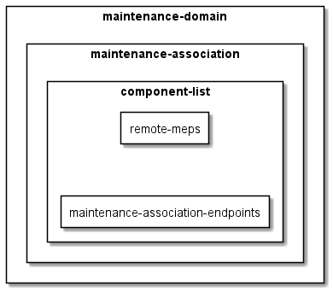
Figure G-1: o-ran-lbm YANG structure
In contrast, the ieee-802-dot1q-cfm YANG model has the structure illustrated in Figure G-2
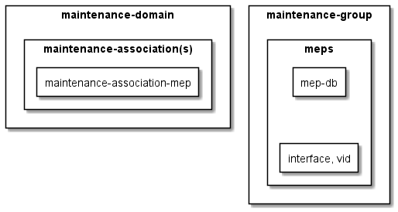
Figure G-2: ieee-802-dot1q-cfm YANG structure
The ieee802-dot1q-cfm.yang model is not standalone model. It needs to be extended to work with ieee-dot1q-cfm-bridge model or some equivalent. In o-ran-ieee802-dot1q-cfm.yang, interface and primary-vid are used to map to o-ran-interfaces (where an l2vlan interface implicitly maps to an IEEE 802.1Q bridge equivalent).
In both models, the maintenance association endpoint (mep) is mapped to a l2vlan interface (bridge interface) and the l2vlan interface is mapped to a bridge equivalent. In the /cfm/maintenance-group/mep, interface and primary-vid represents an ieee equivalent bridge instance. Association towards an ieee equivalent bridge is represented by parameter on MEP in maintenance -group.
In o-ran-lbm.yang model, remote-meps and maintenance-association-end-points are defined on the same level under schema node component-list. Remote-meps contains MEP IDs that are in the MA but are located remotely (opposite to local) and maintenance-association-endpoint contains mep configurations.
In ieee-802-dot1q-cfm model, information of meps is in two lists, maintenance-domain and maintenance-group.
The ieee-802-dot1q-cfm maintenance-association-mep list contains mep-ids for all configured meps that are in the MA. The mep list in maintenance-group list has mep configurations for example mac address, enable parameter etc. And in ieee-802-dot1q-cfm model, each mep contains a mep-db list used to store information of its remote-meps. In ieee-802-dot1q, if a maintenance-group is defined, remote MEP state machine is instantiated to all remote MEPs that are presented in maintenance-association-mep list (that is active).

G.2 Mapping between models
To map the a o-ran-lbm.yang configuration to ieee-802-dot1q-cfm, the level of component which represent a bridge will be mapped to ieee equivalent bridge instance which is represented by the combination of value interface and primary-vid. The remote-meps leaf-list in o-ran-lbm.yang will be mapped to the maintenance-association-mep list in ieee-802-dot1q-cfm model.
To map the a o-ran-lbm.yang configuration to ieee-802-dot1q-cfm, maintenance-group will be generated for each MD, MA combination. maintenance-association-end-point configuration in o-ran-lbm.yang will be mapped as /maintenance-group/MEP in ieee-802-dot1q-cfm model, as illustrated in Tables G-1, G-2, G-3, and G-4 describe the mapping between the two YANG schemas.
Table G-1 High level relationship between o-ran-lbm.yang and ieee-802-dot1q-cfm.yang
Model: o-ran-lbm-.yang | Model: ieee-802-dot1q-cfm.yang | Comment
/md-data-definition/maintenance-domain | /cfm/maintenance-domain
/md-data-definition/maintenance-domain/maintenance-association | /cfm/maintenance-domain /maintenance-association
/md-data-definition/maintenance-domain/maintenance-association /component-list | To parameter interface and vid in  /cfm/maintenance-group/mep
/md-data-definition/maintenance-domain/maintenance-association /component-list/Remote-meps | /cfm/maintenance-domain /maintenance-association /maintenance-association-mep | The local mep ids in lbm model need to be added as well.
/md-data-definition/maintenance-domain/maintenance-association /component-list /maintenance-association-end-point | /cfm/maintenance-group/mep | For each MD MA combination, a new maintenance-group can be created.

Table G-2 Mapping between maintenance-domain in o-ran-lbm.yang and ieee-802-dot1q-cfm.yang
List: /md-data-definition/maintenance-domain | List: /cfm/maintenance-domain | Comment
id | md-id
name | md-name
md-level | md-level

Table G-3 Mapping between maintenance-association lists in o-ran-lbm.yang and ieee-802-dot1q-cfm.yang
/md-data-definition/maintenance-domain/maintenance-association |  | /cfm/maintenance-domain /maintenance-association | Comment
parameter | sub-parameter | parameter
id |  | ma-id
name |  | ma-name
Component-list |  |  | Not mapped
 | Component-id |  | Not mapped
 | name | /cfm/maintenance-group/mep/interface
 | vid | /cfm/maintenance-group/mep/vid
 | Remote-meps | cfm/maintenance-domain /maintenance-association /maintenance-association-mep
 | Maintenance-association-meps | /cfm/maintenance-group/mep

Table G-4 Mapping MEP configuration between o-ran-lbm.yang and ieee-802-dot1q-cfm.yang
/md-data-definiton/maintenance-domain/maintenance-association /component-list /maintenance-association-end-point |  | /cfm/maintenance-group/mep | Comment
parameter | sub-parameter | parameter
Mep-identifier |  | mep-id
interface |  | interface | Augmented in ieee-dot1q-cfm
Primary-vid |  | vid | Augmented in ieee-dot1q-cfm
Administrative-state |  | enabled
Mac-address |  | Mac-address
loopback |  | N/A
 | Reply-transmitted | State/mep-lbr-out

Annex (informative):

Change history/Change request (history)
Date | Revision | Description
2019.03.11 | 01.00 | Summary:  First published version based on import of xRAN M-Plane
2019.07.03 | 02.00 | Summary:  Bug fixes and correction to v01.00  Addition of new functionality, including:  - Beam tilting  - Antenna calibration  - CU plane monitoring  - Trace  - 3GPP MV PnP support  - QSFP
2020.04.17 | 03.00 | Summary:  Bug fixes and correction to v02.00  - NACM table  - Clarifications on CU plane monitoring  - Clarification of allowed sync state transitions  - Corrections on overall Start-Up operation  Addition of new functionality, including:  - Shared cell  - Dying Gasp  - PM Counters  - Config Notification  - Hybrid Health Warning  - Dynamic Spectrum Sharing  - Grouping of eAxC-IDs  - Energy, Power and Environmental statistics
2020.08.10 | 04.00 | Summary:  Bug fixes and correction to v03.00:  - Removing reference to Component eAxC references  - Correcting YANG references for Non-Delay Managed Traffic  - Correcting YANG references for enhanced U-Plane markings  - Correcting YANG references in tables B.3 and C.3  - Clarify that validation of configuration is based on criteria which includes definitions in this document  - Clarification of supervision  Addition of new functionality, including:  - Enabling static configuration of PRACH or SRS  - Supporting flexible TDD pattern configuration  - To allow for different delay management parameters for C and U-plane  - New sync capabilities for reporting estimated time and frequency errors  - New capability to define compression on an endpoint basis  - New optional feature - configurable full-scale offset  - New optional feature - eAxC specific gain correction  - New optional feature - TX gain reference level control

Date | Revision | Description
2020.12.10 | 05.00 | Summary:  Bug fixes and correction to v04.00:  - Clarify operation of default account for certificate access  - Clarify operation of supervision in lock state  - Clarify PRACH patterns  - Fixing copy/paste errors in the S-plane PTP status definitions  - Corrected omissions from optional feature table  - Clarify centre bandwidth parameter  - Replace previous NMS terms with SMO  - Corrections to C/U plane monitoring for FHM  Addition of new functionality, including:  - New NACM permissions for SMO and hybrid O-DU  - New optional feature for performing pnfRegistration  - New optional feature for configured YANG subscriptions sent over JSON/REST  - Updating mandatory cipher to AES128-CTR  - Bandwidth management to avoid over-subscription of O-RU resources  - Shared cell with selective Tx/Rx using Beam ID  - Cascaded FHM Operation  - New capability to support co-ordinated (self) antenna calibration
2021.03.22 | 06.00 | Summary:  Bug fixes and correction to v05.00:  - Clarify operation of non-persistent M-Plane  - Clarify operation of Software Management  - Clarify operation of VLAN-IDs for C- and U-Plane  - Clarify eaxc-id assignment  - Clarify connectivity checks operation  - Clarify procedures for deleting configuration  - Clarify plug and play certificate aspects  Addition of new functionality, including:  - Optional support of NETCONF/TLS  - Supporting IPv6 only O-RUs
2021.07.26 | 07.00 | Summary:  Bug fixes and correction to v06.00:  - Clarify operation of configured subscriptions  - Clarify username syntax  - Correction to log management sequence diagrams  - Clarify delay management operation  - Clarify DHCP operation  - Clarify operation of antenna calibration  - Correct errors in text that describes low-level-[tr]x-endpoint creation  - Clarify modify parameter section  - Clarify revision and namespace compatibility handling  - Clarify certificate enrolment  - Clarify non-persistent operation with software management  - Clarify Fault Management Activation  - Correction to enable multiple measurements to be included in a notification  - Clarify operation of NETCONF supervision with multiple NETCONF clients  Addition of new functionality, including:  - External antenna delay handling  - Optional capability to optimize VLAN discovery  - Capability to support C-Plane limits for packet processing  - FTPES based file transfer  - TD-RSSI measurement capability  - EPE measurements for current and voltage  - Configurable timer for co-ordinated antenna calibration  - Enhanced antenna calibration using different resource sets
2021.10.19 | 07.00.01 | Merge of CRs: CIS-032, CIS-033, CIS-034
2021.10.28 | 07.01 | Updates to align with ETSI PAS Process
2021.10.25 | 07.01.01 | Merge of CRs: MAV-028, CIS-030, HST-001, CIS-036, SAM-065, SAM-066, SAM-064, CIS-031, SAM-059, NOK-082
2021.12.01 | 08.00 | Summary:  Bug fixes and correction to v07.01:  - Deprecate leaf-list(frequency-table) and to add a new list(frequency-bin-table)  - Correction for C-plane message limits  - Antenna Calibration schema node reference corrections  - Clarification for fault ID 24  - DHCP Clarifications  - Clarifications to log management  - Adding SCS information for FHM Combine operations  - Shared cell performance management corrections  Addition of new functionality, including:  - Introduction of alarm-type  - Enable IANA Private Enterprise Number to be used as Vendor Code in software management  - Boundary Clock function  - Capability for supporting multi cell operation  - Compression support for Section Type 6  - Mandatory support of TLS, PKIX, and FTPES  - Supporting multiple transport session types simultaneously  - Shared cell enhancements introducing t-combine-net and tx-duration
2021.12.15 | 08.00.01 | Merge of CRs: CIS-038, CIS-039
2022.03.01 | 08.00.02 | Merge of CRs: FJT-006, SAM-077, NOK-087, CIS-041, CIS-042, INT-019, CIS-040, ERI-041
2022.03.09 | 08.00.03 | Merge of CRs: FJT-007, CIS-044, CIS-043, ERI-038
2022.03.16 | 08.00.04 | Merge of CRs: NOK-105, ERI-039, NOK-100m NOK-102, STL-001, ALS-005
2022.04.18 | 09.00 | Summary:  Bug fixes and correction to v08.00:  - Updates to align with new O-RAN template  - Updates to references to align with DFT guidelines  - Clarify rejection of invalid configuration  - Alignment of eventName field and "remote-file-path" format  - Clarification of handling of an O-RU capable of BF and non-BF modes  - Update clause cases  - Correction Clarification of S-Plane interactions with M-Plane during Startup, and Loss/Recovery of Synchronisation  - Normative Reference to YANG models  - Clarify NACM and user management  - Clarify NETCONF monitoring and <get-schema>  - Reset handling clarification  - NETCONF event stream clarification  - Software Management Clarification  - SSH and SFTP host key clarification  - SFTP host key correction  Addition of new functionality, including:  - New feature flag for O-RU to indicate support of 4-Byte aligned section type 6  - New build-content-download leaf and associated software management definition  - New list for historical alarms  - Defining loopback message to group destination address
2022.06.29 | 09.00.01 | Merge of CRs: SYM-0006, NOK-0107, NOK-0101, ERI-0047, FJT-0011, ERI-0052, SAM-0085, FJT-0012, NOK-0090, NOK-0099
2022.07.06 | 09.00.02 | Merge of CRs: NOK-0113, CIS-0046, ERI-0050, NOK-0109, CIS-0050, CIS-0049, SAM-0086
2022.07.13 | 09.00.03 | Merge of CRs: NOK-0116, CIS-0047, CIS-0048
2022.07.14 | 09.00.04 | Merge of CRs: QCM-0040, ERI-0054, ERI-0049
2022.07.18 | 09.00.05 | Addressing all review comments received
2022.08.15 | 10.00 | Summary:  Bug fixes and correction to v09.00:  - Clarify contradicting statements with regard to TLS 1.2  - Array element fault source and fault source improvements  - Software management clarification  - Correction for module privileges  - Persistence of configured subscription  - Correction for O-RU call home port  - Clarify operation of filter based on xpath  - Clarify operation with factory default software  - Clarification to path definition for file management  - Remove LAA "capability" option from Table C.3-1  - Password for FTPES server  - Call home with multiple A/AAAA records  - PKI Clarifications  - Hybrid management clarifications  Addition of new functionality, including:  - Identifying default NETCONF accounts  - Introduction of O-RU connectors  - Configuration to map from certificates to NETCONF usernames  - Update SFP compliance codes  - DHCPv4 Client DUID/IAID definition  - IEEE 802.1X Port based access control  - Shared O-RU
2022.10.12 | 10.00.01 | Merge of CRs: ERI-0061, QCM-0046
2022.10.21 | 10.00.02 | Merge of CRs: ETR-0015, NOK-0122, CIS-0058, CIS-0053, CIS-0052, CIS-0051, NOK-0118, ERI-0064, NOK-0121
2022.11.01 | 10.00.03 | Merge of CRs: ERI-0063, ERI-0060, ADI-0001, NEC-0018, NOK-0120, ERI-0065
2022.11.03 | 10.00.04 | Merge of CR: CIS-0055
2022.11.07 | 10.00.05 | Merge of CR: CIS-0060
2022.12.05 | 11.00 | Bug fixes and correction to v10.00:  - Correcting hardware access privileges for SMO  - Correct fault ID 31 cancel condition and source  - Correct o-ran-laa YANG tree  - Add voltage and current EPE stats to Annex B.5  - Deprecation of power parameters for shared O-RU  - Annex C.2 and C.3 reformat tables  - Future topics annex  - Clarification for handling of multiple interfaces per optical port  - Clarify writable-running datastore  - Clarification for PM measurement objects modification  - Energy saving state clarification  - Clarification of active parameter  - Adding IEEE 802.1X recommendation  Addition of new functionality, including:  - U-Plane-only DL mode  - SW build level file integrity check  - Session supervision with session-id  - Network energy savings
2023.02.17 | 11.00.01 | Merge of CRs: NOK-0130, CIS-0061, ATT-0011, CIS-0065, SOL-0013, FJT-0022, FJT-0023, NOK-0119, ERI-0070, NOK-0123, ADI-0005, CIS-0064
2023.02.23 | 11.00.02 | Merge of CRs: SOL-0016, FJT-0024, SAM-0095, CIS-0067
2023.03.02 | 11.00.03 | Merge of CRs: SAM-0084, MAV-0031, CIS-0066, CIS-0062
2023.03.08 | 11.00.04 | Merge of CRs: CIS-0068, SAM-0096, ERI-0055, ERI-0067
2023.04.10 | 12.00 | Summary:  Bug fixes and correction to v11.00:  - Correct inconsistency in clause 9.1.3  - Update reference to DHCPv6 Options  - Remove import of ietf-crypto-types@2019-04-29  - Confirmation of backwards compatibility  - Clarification of the accounts name  - DHCP options clarification  - Clarify default operation of 802.1X  - Correction Radio Timing for Copy  - Correction to shared cell counters  - Clarification of PRACH repetition  - Clarified operational state for layer 3 configuration  - Remove erroneous use of SZTP  Addition of new functionality, including:  - 802.1X as Mandatory  - Add supported SCSes of FHM  - Allow all NETCONF clients to change their own password  - NB IoT  - Advanced endpoint capability reporting for NB-IoT & other scenarios  - Allow CA/RA server on non-production VLAN  - Introduce ietf-truststore YANG model  - Introduce SE11-WITH-CONTINUITY-BIT-SUPPORT  - Addition of feature non-scheduled-ueid  - Continuity Check Message support  - U-plane message processing limits
2023.06.26 | 12.00.01 | Merge of CRs: MAV-0033, CIS-0072, ERI-0083, ERI-0084, NOK-0135, CIS-0073, NOK-0140, FJT-0031, CIS-0071, ERI-0079, ERI-0080, MAV-0034
2023.07.04 | 12.00.02 | Merge of CRs: ERI-0077, NOK-0137, ERI-0082
2023.07.10 | 12.00.03 | Review comment corrections
2023.07.12 | 12.00.04 | Merge of CRs: SOL-0022, ERI-0085, NEC-0023
2023.07.14 | 12.00.05 | Updating YANG trees
2023.07.17 | 12.00.06 | Addressing comment spreadsheets
2023.07.19 | 12.00.07 | Template updates
2023.08.14 | 13.00 | Summary:  Bug fixes and correction to v12.00:  - Correction of feature name NON-PERSISTENT-MPLANE  - Clarifying multiple instances of "is responsible"  - Improve M-Plane stack illustration  - Correct LBM terminology  - Correction to CSV file format definitions  - Keep alive for call home O-RU controllers  - Clarify alarm dependency  - Clarify carrier state’s relationship to synchronisation state  Addition of new functionality, including:  - Add optional Major severity for alarm 1  - Call home re-activation  - Add optional Power Amplifier critical severity to alarm #27  - New availability status for [tr]x-array-carriers  - O-RU connectors for ALD ports and External IO ports  - Combine delays per SCS  - Disabling sequence number handling  - Enhanced Network Energy Savings functionality
2023.10.24 | 13.00.01 | Merge of CRs: MAV-0032, CIS-0074, CIS-0075, ERI-0086, CIS-0076
2023.11.01 | 13.00.02 | Merge of CRs: ERI-0091, ERI-0092
2023.11.06 | 13.00.03 | Merge of CRs: CIS-0078, SOL-0014, NEC-0025, SAM-0105
2023.11.07 | 13.00.04 | Merge of CRs: ERI-0090, NOK-0152
2023.12.11 | 14.00 | Summary:  Bug fixes and correction to v13.00:  - Reformat table 6.9.3-1  - Align Table B.1-1 with YANG Model  - Clarify the information which software slot is active is reset persistent  - Clarification for TAC level energy saving  - Model name and namespace clarifications  - C/U Plane Monitoring Clarification  - Fault management clarifications  Addition of new functionality, including:  - New alarm for Rx signal quality  - Adding ietf-netconf to imported folder  - New feature SE23-PRB-BLOCK-MODE-SUPPORT  - Performance Counter for Shared Cell  - Energy saving by Data Layer Control  - bundleOffset in SE 11
2024.02.26 | 14.00.01 | Merge of CRs: NOK-0157, NOK-0155, NOK-0144, ERI-0097, ERI-0101, CIS-0077, ERI-0089, NOK-0145, CIS-0081
2024.03.04 | 14.00.02 | Merge of CRs: QCM-0067, CIS-0079, NOK-0158, QCM-0064, ERI-0094, RMI-0001
2024.03.11 | 14.00.03 | Merge of CRs: SAM-0117, NOK-0165, CIS-0083, ERI-0093, NOK-0150, QCM-0076, SAM-0099
2024.03.18 | 14.00.05 | Merge of CR: CIS-0085
2024.04.15 | 15.00 | Summary:  Bug fixes and correction to v14.00:  - SWM Installation status enum fix  - Clarify port transceiver source for alarm 29  - Clarify user and certificate persistent information  - Correct cross reference to CUS-Plane DSS clause  - Clarify carrier activation deactivation sequence  - Clarifying NETCONF transaction operation  - PM parameter handling  - Lock O-RU clarifications  - Clarifying array element terminology  - Handling long DHCP options  Addition of new functionality, including:  - Per-port S-plane configuration of a multi-port O-RU  - O-RU payload frame size per ethernet interface  - Extended QL TLV Support  - O-RU TCP MSS Configuration  - Multiple beamId table support  - M-Plane TRX Control energy savings  - Deep hibernate energy savings  - PRG size feature  - Adding frequency-table support with EPE-Statistics  - VSWR performance management reporting  - MU-MIMO user group optimization feature  - Delay profile per beamforming method
2024.04.15 | 15.00.01 | Merge of CR: CIS-0085
2024.06.17 | 15.00.02 | Merge of CRs: CIS-0086, NOK-0169, CIS-0093, CIS-0092
2024.06.27 | 15.00.03 | Merge of CRs: SAM-0120, ERI-0106, MAV-0038
2024.07.01 | 15.00.04 | Merge of CRs: DCM-0023, ERI-0112, NOK-0180, ERI-0111, MAV-0037, QCM-0080, QCM-0082, ERI-0120
2024.07.03 | 15.00.05 | Merge of CRs: CIS-0087, CIS-0089, CIS-0091, SAM-0116
2024.07.09 | 15.00.06 | Merge of CRs: DELL-0002, SAM-0115, SAM-0119, CIS-0094, NOK-0185, SAM-0118, CIS-0090, SYM-0006
2024.08.29 | 16.01 | Summary:  Bug fixes and correction to v15.00:  - ETSI cleanup editorials  - Clarify interface connection  - Clarification on update of network layers parameters via NETCONF  - Trust store revision  - Clarifying transport endpoints  - Clarify alarm 28  - Clarify alarm 18  - Clarify vendor certificate and trust anchor handling  - Clarify certificate and trust anchor management for shared O-RU  - Clarify fault management Clause A  - CMPv2 clarification  - Clarify RFC 5277 and RFC 8639 subscriptions  Addition of new functionality, including:  - PAE credential definition  - High IQ Alarm  - VSWR Alarm  - DRMS-BF  - SE-10 feature SE10-MEMBER-CANDIDATE-LIST  - Target value configuration and used-value retrieval  - Configuring IEEE 802.1X addressing  - RSSI measurements when operating in shared spectrum.  - Simple Public Key Method for SSH Client Authentication  - TSSI Measurements  - RSSI Measurements  - Section Extension 27 for O-DU controlled dimensionality reduction  - In service beamforming configuration update  - MACsec  - Certificate lifecycle management
2024.11.06 | 16.01.01 | Merge of CRs: CIS-0095, ERI-0119, CIS-0098, CIS-0099, ERI-0128, DCM-0024, MAV-0043, ATT-0001, CIS-0103, SAM-0125, MAV-0035, NOK-0186, NOK-0196
2024.11.19 | 16.01.02 | Merge of CRs: MAV-0040, MAV-0042, ERI-0117, CIS-0096, ERI-0130
2024.11.20 | 16.01.03 | Merge of CRs: CIS-0097, SAM-0129, SOL-0038
2024.11.21 | 16.01.04 | Merge of CRs: CIS-0101, ERI-0124
2024.11.25 | 16.01.05 | Merge of CRs: ERI-0129, NOK-0191, NOK-0190
2024.12.23 | 17.00 | Summary:  Bug fixes and correction to v16.01:  - British English corrections  - Carrier general configuration  - Backwards compatible clarification  - Revision handling  - Remove S-plane performance requirements  - Correction of the sync state change descriptions  - Correction to feature flag name for dying gasp alarm  - Correction to step numbers in Cross Reference  - Clarification of temperature measurements for transceivers  - Remove case SELECTIVE from shared cell mode configuration  - hardware-state-change clarification  - Deprecate per-band-config list related RPC and Notification  - Clarify ALD operations  - Hybrid and hierarchical clarifications  - Shared cell clarifications  - Clarify U-Plane configuration steps  - Clarify carrier availability status  Addition of new functionality, including:  - Add a generic hardware failure alarm to M-Plane  - Add TX output power statistics to M-Plane  - O-RAN defined security logging  - Dynamic SINR reporting resolution  - Switched to importing RFC 9640, 9641, 9642 instead of Internet-Drafts  - New transceiver measurement for thermoelectric cooler (TEC) current  - New Ethernet statistics counters
2024.01.27 | 17.01 | Summary:  Bug fixes and correction to v17.00:  - Aligned all 3GPP References
2025.03.03 | 17.01.01 | Merge of CRs: ERI-0114, ERI-0144, NEC-0048, QCM-0090, QCM-0088, RMI-0002, QCM-0089, NEC-0049
2025.03.11 | 17.01.02 | Merge of CRs: ERI-0155, NOK-0206, NOK-0205, SAM-0136, FJT-0033, CIS-0100, NOK-0209
2025.03.17 | 17.01.03 | Merge of CRs: CIS-0104
2025.04.14 | 18.00 | Summary:  Bug fixes and correction to v17.01:  - Correcting sync parameter naming  - Correcting carrier management figure  - Correcting mismatch in file management RPC YANG parameters  - Clarify sending of notifications when 'oper-state' changed  - Clarify measurement results in first measurement interval  - Clarify TRX control activation  - Clarify supervision monitoring  - Correct mismatch in o-ran-performance-management features  - Clarify alarm type enumerations  - Correct delay parameter table  - Correct description of TX_TOTAL_C  - Clarification of static routing  Addition of new functionality, including:  - Notification of the transceiver presence change  - Transceiver operating limits thresholds and notifications  - Filtering of troubleshooting log files
2025.06.18 | 18.00.01 | Merge of CRs: NOK-0212, NOK-0225, NOK-0200, DEL-003, SAM-0143
2025.06.25 | 18.00.02 | Merge of CRs: SAM-0132, NOK-0227, CIS-0108
2025.07.02 | 18.00.03 | Merge of CRs: CIS-0107, ERI-0179, ERI-0192, SAM-0132, SAM-0148, SAM-0150
2025.07.07 | 18.00.04 | Merge of CRs: NOK-0229
2025.07.16 | 18.00.07 | Merge of CRs: ERI-0191
2025.08.11 | 19.00 | Summary:  Bug fixes and correction to v18.00:  - Fix of the RX_CORRUPT definition  - Software management install bugfix  - YANG parameter name corrections  - Table C.3-9 corrections  - Clarification of certificate subject in CSR  - Clarifying statements of fact  - Clarify configuration and activation of PM measurement  - Adding missed feature SHARED-CELL-STATS to Table C.2-1  Addition of new functionality, including:  - Fan present and operating change notification  - Configurable TLS Server Hello message  - Max output power control for energy saving  - SE-20 full PRB puncture with different sectionId  - Adding object unit data-direction to tx-stats  - Additional Ethernet counters  - Cyclic delay adjustment
2025.11.04 | 19.00.01 | Merge of CRs: CIS-0100, ERI-0193, NOK-0223, ERI-0158, CIS-0111, NOK-0230, ERI-0208, NOK-0241, NOK-0242, NOK-0240, ERI-0205, CIS-0109, ERI-0215, SAM-0158, ERI-0200, ERI-0201, ERI-0211, NOK-0238, NOK-0239, NOK-0234, SAM-0153, ERI-0202, NOK-0237
2025.11.06 | 19.00.02 | Merge of CRs: ATT-0002, ATT-0004, DELL-0004, SAM-0157, ERI-0199, DCM-0025
2025.11.11 | 19.00.03 | Merge of CRs: ERI-0214, NOK-0245, ERI-0197, ERI-0213, CIS-0112, ERI-0196  Addressing comment spreadsheets from ATT, CIS, NOK, QCM and NEC  Updated YANG model revision statements from merged PRs  Updated YANG trees from merged PRs
2025.11.20 | 19.00.04 | Addressing comment spreadsheets from ERI, SAM and CIS
2025.12.22 | 20.00 | Summary:  Bug fixes and correction to v19.00:  - Correct missing MEAS-UE-RADIAL-SPEED and MEAS-UE-POS features  - Clarify maximum simultaneous eAxC ID formats  - Address ETSI PAS comments  - admin-state and availability-state dependency clarification  - Correct ALD DC enabling  - Performance measurement statistics calculation cleanup  - Clarify CMPv2/HTTPS  - Align password definitions  - Update to history table format  - Clarifications to delete carrier operations  - Correct cross references to CUS-plane specification  - Clarify Trust Anchor Provisioning  - Clarify operation with vendor signed certificates  - Clarify TLS Certificate handling  - Corrections in performance management  - Clarification of low-level link creation  - Correction of PM format examples  - Clarification of handling different M-Plane versions  - Clarify certificate enrolment requirements  - Clarify NETCONF authorisation  Addition of new functionality, including:  - Introduce sub-module handling  - Add new feature POINT-A-OFFSET-TO-ABSOLUTE-FREQUENCY-CENTER-TX  - Switch TLS1.3 to be mandatory  - Configurable SSH algorithms  - Import IETF Features for SSH and TLS Servers  - Self-tunable transceiver diagnostics  - O-RU autonomous re-keying  - CRL checking requirements  - re-pnf-registration-timer  - invalid FOE indication  - MU interference level RRM measurement  - capability for single value SINR report for DFT-sOFDM
2026.03.03 | 20.00.01 | Merge of CRs: ERI.AO-0180, NOK-0254, CIS-0113, DELL-0112, ERI.AO-0178, NOK-0248, ERI-0221, ATT-0003, NOK-0257, NOK-0258, ERI-0224, NOK-0249, NOK.AO-0254, NOK.AO-0253, KEY-0001, ERI-0232
2026.03.06 | 20.00.02 | Addressing review comments
2026.03.09 | 20.00.03 | Merge of CR: QCM-0110, NOK-0252
2026.03.10 | 20.00.04 | Addressing review comments
2026.03.11 | 20.00.05 | Addressing review comments
2026.03.29 | 21.00 | Summary  Clarifications and corrections to v21.00:  - Mirrored ETSI editorial comments provided in v17.01  - Correction of SRCS clause reference for EAP authentication  - Clarification on availability-state influenced by internal faults  - Clarification for array carrier availability-status  - New alarm Abnormally High Unit Temperature of category EQUIPMENT-ALARM added  - Correction of 3gpp spec reference for certain alarm types  - Clarification of O-RU level parameter usage-state  - Editorial correction for Start-up installation procedure  - Update to M-plane parameter description “max-highest-priority-sec-per-cplane-message”  Addition of new functionality, including:  - New feature PM-SUSPECT-REPORTING IMMEDIATE-PM-CONFIGURATION added for performance measurement  - New feature for NULL-STEERING of beams and related features BEAM-ID-SCOPE-NULLING and TARGET-BEAM-RANG added  - M-plane changes for new feature for sending MCS info in Section Ext 31  - M-plane changes for new RRM measurement UE layer pre-equalization SINR.  - M-Plane changes for new feature TRX-CONTROL-BIDIR  - MP changes for new RRM measurement for Uplink Rank and TPMI reporting from O-RU  - Support for major feature Passive Intermodulation (PIM) measurement and cancellation  - RWX permission for notification subscription added for NETCONF client sudo access privilege group  - Write permission added for file-management (fm) module for account groups with execute permission
2026.05.07 | 21.01 | Summary  - Editorial correction in clause 15.4.7.4 to replace uml source code with uml diagram  - Missing Table B.1.1-2 added  - Fixed clause numbering for clause 15.4.7.5 not reflecting in heading summary in word navigation  - Clause 15.4.7.2 and Clause 15.4.7.3 made consistent with approved content in ERI-0178  - Yang module zip file reference changed from 21.00 to 21.01 to align with MP spec version for March 2026 train  - Updated date for yang module revision history change

